Digital Asset Management

Software Architecture Document

Team 2

Version 1.0

Revision History

|  |  |  |  |
| --- | --- | --- | --- |
| **Date** | **Version** | **Description** | **Author** |
| 10/21/2012 | 1.0 |  | Duc Do |
| 11/15/2012 | 2.0 | Revise Introduction, Usecase, Deployment View, Implementation View, Logical View | Duc Do |
| 12/14/1012 | 3.0 | Revise Process View, Size and Performance , Quality | Christopher Koch, Duc Do. |
|  |  |  |  |

Table of Contents

[1.       Introduction](http://web.cs.wpi.edu/%7Egpollice/cs4233-a05/rup_sad.html#1.%20%20%20%20%20%20%20%20%20%20%20%20%20%20%20%20%20%20Introduction)

1.1     Purpose

1.2     Scope

1.3     Definitions, Acronyms and Abbreviations

1.4     References

1.5     Overview

2.       Architectural Representation

3.       Architectural Goals and Constraints

[4.       Use-Case View](http://web.cs.wpi.edu/%7Egpollice/cs4233-a05/rup_sad.html#4.%20%20%20%20%20%20%20%20%20%20%20%20%20%20%20%20%20%20Use-Case%20View)

[4.1 Use-Case Realizations](http://web.cs.wpi.edu/%7Egpollice/cs4233-a05/rup_sad.html#4.1%20%20%20%20%20%20%20%20%20%20%20%20%20%20%20Use-Case%20Realizations)

[5.       Logical View](http://web.cs.wpi.edu/%7Egpollice/cs4233-a05/rup_sad.html#5.%20%20%20%20%20%20%20%20%20%20%20%20%20%20%20%20%20%20Logical%20View)

[5.1     Overview](http://web.cs.wpi.edu/%7Egpollice/cs4233-a05/rup_sad.html#5.1%20%20%20%20%20%20%20%20%20%20%20%20%20%20%20Overview)

[5.2     Architecturally Significant Design Packages](http://web.cs.wpi.edu/%7Egpollice/cs4233-a05/rup_sad.html#5.2%20%20%20%20%20%20%20%20%20%20%20%20%20%20%20Architecturally%20Significant%20Design%20Packages)

[6.       Process View](http://web.cs.wpi.edu/%7Egpollice/cs4233-a05/rup_sad.html#6.%20%20%20%20%20%20%20%20%20%20%20%20%20%20%20%20%20%20Process%20View)

[7.       Deployment View](http://web.cs.wpi.edu/%7Egpollice/cs4233-a05/rup_sad.html#7.%20%20%20%20%20%20%20%20%20%20%20%20%20%20%20%20%20%20Deployment%20View)

[8.       Implementation View](http://web.cs.wpi.edu/%7Egpollice/cs4233-a05/rup_sad.html#8.%20%20%20%20%20%20%20%20%20%20%20%20%20%20%20%20%20%20Implementation%20View)

[8.1     Overview](http://web.cs.wpi.edu/%7Egpollice/cs4233-a05/rup_sad.html#8.1%20%20%20%20%20%20%20%20%20%20%20%20%20%20%20Overview)

[8.2     Layers](http://web.cs.wpi.edu/%7Egpollice/cs4233-a05/rup_sad.html#8.2%20%20%20%20%20%20%20%20%20%20%20%20%20%20%20Layers)

[9.       Data View (optional)](http://web.cs.wpi.edu/%7Egpollice/cs4233-a05/rup_sad.html#9.%20%20%20%20%20%20%20%20%20%20%20%20%20%20%20%20%20%20Data%20View%20%28optional%29)

[10.     Size and Performance](http://web.cs.wpi.edu/%7Egpollice/cs4233-a05/rup_sad.html#10.%20%20%20%20%20%20%20%20%20%20%20%20%20Size%20and%20Performance)

[11.      Quality](http://web.cs.wpi.edu/%7Egpollice/cs4233-a05/rup_sad.html#11.%20%20%20%20%20%20%20%20%20%20%20%20%20Quality)

Software Architecture Document

**1.**                  **Introduction**

This Software Architecture Document (SAD) describes the architecture of Digital Asset Management (DAM) system using different architectural views to illustrate different aspects of the system and to explain the significant architectural decisions. The SAD includes a high-level description of the goals of the architecture, the use cases support by the system and architectural styles and components that have been selected to best achieve the use cases.

**1.1**               **Purpose**

The Software Architecture Document (SAD) provides a comprehensive architectural overview of the Digital Asset Management (DAM) Website developed by team 2, CSC440 Fall 2012. Requested by PR Department in Carroll University, DAM is used to help the department manages their digital archive and to help other Carroll departments download the school’s digital assets.

**1.2**               **Scope**

The scope of this SAD is to depict the architecture of the DAM application created by team 2, CSC440 Fall 2012.

**1.3**               **Definitions, Acronyms and Abbreviations**

DAM: Digital Asset Management

ERD: Entity Relational Diagram

UML: Unified Modified Language

SAD: Software Architecture Document

**1.4**               **References**

[KRU41]: The “4+1” view model of software architecture, Philippe Kruchten, November 1995, <http://www3.software.ibm.com/ibmdl/pub/software/rational/web/whitepapers/2003/Pbk4p1.pdf>

[RSA]: IBM Rational Software Architect

<http://www-306.ibm.com/software/awdtools/architect/swarchitect/index.html>

[RUP]: The IBM Rational Unified Process :

<http://www-306.ibm.com/software/awdtools/rup/index.html>

[RUPRSA]: Developing a J2EE Architecture with Rational Software Architect using the Rational Unified Process®, IBM DeveloperWorks, Jean-Louis Maréchaux, Mars 2005, <http://www-128.ibm.com/developerworks/rational/library/05/0816_Louis/>

**1.5**               **Overview**

Section 2: Architectural Representation

Section 3: Digital Asset Management

Section 4: Use-Case View

Section 5: Logical View

Section 6: Process View

Section 7: Deployment View

Section 8: Implementation View

Section 9: Data View

Section 10: Size and Performance

Section 11: Quality

**2.**                  **Architectural Representation**

This document describes the architecture of DAM using standard UML and ERD diagrams and “4+1” models, including use case, component, package, and deployment diagrams. Readers of this document need to be familiar with the UML and ERD notation.

As defined in “4+1”, below are views will be specified in the documents:

**Logical view**

* Audience: Designers.
* Area: Functional Requirements: describes the design's object model. Also describes the most important use-case realizations.
* Related Artifacts: Design model

**Process view**

* + Audience: Integrators.
  + Area: Non-functional requirements: describes the design's concurrency and synchronization aspects.
  + Related Artifacts: (no specific artifact).

**Implementation view**

* + Audience: Programmers.
  + Area: Software components: describes the layers and subsystems of the application.
  + Related Artifacts: Implementation model, components

**Deployment view**

* + Audience: Deployment managers.
  + Area: describes the mapping of the software onto the hardware and shows the system's distributed aspects.
  + Related Artifacts: Deployment model.

**Use Case view**

* + Audience: all the stakeholders of the system, including the end-users.
  + Area: describes the set of scenarios and/or use cases that represent some significant, central functionality of the system.
  + Related Artifacts : Use-Case Model, Use-Case documents

**Data view (optional)**

* Audience: Data specialists, Database administrators
* Area: Persistence: describes the architecturally significant persistent elements in the data model
* Related Artifacts: Data model.

**3.**                  **Architectural Goals and Constraints**

There are some crucial requirements and systems constraints that significantly impact the architecture:

* The DAM application will be deployed into Carroll IIS Server
* The DAM application development framework is .NET 4.0 and using Microsoft SQL Server 2008.
* Data persistence will be addressed using relational database.
* The searching process must be under 5 seconds.
* For application access, there will be different permission criteria for admin access and user access.
* Authentication: Login using at least a user name and a password
* Authorization: according to their profile, online users must be granted or not to perform some specific actions depending whether they are admin or users.

**4.**                  **Use-Case View**

The following use cases are involved in the Digital Asset Management application.

* UC-1: User Login
* UC-2: Search
* UC-3: Preview
* UC-4: Download File
* UC-5: Upload File
* UC-6: Add User
* UC-7: View Report

**4.1** **Use-Case Realizations**

**UC-1: User Login**

**Use Case Overview**

|  |  |
| --- | --- |
| **Description** | This is the process of an Administrator or a departmental user logging into their account. |
| **Actor(s)** | User, System |
| **Pre-Conditions** | User has already been added to the system. |
| **Post-Conditions** | Success end condition  User will be logged into their account and able to function in the system with their given privileges. |
| **Trigger** | User clicks the log in button |

## Main Flow

|  |  |
| --- | --- |
| **Main** |  |
| 1 | User enters their user name. |
| 2 | User enters their password. |
| 3 | System validates user name and password. |
| 4 | System displays application home page with either departmental user or administrator functionality. |

## Alternate Flows

|  |  |
| --- | --- |
| **Alt 1** | **User not in the system** |
| 1 | System does not find the entered user name. |
| 2 | User will be prompted to submit a request to be set up with a user account. |
| 3 | Use case ends |
| **Alt 2** | **User is logging in for the first time** |
| 1 | System determines that the user is logging in for the first time. |
| 2 | System will prompt user to change their default password and generate a new password. |
| 3 | User enters new password. |
| 4 | System validates that password is acceptable. |
| 5 | System will store new password. |
| 6 | Use case resumes at step 4. |

**UC-2: Search**

**Use Case Overview**

|  |  |
| --- | --- |
| **Description** | This case focuses on searching the database. |
| **Actor(s)** | User, System |
| **Pre-Conditions** | User is logged into their account. |
| **Post-Conditions** | Success end condition  Results from the user’s query will be displayed. |
| **Trigger** | User clicks in the search box. |

## Main Flow

|  |  |
| --- | --- |
| **Main** |  |
| 1 | User types their key words in the search field. |
| 2 | Optional: The user may limit the search to only certain file types by selecting the file type they are searching for.  The following file types will be available:  .mov  wmv  mp4  swf  fla  wav  mp3  jpg  gif  tiff  bmp  png  psd  ai  eps  pdf |
| 3 | Optional: The user may limit the search to only files within specified dates by entering a date range. |
| 4 | Optional: User may enter advanced options to further define the search. (Advanced Options TBD) |
| 5 | User submits query. |
| 6 | System queries database using the user’s key words to select from the tags table. |
| 7 | Results from the query are displayed in the center panel of the web page. |
| 8 | If no match is found in the database the System will display a message indicating that no matches were found for the user’s search. |

**UC-3: Preview**

**Use Case Overview**

|  |  |
| --- | --- |
| **Description** | This case focuses on displaying a preview of a selected file. |
| **Actor(s)** | User, System |
| **Pre-Conditions** | User is logged into their account.  A successful search has been performed with at least one file returned as the result. |
| **Post-Conditions** | Success end condition  User is able to view a preview of the selected file. |
| **Trigger** | User clicks on a file to preview. |

## Main Flow

|  |  |
| --- | --- |
| **Main** |  |
| 1 | From the search results, user clicks on a file to preview. |
| 2 | System queries database for selected file to retrieve file’s detailed information. |
| 3 | System uses file type to determine how to display on the web page. |
| 3 | System display preview page with a preview of the file and information about the file. |

**UC-4: Download File**

**Use Case Overview**

|  |  |
| --- | --- |
| **Description** | This case focuses on a user downloading a file from the server. |
| **Actor(s)** | User, System |
| **Pre-Conditions** | User is logged into their account.  A successful search has been performed with at least one file returned as the result. |
| **Post-Conditions** | Success end condition  File will be downloaded from the server to the user’s desired local location. |
| **Trigger** | User selects file or files to download |

## Main Flow

|  |  |
| --- | --- |
| **Main** |  |
| 1 | User selects a file or multiple files from the search results by clicking in a check box or multiple check boxes. |
| 2 | User clicks download button. |
| 3 | System prompts user to select a local location to store the file or files. |
| 3 | User selects desired local location for file storage. |
| 4 | User clicks button to begin download. |
| 5 | System uses user selection to select the appropriate files from the server’s file system. |
| 6 | Data is sent to user’s local machine using HTTP. |

**UC-5: Upload File**

**Use Case Overview**

|  |  |
| --- | --- |
| **Description** | This case focuses on a user uploading a file to the server. |
| **Actor(s)** | User, System |
| **Pre-Conditions** | User is logged into their account.  User is logged in with an administrator account. |
| **Post-Conditions** | Success end condition  File will be uploaded to the server. |
| **Trigger** | User clicks upload button. |

## Main Flow

|  |  |
| --- | --- |
| **Main** |  |
| 1 | System prompts user to select a file for upload. |
| 2 | User selects a valid file from their local file system. If an invalid file is selected then system will prompt user to select a different file.  The valid file types are:  .mov  wmv  mp4  swf  fla  wav  mp3  jpg  gif  tiff  bmp  png  psd  ai  eps  pdf |
| 3 | System prompts user to enter information for the file, including tags to be used in searches. |
| 3 | User clicks upload button. |
| 4 | File is transferred to server using HTTP. |
| 5 | System stores file on server file system. |
| 6 | System stores information about the file in the database. |
| 7 | System displays a message for the user indicating the upload is complete. |

**UC-6: Add User**

**Use Case Overview**

|  |  |
| --- | --- |
| **Description** | This case focuses on a user uploading a file to the server. |
| **Actor(s)** | User, System |
| **Pre-Conditions** | User is logged into their account.  User is logged in with an administrator account. |
| **Post-Conditions** | Success end condition  A new user is added. |
| **Trigger** | User selects Add New User option. |

## Main Flow

|  |  |
| --- | --- |
| **Main** |  |
| 1 | User types new user log in name into user name field. |
| 2 | User types default password into password field. |
| 3 | User clicks submit button. |
| 3 | System verifies that user name is unique. |
| 4 | System adds new user name and password to the database. |
| 5 | System displays a message indicating that the new user has been successfully added. |

## Alternate Flows

|  |  |
| --- | --- |
| **Alt 1** | **User name already exists in database** |
| 1 | System prompts user that the entered already exists and a new unique user name must be entered. |
| 2 | Use case resumes at step 1. |

**UC-7: View Report**

**Use Case Overview**

|  |  |
| --- | --- |
| **Description** | This case focuses on a user viewing a report. |
| **Actor(s)** | User, System |
| **Pre-Conditions** | User is logged into their account.  User is logged in with an administrator account. |
| **Post-Conditions** | Success end condition  The report is displayed. |
| **Trigger** | User selects the option to view a report. |

## Main Flow

|  |  |
| --- | --- |
| **Main** |  |
|  | User selects one of the available reports.  The following reports are available:  Statistical.  History. |
| 1 | System queries database for report information. |
| 2 | System builds report. |
| 3 | Report is displayed in the center panel of the web page. |
|  | Optional: User may choose to export the report by clicking the export button. System then transfers file to user’s local machine using HTTP. |

**5.**                  **Logical View**

**5.1**               **Overview**

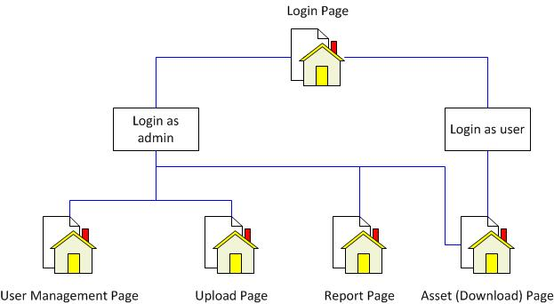

**5.2**               **Architecturally Significant Design Packages**

Since MVC-like architecture is applied, application’s classes reside in different folders/packages are categorized based on their database access capability and their duties as data view, data source or data delegate.

|  |  |
| --- | --- |
| Default.aspx | It is the login page. Users can login as admin or normal users. |
| Asset.aspx | It is the searching/download page. Both normal users and admin can access this page. |
| Admin.aspx | It is the upload page. Only admin can access this page. |
| Report.aspx | It is the reports page. There are user report and data download report. Only admin can access this page. |
| User.aspx | It is for managing user status. Only admin can access this page. The admin can add new users, delete users and change users’ status. |

**6.**                  **Process View**

This section consists of two process diagrams. The first represents the user login process and the second represents the search process.

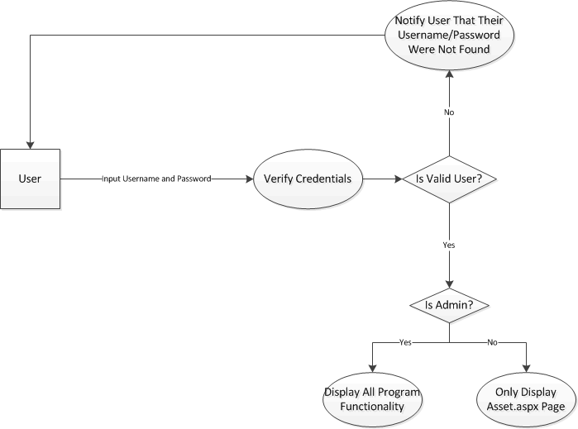

Login Diagram

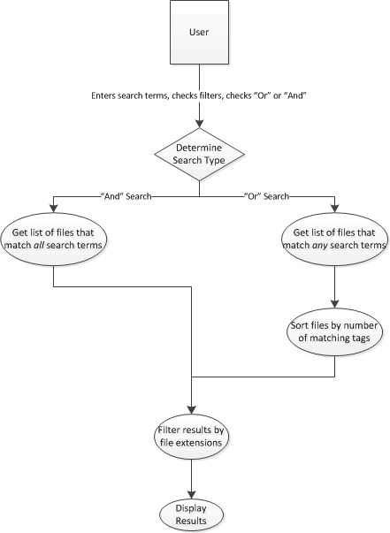

Search Diagram

**7.**                  **Deployment View**

Both the DAM application website and DAM database will be hosted in Carroll University servers. Clients will have access to website using any browser in their personal computer.

[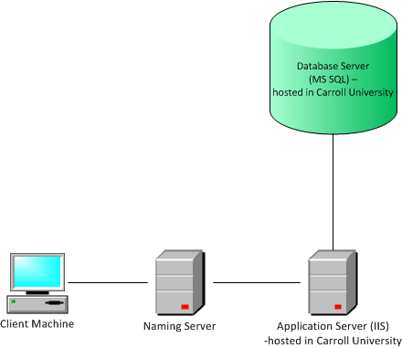

**8.**                  **Implementation View**

**8.1**               **Overview**

Since our design is similar to MVC, application’s classes reside in different folders/packages are categorized based on their database access capability and their duties as data view, data source or data delegate.

**8.2**               **Layers**

**View Layer:**

This layer provides interfaces with users through different .aspx pages. Through the interface, users input are processed by back-end C# codes behind. To communicate with the database, this layer use different model classes written in C#.

**Logic Layer:**This layer connects view layer with data source layer. More specifically, it processes, user inputs, get access to data source, and manipulate the data based on user input, and output results to the View layer. Using LINQ, we created a collection of constructors and getter/setter. Each class in Model package represents a table in the Microsoft SQL database. The querying brain is DataAccess.cs. Back-end codes in View Layer use this class to query information from the Linq Tables.

**Data Access Layer:**This layer is represented by Linqtoalldata.dbml. This database represents our SQL database hosted Carroll Server.



**9.**                  **Data View (optional)**

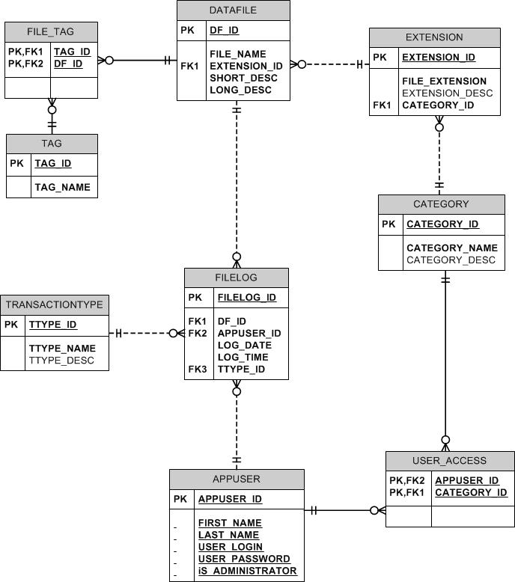

**10.**             **Size and Performance**

During the first deployment, it will be available to admin and PR department for testing and uploading data. After that, it will be accessible for different departments. . Page response times will be less than 10 seconds and ideally should be returned within a second. The system will be backed up on Carroll University server in timely manner.

**11.**             **Quality**

Only registered admin and users can access the system. The application is hosted by Carroll and it should be available 24/7. Users will be notified for scheduled downtime for backup and maintenance. Team 2 will be contacted if admin requires additional information about the application. . Any changes done within the architecture will have less/none effect on other layers of the architecture thus maintaining high portability of the system.