Customer Order Management System
DBII Project Documentation

Technologies Used
Python • Flask • SQLAlchemy • SQLite • HTML/CSS

Database Systems II • 2025 / 2026

1. Problem Statement

Small and medium-sized businesses often rely on spreadsheets or paper-based systems to track their customers, products, and orders. These approaches are error-prone, difficult to query, and do not scale as the business grows. The lack of a structured, relational data model makes it hard to answer even basic questions such as which customer has spent the most, which products are low on stock, or what the total revenue for a given period is.

This project addresses that problem by implementing a web-based Customer Order Management System built on a relational database. The system allows a business to:

- Register and manage customer records including contact information.
- Maintain a product catalogue with pricing and stock levels.
- Create orders that link customers to one or more products through order line items.
- Track order status (pending, completed, cancelled) and calculate revenue automatically.
- Analyse sales data through multi-table JOIN queries that combine information across all four tables.

The application demonstrates core relational database concepts including entity design, primary and foreign keys, one-to-many and many-to-many relationships, and SQL JOIN operations. The user interface is built with Flask and Jinja2, providing full CRUD (Create, Read, Update, Delete) functionality for all entities.

2. Entity-Relationship Model

2.1 Entities Overview
The system contains four entities. The table below summarises their type, primary key, and relationship to other entities.

Entity | Type | Primary Key | Notes
Customers | Strong | id (PK) | Exists independently. No dependency on other tables.
Orders | Strong* | id (PK), customer_id (FK) | Depends on Customers. Cannot have a valid order without a customer.
Products | Strong | id (PK) | Exists independently. No dependency on other tables.
Order Items | Weak | id (PK surrogate), order_id + product_id (natural key) | Cannot exist without both an Order and a Product.

2.2 Strong Entities
A strong entity has its own primary key and can exist independently of any other entity.

- Customers: Customers is a strong entity. A customer record exists on its own — it does not require an order or product to be created first. Its primary key is the auto-incrementing integer id.
- Products: Products is a strong entity. A product exists in the catalogue regardless of whether it has ever been ordered. Its primary key is the auto-incrementing integer id.

2.3 Weak Entity
A weak entity cannot exist without a parent entity. Its existence is dependent on one or more strong entities.

- Order Items: Order Items is the weak entity in this system. An order item record has no meaning unless both a parent Order and a parent Product exist. In strict ER theory, its natural (composite) key is the combination of order_id and product_id. A surrogate id column has been added for convenience, but the true identifier remains the composite foreign key pair.

2.4 Relationships
The diagram below shows the four entities and the relationships between them:

CUSTOMERS ||--o{ ORDERS (one customer places zero or many orders)
ORDERS ||--o{ ORDER_ITEMS (one order contains one or many line items)
PRODUCTS ||--o{ ORDER_ITEMS (one product appears in zero or many line items)

The ORDER_ITEMS table resolves the many-to-many relationship between ORDERS and PRODUCTS. A single order can contain many products, and a single product can appear in many orders. ORDER_ITEMS sits between them, holding one row per product per order, along with the quantity and the unit price at the time of purchase.
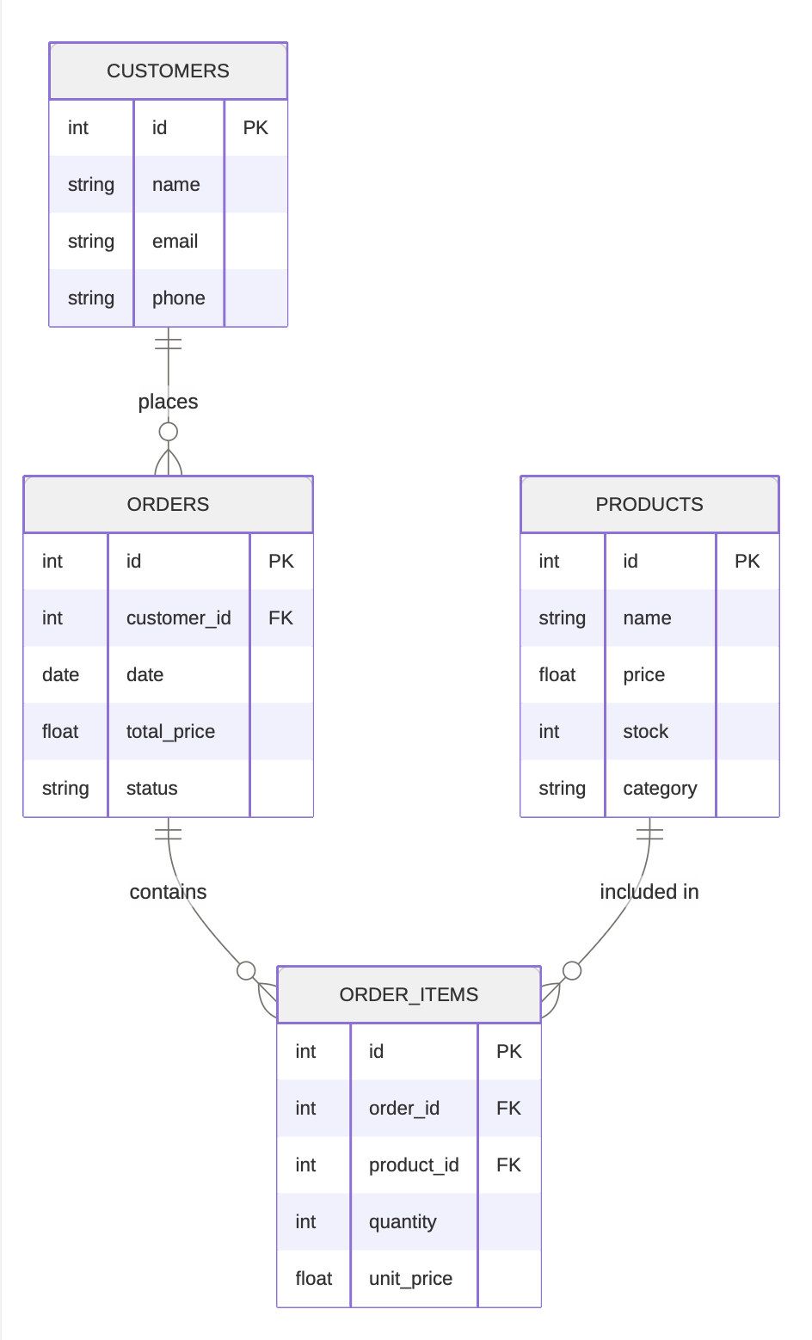

3. Table Definitions

3.1 CUSTOMERS
Stores all customer contact information. This is a strong entity — it has no foreign keys and can exist independently.

Column | Type | Constraint | Description
id | INTEGER | PRIMARY KEY | Auto-incrementing unique identifier
name | TEXT | NOT NULL | Full name of the customer
email | TEXT | NOT NULL, UNIQUE | Email address — must be unique
phone | TEXT | NULLABLE | Optional contact phone number

3.2 ORDERS
Stores each order placed by a customer. Links to CUSTOMERS via a foreign key. One customer can have many orders (one-to-many).

Column | Type | Constraint | Description
id | INTEGER | PRIMARY KEY | Auto-incrementing unique identifier
customer_id | INTEGER | FK -> customers.id | References the customer who placed this order
date | DATE | NOT NULL | Date the order was placed
total_price | REAL | NOT NULL | Calculated total value of the order
status | TEXT | DEFAULT 'pending' | Order status: pending, completed, cancelled

The tables in this application are defined using SQLAlchemy's ORM layer, which automatically generates and executes the equivalent SQL at runtime. The raw SQL representation of all four tables is shown below for clarity:

CREATE TABLE IF NOT EXISTS customers (

id INTEGER PRIMARY KEY AUTOINCREMENT,

name TEXT NOT NULL,

email TEXT NOT NULL UNIQUE,

phone TEXT

);

CREATE TABLE IF NOT EXISTS products (

id INTEGER PRIMARY KEY AUTOINCREMENT,

name TEXT NOT NULL,

price REAL NOT NULL,

stock INTEGER DEFAULT 0,

category TEXT

);

CREATE TABLE IF NOT EXISTS orders (

id INTEGER PRIMARY KEY AUTOINCREMENT,

customer_id INTEGER NOT NULL,

date TEXT NOT NULL,

total_price REAL NOT NULL,

status TEXT DEFAULT 'pending',

FOREIGN KEY (customer_id) REFERENCES customers(id)

);

CREATE TABLE IF NOT EXISTS order_items (

id INTEGER PRIMARY KEY AUTOINCREMENT,

order_id INTEGER NOT NULL,

product_id INTEGER NOT NULL,

quantity INTEGER NOT NULL DEFAULT 1,

unit_price REAL NOT NULL,

FOREIGN KEY (order_id) REFERENCES orders(id),

FOREIGN KEY (product_id) REFERENCES products(id)

);

3.3 PRODUCTS
Stores the product catalogue. This is a strong entity — it has no foreign keys and exists independently of orders.

Column | Type | Constraint | Description
id | INTEGER | PRIMARY KEY | Auto-incrementing unique identifier
name | TEXT | NOT NULL | Name of the product
price | REAL | NOT NULL | Current base price of the product
stock | INTEGER | DEFAULT 0 | Current stock level in units
category | TEXT | NULLABLE | Optional product category for grouping

3.4 ORDER_ITEMS (Weak Entity)
The junction table that resolves the many-to-many relationship between ORDERS and PRODUCTS. Each row represents one product line within one order. This is the weak entity — it cannot exist without both a parent Order and a parent Product.

Column | Type | Constraint | Description
id | INTEGER | PRIMARY KEY (surrogate) | Surrogate key added for convenience
order_id | INTEGER | FK -> orders.id | References the parent order
product_id | INTEGER | FK -> products.id | References the product being ordered
quantity | INTEGER | NOT NULL | Number of units of this product in the order
unit_price | REAL | NOT NULL | Price per unit at time of purchase (price snapshot)

4. JOIN Queries

4.1 JOIN 1 — Orders with Customer Details (2-table JOIN)
Purpose: Display every order alongside the name and email of the customer who placed it. This is a simple INNER JOIN between two tables.

SELECT
orders.id AS order_id,
customers.name AS customer_name,
customers.email AS customer_email,
orders.date AS order_date,
orders.total_price AS total_price,
orders.status AS status
FROM orders
JOIN customers ON orders.customer_id = customers.id
ORDER BY orders.id DESC

How it works: The JOIN condition orders.customer_id = customers.id matches each order row to its corresponding customer row using the foreign key relationship. Only orders that have a matching customer are returned (INNER JOIN behaviour). The result set merges columns from both tables into a single flat result.

4.2 JOIN 2 — Order Item Detail (4-table JOIN)
Purpose: Show a full breakdown of every order line item — which customer ordered it, on which order, which product, at what quantity and price, and what the line total is. This query joins all four tables.

SELECT
order_items.id AS item_id,
customers.name AS customer_name,
orders.id AS order_id,
orders.date AS order_date,
products.name AS product_name,
products.category AS category,
order_items.quantity AS quantity,
order_items.unit_price AS unit_price,
(order_items.quantity * order_items.unit_price) AS line_total
FROM order_items
JOIN orders ON order_items.order_id = orders.id
JOIN customers ON orders.customer_id = customers.id
JOIN products ON order_items.product_id = products.id
ORDER BY orders.id DESC

How it works: The query chains three JOIN operations. Starting from ORDER_ITEMS, it joins to ORDERS to get order metadata, then joins from ORDERS to CUSTOMERS to get the customer name, and finally joins from ORDER_ITEMS to PRODUCTS to get the product name and category.

4.3 JOIN 3 — Product Sales Summary (LEFT JOIN + GROUP BY)
Purpose: Summarise sales performance per product — showing how many times each product was ordered, total units sold, and total revenue generated. Crucially, products that have never been ordered must still appear in the results with zero values.

SELECT
products.name AS product_name,
products.category AS category,
products.price AS unit_price,
products.stock AS stock,
COUNT(order_items.id) AS times_ordered,
COALESCE(SUM(order_items.quantity), 0) AS total_units_sold,
COALESCE(SUM(order_items.quantity * order_items.unit_price), 0) AS total_revenue
FROM products
LEFT JOIN order_items ON order_items.product_id = products.id
GROUP BY products.id
ORDER BY total_revenue DESC

How it works: A LEFT JOIN is used instead of an INNER JOIN so that products with no matching order items are still included in the result (they appear with NULL values that COALESCE converts to 0). The GROUP BY products.id collapses all order_items rows for the same product into a single summary row. Aggregate functions COUNT and SUM operate over each group. The result is ordered by total_revenue descending so the best-selling products appear first.

5. User Interface
The user interface is a web application built with Flask and rendered using Jinja2 HTML templates. All pages share a common layout defined in base.html, which provides a fixed sidebar navigation, a page title header, and a flash message system for user feedback. The application is styled with a custom dark theme.

5.1 Technology Stack

- Backend: Flask (Python) — web framework, routing, request handling
- ORM: SQLAlchemy — ORM for database interaction and schema definition
- Database: SQLite — lightweight file-based relational database (app.db)
- Templates: Jinja2 — server-side HTML templating with inheritance
- Frontend: HTML + CSS — custom dark theme with CSS variables

5.2 Application Pages

Page | Route | Description
Dashboard | / | Live stats: total customers, orders, and revenue. Shows 5 most recent orders.
Customers list | /customers | Table of all customers with order count, Edit and Delete actions.
Add customer | /customers/new | Form to create a new customer record.
Edit customer | /customers/edit/<id> | Pre-filled form to update an existing customer.
Customer detail | /customers/<id> | Full profile of one customer with all their orders listed.
Orders list | /orders | All orders with customer name, date, total, and status badge.
Add / Edit order | /orders/new | Form with dynamic product rows and live total calculator.
Products list | /products | All products with colour-coded stock badges.
Add / Edit product | /products/new | Form to create or update a product.
Reports | /reports | Three raw SQL JOIN query results displayed in separate tables.

5.3 CRUD Operations
The application implements all four CRUD operations for every entity:

- Create (POST): All records are retrieved from the database and displayed in paginated tables.
- Read (GET): New records are created via form submission using HTTP POST requests.
- Update (POST): Existing records can be modified through pre-filled edit forms.
- Delete (POST): Records are removed via POST requests with a browser-native confirmation dialog.

5.4 Template Inheritance
All pages extend base.html using Jinja2 template inheritance. The base template defines three blocks that child pages override:

- {% block title %}: Sets the browser tab title for each page.
- {% block page_title %}: Sets the <h1> heading displayed in the top bar.
- {% block content %}: Contains the unique content of each page — tables, forms, or reports.

This approach eliminates code duplication. The sidebar, navigation, flash message system, and page structure are defined once and inherited by all ten templates.

5.5 Key Implementation Details

- SQLAlchemy relationships allow traversal between tables in Python without writing JOIN queries. For example, order.customer.name retrieves the customer name through the foreign key relationship automatically.
- Flash messages provide one-time success, error, and info notifications after every create, update, and delete operation.
- The order form uses JavaScript to add and remove product rows dynamically, and recalculates the order total in real time as the user selects products and quantities.
- Deleting a customer automatically deletes all their orders and order items via SQLAlchemy cascade rules, maintaining referential integrity.
- The unit_price column in ORDER_ITEMS stores a snapshot of the product price at the time of purchase, ensuring historical orders are not affected if a product price changes later.

