In-Class Coding Quiz

Dropbox will close at 45 minutes into class. The last half hour of class will be an open work session to get help with homework and in-class assignments. I will not help anyone until then so either leave and come back or work quietly if you finish early.

Answer 2 of the 3 questions correctly for full credit on this assignment (equivalent to in-class lab grade). Answer all three to get extra credit. Partial credit will given on two questions only. (In other words, don’t halfway do three questions and try to get all the points- you must answer at least one question correctly to get partial credit on third)

You are not being graded on coding standards, but DO PUT YOUR NAME IN A COMMENT AT THE TOP OF EVERY FILE YOU TURN IN!!!!!!!

1. JavaFX Problem: Create a GUI that looks like the following and when the radio buttons are pressed, change the color of the text to Red, Yellow or Purple.

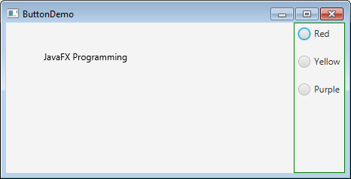

1. Binary Search Tree Problem

Given the file BST.java and TestBST.java – implement the getSize method in BST so that TestBST main prints the correct number of nodes in the tree when it is run. You can change TestBST to add additional tests, but do not delete any of the existing code. Turn both files into the drop box.

1. Multithreading Problem

Given the files Greeting.java, GreetingRunnable1.java, GreetingRunnable2.java and GreetingThreadRunner.java make the application thread safe. Protect the shared data in Greeting.java with locks. Note: it runs fine as is, but needs to be made thread safe.