How to DocuSign a Time Study form
- Type docusign.com on any web portal (Google or Microsoft Edge). Log in using your AHS windows credentials account.
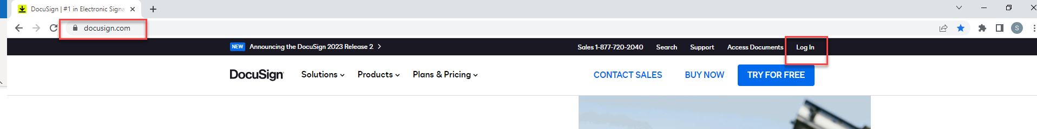
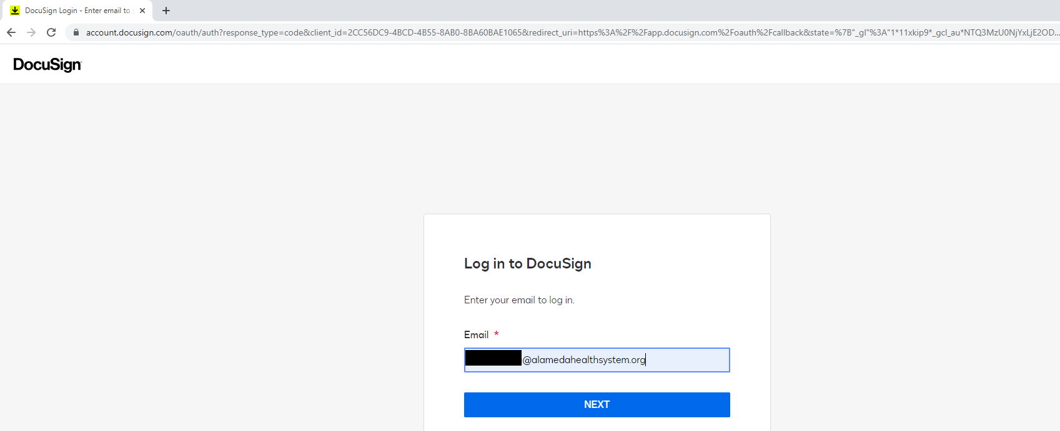
- From the homepage, hit the “Start” button and choose “Sign a Document”.
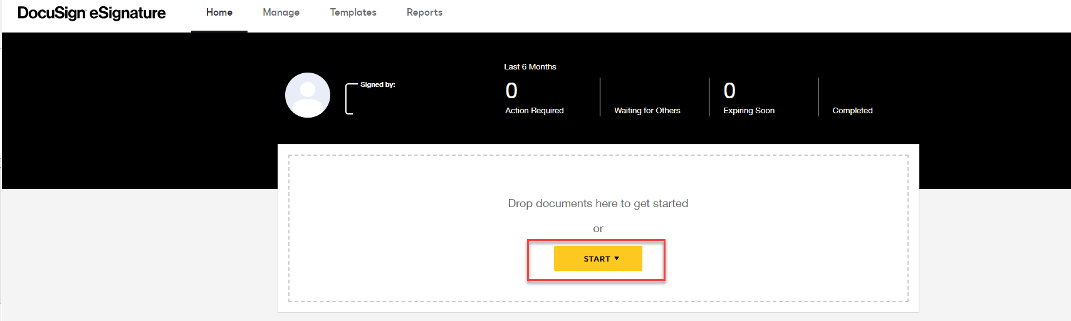
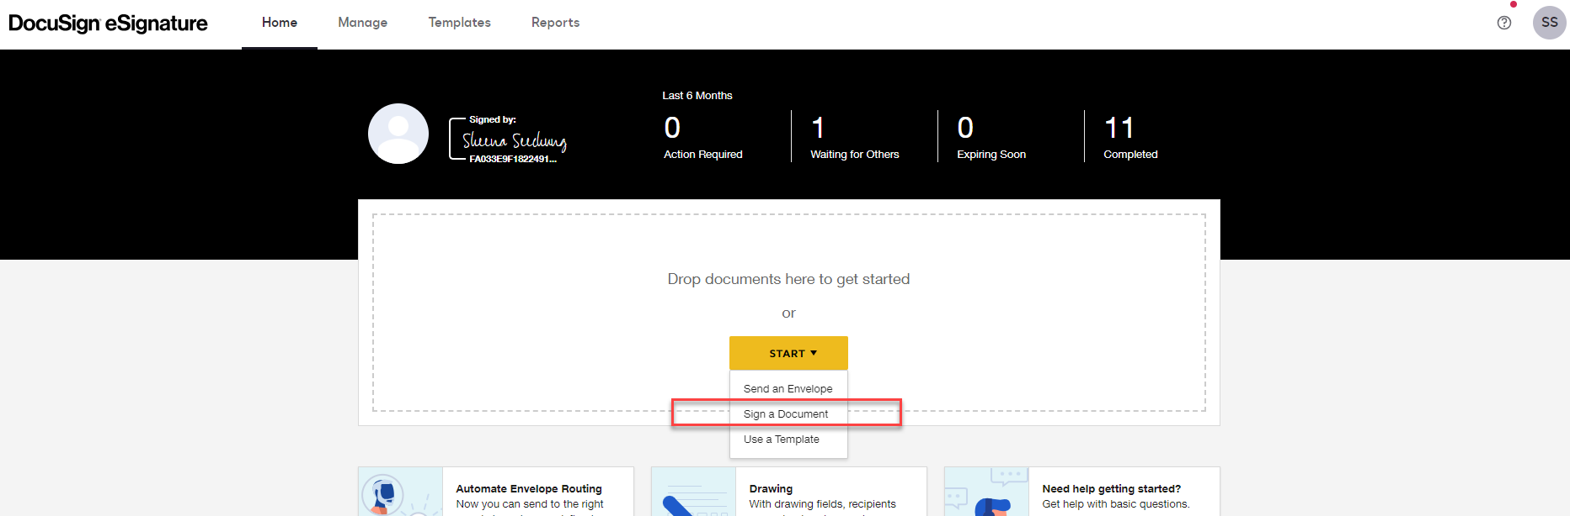
- Click “Upload” to select the file.
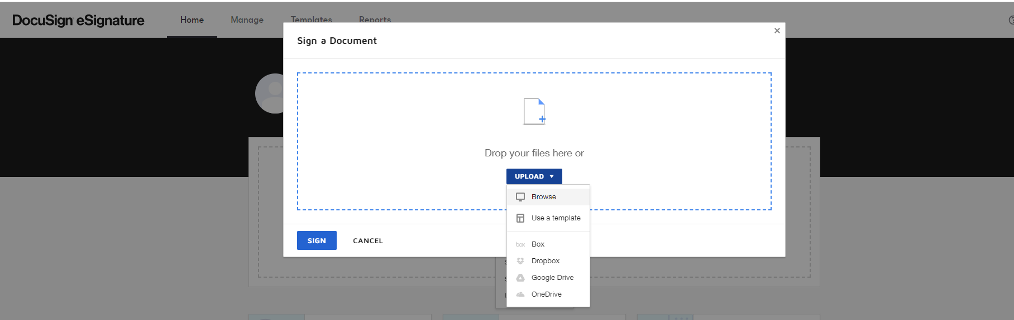
- Wait a few seconds to complete the upload process and hit “Sign”.
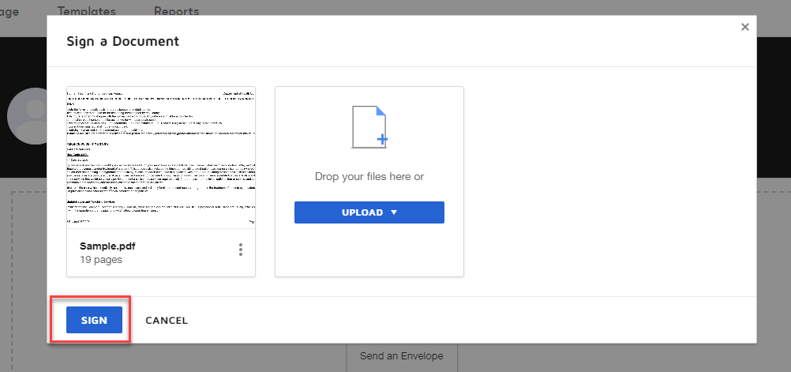

- Drag both the “Signature” and “Date Signed” tags from the fields listed on the left panel and affix to the time study form.
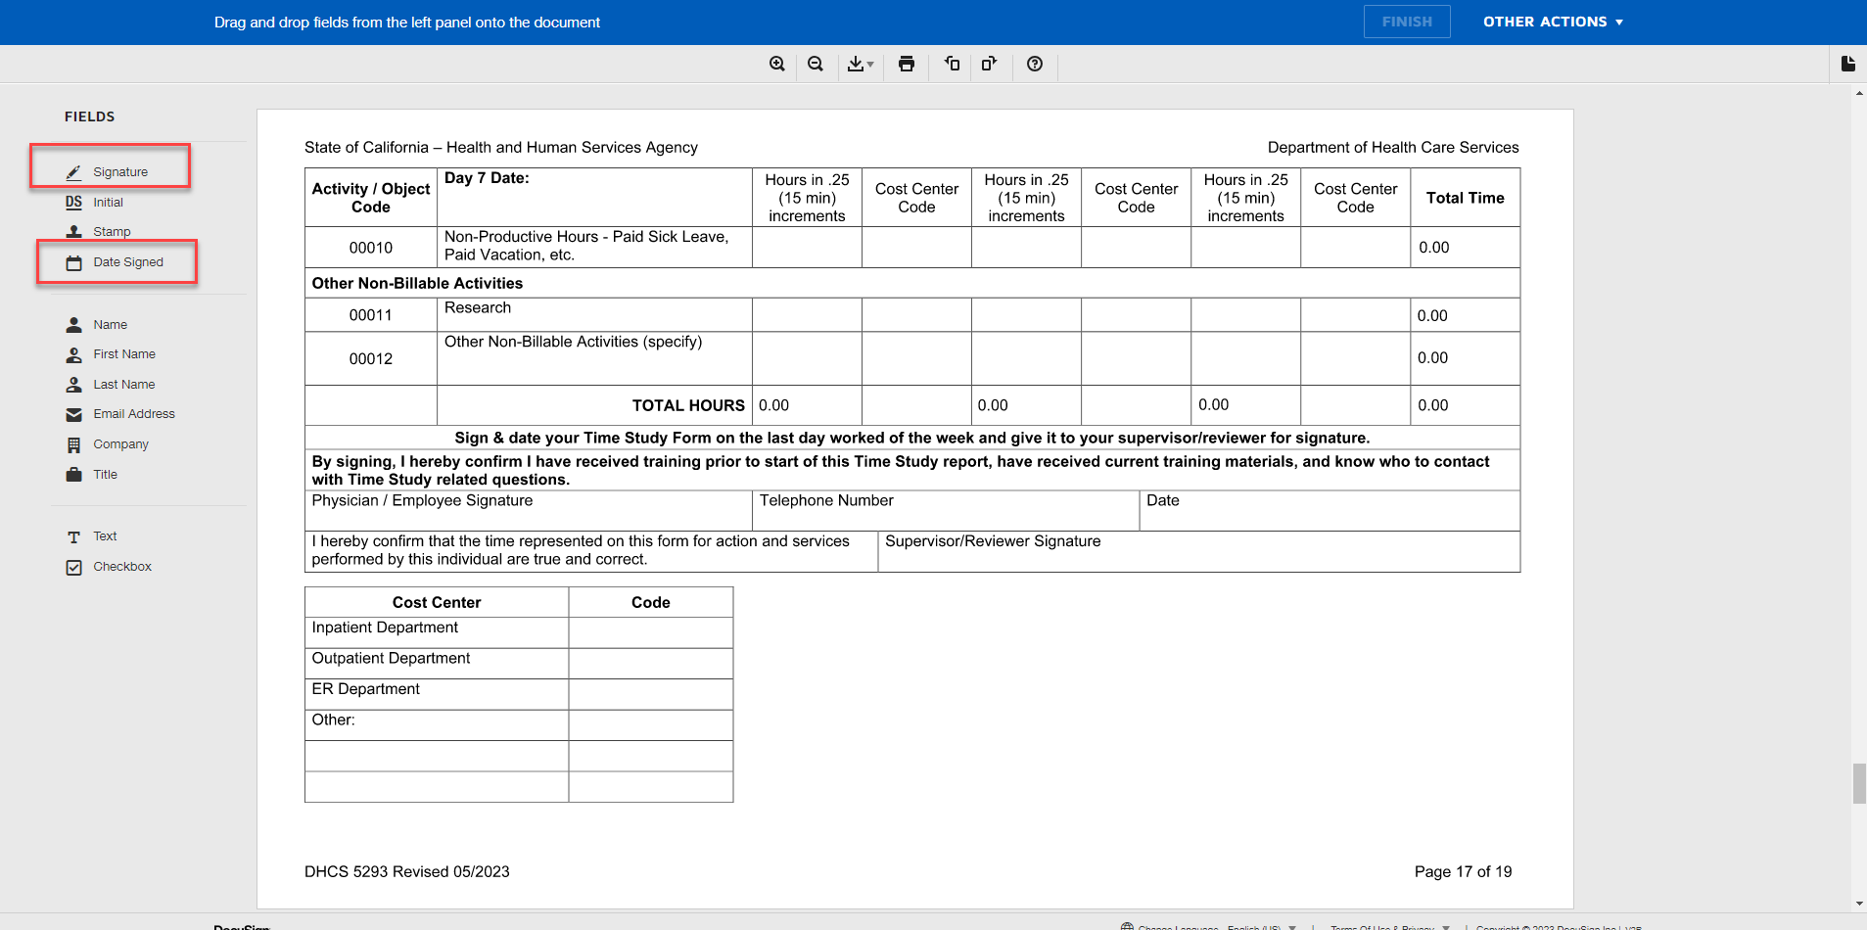
- Hit the “Finish” button to proceed.
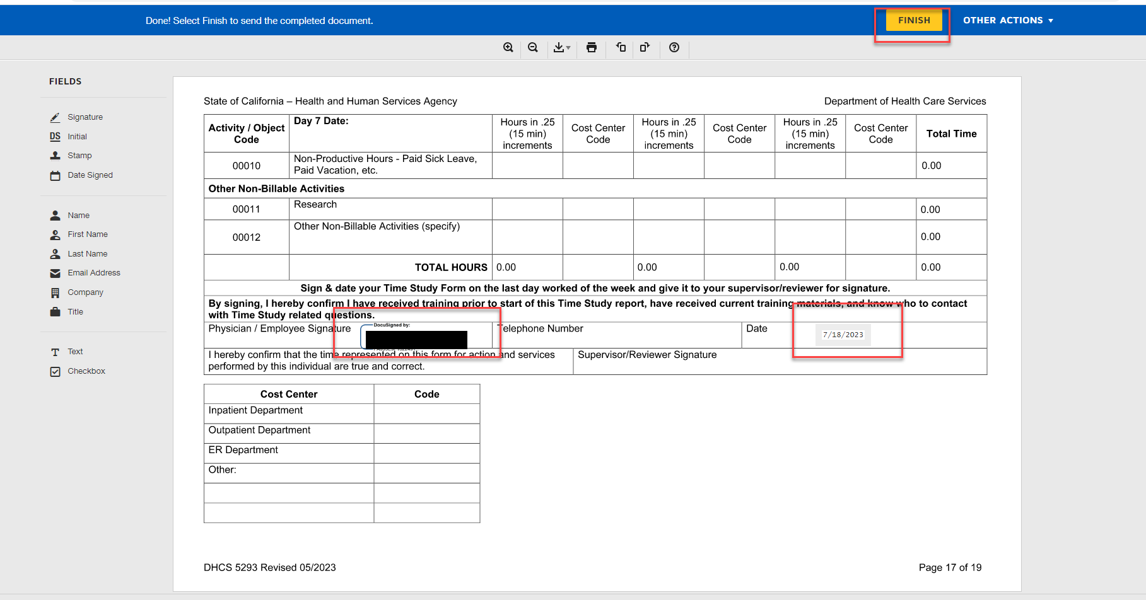

- Send the signed copy to pnpptimestudies@alamedahealthsystem.org
