STEPS FOR SUBMITTING AN ASSIGNMENT

1. 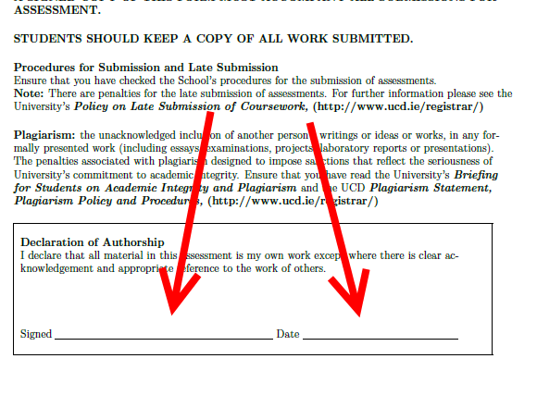Ensure the correct cover sheet is attached to the front of your assignment, and that it is signed and dated



1. Press the “Submit Assignment” button on the touchscreen
2. 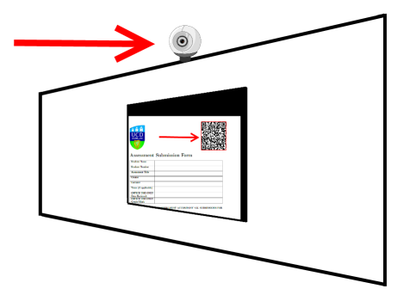Hold the QR code in front of the camera so that it appears on the screen
3. When the code is recognized a red box will appear around it and the screen will briefly go blank



1. A confirmation message will be shown and you will be sent a confirmation email