SCM System Analysis For GlowForge

Rahul Dev Kumar, 660251681

Michael Fetick, 84270

Soohoon Lee, 660252451

Kuldeepkumar Patel, 660252388

Coleman University

Table of Contents

Table of Contents 2

List of Figures 4

Introduction 5

GlowForge’s New Innovations – Laser Technology and Cloud Control Technology 5

Project Planning 5

Analysis Activities 6

Defining the problem – GlowForge needs a Supply Chain Management (SCM) system 6

Identifying GlowForge’s business requirements 7

Defining system requirements 7

Considering Alternatives 8

Our recommendation 11

Design Activities (High Level) 11

System architecture and design 11

SCM design and interfaces 11

SCM databases 12

Prototyping 12

Construct/Build Activities 12

Software Coding 12

Test-driven software development 12

Customer demonstrations 12

Data conversion 13

Implementation Activities 13

Planning and acquisition of resources 13

Manufacturing 13

Shipping 13

Document the system functionality 13

Install the system 13

Educate and train users 14

Support Activities 14

Support team maintains the system 14

Support team enhances the system per negotiations 14

Support team Help Desk for the users 14

Conclusion 14

Appendix A – Project Schedule (Gantt chart) 16

Appendix B – Business Requirements* 17

Appendix C – Use Case Diagrams 26

Appendix D – Activity Diagrams 27

Appendix E – System Sequence Diagrams 28

Appendix F – State-chart Diagrams 29

Appendix G- SCM Process ERD 30

Appendix H- SCM Process MAP 30

References 31

List of Figures

Figure 1. Bitnami ERP Server software applications 10

Figure 2. Cloud-computing service providers partnering with Bitnami 10

Introduction

Our team is the Krazy Insane Flying Monkey Space Rangers, We propose to build a Supply Chain Management (SCM) system for GlowForge. This system will be developed by our team with the project management of the following roles:

Project Manager: Kuldeepkumar Patel

Project Coordinator: Rahul Dev Kumar

Methodology/System Analyst: Soohoon Lee

Software Development/System Analyst: Michael Fetick

GlowForge’s New Innovations – Laser Technology and Cloud Control Technology

GlowForge seems to be the first-comer (Innovator) to the emerging market of 3D Laser (laser-cutting) Printers, called 3D Laser Printers. GlowForge is prime to have an explosive growth in this market. Since the technology involves a laser that cuts material, it would seem to be closer to ‘Lithography’ than ‘printing’ but GlowForge probably wanted to tap the public’s familiarity to printers. The GlowForge 3D Printer operates with control from a remote computer, via cloud computing.

Project Planning

Project planning is the coordination of resources (people), economics (capital), time (schedule), and quality of workmanship. Detailed information of the project is in the appendices. We will define the domain problem (and the scope of the required solution). We will identify the major uses of the new system. GlowForge needs a Supply Cain Management (SCM) system. It should integrate into an Enterprise Resource Platform (ERP). We will produce the project schedule. List tasks, activities, and required staff. Identify milestones and control procedures. Plan to acquire the necessary human resources. We will confirm project feasibility. Investigate economic, organizational, technical, resource, and schedule feasibilities. We will staff the project and acquire the necessary human resources. We will launch the project after it is reviewed and approved by management. This entails the allocation of funds, assigning project members, and obtaining other necessary resources, i.e. office equipment, lab time, development tools. An official announcement often commences the project launch.

Analysis Activities

We will gather information and develop use cases for the new system. This action involves meeting with users to learn as much as possible about the problem domain. We will also observe users working, interview them and ask questions about their work. We will read existing documentation and review existing automated systems. Then we will consult with interested parties, i.e. middle management, senior executives, and sometimes external customers.

Defining the problem – GlowForge needs a Supply Chain Management (SCM) system

Generally, GlowForge has requested a Supply Chain Management (SCM) system to manage the flow of goods and services which includes the movement and storage of raw materials, work-in-process inventory, and finished goods from point of origin to point of consumption. It has been defined as the "design, planning, execution, control, and monitoring of supply chain activities with the objective of creating net value, building a competitive infrastructure, leveraging worldwide logistics, synchronizing supply with demand and measuring performance globally (APICS, 2015)."

A SCM system incorporates processes that seamlessly integrate product development, product acquisition, manufacturing, and inventory management (Satzinger, Jackson, & Burd, 2009). Via a single system, the GlowForge organization will employ automated interfaces for business customers that directly connect their SCM to other organizations’ Customer Relations Management (CRM) systems. This integration will increase the speed and efficiency of business transactions and enable lean business practices for just-in-time (JIT) delivery of raw materials and direct shipment from GlowForge’s manufacturing to third-party resellers.

Identifying GlowForge’s business requirements

We will meet with GlowForge management to identify and prioritize their business requirements. The SCM processes are use cases: ‘Order Processing’ and “Inventory Control.’ These use cases will be analyzed and developed into diagrams, illustrated in appendices C through H, for further analysis and design.

The ‘Order Processing’ use case has the following functional SCM system requirements with further detail in appendix B:

1 – 35 Order Entry

36 – 56 Invoicing

57 – 68 Credit Evaluation

69 – 83 Deals and Discounts

84 – 93 Returns/Credit Memos

94 – 97 Delivery Performance Monitoring

98 – 107 Consignment Process

108 – 110 Official Receipt

111 – 115 Back Order

116 – 128 Reporting Requirements

Additional use cases for SCM processing include purchasing and inventory management.

Defining system requirements

This will be help everyone develop an overall understanding of what is needed and define the functional requirements of the new system. This includes building prototypes for discovery of requirements. Users can review them and often can express their needs easier after looking at the prototype of an alternative. We will prioritize requirements with the most important needs identified because there is always more requests than budget.

**Execute supply chain transactions**

GlowForge has the typical needs of a manufacturer for tools to execute supply chain transactions. The integration of GlowForge’s proposed SCM system with similar/same systems of suppliers and partners will facilitate efficient manufacturing operations with JIT delivery of parts and supplies. This integration is addressed in our recommendation.

**Manage supplier relationships**

As with executing supply chain transactions, GlowForge has the typical needs of a manufacturer for tools to manage supplier relationships. The integration of GlowForge’s proposed SCM system with similar/same systems of suppliers and partners will enhance vital supplier/partner relationships. This integration is addressed in our recommendation.

**Control associated business processes**

The GlowForge 3D Printer operates with control from a remote computer, via cloud computing. The cloud service for such operations would have to be very fast, massive, and flexible. This service must provide this demand for 1) upload speeds, 2) complex processing, and 3) download speeds. This is an associated business process because the operation of the devise depends on the partnership and capabilities of the cloud service provider. This need for demand-dependent cloud service is addressed in our recommendation.

Considering Alternatives

Usually there are implementation alternatives: building the system in-house, buying a software package, or contracting a third-party to develop a new system. Enterprise Resource Platforms (ERP)’s incorporate an organization’s SCM with its CRM, Business Intelligence (BI) and other business systems. An ERP solution may be the best way to go but the ERP provider has to offer a system that fits the needs of GlowForge. It has to be relatively small but could scale with GlowForge’s growth in the market. Companies that offer full ERP solutions are Epicor, IBM, IFS, NetSuite, Pronto, Sage, and SAP (Business-Software.com, 2015).

SCM software includes tools and modules used to execute supply chain transactions, to manage supplier relationships, and control associated business processes. There is a stark distinction with the need of GlowForge’s proposed SCM system, specifically for its 3D Printer product line.

**Recommended growth strategy**

The SCM must incorporate monitoring of the demand-dependent cloud-computing service. Some of the large cloud service providers offer complete suites of products. Choosing one may not make a difference but will probably be permanent. If GlowForge decides to switch service providers later, then the data of processing modules and customer databases will have to be migrated between them. It would require extensive coordination between all three parties.

Instead of only hosting the data with the cloud-computing service provider, GlowForge could develop the data in-house with their own SCM system with an ERP server-application software and push the data up to the cloud-computing service provider for hosting. We found excellent service with Bitnami and they offer several ERP applications, such as OpenERP, ERPNext, Dolibarr, and Odoo, shown in figure 1 (Bitnami, ERP Bitnami Stacks, 2015). They are free open-source.

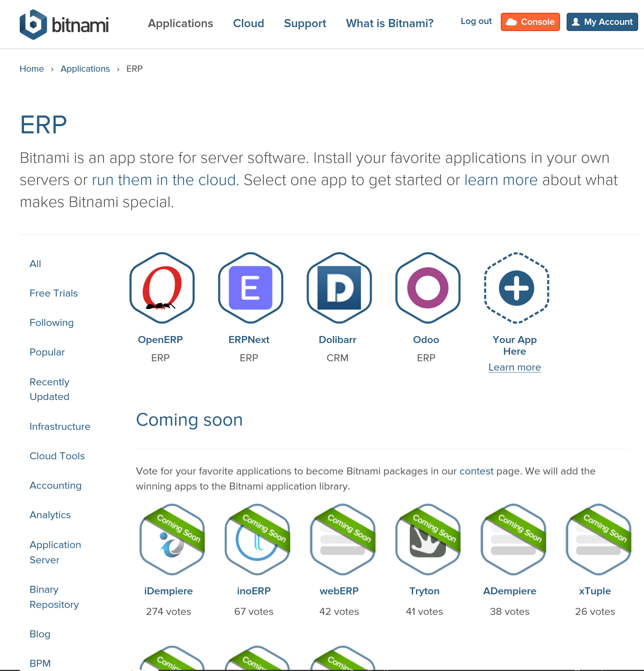

Figure 1. Bitnami ERP Server software applications

(Bitnami, ERP Bitnami Stacks, 2015)

Bitnami can push the data up to the cloud-computing service providers, such as Amazon Web Services (AWS), Google Cloud Platform (GCP), Microsoft Azure, VMware vCloud Air, and Digital Ocean, shown in figure 2 (Bitnami, Bitnami in the Cloud, 2015).

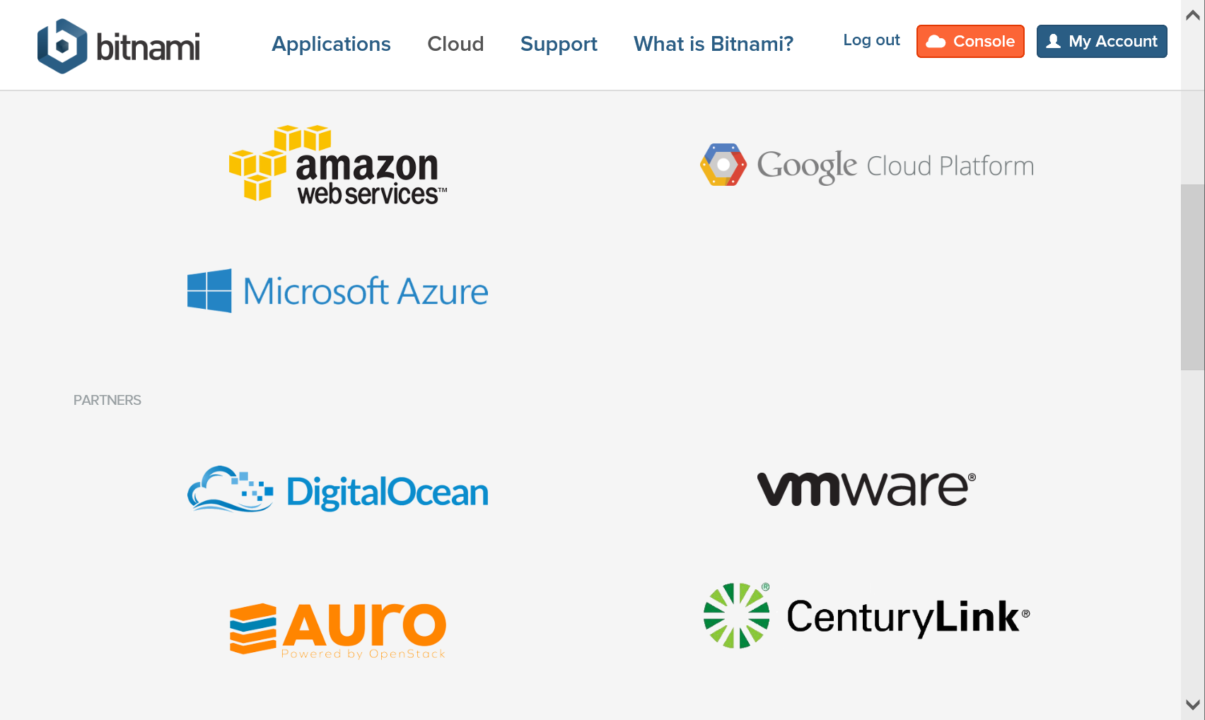

Figure 2. Cloud-computing service providers partnering with Bitnami  
 (Bitnami, Bitnami in the Cloud, 2015)

Our recommendation

Currently, we are making a recommendation for GlowForge to adopt an ERP solution that is open source software. Our team will customize the ERP and SCM system to fit the business needs of GlowForge. It is a web-based system that utilizes the services of cloud-computing.

With further research in customer reviews, GlowForge can decide which server-application software to try and can even develop on more than one for comparison of results. And with further research in customer reviews, GlowForge can decide which cloud-computing service provider to choose for their hosting, based on business results. We hope to review these recommendations with management.

Design Activities (High Level)

System architecture and design

We will design and integrate the computer network at GlowForge site-facilities. Focus is on the specifications for computer equipment, network, and operating systems for a new ERP and specifically for a new SCM system. We will design the application architecture to provide the processing functions for the business requirements.

SCM design and interfaces

The SCM system of the ERP will deploy first and we will focus on that. We will design the user interfaces. During the analysis, our prototyping may define some elements that are combined here into forms, reports, screens, and sequences of interactions. We will design the system interfaces. These are the precisely defined communication links between program modules.

SCM databases

We will design and integrate the online transaction processing database system (OLTP) and illustrate the design with diagrams of the data storage requirements and processes to access the databases of other systems. The database will directly interact with front-end application to store and manipulate data for efficient business process and track all the movements of materials and products.

Prototyping

We will generate prototypes for design details and to verify the correctness or the workability of the design. This includes the design and integration of the system controls. These are needed to protect the integrity of the database and the application program and are integrated into the system as it is being designed.

Construct/Build Activities

Software Coding

We will construct the software components by the conventional, writing of computer programs using software languages Python, Bootstrap, Java, and other languages that are frameworks and scripts that run in web-browsers.

Test-driven software development

We will verify and test the new system continually with test-driven software development during iterative prototyping. Unit testing will done to ensure each component works.

Customer demonstrations

Integrated system testing and demonstration to the customer will be done to ensure the system is what the users want.

Data conversion

We will convert any necessary data sourced from the old systems which requires conversion to the new data format of the new system.

Implementation Activities

Planning and acquisition of resources

The focus on plan incorporates a system, which adjust overall supply-demand to add to a game plan, which require adhering with organization's rules and policies. Planning also is evaluating supply’s totaling, organizing, planning stock, surveying, and resources in all channels. The focus here is that obtained merchandise and administrations to take care of planned and genuine demand.

Manufacturing

Make or manufacturing incorporates forms that acquired merchandise and administrations to take care of arranged and genuine demand. It deals with product and supply chain training and operation training for suppliers, customer support and sales representatives.

Shipping

Shipping focuses on having a manufactured end product reach the customer or the supplier this will be tracked by our online systems and the orders would have to be placed online.

Document the system functionality

We will finalize the validation and documentation of the system functionality of the new SCM system, in our facilities.

Install the system

We will install the system. The new system requires equipment to be in place and functioning, the software installed and working, and the database populated and available. This installation is prevalent and integrated throughout the organization.

Educate and train users

We will educate and train users on the new system’s operation and functionality of the new SCM system, in our facilities, as soon as possible. The operation of this system is prevalent and integrated through the needs of many departments of the organization.

Support Activities

Support team maintains the system

Our support team will maintain the system by performing routine tasks to apply patches and updates as the system matures. This occurs on the server-side and is not disruptive to GlowForge business operations.

Support team enhances the system per negotiations

Our team can enhance the system. As the system use gains popularity there will be requests for design enhancements and we will negotiate follow-on work to deliver these enhancements within the software upgrades.

Support team Help Desk for the users

We will support the users with a help desk that consist of knowledgeable technicians that are available to answer questions quickly and assist users to help increase their productivity. Training users and maintaining documentation is important.

Conclusion

We decided to integrate the SCM for GlowForge into a Bitnami ERP solution. This reduces cost in installation and affords customization of the design for GlowForge’s needs. The business requirements outlined in the appendix will be addressed by the system requirements and implemented into the system design. Iterative development will afford continual customer inspection and improvement in the most feasible fashion and in a timely manner.

The SCM solution on the Bitnami ERP stack simplifies development and provides prototypes for demonstration and attaining stakeholder acceptance. The Bitnami stack is well known and adopted in various industries by many Fortune 100 companies. The system is cloud based and will scale well for both, growth and contraction of the market.

We will work with GlowForge in the development of the best solution for their business needs. We are flexible, adaptive, and highly perceptive to technology advances, preferred business practices and efficient enterprise operations. We look forward to meeting challenges together and attaining your success as your go-to choice for the best solution in supply chain management.

Appendix A – Project Schedule (Gantt chart)

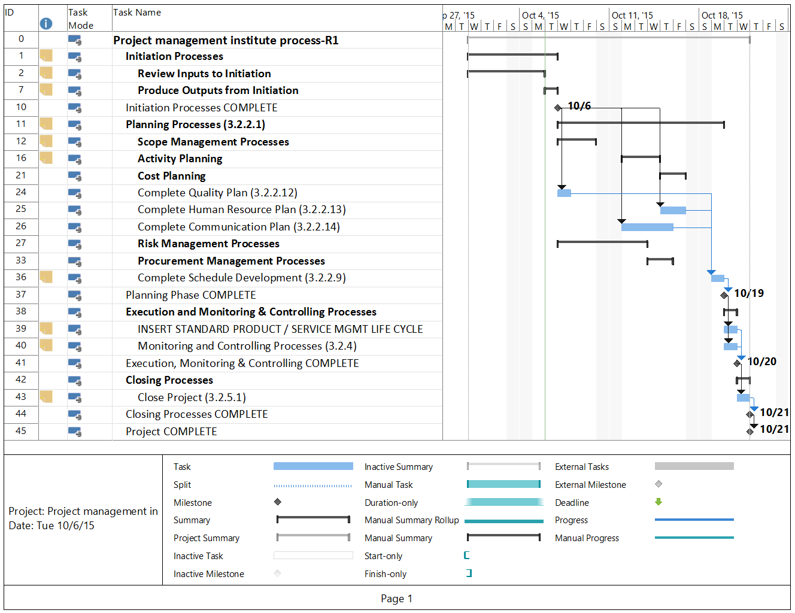

Appendix B – Business Requirements*

* (Template provided by (PMI, 2015)

Order Processing

|  |  |
| --- | --- |
| Note: |  |
| SD – Standard | Requirement is standard to application software no modification needed. |
| MC – Moderate Change | Application software will satisfy this requirement with moderate modification (to be accomplished within two days) |
| SC – Significant Change | A significant customization (beyond 2 days) is needed to satisfy the requirement. |

| No. | Requirement Description | SD | MC | SC | Comments |
| --- | --- | --- | --- | --- | --- |
| Order Entry | | | | | |
|  | Each sales order has unique sales order number |  |  |  |  |
|  | Receives order quantity at a maximum of 6 digits |  |  |  |  |
|  | Allow different sources of order input such as manual entry, EDI, POS, handheld computer, MS Access format, MS Excel format and Web-enabled format (from sales requirements) |  |  |  |  |
|  | Ability to provide different sales order form or screen to facilitate order classifications (e.g., regular order, initial stocking order, indent order, office order, consignment order, guaranteed by supplier order, credit override order or customer define order format, etc.) |  |  |  |  |
|  | Not every sales order needs to be invoiced |  |  |  |  |
|  | Ability to cancel the order before invoice is generated (with authorization) |  |  |  |  |
|  | Salesman code field as mandatory on the order entry screen.  During the sales order entry, the system should only view the dedicated salesman to be placed (each invoice will be credited to proper salesman only) |  |  |  |  |
|  | Facility of Customer Ship-to Address encoding (multiple address code for one customer is allowed) |  |  |  |  |
|  | Every address code has its delivery group code and delivery remark |  |  |  |  |
|  | Option to print out in foreign character/language address |  |  |  |  |
|  | Ability of multiple cross reference to an order (e.g., order number, invoice number, customer purchase order number, third party order number, third party invoice number |  |  |  |  |
|  | Ability to have user defined order status cycle. (e.g., completed, suspended, shipped, cancelled, on hold). Each order status should have a time stamp log for performance tracing. |  |  |  |  |
|  | Ability to alert the user of out of stock during order entry |  |  |  |  |
|  | Facility to handle consignment sales transactions |  |  |  |  |
|  | Allow order in multiple Unit of Measures (UOMs) per item |  |  |  |  |
|  | Allow multiple order lines with the same item code and UOM |  |  |  |  |
|  | Allow order in EAN/Barcode or other item code reference |  |  |  |  |
|  | The order entry screen has ‘order instruction’ field. (At least 10 order comment lines) |  |  |  |  |
|  | Support customer PO number on order entry and will be included on invoice for reference purpose. |  |  |  |  |
|  | Stock is reserved immediately as the order/invoice line entered even before the whole order is confirmed. |  |  |  |  |
|  | Minimum order value is defined at company/division level |  |  |  |  |
|  | For EDI Support, allow converting EDI PO to S.O. with pre-defined values. The PO will be separated by company/division/agency |  |  |  |  |
|  | For EDI Support, during converting EDI PO, pre-defined customer group price will be used; if not found, then price from customer will be used. |  |  |  |  |
|  | Handle non-product sales orders (e.g., charges) |  |  |  |  |
|  | Allow user specification of item shelf life at order entry. |  |  |  |  |
|  | No stock deduction for indent/damage order. Allow cost entry for indent order at order line level. |  |  |  |  |
|  | Order can be defined for discrete stock picking and consolidate stock picking. |  |  |  |  |
|  | Provide sales amount adjustment entry to affect the stock ledger sales amount only. |  |  |  |  |
|  | Provide stock ledger quantity adjustment entry to affect the stock ledger quantity balance without affecting warehouse stock balance. |  |  |  |  |
|  | Provide cost of sales adjustment entry to affect the stock ledger cost of sales amount. |  |  |  |  |
|  | Provide stock value adjustment entry to adjust the stock value of the item without affecting stock quantity. |  |  |  |  |
|  | System can optionally consolidate orders of a customer with multiple salesmen into one invoice defined at customer level. |  |  |  |  |
|  | Multiple warehouses can be chosen for a sales order. |  |  |  |  |
|  | Provide touch-screen feature in order entry. |  |  |  |  |
|  | Support electronic approval of signature on system. |  |  |  |  |
| Invoicing | | | | | |
|  | Facilities to handle Multi-Principal Invoicing. (The system should be able to handle A/R per principal.) |  |  |  |  |
|  | Facility to cancel an invoice (with authorization) before delivery. |  |  |  |  |
|  | Facilities of Order Notes/Shipping Instructions on Invoice. |  |  |  |  |
|  | Optional Tax Calculation (VAT)/Tax Exempt for each Invoice   * Tagging of customers and items as VAT or Non-VAT |  |  |  |  |
|  | Facility to Add Charges on Invoice (e.g., Freight Charges, etc.)   * Tagging of customers having freight charges, etc. |  |  |  |  |
|  | Invoice Skewing Feature (ability to hold printing of invoice until actual delivery date) |  |  |  |  |
|  | Include expected delivery date on invoice. |  |  |  |  |
|  | Support Delivery note/Blanket order handling |  |  |  |  |
|  | Ability to prompt pending invoice for delivery |  |  |  |  |
|  | Option for multiple deliveries with one invoice |  |  |  |  |
|  | Print bar code of invoice number and order number on invoice and sales order. |  |  |  |  |
|  | Support multiple currencies on invoice. |  |  |  |  |
|  | Include forensic classification of item at each invoice line. |  |  |  |  |
|  | Allow size of order quantity in five digits. |  |  |  |  |
|  | Facility to do a positive/negative adjustment on an invoice and credit memo. (Adjustment will affect sales but will not affect inventory quantities) |  |  |  |  |
|  | Allow user defined control for particular customer or customer types purchasing particular SKU or SKU type. |  |  |  |  |
|  | Print remarks on invoice (e.g. early payment discount). |  |  |  |  |
|  | Include Letter of Credit (L/C) and contract number on invoice. |  |  |  |  |
|  | Support printing of delivery address in specified foreign languages and characters. |  |  |  |  |
|  | Provide invoice discount value and distribution allowance summary by agency by product by customer information monthly. |  |  |  |  |
|  | Ability to inform customers of near-expiration products based on records of delivery. |  |  |  |  |
| Credit Evaluation | | | | | |
|  | Allow parameterized (user defined) credit blocking facility (e.g., per credit limit, per overdue account, per customer, etc.) |  |  |  |  |
|  | When a sales order is confirmed, customer credit/overdue status and minimum order value is checked. The order will be suspended if over credit, overdue and under minimum order value (automatic credit checking/overdue account). |  |  |  |  |
|  | Ability to categorize customer on pre-define value such as ‘good/doubtful/bad’ as a result of the account receivable performance. System to maintain a credit watch. |  |  |  |  |
|  | Customer credit availability is automatically deducted on order confirmation. |  |  |  |  |
|  | Customer’s overdue status will be updated online. Provides a mass update function for user to recheck every suspended order. |  |  |  |  |
|  | Orders can be released automatically if the customer is not overdue. (Separate Full invoices and Hanging Balance) |  |  |  |  |
|  | Ability to include customer’s orders not yet delivered and active quotations in credit limit checking. Ability to inquire what makes up total credit outstanding. |  |  |  |  |
|  | Credit hold sales order can be divided into “reviewed” or “waiting for credit release” and accept input of reason for holding. |  |  |  |  |
|  | Allow maintenance on suspended orders and update immediately after any changes made. |  |  |  |  |
|  | User can manually suspend an order (i.e., user-hold order). Stock will be allocated. But no credit available is deducted from customer. |  |  |  |  |
|  | Allow user defined minimum order value checking by customer or customer group or by customer or customer group by agency. |  |  |  |  |
|  | Option to view only transactions that need to be evaluated. |  |  |  |  |
| Deals and Discounts | | | | | |
|  | Supports user-defined multi-level discounting (at least five levels) with its code, description and formula (based on specific agreement per customer). For *GlowForge*, types of deals are as follows: free goods (allow different item as free goods), special price, item discount (line discount) and Invoice total discount (financial discount). |  |  |  |  |
|  | Ability to apply standard price/discount matrix per customer/ customer group against item/item group/agency on sales ordering. |  |  |  |  |
|  | Supports automatic granting of deals as well as manual entry of discount. |  |  |  |  |
|  | Discount can also be defined by amount per quantity instead of percentage. |  |  |  |  |
|  | Allow at least four discount input fields at each invoice line, and each field allows input of both percentage or amount. |  |  |  |  |
|  | Item price can be expressed as item unit price or price per quantities. |  |  |  |  |
|  | Ability to have the deals number prompts automatically during order entry of specific product and customer, as a result of pre-setting of promotion period. |  |  |  |  |
|  | Ability to define the prices and the discounts as price lists for different groups of customers, as general prices or according to individual customer agreements (user defined formula for each customer and discounts). |  |  |  |  |
|  | Allow different price for different item units. |  |  |  |  |
|  | Item price is retrieved from price table automatically. |  |  |  |  |
|  | Provide supervisor override for preset price and discount. |  |  |  |  |
|  | Payment terms can be overridden in each order. Payment terms in sales order cannot exceed the customer's maximum payment term. |  |  |  |  |
|  | Display fee per agency handling. Multiple display fee order line is allowed. |  |  |  |  |
|  | Gross discount calculation can be defined at customer level. User can select either gross or reducing balance discount calculation. |  |  |  |  |
|  | Three next effective dates are provided for item list price, customer group price and discount. The price/discount will roll up automatically on effective date. |  |  |  |  |
| Returns/Credit Memos | | | | | |
|  | Auto-Recall of Invoices for Credit Memos (user-defined, three-year retention period). |  |  |  |  |
|  | The system has to automatically generate Credit Memos and update inventory level upon confirmation of return on WMS-Exceed |  |  |  |  |
|  | Has maintenance for reference reason code of return transaction, customize reason code (interface with WMS). |  |  |  |  |
|  | Has maintenance of sub-reason code for each reason code. |  |  |  |  |
|  | Credit Note can be generated to either refer to an invoice or not. |  |  |  |  |
|  | For Credit Note referred to an invoice, item and quantity returned must check against the original invoice automatically. |  |  |  |  |
|  | More than one Return/Credit Note can be issued against the same invoice, and the item and quantity returned by these Return/Credit Note shall be checked against the original invoice. |  |  |  |  |
|  | Allow return in different UOM in the Credit Note against the original invoice for the same item. |  |  |  |  |
|  | Credit note cancellation is allowed. |  |  |  |  |
|  | Credit Note can be cancelled before it is applied/settled against invoice. |  |  |  |  |
| Delivery Performance Monitoring | | | | | |
|  | Delivery lead-time is defined at company/division level. Delivery date will be calculated automatically which will exclude Saturday, Sunday and holidays. Allow user to specify whether the date is expected or pending per sales order. |  |  |  |  |
|  | Ability to monitor sales order life cycle from sales order date up to delivery date. |  |  |  |  |
|  | Delivery lead-time is defined at company/division level. Delivery date will be calculated automatically which will exclude Sunday and holidays. Allow user to specify whether the date is expected or pending per sales order. |  |  |  |  |
|  | Relate Timeliness of Delivery to Completeness of Delivery (Orders Delivered, Complete, & On-Time - ODCOT) |  |  |  |  |
| Consignment Process | | | | | |
|  | Normal consignment delivery transactions can be processed with Consignment Delivery Notes printed. |  |  |  |  |
|  | Normal consignment sales transactions can be processed with Consignment Sales Invoices printed. |  |  |  |  |
|  | Consignment return (from individual customer delivery location back to main warehouse). |  |  |  |  |
|  | Auto consolidation of all consignment stock. |  |  |  |  |
|  | For any damage goods return, system automatic transfer/write off goods to damage warehouse. |  |  |  |  |
|  | Support inter-consignment location goods transfer. |  |  |  |  |
|  | Maintain individual customer inventory per delivery |  |  |  |  |
|  | Consignment inventory can be captured via handheld terminal so that opening stock can be checked daily. |  |  |  |  |
|  | Allow using scanning device to capture stock in/out and include increase of stock at item return. |  |  |  |  |
|  | Provide download of daily closing stock and consolidation for identification of consignment sales volume. |  |  |  |  |
| Official Receipt | | | | | |
|  | Ability to facilitate entry of Official Receipt which contains Bank Account, Bank Name and Amount, link to CR/DR (Cash Management) |  |  |  |  |
|  | Ability to facilitate Disbursement Voucher |  |  |  |  |
|  | Ability to accept post-dated checks for succeeding months |  |  |  |  |
| Back Order | | | | | |
|  | Provides facility in which any unserved orders (specifically for price protection and deals) will have a grace period (set up as a parameter) for a chance to be served before these are cancelled for re-booking (re-PO). |  |  |  |  |
|  | Ability to prioritize back-orders to be served based on a first come first served basis or any other user-defined criteria. |  |  |  |  |
|  | Provides facility to cancel unserved order (not fully served PO will be cancelled). |  |  |  |  |
|  | Facility of back order monitoring to differentiate double booking using a user-defined period of time to be covered. |  |  |  |  |
|  | Back order handling can be defined at company/division level. (Insufficient stock frequency can be captured for analysis.) |  |  |  |  |
| Reporting Requirements | | | | | |
|  | Registers for Sales, CM & Invoice Adjustment Transactions |  |  |  |  |
|  | Backorder/Service Level Report (double-booking not to be included) |  |  |  |  |
|  | Credit Held/Blocked Sales Order Report |  |  |  |  |
|  | Order status report with order status selection |  |  |  |  |
|  | Suspended order report |  |  |  |  |
|  | Gross & Net Sales Reports (w/ sales forecast) |  |  |  |  |
|  | All Order Entry Reports should be flexible enough to be produced based on each or a combination of the following criteria: |  |  |  |  |
| * By Date Range/Date Definition (MTD/YTD/Comparative) |  |  |  |  |
| * By Company |  |  |  |  |
| * By Territory/Branch/Distribution Center/Zone Deliveries |  |  |  |  |
| * By Sales Group |  |  |  |  |
| * By Customer |  |  |  |  |
| * By Customer Classification |  |  |  |  |
| * By Principal |  |  |  |  |
| * By Product Classification (at least four levels) |  |  |  |  |
| * By Product |  |  |  |  |
| * By Salesman |  |  |  |  |
| * By Reason Code (For Returns Transactions Only) |  |  |  |  |
|  | Daily Scheduled SO Discrepancy Report |  |  |  |  |
|  | Invoice price variation report |  |  |  |  |
|  | Monthly stock movement report/data download in various record selection criteria. |  |  |  |  |
|  | Back Order Report |  |  |  |  |
|  | Service Level Report |  |  |  |  |
| Order Fill Rate (Dollars and Units) |  |  |  |  |
| Line Item Order Fill Rate (Dollars and Units) |  |  |  |  |
| Delivery Turnaround Time (to include partial deliveries for a single order) |  |  |  |  |
|  | Sales order enquiry/report by several external principals' reference numbers should be provided. |  |  |  |  |

Additional use cases for SCM processing include purchasing and inventory management.

Appendix C – Use Case Diagrams

Appendix D – Activity Diagrams

Appendix E – System Sequence Diagrams

Appendix F – State-chart Diagrams

Appendix G- SCM Process ERD

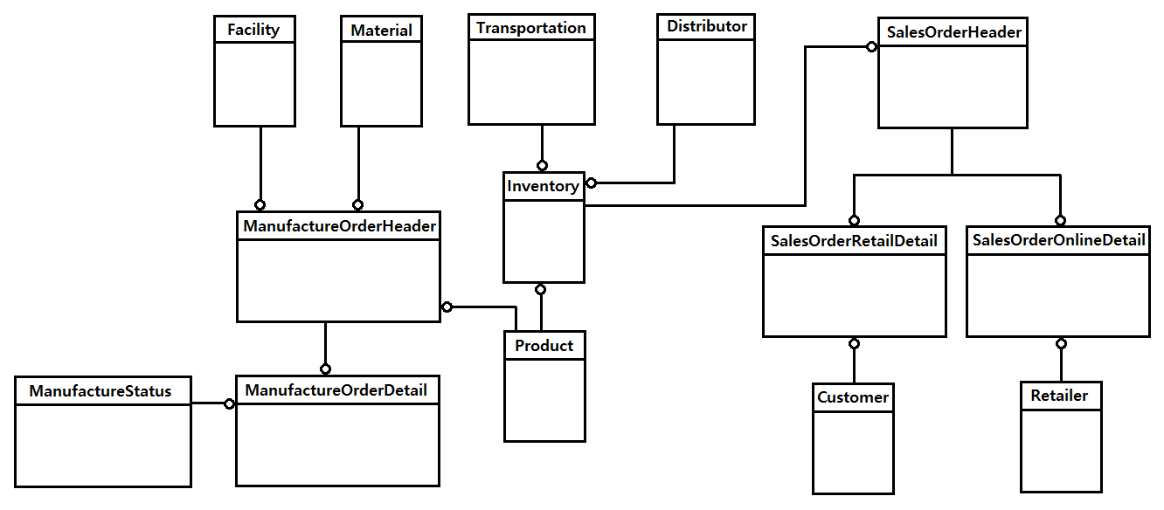

Appendix H- SCM Process MAP

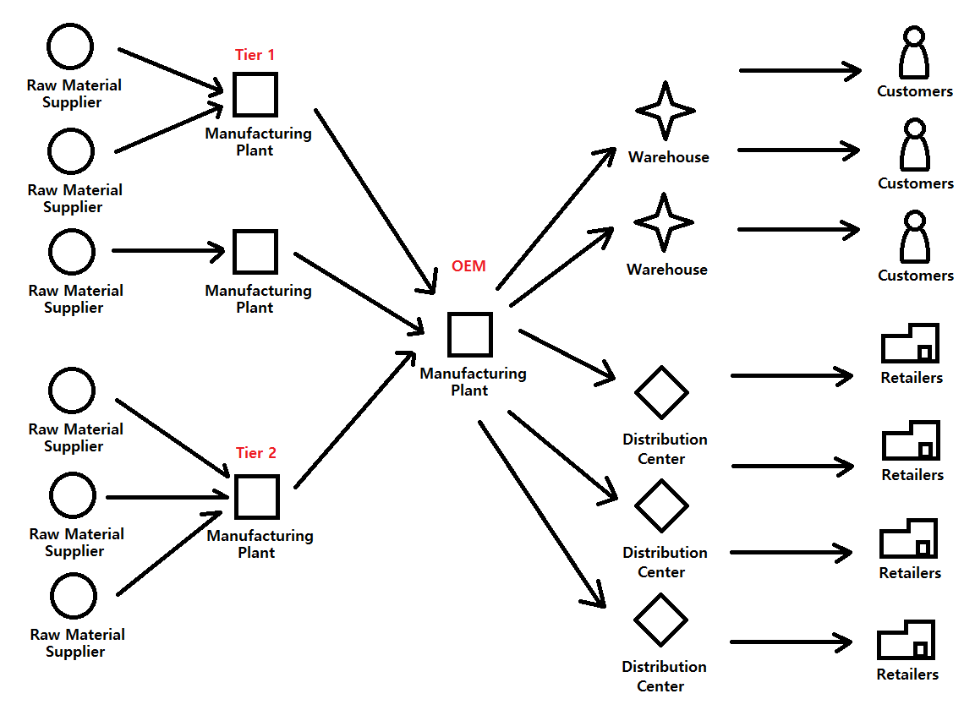

# References

APICS. (2015, September 27). *APICS Dictionary Information*. Retrieved from APICS is the premier professional association for supply chain and operations management. : http://www.apics.org/dictionary/dictionary-information?ID=4202

Bitnami. (2015, September 27). *Bitnami in the Cloud*. Retrieved from Cloud Hosting - Bitnami: https://bitnami.com/cloud

Bitnami. (2015, September 27). *ERP Bitnami Stacks*. Retrieved from Cloud Hosting - Bitnami: https://bitnami.com/stacks/erp

Business-Software.com. (2015, September 27). *Top 20 ERP Software Vendors REVEALED*. Retrieved from Publisher of industry related reports: http://landing.business-software.com/top-20-erp-software-vendors-v4-2.php?track=3436&traffic=GoogleSearch&keyword=erp%20solutions

PMI. (2015). *Sample Request for Proposal (RFP) for Replacing an Information System.* Retrieved from Project Management .com in conjunction with the Project Management Institute (PMI): http://www.projectmanagement.com/deliverables/18635/Sample-RFP-for-Replacing-an-Information-System

Satzinger, J. W., Jackson, R. B., & Burd, S. D. (2009). *Systems Analysis & Design in a Changing World, Fifth Edition.* Course Technology.