analytical innovators

bUSINESS iNTELLIGENCE (bi) – dECISION sUPPORT sYSTEM (dss)

for

SUBWAY RestaurantS

Michael Fetick, 84270

Yuxuan Guan, 660161473

Gabriel Ramirez, 52020

Weilong Qu, 660162539 (Dropped Class)

Chih-Hsiang (Sean) Wu, 660161992

Coleman University

Table of Contents

Table of Contents 2

List of Figures 2

Abstract 3

Overview 3

The Customer Perspective 4

Healthy food – fast (not the proverbial fast-food) 4

Problematic wait times 4

Solution of reducing wait time (pickup an online order) 5

Improving the solution with customer information 5

Questions to develop KPIs for the customer perspective 5

The Financial Perspective 6

Costs in the industry of Limited-Service Restaurants 7

Profit margins of food items 7

Questions to develop KPIs for the financial perspective 8

The Internal Business Processes Perspective 8

Front-end website 9

Back-end database design 9

System Topology 11

Operations research and management of the web system 12

System Development Life Cycle (SDLC) 12

Questions to develop KPIs for the internal business processes perspective 14

The Learning and Growth Perspective 15

Employee training 15

Questions to develop KPIs for the learning and growth perspective 15

The Balanced Scorecard (BSC) 16

KPIs of the balanced scorecard for the customer perspective 16

KPIs of the balanced scorecard for the financial perspective 17

KPIs of the balanced scorecard for the internal business processes perspective 17

KPIs of the balanced scorecard for the learning and growth perspective 17

Summary 17

References 19

List of Figures

Figure 1. An example ordering system ……………...……..……………………………………10 Figure 2. Star structure topology …………………....……..……………………………………11 Figure 3. System Development Life Cycle (SDLC) ...……..……………………………………13

Abstract

The Business Intelligence (BI) – Decision Support System (DSS) is a conceptual framework for the process of supporting managerial decision making. It employs quantitative models of problems and opportunities for solution analysis. It combines architecture, databases, analytical tools, and applications. Analysis for the best solution is gauged by performance measurement of “strategically-aligned metrics” called key performance indicators (KPIs). Each KPI represents a strategic objective and measures performance against a goal (Sharda, Delen, & Turban, 2015). A performance measuring system exists to support a performance management system. One application for a performance management system, and probably the best known and most widely used, is the Kaplan and Norton’s balanced scorecard (Kaplan & Norton, 1992, January). The balanced scorecard views the organization from four perspectives – customer, financial, internal business processes, learning and growth; and it is used to develop objectives relative to each perspective (Sharda, Delen, & Turban, 2015).

Overview

This research paper focuses on a proposed BI–DSS for the Subway Restaurant Chain. Our company is named “Analytical Innovators” and we are a business consulting company (About Analytical Innovators, 2015). Subway came to us for expertise in the development of a performance management system to support decisions to resolve difficulties and pursue opportunities. The challenge is to integrate Subway’s new customer online ordering service into their existing restaurant operations. We will develop a balanced scorecard (BSC) that views the Subway Corporation from four perspectives – customer, financial, internal business processes, learning and growth. The BSC will be used to develop objectives relative to each perspective. KPIs are determined to answer strategic questions for solutions to problems and opportunities.

The Customer Perspective

Healthy food – fast (not the proverbial fast-food)

Subway is a fast food restaurant that prides itself on offering a healthy food menu. Operationally, each restaurant is set up the same way – as a cafeteria-style process for the customer to see the food, choose the sandwich, the bread, and the toppings/condiments, and watch it being made. It is very expedient and has a great culinary appeal to the customers. The ingredients are always fresh and abundant and side dishes, i.e. soup, salad, chips are also offered. Many customers are frequent patrons and they have a favorite sandwich and a unique way it is prepared.

Problematic wait times

Subway recognized a problem of the wait-time for a line of customers. Sometimes, it’s not quite so fast. Though the process is expedient, there is a restriction of preparing only three food orders at any time. This is because the physical workspace will allow only up to three workers to prepare individual sandwich orders – more workers would cause confusion and collisions between them. The facilities are set up for optimal food preparation in a confined space. There are two work stations of the same ingredients and condiments. The food in each station can be reached by a worker (food preparer) and a third worker can be stationed in between to share the ingredients/condiments.

Solution of reducing wait time (pickup an online order)

The solution was to provide customers an online ordering system so the meal can be prepared ahead of time and the customer can just arrive and receive the order. The solution is a web-based application with an interface that works well on a mobile device. It seems to work well for a customer to place the food-order online from a cell phone and pay for the order with a credit card ahead of time.

Improving the solution with customer information

Wait time is also reduced by the prepayment online. There is no cash register activity and no exchange of money. The receipt is already in the bag. But the customer would have to expend the time to do key-entry of their credit card information online. Since they don’t want to do this too many times, why not store the customer financial information in a customer account with provisions for cybersecurity. Their account login would ensure security and could track their favorite Subway Restaurant locations, favorite menu choices, and sandwich ingredients, and payment options. The customer could even save their username and password on their mobile device in an encrypted cookie resulting in a four-click food order: 1) start the phone-app, 2) automatic-login, 3) select a favorite food choice, then 4) confirm the order.

Questions to develop KPIs for the customer perspective

The balanced scorecard will ask the following questions for the customer perspective:

1. How does online food ordering affect the regular customer wait times? Answer: By tracking the KPI: volume (sales), for roll-up reports for peak and lull periods. This reports can be drilled-down to the time-intervals of time of year (seasonal), time of month (economical), day of the week (habitual), time of the day (operational). It must consider external factors geographically of local demand, local competition, local social events, and social media. With a baseline of patterns of fluctuating volume, compare the time stamps of food order purchases of regular customers to determine wait times, before and after the launch of online food ordering.
2. How well do customers accept and use the online food ordering system? Answer: Compare the online food ordering to regular customer food orders by using the same methods described in the answer to question 1, to determine if existing customers have switched to online food ordering (KPI: switched customers using online food ordering). Or maybe new customers are using the online food ordering system by recommendations of friends through social media (KPI: new customers using online food ordering).
3. How satisfied are customers in using the online food ordering system? Answer: We can offer them surveys to answer our questions. Most customers will participate in a survey if they become “very” satisfied or dissatisfied with an application, including the ease of its use, the menu presentations, menu selections, the utility of the application for finding the restaurant location, payment options, favorite’s tracking; (all inclusive to the KPI: application value). Online food ordering can offer the additional incentive of a KPI: discount pricing, since the cost savings can be passed on to the customer.

The Financial Perspective

In their quest for convenience, consumers are increasingly buying meals at restaurants — particularly fast-food outlets — which account for nearly half of food sales in the food industry, besides food retailers (Net Profit Less Than Two Pennies On Each Dollar of Food Sales, 2015). The financial perspective of any business is the continuing goal to be profitable. First instincts would suggest selling food items that have the highest profit margins (mark up). This takes in account the costs and the revenue. The highest profit margin of a restaurant food item is the beverage, especially for the carbonated beverages served in a cup. Subway offers the choice of a meal to the sandwich which includes a drink and chips for a small additional price. But profits are generated by high sales volume, not mark-up.

Costs in the industry of Limited-Service Restaurants

Limited-service restaurants devoted 32 percent of every dollar to the cost of food and beverages, which was nearly identical to the costs for full-service establishments. However, only 29 percent went to salaries and wages, which was lower than that of full-service restaurants. About 8 percent was devoted to restaurant occupancy costs, which was the highest of any type of establishment. Profit before taxes was also the highest for any type of restaurant, at 6 percent (Locsin).

Profit margins of food items

Considering just profit margins per food item can be a mistake and Subway made that mistake with the pastrami sandwich. Subway considered the profit margins of meat and determined that pastrami had the highest profit margin. Maybe Subway made some initial profit but they may have lost revenue by losing some long-term customers. Those television commercials do not air anymore.

Our system will monitor the popularity of menu items by tracking repeat orders and it would determine that the pastrami sandwich is not a repeat-order item. The way our system can do that is to associate the customer information with each order.

Questions to develop KPIs for the financial perspective

The balanced scorecard will ask the following questions for the financial perspective:

1. For supply procurement purposes, how do we rank the popularity of menu items? Answer: By tracking the KPI: repeat orders associated to the customer information with each order.
2. Keeping in mind popularity of menu items, how do we determine the best (highest) profit margins for promotion selection decisions? Answer: By tracking all the costs of food items, i.e. meat, breads, produce, condiments, etc. versus portion sizes and rank accordingly, we can measure the KPI: food item profit margins.
3. How can we increase volume at existing restaurant locations and forgo the need to open new restaurant locations that are too close in proximity? Answer: Online food ordering can expand operations by adding work stations, set up in out-of-site spaces, for the online food order preparation. Opening additional Subway restaurants in close proximity would not be necessary and would save corporate resources of capital for better use. This is feasible in locations that have ample space for additional work stations, determined by measuring the KPI: location space (square footage).
4. We need to know when and where to open new restaurant locations. To analyze this, the BSC will measure the KPI: volume (sales) by geographical area and the KPI: volume (sales) by market segment

The Internal Business Processes Perspective

The internal business processes of Subway restaurants will integrate the addition of the online food ordering operations. This architecture covers three categories of development: 1) Front-end website for customer food orders, 2) Back-end database for order processing, customer information, and supply-chain management (SCM), 3) Operations research and management.

Front-end website

The front-end website has to be well developed and professionally maintained. It presents the company image to the public and provides the interface to the online food ordering application. It is the “view” portion of the model-view-controller (MVC) model and built on a framework of C# and Microsoft SQL Server.

Back-end database design

We took an example ordering system as reference (brianciampa.com), see figure 1. The structure of the whole database is simplified so that no advance database management system is needed, which saves cost and minimizes impact to the current running system of the restaurants.

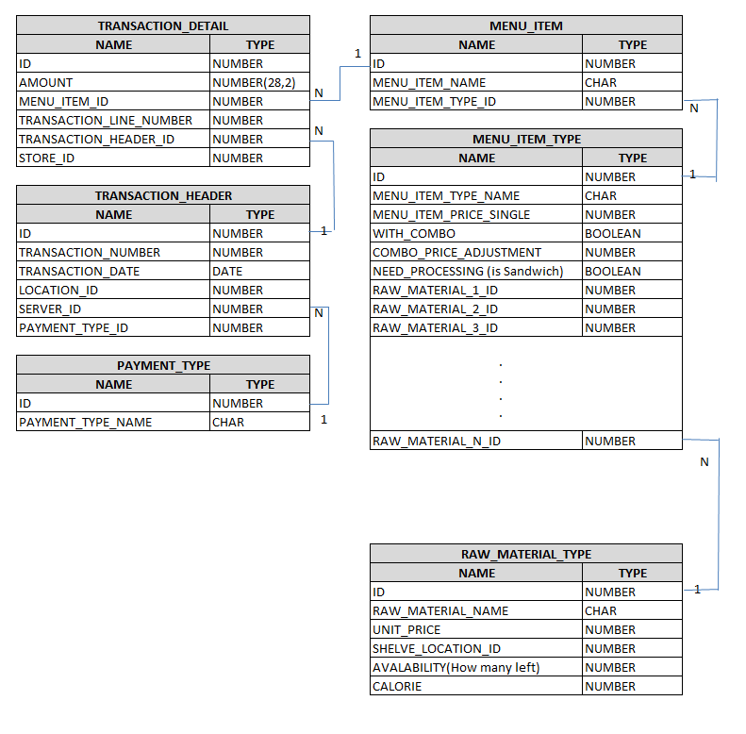

Figure 1. An example ordering system

Subway’s management style and food style is always fast, simple and of lower cost. This philosophy leads us to a simple, robust, easy to deploy and manage database system.

Subway needs a system that is low cost at the terminals, a database system that is stable and can handle peak traffic in short bursts and has minimum impact to the existing system. The structure of the database is simplified so that no advanced DBMS is needed. This saves cost and minimizes impact to the current running system.

The back-end database stores all the data of restaurant information, i.e. locations, hours of operation, etc.; all available menu items, etc. This information is accessed and processed for order processing, customer relations management (CRM), supply-chain management (SCM), integrated into an electronic data interchange (EDI) with our partners.

System Topology

It uses the topology of the Star structure (DCN Computer Network Toplogies, 2015), shown in figure 2. The center is the major Enterprise Database where executives of Subway can use it for big data analysis and data mining of data from each restaurant.

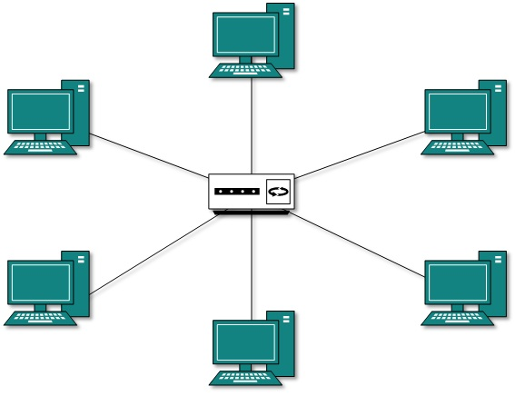

Figure 2. Star structure topology

When customers want to order, they will be directed to the local branch restaurant, and submit their order there and the data will be saved locally. When the restaurant is closed for the day, the system will schedule automation upload to the major Enterprise Database via VPN.

To have each terminal handle orders can distract traffic of peak hours and reduce the requirement of the capacity of the central Enterprise Server, which also save cost of maintenance. The design of the topology also fit our goal to save cost while provide Subway to promote business and run data analysis. Impact is also minimized since a simple database management system is deployed and only minimum training is needed for employees of each restaurant to manage it, due to simple data structure.

Operations research and management of the web system

In order to apply the online food ordering system to Subway’s current business, we need to train and adjust management for the integration of the operation. The new system needs suitable, expert management to exercise efficiently. The main target is to reduce the time wasted from the existing inefficient method of ordering food. We need to train management in the servicing of online customers, as well as the original customers.

Moreover, corporate management needs to add additional technical personnel to input all the additional but required information into database. The database is relational and should be maintained to be normalized to at least the third normal form (3NF) (Codd, 1971). Data will be cleaned to prevent failures or mistakes and can be traced via the system to identify any anomalies and handle exceptions in the data structure. The entire process includes the realization of how management will be changed, and we need to include that in the System Development Life Cycle (SDLC).

System Development Life Cycle (SDLC)

Subway Restaurants have conducted a feasibility study and determined the need for the online food ordering system to reduce the wait time of customers. We use the System Development Life Cycle (SDLC) to ensure that the new Information System (IS) can support Subway Restaurants’ business needs. The SDLC component has four phases: Planning, Analysis, Design and Implementation; as illustrated in figure 3.

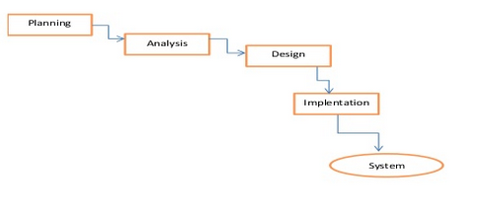

Figure 3. System Development Life Cycle (SDLC)

First, the most critical task is the planning phase, with the main purpose of identifying the needs of the online food ordering system. Do they align to existing operations? Are there any needs that differ or conflict with existing operations?

In the analysis phase, management needs to be diligent in evaluating the current system and any problems it has. With an understanding of its weaknesses and strengths, the company needs to investigate the steps needed for the integration of the new system. KPIs will be developed to effectively measure business performance.

In the design phase, after the requirements have been determined, the system development team determines the required specifications for the software, hardware, data resources and information products. This will satisfy the functional requirement of the process in the new system. Scope will help us to ensure the design meet the requirement of online ordering system process without specification creep.

In the implementation phase, we deploy and install the software application onto the production servers, according to plan. Moreover, looking back to the original purpose for this new system, making sure the system attains the goals we propose in the beginning. We monitor and adjust baseline values to further improve and ensure the integrity of the whole system.

Questions to develop KPIs for the internal business processes perspective

The balanced scorecard will ask the following questions for the internal business processes perspective:

1. How to save costs? Answer: Many of the existing processes are the same for the online order processing. We can identify what resources can be shared or reused by comparing the current enterprise resource planning (ERP) system and incorporating what us relative, such as the KPI: Cooking equipment mean-time-between-failure (MTBF), the KPI: employee turnover, the KPI: franchise break-even point.
2. How to make the system reliable? Answer: Determine if Subway uses a data warehouse and/or dependent Datamarts. Measure how much KPI: system down-time transpires, in the event of a power outage. To ensure that consistent and reliable backup/recovery of data is performed, do periodic drills and measure the KPI: data recovery success-rate.
3. How does online food ordering affect the existing operations of food order preparation for regular customers? Answer: Online food ordering affords the opportunity to expand operations in existing but unused workspaces. This will greatly help production of food order preparation at peak times. Since the customer is ordering online and is not present to choose the food, the food order preparation does not have to be watched by customers. It can be done at additional work stations setup in an out-of-site space that does take up store-front space. Measure the KPI: Work station space (square feet) per restaurant.

The Learning and Growth Perspective

The learning and growth perspective will mostly deal with the training needed by the employees to use the system and any resources required with adjusting to the addition of the system. The intention of the online ordering system is to reduce wait times in the restaurants and improve overall customer satisfaction. This is when the question of whether or not the introduction of the online ordering system actually provides any benefit to wait times. We can also ask how the system will interact with the current operations. There’s a possibility that adding it will create more orders than a restaurant can handle.

Employee training

The online ordering system is design to be small and simple to go along with the rest of the way that Subway is set up to operate. Any required training to use the system should be minimal as well. All employees should be able to operate the online service but only require at most one or two employees having to interact with their end of the dashboard to produce the orders received.

Questions to develop KPIs for the learning and growth perspective

The balanced scorecard will ask the following questions for the learning and growth perspective:

1. Has adding the online ordering system improved the customer satisfaction while in the store? Answer: we can use the surveys already in place to determine the efficacy of the system. We can also add the KPI: customer rating to the customer side of the website so they can leave feedback on their experience of the system
2. What training is needed for the employees to learn to use the system? Answer: a minimal amount of training should be required. All of the employees can be trained but not all employees should be on the online service. After training, a proficiency test can be given to the employees and continued practice for improvement; based on the measurements of the KPI: employee proficiency with speed and the KPI: employee proficiency with accuracy.
3. How does the system interact with current operations? Answer: One or two employees should be handling orders from the online system at any one time. The KPI: orders completed can be used to determine how many orders were completed were completed in a timely manner before and during a test period to determine how the online system and the current operations interfere.
4. What else can the online ordering system be used for? Answer: the system already collects plenty of data, and some of it is can be used to offer promotions to repeat customers
5. What other HRM details need to be accounted for? Answer: There’s a chance that the system might bring up some scheduling conflicts. Measuring KPI: scheduling conflicts would bring more light to this question.

The Balanced Scorecard (BSC)

We developed a balanced scorecard (BSC) that views the Subway Corporation from four perspectives – customer, financial, internal business processes, learning and growth. Our BSC is better than the existing BSC because it includes the integration of the additional online food ordering process. It will assist management in attaining objectives relative to each perspective. The KPIs determine answers to strategic questions for solutions to problems and opportunities.

KPIs of the balanced scorecard for the customer perspective

1. KPI: volume (sales), for roll-up reports for peak and lull periods.
2. KPI: switched customers using online food ordering
3. KPI: new customers using online food ordering
4. KPI: application value
5. KPI: discount pricing

KPIs of the balanced scorecard for the financial perspective

1. KPI: repeat orders associated to the customer information with each order.
2. KPI: food item profit margins
3. KPI: location space (square footage).
4. KPI: volume (sales) by geographical area
5. KPI: volume (sales) by market segment

KPIs of the balanced scorecard for the internal business processes perspective

1. KPI: Cooking equipment mean-time-between-failure (MTBF)
2. KPI: employee turnover
3. KPI: franchise break-even point
4. KPI: data recovery success-rate
5. KPI: Work station space (square feet) per restaurant

KPIs of the balanced scorecard for the learning and growth perspective

1. KPI: customer rating
2. KPI: employee proficiency with speed
3. KPI: employee proficiency with accuracy
4. KPI: orders completed
5. KPI: scheduling conflicts

Summary

We need to ask one question: what exactly does a Subway restaurant need? Online ordering is supposed to save customers time. Customers order something, and pick up when the order is ready. But isn’t Subway already fast enough to save customers time? It only takes them 2 minutes to prepare us a decent sandwich. On the other hand, even customers have ordered a sandwich, they still need to get to the store to pick up. That means the actual time saved is less than 2 minutes (assuming customers want to pay at counter but not on the website).

There are two reasons that they need online ordering. The first reason is to accommodate more customers at peak hours, such as lunch time. The second reason is to get more customers’ data and push promotions. Social media connections and email can be used for new product promotions. Also, users’ order histories will be recorded. Subway can use those big data for data mining.

# References

*About Analytical Innovators*. (2015). Retrieved from Analytical Innovators: www.AnalyticalInnovators.com

Codd, E. (1971). *Further Normalization of the Data Base Relational Model, IBM Research Report RJ909.* New York City: Courant Computer Science Symposia Series 6, "Data Base Systems," Republished by Randall. Retrieved from https://en.wikipedia.org/wiki/Third_normal_form#cite_note-Codd-2

*DCN Computer Network Toplogies*. (2015). Retrieved from Tutorials Point, Simply Easy Learning: http://www.tutorialspoint.com/data_communication_computer_network/computer_network_topologies.htm

Kaplan, R., & Norton, D. (1992, January). The Balanced Scorecard - Measures that drive performance. *Harvard Business Review (online ed.)*. Retrieved from http://hbr.org/1992/01/the-balanced-scorecard-measures-that-drive-performance/ar/1

Locsin, A. (n.d.). *2010 Operations Report - The Average Profit Margin for a Restaurant.* Houston, Texas: National Restaurant Association and Deloitte & Touche LLP. Retrieved 2015, from http://smallbusiness.chron.com/average-profit-margin-restaurant-13477.html

(2015). *Net Profit Less Than Two Pennies On Each Dollar of Food Sales.* Arlington, VA: FMI Food Marketing Institute Food Marketing Institute. Retrieved from http://www.fmi.org/docs/facts-figures/competitionandprofit.pdf?sfvrsn=2

Sharda, R., Delen, D., & Turban, E. (2015). *Business Intelligence and Analytics: Systems for Decision Support.* Upper Saddle River, New Jersey: Pearson Education, Inc.