Critique of Infographics

Group 4

Michael Fetick, 84270

Yuxuan Guan, 660161473

Gabriel Ramirez

Weilong Qu, 660162539

Chih-Hsiang (Sean) Wu, 660161992

Coleman University

**Infographic of a Filled, Radar Graph**

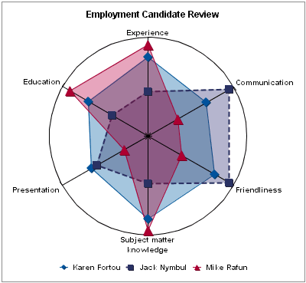

The company wants to compare the abilities from different candidates to choose the suitable person to do the project. In the filled, radar graph, we can see the abilities have been categorized for six major subtopics. It would be much clearer if we could categorize and summarize the diversified abilities into subgroups. We can see at the bottom of the picture, there are three candidates to compare. However, it would be more practical to compare more persons than just the three. Most of time, there would be a large number of candidates to work with; then, this graph would become too busy and confusing. Moreover, it does not clearly provide information for the target audiences (managers) because they have to specifically point out the requirement for the position. Therefore, we have to make it easier for them to read, especially to facilitate the decision making processes. The colors in this graph make it look beautiful but they are not informative. And they distract from the main point. The regions of different colors overlay each other creating even more colors that will also make it difficult read. The reader cannot clearly get the true information.

It will be clearer if the presenter uses a colored bar chart instead of a complicated radar chart. That would afford the reader to be able to weight differently on each elements, depending on the importance of their subject matter knowledge for the position. Therefore, we can get the weight-average number to address the suitability of each candidate for the positon. We can also assess more elements which highly correlates to matching each candidate’s abilities to the job. The bar chart, table, or list could easily do the math, making judgement strong supported by data analysis.