**Homework Assignment 3**

**Social Media**

Michael Fetick, 84270

COM671 Decision Support Systems

Coleman University

June 9, 2015

**Censorship of Social Media by Data Analysts**

A network of 'Moderators' decide what photos can be posted on Facebook, Google, and other social media. Industry insiders and experts say the room for interpretation across time zones and cultures can be a problem for a system that requires a surplus of employees at any hour of the day or night. The system of photo moderation on sites from Facebook to Pinterest to Google is a complex system involving third parties and contractors of contractors (Shapiro, 2012, Sep 12).

Google's social networking arm, Google +, uses a "combination of user reports and automated scanning to detect content that violates our policies," according to a spokesperson for Google. What's okay and not okay on Google + can read a bit vague: promotion of "illegal activities" and "malicious products," for example, is banned, along with "sexually explicit material" and "personal and confidential information. (Shapiro, 2012, Sep 12) "

Pinterest, a site built almost exclusively on photo sharing, has adopted a set of guidelines based on what it calls "Pin Etiquette": nudity in photographs is forbidden, as is "hateful content" or "content that actively promotes self-harm. (Shapiro, 2012, Sep 12) "

Facebook's “Community Standards” use similar language, prohibiting “violence and threats,” “bullying and harassment,” and “graphic content.” All pornography is banned, as is most nudity, with a caveat: “We aspire to respect people’s right to share content of personal importance, whether those are photos of a sculpture like Michelangelo’s David or family photos of a child breastfeeding (Shapiro, 2012, Sep 12).”

The data collected from this article is limited to only a few sources of social media but they are good representative samples because they are the largest, most widespread social media. Two other big ones are Twitter and LinkedIn, not included, but would be interesting to know how they analyze data for censorship. If we tried to included most [if not all] the social media available we would have to consider the list in figure 1. The analysis was presented in a clear way to understand it.

The article is effectiveness to support the claim. The strengths of the research presented by the author was the authenticity of the data because it directly cites the officials at the social media sources. The weaknesses of the research was the limited depth and detail of the analytic process and the tools used.

I would recommend improving the research with further detail to the processes. Also look into what other social media is doing for censorship for a broader comparison of techniques. See figures 1 through 6 for more social media sources.

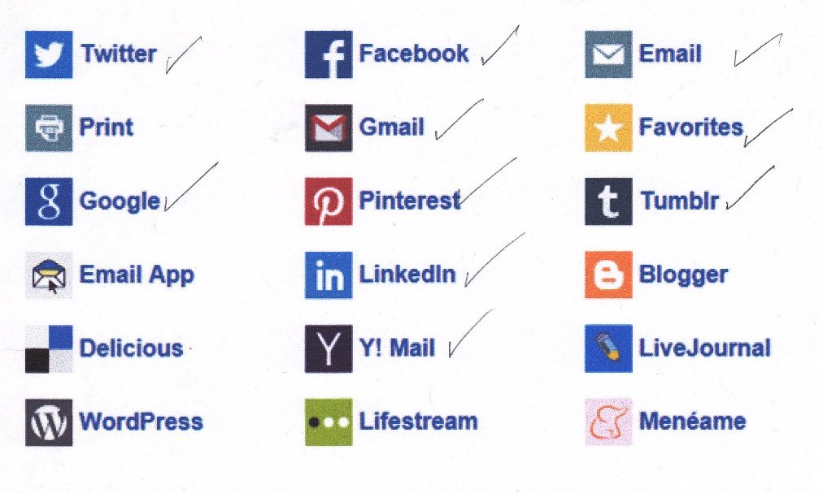

Figure 1. Popular Social Media Sources

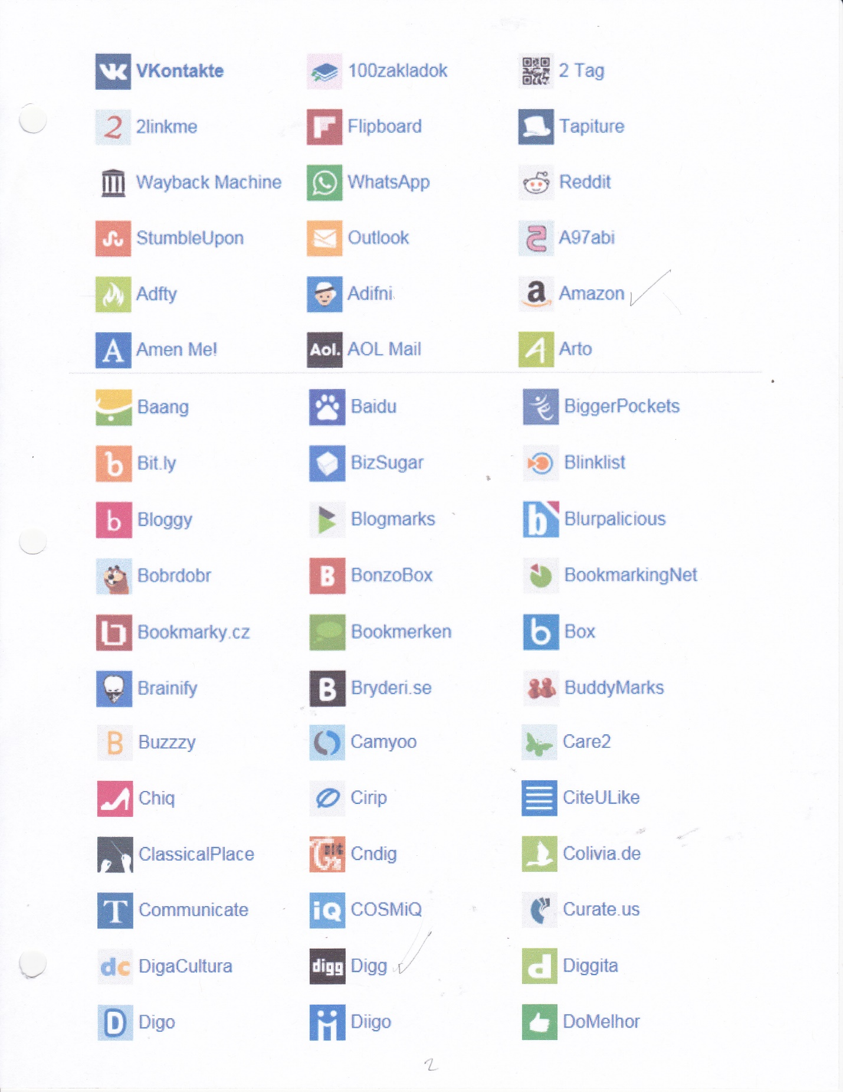

Figure 2. More Popular Social Media Sources

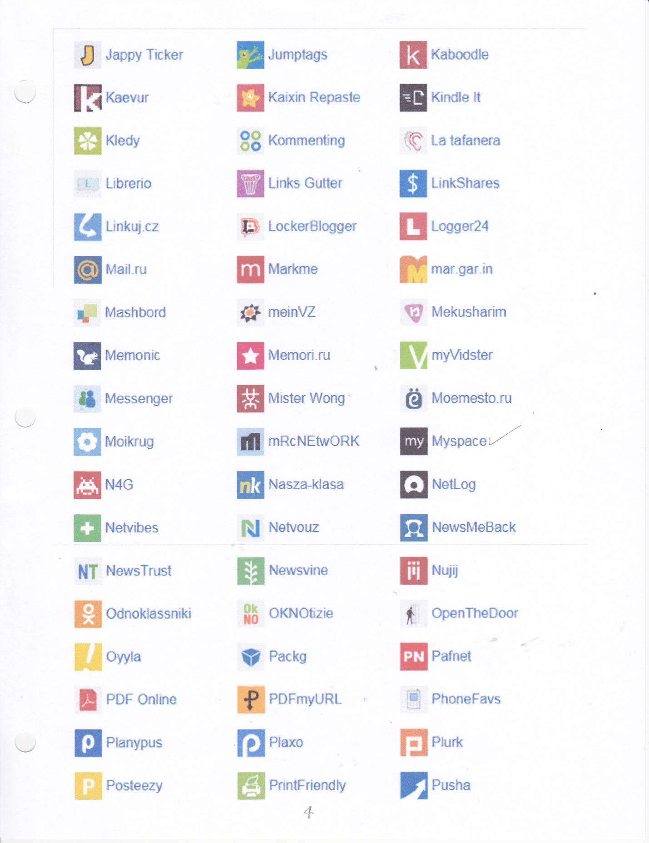

Figure 3. More Popular Social Media Sources

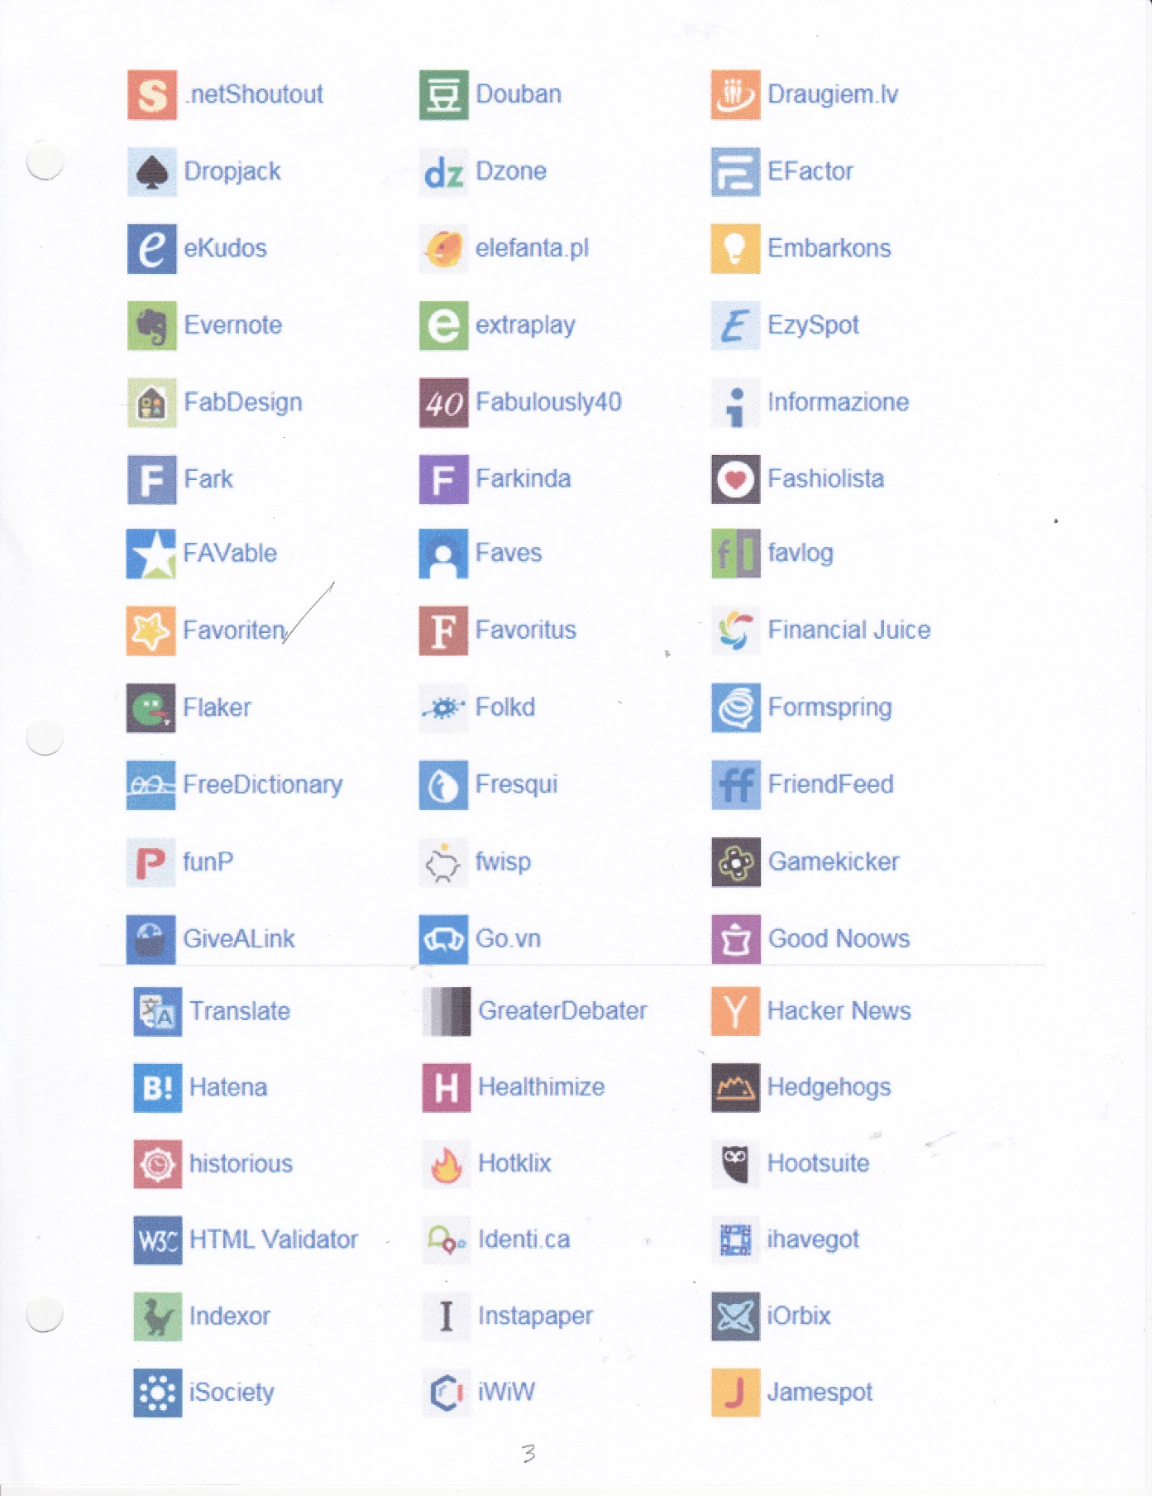

Figure 4. More Popular Social Media Sources

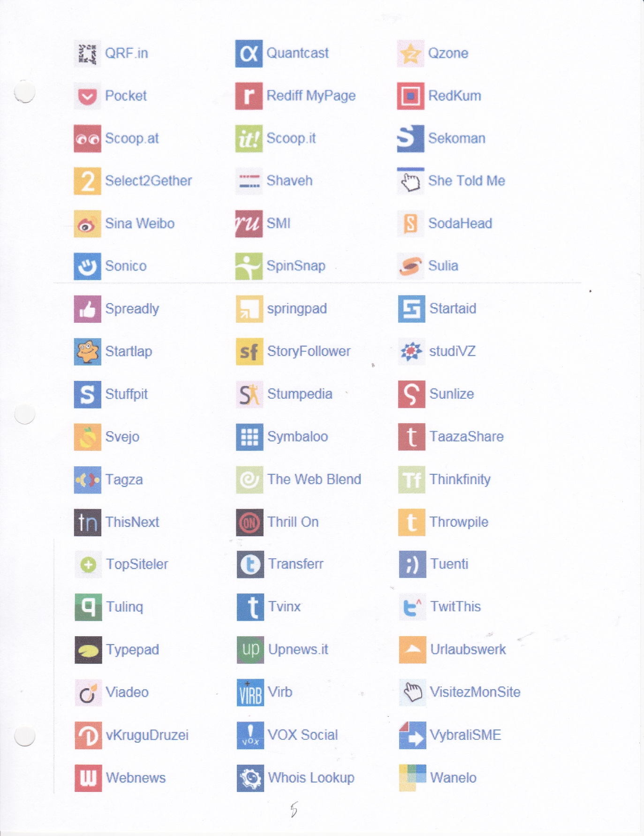

Figure 5. More Popular Social Media Sources

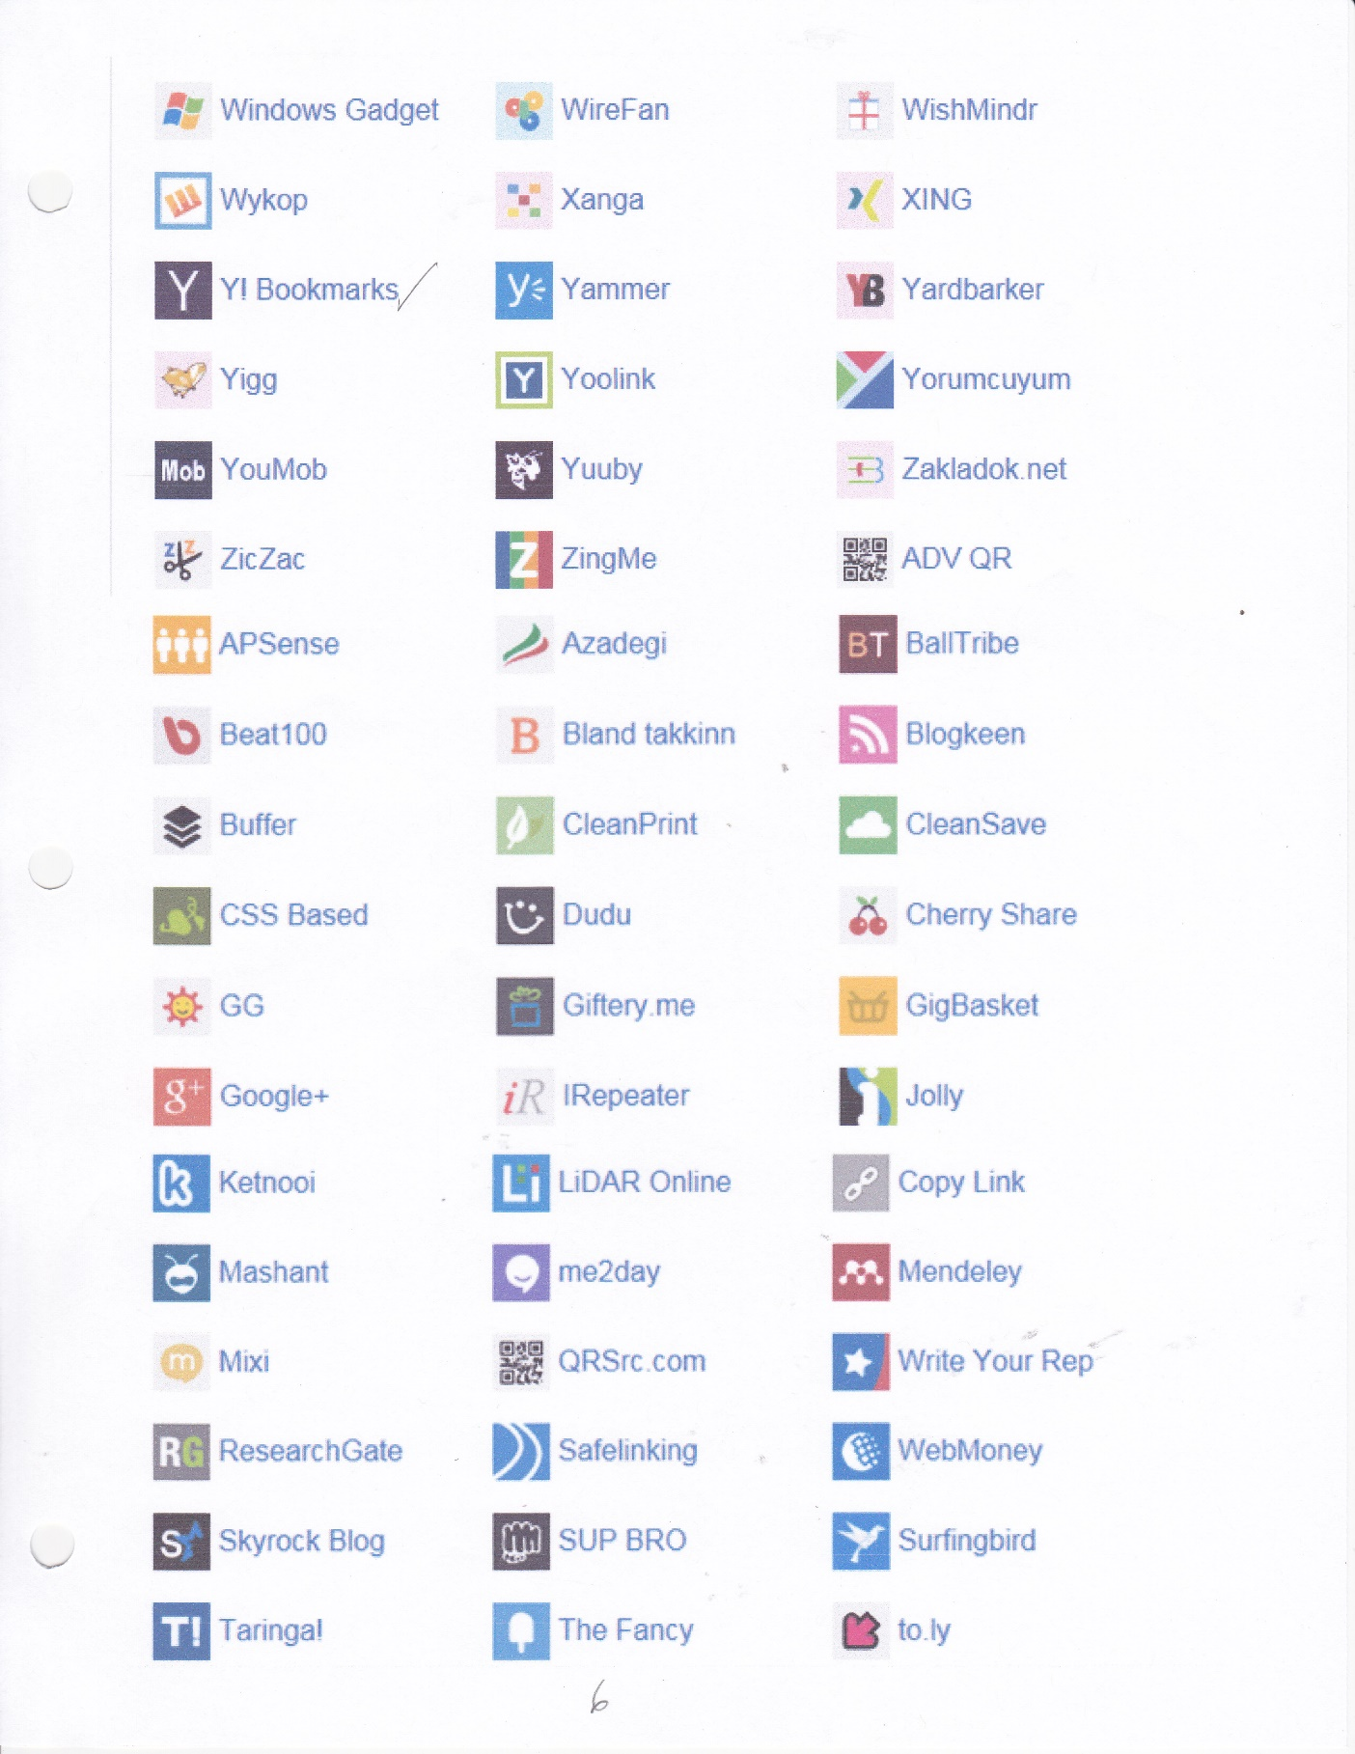

Figure 6. More Popular Social Media Sources



Figure 7. More Popular Social Media Sources

# References

Shapiro, E. (2012, Sep 12). Network of 'moderators' decide what photos can be posted on facebook, google, other social media. *The Daily Beast*. Retrieved from http://search.proquest.com/docview/1673465147?