COM270 C# Programming I
8 Units: 60 Hours Lecture + 40 Hours Lab
Student Manual
Lesson #1
Topic | Introduction | Points
Chapter | One

Main Topics:
- Introduction to C#
- The .NET Environment
- Basic Object-Oriented Concepts
- Classes, Data Members, & Methods

Introduction to C#
The advancement of programming tools and consumer-electronic devices created problems and new requirements. The integration of software components from various languages proved difficult, and installation problems were common because new versions of shared components were incompatible with old software. Developers also discovered they needed Web-based applications that could be accessed and used via the Internet. As a result of the popularity of mobile electronic devices, software developers realized that their clients were no longer restricted to desktop computers. Developers recognized the need for software that was accessible to anyone and available via almost any type of device. To address these needs, in 2000, Microsoft announced the C# programming language. C# was designed specifically for the .NET platform as a language that would enable programmers to migrate easily to .NET. It has roots in C, C++, and Java, adapting the best features of each and adding new features of its own. C# is object oriented and contains a powerful class library of pre-built components, enabling programmers to develop applications quickly. C# and Visual Basic share the Framework Class Library (FCL). C# is appropriate for demanding application development tasks, especially for building today’s popular Web-based applications.

The .NET platform is one over which Web-based applications can be distributed to a great variety of devices and to desktop computers. The platform offers a new software-development model that allows applications created in diverse programming languages to communicate with each other.

C# is an event-driven, visual programming language in which programs are created using an Integrated Development Environment (IDE). With the IDE, a programmer can create, run, test, and debug C# programs easily, thereby reducing the time it takes to produce a working program to a fraction of the time that would be required otherwise. The .NET platform enables language interoperability: Software components from different languages can interact as never before. Developers can package even old software to work with new C# programs. Also, C# applications can interact via the Internet, using industry standards such as XML and SOAP.

The .NET Environment
In 2000 Microsoft announced its .NET initiative, a new vision for using the Internet and the Web in the development and use of software. One key aspect of .NET is its independence from a specific language platform. Rather than being forced to use a single programming language, developers can create a .NET application in any .NET compatible language. Programmers can contribute to the same software project, writing code in the .NET language in which they are most competent. Part of the initiative includes ASP .NET technology, which allows programmers to create applications for the Web. The .NET initiative also includes ADO .NET, which allows developers to connect to a variety of database systems.

Basic Object-Oriented Concepts
Everywhere you look in the real world you see objects—people, animals, plants, cars, planes, computers and so on. Humans think in terms of objects. Telephones, houses, traffic lights, are just a few more objects we see around us every day.
We sometimes divide objects into two categories: animate and inanimate. Animate objects are “alive” in some sense—they move around and do things, inanimate objects do not move on their own. Both types of objects, however, have some things in common. They have attributes (size, color, shape and weight), and they all exhibit behaviors (a ball rolls, bounces, and deflates: a baby cries, sleeps, crawls, and walks: a car accelerates, brakes, and turns). We will study the kinds of attributes and behaviors that software objects have.
Humans learn about objects by studying their attributes and observing their behaviors. Different objects can have similar attributes and can exhibit similar behaviors. Comparisons can be made, for example, between babies and adults and between humans and cats.
Object-oriented design (OOD) models software in terms similar to those that people use to describe real-world objects. It takes advantage of class relationships, where objects of a certain class, such as a class of vehicles, have the same characteristics—cars, trucks, red wagons and roller skates have much in common. OOD takes advantage of inheritance relationships where new classes of objects are derived by absorbing characteristics of existing classes and adding unique characteristics of their own. An object of “convertible” class has the characteristics of the more general class “automobile”, but the roof goes up and down.
Object-oriented design provides a natural and intuitive way to view the software design process—namely, modeling objects by their attributes, behaviors, and interrelationships, just as we describe real-world objects. OOD also models communication between objects. Just as people send messages to one another, objects also communicate via messages. A bank account object may receive a message to decrease its balance by a certain amount because the customer has withdrawn that amount of money.
OOD encapsulates attributes and operations (behaviors) into objects. Objects have the property of information hiding. This means that objects may know how to communicate with other objects across well-defined interfaces, but normally they are not allowed to know how other objects are implemented. The details are hidden within the objects themselves.
Languages like C# are object-oriented. Programming in such a language is called object-oriented programming (OOP), and it allows computer programmers to conveniently implement an object- oriented design as a working software system. Languages like C, on the other hand are procedural, so programming tends to be action oriented. In C, the unit of programming is the function. In C#, the unit of programming is the class, from which objects are instantiated (an OOP term for “created”). C# classes contain methods (C#’s equivalent of C’s functions) that implement operations, and data that implements attributes.

Classes, Data Members and Methods
C# programmers concentrate on creating their own user-defined types called classes. Each class contains data as well as the set of methods that manipulate the data and provide services to clients. The data components of a class are called attributes, or fields. The operation components of a class are called methods. The programmer uses built-in types and other user-defined types as the “building blocks” for constructing new user-defined types (classes).

Classes are to objects as blueprints are to houses. A class is a “plan” for building objects of the class.
Lesson #2
Topic | The IDE | Points
Chapter | Ten
Demo | Create a Simple Application
Main Topics:
- The Basics of the Visual Studio IDE
- Key Commands
- Various Kinds of Windows
- Visual Programming
- Create and execute a simple Visual C# program that displays text and an image using the IDE and the technique of visual programming

Visual Studio 2005 is Microsoft’s Integrated Development Environment (IDE) for creating, running and debugging programs written in a variety of .NET programming languages. In this lesson, we provide an overview of the Visual Studio 2005 IDE and demonstrate how to create a simple C# program by dragging and dropping predefined building blocks into place—a technique called visual programming.

Menus and Toolbars
- Auto-Hide

The IDE
- Solution Explorer
- Toolbox
- Properties Window

Create a simple C# program using Visual Programming techniques.
- Create project
- The form Text property
- Resize the form
- The form BackColor property
- The Label control
- The AutoSize property
- The Font property
- Align the label text
- The PictureBox control
- The Image and SizeMode properties
- Save, Compile, and Run the program

Lesson #3
Topic | C# Applications | Points
Chapter | Two
Demo | Create a Console Application
Main Topics:
- Console Applications
- Create the Application
- Adding Integers
- Operators
- C# Simple Data Types
Create and execute a simple Visual C# program that displays text and an image using the IDE and the technique of visual programming
Most C# applications process information and display results. In this lesson we will introduce console applications. These input and output text in a console window. In newer versions of Microsoft Windows, the console window is the Command Prompt.
In this lesson we will create applications that will display text and perform arithmetic operations. The following concepts will be introduced:
- Comments
- Class methods
- Formatting text
- Arithmetic operations
- Equality and Relational operators
- Simple Data Types
Simple C# Data Types

Type | Size in Bytes | Value Range
bool | 1 | true or false
byte | 1 | 0 to 255
sbyte | 1 | -128 to 127
char | 2 | 0 to 65535
short | 2 | -32768 to 32767
ushort | 2 | 0 to 65535
int | 4 | -2,147,483,648 to 2,147,483,647
uint | 4 | 0 to 4,294,967,295
float | 4 | Approximate negative range:  -3.4028234663852886E+38 to  -1.40129846432481707E-45  Approximate positive range:  1.40129846432481707E-45 to  3.4028234663852886E+38
long | 8 | -9,223,372,036,854,775,808 to  9,223,372,036,854,775,807
ulong | 8 | 0 to 18,446,744,073,709,551,615
double | 8 | Approximate negative range:  -1.79769313488623157E+308 to  -4.940656458412246544E-324  Approximate positive range:  4.940656458412246544E-324 to  1.79769313488623157E+308
decimal | 16 | Negative range:  -7.9E+28 to –1.0E-28  Positive range:  1.0E-28 to 7.9E+28

Lesson #4
Topic | Introduction to Classes and Objects | Points
Chapter | Seven
Demo | Creating Classes

Main Topics:
- Classes, Objects, and Methods
- Declaring a Class with a Method and Instantiating an Object of a Class
- Declaring a Method with a Parameter
- Properties and Instance Variables (Set & Get)
- Value types and Reference types
- Constructors

We introduced the basic terminology and concepts of object-oriented programming in Lesson 1. In Lesson 3, you began to use those concepts to create simple applications that displayed messages to the user, obtained information from the user and performed calculations. One common feature of every application in Lesson 3 was that all the statements that performed tasks were located in method Main( ). Typically, most applications that you develop will consist of two or more classes, each containing one or more methods.

This lesson will present several applications to demonstrate how to create and use your own classes.

Lesson #5
Topic | Control Statements 1 | Points
Chapter | Three
Demo | Control statements

Main Topics:
- Algorithms
- Pseudocode
- The if statement
- The while statement
- Increment and Decrement Operators
- Compound Assignment operators
- Conditional Operator (?:) C#’s only ternary operator
Algorithms:
Any computing problem can be solved by executing a series of actions in a specific order. A procedure for solving a problem in terms of

- the actions to execute and
- the order in which these actions execute

is called an algorithm. The following example demonstrates that correctly specifying the order in which the actions execute is important.

Consider the “rise-and-shine” algorithm followed by one executive for getting out of bed and going to work: (1) Get out of bed: (2) take off pajamas: (3) take a shower: (4) get dressed: (5) eat breakfast: (6) carpool to work. This routine gets the executive to work well prepared to make decisions. Suppose that the same steps are performed in a slightly different order: (1) Get out of bed: (2) take off pajamas: (3) get dressed: (4) take a shower: (5) eat breakfast: (6) carpool to work. In this case, our executive shows up for work soaking wet.

Specifying the order in which statements (actions) execute in an application is called program control. This lesson investigates program control using C#’s control statements.

Pseudocode:
Pseudocode is an informal language that helps programmers develop algorithms without having to worry about the strict details of the C# language. Pseudocode is similar to everyday English, but it is not a programming language.
Pseudocode helps you “think out” an application before attempting to code it. Pseudocode normally describes statements that represent the actions that occur in your program. Variable declarations are not usually included, but may be listed at the beginning along with their purposes.

Selection:
C# has three types of selection statements. The if statement either performs an action if a condition is true or skips the action if the condition is false. The if…else statement performs an action if a condition is true or performs a different action if the condition is false. The switch statement performs one of many different actions, depending on the value of an expression.

Repetition:
C# provides four repetition statements. Repetition statements enable applications to perform statements repeatedly, depending on the value of a loop-continuation condition. The statements are the while, do…while, for, and foreach.

Compound Assignment Operators
+=
-=
*=
/=
%=

Increment and Decrement Operators
++
--

The Conditional Operator
(? :)

Lesson #6
Topic | Control Statements 2 | Points
Chapter | Four
Demo | Control statements

Main Topics:
- Repetition
- The for statement
- The do…while statement
- The foreach statement
- The switch statement
- The switch statement
- Break and Continue
- Logical Operators

Counter-Controlled Repetition requires:
- a control variable (loop counter)
- the initial value of the control variable
- the increment (or decrement) by which the control variable is modified each time through the loop
- the loop-continuation condition that determines whether looping should continue

for

do…while

switch

break and continue

Logical Operators:
- AND (&&)
- OR (||)
- Exclusive OR (^)
- NOT (!)

Lesson #7
Topics | Methods | Points
Chapter | Six
Demo | Method creation

Main Topics:
- Packaging code
- static methods
- static variables
- Methods with multiple parameters
- Random number generation – Dice game
- Scope
- Method Overloading
- Passing parameters by value and by reference

Packaging Code in C#
Three common ways of packaging code are methods, classes, and namespaces. C# applications are written by combining new methods and classes that you write with predefined methods and classes available in the .NET Framework Class Library and in various other class libraries. Related classes are often grouped into namespaces and compiled into class libraries so that they can be reused in other applications. The FCL provides many predefined classes that contain methods for performing common mathematical calculations, string manipulations, character manipulations, input/output operations, database operations, networking operations, file processing, error checking, and many other useful operations.

Methods (called functions or procedures in other programming languages) allow you to modularize an application by separating its tasks into self-contained units. You have declared methods in every application you have written. These methods are sometimes referred to as user-defined methods. The actual statements in the method bodies are written only once, can be reused from several locations in an application and are hidden from other methods.

Random-Number Generation will be illustrated by an application, which will simulate the game of “craps” that requires the rolling of a six-sided die.

The passing of parameters by reference and by value will also be discussed.

Reference: The following URL is the reference document for the Framework Class Library Version 2:

http://msdn2.microsoft.com/en-us/library/ms229335(vs.80).aspx
Lesson #8
Topic | Arrays | Points
Chapter | Five
Demo | Creating arrays and using the foreach loop

Main Topics:
- Declaring arrays
- Creating arrays
- The foreach loop
- Passing arrays and array elements
- Passing arrays by value and by reference
- ArrayLists
An array is a group of variables (called elements) containing values that all have the same data type. Arrays are reference types. What we typically think of as an array is actually a reference to an array instance in memory. The elements of an array can be either value types or reference types (including other arrays).

For example:
int[ ] myIntArray;

The square brackets [ ] tell C# that you are declaring an array, and int specifies the type of elements it will contain.

Instantiate an array using the new keyword:
myIntArray = new int[5];
This statement creates and initializes an array of five integers, all of which are initialized to zero.

You can access the elements of an array using the index operator [ ]. Arrays are zero-based, the index of the first element is always zero. For example:
myIntArray[0]

The Length property of the array tells you how many objects the array holds. Objects are indexed from 0 to Length –1.

ArrayLists:
An ArrayList is an array whose size is dynamically increased as required. The following are some of its supported methods and properties:

Add – Adds an object to the end of the ArrayList
Clear – Removes all objects from an ArrayList
Count – Gets the number of object contained in an ArrayList
Reverse – Reverses the order of the objects
Sort – Sorts the ArrayList

Example:
using System;
using System.Collections;
public class SamplesArrayList {

public static void Main() {

// Creates and initializes a new ArrayList.
ArrayList myAL = new ArrayList();
myAL.Add("Hello");
myAL.Add("World");
myAL.Add("!");

// Displays the properties and values of the ArrayList.
Console.WriteLine( "myAL" );
Console.WriteLine( " Count: {0}", myAL.Count );
Console.WriteLine( " Capacity: {0}", myAL.Capacity );
Console.Write( " Values:" );
PrintValues( myAL );
}

public static void PrintValues( IEnumerable myList ) {
foreach ( Object obj in myList )
Console.Write( " {0}", obj );
Console.WriteLine();
}
}

/*
This code produces the following output.

myAL
Count: 3
Capacity: 16
Values: Hello World !
*/
Lesson #9
Topic | Interface Controls 1 | Points
Chapter | Eleven
Demo | C# control objects

Main Topics:
- Labels, Textboxes, and Buttons
- GroupBoxes and Panels
- CheckBoxes and Radiobuttons
- PictureBox
- Tooltips
- NumericUpDown
- Mouse Event Handling
- Keyboard Event Handling

A graphical user interface (GUI) allows a user to interact visually with a program. A GUI gives a program a distinctive “look and feel.” Providing different applications with a consistent set of intuitive user-interface components enables users to become productive with each application faster.

Windows Forms are used to create the GUIs for programs. A Form is a graphical element that appears on your computer desktop; it can be a dialog, a window or an MDI window.

Normally, a user interacts with an application’s GUI to indicate the tasks that the application should perform. For example, when you write an e-mail in an e-mail application, clicking the Send button tells the application to send the e-mail to the specified address. GUIs are event driven. When the user interacts with a GUI component, the interaction – known as an event – drives the program to perform a task. Common events that might cause an application to perform a task include clicking a Button, typing in a TextBox, selecting an item from a menu, closing a window, and moving the mouse. A method that performs a task in response to an event is called an event handler.

This lesson will cover several common GUI components and how they function on a Windows Form.

Lesson #10
Topic | Interface Controls 2 | Points
Chapter | Eleven
Demo | C# control objects

Main Topics:

- Menus
- MonthCalendar control
- DateTimePicker control
- ListBox
- CheckedListBox
- ComboBox
- ListView
- TabControl

This lesson is a continuation of Lesson 9 and includes more advanced controls.

Lesson #11
Topic | Classes and The Split Method | Points
Chapter | Chapter 13
Demo | The Split Method
Project 1 | Book Order Form | 15
Instruction Materials:
Main Topics:
- Classes vs. Structures
- Create an array of structures and classes
- The Split Method

The Split Method
In this section, you will learn how to split a string into individual fields, and store those fields in an array. The process of splitting a line into individual fields or parts is called parsing.

Understanding the Split Method
The Split method of the String class divides a string into parts based on a delimiter, such as a comma. Each part (field) gets stored in an element of an array. The C# array will grow as necessary to store each field in a different element.

The Split method requires that you define the character or characters that will act as the delimiter (the delimiter separates one field from the next). Most ASCII-delimited files use a comma as the delimiter character, although a delimiter can be any character or character sequence. The char data type stores a single character, which will store a delimiter. The following statement declares a variable having the char data type:
char Delimiter;

To store a character in a char variable, you enclose the desired character in single quotes, as shown:
Delimiter = ‘,’;

The Split Method
The Split method of the String class divides (parses) a string into fields. The Split method returns an array containing one element for each field in the string. C# .NET will resize the array as necessary to store the required number of fields. The Split method accepts one argument, which is the character that will be used as the delimiter, and returns an array of strings.

Code Example:

const char DELIMITER = ‘ , ’ ;
string line = “The Jasmine Moon Murder,Laura Childs,Mystery”;
string[ ] fields;
fields = line.Split(DELIMITER);
Console.WriteLine(fields[0]);
Console.WriteLine(fields[1]);
Console.WriteLine(fields[2]);
The preceding code example declares a string variable named line and stores a string that contains the title, author, and type of a book separated by commas. An array of Strings named fields is also declared. The constant DELIMITER contains a comma, which the Split method will use to divide the line into fields. The call to the Split method divides the string line into an array so that each field is stored in an array element.

The fields array will contain the following elements:
fields[0] will contain “The Jasmine Moon Murder”
fields[1] will contain “Laura Childs”
fields[2] will contain “Mystery”

Using the comma as the delimiter, the Split method divided the string into a three-element array.

In project 1, the Split Method will be used to read data from a Sequential Access file and store it into an array of Classes.

Examine the following example:

const char DELIMITER = ‘,‘ ;
string line =
"The Jasmine Moon Murder,Laura Childs,Mystery,Paperback";

string[] fields;

fields = line.Split(DELIMITER);

foreach(string element in fields)
{
Console.WriteLine(element);
}

In the preceding code the line variable holds the String that will be used by the Split method. The fields array will contain the individual elements of the input line. In this case fields will contain four elements. DELIMITER is a constant of type char that contains the character used to delimit the input string, a comma in this example. element is used by the foreach loop to store each element of the array. The call to the Split method divides the string into its four parts and stores them in four elements of the fields array. Inside the foreach loop each element of the fields array is accessed and displayed. This example only processed a single string and used the foreach loop to print the four fields from the single array that was created by the Split method.

The following code will read records from a Sequential Access Text file and the Split method will process each record and load the data into an ArrayList so the application can use it. This example will use the Console.WriteLine method to print the contents of the ArrayList to verify that the data has been loaded.

using System;
using System.IO;
using System.Collections;

// declare the Book class
public class Book
{
public String title;
public String author;
public String isbn;
public decimal price;
}

public class Tester
{
public static void Main()
{
// declare a delimiter and the input text file
const char DELIMITER = ‘,’;
const String FILENAME = “booktitles.txt”;

// declare an ArrayList to hold the book data
ArrayList myArrayList = new ArrayList();

/*open the input file for reading and declare
a StreamReader object */
FileStream inFile = new FileStream(FILENAME,
FileMode.Open, FileAccess.Read);
StreamReader reader = new StreamReader(inFile);

// declare a string and a string array
String recordIn;
String[] fields;
// read the first record from the input file
recordIn = reader.ReadLine();
/* while valid records come from the input file
process them */
while (recordIn != null)
{
Book bk = new Book();
fields = recordIn.Split(DELIMITER);
bk.title = fields[0];
bk.author = fields[1];
bk.isbn = fields[2];
bk.price = Convert.ToDecimal(fields[3]);

myArrayList.Add(bk);

recordIn = reader.ReadLine();
}
reader.Close();
inFile.Close();

foreach(Book bk_data in myArrayList)
{
Console.WriteLine(“{0} {1} {2} {3}”,
bk_data.title, bk_data.author,
bk_data.isbn, bk_data.price);
}
}
}

Project One
Project One will allow a customer to enter her personal information and select book titles that she wants to order. When she is finished she will confirm the order, which will then be written to a Sequential Access File. Figure 11-1 shows a sample layout for the project. Please do not try to make your project look exactly like the sample. It should be your project; the sample is just a suggestion.

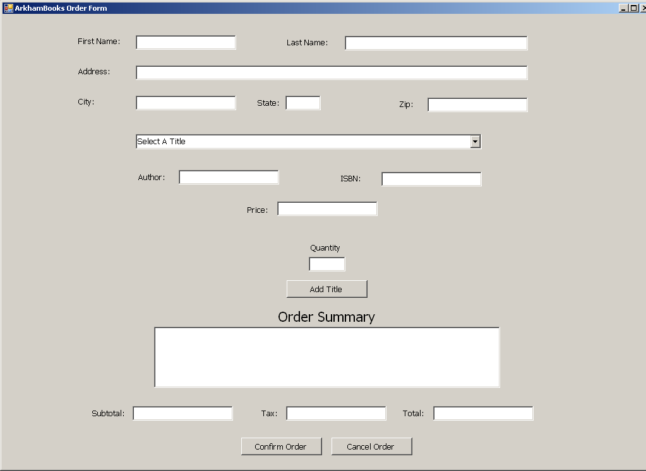

Figure 11-1
Project 1 specifications:
- The book data will be stored in a text file with one book per line, with the following format:
  - Book Name, Author, ISBN, Price
  - A file named BookTitles.txt will be provided by your instructor
- The BookTitles.txt file will be used to populate a Combo Box and will also be used to load an ArrayList to store the book information.
- The customer will provide her name and address data in Text Boxes.
- The customer will select a book title from the Combo Box and the ArrayList will provide additional data for the selected book.
- Next, the customer will enter the quantity that they wish to order of the currently selected book. The Add to Order button will be clicked to add the book to the order. When the Add to Order button is clicked, the book data will be displayed in an order summary area. Subtotal, Tax (7.75%), and Total will be updated.
- When the customer is finished she will click the Confirm Order button and the order data will be saved in a Sequential Access File.
- If the customer decides to cancel the order the Cancel Order button will simply clear the Text Boxes, the Order Summary area, and the order totals
- The format for the order data will be as follows:

-----------------------------------------------------------------------------------------------
Order Date: 10/31/2007
John Richardson
12 Grimauld Place
La Mesa, CA 91942
Title ISBN Quantity Price
The Jasmine Moon Murder 0425198138 2 16.95
SubTotal: 33.90 Tax: 2.63 Order Total: 36.53
------------------------------------------------------------------------------------------------

Be careful when you write the code to format the data going to the file. Make sure that there are no blank lines in the order data.

Lesson #12
Topic | Files and Streams | Points
Chapter | Chapter 13
Demo | Reading from and writing to text files
Instructional Material
Main Topics:
- Files and Streams
- File and Directory Classes
- Reading from a text file
- Writing to a text file
- StreamReader
- StreamWriter
This lesson contains concepts that are used in Project 1

Lesson #13
Topic | Quiz 1, Quiz 2, Test 1 | Points
 | Lessons 1 - 12 | 25

Review Topics:

- The Windows Form Designer Window
- The Solution Explorer
- The Properties Window
- The Toolbox
- The Code Editor
- Label and button controls
- TextBox control
- Align and size controls
- Variables and constants
- Operators
- Variable scope
- Formatting numeric output
- IF statements
- The Switch statement
- Loops
- ListBox
- ComboBox
- CheckBox control
- RadioButton control
- Passing arguments
- Arrays
- ArrayList
- foreach
- Classes
- Methods
- Operators
- Objects
- Constructors
- Properties
- Loops
- Interface controls
- Menus
- The Split Method
- Sequential Access Text Files
  - Reading
  - Writing
- StreamWriter
- StreamReader

Lesson #14
Topic | Classes and Objects – Another Look | Points
Chapter | Chapter 7
Project 2 | Adding a Class Library to a Project | 10

Main Topics:
- Controlling access to members
- This
- Overloaded constructors
- Default constructors
- Garbage collections and destructors
- Class libraries

Instructions for creating a class library:
In almost every example so far, we have seen that classes from preexisting libraries, such as the .NET Framework Class Library, can be imported into a C# application. Each class in the FCL belongs to a namespace that contains a group of related classes. As applications become more complex, namespaces help you manage the complexity of application components. Class libraries and namespaces also facilitate software reuse by enabling applications to add classes from other namespaces. This section introduces how to create your own class libraries.

Steps for Declaring and Using a Reusable Class
Before a class can be used in multiple applications, it must be placed in a class library to make it reusable. Figure 14.1 shows how to specify the namespace in which a class should be placed in the library. Figure 14.2 shows how to use our class library in an application.
using System.Collections.Generic;
using System.Text;
namespace Project2
{
public class Square
{
private int side;
public Square()
{
side = 0;
}
public Square(int side)
{
this.side = side;
}
public int Side
{
get
{
return side;
}
set
{
if (value > 0)
side = value;
else
side = 0;
}
}
public int CalculateArea()
{
return Side * Side;
}
}
}
Figure 14.1
using System;
using System.Collections.Generic;
using System.Text;
using Project2;
namespace ClassLibTest
{
class LibTest
{
static void Main(string[] args)
{
Square mySquare = new Square(10);
Console.WriteLine(“The side of the square is {0}”,
mySquare.Side);
Console.WriteLine(“The area of the square is {0}”,
mySquare.CalculateArea());
}
}
}
Figure 14.2
The steps for creating a reusable class are:
- Declare a public class. If the class is not public, it can be used only by other classes in the same assembly
- Choose a namespace name and add a namespace declaration to the source-code file for the reusable class declaration
- Compile the class into a class library
- Add a reference to the class library in an application
- Specify a using directive for the namespace of the reusable class and use the class.

Step 1: Creating a public class
For Step 1 in this discussion, we use the public class Square declared in Figure 14.1.

Step 2: Adding the namespace Declaration
For Step 2, we use a namespace declaration as shown in Figure 14.1. We declare a namespace named Project2. Placing the Square class inside the namespace declaration indicates that the class is part of the specified namespace. The namespace name is part of the fully qualified class name, so the name of class Square is actually Project2.Square. You can use this fully qualified name in your application, or you can write a using directive and use its simple name Square in the application.

Only class declarations declared public will be reusable by clients of the class library. Non-public classes are typically placed in a library to support the public reusable classes in that library.

Step 3: Compiling the Class Library
Step 3 is to compile the class into a class library. To create a class library in Visual C#, we must create a new project by clicking the File menu, selecting New Project… and choosing Class Library from the list of templates. Then add the code from Figure 14.1 into the new project. In the projects you have created so far, the C# compiler created an executable .exe containing the application. When you compile a Class Library project (Make sure that you Build this project and do not try to execute it). The compiler creates a .dll file, known as a dynamic link library—a type of assembly that you can reference from other applications.

Step 4: Adding a Reference to the Class Library
Once the class is compiled and stored in the class library file, the library can be referenced from any application by indicating to the Visual C# IDE where to find the class library file. Create a new empty project and right-click the project name in the Solution Explorer window. Select Add References… from the pop-up menu that appears. The dialog box that appears will contain a list of class libraries from the .NET Framework. Some class libraries, like the one containing the System namespace, are so common that they are added to your application implicitly. The ones in this list are not.

In the Add Reference… dialog box, click the Browse tab. When you build an application Visual C# places the .exe file in the bin\debug folder in the directory of you application. When you build a class library, Visual C# places the .dll file in the same place. In the Browse tab, you can navigate to the directory containing the class library file you created in Step 3, as shown in Figure 14.3. Select the .dll file and click OK.. (Visual C# places a copy of the library file into you project, so that the application can be executed anywhere.)
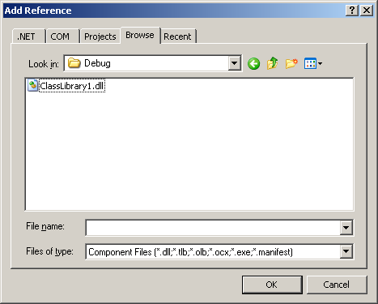

Figure 14.3

Step 5: Using the Class from an Application
Add the code in Figure 14.2 to your project. Now that you have added a reference to your class library in this application, the Square class can be used without adding the class source code file to the project.

Project 2

The first part of Project 2 will consist of adding a class to Project 1. This class will take the place of the code to write the order data to the Sequential Access File. The class will have a property to accept the name of the file and the string to be written. The class will append the string to the designated file. The class method to write the file will be a Static method.

In Part 2 you will move the class that you created in Part 1 into a class library and set a reference to it. By doing that the class will be available to other projects.

Lesson #15
Topic | Exception Handling | Points
Chapter | Chapter 9
Demo | Error Handling

Main Topics:
- Overview
- Try/Catch
- Finally

Various methods of trapping errors will be covered in this lesson.

Lesson #16
Topic | Strings | Points
Demo | String Handling

Main Topics:
- Introduction
- Comparing strings
- Locating characters and substrings
- CHAR methods
- Regular Expressions

This lesson introduces the FCL’s string and character-processing capabilities.
Lesson #17
Topics | Introduction to ADO .NET | Points
 | Lecture
Demo | Database Access

Main Topics:
- What is ADO .NET
- ADO .NET components
- Linking a database and an application
- Adding a Data Connection to an application
- Adding a Data Source to an application
- Adding database functionality to an application
- Creating a DataGridView and a Detail form
- The Connection object
A programming language connects to and interacts with a relational database via a database interface—software that facilitates communication between a database management system and a program. C# programs communicate with databases and manipulate their data through ADO .NET.
What is ADO .NET?
A data store is defined as any organized collection of data and a database is defined as a data store whose contents can be systematically and easily accessed, managed, and updated. ADO .NET is a data access API capable of accessing Microsoft SQL Server databases as well as any other kind of data store that implements OLE DB. Such data stores include simple text files, electronic spreadsheets, Microsoft Access databases, or other types of databases. OLE DB (Object Linking and Embedding for Databases) is a Microsoft technology for interfacing with data stores. It comes under the umbrella of the Component Object Model (COM), a Microsoft technology for intersoftware communication using objects. In addition to accessing data in data stores, ADO .NET is also capable of accessing data in XML format. XML is a simple, widely used, human-readable, text-based format for storing data using customized tags similar to those found in Web pages.

ADO .NET does not require that the application be continuously connected to a database during program execution. Such a continuous connection prevents other applications from accessing the database. Instead, ADO .NET allows the application to quickly download the required data from a central database to the individual user’s computer and then close the data connection, thus allowing many other users to access the same database in a similar way. ADO .NET provides many different methods to store modified data back to the central database, thus assuring the integrity in the database.

For an application to interact with a database, a data access API (such as ADO .NET) must effectively bridge the gap between the two.

Database and Application
A database is usually created using a relational database management system (RDBMS), such as SQL Server, Oracle, DB2, or Access. This database can reside on a separate computer (a database server) or on the user’s computer. The usual situation in the real world is that many users, using many different computers, access one or more database servers via a network. In any case, the principles of database access remain the same. The application could be a Windows application written in a .NET language, or a Web application written using ASP .NET. The objective is to get the data from the database to the application so the user can view and possibly make changes to the data. Then the application needs the ability to send the updated data back to the database.

ADO .NET is the software that bridges the gap between database and application. ADO .NET consists of two major parts, the data provider and the dataset. A data provider is a set of classes that provides the link between the dataset and the database. The data provider works directly with the database to extract data requested by the application for the dataset. A dataset is a separate memory resident representation of only that part of the database, which an application needs. An application may need only a small part of a very large database or it may need the entire database. If the application updates the data in the dataset, the data provider writes the dataset back to the database.

The data provider normally makes a connection with a database, quickly gets the required data for the dataset, and then disconnects from the database. Then the user can view the data and make any necessary changes. Finally, the user can save the updated data back to the database by connecting, immediately transferring the data, and then disconnecting. There are two major advantages of using a separate, disconnected dataset instead of remaining connected to the database for a longer period of time: (1) a smaller dataset stored on the user’s computer provides the application with faster access to data and (2) the database, when disconnected from the user’s computer, is available to other users.

ADO .NET Components
The two major parts of ADO .NET will be expanded to reveal their components. The dataset will be examined first.

The DataSet object contains a DataTableCollection object. This represents a collection of all the individual DataTable objects that the application needs. A DataTable object in the DataSet corresponds to a table in the database. Each DataTable object has a DataColumnCollection object (the collection of all DataColumn objects in a DataTable), a DataRowCollection object (the collection of DataRow objects), and a ConstraintCollection object (the collection of all primary key and foreign key constraints for the DataTable objects). DataColumn objects define a column’s data type, whether or not null values are allowed, whether the column is read-only or read-write, and so on. DataRow objects contain the data for DataTable rows and control how to retrieve, insert, delete, and update values in these rows. The DataRelationCollection object contains relationship information between two tables. This occurs when two tables contain columns that hold identical data, such as primary key/foreign key relationships.

The other major component of ADO .NET is the data provider. ADO .NET includes data providers for SQL Server, Oracle, and any other database the implements the OLE DB or ODBC standards.

Here is a list of the specific classes in the SQL Server Data Provider.
- SqlCommand—represents an SQL statement or stored procedure to execute against a database; it may contain parameters or variables
- SqlConnection—represents an open connection to the database, including database location and logon information
- SqlDataAdapter—uses SqlCommand and its properties (SelectCommand, InsertCommand, …) to fill a dataset or update a SQL Server database
- SqlReader—uses SqlCommand for more rapid forward-only, read-only retrieval of data from a database to the dataset

The data provider is used to fill the dataset with data from the database and to update the database with new information from the application. The SqlDataAdapter has four properties that are used to execute the most common types of commands on a database:
- SelectCommand
- InsertCommand
- UpdateCommand
- DeleteCommand

The SqlCommand object is also used for any other kind of SQL command or stored procedure.

Linking a Database and an Application
In this section you will learn how to use C# 2005 to link a SQL Server database to a Visual C# application. Figure 17.1 shows the Visual Studio window for the ArkhamBooks application with an empty form.

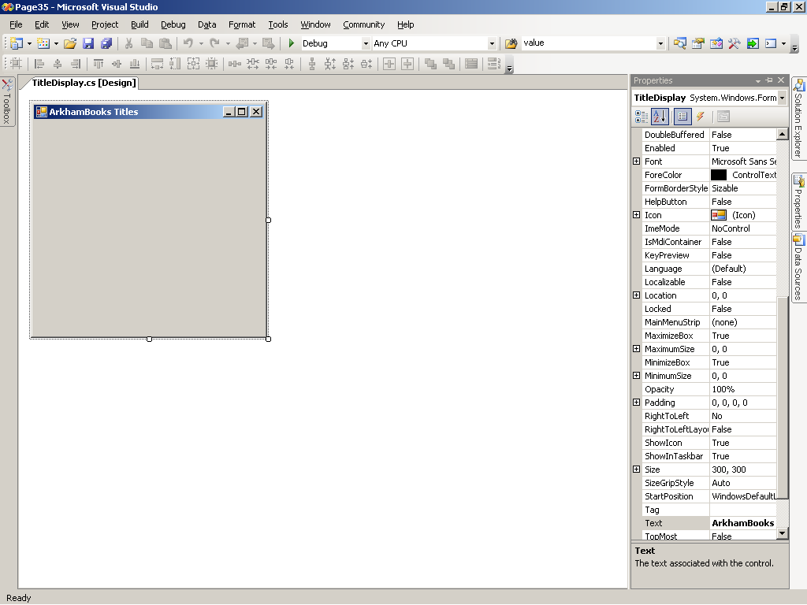

Figure 17.1

The form in Figure 17.1 will be used to display records of the Title table in the ArkhamBooks database. Figure 17.2 shows the structure of the Title table as viewed in SQL Server. The process of creating a Visual C# application that uses a database involves four basic steps:

- Adding a data connection to the application
- Adding a data source (dataset) to the application
- Adding controls to a form to display the dataset
- Adding controls to execute queries (select, add, delete, and update) on the dataset

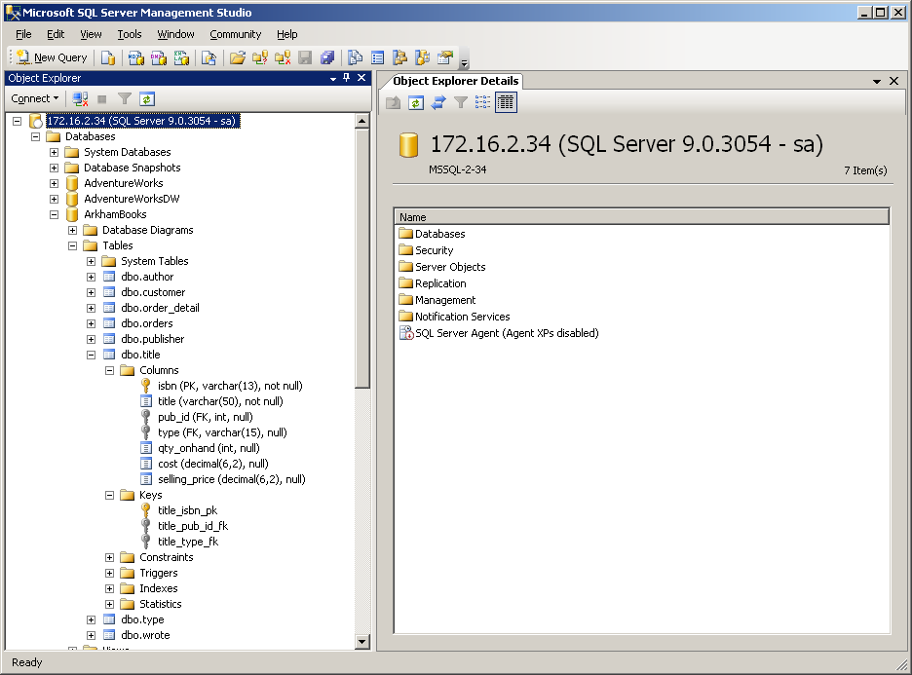

Figure 17.2

Adding a Data Connection to an Application
- Create a Visual C# application with an empty form as shown in Figure 17.1.
- To display the Server Explorer window in Visual Studio, click View in the menu and then click Server Explorer.
- Right-click the Data Connection icon in the Server Explorer and click Add Connection. The Add Connection dialog box appears, as shown in Figure 17.3

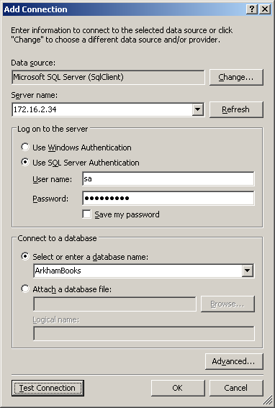

Figure 17.3

- If the Data Source is not Microsoft SQL Server as shown in Figure 17.3. Click the Change button and the Change Data Source dialog will appear as shown in Figure 17.4. Select Microsoft SQL Server as shown and click OK.
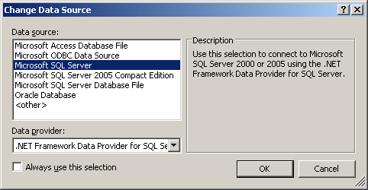

Figure 17.4

Your instructor will give the correct information to fill in the Server Name, how to Log on to the server, and the Database to use (in this case ArkhamBooks).

- In the Add Connection dialog box, click Test Connection. If all settings are correct, you will see the Microsoft Visual Studio dialog box shown in Figure 17.5; if not an error message will be displayed and you will need to check your settings with your instructor.

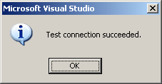

Figure 17.5

- If the connection test is successful, click OK in the connection test result dialog box and click OK in the Add Connection dialog box. The Server Explorer will show your new connection as shown in Figure 17.6.
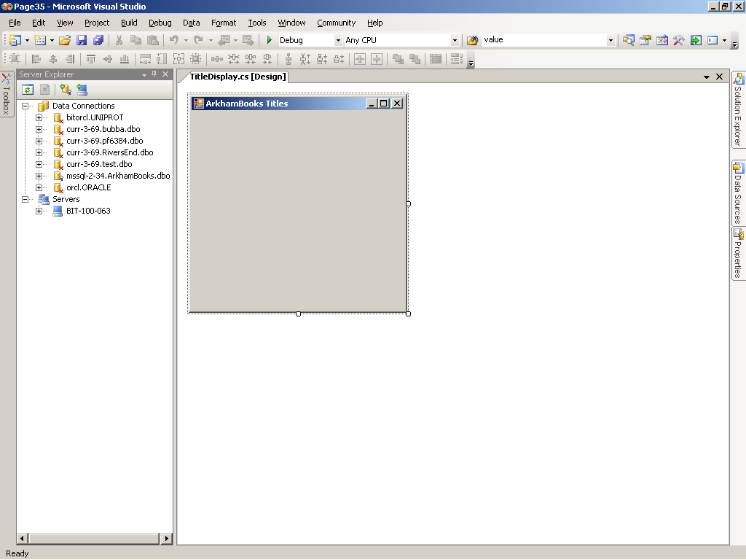

Figure 17.6
Add a Data Source to an Application
- Begin with an application that has a data connection. In the Visual Studio menu, click Data and then click Show Data Sources. The Data Sources window appears.
- The Data Sources window will tell you that you project does not have a data source associated with it. Click Add New Data Source… The Data Source Configuration Wizard opens. The first page of the wizard, the Choose a Data Source Type page, is shown in Figure 17.7.

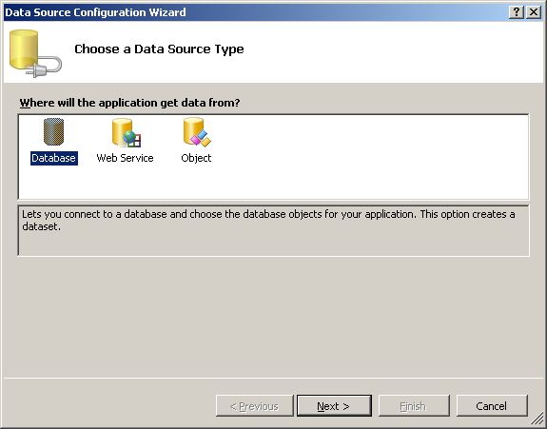

Figure 17.7

- In the Choose a Data Source Type page, click the Database option and then click Next. The Choose Your Data Connection page opens.
- Select the desired data connection. Select Yes, include sensitive data in the connection string. Click Next.
- Click Next to save your connection string. The Choose Your Database Objects page opens, as shown in Figure 17.8.
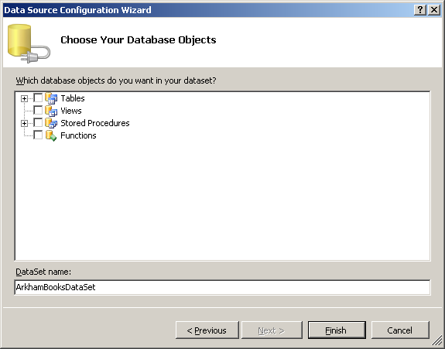

Figure 17.8

- In the Choose Your Database Objects page, a list of database objects with check boxes (Tables, Views, Stored Procedures, and Functions) is presented for possible inclusion in the newly created DataSet object. Click the + next to each type of object to expand the list. Check only those objects required for your application Click the + to the left of Tables. Click the check box to the left of the Title table. Click Finish.

Figure 17.9 shows the results of adding the ArkhamBooks Title table to your project.

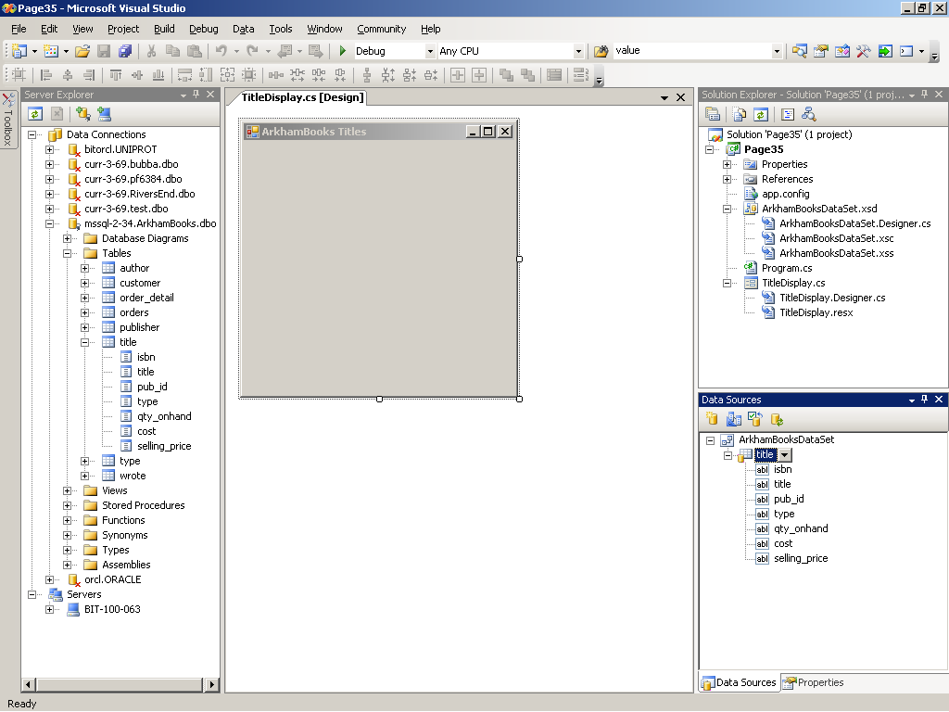

Figure 17.9

The Server Explorer exposes the complete ArkhamBooks database. The Data Sources window shows the ArkhamBooksDataSet, which contains only the Title table (all columns are included). The Solution Explorer shows two new files: app.config (the application configuration file, written in XML format, which contains the connection string) and ArkhamBooksDataSet.xsd (the XML schema definition, which defines the database objects contained in the dataset).

A little more should be said about the file ArkhamBooksDataSet.xsd. This is an XML file that represents the ArkhamBooks application’s DataSet object, called ArkhamBooksDataSet. Double-clicking this file graphically displays the entire DataSet for this application as shown in Figure 17.10. Only one table (Title) is currently part of the DataSet. The top section of the DataSet graphic represents the Title DataTable object. The bottom section represents the titleTableAdapter object. This is similar to the more general DataAdapter object. A TableAdapter object contains a Connection object and has the properties DeleteCommand, InsertCommand, SelectCommand, and UpdateCommand, as shown in Figure 17.10. Also note in the graphic that two methods are shown, Fill and GetData. The Fill method is used by the TableAdapter to get data from a database to fill an existing DataTable, while the GetData method is used to get data and fill a new DataTable in the DataSet. Recall that the DataSet object is a memory resident cache of data obtained from the database just for this application. When the application runs, it immediately makes a connection with the ArkhamBooks database, gets the data from the Title table, and closes the connections so other applications can then connect to the database.

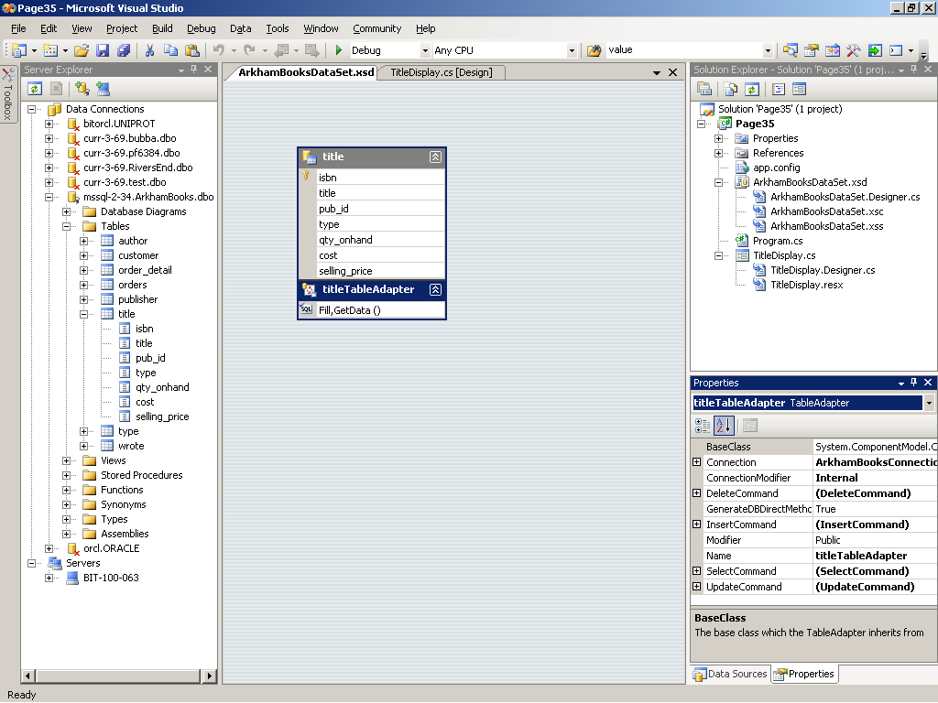

Figure 17.10

Adding Database Functionality to an Application
An application with only a data connection and a data source is far from complete. It needs controls, such as labels, text fields, and buttons, to perform operations using the database. The next section uses a DataGridView to work with the database.

A DataGridView control in a form displays the rows and columns of a table or query in a familiar grid format. The next section explains how to add a DataGridView to a form.

- With an empty form displayed in the Windows Form Designer, make sure that the Data Sources window is open. (Click Data and click Show Data Sources in the menu to open the Data Sources window). Drag a table from the Data Sources window to the form. A DataGridView control appears on the screen.
- To make the DataGridView fill the form, click the DataGridView so that its properties appear in the Properties window. In the Properties window, scroll to the Dock property and click the value of the Dock property, and select the center section of the graphic to select the value Fill.
- Adjust the size of the form as necessary.
- To add or remove columns in the DataGridView and make changes to the properties of individual columns, such as HeaderText, ReadOnly, Resizeable, and Width, right-click on the DataGridView and click Edit Columns. Make the desired changes and Click OK.

From the Data Sources window drag the Title table to the form. The results will be similar to Figure 17.11.

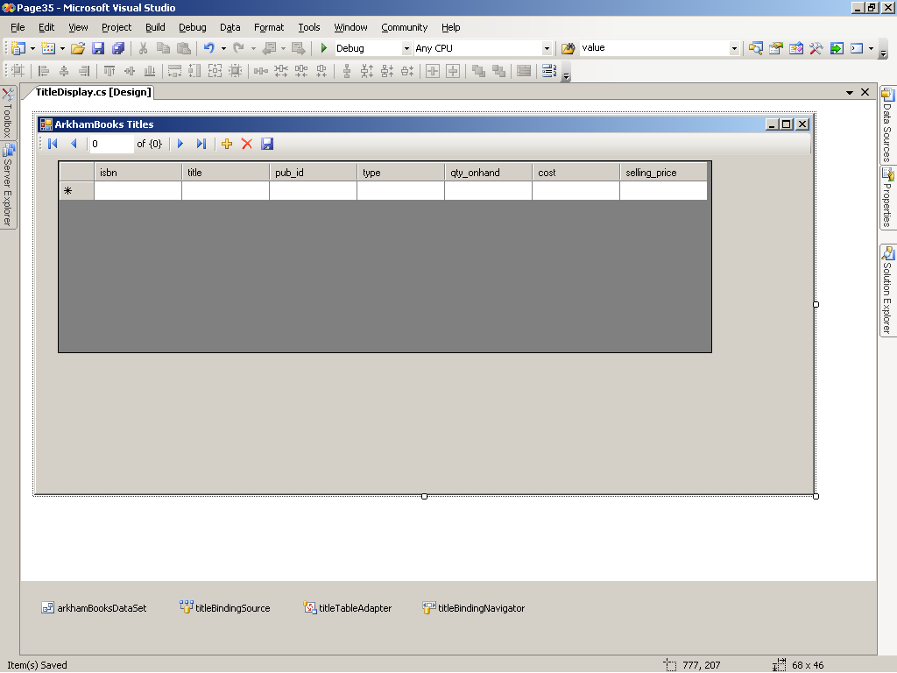

Figure 17.11

The component tray contains four objects:
- The arkhamBooksDataSet is the DataSet object for the ArkhamBooks database
- The titleTableAdapter is the link between the DataSet and the Database
- The titleBindingSource binds or links the form component titleDataGridView to a DataTable (Title) in a DataSet (ArkhamBooksDataSet), thus allowing the form component to display data. A BindingSource also handles concurrency management, a database management process for maintaining data consistency when two or more users access the same data simultaneously.
- The titleBindingNavigator object is responsible for navigating and manipulating the data in a DataGridView object. A BindingNavigator object is associated with the ToolStrip buttons shown at the top of the DataGridView. A BindingNavigator allows you to move from row to row, add new rows, delete existing rows, and save changes in data to the database.

Run the application and the results should be similar to Figure 17.12.

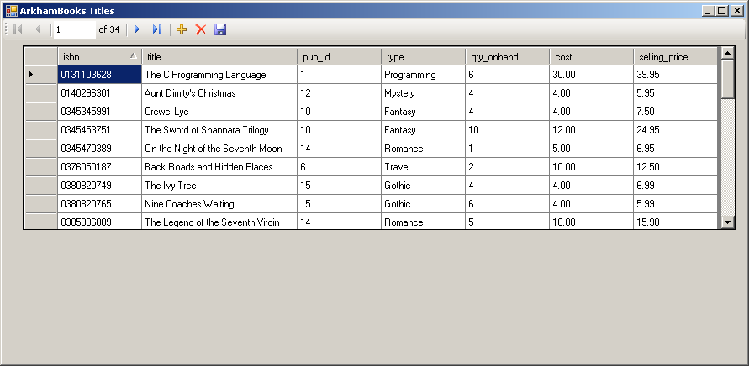

Figure 17.12

Some formatting has been done to the DataGridView. Yours may look different.

Creating a Detail Form
As an alternative to a DataGridView, you can drag a data source to a form to automatically create controls that display one record at a time. You can even pre-select the type of control used for displaying data. This procedure is detailed next:

- With an empty form displayed in the Windows Form Designer, make sure that the Data Sources window is open. Add a new data source for the Title table of the ArkhamBooks database.
- Click the Title table in the Data Sources window. A drop-down arrow appears to the right of the table name.
- Click the drop-down arrow and then click Details in the list.
- Click the + sign to the left of the Title table to expand it into its fields. By default, a TextField icon is displayed to the left of each field.
- Click on the isbn field to display a drop-down arrow for that field. Click the drop-down arrow to display a list of alternative control types. Click the label control type.
- Drag the Title table to the form. Labels and other controls are automatically added to the form, including DataSet, BindingSource, TableAdapter, and BindingNavigator controls in the component tray.

Figure 17.13 shows the results of the previous steps before the Title table has been dragged to the form.
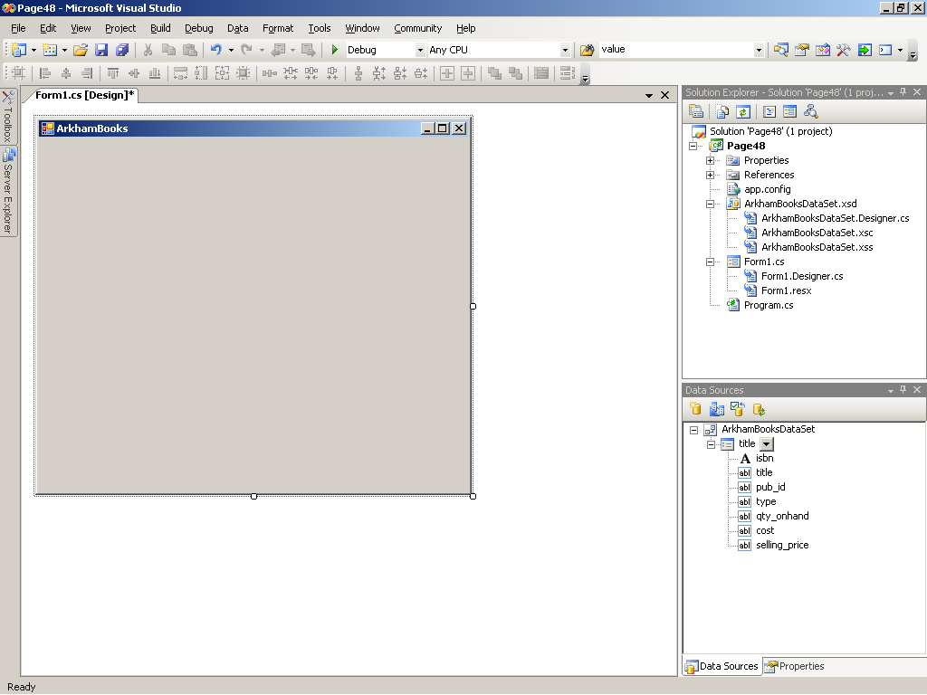

Figure 17.13

Figure 17.14 shows a sample run of this application. Note that the first field has been changed to a label. This prevents the isbn from being changed.
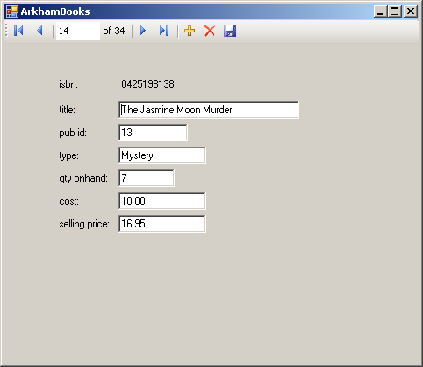

Figure 17.14
Lesson #18
Topics | The Connection Object | Points
 | Lecture
Projects 3 and 4 | The ArkhamBooks Order Application | 25

Main Topics:
- The Data Provider
- The Connection Object
- Working with Multiple Forms

The Connection Object
Using SqlConnection

The following code example opens and checks a connection:

using System;
using System.Data;
using System.Data.SqlClient;

namespace Connection1
{
class ConnectionSql
{
static void Main( )
{
// Connection string
string connString = @”
server = ???; user id = ??; password = ??? database = ???”;

// Create connection
SqlConnection conn = new SqlConnection(connString);

try
{
// Open connection
conn.Open();
Console.WriteLine(“Connection opened”);
}
catch (SqlException e)
{
// Display error
Console.WriteLine(“Error: “ + e);
}
finally
{
// Close connection
conn.Close( );
Console.WriteLine(“Connection closed”);
}
}
}
}
Displaying Connection Information
The following application displays connection information:

using System;
using System.Data;
using System.Data.SqlClient;

namespace Connection1
{
class ConnectionSql
{
static void Main()
{
// Connection string
string connString = @"
server = ???; user id = ??; password = ???; database = ??";

// Create connection
SqlConnection conn = new SqlConnection(connString);

try
{
// Open connection
conn.Open();
Console.WriteLine("Connection opened");

// Display connection properties
Console.WriteLine("Connection Properties:");

Console.WriteLine("\tConnection String: {0}", conn.ConnectionString);

Console.WriteLine("\tDatabase: {0}", conn.Database);

Console.WriteLine("\tDataSource: {0}", conn.DataSource);

Console.WriteLine("\tServerVersion: {0}", conn.ServerVersion);

Console.WriteLine("\tState: {0}", conn.State);

Console.WriteLine("\tWorkstationId: {0}", conn.WorkstationId);
}
catch (SqlException e)
{
// Display error
Console.WriteLine("Error: " + e);
}
finally
{
// Close connection
conn.Close();
Console.WriteLine("Connection closed");
}
}
}
}

Projects 3 & 4
Project 3 consists of an Order Application for River’s End Books. The project will use C# .NET and ADO .NET to connect to a SQL Server database.

Project 3 is the beginning of an application that will consist of two forms. The first form (Project 3), which will manage the customer data, will use parameterized queries to update the database.

The second form (Project 4), which will display the items that the user wants to order and other order data, will use SQL Server Stored Procedures to manage changes to the database.

Figure 18-1 is a sample layout of the first form, which will allow the user to select a customer, add a new customer, and edit existing customer data. This form will also create the Order record. This will be done by the Continue button, which will also switch to the second form.
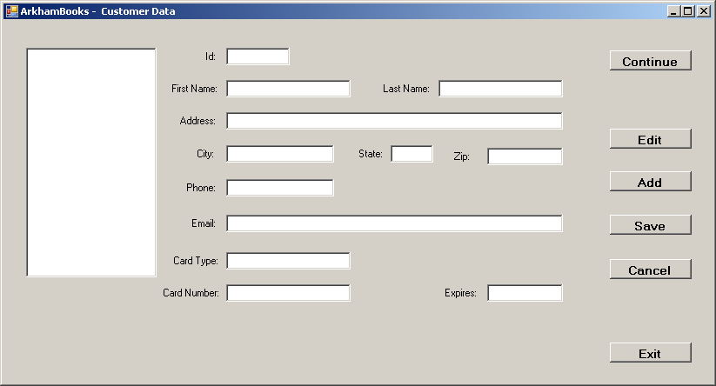

Figure 18-1

The Continue button will create the Order record when it displays the second form. You will create a stored procedure named sp_CreateOrder to accomplish this. In the event handler for the Continue button you will also move the Customer name to the second form. The following section will demonstrate the procedures for moving between forms and passing data from one form to another. The second form will use Stored Procedures to handle all the major tasks. This method is very efficient as it allows the processing of the application to be shared between C# .NET and the Sql Server database. You will create Stored Procedures to provide functionality for the following buttons:

- Add Title
- Update Quantity
- Delete Title
- Cancel Order

Figure 18-2 is a sample layout for the second form

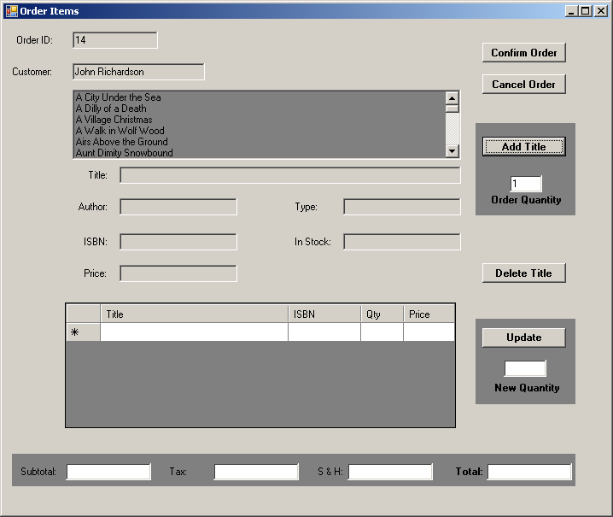

Figure 18-2
The List Box at the top of the form will display the book title. When the user selects a book the rest of the data for that book will be displayed in the text boxes. When you create the DataAdapters on this form (one for the List Box to display titles, and one for the DataGridView that will display the order summary) C# .NET will only be able to create the SELECT command and the Table Mapping. Don’t worry, we are only going to use the data from the DataAdapters as input to the Stored Procedures, which are going to do all the work.
Working with Multiple Forms
This section will show you how to work with multiple forms. The example will display a form and let the user enter some data into a text box and click a button to display the text in a label control. The user can then click another button to hide the form and display another. The second form will display and the user can click a button to return to the same instance of the first form.

We will need a variable that points to the specific instance of Form1 that we want to display. One way to do this is to use a public, static variable to hold the reference to the instance. The difference between static and instance class members, such as variables, is that static members do not have to be instantiated.

Figure 18.3 shows Form1.

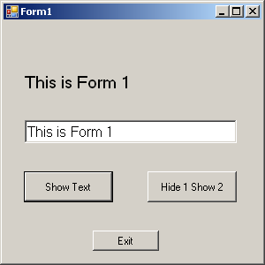

Figure 18.3

Figure 18.4 shows Form2:

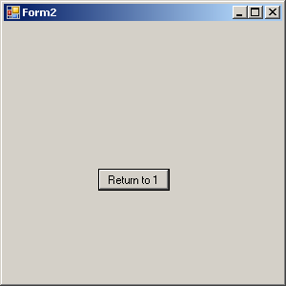

Figure 18.4

The listing below is the Form1 class declaration. The variable is named form1Var.

using System;
using System.Collections.Generic;
using System.ComponentModel;
using System.Data;
using System.Drawing;
using System.Text;
using System.Windows.Forms;

namespace MultiForms3
{
public partial class Form1 : Form
{
public static Form1 form1Var = null;
public Form1()
{
InitializeComponent();
}

private void button1_Click(object sender, EventArgs e)
{
label1.Text = textBox1.Text;
}

private void button3_Click(object sender, EventArgs e)
{
this.Close();
}

private void button2_Click(object sender, EventArgs e)
{
form1Var = this;
this.Hide();
Form2 form2 = new Form2();
form2.Show();
}
}
}

By the way, there is no reason to place this variable in the Form1 module—as long as it is public and static, you can put wherever you like. If you have multiple public, static variables, it may be a good idea to create a class in a separate class module just for them. When it’s time to display the Form2 instance, use the this keyword to store a reference to the current Form1 instance in the form1Var variable:
form1Var = this;

The click event handler for Button2 in the Form1 class declaration shows the code to display Form2.

Now it’s easy to open the desired instance of Form1 from Form2 just by using the reference stored in the Form1.form1Var variable.

The listing below shows the Form2 class declaration:

using System;
using System.Collections.Generic;
using System.ComponentModel;
using System.Data;
using System.Drawing;
using System.Text;
using System.Windows.Forms;

namespace MultiForms3
{
public partial class Form2 : Form
{
public Form2()
{
InitializeComponent();
}

private void button1_Click(object sender, EventArgs e)
{
this.Close();
Form1.form1Var.Show();
}
}
}

Run the project again. Enter some text in the Form1 text box. Click the button to display the text in the label. Click the other button to hide Form1 and show Form2. When you click the Show 1 button on Form2, the instance of Form1 with your input will be displayed.

This method works just fine. However, extensive use of public variables violates the rules of good programming practice. A better solution is to store the form instance reference as a property of one of the classes.

We will add a property to the Form2 class that stores a reference to an instance of a Form class. (Note that the property uses the more general Form class rather than the specific Form1, so a reference to an instance of any Form class can be stored in the property, not just a Form1 instance.)

Here is the property added to the Form2 class module (it can go anywhere in the body of the class):

private Form instanceRef = null;
public Form InstanceRef
{
get
{
return instanceRef;
}
set
{
instanceRef = value;
}
}

The click event handler in Form1 that invokes Form2 needs to be modified to use the property rather than the public variable. We will assign a reference to this to the property:

private void button2_Click(object sender, EventArgs e)
{
this.Hide();
Form2 form2 = new Form2();
form2.InstanceRef = this;
form2.Show();
}

Finally, the property is used in Form2 to invoke the correct instance of Form1:
private void button1_Click(object sender, EventArgs e)
{
this.Close();
InstanceRef.Show();
}

Properties work well for communicating form instances between the various modules in a Windows form application and provide a more encapsulated approach than using a public, static variable.

A public propery can also be used to pass any data on Form1 that you wish to have available on Form2. This property could be made read-only if necessary.

Lesson #19
Topic | The Command Object | Points
Demo | Database Topics
Instruction Materials:
Main Topics:
- The Command Object
    - Creating commands
    - Associating commands with connections
    - Using connection methods that apply to commands
    - Using command properties and methods
    - Setting command text
    - Executing commands
    - Processing command results
    - Using command parameters

You can create a command either using the SqlCommand constructor or using methods that create the object for you. Let’s look at the first of these alternatives.

In this example, you will create a SqlCommand object. Your Instructor will give you the IP address for the Microsoft SQLServer.

using System;
using System.Data;
using System.Data.SqlClient;

namespace Command1
{
class CommandSql
{
static void Main()
{
// Connection string
string connString = @"
server = ???; user id = ??; password = ???; database = ???";

// Create connection
SqlConnection conn = new SqlConnection(connString);

// Create command
SqlCommand cmd = new SqlCommand();
Console.WriteLine(“Command created”);

try
{
// Open connection
conn.Open();
Console.WriteLine(“Connection Opened”);
}

catch (SqlException ex)
{
Console.WriteLine(ex.ToString());
}
finally
{
conn.Close();
Console.WriteLine(“Connection Closed”);
}
}
}
}

For your commands to be executed against a database, each command must be associated with a connection to the database. You do this by setting the Connection property of the command, and in order to save resources, multiple commands can use the same connection.

Setting the Connection Property:
using System;
using System.Data;
using System.Data.SqlClient;

namespace Command2
{
class CommandSql
{
static void Main()
{
// Connection string
string connString = @"
server = ???; user id = ??;
password = ???; database = ???";

// Create connection
SqlConnection conn = new SqlConnection(connString);

// Create command
SqlCommand cmd = new SqlCommand();
Console.WriteLine("Command created");

try
{
// Open connection
conn.Open();
Console.WriteLine(“Connection Opened”);

// Connect command to connection
cmd.Connection = conn;
Console.WriteLine("Connected command to this connection");
}
catch (SqlException ex)
{
Console.WriteLine(ex.ToString());
}
finally
{
conn.Close();
Console.WriteLine("Connection Closed");
}
}
}
}

Assigning Text to a Command:
Every command has a property, CommandText, that holds the SQL to execute. You can assign this property directly or specify it when constructing the command.

using System;
using System.Data;
using System.Data.SqlClient;

namespace Command3
{
class CommandSql
{
static void Main()
{
// Connection string
string connString = @"
server = ???; user id = ??; password = ???; database = ???";

// Create connection
SqlConnection conn = new SqlConnection(connString);

// Create command
SqlCommand cmd = new SqlCommand();
Console.WriteLine("Command created");

try
{
// Open connection
conn.Open();
Console.WriteLine(“Connection Opened”);

// Connect command to connection
cmd.Connection = conn;
Console.WriteLine("Connected command to this connection");

// Associate SQL with command
cmd.CommandText = "SELECT COUNT(*) FROM title";
Console.WriteLine("Ready to execute SQL: {0}",
cmd.CommandText);
}
catch (SqlException ex)
{
Console.WriteLine(ex.ToString());
}
finally
{
conn.Close();
Console.WriteLine("Connection Closed");
}
}
}
}

You must set both the connection and the CommandText properties of a command before the command can be executed.

You can set the Connection and the CommandText properties when you create the command with another variation of its constructor, as shown below:

// Create command with both text and connection
string sql = @”SELECT COUNT(*) FROM title”;

SqlCommand cmd = new SqlCommand(sql, thisConnection);

Executing Commands:
Commands aren’t much use unless you can execute them. Commands have several different methods for executing SQL. The differences between these methods depend on the results you expect from the SQL. Queries return rows of data (result sets), but statements don’t. You determine which method to use by considering what you expect to be returned. The SQL you just used in the example should return one value, the number of titles. You should use the ExecuteScalar method of SqlCommand to return this one result.

using System;
using System.Data;
using System.Data.SqlClient;

namespace Command4
{
class CommandSql
{
static void Main()
{
// Define connection string
string connString = @"
server = ???; user id = ??; password = ???; database = ???";

// Create connection
SqlConnection conn = new SqlConnection(connString);

// Create query string
string sql = "SELECT COUNT(*) FROM title";

// Create command with connection
SqlCommand cmd = new SqlCommand(sql, conn);
Console.WriteLine("Command created with connection");

try
{
// Open connection
conn.Open();

// Execute query
Console.WriteLine("Number of Titles is {0}",
cmd.ExecuteScalar());

}
catch (SqlException ex)
{
Console.WriteLine(ex.ToString());
}
finally
{
conn.Close();
Console.WriteLine("Connection Closed");
}
}
}
}

ExecuteScalar( ) takes the CommandText property and sends it to the database using the command’s Connection property. It returns the result, 34, as a single object, which you display with Console.WriteLine( ).

This is pretty simple to follow, but it is worth noting this really is simpler than usual because Console.WriteLine( ) takes any kind of object as its input. In fact, ExecuteScalar( )’s return type is object, the base class of all types in the .NET Framework, which makes perfect sense when you remember that a database can hold any type of data. So, if you want to assign the returned object to a variable of a specific type (int, for example), you must cast the object to the specific type. If the types are not compatible, the system will generate a runtime error that indicates an invalid cast. The following is an example that demonstrates this idea. In it, you store the result from ExecuteScalar( ) in the variable count, casting it to the specific type int:

int count = (int) cmd.ExecuteScalar( );
Console.WriteLine(“Number of Emoloyees is: {0}”, count);

If you are sure the type of result will always be an int (a safe bet with COUNT(*), then the previous code is safe. However if you left the cast in place and changed the CommandText of the command to

SELECT type
from title
where title = ‘Snowfire’

then ExecuteScalar( ) would return the string “Romance” instead of an integer, and you would get this exception

Unhandled Exception: System.InvalidCastException: Specified cast is not valid.

Another problem may occur if a query actually returns multiple rows where you thought it would return only one. ExecuteScalar just returns the first row of the result and ignores the rest.

Executing Commands with Multiple Results
For queries when you are expecting multiple rows and columns to be returned, use the command’s ExecuteReader( ) method.

ExecuteReader( ) returns a data reader, an instance of the SqlDataReader class. Data readers have methods that allow you to read successive rows in the result set and retrieve individual column values.

We will give a brief example here of using the ExecuteReader( ) method to create a SqlDataReader from a command to display query results.

using System;
using System.Data;
using System.Data.SqlClient;

namespace Command4
{
class CommandSql
{
static void Main()
{
// Connection string
string connString = @"
server = ???; user id = ??; password = ???; database = ???";

// Create connection
SqlConnection conn = new SqlConnection(connString);

// Create query string
string sql = "SELECT title, type FROM title";

// Create command with connection
SqlCommand cmd = new SqlCommand(sql, conn);
Console.WriteLine("Command created with connection");

try
{
// Open connection
conn.Open();

// Execute query
SqlDataReader rdr = cmd.ExecuteReader();

while (rdr.Read())
{
Console.WriteLine("Title and type: {0} - {1}",
rdr.GetValue(0), rdr.GetValue(1));
}

}
catch (SqlException ex)
{
Console.WriteLine(ex.ToString());
}
finally
{
conn.Close();
Console.WriteLine("Connection Closed");
}
}
}
}

In this example, you use the ExecuteReader method to retrieve and then output the title and type of all the books in the title table. As with ExecuteScalar( ), ExecuteReader( ) takes the CommandText property and sends it to the database.

When you use the ExecuteScalar method, you produce only a single scalar value. In contrast, using ExecuteReader( ) returns a SqlDataReader object.

The SqlDataReader object has a Read method that gets each row in turn and a GetValue method that gets the value of a column in the row. The particular column whose value it retrives is given by the integer parameter indicating the index of the column. Note that GetValue( ) uses a zero-based index.

Executing Statements
The ExecuteNonQuery method of the command executes SQL statements instead of queries.

For example:

using System;
using System.Data;
using System.Data.SqlClient;

namespace Command4
{
class CommandSql
{
static void Main()
{
// Connection string
string connString = @"
server = ???; user id = ??; password = ???; database = ???";

// Create connection
SqlConnection conn = new SqlConnection(connString);

// Define query string
string sqlqry = "SELECT COUNT(*) FROM author";

// Define insert statment
string sqlins = @"INSERT INTO author(last_name, first_name)
VALUES('Frost', 'Robert')";

// Define delete statement
string sqldel = @"DELETE FROM author WHERE first_name = 'Robert' and last_name = 'Frost'";

// Create commands with connections
SqlCommand cmdqry = new SqlCommand(sqlqry, conn);
SqlCommand cmdnon = new SqlCommand(sqlins, conn);

Console.WriteLine("Commands created with connections");

try
{
// Open connection
conn.Open();

// Execute query to get number of authors
Console.WriteLine("Before INSERT: Number of authors {0}\n",
cmdqry.ExecuteScalar());

// Execute nonquery (statement) to insert an author
Console.WriteLine("Executing statement {0}",
cmdnon.CommandText);

cmdnon.ExecuteNonQuery();

Console.WriteLine("After INSERT: Number of authors {0}\n",
cmdqry.ExecuteScalar());

// Execute nonquery (statement) to delete an author
cmdnon.CommandText = sqldel;

Console.WriteLine("Executing statement {0}",
cmdnon.CommandText);

cmdnon.ExecuteNonQuery();

Console.WriteLine("After DELETE: Number of authors {0}\n",
cmdqry.ExecuteScalar());

}
catch (SqlException ex)
{
Console.WriteLine(ex.ToString());
}
finally
{
conn.Close();
Console.WriteLine("Connection Closed");
}
}
}
}

Note the both cmdqry and cmdnon are SqlCommand objects. The difference between submitting queries and statements is the method you use to submit them.

Command Parameters
In the last example, you hard-coded the values for the INSERT statement. Although this is perfectly valid SQL, its something you almost never want (or need) to do. You need to be able to store whatever values are appropriate at any given time.

A command parameter is a placeholder in the command text where a value will be substituted. In SQL Server, named parameters are used. They begin with @ followed by the parameter with no intervening space. In the following INSERT statement, @MyName and @MyNumber are both parameters:
INSERT INTO MyTable VALUES (@MyName, @MyNumber)

Command parameters have several advantages:
- The mapping between the variables and where they are being used in SQL is clearer
- Parameters let you use the type definitions that are specific to a particular ADO .NET data provider to ensure that your variables are mapped to the correct SQL data types
- Parameters are used extensively in other programming techniques, such as stored procedures

using System;
using System.Data;
using System.Data.SqlClient;

namespace Command4
{
class CommandSql
{
static void Main()
{
// Set up data
string fname = "Robert";
string lname = "Frost";

// Connection string
string connString = @"
server = ???; user id = ??; password = ???; database = ???";

// Create connection
SqlConnection conn = new SqlConnection(connString);

// Define query string
string sqlqry = "SELECT COUNT(*) FROM author";

// Define insert statment
string sqlins = @"INSERT INTO author(last_name, first_name)
VALUES(@lname, @fname)";

// Define delete statement
string sqldel = @"DELETE FROM author
WHERE first_name = @fname AND last_name = @lname";

// Create commands with connections
SqlCommand cmdqry = new SqlCommand(sqlqry, conn);
SqlCommand cmdnon = new SqlCommand(sqlins, conn);

Console.WriteLine("Commands created with connections");

// Add parameters to the command
cmdnon.Parameters.Add("@fname", SqlDbType.VarChar, 15);
cmdnon.Parameters.Add("@lname", SqlDbType.VarChar, 20);

try
{
// Open connection
conn.Open();

// Execute query to get number of authors
Console.WriteLine("Before INSERT: Number of authors {0}\n",
cmdqry.ExecuteScalar());

// Execute nonquery (statement) to insert an author
cmdnon.Parameters["@fname"].Value = fname;
cmdnon.Parameters["@lname"].Value = lname;

Console.WriteLine("Executing statement {0}",
cmdnon.CommandText);

cmdnon.ExecuteNonQuery();

Console.WriteLine("After INSERT: Number of authors {0}\n",
cmdqry.ExecuteScalar());

// Execute nonquery (statement) to delete an author
cmdnon.CommandText = sqldel;

Console.WriteLine("Executing statement {0}",
cmdnon.CommandText);

cmdnon.ExecuteNonQuery();

Console.WriteLine("After DELETE: Number of authors {0}\n",
cmdqry.ExecuteScalar());
}
catch (SqlException ex)
{
Console.WriteLine(ex.ToString());
}
finally
{
conn.Close();
Console.WriteLine("Connection Closed");
}
}
}
}

Notice that when you display the SQL in CommandText, you see the parameter names rather than their values. Values are substituted for parameters when the SQL is submitted to the database server, not when the values are assigned to the members of the Parameters collection.
Lesson #20
Topics | Data Readers | Points
 | Lecture

Main Topics:
- Data Readers
- Ordinal Indexers
- Column Name Indexers
- Typed Accessor Methods
- Data about data
- Data about tables

Data Readers
The third component of a data provider, in addition to connections and commands, is the data reader. Once you have connected to a database and queried it, you need some way to access the result set. This is where the data reader comes in.

A data reader is a fast unbuffered, forward-only, read-only connected stream that retrieves data on a per-row basis. It reads one row at a time as it loops through a result set. You can’t instantiate a data reader directly; instead, you create one with the ExecuteReader method of a command. For example, assuming cmd is a SqlClient command object for a query, the following will create a data reader:

SqlDataReader rdr = cmd.ExecuteReader();

The first example is the most basic; it simply uses a data reader to loop through a result set.

using System;
using System.Data;
using System.Data.SqlClient;

namespace Command4
{
class CommandSql
{
static void Main()
{

// Connection string
string connString = @"
server = ???; user id = ??; password = ???; database = ???";

// Create connection
SqlConnection conn = new SqlConnection(connString);

// Define query string
string sql = "SELECT contact FROM publisher";

// Create command with connection
SqlCommand cmd = new SqlCommand(sql, conn);

Console.WriteLine("Commands created with connections");

try
{
// Open connection
conn.Open();

// Create data reader
SqlDataReader rdr = cmd.ExecuteReader();

// Loop through result set
while (rdr.Read())
{
// Print one row at a time
Console.WriteLine("{0}", rdr[0]);

}
rdr.Close();
}

catch (SqlException ex)
{
Console.WriteLine(ex.ToString());
}
finally
{
conn.Close();
Console.WriteLine("Connection Closed");
}
}
}
}

Using Ordinal Indexers
You use an ordinal indexer to retrieve column data from the result set. The code

rdr[0]

is a reference to the data reader’s Item property, and returns the value in the column specified for the current row. The value is returned as an object.

using System;
using System.Data;
using System.Data.SqlClient;

namespace Command4
{
class CommandSql
{
static void Main()
{

// Connection string
string connString = @"
server = ???; user id = ??; password = ???; database = ???";

// Create connection
SqlConnection conn = new SqlConnection(connString);

// Define query string
string sql = "select title, type from title";

// Create command with connection
SqlCommand cmd = new SqlCommand(sql, conn);

Console.WriteLine("Commands created with connections");

try
{
// Open connection
conn.Open();

// Create data reader
SqlDataReader rdr = cmd.ExecuteReader();

// Print headings
Console.WriteLine("{0} {1}",
"Title".PadRight(45), "Type".PadRight(15));

Console.WriteLine("{0} {1}",
"====================================".PadRight(45), "================".PadRight(15));

// Loop through result set
while (rdr.Read())
{
// Print one row at a time
Console.WriteLine("{0} {1}", rdr[0].ToString().PadRight(45), rdr[1].ToString().PadRight(15));

}
rdr.Close();
}

catch (SqlException ex)
{
Console.WriteLine(ex.ToString());
}
finally
{
conn.Close();
Console.WriteLine("Connection Closed");
}
}
}
}

Using Column Name Indexers
Most of the time we don’t really keep track of column numbers and instead prefer retrieving values by their column names, simply because it’s much easier to remember them by their names, which also makes the code more self-documenting.

You use column name indexing by specifying column names instead of ordinal index numbers. This has its advantages. For example, a table may be changed by the addition or deletion of one or more columns, upsetting column ordering and raising exceptions in older code that uses ordinal indexers. Using column name indexers avoids this issue, but ordinal indexers are faster, since they directly reference columns rather than looking them up by name. Make the following changes to the previous example and you will get the same results:

// Loop through result set
while (rdr.Read())
{
// Print one row at a time
Console.WriteLine("{0} {1}", rdr[“title”].ToString().PadRight(45),
rdr[“type”].ToString().PadRight(15));

}

The next section covers a better approach for most cases.

Using Typed Accessor Methods
When a data reader returns a value from a data source, the resulting value is retrieved and stored locally in a .NET type rather than in the original data source type. This in-place, type-conversion feature is a trade-off between consistency and speed, so to give some control over the data being retrieved, the data reader exposes typed accessor methods that you can use if you know the specific type of the value being returned.

Typed accessor methods all begin with Get, take an ordinal index for data retrieval, and are type safe; C# won’t allow you to get away with unsafe casts. These methods turn out to be faster than both the ordinal and the column name indexer methods. Being faster than column name seems only logical, as the typed accessor methods take ordinals for referencing; however, we need to explain how it’s faster than ordinal indexing. This is because even though both techniques take in a column number, the conventional ordinal indexing method needs to look up the data source type of the result and then go through a type conversion. This overhead of looking up the schema is avoided with typed accessors. .NET types and typed accessor methods are available for almost all data types supported by SQL Server.

Table 20-1 should give you an idea of when to use typed accessors and with what data type. It lists SQL Server data types, their corresponding .NET types, .NET typed accessors, and special SQL Server-specific typed accessors designed particularly for returning objects of type System.Data.SqlTypes.

SQL Server Data Type | .Net Type | .NET Typed Accessor
bigint | Int64 | GetInt64
binary | Byte[ ] | GetBytes
bit | Boolean | GetBoolean
char | String or Char[ ] | GetString or GetChars
datetime | DataTime | GetDateTime
decimal | Decimal | GetDecimal
float | Double | GetDouble
image or long varbinary | Byte[ ] | GetBytes
int | Int32 | GetInt32
money | Decimal | GetDecimal
nchar | String or Char[ ] | GetString or GetChars
ntext | String or Char[ ] | GetString or GetChars
numeric | Decimal | GetDecimal
nvarchar | String or Char[ ] | GetString or GetChars
real | Single | GetFloat
smalldatetime | DataTime | GetDateTime
smallint | Int16 | GetInt16
smallmoney | Decimal | GetDecimal
sql_variant | Object | GetValue
long varchar | String or Char[ ] | GetString or GetChars
timestamp | Byte[ ] | GetBytes
tinyint | Byte | GetByte
uniqueidentifier | Guid | GetGuid
varbinary | Byte[ ] | GetBytes
varchar | String or Char[ ] | GetString or GetChars

Table 20-1
The following example uses typed accessors:

using System;
using System.Data;
using System.Data.SqlClient;

namespace Command4
{
class CommandSql
{
static void Main()
{

// Connection string
string connString = @"
server = ???; user id = ??; password = ???; database = ???";

// Create connection
SqlConnection conn = new SqlConnection(connString);

// Define query string
string sql = @"SELECT order_id, order_date, card_type FROM orders";

try
{
// Open connection
conn.Open();

// Create command with connection
SqlCommand cmd = new SqlCommand(sql, conn);
Console.WriteLine("Commands created with connections");

// Create data reader
SqlDataReader rdr = cmd.ExecuteReader();

// Loop through result set
while (rdr.Read())
{
// Print one row at a time
Console.WriteLine("{0}\t {1}\t {2}",
rdr.GetInt32(0),
rdr.GetDateTime(1),
rdr.GetString(2));
}
rdr.Close();
}

catch (SqlException ex)
{
Console.WriteLine(ex.ToString());
}
finally
{
conn.Close();
Console.WriteLine("Connection Closed");
}
}
}
}

Getting Data About Data
So far, all you have done is retrieve data from a data source. Once you have a populated data reader in your hands, you can do a lot more. Here are a number of useful methods for retrieving schema information or retrieving information directly related to a result set. Table 20-2 describes some of the metadata methods and properties of a data reader.

Method or Property Name | Description
Depth | A property that gets the depth of nesting for the current row
FieldCount | A property that holds the number of columns in the current row
GetDataTypeName | A method that accepts an index and returns a string containing the name of the column data type
GetFieldType | A method that accepts an index and returns the .NET Framework type of the object
GetName | A method that accepts an index and returns the name of the specified column
GetOrdinal | A method that accepts a column name and returns the column index
GetSchemaTable | A method that returns column metadata
HasRows | A property that indicates of the data reader has any rows
RecordsAffected | A property that gets the number of rows changed, inserted, or deleted

Table 20-2

Let’s use some of these methods and properties:

using System;
using System.Data;
using System.Data.SqlClient;

namespace Command4
{
class CommandSql
{
static void Main()
{

// Connection string
string connString = @"
server = ???; user id = ??; password = ???; database = ???";

// Create connection
SqlConnection conn = new SqlConnection(connString);

// Define query string
string sql = @"SELECT order_id, order_date, card_type FROM orders";

try
{
// Open connection
conn.Open();

// Create command with connection
SqlCommand cmd = new SqlCommand(sql, conn);
Console.WriteLine("Commands created with connections");

// Create data reader
SqlDataReader rdr = cmd.ExecuteReader();

// Get column names
Console.Write("Column Name:".PadRight(15));
Console.WriteLine("{0} {1} {2}",
rdr.GetName(0).PadRight(10),
rdr.GetName(1).PadRight(25),
rdr.GetName(2));

// Get column data types
Console.Write("Data Type:".PadRight(15));
Console.WriteLine("{0} {1} {2}",
rdr.GetDataTypeName(0).PadRight(10),
rdr.GetDataTypeName(1).PadRight(25),
rdr.GetDataTypeName(2));

Console.WriteLine();

// Loop through result set
while (rdr.Read())
{
// Print one row at a time
Console.WriteLine("{0} {1} {2}",
rdr.GetInt32(0).ToString().PadLeft(25),
rdr.GetDateTime(1).ToString().PadRight(25),
rdr.GetString(2));
}

// Get number of columns
Console.WriteLine();
Console.WriteLine("Number of columns in a row: {0}",
rdr.FieldCount);

// Get info about each column
Console.WriteLine("'{0}' is at index {1} " +
"and its type is: {2}",
rdr.GetName(0),
rdr.GetOrdinal("order_id"),
rdr.GetFieldType(0));

Console.WriteLine("'{0}' is at index {1} " +
"and its type is: {2}",
rdr.GetName(1),
rdr.GetOrdinal("order_date"),
rdr.GetFieldType(1));

Console.WriteLine("'{0}' is at index {1} " +
"and its type is: {2}",
rdr.GetName(2),
rdr.GetOrdinal("card_type"),
rdr.GetFieldType(2));

rdr.Close();
}

catch (SqlException ex)
{
Console.WriteLine(ex.ToString());
}
finally
{
conn.Close();
Console.WriteLine("Connection Closed");
}
}
}
}

Getting Data About Tables
The term schema has several meanings in relational databases. Here, we use it to refer to the design of a data structure, particularly a database table. A table consists of rows and columns, and each column can have a different data type. The columns and their attributes make up the table’s schema.

To retrieve schema information easily, you can call the GetSchemaTable method on a data reader. As the name suggest, this method returns a System.Data.DataTable object, which is a representation of the table queried and contains a collection of rows and columns in the form of DataRow and DataColumn objects. These rows and columns are returned as collection objects by the properties Rows and Columns of the DataTable class.

However, here’s where a slight confusion usually occurs. Data column objects are not column values but rather column definitions that represent and control the behavior of individual columns. They can be looped through by using a column name indexer and can tell you a lot about the dataset.

using System;
using System.Data;
using System.Data.SqlClient;

namespace Command4
{
class CommandSql
{
static void Main()
{

// Connection string
string connString = @"
server = ???; user id = ??; password = ???; database = ???";

// Create connection
SqlConnection conn = new SqlConnection(connString);

// Define query string
string sql = "SELECT * FROM title";

try
{
// Open connection
conn.Open();

// Create command with connection
SqlCommand cmd = new SqlCommand(sql, conn);
Console.WriteLine("Commands created with connections");

// Create data reader
SqlDataReader rdr = cmd.ExecuteReader();

// Store Title schema in a data table
DataTable schema = rdr.GetSchemaTable();

// Display info from each row in the data table
foreach (DataRow row in schema.Rows)
{
foreach (DataColumn col in schema.Columns)
Console.WriteLine(col.ColumnName + " = " + row[col]);
Console.WriteLine("--------------");
}

rdr.Close();
}

catch (SqlException ex)
{
Console.WriteLine(ex.ToString());
}
finally
{
conn.Close();
Console.WriteLine("Connection Closed");
}
}
}
}

Lesson #21
Topics | Datasets and Data Adapters | Points
 | Lecture

Main Topics:
- Datasets
- Data Adapters
- Data Tables
- Data Columns
- Data Rows

Datasets and Data Adapters
In this section, you will look at a new object for accessing data—the dataset. Unlike data readers, which are objects of data provider-specific classes that implement the System.Data.IdataReader interface, datasets are objects of the class System.Data.DataSet, a distinct ADO .NET component used by all data providers. Datasets are completely independent of and can be used either connected to or disconnected from data sources. Their fundamental purpose is to provide a relational view of data stored in an in-memory cache.

If a dataset doesn’t have to be connected to a database, then how do you populate it with data and save its data back to the database? This is where data adapters come in. Think of data adapters as bridges between datasets and data sources. Without a data adapter, a dataset can’t access any kind of data source. The data adapter takes care of all connection details for the dataset, populates it with data, and updates the data source.

Datasets vs. Data Readers
If you simply want to read and display data, then you need to use only a data reader. If you want a fast sequential reader, the data reader does this job in an efficient way. If you need to manipulate the data in any way and then update the database, then you need a dataset. A data adapter fills a dataset by using a data reader.

using System;
using System.Data;
using System.Data.SqlClient;

namespace Command4
{
class CommandSql
{
static void Main()
{

// Connection string
string connString = @"
server = ???; user id = ??; password = ???; database = ???";

// Create connection
SqlConnection conn = new SqlConnection(connString);

// Define query string
string sql = "SELECT title, cost FROM title";

try
{
// Open connection
conn.Open();

// Create data adapter
SqlDataAdapter da = new SqlDataAdapter(sql, conn);

// Create dataset
DataSet ds = new DataSet();

// Fill dataset
da.Fill(ds, "title");

// Get data table
DataTable dt = ds.Tables["title"];

// Display data
foreach (DataRow row in dt.Rows)
{
foreach (DataColumn col in dt.Columns)
Console.WriteLine(row[col]);
Console.WriteLine("".PadLeft(20, '='));
}
}

catch (SqlException ex)
{
Console.WriteLine(ex.ToString());
}
finally
{
conn.Close();
Console.WriteLine("Connection Closed");
}
}
}
}

Filtering and Sorting in a Dataset
In the previous example, you saw how to extract data from a dataset. However, if you are working with datasets, then chances are that you are going to want to do more with the data than merely display it. Often, you will want to dynamically filter or sort the data.

using System;
using System.Data;
using System.Data.SqlClient;

namespace Command4
{
class CommandSql
{
static void Main()
{

// Connection string
string connString = @"
server = ???; user id = ??; password = ???; database = ???";

// Create connection
SqlConnection conn = new SqlConnection(connString);

// Define query string 1
string sql1 = "SELECT * FROM title ";

// Define query string 2
string sql2 = "SELECT * FROM customer";

// Combine queries
string sql = sql1 + sql2;

try
{

// Create data adapter
SqlDataAdapter da = new SqlDataAdapter();
da.SelectCommand = new SqlCommand(sql, conn);

// Create and Fill dataset
DataSet ds = new DataSet();
da.Fill(ds, "title");

// Get the data tables collection
DataTableCollection dtc = ds.Tables;

// Display data from the first table
//
// Display output header
Console.WriteLine("Results from Title table:");
Console.WriteLine("Title".PadRight(32) + "Type".PadRight(18) + "\n");

// Set display filter
string fl = "type = 'Mystery'";

// Set sort
string srt = "title asc";

// Display filtered and sorted data
foreach (DataRow row in dtc["title"].Select(fl, srt))
{
Console.WriteLine("{0}\t{1}",
row["title"].ToString().PadRight(30),
row["type"]);
}

// Display data from second table
//
// Display output header
Console.WriteLine("\n--------------------------");
Console.WriteLine("Results from Customer table:");
Console.WriteLine("First Name".PadRight(20) + "Last Name");

// Display data
foreach (DataRow row in dtc[1].Rows)
{
Console.WriteLine("{0}{1}",
row["first_name"].ToString().PadRight(20),
row["last_name"]);
}

}

catch (SqlException ex)
{
Console.WriteLine(ex.ToString());
}
finally
{
conn.Close();
Console.WriteLine("Connection Closed");
}
}
}
}

Modifying a Data Table in a Dataset
In the following sections, you will work through a practical example showing a number of ways to update data in data tables programmatically. Note that here you will just modify the data in the dataset but not update the data in the database. A later section will show you how to commit those changes to the database.

using System;
using System.Data;
using System.Data.SqlClient;

namespace Command4
{
class CommandSql
{
static void Main()
{

// Connection string
string connString = @"
server = ???; user id = ??; password = ???; database = ???";

// Create connection
SqlConnection conn = new SqlConnection(connString);

// Define query
string sql =
"SELECT * FROM title WHERE type = 'Modern Gaming'";

try
{

// Create data adapter
SqlDataAdapter da = new SqlDataAdapter();
da.SelectCommand = new SqlCommand(sql, conn);

// Create and Fill dataset
DataSet ds = new DataSet();
da.Fill(ds, "title");

// Get data table reference
DataTable dt = ds.Tables["title"];

// Modify cost in first row
dt.Rows[0]["cost"] = 5;

// Add a row
DataRow newRow = dt.NewRow();
newRow["isbn"] = "9781588463241";
newRow["title"] = "Werewolf: the Forsaken";
newRow["pub_id"] = 18;
newRow["type"] = "Modern Gaming";
newRow["qty_onhand"] = 12;
newRow["cost"] = 12;
newRow["selling_price"] = 24;
dt.Rows.Add(newRow);

// Display rows
foreach (DataRow row in dt.Rows)
{
Console.WriteLine("{0}{1}{2}{3}",
row["title"].ToString().PadRight(35),
row["type"].ToString().PadRight(15),
row["qty_onhand"].ToString().PadRight(5),
row["cost"]);
}

}

catch (SqlException ex)
{
Console.WriteLine(ex.ToString());
}
finally
{
conn.Close();
Console.WriteLine("Connection Closed");
}
}
}
}

Propagating Changes to a Data Source
You have seen how a data adapter populates a dataset’s data tables. What you have not looked at yet is how a data adapter updates and synchronizes a data source with data from a dataset. It has three properties that support this (similar to its SelectCommand property that supports queries):

- UpdateCommand
- InsertCommand
- DeleteCommand

UpdateCommand Property
The UpdateCommand property of the data adapter holds the command used to update the data source when the data adapter’s Update method is called.

using System;
using System.Data;
using System.Data.SqlClient;

namespace Command4
{
class CommandSql
{
static void Main()
{

// Connection string
string connString = @"
server = ???; user id = ??; password = ???; database = ???";

// Create connection
SqlConnection conn = new SqlConnection(connString);

// Define query
string qry = "SELECT * FROM customer";

// SQL to update customer
string upd = @"
UPDATE customer
SET
city = @city
WHERE cust_id = @cust_id";

try
{

// Create data adapter
SqlDataAdapter da = new SqlDataAdapter();
da.SelectCommand = new SqlCommand(qry, conn);

// Create and Fill dataset
DataSet ds = new DataSet();
da.Fill(ds, "customer");

// Get data table reference
DataTable dt = ds.Tables["customer"];

// Modify city in first row
dt.Rows[0]["city"] = "San Diego";

// Display rows
foreach (DataRow row in dt.Rows)
{
Console.WriteLine("{0}{1}{2}",
row["first_name"].ToString().PadRight(20),
row["last_name"].ToString().PadRight(20),
row["city"].ToString().PadRight(5));
}

// Update Customer
//
// Create command
SqlCommand cmd = new SqlCommand(upd, conn);
//
// Map parameters
//
// City
cmd.Parameters.Add("@city", SqlDbType.VarChar, 20, "city");
//
// Cust_id
SqlParameter parm = cmd.Parameters.Add("cust_id", SqlDbType.Int, 4, "cust_id");

parm.SourceVersion = DataRowVersion.Original;
//
// Update database
da.UpdateCommand = cmd;
da.Update(ds, "customer");

}

catch (SqlException ex)
{
Console.WriteLine(ex.ToString());
}
finally
{
conn.Close();
Console.WriteLine("Connection Closed");
}
}
}
}

InsertCommand Property
The data adapter uses the InsertCommand property for inserting rows into a table. Upon calling the Update method, all rows added to the data table will be searched for and propagated to the database.

using System;
using System.Data;
using System.Data.SqlClient;

namespace Command4
{
class CommandSql
{
static void Main()
{

// Connection string
string connString = @"
server = ???; user id = ??; password = ???; database = ???";

// Create connection
SqlConnection conn = new SqlConnection(connString);

// Define query
string qry = "SELECT * FROM customer";

// SQL to insert customer
string ins = @"
INSERT INTO customer(last_name, first_name, address, city, state, zip)
VALUES(@first_name, @last_name, @address, @city, @state, @zip)";

try
{

// Create data adapter
SqlDataAdapter da = new SqlDataAdapter();
da.SelectCommand = new SqlCommand(qry, conn);

// Create and Fill dataset
DataSet ds = new DataSet();
da.Fill(ds, "customer");

// Get data table reference
DataTable dt = ds.Tables["customer"];

// Add a row
DataRow newRow = dt.NewRow();
newRow["first_name"] = "John";
newRow["last_name"] = "Doe";
newRow["address"] = "12 Pine St.";
newRow["city"] = "La Jolla";
newRow["state"] = "CA";
newRow["zip"] = "92109";
dt.Rows.Add(newRow);

// Display rows
foreach (DataRow row in dt.Rows)
{
Console.WriteLine("{0}{1}{2}",
row["first_name"].ToString().PadRight(20),
row["last_name"].ToString().PadRight(20),
row["city"].ToString().PadRight(5));
}

// Insert Customer
//
// Create command
SqlCommand cmd = new SqlCommand(ins, conn);
//
// Map parameters
cmd.Parameters.Add("@first_name", SqlDbType.VarChar, 15, "first_name");
cmd.Parameters.Add("@last_name", SqlDbType.VarChar, 20, "last_name");
cmd.Parameters.Add("@address", SqlDbType.VarChar, 30, "address");
cmd.Parameters.Add("@city", SqlDbType.VarChar, 20, "city");
cmd.Parameters.Add("@state", SqlDbType.Char, 2, "state");
cmd.Parameters.Add("@zip", SqlDbType.Char, 15, "zip");

// Insert customers
da.InsertCommand = cmd;
da.Update(ds, "customer");

}

catch (SqlException ex)
{
Console.WriteLine(ex.ToString());
}
finally
{
conn.Close();
Console.WriteLine("Connection Closed");
}
}
}
}

DeleteCommand Property
The DeleteCommand property is used to execute SQL DELETE statements.

using System;
using System.Data;
using System.Data.SqlClient;

namespace Command4
{
class CommandSql
{
static void Main()
{

// Connection string
string connString = @"
server = ???; user id = ??; password = ???; database = ???";

// Create connection
SqlConnection conn = new SqlConnection(connString);

// Define query
string qry = "SELECT * FROM customer";

// SQL to delete customer
string del = @"
DELETE FROM customer WHERE cust_id = @cust_id";

try
{

// Create data adapter
SqlDataAdapter da = new SqlDataAdapter();
da.SelectCommand = new SqlCommand(qry, conn);

// Create and Fill dataset
DataSet ds = new DataSet();
da.Fill(ds, "customer");

// Get data table reference
DataTable dt = ds.Tables["customer"];

// Delete customers
//
// Create command
SqlCommand cmd = new SqlCommand(del, conn);
//
// Map parameters
cmd.Parameters.Add("@cust_id", SqlDbType.Int, 4, "cust_id");
//
// Select customers
string filt = " first_name = 'John' and last_name = 'Doe' ";
//
foreach (DataRow row in dt.Select(filt))
{
row.Delete();
}
da.DeleteCommand = cmd;
da.Update(ds, "customer");

// Display rows
foreach (DataRow row in dt.Rows)
{
Console.WriteLine("{0}{1}{2}",
row["first_name"].ToString().PadRight(20),
row["last_name"].ToString().PadRight(20),
row["city"].ToString().PadRight(5));
}
}

catch (SqlException ex)
{
Console.WriteLine(ex.ToString());
}
finally
{
conn.Close();
Console.WriteLine("Connection Closed");
}
}
}
}

Using Data Tables Without Datasets
This involves calling the same methods on data tables that you use for datasets.

using System;
using System.Data;
using System.Data.SqlClient;

namespace Command4
{
class CommandSql
{
static void Main()
{

// Connection string
string connString = @"
server = ???; user id = ??; password = ???; database = ???";

// Create connection
SqlConnection conn = new SqlConnection(connString);

// Define query
string qry = "SELECT * FROM customer";

try
{

// Create data adapter
SqlDataAdapter da = new SqlDataAdapter();
da.SelectCommand = new SqlCommand(qry, conn);

// Create data table
DataTable dt = new DataTable();

// Fill data table
da.Fill(dt);

// Display rows
foreach (DataRow row in dt.Rows)
{
foreach(DataColumn col in dt.Columns)
Console.WriteLine(row[col]);

Console.WriteLine("".PadLeft(20, '='));

}
}

catch (SqlException ex)
{
Console.WriteLine(ex.ToString());
}
finally
{
conn.Close();
Console.WriteLine("Connection Closed");
}
}
}
}

Lesson #22
Topics | Data Binding | Points
 | Lecture

Main Topics:
- Data Binding
  - Simple
  - Complex
- Synchronizing Controls with a Data Source

Data Binding
The term data binding refers to mapping elements of a data source to a graphical interface component so the component can work with the data automatically. For example, you can bind a column (but only one value at a time) to the Text property of a TextBox control or even bind an entire table to a data grid, such as the DataGridView control.

You can bind Windows Forms controls to data in the following two ways:

- Simple data binding
- Complex data binding

Simple Data Binding
Simple data binding is a one-to-one association between an individual control property and a single element of a data source. You can use it for controls that show only one value at a time. If the underlying data source is modified, then the control’s refresh method will update the bound value, reflecting any changes.

You will code a small Windows application that uses simple data binding to bind to TextBox controls to two different columns of the River’s End Title table.

Create a new Windows Application project and complete the following steps:
- Add two text boxes to the form, as shown in Figure 22.1.

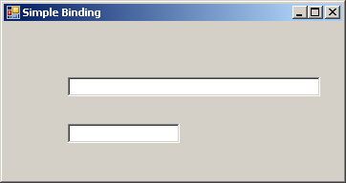

Figure 22.1

- Add a using directive for the System.Data.SqlClient namespace.
- Insert the following code into the Form Load method:

string connString = @”
server = ???; user id = ??; password = ???;
database = ???”;

string sql = @”SELECT * FROM title”;

SqlConnection conn = new SqlConnection(connString);
SqlDataAdapter da = new SqlDataAdapter(sql, conn);
DataSet ds = new DataSet();
da.Fill(ds, "title");

// Bind to title column of the Title table
textBox1.DataBindings.Add("text", ds, "title.title");
// Bind to type column of the Title table
textBox2.DataBindings.Add("text", ds, "title.type");

- Run the form with Ctrl+F5, and you should see the result in Figure 22.2.

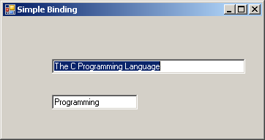

Figure 22.2

Complex Data Binding
Complex data binding is an association between a control and one or more data elements of a data source. You can perform this type of binding with controls that allow more than one value to be displayed at a time, such as a data grid or a data list. The next example uses a data grid (a DataGridView control) to display all rows and columns of the RiversEnd publisher table.

- Create a Windows Application project named ComplexBinding.
- Add a DataGridView control from the Toolbox. The DataGridView task menu is shown in Figure 22.3.
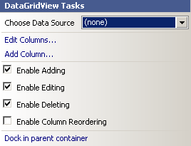

Figure 22.3

- Open the drop-down list, and you’ll see the window shown in Figure 22.4.

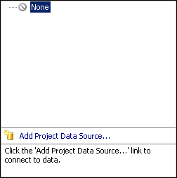

Figure 22.4

- Click Add Project Data Source… The Data Source Configuration Wizard will appear, as shown in Figure 22.5.

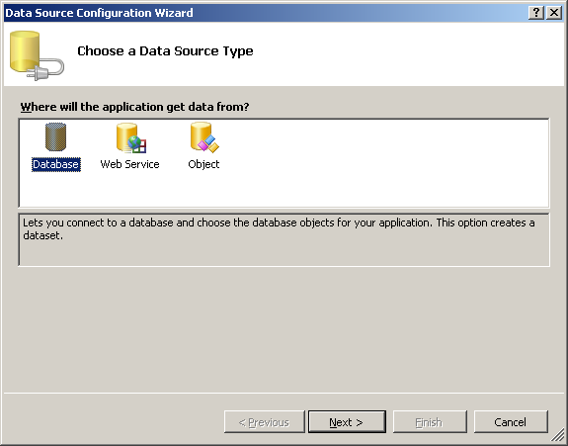

Figure 22.5

- Click the Database icon, then click Next. The Choose Your Data Connection window will appear, as shown in Figure 22.6.

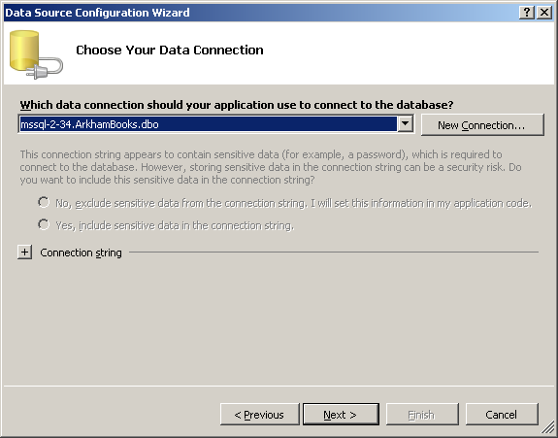

Figure 22.6

- Choose the appropriate connection (Figure 22.6) and click Next to display a panel (Figure 22.7) to save your connection string. Click Next. You will be prompted to choose the database objects to be stored in a dataset, as shown in Figure 22.8.

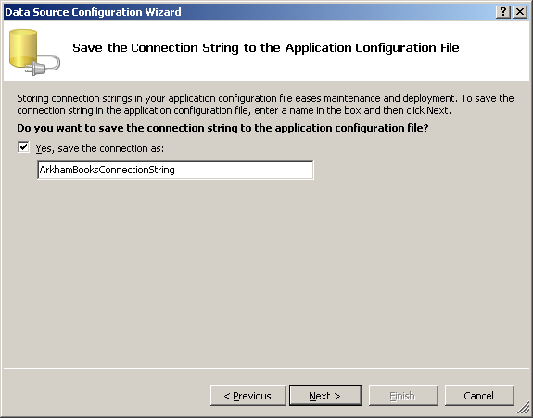

Figure 22.7

Figure 22.8

- Expand the Tables node and check the Publisher table, as shown in Figure 22.9.

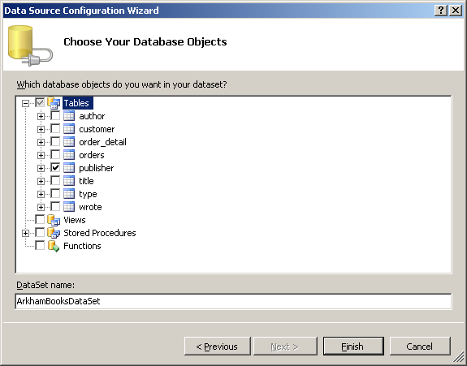

Figure 22.9

- Click Finish, and you will go back to the window in Figure 22.3. Click outside it to dismiss it. You’ll see the screen shown in Figure 22.10.

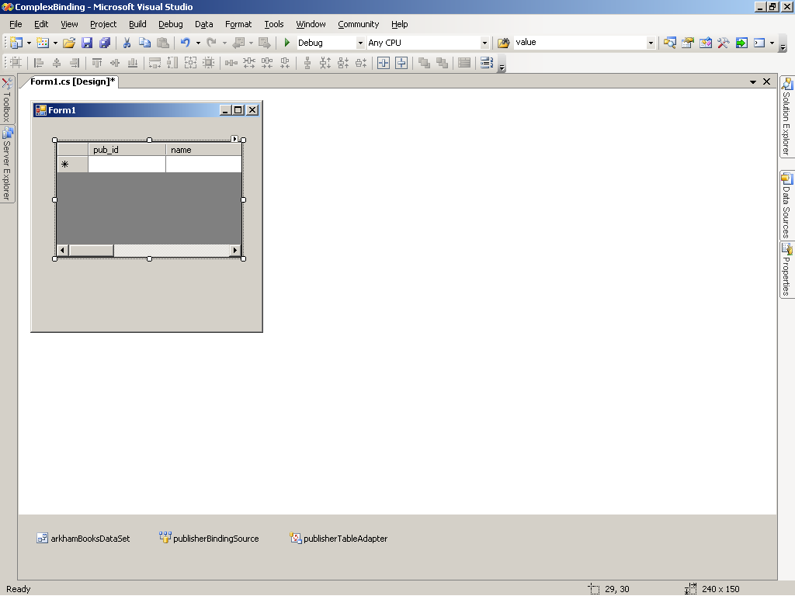

Figure 22.10

- Notice that the data grid now shows a row of column headings and a row for data and that three icons appear in the tray at the bottom of the Design window. Resize the form and grid to display several rows and all the columns.
- Run the project. You should see a result similar to Figure 22.11.

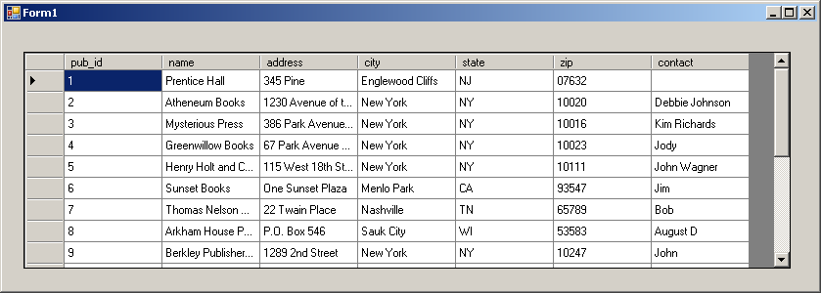

Figure 22.11

Understanding Data Binding
You have now done both simple and complex data binding, but how does all this work? How do controls bind themselves to data sources? To answer these questions, we will give you some insight into the data-binding mechanism and show how it works.

The Windows data-bound controls are able to bind to data because of the functionality made available by the Binding class. This class is responsible for creating a simple binding between a single control property and a data element in a data source.

The DataBindings property of a control returns a ControlBindingsCollection object, which is a collection of Binding objects, each of which you can add to the collection with its Add method. A data-bound control can have a collection of bindings, each associated with a different property of the control. For example, you can bind the Text property of a Label control to a single column in a table and at the same time bind its ForeColor property to an array of different color values, completely unrelated to the table.

Lesson #23
Topic | SQL Server Stored Procedures | Points
Demo | Stored Procedures

Instruction Materials:

Main Topics:
- SQL Server Stored Procedures

Stored procedures are programs run on the database server that allow you to package SQL in an optimal fashion for reuse. Writing stored procedures is a major study in itself. Our goal here is to introduce you to the basics of stored procedures so you understand how C# programs need to interact with them.

Creating Stored Procedures
Stored procedures can have parameters that can be used for input or output. They also have a single integer return value (which defaults to zero), and they can return zero or more result sets. They can be called from client programs or other stored procedures. They are very powerful and are becoming the preferred mode for much database programming, particularly for multi-tier applications and Web services, since they can dramatically reduce network traffic.

This first example produces a list of the Mystery titles in the ArkhamBooks database. It requires no input and does not need to set a return value.

- In the Object Explorer of the SQL Server Management Studio, expand the ArkhamBooks node, expand the Programmability node, right-click the Stored Procedures node, and click New Stored Procedure. You will see an SQL edit window as shown in Figure 23.1.

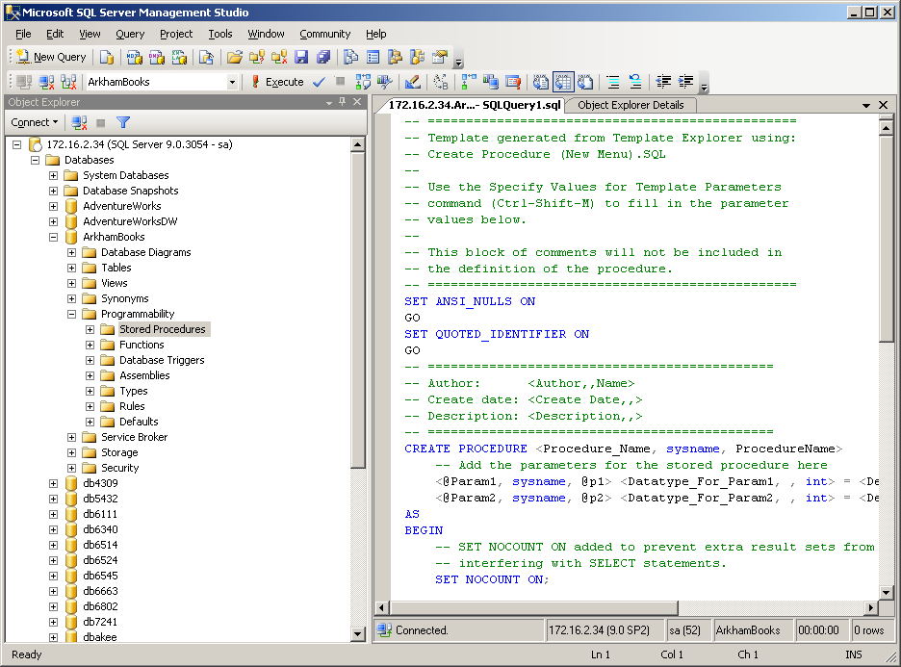

Figure 23.1
- It has some comments and a bit of SQL already generated, which provide a template for stored procedure code, but we don’t need any of this, so replace it all with the following SQL:

create procedure sp_SelectMysteryTitles
as
select title, isbn, type
from title
where type = ‘Mystery’

- Execute the SQL. You should see the screen in Figure 23.2.

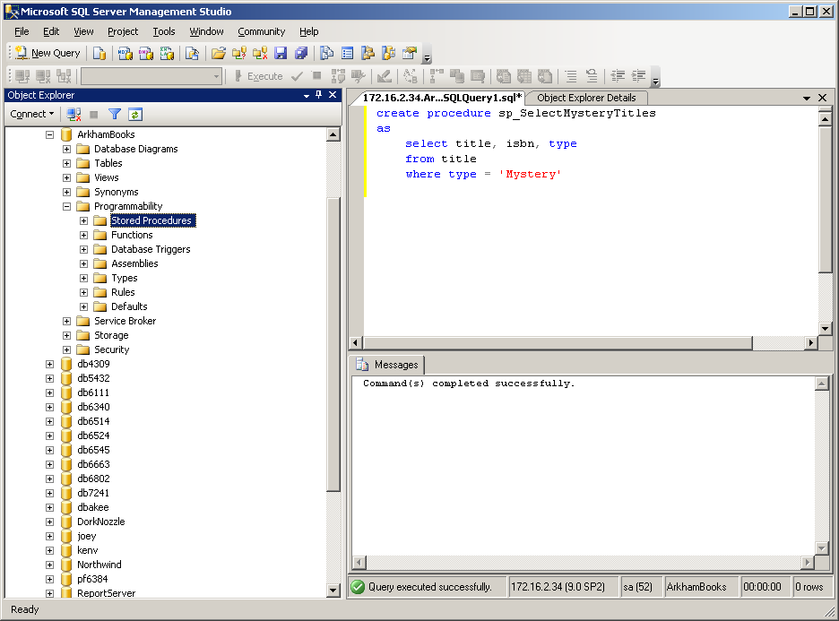

Figure 23.2

- To execute the stored procedure, expand the Stored Procedure node, right-click it and Click Refresh, to display the new stored procedure node. Then right-click dbo.spSelectMysteryTitles and click Execute Stored Procedure. A prompt window will appear as in Figure 23.3, where you could enter values for input parameters, but there are none for this stored procedure, so just click OK.

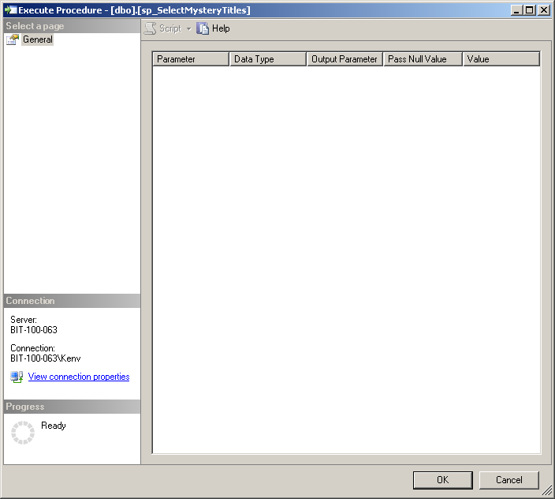

Figure 23.3

- The stored procedure runs, and you should get the results in Figure 23.4. Note that the Management Studio displays both the result set and the return value in grids. The return value is zero by default. Now scroll down in the Results window and see how many rows are in the result set. It should be 9. Look at the rightmost entry in the status bar. It says “10 rows”. All of the rows it returned are being reported, both the Results and the row in the Return Value.
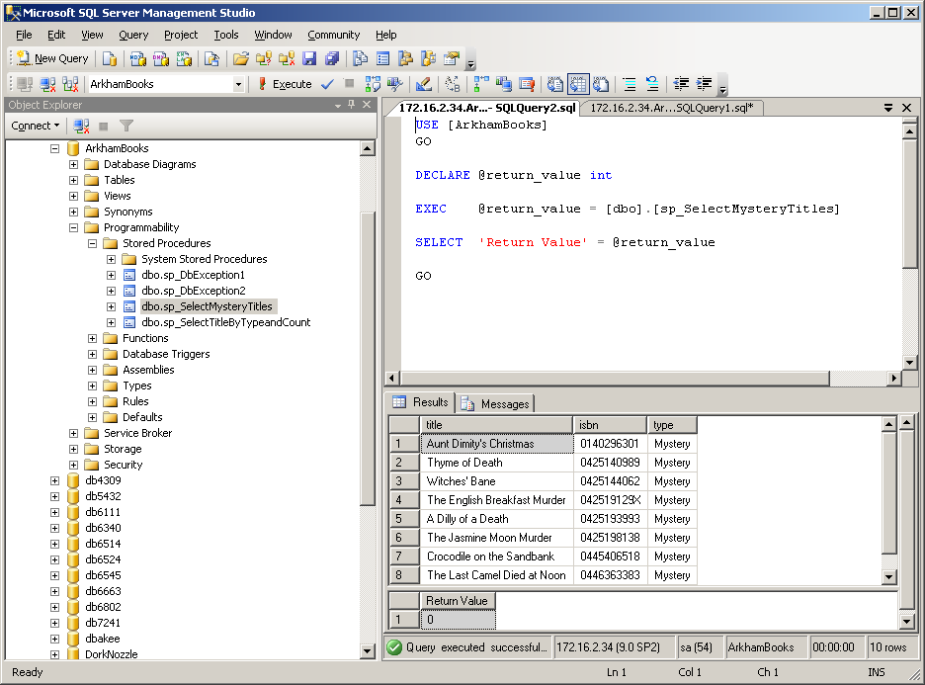

Figure 23.4
The next example will modify the previous query to use an input parameter to allow the user to provide the type of books to be viewed.

- Reopen the first SQL edit window by clicking its tab. Replace the SQL there with the following:

create procedure sp_SelectTitleByType
@type char(15)
as
select title, isbn, type
from title
where type = @type;

and execute it to create the stored procedure.

- To execute the stored procedure, refresh the Stored Procedure need, right-click dbo.spSelectTitlesByType, and Execute Stored Procedure. Enter Horror in the Value column of the prompt window and click OK. You should get the results in Figure 23.5

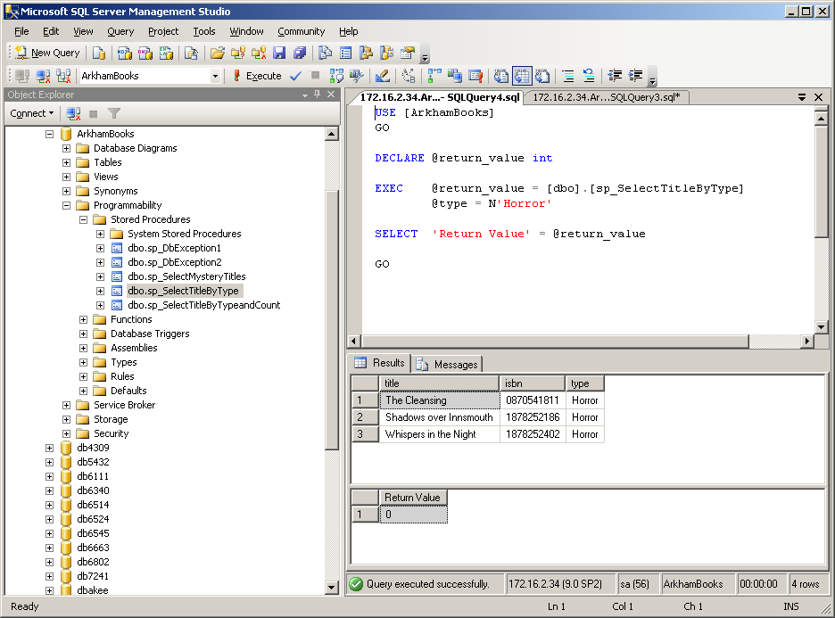

Figure 23.5

Output parameters are typically used to pass values between stored procedures, but sometimes they need to be accessed from C#, so we will write a stored procedure with an output parameter so we can use it in a C# program later. We will also show how to return a value other than zero.

- Reopen the first SQL edit window. Replace the SQL with the following:

create procedure sp_SelectTitleByTypeandCount
@type char(15),
@typecount int = 0 output
as
select title, isbn, type
from title
where type = @type;

select @typecount = count(*)
from title
where type = @type;

return @typecount

Execute it to create the stored procedure.

- Execute the Stored Procedure. If you enter Gothic as the type the results will look like Figure 23.6

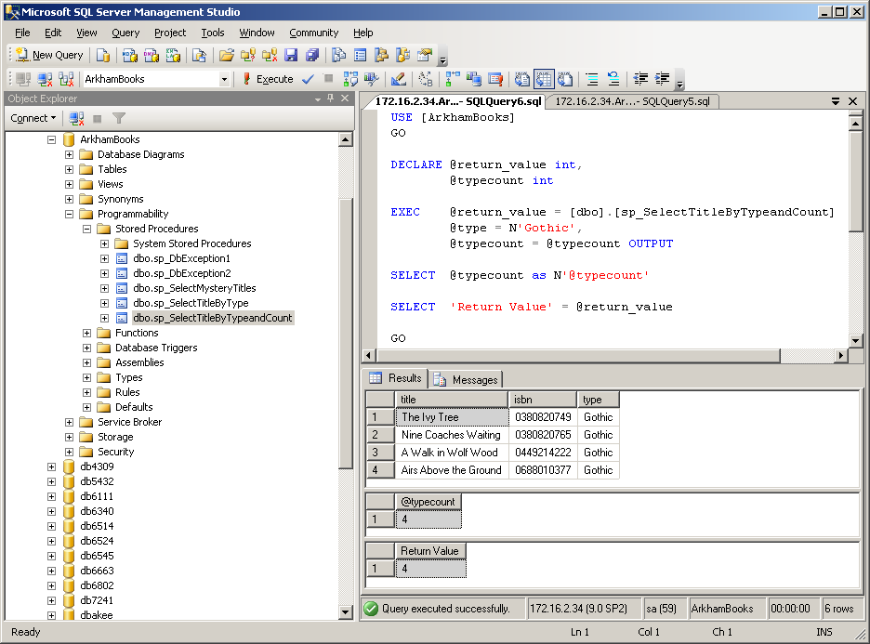

Figure 23.6
Working with Stored Procedures in C#
Create a new Console Application and replace the generated code with:

using System;
using System.Data;
using System.Data.SqlClient;

namespace StoredProcedure
{
class CallSp
{
static void Main( )
{
// create connection
string connString = @"
server = ???; user id = ??; password = ??; database = ???";

SqlConnection conn = new SqlConnection(connString);

try
{

// open connection
conn.Open();

// Create command
SqlCommand cmd = conn.CreateCommand();

// Specify stored procedure to execute
cmd.CommandType = CommandType.StoredProcedure;
cmd.CommandText = “sp_SelectMysteryTitles”;

// Execute command
SqlDataReader rdr = cmd.ExecuteReader();

// Process the result set
while (rdr.Read())
{
Console.WriteLine("{0} {1} {2}",
rdr[0].ToString().PadRight(40),
rdr[1].ToString().PadRight(15),
rdr[2].ToString());
}
rdr.Close();
}
catch (SqlException ex)
{
Console.WriteLine(ex.ToString());
}
finally
{
conn.Close();
}
}
}
}

Run the solution by pressing Ctrl+F5. You should see the results in Figure 23.7
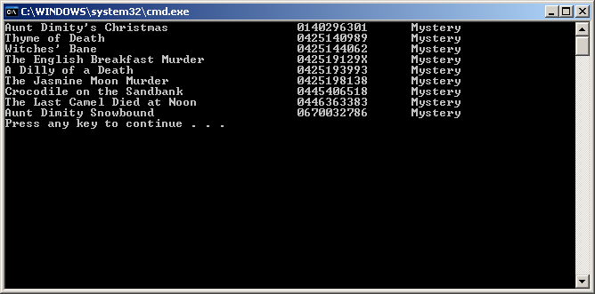
Figure 23.7
Instead of using new to create a command (and pass a query and a connection to its constructor), you used the connection’s CreateCommand method. You then specified that the command type was for a stored procedure call rather than a query. Finally, you set the command text to the stored procedure name. The rest of the code changed only slightly. You used ExecuteReader just as you would for a query, which makes sense, since the stored procedure simply executes a query and returns a result set.
The next example executes a stored procedure with parameters. Create a new C# Console Application and replace the code with the following:
using System;
using System.Data;
using System.Data.SqlClient;

namespace StoredTwo
{
class CallSp2
{
static void Main()
{
// Create connection
string connString = @"
server = ???; user id = ??; password = ???; database = ???";

SqlConnection conn = new SqlConnection(connString);

try
{
// Open connection
conn.Open();

SqlCommand cmd = conn.CreateCommand();

// Specify stored procedure to
// execute
cmd.CommandType = CommandType.StoredProcedure;
cmd.CommandText = “sp_SelectTitleByTypeandCount”;

// Create input parameter
SqlParameter inparm = cmd.Parameters.Add(“@type”, SqlDbType.Char);

inparm.Direction = ParameterDirection.Input;
inparm.Value = “Gothic”;

// Create output parameter
SqlParameter outparm = cmd.Parameters.Add(“@typecount”, SqlDbType.Int);

outparm.Direction = ParameterDirection.Output;

// create return value paramter
SqlParameter retval = cmd.Parameters.Add(“return_value”, SqlDbType.Int);

retval.Direction = ParameterDirection.ReturnValue;

// Execute command
SqlDataReader rdr = cmd.ExecuteReader();

// Process the result set
while (rdr.Read())
{
Console.WriteLine(“{0} {1} {2}”, rdr[0].ToString().PadRight(40), rdr[1].ToString().PadRight(15),
rdr[2].ToString());
}
rdr.Close();

// Display output parameter value
Console.WriteLine(“The output parameter value is {0}”, cmd.Parameters[“@typecount”].Value);
// Display return value
Console.WriteLine(“The return value is {0}”, cmd.Parameters[“return_value”].Value);
}

catch (SqlException ex)
{
Console.WriteLine(ex.ToString());
}
finally
{
conn.Close();
}
}
}
}

Run the program and you should see results similar to Figure 23.8
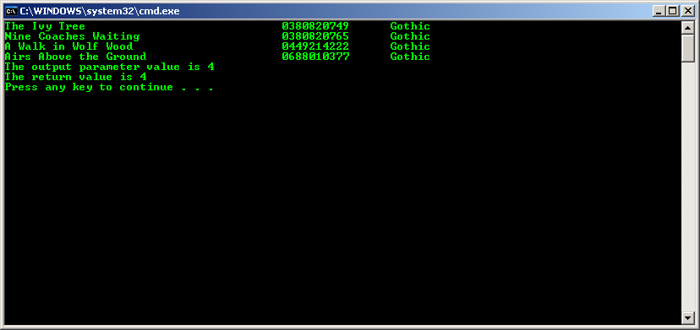
Figure 23.8

Lesson #24
Topics | Handling Exceptions | Points
 | Lecture

Main Topics:
- Handling ADO .NET Exceptions
- Handling Database Exceptions

Up to now, we have been rather relaxed in our handling of database exceptions. Robust database applications demand more careful attention to this important issue. Structured exception handling is both elegant and robust. In database programming, errors come from three sources: application programs, ADO .NET, and database servers. We will focus on the last two sources.

Handling ADO .NET Exceptions
ADO .NET exceptions arise when ADO .NET is trying to communicate with SQL Server, before the database server responds. We will use a Windows application, since it makes generating and viewing error situations and messages more convenient. To generate an error you will try to execute a stored procedure without specifying the CommandText property. You will do this first without handling the exception, then you will modify things to handle it.

Create a new Windows Application.
Add a tab control to the form. Add two buttons and two labels to the first tab and change the names as shown in Figure 24.1.

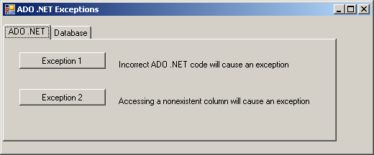

Figure 24.1

Add the following using directive: using System.Data.SqlClient;

Insert the following code into the click event handler for the Exception 1 button.

// Create connection
string connString = @"
server = ???; user id = ??; password = ???; database = ??";

SqlConnection conn = new SqlConnection(connString);

// Create command
SqlCommand cmd = conn.CreateCommand();

//Specify that a stored procedure is to be executed
cmd.CommandType = CommandType.StoredProcedure;

// Fail to specify the procedure
// cmd.CommandText = “sp_SelectMysteryTitles”;

// Open connection
conn.Open();

// Create DataReader
SqlDataReader dr = cmd.ExecuteReader();

// Close reader
dr.Close();

if (conn.State == ConnectionState.Open)
{
MessageBox.Show(“Closing the connection”, “Finally”);
conn.Close();
}

Run the program. Click the Exception 1 button, and you will see the message box shown in Figure 24.2

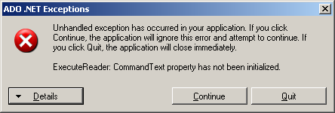

Figure 24.2

Modify the Exception 1 button event handler with the bold code shown below:

// Create connection
string connString = @"
server = ???; user id = ??; password = ???; database = ??";

SqlConnection conn = new SqlConnection(connString);

// Create command
SqlCommand cmd = conn.CreateCommand();

//Specify that a stored procedure is to be executed
cmd.CommandType = CommandType.StoredProcedure;

// Fail to specify the procedure
// cmd.CommandText = “sp_SelectMysteryTitles”;

try
{

// Open connection
conn.Open();

// Create DataReader
SqlDataReader dr = cmd.ExecuteReader();

// Close reader
dr.Close();
}
catch (System.Data.SqlClient.SqlException ex)
{
string str;
str = “Source: “ + ex.Source;
str += “\n” + “Exception Message: “ + ex.Message;
MessageBox.Show (str, “Database Exception”);
}
catch (System.Exception ex)
{
string str;
str = “Source: “ + ex.Source;
str += “\n” + “Exception Message: “ + ex.Message;
MessageBox.Show (str, “Non-Database Exception”);
}
finally
{
if (conn.State == ConnectionState.Open)
{
MessageBox.Show(“Closing the connection”, “Finally”);
conn.Close();
}
}

Run the program. Click the Exception 1 button, and you will see the message box shown in Figure 24.3. Click OK.

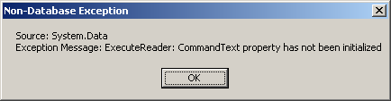

Figure 24.3

When the message box in Figure 24.4 appears, click OK, then close the window.

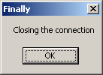

Figure 24.4

For this example you will execute a stored procedure and then reference a nonexistent column in the returned dataset. This will throw an ADO .NET exception. This time you will code a specific catch clause to handle the exception.

Insert the following code into the body of the Exception 2 click method.

// Create connection
string connString = @"
server = ???; user id = ??; password = ???; database = ??";

SqlConnection conn = new SqlConnection(connString);

// Create command
SqlCommand cmd = conn.CreateCommand();

//Specify that a stored procedure is to be executed
cmd.CommandType = CommandType.StoredProcedure;
cmd.CommandText = "sp_SelectMysteryTitles";

try
{
// Open connection
conn.Open();

// Create DataReader
SqlDataReader dr = cmd.ExecuteReader();

// Access nonexistent column
string str = dr.GetValue(20).ToString();

// Close reader
dr.Close();
}
catch (System.InvalidOperationException ex)
{
string str;
str = "Source: " + ex.Source;
str += "\n" + "Message: " + ex.Message;
str += "\n\n";
str += "\n" + "Stack Trace: " +ex.StackTrace;
MessageBox.Show (str, "Specific Exception");
}
catch (System.Data.SqlClient.SqlException ex)
{
string str;
str = "Source: " + ex.Source;
str += "\n" + "Exception Message: " + ex.Message;
MessageBox.Show (str, "Database Exception");
}
catch (System.Exception ex)
{
string str;
str = "Source: " + ex.Source;
str += "\n" + "Exception Message: " + ex.Message;
MessageBox.Show (str, "Non-Database Exception");
}
finally
{
if (conn.State == ConnectionState.Open)
{
MessageBox.Show("Closing the connection", "Finally");
conn.Close();
}
}

Run the program. Click the Exception 2 button and you will see the message box shown in Figure 24.5. Click OK. When the Finally MessageBox appears, click OK, then close the window.

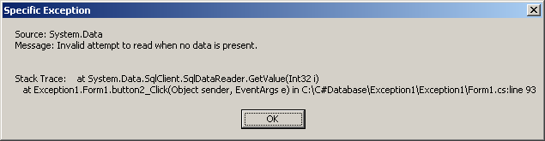

Figure 24.5

Now generate a SQL Server exception. Alter the name of the stored procedure in the code to a name that doesn’t exist.
For example:

cmd.CommandText = “sp_SelectGothicTitles”;

Run the program. Click the Exception 2 button and you will see the message box shown in Figure 24.6. Click OK. When the Finally MessageBox appears, click OK, then close the window.

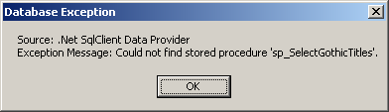

Figure 24.6
Handling Database Exceptions
An exception of type System.Data.SqlClient.SqlException is thrown when SQL Server returns a warning or error. An instance of SqlException is thrown whenever the .NET data provider for SQL Server encounters an error or warning from the database.

When an error occurs within SQL Server, it uses a T-SQL RAISERROR statement to raise an error and send it back to the calling program. A typical error message looks like the following:

Server: Msg 2812, Level 16, State 62, Line 1
Could not find stored procedure ‘sp_DoesNotExist’

In this message, 2812 represents the error number, 16 represents the severity level, and 62 represents the state of the error.

You can also use the RAISERROR statement to display specific messages within a stored procedure. The RAISERROR statement in its simplest form takes three parameters. The first parameter is the message that needs to be shown. The second parameter is the severity level of the error. Any user can use serverity levels 11 through 16. The third parameter is an arbitrary integer from 1 through 127 that represents information about the state or source of the error.

On the Database tab page, create three buttons and three labels. The layout should look like Figure 24.7.
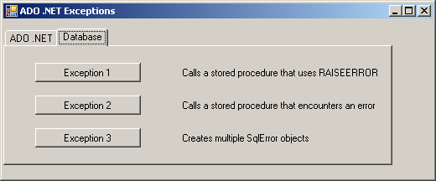

Figure 24.7

Using Sql Server Management Studio create the following stored procedure.

create procedure sp_DbException1
as
set nocount on

declare @authorcount int

select @authorcount = count(*) from author

if @authorcount > 15
raiserror (‘Author count is greater than 15 –Notify the Buyer’, 16, 1)

Add the following code to the Database tab Exception 1 button click event handler:

// Create connection
string connString = @"
server = ???; user id = ??; password = ???; database = ??";

SqlConnection conn = new SqlConnection(connString);

// Create command
SqlCommand cmd = conn.CreateCommand();

//Specify that a stored procedure is to be executed
cmd.CommandType = CommandType.StoredProcedure;
cmd.CommandText = "sp_DbException1";

try
{
// Open connection
conn.Open();

// Execute stored procedure
cmd.ExecuteNonQuery();
}
catch (System.Data.SqlClient.SqlException ex)
{
string str;
str = "Source: " + ex.Source;
str += "\n" + "Number: " + ex.Number.ToString();
str += "\n" + "Message: " + ex.Message;
str += "\n" + "Class: " + ex.Class.ToString();
str += "\n" + "Procedure: " + ex.Procedure.ToString();
str += "\n" + "Line Number: " + ex.LineNumber.ToString();
str += "\n" + "Server: " + ex.Server.ToString();

MessageBox.Show(str, "Database Exception");
}
catch (System.Exception ex)
{
string str;
str = "Source: " + ex.Source;
str += "\n" + "Exception Message: " + ex.Message;
MessageBox.Show(str, "General Exception");
}
finally
{
if (conn.State == ConnectionState.Open)
{
MessageBox.Show("Closing the connection", "Finally");
conn.Close();
}
}

Run the program, then click the Database tab Exception 1 button. You will see the message box shown in Figure 24.8. Click OK to close the message box, then click OK to close the next one, then close the window.

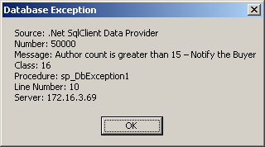

Figure 24.8

Observe the caption and contents of the message box. The source, message, name of the stored procedure, exact line number where the error was found, and the name of the server are all displayed. You obtain this detailed information about the exception from the SqlException object.

Now let’s see what happens when a statement in a stored procedure encounters an error. You will create a stored procedure that attempts an illegal INSERT, and then you will extract information from the SqlException object:

Using the Sql Server Management Studio create the following stored procedure:

create procedure sp_DbException2
as
set nocount on

insert into publisher (pub_id, name) values (50, ‘Arkham House’)

Insert the following code into the Database tab Exception 2 click event handler:

// Create connection
string connString = @"
server = ???; user id = ??; password = ???; database = ??";

SqlConnection conn = new SqlConnection(connString);

// Create command
SqlCommand cmd = conn.CreateCommand();

//Specify that a stored procedure is to be executed
cmd.CommandType = CommandType.StoredProcedure;
cmd.CommandText = "sp_DbException2";

try
{
// Open connection
conn.Open();

// Execute stored procedure
cmd.ExecuteNonQuery();
}
catch (System.Data.SqlClient.SqlException ex)
{
string str;
str = "Source: " + ex.Source;
str += "\n" + "Number: " + ex.Number.ToString();
str += "\n" + "Message: " + ex.Message;
str += "\n" + "Class: " + ex.Class.ToString();
str += "\n" + "Procedure: " + ex.Procedure.ToString();
str += "\n" + "Line Number: " + ex.LineNumber.ToString();
str += "\n" + "Server: " + ex.Server.ToString();

MessageBox.Show(str, "Database Exception");
}
catch (System.Exception ex)
{
string str;
str = "Source: " + ex.Source;
str += "\n" + "Exception Message: " + ex.Message;
MessageBox.Show(str, "ADO .NET Exception");
}
finally
{
if (conn.State == ConnectionState.Open)
{
MessageBox.Show("Closing the connection", "Finally");
conn.Close();
}
}

Run the program, then click the Database tab Exception 1 button. You will see the message box shown in Figure 24.9. Click OK to close the message box, then click OK to close the next one, then close the window.

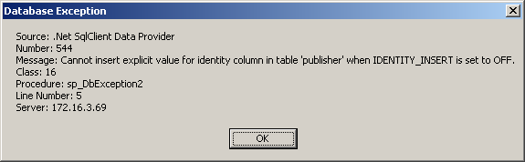

Figure 24.9

The SqlException class has an Errors collection property. Each item in the Errors collection is an object of type SqlError. When a database exception occurs, the Errors collection is populated. For example, let’s try to establish a connection to a nonexistent database and investigate the Errors collection:

Add the following code to the Database tab Exception 3 click event handler. Make sure that you enter in a Database name that is not correct.

// Create connection
string connString = @"
server = ???; user id = ??; password = ???; database = ??";

SqlConnection conn = new SqlConnection(connString);

// Create command
SqlCommand cmd = conn.CreateCommand();

//Specify that a stored procedure is to be executed
cmd.CommandType = CommandType.StoredProcedure;
cmd.CommandText = "sp_DbException2";

try
{
// Open connection
conn.Open();

// Execute stored procedure
cmd.ExecuteNonQuery();
}
catch (System.Data.SqlClient.SqlException ex)
{
string str = "";
for (int i = 0; i < ex.Errors.Count; i++)
{
str += "\n" + "Index #" + i + "\n"
+ "Exception: " + ex.Errors[i].ToString() + "\n"
+ "Number: " + ex.Errors[i].Number.ToString() + "\n";
}

MessageBox.Show(str, "Database Exception");
}
catch (System.Exception ex)
{
string str;
str = "Source: " + ex.Source;
str += "\n" + "Exception Message: " + ex.Message;
MessageBox.Show(str, "ADO .NET Exception");
}
finally
{
if (conn.State == ConnectionState.Open)
{
MessageBox.Show("Closing the connection", "Finally");
conn.Close();
}
}

Run the program, click the Database tab Exception 3 button and observe the message box shown in Figure 24.10.

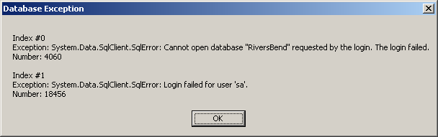

Figure 24.10

Two items are found in the Errors collection, and their error numbers are different.

Lesson #25
Topic | Quiz 3, Quiz 4, Test 2 | Points
 | Lessons 14 - 24 | 25
Instruction Materials:
Review Topics:

- Controlling access to class members
- This
- Garbage Collectors and Destructors
- Class Libraries
- The Try/Catch Block
- Comparing Strings
- Locating characters and substrings
- Regular Expressions
- The ADO .NET Object Model
- Data Providers
- Connection Objects
- Multiple Forms
- The Command Object
  - ExecuteScalar
  - ExecuteReader
  - ExecuteNonQuery
- Command Parameters
- Data Readers
  - Ordinal Indexers
  - Column Name Indexers
  - Typed Accessor methods
- Datasets
- Data Adapters
- Data Tables
- Data Columns
- Data Rows
- Simple and Complex Data Binding
- Stored Procedures
- ADO .NET and Database Exceptions

