COM272 ASP.NET
4 Units: 30 Hours Lecture + 20 Hours Lab
Student Manual
Lesson #1
Topic | Introduction to ASP .NET 2.0 | Points
Chapters | 1 and 3
Labs | Lab 1

Topics:
- Your first ASP .NET page
- The ASP .NET page structure
  - Directives
  - Code Declaration Blocks
  - Code Render Blocks
  - ASP .NET Server Controls
  - Comments
  - Literal Text and HTML Tags
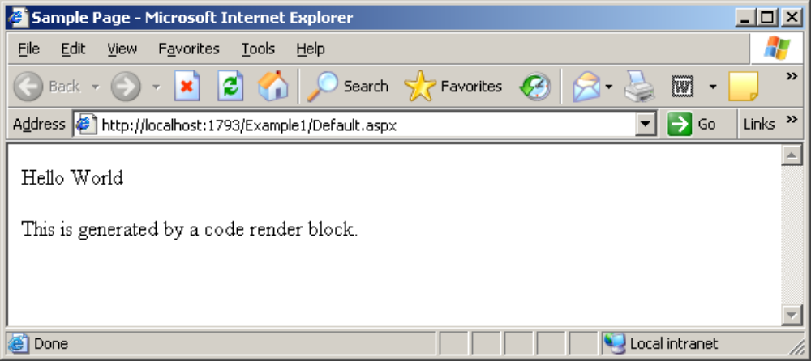

Figure 1.1
<%@ Page Language="C#" AutoEventWireup="true" CodeBehind="default.aspx.cs" Inherits="Lesson1Example._Default" %>

<!DOCTYPE html PUBLIC "-//W3C//DTD XHTML 1.0 Transitional//EN" "http://www.w3.org/TR/xhtml1/DTD/xhtml1-transitional.dtd">

<html xmlns="http://www.w3.org/1999/xhtml">
<head>
<title>Lesson 1 Example</title>
<script runat="server">
void Page_Load()
{
labelMessage.Text = "Hello World";
}
</script>
</head>
<body>
<form id="Form1" runat="server">
<p>
<asp:Label id="labelMessage" runat="server" />
</p>
<p>
<%-- Declare the title as string and set it --%>
<% string Title = "This is generated by a code render " +
"block."; %>
<%= Title %>
</p>
</form>
</body>
</html>

Code Sample 1

Directives:
The directives section is one of the most important parts of an ASP.NET page. Directives control how a page is compiled, specify how a page is cached by web browsers, aid debugging (error-fixing), and allow you to import classes to use within your page’s code. Each directive starts with <%@. This is followed by the directive name, plus any attributes and their corresponding values. The directive then ends with %>.

There are many directives that you can use within your pages, and we’ll discuss them in greater detail later, but, for now, know that the Import and Page directives are the most useful for ASP.NET development. Looking at the sample ASP.NET page in Code Sample 1, we can see that a Page directive was used at the top of the page like so:

<%@ Page Language="C#" AutoEventWireup="true" CodeBehind="default.aspx.cs" Inherits="Lesson1Example._default" %>

In this case, the Page directive specifies the language that’s to be used for the application logic by setting the Language attribute. The value provided for this attribute, which appears in quotes, specifies that we’re using C#.

Code Declaration Blocks:
In a later lesson, we’ll talk about code-behind pages and how they let us separate our application logic from an ASP.NET page’s HTML. However, if you’re not working with code-behind pages, you must use code declaration blocks to contain all the application logic of your ASP.NET page. This application logic defines variables, subroutines, functions, and more. In our page, we’ve placed the code inside <script> tags, like so:

<script runat="server">
void Page_Load()
{
labelMessage.Text = "Hello World";
}
</script>

Code declaration blocks are generally placed inside the head of you ASP .NET page. The sample ASP .NET page shown in Code Sample 1 contains the script tag shown above.

The <script runat="server"> tag can also accept another atribute. You can set the language that is being used in this code declaration block with the language attribute:

<script runat="server" language="C#">

If you don’t specify a language within the code declaration block, the ASP .NET page will use the language provided by the language attribute of the Page directive. Each page’s code must be written in a single language.

Code Render Blocks
You can use code render blocks to define inline code or expressions that will execute when a page is rendered. Code within a code render block is executed immediately when it is encountered—usually when the page is loaded or rendered. On the other hand, code within a code declaration block (within <script> tags) is executed only when it is called or triggered by user or page interactions. There are two types of code render blocks—inline code, and inline expressions—both of which are typically written within the body of the ASP.NET page. Inline code render blocks execute one or more statements, and are placed directly inside a page’s HTML between <% and %> delimiters. In our example, the following is a code render block:

<% string Title = "This is generated by a code render block."; %>

These code blocks simply declare a String variable called Title, and assign it the value This is generated by a code render block.

Inline expression render blocks can be compared to Response.Write in classic ASP. They start with <%= and end with %>, and are used to display the values of variables and methods on a page. In our example, an inline expression appears immediately after our inline code block:

<%= Title %>

ASP.NET Server Controls
At the heart of any ASP.NET page lie server controls, which represent dynamic elements with which your users can interact. There are three basic types of server control: ASP.NET controls, HTML controls, and web user controls.

Usually, an ASP.NET control must reside within a <form runat="server"> tag in order to function correctly. Controls offer the following advantages to ASP.NET developers:

They give us the ability to access HTML elements easily from within our code: we can change these elements’ characteristics, check their values, or even update them dynamically from our server-side programming language of choice.

ASP.NET controls retain their properties thanks to a mechanism called view state. We’ll be covering view state later. For now, you need to know that view state prevents users from losing the data they’ve entered into a form once that form has been sent to the server for processing. When the response comes back to the client, text box entries, drop-down list selections, and so on, are all retained through view state.

With ASP.NET controls, developers are able to separate a page’s presentational elements (everything the user sees) from its application logic (the dynamic portions of the ASP.NET page), so that each can be considered separately.

Many ASP.NET controls can be "bound" to the data sources from which they will extract data for display with minimal (if any) coding effort.

ASP.NET is all about controls, so we’ll be discussing them in greater detail as we move through this class. In particular, Lessons 2 & 3 explain many of the controls that ship with ASP.NET. For now, though, let’s continue with our dissection of an ASP.NET page.

Server-side Comments
Server-side comments allow you to include within the page comments or notes that will not be processed by ASP.NET.

Traditional HTML uses the <!-- and --> character sequences to delimit comments; any information included between these tags will not be displayed to the user. ASP.NET comments look very similar, but use the sequences <%-- and --%>.

Literal Text and HTML Tags
The final elements of an ASP.NET page are plain old text and HTML. Generally, you can’t do without these elements—after all, HTML allows the display of the information in your ASP.NET controls and code in a way that’s suitable for users. Let’s take a look at the literal text and HTML tags that were used to produce the display in Figure 1.1:

<%@ Page Language="C#" AutoEventWireup="true" CodeBehind="default.aspx.cs" Inherits="Lesson1Example._default" %>

<!DOCTYPE html PUBLIC "-//W3C//DTD XHTML 1.0 Transitional//EN" "http://www.w3.org/TR/xhtml1/DTD/xhtml1-transitional.dtd">

<html xmlns="http://www.w3.org/1999/xhtml">
<head>
<title>Lesson 1 Example</title>
<script runat="server">
void Page_Load()
{
labelMessage.Text = "Hello World";
}
</script>
</head>
<body>
<form id="Form1" runat="server">
<p>
<asp:Label id="labelMessage" runat="server" />
</p>
<p>
<%-- Declare the title as string and set it --%>
<% string Title = "This is generated by a code render " +
"block."; %>
<%= Title %>
</p>
</form>
</body>
</html>

The bold code above highlights the fact that literal text and HTML tags provide the structure for presenting our dynamic data. Without these elements, this page would have no format, and the browser would be unable to understand it.

You now have a clearer understanding of the structure of an ASP.NET page. As you work through the examples in this class, you’ll begin to realize that, in many cases, you won’t need to use all of these elements. For the most part, your development will be modularized within code declaration blocks, and all of the dynamic portions of your pages will be contained within code render blocks or controls located inside a <form runat="server"> tag.

Later in the class you will also see that when you use Visual Studio’s page design features, code declaration and code render blocks will see a lot less use.

Try It:

This section will be an introduction to ASP .NET using Visual Studio.

- Start Visual Studio (if this is the first time Visual Studio has been run, select the C# environment).
- Click the File menu and select New > Project.
- When the New Project dialog appears select Web under Visual C# and select the ASP.NET Web Application template. Name the project Lesson1Example

You will see the following screen:

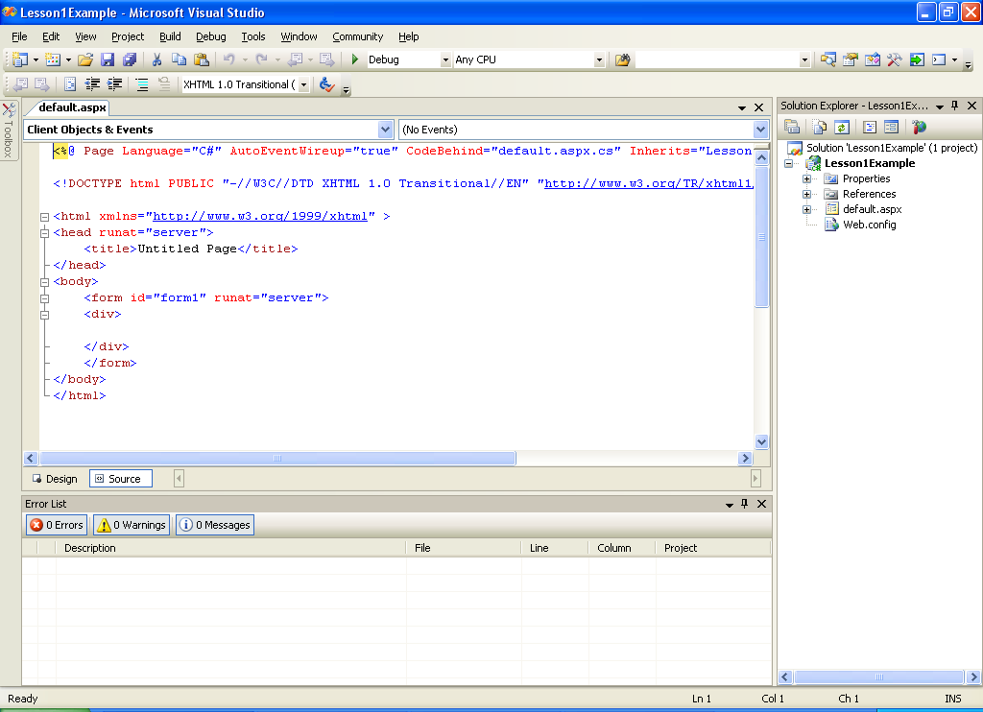

Figure 1.2

Replace all the code with the code from Code Sample 1.

Later we will use a code-behind file to contain the C# code that will run our Web application, but for now we will use the <script> tab to define the Page_Load( ) event handler. In order for this to work we need to delete the Page_Load( ) event handler from the generated code-behind file. In the Solution Explorer you will see the files that are part of this project. Click on the + sign to the left of the default.aspx file. The node will expand and you will see two more files.

Default.aspx.cs and Default.aspx.designer.cs

For now we are only concerned with the Default.aspx.cs file. This is the code-behind file that we will use later to store the C# code to run our applications. But right now all we need to do is double-click the icon to the left of the Default.aspx.cs file and view the code-behind file. Delete the following code:

protected void Page_Load(object sender, EventArgs e)
{

}

Now you can run the application by pressing the F5 key. Visual Studio’s built in Web Server will run you application using Internet Explorer as shown in Figure 1.3:

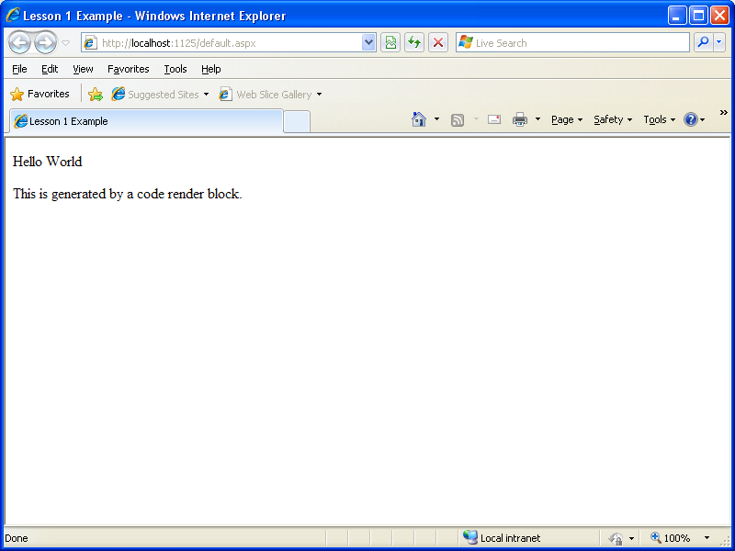

Figure 1.3

Lab 1
A Simple One-Page Applet

This Lab demonstrates how server-based controls work using a single page applet. This type of program, which combines user input and the program output on the same page, is used to provide popular tools on many sites. Some examples include: calculators for mortgages, taxes, health or weight indices, and retirement savings plans; single-phrase translators; and stock-tracking utilities.

The page shown in Figure 1-4 allows the user to convert a number of U.S. dollars to the equivalent amount of Euros.

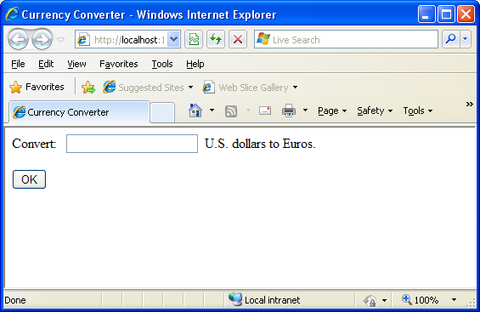

Figure 1-4

The following listing shows the HTML for this page. This page has two <input> tags: one for the text box and one for the submit button. These elements are enclosed in a <form> tag, so they can submit information to the server when the button is clicked. The rest of the page consists of static text:

<html xmlns="http://www.w3.org/1999/xhtml" >
<head>
<title>Currency Converter</title>
</head>
<body>
<form action="Default.aspx" method="post">
<div>
Convert: &nbsp;
<input type="text" />&nbsp; U.S. dollars to Euros.
<br /><br />
<input type="submit" value="OK" />
</div>
</form>
</body>
</html>

Create a new Web Application called Lab1 and leave the Web Page that is created named Default.aspx .

As it stands, this page looks nice but provides no functionality. It consists entirely of the user interface (HTML tags) and contains no code. Paste the above HTML content and overwrite everything that’s currently on the page, except the page directive & the DOCTYPE tag. The page directive gives ASP.NET basic information about how to compile the page. It indicates the language you’re using for your code and the way you connect your event handlers. If you’re using the code-behind approach, which is recommended, the page directive also indicates where the code file is located and the name of your custom page class.

Execute the application and you should see Figure 1-4.

Now you need to add the attribute runat="server" to each tag that you want to transform into a server control. You should also add an id attribute to each control that you need to interact with in code. The id attribute assigns the unique name that you’ll use to refer to the control in code.

Add the runat=“server” attribute and the id attribute to the form tag and the two input tags as shown below:

<%@ Page Language="C#" AutoEventWireup="true" CodeFile="Default.aspx.cs" Inherits="Lab1._Default" %>

<!DOCTYPE html PUBLIC "-//W3C//DTD XHTML 1.0 Transitional//EN" "http://www.w3.org/TR/xhtml1/DTD/xhtml1-transitional.dtd">

<html xmlns="http://www.w3.org/1999/xhtml" >
<head>
<title>Currency Converter</title>
</head>
<body>
<form action="Default.aspx" method="post" id=“Form1” runat="server">
<div>
Convert: &nbsp;
<input type="text" id="US" runat="server" />&nbsp; U.S. dollars to Euros.
<br /><br />
<input type="submit" value="OK" id="Convert" runat="server" />
</div>
</form>
</body>
</html>

ASP.NET controls are always placed inside the <form> tag of the page. The <form> tag is a part of the standard for HTML forms, and it allows the browser to send information to the web server.

View State
To try this page, launch it in Visual Studio. Then, select View > Source in your browser to look at the HTML that ASP.NET sent your way. The first thing you’ll notice is that the HTML that was sent to the browser is slightly different from the information in the .aspx file. First, the runat="server" attributes are stripped out (because they have no meaning to the client browser, which can’t interpret them). Second, and more important, an additional hidden field has been added to the form, as shown here:

<!DOCTYPE html PUBLIC "-//W3C//DTD XHTML 1.0 Transitional//EN" "http://www.w3.org/TR/xhtml1/DTD/xhtml1-transitional.dtd">

<html xmlns="http://www.w3.org/1999/xhtml" >
<head>
<title>Currency Converter</title>
</head>
<body>
<form name="Form1" method="post" action="Default.aspx" id="Form1">

<div>
<input type="hidden" name="__VIEWSTATE" id="__VIEWSTATE" value="/wEPDwUKLTg2NjIxOTM2OWRkWdtFVWAyIdRdLZdxm+V0gT425gg=" />
</div>

<div>

<input type="hidden" name="__EVENTVALIDATION" id="__EVENTVALIDATION" value="/wEWAwKPiOyGCwLr797wDAK26f/+BYPQlWnJgdP96/NIZxT4AeUdIxen" />
</div>

<div>
Convert: &nbsp;
<input name="US" type="text" id="US" />&nbsp; U.S. dollars to Euros.
<br /><br />
<input name="Convert" type="submit" id="Convert" value="OK" />
</div>
</form>
</body>
</html>

This hidden field stores information, in a compressed format, about the state of every control on the page. It allows you to manipulate control properties in code and have the changes automatically persisted. This is a key part of the web forms programming model. Thanks to view state, you can often forget about the stateless nature of the Internet and treat your page like a continuously running application. Don’t be concerned about the other hidden field, it will be covered later.

Even though the currency converter program doesn’t yet include any code, you’ll already notice one change. If you enter information in the text box and click the submit button to post the page, the refreshed page will still contain the value you entered in the text box. (In the original example that uses ordinary HTML elements, the value will be cleared every time the page is posted back.) This change occurs because ASP.NET controls automatically retain state.

To actually add some functionality to the currency converter, you need to add some ASP.NET code. Web forms are event-driven, which means every piece of code acts in response to a specific event. In the simple currency converter page example, the most useful event occurs when the user clicks the submit button (named Convert). The HtmlInputButton allows you to react to this action by handling the ServerClick event.

Before you continue, it makes sense to add another control that can display the result of the calculation. In this case, you can use a <div> tag named Result. The <div> tag is one way to insert a block of formatted text into a web page. Here’s the line of HTML that you’ll need:

<div style=“font-weight: bold” id=“Result” runat=“server”>

The style attribute applies the CSS properties used to format the text. In this example, it merely applies a bold font.

The example now has the following four server controls:
• A form. This is the only control you do not need to access in your code-behind class.
• An input text box named US.
• A submit button named Convert.
• A <div> tag named Result.

The following code shows the updated HTML that includes the <div> tag for the result. This code also includes the attribute for OnServerClick, which will allow the page to respond when the user clicks the OK button. Do Not execute the page until you have completed the next section, which will add code to the code-behind file.

<html xmlns="http://www.w3.org/1999/xhtml" >
<head>
<title>Currency Converter</title>
</head>
<body>
<form action="Default.aspx" method="post" id="Form1" runat="server">
<div>
Convert: &nbsp;
<input type="text" id="US" runat="server" />&nbsp; U.S. dollars to Euros.
<br /><br />
<input type="submit" value="OK" id="Convert" runat="server" onserverclick="Convert_ServerClick" />
<br /><br />
<div style="font-weight: bold" id="Result" runat="server" />
</div>
</form>
</body>
</html>
Go into the Design screen for Default.aspx and double-click the OK button. This will generate an event handler that will contain code to perform the conversion. The Page_Load event handler is created by default and can just be left empty for now.

Add the following bolded code to the Convert_ServerClick method:
using System;
using System.Data;
using System.Configuration;
using System.Web;
using System.Web.Security;
using System.Web.UI;
using System.Web.UI.WebControls;
using System.Web.UI.WebControls.WebParts;
using System.Web.UI.HtmlControls;

public partial class _Default : System.Web.UI.Page
{
protected void Page_Load(object sender, EventArgs e)
{

}
protected void Convert_ServerClick(object sender, EventArgs e)
{
decimal USAmount = decimal.Parse(US.Value);
decimal euroAmount = USAmount * 0.85M;
Result.InnerText = USAmount.ToString() + " U.S. dollars = ";
Result.InnerText += euroAmount.ToString() + " Euros.";
}
}
The code-behind class is a typical example of an ASP.NET page. You’ll notice the following conventions:

• It starts with several using statements. This provides access to all the important namespaces. This is a typical first step in any code-behind file.

• The page class is defined with the partial keyword. That’s because your class code is merged with another code file. This extra code, which ASP.NET generates automatically, defines all the server controls that are used on the page. This allows you to access them by name in your code.

• The page defines a single event handler. This event handler retrieves the value from the text box, multiplies it by a preset conversion ratio (which would typically be stored in another file or a database), and sets the text of the <div> tag. You’ll notice that the event handler accepts two parameters (sender and e). This is the .NET standard for all control events. It allows your code to identify the control that sent the event (through the sender parameter) and retrieve any other information that may be associated with the event (through the e parameter).

• The event handler is connected to the control event using the OnServerClick attribute
in the <input> tag for the button. You’ll learn more about how this hookup works in the next section.

• The event handler uses ToString( ) to convert the decimal value to text. Remember, C# is notoriously strict about data type conversions. Before you can display your information in the page, you need to convert the decimal value to a string so that it can be added to the InnerText property.

You can launch this page to test your code. When you enter a value and click the OK button, the page is resubmitted, the event handling code runs, and the page is returned to you with the conversion details as shown in Figure 1-5.

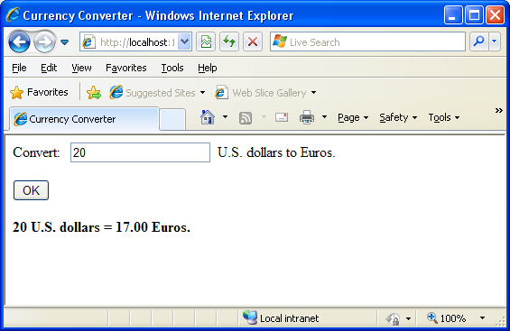

Figure 1-5

This example works using a technique called automatic event wireup. To use this approach, you use an attribute in the control tag to connect your event handler. For example, if you want to handle the ServerClick method of the Convert button, you simply need to set the OnServerClick attribute in the control tag with the name of the event handler you want to use:

<input type="submit" value="OK" id="Convert" runat="server" onserverclick="Convert_ServerClick" />

ASP.NET controls always use this syntax and give the attribute the event name preceded by the word On. For example, if you want to handle an event named ServerChange, you’d set an attribute in the control tag named OnServerChange. You don’t need to connect a small set of page events through a control tag, such as PageLoad event. Everything else is hooked up using the control tag. When you double-click a control in Visual Studio, this change takes place automatically, so you never need to hook up your event handlers manually.

Improving the Currency Converter

Now that you’ve looked at the basic server controls, it might seem that their benefits are fairly minor compared with the cost of learning a whole new system of web programming. In the next section, you’ll start to extend the currency converter applet. You’ll see how you can “snap in” additional functionality to the existing program in an elegant, modular way. As the program grows, ASP.NET handles its complexity easily, steering you away from the tangled and intricate code that would be required in old-style ASP applications.

Adding Multiple Currencies

The first task is to allow the user to choose a destination currency. In this case, you need to use a drop-down list box. In HTML, a drop-down list is represented by a <select> element that contains one or more <option> elements. Each <option> element corresponds to a separate item in the list.
To reduce the amount of HTML in the currency converter, you can define a drop-down list without any list items by adding an empty <select> tag. As long as you ensure that this <select> tag is a server control (by giving it a name and adding the runat="server" attribute), you’ll be able to interact with it in code and add the required items when the page loads. Here’s the revised HTML for the CurrencyConverter.aspx page:

<%@ Page Language="C#" AutoEventWireup="true" CodeFile="Default.aspx.cs" Inherits="Lab1._Default" %>

<!DOCTYPE html PUBLIC "-//W3C//DTD XHTML 1.0 Transitional//EN" "http://www.w3.org/TR/xhtml1/DTD/xhtml1-transitional.dtd">

<html xmlns="http://www.w3.org/1999/xhtml" >
<head>
<title>Currency Converter</title>
</head>
<body>
<form action="Default.aspx" method="post" id="Form1" runat="server">
<div>
Convert: &nbsp;
<input type="text" id="US" runat="server" />&nbsp; U.S. dollars to &nbsp;
<select id="Currency" runat="server" />
<br /><br />
<input type="submit" value="OK" id="Convert" runat="server"
onserverclick="Convert_ServerClick" />
<br /><br />
<div style="font-weight: bold" id="Result" runat="server" />
</div>
</form>
</body>
</html>

The currency list can now be filled using code at runtime. In this case, the ideal event is the Page_Load event, because this is the first event that occurs when the page is executed.

Add the following code to the Page_Load event handler:

if (this.IsPostBack == false)
{
Currency.Items.Add("Euros");
Currency.Items.Add("Japanese Yen");
Currency.Items.Add("Canadian Dollars");
}

This example illustrates two important points:

• You can use the Items property to get items in a list control. This allows you to append, insert, and remove <option> elements. Remember, when generating dynamic content with a server control, you set the properties, and the control creates the appropriate HTML tags.

• Before adding any items to this list, you need to make sure this is the first time the page is being served. Otherwise, the page will continuously add more items to the list or inadvertently overwrite the user’s selection every time the user interacts with the page. To perform this test, you check the this.IsPostBack property. The this keyword points to the current instance of the page class. If IsPostBack is false, the page is being created for the first time, and it’s safe to initialize it.

Storing Information in the List

Of course, if you’re a veteran HTML coder, you know that a select list also provides a value attribute that you can use to store additional information. Because the currency converter uses a short list of hard-coded values, this is an ideal place to store the conversion rate. To set the value tag, you need to create a ListItem object and add that to the HtmlInputSelect control. The ListItem class provides a constructor that lets you specify the text and value at the same time that you create it. Replace the code in the Page_Load event handler with the following:

if (this.IsPostBack == false)
{
Currency.Items.Add(new ListItem("Euros", "0.85"));
Currency.Items.Add(new ListItem("Japanese Yen", "110.33"));
Currency.Items.Add(new ListItem("Canadian Dollars", "1.2"));
}
To complete the example, you must rewrite the calculation code to take the selected currency into account, as follows:

protected void Convert_ServerClick(object sender, EventArgs e)
{
decimal amount = decimal.Parse(US.Value);

ListItem item = Currency.Items[Currency.SelectedIndex];
decimal newAmount = amount * Decimal.Parse(item.Value);
Result.InnerText = amount.ToString() + " U.S. dollars = ";
Result.InnerText += newAmount.ToString() + " " + item.Text;
}

Run the page. Figure 1-6 shows the revamped currency converter.

All in all, this is a good example of how you can store information in HTML tags using the value attribute. However, in a more sophisticated application, you probably wouldn’t store the currency rate. Instead, you would just store some sort of unique identifying ID value. Then, when the user submits the page, you would retrieve the corresponding conversion rate from a database or some other storage location (such as an in-memory cache).

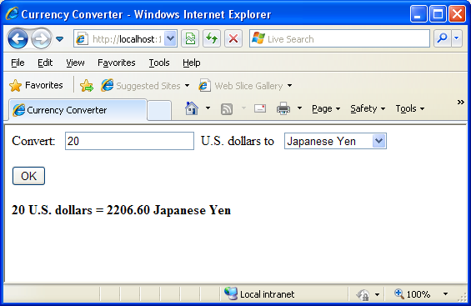

Figure 1-6

Adding other functionality to the currency converter is just as easy as adding a new button. For example, it might be useful for the utility to display a currency conversion rate graph. To provide this feature, the program would need an additional button and image control. Here’s the revised HTML:

<%@ Page Language="C#" AutoEventWireup="true" CodeFile="Default.aspx.cs" Inherits="Lab1._Default" %>

<!DOCTYPE html PUBLIC "-//W3C//DTD XHTML 1.0 Transitional//EN" "http://www.w3.org/TR/xhtml1/DTD/xhtml1-transitional.dtd">

<html xmlns="http://www.w3.org/1999/xhtml" >
<head>
<title>Currency Converter</title>
</head>
<body>
<form action="Default.aspx" method="post" id="Form1" runat="server">
<div>
Convert: &nbsp;
<input type="text" id="US" runat="server" />&nbsp; U.S. dollars to &nbsp;
<select id="Currency" runat="server" />
<br /><br />
<input type="submit" value="OK" id="Convert" runat="server" onserverclick="Convert_ServerClick" />
<input type="submit" value="Show Graph" id="ShowGraph" runat="server" />
<br /><br />
<img id="Graph" alt="Graph" src=" " runat="server" />
<br /><br />
<div style="font-weight: bold" id="Result" runat="server" />
</div>
</form>
</body>
</html>

As it’s currently declared, the image doesn’t refer to a picture. For that reason, it makes sense to hide it when the page is first loaded by using this code:

protected void Page_Load(object sender, EventArgs e)
{
if (this.IsPostBack == false)
{
Currency.Items.Add(new ListItem("Euros", "0.85"));
Currency.Items.Add(new ListItem("Japanese Yen", "110.33"));
Currency.Items.Add(new ListItem("Canadian Dollars", "1.2"));
}
Graph.Visible = false;
}

Now you can handle the click event of the new button to display the appropriate picture. The currency converter has three possible picture files—pic0.png, pic1.png, and pic2.png—depending on the selected currency. Double-click the Graph button to create a ServerClick event handler to display the graph.

Use the following code:

protected void ShowGraph_ServerClick(object sender, EventArgs e)
{
Graph.Src = "Pic" + Currency.SelectedIndex.ToString() + ".png";
Graph.Visible = true;
}

Before you run the project you will need to add the graph images to your project. In the Solution Explorer right-click on the Lab1 node and select Add > Existing Item. In the dialog select the O: drive, then the COM272 directory, and finally the Lab 1 directory. Select the three image files to add them to you project.

Run the project. You should see a display similar to Figure 1-7.

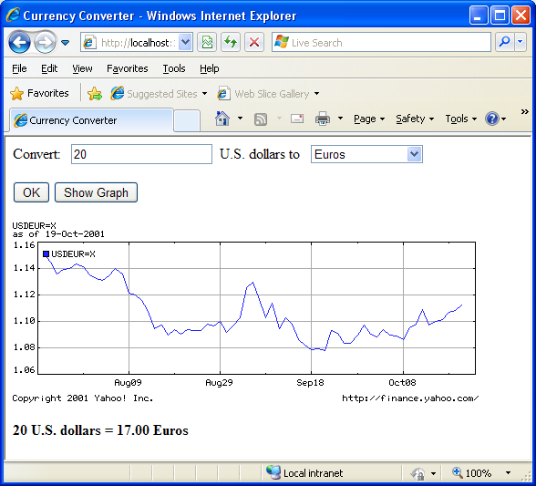

Figure 1-7

Setting Styles

In addition to a limited set of properties, each HTML control also provides access to the CSS style attributes through its Style collection. To use this collection, you need to specify the name of the CSS style attribute and the value you want to assign to it. Here’s the basic syntax:

ControlName.Style[“AttributeName”] = “AttributeValue”

For example, you could use this technique to emphasize an invalid entry in the currency converter with the color red. In this case, you’ll also need to reset the color to its original value for valid input, because the control uses view state to remember all its settings, including its style properties:

protected void Convert_ServerClick(object sender, EventArgs e)
{
decimal amount = decimal.Parse(US.Value);
if (amount <= 0)
{
Result.Style["color"] = "Red";
Result.InnerText = "Input Invalid - Please enter a positive” + “ numeric value";
}
else
{
Result.Style["color"] = "Black";

ListItem item = Currency.Items[Currency.SelectedIndex];

decimal newAmount = amount * Decimal.Parse(item.Value);
Result.InnerText = amount.ToString() + " U.S. dollars = ";
Result.InnerText += newAmount.ToString() + " " + item.Text;
}
}

Run the page and enter -5 as the input value.

The only problem with the previous example is that it generates an error if the user doesn’t cooperate and enters a non-numeric value. Using the TryParse( ) method will make the error handling more user friendly.

Make the following changes to Convert_ServerClick.

protected void Convert_ServerClick(object sender, EventArgs e)
{
Decimal amount;
Decimal.TryParse(US.Value, out amount);

if (amount <= 0)
{
Result.Style["color"] = "Red";
Result.InnerText = "Input Invalid - Please enter a positive” + “ numeric value";
}
else
{
Result.Style["color"] = "Black";

ListItem item = Currency.Items[Currency.SelectedIndex];

decimal newAmount = amount * Decimal.Parse(item.Value);
Result.InnerText = amount.ToString() + " U.S. dollars = ";
Result.InnerText += newAmount.ToString() + " " + item.Text;
}
}

Run the page and enter a letter in the input box.
Lesson #2
Topic | Building ASP .NET Web Pages | Points
Chapters | 4

Topics:
- Web page
- HTML Server Controls
- Tables
- Web Server Controls
  - Label
  - Literal
  - TextBox
  - Hidden Field
  - Button
  - LinkButton
  - ImageButton
  - Hyperlink
  - Check Box
  - Radio Button
  - Image
  - Image Map
  - Placeholder
  - Panel

A web page in ASP .NET is a file with an extension of .aspx and is one of the main components of a web application.

Normal HTML controls such as <h1>, <a>, and <input> are not processed by the server but are sent directly to the browser for display. Standard HTML controls can be exposed to the server and made available for server-side processing by turning them into HTML server controls.

To convert an HTML control to an HTML server control, simply add the attribute runat=”server”. In addition, you will probably want to add an id attribute, so the control contents can be accessed and controlled programmatically. For example, start with a simple input control:

<input type=”text” size=”40”>

You can convert it to an HTML server control by adding the id and runat attributes, as follows:

<input type=”text” id=”BookTitle size=”40” runat=”server”>

There are two main reasons for using HTML server controls rather than ASP .NET controls:
- Converting existing HTML pages to run under ASP .NET
  - To convert an HTML file to run under ASP .NET, all you need to do is change the extension of the file to .aspx. However, the HTML control will run client side, not server side. To take advantage of server-side processing, including automatic maintenance of state, you must add the runat attribute.
- Using HTML tables for page layout
  - Server-side controls consume server resources. For static tables commonly used to lay out the page, server-side processing is unnecessary unless you need to refer to one or more of the table elements in your code.

The primary control type used in ASP .NET is the ASP .NET server control. Server controls may have methods and event handlers associated with them, and this code is processed on the server. If the control has a visual component (e.g., labels, buttons, and tables), ASP .NET renders classic HTML to the browser. What is sent to the client is plain vanilla HTML, so ASP .NET programs can be run on any browser.

The ASP .NET server controls include all the functionality provided by HTML controls and much more. This includes basic controls such as buttons, labels, checkboxes, and tables, advanced data controls (such as data sources, lists, data grids, and grid views), validation controls, security and login controls, and rich controls (such as the Calendar, AdRotator, Menu and DynamicImage controls).

In the content file, the syntax used to implement ASP .NET server controls is of this form:

<asp:controlType
id=”ControlID”
runat=”server”
thisProperty=”this value”
thatProperty=”that value” />

The control tag always begins with asp:. The controlType is the type, or class, of the control, such as Button, CheckBoxList, or GridView. An id attribute allows you to refer to this instance of the control programmatically. The runat attribute tells the server this control is to be processed on the server.

ASP .NET server controls use well-formed XHTML syntax.

The browser never sees the ASP .NET server control. The server process the ASP .NET server control and sends standard HTML to the browser.

The Label control is used to display text. The Label control’s Text property contains the text string to be displayed.

The Literal is perhaps the simplest control in ASP .NET. If you set Literal’s Text property, it will simply insert that text into the output HTML code without altering it. Literal does not allow the setting of style information.

The TextBox control can be used for both user input and read-only text display. It may be configured to be single line or multiline or to accept passwords. If you set it to multiline, it automatically wraps unless the Wrap property is set to false.

The following example demonstrates the basic use of a Label and a TextBox control, including changing the Text property of a label and the use of the TextChanged event. This example uses two text boxes: one to input text, and a second, read-only control, to echo the contents of the first box. It also uses a Page_Load event to set the Text property of a label. The web page should look something like Figure 2.1 after changing the text in the input box.

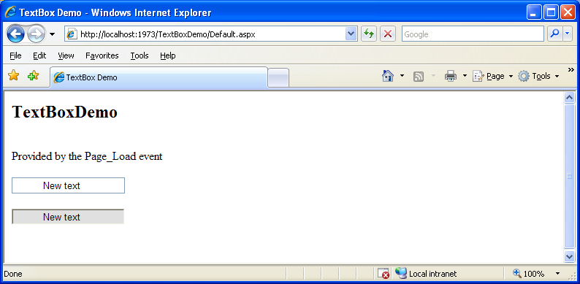

Figure 2.1

Create a Web Application project in VS2005 called TextBoxDemo. Drag one Label control and two TextBox controls onto the page. Set the ID property of the first TextBox to txtInput and the second to txtEcho. Set the ID property of the Label to lblMessage. Set the AutoPostBack property of txtInput to true, so that the form will automatically post back whenever the contents of the control changes. Set the BackColor property of txtEcho to LightGray and the ReadOnly property to true. The Default.aspx page source code should look like the following:

<%@ Page Language="C#" AutoEventWireup="true" CodeFile="Default.aspx.cs"
Inherits="TextBoxDemo._Default" %>

<!DOCTYPE html PUBLIC "-//W3C//DTD XHTML 1.0 Transitional//EN"
"http://www.w3.org/TR/xhtml1/DTD/xhtml1-transitional.dtd">

<html xmlns="http://www.w3.org/1999/xhtml" >
<head runat="server">
<title>Text Box Demo</title>
</head>
<body>
<form id="form1" runat="server">
<div>
<h2>TextBoxDemo</h2><br />
<asp:Label ID="lblMessage" runat="server"
Text="Label"></asp:Label><br />
<br />
<asp:TextBox ID="txtInput" runat="server" AutoPostBack="True"
OnTextChanged="txtInput_TextChanged">
Enter some text
</asp:TextBox><br />
<br />
<asp:TextBox ID="txtEcho" runat="server"
BackColor="#E0E0E0" ReadOnly="True"></asp:TextBox><br />
<br />
&nbsp;</div>
</form>
</body>
</html>

The following code goes in the code behind file:

using System;
using System.Data;
using System.Configuration;
using System.Web;
using System.Web.Security;
using System.Web.UI;
using System.Web.UI.WebControls;
using System.Web.UI.WebControls.WebParts;
using System.Web.UI.HtmlControls;

public partial class _Default : System.Web.UI.Page
{
protected void Page_Load(object sender, EventArgs e)
{
lblMessage.Text = "Provided by the Page_Load event";
}
protected void txtInput_TextChanged(object sender, EventArgs e)
{
txtEcho.Text = txtInput.Text;
}
}

HiddenField is a simple control that renders an input element whose type attribute is set to hidden. We can set its only important property, Value.

Buttons are controls that post the form back to the server, enabling server-side processing to commence. There are three types of ASP .NET Button controls:
- Button - This is the standard button.
- LinkButton - The LinkButton is sort of a cross between a standard button and a HyperLink control. A LinkButton appears to the user as a hyperlink.
- ImageButton - The ImageButton control performs the same function as the standard button, except that an image bitmap takes the place of the button. For the ImageButton control, there is no Text attribute but there is an AlternateText attribute for non-graphical browsers.

The next example, ButtonDemo, creates a web page containing a Button, a LinkButton, and an ImageButton. Each button transfers control to another web page.

The content file is shown below:

<%@ Page Language="C#" AutoEventWireup="true" CodeFile="Default.aspx.cs"
Inherits="ButtonDemo._Default" %>

<!DOCTYPE html PUBLIC "-//W3C//DTD XHTML 1.0 Transitional//EN"
"http://www.w3.org/TR/xhtml1/DTD/xhtml1-transitional.dtd">

<html xmlns="http://www.w3.org/1999/xhtml" >
<head runat="server">
<title>Button Demo</title>
</head>
<body>
<form id="form1" runat="server">
<div>
<h1>Button Controls</h1>
<asp:Button ID="btnLink" runat="server"
Text="Link To Target Page"
ToolTip="Click here to go to the target page."
OnClick="btnLink_Click" />
<asp:ImageButton ID="imgLink" runat="server"
AlternateText="Link to Target Page"
ImageUrl="~/Images/green.bmp"
ToolTip="Click here to go to target page."
OnClick="imgLink_Click" />
<asp:LinkButton ID="lnkLink" runat="server"
ToolTip="Click here to go to the target page."
Font-Name="Comic Sans MS Bold"
Font-Size="16pt"
OnClick="btnLink_Click">
LinkButton to Target Page
</asp:LinkButton>
</div>
</form>
</body>
</html>

The code for the code behind file is shown below:

using System;
using System.Data;
using System.Configuration;
using System.Web;
using System.Web.Security;
using System.Web.UI;
using System.Web.UI.WebControls;
using System.Web.UI.WebControls.WebParts;
using System.Web.UI.HtmlControls;

public partial class _Default : System.Web.UI.Page
{
protected void Page_Load(object sender, EventArgs e)
{

}
protected void btnLink_Click(object sender, EventArgs e)
{
Response.Redirect("TargetPage.aspx");
}
protected void imgLink_Click(object sender,ImageClickEventArgs e)
{
Response.Redirect("TargetPage.aspx");
}
}

Create a Web Page and name it TargetPage.aspx

<%@ Page Language="C#" AutoEventWireup="true" CodeBehind="TargetPage.aspx.cs"
Inherits="ButtonDemo.TargetPage" %>

<!DOCTYPE html PUBLIC "-//W3C//DTD XHTML 1.0 Transitional//EN"
"http://www.w3.org/TR/xhtml1/DTD/xhtml1-transitional.dtd">

<html xmlns="http://www.w3.org/1999/xhtml" >
<head runat="server">
<title>Target Page</title>
</head>
<body>
<form id="form1" runat="server">
<div>
<h1>This is the Target Page</h1>
</div>
</form>
</body>
</html>

The HyperLink control creates on your page a hyperlink that links to the URL in the NavigateUrl property. Unlike the LinkButton control, which offers features such as Click events and validation, Hyperlinks are meant to be used to navigate from one page to the next.

<asp:HyperLink id=”myLink” NavigateUrl=”http://www.arkhambooks.com”
ImageUrl=”arkhamlogo.gif” runat=”server”>Arkham Books</asp:HyperLink>

If it’s specified, the ImageUrl attribute causes the control to display the specified image, in which case the text is demoted to acting as the image’s alternate text.

You can use a CheckBox control to represent a choice that can have only two possible states - checked or unchecked.

<asp:CheckBox id=”questionCheck” Text=”I agree, I like .NET”
Checked=”True” runat=”server” />

The main event associated with a Checkbox is the CheckChanged event, which can be handled with the OnCheckChanged attribute. The Checked property is True if the box is checked, and False otherwise.

A RadioButton is a lot like a CheckBox, except that RadioButtons can be grouped together to represent a set of options from which only one can be selected. Radio buttons are grouped together using the GroupName property.

<asp:RadioButton id=”sanDiego” GroupName=”City” Text=”San Diego”
runat=”server” /><br />
<asp:RadioButton id=”boston” GroupName=”City” Text=”Boston”
runat=”server” /><br />
<asp:RadioButton id=”phoenix” GroupName=”City” Text=”Phoenix”
runat=”server” /><br />

Like the CheckBox control, the main event associated with RadioButtons is the CheckChanged event, which can be handled with the OnCheckChanged attribute. The other control we can use to display radio buttons is RadioButtonList, which will be covered in the next lesson.

An Image control creates an image that can be accessed dynamically from code; it equates to the <img> tag in HTML. Here’s an example:

<asp:Image id=”myImage” ImageUrl=”myGif.gif” runat=”server”
AlternateText=”Description” />

The ImageMap control generates HTML to display images that have certain clickable regions called hot spots. Each hot spot reacts differently when clicked by the user.

These areas are defined using three controls that generate hot spots of different shapes: CircleHotSpot, RectangleHotSpot, and PolygonHotSpot.

The following example defines an image map with two circular hot spots:

<asp:ImageMap id=”myImageMap” runat=”server” ImageUrl=”image.jpg”>
<asp:CircleHotSpot AlternateText=”Button1”
Radius=”20” X=”50” Y=”50” />
<asp:CircleHotSpot AlternateText=”Button2”
Radius=”20” X=”100” Y=”50” />
</asp:ImageMap>

Possible values of HotSpotMode:

HotSpotMode value | Behavior when hot spot is clicked
Inactive | None
Navigate | The user is navigated to the specific URL
NotSet | When set for a HotSpot, the behavior is inherited from the parent ImageMap; if the parent ImageMap doesn’t specify a default value, Navigate is set
PostBack | The hot spot raises the click event that can be handled server-side to respond to the user action

To configure the action that results when a hot spot is clicked by the user, we set the HotSpotMode property of the ImageMap control, or the HotSpotMode property of the individual hot spot objects, or both, using the values shown above. If the HotSpotMode property is set for the ImageMap control as well as for an individual hot spot, the latter property will override that set for the more general ImageMap control.

The PlaceHolder control lets us add elements at a particular place on a page at any time, dynamically, through our code.

<asp:PlaceHolder id=”placeholder” runat=”server” />

The following code dynamically adds a new HtmlButton control within the placeholder:

public void Page_Load( )
{
HtmlButton myButton = new HtmlButton( );
myButton.InnerText = “My New Button”;
placeholder.Controls.Add(myButton);
}
The Panel control functions similarly to the div element in HTML, in that it allows the set of items that resides within the tag to be manipulated as a group. For instance, the Panel could by made visible or hidden by a Button’s Click.

<asp:Panel id=”myPanel runat=”server”>
<p>Username: <asp:TextBox id=”usernameTextBox” Columns=”30”
runat=”server” /></p>
<p>Password: <asp:TextBox id=”passwordTextBox”
TextMode=”Password” Columns=”30” runat=”server” /></p>
</asp:Panel>
<asp:Button id=”hideButton” Text=”Hide Panel” OnClick=”HidePanel” runat=”server” />

The code above places two TextBoxes within a Panel control. The Button control is outside of the Panel. The HidePanel subroutine would then control the Panel’s visibility by setting its Visible property to False:

public void HidePanel (Object s, EventArgs e)
{
myPanel.Visible = false;
}

In this case, when the user clicks the button, the Click event is raised and the HidePanel subroutine is called, which sets the Visible property of the Panel control to False.

Lesson #3
Topic | Advanced Server Controls | Points
Chapters | 4, 5 and 12

Topics:

- List Controls
  - Drop Down List
  - List Box
  - Radio Button List
  - Check Box List
  - Bulleted List
- Calendar
- AdRotator
- TreeView
- Site Map Path
- Menu
- MultiView and View Controls
- Master Pages
- Handling Page Navigation
- CSS
- Themes
- Skins

List Controls
In this lesson, we will discuss the ASP .NET controls that display simple list of elements: ListBox, DropDownList, CheckBoxList, RadioButtonList, and BulletedList.

DropDownList
A DropDownList control is similar to the HTML select element. The DropDownList control allows you to select one item from a list using a drop-down menu.

<asp:DropDownList id=”ddlFavColor” runat=”server”>
<asp:ListItem Text=”Red” value=”red” />
<asp:ListItem Text=”Blue” value=”blue” />
<asp:ListItem Text=”Green” value=”green” />
</asp:DropDownList>

The most useful event that this control provides is SelectedIndexChanged. This event is exposed by other list controls, such as the CheckBoxList and RadioButtonList controls, allowing for easy programmatic interaction with the control. These controls can also be bound to a database, allowing you to extract dynamic content into a drop-down menu.

ListBox
A ListBox equates to the HTML select with either the multiple or size attribute (size would need to be set to a value of 2 or more). If you set the SelectionMode attribute to Multiple, the user will be able to select more than one item from the list, as in this example:

<asp:ListBox id=”listTechnologies” runat=”server”
SelectionMode=”Multiple”>
<asp:ListItem Text=”ASP .NET” Value=”aspnet” />
<asp:ListItem Text=”JSP” Value=”jsp” />
<asp:ListItem Text=”PHP” Value=”php” />
<asp:ListItem Text=”CGI” Value=”cgi” />
<asp:ListItem Text=”ColdFusion” Value=”cf” />
</asp:Listbox>
RadioButtonList
Like the RadioButton control, the RadioButtonList control represents a list of radio buttons and uses more compact syntax. Here’s an example:

<asp:RadioButtonList id=”favoriteColor” runat=”server”>
<asp:ListItem Text=”Red” Value=”red” />
<asp:ListItem Text=”Blue” Value=”blue” />
<asp:ListItem Text=”Green” Value=”green” />
</asp:RadioButtonList>

CheckBoxList
The CheckBoxList control represents a group of check boxes: it’s equivalent to using several CheckBox controls in a row:

<asp:CheckBoxList id=”favoriteFood” runat=”server”>
<asp:ListItem Text=”Pizza” Value=”tacos” />
<asp:ListItem Text=”Tacos” Value=”blue” />
<asp:ListItem Text=”Pasta” Value=”pasta” />
</asp:CheckBoxList>

BulletedList
The BulletedList control displays bulleted or numbered lists, using <ul> (unordered list) or <ol> (ordered list) tags. Unlike the other list controls, the BulletedList doesn’t allow the selection of items, so the SelectedIndexChanged event isn’t supported.

The first property you’ll want to set is DisplayMode, which can be Text (the default), or HyperLink, which will render the list items as links. When DisplayMode is set to HyperLink, you can use the Click event to react when the user clicks on one of the items.

The other important property is BulletStyle, which determines the style of the bullets. The accepted values are Numbered (1, 2, 3, …), LowerAlpha (a, b, c, …), UpperAlpha (A, B, C, …), LowerRoman (i, ii, iii, …), UpperRoman (I, II, III, …), Circle, Disc, Square, and CustomImage. If the style is set to CustomImage, you’ll also need to set the BulletStyleImageUrl to specify the image to be used for the bullets. If the style is one of the numbered lists, you can also set the FirstBulletNumber property to specify the first number or letter that’s to be used.

The Calendar is a great example of the reusable nature of ASP .NET controls, The Calendar control generates the markup to display an intuitive calendar in which the user can click to select or move between days, weeks, months, and so on.

The Calendar control requires very little customization, and can be created within a page like this:

<!DOCTYPE HTML PUBLIC "-//W3C//DTD HTML 4.01//EN"
"http://www.w3.org/TR/html4/strict.dtd">
<html>
<head>
<title>Calendar Test</title>
</head>
<body>
<form runat="server">
<asp:Calendar id="myCalendar" runat="server" />
</form>
</body>
</html>

The above code will display the following page:

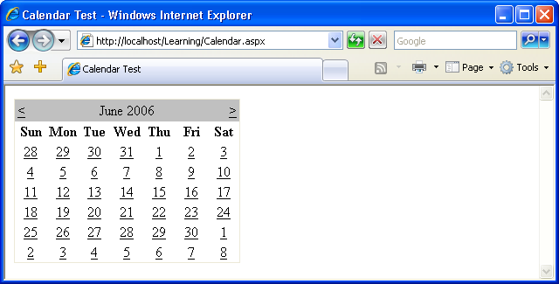

The Calendar control contains a wide range of properties, methods, and events, including those listed in the following table.

Property | Description
DayNameFormat | Sets the format of the day names. Its possible values are FirstLetter, FirstTwoLetters, Full, and Short. The default is Short, which displays the three-letter abbreviation.
FirstDayOfWeek | Sets the day of the week that begins each week in the calendar. By default, the value of this property is determined by your server’s region settings, but you can set this to Sunday or Monday if you want to control it.
NextPrevFormat | Set to CustomText by default, this property can be set to ShortMonth or FullMonth to control the format of the next and previous month links.
SelectedDate | Contains a DataTime value that specifies the hightlighted day, You’ll use this property a lot to determine which day the user has selected.
SelectionMode | This property determines whether days, weeks, or months can be selected: its possible values are Day, DayWeek, DayWeekMonth, and None, and the default is Day. When Day is selected, a user can only select a day; when DayWeek is selected, a user can select a day or an entire week; and so on.
SelectMonthText | Controls the text of the link that’s displayed to allow users to select an entire month from the calendar.
SelectWeekText | Controls the text of the link that’s displayed to allow users to select and entire week from the calendar.
ShowDayHeader | If True, this property displays the names of the days of the week. The default is True.
ShowGridLines | If True, this property renders the calendar with grid lines. The default is True.
ShowNextPrevMonth | If True, this property displays next/previous month links. The default is True.
ShowTitle | If True, This property displays the calendar’s title. The default is False.
TitleFormat | This property determines how the month name appears in the title bar. Possible values are Month and MonthYear. The default is MonthYear.
TodaysDate | This DateTime value sets the calendar’s current date. By default, this value is not highlighted within the Calendar control.
VisibleDate | This DateTime value controls which month is displayed.

The next example uses some of these properties, events, and methods to create a Calendar control that allows users to select days, weeks, and months. Modify the code from the first example and add a label to it, as follows:

<asp:Calendar ID="myCalendar" runat="server" DayNameFormat="Short"
FirstDayOfWeek="Sunday" NextPrevFormat="FullMonth"
SelectionMode="DayWeekMonth" SelectWeekText="Select Week"
SelectMonthText="Select Month" TitleFormat="Month"
OnSelectionChanged="SelectionChanged" />
<h2>You selected these dates:</h2>
<asp:Label ID="myLabel" runat="server" />

Now add a <script runat=”server”> to the head of the web form to include the SelectionChanged event handler referenced by your calendar:

<script runat="server" language="C#">
void SelectionChanged(Object s, EventArgs e)
{
yLabel.Text = "";
foreach (DateTime d in myCalendar.SelectedDates)
{
yLabel.Text += d.ToString("D") + "<br />";
}
</script>

Save your work and test it in a browser. Try selecting a day, week, or month. The selection will be highlighted similar to the display show below.

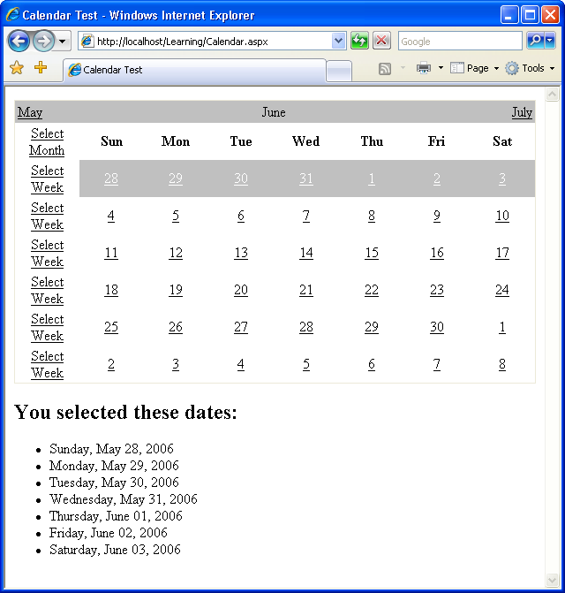

In SelectionChanged, we loop through each date that the user has selected, and append it to the Label we added to the page.

The AdRotator control allows you to display a list of banner advertisements within your web application at random. However, it’s more than a mere substitute for creating a randomization script from scratch. Since the AdRotator control gets its content from an XML file, the administration and updating of banner advertisement files and their properties is a snap. Also, the XML file allows you to control the banner’s image, link, link target, and frequency of appearance in relation to other banner ads.

The benefits of using this control don’t stop there, though. As most of the AdRotator control’s properties reside within an XML file, if you wished, you could share that XML file on the Web, essentially allowing value added resellers, or possibly your companies’ partners, to use your banner ads on their web sites.

XML Basics

In essence, XML is simply a text-based format for the transfer or storage of data; it contains no details on how that data should be presented. XML is very easy to start with because of its close resemblance to HTML: both are largely comprised of tags inside angle brackets (< and >), and any tag may contain attributes specific to that tag. The biggest difference between XML and HTML is that, rather than providing a fixed set of tags as HTML does, XML allows us to create our own tags to describe the data we wish to represent.

Take a look at the following HTML element:

<p>The Nightmare Before Christmas</p>

This example describes the content between the tags as a paragraph. This is fine if all we are concerned with is displaying the words “The Nightmare Before Christmas” on a web page. But what if we want to access those words as data?

Like HTML, XML’s purpose is to describe the content of a document. But unlike HTML, XML doesn’t describe how that content should be displayed; it describes what the content is. Using XML, the web author can mark up the contents of a document, describing that content in terms of its relevance as data.

We can use XML to mark up the words “The Nightmare Before Christmas” in a way that better reflects this content’s significance as data:

<film>
<title> The Nightmare Before Christmas</title>
</film>

Here, the XML tag names we’ve chosen best describe the contents of the element. We also define our own attribute names as necessary. For instance, in the example above, you may decide that you want to differentiate between the VHS version and the DVD version of the film, or record the name of the movie’s director. This can be achieved by adding attributes and elements, as shown below:

<film>
<title> The Nightmare Before Christmas</title>
<director>Tim Burton</director>
</film>

If you want to print this out, create a file called ads.xml and insert the content listed below.

<Advertisements>
<Ad>
<ImageUrl>workatglacier.gif</ImageUrl>
<NavigateUrl>http://www.glacierpoint.com</NavigateUrl>
<TargetUrl>_blank</TargetUrl>
<AlternateText>Work at GlacierPoint.com!</AlternateText>
<Keyword>HR Sites</Keyword>
<Impressions>2</Impressions>
</Ad>
<Ad>
<ImageUrl>getthenewsletter.gif</ImageUrl>
<NavigateUrl>http://www.glacierpoint.com</NavigateUrl>
<TargetUrl>_blank</TargetUrl>
<AlternateText>Get the Glacier Newsletter!</AlternateText>
<Keyword>Marketing Sites</Keyword>
<Impressions>1</Impressions>
</Ad>
</Advertisements>

As you can see, the Advertisements element is the root node, and in accordance with the XML specification, it appears only once. For each individual advertisement, we simply add an Ad child element. For instance, the above file contains details for two banner ads.

The elements of the Ad file include:

ImageURL - the URL of the image to display for the banner ad

NavigateURL - the web page to which your users will navigate when they click the banner ad

AlternateText - the alternate text to display for browsers that do not support images

Keyword - the keyword to use to categorize your banner ad
If you use the KeywordFilter property of the AdRotator control, you can specify the categories of banner ads to display.

Impressions - the relative frequency that a particular banner should be shown in relation to other banner ads. The higher this number the more frequently that specific banner will display in the browser.
Except for ImageURL, all these elements are optional. Also, if you specify an Ad without a NavigateURL, the banner ad will display without a hyperlink.

To make use of this ads.xml file, create a new ASP .NET page, called AdRotator.aspx, with the following code:

<!DOCTYPE html PUBLIC "-//W3C//DTD XHTML 1.0 Strict//EN"
"http://www.w3.org/TR/xhtml1/DTD/xhtml1-strict.dtd">
<html>
<head>
<title>AdRotator Control</title>
</head>
<body>
<form runat="server">
<asp:AdRotator ID="adRotator" runat="server"
AdvertisementFile="Ads.xml" />
</form>
</body>
</html>

The images list are only examples, you will need to download the images that you want to use.

The TreeView control is a very powerful control that’s capable of displaying a complex hierarchical structure of items. Typically we’d use it to view a directory structure or a site navigation hierarchy, but it could by used to display a family tree, a coporate organizational chart, or any other hierarchical structure.

The TreeView can pull its data from various sources. Here we’ll focus on the SiteMapDataSource class, which, as its name suggests, contains a hierarchical sitemap. By default, this sitemap is read from a file called Web.sitemap located in the root of your project. The Web.sitemap is an XML file that looks like this:

<siteMap
xmlns="http://schemas.microsoft.com/AspNet/SiteMap-File-1.0">
<siteMapNode title="Home" url="~/Default.aspx"
description="Home">
<siteMapNode title="TreeViewDemo" url="~/TreeViewDemo.aspx"
description="TreeView Example" />
<siteMapNode title="ClickEvent" url="~/ClickEvent.aspx"
description="ClickEvent Example" />
<siteMapNode title="Loops" url="~/Loops.aspx"
description="Loops Example" />
</siteMapNode>
</sitemap>

To use this file, you’ll need to add a SiteMapDataSource to the page, as well as a TreeView control that uses this data source, like this:

<!DOCTYPE html PUBLIC "-//W3C//DTD XHTML 1.0 Strict//EN"
"http://www.w3.org/TR/xhtml1/DTD/xhtml1-strict.dtd">
<html>
<head>
<title>TreeView Demo</title>
</head>
<body>
<form runat="server">
<asp:SiteMapDataSource ID="mySiteMapDataSource"
runat="server" />
<asp:TreeView ID="myTreeView" runat="server"
DataSourceID="mySiteMapDataSource" />
</form>
</body>
</html>

Note that although the SiteMapDataSource is a control, it does not generate any HTML within the web page.

When combined the the Web.sitemap file, this web form would generate an output shown below.

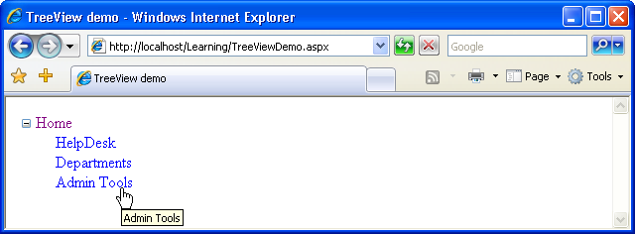

As you can see, the TreeView control generated the tree for use. The root Home node can even be collapsed or expanded. In many cases, we don’t want to show the root node: we can hide it from view by setting the ShowStartingNode property of the SiteMapDataSource to false:

<asp:SiteMapDataSource ID="mySiteMapDataSource" runat="server"
ShowStartingNode="false" />

The SiteMapPath control provides the functionality to generate a breadcrumb navigational structure for your site. Breadcrumb systems help to orientate users, giving them an easy way to identify their current location within the site, and provide handy links to the current location’s ancestor nodes. An example of a breadcrumb navigation system is shown below.

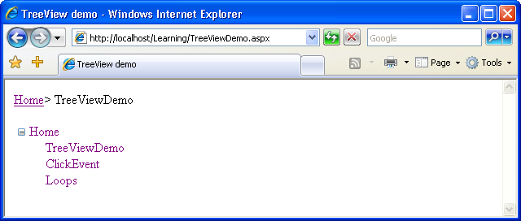

The SiteMapPath control will automatically use any SiteMapDataSource control that exists in a web form to display a user’s current location. For example, you could simply add the following code to the form you worked with in the previous example to achieve the effect shown above:

<asp:SiteMapPath id="mySiteMapPath" runat="server"
PathSeparator=" > ">
</asp:SiteMapPath>

If you run the example now, you’ll see the breadcrumb appear exactly as it’s shown above.

Note that the SiteMapPath control shows only the nodes that correspond to existing pages of your site, so if you don’t have a file named Default.aspx, the root node link won’t show up. Similarly, if the page you’re loading isn’t named TreeViewDemo.aspx, the SiteMapPath control won’t generate any output.

The Menu control is similar to TreeView in that it displays hierarchical data from a data source; the ways in which we work with both controls are also very similar. The most important differences between the two lie in their appearances, and the fact that Menu supports templates for better customization and displays only two levels of items (menu and submenu items).

The MultiView control is similar to Panel in that it doesn’t generate interface elements itself, but contains other controls. A MultiView can store more pages of data (called views), and lets you show one page at a time. You can change the active view by setting the value of the ActiveViewIndex property. The first page corresponds to an ActiveViewIndex of 0, the second page is 1, the third page is 2, and so on.

The contents of each template are defined inside child View elements. Consider the following code, which creates a Button control, and a MultiView control:

<!DOCTYPE html PUBLIC "-//W3C//DTD XHTML 1.0 Strict//EN"
"http://www.w3.org/TR/xhtml1/DTD/xhtml1-strict.dtd">
<html>
<head>
<title>MultiView Demo</title>
</head>
<body>
<form runat="server">
<p>
<asp:Button id="myButton" Text="Switch Page"
runat="server" OnClick="SwitchPage" />
</p>
<asp:MultiView ID="myMultiView" runat="server"
ActiveViewIndex="0">
<asp:View ID="firstView" runat="server">
<p>... contents of the first view ...</p>
</asp:View>
<asp:View ID="secondView" runat="server">
<p>... contents of the second view ...</p>
</asp:View>
</asp:MultiView>
</form>
</body>
</html>

As you can see, by default, the ActiveViewIndex is 0, so when this code is first executed, the MultiView will display its first template, shown below.

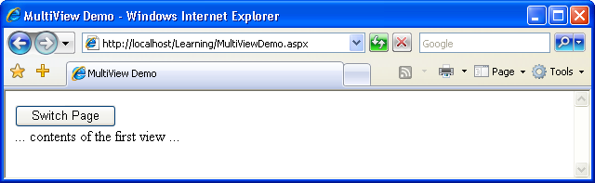

Clicking the button will cause the second template to be displayed. Here’s the code for the SwitchPage event handler:

<script runat="server" language="C#">
public void SwitchPage(Object s, EventArgs e)
{
myMultiView.ActiveViewIndex =
(myMultiView.ActiveViewIndex + 1) % 2;
}
</script>

This simple subroutine uses the modulo operator to set the ActiveViewIndex to 1 when its original value is 0, and vice versa.

The MultiView control has a number of other handy features, so be sure to check the documentation for this control.

Lesson #4
Topic | Web Application Features | Points
Chapter | 2

Topics:

- The Web Forms Designer
- The Code Editor
- Toolbox
- Properties Window
- Running the application
- Web.config
- Global.asax
- Using Application State
- User Sessions
- Caching
- Cookies

Web.config
Almost every ASP.NET web application contains a file named Web.config, which stores various application settings. By default, all ASP.NET web applications are configured in the Machine.config file, which contains machine-wide settings, and lives in the C:\WINDOWS\Microsoft.NET\Framework\version\CONFIG directory.

For the most part, you won’t want to make any modifications to this file. However, you can override certain settings of the Machine.config file by adding a Web.config file to the root directory of your application. You may already have this file in your project; if you don’t, you can add one by accessing File > New > File…, then selecting Web Configuration File from the dialog that appears.

The Web.config file is an XML file that can hold configuration settings for the application in which the file resides. One of the most useful settings that Web.config controls is ASP.NET’s debug mode.

When using C#, you’ll need to create the Web.config file yourself. Go to File > New File…, then select Web Configuration File from the dialog that appears, and click Add. This will create the default Web.config file, which will contain the following section:

<!--
Set compilation debug="true" to insert debugging
symbols into the compiled page. Because this
affects performance, set this value to true only
during development.
-->
<compilation debug="false" />

Set debug to true to enable ASP.NET’s debugging features.

Global.asax

Global.asax is another special file that can be added to the root of an application. It defines subroutines that are executed in response to application-wide events.
For instance, Application_Start is executed the first time the application runs (or just after we restart the server). This makes this method the perfect place to execute any initialization code that needs to run when the application loads for the first time. Another useful method is Application_Error, which is called whenever an unhandled error occurs within a page. The following is a list of the handlers that you’ll use most often within the Global.asax file:

Application_Start
called immediately after the application is created; this event occurs once only

Application_End
called immediately before the end of all application instances

Application_Error
called by an unhandled error in the application

Application_BeginRequest
called by every request to the server

Application_EndRequest
called at the end of every request to the server

Application_PreSendRequestHeaders
called before headers are sent to the browser

Application_PreSendRequestContent
called before content is sent to the browser

Application_AuthenticateRequest
called before authenticating a user

Application_AuthorizeRequest
called before authorizing a user

The Global.asax file is created in the same way as the Web.config file—just select File > New > File…, then choose the Global Application Class template, as depicted in Figure 4.1.

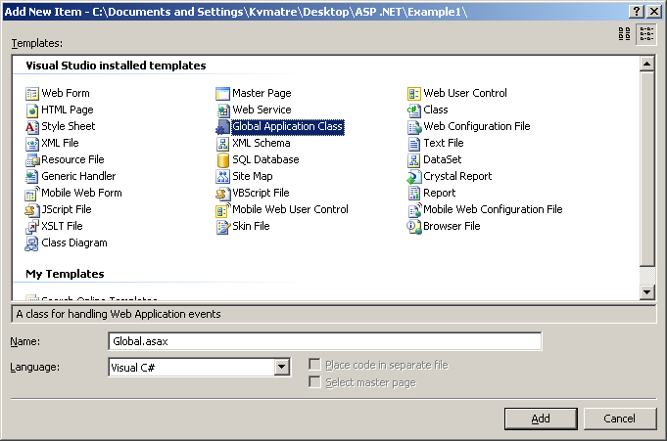
Figure 4.1

Clicking Add will create in the root of your project a new file named Global.asax, which contains empty stubs for a number of event handlers, and comments that explain their roles. A typical event handler in a Global.asax file looks something like this:

void Application_EventName(Object sender, EventArgs e)
{
…
}

Be cautious when you add and modify code within the Global.asax file. Any additions or modifications you make within this file will cause the application to restart, so you’ll lose any data stored in application state.

Using Application State
You can store the variables and objects you want to use throughout an entire application in a special object called Application. The data stored in this object is called application state. The Application object also provides you with methods that allow you to share application state data between all the pages in a given ASP.NET application very easily.

Application state is closely related to another concept: session state. The key difference between the two is that session state stores variables and objects for one particular user for the duration of that user’s current visit, whereas application state stores objects and variables that are shared between all users of an application at the same time. Thus, application state is ideal for storing data that’s used by all users of the same application.

In ASP.NET, session and application state are both implemented as collections, or sets of name-value pairs. You can set the value of an application variable named SiteName like this:

Application["SiteName"] = "GlacierPoint Intranet Application";

With SiteName set, any pages in the application can read this string:

String appName = Application["SiteName"];

You can remove an object from application state using the Remove method, like this:

Application.Remove("SiteName");

If you find you have multiple objects and application variables lingering in application state, you can remove them all at once using the RemoveAll method:

Application.RemoveAll();

It’s important to be cautious when using application variables. Objects remain in application state until you remove them using the Remove or RemoveAll methods, or shut down the application in IIS. If you continue to save objects into the application state without removing them, you can place a heavy demand on server resources and dramatically decrease the performance of your applications.

Let’s take a look at application state in action. Application state is very commonly used to maintain hit counters, so our first task in this example will be to build one! Let’s modify the Default.aspx page that Visual Web Developer created for us. Double-click Default.aspx in Solution Explorer, and add a Label control inside the form element. You could drag the control from the Toolbox (in either Design View or Source View) and modify the generated code, or you could simply enter the new code by hand. We’ll also add a bit of text to the page, and change the Label’s ID to myLabel, as shown below:

<form id="form1" runat="server">
<div>

The page has been requested
<asp:Label ID="myLabel" runat="server" />
times!

</div>
</form>

In Design View, you should see your label appear inside the text, as shown in Figure 4.2.

Now, let’s modify the code-behind file to use an application variable that will keep track of the number of hits our page receives. Double-click in any empty space on your form; Visual Web Developer will create a Page_Load subroutine automatically, and display it in the code editor.

The new label appearing in Design View:

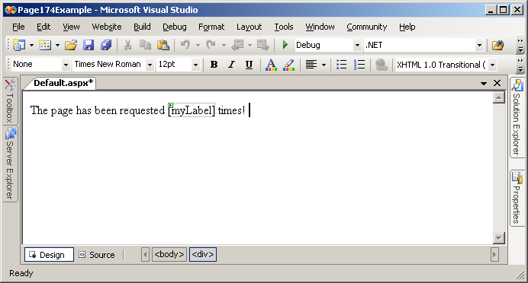
Figure 4.2

public partial class _Default : System.Web.UI.Page
{
protected void Page_Load(object sender, EventArgs e)
{

}
}

Now, let’s modify the automatically generated method by adding the code that we want to run every time the page is loaded. Modify Page_Load as shown below:

protected void Page_Load(object sender, EventArgs e)
{
// Reset counter when it reaches 10
if ( Application["PageCounter"] != null &&
(int)Application["PageCounter"] >= 10 )
{
Application.Remove("PageCounter");
}
// Initialize or increment page counter each time the page loads
if (Application["PageCounter"] == null)
{
Application["PageCounter"] = 1;
}
else
{
Application["PageCounter"] =
(int)Application["PageCounter"] + 1;
}
// Display page counter
myLabel.Text = Convert.ToString(Application["PageCounter"]);
}

Before analyzing the code, press F5 to run the site and ensure that everything works properly. Every time you refresh the page, the hit counter should increase by one until it reaches ten, when it starts over. Now, shut down your browser altogether, and open the page in another browser. We’ve stored the value within application state, so when you restart the application, the page hit counter will remember the value it reached in the original browser, as Figure 4.3 shows.

If you play with the page, reloading it over and over again, you’ll see that the code increments PageCounter every time the page is loaded. First, though, the code verifies that the counter hasn’t reached or exceeded ten requests. If it has, the counter variable is removed from the application state.

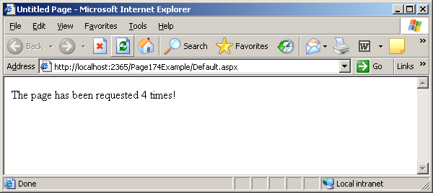

Figure 4.3

As everything in application state is stored as an Object, C# requires that we cast the value to an integer before we make use of it. This conversion won’t work if PageCounter hasn’t been added to application state, so we also need to check that it’s not equal to null.

Next, we try to increase the hit counter. First of all, we need to verify that the counter variable exists in the application state. If it doesn’t, we set it to 1, reflecting that the page is being loaded.

We compare the value to null in C#:

// Initialize or increment page counter each time the page loads
if (Application["PageCounter"] == null)
{
Application["PageCounter"] = 1;
}
else
{
Application["PageCounter"] =
(int)Application["PageCounter"] + 1;
}

The last piece of code simply displays the hit counter value in the label.

There’s one small problem with our code: if two people were to open the page simultaneously, the value could increment only by one, rather than two. The reason for this has to do with the code that increments the counter:

Application["PageCounter"] =
(int)Application["PageCounter"] + 1;

The expression to the right of the = operator is evaluated first; to do this, the server must read the value of the PageCounter value stored in the application. It adds one to this value, then stores the updated value in application state.

Now, let’s imagine that two users visit this page at the same time, and that the web server processes the first user’s request a fraction of a second before the other request. The web form that’s loaded for the first user might read Page-Counter from application state and obtain a value of 5, to which it would add 1 to obtain 6. However, before the web form had a chance to store this new value into application state, another copy of the web form, running for the second user, might read PageCounter and also obtain the value 5. Both copies of the page will have read the same value, and both will store an updated value of 6!

To avoid this kind of confusion, we should develop the application so that each user locks application state, updates the value, and then unlocks application state so that other users can do the same thing.

Let’s modify our code slightly to create these locks:

// Initialize or increment page counter each time the page loads
if (Application["PageCounter"] == null)
{
Application["PageCounter"] = 1;
}
else
{
// Lock the Application object
Application.Lock();
// Increment counter
Application["PageCounter"] =
(int)Application["PageCounter"] + 1;
// Unlock the Application object
Application.UnLock();
}

In this case, the Lock method guarantees that only one user can work with the application variable at any time. Next, we call the UnLock method to unlock the application variable for the next request. Our use of Lock and UnLock in this scenario guarantees that the application variable is incremented by one for each visit that’s made to the page.

Working with User Sessions
Like application state, session state is an important way to store temporary information across multiple page requests. However, unlike application state, which is accessible to all users, each object stored in session state is associated with a particular user’s visit to your site. Stored on the server, session state allocates each user free memory on that server for the temporary storage of objects (strings, integers, or any other kinds of objects).

The process of reading and writing data into session state is very similar to the way we read and write data to the application state: instead of using the Application object, we use the Session object. However, the Session object doesn’t support locking and unlocking like the Application object does.

To test session state, you could simply edit the Page_Load method to use Session instead of Application, and remove the Lock and UnLock calls if you added them. The easiest way to replace Application with Session is by selecting Edit > Find and Replace > Quick Replace.

In the page hit counter example that we created earlier in this chapter, we stored the count in the application state, which created a single hit count that was shared by all users of the site. Now, if you load the page in multiple browsers, you’ll see that each increments its counter independently of the others.

Like objects stored in application state, session state objects linger on the server even after the user leaves the page that created them. However, unlike application variables, session variables disappear after a certain period of user inactivity. Since web browsers don’t notify web servers when a user leaves a web site, ASP.NET can only assume that a user has left your site after a period in which it hasn’t received any page requests from that user. By default, a user’s session will expire after 20 minutes of inactivity. We can change this timeframe simply by increasing or decreasing the Timeout property of the Session object, as follows:

Session.Timeout = 1560;

You can do this anywhere in your code, but the most common place to set the Timeout property is in the Global.asax file. If you open Global.asax, you’ll see that it contains an event handler named Session_Start. This method runs before the first request from each user’s visit to your site is processed, and gives you the opportunity to initialize their session variables before the code in your web form has a chance to access them.

Here’s a Session_Start that sets the Timeout property to 15 minutes:

void Session_Start(Object sender, EventArgs e)
{
Session.Timeout = 1560;
}

Using the Cache Object
In traditional ASP, developers used application state to cache data. Although there’s nothing to prevent you from doing the same thing here, ASP.NET provides a new object, Cache, specifically for that purpose. Cache is also a collection, and we access its contents similarly to the way we accessed the contents of Application. Another similarity is that both have application-wide visibility, being shared between all users who access a web application.

Let’s assume that there’s a list of employees that you’d normally read from the database. To spare the database server’s resources, after you read the table from the database the first time, you might save it into the cache using a command like this:

Cache["Employees"] = employeesTable;

By default, objects stay in the cache until we remove them, or server resources become low, at which point objects begin to be removed from the cache in the order in which they were added. The Cache object also lets us control expiration—if, for example, we want to add an object to the cache for a period of ten minutes, we can use the Insert method. Here’s an example:

Cache.Insert("Employees", employeesTable, null,
DateTime.MaxValue, TimeSpan.FromMinutes(10));

The third parameter, which in this case is Nothing or null, can be used to add cache dependencies. We could use such dependencies to invalidate cached items when some external indicator changes, but that kind of task is a little beyond the scope of this discussion.

Later in the code, we could use the cached object as follows:

employeesTable = Cache["Employees"];

Objects in the cache can expire, so it’s good practice to verify that the object you’re expecting does actually exist, to avoid any surprises:

employeesTable = Cache["Employees"];
if (employeesTable == null)
{
// Read the employees table from another source
Cache["Employees"] = employeesTable;
}

This sample code checks to see if the data you’re expecting exists in the cache. If not, it means that this is the first time the code has been executed, or that the item has been removed from the cache. Thus, we can populate employeesTable from the database, remembering to store the retrieved data into the cache. The trip to the database server is made only if the cache is empty or not present.

Using Cookies
If you want to store data related to a particular user, you could use the Session object, but this approach has an important drawback: its contents are lost when the user closes the browser window.

To store user data for longer periods of time, you need to use cookies. Cookies are pieces of data that your ASP.NET application can save on the user’s browser, to be read later by your application. Cookies aren’t lost when the browser is closed (unless the user deletes them), so you can save data that helps identify your user in a cookie.
In ASP.NET, a cookie is represented by the HttpCookie class. We read the user’s cookies through the Cookies property of the Request object, and we set cookies through the Cookies property of the Response object. Cookies expire by default when the browser window is closed (much like session state), but their points of expiration can be set to dates in the future; in such cases, they become persistent cookies.

Let’s do a quick test. First, open Default.aspx and remove the text surrounding myLabel:

<form id="form1" runat="server">
<div>
<asp:Label ID="myLabel" runat="server" />
</div>
</form>

Then, modify Page_Load in the code-behind file as shown:

protected void Page_Load(object sender, EventArgs e)
{
// Declare a cookie variable
HttpCookie userCookie;
// Try to retrieve user's ID by reading the UserID cookie
userCookie = Request.Cookies["UserID"];
// Verify if the cookie exists
if (userCookie == null)
{
// Display message
myLabel.Text =
"Cookie doesn't exist! Creating a cookie now.";
// Create cookie
userCookie = new HttpCookie("UserID", "JoeBlack");
// Set cookie to expire in one month
userCookie.Expires = DateTime.Now.AddMonths(1);
// Save the cookie on the client
Response.Cookies.Add(userCookie);
}
else
{
// Display message
myLabel.Text = "Welcome back, " + userCookie.Value;
}
}

The first time you load the page, you’ll be notified that the cookie doesn’t exist, and that a new cookie is being created, via a message like the one shown in Figure 4.4.
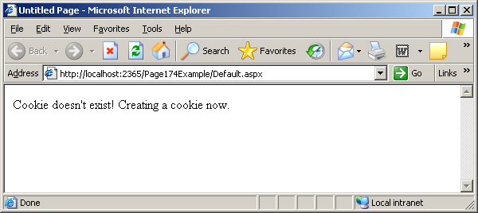

Figure 4.4

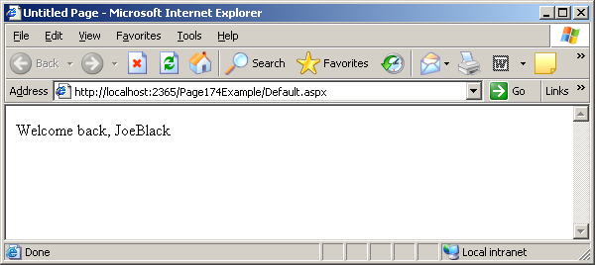

Figure 4.5

If you reload the page, the cookie will be found, and you’ll get a different message, as Figure 4.5 shows.

If you go through the code, you’ll see that it’s pretty much self-explanatory. What’s interesting to observe is that you can close the browser window, or even restart your computer—the cookie will still be there, and the application will be able to identify that you’re a returning visitor. As you can see in the code, the cookie is set to expire one month after creation.

Be aware that visitors can choose to reject your cookies, so you can’t rely on them for essential features of your application.

Lesson #5
Topic | Introduction to the GlacierPoint Tutorial | Points
Chapter | 12 and 13
GlacierPoint | Part 1

Topics:
- Preparing a SiteMap
- Creating a Theme
- The Master Page
- Creating a Web Page that uses a Master Page
- The GlacierPoint Tutorial - Part One

The Glacier Point Tutorial will demonstrate how to develop a simple, but fairly complete company intranet web application. The tutorial will span the next few lessons, with each lesson adding more pages to the application. Create a new Web Application and name it GlacierPoint. Select the ASP.NET Web Application template, identify the location where the application should be created, leave the checkbox checked and Click OK.

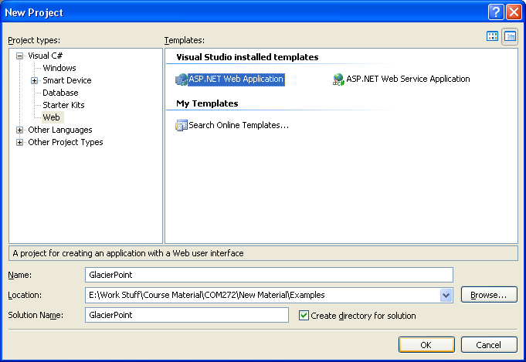
Figure 5-1

The GlacierPoint Intranet
Part 1

Real-world web development project are built according to a detailed specification document, which includes, among other information, specific details of the site’s layout. We will assume that the pages in the GlacierPoint intranet will be laid out as shown in Figure 5-2.

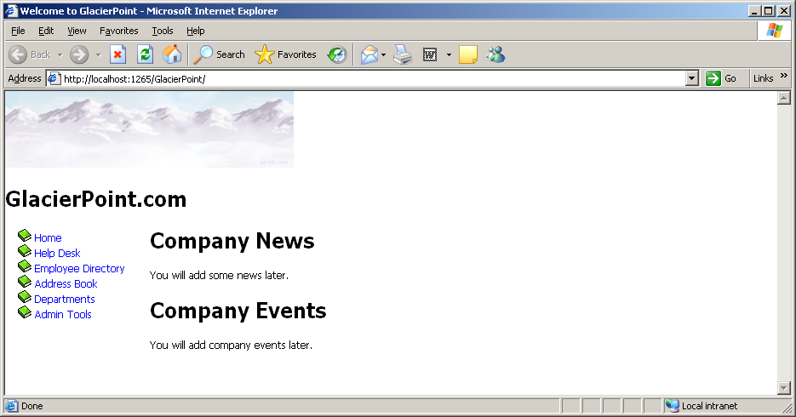
Figure 5-2

The menu on the left suggests that the site will have more pages than this homepage, and that they will have the same structure: On every page of the site, the menu will sit on the left, and the header will be identical to the one shown here. Only the contents of each individual page will be different from the others.

The intranet application that you will develop will offer the following functionality:
- Homepage—you can customize this page by including news about the GlacierPoint Company.
- Help desk—this page allows GlacierPoint employees to submit problems they experience with software, hardware, or their computers, as help desk tickets that are sent to an IT administrator.
- Employee directory—employees will likely want to call other employees about company matters. The employee directory will let employees find other staff members’ details.
- Address book—while the employee directory houses handy information for staff use, the purpose of the address book is to provide more detailed information about every employee within the company.
- Departments—the departments page displays information about GlacierPoint’s various departments.
- Admin tools—administrators will need the ability to perform various administrative tasks, such as updating users’ information. The Admin Tools section will provide the interface for those kinds of tasks.

You will learn new techniques when building each of these pages.

You have already created the Web Application and now you will start developing it.

The star of the show will be the master page, but because it needs to have the sitemap and the theme in place, you will deal with those first.

Preparing the Sitemap
As you saw in Figure 5-2, on the left of every page of the GlacierPoint site will sit a menu that contains links to the site’s pages. You will implement that list using the SiteMapDataSource control, which will require a sitemap file.

In the Solution Explorer, right-click the root node and select Add > New Item…, this will display the dialog box shown in Figure 5-3.

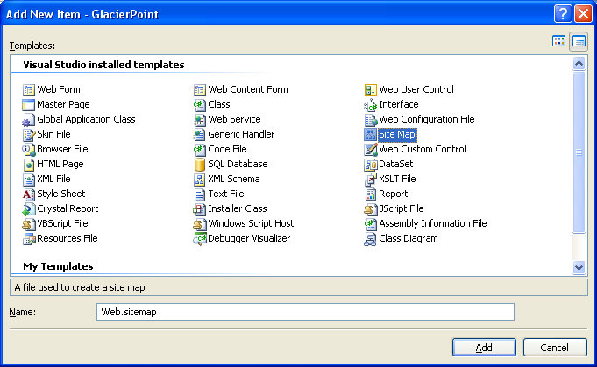

Figure 5-3

From the templates list, choose Site Map, as shown in Figure 2 and leave the filename as Web.sitemap. Click Add to have the file created and added to your project. You will be presented with a default, empty sitemap that you can start modifying. Change its contents as shown in Code Sample 1.

<?xml version="1.0" encoding="utf-8" ?>
<siteMap
xmlns="http://schemas.microsoft.com/AspNet/SiteMap-File-1.0" >
<siteMapNode url="~/" title="Root" description="Root">
<siteMapNode url="~/Default.aspx" title="Home"
description="GlacierPoint Home" />
<siteMapNode url="~/HelpDesk.aspx" title="Help Desk"
description="GlacierPoint Help Desk" />
<siteMapNode url="~/EmployeeDirectory.aspx"
title="Employee Directory"
description="GlacierPoint Employee Directory" />
<siteMapNode url="~/AddressBook.aspx" title="Address Book"
description="GlacierPoint Address Book" />
<siteMapNode url="~/Departments.aspx" title="Departments"
description="GlacierPoint Departments" />
<siteMapNode url="~/AdminTools.aspx" title="Admin Tools"
description="Admin Tools" />
</siteMapNode>
</siteMap>
Code Sample 1
Your sitemap file is ready to be used.

Using Themes, Skins, and Styles
You will be using CSS to build the layout of the GlacierPoint interface. CSS provides developers with flexibility and control over the look of their web applications, and makes it very simple to keep the appearance of the web site consistent.

In ASP .NET, style sheets can be managed through a mechanism called themes. Themes can be used to do much more than simply select which style sheets are applied to an application, as you will see shortly. But first, you will add a style sheet to your GlacierPoint site.

Creating a New Theme Folder
Right-click the root node in the Solution Explorer, and select Add > ASP.NET Folder > Theme. You will then be able to type in a name for the new theme. Type Blue, then press Enter. You will now have a new folder called App_Themes in the root of your project, with a subfolder called Blue.

You will keep all the files related to the default appearance of GlacierPoint in the Blue folder.
Creating a New Style Sheet
You will start by adding a new CSS file to the Blue theme. CSS files can be created independently of themes, but it’s easier in the long term to save them to themes—this way, your solution becomes more manageable, and you can save different versions of you CSS files under different themes. Any files with the .css in a theme’s folder will be automatically linked to any web form that uses that theme.

Right-click the “Blue” theme folder, and select Add > New Item… Select the Style Sheet template to create a new file named GlacierPoint.css, and click Add. By default, GlacierPoint.css will be almost empty. Add the following styles to GlacierPoint.css. You will use these styles soon, when you build the first page of GlacierPoint.

body
{
font-family: Tahoma, Helvetica, Arial, sans-serif;
font-size: 12px;
}
h1
{
font-size: 25px;
}
a:link, a:visited
{
text-decoration: none;
color: Blue;
}
a:hover
{
color: Red;
}
.Header
{
top: 0px;
left: 0px;
position: absolute;
width: 800px;
}
.Menu
{
top: 160px;
left: 15px;
width: 195px;
position: absolute;
}
.Content
{
top: 160px;
left: 170px;
position: absolute;
width: 600px;
}
Remember, you are not limited to using these styles. If, during the development of the application, you decide to add more styles, you simply need to open the GlacierPoint.css file and add them as necessary.

Styling Web Server Controls
CSS styles can apply only to HTML elements—they can’t really be used to keep the appearance of web server controls consistent.

If CSS cannot keep web server controls consistent, then what can? Skins, which were introduced in ASP .NET 2.0, they can define default values for server-side controls.

Skin definitions are saved into files with the .skin extension. A skin definition looks like the markup for a normal web server control, except that it does not have an ID, and it can’t set event handlers. This makes sense, since the skin isn’t an actual control.

If a skin is part of the theme that’s applied to the current page, all controls of the same type will inherit all of these property values automatically. These values can be overridden, but the skin provides the default values.

A skin can also contain a SkinId property, and if it does, it becomes a named skin. A named skin doesn’t apply automatically to all controls of its type. It only affects those that specify that the skin applies to them.

Adding a Skin
The truth is, you don’t really need skins for this site, but you will add one so that you can get a feel for their functionality. Right-click on the Blue node in the Solution Explorer, and select Add > New Item… Choose the Skin File template, name it SkinFile.skin, and click Add.

Visual Studio adds a comment to the file. This comment contains default text that briefly describes skins. A theme can contain one or may skin files, and each skin file can contain one or more skin definitions. ASP .NET will automatically read all the files with the .skin extension.

Let’s say that you want all TextBox controls to have the default ForeColor property set to blue. Without skins, you would need to set this property manually on all TextBox controls in your site. However, you can achieve the same effect by adding this line (after the comments) to your SkinFile.skin file:

<asp:TextBox runat=“server” ForeColor=“blue” />

Once the theme containing this skin has been applied, this new skin will give all TextBox controls on your site the default ForeColor of blue.

Applying the Theme
In order for your CSS and the skin to take effect, you will need to apply the theme to your web page. Once the new theme has been created, applying it is easy. You can apply a new theme using the Web.config configuration file, or through your code.

For now you will use Web.config. The theme can be set using the theme attribute of the pages element, which should be located inside the system.web element.

You will need to add the pages element to the system.web element yourself:

<system.web>

<pages theme=“Blue” />
…
</system.web>

Building the Master Page
All of the pages in GlacierPoint have a common structure, with the same header on the top, and the same menu on the left, so it makes sense to build a master page. With this master page in place, you will be able to create pages for the site by writing only the content that makes them different, rather than writing the header and the menu for each page.

Right-click the root node in the Solution Explorer and select Add > New Item… Select the Master Page template, and name it GlacierPoint.master.

After you click the Add button, Visual Studio creates the new master page, which will appear in the Solution Explorer. If you expand its node you will see its code-behind file listed as a child node.

Double-click the GlacierPoint.master file (not its code-behind file) in the Solution Explorer, and you will find that Visual Studio has given you a very simple default master page. Edit the markup inside the body element as shown below:

<body>
<form id="form1" runat="server">
<!-- Header -->
<div class="Header">
<asp:Image id="Image1" runat="server"
ImageUrl="~/Images/GlacierPoint.jpg" Width="339" Height="90"
AlternateText="The GlacierPoint Company Intranet" />
<h1>GlacierPoint.com</h1>
</div>
<!-- Menu -->
<div class="Menu">
<asp:SiteMapDataSource id="glacierPointSiteMap" runat="server"
ShowStartingNode="false" />
<asp:Menu id="glacierPointMenu" runat="server"
DataSourceID="glacierPointSiteMap">
<StaticItemTemplate>
<img src="Images/Book_Closed.gif" alt="+"
width="16" height="16" style="border-width: 0;" />
<%# Eval("Text")%>
</StaticItemTemplate>
</asp:Menu>
</div>
<!-- Content -->
<div class="Content">
<asp:ContentPlaceHolder id="ContentPlaceHolder1"
runat="server" />
</div>
</form>
</body>

Code Sample 2

The code is pretty simple. Basically, it defines the layout of all the GlacierPoint pages. Each of the three sections defined here starts with a comment that identifies the section as being the header, the menu on the left, or the content area. These elements are positioned on the page using the CSS styles you added earlier to the GlacierPoint.css file, so you may want to have another look at that file to refresh your memory.

To build the menu on the left-side of the page, you created a Web.sitemap file, then added a SiteMapDataSource control to your master page.

<asp:SiteMapDataSource id="glacierPointSiteMap" runat="server"
ShowStartingNode="false" />

The Web.sitemap file forces you to add a root siteMapNode element, but you can supress this root element using the SiteMapDataSource. You will set its ShowStartingNode property to False.

To have the Menu control simply display the list of nodes, it’s sufficient to set its DataSourceID to the ID of the SiteMapDataSource. However, the Menu control also gives us the potential to customize the look of each menu item through templates. Here, we used the StaticItemTemplate to add a little book image to the left of each menu item:

<asp:Menu id="glacierPointMenu" runat="server"
DataSourceID="glacierPointSiteMap">
<StaticItemTemplate>
<img src="Images/book_closed.gif" alt="+"
width="16" height="16" style="border-width: 0;" />
<%# Eval("Text")%>
</StaticItemTemplate>
</asp:Menu>

Now you will need to add a folder to your project to hold the images that are used by the master file. Right-click the root node in the Solution Explorer and select Add > New Folder. Name the new folder Images. Now you will copy two images from the O: drive. Right-click the Images folder and select Add > Existing Item… Select the O: drive and the COM272 directory. From the GlacierPoint directory select the two picture files (GlacierPoint.jpg and Book_Closed.gif) and click Add.

The master page is now in place. Click the Design button at the base of the editor window to see a preview of the page. It should look like Figure 5-4.

Note that the CSS styles do not apply at design time.

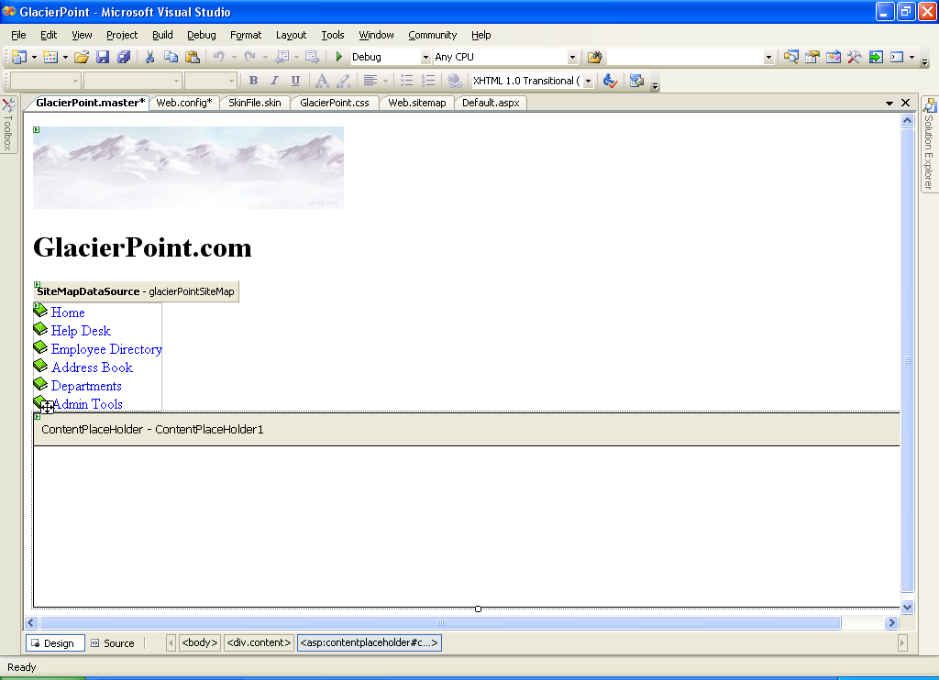

Figure 5-4
Now you will assemble all the pieces that you have been building and put them to work. You will start by re-creating the Default.aspx web form, but this time you will use the master page. Start by deleting your current Default.aspx by right-clicking that file in the Solution Explorer, and choosing Delete. You will be warned that the file is about to be deleted. Choose OK.

Right-click the root node and select Add > New Item… from the context menu.

In the dialog that appears, choose the Web Content Form template and name it Default.aspx. The Web Content Form will allow you to select a master page. See Figure 5-5.

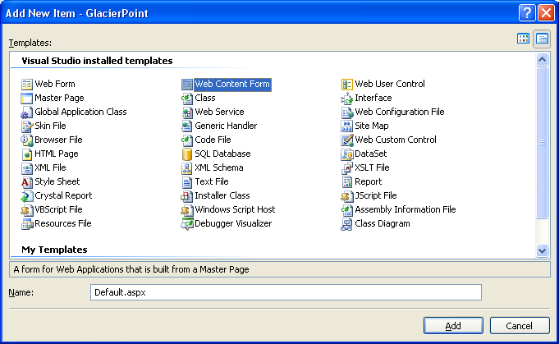

Figure 5-5

Once you click Add, you will be asked to select the master page you want to use. Choose GlacierPoint.master, and click OK. Your new form inherits everything from its master page, so its code is minimal:

You will modify the file by adding some content to the ContentPlaceHolder, and altering the page title. Edit the file to reflect the highlighted sections below:

<%@ Page Language="C#" MasterPageFile="~/GlacierPoint.master"
AutoEventWireup="true" CodeFile="Default.aspx.cs"
Inherits="_Default" Title="Welcome to GlacierPoint" %>
<asp:Content ID="Content1"
ContentPlaceHolderID="ContentPlaceHolder1" Runat="Server">
<h1>Company News</h1>
<p>You will add some news later.</p>
<h1>Company Events</h1>
<p>You will add company events later.</p>
</asp:Content>

Switch to Design View to see a preview of the whole page, like the one shown in Figure 5-6. The master page areas will be grayed out, and only the content placeholder will be editable.

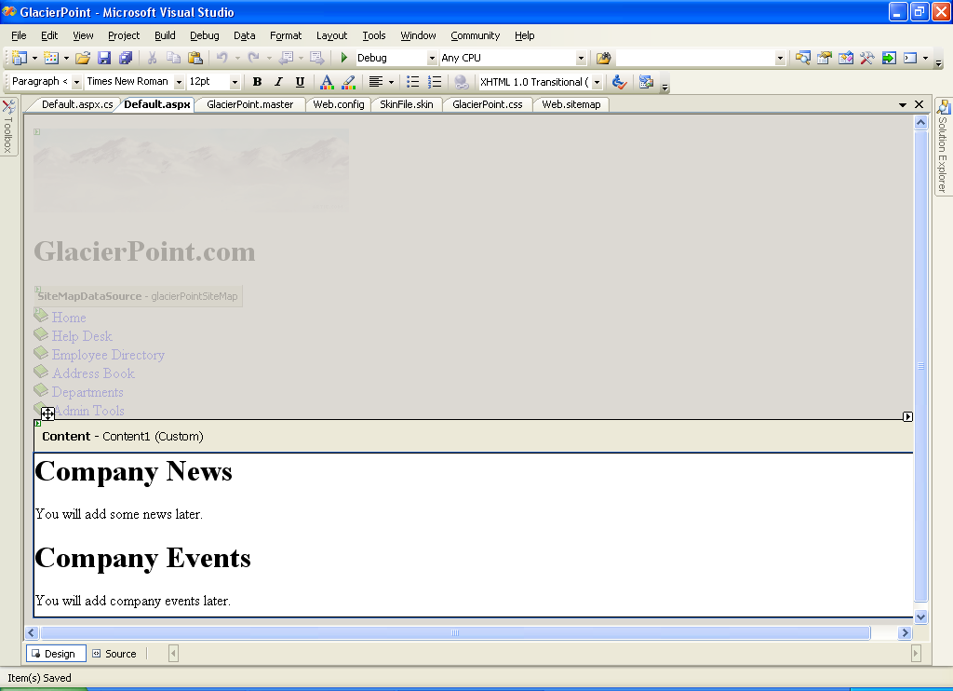

Figure 5-6

By default, when you press F5, Visual Studio executes the page that’s being edited. However, if you prefer, you can set a particular page to execute whenever you run the application. To make sure that Default.aspx is the page that’s loaded when the project is executed, right-click Default.aspx in the Solution Explorer, and select Set As Start Page.

Now execute the project by pressing F5. It should appear as per the page in Figure 5-7.

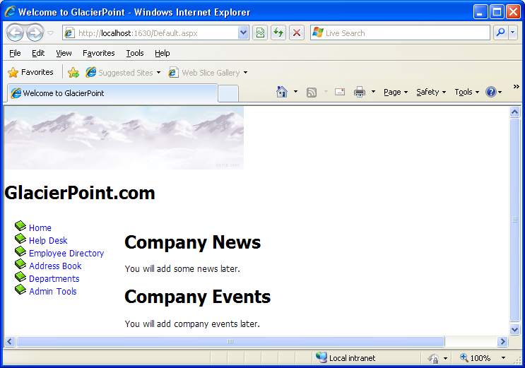

Figure 5-7
Extending GlacierPoint
You will extend the GlacierPoint site by adding an employee help desk request web content form. This form will allow GlacierPoint employees to report hardware, software, and workstation problems to the help desk. The web form will be arranged into a series of simple steps that users will follow to report their problems. The process will include the following stages:
- Choose from a predefined list of potential problem areas.
- Choose from a range of predefined subjects that are related to the problem area.
- Enter a description of the problem.
- Submit the request.

As we already have a master page that defines the layout of the site’s pages, adding a new page is now a trivial task. Create a web content form in the same way you created Default.aspx, but this time, name it HelpDesk.aspx. Be sure to select GlacierPoint.master as the master page file. Modify the default code as show below:

<%@ Page Language="C#" MasterPageFile="~/GlacierPoint.master" AutoEventWireup="true" CodeFile="HelpDesk.aspx.cs" Inherits="GlacierPoint.HelpDesk" Title="GlacierPoint Help Desk" %>
<asp:Content ID="Content1" ContentPlaceHolderID="ContentPlaceHolder1" runat="Server">
<h1>Employee Help Desk Request</h1>
<p>
Station Number:<br />
<asp:TextBox id="stationTextBox" runat="server"
CssClass="textbox" />
</p>
<p>
Problem Category:<br />
<asp:DropDownList id="categoryList" runat="server"
CssClass="dropdownmenu" />
</p>
<p>
Problem Subject:<br />
<asp:DropDownList id="subjectList" runat="server"
CssClass="dropdownmenu" />
</p>
<p>
Problem Description:<br />
<asp:TextBox id="descriptionTextBox" runat="server"
CssClass="textbox" Columns="40" Rows="4"
TextMode="MultiLine" />
</p>
<p>
<asp:Button id="submitButton" runat="server"
CssClass="button" Text="Submit Request" /></p>
</asp:Content>
Don’t worry that the DropDownList controls don’t have items associated with them—eventually, the categories and subjects will be retrieved from a database. When you’re finished, save your work, execute the project, and click the Help Desk link from the menu. You should see the display shown in Figure 5-8.

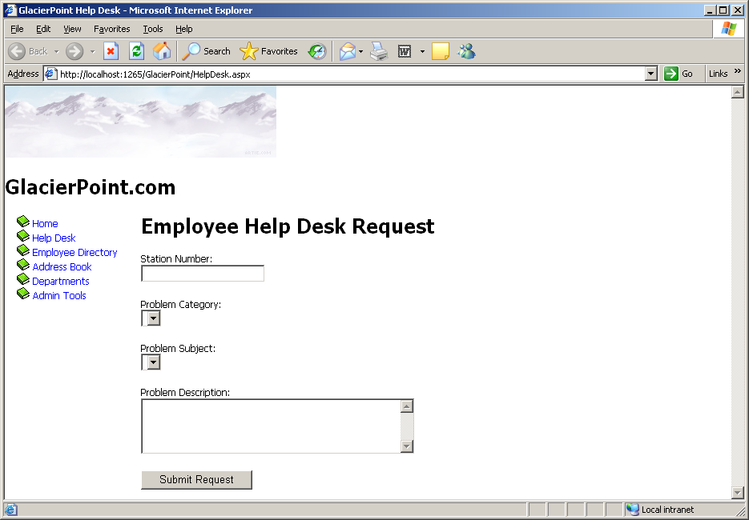
Figure 5-8

This page gives you the opportunity to test the skin file you created earlier. If you type text into the text boxes, you will see that the color of the text is blue. True, this effect could have been achieved just as easily through CSS, but in the future, when you are working on projects that utilize more complex controls and properties, skins might be your only choice.
Lesson #6
Topic | Validation Controls | Points
Chapter | 8

Topics:
- Server-Side Validation
- Client-Side Validation
- Validation Controls – Handout (provided by your Instructor)
  - Required Field
  - Range
  - Regular Expression
  - Compare
  - Custom
  - Validation Summary
- The GlacierPoint Tutorial – Part Two

The GlacierPoint Intranet
Part 2

Updating GlacierPoint

Now that you’ve spent some time with validation controls, let’s use them to update GlacierPoint’s Help Desk page. The following rules must be met before the user can submit a new help desk request:

- The station number text box cannot be empty.
- The station number must be a valid number.
- The station number must be a numeral between 1 and 50.
- A description of the problem must be entered.

To make changes to the help desk page, you first need to load the GlacierPoint project in Visual Studio. Go to File > Open > Project/Solution… and select the GlacierPoint project.
After GlacierPoint loads, open HelpDesk.aspx in the editor and make the following changes to the file:

<%@ Page Language="C#" MasterPageFile="~/GlacierPoint.master"
AutoEventWireup="true" CodeFile="HelpDesk.aspx.cs" Inherits="GlacierPoint.HelpDesk"
Title="GlacierPoint Help Desk"%>
<asp:Content ID="Content1"
ContentPlaceHolderID="ContentPlaceHolder1" Runat="Server">
<h1>Employee Help Desk Request</h1>
<p>
Station Number:<br />
<asp:TextBox id="stationTextBox" runat="server"
CssClass="textbox" />
<asp:RequiredFieldValidator id="stationNumReq" runat="server"
ControlToValidate="stationTextBox"
ErrorMessage="<br />You must enter a station number!"
Display="Dynamic" />
<asp:CompareValidator id="stationNumCheck" runat="server"
ControlToValidate="stationTextBox"
Operator="DataTypeCheck" Type="Integer"
ErrorMessage="<br />The value must be a number!"
Display="Dynamic" />
<asp:RangeValidator id="stationNumRangeCheck" runat="server"
ControlToValidate="stationTextBox"
MinimumValue="1" MaximumValue="50" Type="Integer"
ErrorMessage="<br />Number must be between 1 and 50."
Display="Dynamic" />
</p>
<p>
Problem Category:<br />
<asp:DropDownList id="categoryList" runat="server"
CssClass="dropdownmenu" />
</p>
<p>
Problem Subject:<br />
<asp:DropDownList id="subjectList" runat="server"
CssClass="dropdownmenu" />
</p>
<p>
Problem Description:<br />
<asp:TextBox id="descriptionTextBox" runat="server"
CssClass="textbox" Columns="40" Rows="4"
TextMode="MultiLine" />
<asp:RequiredFieldValidator id="descriptionReq" runat="server"
ControlToValidate="descriptionTextBox"
ErrorMessage="<br />You must enter a description!"
Display="Dynamic" />
</p>
<p>
<asp:Button id="submitButton" runat="server"
CssClass="button" Text="Submit Request" />
</p>
</asp:Content>

Now execute the project, and select the Help Desk page from the menu. Clicking Submit without entering valid data triggers the validation controls, as Figure 6-1 shows.

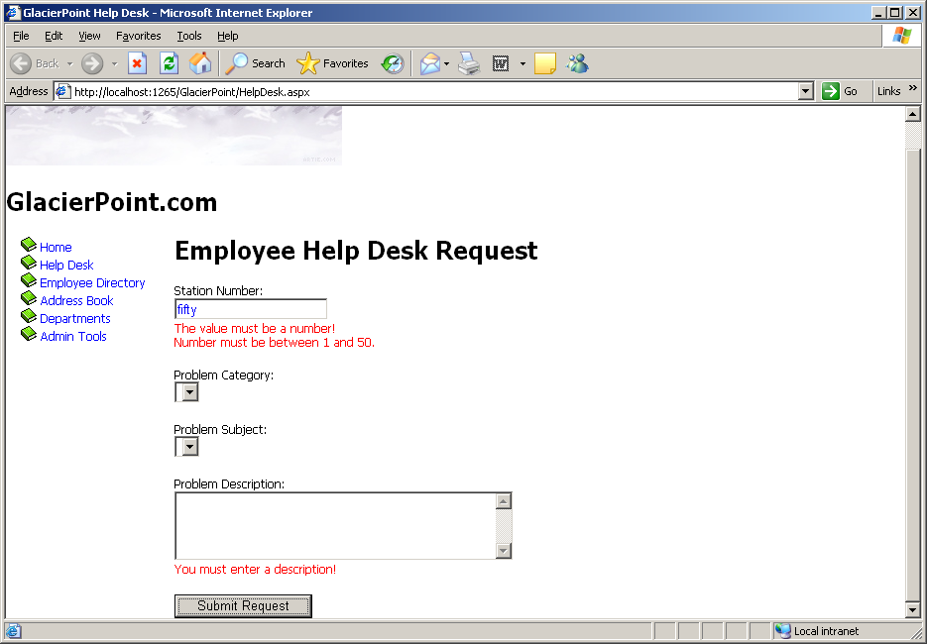
Figure 6-1

Right now, we’re not doing anything with the data that’s been entered, but we’ll take care of that in following lessons. When we finally do something with this data, we don’t want our server-side code to try to work with invalid data. Let’s add the safety check to the server side as well, to make sure we have a solid foundation from which to start developing our server-side functionality in the next chapters.

Stop the project from within Visual Studio, and open HelpDesk.aspx in Design View. There, double-click the Submit Request button to have its Click event handler generated for you.

Add the following code to the event handler:

if (Page.IsValid)
{
// Code that uses the data entered by the user
}

Up to this point, we’ve only discussed one way of tying a control’s event to an event handler method. This approach involves setting a property, such as OnClick, on the control, as shown here:

<asp:Button id="submitButton" runat="server" CssClass="button"
Text="Submit Request" OnClick="submitButton_Click" />

This property causes ASP.NET to call a method named submitButton_Click whenever this button is clicked. If you’re using C#, you’ll see that Visual Studio added this property to the submitButton when it generated your event handler, as is shown above.

You will expand the code inside this method in later lessons, but for the time being, you can rest assured that you’ve put the validation mechanism in place.

Lesson #7
Topic | Using ADO .NET with ASP .NET | Points
Chapters | 9 and 10

Topics:
- SqlConnection
- SqlCommand
- SqlDataReader
- The Repeater Control
- The GlacierPoint Tutorial - Part 3

ADO .NET
The next step is to learn how to access a database using C# code. This, of course, is the goal we’ve been aiming for from the beginning of our adventures in ASP.NET. The whole purpose of the data store is to support an application; in our case, that application is the GlacierPoint Intranet web application, the purpose of which is to offer users an easy-to-use interface to company data.

ADO.NET (ActiveX Data Objects .NET) is a modern Microsoft technology that permits us to access a relational database from an application’s code. With ADO.NET, we’ll be able to display lists of employees and departments, and allow users to add data to the data store, directly from the GlacierPoint application.

In this lesson, you’ll learn:

- how to connect to your database using ADO.NET
- how to execute SQL queries and retrieve their results using ADO.NET
- how to display data that is read from a database
- how to handle data access errors

Before you go any further you need to create the GlacierPoint database. You will use the file GlacierPoint.sql from the COM272 directory of the O:\ drive. Your instructor will show you how to do this.

ADO.NET is able to use different types of data connections, depending on the kind of database to which the application is trying to connect. The ADO.NET classes whose names start with Sql (such as SqlConnection, SqlCommand, etc.) are specifically built to connect to an MS SqlServer database.

Similar classes are provided for other databases—for example, if you’re working with Oracle, you can use classes such as OracleConnection, OracleCommand, and so on. If, on the other hand, you’re working with database systems for which such classes are not specifically designed, you can use generic low-level interfaces; most databases can be accessed through the OLE DB interface (using classes such as OleDbConnection and OleDbCommand), or the older ODBC interface (using classes such as OdbcConnection and OdbcCommand).

In this lesson, we’ll use only the MS SqlServer classes, but it’s good to know that you have options!

In order to use ADO.NET, we must first decide which kind of database we’ll use, and import those namespaces containing classes that work with the database. Since we’re using MS SqlServer, you’ll need to import the System.Data.SqlClient namespace. This contains all the required MS SqlServer classes, the most important of which are:

SqlConnection
This class exposes properties and methods for connecting to an MS SqlServer database.

SqlCommand
This class holds data about the SQL queries and stored procedures that you intend to run on your MS SqlServer database.

SqlDataReader
Data is returned from the database in a SqlDataReader class. This class comes with properties and methods that let you iterate through the data it contains. Traditional ASP developers can think of the SqlDataReader as being similar to a forward-only RecordSet, in which data can only be read forward, one record at a time, and you cannot move back to the beginning of the data stream.

The System.Data.SqlClient namespace exposes many more than the few classes listed above. Once you’re ready to begin working with ADO.NET, the task of establishing a link between the database and your application is a straightforward, six-step process:

- Import the necessary namespaces. ( By default, the .dll file that contains System.Data.SqlClient is included in a Web application, but you will need to include the following command in the code-behind file: using System.Data.SqlClient; )
2. Define a connection to your database with a SqlConnection object.
3. When you’re ready to manipulate your database, set up the appropriate query in a SqlCommand object.
4. Open the connection and execute the SQL query to return the results into a SqlDataReader object.
5. Extract relevant database data from the SqlDataReader object and display it on your web page.
6. Close the database connection.

Let’s walk through this process, discussing each step.

Importing the SqlClient Namespace

Since you will be using a code behind file you don’t need to import the System.Data.SqlClient namespace. You will, however, need to add the following to the code-behind file:

using System.Data.SqlClient;

Using Visual Studio create a new Web Application project named ADOTest. Delete the Default.aspx page and create a Web Form named AccessingData.aspx as shown in Figure 7-1.

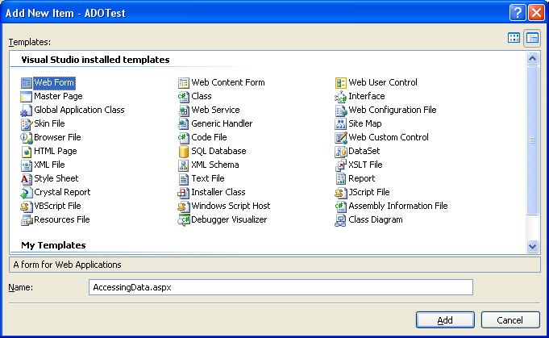
Figure 7-1

Defining the Database Connection
We can now create a new instance of the SqlConnection, which will facilitate our connection to the database. To initialize this connection, we need to specify a connection string—a string in which we specify the database we want to connect to, and provide any required authentication details. A typical connection string for an MS Sql Server database looks like this:

Data Source=172.16.2.34; Initial Catalog=your_database;
User ID=your_id; Password=your_password

The connection string must specify the name or address of the computer on which the database is located, when connecting to MS SqlServer you usually use the address of the server that you are connecting to (in this case ‘172.16.2.34’. Also required are the user ID, and the password for that user account.

Let’s put this into practice by creating an SqlConnection in the Page_Load event handler. Switch to the code behind file to see the Page_Load method that was created for you. Enter the code shown in bold below:

protected void Page_Load(object sender, EventArgs e)
{
// Define database connection
SqlConnection conn = new SqlConnection( @"Data Source=172.16.2.34; Initial Catalog=your_database;
User ID=your_id; Password=your_password");
}

Now we’re at step three, in which we create a SqlCommand object and pass in our SQL statement. The SqlCommand object accepts two parameters: the first is the SQL statement, and the second is the connection object that we created in the previous step.

protected void Page_Load(object sender, EventArgs e)
{
// Define database connection

SqlConnection conn = new SqlConnection(@"Data Source=172.16.2.34; Initial Catalog=your_database; User ID=your_id;

Password=your_password");
// Create command object

SqlCommand comm = new SqlCommand(
“SELECT EmployeeId, Name FROM gp_Employee”, conn);
}

Executing the Command
When we’re ready to run the query, we open the connection and execute the command. The SqlCommand class has three methods that we can use to execute a command; we simply choose between them depending on the specifics of our query. The three methods are as follows:

ExecuteReader
ExecuteReader is used for queries or stored procedures that return one or more rows of data. ExecuteReader returns a SqlDataReader object that can be used to read the results of the query one by one, in a forward-only, read-only manner. Using the SqlDataReader object is the fastest way to retrieve records from the database, but it can’t be used to update the data or to access the results in random order.

The SqlDataReader keeps the database connection open until all the records have been read. This can be a problem, as the database server will usually have a limited number of connections—people who are using your application simultaneously may start to see errors if you leave these connections open. To alleviate this problem, we can read all the results from the SqlDataReader object into an object such as a DataSet or a DataTable, which store the data locally without needing a database connection.

ExecuteScalar
ExecuteScalar is used to execute SQL queries or stored procedures that return a single value, such as a query that counts the number of employees in a company. This method returns an Object, which you can convert to specific data types depending on the kinds of data you expect to receive.

ExecuteNonQuery
ExecuteNonQuery is an oddly-named method that’s used to execute stored procedures and SQL queries that insert, modify, or update data. The return value will be the number of affected rows.

As we’re reading a list of employees, we’ll be using ExecuteReader. After we execute this method, we’ll follow standard practice, reading the data from the returned SqlDataReader as quickly as possible, then closing both the SqlDataReader and the SqlConnection, to ensure we don’t keep any database resources tied up for longer than is necessary.

protected void Page_Load(object sender, EventArgs e)
{
// Define database connection

SqlConnection conn = new SqlConnection(
@"Data Source=172.16.2.34; Initial Catalog=your_database;
User ID=your_id; Password=your_password");
// Create command object

SqlCommand comm = new SqlCommand(
“SELECT EmployeeId, Name FROM gp_Employee”, conn);
// Open connection
conn.Open();
// Execute the command
SqlDataReader reader = comm.ExecuteReader();
// Do something with the data
// Close the reader and the connection
reader.Close();
conn.Close();
}

Let’s take a look at a few of the methods that are being introduced here. Before we can query our database, a connection must be opened, so we need to call the Open( ) method of our SqlConnection object conn. Once the connection is opened, we call the ExecuteReader method of our SqlCommand object comm to run our query. ExecuteReader will retrieve a list of all employees and return the list in an open SqlDataReader object.

At this point, we would usually do something with the data in reader, but for now, we’ve left a comment to remind us that this method doesn’t produce any output.

Immediately after we’ve done something with the data, we close our SqlDataReader and SqlConnection objects using their Close( ) methods. Keeping the connection open for longer than necessary can waste database resources, which can be an issue in real-world applications where hundreds or more users might be accessing the same database at once. As such, it is a good practice to keep the connection open for the minimum time.

The code above doesn’t have any “real” functionality, as it doesn’t actually display anything for the user; however, it does open a connection to your database.

Reading the Data
Okay, so you’ve opened the connection and executed the command. Let’s do something with the returned data!

A good task for us to start with is to display the list of employees we read from the database. To do this, we’ll simply use a While loop to add the data to a Label control that we’ll place in the form. Start by adding a Label named employeesLabel to the AccessingData.aspx web form. We’ll also change the title of the page to “Using ADO.NET.”

<html xmlns="http://www.w3.org/1999/xhtml" >
<head runat="server">
<title>Using ADO.NET</title>
</head>
<body>
<form id="form1" runat="server">
<div>
<asp:Label ID="employeesLabel" runat="server" />
</div>
</form>
</body>
</html>

Now, let’s use the SqlDataReader’s Read( ) method to loop through the data items held in the reader; we’ll display them by adding their text to the employeesLabel object as we go.

protected void Page_Load(object sender, EventArgs e)
{
// Define database connection

SqlConnection conn = new SqlConnection(
@"Data Source=172.16.2.34; Initial Catalog=your_database;
User ID=your_id; Password=your_password");
// Create command object

SqlCommand comm = new SqlCommand(
“SELECT EmployeeId, Name FROM gp_Employee”, conn);
// Open connection
conn.Open();
// Execute the command
SqlDataReader reader = comm.ExecuteReader();
// Read and display the data
while (reader.Read())
{
employeesLabel.Text += reader["Name"] + "<br />";
}
// Close the reader and the connection
reader.Close();
conn.Close();
}

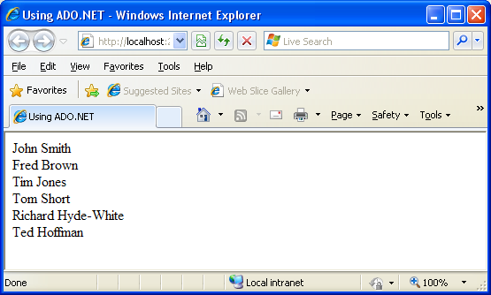

Figure 7-2

Note: The names may be in a different order.

We already know that the SqlDataReader class reads the data row by row, in a forward-only fashion. Only one row can be read at any moment. When we call
reader.Read( ), our SqlDataReader reads the next row of data from the database. If there’s data to be read, it returns True; otherwise—if we’ve already read the last record returned by the query—the Read method returns False. If we view this page in the browser, we’ll see something like Figure 7-2.

Using Parameters with Queries
What if the user doesn’t want to view information for all employees, but instead, wants to see details for one specific employee?

To get this information from our Employees table, we’d run the following query, replacing @EmployeeID with the ID of the employee in which the user was interested.

SELECT EmployeeId, Name, Username, Password
FROM gp_Employee
WHERE EmployeeId = @EmployeeId

Let’s build a page like the one shown in Figure 7-3 to display this information.

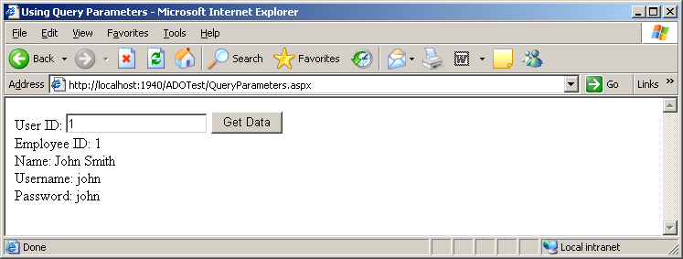
Figure 7-3

Create a new web form in the ADOTest Web Site called QueryParameters.aspx. Alter it to reflect the code shown here:

<html xmlns="http://www.w3.org/1999/xhtml" >
<head runat="server">
<title>Using Query Parameters</title>
</head>
<body>
<form id="form1" runat="server">
<div>
User ID:
<asp:TextBox ID="idTextBox" runat="server" />
<asp:Button ID="submitButton" runat="server"
Text="Get Data" /><br />
<asp:Label ID="userLabel" runat="server" />
</div>
</form>
</body>
</html>

With these amendments, we’ve added a Textbox control into which users can type in the ID of the employee whose information they want to see. We’ve also added a Button that will be used to submit the form and retrieve the data.

Next, we need to add a Click event handler to the Button control. When this button is clicked, our web form will need to execute the following tasks:
1. Read the ID typed by the user in the idTextBox control.
2. Prepare an SQL query to retrieve data about the specified employee.
3. Execute the query and read the results.

Now, we could perform this query using the following code:
comm = New SqlCommand(
"SELECT EmployeeId, Name, Username, Password " +
"FROM gp_Employee WHERE EmployeeId = " + idTextBox.Text , conn)

If the user entered the number 5 into the text box and clicked the button, the following query would be run:
SELECT EmployeeId, Name, Username, Password
FROM gp_Employee

WHERE EmployeeId = 5

The database would run this query without complaint, and your program would execute as expected. However, if—as is perhaps more likely—the user entered an employee’s name, your application would attempt to run the following query:

SELECT EmployeeId, Name, Username, Password
FROM gp_Employee
WHERE EmployeeId = Tim Jones

This query would cause an error in the database, which would, in turn, cause an exception in your web form. As a safeguard against this eventuality, ADO.NET allows you to define parameters in your query, and to give each of those parameters a type. Inserting parameters into your query is a simple task:

comm = New SqlCommand( _
"SELECT EmployeeId, Name, Username, Password " +
"FROM gp_Employee WHERE EmployeeId = @EmployeeId", conn)
We’ve added a placeholder for our parameter to the query above. To do so, we add the @ symbol, followed by an identifier for our parameter (in this case, we’ve used EmployeeId). Next, we need to add this parameter to the SqlCommand object, and give it a value:

comm.Parameters.Add("@EmployeeId", System.Data.SqlDbType.Int);
comm.Parameters["@EmployeeId"].Value = idTextBox.Text

Here, we call the Add method of comm.Parameters, passing in the name of the parameter EmployeeId and the parameter’s type; we’ve told ADO.NET that we’re expecting a number to be passed to the database, but we could specify any of the SqlDb data types here.

One of the most common SqlServer data types is nvarchar. If your query involved a nvarchar parameter named @Username, for example, you could set its value with the following code:

comm.Parameters.Add("@Username", SqlDbType.NVarChar, 50);
comm.Parameters["@Username"].Value = username;

Notice that we’ve included an additional parameter in our call to the Add method. This optional parameter tells the SqlCommand object the maximum allowable size of the NVarchar field in the database. We’ve given the Username field in our Employee table a maximum size of 50 characters, so our code should reflect this.

For a list of all the types you can use when calling comm.Parameters.Add, see the entry on System.Data.SqlDbType Enumeration in the .NET Framework’s SDK Documentation.

Let’s put parameters into action in QueryParameters.aspx. First, create a Click event handler for the Button control by double-clicking it in Design View. Next, fill the event handler with the code shown below:

protected void submitButton_Click(object sender, EventArgs e)
{
// Declare objects
SqlConnection conn;
SqlCommand comm;
SqlDataReader reader;
// Initialize connection
conn = new SqlConnection(
@"Data Source=172.16.2.34; Initial Catalog=your_database; User ID=your_id; Password=your_password");
// Create command
comm = new SqlCommand(
"SELECT EmployeeId, Name, Username, Password " +
"FROM gp_Employee WHERE EmployeeId = @EmployeeId", conn);
// Verify if the ID entered by the visitor is numeric
int employeeId;
if (!int.TryParse(idTextBox.Text, out employeeId))
{
// If the user didn't enter numeric ID
userLabel.Text = "Please enter a numeric ID!";
}
else
{
// Add parameter
comm.Parameters.Add("@EmployeeId", System.Data.SqlDbType.Int);
comm.Parameters["@EmployeeId"].Value = employeeId;
// Open the connection
conn.Open();
// Execute the command
reader = comm.ExecuteReader();
// Display the requested data
if (reader.Read())
{
userLabel.Text = "Employee Id: " +
reader["EmployeeId"] + "<br />" +
"Name: " + reader["Name"] + "<br />" +
"Username: " + reader["Username"] + "<br />" +
"Password: " + reader["Password"];
}
else
{
userLabel.Text =
"There is no user with this Id: " + employeeId;
}
// Close the reader and the connection
reader.Close();
conn.Close();
}
}

Now, when the user clicks the button, the Click event is raised, and the event handler is executed. In that method, we grab the Employee Id from the Text property of the TextBox control, and check that it’s a valid integer. This check is done with the int.TryParse method.

This method verifies whether or not the string we pass as the first parameter can be cast to an integer, and if yes, the integer is returned through the second parameter.

Note that in C#, this is an out parameter. Out parameters are parameters that are used to retrieve data from a function, rather than send data to that function. Out parameters are similar to return values, except that more than one of them can exist for any method. The return value of TryParse is a Boolean value that specifies whether or not the value could be properly converted.

If the ID that’s entered isn’t a valid number, we notify the user, as Figure 7-4 illustrates.

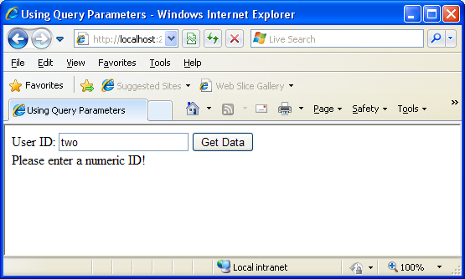

Figure 7-4

We also notify the user if the query doesn’t return any results. This feature is simple to implement, because reader.Read( ) only returns True if the query returns a record.

Figure 7-5 shows the message you’ll see if you enter an ID that doesn’t exist in the database.

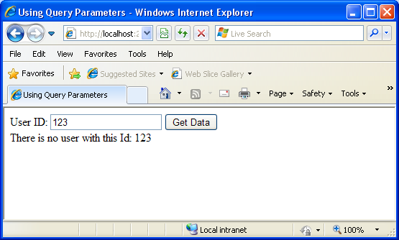

Figure 7-5

There are still a couple of details that we could improve in this system. For example, if an error occurs in the code, the connection will never be closed. Let’s look at this problem next.

Bulletproofing Data Access Code
Right now, the code in QueryParameters.aspx seems to be perfect, right? Well, not quite. While the code does its job most of the time, it still has one important weakness: it doesn’t take into account potential errors that could occur in the data access code. It’s a very good practice to enclose such code in Try-Catch-Finally blocks, and always use the Finally block to close any open data objects.

Take a look at the following code sample:

protected void submitButton_Click(object sender, EventArgs e)
{
// Declare objects
SqlConnection conn;
SqlCommand comm;
SqlDataReader reader;
// Initialize connection
conn = new SqlConnection(
@"Data Source=172.16.2.34; Initial Catalog=your_database; User ID=your_id; Password=your_password");
// Create command
comm = new SqlCommand(
"SELECT EmployeeId, Name, Username, Password " +
"FROM gp_Employee WHERE EmployeeId = @EmployeeId", conn);
// Verify if the ID entered by the visitor is numeric
int employeeId;
if (!int.TryParse(idTextBox.Text, out employeeId))
{
// If the user didn't enter numeric ID
userLabel.Text = "Please enter a numeric ID!";
}
else
{
// Add parameter
comm.Parameters.Add("@EmployeeId", System.Data.SqlDbType.Int);
comm.Parameters["@EmployeeId"].Value = employeeId;
// Enclose database code in Try-Catch-Finally
try
{
// Open the connection
conn.Open();
// Execute the command
reader = comm.ExecuteReader();
// Display the requested data
if (reader.Read())
{
userLabel.Text = "Employee ID: " +
reader["EmployeeId"] + "<br />" +
"Name: " + reader["Name"] + "<br />" +
"Username: " + reader["Username"] + "<br />" +
"Password: " + reader["Password"];
}
else
{
userLabel.Text =
"There is no user with this ID: " + employeeId;
}
// Close the reader
reader.Close();
}
catch
{
// Display error message
userLabel.Text = "Error retrieving user data.";
}
finally
{
// Close the connection
conn.Close();
}
}
}

So, what’s new in this version of the event handler, apart from the fact that it’s become larger? First of all—and most important—we have the Try-Catch-Finally block in place. Everything that manipulates the database is in the Try block. If an error arises, we display a message for the user through the Catch block. In the Finally block, which is always guaranteed to execute, we close the database connection.

Using the Repeater Control
The .NET Framework comes bundled with a few controls that can help us to display more complex lists of data: Repeater, DataList, GridView, DetailsView, and FormView. These controls allow you to easily format database data within an ASP.NET page.

In this section, you’ll learn how to work with the Repeater; we’ll cover the other controls in the next few sections. Note that these controls aren’t part of ADO.NET, but we’re presenting them together with ADO.NET because they’re frequently used in work with databases.

The Repeater control is a lightweight ASP.NET control that allows the easy presentation of data directly from a data source, usually in just a handful of lines of code. Let’s look at a quick example of how a Repeater control can be added to a page:

<asp:Repeater id="myRepeater" runat="server">
<ItemTemplate>
<%# Eval("Name")%>
</ItemTemplate>
</asp:Repeater>

As you can see, the Repeater control looks a little different to the other web controls we’ve used thus far. The difference with this control is that it has an <ItemTemplate> subtag—otherwise known as a child tag—located within the main <asp:Repeater> tag, or parent tag. This child tag contains a code render block that specifies the particular data item that we want to appear in the Repeater. However, before this data can be displayed, we have to bind an SqlDataReader object (which contains the results of an SQL query) to the Repeater control using the process known as data binding. This task is achieved from a code block like so:

myRepeater.DataSource = reader
myRepeater.DataBind()

It’s that easy! In a moment, we’ll display the code within the framework of a new example. First, let’s discuss what’s happening here in more detail.

True to its name, the Repeater control lets us output some markup for each record in a SqlDataReader, inserting values from those records wherever we like in this repeated markup. The markup to be repeated is provided as templates for the Repeater to use. For example, if we wanted to display the results of a database query in an HTML table, we could use a Repeater to generate an HTML table row for each record in that results set. We’d provide a template containing <tr> and </tr> tags, as well as <td> and </td> tags, and we’d indicate where in that template we wanted the values from the results set to appear.

To gain greater flexibility in the presentation of our results, we can provide the Repeater control with a number of different types of templates, which the Repeater will use in the circumstances described in the list of templates below. Each of these templates must be specified in a child tag of the <asp:Repeater> tag:

<HeaderTemplate>
This template provides a header for the output. If we’re generating an HTML table, for example, we could include the opening <table> tag, provide a row of header cells <th>, and even specify a caption for the table.

<ItemTemplate>
The only template that is actually required, <ItemTemplate> specifies the markup that should be output for each item in the data source. If we were generating an HTML table, this template would contain the <td> and </td> tags and their contents.

<AlternatingItemTemplate>
This template, if provided, will be applied instead of ItemTemplate to every second record in the data source, making it easy to produce effects such as alternating table row colors.

<SeparatorTemplate>
This template provides markup that will appear between the items in the data source. It will not appear before the first item or after the last item.

<FooterTemplate>
This template provides a footer for the resulting output, which will appear after all the items in the data source. If you’re generating an HTML table, you could include the closing </table> tag in this template.

Let’s take a look at a repeater control that displays a table of employees. In the ADOTest project create a new web form named UsingRepeater.aspx. The following code will set up a Repeater that can be used to display a table of employees, listing their employee IDs, Names, Usernames, and Passwords:

<html xmlns="http://www.w3.org/1999/xhtml" >
<head runat="server">
<title>Using the Repeater</title>
</head>
<body>
<form id="form1" runat="server">
<div>
<asp:Repeater ID="myRepeater" runat="server">
<HeaderTemplate>
<table width="400" border="1">
<tr>
<th>Employee Id</th>
<th>Name</th>
<th>Username</th>
<th>Password</th>
</tr>
</HeaderTemplate>
<ItemTemplate>
<tr>
<td><%# Eval("EmployeeId") %></td>
<td><%# Eval("Name") %></td>
<td><%# Eval("Username") %></td>
<td><%# Eval("Password") %></td>
</tr>
</ItemTemplate>
<FooterTemplate>
</table>
</FooterTemplate>
</asp:Repeater>
</div>
</form>
</body>
</html>

The Repeater control naturally lends itself to generating HTML tables, and that’s just what we’re doing here. First, we include a <HeaderTemplate>, which includes the opening <table> tag, along with the table’s heading row.

Next, we provide a template for each item in the result set. The template specifies a table row containing four table cells, each of which contains a code render block that outputs the values taken from each record in the results set. In C#, we use Eval to retrieve database values. Alternatively, you could use the longer form, DataBinder.Eval(Container.DataItem, "FieldName"), but we’ll stick with Eval in this section.

Finally, there’s a <FooterTemplate> that includes the closing </table> tag.

To make the repeater display any information, we need to bind a data source to it. Use Visual Studio to generate the web form’s Load event handler, and complete it like this:

protected void Page_Load(object sender, EventArgs e)
{
// Declare objects
SqlConnection conn;
SqlCommand comm;
SqlDataReader reader;
// Initialize connection
conn = new SqlConnection(
@"Data Source=172.16.2.34; Initial Catalog=your_database;
User ID=your_id; Password=your_password");
// Create command
comm = new SqlCommand(
"SELECT EmployeeId, Name, Username, Password " +
"FROM gp_Employee", conn);
// Enclose database code in Try-Catch-Finally
try
{
// Open the connection
conn.Open();
// Execute the command
reader = comm.ExecuteReader();
// Bind the repeater to the data source
myRepeater.DataSource = reader;
myRepeater.DataBind();
// Close the data reader
reader.Close();
}
catch
{
// Display error message
Response.Write("Error retrieving user data.");
}
finally
{
// Close the connection
conn.Close();
}
}

As you can see, by binding a control to a data source, it’s very easy to get our data to display in the web form. In this case, we’ve used the Repeater control, which, in the server-side code, we bound to the SqlDataReader that contains our data. The results of this work are shown in Figure 7-6.

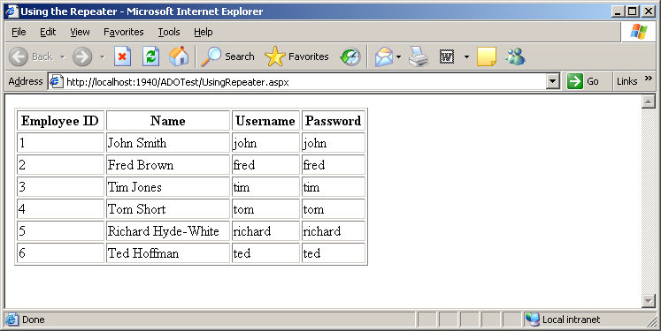
Figure 7-6

The GlacierPoint Intranet
Part 3

Great work! You’re presenting data in the browser window based on user interaction, and you’ve even allowed your users to filter that data in accordance with their own search parameters. Your code also takes care to always close the database connection in case an error occurs along the way.

It’s time to apply the theory we’re learning directly to the GlacierPoint application. In the following lessons, you'll insert, update, and delete database records in a new GlacierPoint Employee Directory web form. You’ll also learn how to call stored procedures using ADO.NET.

Start by loading the GlacierPoint project and creating a new web content form. Make sure you name it EmployeeDirectory.aspx, and confirm that your new page is based on the master page GlacierPoint.master. Then, modify the automatically generated code like this:

<%@ Page Language="C#" MasterPageFile="~/GlacierPoint.master"
AutoEventWireup="true" CodeFile="EmployeeDirectory.aspx.cs"
Inherits="EmployeeDirectory"
title="GlacierPoint Employee Directory" %>
<asp:Content ID="Content1"
ContentPlaceHolderID="ContentPlaceHolder1" Runat="Server">
<h1>Employee Directory</h1>
<asp:Repeater id="employeesRepeater" runat="server">
<ItemTemplate>
Employee ID:
<strong><%#Eval("EmployeeId")%></strong><br />
Name: <strong><%#Eval("Name")%></strong><br />
Username: <strong><%#Eval("Username")%></strong>
</ItemTemplate>
<SeparatorTemplate>
<hr />
</SeparatorTemplate>
</asp:Repeater>
</asp:Content>

This Repeater includes item and separator templates. The item template contains code render blocks that will display the data from a SqlDataReader. When this repeater is properly populated with data, the employee directory page will look like the one shown in Figure 7-7.

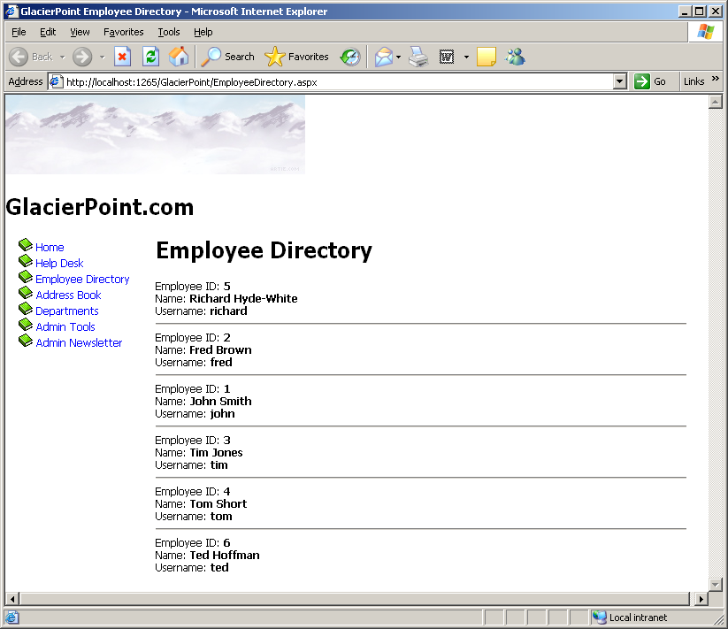
Figure 7-7

We’ll write the code that populates the repeater in the Page_Load method within our code-behind file. Add this code:

// Define data objects
SqlConnection conn;
SqlCommand comm;
SqlDataReader reader;
// Read the connection string from Web.config
string connectionString =
ConfigurationManager.ConnectionStrings[
"GlacierPoint"].ConnectionString;
// Initialize connection
conn = new SqlConnection(connectionString);
// Create command
comm = new SqlCommand(
"SELECT EmployeeId, Name, Username FROM gp_Employee", conn);
// Enclose database code in Try-Catch-Finally
try
{
// Open the connection
conn.Open();
// Execute the command
reader = comm.ExecuteReader();
// Bind the reader to the repeater
employeesRepeater.DataSource = reader;
employeesRepeater.DataBind();
// Close the reader
reader.Close();
}
finally
{
// Close the connection
conn.Close();
}

Most of the code should look familiar, except for the following bit, which reads the connection string:

// Read the connection string from Web.config
string connectionString = ConfigurationManager.ConnectionStrings[
"GlacierPoint"].ConnectionString;

Anticipating that many applications will use Web.config to store their connection strings, the designers of .NET reserved a special place in Web.config for database connection strings. If you open Web.config now, you’ll see an empty connectionStrings element located inside the configuration element. Modify Web.config like this:

<configuration>
<connectionStrings>
<add name="GlacierPoint"
connectionString="Data Source=172.16.2.34;
User Id=your_id; Password=your_password;
Initial Catalog=your_database"
providerName="System.Data.SqlClient" />
</connectionStrings>
</configuration>

You can add more connection strings under the connectionStrings element by inserting add elements with three attributes: connectionString contains the actual connection string, name gives the connection string an identifier that we can reference within our code, and providerName indicates the type of data provider we want to use for the connection. In our case, providerName="System. Data.SqlClient" specifies that we’re connecting to a SqlServer database.

To retrieve configuration data from Web.config we use the ConfigurationManager class, which is located in the System.Configuration namespace.

Also, you may have noticed that we don’t have a Catch block in our database handling code. When a Catch block is not present, any exceptions that are raised are not caught, although the code in the Finally block is still executed. In other words, we’re choosing not to handle potential errors in EmployeeDirectory.aspx, but we still want to ensure that the database connection is properly closed if an error arises.

The rest of the code comprises the typical data access routine, involving a SqlConnection object, a SqlCommand object, and a SqlDataReader object. Once the reader has been filled with the database data, it is bound to the Repeater control’s DataSource property, and from this point, the repeater takes control and reads all the data from the data source. If you save and run this page, it should appear as shown in Figure 7-7.

More Data Binding

The term “data binding” describes the act of associating a data source with a data consumer. In our previous examples, the data source was an SqlDataReader object, and the consumer was a Repeater control that read and displayed the data. Data binding typically involves setting the DataSource property of the consumer object to the data source object, and calling the DataBind method to apply the binding:

// Bind the reader to the repeater
employeesRepeater.DataSource = reader;
employeesRepeater.DataBind();

As mentioned earlier, ASP.NET includes a few controls that specialize in displaying data that comes from data sources, but you can also bind data to numerous other controls, including lists, menus, text boxes, and so on. To explore the process of control binding further, let’s open the Help Desk page again. If you remember, we left the Category and Subject drop-down lists empty earlier in the lesson. We did so because we knew that, eventually, those items would have to be populated dynamically through code. Sure, we could have hard-coded the values ourselves, but imagine what would happen if additions or deletions needed to be made to that list. In order to make the necessary changes to the controls, we would have to open every page that contained lists of categories and subjects.

It’s preferable to store the lists of categories and subjects in database tables, and to bind this data to the drop-down lists in the Help Desk page. Whenever a change needs to be made, we can make it once within the database; all the controls that are bound to that database table will change automatically.

Let’s go ahead and add the necessary code to Page_Load in HelpDesk.aspx to populate the DropDownList controls from the database. After the changes are made, the lists will be populated with the data from your database, as shown in Figure 7-8.

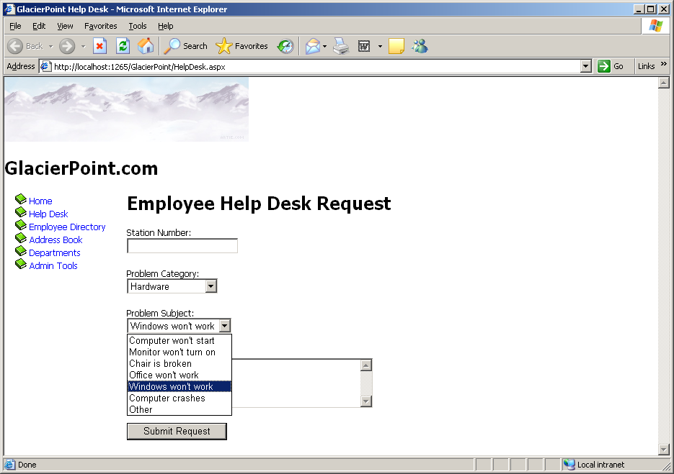
Figure 7-8

Open the HelpDesk code-behind file and add the following code to the Page_Load event handler:

using System.Data.SqlClient;
protected void Page_Load(object sender, EventArgs e)
{
if (!IsPostBack)
{
// Declare objects
SqlConnection conn;
SqlCommand categoryComm;
SqlCommand subjectComm;
SqlDataReader reader;
// Read the connection string from Web.config
string connectionString =
ConfigurationManager.ConnectionStrings[
"GlacierPoint"].ConnectionString;
// Initialize connection
conn = new SqlConnection(connectionString);
// Create command to read the help desk categories
categoryComm = new SqlCommand(
"SELECT CategoryId, Category FROM gp_HelpDeskCategory",
conn);
// Create command to read the help desk subjects
subjectComm = new SqlCommand(
"SELECT SubjectId, Subject FROM gp_HelpDeskSubject", conn);
try
{
// Open the connection
conn.Open();
// Execute the category command
reader = categoryComm.ExecuteReader();
// Populate the list of categories
categoryList.DataSource = reader;
categoryList.DataValueField = "CategoryId";
categoryList.DataTextField = "Category";
categoryList.DataBind();
// Close the reader
reader.Close();
// Execute the subject command
reader = subjectComm.ExecuteReader();
// Populate the list of subjects
subjectList.DataSource = reader;
subjectList.DataValueField = "SubjectId";
subjectList.DataTextField = "Subject";
subjectList.DataBind();
// Close the reader
reader.Close();
}
finally
{
// Close the connection
conn.Close();
}
}
}

You’ll notice that the guts of Page_Load are enclosed in an If statement, which tests to see if IsPostBack is True. But just what is this IsPostBack? View State allows your user controls to remember their states across page loads. Every time an event that needs to be handled on the server is raised, the form in the page is submitted to the server—a process known as a post back. For example, when a button with a server-side Click event handler is clicked, a post back occurs so that the server-side code can respond to the Click event.

After such an event occurs, all the controls in the web form retain their values, but the Page_Load method is executed again regardless. In consequence, if you click the Submit Request button ten times, Page_Load will be executed ten times. If the data access code that fills the form with values is in Page_Load, the database will be queried ten times, even though the data that needs to be displayed on the page doesn’t change!

It’s here that IsPostBack comes into play. IsPostBack returns False if the web form is being loaded for the first time; it returns True if the page is being loaded because the form has been posted back to the server.

Referring to IsPostBack
IsPostBack is actually a property of the Page class, but since our web form is a class that inherits from Page, we can refer to IsPostBack directly. If we wanted to, we could refer to this property as this.IsPostBack

Using the IsPostBack Property Appropriately
It’s not always appropriate to use IsPostBack as we’re using it here. We’re loading the form with data only the first time the page is loaded, because we know that the data in the drop-down lists won’t change in response to other changes in the form. In cases in which the data in the drop-down lists may change, it may be appropriate to access the database and re-fill the form with data every time the form is loaded. For example, we might want to take such action in a car search form in which, when the user selects a car manufacturer, their selection triggers a request to the server to load a list of all models of car made by that manufacturer.

Once it has been established that this is the first time the page has been loaded, the code continues in a pattern similar to the previous code samples. We retrieve the connection string from Web.config, create a new connection to the database, and set up our SqlCommand objects. In this page, we retrieve two lists—a list of help desk request categories and a list of subjects—so we’ll need to execute two queries. These queries are stored in two SqlCommand objects: categoryComm and subjectComm.

Next, inside a Try-Catch-Finally block, we execute the commands and bind the data in our SqlDataReaders to the existing controls. First, we execute categoryComm to retrieve a list of categories; then, we bind that list to categoryList:

// Execute the category command
reader = categoryComm.ExecuteReader();
// Populate the list of categories
categoryList.DataSource = reader;
categoryList.DataValueField = "CategoryId";
categoryList.DataTextField = "Category";
categoryList.DataBind();
// Close the reader
reader.Close();

Note that not all controls handle their bindings in the same way. In this case, we want the DropDownList control to display the data from the Category column of the HelpDeskCategories table. The DropDownList control is cleverly designed, and it can also store an ID associated with each item in the list. This can be very helpful when we’re performing database operations using the items selected from a DropDownList, because the database operations are always carried out using the items’ IDs.

The DataTextField property of the DropDownList needs to be set to the name of the column that provides the text to be displayed, and the DataValueField must be set to the name of the column that contains the ID. This allows us to pass the ID of the category or subject along to any part of the application when a user makes a selection from the drop-down lists. When the page loads, all the categories and subjects will be loaded into their respective DropDownList controls, as shown in Figure 7-8.

Inserting Records

The code that inserts records from your application into a database isn’t too different from what we’ve already seen. The main difference is that now we need to retrieve data from the user input controls in the page, and use this data as the parameters to our INSERT query, rather than simply firing off a simple SELECT query. As we discussed earlier in this chapter, to execute such a query, you’d need to use the ExecuteNonQuery( ) method of the SqlCommand object, as INSERT queries don’t return results.

When inserting user-entered data into the database, you need to be extra careful about validating that data in case the users don’t type whatever you expect them to (those users always seem to find unimaginable ways to do things!).

A typical INSERT statement is coded as follows:

comm = New SqlCommand( _
"INSERT INTO HelpDesk (Field1, Field2, …) " +
"VALUES (@Parameter1, @Parameter2, …)", conn);

Once the SqlCommand object has been created with a parameterized INSERT query, we simply pass in the necessary parameters, similarly to the process we followed for SELECT queries:

comm.Parameters.Add("@Parameter1",SqlDbType.Type1);
comm.Parameters["@Parameter1"].Value = value1;
comm.Parameters.Add("@Parameter2",SqlDbType.Type2);
comm.Parameters["@Parameter2"].Value = value2;

To demonstrate the process of inserting records into the database, let’s finish the help desk page.

When employees visit the help desk page, they’ll fill out the necessary information, click Submit Request, and the information will be saved within the HelpDesk table. The HelpDesk table acts as a queue for IT personnel to review and respond to reported issues.

First, open HelpDesk.aspx, and add a label just below the page’s heading.

<h1>Employee Help Desk Request</h1>
<asp:Label ID="dbErrorMessage" ForeColor="Red" runat="server" />
<p>
Station Number:<br />
<asp:TextBox id="stationTextBox" runat="server"
CssClass="textbox" />

The form already contains numerous validation controls that display error messages if they find problems with the entered data. We’re adding this Label control to display errors that arise when an exception is caught while the database query is executing. This is necessary because, although the validation controls prevent most of the errors that could occur, they can’t guarantee that the database query will run flawlessly. For example, if the database server is rebooted, and we try to run a database query, we’ll receive an error until the database is up and running again. There could be other kinds of errors, too.

You already have a Click event handler for the Submit Request button in HelpDesk.aspx—that you added earlier, when you added validation controls to the page. The event handler should look like this:

protected void submitButton_Click(object sender, EventArgs e)
{
if (Page.IsValid)
{
// Code that uses the data entered by the user
}
}

Modify this method by adding code that inserts the user-submitted help desk request into the database, as shown below:

protected void submitButton_Click(object sender, EventArgs e)
{
if (Page.IsValid)
{
// Define data objects
SqlConnection conn;
SqlCommand comm;
// Read the connection string from Web.config
string connectionString =
ConfigurationManager.ConnectionStrings
["GlacierPoint"].ConnectionString;

// Initialize connection
conn = new SqlConnection(connectionString);

// Create insert command
comm = new SqlCommand(
"INSERT INTO gp_Helpdesk(EmployeeId,StationNumber,CategoryId," + “SubjectId,Description,StatusId) ” +
“VALUES (@EmployeeId, @StationNumber,” +
“@CategoryId, @SubjectId, @Description, @StatusId)”, conn);

// Add command parameters
comm.Parameters.Add("@EmployeeId", System.Data.SqlDbType.Int);
comm.Parameters["@EmployeeId"].Value = 5;
comm.Parameters.Add("@StationNumber",
System.Data.SqlDbType.Int);
comm.Parameters["@StationNumber"].Value = stationTextBox.Text;
comm.Parameters.Add("@CategoryId", System.Data.SqlDbType.Int);
comm.Parameters["@CategoryId"].Value =
categoryList.SelectedItem.Value;
comm.Parameters.Add("@SubjectId", System.Data.SqlDbType.Int);
comm.Parameters["@SubjectId"].Value =
subjectList.SelectedItem.Value;
comm.Parameters.Add("@Description",
System.Data.SqlDbType.NVarChar, 50);
comm.Parameters["@Description"].Value =
descriptionTextBox.Text;
comm.Parameters.Add("@StatusId", System.Data.SqlDbType.Int);
comm.Parameters["@StatusId"].Value = 1;
// Enclose database code in Try-Catch-Finally
try
{
// Open the connection
conn.Open();
// Execute the command
comm.ExecuteNonQuery();
// Reload page if the query executed successfully
Response.Redirect("HelpDesk.aspx");
}
catch
{

// Display error message
dbErrorMessage.Text =
"Error submitting the help desk request! Please " +
"try again later, and/or change the entered data!";
}
finally
{
// Close the connection
conn.Close();
}
}
}
}

Did you notice the use of the ExecuteNonQuery( ) method? As you know, we use this method when we’re executing any SQL query that doesn’t return a set of results, such as INSERT, UPDATE, and DELETE queries.

You’ll remember that, in order to make the example simpler, we hard-coded the EmployeeId (to the value of 5), and the Status (to the value of 1). To make the application complete, you could add another drop-down list from which employees could select their names, and take the IDs from there. For now, just make sure that the Employees table has a record with an EmployeeId of 5, otherwise the query won’t execute successfully.

The other potentially unfamiliar part of this code is the final line of the Try block, which uses Response.Redirect. This method should be quite familiar to developers who are experienced with ASP. Response.Redirect simply redirects the browser to another page. For example, the following line of code redirects the user to a page called SomeForm.aspx:

Response.Redirect("SomeForm.aspx");

In our example, we redirect the user back to the same web form. Why on earth would we want to do that? It’s because of view state—if we didn’t end our event handler this way, the same page would display in the browser, but ASP.NET would preserve all of the values that the user had typed into the form fields. The user might not realize the form had even been submitted, and might submit the form repeatedly in confusion. Redirecting the user in the way outlined above causes the browser to reload the page from scratch, clearing the form fields to indicate the completed submission.

Save your work and run it in a browser. Now, we can enter help desk information, as shown in Figure 7-9, and click Submit Request.

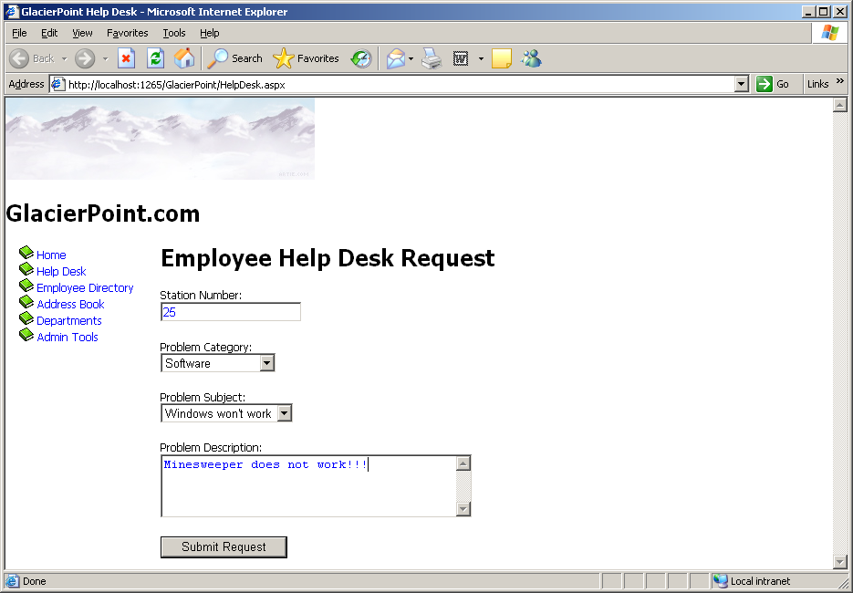
Figure 7-9

Once we click Submit Request, the Click event is raised, the submitButton_Click method is called, all the parameters from the form are passed into the SQL statement, and the data is inserted into the Helpdesk table.
Lesson #8
Topic | Quiz 1 and Test 1 | Points
Lessons | 1 - 7 | 25

Topic Review:
- The ASP .NET page structure

  - Directives
  - Code Declaration Blocks
  - Code Render Blocks
  - ASP .NET Server Controls
  - Comments
  - Literal Text and HTML Tags
- Web Forms
- HTML Server Controls
- Web Server Controls
  - Label
  - Literal
  - TextBox
  - Hidden Field
  - Button
  - Image Button
  - Link Button
  - Hyperlink
  - Check Box
  - Radio Button
  - Image
  - Image Map
  - Placeholder
  - Panel
- Tables
- List Controls
  - Drop Down List
  - List Box
  - Radio Button List
  - Check Box List
  - Bulleted List
- Calendar
- AdRotator
- TreeView
- Site Map Path
- Menu
- MultiView and View Controls
- Master Pages
- Handling Page Navigation
- CSS
- The Web Forms Designer
- The Code Editor
- Toolbox
- Properties Window
- Running the application
- Web.config
- Global.asax
- Using Application State
- User Sessions
- Caching
- Cookies
- Preparing a SiteMap
- Creating a Theme
- The Master Page
- Creating a Web Page that uses a Master Page
- Debugging
- Server-Side Validation
- Client-Side Validation
- Validation Controls
  - Required Field
  - Range
  - Regular Expression
  - Compare
  - Custom
  - Validation Summary
- SqlConnection
- SqlCommand
- SqlDataReader
- The Repeater Control

Lesson #9
Topic | Using Data Access Methods in Glacier Point | Points
Chapter | 9

Topics:
- Data Binding

Lesson #10
Topic | Managing Database Records | Points
Chapter | 9

Topics:
- Updating records
- Deleting records
- Using Stored Procedures
- The GlacierPoint Tutorial - Part 4

The GlacierPoint Intranet
Part 4

Updating Records

The major difference between inserting new database records and updating existing ones is that if a user wants to update a record, you’ll usually want to display the information that already exists in the database table before allowing the user to update it. This gives the user a chance to review the data, make the necessary changes, and, finally, submit the updated values. Before we get ahead of ourselves, though, let’s take a look at the code we’ll use to update records within the database table:

comm = new SqlCommand ("UPDATE Table " +
"SET Field1=@Parameter1, Field2=@Parameter2, … " +
"WHERE UniqueField=@UniqueFieldParameter", conn);

comm.Parameters.Add("@Parameter1", SqlDbType.Type1);
comm.Parameters["@Parameter1"].Value = value1;
comm.Parameters.Add("@Parameter2", SqlDbType.Type2);
comm.Parameters["@Parameter2"].Value = value2;

Once the SqlCommand object has been created using this UPDATE statement, we simply pass in the necessary parameters, as we did with the INSERT statement. The important thing to remember when updating records is that you must take care to perform the UPDATE on the correct record. To do this, you must include a WHERE clause that specifies the correct record using a value from a suitable unique column (usually the primary key), as shown above.

Let’s put all this theory into practice as we build the Admin Tools page. The database doesn’t contain a table that’s dedicated to this page; however, we’ll use the Admin Tools page as a centralized location for a number of tables associated with other pages, including the Employees and Departments tables. For instance, in this section, we’ll allow an administrator to change the details of a specific employee.

Create a new web content form named AdminTools.aspx in the same way you created the other web forms we’ve built so far. Use the GlacierPoint.master master page and a code-behind file. Then, add the following code to the content placeholder, and modify the page title as shown below.

<%@ Page Language="C#" MasterPageFile="~/GlacierPoint.master"
AutoEventWireup="true" CodeFile="AdminTools.aspx.cs"
Inherits="AdminTools" Title="GlacierPoint Admin Tools" %>
<asp:Content ID="Content1"
ContentPlaceHolderID="ContentPlaceHolder1" runat="Server">
<h1>Admin Tools</h1>
<asp:Label ID="dbErrorLabel" ForeColor="Red" runat="server" />
<p>
Select an employee to update:<br />
<asp:DropDownList ID="employeesList" runat="server" />
<asp:Button ID="selectButton" Text="Select" runat="server" />
</p>
<p>
<asp:Label ID="nameLabel" runat="server"
Text="Name:" Width="100" />
<asp:TextBox ID="nameTextBox" runat="server" />
</p>
<p>
<asp:Label ID="usernameLabel" runat="server"
Text="Username:" Width="100" />
<asp:TextBox ID="usernameTextBox" runat="server" />
</p>
<p>
<asp:Label ID="addressLabel" runat="server"
Text="Address:" Width="100" />
<asp:TextBox ID="addressTextBox" runat="server" />
</p>
<p>
<asp:Label ID="cityLabel" runat="server"
Text="City:" Width="100" />
<asp:TextBox ID="cityTextBox" runat="server" />
</p>
<p>
<asp:Label ID="stateLabel" runat="server"
Text="State:" Width="100" />
<asp:TextBox ID="stateTextBox" runat="server" />
</p>
<p>
<asp:Label ID="zipLabel" runat="server"
Text="Zip:" Width="100" />
<asp:TextBox ID="zipTextBox" runat="server" />
</p>
<p>
<asp:Label ID="homePhoneLabel" runat="server"
Text="Home Phone:" Width="100" />
<asp:TextBox ID="homePhoneTextBox" runat="server" />
</p>
<p>
<asp:Label ID="extensionLabel" runat="server"
Text="Extension:" Width="100" />
<asp:TextBox ID="extensionTextBox" runat="server" />
</p>
<p>
<asp:Label ID="mobilePhoneLabel" runat="server"
Text="Mobile Phone:" Width="100" />
<asp:TextBox ID="mobilePhoneTextBox" runat="server" />
</p>
<p>
<asp:Button ID="updateButton" Text="Update Employee"
Enabled="False" runat="server" />
</p>
</asp:Content>

You can switch to Design View to ensure you created your form correctly; it should look like the one shown in Figure 10-1.

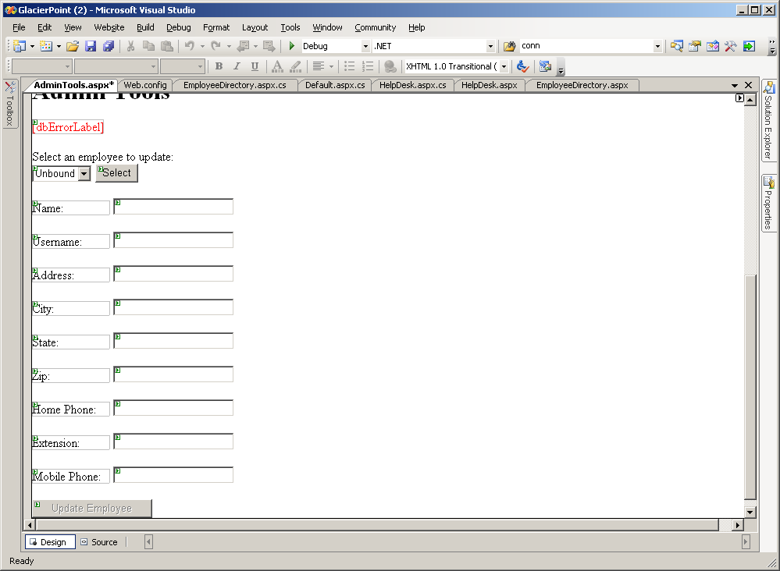
Figure 10-1

We’ve added the following controls to our form:

employeesList
In order for administrators to select the record for the employee whose details
they want to update, we’ll first have to bind the Employee table to this DropDownList control.

selectButton
Once the users select the record for the employee whose details they want to update, they’ll click this Button control. The Click event will be raised, and the Employee ID selected from employeesList will be passed to the web form—this will be used in a SqlCommand to retrieve the details for this employee.

nameLabel, usernameLabel, addressLabel, cityLabel, stateLabel, zipLabel,
homePhoneLabel, extensionLabel, mobilePhoneLabel
These are the labels for the following TextBox controls.

nameTextBox, usernameTextBox, addressTextBox, cityTextBox, stateTextBox, zipTextBox, homePhoneTextBox, extensionTextBox, mobilePhoneTextBox
Within the selectButton’s Click event handler, we’ll add some code that binds user information to these TextBox controls.

updateButton
When the users make the desired changes to the TextBox controls listed above, they’ll click this button to update the database.

dbErrorLabel
We use dbErrorLabel to display an error message if a database operation fails.

Our first task is to populate the employeesList control with the list of employees from our database. Add this code to the AdminTools Page_Load event handler:

using System;
using System.Data;
using System.Configuration;
using System.Collections;
using System.Web;
using System.Web.Security;
using System.Web.UI;
using System.Web.UI.WebControls;
using System.Web.UI.WebControls.WebParts;
using System.Web.UI.HtmlControls;
using System.Data.SqlClient;
public partial class AdminTools : System.Web.UI.Page
{
protected void Page_Load(object sender, EventArgs e)
{
// Read the employees list when initially loading the page
if (!IsPostBack)
{
LoadEmployeesList();
}
}
Create a method called LoadEmployeesList and add the following code:

private void LoadEmployeesList()
{
// Declare objects
SqlConnection conn;
SqlCommand comm;
SqlDataReader reader;
// Read the connection string from Web.config
string connectionString =
ConfigurationManager.ConnectionStrings[
"GlacierPoint"].ConnectionString;
// Initialize connection
conn = new SqlConnection(connectionString);
// Create command
comm = new SqlCommand(
"SELECT EmployeeId, Name FROM gp_Employee", conn);
// Enclose database code in Try-Catch-Finally
try
{
// Open the connection
conn.Open();
// Execute the command
reader = comm.ExecuteReader();
// Populate the list of employees
employeesList.DataSource = reader;
employeesList.DataValueField = "EmployeeId";
employeesList.DataTextField = "Name";
employeesList.DataBind();
// Close the reader
reader.Close();
}
catch
{
// Display error message
dbErrorLabel.Text =
"Error loading the list of employees!<br />";
}
finally
{
// Close the connection
conn.Close();
}
// Disable the update button
updateButton.Enabled = false;
// Clear any values in the TextBox controls
nameTextBox.Text = "";
usernameTextBox.Text = "";
addressTextBox.Text = "";
cityTextBox.Text = "";
stateTextBox.Text = "";
zipTextBox.Text = "";
homePhoneTextBox.Text = "";
extensionTextBox.Text = "";
mobilePhoneTextBox.Text = "";
}
}
Note that we’ve put the code to populate the employeesList in a separate subroutine called LoadEmployeeList. Later on, we’ll need to reload the names in this list in case any of the names have been edited; we put this code into its own subroutine so that we don’t need to repeat it.

Load the page now, and test that the list of employees is bound to employeesList, and that the page displays as shown in Figure 10-2.

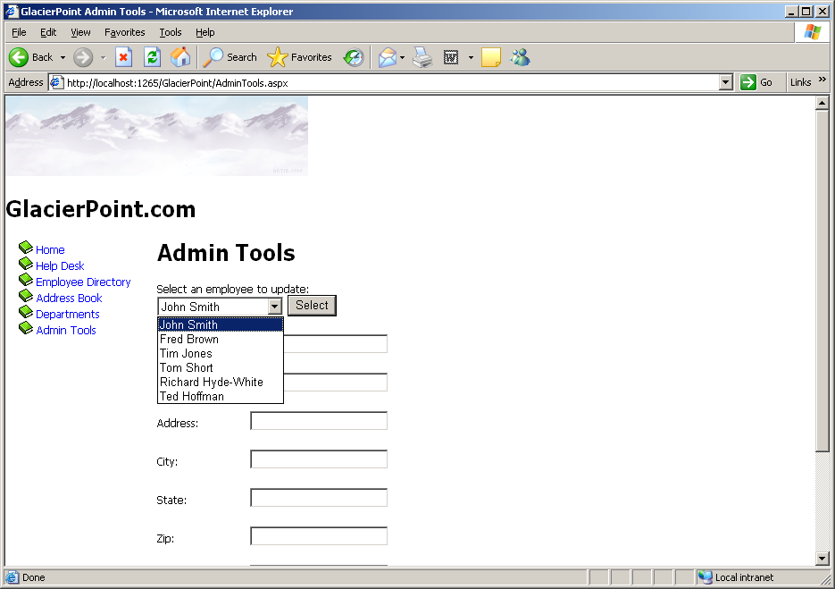
Figure 10-2

As you can see, all the employees are listed within the employee drop-down menu.
Again, the employees’ names are shown because the Name field is bound to the DataTextField property of the DropDownList control. Similarly, the EmployeeId field is bound to the DataValueField property of the DropDownList control, ensuring that a selected employee’s ID will be submitted as the value of the field.

We need to undertake two more tasks to complete this page’s functionality. First, we need to handle the Click event of the Select button so that it will load the form with data about the selected employee. Then, we’ll need to handle the Click event of the Update button, to update the information for the selected employee.

Let’s start with the Select button. Double-click the button in Design View to have the Click event handler generated for you, then complete the code like this:

protected void selectButton_Click(object sender, EventArgs e)
{
// Declare objects
SqlConnection conn;
SqlCommand comm;
SqlDataReader reader;
// Read the connection string from Web.config
string connectionString =
ConfigurationManager.ConnectionStrings[
"GlacierPoint"].ConnectionString;
// Initialize connection
conn = new SqlConnection(connectionString);
// Create command
comm = new SqlCommand(
"SELECT Name, Username, Address, City, State, Zip, " +
"HomePhone, Extension, MobilePhone FROM gp_Employee " +
"WHERE EmployeeId = @EmployeeId", conn);
// Add command parameters
comm.Parameters.Add("@EmployeeId", SqlDbType.Int);
comm.Parameters["@EmployeeId"].Value =
employeesList.SelectedItem.Value;
// Enclose database code in Try-Catch-Finally
try
{
// Open the connection
conn.Open();
// Execute the command
reader = comm.ExecuteReader();
// Display the data on the form
if (reader.Read())
{
nameTextBox.Text = reader["Name"].ToString();
usernameTextBox.Text = reader["Username"].ToString();
addressTextBox.Text = reader["Address"].ToString();
cityTextBox.Text = reader["City"].ToString();
stateTextBox.Text = reader["State"].ToString();
zipTextBox.Text = reader["Zip"].ToString();
homePhoneTextBox.Text = reader["HomePhone"].ToString();
extensionTextBox.Text = reader["Extension"].ToString();
mobilePhoneTextBox.Text = reader["MobilePhone"].ToString();
}
// Close the reader
reader.Close();
// Enable the Update button
updateButton.Enabled = true;
}
catch
{
// Display error message
dbErrorLabel.Text =
"Error loading the employee details!<br />";
}
finally
{
// Close the connection
conn.Close();
}
}

If you load the page, select an employee, and click the Select button, the form will be populated with the employee’s details. See Figure 10-3.

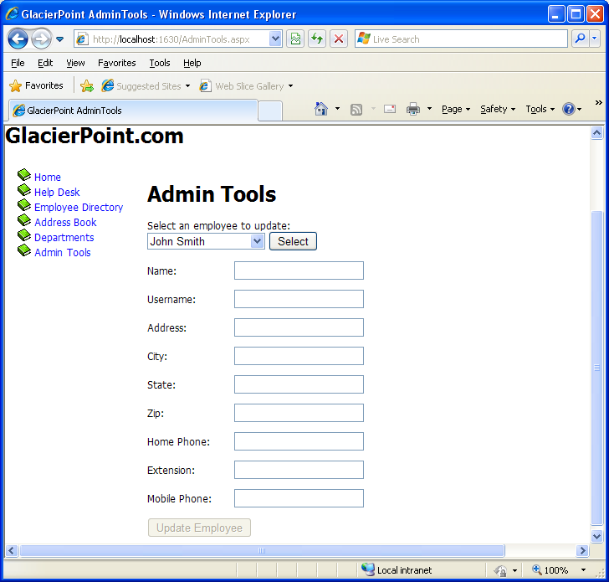

Figure 10-3

The last thing we need to do is add code to handle the update interaction. You may have noticed that the Button control has an Enabled property, which is initially set to False. The reason for this is simple: you don’t want your users updating information before they’ve selected an employee. You want them to use the Update Employee button only when data for an existing employee has been loaded into the TextBox controls. If you look at the selectButton_Click method just before the Catch statement, you’ll notice that we enable this button after binding the user data to the fields.

Now that these TextBox controls are populated and the Update Employee button is enabled, let’s add some code to update an employee’s details. Open AdminTools.aspx in Design View, and double-click the Update Employee button. Visual Studio will generate the signature of the event handler subroutine (updateButton_Click) for you. Finally, let’s add the necessary code to handle updating the employee data:

protected void updateButton_Click(object sender, EventArgs e)
{
// Declare objects
SqlConnection conn;
SqlCommand comm;
// Read the connection string from Web.config
string connectionString =
ConfigurationManager.ConnectionStrings[
"GlacierPoint"].ConnectionString;
// Initialize connection
conn = new SqlConnection(connectionString);

// Create command
comm = new SqlCommand(
"UPDATE gp_Employee SET Name=@Name, Username=@Username, " +
"Address=@Address, City=@City, State=@State, Zip=@Zip, " +
"HomePhone=@HomePhone, Extension=@Extension, " +
"MobilePhone=@MobilePhone " +
"WHERE EmployeeId=@EmployeeId", conn);

// Add command parameters
comm.Parameters.Add("@Name", SqlDbType.NVarChar,50);
comm.Parameters["@Name"].Value = nameTextBox.Text;
comm.Parameters.Add("@Username", SqlDbType.NVarChar, 50);
comm.Parameters["@Username"].Value = usernameTextBox.Text;
comm.Parameters.Add("@Address", SqlDbType.NVarChar, 50);
comm.Parameters["@Address"].Value = addressTextBox.Text;
comm.Parameters.Add("@City", SqlDbType.NVarChar, 50);
comm.Parameters["@City"].Value = cityTextBox.Text;
comm.Parameters.Add("@State", SqlDbType.NVarChar, 50);
comm.Parameters["@State"].Value = stateTextBox.Text;
comm.Parameters.Add("@Zip", SqlDbType.NVarChar, 50);
comm.Parameters["@Zip"].Value = zipTextBox.Text;
comm.Parameters.Add("@HomePhone", SqlDbType.NVarChar, 50);
comm.Parameters["@HomePhone"].Value = homePhoneTextBox.Text;
comm.Parameters.Add("@Extension", SqlDbType.NVarChar, 50);
comm.Parameters["@Extension"].Value = extensionTextBox.Text;
comm.Parameters.Add("@MobilePhone", SqlDbType.NVarChar, 50);
comm.Parameters["@MobilePhone"].Value = mobilePhoneTextBox.Text;
comm.Parameters.Add("@EmployeeId", SqlDbType.Int);
comm.Parameters["@EmployeeId"].Value = employeesList.SelectedItem.Value;

// Enclose database code in Try-Catch-Finally
try
{
// Open the connection
conn.Open();
// Execute the command
comm.ExecuteNonQuery();
}
catch
{
// Display error message
dbErrorLabel.Text = "Error updating the employee details!<br />";
}
finally
{
// Close the connection
conn.Close();
}
// Refresh the employees list
LoadEmployeesList();
}

As you can see, the only real differences between this and the help desk page are that we’re using an UPDATE query instead of an INSERT query, and we’ve had to let the user choose an entry from the database to update. We use that selection not only to populate the form fields with the existing database values, but to restrict our UPDATE query so that it only affects that one record.

You’ll also notice that at the very end of this method, we call LoadEmployeesList to reload the list of employees, as the user may have changed the name of one of the employees. LoadEmployeesList also disables the Update Employee button and clears the contents of the page’s TextBox controls. Once LoadEmployeesList has executed, the page is ready for the user to select another employee for updating.

Deleting Records

Just as we can insert and update records within the database, we can also delete them. Again, most of the code for deleting records resembles that which we’ve already seen. The only major part that changes is the SQL statement within the command:

comm = new SqlCommand("DELETE FROM Table " +
"WHERE UniqueField=@UniqueFieldParameter", conn)

Once we’ve created the DELETE query’s SqlCommand object, we can simply pass in the necessary parameter:

comm.Parameters.Add("@UniqueFieldParameter", SqlDbType.Type);
comm.Parameters["@UniqueFieldParameter"].Value = UniqueValue;

To demonstrate the process of deleting an item from a database table, we’ll expand on the Admin Tools page. Since we’re allowing administrators to update information within the Employees table, let’s also give them the ability to delete an employee’s record from the database. To do this, we’ll place a new Button control for deleting the selected record next to our Update Employee button.

Start by adding the new control at the end of AdminTools.aspx:

<p>
<asp:Button ID="updateButton" Text="Update Employee"
Enabled="False" runat="server" />
<asp:Button ID="deleteButton" Text="Delete Employee"

Enabled="False" runat="server" />
</p>

Next, update selectButton_Click to enable the Delete Employee button when an employee is selected:

// Enable the Update button
updateButton.Enabled = true;
// Enable the Delete button
deleteButton.Enabled = true;

Next, write the code for the Delete button’s event handler. Remember that you can double-click the button in Visual Studio’s Design View to have the signature generated for you.

protected void deleteButton_Click(object sender, EventArgs e)
{
// Define data objects
SqlConnection conn;
SqlCommand comm;
// Read the connection string from Web.config
string connectionString =
ConfigurationManager.ConnectionStrings[
"GlacierPoint"].ConnectionString;
// Initialize connection
conn = new SqlConnection(connectionString);
// Create command
comm = new SqlCommand("DELETE FROM gp_Employee " +
"WHERE EmployeeId = @EmployeeId", conn);
// Add command parameters
comm.Parameters.Add("@EmployeeId", SqlDbType.Int);
comm.Parameters["@EmployeeId"].Value = employeesList.SelectedItem.Value;
try
{
// Open the connection
conn.Open();
// Execute the command
comm.ExecuteNonQuery();
}
catch
{
// Display error message
dbErrorLabel.Text = "Error deleting employee!<br />";
}
finally
{
// Close the connection
conn.Close();
}
// Refresh the employees list
LoadEmployeesList();
}

Save your work and test it within the browser. For testing purposes, feel free to add more records to the gp_Employee table using the Management Studio Express, then delete them through the GlacierPoint application (if you do that, note you’ll need to refresh the view of the gp_Employee table manually in order to see the changes).

You will notice that when you delete an employee the Delete button is still enabled. Modify the following code in the LoadEmployeeList event handler to correct this:

// Disable the update button
updateButton.Enabled = false;
// Disable the delete button
deleteButton.Enabled = false;

Using Stored Procedures

In the previous lesson, you learned how to add stored procedures to your database. As far as ADO.NET is concerned, a stored procedure is much like a query that has parameters.

Let’s assume you’d prefer to use a stored procedure to add help desk requests, rather than typing the SQL code in HelpDesk.aspx.cs. The first step would be to add a stored procedure to your GlacierPoint database, which would look something like this:

CREATE PROCEDURE sp_InsertHelpDesk
@EmployeeId int,
@StationNumber int,
@CategoryId int,
@SubjectId int,
@Description nvarchar(50),
@StatusId int
AS
INSERT INTO gp_HelpDesk (EmployeeId, StationNumber, CategoryId,
SubjectId, Description, StatusId)
VALUES(@EmployeeID, @StationNumber, @CategoryID, @SubjectID, @Description, @StatusID);

To use this stored procedure, you’d need to modify the submitButton_Click method in HelpDesk.aspx.cs as shown below:

// Define data objects
SqlConnection conn;
SqlCommand comm;
SqlCommand requestIdComm;
// Read the connection string from Web.config
string connectionString =
ConfigurationManager.ConnectionStrings
["GlacierPoint"].ConnectionString;
// Initialize connection
conn = new SqlConnection(connectionString);

// Create command
comm = new SqlCommand(“sp_InsertHelpDesk”, conn);
comm.CommandType = System.Data.CommandType.StoredProcedure;

// Add command parameters
comm.Parameters.Add("@EmployeeID", System.Data.SqlDbType.Int);
comm.Parameters["@EmployeeID"].Value = 5;
comm.Parameters.Add("@StationNumber",
System.Data.SqlDbType.Int);
comm.Parameters["@StationNumber"].Value = stationTextBox.Text;
comm.Parameters.Add("@CategoryID", System.Data.SqlDbType.Int);
comm.Parameters["@CategoryID"].Value =
categoryList.SelectedItem.Value;
comm.Parameters.Add("@SubjectID", System.Data.SqlDbType.Int);
comm.Parameters["@SubjectID"].Value =
subjectList.SelectedItem.Value;
comm.Parameters.Add("@Description",
System.Data.SqlDbType.NVarChar, 50);
comm.Parameters["@Description"].Value =
descriptionTextBox.Text;
comm.Parameters.Add("@StatusID", System.Data.SqlDbType.Int);
comm.Parameters["@StatusID"].Value = 1;
// Enclose database code in Try-Catch-Finally
try
{
// Open the connection
conn.Open();
// Execute the command
comm.ExecuteNonQuery();
// Reload page if the query executed successfully
Response.Redirect("HelpDesk.aspx");
}
catch
{

// Display error message
dbErrorMessage.Text =
"Error submitting the help desk request! Please " +
"try again later, and/or change the entered data!";
}
finally
{
// Close the connection
conn.Close();
}
}

If you now load the Help Desk page, you’ll see that it works just as it used to, but behind the scenes, it’s making use of a stored procedure. You can verify that this approach works by adding a new help desk request through the web form, then opening the gp_HelpDesk table and checking for your new help desk request.

As you can see, using stored procedures is very easy. Apart for specifying the procedure’s name, you also need to set the CommandType of the SqlCommand object to StoredProcedure. That’s it! Everything else is the same as when working with a parameterized query.

Lesson #11
Topic | The DataList Control | Points
Chapter | 9

Topics:
- The DataList Control
- The GlacierPoint Tutorial - Part 5

The GlacierPoint Intranet
Part 5

Displaying Content Using Data Lists

Similar to the Repeater control, the DataList control allows you to bind and customize the presentation of database data. The fundamental difference is that while the Repeater requires you to build the template from scratch (allowing you to customize the generated HTML output in any way you like), the DataList control automatically generates a single-column HTML table for you, like the one shown below:

<table>
<tr>
<td>
<p>Employee Id: 1</p>
<p>Name: John Smith</p>
<p>Username: john</p>
</td>
</tr>
<tr>
<td>
<p>Employee Id: 2</p>
<p>Name: Fred Brown</p>
<p>Username: fred</p>
</td>
</tr>
<tr>
<td>
<p>Employee Id: 3</p>
<p>Name: Tim Jones</p>
<p>Username: tim</p>
</td>
</tr>
</table>

As you can see, DataList has, as the name implies, been designed to display lists of data, and while it’s less flexible than the Repeater, it contains more built-in functionality that can help make the implementation of certain features faster and easier. In the following pages, you’ll learn:
- the basics of the DataList control
- how to handle DataList events
- how to edit DataList items
- how to handle the controls inside the DataList templates
- how to use Visual Studio to edit the DataList

DataList Basics

To learn how to use the DataList, we’ll update the GlacierPoint Employee Directory page to use a DataList control instead of a Repeater control. This update will be particularly easy to do because the Employee Directory already has a listlike format.

If you now open EmployeeDirectory.aspx, you’ll see the Repeater control is used like this:

<asp:Repeater id="employeesRepeater" runat="server">
<ItemTemplate>
Employee ID:
<strong><%#Eval("EmployeeId")%></strong><br />
Name: <strong><%#Eval("Name")%></strong><br />
Username: <strong><%#Eval("Username")%></strong>
</ItemTemplate>
<SeparatorTemplate>
<hr />
</SeparatorTemplate>
</asp:Repeater>

Now, let’s update the employee directory page to use a DataList instead of a Repeater. We can do this simply by replacing the <asp:Repeater> and </asp:Repeater> tags with the tags for a DataList:

<asp:DataList id="employeesList" runat="server">
<ItemTemplate>
Employee ID:
<strong><%#Eval("EmployeeId")%></strong><br />
Name: <strong><%#Eval("Name")%></strong><br />
Username: <strong><%#Eval("Username")%></strong>
</ItemTemplate>
<SeparatorTemplate>
<hr />
</SeparatorTemplate>
</asp:DataList>

As we’ve changed the ID for this control, we’ll need to change the name of the control in the code-behind file as well. Locate the following lines of code and change employeesRepeater to employeesList, as shown:

// Open the connection
conn.Open();
// Execute the command
reader = comm.ExecuteReader();
// Bind the reader to the DataList
employeesList.DataSource = reader;
employeesList.DataBind();
// Close the reader
reader.Close();

As you can see, the changes required to use DataList instead of Repeater are minimal in this case. That’s largely because the Repeater was displaying a basic list of data anyway.

As with the Repeater control, we can feed data into a DataList control by binding it to a data source. Both Repeater and DataList support the ItemTemplate and SeparatorTemplate templates, but in case of the DataList, the templates specify the content that is to be inserted in the td elements of the table.

At the moment, the output appears very similar to the output we generated using the Repeater, as Figure 11-1 illustrates.

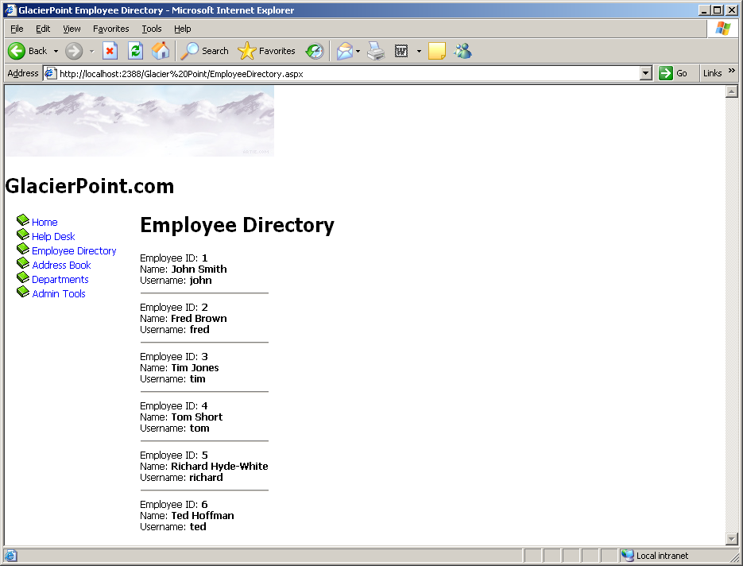
Figure 11-1

In this example, we’ve used the ItemTemplate of our DataList. The DataList offers a number of templates:

ItemTemplate
This template is replicated for each record that’s read from the data source. The contents of the ItemTemplate are repeated for each record, and placed inside td elements.

AlternatingItemTemplate
If this template is defined, it will be used instead of ItemTemplate to display every second element.

SelectedItemTemplate
This template is used to display the selected item of the list. The DataList control doesn’t automatically give the user a way to select an item in the list, but you can mark an item as selected by setting the DataLists control’s SelectedIndex property. Setting this property to 0 will mark the first item as selected; setting SelectedIndex to 1 will mark the second item as selected; and so on. Setting SelectedIndex to -1 unselects any selected item.

EditItemTemplate
Similar to SelectedItemTemplate, this template applies to an item that’s being edited. We can set the item being edited using the EditItemIndex property of the DataList, which operates in the same way as the SelectedIndex property. Later in this lesson, you’ll learn how to edit your DataList using the EditItemTemplate.

HeaderTemplate
This template specifies the content to be used for the list header.

FooterTemplate
This template defines the list footer.

SeparatorTemplate
This template specifies the content to be inserted between two consecutive data items. This content will appear inside its own table cell.

Handling DataList Events

One problem you may encounter when working with container controls such as the DataList or the Repeater is that you can’t access the controls inside their templates directly from your code. For example, consider the following ItemTemplate, which contains a Button control:

<asp:DataList ID="employeesList" runat="server">
<ItemTemplate>
Employee ID: <strong><%#Eval("EmployeeId")%></strong>
<asp:Button runat="server" ID="myButton" Text="Select" />
</ItemTemplate>
</asp:DataList>

Things get even more complicated if you want to handle the Button’s Click event, because—you guessed it—you can’t do so without jumping through some hoops.

So, if we can’t handle events raised by the buttons and links inside a template, how can we interact with the data in each template? We’ll improve our employee directory by making a simpler, basic view of the items, and add a “View More” link that users can click in order to access more details about the employee. To keep things simple, for now, we’ll hide only the employee ID from the standard view; we’ll show it when the visitor clicks the View More link.

After we implement this feature, our list will appear as shown in Figure 11-2. You’ll be able to view more details about any employee by clicking on the appropriate link.

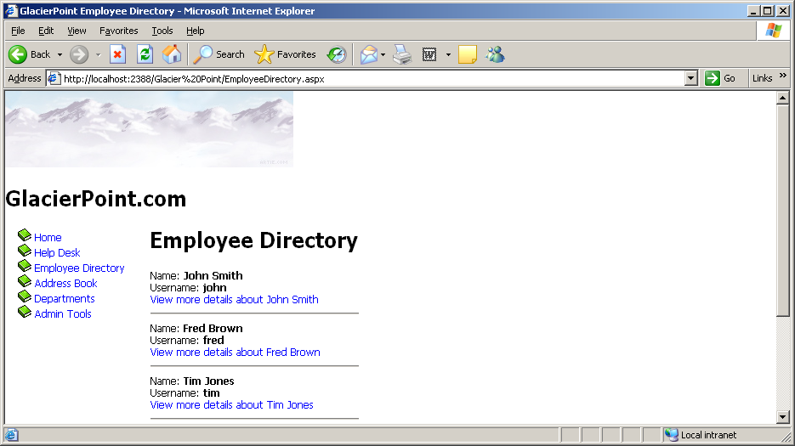
Figure 11-2

Open EmployeeDirectory.aspx, and modify the ItemTemplate of the DataList as shown below:

<asp:DataList id="employeesList" runat="server">
<ItemTemplate>
<asp:Literal ID="extraDetailsLiteral" runat="server"
EnableViewState="false" />
Name: <strong><%#Eval("Name")%></strong><br />
Username: <strong><%#Eval("Username")%></strong><br />
<asp:LinkButton ID="detailsButton" runat="server"
Text=’<%#"View more details about " + Eval("Name")%>’
CommandName="MoreDetailsPlease"
CommandArgument=’<%#Eval("EmployeeId")%>’ />
</ItemTemplate>
<SeparatorTemplate>
<hr />
</SeparatorTemplate>
</asp:DataList>

Here, we’ve added two controls. The first is a Literal control, which serves as a placeholder that we can replace with HTML later when the user clicks on the other control we’ve added—a LinkButton. Even though the LinkButton looks like a link, it really behaves like a button. When someone clicks this button, it generates an event that can be handled on the server side. If you prefer, you can change the LinkButton to a Button, and the functionality will remain identical. If you load the page now, it should appear as shown in Figure 11-2.

Now you have a LinkButton that’s displayed for each employee in the list. In order to react to this LinkButton being clicked, you might think that you’d need to handle its Click event. Not this time! The button is “inside” the DataList as part of its ItemTemplate, so it’s not directly visible to your code. Also, when the code executes, you’ll have more instances of this button—so on the server side, you’ll need a way to know which of them was clicked!

Luckily, ASP.NET provides an ingenious means of handling this scenario. Whenever a button inside a DataList generates a Click event, the DataList generates itself a ItemCommand event. The DataList control is accessible in your code, so you can handle its ItemCommand event, whose arguments will give us information about which control was clicked.

Within the ItemCommand event handler, we can retrieve the data contained in the LinkButton’s CommandName and CommandArgument properties. We use these properties to pass the employee ID to the ItemCommand event handler, which can use the ID to get more data about that particular employee.

Take another look at the button definition from the DataList’s ItemTemplate:

<asp:LinkButton ID="detailsButton" runat="server"
Text=’<%#"View more details about " & Eval("Name")%>’
CommandName="MoreDetailsPlease"
CommandArgument=’<%#Eval("EmployeeId")%>’ />

Here, you can see that we’re using CommandArgument to save the ID of the employee record with which it’s associated. We’re able to read this data from the DataList’s ItemCommand event handler.

Let’s use Visual Studio to generate the ItemCommand event handler. Open EmployeeDirectory.aspx in Design View, select the DataList, and hit F4 to open its Properties window. There, click the yellow lightning symbol to open the list of events, and double-click the ItemCommand event in that list. Visual Studio will generate an empty event handler, and take you to the event handler’s code in the code-behind file.
Modify the code in employeesList_ItemCommand as shown below.

protected void employeesList_ItemCommand(object source,
DataListCommandEventArgs e)
{
// Which button was clicked?
if (e.CommandName == "MoreDetailsPlease")
{
// Find the Literal control in the DataList item
Literal li;
li = (Literal)e.Item.FindControl("extraDetailsLiteral");
// Add content to the Literal control
li.Text = "Employee Id: <strong>" + e.CommandArgument + "</strong><br />";
}
}

Our code is almost ready to execute, but we should make one more minor tweak before we execute this page. At the moment, the Page_Load method will data bind the DataList every time the page loads, which will put unnecessary load on our database server. Let’s change this code so that the data binding only takes place when the page is being loaded for the first time. We’ll also move the data binding code into its own function, so that we can make use of it later. Modify the code as shown below, moving the current contents of Page_Load into a new method called BindList:

protected void Page_Load(object sender, EventArgs e)
{
if (!IsPostBack)
{
BindList();
}
}
protected void BindList()
{
// Define data objects
SqlConnection conn;
SqlCommand comm;
SqlDataReader reader;
…
}

Execute the project and click the View more details link to see the employee ID appear, as shown in Figure 11-3.

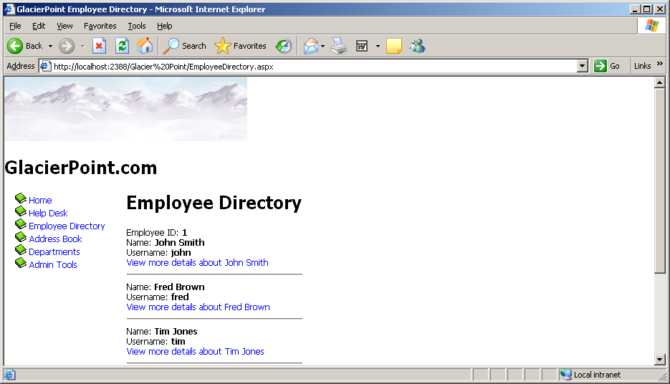
Figure 11-3

The code in employeesList_ItemCommand shows how you can work with controls inside a DataList template, and how to handle their events. We determine which control was clicked by checking the value of e.CommandName in the event handler, which will be populated with the value of the CommandName property of the control that was clicked. Since our LinkButton has the CommandName value MoreDetailsPlease, we check for this value in the ItemCommand event handler, as shown below:

// Which button was clicked?
if (e.CommandName == "MoreDetailsPlease")
{

Once we know the View more details button was pressed, we want to use the extraDetailsLiteral control from our template to display the employee ID. But, given that this control is inside our template, how can we access it through code?

To use a control inside a DataList, we use the FindControl method of the object e.Item. Here, e.Item refers to the template that contains the control; the FindControl method will return a reference to any control within the template that has the supplied ID. So, in order to obtain a reference to the control with the ID extraDetailsLiteral, we use FindControl like this:

// Find the Literal control in the DataList item
Literal li;
li = (Literal)e.Item.FindControl("extraDetailsLiteral");

In C#, we need an explicit cast, as shown above.

Finally, once we have access to the Literal control in a local variable, setting its contents is a piece of cake:

// Add content to the Literal control
li.Text = "Employee Id: <strong>" + e.CommandArgument +
"</strong><br />";

Disabling View State

If you take a look at the definition of the extraDetailsLiteral control in EmployeeDirectory.aspx, you’ll see that we set its EnableViewState property to False:

<asp:Literal ID="extraDetailsLiteral" runat="server"
EnableViewState="false" />

When this property is False, its contents aren’t persisted during postback events. In our case, once the visitor clicks another View more details button, all the instances of that Literal control lose their values. This way, at any given moment, no more than one employee’s ID will be displayed. If you change EnableViewState to True (the default value), then click the View more details button, you’ll see that all employee IDs remain in the form, as they’re persisted by the view state mechanism.

Editing DataList Items and Using Templates

Continuing our journey into the world of DataList, let’s learn a little more about its templates, and see how you can use the EditItemTemplate to edit its contents. Our goal here is to allow users to change the name or username of any employee.

Start by adding another button to the ItemTemplate of the DataList. This button will read Edit employee Employee Name and, when clicked, it will cause the item of which it’s a part to become editable.

<ItemTemplate>
<asp:Literal ID="extraDetailsLiteral" runat="server"
EnableViewState="false" />
Name: <strong><%#Eval("Name")%></strong><br />
Username: <strong><%#Eval("Username")%></strong><br />
<asp:LinkButton ID="detailsButton" runat="server"
Text=’<%#"View more details about " + Eval("Name")%>’
CommandName="MoreDetailsPlease"
CommandArgument=’<%#Eval("EmployeeId")%>’ /><br />
<asp:LinkButton ID="editButton" runat="server"
Text=’<%#"Edit employee " + Eval("Name")%>’
CommandName="EditItem"
CommandArgument=’<%#Eval("EmployeeId")%>’ />
</ItemTemplate>

When an Edit employee button is clicked, we will make the item enter edit mode. When one of the DataList items is in edit mode, the EditItemTemplate template of the DataList is used to generate the contents of that item. All the other items are generated by the ItemTemplate, as usual.

Modify EmployeeDirectory.aspx by adding the EditItemTemplate to the DataList. The EditItemTemplate contains TextBox controls into which the user can enter the employee’s name and username, and two buttons: Update Item and Cancel Editing, those names are self-explanatory.

<EditItemTemplate>
Name: <asp:TextBox ID="nameTextBox" runat="server"
Text=’<%#Eval("Name")%>’ /><br />
Username: <asp:TextBox ID="usernameTextBox" runat="server"
Text=’<%#Eval("Username")%>’ /><br />
<asp:LinkButton ID="updateButton" runat="server"
Text="Update Item" CommandName="UpdateItem"
CommandArgument=’<%#Eval("EmployeeId")%>’ />
or
<asp:LinkButton ID="cancelButton" runat="server"
Text="Cancel Editing" CommandName="CancelEditing"
CommandArgument=’<%#Eval("EmployeeId")%>’ />
</EditItemTemplate>

Finally, before you can see your new template, we need to handle the Edit employee button. Again, when that button is clicked, the DataList’s ItemCommand event is fired. This time, the CommandName of the new button is EditItem, and when we discover that this button was clicked, we’ll put the item into edit mode. To put a DataList item into edit mode, we set its EditItemIndex to the index of the item, then bind the DataList to its data source again to refresh its contents. Add this code:

protected void employeesList_ItemCommand(object source,
DataListCommandEventArgs e)
{
// Which button was clicked?
if (e.CommandName == "MoreDetailsPlease")
{
// Find the Literal control in the DataList item
Literal li;
li = (Literal)e.Item.FindControl("extraDetailsLiteral");
// Add content to the Literal control
li.Text = "Employee Id: <strong>" + e.CommandArgument +
"</strong><br />";
}
else if (e.CommandName == "EditItem")
{
// Set the index of the item being edited
employeesList.EditItemIndex = e.Item.ItemIndex;
// Bind again the list to update the list
BindList();
}
}

Execute the project now, load the employee directory, and enter one of your items into edit mode, as shown in Figure 11-4.

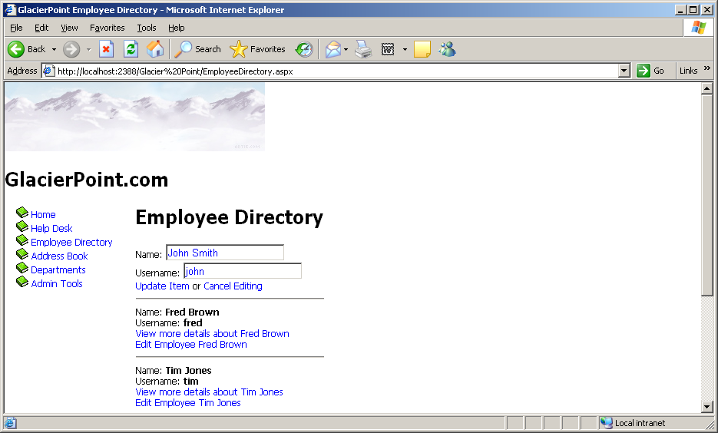
Figure 11-4

We need to implement functionality for two more buttons: Update Item, and Cancel Editing. We’ll take them one at a time, starting with Cancel Editing, which is easier to handle. Modify employeesList_ItemCommand like this:

protected void employeesList_ItemCommand(object source,
DataListCommandEventArgs e)
{
// Which button was clicked?
if (e.CommandName == "MoreDetailsPlease")
{
// Find the Literal control in the DataList item
Literal li;
li = (Literal)e.Item.FindControl("extraDetailsLiteral");
// Add content to the Literal control
li.Text = "Employee Id: <strong>" + e.CommandArgument +
"</strong><br />";
}
else if (e.CommandName == "EditItem")
{
// Set the index of the item being edited
employeesList.EditItemIndex = e.Item.ItemIndex;
// Bind again the list to update the list
BindList();
}

else if (e.CommandName == "CancelEditing")
{
// Cancel edit mode
employeesList.EditItemIndex = -1;
// Refresh the DataList
BindList();
}
}

Execute your project again and check that your new button works. As you can see, exiting edit mode is really simple. You simply need to set the EditItemIndex property of the DataList to -1, then refresh the DataList’s contents.

Let’s deal with the task of updating the record now. We read the ID of the employee whose details are being edited from the button’s CommandArgument property, and the employee’s new name and username from the TextBox control. The techniques used in this code are the ones we used earlier, but be sure to read the code carefully to ensure that you understand how it works.

else if (e.CommandName == "CancelEditing")
{
// Cancel edit mode
employeesList.EditItemIndex = -1;
// Refresh the DataList
BindList();
}
else if (e.CommandName == "UpdateItem")
{
// Get the employee ID
int employeeId = Convert.ToInt32(e.CommandArgument);
// Get the new username
TextBox nameTextBox =
(TextBox)e.Item.FindControl("nameTextBox");
string newName = nameTextBox.Text;
// Get the new name
TextBox usernameTextBox =
(TextBox)e.Item.FindControl("usernameTextBox");
string newUsername = usernameTextBox.Text;
// Update the item
UpdateItem(employeeId, newName, newUsername);
// Cancel edit mode
employeesList.EditItemIndex = -1;
// Refresh the DataList
BindList();
}
As you can see, a mysterious method named UpdateItem is used to perform the actual update. We’ve created a separate method to make the code easier to manage. Add this code to your code-behind file:

protected void UpdateItem(int employeeId, string newName,
string newUsername)
{
// Declare data objects
SqlConnection conn;
SqlCommand comm;
// Read the connection string from Web.config
string connectionString =
ConfigurationManager.ConnectionStrings[
"GlacierPoint"].ConnectionString;
// Initialize connection
conn = new SqlConnection(connectionString);
// Create command
comm = new SqlCommand("sp_UpdateEmployee", conn);
// Specify we're calling a stored procedure
comm.CommandType = System.Data.CommandType.StoredProcedure;
// Add command parameters
comm.Parameters.Add("@EmployeeId", SqlDbType.Int);
comm.Parameters["@EmployeeId"].Value = employeeId;
comm.Parameters.Add("@NewName", SqlDbType.VarChar, 50);
comm.Parameters["@NewName"].Value = newName;
comm.Parameters.Add("@NewUsername", SqlDbType.VarChar, 50);
comm.Parameters["@NewUsername"].Value = newUsername;
// Enclose database code in Try-Catch-Finally
try
{
// Open the connection
conn.Open();
// Execute the command
comm.ExecuteNonQuery();
}
finally
{
// Close the connection
conn.Close();
}
}

Once the parameters are all prepared, the UpdateItem method calls the UpdateEmployee stored procedure, which performs the database operation. Next, let’s add the UpdateEmployee stored procedure to our database by running the following script using Management Studio Express:

CREATE PROCEDURE sp_UpdateEmployee
(@EmployeeId Int,
@NewName nvarchar(50),
@NewUsername nvarchar(50))
AS
UPDATE gp_Employee
SET Name = @NewName, Username = @NewUsername
WHERE EmployeeId = @EmployeeId;

Finally, execute the project again, load the Employee Directory page, and enter one of the employees into edit mode. You should see a display like the one shown in Figure 11-5.

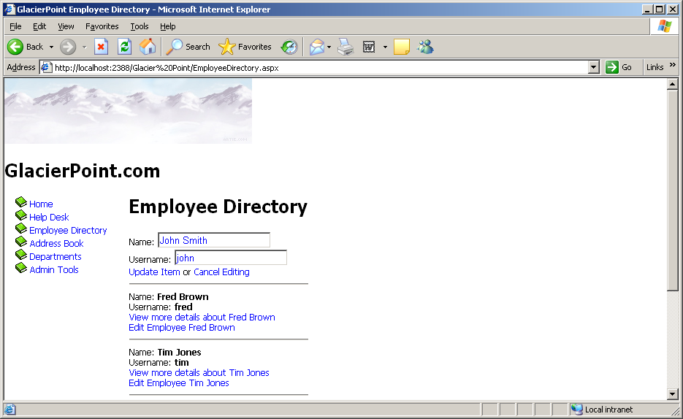
Figure 11-5

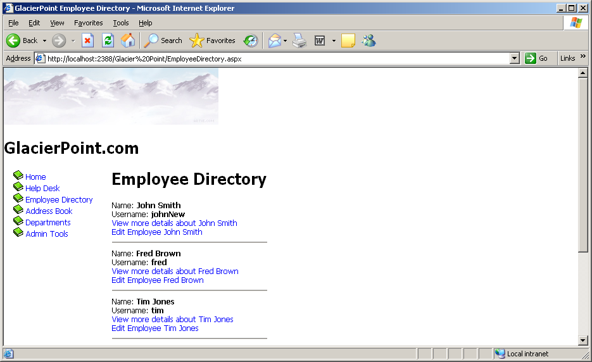
Figure 11-6

Change the name or username, and click Update Item to see the listed data change. In Figure 11-6, you can see that I’ve changed John’s username to johnNew.

DataList and Visual Studio

Just like some of the more complex web server controls, DataLists offer a number of design-time features that are tightly integrated within Visual Studio. One of these slick features is the smart tag, which appears as a little arrow button in the upper-right part of the control when the cursor is hovered over the control in Design View.

You’ll be working with these neat features in coming lessons, but we can’t finish a lesson on DataLists without making ourselves aware of them. If you open EmployeeDirectory.aspx in Design View, and click the smart tag, you’ll see the menu depicted in Figure 11-7.

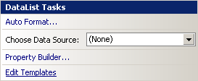

Figure 11-7

You can use this menu to apply predefined styles to your grid, choose a data source control (you’ll learn more about these in the following lessons), or edit the grid’s templates.

If you click Edit Templates, you can build the DataList’s templates visually, as Figure 11-8 indicates.

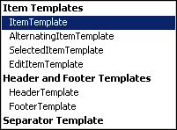

Figure 11-8

We’ll generally write most of the code by hand, but it’s good to know that you also have this visual option.

Choosing the Property Builder from the smart tag’s menu displays a window that lets us set various properties of a DataList. We can access the same settings through the Properties window, but with the DataList we have another way to set these properties.

The Choose Data Source item in the smart tag’s menu lets us choose a data source control for our list. You’ll learn a lot more about this in a later lesson.

Styling the DataList

The Auto Format item in the smart tag menu is probably the most interesting. I left this discussion until the end of the chapter to give you the chance to play with it a little beforehand. When you select Auto Format, a dialog with a number of predefined setups will appear; you can customize these options manually to suit your tastes, as Figure 11-9 illustrates.

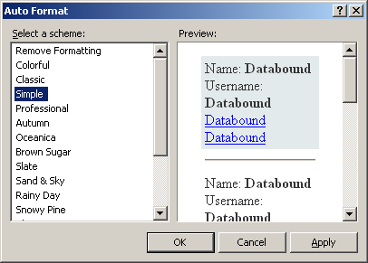

Figure 11-9

If you choose the Simple style, then remove the SeparatorTemplate from your DataList, your Employee Directory page will look like the one shown in Figure 11-10.
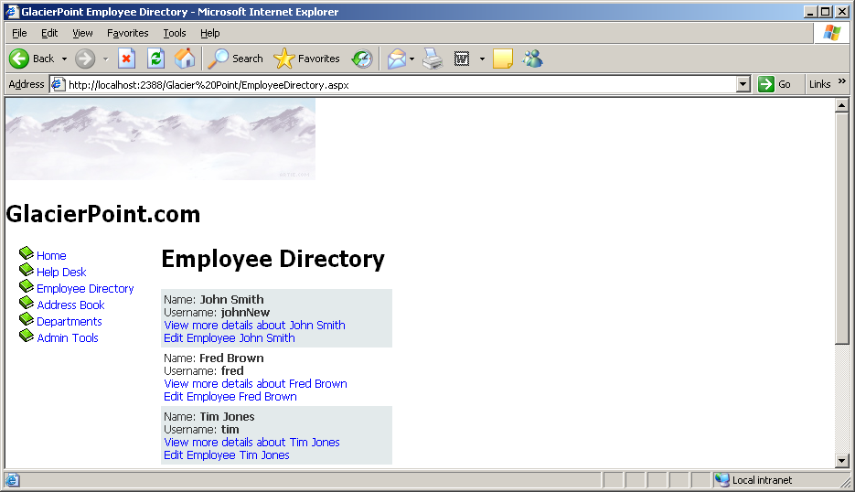

Figure 11-10
You may ask what happened behind the scenes. If you look at the DataList definition in EmployeeDirectory.aspx, you’ll see it contains a few new lines that Visual Studio generated for us after we chose the style:

</EditItemTemplate>
<FooterStyle BackColor="#1C5E55" Font-Bold="True"
ForeColor="White" />
<SelectedItemStyle BackColor="#C5BBAF" Font-Bold="True"
ForeColor="#333333" />
<AlternatingItemStyle BackColor="White" />
<ItemStyle BackColor="#E3EAEB" />
<HeaderStyle BackColor="#1C5E55" Font-Bold="True"
ForeColor="White" />
</asp:DataList>

The significance of these new elements is as follows:

HeaderStyle
customizes the appearance of the DataList’s heading

ItemStyle
customizes the appearance of each item displayed within the DataList

AlternatingItemStyle
customizes the appearance of every other item displayed within the DataList

FooterStyle
customizes the appearance of the DataList’s footer

SelectedItemStyle
customizes the appearance of a selected item within the DataList

EditItemStyle
customizes the appearance of the DataList when in edit mode

Lesson #12
Topic | The GridView and DetailsView Controls | Points
Chapter | Nine
Project | One – The Arkham Books Web Site – Part 1 | 10

Topics:
- The GridView Control
- The DetailsView Control
- The GlacierPoint Tutorial - Part 6
- The GlacierPoint Tutorial – Part 7 – Handout (Part 7 is Optional)

The GlacierPoint Project
Part 6

Managing Content Using GridView and Details View

In the previous lessons, you learned some of the important concepts surrounding data access and presentation. You learned that when connecting to a database, we have to establish a connection using the SqlConnection class. You also learned that in order to retrieve data from the database table, we must write an SQL statement within a command using the SqlCommand class. You discovered that we use the SqlDataReader class to place the database records into a virtual container. Finally, you learned that presenting the data within the SqlDataReader was simply a matter of binding the SqlDataReader to a data control such as the Repeater or DataList controls.

The Repeater and DataList controls offer flexibility in the sense that their templates can easily be customized with inline HTML, in conjunction with code render blocks, to display the contents in a clean and neatly formatted manner. So far, these two controls have been great! They certainly have their place, and I’m not about to discourage you from using them. However, these controls do remind ASP developers a little too much of the bad old days when we had to write our HTML table and table row tags in While loops. Within those table row tags, we also had to add code render blocks to display the contents of the data source. As you’ve probably noticed, the Repeater control isn’t much different from the techniques we were forced to use in those bad old days. HTML table row tags still have to be added within the <HeaderTemplate>, <ItemTemplate>, and <FooterTemplate> tags, and code render blocks must still be used within the table data cells. The DataList makes things a bit easier by generating a single column table for us, but even so, the built-in functionality isn’t overwhelming.

Here, we’ll learn about two more controls that offer much more functionality and make it very easy for you to create a table: GridView and DetailsView. These controls, which form part of ASP.NET’s set of data controls, give developers much more power and flexibility over presentation, as you’ll see in the next few sections. The processes by which information within a table is presented, formatted, and edited have been completely revamped with the GridView and DetailsView controls.

Using the GridView Control

The GridView control solves a problem that has plagued developers for years: data presentation. The GridView control generates simple HTML tables, so information within a GridView is presented to the end user in a familiar, cleanly formatted, tabular structure. Similar to the Repeater control, the GridView can also automatically display all the content contained in a SqlDataReader on a page, based on styles we set within its templates. However, unlike the Repeater control, the GridView offers several more advanced features, such as sorting or paging (i.e. splitting a large result set into pages), and makes it easy to modify the data in the underlying data source.

To sum up, GridView controls provide the following functionality:

- database table-like presentation
- table headers and footers
- paging
- sorting
- style modification through templates
- customizable columns for advanced editing

You’ll learn about some of these features in this chapter, though we’ll leave the more advanced ones (sorting, paging, and editing) for the next lesson.

As with any other ASP.NET server control, GridView controls are added to the page using a specific element:

<asp:GridView id="myGridView" runat="server" />

Once we add the GridView to the page, we can bind an SqlDataReader to it as follows:

myGridView.DataSource = myDataReader;
myGridView.DataBind();

So far, the GridView doesn’t seem to function very differently from the Repeater control, right? Think again! The Repeater control didn’t work unless we specified content within the required <ItemTemplate> and </ItemTemplate> tags. The GridView takes the structure of the database table automatically, and presents the data to the user in a cleanly formatted HTML table.

Let’s take a look at GridView in action as we develop the GlacierPoint intranet’s address book page. Start by opening the GlacierPoint project, if it’s not already open, and creating a new web content form named AddressBook.aspx, based on the GlacierPoint.master master page.

Now, open AddressBook.aspx, and complete its code as shown in the following code snippet.

<%@ Page Language="C#" MasterPageFile="~/GlacierPoint.master"
AutoEventWireup="True" CodeFile="AddressBook.aspx.cs"
Inherits="AddressBook" title="GlacierPoint Address Book" %>
<asp:Content ID="Content1"
ContentPlaceHolderID="ContentPlaceHolder1" Runat="Server">
<h1>Address Book</h1>
<asp:GridView id="grid" runat="server" />
</asp:Content>

By switching to Design View you can see how your grid is represented in the designer, as Figure 12-1 indicates.

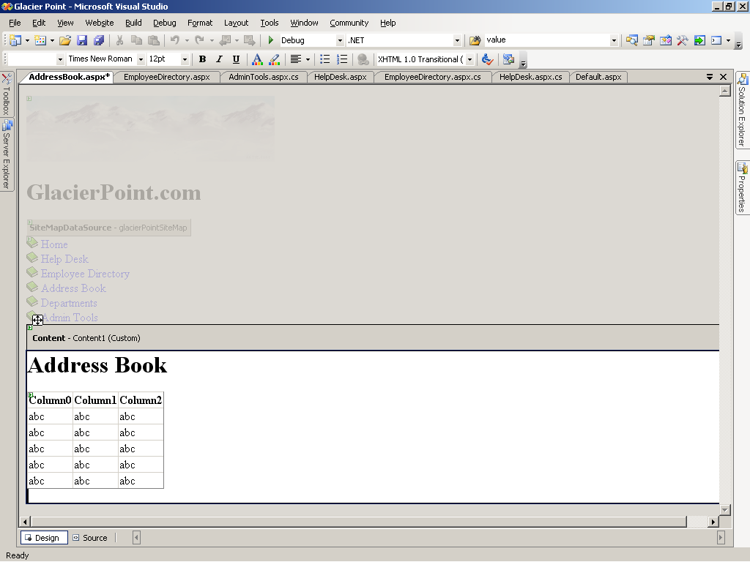
Figure 12-1

In Page_Load, we’ll call a method named BindGrid, which will, in turn, create a database connection and a database command object, execute that command, and bind the resulting data reader to the grid, as shown below:
using System;
using System.Data;
using System.Data.SqlClient;
using System.Configuration;
using System.Collections;
using System.Web;
using System.Web.Security;
using System.Web.UI;
using System.Web.UI.WebControls;
using System.Web.UI.WebControls.WebParts;
using System.Web.UI.HtmlControls;
using System.Data.SqlClient;
public partial class AddressBook : System.Web.UI.Page
{
protected void Page_Load(object sender, EventArgs e)
{
if (!IsPostBack)
{
BindGrid();
}
}
private void BindGrid()
{
// Define data objects
SqlConnection conn;
SqlCommand comm;
SqlDataReader reader;
// Read the connection string from Web.config
string connectionString =
ConfigurationManager.ConnectionStrings[
"GlacierPoint"].ConnectionString;
// Initialize connection
conn = new SqlConnection(connectionString);
// Create command
comm = new SqlCommand(
"SELECT EmployeeId, Name, City, State, MobilePhone " +
"FROM gp_Employee", conn);
// Enclose database code in Try-Catch-Finally
try
{
// Open the connection
conn.Open();
// Execute the command
reader = comm.ExecuteReader();
// Fill the grid with data
grid.DataSource = reader;
grid.DataBind();
// Close the reader
reader.Close();
}
finally
{
// Close the connection
conn.Close();
}
}
}

What’s going on here? If you disregard the fact that you’re binding the SqlDataReader to a GridView instead of a Repeater or DataList, the code is almost identical to that which we saw in the previous lesson.

Now save your work and open the page in the browser. Figure 12-2 shows how the GridView presents all of the data within the Employee table in a cleanly formatted structure.

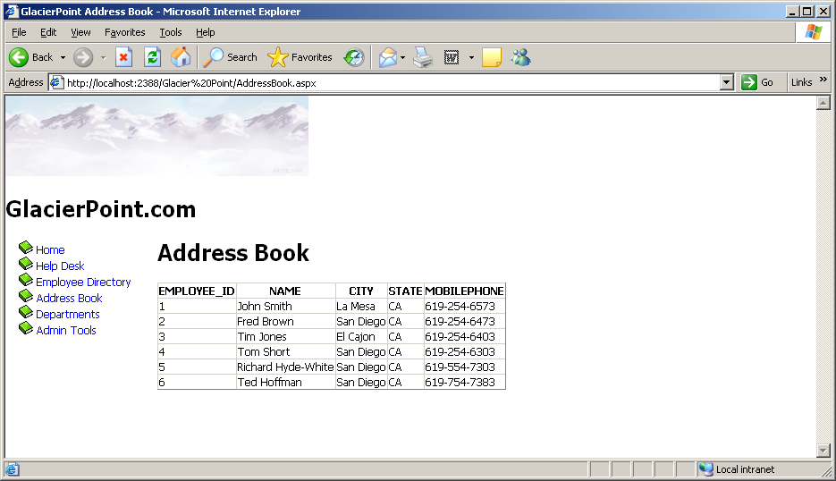
Figure 12-2

Well, okay, perhaps it doesn’t look all that clean right now! However, the display will change as we get some practice using the GridView’s powerful yet intuitive formatting capabilities. You’ll notice that the GridView closely resembles the structure of the query’s result as you might see it in Visual Management Studio Express. All the names of the columns in the database table show as headers within the table, and all the rows from the database table are repeated down the page.

If you look at the generated page source (right-click the page in browser and choose View Source or similar), you’ll see that the GridView indeed generated a table for you:

<table cellspacing="0" rules="all" border="1"
id="ctl00_ContentPlaceHolder1_grid"
style="border-collapse:collapse;">
<tr>
<th scope="col">EmployeeId</th>
<th scope="col">Name</th>
<th scope="col">City</th>
<th scope="col">State</th>
<th scope="col">MobilePhone</th>
</tr>
<tr>
<td>1</td>
<td>Fred Brown</td>
<td>San Diego</td>
<td>CA</td>
<td>619-254-6473</td>
</tr>
<tr>
<td>2</td>
<td>Tom Short</td>
<td>San Diego</td>
<td>CA</td>
<td>619-254-6303</td>
</tr>
…
</table>

The HTML generated by ASP.NET won’t look exactly as it does above, you’ll find that ASP.NET will output long, difficult-to-read lines of td elements, each of which appears directly after the previous one. We’ve simply made it a little easier to read; the two HTML tables are otherwise identical.

There’s no doubt that the GridView’s automatic presentation features are useful. The GridView automatically displays all columns retrieved from the database in the order in which they’re sent from the database. While this is very useful, in some cases you’ll want your grid to display only a subset of the information retrieved from the database, and in many cases you’ll also want to change the order in which the columns of data are displayed.

Let’s learn how to customize the GridView by selecting which columns to show, in what order. In our case, one of the columns that we want to retrieve from the database, but hide from users, is the EmployeeId column. We need to retrieve the table’s primary key because it’s required for any database operations that involve the unique identification of a record (including tasks such as editing or deleting an employee from the list). The user doesn’t need to be overwhelmed with this information, though—after all, humans don’t use numeric IDs to identify people in a list.

Customizing the GridView Columns

Our next task is to customize the columns displayed by the GridView. In this case, our goal is to prevent the EmployeeId column from showing up, but the same techniques can be used to make all sorts of customizations.

If you wish to restrict the information that appears within your GridView, you can select the columns you want to display by making a few simple modifications. When you simply bind an SqlDataReader to the GridView, you're presented with a quick, simple representation of the data you’ve retrieved from the database, with automatically generated column headers.

One of the properties available to GridView is AutoGenerateColumns, which is set to True by default. If you want to name the columns that your GridView displays manually, you must set this property to False.

If you set this property to False and test it in the browser, you’ll find that the grid doesn’t show up any more. The reason for this is simple: as the GridView can’t generate its own column headers, you must manually specify the columns that you want displayed. To do so, list the columns inside the <asp:GridView> and </asp:GridView> tags, as shown below:

<asp:GridView ID="grid" runat="server"
AutoGenerateColumns="False">
<Columns>
<asp:BoundField DataField="Name" HeaderText="Name" />
<asp:BoundField DataField="City" HeaderText="City" />
<asp:BoundField DataField="MobilePhone"
HeaderText="Mobile Phone" />
</Columns>
</asp:GridView>

Notice that each column that we want to display is created using a BoundField control inside a set of <Columns> and </Columns> tags. Each BoundField control has a DataField property, which specifies the name of the column, and a HeaderText property, which sets the name of the column, as you want it displayed to the user.

Now, save your work and view it in the browser. This time, only the columns that you specified to be bound are displayed in the GridView. The results should appear as shown in Figure 12-3. Note that if you don’t include the HeaderText property for any of the bound columns, those columns will not have a header.

We’ve now succeeded in displaying only the information we want to display, but the GridView still looks plain. In the next section, we’ll use styles to customize the look of our GridView.

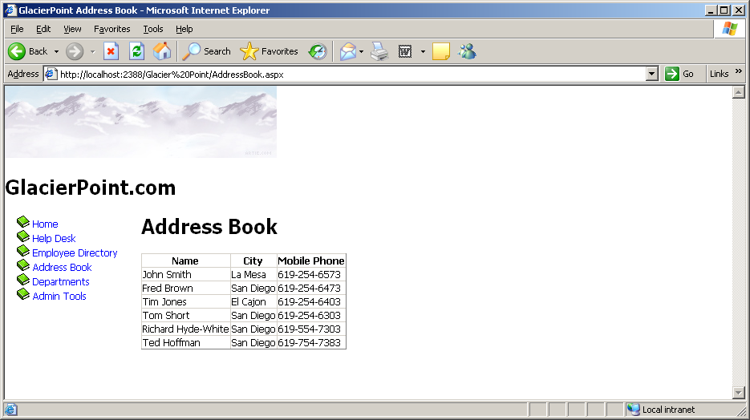
Figure 12-3

Styling the GridView with Templates, Skins, and CSS

The GridView control offers a number of design-time features that are tightly integrated with Visual Studio. As with the DataList class, when you click the grid’s smart tag, you get quick access to a number of very useful features, as Figure 12-4 illustrates.

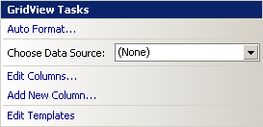

Figure 12-4

If you click the Auto Format… link from the smart tag menu and choose one of the predefined styles, Visual Studio generates a number of template styles for you, like this:

<asp:GridView ID="grid" runat="server" AutoGenerateColumns="False"
CellPadding="4" ForeColor="#333333" GridLines="None">
<Columns>
<asp:BoundField DataField="Name" HeaderText="Name" />
<asp:BoundField DataField="City" HeaderText="City" />
<asp:BoundField DataField="MobilePhone" HeaderText="Mobile Phone" />
</Columns>
<FooterStyle BackColor="#5D7B9D" Font-Bold="True"
ForeColor="White" />
<RowStyle BackColor="#F7F6F3" ForeColor="#333333" />
<EditRowStyle BackColor="#999999" />
<SelectedRowStyle BackColor="#E2DED6" Font-Bold="True"

ForeColor="#333333" />
<PagerStyle BackColor="#284775" ForeColor="White"
HorizontalAlign="Center" />
<HeaderStyle BackColor="#5D7B9D" Font-Bold="True"
ForeColor="White" />
<AlternatingRowStyle BackColor="White" ForeColor="#284775" />
</asp:GridView>

However, this time, we prefer not to rely on the predefined templates, but to define our own styles through CSS. Additionally, we want to add a new skin definition for the GridView, so that all the GridView controls throughout our site have a standard appearance.

Open your GlacierPoint.css file from the App_Themes/Blue folder and add these styles to it:

.GridMain
{
border-right: gainsboro thin solid;
border-top: gainsboro thin solid;
border-left: gainsboro thin solid;
border-bottom: gainsboro thin solid;
background-color: #333333;
width: 400px;
}
.GridRow
{
background-color: #FFFAFA;
}
.GridSelectedRow
{
background-color: #E6E6FA;
}
.GridHeader
{
background-color: #ADD8E6;
font-weight: bold;
text-align: left;
}

Then modify the skin file SkinFile.skin in App_Themes/Blue by adding this skin definition:

<asp:GridView runat="server" CssClass="GridMain" CellPadding="4"
GridLines="None">
<RowStyle CssClass="GridRow" />
<SelectedRowStyle CssClass="GridSelectedRow" />
<HeaderStyle CssClass="GridHeader" />
</asp:GridView>

Finally, make sure that your GridView declaration in AddressBook.aspx doesn’t contain any styling details, as shown here:

<asp:GridView ID="grid" runat="server"
AutoGenerateColumns="false">
<Columns>
<asp:BoundField DataField="Name" HeaderText="Name" />
<asp:BoundField DataField="City" HeaderText="City" />
<asp:BoundField DataField="MobilePhone"
HeaderText="Mobile Phone" />
</Columns>
</asp:GridView>

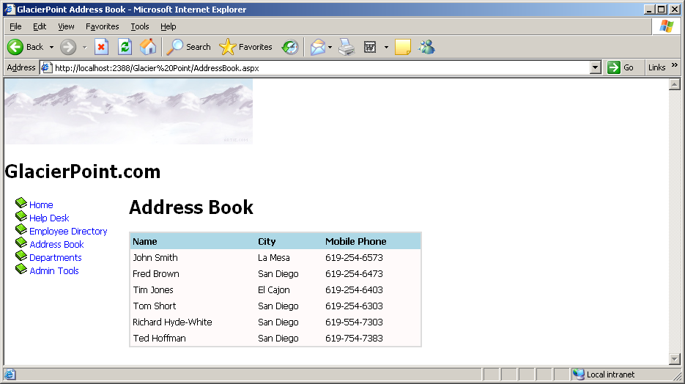
Figure 12-5

All the styling we need is already defined in the skin file; we’d only need to define new properties if we wanted to alter the default values provided through the skin file. Save your work and view the results in the browser. Do they look like the display in Figure 12-5?

Congratulations! You’ve harnessed the power of CSS and skin files, and combined it with the flexibility of a GridView to easily create a good-looking address book! As you can see, you can style the items in the GridView by altering their font types, colors, and sizes. You can also style the column headers and apply an alternating item style to alternate rows in the table. Now, when the GridView is viewed in the browser, we see a little more room between cells, and the lines surrounding the GridView are gone.

Selecting Grid Records

We’ve already made quite a few changes to the display of our GridView. The next step will be to allow users to select one of the rows in the GridView so they can view more information about the selected employee.

There are several types of columns that we can create in a GridView in addition to the BoundField columns we’ve already seen. For instance, we could create a ButtonField column, which displays a button in each row. The complete set of column controls and their descriptions are listed here:

BoundField
As you’ve seen, the BoundField provides flexibility in presentation by allowing you to specify which columns will appear within the GridView. When the grid enters edit mode, this field renders itself as an editable text box, as we’ll see later.

ButtonField
Use the ButtonField to display a clickable button for each row within the GridView. When clicked, the button triggers a configurable event that you can handle within your code to respond to the user’s action. The possible event types that a button can trigger are: Cancel, Delete, Edit, Select, and Update.

CheckBoxField
The CheckBoxField displays a checkbox in each row, allowing you to easily present Boolean data in the display.

CommandField
The CommandField column automatically generates a ButtonField in your grid. The actions performed by these buttons depend on the grid’s current state. For example, if CommandField is set to generate Edit buttons, it will display an Edit button when the grid is in non-editable mode, and will display Update and Cancel buttons when the grid is being edited.

HyperLinkField
Use the HyperLinkField to display a clickable link within the GridView. This link simply acts as a hyperlink to a URL; it raises no server-side events.

ImageField
This control displays an image inside your grid.

TemplateField
Use the TemplateField to display markup within the GridView.

If you’re using Visual Studio, you can quickly and easily add a new column to your table in Design View. Click the GridView’s smart tag, and click the Add New Column... item, as shown in Figure 12-6.

Figure 12-6

In the dialog that appears, change the field type to ButtonField, the button type to Link, the command name to Select, and set the Text field to Select, so the dialog appears as it does in Figure 12-7.

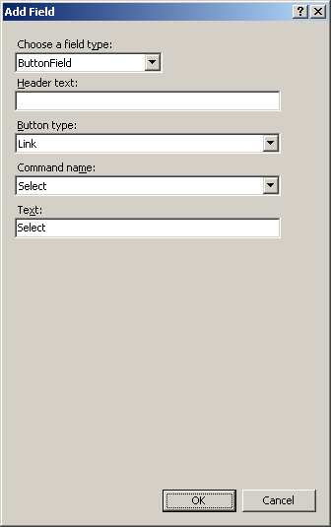

Figure 12-7

After clicking OK, your brand new column shows up in Design View. If you switch to Source View, you can see it there, too:

<asp:GridView ID="grid" runat="server"
AutoGenerateColumns="false">
<Columns>
<asp:BoundField DataField="Name" HeaderText="Name" />
<asp:BoundField DataField="City" HeaderText="City" />
<asp:BoundField DataField="MobilePhone"
HeaderText="Mobile Phone" />
<asp:ButtonField CommandName="Select" Text="Select" />
</Columns>
</asp:GridView>

If you execute the project now, and click the new button, the row will become highlighted, as Figure 12-8 indicates. Notice that you didn’t write any code to implement this feature? We’re relying on the functionality provided by the ButtonField control when its CommandName property is set to Select, and the style settings you set earlier, to produce this functionality.

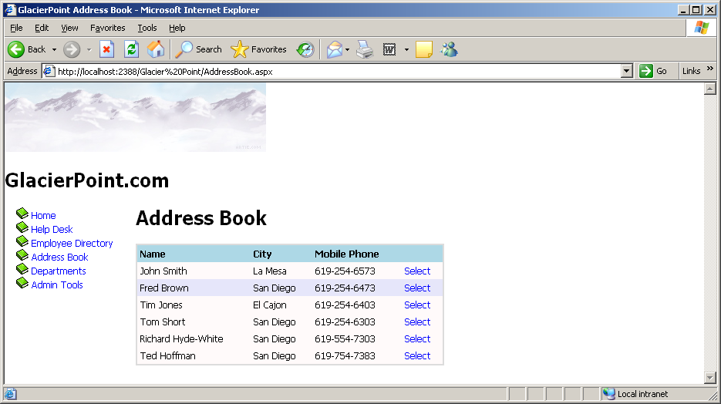
Figure 12-8

We usually want extra work—in addition to the row highlight—to be performed when a user selects a row in the address book. When the Select button is pressed, the GridView fires the SelectedIndexChanged event, which we handle if we need to do any further processing. We can generate the GridView’s SelectedIndexChanged event handler simply by double-clicking the GridView in the Visual Studio designer.

Double-clicking a control in the designer causes Visual Studio to generate the handler of the control’s default event. The default event of the GridView is SelectedIndexChanged, which explains why it’s so easy to generate its signature. Remember that you can use the Properties window to have Visual Studio generate handlers for other events—just click the lightning icon in the Properties window, then double-click on any of the listed events.

Before we handle the SelectedIndexChanged event, let’s add just below the GridView control in AddressBook.aspx a label that we can use to display some details of the selected record. You can use Visual Studio’s designer to add the control, or you can write the code manually:

</asp:GridView>
<br />
<asp:Label ID="detailsLabel" runat="server" />
</asp:Content>

Now, generate the SelectedIndexChanged event handler by double-clicking the GridView control in Design View, then update the event handler to display a short message about the selected record:

protected void grid_SelectedIndexChanged(object sender,
EventArgs e)
{
// Obtain the index of the selected row
int selectedRowIndex;
selectedRowIndex = grid.SelectedIndex;
// Read the name from the grid
GridViewRow row = grid.Rows[selectedRowIndex];
string name = row.Cells[0].Text;
// Update the details label
detailsLabel.Text = "You selected " + name + ".";
}

Execute the project, and select one of the records. You should see a display like the one in Figure 12-9.

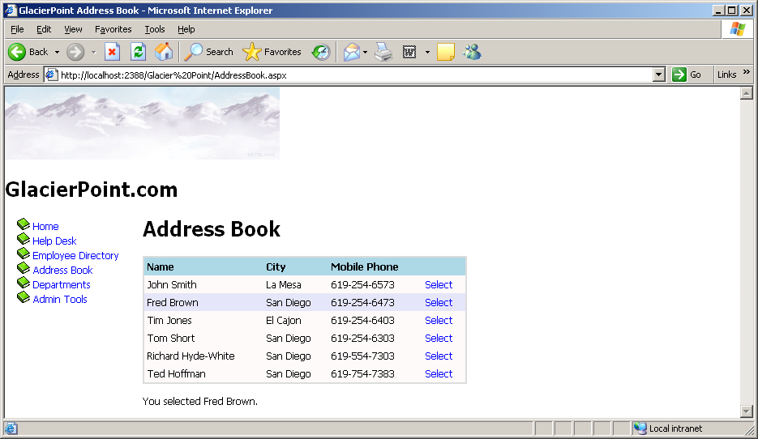
Figure 12-9

Using the DetailsView Control

ASP.NET 2.0 introduced the DetailsView control, which can come in very handy when you want to display more details about one record in a grid. You’ll find this control very useful when you need to display details about a record that contains many fields—so many, in fact, that the main grid can’t display all of them.

A common use of the DetailsView control is to create a page that shows a list of items, and allows you to drill down to view the details of each item. For instance, an ecommerce site might initially present users with only a little information about all available products, to reduce download time and make the information more readable. Users could then select a product to see a more detailed view of that product.

Let’s see how this works by using a GridView and a DetailsView in our Address Book web form.

Replace detailsLabel with a DetailsView control, as shown in the following code snippet:

</asp:GridView>
<br />
<asp:DetailsView id="employeeDetails" runat="server" />
</asp:Content>

Next, we’ll modify the BindGrid method to specify the grid’s data key. The data key feature of the GridView control basically allows us to store a piece of data about each row without actually displaying that data. We’ll use it to store the EmployeeId of each record. Later, when we need to retrieve additional data about the selected employee, we’ll be able to read the employee’s ID from the data key, and use it in our SELECT query.

Add this line to your code-behind file:

// Open the connection
conn.Open();
// Execute the command
reader = comm.ExecuteReader();
// Fill the grid with data
grid.DataSource = reader;
grid.DataKeyNames = new string[] { "EmployeeId" };
grid.DataBind();
// Close the reader
reader.Close();

As you can see, we tell the GridView which keys to store by setting the DataKeyNames property. This property needs to be populated with an array of keys, because the GridView supports storing zero, one, or many keys for each row it displays. In this case, we create an array that contains just one value: EmployeeID. In the code you’ve just written, you can see the syntax creates such an array on the fly, without declaring an array first.

After you make this change, you’ll be able to access the EmployeeId value for any given row through the GridView’s DataKeys property.

With this new data at hand, loading the details of the selected employee into the DetailsView is a straightforward process. In the GridView’s SelectedIndexChanged event handler, we just need to make another database query to read the details we want to display for the selected employee, then simply feed the results to the DetailsView object. Replace the code in the GridView’s SelectedIndexChanged event handler with the code shown below and add the BindDetails( ) method.

protected void grid_SelectedIndexChanged(object sender,
EventArgs e)
{
BindDetails();
}

private void BindDetails()
{
// Obtain the index of the selected row
int selectedRowIndex = grid.SelectedIndex;
// Read the employee ID
int employeeId = Convert.ToInt32(grid.DataKeys[selectedRowIndex].Value);
// Define data objects
SqlConnection conn;
SqlCommand comm;
SqlDataReader reader;
// Read the connection string from Web.config
string connectionString =
ConfigurationManager.ConnectionStrings[
"GlacierPoint"].ConnectionString;
// Initialize connection
conn = new SqlConnection(connectionString);
// Create command
comm = new SqlCommand(
"SELECT EmployeeId, Name, Address, City, State, Zip, " +
"HomePhone, Extension FROM gp_Employee " +
"WHERE EmployeeId=@EmployeeId", conn);
// Add the EmployeeID parameter
comm.Parameters.Add("@EmployeeId", SqlDbType.Int);
comm.Parameters["@EmployeeId"].Value = employeeId;
// Enclose database code in Try-Catch-Finally
try
{
// Open the connection
conn.Open();
// Execute the command
reader = comm.ExecuteReader();
// Fill the grid with data
employeeDetails.DataSource = reader;
employeeDetails.DataKeyNames = new string[] {"EmployeeId"};
employeeDetails.DataBind();
// Close the reader
reader.Close();
}
finally
{
// Close the connection
conn.Close();
}
}

Now, if you execute the project and select one of the employees, you should see a page like the one shown in Figure 12-10.

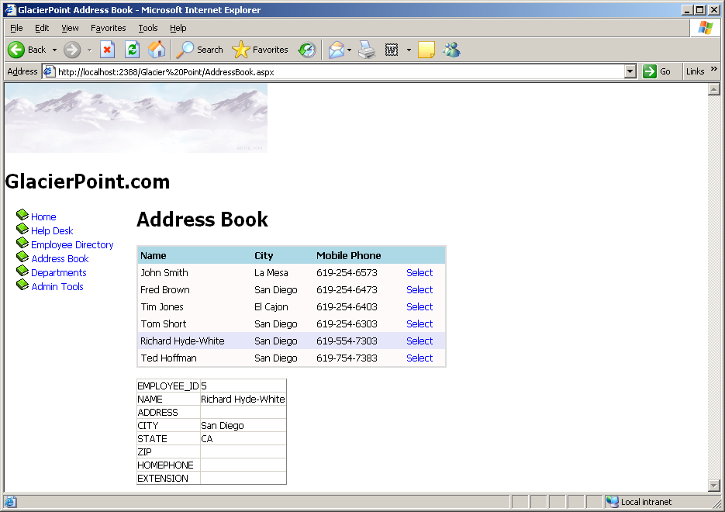
Figure 12-10

Styling the DetailsView

Displaying the data in the DetailsView control is easy enough, but you’ll probably want to make it look a bit prettier. We’ll start by changing the row headings in the left-hand column. Open AddressBook.aspx and modify the DetailsView control like this:

<asp:DetailsView id="employeeDetails" runat="server"
AutoGenerateRows="False">
<Fields>
<asp:BoundField DataField="Address" HeaderText="Address" />
<asp:BoundField DataField="City" HeaderText="City" />
<asp:BoundField DataField="State" HeaderText="State" />
<asp:BoundField DataField="Zip" HeaderText="Zip" />
<asp:BoundField DataField="HomePhone"
HeaderText="Home Phone" />
<asp:BoundField DataField="Extension"
HeaderText="Extension" />
</Fields>
<HeaderTemplate>
<%#Eval("Name")%>
</HeaderTemplate>
</asp:DetailsView>

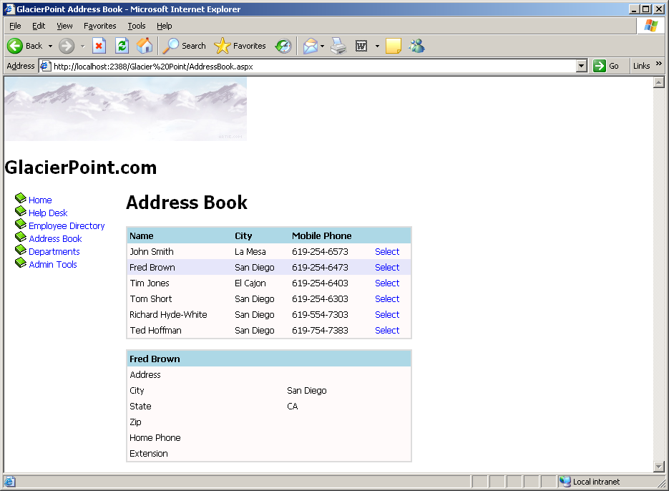
Figure 12-11

As you can see, we customize the DetailsView control in a similar way to the GridView, except that this time we’re dealing with fields instead of rows. We set the AutoGenerateRows property to False; then, we define the fields we want to show, and create a HeaderTemplate which displays the name of the employee in the header—we’ll see what this looks like in a minute.

To further improve the appearance of the DetailsView, add this skin to SkinFile.skin:

<asp:DetailsView runat="server" CssClass="GridMain"
CellPadding="4" GridLines="None">
<RowStyle CssClass="GridRow" />
<HeaderStyle CssClass="GridHeader" />
</asp:DetailsView>

Here, we’ve defined a similar style to the GridView control, which will ensure that our page has a consistent appearance. Save your work, open AddressBook.aspx in the browser, and select an employee. You should see something similar to Figure 12-11.

We’re really making progress now. There’s only one problem—our employee records don’t include any addresses, and at this moment there’s no way to add any! Let’s take care of this.

GridView and DetailsView Events

In order to use the GridView and DetailsView controls effectively, we need to know how to handle their events. In this section, we’ll learn about the events raised by these controls, with an emphasis on the events that relate to editing and updating data, as our next goal will be to allow users to edit the employee details in the DetailsView.

Earlier, you learned how to respond to the user’s clicking of the Select button by handling the GridView’s SelectedIndexChanged event. Soon you’ll implement editing functionality, which you’ll achieve by adding an Edit button to the DetailsView control. The editing features of the GridView and the DetailsView are very similar, so you can apply the same principles, and even almost the same code, to both of them.

Both the GridView and DetailsView controls support Edit command buttons, which will place Edit buttons in the control when the page loads. Once one of the Edit buttons has been clicked, the row (in case of GridView) or the entire form (in case of DetailsView) will become editable, and instead of an Edit button, users will see Update and Cancel buttons.

These features are pretty amazing, because you can achieve this “edit mode” without writing any HTML at all: the columns know how to render their editable modes by themselves. If you don’t like their default edit mode appearances, you can customize them using templates.

Figure 12-12 shows a DetailsView control in edit mode.

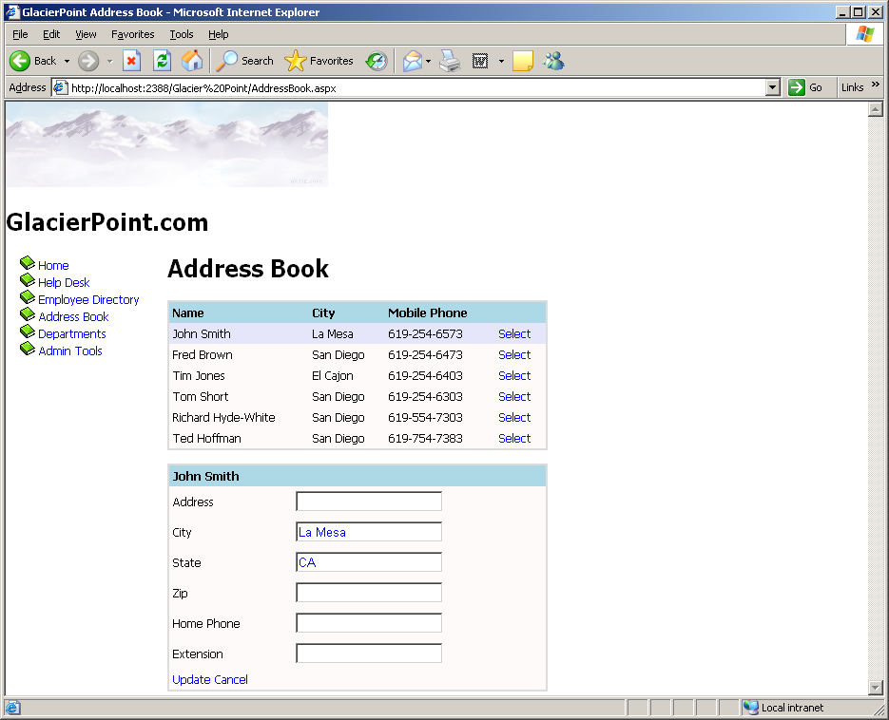
Figure 12-12

When command buttons such as Edit are clicked, they raise events that we can handle on the server side. The GridView supports more kinds of command buttons, each of which triggers a certain event that we can handle. The action types and the events they trigger are listed in Table 1.

Table 1

Action | Events triggered when clicked
Select | SelectedIndexChanging, SelectedIndexChanged
Edit | RowEditing
Update | RowUpdating, RowUpdated
Cancel | RowCancelingEdit
Delete | RowDeleting, RowDeleted
sorting buttons | RowSorting, RowSorted
custom action | RowCommand

The DetailsView control, on the other hand, has buttons and events that refer to items, rather than rows, which makes sense when you realize that DetailsView is used to display the items in one record, while GridView displays a few items from many records. The DetailsView action types, and the events they generate, are listed in Table 2.

Table 2

Action | Events triggered when clicked
paging controls | PageIndexChanging, PageIndexChanged
Delete | ItemDeleting, ItemDeleted
Insert | ItemInserting, ItemInserted
Edit | ModeChanging, ModeChanged
Update | ItemUpdating, ItemUpdated
Delete | RowDeleting, RowDeleted
custom action | ItemCommand

Notice that, except for the RowCommand (for the GridView) and the ItemCommand (for the DetailsView) events, we have events that are named in the present tense (i.e. those that end in “ing,” such as SelectedIndexChanging and ItemUpdating), and events that are named in the past tense (i.e. those that end in “ed,” such as SelectIndexChanged and ItemUpdated). The events that end in “ing” are fired just before their past tense counterparts, and should be handled only if you want to implement some logic to determine whether the action in question should be performed.

The “ed” events, on the other hand, should perform the actual task of the button. We saw such an event handler when we handled the SelectIndexChanged event of our GridView control. In this handler, we queried the database to get the details of the selected employee, and then displayed the result in a DetailsView control.

If we wanted to disallow the selection of a particular employee (say, the employee with the ID 1), we could do so by setting e.Cancel to False in the SelectIndexChanging event handler, as shown below:

protected void grid_SelectedIndexChanging(object sender,
GridViewSelectEventArgs e)
{
// Obtain the index of the selected row
int selectedRowIndex = grid.SelectedIndex;
// Read the employee ID
int employeeId = Convert.ToInt32(grid.DataKeys[selectedRowIndex].Value);
// Cancel the selection if Employee #1 was selected
if (employeeId == 1)
{
e.Cancel = false;
}
}

Entering Edit Mode

To get a better grasp on all this theory, let’s look at another example. Here, we’ll modify the DetailsView control to let users update employee data. To implement GridView or DetailsView editing, we can use a CommandField column.

Let’s get started. Open AddressBook.aspx in the designer, click the DetailsView’s smart tag, and choose Add New Field…. In the Choose a field type drop-down, select CommandField, and check the Edit/Update checkbox, as shown in Figure 12-13. Click OK.

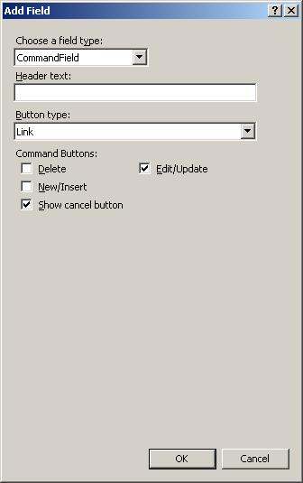

Figure 12-13

If you’d prefer to add the new field by hand, do so by adding it in AddressBook.aspx. Either way, you should end up with the following code:

<asp:DetailsView id="employeeDetails" runat="server"
AutoGenerateRows="False">
<Fields>
<asp:BoundField DataField="Address" HeaderText="Address" />
<asp:BoundField DataField="City" HeaderText="City" />
<asp:BoundField DataField="State" HeaderText="State" />
<asp:BoundField DataField="Zip" HeaderText="Zip" />
<asp:BoundField DataField="HomePhone"
HeaderText="Home Phone" />
<asp:BoundField DataField="Extension"
HeaderText="Extension" />
<asp:CommandField ShowEditButton="True" />
</Fields>
<HeaderTemplate>
<%#Eval("Name")%>
</HeaderTemplate>
</asp:DetailsView>

The new item will appear in the designer as an Edit link immediately below the list of columns. If you execute the project and click that Edit link, an exception will be thrown, telling you that you didn’t handle the ModeChanging event. The DetailsView control doesn’t know how to switch itself to edit mode, but fortunately, it’s extremely easy to write the code yourself.

To have Visual Studio generate the ModeChanging event signature for you, open AddressBook.aspx in Design View, select the DetailsView control, click the yellow button with the lightning symbol in the Properties window to bring up the list of the control’s events, and double-click on the ModeChanging entry. This will generate an empty event handler for you, and take you straight to the function in the code-behind file. Complete the generated code like this:

protected void employeeDetails_ModeChanging(object sender,
DetailsViewModeEventArgs e)
{
// Change current mode to the selected one
employeeDetails.ChangeMode(e.NewMode);
// Rebind the details view
BindDetails();
}

Execute the project and click the Edit button. This will transform the control as shown in Figure 12-14.

Figure 12-14

In order to understand the code in employeeDetails_ModeChanging, you need to know about the display modes of the DetailsView control. The DetailsView control supports three display modes. You can change the current mode using its ChangeMode method, providing as parameter one of these values:

DetailsViewMode.ReadOnly
This is the default mode, which is used to display data. When you execute your project, and load the details of an employee, you see those details in ReadOnly mode.

DetailsViewMode.Edit
This mode is used to edit an existing record. We saw this mode in action earlier, when we clicked the Edit button.

DetailsViewMode.Insert
We use this mode to insert a new record. It’s similar to the edit mode, except all the controls are empty, so you can fill in data for a new item.

If you look at the employeeDetails_ModeChanging, you’ll see it receives a parameter named e that is an object of class DetailsViewModeEventArgs. e’s NewMode property tells us which display mode was requested by the user. Its value will be DetailsViewMode.Edit when the ModeChanging event is fired as a result of the Edit button being clicked. We pass this value to the DetailsView control’s ChangeMode method, which does exactly as its name suggests: it changes the mode of the DetailsView. With this code, you’ve implemented the functionality to make both the Edit and Cancel buttons work correctly, as we’ll see in an example shortly.

However, note that once you switch to edit mode, clicking the Update button will generate an error, because we still haven’t handled the ItemUpdating event that’s fired when the user tries to save changes to a record. We’ll create the event handler later; next, we want to improve our existing solution using templates.

Using Templates
The built-in column types are sufficiently varied and configurable to provide for most of the functionality you’re likely to need, but in cases where further customization is required, you can make the desired changes using templates. In the smart tag menu of the GridView and DetailsView controls, an option called EditColumns (for the GridView) or Edit Fields (for the DetailsView) is available. Selecting that option opens a dialog that provides us with a great deal of control over the options for each column or field.

You’ll notice a Convert this field into a TemplateField link in the dialog. Let’s see how this works. Click the smart tag of your DetailsView control, then click Edit Fields. In the dialog that appears, select the Address field from the Selected fields list, as shown in Figure 12-15.

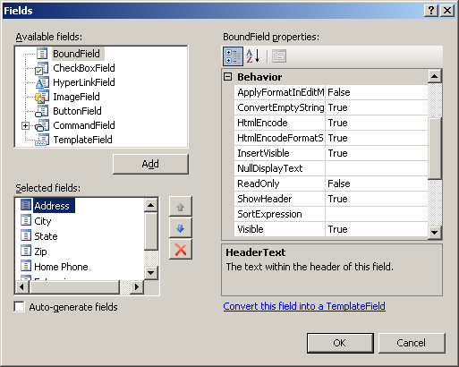
Figure 12-15

Click the Convert this field into a TemplateField link to have Visual Studio create a template that simulates the current functionality of the field, then click OK to close the dialog.

So, what happened? Let’s switch AddressBook.aspx to Source View. After you convert the field to a template field, its definition will look like this:

<asp:DetailsView id="employeeDetails" runat="server"
AutoGenerateRows="False">
<Fields>
<asp:TemplateField HeaderText="Address">
<EditItemTemplate>
<asp:TextBox ID="TextBox1" runat="server"
Text='<%# Bind("Address") %>'></asp:TextBox>
</EditItemTemplate>
<InsertItemTemplate>
<asp:TextBox ID="TextBox1" runat="server"

Text='<%# Bind("Address") %>'></asp:TextBox>
</InsertItemTemplate>
<ItemTemplate>
<asp:Label ID="Label1" runat="server"
Text='<%# Bind("Address") %>'></asp:Label>
</ItemTemplate>
</asp:TemplateField>
<asp:BoundField DataField="City" HeaderText="City" />
…
<asp:CommandField ShowEditButton="True" />
</Fields>
<HeaderTemplate>
<%#Eval("Name")%>
</HeaderTemplate>
</asp:DetailsView>

Pretty cool, huh? Visual Studio did a little bit of magic for us: it replaced the BoundField column that used to display the address with a TemplateField containing an ItemTemplate, an EditItemTemplate, and an InsertItemTemplate. Despite these alterations, the current functionality hasn’t changed: you can still execute your project and load the address book, and it will continue to work as before. The difference is that now you can easily refer to these inner controls from your code, you can easily change their appearance using custom HTML code, and, if you wish, you can replace them with totally different controls. The power is in your hands. For example, you can widen the TextBox controls used to edit your fields, as well as performing other kinds of customizations. You can also give specific IDs to the inner template controls, rather than using their default generic names, so you can find them easily when you need to.

Beware of ReadOnly

Note that if you set a column as read-only (by setting the column’s ReadOnly property to True) prior to its conversion, Visual Studio will use a Label control instead of a TextBox control in the EditItemTemplate for that field. Thus, when the grid enters edit mode, that particular column won’t be transformed into a TextBox, so its read-only behavior will be conserved.

Now, convert the other fields—except for CommandField—to template fields. Then, we’ll modify the generated code by altering the TextBox controls, and assigning appropriate names to our controls. To keep things simple, we’re only going to make changes to the Address and City fields in the code samples provided here—you can update the others yourself. Make the changes below (indicated in bold):

<asp:TemplateField HeaderText="Address">
<EditItemTemplate>
<asp:TextBox ID="editAddressTextBox" runat="server"
Text='<%# Bind("Address") %>'></asp:TextBox>
</EditItemTemplate>
<InsertItemTemplate>
<asp:TextBox ID="insertAddressTextBox" runat="server"
Text='<%# Bind("Address") %>'></asp:TextBox>
</InsertItemTemplate>
<ItemTemplate>
<asp:Label ID="addressLabel" runat="server"
Text='<%# Bind("Address") %>'></asp:Label>
</ItemTemplate>
</asp:TemplateField>
<asp:TemplateField HeaderText="City">
<EditItemTemplate>
<asp:TextBox ID="editCityTextBox" runat="server"
Text='<%# Bind("City") %>'></asp:TextBox>
</EditItemTemplate>
<InsertItemTemplate>
<asp:TextBox ID="insertCityTextBox" runat="server"
Text='<%# Bind("City") %>'></asp:TextBox>
</InsertItemTemplate>
<ItemTemplate>
<asp:Label ID="cityLabel" runat="server"
Text='<%# Bind("City") %>'></asp:Label>
</ItemTemplate>
</asp:TemplateField>

Updating Employee Details

To keep the code in this chapter short, we’re only showing the code required to update a couple of the fields in the Employees table. Adding more fields is a trivial task.

Execute your project, load the address book, select one employee, and click the Edit link to ensure everything works (and looks) as shown in Figure 12-16.

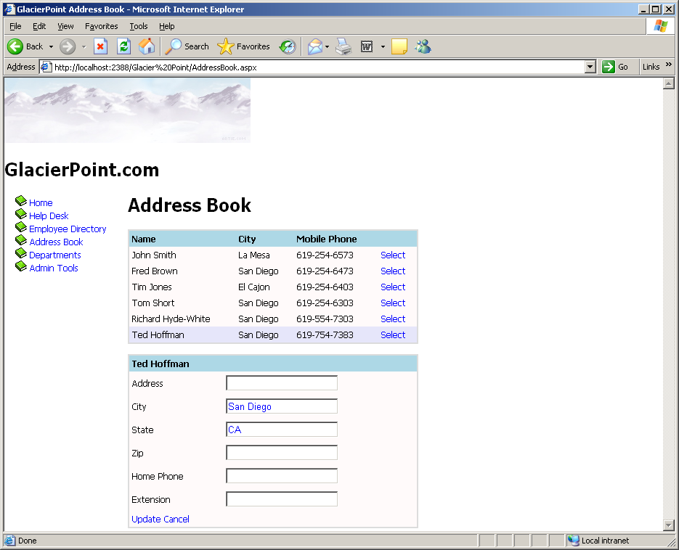
Figure 12-16

Updating DetailsView Records

Now that you have your DetailsView control in place, let’s complete its functionality by making the Update link functional. To begin, we’ll generate the ItemUpdating event handler. The ItemUpdating event is triggered when the Update link is clicked—an action that will occur once the user enters new data into the text boxes and is ready to commit the updated data to the database.

Open AddressBook.aspx in the designer, select the DetailsView control, and switch to the events viewer by clicking the Event button (the little lightning symbol) in the Properties window. There, double-click the ItemUpdating row to have the designer generate the employeeDetails_ItemUpdating method for you, and update the handler with the code shown below:

protected void employeeDetails_ItemUpdating(object sender,
DetailsViewUpdateEventArgs e)
{
// Read the employee from the DetailsView object
int employeeId = Convert.ToInt32(employeeDetails.DataKey.Value);
// Find the TextBox controls with updated data
TextBox newAddressTextBox =
(TextBox)employeeDetails.FindControl("editAddressTextBox");
TextBox newCityTextBox =
(TextBox)employeeDetails.FindControl("editCityTextBox");
// Extract the updated data from the TextBoxes
string newAddress = newAddressTextBox.Text;
string newCity = newCityTextBox.Text;
// Define data objects
SqlConnection conn;
SqlCommand comm;
// Initialize connection
string connectionString =
ConfigurationManager.ConnectionStrings[
"GlacierPoint"].ConnectionString;
// Initialize connection
conn = new SqlConnection(connectionString);
// Create command
comm = new SqlCommand("sp_UpdateEmployeeDetails", conn);
comm.CommandType = CommandType.StoredProcedure;
// Add command parameters
comm.Parameters.Add("@EmployeeId", SqlDbType.Int);
comm.Parameters["@EmployeeId"].Value = employeeId;
comm.Parameters.Add("@NewAddress", SqlDbType.NVarChar, 50);
comm.Parameters["@NewAddress"].Value = newAddress;
comm.Parameters.Add("@NewCity", SqlDbType.NVarChar, 50);
comm.Parameters["@NewCity"].Value = newCity;
// Enclose database code in Try-Catch-Finally
try
{
// Open the connection
conn.Open();
// Execute the command
comm.ExecuteNonQuery();
}
finally
{
// Close the connection
conn.Close();
}
// Exit edit mode
employeeDetails.ChangeMode(DetailsViewMode.ReadOnly);
// Reload the employee grid
BindGrid();
// Reload the details view
BindDetails();
}

This code is pretty straightforward. It starts by reading the value of the DataKey of the DetailsView object. As we saw earlier, the DetailsView, like the GridView, is able to store the ID of the record (or records) it’s displaying. You’ll remember that we made the DetailsView object aware of the EmployeeID data key when we bound the DetailsView to its data source in the BindDetails method. We read this information in the ItemUpdating event handler, like so:

// Read the employee from the DetailsView object
int employeeId = Convert.ToInt32(employeeDetails.DataKey.Value);

The next step is to find the TextBox objects that contain the updated data. We do this using the FindControl method, as we’ve seen previously. After we obtain the control references, we obtain the string values that we’re interested in simply by reading their Text properties, as is shown in the following code snippet:

// Find the TextBox controls with updated data
TextBox newAddressTextBox =
(TextBox)employeeDetails.FindControl("editAddressTextBox");
TextBox newCityTextBox =
(TextBox)employeeDetails.FindControl("editCityTextBox");
// Extract the updated data from the TextBoxes
string newAddress = newAddressTextBox.Text;
string newCity = newCityTextBox.Text;

Next, we call a stored procedure to take care of the database update. To create this stored procedure, run the following script in SqlServer Management Studio:

CREATE PROCEDURE sp_UpdateEmployeeDetails
(@EmployeeId Int, @NewAddress nvarchar(50),@NewCity nvarchar(50))
AS
UPDATE gp_Employee
SET Address = @NewAddress, City = @NewCity
WHERE EmployeeId = @EmployeeId;

In the last part of employeeDetails_ItemUpdating, we rebind both the GridView and the DetailsView with the updated information, and switch the DetailsView back to its read-only state:

// Exit edit mode
employeeDetails.ChangeMode(DetailsViewMode.ReadOnly);
// Reload the employee grid
BindGrid();
// Reload the details view
BindDetails();

The code is ready to be executed now! Try updating the addresses of your employees to ensure the feature works correctly—it should display as shown in Figure 12-17.

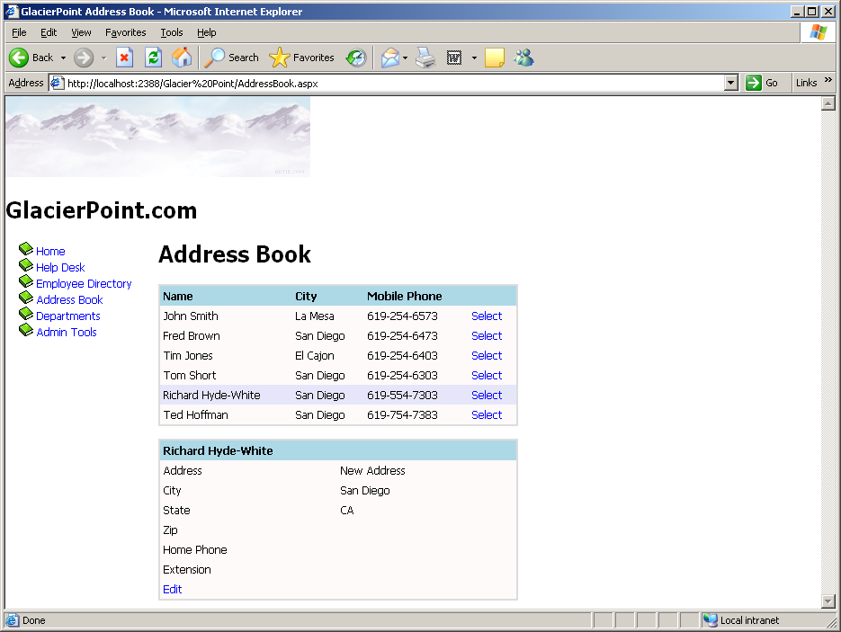
Figure 12-17

Project One (10 Points)
The Arkham Books Web Site Project - Part 1

You will create the following to give your web site a consistent look and feel.
- Create a site map
- Create a master page
  - For web site navigation you can use a Menu or a TreeView
- Create a Theme folder
  - Create a CSS file
  - Create a Skin file

You can use the Tutorial as a guide for your web site, but make it your own design.

You will need to create a Menu or TreeView that includes the following items:
- Home
- Select titles by type of book
- Select titles by author
- Select a list of customers
- Select a list of orders
- Select items on an order when you provide an OrderId
- Provide a page to add a title or edit an existing title

In Projects Two and Three you will write the web pages.

Your instructor will give you additional information to complete this project.
Lesson #13
Topic | Advanced Data Access | Points
Chapter | Nine
Project | Two - The Arkham Books Web Site – Part 2 | 20

Topics:
- DataSource Controls
- DataSets

Project Two (20 Points)
The Arkham Books Web Site Project - Part 2

This project will consist of writing the following web pages. These will be added to the web application that you created in Project 1.

- Home
- Select titles by type of book
- Select titles by author
- Select a list of customers

Your instructor will give you additional information to complete this project.

Lesson #14
Topic | Security and User Authentication | Points
Chapter | Eleven
Project | Three - The Arkham Books Web Site – Part 3 | 20

Topics:
- Basic Securiy Guidelines
  - Validate user input
  - Protect your database
  - Display data correctly
  - Keep sensitive data to yourself
  - Use encryption or hashing whenever necessary
  - Use secure communication channels when necessary
- Authentication
- Authorization
- Forms Authentication
- Authenticating Users
- ASP.NET 2.0 Membership and Roles

Back in the early days of personal computing, when each user’s computer stood alone and isolated, security was not such a big deal. Until computers became networked and viruses were let loose as a scourge on the Internet, security for most PCs meant screen-saver passwords and a lock on the office door.

All that has changed. Today’s computers are interconnected in many ways, on local networks and over the Internet. The pipes of data that connect your machine to the rest of the world are very beneficial, but at the same time potentially harmful, opening your machine to outsiders. Some of those outsiders are malicious or just plain unwelcome. In any case, it is the job of security to let the good stuff in and keep the bad stuff out.

As part of the .NET Framework, ASP .NET 2.0 has a robust security infrastructure. ASP .NET is designed to work with Microsoft Internet Information Server (IIS), Windows, and the NTFS filesystem. Consequently, there is tight integration with the security provided in those environments. If you are on an intranet and are certain that all your clients will be using Windows and IE, there are features your can use to make your job as software developer easier. You can also implement your security system independent of Windows and NTFS using the new forms-based security control.

The fundamental role of security in ASP .NET is to restrict access to portions of a web site. It does this through the following methods:
- Authentication - Verifying that a client is who he says he is.
- Authorization - Determining whether the client has permission to access the resource he is requesting.
- Impersonation - ASP .NET assumes the role of the user gaining access, limiting system access to that which is allowed to the user.
- Delegation - A more powerful form of impersonation that allows remote resources to be accessed by the web server while it is impersonating the client.

The decision to allow or deny access is based on Windows and NTFS security features in conjunction with IIS or by verifying credentials against a security database. ASP .NET 2.0 makes creating a security database simple, setting up all the tables you need for authentication and authorization and for personalization and role-based access.

Security in ASP .NET is a two-layered process. All web requests are first handled by IIS. This gives IIS security a chance to accept or reject the request. If the request is accepted by IIS, it will be passed to ASP .NET, where it will again be subjected to a security decision and accepted or rejected. The security systems of IIS and ASP .NET are independent of each other. They can be used independently or in coordination.

Authentication
Authentication is the process of ensuring that clients are who they claim to be. Authentication is accomplished using credentials, or some form of identification. The requesting client presents the credentials to IIS and the ASP .NET application, usually in the form of a username and password.

The credentials are validated against some authority. Depending on how authentication is configured, that authority might be Windows security, or it might be a store of names, passwords, and rights maintained in a configuration file such as web.config, a relational database, or an XML file.

Authentication is not required. If no authentication is performed, then the client will be an anonymous user. By default, all web sites allow anonymous access. However, if you need to restrict access to any part of the web site, authentication is a necessary step.

If the system cannot identify a user based on the credentials presented and if anonymous users are disallowed, then access will be denied. If the system can identify the user, then that user will be considered an authenticated identity and allowed to proceed on to authorization.

Authentication is provided through code modules called authentication providers. Authentication providers are enabled using the ASP .NET configuration files, either machine.config or the copy of web.config in the application virtual root directory.

A typical entry in a configuration file to enable authentication would look like the following:

<configuration>
<system.web>
<authentication mode =”Windows” />
</system.web>
</configuration>

The mode attribute determines which authentication provider is used. There are four possible values for the mode attribute, as shown below:

- None - No authentication will be performed. Enables anonymous access.
- Windows - Windows authentication will be used in conjunction with IIS. This is the default.
- Passport - Centralized commercial authentication service offered by Microsoft to web site developers, providing single logon across web sites.
- Forms - Unauthenticated requests are redirected to a web page that gathers credentials from the user and submits them to the application for authentication.

Anonymous Access

Anonymous access occurs when a web application does not need to know the identity of users. In this case, credentials are not requested by IIS, and authentication is not performed. Allowing anonymous access is the default configuration for web sites.

Windows Authentication

Windows authentication offers the developer a way to leverage the security built into the Windows platform and the NTFS filesystem. It takes advantage of the security built into IIS. Using Windows authentication, a high level of security can be built into an ASP .NET application with little or no code being written by the developer. The trade off is that Windows authentication only works if the client is using a Windows platform and has a user account of the web server or in the Windows domain to which the web server belongs.

Passport Authentication

Passport is a centralized authentication service provided by Microsoft. It offers a single logon for all web sites that have registered with the Passport service, accepted the license agreement, paid the fee, and installed the Passport SDK.

Forms Authentication

Integrated Windows authentication offers many advantages to the developer who is deploying to an environment where all the clients are know to have user accounts in the required Windows domain or Active Directory and are known to be using a recent version of Internet Explorer. However, in many web applications, one or both of these conditions will not be true. In these cases, forms authentication allows the developer to collect credentials from the client and authenticate them.

In forms authentication, a login form is presented to the user to gather credentials. The form does not necessarily authenticate the user, but submits the credentials, via form post, to application code that performs the authentication. The application code generally authenticates by comparing the credentials submitted with usernames and passwords contained in a data store of some sort.

Project Three (20 Points)
The Arkham Books Web Site Project - Part 3

This project will consist of writing the following web pages. These will be added to the web application that you created in Project 1.

- Select a list of orders
- Select items on an order when you provide an OrderId
- Provide a page to add a title or edit an existing title

Your instructor will give you additional information to complete this project.

Lesson #15
Topic | Quiz 2 and Test 2 | Points
Lesson | 9 - 14 | 25

Topic Review:

- The GlacierPoint Tutorial Part 3
- Data Binding
- Updating records
- Deleting records
- Using Stored Procedures
- The GlacierPoint Tutorial – Part 4
- The DataList Control
- The GlacierPoint Tutorial - Part 5
- The GridView Control
- The DetailsView Control
- The GlacierPoint Tutorial - Part 6
- DataSource Controls
- DataSets
- Basic Security Guidelines
  - Validate user input
  - Protect your database
  - Display data correctly
  - Keep sensitive data to yourself
  - Use encryption or hashing whenever necessary
  - Use secure communication channels when necessary
- Authentication
- Authorization
- Authenticating Users

