Project Portfolio
Project 1 – Mini Case Study (IC EX 6A – Individual Project)
Michael V. Fetick, 84270
COM 660 Database Selection & Administration
March 27, 2016
Coleman University
Table of Contents
Project 1 – Mini Case Study (IC EX 6A – Individual Project) 3
Mason Clinic case study: 3
Entity Relationship Diagram (ERD) 3
Answers to Concept/Terminology Questions (1 through 7) 4
Correct MS Access SQL syntax (for each query 1 through 18) 5
Project Database to submit 7

Project 1 – Mini Case Study (IC EX 6A – Individual Project)

Mason Clinic case study:
Mason Clinic located in CA provides various clinical services to its patients. It hires therapists who treat many patients though some therapists only conduct research or perform admin duties. Each patient is assigned to a therapist at admission. Patients are also billed for the services. If patient’s insurance company pays the bill, then any outstanding bill is reflected on patient record. Therapists keep track of their total billing and how much they have been paid.

Entity Relationship Diagram (ERD)
An Entity Relationship Diagram (ERD) for the Mason Clinic case study was created with Microsoft® Visio. The ER Diagram, shown in figure 1, shows all the entities, relationships, primary and foreign keys and it adheres to the proper symbols described in the course textbook and discussed in class.
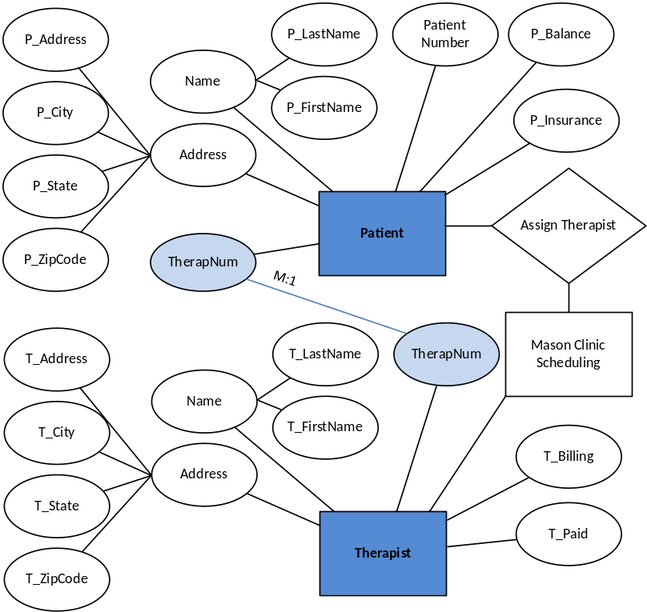
Figure 1. Entity Relationship Diagram (ERD) for the Mason Clinic case study.

Answers to Concept/Terminology Questions (1 through 7)
The following questions are answered with no more than 50‐75 words:
- How many entities are there in this database? What is degree of relationship of each entity?
Answer: There are two entities in this database, the “Patient” and the “Therapist.”
- How many attributes and tuples to each of these entities?
Answer: The “Patient” entity has 10 attributes (or columns) and 10 tuples (or rows). The “Therapist” entity has nine attributes (or columns) and three tuples (or rows).
- What is the corresponding terminology in SQL for entity, attribute and records?
Answer: The corresponding terminology in SQL for entity is “table,” for an attribute is “field” or “column,” and records are “tuples’ or “rows.”
- What is the semantic (business) rule between the two entities?
Answer: A business rule is a brief, precise, and unambiguous description of a policy, procedure, or principle within an organization. The semantic (business) rule between the two entities, patient and therapist, is that each patient is assigned to only one therapist. Some therapists have no patients and some have one or many patients.
- What is the type of relationship between these entities?
Answer: The entities, “Therapist” and “Patient,” have a relationship which is called a one-to-many relationship and is reflected by the patient having only one therapist but the therapist may have many patients.
- What are the primary keys for each of the entities? Should Nulls be required for these keys?
Answer: The primary key for the entity “Therapist” is the field “TherapNum.” And the primary key for the entity “Patient” is the field “PatientNumber.” Nulls should not be permitted for primary keys. This rule prohibits data redundancy (of multiple nulls) to ensure entity integrity. Some database designers use a dummy value instead of allowing nulls in the foreign key. This is done to flag an event that can be handled, such as maintaining a record of “yet to be processed” status.
- What is a foreign key? Are there any foreign keys in this database and why is it a foreign key?
Answer: A foreign key (FK) links to a matching primary key (PK) in another table; this connects (links) the tables together at the corresponding tuples (rows) of each table. Or the foreign key can contain a null value and not link to any other record. It is said, the attributes of the connection are functionally dependent, based on the concept of determination. There is one foreign key in the database; it is the “TherapNum” field in the “Patient” table. It is used as a foreign key to connect to primary key in the “Therapist” table to determine the correct record of the therapist that is treating the patient. This is a way to further normalize the data to eliminate redundancy.

Correct MS Access SQL syntax (for each query 1 through 18)
Each of the following questions are solved with the correct SQL query syntax provided. Relational algebra defines the theoretical way of manipulating table contents using eight relational operators: SELECT, PROJECT, JOIN, INTERSECT, UNION, DIFFERENCE, PRODUCT, and DIVIDE.
1. Display the number, last name, first name and address of patients living in Lamont.
SQL query Q1: SELECT Patient.[PatientNumber], Patient.[P_LastName], Patient.[P_FirstName], Patient.P_Address FROM Patient WHERE (((Patient.[P_City])="Lamont"));
2. Display the number, last name, first name and address of patients whose last names begin with letters Pe.
SQL query Q2: SELECT Patient.[PatientNumber], Patient.[P_LastName], Patient.[P_FirstName], Patient.P_Address FROM Patient WHERE (((Patient.[P_LastName]) Like "Pe*"));
3. Display the states in which patients reside sorted in alphabetical order.
SQL query Q3: SELECT Patient.P_State FROM Patient ORDER BY Patient.P_State;
4. Display the states and cities in which patients reside in alphabetical order (first, states are sorted and then cities within each state are sorted).
SQL query Q4: SELECT Patient.P_State, Patient.P_City FROM Patient ORDER BY Patient.P_State, Patient.P_City;
5. Display the first name and last name of the therapist for patient, Lisa Alardyce (using concatenation).
SQL query Q5: SELECT Therapist.T_FirstName, Therapist.T_LastName FROM Patient INNER JOIN Therapist ON Patient.TherapNum = Therapist.TherapNum WHERE ((([P_FirstName] & " " & [P_LastName])="Lisa Alardyce"));
6. Show all the patient states that end in the letter I.
SQL query Q6: SELECT TOP 1 Patient.P_State FROM Patient INNER JOIN Therapist ON Patient.TherapNum = Therapist.TherapNum GROUP BY Patient.P_State HAVING (((Patient.P_State) Like "*I"));
7. Display the names of all the patients being treated by therapist, Richard Foster.
SQL query Q7: SELECT Patient.P_LastName, Patient.P_FirstName
FROM Therapist, Therapist AS Therapist_1 INNER JOIN Patient ON Therapist_1.TherapNum = Patient.TherapNum WHERE ((([Therapist]![T_FirstName]+" "+[Therapist]![T_LastName])="Richard Foster")) ORDER BY Patient.P_LastName, Patient.P_FirstName;
8. Display the number, name and patient amount (balance minus insurance) for all patients.
SQL query Q8: SELECT Patient.PatientNumber, Patient.P_LastName, Patient.P_FirstName, [P_Balance]-[P_Insurance] AS P_Amount FROM Therapist, Therapist AS Therapist_1 INNER JOIN Patient ON Therapist_1.TherapNum = Patient.TherapNum ORDER BY Patient.PatientNumber;
9. Calculate the average balance for all patients of therapist 08.
SQL query Q9: SELECT Therapist.TherapNum, Avg(Patient.P_Balance) AS AvgOfP_Balance
FROM Therapist INNER JOIN Patient ON Therapist.TherapNum = Patient.TherapNum GROUP BY Therapist.TherapNum HAVING (((Therapist.TherapNum)="08"));
10. Calculate the average balance for all patients of each therapist.
SQL query Q10: SELECT Therapist.TherapNum, Avg(Patient.P_Balance) AS AvgOfP_Balance
FROM Therapist INNER JOIN Patient ON Therapist.TherapNum = Patient.TherapNum GROUP BY Therapist.TherapNum;
11. How many total patients are there in Mason Clinic?
SQL query Q11: SELECT Count(Patient.PatientNumber) AS CountOfPatientNumber FROM Patient;
12. Display names of the therapists whose patients have a balance between $100 and $200.
SQL query Q12: SELECT Therapist.T_LastName, Therapist.T_FirstName FROM Therapist INNER JOIN Patient ON Therapist.TherapNum = Patient.TherapNum WHERE (((Patient.P_Balance)>100 And (Patient.P_Balance)<200)) GROUP BY Therapist.T_LastName, Therapist.T_FirstName;
13. Names and addresses of those patients living in City name starting between B and L, both included.
SQL query Q13: SELECT Patient.P_FirstName, Patient.P_LastName, Patient.P_Address, Patient.P_City, Patient.P_State, Patient.P_ZipCode FROM Patient WHERE (((Patient.P_City) Like "[B-L]*")) GROUP BY Patient.P_FirstName, Patient.P_LastName, Patient.P_Address, Patient.P_City, Patient.P_State, Patient.P_ZipCode;
14. Find the Patient Number of patients with last name of Acton or Lawrence and who have a balance between $300 and $500.
SQL query Q14: SELECT Patient.PatientNumber FROM Patient WHERE (((Patient.P_LastName)="Acton") AND ((Patient.P_Balance)>300 And (Patient.P_Balance)<500)) OR (((Patient.P_LastName)="Lawrence")) GROUP BY Patient.PatientNumber;
15. Find the Patient Number of patient with last name of Acton or Lawrence or who have a balance between $300 and $500.
SQL query Q15: SELECT Patient.PatientNumber FROM Patient WHERE (((Patient.P_LastName)="Acton") OR ((Patient.P_Balance)>300 And (Patient.P_Balance)<500)) OR (((Patient.P_LastName)="Lawrence")) GROUP BY Patient.PatientNumber;
16. Find the names of patients not being treated by therapists, Richard Foster and Juanita Galvez.
SQL query Q16: SELECT Patient.P_LastName, Patient.P_FirstName, Therapist.T_FirstName, Therapist.T_LastName FROM Therapist INNER JOIN Patient ON Therapist.TherapNum = Patient.TherapNum WHERE ((Not ([T_FirstName]+" "+[T_LastName])="Richard Foster") AND (Not ([T_FirstName]+" "+[T_LastName])="Juanita Galvez")) GROUP BY Patient.P_LastName, Patient.P_FirstName, Therapist.T_FirstName, Therapist.T_LastName;
17. Display the average patient balance and patient states, grouped by states, for those patients being treated by therapists 5 or 8 and whose patient balance is more than $100.
SQL query Q17 [ AN INVALID EXPRESSION ]: SELECT Patient.P_State, Therapist.TherapNum, Avg(Patient.P_Balance) AS AvgOfP_Balance1, Patient.P_Balance FROM Therapist INNER JOIN Patient ON Therapist.TherapNum = Patient.TherapNum GROUP BY Patient.P_State, Therapist.TherapNum, Patient.P_Balance HAVING (((Therapist.TherapNum)="05") AND ((Patient.P_Balance)>100)) OR (((Therapist.TherapNum)="08") AND ((Patient.P_Balance)>100));
18. Display the average patient balance and patient states, grouped by states, for those patients being treated by therapists 5 or 8 and whose average patient balance is more than $100. (Hint: Use HAVING clause)
NOTE: There is a difference in the data between the written assignment instructions and the downloaded database, specifically in table Patient, in rows where PatientNum=GC92 and LI66. The TherapNum was changed from “05” to “02” in the downloaded data. This affects the results of queries Q17 and Q18.
SQL query Q18: SELECT Patient.P_State, Therapist.TherapNum, Avg(Patient.P_Balance) AS AvgOfP_Balance FROM Therapist INNER JOIN Patient ON Therapist.TherapNum = Patient.TherapNum GROUP BY Patient.P_State, Therapist.TherapNum HAVING (((Therapist.TherapNum)="05") AND ((Avg(Patient.P_Balance))>100)) OR (((Therapist.TherapNum)="08") AND ((Avg(Patient.P_Balance))>100));
Project Database to submit
Besides this portfolio, another project deliverable is a complete MS Access database with tables, queries, forms and reports to be submitted. The database will have:
- Both the tables [PATIENT] and [THERAPIST] with proper formatting, primary keys, and referential integrity constraints established between Patient and Therapist tables.
- Each of the queries named as Q1, Q2, … Q18.
- Design a form for data entry for each patient and therapist.
- Design a report showing which therapist is treating whom – showing full names and IDs of each therapist and patients.

