Evolution and comparison of network protocols
Michael V. Fetick
Coleman University
Author Note
There is no grant/funding information.

Table of Contents
Introduction 5
Analysis 5
Choices of Network Protocols 5
Early Network Protocols 6
TCP/IP: LAN and Dial-up Networks 6
Today’s Wired Network Protocols 7
Ethernet 7
Fast Ethernet 8
Local Talk 8
Token Ring 8
FDDI 9
ATM 9
Gigabit Ethernet 10
Today’s Wireless Network Protocols 10
Wireless Fidelity (Wi-Fi) 10
IEEE 802.11b 11
IEEE 802.11a 12
802.11g 13
Conclusion 15
References 16
List of Figures
Figure 1 Network Protocol Symbols (Mueller, Aug 2011) 5
List of Tables
Table 1. Early Network Protocols (Mueller, Aug 2011) 6
Table 2 TCP/IP Properties by Connection Type (Mueller, Aug 2011) 7

Introduction
What are Network Standards (Protocols)? Network standards are rules that govern the exchange of messages between hardware and software processes on different computers, including messages (ordering, semantics, and syntax), reliability, and connection orientation. These rules are guidelines that regulate the characteristics of a network: the access method, allowed physical topologies, types of cabling, and speed of data transfer of the network. A network is an organizational concept of a group of host computers, single networks, and routers owned by a single organization (Panko, 2009). Network protocols are evolving from the early days of IPX/SPX and NetBEUI, leading to the TCP/IP we use today with the latest innovations of the IPv6. Our world’s cultures want faster and better networks and protocols that are globally standardized.

Analysis

Choices of Network Protocols
The first choice in a network design is the topography. The most common network protocols are: Ethernet, Local Talk, Token Ring, FDDI, and ATM with some commonly used network symbols depicted in figure 1 (Mueller, Aug 2011).
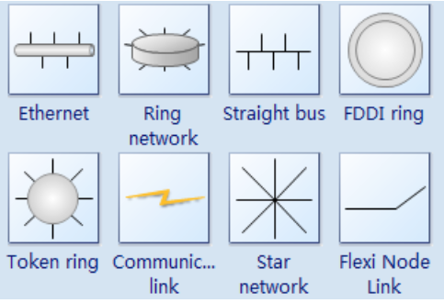
Figure 1 Network Protocol Symbols (Mueller, Aug 2011)

Early Network Protocols
Just a few years ago, the second-most important choice you had to make when you created a network was which network protocol to use because it affects which types of computers your network can connect. Today, the choice has largely been made for us: TCP/IP has replaced other network protocols such as IPX/SPX (used in older versions of Novell NetWare) and NetBEUI (used in older Windows and DOS-based peer-to-peer networks) because it can be used both for Internet and LAN connectivity. TCP/IP is a universal protocol that virtually all OSs can use. Table 1. summarizes the differences between these protocols (Mueller, Aug 2011).
Table 1. Early Network Protocols (Mueller, Aug 2011)
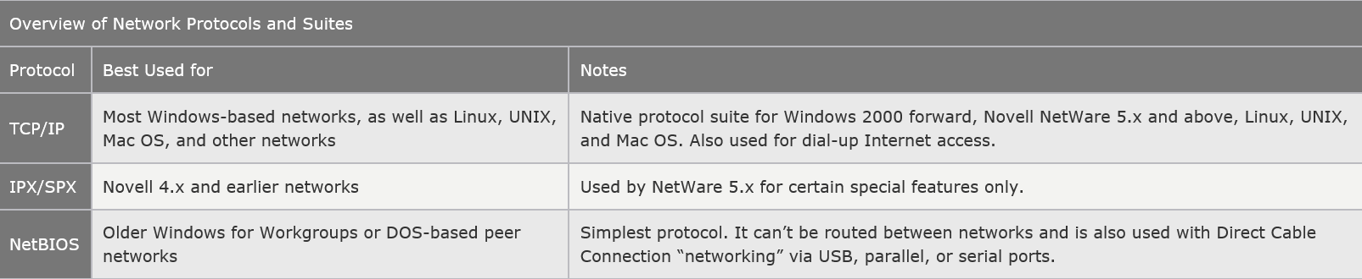
Later, the TCP/IP protocols were adopted by the UNIX OSs. They have now become the most commonly used protocol suite on PC LANs. Virtually every OS with networking capabilities supports TCP/IP, and it is well on its way to displacing all the other competing protocols. Novell NetWare 6 and above, Linux, Windows XP and newer all use TCP/IP as their native network protocol.

TCP/IP: LAN and Dial-up Networks
TCP/IP, unlike the other network protocols listed in the previous section, is also a protocol used by people who have never seen a NIC. People who access the Internet via modems (this is referred to as dial-up networking in some older Windows versions) use TCP/IP just as those whose Web access is done with their existing LANs. Although the same protocol is used in both cases, the settings vary a great deal. Table 2 summarizes the differences people encountered between accessing the Internet with modems and a LAN. The TCP/IP properties for modems and LANs must be set correctly and set browser settings to indicate which connection type is used.
Table 2 TCP/IP Properties by Connection Type (Mueller, Aug 2011)
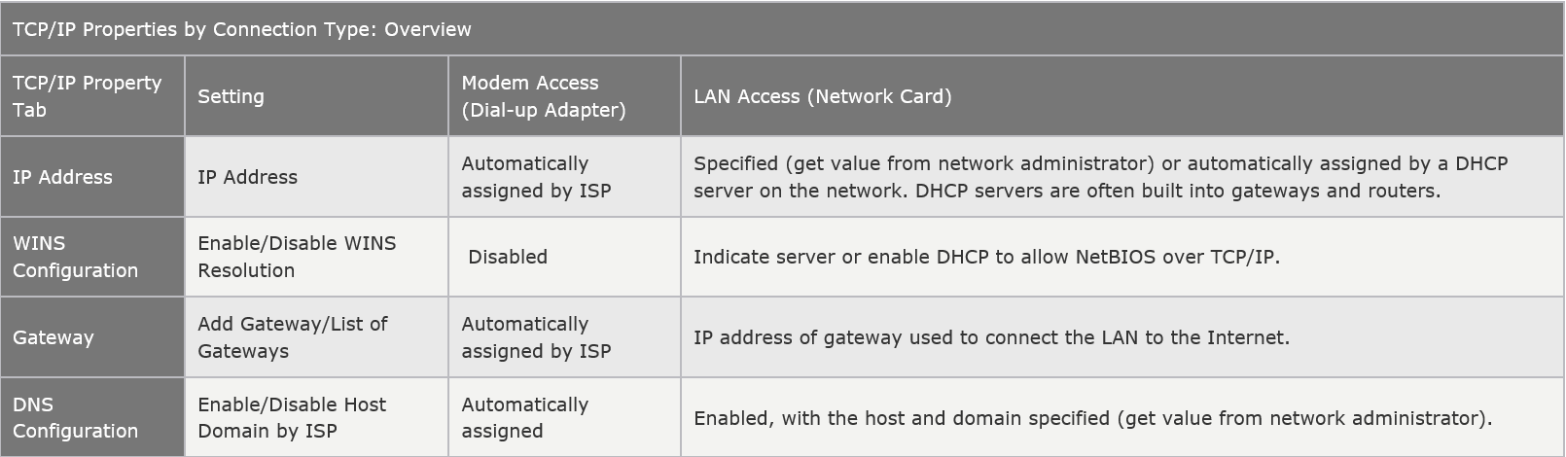

Today’s Wired Network Protocols
Wired networks are connected with various types of cable but the most prevalent is the unshielded, twisted pair (UTP).

Ethernet
The Ethernet protocol is by far the most widely used one. Ethernet uses an access method called CSMA/CD (Carrier Sense Multiple Access/Collision Detection). This is a system where each computer listens to the cable before sending anything through the network. If the network is clear, the computer will transmit. If some other nodes have already transmitted on the cable, the computer will wait and try again when the line is clear. Sometimes, two computers attempt to transmit at the same instant. A collision occurs when this happens. Each computer then backs off and waits a random amount of time before attempting to retransmit. With this access method, it is normal to have collisions. However, the delay caused by collisions and retransmitting is very small and does not normally effect the speed of transmission on the network. The Ethernet protocol allows for linear bus, star, or tree topologies. Data can be transmitted over wireless access points, twisted pair, coaxial, or fiber optic cable at a speed of 10 Mbps up to 1000 Mbps (Network Protocol - Types of Network Protocols, 2016).

Fast Ethernet
To allow for an increased speed of transmission, the Ethernet protocol has developed a new standard that supports 100 Mbps. This is commonly called Fast Ethernet. Fast Ethernet requires the application of different, more expensive network concentrators/hubs and network interface cards. In addition, category 5 twisted pair or fiber optic cable is necessary. Fast Ethernet is becoming common in schools that have been recently wired (Network Protocol - Types of Network Protocols, 2016).

Local Talk
Local Talk is a network protocol that was developed by Apple Computer, Inc. for Macintosh computers. The method used by Local Talk is called CSMA/CA (Carrier Sense Multiple Access with Collision Avoidance). It is similar to CSMA/CD except that a computer signals its intent to transmit before it actually does so. Local Talk adapters and special twisted pair cable can be used to connect a series of computers through the serial port. The Macintosh operating system allows the establishment of a peer-to-peer network without the need for additional software. With the addition of the server version of AppleShare software, a client/server network can be established. The Local Talk protocol allows for linear bus, star, or tree topologies using twisted pair cable. A primary disadvantage of Local Talk is low speed. Its speed of transmission is only 230 Kbps (Network Protocol - Types of Network Protocols, 2016).

Token Ring
The Token Ring protocol was developed by IBM in the mid-1980s. The access method used involves token-passing. In Token Ring, the computers are connected so that the signal travels around the network from one computer to another in a logical ring. A single electronic token moves around the ring from one computer to the next. If a computer does not have information to transmit, it simply passes the token on to the next workstation. If a computer wishes to transmit and receives an empty token, it attaches data to the token. The token then proceeds around the ring until it comes to the computer for which the data is meant. At this point, the data is captured by the receiving computer. The Token Ring protocol requires a star-wired ring using twisted pair or fiber optic cable. It can operate at transmission speeds of 4 Mbps or 16 Mbps. Due to the increasing popularity of Ethernet, the use of Token Ring in school environments has decreased (Network Protocol - Types of Network Protocols, 2016).

FDDI
Fiber Distributed Data Interface (FDDI) is a network protocol that is used primarily to interconnect two or more local area networks, often over large distances. The access method used by FDDI involves token-passing. FDDI uses a dual ring physical topology. Transmission normally occurs on one of the rings; however, if a break occurs, the system keeps information moving by automatically using portions of the second ring to create a new complete ring. A major advantage of FDDI is high speed. It operates over fiber optic cable at 100 Mbps (Network Protocol - Types of Network Protocols, 2016).

ATM
Asynchronous Transfer Mode (ATM) is a network protocol that transmits data at a speed of 155 Mbps and higher. ATM works by transmitting all data in small packets of a fixed size; whereas, other protocols transfer variable length packets. ATM supports a variety of media such as video, CD-quality audio, and imaging. ATM employs a star topology, which can work with fiber optic as well as twisted pair cable. ATM is most often used to interconnect two or more local area networks. It is also frequently used by Internet Service Providers to utilize high-speed access to the Internet for their clients. As ATM technology becomes more cost-effective, it will provide another solution for constructing faster local area networks (Network Protocol - Types of Network Protocols, 2016).

Gigabit Ethernet
The most latest development in the Ethernet standard is a protocol that has a transmission speed of 1 Gbps. Gigabit Ethernet is primarily used for backbones on a network at this time. In the future, it will probably also be used for workstation and server connections. It can be used with both fiber optic cabling and copper. The 1000BaseTX, the copper cable used for Gigabit Ethernet, became the formal standard in 1999 (Network Protocol - Types of Network Protocols, 2016).

Today’s Wireless Network Protocols
Just a few years ago, the only wireless connections were established with cellular data, through the telephone company’s subscriber circuits. Now there are various modalities of wireless networks. The most common forms of wireless networking are built around various versions of the IEEE 802.11 wireless Ethernet standards, including IEEE 802.11b, IEEE 802.11a, IEEE 802.11g, and IEEE 802.11n (Network Protocol - Types of Network Protocols, 2016).

Wireless Fidelity (Wi-Fi)
Wireless Fidelity (Wi-Fi) is a logo and term given to any IEEE 802.11 wireless network product certified to conform to specific interoperability standards. Wi-Fi certification comes from the Wi-Fi Alliance, a nonprofit international trade organization that tests 802.11-based wireless equipment to ensure it meets the Wi-Fi standard. To carry the Wi-Fi logo, an 802.11 networking product must pass specific compatibility and performance tests, which ensure that the product will work with all other manufacturers’ Wi-Fi equipment on the market. This certification arose from the fact that certain ambiguities in the 802.11 standards allowed for potential problems with interoperability between devices. By purchasing only devices bearing the Wi-Fi logo, you ensure that they will work together and not fall into loopholes in the standards (Network Protocol - Types of Network Protocols, 2016).

IEEE 802.11b
IEEE 802.11b (Wi-Fi, 2.4 GHz band–compliant, also known as Wireless-B) wireless networks run at a maximum speed of 11 Mb/s, about the same as 10BASE-T Ethernet (the original version of IEEE 802.11 supported data rates up to 2 Mb/s only). 802.11b networks can connect to conventional Ethernet networks or be used as independent networks, similar to other wireless networks. Wireless networks running 802.11b hardware use the same 2.4 GHz spectrum that many portable phones, wireless speakers, security devices, microwave ovens, and the Bluetooth short-range networking products use. Although the increasing use of these products is a potential source of interference, the short range of wireless networks (indoor ranges up to approximately 150 feet and outdoor ranges up to about 300 feet, varying by product) minimizes the practical risks. Many devices use a spread-spectrum method of connecting with other products to minimize potential interference (Network Protocol - Types of Network Protocols, 2016).
Although 802.11b supports a maximum speed of 11 Mb/s, that top speed is seldom reached in practice, and speed varies by distance. Most 802.11b hardware is designed to run at four speeds, using one of four data-encoding methods, depending on the speed range:
- 11 Mb/s—Uses quaternary phase-shift keying/complementary code keying (QPSK/CCK)
- 5.5 Mb/s—Also uses quaternary phase-shift keying/complementary code keying (QPSK/CCK)
- 2 Mb/s—Uses differential quaternary phase-shift keying (DQPSK)
- 1 Mb/s—Uses differential binary phase-shift keying (DBPSK)
As distances change and signal strength increases or decreases, 802.11b hardware switches to the most suitable data-encoding method. The overhead required to track and change signaling methods, along with the additional overhead required when security features are enabled, helps explain why wireless hardware throughput is consistently lower than the rated speed. The figure below is a simplified diagram showing how speed is reduced with distance. Figures given are for best-case situations; building design and antenna positioning can also reduce speed and signal strength, even at relatively short distances (Network Protocol - Types of Network Protocols, 2016).

IEEE 802.11a
The second flavor of Wi-Fi is the wireless network known officially as IEEE 802.11a. 802.11a (also referred to as Wireless-A) uses the 5 GHz frequency band, which allows for much higher speeds (up to 54 Mb/s) and helps avoid interference from devices that cause interference with lower-frequency 802.11b networks. Although real-world 802.11a hardware seldom, if ever, reaches that speed (almost five times that of 802.11b), 802.11a relatively maintains its speeds at both short and long distances (Network Protocol - Types of Network Protocols, 2016).
For example, in a typical office floor layout, the real-world throughput (always slower than the rated speed due to security and signaling overhead) of a typical 802.11b device at 100 feet might drop to about 5 Mb/s, whereas a typical 802.11a device at the same distance could have a throughput of around 15 Mb/s. At a distance of about 50 feet, 802.11a real-world throughput can be four times faster than 802.11b. 802.11a has a shorter maximum distance than 802.11b (approximately 75 feet indoors), but you get your data much more quickly.
Given the difference in throughput (especially at long distances), and if we take the existence of 802.11g out of the equation for a moment, why not skip 802.11b altogether? In a single word: frequency. By using the 5 GHz frequency instead of the 2.4 GHz frequency used by 802.11b/g, standard 802.11a hardware cuts itself off from the already vast 802.11b/g universe, including the growing number of public and semipublic 802.11b/g wireless Internet connections (called hot spots) showing up in cafes, airports, hotels, and business campuses.
The current solution for maximum flexibility is to use dual-band hardware. Dual-band hardware can work with either 802.11a or 802.11b/g networks, enabling you to move from an 802.11b/g wireless network at home or at Starbucks to a faster 802.11a office network.

802.11g
IEEE 802.11g, also known to some as Wireless-G, is a standard that offers compatibility with 802.11b along with higher speeds. The final 802.11g standard was ratified in mid-2003.
Although 802.11g is designed to connect seamlessly with existing 802.11b hardware, early 802.11g hardware was slower and less compatible than the specification promised. In some cases, problems with early-release 802.11g hardware can be solved through firmware or driver upgrades.

Conclusion
We are just a few decades into the evolution of the Internet. As we advance through the 21st century, advancements in IPv6 will bring address capacity that can handle the proliferation of devices in the connected, Internet of Things. Our society is truly on a global scale, and with our mobility is increasing, we are exchanging ideas and concepts at a faster pace. We will probably accept full wireless networks if all the issues of security and transmission speeds are addressed.

References
Mueller, S. (Aug 2011). Upgrading And Repairing PCs (20th ed.). Que. Retrieved from http://www.tomshardware.com/print/local-area-network-wi-fi-wireless,reviews-3020.html
Network Protocol - Types of Network Protocols. (2016, Feb 9). Retrieved from All-In-One Diagram Software for Flowchart, Org Chart and Mind Map: https://www.edrawsoft.com/Network-Protocol.php
Panko, R. R. (2009). Business Data Networksand Telecommunications (7th ed.). Upper Saddle River, New Jersey: Pearson Education, Inc.

