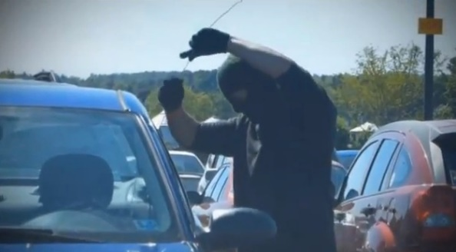

**SmartKeyTM**



**911: “Hello 911”**

**Upgrade your vehicle**

**Security/Alarm System**

**– Wait 30 minutes (dealership)\***

**– or by mail (3-5 business days)**

**Vibrates/Blinks – You 911:**

**“The police are on their way”**



**SATISFACTION**

**90-Day Guarantee**

**Send directly back to us.**

**Authorized Return Service (ARS) included (no S&H charge)**

**\*Check Your Availability at www.SmartKey.com**

**SmartKeyTM, Smart Key Systems LLP, San Diego, CA**

**Patents pending: 84,270,000 660,162,539, 76,210,000 660,161,473, 73,600,000 660,161,500.**