Case Study Of Impact of Google Ads On E-Commerce

Michael Fetick, 84270

Eddie McDowell, 25700

Coleman University

Table of Contents

Table of Contents 2

List of Figures 2

Abstract 3

Introduction – Google Ads 3

Google AdWords 4

Google AdSense 6

Technological Innovation of Google 7

Google Mobile Ads 9

The business of Answer.com 10

Answer.com uses Google AdSense 10

References 11

List of Figures

Figure 1. Google Ads webpage 3

Figure 2. Google’s AdWords webpage 4

Figure 3. Google’s AdSense webpage 6

Abstract

This is a team case study of the company, Answers.com and the impact of Google ads on its business as an e-commerce success story. The purpose of this study is to determine the technology readiness of the organization, Answers.com, with its use of Google AdSense TM. This study follows how Answers.com managed change to both its business model and technology infrastructure to provide an e‑commerce solution.

Introduction – Google Ads

Our research starts at the source to acquire Google Ads, at http://www.google.com/ads. Figure 1 shows an image of Google’s webpage that advertises two products: Google AdWords TM and Google AdSense TM (Google Inc., 2015).

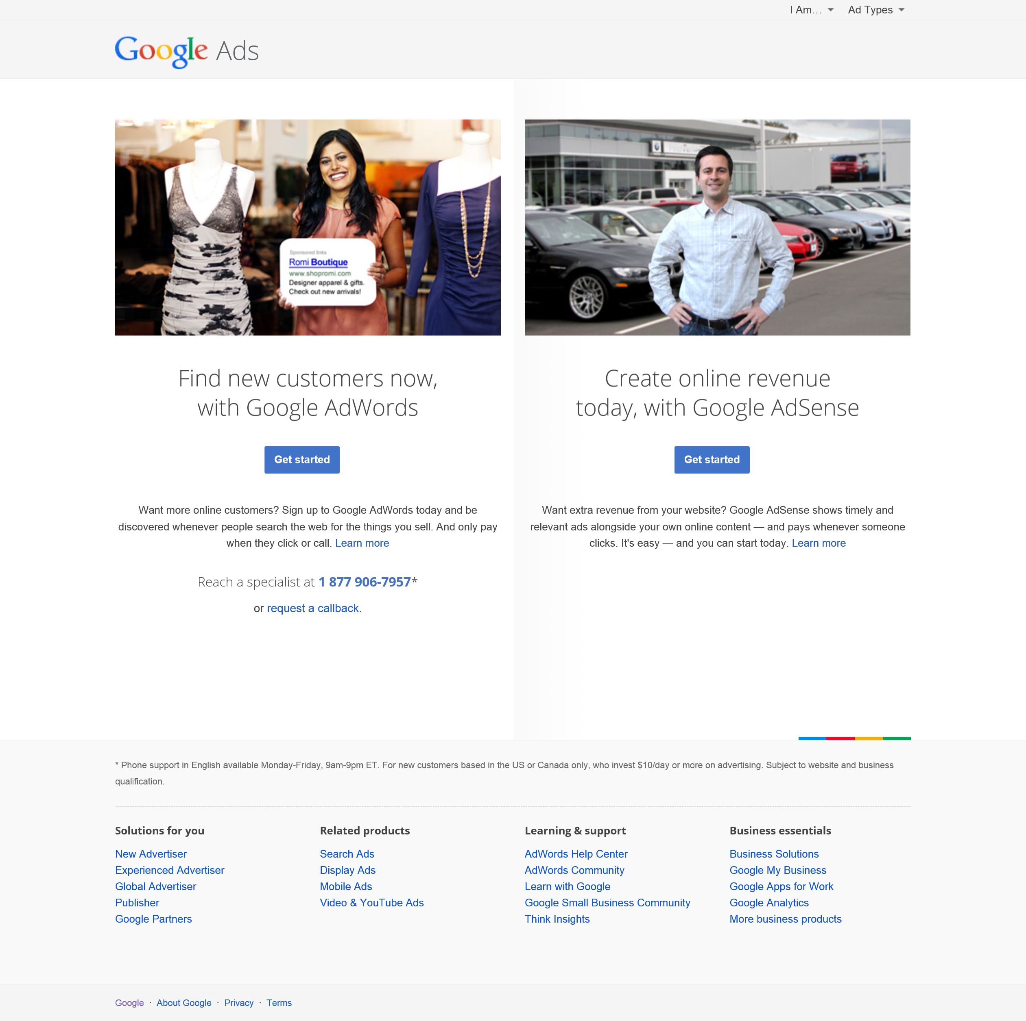

Figure 1. Google Ads webpage (Google Inc., 2015)

Google AdWords

Google’s main revenue stream comes from its AdWords service, where marketers bid for keywords on Google’s search engine. Figure 2 shows an image of Google’s webpage that tells more about AdWords.

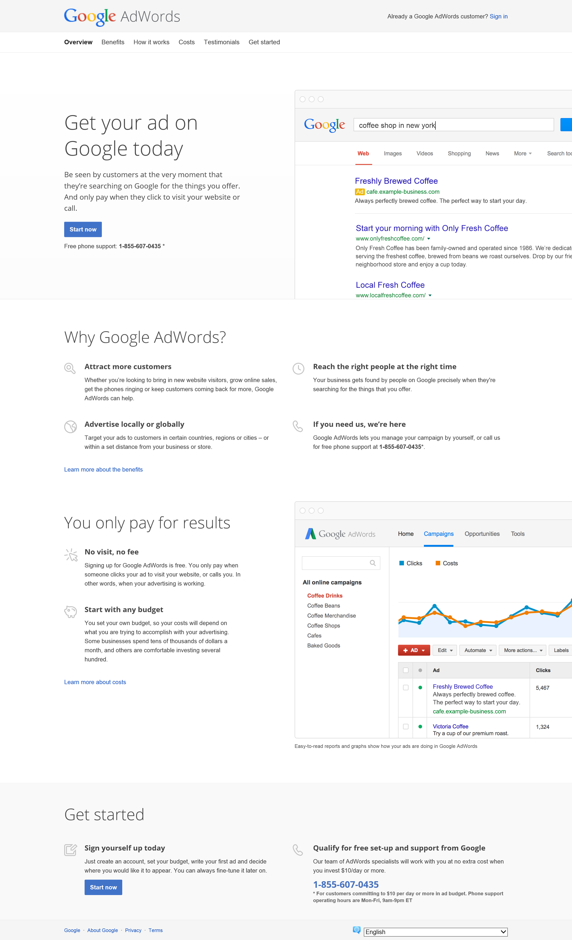

Figure 2 Google AdWords webpage (Google Inc., 2015)

It reads, “Be seen by customers at the very moment that they’re searching on Google for the things you offer. And only pay when they click to visit your website or call (Google Inc., 2015).” When a computer user uses the Google search engine to find information, the results show a list of links to relevant sources of information that match the user’s text; with the order based on an algorithm. But AdWords appear at the top of the list because they are paid advertisements, to put the user’s attention “eyes on” the ad first. And the ad will have relevance to the text search, which should have appeal to the user.

Initially, in 2000 Goto.com (later Overture) allowed advertisers to bid for placement on their search engine results, and Google followed suit in 2003 with its AdWords program, which allowed advertisers to bid for placement of short text ads on Google search results. The spectacular increase in Internet advertising revenues (which have been growing at around 20%–25% annually over the last few years) has helped search engines transform themselves into major shopping tools and created an entire new industry called “search engine marketing.” When users enter a search term at Google, Bing, Yahoo, or any of the other Web sites serviced by these search engines, they receive two types of listings: sponsored links, for which advertisers have paid to be listed (usually at the top of the search results page), and unsponsored “organic” search results. Also, advertisers can purchase small text ads on the right side of the search results page.

AdWords used to be the same whether displayed on a PC or a mobile device. Google has upgraded its AdWords service to optimize ads for user contexts and devices, and to provide management of campaigns across all mobile and desktop devices. The new service is called Enhanced AdWords. For instance, if a customer searches for “pizza” on a desktop PC from work at 1 PM, he or she would be shown restaurants nearby and a quick order form. If the customer searched for “pizza” at 8 PM on a smartphone within a half-mile of a pizza restaurant, he or she might be shown a click-to-call phone number and directions to the restaurant. Pizza restaurants pay Google for the chance to show up in these searches. The ‘cost per click’ basis of Google AdWords is a mechanism also used by social media platforms such as Pinterest’s Promoted Pins in 2014 and Twitter’s Promoted Tweets (Laudon & Traver, 2015).

Google AdSense

Figure 3 shows an image of Google’s webpage telling more about AdSense. It reads, “AdSense is a free, simple way to earn money by displaying targeted ads next to your online content. With AdSense, you can show relevant and engaging ads to your site visitors and even customize the look and feel of ads to match your website. (Google Inc., 2015).”

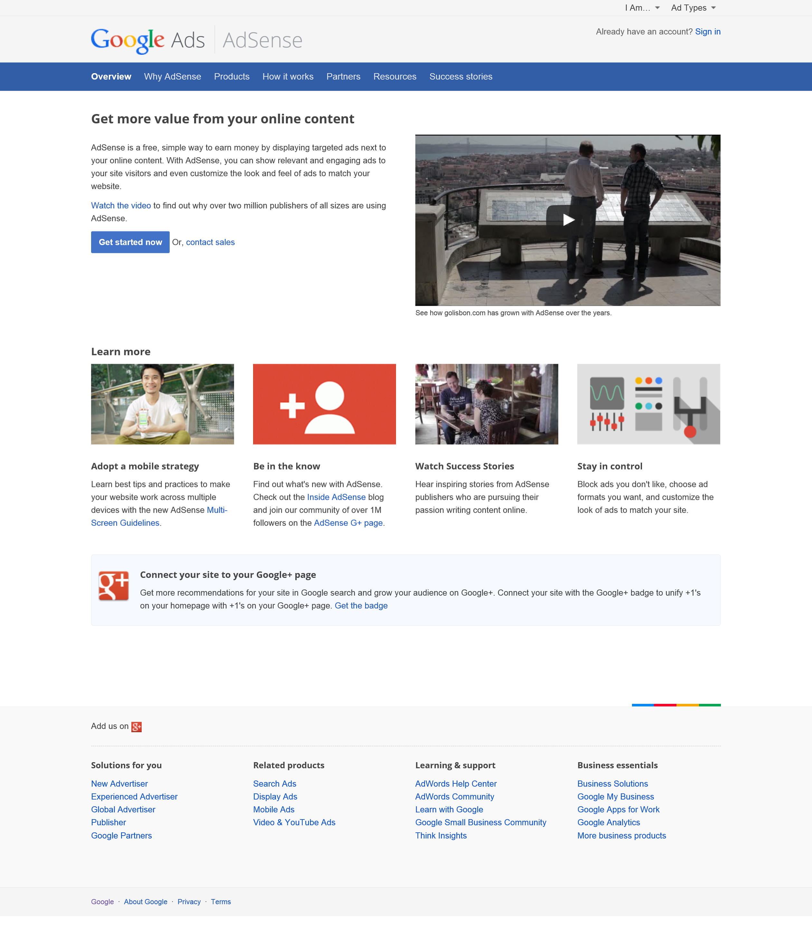

Figure 3 Google AdSense webpage (Google Inc., 2015)

Bloggers often sign up for Google’s AdSense program to attract advertisers to their sites. This is affiliate marketing, a form of marketing where a firm pays a commission (typically between 4% and 20%) to other Web sites (including blogs) for sending customers to their Web site. They are paid for each click on an ad and sometimes for subsequent purchases made by visitors (Laudon & Traver, 2015).

Technological Innovation of Google

Google is involved in the development of many technologies, primarily starting with the Google search engine, then Google Maps, Google analytics, Google Play (Store) for the development, deployment, and distribution of mobile applications for the Android smartphones, Web Services, Google Glass, Drones, Project Loon, Chrome, etc. The technologies may converge in the future.

**Google maps.** The most common local marketing tools are geo-targeting using Google Maps (local stores appearing on a Google map),.

**Google analytics.** Analytics keep track of your site’s customer activities and the success of your Web advertising campaign. Google Analytics is an analytics product that is used by an estimated 60% of the top 1 million Web sites. Basic service is free and a premium package is available for a fee. Mobile analytics is a subset of Web analytics that seeks to understand how potential customers use a firm’s apps and mobile Web sites—from discovery of the app, to download, and engagement. Google Analytics for Mobile, was introduced in 2010. The service works across both tablets and smartphones, and is fully integrated with the regular Google

**Google Glass.** In the future, business ads may show up on the Google Glasses of users visiting or searching for points of interest in their neighborhood. Currently, Google does not allow ‘ad serving’ on Glass, but in August 2013, the U.S. Patent and Trademark Office approved a patent Google had filed for a head-mounted eye-tracking system. Analysts speculated that recognition software would identify images and generate a log of viewed items that could be used to develop a “pay-per-gaze” advertising model. Advertisers could be charged each time an image, either online or in the real world, including billboards, posters, and bus ads, is viewed. What’s more, pupil dilation may be used to gauge the viewer’s reaction and emotional state upon viewing the advertisement. Online ads could be triggered when a positive response is recorded to a real world ad and feedback provided to the advertiser about which images and messages are most effective. Length of gaze and which image within a scene draws the gaze also will be measurable. While further privacy concerns are raised, not to mention whether Glass wearers are going to accept automatic ad serving based on their reactions to images, the patent suggests that personally identifying data may be removed, opt-in or opt-out options offered, and anonymous analytics provided to advertisers (Laudon & Traver, 2015).”

**Advertising Networks** By early 2000, specialized marketing firms called advertising networks appeared to help firms take advantage of the powerful marketing potential of the Internet, and to make the entire process of buying and selling online ads more efficient and transparent. These ad networks have proliferated and have greatly increased the scale and liquidity of online marketing. Advertising networks sell advertising and marketing opportunities (slots) to companies who wish to buy exposure to an online audience (advertisers). Advertising networks obtain their inventory of ad opportunities from a network of participating sites that want to display ads on their sites in return for receiving a payment from advertisers, every time a visitor clicks on an ad. These sites are usually referred to as Web publishers. Marketers buy audiences and publishers sell audiences by attracting an audience and capturing audience information. Ad networks are the intermediaries who make this market work efficiently. An ad exchange will allow you to bid in real time on this audience against other advertisers, and then manage the placement of ads, accounting, and measurement for your firm. Ad exchanges offer tremendous global scale and efficiency. One of the best known is Google’s DoubleClick Ad Exchange, which is based on more than 100 ad networks (the supply side), and provides a computer-based market for buyers to purchase audiences (the demand side). This exchange sells audiences sliced into 1,600 interest categories. It displays more than 250 billion ad impressions a month across 2 million Web sites worldwide, and maintains or distributes more than 500 million user profiles of Internet users. Ad networks such as Google’s AdMob, Apple’s iAd, Twitter’s MoPub, and Millennial Media are also important players in the mobile advertising market (Laudon & Traver, 2015).

Google Mobile Ads

Mobile advertising is dominated by Google with an expected $7.1 billion in mobile ad revenues, constituting about 40% of the entire market. On the mobile platform, Google is king of search, garnering almost two-thirds of all mobile search ad spending, and expected to total almost $6 billion in 2014. Google is also the largest distributor of video ads on the mobile platform because of YouTube, and is expected to earn about $1.1 billion in video ad revenues in 2014. Facebook is second with $3.3 billion (18%) of mobile ad revenues, of which over 95% ($3.2 billion) is generated by mobile display ads. Facebook is the leading display ad site on mobile devices, accounting for more than 40% of all spending on mobile display ads. Google purchased a mobile advertising firm called AdMob in 2009 and claims to be the world’s largest mobile advertising firm for both Android and Apple’s iOS operating systems. App developers use AdMob to provide their apps with consumer and user location information. Google also sells location information to independent marketing firms. Marketing firms use AdMob to develop full-screen rich media ads.

The business of Answer.com

Answers is the leading question and answer site on the Internet, and is a comScore top 15 site. About 100 million people a month come to Answers, and about 35,000 people every day ask questions.

Answer.com uses Google AdSense

Peter Horan, President and COO of Answers.com is quoted to saying, “AdSense is extremely important to our business. People who come to our site are looking for answers to questions that are typically very specific. AdSense presents content that's interesting, relevant and appropriate for our visitors, serving ads that enhance the time the users spend on our site. From the publisher perspective, I'm actually earning revenue in a way that improves our users' experience. Over the past ten years, I've seen AdSense evolve to meet new challenges. Take mobile, for example: Users are increasingly using their smartphones and tablets to search for information. It's very important for us to provide them with a great experience. AdSense has enabled us to have a robust and profitable mobile business that's growing quickly year on year, and to make big bets moving forward through ads that add to our users' experience. AdSense provides a bedrock monetization solution for your site, and if your site is growing, then AdSense will grow with you. For our business, there’s nothing as good as AdSense (Horan, 2015).”

# References

Google Inc. (2015, Sep 28). *Google Ads*. Retrieved from Google: http://www.google.com/ads/

Horan, P. (2015). Peter Horan, President and COO of Answer.com. (Google, Interviewer)

Laudon, K. C., & Traver, C. G. (2015). *E-commerce 2015. Business. Technology. Society. 11th Edition.* Pearson Education, Inc.