Wavelet Analysis Experiments With Scilab and Matlab

Objective look at porting scilab apps between scilab and matlab
For porting grid apps between high throughput PC clusters and compute resources with matlab.

Following wavelet grid application developed grid application performs the following steps.

Following functions used for scilab analysis

To convert to matlab

Note the name of the called main function for the matlab function must
Have same name as the file which is a .m file

- replace % pi with just pi and %i with just i
- replace // comment marks with %
- comment out end function statements
- Replace mfopen, mfprintf, mfscanf, mfclose with fopen, fprintf, fscanf and fclose

Other Guidelines for Writing Scilab Apps That Run In Matlab
- For use with interactive matlab always remember to terminate lines with ; unless output is specifically required
- Any new functions that are called as major task drivers from the interactive session must be contained in separate .m files with the filename being the same as the function name

Running App From Mat lab

Use the real, imag or abs function to generate the real, imaginary or absolute component of the ouptut matrix.

Plot the output matrix using the surf function.
To print the output use the following command (outputs the figure as a jpg)

print –djpeg myfilename.jpg

Reading and Writing Output

Use fopen, fprintf, fscanf and fclose to write and read formatted output. Use the conversion identified in 4 above when using scilab.
To save output

To read ascii data use the command

mymat=load filename –ascii

This command will return all data in the file as a single double array with its name take from the filename.

Using the ODE Solver

The scilab ode solver called in the following way
//-->s=ode(s0,t0,t,list(sdot,b,beta,sav,i,d))
function [sdotr]=sdot(t,s,b,beta,iav,i,d)
sdotr=b-beta*s*(i+iav)-(d*s)
endfunction

In matlab

The solvers are called in the following way:

The solver can be called as follows
newy=solver(@ydot, [t0 tf], p1, p2, p3)

@ denotes a handle to the ydot function defined by:

function [ydot]=ydot(t,y,p1,p2,…..)
ydot=somefunction(t,y,p1,p2…)
%endfunction

The p1, p2, p3 are parameters passed to the function.
The [t0 tf] is a matlab vector specifying the interval of integration for the ODE.

The solvers used by matlab can be any one of the following
ode45, ode23, ode113, ode15s, ode23s, ode23t, ode23tb

ode45 is a non stiff medium accuracy used much of the time for the initial stages it is based on the Runge Kutta algorithm

Using the Wavelets Example
//In addition to the amplitude of any periodic signals, we would also like information
//on the phase. In practice, the Mortlet wavelet shown in Figure 2a is defined as the
//product of a complex exponential wave and a Gaussian envelope
//http://paos.colorado.edu/research/wavelets/wavelet2.html
//http://users.rowan.edu/~polikar/WAVELETS/WTpart1.html

function [wavesm]=wavesm(xv,n,col,deltat,s, omega0)

for i=1:n
for j=1:col
mw(i,j)=wavelett(xv,n,i,j*deltat,i*s)
end
end

wavesm=mw

endfunction

function [wavelett]=wavelett(x, n, ndash, deltat, s, omega0)

rsum=0

for i=1:n
wv=x(i)*conj(shiftedmortlet(ndash,n-1,deltat,s,omega0))
rsum=rsum+wv
end

wavelett=rsum
endfunction

function [shiftedmortlet]=shiftedmortlet(n, ndash, deltat, s, omega0)

shiftedmortlet= sqrt(deltat/s)*mortlet((ndash-n)*deltat/s, omega0)

endfunction

function [mortlet]=mortlet(eta, omega0)

mortlet= %pi^(-0.25)*exp(%i*omega0*eta)*exp(-eta^2/2)

endfunction

function [wavess]=wavess(x,n,deltat,s)

for i=1:n
vwaves(i)=wavelett(x,n,i,deltat,s)

end

wavess=vwaves
endfunction
Time series to be analysed in the following domain
t=(0:0.05:1);

Wavelet Analysis matrix ouput labels
X1=(1:1:21)

x2=(1:1:21)

Test 1.
ft=cos(3*%pi*t);

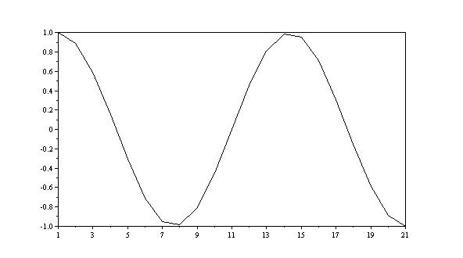

Fast Fourier Transform generated using fft(ft,-1)

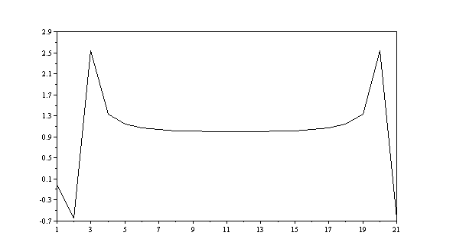

Wavelet analysis generated using
wv=wavesm(ft,21,21,deltat,1.1,%pi);

Table of deltat parameters deltat for diagrams below
0.05 | 0.15
0.25 | 0.35

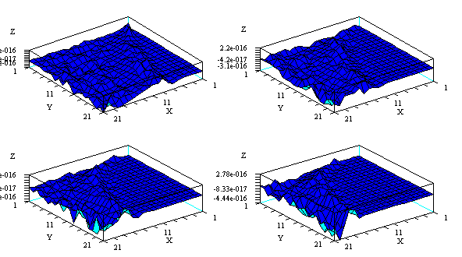

Test 2.
ft=cos(%pi*t);

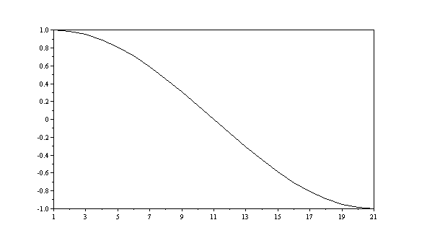

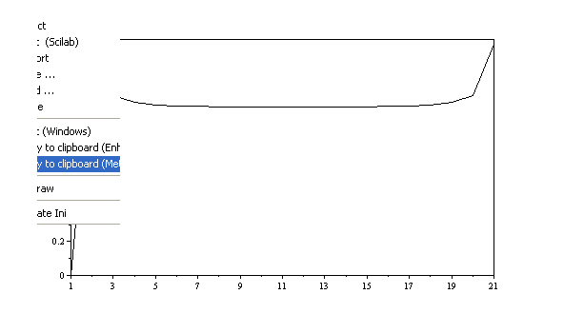

Wavelet analysis generated using
wv=wavesm(ft,21,21,deltat,1.1,%pi);

Table of deltat parameters deltat for diagrams below
0.05 | 0.15
0.25 | 0.35

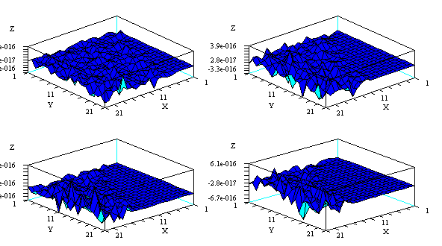

Use a narrower wavelet to sample the signal.

Test 3.
ft=cos(%pi*t);

Wavelet analysis generated using
wv=wavesm(ft,21,21,deltat,1.1,%pi/4);

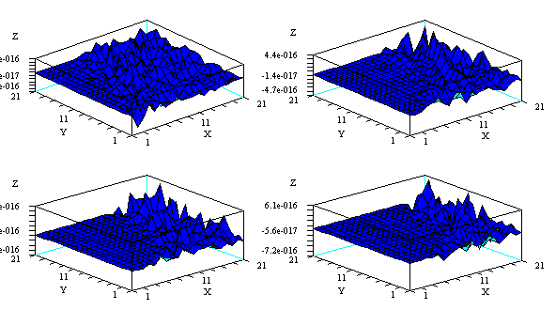

Test 3.
ft=cos(%pi*t);

Wavelet analysis generated using
wv=wavesm(ft,21,21,deltat,1.1,4*%pi);

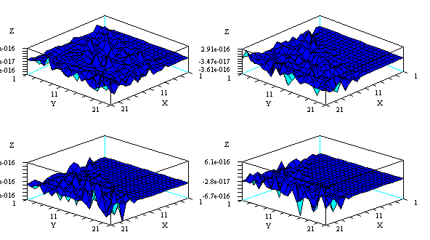

Test 4
ft=cos(%pi*t)+cos(4*%pi*t);
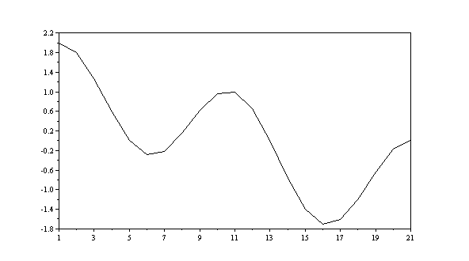

Fast Fourier transform of the signal fft(ft, -1)
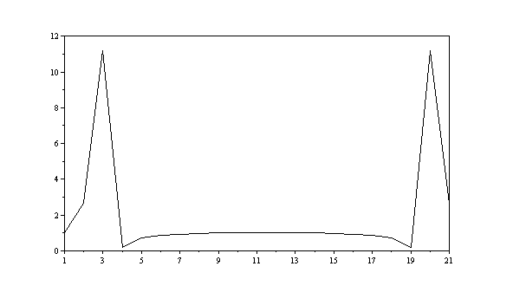

Wavelet analysis generated using
wv=wavesm(ft,21,21,deltat,1.1,%pi);

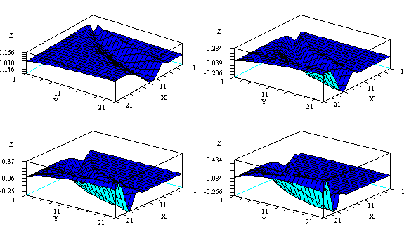

Test 5
ft=cos(%pi*t)+cos(4*%pi*t);

Wavelet analysis generated using
wv=wavesm(ft,21,21,deltat,1.1,4*%pi);

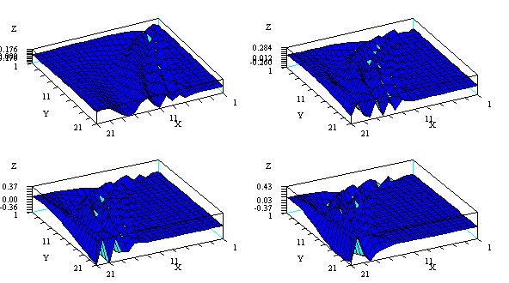

Test 6
ft=cos(%pi*t)+cos(4*%pi*t);

Wavelet analysis generated using
wv=wavesm(ft,21,21,deltat,1.1,%pi/4);

