Somagic EasyCap SMI-2021CBE

Raspberry Pi 4 B+ 4gb. driver and software installation.

When the driver is installed (sudo somagic-init) the ID will change from 1c88:0007 to 1c88:003f.

Make sure the system is fully up to date.
sudo apt-get update
sudo apt-get full-upgrade

I have only had success using a Raspberry Pi 4B+ with 4 gb RAM
I did try a 2 gb but it seemed to have a lot of framing errors. It could have been a faulty Rpi !.
I put all the somagic and driver files in a folder named sm (/home/pi/sm)

All text in italic is run in the terminal. Normal text is the result or a comment.

sudo apt-get update
sudo apt-get install mplayer
cd ~
cd /home/pi/sm/somagic-easycap_1.1
make

make: Nothing to be done for 'all'.

sudo make install

mkdir -p /usr/local/bin
install somagic-init somagic-capture /usr/local/bin/
mkdir -p /usr/local/share/man/man1
install man/somagic-init.1 man/somagic-capture.1 /usr/local/share/man/man1/

cd ~
cd /home/pi/sm/somagic-easycap-tools_1.1

make

make: Nothing to be done for 'all'.

sudo make install

mkdir -p /usr/local/bin
install somagic-extract-firmware /usr/local/bin/
mkdir -p /usr/local/share/man/man1
install man/somagic-extract-firmware.1 /usr/local/share/man/man1/

cd ~
cd /home/pi/sm/firmware
sudo somagic-extract-firmware SmiUsbGrabber3F.sys
Firmware written to '/lib/firmware/somagic_firmware.bin'.

sudo somagic-init
lsusb

Bus 001 Device 009: ID 1c88:003f Somagic, Inc.
Note|- ID has changed from 1c88:0007 to 1c88:003f.

cd /home/pi/sm

To make a auto run bin file (play.sh). In the sm folder create a text file with the following in it.
If you have downloaded the sm files the play.sh file is already in the sm folder. You will still need to make it executable.

#!/bin/sh
sudo somagic-init
sudo somagic-capture | mplayer -vf yadif,screenshot -demuxer rawvideo -rawvideo "pal:format=uyvy:fps=25" -aspect 4:3 -

Save it and make the file executable.

chmod +x play.sh

You can run it from the terminal with.

./play.sh

Use the following for testing.

sudo somagic-init
somagic-capture --help

This will list all the options for somagic-capture.

FOR PAL

sudo somagic-capture | mplayer -vf yadif,screenshot -demuxer rawvideo -rawvideo "pal:format=uyvy:fps=25" -aspect 4:3 -

FOR NTSC

sudo somagic-capture -n -s | mplayer -vf yadif,screenshot -demuxer rawvideo -rawvideo "ntsc:format=uyvy:fps=30000/1001" -aspect 4:3 -

ERROR

Some times the display will be jittery. Quit mplayer and re run it from the terminal command line.

The sm folder and all the files used above can be downloaded from

https://drive.google.com/drive/folders/1PY8F1iEJY2gV4psjtB6omylxNfd9n2Sb?usp=sharing

I can be contacted at mike.crean@y7mail.com

Below is a shot of the grabber at work with a small composite camera on the Rpi 4B+ 4gb.
The grainy look of the picture was the camera and was not seen on the monitor.

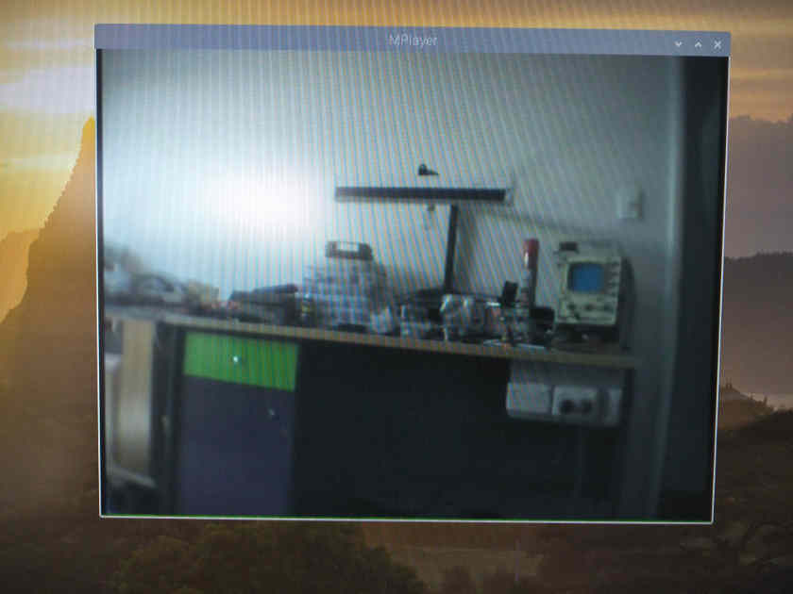

This is a shot from the Rpi 4B+ 2gb.

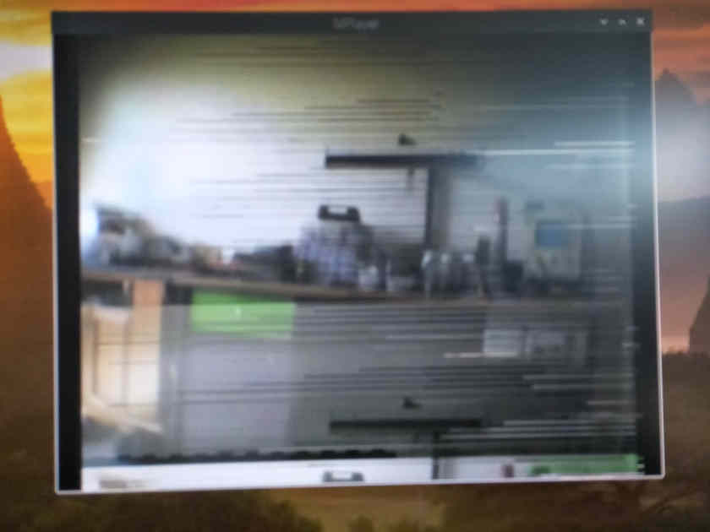

Me and the next generation of code cutters.

