POI 13 – Statue of Jesus

Title: At the heart of the College

Brief blurb:

Notes:

Our lady of Good Hope: to connect with a card in the Brother’s house (not sure which yet)

Images:

1. 13.08

2. 13.34

3. 13.39b

4. 13.31 (from 0.07 to 05.49)

5. 13.07

6. 13.12

**Card 1:**

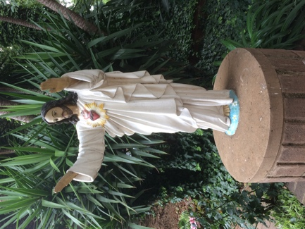

Text: The statue of Jesus and the Sacred Heart

(Images: C Kamana)

Further text:

For Christians, in particular Catholics, the Sacred Heart of Jesus is an extremely important symbol that represents a physical manifestation of God’s divine love for all humanity. This image is particularly relevant to the Marists; linking to Champagnat’s vision of providing education for all children born out of equal love for them through the way of Mary, mother of Jesus.

The school’s slogan is “Education with heart that knows no bounds”.

This photograph, taken in 2016, shows how the statue of Jesus positioned facing the college entrance steps looks today. However, this has not always been the case. The statue previously stood in two other locations at Sacred Heart College and was moved for particular reasons to be explained now. The fact that the statue is now also painted with colours, unlike most of the other statues around the school (with the exception of the Madonna and Child), is also significant. An event in the late 1980s occurred which led to the statue’s repainting and repositioning (further information about this is found in following slides). This statue of Jesus is an object of much more than symbolism around the name of the College – it is one that physically links Sacred Heart College to its ongoing mission to uphold its community members’ struggle for peace, truth and justice. Without being aware of the particular narrative of the 1980s, teacher Boitumelo Letho, explained that her pupils (in grade 00) are curious about the statue. Several times, when passing the statue on walks around the school with them she has heard snippets of conversations such as these:

“Wow, look it’s Jesus!” … “No, it’s not real” …. “But it is actually where Jesus is buried” … “it is like a signpost” … “well I think Nelson Mandela is buried here” … “at night maybe they talk to each other” ...

No matter what their age or whether they know of the narratives relating the statue, this is a focal point for the community of Sacred Heart College.

**Card 2:**

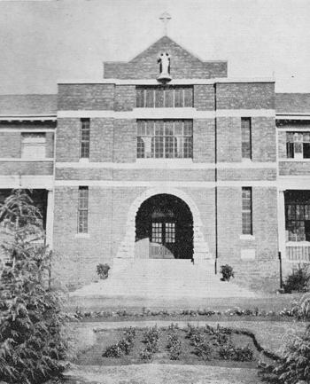

Text: 1933, central façade of College building with Statue of Jesus and Sacred Heart in the top niche.

(Image: Marist Archive)

Further text:

The statue was installed in the empty niche in around 1930. The statue of Jesus and Sacred Heart was not painted – it was originally plain white as the statues in the intermediate quad and in the Memorial Chapel plaza are today.

There is speculation over why the niche was empty for the first few years of the college’s life at Observatory. Perhaps it was originally intended to contain a statue of Marcellin Champagnat since in the early days the College was, briefly, called St Benedict’s in his honour. By the early thirties however, though colloquially referred to as Marist Observatory, the school name was officially Sacred Heart College so it’s likely that the installation of this statue in this niche was part of the physical cementing of this fact.

Today, in the niche, sits a copy of the statue of Our Lady of Good Hope. The original Our Lady of Good Hope statue came from Marist College, Uitenhage and is kept in the Brother’s residence.

**Card 3:**

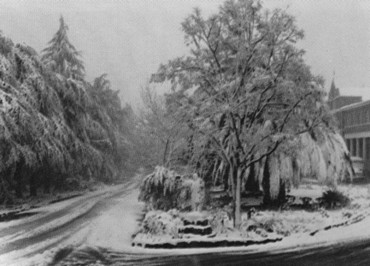

Text: The Statue of Jesus with Sacred Heart under snow in September 1981. The statue was situated just at the top of the traffic island found immediately as you entered the college gates.

(Image: Marist Archive)

Further text:

The statue of Jesus with the Sacred Heart was moved to this position by the gates in the late 1970s in preparation for the ‘new’ co-educational Sacred Heart College to open as an amalgamation of the three schools (Marist Observatory, St. Angela’s Convent in Kensington and Holy Family Convent, Yeoville) and symbolically welcomed people to this place of ‘love for all’. Sacred Heart College, the name of the school in which these three groups of learners would converge was already the name of the school but until that point not widely used by the school or wider community, who preferred to use the name Marist Observatory to distinguish it from the other Sacred Heart College in Koch street (then preparatory school for Sacred Heart College from 1926 until 1965), continuing out of habit for more than a decade after Koch street closed.

The last issue of the Maristonian, published in1 979 (replaced by the Sacred Heart College yearbook) paid tribute to the Marist Brothers, the Ursuline Sisters and the Holy Family sisters, now united in Sacred Heart College, under a picture of this statue already situated in its new location just inside the school gates.

The statue was only to remain in this spot for about seven years. Events in 1987 necessitated restoration of the statue and resulted in the statue being moved to its current location today.

**Card 4:**



Text: Br Neil’s recollections about the necklacing of the statue of Jesus with Sacred Heart.

(Image: C Kamana)

Further text:

Brother Neil McGurk, Principal of the college for 20 years was responsible for the transformative processes that Sacred Heart College began in the 1970s/80s (first with the admittance of black learners in 1976 and then in 1890 with co-education).

Here Brother Neil recalls the events of a night in June in 1987 when the statue of Jesus with Sacred Heart was necklaced, the socio-political climate during the second State of Emergency in South Africa and some of the involvement of the Marist Brothers and Sacred Heart College in the struggle.

**Card 5:**

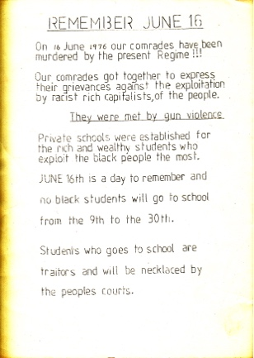

Text:

One of the leaflets dropped at the time of the statue’s necklacing, collected by Brother Neil McGurk in 1987.

(Image: Marist Archive)

Further text:

Printed as if a warning to black students not to attend school in June 1897 in solidarity with the events of June 1976 and the student uprising that began the unsettling of the apartheid regime, this leaflet was more likely created to give the impression that black students were behind the necklacing of the Sacred Heart Statue and intended to create discord within the community (both school and Marist) that was known already for its inclusivity and racially mixed make-up and was printed by those connected with and aligned to the governing political body.

As Brother Neil’s account explains (this can be heard in the previous slide) it was more likely printed and distributed by the (rogue) security forces and personally dropped by one Sergeant Beyers, who as if in some ironic-comic performance, was dispatched to the school the next morning when Brother Neil called the authorities to explain what had occurred at the school during the night.

The statue of Jesus was removed by Brother Neil and two other colleagues that day for fear of the effects of seeing the post-necklaced might have on the students (both white and black) coming into school. Brother Neil’s sister Geraldine (also responsible for the grotto statue) repainted the statue of Jesus and added the colour to it at that time.

The re-erection of the statue opposite the main steps was to signify defiance towards those responsible for the necklacing at the time – rather than discarding the burnt statue, it had been brought literally closer to the heart of the school demonstrating that ‘love for all’ was the true nature of Sacred Heart College.

**Card 6:**

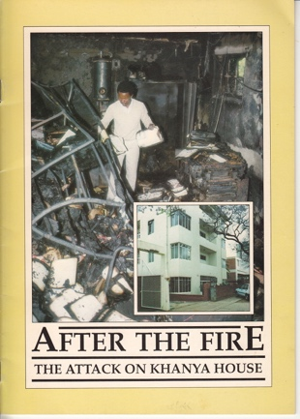

Text: Cover of *After The Fire: The Attack on Khanya House.* A booklet published by the Southern African Catholic Bishops’ Conference (SACBC) in response to the petrol bombing of Khanya House in 1988.

(Image: Anna Zeminski/Afrapix/SACBC in Marist Archive)

Further text:

Wilfred Napier, President of the SACBC, in the preface to the booklet described the attack as “an attempt to destroy the commitment and the spirit of justice, love and truth that inspired the Southern African Bishops’ Conference in its opposition to apartheid”.

Brother Jude related that explosives (including limpet mines) were found in the building after the fire, the planting of which he explained, was most likely intended to extended the damaged caused in the fire.

“What has occurred at Khanya House is a tragedy, not only for the Bishops’ Conference but for the country as well. THIS IS NOT A TIME FOR POLITICAL POINT SCORING. It is a time for all South Africans to realise that violence will not solve the problems of the country. The Bishops’ Conference remains committed to seeking a peaceful solution to the problems of our country” Br Jude Pieterse, Sec. Gen. SACBC 1988

The attack on Khanya House was the third similar of incident that year. Previously that year Cosatu House, the Trade Union Headquarters and Khosto House, the hub for the South African Council of Churches and other community activist organisations had been attacked already.

Brother Jude, former Marist Provincial, who resided with the Brothers at Observatory but spent much time at Khanya House in his position of Secretary General for SACBC had been actively working towards the desegregation of schools in talks with the then government as Director of the Catholic Institute of Education. The fear of the power of educational and spiritual related missions against the ideals of apartheid regime was palpable. The statue of Jesus with Sacred Heart remains a reminder of the transformative potential of that power.