**POI 16 – Marcellin Champagnat**

Title: St Marcellin Champagnat

Blurb: St Marcellin’s story and Sacred Heart College

Note: Goyo in card 4 to link to POI 36 (card 3)

Stained glass window in cards 1 & 2 link to POI 23(card4)

Images:

1. 23.18a
2. 23.27
3. 16.21b
4. 16.42

5. 16.10

6. 16.27 & 16.37

**Card 1:**

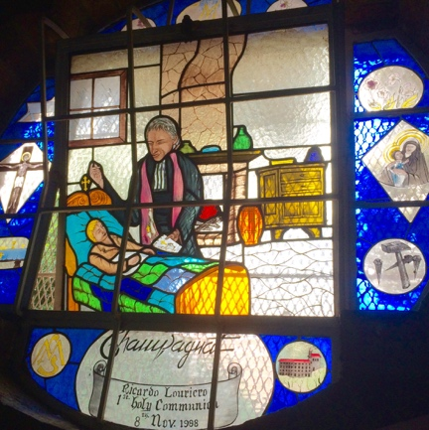

Text:

Stained glass window in Memorial Chapel at Sacred Heart College. By artist Barry Thompson, it depicts Champagnat at the bedside of the dying youth, Jean Baptiste Montagne, who had had no spiritual or other education.

(Image: C Kamana)

Further Text:

Champagnat’s experience with the Montagne boy confirmed his calling to teach the children in the rural areas of his parish. Within a few months of the boy’s death Champagnat had found two men willing to train as teachers and to follow in the way of Mary – with them Champagnat, curate the village of La Valla, started a school and a foundation house (part monastery and part teacher training college) for the newly founded congregation of Marist Brothers on 2 January 1817. The original foundation house soon became too small and Notre Dame de L’Hermitage (depicted in bottom right of window as a red roofed building) was built in 1825 to accommodate 100 Brothers.

This window was gifted to the school chapel on the occasion of then pupil, Ricardo Louriero’s, First Holy Communion (1998) in 2000 by his family. Also of interest is the Champagnat signature copied from Champagnat’s own handwritten letters. The violets – a tiny but strongly fragrant flower - symbolise the three quiet virtues espoused by the Marist tradition, humility, simplicity, and modesty. The three nails allude not only to the crucifixion but also to the trade plied by the Marist Brothers in their early days, that of making nails. The largest nearby town, St Etienne, was (and remains) a center for metalwork.

**Card 2:**

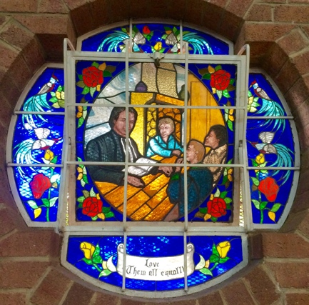

Text:

Stained glass window in Memorial Chapel at Sacred Heart College. By artist Barry Thompson, it depicts Champagnat as a teacher and an abbreviation of oft quoted saying “to teach children well, you must first love them and love them all equally.”

(Image: C Kamana)

Further text:

This window was added to the school chapel in 2003 funded by a donation, specifically marked for a further Champagnat window. Champagnat envisioned a brotherhood to tend to the educational and spiritual needs of children.

Champagnat outlined his intentions:

Ordained a priest in 1816, I was assigned to a town in the district of St.-Chamond (Loire). What I saw with my own eyes in that new post, with reference to the education, reminded me of the difficulties I had experienced myself at their age, for lack of teachers.

Champagnat to Queen Marie-Amélie, Letters, 59

Champagnat first employed a lay teacher at La Valla to support his teaching whilst he trained the two first brothers. By the time of his death in 1840, only 23 years after the founding of the Marist Brothers, there were 278 Brothers in 48 schools. In 2015 there were c.3,250 Brothers and c.70,000 lay people/teachers associated with the Marist congregation, as well as c.655,000 children.

**Card 3:**

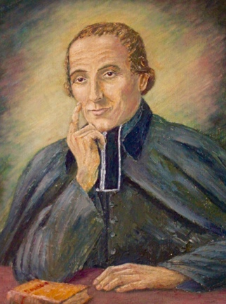

Text:

Portrait of Marcellin Champagnat (c70 x 45cm), artist and date unknown, that hangs in the Marist Provincial House at Sacred Heart College.

(Image: C Kamana)

Further text:

The Beatification of Champagnat was proclaimed by Pope Pius XII on 29 May 1955 – from then Champagnat was afforded the title of the Venerable (or Blessed) Champagnat. Artist Tito Ridolfi was commissioned to paint an official portrait of Champagnat for this event, but he lost his sight during work on the piece and as it was unfinished, the portrait was never officially released by the Marist Brothers. The Provincial House portrait is very similar to Ridolfi’s portrait, bar the positioning of Champagnat’s hands and the lighter overall colourings used. In the chapel, a portrait painted by Br Dominguez Garcia in 1948 at Sacred Heart, combines the hand positioning of Ridolfi’s portrait with the lighter colourings seen in this painting. To celebrate the 1955 event, pupils from Sacred Heart (both Koch Street and Observatory) and from St David’s attended a special Pontifical Mass at City Hall.

**Card 4:**

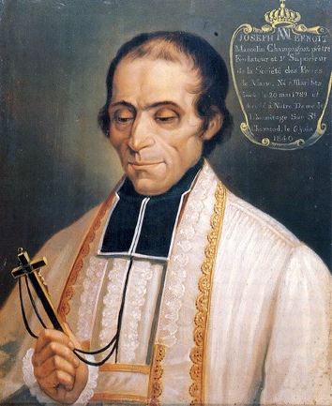

Text:

Official portrait of Champagnat (20 x 60 cm) by A.V.Ravery, 1840. The portrait hangs in the Superior’s Chapel at the General House in Rome.

(Image: <http://www.champagnat.org/images/marcelino/big/Ravery1840.jpg> )

Further text:

Ravery’s portrait is rather a likeness of Champagnat since it was painted immediately after Champagnat’s death from cancer on 6th June 1840 (celebrated as Champagnat Day by the Marist communities). Ravery, who had painted several paintings for the chapel at L’Hermitage, was called to paint the deceased who had been washed, dressed in his cassock, stole and surplice and placed with his profession cross in his right hand on a sofa in his room.

Marcellin Champagnat was not painted in life, and well before the advent of photography which made visual memorials more widely accessible, considered (as many religious people did previously) that sitting for a portrait was a demonstration of pride or of unnecessary luxury and therefore something to be avoided.

All later portraits and representations of Champagnat, including Ridolfi’s and Goyo’s (the latter was commissioned specially for the Canonisation in 1999) are artistic interpretations of this painting and as such attempt to portray something of the spiritual legacy that Champagnat created.

**Card 5:**

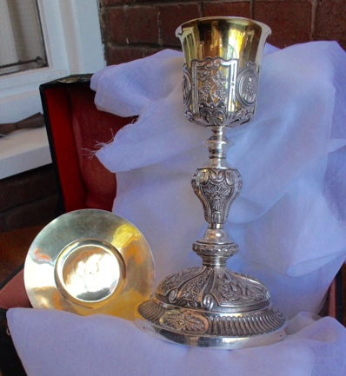

Text: One of only two original chalices given to Marcellin Champagnat during his life.

(Image: C Kamana)

Further text:

The chalice of Marcellin Champagnat is gold and silver plated and measures approx. 15 x 30 cms. It is boxed in its original casing along with Champagnat’s patten. Engraved with “Calice du Vénérable Père Champagnac [*si*c]”at the base. Translated as ‘Chalice of the Venerable Father Champagnat’.

Champagnat’s chalice was brought to South Africa by Rev Br Justinian from the General House (then located in Grugliasco, northern Italy) around the time of Champagnat’s Beatification in 1955. Rev Br Justin, a former Principal of Obs who at the time was Assistant General of the Marist Brothers arranged for its transportation in time for the dedication of the Memorial Chapel in 1956 and is kept by the Marist Brothers under lock and key. Br Jude Pieterse (former Provincial) suggests that Br Justinian was granted this request because South Africa was the first country that the Marists established schools in outside of Europe.

This chalice is mainly used for special occasions at the three Johannesburg Marist schools such as First Holy Communions, Confirmations and at special masses like those on Champagnat Day in June, but on occasion travels elsewhere in the Province of Southern Africa for similarly significant events.

**Card 6:**

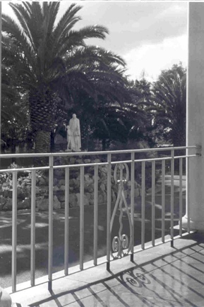

Text:

The statue of Champagnat, now in the Intermediate quad, was first installed at Sacred Heart College in 1961 on the traffic island opposite the main reception steps.

(Image: Marist Archive)

Further text:

The Champagnat statue, which is life-size, was unveiled and blessed by Fr Barry on Champagnat Day (or Founders Day), 6th June 1961. An identical statue is also to be found at the two other Marist schools in Johannesburg, St David’s, Inanda and Marian College, Linmeyer.

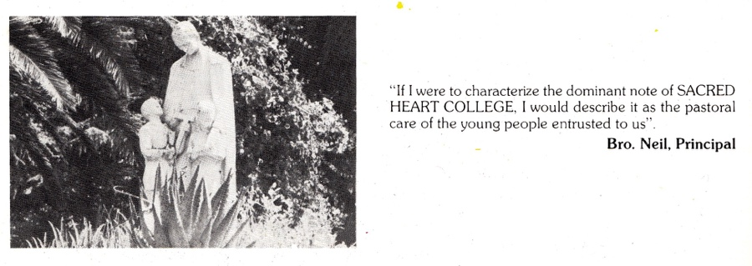

1980 Maristonian, p80