POI 18 – Foundation Quad

Title: Foundation Quad

Brief blurb: This block of classrooms was added in 1935

Notes:

????:

Images:

1. 18.01 c

2. 18.10

3. 18.11

4. 18.13

**Card 1:**

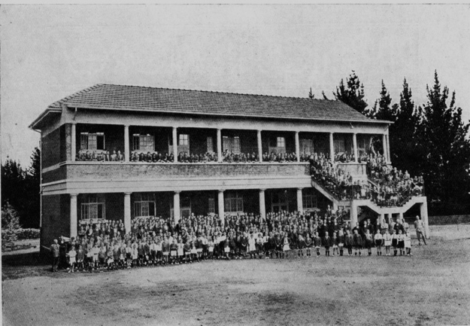

Text:

1935, the “new block”. Now part of the Foundation Quad.

(Image: Marist Archive)

Further text:

For sometime the steady increase in the number of students seeking admission into the College had emphasised the need for additional class-rooms and further staff accommodation, so to meet this need, Mr. E. L. Keenor, the architect who had planned the wing added in 1931, designed a two-storey block of twelve classrooms with an exterior that matched the already established College buildings. He was careful to provide in his plans for the latest improvements in acoustics and comfort.

In addition to the twelve classroom block built under Mr. A Bennett in 1935, a games-room, extra lodgings for the support staff together with a bicycle shed with racks for some 170 bicycles, were constructed by Mr. J. E. Morren.

Two days before the re-opening of the College, which took place that year on the 28th January, the new buildings were blessed by His Excellency the Rt. Rev. Bishop O'Leary, O.M.I, and dedicated to the Christian education of youth. He was assisted in ceremony by Rev. Fathers E. Roux, O.M.I., and Abramo, O.M.I, of Yeoville and Kerk Street parishes.

(text adapted from the 1935 Maristonian p55)

**Card 2:**

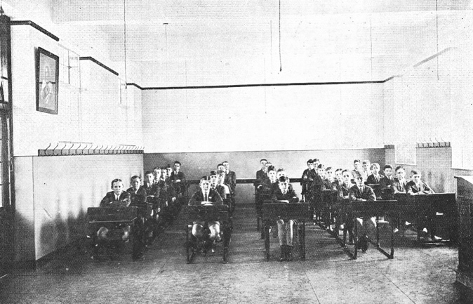

Text:

The interior of one of the new classrooms added in 1935.

(Image: Marist Archive)

Further text:

Today these classrooms are used for the Junior Primary classes (grades 1 to 3).

**Card 3:**

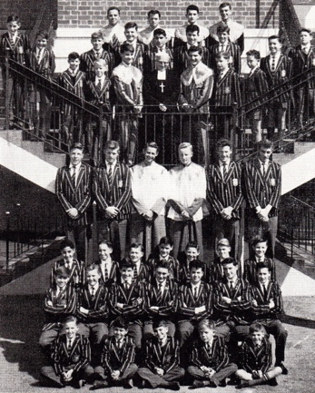

Text:

The Knights of the Altar in 1963 pictured on the staircase of the ‘new block’ as it was still known thirty years after it opened.

(Image: Marist Archive)

Further text:

The Knights of the Altar were a society established by Brother Otto whilst posted on mission to a Marist school in China in 1938. Their function was, as a group of boys who were responsible for duties assisting Ministers during Mass, “to form a worthy guard of honour of our Divine Eucharistic King”. The Knights of the Altar were first established in South Africa at Obs in 1960 and then after in other Marist schools in the Republic. Brother Otto is pictured centre in this image, with D. Ball (Supreme Grand Knight) to his left and P. Abraham (Vice-Supreme Grand Knight) to his right.

**Card 4:**

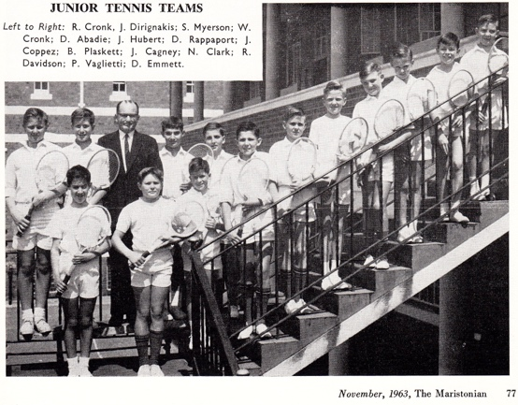

Text:

Until the addition of a roof over the staircase in 1969 after renovations to the quad, this spot in college was used for official group photographs.

(Image: Marist Archive)

Further text:

none