POI 20 – Music

Title: Music

Brief blurb: Musical traditions then and now

Notes:

Letebele: Link to POI Workshop (11) – not sure yet which card

Images:

1. 20.04a

2. 20.06b

3. 20.12

4. 20.19b

5. 20.11

6. 20.17 <https://www.youtube.com/watch?v=urEOjdDQpL0>

**Card 1:**

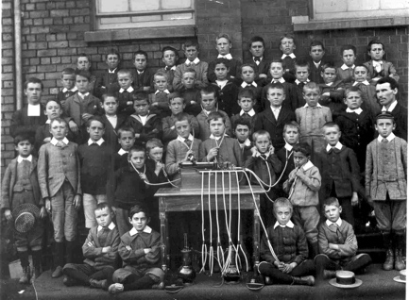

Text: c1904, Marist Pupils listening to a Phonograph

(Image: Marist Archive)

Further text:

The phonograph was invented by Thomas Edison (also the inventor of the lightbulb) in 1877. It was the first machine on which sound could be recorded and reproduced on a prototype ‘record’. The phonograph evolved to become the gramophone and then the record player –the precursor to cassettes, CDs and downloadable music files. Some DJs however still prefer the sound quality of vinyl or ‘records’ on which to play their sets. The first of these machines arrived in Johannesburg in the 1890s and the Brothers saw to acquire one for the school.

In this picture an early phonograph machine is set on the table with several sets of earphones (though these were more like medical stethoscopes!) attached. The Brothers ran a fundraising scheme for the school with the boys paying three-pence each to listen to the recording – either music or special listings. The Brothers also recorded the names of boys who had attained good results or deserved special mention for particular activities and these names were listed and played during assemblies (for the phonograph could also be played with a horn like attachment which acted as a kind of loudspeaker).

**Card 2:**

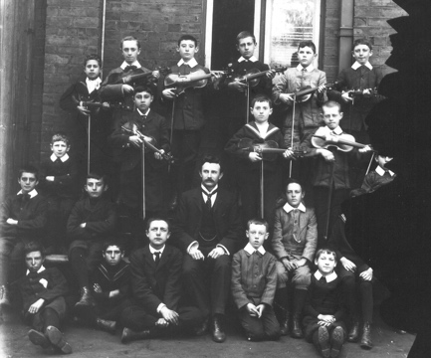

Text Teacher Garvin and his musicians in 1897

(Image: Marist Archive)

Further text:

Teacher Garvin was one of the first music teachers employed at the school, along with Mr Hyde who was responsible for the Brass Band, together they some of the first lay members of staff - since staff were principally Brothers. Many of the boys learnt instruments as part of early extra –mural activities. Singing, regarded as an important skill was a compulsory subject for all the boys. To accompany the Cadet Corps there was both a Reed Band (woodwind) and a Brass Band.

**Card 3:**

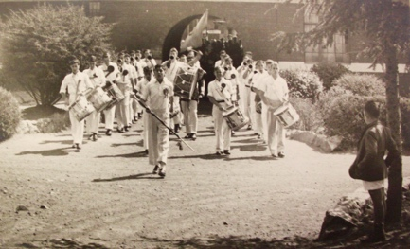

Text: c.1950 Sacred Heart College’s Marching Band

(Image: Marist Archive)

Further text:

The Marching Band at Sacred Heart College held a very special position within the school’s history – from the Koch Street days and throughout many years at Observatory. Starting off as The Marching Band that led Cadet Corps displays, even after the Cadet’s dissolution, the band ‘marched on’ leading learners to athletics meetings and swimming galas. It is because of this tradition that a ‘march on’ is still the format in which the school progresses to the top fields to take part in the annual inter-house athletics meeting in September but now music is played through the loudspeaker system rather than accompanied with an actual band.

**Card 4:**

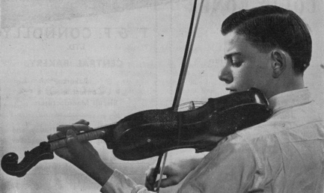

Text: Alumni Vincent Fritelli, aged 14 in 1955

(Image: Marist Archive)

Further text:

In addition to class music lessons many learners take extra instrumental or vocals lessons and are part of musical societies at school. Several alumni, like the pictured Vincent Fritelli, who in the 1955 Maristonian was described as a “prodigy of the violin” have gone onto become professional musicians. Fritelli, who a member of the Johannesburg Symphony Orchestra and Conductor for the Johannesburg Concerto Festival is now a Professor of Music at the University of Texas, Austin USA. More recent alumni to have achieved internationally acclaimed status in the music world include jazz musicians Vuma Levin (matric 2005), who credits belonging to the Sacred Heart Choir aged 14 as the catalyst for his career as an international award winning guitarist and composer and Yamikani Mahaka-Phiri (matric 2009), renowned actor-cum-singer who performs on stage in South Africa and overseas. Levin and Mahaka-Phiri, along with South African music legend Sipho ‘Hotsitx’ Mabuse, parent and grandparent to current pupils at the school, are some of those currently inspiring a thriving music scene for Sacred Heart learners.

**Card 5:**

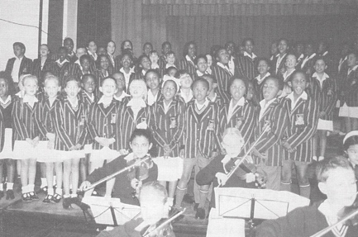

Text:

Text: Primary Choir and Orchestra performing in 1998

(Image: Marist Archive)

Further text:

The Letebele Music Centre was opened in 2002 by Joseph Letebele and named for the family’s long history with and worthy contributions to the school community. The centre, which was converted from staff accommodation at the turn of the millenium to a music block contained one large teaching classroom and twelve small rooms for musical tuition and practice. Today this space set aside for musical learning has become inadequate for the needs of the learners at Sacred Heart and so a new M.A.D Centre (Music, Arts and Drama Centre) is currently being fundraised for. Architectural plans have been drawn up and soon construction should begin for this new facility on the site of the existing kiosk in the sports fields. This should allow for the prodigious talents of the school learners in the arts to continue to grow and flourish further.

**Card 6:**

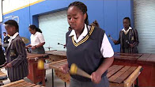

Text: Iyon Brew, the Sacred Heart College Marimba Band performs at Sacred Heart Day, October 2016

(Image: Sacred Heart College)

Further text:

Both the Primary and High Schools have several musical ensembles – including the seniors’ One Heart Choir, String and Woodwind ensemble, The Sacred Heart Jazz band and a number of Marimba groups (including the featured Iyon Brew). As well as players of more traditional instruments there are a growing number of contemporary musicians and vocalists who refine their skills at school. With a burgeoning and reinvigorated music scene at the school it is fitting that The One Heart Music Festival, annual hot ticket during the City of Johannesburg’s Heritage Day celebrations, showcases the combined talents of performers from Sacred Heart and other Marist schools alongside those more well known (both at home and abroad) such as Sipho ‘Hotstix’ Mabuse, Feya Faku, Judith Sephuma, MiCasa, Lira and Black Coffee. The Festival, which developed out of the Sacred Heart Cultural Festival and School Fête, raises awareness around xenophobia amidst the celebration of national heritages with proceeds from tickets going towards funding the Three2Six school and, in recent years, the Field of Flowers Scholarship (a fund enabling disadvantaged children to study at Sacred Heart College).