POI 22 – The Macartin Centre

Title: The Macartin Centre

Brief blurb: Indoor sports and community space

Notes:

Gate: link to POI 21 card 5

Midmar Mile: link to POI 21 card 4

Images:

1 12.29

2. 22.12

3. 21.19

4. 22.10

5. 22.20

6. 22.13

**Card 1:**

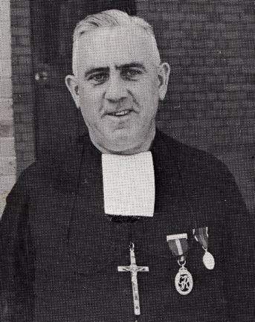

Text: Br Macartin with his some of his awarded medals pictured in the 1973 Maristonian

(Image: Marist Archive)

Further text:

Born in Ireland in 1889 (Christopher Hagan) Br Macartin arrived in South Africa in 1920. He taught at several of the Marist schools including Sacred Heart College at Koch Street, Uitenhage and Pietermaritzburg but it was at Observatory that he spent most of his teaching career both in the classroom, on the sports field and with the Cadet Corps. He was headmaster of five of the South African Marist schools in South Africa during his career.

Brother Macartin was decorated with several medals, some of which are pictured here. These included one awarded by Queen Elizabeth II for services to education, the King George medal for long and meritorious service as a Cadet Officer, a medal for being the best at Musketry in the British Empire and the African Medal for services on the Home Front during the Second World War. Macartin was also sent a gold medallion by Pope John Paul II when he had served 70 years as a Brother.

**Card 2:**

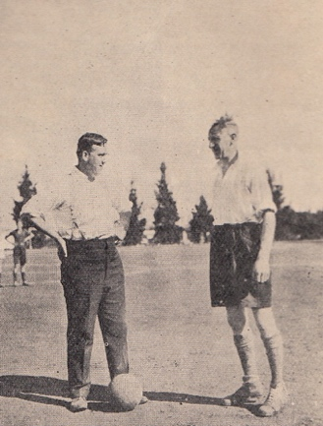

Text:

Br Macartin (on left) with J. Collins, a coach visiting from overseas, in 1933 on the fields at Observatory.

(Image: Marist Archive)

Further text:

Brother Macartin, for whom the sports centre is named, was as a celebrated teacher and sportsman and later coach (of soccer and cricket) until an accident slightly lamed him, as a result he was nicknamed “Hoppy” by the boys. When too elderly to coach sports but before his retirement to Nazareth House he was to be found polishing and ordering the school sports equipment in “Hoppy’s Hole” (now the alumni office run by Ellen Howell). He was not the only Brother to have been associated with a zeal for sport but his death, in 1990, was timeous with the construction of the new sports and community centre.

Brother Macartin could also be considered as one of the pioneers of Observatory college. On a Sunday stroll from Koch Street in approx. 1918 it was Brother Macartin, with some of his peers, that came across the land at Eckstien Street remarking that it would be suitable as the extension site that the Brothers were looking for in Johannesburg to enlarge their school. Since the sports facilities were inadequate at Koch Street it was the idea of expansive playing fields that particularly caught Br Macartin’s attention.

**Card 3:**

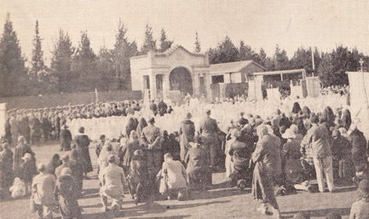

Text: 1933, Corpus Christi Procession gathering on the site where the Macartin Centre now stands. This year there was a crowd of 6,000 people.

(Image: Marist Archive)

Further text:

During the 1930s and 1940s thousands of Catholics from all over the Johannesburg area congregated at Sacred Heart College in Observatory to celebrate the feast of Corpus Christi. As is traditional, Corpus Christi (a celebration of the bodily presence of Jesus in the Eucharistic service) is celebrated on the second Sunday after Pentecost, approximately six weeks after Easter. The festival was marked with a procession, Mystery Plays and with the celebration of the Eucharist at several points around the college grounds. One altar for this purpose was set up in the arched entrance to the swimming pool – seen in this image with the double columns on either side of the archway.

This entrance to the swimming pool is still in existence at Sacred Heart College though its position has since moved and its structure adapted; the building of the Macartin Centre alongside the swimming pool area meant that the entrance to the pool shifted westwards. You will notice the same gate from the 1930s has been incorporated into an adapted gateway to the swimming pool today.

The Macartin Centre and Memorial Chapel were constructed on this same garden area that could hold thousands of people at the Corpus Christi festival. When the Memorial Chapel was built this area became a landscaped lawn shaded by trees serving as a meditational space. In 1969, the College Library was added. This is the extension which you can see coming off the cloistered walk way to the Chapel and contains foundation phase classrooms today.

**Card 4:**

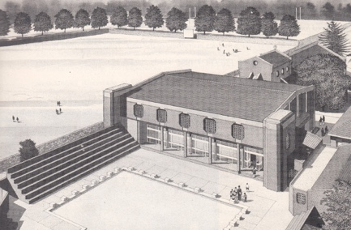

Text: Architect’s impression of the proposed new sports hall in 1984, the year The Development Fund was started.

(Image: Marist Archive)

Further text:

The Brother Macartin Indoor Sports & Community Centre was officially opened on 18th July 1992 by The Right Reverend, Reginald Orsmond, Bishop of Johannesburg. The opening of the Macartin Centre marked the end of the 1992 Cultural Festival and the culmination of eight years of fundraising by the Development Fund. Several other school projects (such as the computer rooms and lighting in the Hall) benefited too.

Linda Giuricich, (née Hurly) a long serving member of academic and sporting staff at the school (for a period of about 20 years between the early 1970s-90s, teaching PE, standard 3 and for six of those years Head of the Foundation Phase) organised the Cultural Festival year after year (the forerunner of the Heritage Day Music festival) and the opening of the Macartin Centre.

The Hurly and Giuricich families have a lengthy relationship with Sacred Heart College; generations of both families (boys and girls) attended the family of schools at Koch Street, Observatory and Holy Family Convent from the 1880s until the early 2000s. For example, when the Giuricich Brothers prepared for the building of Rosebank Mall in the 1960s the excavated earth was brought to Observatory to level some of the playing fields at the school. Linda’s grandmother was Head of the Ladies’ Committee responsible for raising the funds to build The Memorial Chapel. Linda recalls family tales around her grandfather Hurly (after whom Hurlyvale, Edenvale is named) receiving the first Marist Brothers off their Ox Wagon arriving from Kimberley in 1887, as they stopped at the Hurly farm before going to be received in town by Fr Monginoux O.M.I. No longer a permanent member of staff, Linda still runs Aerials Rhythmic Gymnastics club which has been operating at the school since 1980. 2006 Springbok gymnasts, and Sacred Heart alumni, Chantal Moonsammy and Nadia Harris were her students. Three current Sacred Heart learners, who train at Aerials, are members of the South African gymnastics team.

**Card 5:**

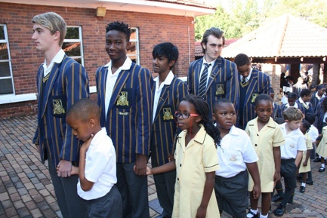

Text: 2016’s first Academic Mass; the outgoing Matrics lead the incoming Grade 1s up the steps and into the Macartin Centre.

(Image: Sacred Heart College Archive)

Further text:

The Macartin Centre is foremost a sports hub but has many other uses in line with its original purposing as a Sports and Community Centre. Several times a year whole school Masses are held in the space – for it is the only indoor space large enough to hold the Pre-Primary, Primary, High School and Three2Six schools that make up Sacred Heart College.

Masses such as these are held to celebrate Founder’s Day in memory of Marcellin Champagnat on 6th June as well as academic masses at the start and end of each year. A tradition that has been in place for many years is the walking in of the oldest and youngest main school pupils which is a physical reminder of the strength of relations between pupils of all stages in their careers at Sacred Heart College. On Founder’s Day, cool drinks and sticky buns are served as a treat to learners. This tradition goes right back to the Koch Street days.

**Card 6:**

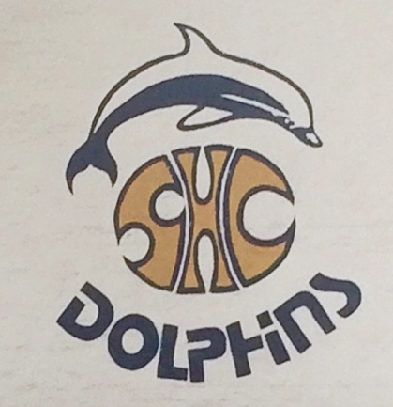

Text: Sacred Heart College Dolphins logo painted as a mural inside the Macartin Centre

(Image: C Kamana)

Further text:

This logo which is used by both swimming and basketball teams at Sacred Heart was devised by alumni Paul Swart (matric 1989) during his time at the school. Swart went on to become an architect after his time at Sacred Heart. 1989 was the first year that swimmers from Sacred Heart College swam the Midmar Mile (the world’s largest open water swim that takes place in February each year) coached by Veronica Sandham, then PE teacher and the swimming team wanted something to put on their team t-shirts to mark this event. The dolphin was suggested by Franco Gilardi (alumni and then PE teacher at school) and since the late 1980s has been associated with Sacred Heart’s swimmers and basketball players (since they use the space in which the mural was created). The same logo is to be found on the flooring of Macartin Centre as well as mosaicked onto the bottom of the swimming pool.