**POI 23 – The Memorial Chapel**

Title: The Memorial Chapel

Blurb: The ‘new’ College Chapel completed in 1956

Note: old chapel (card 1) to link to POI 39 (card1).   
 Mary (card 2) to link to POI 39 (card 4)

Plaque (card 3) Link to POI 29 (card 1)

Ridolfi (card 4) link to POI 16 (card 3)

Images:

1. 23.05b
2. 23.34c
3. 23.63
4. 23.25
5. 23.06
6. 6. grade 9<https://www.youtube.com/watch?v=Y64HYUToe4Y>

**Card 1:**

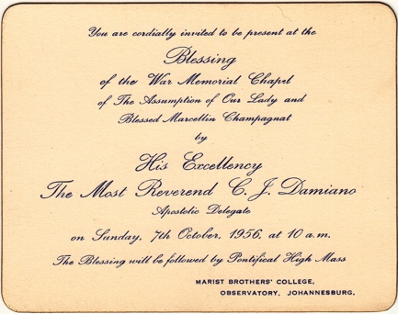

Text:

Invitation to the opening blessing of **The War Memorial Chapel of the Assumption of Our Lady and Blessed Marcellin Champagnat** and Pontifical High Mass in 1956.

(Image: Catholic History Bureau)

Further text:

The Apostolic Delegate (a representative of the Pope in a country where there are no regular diplomatic relations with the Vatican), The Most Reverend Damiano, consecrated the new college chapel on 7th October 1956.

A Pontifical High Mass is one celebrated by a Bishop (Most Reverend as a title denotes an Archbishop as Damiano was at the time of the then Transvaal) with special ceremonies – in this case relating to the consecration of the chapel.

The old chapel was not officially consecrated (meaning to set apart for association with the sacred rather than with this-world things) as a place of worship, rather dedicated. The difference between blessing/dedication and consecration is to do with permanence and ownership. One can assume this was because Sacred Heart College was built with funds from a mortgage for building works so the old chapel technically didn’t belong (literally) to the Marists at the time of the school opening, only once the mortgage had been paid off years later.

However, the entire funds (£20,000 South African pounds, equivalent to about R750,000 today) for the building, decoration and furnishing of the 1956 chapel were raised by the Ladies Committee over a ten-year period through fairs, sales, dances ‘and other ingenious schemes’ (according to the 1956 Maristonian).

**Card 2:**

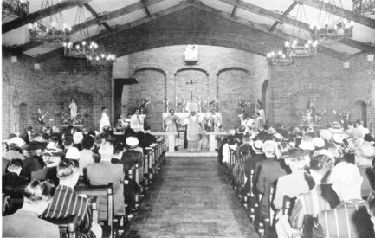

Text:

Apostolic Delegate, His Excellency The Most Reverend C. J. Damiano, officiating Pontifical High Mass at the consecration of the school chapel in October 1956.

(Image: Marist Archive)

Further text:

Prior to the opening of the Memorial Chapel the foundation stone was laid and blessed by The Very Reverend Hugh Boyle, Bishop of Johannesburg, in June 1956, fittingly on Champagnat Day. This is commemorated with an engraved stone that can be seen on outside of chapel (front left of the main doors). The chapel architect was J. W. Van Gemert and the builder, J. Brouwers. In accordance with consecration ceremonies, they, along with the extended Marist community seen in this photograph would have been present in October 1956.

In this image the original parquet flooring is visible. Over time this was replaced with tiling because of water damage through a leaking ceiling. The ceiling was restored and is today exactly as it looked in 1956. Also visible is a stone altar rail used to demarcate the more holy area of the chapel (since removed). The crucifix above the altar and the same 36 mahogany pews in use today, these cost £100 and £1260 respectively at the time. The statues to the left and right of the chancel area, of Mary and Joseph, came from the old chapel.

**Card 3:**

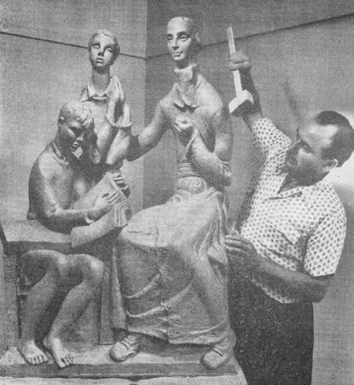

Text:

Hungarian sculptor and artist, Zoltan Borbereki, creating the Champagnat sculpture that sits above the altar, in 1956.

(Image: Marist Archive)

Further text:

Borbereki, who died in 1992, was a world renowned artist commissioned specially to create the Champagnat sculpture. Made from marble it was purchased for £300 (approx. R10 500 today). Other works by Borbereki can be found at the Johannesburg Art Gallery and in Standard Bank’s corporate art collection.

The full name of the chapel is **The War Memorial Chapel of the Assumption of Our Lady and Blessed Marcellin Champagnat.** The building fund was started in the name of the “Marist Brothers’ War Memorial Chapel Appeal” and was intended, as it is today, to serve as a place of reverent remembrance for those (Brothers and alumni) who died in both the First and Second World Wars of the twentieth century. A plaque with the names of 49 Old Boys who gave their lives in the First World War (1914 – 1918) can be seen at the back of the College Hall. A plaque for the 78 Old Boys named (in the 1944 Maristonian) as killed in action during the Second World war was proposed but never constructed.

The Assumption of Our Lady, traditionally celebrated on 15th August, is a feast day commemorating the ascension of Mary to heaven. The chapel is also dedicated to the Blessed Marcellin Champagnat, being built only a year after his Beatification and hence the use of the title “Blessed” rather than “Saint”. The altar, made from sandstone imported from Germany, contains relics of Champagnat.

**Card 4:**

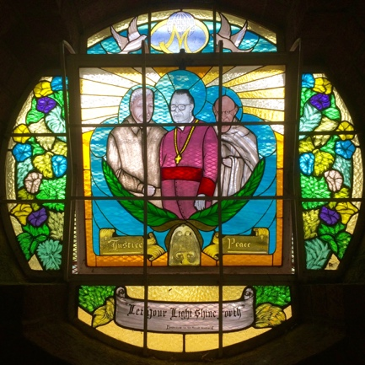

Text:

This window features representations of Nelson Mandela, Bishop Hurley and Mahatma Ghandi, three figures embodying the virtues of peace and justice. Bishop Hurley, perhaps not as internationally famous those standing next to him, grew up on Robben Island as his father was the lighthouse keeper. Twice President of the South African Catholic Bishops Council he was an outspoken and active opponent of apartheid. This window is dedicated to the Marist Brothers.

(Image: C Kamana)

Further text:

There are twelve stained glass windows in the chapel. All but one were designed and made by Barry Thompson with most of the windows being added to the chapel between 2000 and 2004, a project overseen by the then Primary Principal Mrs Gorst Allman. In 1956 the windows of the chapel were made of plain glass exactly as the circular windows set high above in the chancel area are still today.

The windows were sponsored by donors for individual reasons. For example, the Pre-School raised the funds for the window dedicated to St Francis of Assisi and some of the windows were sponsored by families wishing to mark the First Holy Communions of their children. Other windows were installed in remembrance of school staff members such as the ‘Safe in the arms of Jesus’ window dedicated to much loved primary teacher Penny Frangiskakis who died from cancer in 2002.

**Card 5:**

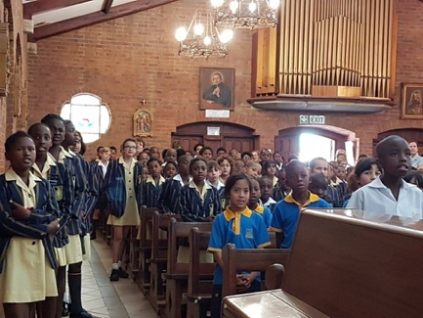

Text:

Primary school pupils at a mass to celebrate visit by Marist Superior General Emili Turú in September 2016

(Image: Sacred Heart College Archive)

Further text:

The Memorial Chapel is not a parish church and as such regular services are not held by the diocese here. However, during the school week masses are attended by all High and Primary school pupils and pupils from pre-primary to Matric meet with Fr Dryden the school chaplain. Special services throughout the year are also held, such as the Matric’s valdedictory. Today, in keeping with the inclusive nature of the school, special holy days from other faiths, such as Diwali, are also marked in the space. The chapel is used for special services outside of school days by alumni and the extended Marist congregation for marriages, memorials and sometimes ordinations. Performances such as the Pre-Primary nativity are held here as are numerous musical recitals.

Visible in this picture is the organ, with over 300 pipes, in 1956. Unfortunately, despite several visits from specialists who tried to restore it the organ is no longer in working order.

A portrait of Champagnat similar to Ridolfi’s can be seen to the left of the organ. Four of the fourteen carved and painted stations of the cross can be seen in this picture, originally these hung in the old chapel. On Good Friday today, as every year since the establishment of the school, the Marist Brothers lead a walk through 14 stations of reflection and prayer through the grounds, culminating in the orchard.

**Card 6:**

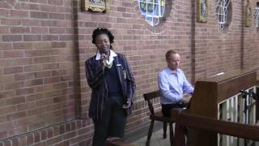

Text: Grade 9 pupil sings in the chapel, accompanied on the piano by Wayne Purchase, Deputy Principal of the High School and Head of Music.

(Image: Sacred Heart College Archive)

Further text:

*Forever Young* by Bob Dylan, covered by a very talented grade 9 vocalist in 2016. The acoustics in the chapel are excellent.