POI 26 - Uniform

Title: Uniform

Brief blurb: School uniform and badges over the last 128 years

1. 02.180

2. 36.40

3. 36.11

4. 36.24

5.36.55

6.36.50c

7. 36.12

**Card 1:**

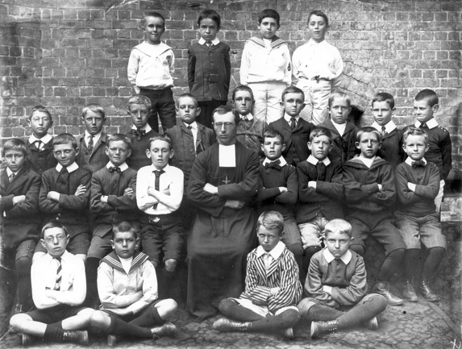

Text:

1912, Br Leudomire and his class (form 4) at Sacred Heart College at Koch Street. There was no set uniform. Boys were asked to dress as similarly as possible.

(Image: Marist Archive)

Further text:

The Brothers however always wore ‘uniform’ when performing their duties at school. Their black soutanes (robes) with white starched split rectangular collars earnt them the nickname of “crows” amongst the boys both at Koch Street and in Observatory.

The first official and compulsory uniforms were introduced at the former Marist school in Pietermaritzburg (then Maritzburg) in 1927 by then Principal Br Paul-Camille. This consisted of a blue blazer of with a braid of alternate sections of blue and gold around the edges of the lapel, pockets and cuffs. Br Paul- Camille had been stationed in the early 1900s at the Cala Marist Brothers College in then Tembuland, possibly he took the idea from the blue and gold uniform worn by cadets there at the time. The earliest evidence of the Blue and Gold combination as “Marist” in South Africa is in the 1903 edition of the Marist College Uitenhage magazine called “Blue & Gold”. As the Uitenhage college was the fifth Marist school to open in South Africa, it is likely that these colours had already been adopted at the earlier schools in Cape Town and Port Elizabeth but no documentation exists to confirm this. Br Paul-Camille became Principal at Sacred Heart (Observatory) in 1935.

**Card 2:**

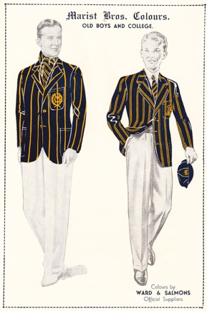

Text:

Ward & Salmons advert showing Old Boys and Marist Uniform from the 1838 Maristonian.

McCulloch & Bothwell, the current official school outfitters, also advertised in the Maristonian from the 1930s.

Further text:

The first uniform was a plain blue blazer with a blue and gold edging and was worn at Observatory until the early 1930s. The striped blazer came in after a 1933 resolution by the Provincial council of South African Marists decreed the following:

“the uniform of all Marist schools in the country must include a light navy-blue blazer of Venetian cloth with pairs of gold-yellow stripes an eighth inch wide and an eight inch apart, at a distance of 1 ½ inch between each pair”

The Marist Centenary Digest magazine (1967) surmises this about the blue and gold combination:

“Some claim that the colours were brought to South Africa from St Joseph’s College at Dumfries in Scotland. Others say that the blue was chosen for Marist (blue for Our Lady) and the gold from the white and gold of the Papal colours… that blue is the colour of the heavens which bids us cherish the highest ideals; and that gold represents the sterling qualities of character which the Brothers endeavour to instil in their pupils.”

**Card 3:**

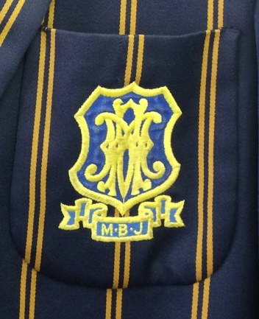

Text: The first badge used on Sacred Heart College blazers.

(Image: C Kamana)

Further text:

M.B.C stood for Marist Brothers College and was emblazoned below the badge with the Marist monogram AM at Sacred Heart Colleges at Koch Street and at Observatory. The monogram consists of the letters A and M intertwined representing the Marist’s motto *Ad Jesum per Mariam* (To Jesus through the way of Mary). AM as a Catholic monogram (usually standing for *Ave Maria* – praise/hail Mary) is not unique to the Marist Brothers but AM in this distinctive yellow and blue script is internationally associated with the Marist Congregation. This blazer crest, with M.B.J, is still used on ‘ordinary’ blazers (as opposed to Honors blazers) at St David’s College, Inanda and at Marian College, Linmeyer.

**Card 4:**

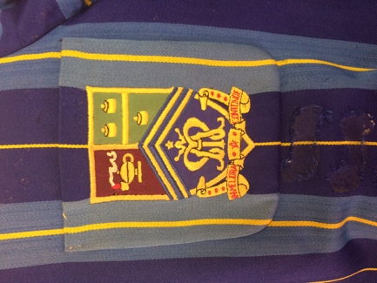

Text: The crest created for Sacred Heart College, Observatory in 1926

Further text:

The blazer badge shown in this image is that of the school badge that was created especially for the College. Blazer badges, in the past, were not necessarily the same as that of the school badges or crests. Though today this is not the case as the college crest is that which appears on the blazer badge.

The badge shown here was used on Honours blazers only (like the one shown here with varying blues and widths of stripes used until the 1980s) and was used only up until the 1960s and after that as a blazer badge for ‘ordinary’ school blazers in the 1970s and early 1980s. Honours blazers today are not striped but plain blue with gold edging – rather like the first school blazers.

The school badge has a panel showing three gold stampers in the top right segment, similar to what appears on the crest of the City of Johannesburg and an allusion to location of the college being in the mining town. The left hand symbol is that of the lamp of learning and below is the AM monogram. The reason for the addition of the green and red is not clear but demonstrate the two other colours of the school houses (not represented by the blue and gold already in the crest). The school motto ‘In Meliora Contende’ meaning ‘strive for better’ is embroidered at the bottom of the badge.

**Card 5:**

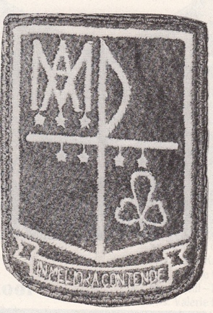

Text:

The school badge designed for 1980 when the Sacred Heart College became co-educational and amalgamated with two other schools.

Further text:

This badge was designed by Sister Mara O.S.U who was Deputy Principal of the Junior Primary school at the time and was a combination of symbols from the three schools that joined together in 1980. These three schools were Sacred Heart College Observatory, Holy Family Convent, Yeoville and St. Angela’s Convent, Bezuidenhout. For Sacred Heart College (or Marist Obs) the AM monongram is preserved in the badge. The Holy Family Convent, Yeoville (which continued to house the Sacred Heart nursery school until the 1990s) shamrock representing the Holy Family (Jesus, Mary and Joseph) is found in the bottom right. The seven stars in the Ursuline badge (for St Angela’s Convent was run by the Ursuline Order) are arranged in the constellation of Ursula Minor. In this badge the seven stars are rearranged and attached to the cross, the symbol of Christianity, which bound all three schools together. The cross was represented with a crook at the top. A crook is used by both Bishops and shepherds - for both of these figures is a tool that speaks to the care and management of a flock.

**Card 6:**



Text:

1980, Standard 2 class wearing a selection of different blazer badges. Ms Field, their class teacher, remains a member of the teaching staff at the college today having started at the school in 1978.

Further text:

Both the primary and secondary schools were permitted to wear a mix of blazer badges until the mid 1980s in the years immediately after the amalgamation of schools. In this image you can make out at least three (the old and new badge at Sacred Heart, and the Ursuline badge). The dresses worn by the girls were also a mix of styles – today’s ‘banana dress’ is an adaptation of the dress that came from Holy Family, Yeoville (seen on the girl on far left). Another style of dress, a pinafore with collarless shirt underneath, from St Angela’s, was also worn (seen on the girl in far right of picture).

**Card 7:**

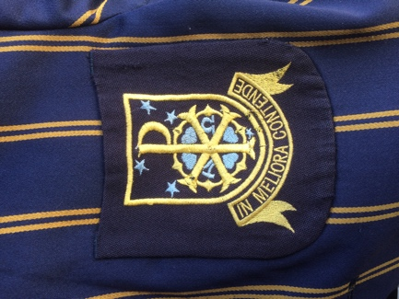

text:

The current blazer and school badge, created in 1985, by Kobus Esterhuzien.

Further text:

In 1986 the school proposed a two section high school with either Afrikaans or English offered as the medium of instruction (rather than only English). In addition, Sotho, French, Portuguese and Italian were offered as second languages. Though the whole school (Nursery, Primary and High School) was to retain the name Sacred Heart College, the High School was renamed Observatory College/Kollege. Both instruction medium groups were combined for sporting and cultural activities but split for Languages, Mathematics, Physical and Social Sciences. This dual first language programme lasted only a couple of years.

The badge created in 1985 was created to launch the above mentioned initiative, but has lasted for at least thirty years longer than the initial reason for its design. The cross with crook has been set within a Huguenot cross to signify the union of both the Catholic and Reformed theological traditions within the mediums of instruction to be offered. The Α and Ω , the first and last letters of the Greek alphabet (alpha and omega) used together traditionally signify wholeness and were incorporated to symbolize the diverse (religious, racial and cultural) and co-educational nature of the school. The hearts in the center are the three petals of the Holy Family shamrock and a fourth for the Sacred Heart of Jesus. The stars (though here only five can be seen, with the idea that the other two are artistically ‘hidden’ behind the logo) are the seven of the constellation Ursula Minor (or little bear) from the Ursuline badge which points to the Pole star, traditionally the star towards which one looks to for direction. As such, the badge speaks to more than just the dual language programme that it was created to around but commemorates the union of three schools and celebrates the diverse and inclusive nature of the Sacred Heart College community.