POI 28 – St Angela

Title: Co-Education and Sacred Heart

Brief blurb: Marists, Holy Family Sisters and Ursuline Sisters combine in Sacred Heart College

Notes:

POI 26 Uniform (slides 5, 6 and 7) : links with POI 26 Uniform (slides 5).

Images:

1. 28.79 and 28.82b

2. 28.80

3. 28.25b

4. 28.85

5. 30.03c

6. 28.13

**Card 1:**

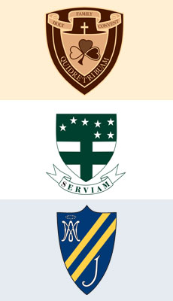28.79

Text:

The school crests of the three schools that amalgamated in 1980 to form Sacred Heart College. From top: Holy Family Convent, St Angela’s Convent and Marist Brothers’ Observatory.

(Images: Sacred Heart College Archive)

Further text:

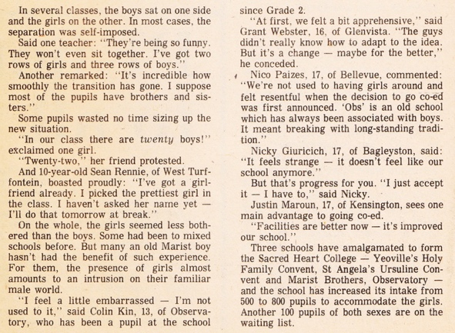

‘Oh brother! It’s girls, girls and more girls!’ *Rand Daily Mail* 12.01.1980

The story behind the amalgamation of the three school crests from Marist Brothers’ College, Observatory, Holy Family Convent, Yeoville and St. Angela’s Ursuline Convent, Kensington into one school blazer badge for Sacred Heart in 1980 can be read at POI 26 Uniform (slides 5, 6 and 7).

This article from the *Rand Daily Mail* gives some of the student perspectives on the merging of the three schools. Not only did learners arrive from the girls’ schools but many of the Sisters and their lay-staff came too Sacred Heart at that time as well.   
  
Brother Neil McGurk explained that the decision to become co-educational was not only a practical solution for the female pupils when the two Convent schools decided to close and one that saw the already intertwined educational heritages of the three congregations become physically linked but, rather hinged around something deeper:

“For many of us the cultural context of the emerging South Africa required transforming the male hubris of the all-boys school, which had dominated much of the sporting and cultural activities of Sacred Heart College in the past. However, it was not a popular decision at the time with those traditionalists who had epitomised a good education for boys with such a hubris, which seemed to be required for success in the corridors of power in society. The girls did not disappoint. They brought a new human quality to the College’s social, cultural and spiritual life, and quickly rising to leadership roles, they assisted in re-defining the nature of those roles.” Brother Neil McGurk, 2015

**Card 2:**

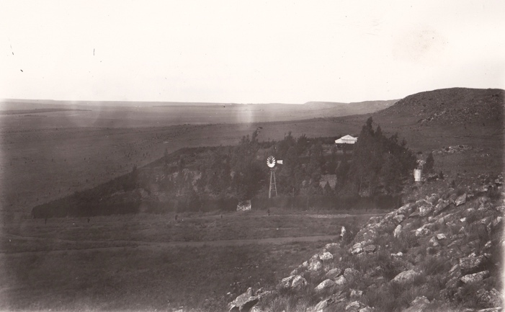

Text:

The farm in Kensington that belonged to the Ursuline Sisters and where St. Angela’s Convent was established in 1914.

(Image: Marist Archive)

Further text:

The Ursuline Order or Sisters was founded by St Angela de Merici who gathered together a group of women called to teach girls in the 1500s which was way before formal education of girls was accepted as the norm. At first the women continued to live with their own families but, as their mission became more focused on structured education and the provision of schools it was decided that they would begin to live together in religious communities where teaching could be done along side communal prayer. The first was established at Brescia in Italy and Angela Merici chose St Ursula as patron saint for her order it was before an image of St Ursula in the church of San Francesco in her home town Brescia that she prayed. Angela was deeply influenced by the legends surrounding Princess Ursula, a young woman whose faith in God was stronger than death and was martyred in the 3rd Century along with a group of faithful virgins.

A group of Ursuline Sisters, made up of Dutch and British Sisters arrived in South Africa in 1895 settling in Barberton but only a few years later this town collapsed as a mining centre whilst Johannesburg continued to flourish. By 1889 the Ursuline Sisters had come to Johannesburg and took over a school in Braamfontein that had been first established by the Holy Family Sisters – an early joint mission between the two congregations that were to reunite within Sacred Heart College one hundred years later. The Braamfontein school closed in 1907 and the Sisters transferred to Krugersdorp (later moving to Roodeport and selling their site to the La Salle Brothers) and not long after their school was established in Krugersdorp they also turned their farm land in the Bezuidenhout Valley, Kensington into the Convent School of St. Angela’s, which existed from 1914 until its merger with Sacred Heart in 1980. A further Ursuline school was established in Bryanston in the 1960s, Brescia House, which still exists today.

**Card 3:**

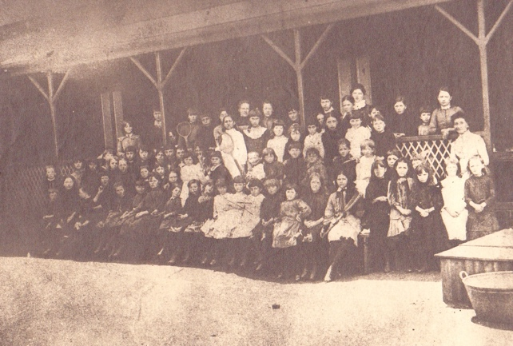

Text:

Some of the first pupils to be registered at Holy Family Convent, End Street. Picture taken sometime between October 1887 and December 1889.

(Image: Catholic History Bureau)

Further text:

The Holy Family of Bordeaux are a Catholic congregation formed by Pierre-Beinvenu de Noailles in 1820 when three young girls came to the newly ordained priest for spiritual direction and on consultation with his superior established a sisterhood inspired by imitation of the the Holy Family (Mary, Joseph and Jesus) and devotion to the three-in-one Christian concept of the God as a Trinity (Father, Son and Holy Spirit). The Sisterhood was to go onto have several branches each with a special focus, some on nursing, others on teaching and others in Christian mission.

Holy Family Sisters were invited to Johannesburg by Fr Monginoux O.M.I (who had also called the Marist Brothers to the city) and arrived in 1887. They set up a convent school at End Street (at the junction of Fox and Smal Streets) in Doornfontein. End Street was so named because at that time, in the 1880s, End Street formed the far eastern boundary of the city – the East End so to speak of Johannesburg, with Fordsburg being the furthest settlement to the West. The district of Doornfontein was entirely residential at the time.

Boys who had registered at the Holy Family Convent were some of the first pupils to move over to the newly established boys ‘school, Marist Brothers College at Koch Street in 1889. It is possible that some of the boys in this picture were amongst those first boys to attend Koch Street.

The Holy Family Sisters, from their beginnings in Johannesburg in the 1880s, flourished and set up several convent schools in the city. By the 1960s they had 100 sisters split between convents in Yeoville, Parktown, Coronationville, Kensington and Victory Park and a further 140 sisters in the rest of South Africa. The Holy Family Schools in Parktown and Coronationville still exist today.

**Card 4:**

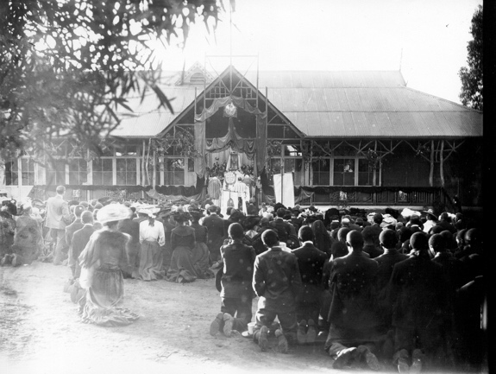

Text:

1906, Eucharistic procession at End Street Convent with girls from The Holy Family Convent and Boys from Sacred Heart College, Koch Street.

(Image: Marist Archive)

Further text:

An example of some of the shared activities between the girls’ and boys’ schools for by 1906 the schools were single sex. However, the Holy Family Convent at Yeoville which merged with Marist Brothers’ College took boys until standard 2 only. From standard 3 most of those boys, including Brother Neil (later Principal of Sacred Heart) attended Marist Obs. Brother Neil and Beverly Fulton Blow, ballet teacher at Sacred Heart College from 1980 -2016, were in the same junior primary classes together at Yeoville Convent. Of course they were not even born when this picture was taken but their shared history traces one strand of the interconnections between the three schools that were later to merge.

**Card 5:**

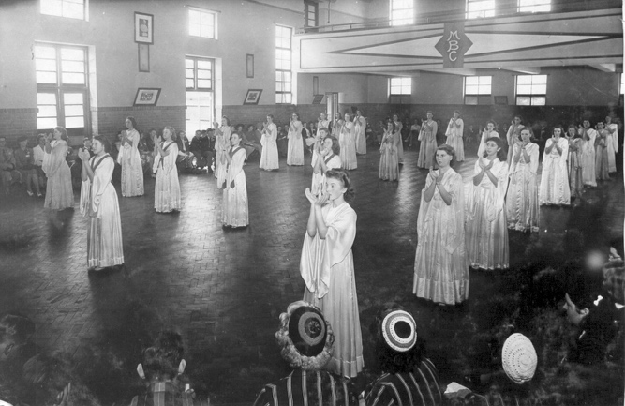

Text:

Ursuline Girls perform a dramatized Mass in the Hall at Sacred Heart College, Koch Street in 1950.

(Image: Marist Archive)

Further text:

Another example of the communal activities between learners of the three schools that later merged can be seen here in the performance of Ursuline girls in the hall at Koch Street in 1950. Not only were the Catholic congregations coming together but this picture shows three yarmulke wearing boys, representative of the high proportion of Jewish pupils at both Sacred Heart Colleges in Koch Street and at Observatory. At least three of the pictured girls went on to join the sisterhood; Maureen Murray at the front right of the picture became Sister Veronica Murray who taught at the Ursuline School in Kensington and later became Headmistress of Brescia House from 1975-1980.

**Card 6:**

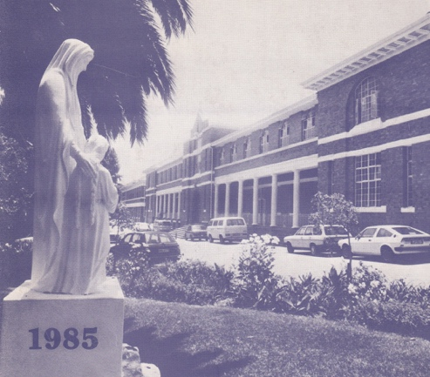

Text:

The Statue of St Angela, in front of the College, in 1985.

(Image: Marist Archive)

Further text:

“If mothers in the world had a thousand children, they would find a place for each one in their hearts” wrote Sister Stella in the 1980 Sacred Heart College yearbook, echoing the words of St Angela, the foundress of the Ursuline Order. The message is similarly understood to that of Marcellin Champagnat’s “to teach children well you must first love them and love them equally” and demonstrates the filial bond between the Catholic Orders that came together in the extended family of Sacred Heart College.

This statue of St Angela with a girl represents how the foundress of the Ursuline Sisters’ mission began when she gathered women to dedicate themselves to the teaching of girls, particularly impoverished girls, at a time when formal education for girls was unheard of.

This statue came from the St. Angela’s Ursuline Convent in Kensington to Sacred Heart in 1980 and was first installed, after being re-painted in white, on one of the traffic islands in front of the College (as can be seen in this picture). At the Ursuline Convent the statue was positioned in an alcove above an archway and this niche was, over time, colonized by honeybees. When the Chapel piazza was repaved in 1995, the statue of St Angela was moved to her current position between the Memorial Chapel and the main quad tunnel. It was at this time that the explanatory plaque under the statue was added.