**POI 29 – WW1 memorial**

Title: WW1 memorial

Blurb: Marist pupils from Koch Street who served in WW1

Note: Marist International Crest card 1 link to POI 1 (card 2)

Cadet card 2 - link to POI 19

plaque (link from POI 23 card 3)

MIGHT remove card 4 – it’s a bit of a tenuous link…

Images:

1. 29.11
2. 19.12 or 19.16a (pls choose which fits better on the app screen?)
3. 29.19
4. 29.20 or <https://www.youtube.com/watch?v=cfgyaLBc2MM>
5. 29.22
6. 29.23

**Card 1:**

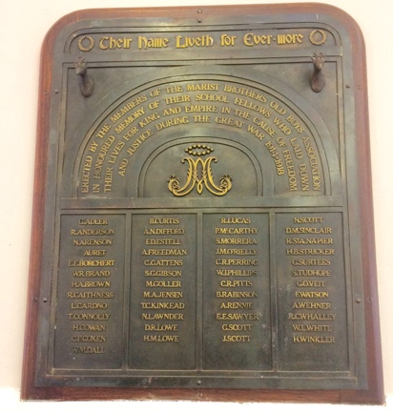

Text:

Memorial plaque mounted in the school hall to the memory of those who died in WW1

(Image: C Kamana)

Further text:

This plaque found in the school hall is a memorial to Koch Street Old Boys who died in service during WW1 (1914-1918). The plaque was erected by the Old Boys Association in memory of their peers. There are 49 names listed and is emblazoned with the Marist International crest and two springboks, the symbol used South African soldiers in WW1. The Koch Street exam records list every boy who sat for Matriculation. G. Adler, the first alphabetically listed, was a Matric in 1910. A. Freedman, Matric 1911; A. Rennie, Matric 1912. The 1912 Maristonian describes some of its Old Boys; G.O.Veit who was born in 1890 (thus between 24 and 28 when he was killed in action) as a solicitor who still enjoyed cricket and hockey. Each one of the 49 will have been recorded school annals; mentioned here are but four. The year in which they sat Matric a stark reminder of the youths that they were when these 49 Marist boys were killed in action.

**Card 2:**

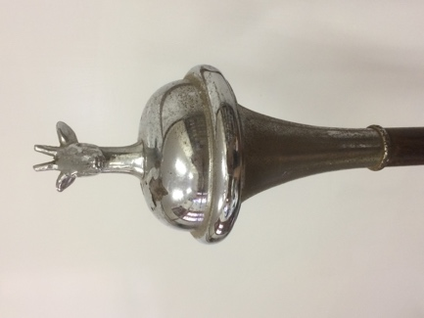 or 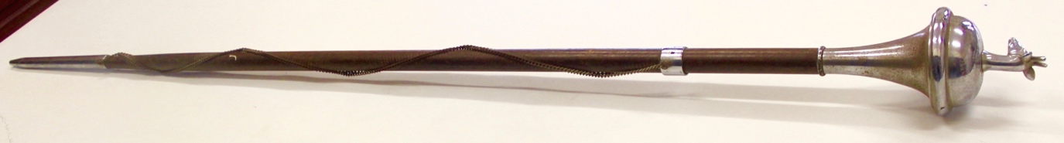

Text: Springbok atop the ceremonial mace of the (now disbanded) Marist Brothers Cadet Corps.

(Image: C Kamana)

Further text:

The springbok sits atop the ceremonial mace, still kept by Sacred Heart College, along with the Cadet corps ceremonial sword, that was used by the Marist Brothers Cadet Corps. It would have been used at military inspections, pageants and for drills.

The mace is made of a dark wood, perhaps mahogany, with silver plating and measures 150 cm in length.

**Card 3:**

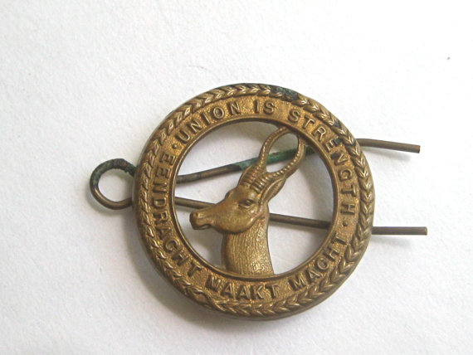

Text:

Hat pin worn by soldiers of the South African Infantry Brigade in WW1 with springbok emblem and as such certainly worn by Marist pupils serving in WW1 (unless they were pilots or sailors as a few were).

(image: <https://www.etsy.com/au/listing/196162545/antique-wwi-era-springbok-south-african> )

Further text:

The motto was that of the Union of South Africa, post 1910, and referred to the strength perceived to have been created when combining the Boer Republics (Transvaal and Orange Free State) with the two British Colonies (Cape and Natal) and signified the union of Afrikaans and English speaking South Africans in a common South African identity. The nickname “Springboks” stayed with South African servicemen and women throughout the First and Second World Wars. Today it is a nickname more readily associated with South African sports teams.

The South African Infantry Brigade was formed of four battalions. Soldiers from the then Transvaal, hence Marist boys from Sacred Heart College in Koch Street, would have formed part of either the 3rd regiment or 4th regiments.

**Card 4:**

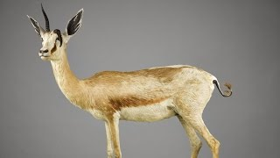

Text:

Nancy the springbok was an actual springbok mascot who accompanied the 4th regiment of the South African Infantry Brigade to Egypt and France during WW1

(Image: <https://www.youtube.com/watch?v=cfgyaLBc2MM&feature=em-share_video_user> )

Further text:

Nancy, persevered after her death, was displayed from 1958 at the Johannesburg National Museum of Military History where she remains part of their collection of war related artefacts.

**Card 5:**

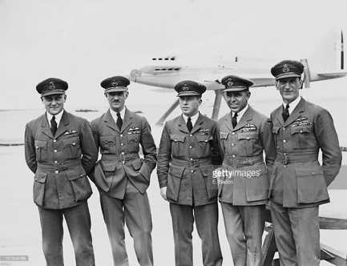

Text:

The British team for the Schneider Trophy standing in front of two seaplanes at Calshot, UK. Flight Lieutenant Samuel Kinkead second from left (9th August 1927)

(Image: E. Bacon/Topical Press Agency/Getty Images)

Further text:

Flight Lieutenant Samuel Marcus Kinkead R.N.A.S, D.F.C Bar, D.S.C Bar and D.S.O born in 1897 was a matric at Koch Street in 1911. After leaving Sacred Heart College, S.M. Kinkead trained with the R.F.C and became a highly skilled fighter pilot during WW1 and speed aviator afterwards. He died during an attempt to break the world record for the fastest ever recorded seaplane flight in 1928.

S.M.Kinkead’s elder brother, Thompson Calder Kinkead, also an alumni of Sacred Heart at Koch street was killed during WW1 in a flying accident in 1917. Second Lieutenant T.C.Kinkead is remembered as one of the 49 names on the WWI memorial plaque.

**Card 6:**

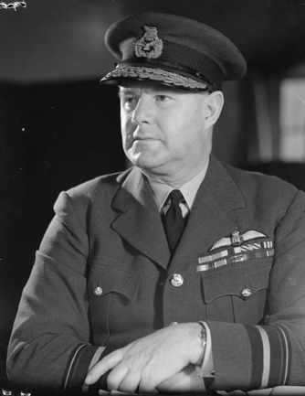

Text: Air Vice Marshall Hugh Saunders, Matric 1907

(Image: <http://www.theaerodrome.com/aces/safrica/saunders3.php> )

Further text:

Along with an alumni of Marist College in Uitenhage, Sir Quentin Brand, Air Vice Marshall Saunders was one of two Old Boys involved in the Battle of Britain in 1942. In WW1 he was awarded the M.C (Military Cross) for gallantry and devotion to duty whilst serving on horseback. In WW2 he transferred to the air force and 1943 he was awarded a CBE in recognition of his services, which entitled him to use the title ‘Sir’. He retired from the armed forces in 1953 as Air Vice Marshall, one of the highest possible military rankings and he died in 1987.