POI 2 – Koch Street

Title: Marists at Koch Street in Doornfontein

Brief blurb: The first Sacred Heart College in Johannesburg

Notes:

O.M.I: link to Houses POI 36 (Card5)

Brother Paul: Link to POI 12 (don’t know which card yet)

Images:

1. 01.38c

2. 02.152 (01.25b & 01.26b)

3. 02.65f

4. 02.172

5. 02.58c

6. 02.129b

7. 02.145

8. 02.252

**Card 1:**

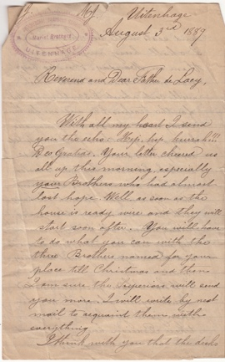

Text:

“Hip Hip Hurrah! Deo Gratias [Thanks be to God]” in response to news that Marist Brothers could soon arrive to begin setting up a school in Johannesburg.

Letter from Br Nectaire, Principal of Marist Uitenhage College, to Fr De Lacy O.M.I. (and Apostolic Delegate) in August 1889

(Image: Catholic History Bureau)

Further text:

The first Catholic Mass was said in Ferreira’s camp in February 1887, ten years after the first Catholics (Oblate priests from the O.M.I missionary congregation) arrived in the then Transvaal at Pretoria in 1878. Shortly after the first Catholic Mass was said it was decided a school for Catholic children was needed. The Holy Family sent six Sisters who set up a Convent school in October 1887, the first official school set up in Johannesburg. It was such a success that expansion was needed, specifically a school for boys. The O.M.I priests, not teachers themselves, wrote to the Marist Brothers asking them to extend their missions already established elsewhere in South Africa and to consider the Transvaal.

The archive of the Catholic History Bureau (in Victory Park) keeps a series of letters between the Marists (written by Br Nectaire in Uitenhage) and two of the O.M.I priests, then based in Pretoria and Johannesburg (Father Monginoux and Father De Lacy). The letters discuss the possibility of bringing the Marist Brothers to the then Transvaal relaying responses from the Marist General House in France around initial concerns. The Marist Superiors were worried about ‘faithless, lawless and dirty’ Johannesburg fearing that the town would ‘vanish in the dust’ like early American pioneer towns within a few years, preferring to start in the by then more established Pretoria. Brother Nectaire convinced them otherwise and eventually arrangements were made to send Brothers from Europe specifically for two schools to be opened in Johannesburg and Pretoria. The latter didn’t happen since missions in Natal and Kimberley appropriated the Brothers sent for Pretoria. The letters (to Father De Lacy) were written in English and (to Father Monginoux) in French. Later letters in the collection discuss the specifics of the Marist mission to Johannesburg and the setting up of the school (its physical make up and visions for educational practice).

The selected letter is a reply to a letter from Father de Lacy who had assured Br Nectaire that land and permits to set up a school by the soon to arrive Marists had been secured and that building had begun. The reference to ‘your Brothers’ is particular to the three Brothers ‘earmarked’ to go to Johannesburg; two who had in 1889 only recently arrived from Europe and one who had been teaching already in South Africa. There had been many delays around getting them to Johannesburg (to do with security concerns, financing and demands from other Marist missions in South Africa) and, according to Brother Nectaire, the three Brothers had begun to lose hope that they might ever reach their destination.

**Card 2:**

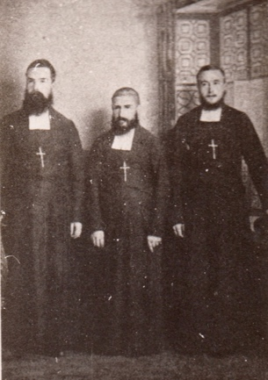

Text:

October 1889, the Brothers who first came to Johannesburg to set up the Marist Brothers College at Koch Street. Brother Albert Dominic (left), Brother Frederick, Principal (center) and Brother Euphrase (right).

(Image: Marist Archive)

Further text : (Is this possible Mike – to have an image, well two actually as they were on separate pages of a letter – to have these in the further text section? If not – just have the text!):

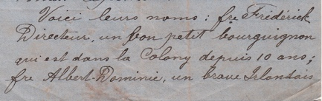

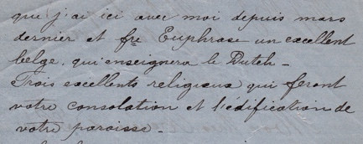

(Images: Catholic History Bureau)

Brother Nectaire described each of these Brothers to Father Monginoux in a letter written in November 1888.

“Here are their names: Brother Frederick, Principal, a good little Bourguignon* who has been in the Colony for 10 years already; Brother Albert-Dominic, a courageous Irishman who has been with me here since last March and Brother Euphrase an excellent Belgian who will teach Dutch. Three excellent pious men who will be an asset to you and edifying for your parish.”

*from the Bourgogne region in France.

Brother Frederick remained Principal for the first thirteen years of the school’s existence until 1903 when he was appointed Marist Provincial for the newly created administrative Province of South Africa (the first outside of Europe). By his former pupils he was considered as fatherly figure who was famed around the school for carrying a small black bag with him at most times – which contained sweets and sticks – that he dove into to appropriately reward or rebuke deserving pupils. Brother Frederick lived until three weeks before his 100th birthday in 1946. Brother Albert- Dominic died after an illness in 1894 and Brother Euphrase was killed during a cyclone in 1912.

**Card 3:**

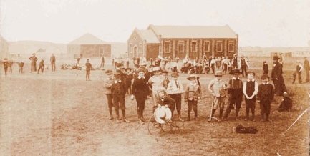

Text: One of the first photographs taken at the newly established school; boys and Brothers at Koch Street in 1889.

(Image: Marist Archive)

Further text:

According to records, 27 pupils (7 Catholics, 12 non-Catholics and 8 Jews) arrived to register on the first day, Wednesday 9th October 1889. The the first school pupil to arrive at the new school was Peter Busschau (in 2017 there are still Busschau’s from the same family at Marist schools). Not long after Busschau’s arrival a wagon load of boys came from the End Street Convent, run by the Holy Family sisters, bringing their desks with them. Within the first two years the school roll was at 300 pupils. In these early days the school was known as Marist Brothers’ College,

The single-storey building in the background was the school house – divided inside with wood and glass panels into three classroom areas. This became the ground floor of the western wing of the Koch street premises as it started to grow. The playground at this stage was open veld for Doornfontein was not yet built up.

In this photograph the boy on the tricycle is identified as George Nolan – later to become uncle of Brother Paul, a much beloved member of the Eckstein Street community of Marist Brothers. Another of the boys here, as recorded in the Marist Archives (but not clearly identifiable due to the quality of the image) is Joe Geddes – later to become a teacher at the school and after whom one of the school houses is named.

**Card 4:**

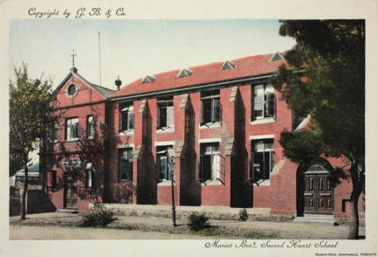

Text:

Postcard of Marist Brothers College showing how the school looked in the late 1890s.

(Image: Museum Africa Archive)

Further text:

By 1890 the school roll had reached 800 and the school building was far too cramped to accommodate even half of the boys thus a new double-storey school house was constructed. Even so, the most junior pupils still couldn’t be accommodated within the new building and nearly 200 of these were taught in a marquee pitched in the playground, with others timetabled to sporting and other subjects taught in areas around the playground. No longer open veld, the walled playground which doubled as a cadet training ground and cricket field/soccer pitch also contained a cottage where the Brothers (and their beehives) resided, a gym, a greenhouse, a woodwork room, a chapel and prototype science laboratory (for which pupils were charged an extra fee to use). Space at Koch Street was already becoming tight.

The school was creating quite a reputation for itself in Johannesburg. Gymnastic displays put on by the school became quite a societal fixture with crowds of people turning out to watch. So many in fact that the school yard was not big enough and the Wanderers grounds were used for displays. The boys were invited to take part in the annual Carnival Procession through the streets of the city and again in special displays (on foot, on bicycles, with gym equipment, in Reed or Brass Bands leading the Cadet Corps) for the Diamond Jubilee of Queen Victoria in 1897 and the Coronation of King Edward in 1902.

**Card 5:**

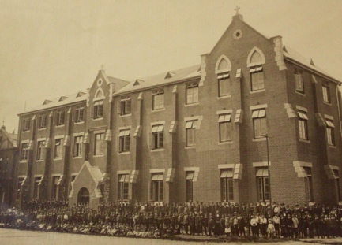

Text:

The school, known officially known as Sacred Heart College, after further renovations and extensions in c.1907/8.

(Image: Museum Africa Archive)

Further text:

During the Anglo Boer War, the school roll had dropped to 150 and some of the school was turned into a military hospital under the care of the French Red Cross assisted by the Brothers. By 1905 the pupil numbers rose back to over 500 and by 1906 the school was re-extended, this time into a triple-storey building. By 1914 the school roll was over 600 again and plans began to take shape at this time, not to extend the existing school (which was impossible due to the ever increasing density of the Doornfontein neighbourhood) but to look for an additional site further afield. In around 1918 this additional land was found in Observatory and purchased in 1919 by the Marist Provincial (then The Revd. Brother Vital) for development as soon as possible following the settling down of socio-economics following the First World War.

In a letter to his Lordship, Right Rev. Dr William Miller, Vicar Apostolic of the Transvaal written in 1910, Br Frederick defended the particular nature of Sacred Heart School at Koch Street. Accusations had been by the Catholic administration that the school wasn’t ‘Catholic’ enough and they had too many ‘other’ pupils. Brother Frederick assured the Right Rev. Miller that Catechism classes, the rosary and regular masses were held and that provision was made for the Catholic boys of whom there were 135 on the roll. This implies that there were at least 450 children attending the school who were not Catholics (at the time most likely Jewish and Protestant children). A Catholic school inclusive and diverse in make-up; as Sacred Heart College remains today.

**Card 6:**

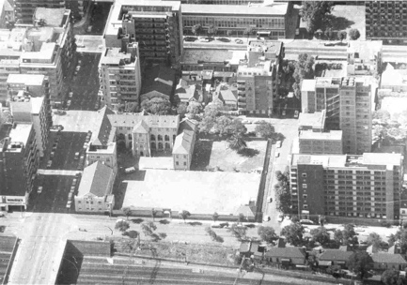

Text: Aerial view of Sacred Heart College, Koch Street in c.1960

(Image: Marist Archive)

Further text:

By the 1960s the land around Sacred Heart College was entirely built up. This a view shows how close the school was the train tracks (that lead to Park Station) and how little room, if at all, there was for expansion. The block on which Sacred Heart College stood is bordered by Koch Street to the north, Claim Street to the east, Hancock Street to the south and Banket Street to the east.

As is visible from this photograph there was no room for expansion of the current school, which since the late 1920s had served as the preparatory school for Sacred Heart College in Observatory and also fed some boys to St. David’s College, Inanda once this school had opened in 1940 after the Marist Brothers had purchased land north of Rosebank on which to build a new college. It was clear from the early 1930s that even with two Sacred Heart Colleges, a further Marist school was needed to accommodate the number of applicants wishing to be taught by the Brothers.

**Card 7:**

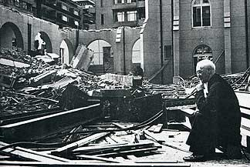

Text:

Brother Aquinas after demolition began at the Koch Street in the mid 1960s.

(Image: The Star, Marist Archive)

Further text:

The Brothers sold the land at Koch Street in the mid 1960s when it became unsuitable for a school to be set within the high rise buildings of the ever developing city center. A site to the south and (at the time) far outside of construction in town was bought in Linmeyer. The final assembly at Sacred Heart College on the Koch Street Site was held in 1965.

The Star, in 1966, reported that many Old Boys from Koch Street had gone to the site when demolition started to salvage mementos from the buildings, like bricks to set into their homes such was the sentiment surrounding the school. In 1966 Marian College Linmeyer was opened – the foundation stone laid at Koch Street and the organ from the chapel at Koch Street were incorporated into this new Marist school. Most of the boys from the younger years at Koch Street transferred to Marian College Linmeyer since boys were only admitted from Standard 3 (grade 5 today) at Observatory before the end of the 1970s. Some of the older boys went to the already established Marist Colleges in Observatory and Inanda. Since Koch Street had been the preparatory school for Sacred Heart or Marist Obs as it was known, Sacred Heart Koch street can be considered as the mother school of the school today at Eckstein Street.

**Card 8:**

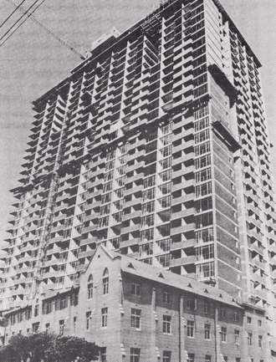

Text: The Mariston in 1971 (with part of Sacred Heart College still standing at its base)

(Image: Marist Archive)

The Mariston, appropriately named with a nod to the former landowners, a 31-storey building opened in 1971. One part of the school building (seen here) was left standing for some time after the Mariston was constructed, but this has since also been demolished and rebuilt over. The Mariston Building was, and is (for this 31-storey building still exists today), created as a multi-usage building with the majority of the plan being for 550 flats. A swimming pool, restaurant and landscape gardens for residents was planned at the time of construction but it isn’t clear that this was followed through with. Today a hotel occupies the first six floors with student accommodation, short term lets and other premises on the remaining levels.