POI 30 – The Hall

Title: The Hall

Brief blurb: A concourse for the body and mind

Notes:

????:

Images:

1. 30.12

2. 30.09, 30.10

3. 30.02b

4. 30.04a

5. 30.23

6. 30.24

7. 30.39/ 30.37

**Card 1:**

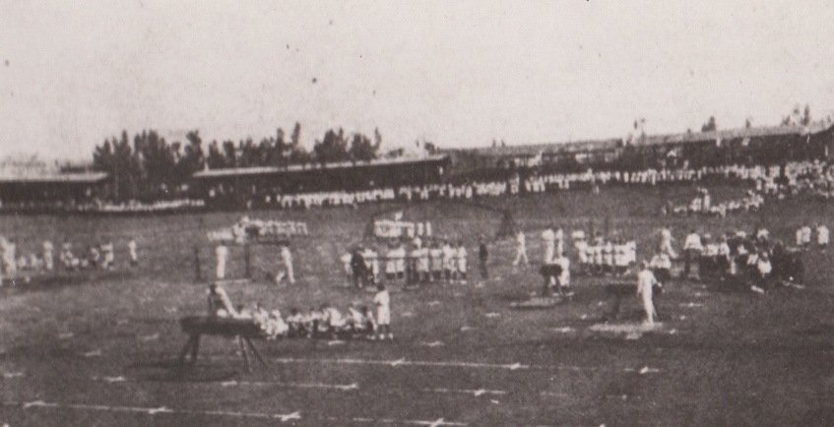

Text:

Sacred Heart (Koch Street) gym display at the Old Wanderers Ground in the 1890s

(Image: Marist Archive)

Further text:

When Sacred Heart College opened in 1889 there was no hall space to use for assemblies or PT (physical training). The school used the open space at the Wanderers Club (not to be confused with the Wanderers Club’s new grounds in Illovo) for when not in use by the cricket club it was available for use by the public. It was west of Joubert Park and a few blocks away from the Koch Street school. Today the Old Wanderers Club grounds have been built over with railway lines as the ground was purchased by the railways to enlarge Park Station in the 1930s.

Large crowds of people came to watch the displays by the Marist boys at the Wanderers Club – often many hundreds of spectators. The boys developed such a prestigious local reputation for their displays that they became a much anticipated feature of the annual carnival parade in town. During the South African war when there was a curfew placed on residents of Johannesburg, the entry ticket to the Marist gym display was used as a ‘late pass’ and therefore much coveted as no one was allowed out after 9pm without a pass.

**Card 2:**

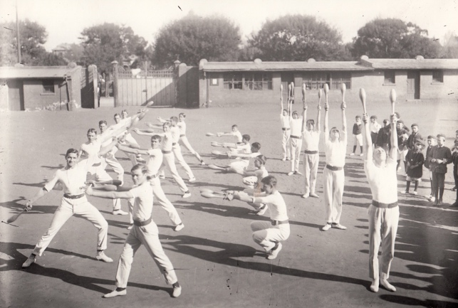

Text:

Senior boys at Sacred Heart College (Koch Street) practicing PT drills with clubs. Junior boys looking on. c.1890-1910

(Image: Rory Birkby Photography / Marist Archive)

Further text:

PT was the acronym for physical training. It was essentially fitness training using gymnastic techniques. Today’s PE, physical education, is more holistic a subject as it incorporates skills that can be used in a variety of different sports as well as fitness training. The boys here are using clubs as part of their training. Clubs were particularly used to develop strength in the arms but using them in a variety of motions (as shown in this picture) can tone muscles in the whole body and as such increase overall fitness levels.

The younger Marist boys looking on are wearing school caps with the Marist monogram embroidered on the front. The senior boys performing the PT exercises are wearing the uniform that was compulsorary for sports at both Koch Street and at Observatory in the early days – no shorts but long trousers for the seniors, a thick clasped belt and leather ankle shoes.

Visible behind the boys is one of the gates to the Koch Street school – the Marist monogram sits on top of the gate.

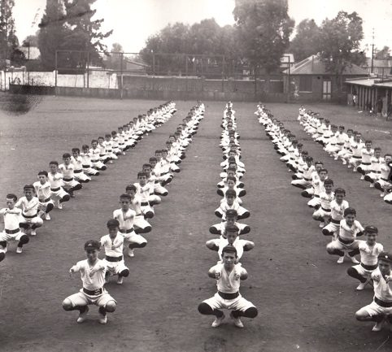 (image: Rory Birkby Photography / Marist Archive)

Junior boys at Koch Street in PT drill training

**Card 3:**

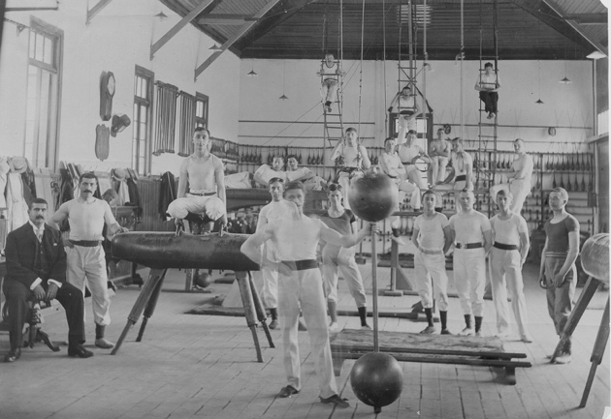

Text:

1895 – the gym at Koch Street is built and used not only by pupils at the school. This picture shows some senior boys (in Marist PT uniform) and some other adults training ‘after hours’.

(Image: Marist Archive)

Further text:

There was no gym at the Koch Street l to begin with but enthusiasm for gym training saw one of the first fundraising exercises at the school. Money was raised by the school and contributed to by local businessmen as the idea was that after school hours the new gym would be used by residents of the area. Sir Lionel Philips, Randlord and husband of the foundress of the Johannesburg Art Gallery was one of the largest donors – giving 100 guineas. Frank Fillis, circus master (and at the time considered the most important public entertainer), organised a special fund-raising matinee as a contribution.

When the gym opened in 1895 it was considered a state-of-the-art and luxurious facility. The gymnastic displays continued to be a huge feature on Johannesburg’s early entertainments calendars. The first gymnastics and PT teacher was killed during the South African War and for a time senior boys took over his classes until a replacement, Mr. Barend Vieyra was found. Mr Vieyra was supported by Mr Jack Lelie (a professional sportsman who also taught the girls at Yeoville Convent in the 1920s and 30s). Mr. Vieyra, a Jewish immigrant the Netherlands had arrived in Johannesburg in 1896 became a favoured teacher at the school, remembered for his echoing around the school of ‘von-two-three…von-two-three’ to encourage precision in the repetition of exercises. He was considered to have been one of the greatest early South African gymnasts and contributed much to the development of the sport in the country. Mr. Vierya’s son, Herbert Vieyra, an alumni of Koch Street, became an advocate who was legal advisor to the Regent of Basutoland and latterly became a Judge. Herbert Vieyra converted to Catholicism (contrary to the wishes of his family) and became a lay member of the Dominican Order in the 1930s. He is particularly remembered for his dedication to the cause of social justice and his contribution to the SACBC (South African Catholic Bishops’ Conference) stance against apartheid in his role as Chair of the Joint Council for Catholic African and Europeans (JCCAE) in the 1950s.

**Card 4:**

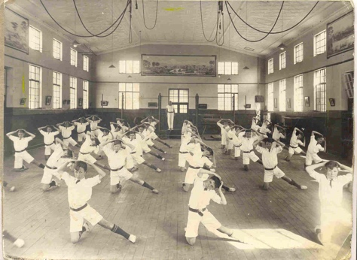

Text:

The Hall at Obs in c1928

(Image: Marist Archive)

Further text:

The Hall was built at the same time as the main school building at Observatory and was ready for the opening of the school in 1926. This photograph was taken in the very early days before the installation of the World War One memorial which was installed by 1930 to the left hand side of the door in the centre of the back wall. Note the gymnastics apparatus that was fixed into the ceiling. The original ceiling, pressed metal panelling painted in white can also be seen. The boys here are wearing shorts with their gymnastic kit which was an addition to the uniform for the junior boys.

**Card 5:**

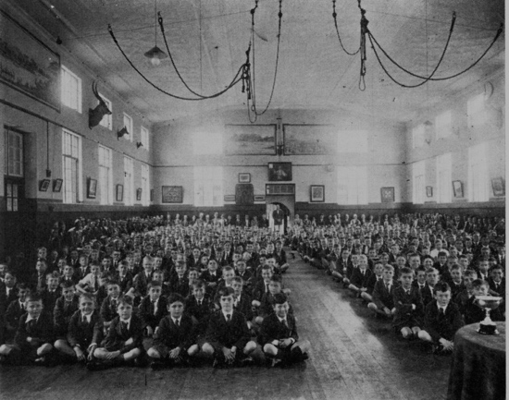

Text: 1937 prize-giving in The Hall

(Image: Marist Archive)

Further text:

The school hall was not only used for gym and PT but for formal occasions such as prize-giving as in the occasion shown here. Only very senior boys and staff were allowed to sit on chairs. At Koch Street a new gym was built in 1935 for by then the original one was 40 years old and no longer big enough and the equipment outdated. At Observatory, the 1926 gym was modified several times. In 1938 a stage was added (hence the table just visible on the floor in this image), in 1945 a lighting rig was added to the ceiling and between the 1950s and 1990s further improvements were made which included modifications to the stage dressing rooms, sound and lighting facilities.

**Card 6:**

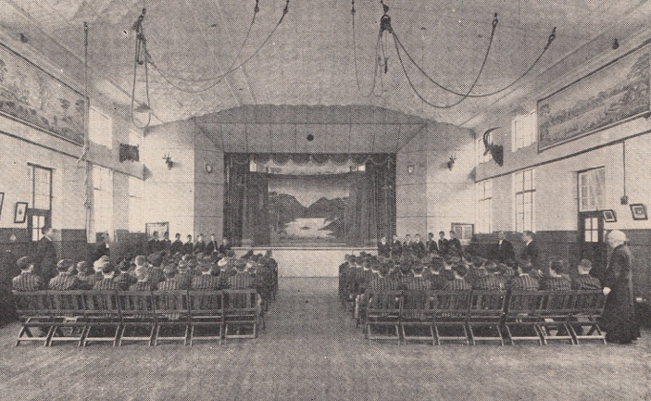

Text:

In 1938 a stage was added to the Hall. This feature used for college productions, also doubled as the setting for the College Bioscope which entertained boarders and staff at the weekends.

(Image: Marist Archive)

Further text:

As well as being used for indoor sports training and for events like prize-giving and formal dinners the hall was used for drama and other entertainments, much as it is today (though not for indoor sports since the Macartin Centre was built). Every Saturday during term time the Hall was turned into a cinema, or bioscope, for the entertainment of the boarders and staff. The 1938 Maristonian records that in that year a ‘Talkie’ machine was added to the bioscope – much to the excitement of everyone since up until then the movies had all been silent. The addition of the stage created more of a cinema-like effect for the showing of films that had been a regular feature at Sacred Heart for years, even at Koch Street in the early days as Brother Frederick had acquired a bioscope for use there. E. Joffe who was a boarder in the 1940s recalls in his memoires that Saturday evenings were, because of the bioscope, a highlight of the week. Films were usually educational in nature, with the odd ‘B’ movie comedy or western being shown. Since the reel needed to be changed during the film there were intervals during the screenings and it was at this time that the tuck shop was at its busiest. Joffe also recalls that the Brothers allowed all the staff at the school to watch the films – something of a rarity in those days since there were no picture houses in town open for black audiences.

Card 7:

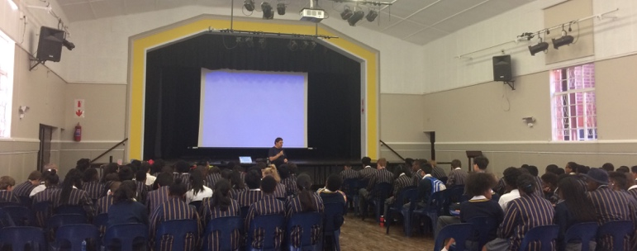 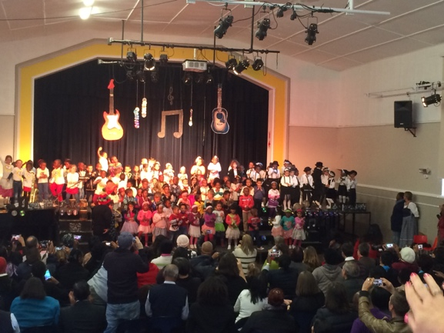

text:

The Hall continues to be a multi-functional space. Examples of some of its uses shown here are an App Building Workshop for Grades 8&9 led by Colin Northmore (left) and the Pre-Primary performing a “Musical Medley” (right).

(Images: C Kamana)