POI 32 – Struggles

Title: The Struggle(s)

Brief blurb: Selected stories about some Sacred Heart’s activists from 1976-2016

Notes:

Dr Mandela in Pollsmoor Prison: Link to POI 14 (not sure which card yet)

Images:

1. 32.10b

2. 32.19

3. 32.08

4. 32.11 or <https://soundcloud.com/caroline-kamana/br-neil-mcgurk-reflects-on-eric-molobi-and-sacred-heart-during-the-1980s/s-bfIsG>

5.41.22 & 32.01 or <https://soundcloud.com/caroline-kamana/open-letter-written-by-11-year-old-sacred-heart-pupil-read-by-the-author/s-Pjida>

6. 32.05

7. 32.20

**Card 1:**

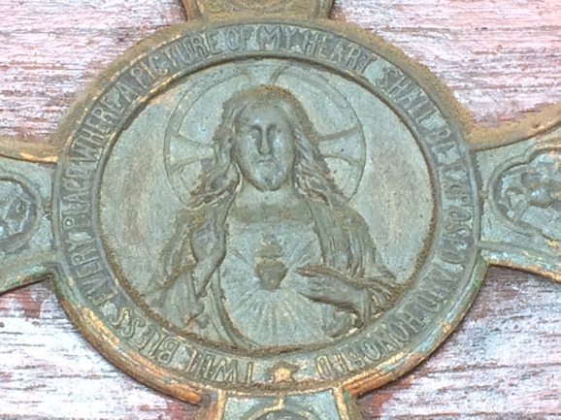

Text:

Plaque above Marist Provincial Offices’ front door which reads ‘I will bless every place where a picture of my heart shall be exposed and honored’ around an image of Jesus with Sacred Heart. The same plaque is also affixed above the door to the room where Eric Molobi stayed whilst being given refuge at the College during the 1980s.

(Image: C Kamana)

Further text:

Particularly between 1976-1996 but throughout the years that followed (and still ongoing) Sacred Heart College inspires and demands a social consciousness that reflects around and actively seeks practical ways to move forward through the complexity of South African society. Though at Sacred Heart the ethos is undoubtedly underpinned by Christian (specifically Marist) principles, it is the richness in and appreciation of a shared spirituality expressed through love and mutual respect that draws from many cultures and faiths (Islam and Hinduism in particular since a large number of the school community come from these traditions) and from those with a deep sense of morality expressed through shared values that knit together community members into a common order. In fact, it is often most precisely because of the diversity within the Sacred Heart community that traditional values are honed and shared because each member can reflect on the common threads of humanity that bind them to each other.

The information that is included in this POI (walking tour stop) is by no means a comprehensive collection of all the stories connected to individuals from Sacred Heart’s community who have contributed (and continue to contribute) towards positive change within in and to transformative dialogue around socio-political issues. Herewith a selection of some of the stories associated with the activists from Sacred Heart’s congregation.

**Card 2:**

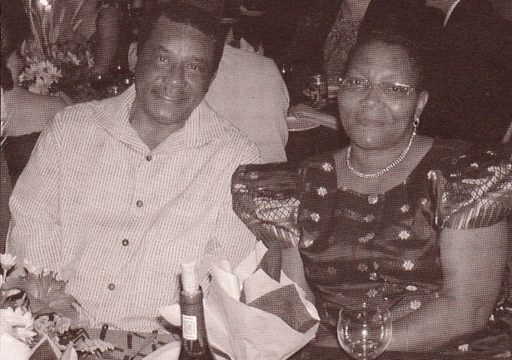

Text:

Eric Molobi and Martha Molobi pictured in 2002 at a farewell dinner for then Principal of Sacred Heart, Steven Lowry.

(Image: Marist Archive)

Further text:

Mr. Lowry, as a worker for the South African Catholic Bishops’ Conference (SACBC) and Mr. Molobi, were both been detained by the government during the 1980s. They were arrested because of their involvement in activities that promoted peace and justice during the years of the apartheid regime. During the 1970s Eric Molobi had been imprisoned on Robben Island for his work with the then-banned ANC. After his release Molobi, along with Sheila Sisulu, other community leaders and supported by the South African Council of Churches and the SACBC worked within two educationally focused activist groups; The Joint Enrichment Program (that dealt with civic leadership in townships and their school) and The National Education Crisis Committee. At the same time Molobi was administrator for the Kagiso Trust (that benefited black South Africans in the 1980s funded by the European Commission). Molobi later became CEO of the re-formed Kagiso Trust Investments from 1993 which continued to support and promote learning by young black South Africans once the new government took over.

**Card 3:**

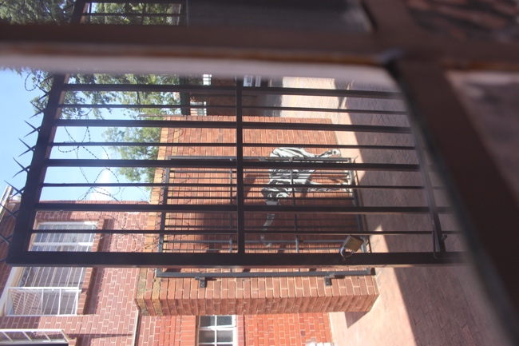

Text:

The view from the window of the room where Eric Molobi was given refuge at Sacred Heart College in 1988.

(Image: C Kamana)

Further text:

“[Eric Molobi] was to play a variety of prominent roles in the struggle in the ensuing decade, perhaps, most prominently, in visiting Dr Mandela in Pollsmoor Prison to discuss the negotiations linked to the suspension of the armed struggle.

With the renewal of the state of emergency in 1988, Eric was pursued by the security police, whom he evaded for many months in a place of refuge supplied on the College premises. He would masquerade by day decked out in a peaked cap and the other paraphernalia of a chauffer’s uniform. He was finally picked up when the security police followed Fatima Meer to Durban airport where she had gone to meet the disguised Eric. Martha, his wife was employed by the college as a receptionist, a position she subsequently held for twenty years, until a year after Eric’s death in 2007. She soon became the resident mother figure. Many students over the years have had recourse to Martha for succour and advice. Martha is still a serving member on our board of trustees of the outreach programme to rural communities. “ Br Neil McGurk, 2015

During the late 1970s and 1980s Sacred Heart College was undergoing a period of transformation. Not only did the school begin to admit pupils other than white boys by first becoming an Open school and then Co-Educational (the latter was not only done to consolidate three schools but also as part of a conscious move to destabilise the male-centric nature of the school and imbalances of power that were reflected in the apartheid regime (the disbanding of the Cadets and the de-structuring of the Prefect System were examples of this) that the college were moving away from. Then Principal Brother Neil McGurk and Brother Jude Pieterse (then Secretary General of SACBC and Chairperson of the SA Catholic Schools Association) were not only influential in the transformation of the school but also in the nation’s forthcoming socio-political transformations, particularly in the area of educational reforms. Both men were integral to negotiations with the Government, specifically in talks with the then Administrator of the Transvaal, Sybrand Van Niekerk and the Minister of National Education, Piet Koornhoff. These talks revealed the divisions beginning to appear within the apartheid regime surrounding principles of inclusion in education, with the Brothers offering Catholic principles of inclusivity as a basis for educational reform supported by international opinion regarding segregation in South Africa and concluding with discussions of how moving against the Open Schools would further damage international relations in the wake of Soweto, the death of Steve Biko and the cultural boycott.

**Card 4:**



Text: Brother Neil McGurk discusses Eric Molobi and the socio-political situation within which Sacred Heart College sat in the 1980s

(Image: Wits University, Historical Papers Archive)

(Audio: C Kamana)

Further text:

“Two of the first group of students admitted into the primary school subsequently became well-known business personalities in South Africa. Simphwe Tshabalala is currently the CEO of Standard Bank, Southern Africa. Molefe Kgomo, the son of Dr Jubilee Kgomo, who with Dr Motlana was in charge of Letsedi Clinic in Soweto at the time, is now a director of a large steel construction business. Dr Kgomo subsequently become a long-serving member of the Governing Body of the College. With the opening of the 1978 academic year the presence of an increasing number of black students in our schools was noted. This encouraged more applications and admissions. It soon became an issue for the media. The provincial and national authorities also had to respond. There were immediate threats of closure from the Administrator of the Transvaal, at the time, Sybrand van Niekerk.” Br Neil McGurk, 2015

In 1986 and 1987 Sacred Heart was the scene of talks between college students and those from the townships around the subject of schooling. In 1988, the Molobis had chosen Sacred Heart as the school for their children to attend – during that year Molobi had no contact with them except to watch them going to and from school through his refuge’s window and before he was again arrested, detained and then placed under effective house-arrest on his release. By 1989 leaders from Sacred Heart College were included in the Five Freedoms Forum Delegation to meet with ANC leadership in Lusaka; as well as discussion of suspension of armed struggle and broader issues the enrolment the ANC’s leader’s children and grandchildren in school was arranged, assuming an imminent return from exile. Then, and into the early 1990s the Sacred Heart teaching community, in conjunction with the Brothers, attended to local (and by default, national) issues surrounding the rapidly changing socio-economic demographic of central Johannesburg and were instrumental in the setting up of Model D schools - ensuring educational provision for black pupils and continued employment for teachers from the white community as well as training for teachers from the black community.

In the subsequent years the College (and its satellite at Yeoville Convent which served as an overflow to the main school following a pique in student numbers and as the site for the junior primary) was the choice of school for the children and grandchildren of the returning exiles in the 1990s. These included the Mandela, Ramaphosa, Ramogopa, Manganyi, Slovo, Letsebe, Motshega, Sisulu and Manthata families but there were many others.

**Card 5:**

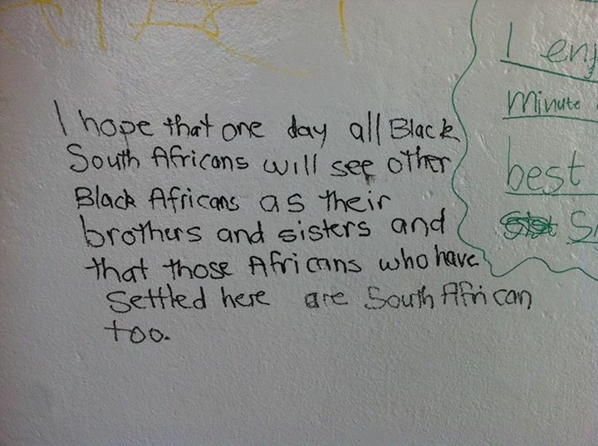

Text:

Messages of reflection were encouraged to be added to a wall in the College grounds during the 2015 Hearts into the Future Cycle Ride that held on Heritage Day prior to the One Heart Music Festival. Both the cycle ride and the music festival were events organised to bring awareness to and conscientise around issues surrounding xenophobia.

(Image and Audio: C Kamana)

Further text:



An 11-year-old pupil wrote of her fears and hopes during the outbursts of xenophobic violence in South Africa in April 2015. The girl wrote an ‘Open Letter’ and asked her teacher at Sacred Heart College to help her spread her message; the letter subsequently went viral after it was posted by Colin Northmore on social media and sent in communications to the Sacred Heart College community encouraging awareness of and activating against xenophobic discriminations. SABC featured the letter in their news-coverage at the time, heightening the exposure her message needed to be effective and the letter was also reproduced for an exhibition and in the school yearbook. The pupil, who used a pseudonym while writing, also read the letter at a youth rally held in June of that year at Constitution Hill. Here you can hear her read her own words.

Sacred Heart College, in the thirty years after the shift towards transformation that was activated in 1976, evolved driven by Marist principles to evidence a diverse sanctuary-like school and microcosm of the positive possibilities of South African society. This is demonstrated through this letter written by one of its learners.

**Card 6:**

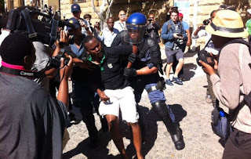

Text: Sacred Heart College alumni Rekgofatse Chikane being arrested during the protests to support #FeesMustFall in the Cape Town parliamentary precinct in 2015.

(Image: James-Brent Styan)

Further text:

The Co-Educational and Open policies of the school post 1980 afforded a multicultural, dynamic and balanced culture to the College which is often remarked on by those meeting alumni in the fields of further education and business. A confidence instilled in the individual through allowing no single grouping to dominate amongst the pupils – no sporting, academic or cultural merits are ranked more important than others, along side the cultivation of essential respect for the values of equality and freedoms, encouragement of critical thinking skills produces well balanced, respectful but equally opinionated and strong willed alumni.

That many of the leaders in the 2015 and 2016 protests around access to education and its fee structures were alumni of Sacred Heart College came as no surprise. Pictured alumni Rekgofatse Chikane and Wits SRC Secretary General for 2016, Fasiha Hassan (matric 2011), are but two examples; many others, including some of the older students still attending the College also stepped forward to demonstrate their solidarity with the cause.

Rekgofatse Chikane, who in his final year at Sacred Heart was chairperson of the Learners Representative Council, is the son of Rev. Frank Chikane. Frank Chikane first associated with the school in 1971 when he came from Soweto to Observatory for extra Saturday lessons to boost his tuition before his matriculation exams that year. Later, in 1988 Frank Chikane, like Eric Molobi, was given refuge when he was being sought by the Security Police. He was harboured at the Holy Family Convent in Yeoville, by then a satellite premises for Sacred Heart. Though the property was raided and paper bombed, on the same night that Sacred Heart’s statue of Jesus was necklaced, Chikane was not at the property at the time. Later, however, Frank Chikane was subjected to a near-fatal poisoning which was surfaced during the Truth and Reconciliation Commission.

**Card 7:**

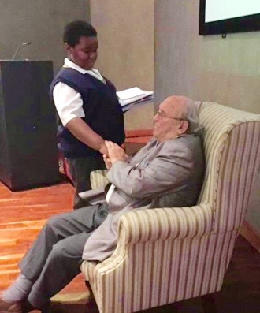

Text:

The great-grandson of Walter Sisulu (and Sacred Heart learner) meets Denis Goldberg at Liliesleaf during a school visit in 2016. Walter Sisulu and Denis Goldberg were two of ten liberationists arrested during a raid at Liliesleaf and subsequently imprisoned after the Rivonia Trial in 1964.

(Image: Bea Roberts)

Further text:

There are many interconnections between individuals involved in the struggles, some of which continue to this day, and the Sacred Heart Community that can be traced over many years. This picture offers an insight into just one of these stories.

Though the meeting of Denis Goldberg and Walter Sisulu’s grandson took place in 2016, the foundations of this particular narrative can be traced back through Sacred Heart to 1913.

In 1964 Joel Joffe was the attorney who took on defending the cases of Sisulu and Goldberg at the Rivonia Trial. Joffe was at ‘Obs’ and matriculated in 1948 with first class results. Bram Fischer, who was lead counsel of the defense team, chose to send his children to Sacred Heart College some years later. Nelson Mandela was also convicted at the Rivonia Trial, having been found not guilty in the earlier Treason Trial of the 1950s. The leader of the Treason Trial defense team was Israel Maisels, perhaps better known as Issy Maisels, as he was called by his peers and teachers, when he started at Koch Street in 1913. Liliesleaf Farm was used as a hideout for many of those connected to the ANC and other liberationist movements whose workings had been strengthened in the wake of the Treason Trial’s outcome.