**POI 36 – Houses**

Title: Houses

Blurb: The school houses and their namesakes

Images:

1. 36.14b (1)

2. 36.34(1), 36.35 (1), 36.36 (1), 36.37 (1)

3. 36.66

4. 36.32b

5. 36.42a

6. 36.16

**Card 1:**

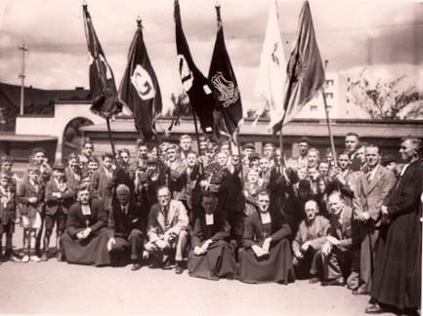

Text:

Presentation of School and House flags by Old Boys in 1939 at Koch Street.

Flags for the four school houses at Koch Street - Frederick (far left), Geddes (second left), Valerian (third left) and O’Leary (second from right), a flag for Marist Brothers College (third from right), and a flag with an obscured symbol, possibly the Sacred Heart (far right).

(Image: *Rand Daily Mail*, Marist Archive)

Further text:

Though this image from 1939, is in black and white, one can just about make out the hues of the colours of the four school houses – the colours still used today. Each flag has a single letter which denotes the house; **F**rederick in green, **G**eddes in blue, **V**alerian in red and **O**’**L**eary in yellow. At Observatory, Frederick House was replaced by Benedict House.

The Marist Brothers flag consists of the letters A and M intertwined, the Marist monogram representing their motto *Ad Jesum per Mariam* (To Jesus through the way of Mary). AM as a Catholic monogram (usually standing for *Ave Maria* – praise/hail Mary) is not unique to the Marist Brothers but AM in this distinctive yellow and blue script is internationally associated with the Marist Congregation. Underneath the monogram is a scroll with the letters M.B.C. (Marist Brothers College), and underneath these further letters, most likely JHB.

The sixth flag is not absolutely identifiable in this picture. Perhaps it contains the Sacred Heart emblem. This was first flown above the Koch Street school in the French flag, hoisted by Br Frederick to demonstrate the neutrality of the hospital-cum-school during the second Anglo-Boer war in 1900. Another, more likely, possibility is that it contained the logo of the Old Boys Association (see POI 36, card 2) as these flags were presented by the Old Boys Association.

Second from right is W. Singleton, pupil at Koch Street and then teacher at Observatory and later first librarian when the purpose-built library was added to Sacred Heart College in 1961.

Learners at the school, from pre-primary to matric, are divided amongst the four school houses; with siblings allocated to the same houses. The house system is most visible during sports events; particularly at the annual swimming galas and athletics meets. At these, and at other house associated events, the learners wear their assigned house coloured t-shirts.

**Card 2:**

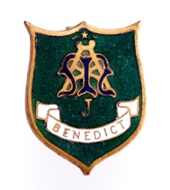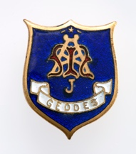

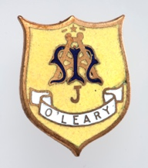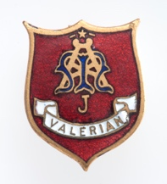

Text:

Badges worn in lapels by learners between to denote house allocation, phased out during the early 1940s.

(Images: Museum Africa)

Further text:

These enamel and metal badges (measuring approx. 1.5 x 2 cm) were worn in the left hand lapel. Pictures can be found in the Maristonian of learners wearing these badges between the years of approx. 1928-1942. It is likely that post World War Two, when finances were tight, that these were phased out for this reason. This collection of badges was donated to Museum Africa in 1951.

The Marist AM monogram is centred in the badge, with the house name written in the scroll below the monogram. The colour background is the colour associated with the house. Above the monogram is a single star; likely alluding to guiding star that Mary is for the Marists, as the star was for the Magi according to Biblical texts and similarly referring to the House of David’s crest (a single star) to which Jesus’ ancestry is ascribed.

The “J” below the monogram is either representative of **J**ohannesburg, or **J**unior Marist (categorised as pupils in standards 1 to 5, equivalent of grades 2-6 today). It is most likely Johannesburg as, prior to 1933 (when the Brother’s Council’s resolution allowed for non-standardisation of Marist blazers amongst the South African schools), Marist uniforms between schools were distinguished by a metal badge, similar to the above, with a slight change in lettering to denote the school. For example, MBR for Marist Brothers Rondebosch and MBD for Marist Brothers Durban.

**Card 3:**

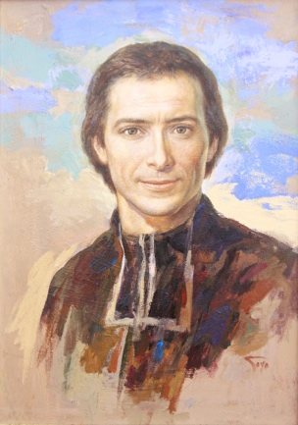

Title:

Portrait of St Marcellin Benedict Champagnat by Gregorio (Goyo) Dominguez, 1999

(Image: <http://champagnat.fms.it/img/alta/Goyo1999.jpg> )

Further text:

Benedict House is named for the Founder of the Marist Congregation, Marcellin Joseph Benedict Champagnat. It seems odd that the house should not instead have been named Marcellin. The explanation may lie in the fact that shortly before the school opened, the chapel was dedi­cated by Bishop O'Leary to St. Benedict; documents in the Marist Archive suggest that the school originally opened as St. Benedict's (to differentiate from Sacred Heart College at Koch Street) and that the name was later changed to Sacred Heart Col­lege, though Marist Brothers Observatory (or ‘Obs’) was used colloquially until the 1980s. Benedict House is the only house which didn’t exist at Koch Street – replacing Frederick House (Br Frederick was the first Principal).

Marcellin Champagnat was born in France in 1789 during a time of economic, spiritual and cultural unrest (the time of the French revolution and its socio-politically de-structured aftermath). Having pledged fidelity to the way of Mary as a spiritual and practical path with his co-ordained in 1816 as part of the “Society of Mary”, in 1817 Champagnat established the “little brothers of Mary” or Marist Brothers, a group of teaching brothers whose primary concern was the spiritual and educational nurture of young people, particularly for those who are least favoured by life.

Goyo painted this portrait in acrylic on a wood panel measuring 70 x 50cm in 1999. Goyo was a Marist pupil in Spain from the age of 10 and a Brother in his twenties. Though he left the Institution he kept very close relations with his Marist family and in the late 1990s was asked to create a new portrait of Champagnat to be used for the Canonisation of St Marcellin. A large version of this portrait was displayed in St Peter’s Basilica, Rome when Champagnat was canonised in 1999. A print of this portrait can be found, amongst other places around the school, hanging in the main school reception hall.

**Card 4:**

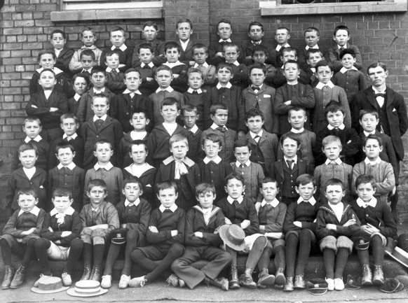

Text:

Mr Joe Geddes (far right) with learners at Koch Street in 1896.

(Image: Marist Archive)

Further text:

Mr Joe Geddes, after whom one of the houses is named, was one of the first pupils to start at Koch Street in 1889 having arrived with his father, who came to mine, in Johannesburg the year before. Geddes became a student teacher in the early 1890s, after just a few years at school, and stayed as a permanent teacher on completion of his training. According to material in the Marist Archive, Geddes lost his right hand in his youth but was reputed to have the best handwriting in the school. He was, according to the 75th Anniversary Maristonian (1964), a ‘landmark at the school’. His brother, Robert Geddes, also a Koch Street pupil, wrote in the 1926 Maristonian about Joe Geddes’ fervour for soccer, bowls and cricket and remembered how, at a young age, Joe narrowly escaped being attacked by a snake whilst on a trek. Robert Geddes wrote that his brother - a great character builder - should be remembered for embodying his life motto ‘everything worth doing, is worth doing well’. Joe Geddes died in 1923.

Though Joe Geddes was the first Sacred Heart alumni to become part of the teaching staff, he certainly wasn’t the last. Current alumni now staff include Ms King (primary) and Ms Niken (high school).

**Card 5:**

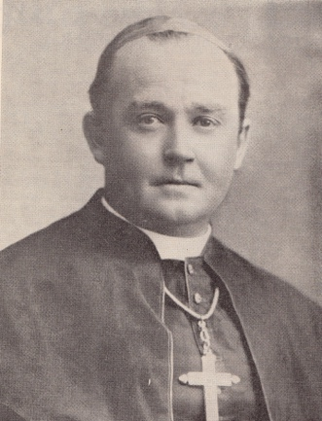

Text:

Rt. Rev David O’Leary O.M.I in 1925 at his consecration as Bishop

(Image: Marist Archive)

Further text:

O’Leary House is named after the Rt. Rev David O’Leary, Bishop (or Vicar Apostolic of the Transvaal Vicariate) of the then Transvaal at the time that the school was opened in Observatory; he blessed the college chapel and officiated at the opening ceremony for the new school. O.M.I denotes his membership of the The Missionary Oblates of Mary Immaculate, another Catholic congregation founded by Eugene de Mazenod in 1816, a contemporary of Marcellin Champagnat.

O’Leary was born in Kimberley in 1880 and attended the Marist Brothers’ College in Uitenhage. During the first world war, O’Leary served as military chaplain to the Allied Forces in East Africa. O’Leary was an active ‘Old Boy’ for the Marists – he played cricket for their teams and also is reported to have enjoyed soccer. O’Leary was the first South African to form part of the Episcopacy (the Church government) and was honoured by the Vatican with the positions of Papal Count and Assistant to the Pontifical Throne.

In the 1958 Maristonian, published in the year of his death, notes that “St. David’s College, Inanda, which has been named after him and O’Leary House at Observatory will help to keep ever green the memory of a great friend and counsellor.”

**Card 6:**

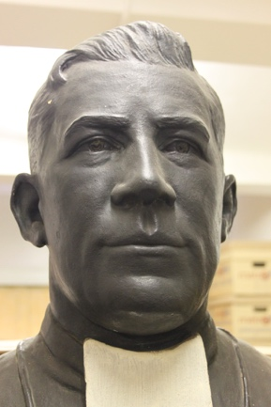

Text:

Bust of Brother Valerian presented by the Old Boys in 1916 at Koch Street (Marist Archive).

(Image: C Kamana)

Further Text:

Brother Valerian (1865-1914) arrived in South Africa in 1889 from Ireland and went first to the Marist’s school at Uitenhage in 1890 and then to Koch Street in the same year. In the 75th Anniversary issue of the Maristonian, Br Jordan wrote that “the energy of Brother Valerian underlies every phase of the early history of the school’. Br Valerian taught the senior Matric class with his “splendid mind” (something that was commemorated in the Valerian Prize, awarded for academic excellence to one Junior Matric at Koch Street – the equivalent of grade 10 today).

Br Valerian, wrote Br Jordan, was remembered for not being able to “disassociate purely scholastic work from physical training” and thus was associated with academic teaching as well as gym, athletics and the cadets. Br Valerian is also remembered by former pupils for his emphasis on cultural education taking his class to hear the first phonograph in Johannesburg, at the time a huge novelty and exhibited in the glass roofed Old Arcade, and he was responsible for producing the first school magazine in 1908.

Br Valerian was held in high esteem by staff, parents and pupils. In 1894, since only three pupils in the then Transvaal were sitting matric, Br Valerian supervised the boys transit and examinations in Bloemfontein. An illuminated manuscript of thanks to Br Valerian from the parents of these three boys can be found in the Marist archive. Morris Alexander, one of the first pupils in 1889, and writing in the 1941 Maristonian, credits Br Valerian for his valuable assistance in getting him through his matric in 1900. In this year the exam papers were brought by military escort from Cape Town. The bust from which the image is taken was presented by Old Boys in October 1916 as a token of gratitude, was dedicated to the memory of Br Valerian.