POI 37 – Library / Media Centre

Title: Library / Media Centre

Brief blurb: This was formerly the boarders’ dining room

Notes:

Letebele Music Centre: link to POI 20 card 5

Eric Molobi: link to POI 32 card 2

Images:

1. 37.17

2. 37.18

3. 37.11

4. 22.17a

5. 37.22

6. 37.13.

**Card 1:**

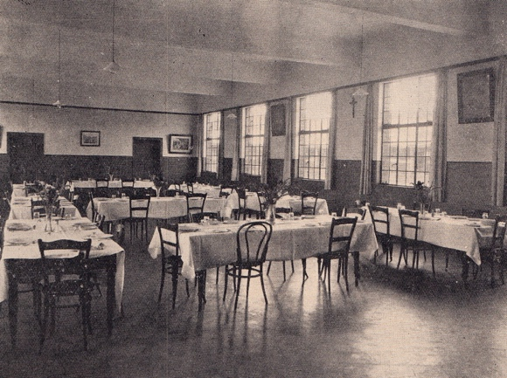

Text:

1928, The Boarders’ Refectory

(Images: Marist Archive)

Further text:

The room which learners and staff know as the Pulse Media Centre, situated in the Marcia Hyam Library, started off as the Boarders’ Refectory (dining room) when the College opened in 1926. One of the first Chefs at the college was Ephraim Letebele who started at the school in 1934 and stayed until his retirement in 1974, coinciding with the end of the boarders’ time at the College. His kitchen was situated behind the high school tuck-shop. Ephraim Letebele’s legacy at the school carries on today – his grandchildren and great-grandchildren have passed through the school as learners and his son, Joseph Letebele, who started as College Handyman in 1961 is an indispensable part of the Maintenance Staff. The Letebele Music Centre which was opened in 2002 was named for this family’s association with and contribution to Sacred Heart College.

**Card 2:**

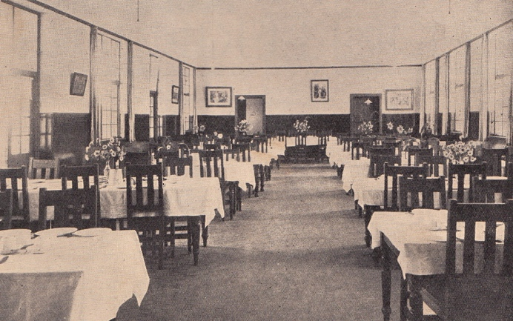

Text:

The Boarders’ Refectory in the 1930s

(Image: Marist Archive)

Further text:

The food served in the Refectory was adjusted seasonally; a menu for summer and a menu for winter. Year round, as in most Christian (especially Catholic) institutions, fish was served on Fridays. During the war years of the 1930s-1940s when provisions were in shorter supply and budget was restricted the main staple was corned beef. The Chef created a variety of ways in which to serve it; curried, fried, minced with rice, cold with salad at lunch or hashed with potatoes. Eggs and porridge were served at breakfast.

The boarders were known for their fondness of adding a variety of condiments like piccalilli, tomato sauce, vinegar and Worcestershire sauce to their meals and for which there was a separate table that the boys could laden with their personal supplies. Though several of the Brothers, or Crows as they were known by the boys, were on duty in the Refectory at meal times, the rest ate in their own separate dining room (now this room is used as Habits, the Coffee Shop) – the interconnecting door between the two dining rooms is still functional. It isn’t clear whether the Brothers had their own menus or shared that of the boys.

In the archives menus from celebratory dinners exist – for example the Golden Jubilee Dinner of The Marist Old Boys’ Association held in 1951 consisted of ‘Spaghetti mince soufflé’ followed by ‘Fruit in jelly with custard’ and likely was a similar meal to that which was served while they were actual pupils at the school.

**Card 3:**

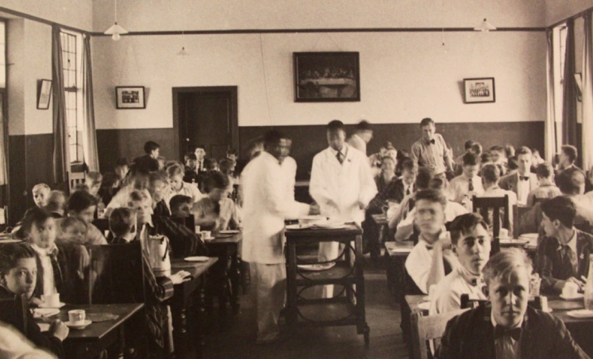

Text:

The Boarders’ Refectory in the 1950s

(Image: Marist Archive)

Further text:

The dining room would have sat up to 80-100 boys. Each table seated 8 and was arranged with a Table Captain and Vice-Captain who were appointed from the senior boys to be in charge of behaviour and the serving out of food. Some recalled this system to have been less than democratic and the portions received reflective of this. Not unimaginable was the hierarchical system that it created and the likely disproportionate rationing of food between boys of different ages. E. Joffe’s memoires “*Before Mandela’s Rainbow*”, from where this information about the dining room system was taken, also reflected on the boarders’ delight at supplementing their meals from the dining room with offerings from the day boys’ packed lunches and with trips to the shops in Yeoville. Of course this latter possibility was only a privilege available to the older boys who were able to leave the school grounds for such excursions.

**Card 4:**

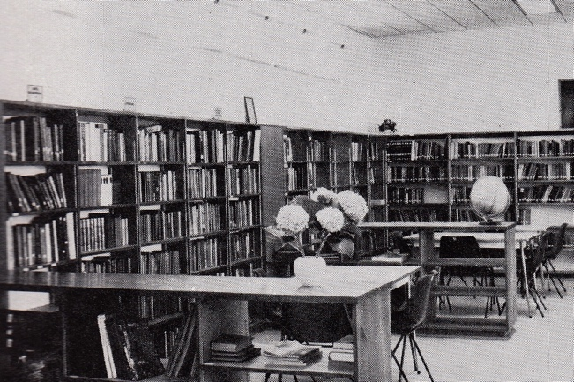

Text:

The interior of the first purpose built College Library in 1969. Seating for 60 readers was provided and this year saw the introduction of Library as a timetabled lesson.

(Image: Marist Archive)

Further text:

When the College first opened there was no stand-alone library. There was a small bookshelf available for the Boarders only which was found in the New Wing (added in 1931). In 1937 the City Council presented the school with an Oak bookcase (which can still be found today in the library) to celebrate the Coronation of King George VI and Queen Elizabeth I. Day boys were not permitted to access these as well because of the lack of books and during the 1940s and 50s appeals were made by the P.T.A. (now P.A. and prior to 1960s The Ladies’ Association) for donations to grow the library which was managed by the Brothers.

By the 1960s, after the success of these appeals, all boys were allowed to use the lending library. In 1969 the amount of books necessitated an upgraded to the space and the school library was built (between the chapel and the Junior Primary Quad). When the Senior Primary (or Intermediate Quad) was added at the end of 1980s and the library was converted into classrooms for the junior pupils once the school roll had again increased, the Refectory (now defunct after there were no more boarders at the school) was turned into the Senior Library. The Primary School used, as still today, the purpose built library in the Intermediate Quad basement.

**Card 5:**

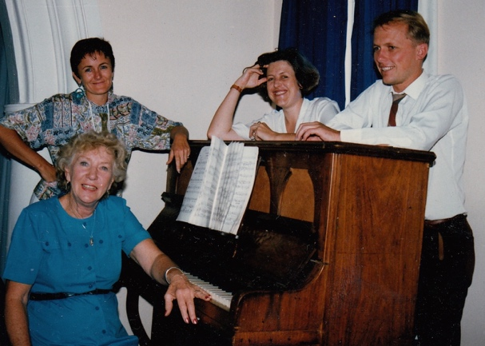

Text: Dr Marcia Hyam, seated at the Piano in the Old Chapel Theatre in c.1990.

(Image: Sacred Heart College Archive)

Further Text:

Dr Marcia Hyam, neé Warmback, after whom the College Library is named, and her two brothers, André and Patrick, had a long and deep connection with the school. André and Patrick attended Yeoville Convent until Standard 3 when they moved to Sacred Heart at Observatory. André, a school Cadet member joined the forces fighting in the North African desert in the Second World War. Later, he became part of South African Air Force but after a raid on Italy in 1945 went missing whilst flying a Lancaster Bomber, presumed killed.   
  
In 1938, aged 14 and in Standard 9, Marcia had a part in the Sacred Heart College production of Abraham Lincoln by John Drinkwater, along with two other girls from Yeoville Convent. The Headmistress of Yeoville Convent at the time insisted that the girls were chaperoned to and from rehearsals at the College and asked for the help of a few boys to do so. Records show that 66 boys volunteered their services!

Dr Marcia Hyam returned to her alma mater to teach for 27 years and from 1980 she taught at Sacred Heart College. She taught maths, heading up the Department for ten years until her retirement and emigration to Australia in 1992. Dr Hyam also played the piano and organ at school events and composed the music and lyrics for the school song.

The 1992 Sacred Heart College yearbook recalls her incredible drive, her wrangles with College management and dedication to her students as well as her often used catchphrases, including:

"Now is the time, not tomorrow."

"Don't sit and wait for better days. They won't come. You must make them NOW!"

"Mommy and Nanny didn't pack your calculator today."

"Just because you are in maths, doesn't mean you only have to learn mathematics."

"Now go home to-day (with your hands on your eyes) and THINK for five minutes."

"I can conquer the problems that conquered you in the test".

**Card 6:**

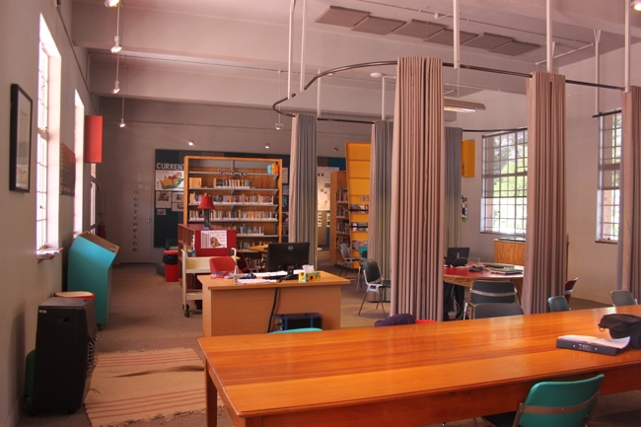

Text:

The Pulse Media Centre, situated in the Marcia Hyam Library.

(Image: C Kamana)

Further text:

In 2012 the Marcia Hyam Library was redesigned for 21st Century leaners at the College. The designs which include an AV room, a think tank that can be secluded with curtains, access to digital reference books and a reading zone were put together by André Croucamp founder of Critical Thinking education provider MindBurst; writer, researcher, editor and College parent Bea Roberts, and architect Nabeel Essa. The centre was named Pulse in collaboration with Croucamp and Roberts after a workshop with learners at the school and reflects its essence, heart, connectedness and sensitivity to world rhythms and dynamics.

As is reflective of the innovative and progressive teaching and learning at Sacred Heart, the librarians are learners who support the teachers rather than the other way around, and echoes Eric Molobi and the Robben Island Prisoners motto “Each One Teach One”. The funding for the new centre was provided by Zwelakhe Sisulu (who died three weeks before the centre opened) and the Friends of Eric Molobi, reflecting the mutual association of these struggle activists and the College connected in their personal narratives but also through their dedication to freedom of information, access to education and the fight for social justice. The Sisulu and Molobi families both have long and involved relations with the school, from the 1960s, which continue to this day.