**POI 38 – Foyer**

Title: Main Reception Foyer

Blurb: The hallway – a passage through time…

Notes: Ave Maria – card 2 – link to POI 36 (card 1)

Joseph Letebele – card 3 (link to workshop POI 11; not sure which card yet)

Images:

1. 38.04

2. 38.10 / 38.22

3. 38.15b

4. 38.23

5. 38.29

6 38.16b

**Card 1:**

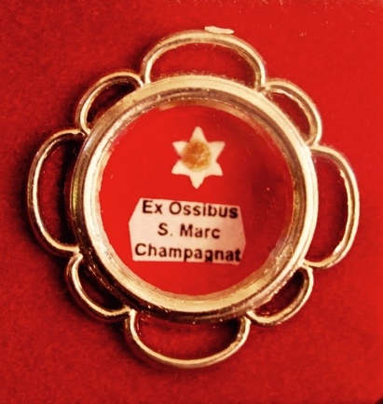

Text: Relic of Marcellin Champagnat presented to the College to mark his canonisation in 1999.

(Image: C Kamana)

Further text:

The Champagnat Cabinet in the foyer contains a number of items such as silver and bronze representations of Champagnat and of his role model, Mary the mother of Jesus. These items relating to the memory of Marcellin Champagnat, the founder of the Marist Brothers in turn remind visitors to the school of the significance and heritage of the school’s patron Saint and founder.

In 1999 all Marist schools received a similar cabinet, each with their own relic. The one at Sacred Heart is believed to be from Champagnat’s finger. The relic is authenticated by a Latin certificate. The wording can be translated as follows:

*Brother Gabriel Andreucci, Postulator General of the Marist Brothers of the Schools:*

*We entrust our faith in all those individuals about to inspect these papers and bear witness that we, by virtue of our office, have extracted a particle from the bones of St Marcellin Champagnat from authentic sources and have placed this particle in a round-shaped metal case, protected by unique crystal, bound with a red silk string and signed by our seal in red Spanish wax.*

*We grant into their care these papers signed by our hand and protected by our dry seal.*

**Card 2:**

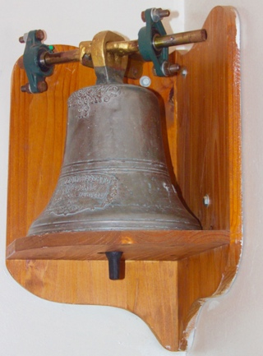 or 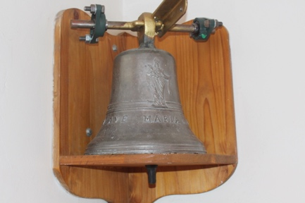 or both?

Text: The Marist Bell

(Image on left: C Kamana; Image on right: Sacred Heart College Archive)

Further text:

This bell came from the third General House (headquarters) of the Marist Brothers. The first General House (or Generalate) was in France at the Brother’s residence L’Hermitage just outside St-Chamond, established in 1825. Later it was moved to Lyon. When all religious institutes were expelled from France in 1903, the Brothers established their third General House in Grugliasco, northern Italy. In 1958, the Generalate was moved to Rome. Br Jordan, the Principal of the College in the late fifties and during the building of the Memorial Chapel, requested that the bell at Grugliasco which had called the Brothers to prayer and meals for over fifty years, be given to the College for its new chapel. Thus this bell came to Sacred Heart College in the late 1950s. You can still see where the bell hung in the passage way between the chapel and the Macartin centre; note the iron fixtures high up on the wall in the nook. In recent years, it was taken down and hung in its current position in the reception foyer.

The bell is made of cast iron and was made by the Mazzola Foundry in Valduggia, near Grugliasco. This foundry was run by the Mazzola family since 1475 but closed in 2004. One side of the bell is embossed with ‘Ave Maria‘ and an image of Mary with the other side featuring the Mazzola logo.

**Card 3:**

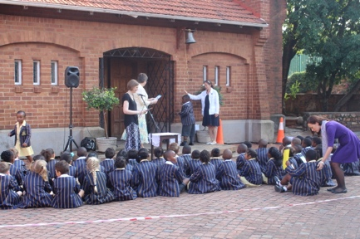

Text: Grade 1s Bell Ringing Ceremony in 2016

(Image: Sacred Heart College Archive)

Further text:

Sacred Heart College started a new tradition in 2015. At the beginning of each school year, the bell is moved to the front of the Chapel where the Grade 1s of that year ring the bell to mark the start of their school career. The Matrics of that year ring the bell at their Valedictory Mass to mark the end of their time at Sacred Heart.

The rope and metal rod used to ring the bell was crafted by Joseph Letebele, as well as the brackets used to fix the bell in the foyer, and these kept in the workshop until needed each year. One of the reasons it was taken down, apart from it being stuck at the back of the chapel and out of view since the Macartin centre was built, was because it was just too tempting for those walking past not to ring it!

**Card 4:**

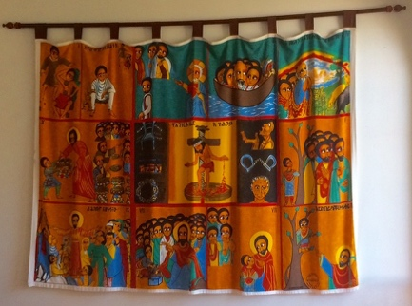

Text: Ethiopian Hunger Cloth (Alemayehu Bizuneleh, 1978)

(Image: C Kamana)

Further text:

This printed fabric wall hanging was given to the college by Fr Dryden the college Chaplain.

Hunger cloths, which are produced all over the Christian world, were used first in the middle ages as a visual representation of Biblical stories to enable an understanding of God before reading was a skill available to all social classes and generations. In many developing countries with a Christian influence hunger cloths are still created and used for the same purposes as well as to serve as a reminder of how God relieves the struggles of those in need.

In the middle ages these cloths were used to cover altars during lent (a period of fasting before the feast of Easter) and so referred to as Hunger Cloths. The one that hangs in the foyer at Sacred Heart is a copy of one that was created by Ethiopian artist Alemayehu Bizuneleh in 1978 and depicts a series of stories from both the Old and New Testaments, the text is in Amharic, the official language of Ethiopia.

**Card 5:**

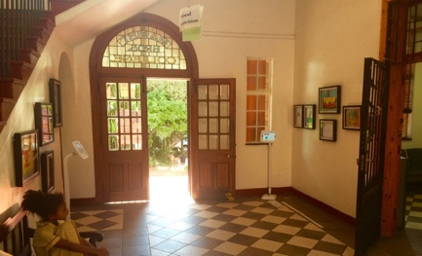

Text: The foyer set up for All & Every, an exhibition of art work by children Three2Six in 2015

(Image: C Kamana)

Further text:

A number of temporary exhibitions, usually of art work by Sacred Heart College pupils but sometimes other informative displays such as updates on alumni news or materials relating to the critical thinking learning programme. Visible is one such item ‘good nutrition’ which was one of many information points set up around the school.

At the top of the door, Marist Bros. College is set into the glass panel, in the school colours of blue and gold. Though the official name of the school was always Sacred Heart College, and opened as the senior school to the Koch Street Sacred Heart College (the preparatory or primary section) the name that the school was known locally until 1980 was either, Marist Brother’s College, Marist ‘Obs’ (short for Observatory) or simply ‘Obs’.

**Card 6:**

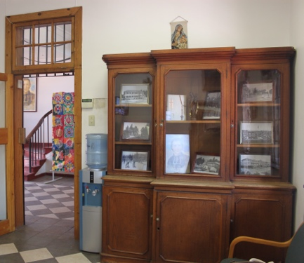

Text:

The school office display cabinet and view to foyer.

(Image: C Kamana)

Further text:

The display cabinet contains a selection of photographs that relate to the heritage of Sacred Heart College.

Through the door and into the foyer area another art display, this time from the Grade 6 World Religions through Art exhibition of work created in 2016.