POI 3 – Observatory

Title: Observatory

Brief blurb: From Marist ‘Obs’ to Sacred Heart College of today

Notes:

Brother Martin: link to POI 12 or POI 31 (not sure yet which)

St Benedict’s : link to POI 36 (card 3)

Marist Educational principles : link to POI 15 (not sure which card yet)

Three2Six: Link to POI 33 (not sure which card yet)

Images:

1. 03.91 & 03.100b & 03.168

2. 02.138

3. 03.24b

4. 03.116

5. 03.26h

6. 03.166 & 34.20

7. 03.99

**Card 1:**

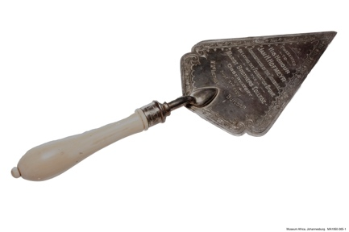

Text:

The ivory handled and silver bladed Ceremonial Trowel used by The Honourable Mr J. Hofmeyer, Administrator of the Transvaal, during the laying of The Foundation Stone on 03.09.1924.

(Image: Museum Africa)

Further text:

After 1913 there were no more additions to the school buildings Koch Street, despite the continuing growing number of boys on the roll and waiting lists for places. With the spread of Johannesburg, a town not much older than Sacred Heart College itself, space was at a premium and no more existed at Koch Street or in its direct surrounds. Sporting events (and overspill at break-time for even the playground space was inadequate) were held at the (Old) Wanderers Grounds, a few blocks walk away and across the railway tracks. The Brothers decided then that another premises was necessary if they were to continue to expand their teaching provisions alongside the growing city (though Johannesburg was only officially designated as a city in 1928). The First World War (1914-18) delayed focus on the search for another property but in 1919 32 acres of land on Observatory ridge, then outside Johannesburg, were purchased by the Brothers.

In 1924 The Foundation Stone was laid by The Honourable Mr J. Hofmeyer (Administrator of the Transvaal) and blessed by the Right Revd. Bishop Cox. Building works at the Observatory site took a little over a year to complete; not only did the school need to be built from scratch but the ground needed to be levelled and outcrops of granite and iron containing rocks needed to be blasted to lay the sports grounds that were sorely missed at Koch Street. The architect, Mr P.J. Hill was a former Marist pupil, having been taught by the Brothers at Uitenhage. Much of the blasting was completed by Brother Henry who took out a special licence in order to do so and the grounds were landscaped under the direction of Brother Florian who was to become the first Principal of the College.

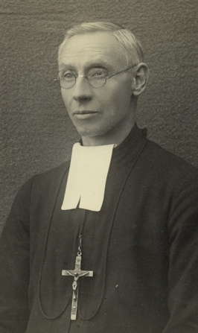 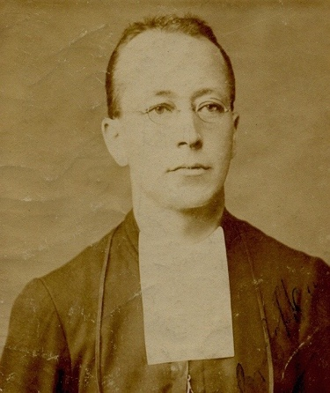

Brother Florian Arnal Brother Henry Julian Francois

(Image: Marist Archive) (Image: Marist Archive)

**Card 2:**

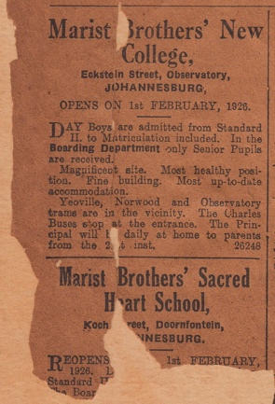

Text:

1926 Newspaper Advertisement for “Marist Brothers’ New College”

(Image: Marist Archive)

Further text:

The new school opened on 1st February 1926 in Observatory to approximately 250 pupils - the senior classes, from Standard II (Grade 4 today) to Matric, from Koch Street were moved to the new premises. At first this was met with some resentment for it was felt by many that the new site was too far out of town to be easily accessed. Sacred Heart College at Koch Street then became the preparatory school to Observatory. Brother Martin however suggested that an early idea was that the Observatory school would be set up as the preparatory school, with Koch Street as the senior school; this we know didn’t happen and perhaps was due to the superior sporting facilities at Observatory being preferred for the older boys. The early 1900s saw several other boys’ schools open Johannesburg College (later renamed as King Edward VII School (K.E.S) St. John’s and Jeppe High School for Boys and it was likely that in order to compete with these schools on a sporting level the decision was reversed.

At the time of opening there were 12 teaching Brothers assisted by several specialist lay-teachers including alumni Mr. W. Singleton who had up until then taught at Koch Street. Sources record that “the boys were full of admiration for the well – ventilated classrooms, the hall, the tennis-courts and the wide open spaces.”

Interestingly the school name is not given in this advertisement – other than Marist Brothers’ New College. The original name for the school, as suggested in archival material, was St Benedict’s (to differentiate from Sacred Heart College at Koch Street). Though this name was later changed to Sacred Heart Col­lege and is recorded as such in documents from the 1930s, the names Marist Brothers College or Marist ‘Obs’ (as a shortened form of Observatory) was used colloquially until the 1980s.

**Card 3:**

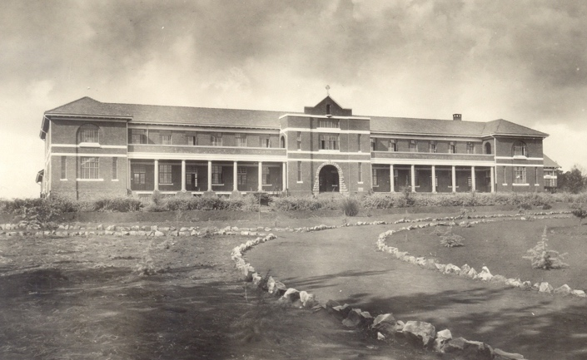

Text:

The school pictured in 1927. In the archives this picture is labeled as “Obs in the veld”.

(Image: Marist Archive)

Further text:

The first few years at Obs were years of expansion – in terms of both buildings and pupil numbers. In this image you can just make out the Hall building to the right of the main building. One of the first ‘extras’ was the swimming pool added in 1930. The school opened as a school for boys – white boys – with some Chinese pupils being admitted in the 1930s. Obs, like Sacred Heart at Koch Street, also offered boarding facilities. The number of pupils grew so quickly that a new wing was added in 1931 which added several classrooms, Chaplain’s quarters, a library, a sanatorium and a second dormitory. This is the building that today houses the Marist Provincial Offices and a number of classrooms, situated parallel to the Hall.

**Card 4:**

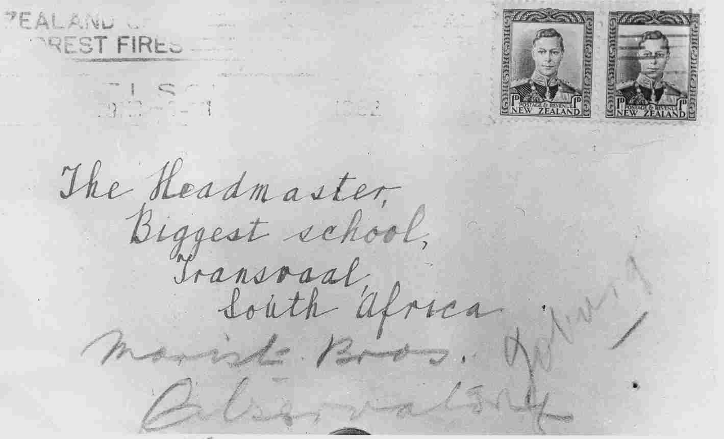

Text:

1932 – a letter sent from New Zealand was delivered to ‘Obs’ addressed only to ‘Biggest School, Transvaal, South Africa’!

(Image: Marist Archive)

Further text:

The additional text which reads ‘Marist Bros. Observatory, Joburg’ was added by the Post Office who had identified Obs as the ‘biggest school’ in the Transvaal – by 1932 Johannesburg was already by far the largest city in South Africa. That Obs was recognised as the ‘Biggest School’ in the city speaks volumes about its then reputation. This reputation initially extended from that of its mother school in Koch Street but in very little time Obs was to become the Marist ‘monument’ that it remains today.

By the mid 1930s the school numbers were close to 400 and a new classroom block was added (now part of the junior primary quad) and further sporting facilities added. The school was full to capacity and Koch Street was by now again oversubscribed, particularly for both schools in the boarding departments. By the early 1940s Obs had over 600 pupils and more primary aged pupils were admitted to the school (meaning that Koch Street was not the only preparatory school, though it continued to take the very youngest Marist pupils). The Marist Brothers sought to acquire another site and in 1941 St. David’s Inanda was opened.

**Card 5:**

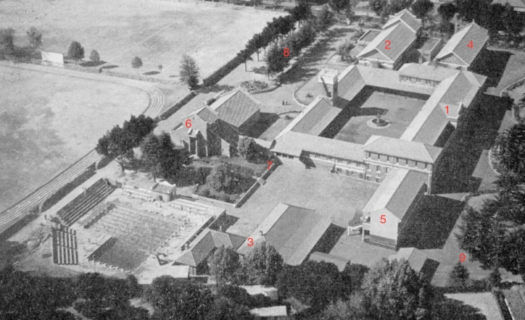

Text:

Photograph taken by Brother Rudolf in 1961 showing additions to the school by this time. Mr. Armstrong, parent of a Sacred Heart pupil, made his plane available to Brother Rudolf specially to take this aerial view of the school. Brother Rudolf, who taught science, also ran the school photography club.

(Image: Marist Archive)

Further text:

1 - The original main building built 1924-26 was constructed around the fountain quad.

2 - The hall was completed for 1926 and renovated in 1951.

3 - In 1926 a block was built for lay staff accommodation and included a separated structure that was the pupils’ toilets and washing facilities.

4 - The 1931 addition containing a new dormitory, sanatorium, classes and library.

5 - The ‘new block’ built in 1935.

6 - The Memorial Chapel was built in 1956 - note the open bell tower fixture visible on north side and the established gardens that served the Chapel.

7 - This area of Chapel gardens was built onto with a new library and primary quad extensions in 1969.

8 - This tree lined area formerly known as ‘The Glade’ was built on to add the new Science block in 1973.

9 – The Senior Primary Quad (know also known as the Intermediate Quad) was added in 1987.

**Card 6:**

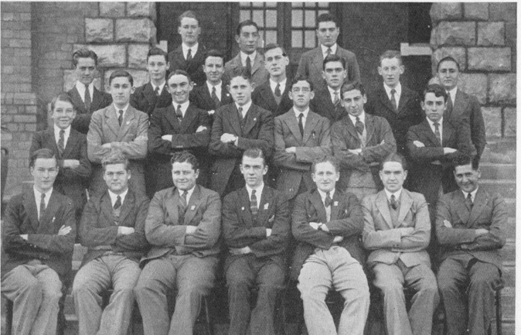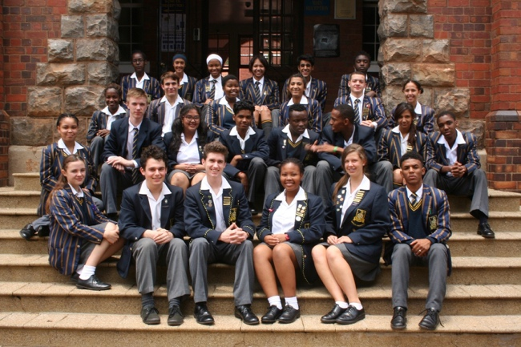

Text:

The changing face of Sacred Heart College. Matrics of 1930 (left) and Matrics of 2016 (right)

(Images: Marist Archive (left) and Sacred Heart College (right))

Further text:

Though the expansions of the school buildings speak about the physical changes of the school terms of pupil numbers and improvements to facilities, the transformations of the Sacred Heart community should rather be understood in terms of its socio-cultural developments. Just as the school at Koch Street, whilst a Catholic school, admitted pupils of different religious backgrounds its daughter school, Sacred Heart College Observatory, did the same. In the 1930s and 40s the Jewish learners were supported by weekly instruction from a visiting Rabbi. Catholic pupils were encouraged by lessons in Catechism and offered opportunities to belong to religious sodalities (societies focused on faith, in particular as in keeping with the Marist ethos, in the way of Mary). The South African Catholic Bishops Conference (SACBC), to whom the Marists belonged (and in the 1930s had hosted at Observatory) had been publically denouncing discriminatory policies. In 1975 the SACBC declared their position around Open Schooling (racially integrated) and not long after the Soweto uprising brought to the fore this issue at home and internationally.

In 1976 no school magazine was produced. By no means was this was to erase the significance of this year but rather highlights the year as a new starting point in the history of the school. The years between 1976-1980 saw the school become Open and Co-Educational.

Former Principal, Steven Lowry, wrote in 2002:

“From 1976 the school was led by Brother Neil McGurk who had an inspired vision of what education could be in the South Africa of 25 years ago. The Marist Brothers’ understanding of their mission led them to defy government decree and open the school to boys of all races. However the newcomers did not present a real challenge to the school… The real cultural revolution probably took place four years later when in 1980 girls were first admitted to the school when it amalgamated with two near-by convents. “Marist Brothers’ – Observatory” reverted to its religious name, Sacred Heart College”.”

**Card 7:**

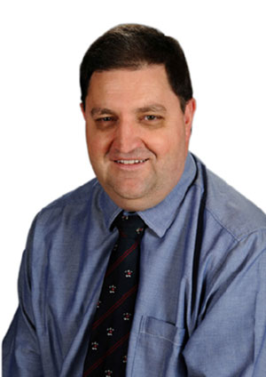

Text:

Colin Northmore, current Principal of Sacred Heart College (since 2003)

(Image: Sacred Heart College)

Further text:

Today, in 2017, Sacred Heart College serves approx. 1,200 learners from pre-primary to grade 12. In addition, there are about 200 children who attend the Three2Six school that use the college facilities daily. The school provides a nurturing and dynamic learning environment still very much adhering to Marist educational principles as well as providing a more representative and diverse sanctuary as a microcosm of the positive possibilities of South African society. The school is conscious of its heritage and whilst proud and protective of its positive contributions also manages to push forward with innovations that sometimes leave these behind for the better (as evidenced by its ‘changing face’).

Colin Northmore prefaced the 2010 yearbook with this summary of the unique character of the college:

“It may seem to be an obvious truth to say that the future of our country is dependent on our education system. Just as obvious…in this context, it is not difficult to clearly discern the role of an independent school such as ours. Sacred Heart has always had a reputation for making bold decisions in curriculum innovation and when it comes to addressing the social evils of our time. Right back to the time when the Brothers turned the school into a hospital for the Boers and the Brits during the South African War, and created a situation where sworn enemies lay side by side recovering from the wounds they inflicted upon one another, our school been a beacon of hope.”