POI 4 – Boarding

Title: The Boarders

Brief blurb: Boarding was offered until the mid 1970s

Notes:

????:

Images:

1. 04.05b

2. 04.04

3. 04.03b

4. 04.06

5. 03.52b&03.53b

6. 03.51b & 03.49b

**Card 1:**

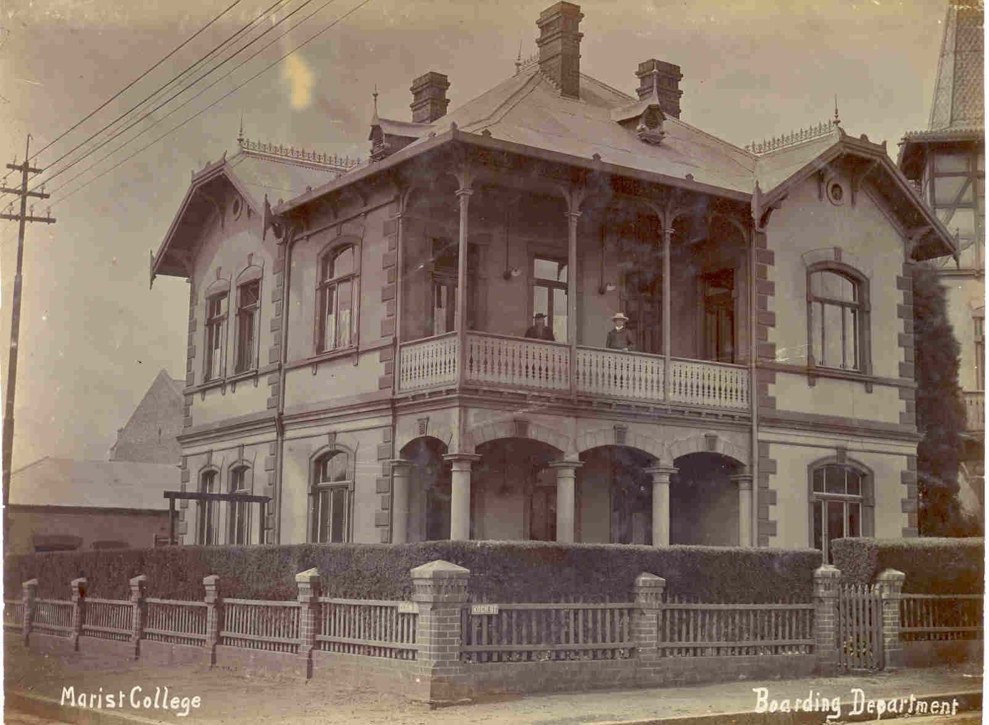

Text:

The Boarding House for Sacred Heart College, 1908.

(Images: Marist Archive)

Further text:

The building was located opposite the school on the other side of the street on the Koch Street/Claim Street corner. In the 1960s when the school closed the boarding house was converted to be used as a nursing home. The man on the balcony (with the beard standing on the left) is Brother Joseph.

**Card 2:**

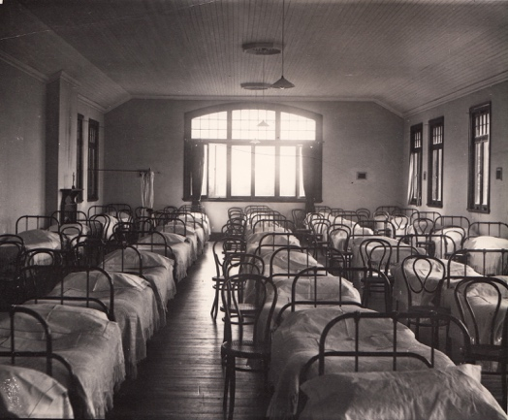

Text:

Inside the dormitory at Koch Street (picture undated).

(Image: Marist Archive)

Further text:

There are at least 33 beds visible in this picture – more are perhaps out of shot of the camera. Note that the bed in the top left corner of the photograph has a rail and curtain suspended around it; likely to have belonged to the most senior boy or ‘dormitory captain’ and his privilege of privacy a reward for holding this position. Apart from a crucifix on the mantelpiece and a small picture in the curtained section there is no decoration in the room.

**Card 3:**

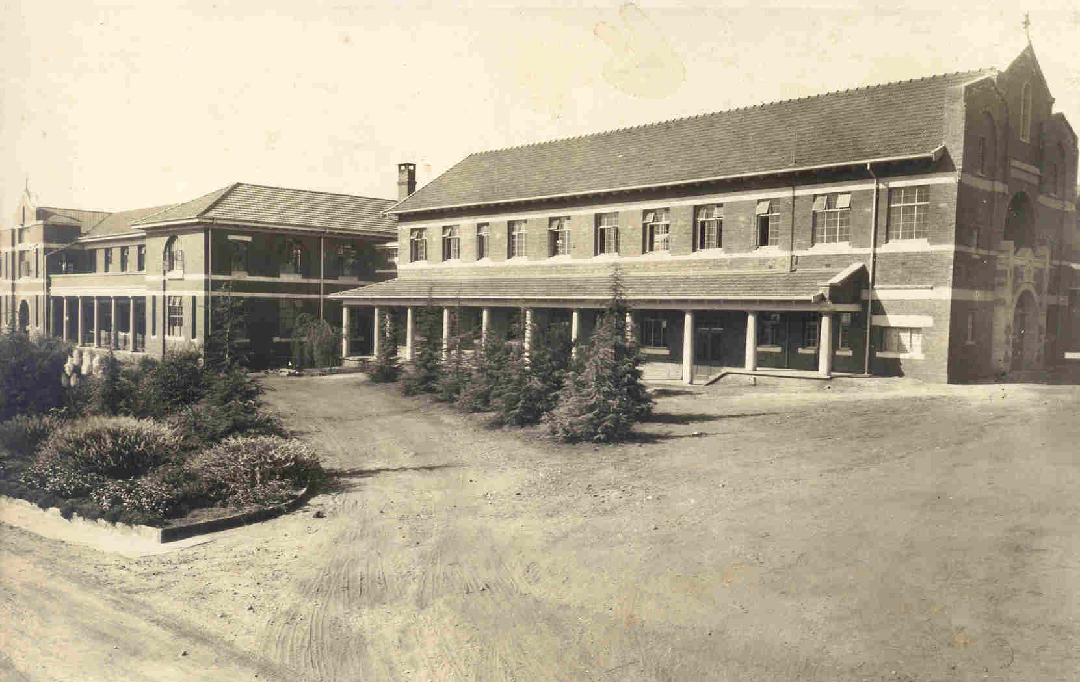

Text:

The ‘new wing’ extension to the college, built in 1931. The upstairs of this wing contained a dormitory added to sleep an additional 50 boarders which doubled boarding capacity at the time.

(Image: Marist Archive)

Further text:

Boarders were admitted to Sacred Heart, Observatory from its opening in 1926 until 1973. Until the second dormitory was added the boarders weren’t all accommodated in the main school, such was the demand for boarding places – some were lodged in houses in the Observatory neighbourhood and others were put up in spare rooms around the College. However, this wasn’t satisfactory so the new wing was added. This new wing contained a further dormitory, a library, Chaplain’s rooms and a Sanatorium. The 1937 Maristonian reads “ample accommodation is provided in the handsome and extensive buildings, which, recently erected, have been designed to ensure the comfort and health of the pupils”. The new dormitory was designed to sleep about 60 boarders but later accounts record that each dormitory slept up to 100 boys at a time.

The Brothers slept in rooms in the main College off the other side of the main staircase from the Junior Dormitory (now the upstairs area in which the staff room and administrative offices that belong to the School Counsellor and Chaplain can be found). According to those who still recall those days it was so cold in winter that boys and Brothers sometimes slept underneath their mattresses! The Senior Boarders were luckier – in the new wing was added electric heating was installed.

The second dormitory in the new wing became the Senior Boarders room. The first dormitory, which was then designated to the Junior Boarders, was in the main building. The first dormitory, once an open-plan large room that was designed to sleep up to 50 boys was later partitioned off to make the the classrooms that now situated above the media centre and coffee shop. The senior dormitory was also partitioned off to make classrooms in the late 1970s to allow for the increase in pupil numbers after the school amalgamated with two Convent schools to become Co-Educational in 1980.

**Card 4:**

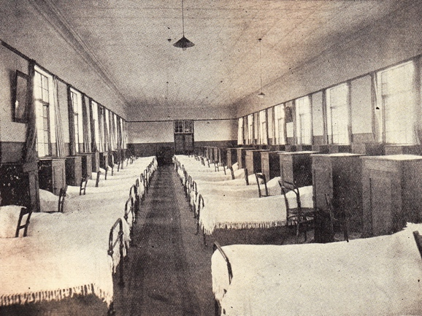

Text:

Inside the dormitory in 1929.

(Image: Marist Archive)

Further text:

The image shows the beds with the head of the bed against the window – once the boarding numbers increased and space was tight, four rows of beds were packed into the room, with the beds placed parallel to the walls. Each boy had a locker (the tall piece of furniture seen in this photograph) in which to keep their belongings. These had hinged tops which lifted to reveal a space for toiletries and small items. Underneath was a cupboard with shelving used to keep clothing in. Though these items of furniture were called lockers none of them ever had locks on for there were frequent inspections to make sure that everything was in order (and that nothing illicit was kept in the dormitory – for example food was banned from the dorms). Every item that the boys had at school were labeled with their names and M.C.O.J (Marist College Observatory Johannesburg) and where washed in the college laundry rooms. When boarding was phased out in the 1970s the laundry and ironing rooms were converted into the school workshop (located at the side of The Orchard).

**Card 5:**

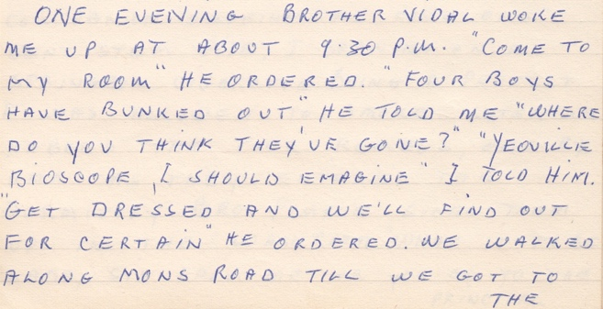

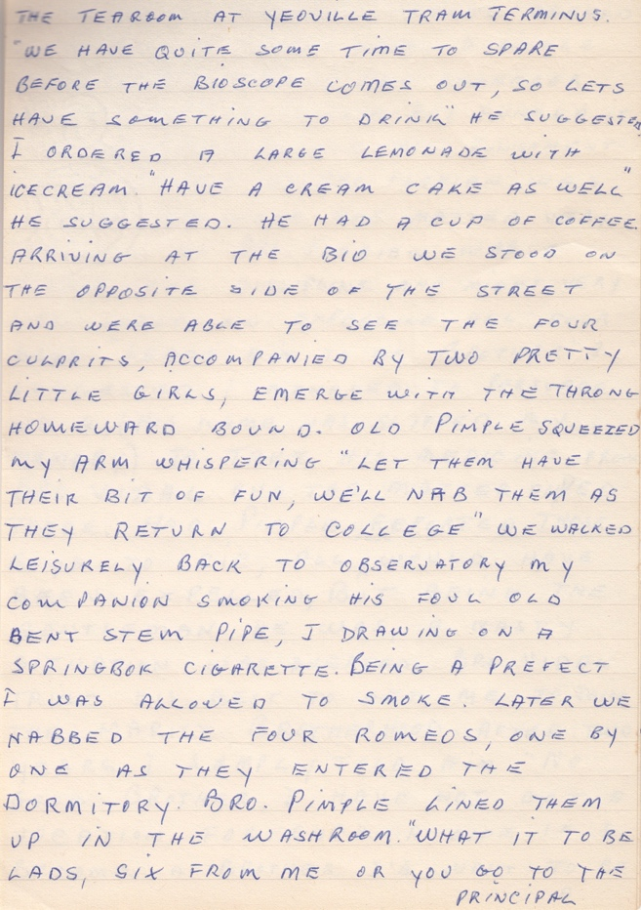

Text:

Excerpt from G.Nolan’s recollective document “M.B.C Golden Jubilee at Observatory” written in 1974. This document, which reads like a post-dinner speech, was likely written for the Golden Jubilee Dinner celebrating 50 years of Sacred Heart College, Observatory held in The Ballroom of The Carlton Hotel in September 1974. The Ballroom was specially decorated in Blue & Gold for the occasion. G. Nolan was House Captain of O’Leary House in 1928.

(Image: Marist Archive)

Further text:

“have you ever noticed that the windows, opposite the Standard 8, 9, 10 classrooms on the top floor of the main building, are of the type that only open slightly? These were put in to stop the boarders climbing out at night! Sometimes they would hurt themselves or damage roof tiles while sneaking out to meet their friends and go to a film at the Piccadilly in Yeoville, or the Victory in Orange Grove. The door at the top of the main staircase was also kept permanently locked in a bid to prevent such nocturnal adventures.”

Sacred Heart College Yearbook, 1989 (p.10)

**Card 6:**

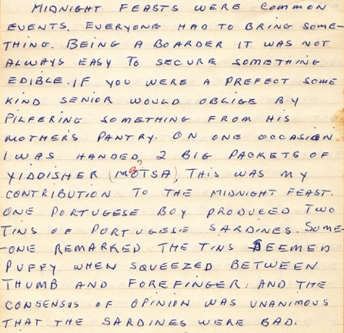

Text:

Excerpt from G.Nolan’s recollective document “M.B.C Golden Jubilee at Observatory” written in 1974.

(Images: Marist Archive)

Further text:

As Nolan went onto explain, it was …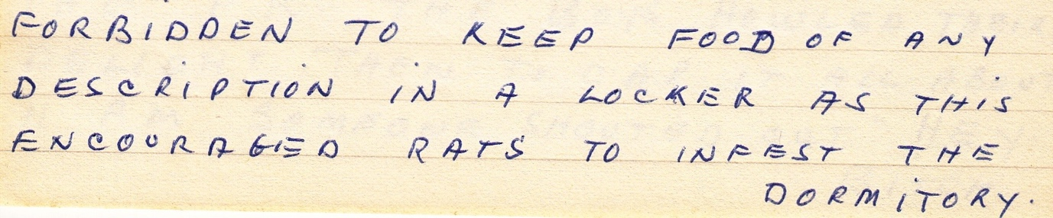

… he continues by describing a terrible bout of food poisoning that one boy endured as a result of eating the tin of sardines mentioned above. However, this (and the threat of rats) did not seem to deter the boarders from midnight feasts as he recounts several of them, as does another alumni, E. Joffe who was a boarder during the 1940s. Joffe also recalls thick brown drapes at the end of one of the dormitories behind which rows of pegs were positioned to hang ones blazers on. He also recalled these drapes being particularly useful for boys to hide behind when they were trying to escape being caught out of bed or in the dormitory at prohibited times.