POI 7 – Pre-Primary

Title: Pre-Primary School

Brief blurb: The Orchard, Yeoville and the Pre-School

Notes:

Jesus with Sacred Heart: Link to POI 13 card 1

Old Chapel: Link to POI 39 card 3

Images:

1. 07.22b

2. 07. 32 & 07.03b

3. 07.33

4. 28.83b

5. 07.25

6. 07.12b

**Card 1:**

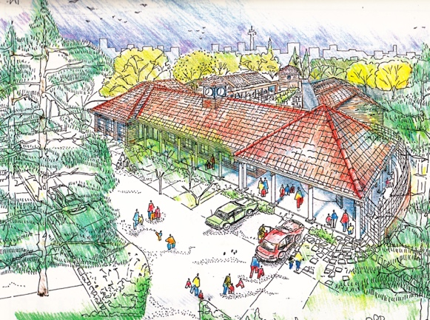

Text:

Artists’ impression of the proposed Pre-Primary buildings c.1994. The architect was Christian Gottschalk of Alfio Torrisi Architects; the buildings were opened in 1996.

(Images: Marist Archive)

Further text:

Though the physical buildings of the Sacred Heart Pre-Primary School were built in 1995-1996 the story of the Pre-Primary section of the school is intertwined with that of the local community in Yeoville from 1914 and with the changing dynamic of inner city Johannesburg from the late 1980s. The existing Pre-Primary school’s foundation stone was laid by Bishop of Johannesburg, The Right Revd. Orsmond in 1995 and the facility was opened in 1996 by Prof. Bengu, Minister of Education.

Funding for the buildings was contributed by Anglo American and De Beers Chairman’s Funds (in 1998 this became one fund), Sacred Heart’s Development Fund and the Genesis Foundation amongst other donors. The two conical stone pillars outside the entrance contain plaques which remind passers by of these facts. However, these two stone towers are testament to a much richer communal narrative and this is outlined over the next few slides.

Colin Northmore recounts an anecdote about the two pillars which could be said to represent the opposing views of The Surveyor and The Architect for the Pre-Primary building project. There was a disagreement over whether The Orchard land that was set aside for the new buildings was over landfill or a ridge of quartz. Of course this would have made a difference to the depth of the foundations that were to be laid and to the final design and structure of the building. They threw their hats on the ground during ‘discussions’ and, it turned out, this was the ideal place at which to test their theories by digging exploratory holes. The two pillars not only conveniently hold the plaques that mark the beginnings of the Pre-Primary but the middle ground that was found between their two plans and the start of the two men working together with a shared vision. Of course the pillars also mark the physical entry point into the Pre-Primary Foyer.

**Card 2:**

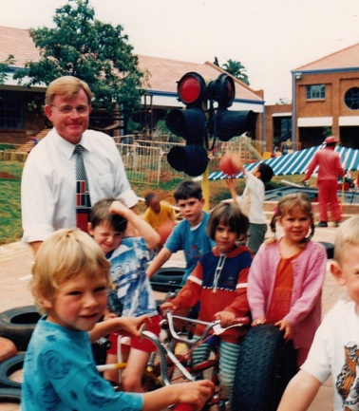

Text:

Brother Joseph Walton, former Principal of the Primary School and former Marist Provincial at the Pre-Primary with some of the learners in c1996-7.

(Image: Sacred Heart College)

Further text:

The Pre-Primary building was designed in the 1990s to resemble 1920s main buildings of the College and at the same time reflect and incorporate features (such as the indigenous trees) of the triangular shaped part of the Orchard that it was to be built in. The Pre-Primary was built to accommodate 250 children in 9 classrooms, with extra spaces such as a library, staff offices, a large multi-functional foyer and an aftercare facility. The buildings and landscaped play areas were designed to connect the pre-schoolers with their Orchard setting; pens for farmyard animals were also included in the colonnaded verandahs along with aviaries and a vegetable patch were also provided.

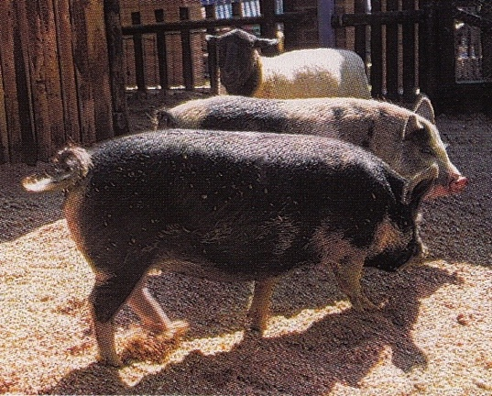

Text:

Some of the first Pre-Primary residents included sheep, pigs and ducks that mingled with the children in the specially enclosed play area.

Image: Marian Geisen

**Card 3:**

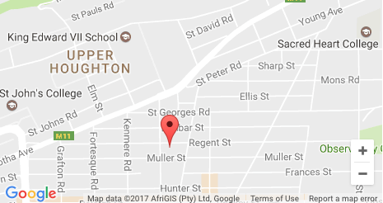

Text:

The Yeoville Campus of Sacred Heart College (in the former Holy Family Convent at Muller/Regent Street) was 1,5 km away from the main school at (top right on map) and was in operation from 1980 to 1995. It was home to the Junior Primary until 1992 and the Nursery and Pre-Primary until 1995.

(Image: Google Maps at <http://yeovillecommunityschool.weebly.com> )

Further text:

After the consolidation of three schools into Sacred Heart College in 1980, the increased pupil roll (from 500 to over 800) all learners could not be accommodated at the Observatory campus. The Holy Family Convent was used for the Sacred Heart College Junior Primary and Nursery schools. In 1993, after the completion of the new buildings (which now form the Intermediate Quad) the Junior Primary was moved back to Observatory. The classrooms vacated by the Junior Primary of Sacred Heart College at Yeoville were given over to the foundation of a new school, Yeoville Community School.

Much of the student body of the new Model C school was formed by children of the returning political exiles who began to come back to South Africa in the early 1990s and were aided through the Batlagae Trust along with children from the existing inner-city area, who until this point were unable to access their local school. Many of the pupils had been denied access to other city schools, often on the grounds of language and educational inadequacies, and the new school saw to it that the bridging of these gaps was achieved, with pupils then able to access other mainstream schools in due course. A similar pattern of assistance can be seen in the format currently employed in the Three2Six school that functions at the Sacred Heart premises today. Yeoville Community School, first headed by Jackie Stevenson (who came from the staff at Sacred Heart College) began as a school of less than 200 children, doubled again in size once the Sacred Heart nursery/Pre-Primary relocated to Observatory after 1995 and now has a roll of over 1000 learners.

Sacred Heart College through its staff, several of whom moved to work at the new schools in the name of providing experienced staff to a new community initiative, and the Marist Brothers (in negotiations with the Department of Education) were lynchpins in the establishment of quality education in the local environs. Barnato Park High School and Orange Grove Primary were amongst the first Model D schools opened in the early 1990s, established through efforts of the Marist Brothers and their supporters, many of whom were staff and parents of Sacred Heart College.

**Card 4:**

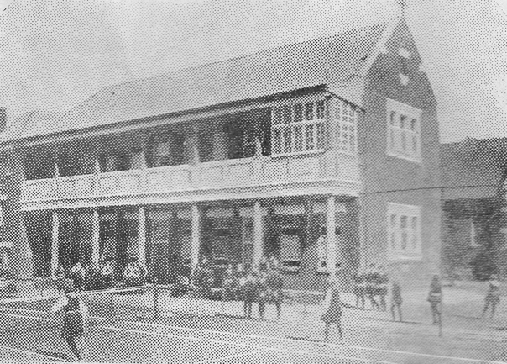

Text: Holy Family Convent Yeoville as pictured in the 1931 Maristonian – part of an advertisement presumably aimed at the families of boys already at Obs to consider for their daughters.

(Image: Marist Archive)

Further text:

The Holy Family Convent school was built in Yeoville in 1914. The colonnaded verandahs and balconies shown in this picture are still a feature of the school today however the grounds and buildings themselves are no longer in good repair. The allocated government subsidy doesn’t stretch to covering the buildings’ maintenance (purchased by the Department of Education in 2003) as well as providing for some of the other needs of the staff and pupils at Yeoville Community School, such as learning equipment and salaries.

In the first few years after Nelson Mandela’s release from prison and during his Presidency he was a regular visitor to the Sacred Heart community and until 1995, this was at both campuses. In the early 1990s Mandela attended one of the Junior Primary concerts at the Yeoville campus and was so impressed by the diversity and cohesion of the students and staff that he advised Oliver Tambo to attend to see for himself how the new South Africa could and should be. Oliver Tambo indeed joined the audience of the concert the next evening.

**Card 5:**

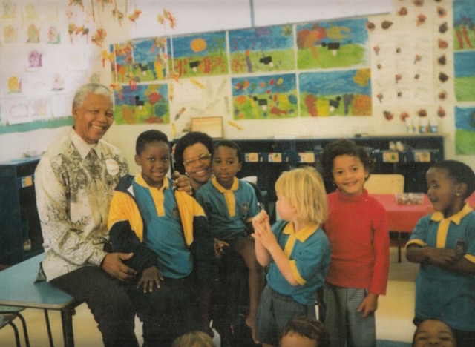

Text:

Nelson Mandela and Graça Machel visit one of the Pre-Primary classes in 1999.

(Image: Sacred Heart College)

Further text:

According to Brother Neil McGurk and Brother Joseph Walton, Principals of the College and Primary School respectively, Nelson Mandela often liked to visit the Pre-Primary school in particular for of course during his time in prison he was starved of contact with children, not least his own children and grandchildren who in the 1990s were enrolled at Sacred Heart College.

Brother Joseph recollecting in 2016 about some of Mandela’s visits to the school:

“I remember him coming here and it’s a silly little story but it shows the man himself, his humour … He was coming to visit the nursery school and I took him across and of course the children didn’t know who he was, just another person coming through and the children kept on saying “good morning Brother Joseph, good morning Brother Joseph, good morning Brother Joseph” and then he [Mandela] said to me “looks like you are more popular... you are more famous than I am!” and he laughed out loud.”

This is in contrast today’s learners at the Pre-Primary for, according to teacher Boitomelo Letho who has taught at the Pre-Primary since the Yeoville days, they are well informed about politics and world affairs, debating amongst themselves around topics as varied as Donald Trump and the Olympics and of course, the legacy of Nelson Mandela. One of her favourite moments as a teacher of the grade 00s came when. whilst leading them her class through the school grounds passing the statue of Jesus with Sacred Heart she overheard a discussion between a few of the 5 year olds. Was this perhaps the resting place of Jesus or Nelson Mandela they debated – for such a spot with this prominent statue as marker could only be, in their minds, a signifier for one of these two equally momentous figures in their schools’ narrative.

**Card 6:**

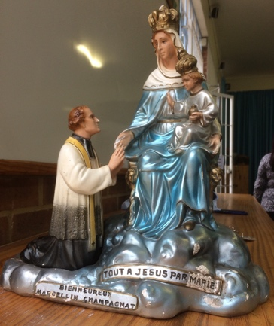

Text:

A statuette of Marcellin Champagnat with Mary and Jesus that can be found in the Pre-Primary Foyer.

(Image: C Kamana)

Further text:

This statuette of Marcellin Champagnat kneeling in-front of the Virgin Mary and Child was made by celebrated Canadaian figurine maker E.Dini who was particularly renowned during the 1940s and 1950s for his painted plaster molded religious icons that have been collected all over the world. It is one of a few artefacts found around the Pre-Primary that speak to the Marist ethos and founders of the school. Another example is the statue of Jesus that is mounted in the foyer above the entry point to the reception office; this statue of Jesus was once installed above the altar in the Old Chapel and moved to its current position in the late 1990s.