Stack ADT using a model SEQ[G]

Class SEQ[G] is part of library **mathmodels**.

In OOSC2, the ADT specification of a stack is given as follows:

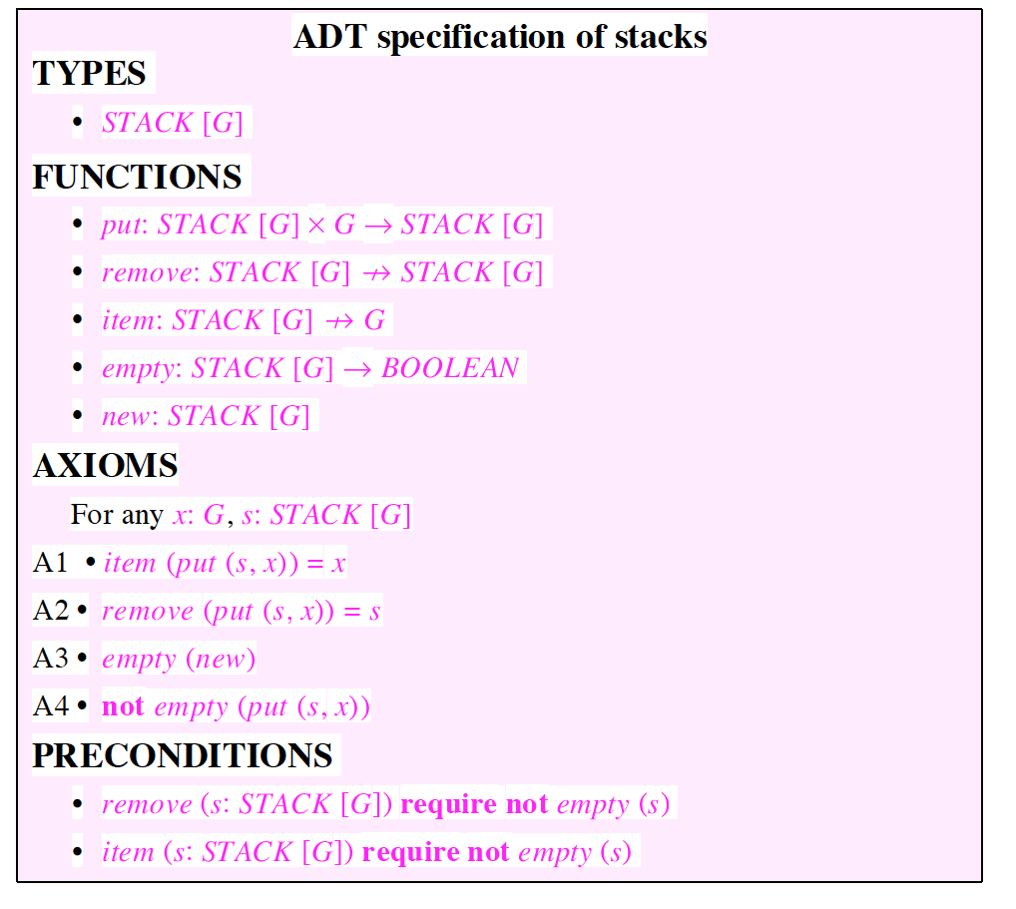

We will use SEQ[G] as a mathematical model for an abstract stack class, allowing not only classical contracts but also complete contracts.

# Chart View of SEQ[G]

|  |
| --- |
| **class**  SEQ [G -> **attached** ANY]  **General**  cluster: mathmodels  description:   "(1) Model contracts for finite sequences for elements of type G.  (2) Queries are side effect free and return sequences via   deep_twin; thus inefficient (use only for contracts).  (3) Commands change the current sequence.   (4) A valid index is 1..count.  (5) Array notation can be used, as well as iteration (across).  (6) Empty sequences can be created, or creation can be from an array.   (7) Sequences have a first item (the head), a tail and last item.  (8) Infix notation for prepended_by(x:G):  seq1 |< x  (9) Infix notation for appended_by(x:G):  seq1 |> x  (10) For concatenation may use infix: seq1 |++| seq2  (11) For queries, to assert that the state is not changed,   the postcondition is  Current ~ old Current.deep_twin"  create: make_empty, make_from_array  **Ancestors**  DEBUG_OUTPUT*  ITERABLE* [G]  **Queries**  appended **alias** "|->" (v: G): [**like** **Current**] **attached** SEQ [G]  as_array: ARRAY [G]  as_function: FUN [INTEGER_32, G]  comprehension **alias** "|" (exp: PREDICATE [PAIR [INTEGER_32, G]]):  [**like** **Current**] **attached** SEQ [G]  concatenated **alias** "|++|" (other: [**like** **Current**] **attached** SEQ [G]):  [**like** **Current**] **attached** SEQ [G]  count **alias** "#": INTEGER_32  debug_output: STRING_8  first: G  front: [**like** **Current**] **attached** SEQ [G]  has (v: G): BOOLEAN  hold_count (exp: PREDICATE [PAIR [INTEGER_32, G]]): INTEGER_32  inserted (v: G; i: INTEGER_32): [**like** **Current**] **attached** SEQ [G]  is_contiguous_subseq_of (other: [**like** **Current**] **attached** SEQ [G]): BOOLEAN  is_empty: BOOLEAN  is_equal (other: [**like** **Current**] **attached** SEQ [G]): BOOLEAN  is_subsequence_of **alias** "|<:" (other: [**like** **Current**] **attached** SEQ [G]): BOOLEAN  item **alias** "[]" (i: INTEGER_32): G  last: G  lower: INTEGER_32  new_cursor: ITERATION_CURSOR [G]  out: STRING_8  overriden (v: G; i: INTEGER_32): [**like** **Current**] **attached** SEQ [G]  prepended **alias** "|<-" (v: G): [**like** **Current**] **attached** SEQ [G]  removed (i: INTEGER_32): [**like** **Current**] **attached** SEQ [G]  reversed: [**like** **Current**] **attached** SEQ [G]  slice (a_start, a_end, a_step: INTEGER_32): [**like** **Current**] **attached** SEQ [G]  subsequenced (i, j: INTEGER_32): [**like** **Current**] **attached** SEQ [G]  tail: [**like** **Current**] **attached** SEQ [G]  twin2: [**like** **Current**] **attached** SEQ [G]  upper: INTEGER_32  valid_position (pos: INTEGER_32): BOOLEAN  **Commands**  append (v: G)  concatenate (other: [**like** **Current**] **attached** SEQ [G])  insert (v: G; i: INTEGER_32)  make_empty  make_from_array (a: ARRAY [G])  override (v: G; i: INTEGER_32)  prepend (v: G)  remove (i: INTEGER_32)  reverse  subsequence (i, j: INTEGER_32)  **Constraints**  value semantics  value semantics  value semantics  value semantics  properties:  **not** is_empty **implies**  **Current** ~ tail**.**prepended (first) **and** **Current** ~ front**.**appended (last) |

# ADT-STACK

|  |
| --- |
| **note**  description: "[  Abstract Data Type for a Stack, with value semantics.  Classic contracts vs. Complete contracts with a model.  ]"  author: "JSO"  **deferred** **class**   ADT_STACK [G -> **attached** ANY]  **inherit**  ANY  **undefine**  is_equal  **end**  **feature** -- model   model: SEQ [G]  -- abstract mathematical description of stack  -- abstraction function  **deferred**  **end**   **feature** -- queries   count: INTEGER_32  -- number of items in stack  **deferred**  **ensure**  complete: **Result** = model**.**count  **end**   is_empty: BOOLEAN  -- is the queue empty?  **deferred**  **ensure**  complete: **Result** = model**.**is_empty  **end**   item: G  -- Top element of stack ("peek")  **require**  **not** is_empty  **deferred**  **ensure**  complete: **Result** ~ model**.**last  **end**  is_equal (other: **like** **Current**): BOOLEAN  -- Is `other' attached to an object considered  -- equal to current object?  **deferred**  **ensure then**  complete: model ~ other**.**model  **end**   **feature** -- commands   make_empty  -- Initialization for `Current'.  **deferred**  **ensure**  classic: is_empty  **end**   put (x: G)  -- push 'x' on top of stack ("push")  **deferred**  **ensure**  classic: count = **old** count + 1  classic: item ~ x  complete: model ~ ((**old** model) |-> x)  **end**   remove  -- pop off top of stack ("pop")  **require**  **not** is_empty  **deferred**  **ensure**  classic: count = **old** count - 1  complete: (**old** model) ~ (model |-> (**old** item))  **end**   **feature** -- axioms   axiom (x: G)  **do**  **Current.**put (x)  **Current.**remove  **ensure**  model ~ (**old** model)  **end**   **end** -- class ADT_STACK |

# MY_STACK text

|  |
| --- |
| **class**   MY_STACK [G -> **attached** ANY]  **inherit**  ADT_STACK [G]  **create**   make_empty  **feature** {ADT_STACK} -- Initialization   imp: LINKED_LIST [G]  -- implementation   make_empty  -- Initialization for `Current'.  **do**  **create** imp**.**make  imp**.**compare_objects  **end**   **feature** -- model   model: SEQ [G]  -- abstract mathematical description of stack  -- abstraction function  **do**  **create** **Result.**make_empty  **across**  imp **as** cr  **loop**  **Result.**append (cr**.**item)  **end**  **end**   **feature** -- queries   count: INTEGER_32  -- number of items in stack  **do**  **Result** := imp**.**count  **end**   is_empty: BOOLEAN  -- is the queue empty?  **do**  **Result** := imp**.**is_empty  **end**   item: G  -- Top element of stack ("peek")  **do**  **Result** := imp**.**last  **end**   is_equal (other: **like** **Current**): BOOLEAN  -- Is `other' attached to an object considered  -- equal to current object?  **do**  **Result** := imp ~ other**.**imp  **end**  **feature** -- command   put (x: G)  -- push 'x' on top of stack ("push")  **do**  imp**.**extend (x)  **end**   remove  -- pop off top of stack ("pop")  **do**  imp**.**go_i_th (imp**.**count)  imp**.**remove  **end**   **end** -- class MY_STACK  -- Generated by ISE Eiffel --  -- For more details: http://www.eiffel.com -- |