
Angry Dolphin -- D&O Underwriting Worksheet
CATERPILLAR INC (CAT)
Generated: April 03, 2026
[Table of Contents -- Update in Word]

CATERPILLAR INC.’s D&O risk profile is bifurcated, with a strong operational and financial base undermined by acute, high-severity legal threats. The company’s inherent risk score of 8.72% and a composite score of 88.2 place it in the "WALK" tier, necessitating a restrictive underwriting stance of "Excess/Side A only, with a high attachment point." This positioning is directly driven by two critical red flags: an active DOJ criminal investigation, which imposes a 30-point scoring ceiling, and whistleblower language referencing "retaliation" in SEC filings, indicating potential FCA or SEC actions and imposing a 100-point ceiling. These governance failures are compounded by a significant prior litigation deduction of 3.19 points from 70 identified signals and a 3.13-point deduction for M&A activity. The resulting claim probability band of 4.17% to 5.95% is MODERATE but skewed toward high-severity events that would trigger Side A coverage. Mitigants include a clean SEC enforcement pipeline, an Altman Z-Score showing no financial distress, and stable C-suite tenure over the last 18 months. However, the DOJ probe and whistleblower evidence create a binary litigation risk that outweighs CAT’s $335.6B market cap and positive free cash flow. Consequently, primary layers are unwritable; capacity should be directed solely to excess layers protecting individual director assets.
Executive Summary
Underwriting Thesis
CATERPILLAR INC is a $335.6B (Decile 1 of 10) mega-cap industrials company that would normally present as a stronger underwriting account were it not for critical red flags: DOJ Criminal Investigation and Active DOJ Criminal Investigation. These findings impose a hard quality score ceiling of 30, placing the account in WALK tier (26/100) regardless of other favorable factors. The primary risk driver is Prior Litigation, driving elevated risk in this area. Signal-driven scoring: 70 signals, coverage=100%. At a 4-6% claim probability (8.7% adjusted rate, 3.5x the Industrials sector baseline of 2.5%), this account requires high-excess positioning with elevated attachment.
Company Snapshot
Attribute | Value | Source
Company | CATERPILLAR INC
Ticker | CAT
Exchange | NYSE
Sector | Industrials
Industry | Farm & Heavy Construction Machinery
Market Cap | $335.6B [Decile 1 (largest ~400 accounts)] (Ranks at the 100th percentile among 9 peers) | [yfinance, filed 2026-04-03, MEDIUM confidence]
Revenue | $67.6B | [10-K 2025-12-31 CIK18230 accn:0000018230-26-000008, filed 2025-12-31, HIGH confidence]
Employees | 118,000 | [yfinance, filed 2026-04-03, MEDIUM confidence]
SIC | 3531 -- Construction Machinery & Equip
FPI Status | No
Fiscal Year End | 12-31
Tier Classification
Attribute | Value
Tier | WALK
Composite Score | 88.2/100
Quality Score | 25.5/100
Factor Breakdown | F1: 3.2, F2: 0.7, F3: 1.5, F4: 3.1, F5: 0.3, F6: 1.5, F7: 0.6, F8: 0.0, F9: 0.7, F10: 0.1
Score Ceiling | Capped at 30 by CRF-3 (DOJ Criminal Investigation)
Position | 88.2 falls in WALK range (11-30)
Appetite | Excess/Side A only, high attachment required
Classification: WALK [CRITICAL]
Inherent Risk Baseline
Component | Value
Market Cap Tier | MEGA [Decile 1 (largest ~400 accounts)]
Sector | Industrials (Base rate: 2.5%)
Size Adjustment | 1.56x (MEGA cap multiplier) -> 3.9%
Score Adjustment | 2.24x (quality score multiplier) -> 8.7%
Severity Percentile | Settlement Estimate
25th (favorable) | $25.0M
50th (median) | $75.0M
75th (adverse) | $112.5M
95th (catastrophic) | $150.0M
At a 8.7% adjusted claim rate, the company faces 3.5x its sector baseline of 2.5% for Industrials companies. This rate reflects the MEGA cap multiplier (1.56x) combined with the quality score multiplier (2.24x from WALK tier classification). If the score improved to WRITE tier, the rate would drop to approximately 3.9%.
Note: NEEDS CALIBRATION
Underwriting Headwinds
1. DOJ Investigation [CRITICAL]
A federal DOJ investigation is pending against Caterpillar Inc.: DOJ criminal: investigation. DOJ investigations create derivative liability risk and signal governance failures that plaintiffs' counsel will incorporate into any securities complaint, strengthening scienter allegations. Criminal proceedings also create Side A exposure for individual directors and officers. This triggers a Critical Red Flag, imposing a score ceiling of 25. (see Litigation)
2. Critical Red Flag [CRITICAL]
Critical Red Flag: Whistleblower/Qui Tam Disclosure — NLP whistleblower signal: Whistleblower/qui tam language detected: retaliation. Presence of such language in filings may indicate pending or potential False Claims Act or SEC whistleblower actions.. This triggers a Critical Red Flag, imposing a score ceiling of 25. (see Litigation)
3. Structural Complexity & Litigation History [HIGH]
The current docket includes 5 derivative suits. With 5 pending matters at $335.6B market cap, Caterpillar Inc. has an active litigation profile that will factor into loss-pick and pricing. (see Litigation)
4. Transaction-Related Exposure [HIGH]
Caterpillar Inc. has transaction-related risk factors. At $335.6B market cap, transaction claims carry both Section 10(b) exposure (misleading disclosures) and Section 14(a) exposure (deficient proxy statements).
5. Earnings Guidance Track Record [HIGH]
Caterpillar Inc. has missed earnings guidance in 5 quarters, with management credibility score at 79%. At $335.6B market cap with an estimated DDL of $2.9B, guidance misses generate large absolute loss figures that attract institutional lead plaintiffs. (see Market & Trading)
Risk Mitigants
1. Clean Regulatory Record
Caterpillar Inc. has no active SEC enforcement pipeline activity, open investigations, or pending Wells Notices. A clean regulatory record for Caterpillar Inc. eliminates the highest-severity D&O claim catalyst and supports favorable underwriting consideration. (see Litigation)
2. Sound Financial Position
No financial distress indicators present (Altman Z-Score of 4.79, D/E of 1.70, current ratio of 1.4x, interest coverage of 7.5x). An Altman Z of 4.79 places Caterpillar Inc. firmly in the safe zone, eliminating going-concern, covenant violation, and creditor-related D&O exposure. (see Financial Health)
3. Stable Executive Leadership
Joseph Creed has led Caterpillar Inc. for 2 years with no recent C-suite departures. While Joseph Creed leads the organization, the relatively brief 2-year tenure means limited track record for evaluating management's response to adversity. (see Governance)
4. Low Short Interest
Short interest is low at 1.7% of float, indicating institutional investors are not positioning against the stock. At 1.7%, short positioning is minimal -- there is no institutional bearish thesis driving potential short-seller reports or activist campaigns against Caterpillar Inc.. (see Market & Trading)
5. Positive free cash flow from most recent period, indicating
Positive free cash flow from most recent period, indicating operational strength. (see Financial Health)
Claim Probability
Metric | Value
Band | MODERATE
Company Rate | 4.2% - 6.0%
Industry Base Rate | 2.5%
Severity Favorable | $119.3M
Severity Median | $248.9M
Severity Adverse | $518.5M
Severity Catastrophic | $1.1B
Probability Band: MODERATE [ELEVATED]
The 4-6% probability band represents approximately 2x the Industrials sector base rate of 2.5%. Accounts in WALK tier historically produce claims at elevated frequency. Industry base rate: 2.5%. Tier WALK (15-20%): Substantially above base rate. Critical risk factors and/or red flags indicate high claim probability. NEEDS CALIBRATION: Probability estimates are indicative and require actuarial validation per SECT7-11. Enhanced frequency: 4.50% base x 0.80 hazard x 1.65 signal = 5.95%.
Tower Recommendation
Metric | Value
Position | High Excess
Min Attachment | $207.4M (based on 50th percentile settlement)
Side A/DIC | Standard Side A considerations
Layer | Risk Assessment | Premium Guidance
PRIMARY | Primary layer carries 57% of expected loss exposure. Highest frequency of attachment; most likely to be eroded in any claim scenario. | Full rate, slight discount for WIN
LOW_EXCESS | Low excess layer carries 18% of expected loss exposure. Attaches after primary exhaustion; moderate frequency in adverse scenarios. | Market rate
MID_EXCESS | Mid excess layer carries 13% of expected loss exposure. Attaches in adverse scenarios; lower frequency but higher severity when reached. | Market to 1.3x
HIGH_EXCESS | High excess layer carries 11% of expected loss exposure. Attaches only in catastrophic scenarios; lowest frequency, highest severity. | 1.3-2x with attachment
DECLINE | WALK+ with compounding factors | N/A
Market Context
No market pricing data available.

Company Overview
Caterpillar Inc. (NYSE: CAT), with a $336 billion market cap and 118,000 employees, is the world's leading manufacturer of construction and mining equipment, diesel and natural gas engines, and locomotives. Its industrial scale and global importance in infrastructure place it in the MEGA risk classification, where regulatory or governance failures can trigger shareholder claims with potential losses in the billions, directly implicating officer oversight.
Revenue Model
Revenue is generated from machinery and engine sales across its Construction Industries, Resource Industries, and Power & Energy segments, supported by its Financial Products segment. The 40% sales decline during the 2015-2016 downturn exemplifies the model's vulnerability to global capital expenditure cycles, pressuring management to hit targets and creating D&O liability risk for allegations of earnings manipulation or misleading guidance during downturns.
D&O Risk Profile
The primary exposure is multi-jurisdictional regulatory enforcement, including an ongoing IRS dispute over a $2.4 billion tax bill and DOJ/SEC investigations into its Swiss subsidiary, creating direct officer liability for financial reporting and compliance oversight. Its geographic footprint across North America, Latin America, EMEA, and Asia Pacific exposes directors to FCPA and sanctions violations inherent in sales to state-owned entities, a core customer base. Furthermore, its 118,000-strong workforce presents systemic employment litigation risk, where broad workplace policies can lead to class-action claims directly targeting board-level governance decisions.
Section 2: Company Profile
CATERPILLAR INC operates in the Farm & Heavy Construction Machinery industry. The company has 118,000 employees and $335.6B market cap. Key D&O exposure factors include: Regulatory Multi Jurisdiction, Employment Litigation Risk, Transaction Litigation Risk. [derived:section_summary, 2026-04-03, LOW]
Company Identity
Field | Value | Source
Legal Name | CATERPILLAR INC | [SEC EDGAR submissions, filed 2026-04-03, HIGH confidence]
Ticker | CAT
CIK | 18230 | [SEC EDGAR submissions, filed 2026-04-03, HIGH confidence]
Sector | Industrials | [SEC EDGAR submissions, filed 2026-04-03, HIGH confidence]
SIC Code | 3531 | [SEC EDGAR submissions, filed 2026-04-03, HIGH confidence]
SIC Description | Construction Machinery & Equip
GICS Code | N/A
NAICS Code | N/A
Exchange | NYSE | [SEC EDGAR submissions, filed 2026-04-03, HIGH confidence]
State of Incorporation | DE | [SEC EDGAR submissions, filed 2026-04-03, HIGH confidence]
FPI Status | No
Fiscal Year End | 12-31 | [SEC EDGAR submissions, filed 2026-04-03, HIGH confidence]
Business Description
Caterpillar Inc. is the world's leading manufacturer of construction and mining equipment, off-highway diesel and natural gas engines, industrial gas turbines, and diesel-electric locomotives. The company generates revenue primarily through the sale of machinery and engines across its reportable segments: Construction Industries, Resource Industries, Power & Energy, and Financial Products. Its business model combines manufacturing and sales of heavy equipment with a captive financing arm (Cat Financial) that provides financing to customers and dealers. Profitability is driven by global infrastructure spending, commodity cycles, and operational excellence in manufacturing and supply chain management. [10-K (LLM), filed 2026-04-03, HIGH confidence]
Subsidiaries
Subsidiary data not available.
Business Model Profile
Dimension | Assessment
Revenue Model | TRANSACTION
Key Person Risk | LOW (Score: 0/3) - CEO tenure: 1yr
Disruption Risk | HIGH (3 threats) - Cybersecurity threats to IT systems and connected products; Technological shifts in energy and automation; Trade policy changes and tariffs impacting costs
Segment Lifecycle
Segment | Stage | Growth Rate
Construction Industries | GROWTH | 0.0%
Resource Industries | UNKNOWN | 0.0%
Power & Energy | GROWTH | 0.0%
Financial Products | MATURE | 0.0%
Operational Complexity
Complexity Score: 118000/20 -- HIGH [HIGH]
Component | Value
Jurisdictions | 0 (0 high-regulatory)
Workforce | 118,000
Segments | 4
Geographic Concentration | 0/100
Supply Chain | moderate
Overall Resilience | ADEQUATE
Structural Indicators: [X] VIE / SPE | [ ] Dual-Class | [X] Holding Depth | [X] OBS Exposure
Corporate Events & Transaction Risk
Event Type | Assessment
M&A Activity | MODERATE (Score: 1/4) | 2 acquisition years | Goodwill growth: 35.6% | Acq/Rev: 0.1%
Business Changes:
- 12 current event filings (8-K), most recent 2026-03-26
- M&A activity indicated (acquisition, divestiture, restructuring)
Structural Complexity
Dimension | Assessment
Disclosure Complexity | LOW
Non-GAAP Usage | HIGH (3)
Related Party Density | LOW
Off-Balance-Sheet Exposure | HIGH (7)
Holding Structure Depth | HIGH (4)
Peer Group Comparison
Ticker | Name | Market Cap | Quality Score | Similarity
GE | GE Aerospace | $296.6B | N/A | Sector Etf / 40%
HON | Honeywell International Inc. | $145.9B | N/A | Sector Etf / 20%
UNP | Union Pacific Corporation | $145.3B | N/A | Sector Etf / 16%
RTX | RTX Corporation | $264.1B | N/A | Sector Etf / 37%
BA | Boeing Company (The) | $163.6B | N/A | Sector Etf / 22%
DE | Deere & Company | $155.5B | N/A | Sector Etf / 32%
LMT | Lockheed Martin Corporation | $143.5B | N/A | Sector Etf / 25%
UPS | United Parcel Service, Inc. | $83.4B | N/A | Sector Etf / 22%
MMM | 3M Company | $76.1B | N/A | Sector Etf / 17%
The peer group of 9 companies shares the same industry classification (SIC 3531). CATERPILLAR INC ranks at the 100th percentile among 9 peers by market capitalization.
Revenue Segments
Revenue segment data not available.
Geographic Footprint
Region | Revenue | % of Total
North America | N/A
Latin America | N/A
EMEA (Europe, Africa, Middle East) | N/A
Asia Pacific | N/A
Customer & Supplier Concentration
Concentration data not available from filings.
D&O Exposure Factors
Exposure Type | Risk Level | Description | Coverage Part
Securities Litigation | See analysis sections | Shareholder class actions, SEC enforcement | Side A/B/C
Derivative Actions | See analysis sections | Breach of fiduciary duty, waste claims | Side A/B
Employment Practices | See analysis sections | Discrimination, harassment, wrongful termination | Side B/C (EPLI)
Regulatory/Government | See analysis sections | DOJ, SEC, FTC, state AG investigations | Side A (primarily)
Fiduciary (ERISA) | See analysis sections | 401(k) plan mismanagement, fee litigation | Fiduciary Liability
Standard D&O exposure categories shown. See individual analysis sections for company-specific risk levels.
Classification
Attribute | Value
Market Cap Tier | MEGA
Sector | INDU (INDU)
Years Public | N/A
Base Filing Rate | 4.5%
Severity Band | $150.0M -- $500.0M
DDL Exposure Base | $50.3B
IPO Multiplier | 1.00x
Cap Filing Multiplier | 1.80x
Hazard Profile (Inherent Exposure Score)
IES: 30/100 (LOW) | Multiplier: 0.80x | Data Coverage: 73% [MODERATE]
Top Risk Dimensions (Elevated+)
Dimension | Score | Exposure | Evidence
Board Independence | 70 | HIGH | Proxy: independence score 3.0; Estimated from related indicators.
Industry Expertise Match | 67 | HIGH | No executives with explicit INDU background in bios
Anti-Takeover Provisions | 54 | ELEVATED | Proxy: governance score 45.6; Estimated from related indicators.
Customer & Supplier Concentration | 50 | ELEVATED | No data available — scored at baseline (MODERATE)
Technology Platform Dependency | 50 | ELEVATED | No data available — scored at baseline (MODERATE)
IP Dependency | 50 | ELEVATED | No data available — scored at baseline (MODERATE)
Scale Experience Mismatch | 50 | ELEVATED | No data available — scored at baseline (MODERATE)
Key Person Dependency | 50 | ELEVATED | No data available — scored at baseline (MODERATE)
Management Turnover | 50 | ELEVATED | No data available — scored at baseline (MODERATE)
Off-Balance Sheet Arrangements | 50 | ELEVATED | No data available — scored at baseline (MODERATE)
Related Party Transactions | 50 | ELEVATED | No data available — scored at baseline (MODERATE)
Capital Markets Activity | 50 | ELEVATED | No data available — scored at baseline (MODERATE)
Audit Committee Quality | 50 | ELEVATED | Committee quality score 0.0/10 (weak); Estimated from related indicators.
IPO Recency | 50 | ELEVATED | No data available — scored at baseline (MODERATE)
Method of Going Public | 50 | ELEVATED | No data available — scored at baseline (MODERATE)
Seasoning & Track Record | 50 | ELEVATED | No data available — scored at baseline (MODERATE)
Market Cycle Position | 50 | ELEVATED | Market cycle scored at config default (moderate -- apply system-wide); Estimated from related indicators.
Political & Policy Environment | 50 | ELEVATED | Political/policy environment at config default (moderate); Estimated from related indicators.
Interest Rate Environment | 50 | ELEVATED | Interest rate environment at config default; Estimated from related indicators.
Plaintiff Attorney Activity | 50 | ELEVATED | Plaintiff attorney activity at moderate baseline (no specific data); Estimated from related indicators.
Geopolitical Risk | 50 | ELEVATED | 4 geographic regions (moderate international exposure)
Cybersecurity Governance | 50 | ELEVATED | No data available — scored at baseline (MODERATE)
Crypto / Digital Asset Exposure | 50 | ELEVATED | No data available — scored at baseline (MODERATE)
Social Media / Public Persona Risk | 50 | ELEVATED | No data available — scored at baseline (MODERATE)
All Hazard Dimensions (55 dimensions)
Dimension | Score | Exposure | Category | Evidence
Board Independence | 70 | HIGH | Governance Structure | Proxy: independence score 3.0
Industry Expertise Match | 67 | HIGH | People & Management | No executives with explicit INDU background in bios
Anti-Takeover Provisions | 54 | ELEVATED | Governance Structure | Proxy: governance score 45.6
Customer & Supplier Concentration | 50 | ELEVATED | Business & Operating Model | No data available — scored at baseline (MODERATE)
Technology Platform Dependency | 50 | ELEVATED | Business & Operating Model | No data available — scored at baseline (MODERATE)
IP Dependency | 50 | ELEVATED | Business & Operating Model | No data available — scored at baseline (MODERATE)
Scale Experience Mismatch | 50 | ELEVATED | People & Management | No data available — scored at baseline (MODERATE)
Key Person Dependency | 50 | ELEVATED | People & Management | No data available — scored at baseline (MODERATE)
Management Turnover | 50 | ELEVATED | People & Management | No data available — scored at baseline (MODERATE)
Off-Balance Sheet Arrangements | 50 | ELEVATED | Financial Structure | No data available — scored at baseline (MODERATE)
Related Party Transactions | 50 | ELEVATED | Financial Structure | No data available — scored at baseline (MODERATE)
Capital Markets Activity | 50 | ELEVATED | Financial Structure | No data available — scored at baseline (MODERATE)
Audit Committee Quality | 50 | ELEVATED | Governance Structure | Committee quality score 0.0/10 (weak)
IPO Recency | 50 | ELEVATED | Public Company Maturity | No data available — scored at baseline (MODERATE)
Method of Going Public | 50 | ELEVATED | Public Company Maturity | No data available — scored at baseline (MODERATE)
Seasoning & Track Record | 50 | ELEVATED | Public Company Maturity | No data available — scored at baseline (MODERATE)
Market Cycle Position | 50 | ELEVATED | External Environment | Market cycle scored at config default (moderate -- apply system-wide)
Political & Policy Environment | 50 | ELEVATED | External Environment | Political/policy environment at config default (moderate)
Interest Rate Environment | 50 | ELEVATED | External Environment | Interest rate environment at config default
Plaintiff Attorney Activity | 50 | ELEVATED | External Environment | Plaintiff attorney activity at moderate baseline (no specific data)
Geopolitical Risk | 50 | ELEVATED | External Environment | 4 geographic regions (moderate international exposure)
Cybersecurity Governance | 50 | ELEVATED | Emerging / Modern Hazards | No data available — scored at baseline (MODERATE)
Crypto / Digital Asset Exposure | 50 | ELEVATED | Emerging / Modern Hazards | No data available — scored at baseline (MODERATE)
Social Media / Public Persona Risk | 50 | ELEVATED | Emerging / Modern Hazards | No data available — scored at baseline (MODERATE)
ESG / Climate Exposure | 43 | MODERATE | Emerging / Modern Hazards | Sector 'INDU' has inherent ESG/climate sensitivity (1.0)
Regulatory Intensity | 40 | MODERATE | Business & Operating Model | Sector 'INDU' regulatory intensity: 2.0/5.0
Geographic Complexity | 40 | MODERATE | Business & Operating Model | 4 regions, ? subsidiaries (MODERATE)
Leverage & Capital Structure | 40 | MODERATE | Financial Structure | Debt/Equity 1.70 (MODERATE)
Shareholder Rights | 33 | LOW | Governance Structure | Governance score 45.6/100 (moderate)
Compensation Structure | 33 | LOW | Governance Structure | Clawback policy in place
Industry Regulatory Spotlight | 33 | LOW | External Environment | Sector 'INDU' regulatory spotlight level: 1.0/3.0
Industry Sector Risk Tier | 25 | LOW | Business & Operating Model | Sector 'INDU' maps to risk score 2.5/10.0
State of Incorporation | 25 | LOW | Governance Structure | Incorporated in DE (standard D&O protections)
Workforce & Labor Model | 25 | LOW | Emerging / Modern Hazards | Large workforce (118,000 employees) -- labor risk surface
M&A Activity | 20 | LOW | Business & Operating Model | 1 acquisition(s) noted
Management Public Company Experience | 20 | LOW | People & Management | CEO tenure 2.0y
Non-GAAP Reliance | 17 | LOW | Business & Operating Model | No non-GAAP reliance indicators found
Founder-Led vs Professional Management | 17 | LOW | People & Management | Professional (non-founder) CEO
Goodwill-Heavy Balance Sheet | 17 | LOW | Financial Structure | Goodwill 5.4% of assets (LOW)
Cash Flow vs Earnings Divergence | 17 | LOW | Financial Structure | OCF/NI ratio 1.32 -- aligned
Industry Litigation Wave | 17 | LOW | External Environment | Sector 'INDU' litigation wave level: 0.5/3.0
AI Adoption & Governance | 12 | LOW | Emerging / Modern Hazards | AI risk score 0/100 (LOW)
Speed of Growth | 10 | LOW | Business & Operating Model | Revenue growth 4.3% (STABLE)
Business Model Complexity | 0 | LOW | Business & Operating Model
Revenue Model Manipulation Surface | 0 | LOW | Business & Operating Model
Capital Intensity | 0 | LOW | Business & Operating Model | CapEx/Revenue 4.2% (LOW)
Dual-Class Structure | 0 | LOW | Business & Operating Model
Board Governance Experience & Quality | 0 | LOW | People & Management
Tone at the Top | 0 | LOW | People & Management | Estimated from related indicators.
Earnings Quality Characteristics | 0 | LOW | Financial Structure | Beneish M-Score -3.00 -- safe zone
Pre-Revenue / Cash Burn | 0 | LOW | Financial Structure | Revenue-generating company with positive cash flow profile
Combined CEO / Board Chair | 0 | LOW | Governance Structure | CEO and Chair roles separated
Compliance Infrastructure | 0 | LOW | Governance Structure | No material weaknesses or going concern issues identified
Exchange & Index Membership | 0 | LOW | Public Company Maturity | Listed on NYSE (major exchange -- standard oversight)
FPI / ADR Status | 0 | LOW | Public Company Maturity | Domestic issuer (standard SEC reporting)
Category Summary
Category | Weight | Score | Weighted | Dims Scored | Coverage
Business & Operating Model | 32.5% | 23.2 | 7.5 | 10/13 | 77%
People & Management | 15.0% | 31.7 | 4.8 | 5/8 | 62%
Financial Structure | 15.0% | 27.9 | 4.2 | 5/8 | 62%
Governance Structure | 7.5% | 33.2 | 2.5 | 8/8 | 100%
Public Company Maturity | 10.0% | 30.0 | 3.0 | 2/5 | 40%
External Environment | 10.0% | 42.9 | 4.3 | 7/7 | 100%
Emerging / Modern Hazards | 10.0% | 38.5 | 3.9 | 3/6 | 50%
Risk Factors (D&O-Relevant)
Risk Factor | Category | Severity | D&O Relevance | Source Passage
Increased information technology security threats and more sophisticated computer crime | CYBER | HIGH | MEDIUM | Increased information technology security threats and more sophisticated computer crime pose a risk to our systems, networks, products and services.
Global economic conditions and commodity prices | FINANCIAL | HIGH | MEDIUM | Our business is sensitive to global economic conditions and commodity prices, which impact demand for our products.
Supply chain disruptions | OPERATIONAL | HIGH | LOW | We rely on a global supply chain, and disruptions could affect our ability to manufacture and deliver products.
Trade policies and tariffs | REGULATORY | HIGH | HIGH | Changes in trade policies, including tariffs, could increase our manufacturing costs and impact profitability.
Fluctuations in currency exchange rates | FINANCIAL | MEDIUM | MEDIUM | Our results are affected by currency exchange rate fluctuations due to our global operations.
Interest rate risk | FINANCIAL | MEDIUM | MEDIUM | Changes in interest rates impact our borrowing costs and the profitability of our Financial Products segment.
Pension and OPEB obligations | FINANCIAL | MEDIUM | MEDIUM | We have significant pension and other postretirement benefit obligations that are subject to market volatility.
Product liability and warranty claims | LITIGATION | MEDIUM | HIGH | We are exposed to product liability and warranty claims, which could result in significant costs.
Regulatory compliance and environmental laws | REGULATORY | MEDIUM | HIGH | We are subject to extensive environmental, health, and safety regulations worldwide.
9 D&O-relevant risk factors (0 new this year, 4 high severity).

CRITICAL RISK
CATERPILLAR's stock sits at $717.22, a 9.19% decline from its 52-week high of $789.81, but the real story is the volatility beneath that, including a severe single-day drop of 8.64% on April 3, 2025. That specific event, one of 7 cluster events, provides a clear loss causation date for plaintiffs to anchor a Dura Pharmaceuticals argument. Insider activity shows net selling totaling $99.48 million, with 23.1% of it being structured 10b5-1 plans, which complicates but does not eliminate the scienter inference under Tellabs given the sheer volume against a backdrop of 7 cluster events. The presence of these 7 cluster events around executive transactions creates a pattern that a plaintiff's bar will aggressively map to any subsequent negative disclosure to allege a scheme. While analyst consensus is still a "BUY" with zero recent downgrades, the insider direction and the stock's 52-week low of $267.30 demonstrate a boardroom-level recognition of risk that the street may be discounting. My primary concern is that the next operational misstep will be litigated using the April 3rd, 2025 drop as the damages model, with the $99.48 million in insider sales history used to plead fraudulent intent. The lack of recent analyst downgrades offers no counter-narrative to that potential complaint, leaving the insider sales as the dominant narrative. Underwriting here requires a specific reserve for litigation following that April date, as the stock's 52-week range shows it can fall 62.7% from its high, providing ample room for claimed damages.
Section 4: Market & Trading Analysis
The stock trades 9.2% below its 52-week high ($790), within normal trading variance. Worst single-day decline: 8.6% on 2025-04-03. Short interest of 1.7% of float is low (6-month trend: DECLINING). Analyst consensus: BUY.
Stock Performance
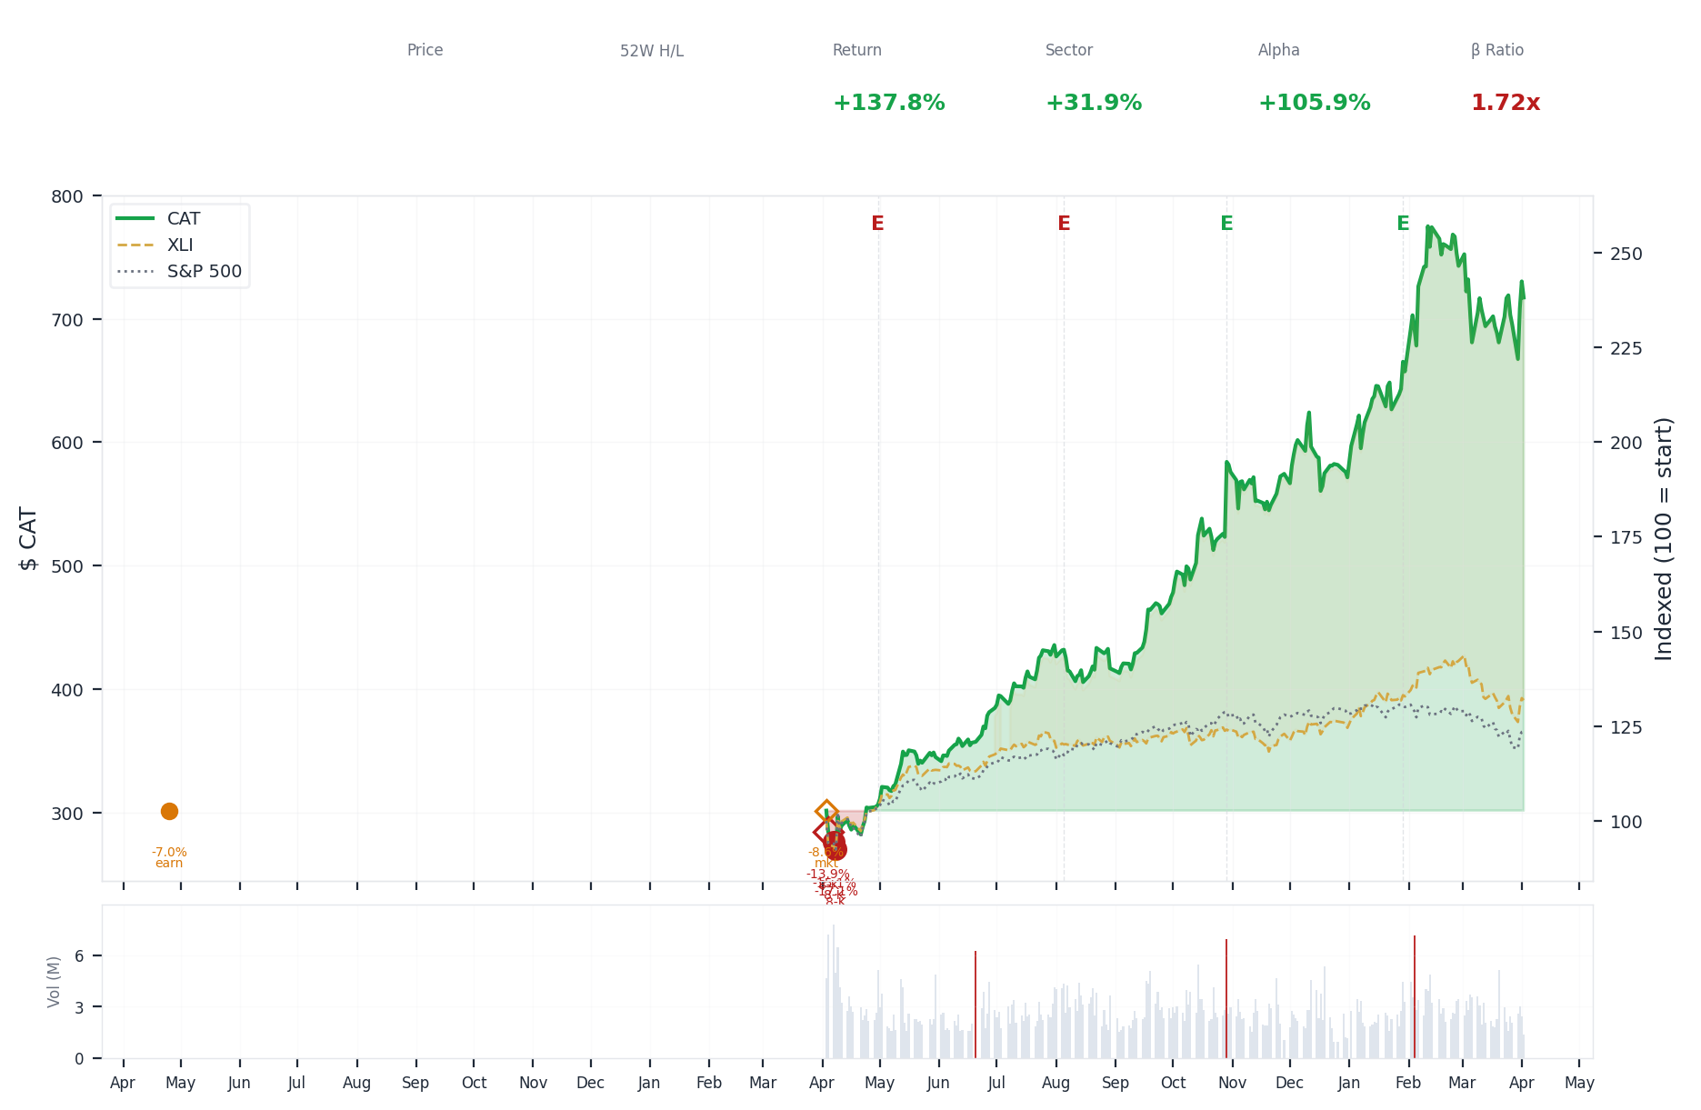
1-Year Performance (Indexed to 100). Red triangles mark single-day drops >= 8%. Orange bands mark multi-day declines >= 15%.
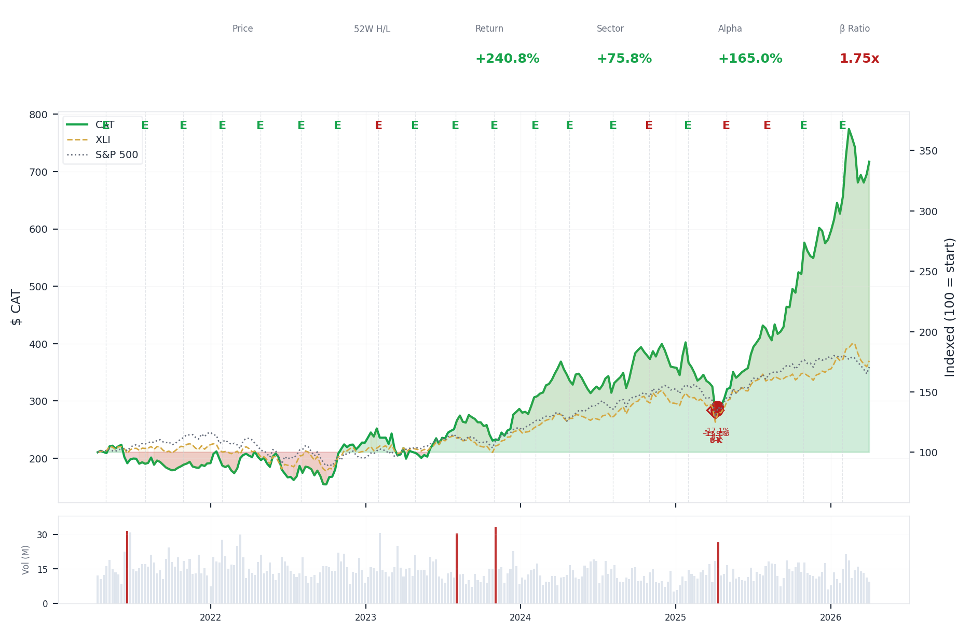
5-Year Performance (Indexed to 100)
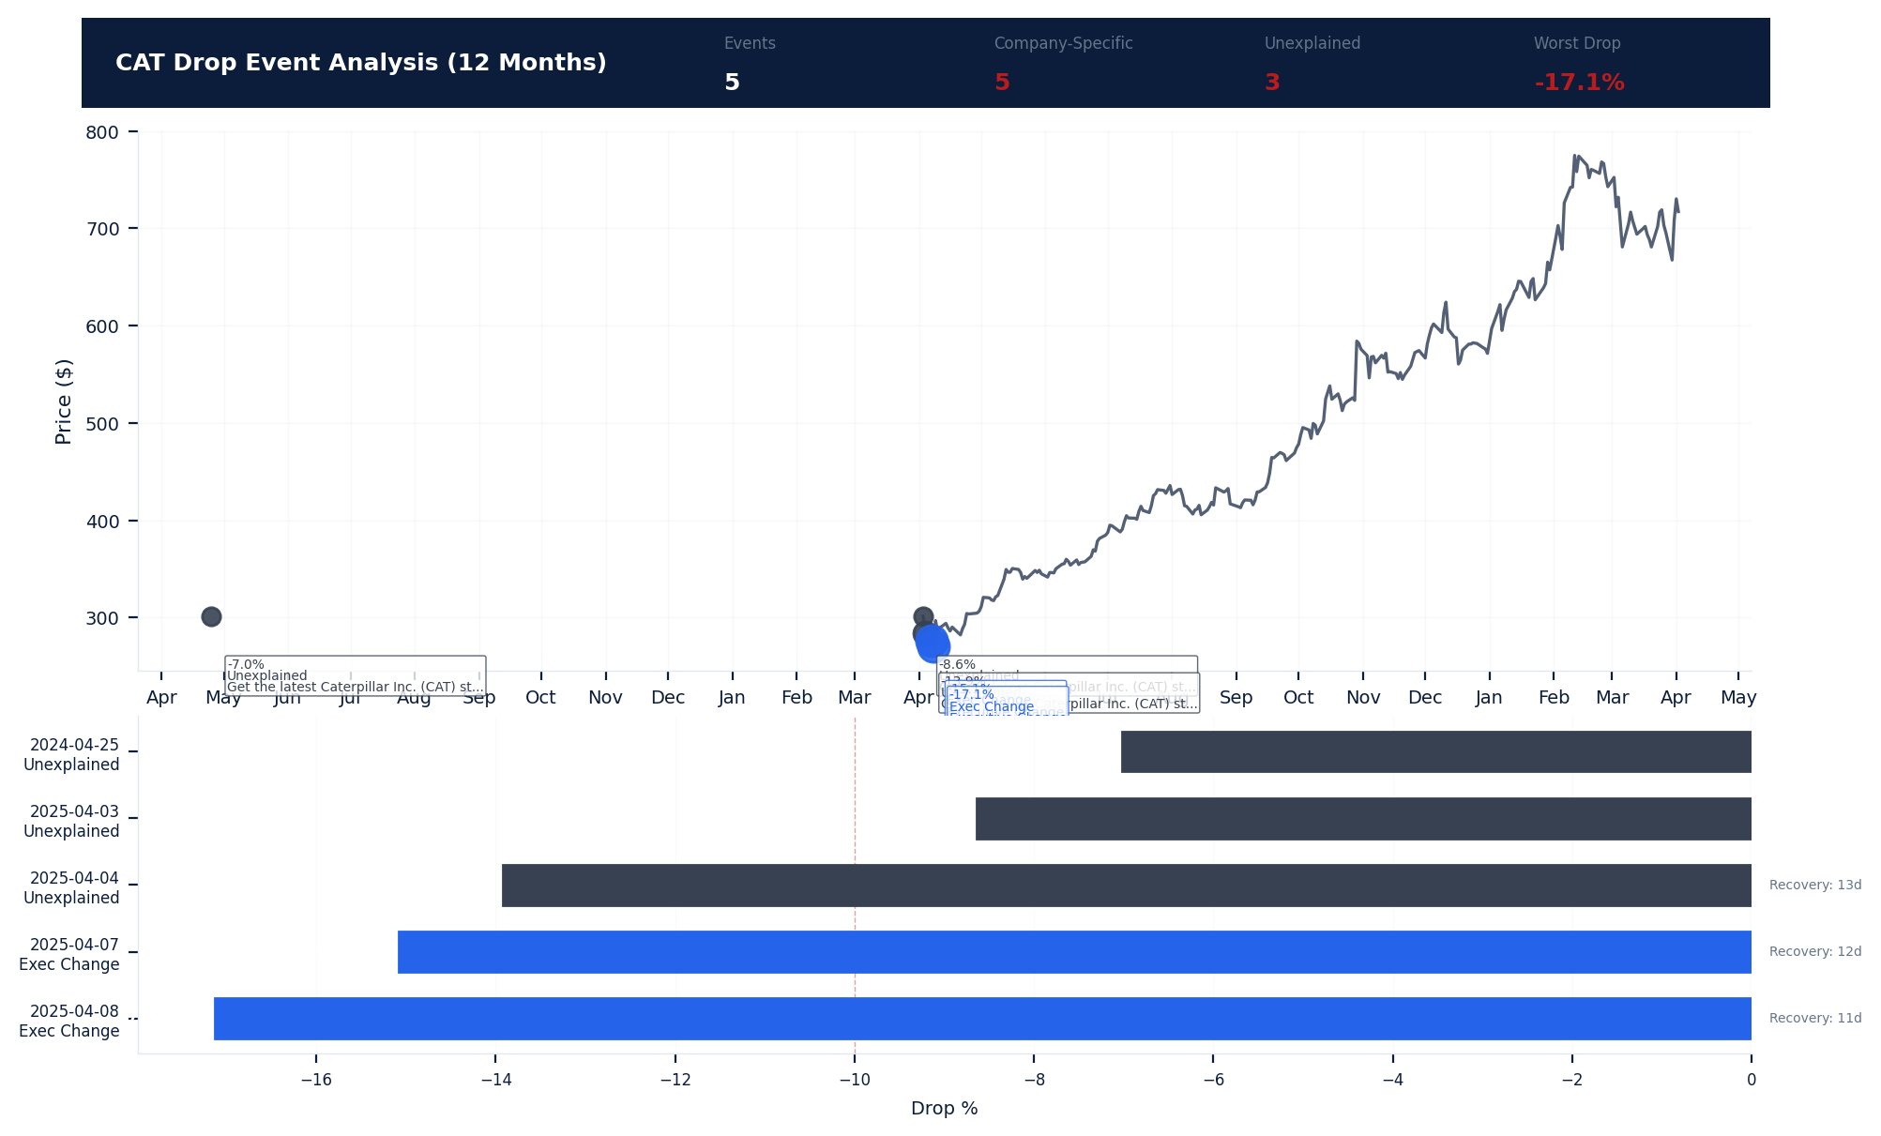
Drop Event Analysis (12 Months)
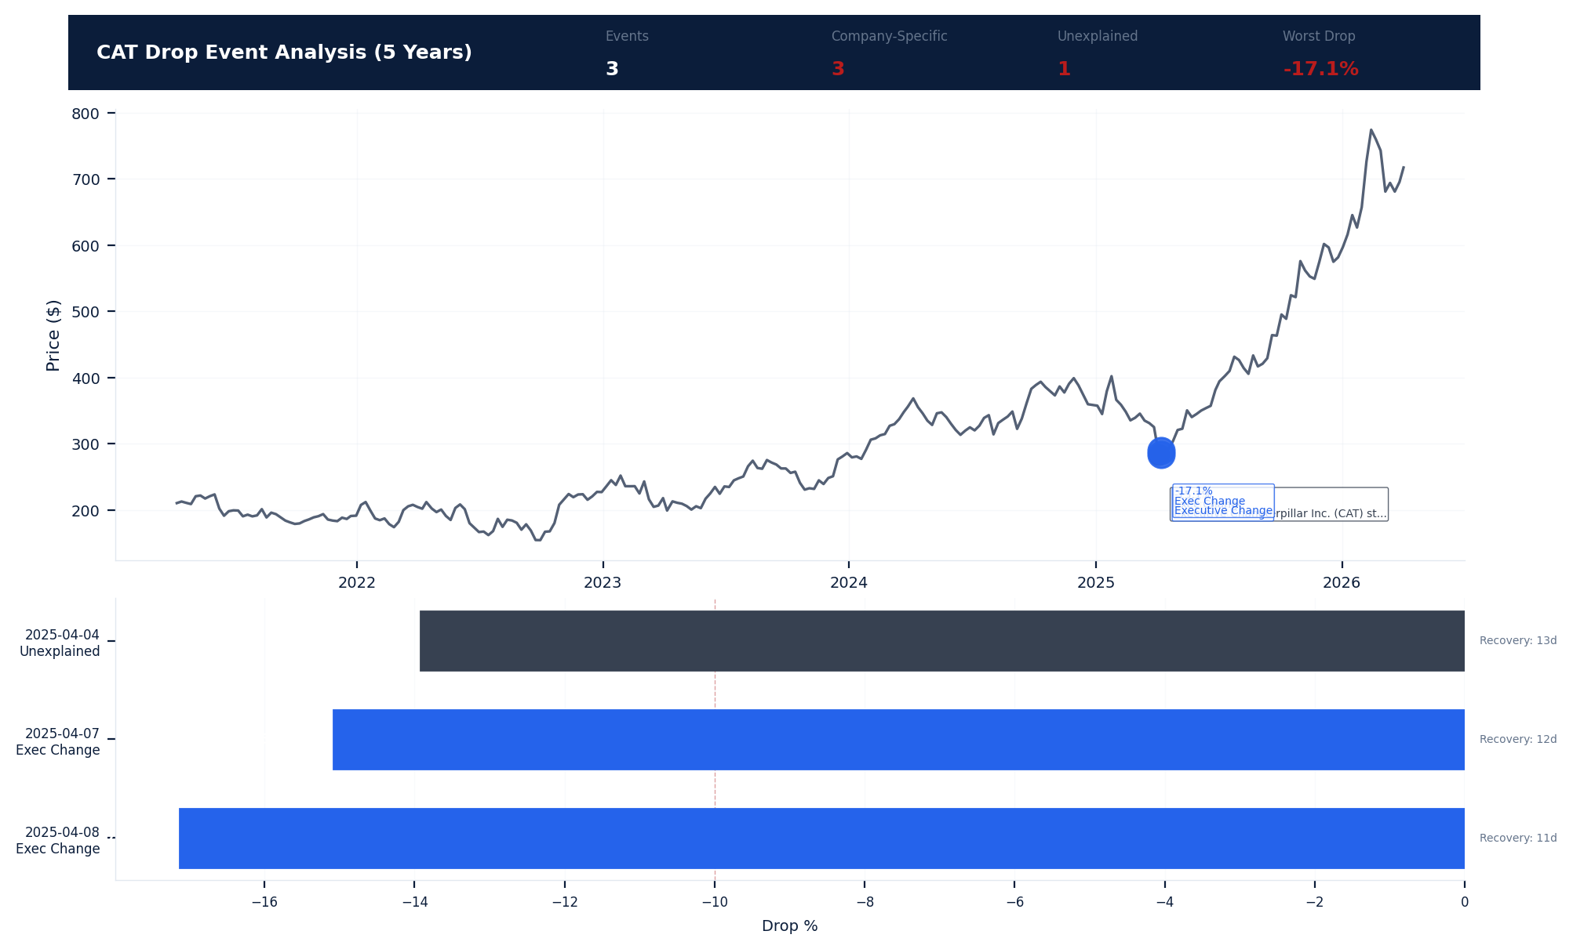
Drop Event Analysis (5 Years)
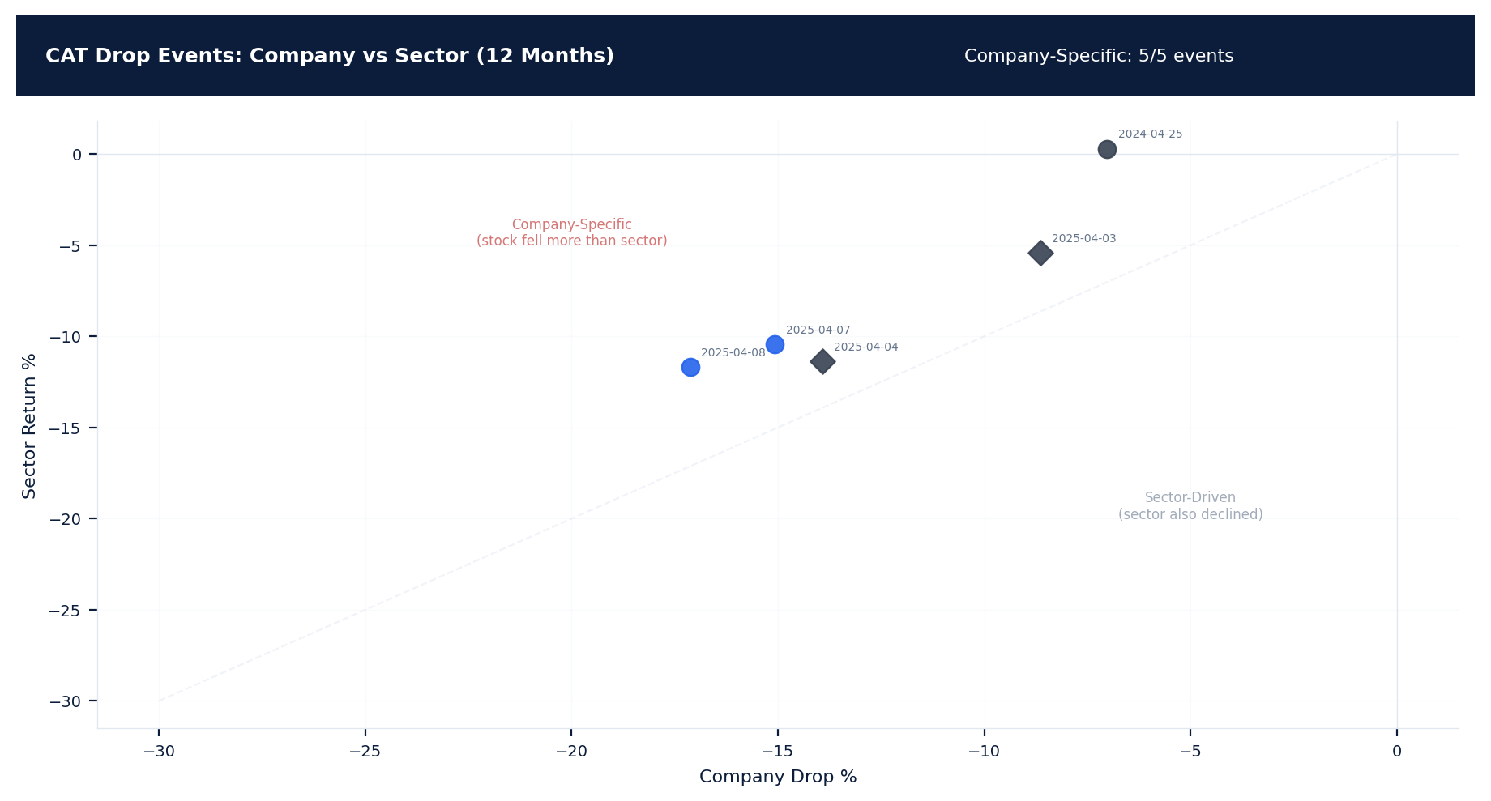
Drop Events: Company vs Sector (12 Months)
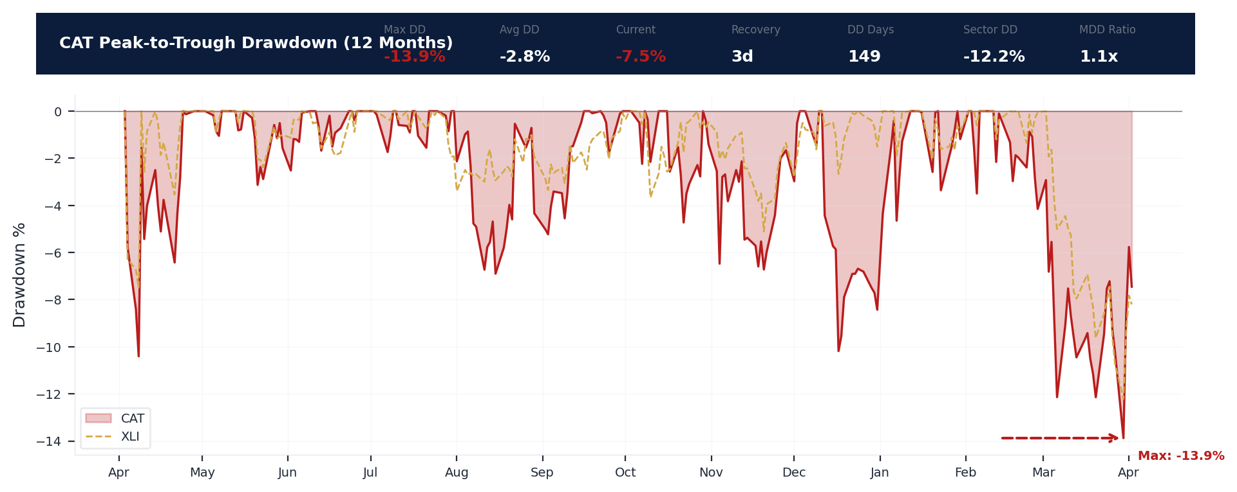
Drawdown Analysis (12 Months)
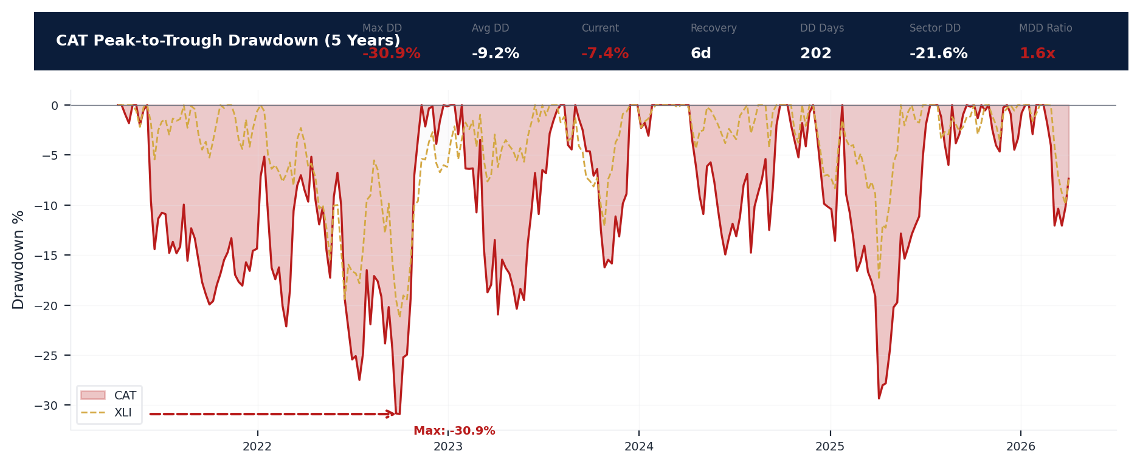
Drawdown Analysis (5 Years)
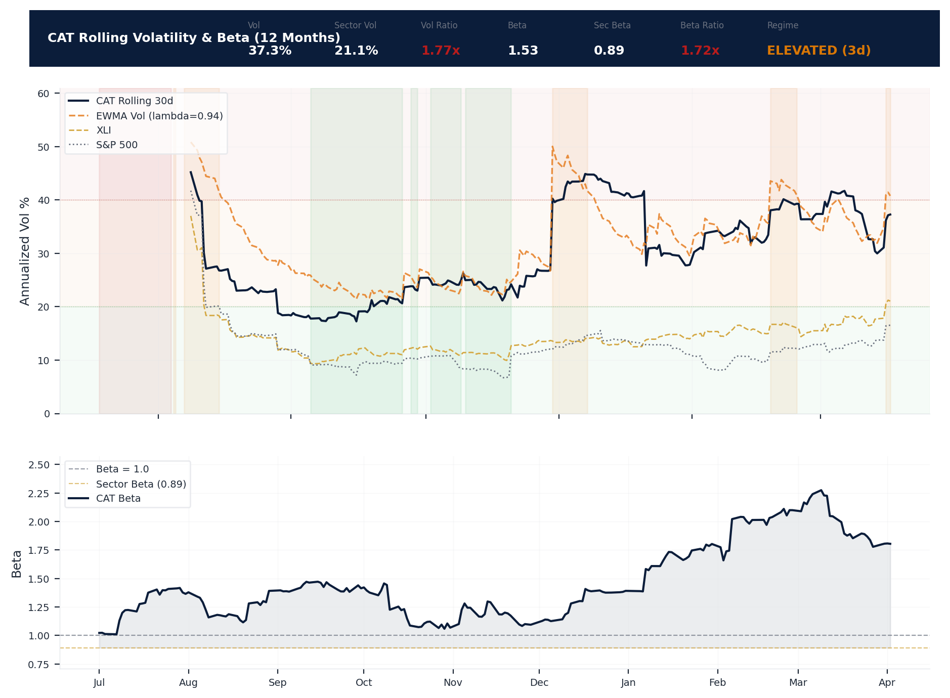
Volatility & Beta Analysis (12 Months)
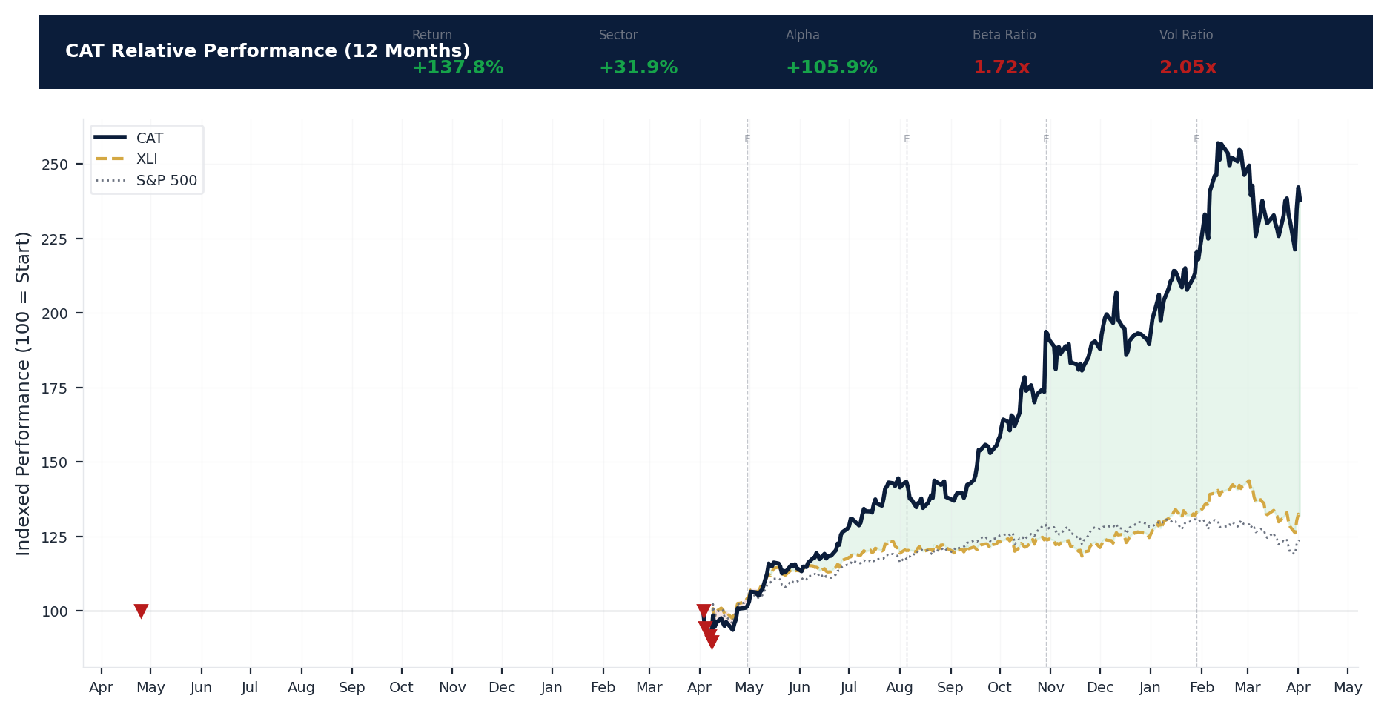
Relative Performance (12 Months)
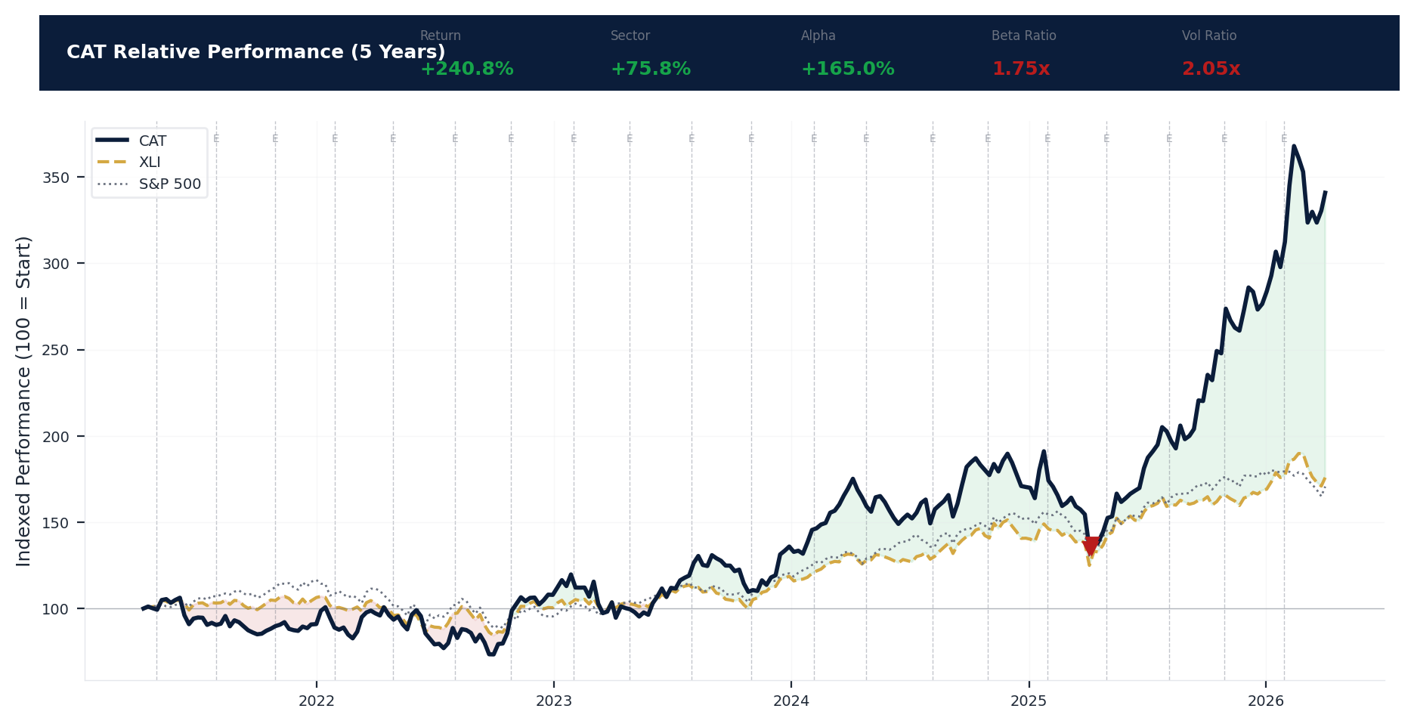
Relative Performance (5 Years)
Metric | Value
Current Price | $717.22
52-Week High | $789.81
52-Week Low | $267.30
1-Year Return | 137.8%
Max Drawdown (1Y) | -13.9%
90-Day Volatility | 36.4% (Ranks at the 0th percentile among 0 peers (peer median: 2.5%))
Beta (vs S&P 500) | 1.53
5 significant stock decline events detected in the 1Y period: 3 critical (>10%), 2 notable (5-10%). 5 were company-specific, 3 were market-wide.
Date | Drop % | Recency | Recovery | Trigger Event | Type | Source
2025-04-03 to 2025-04-08 (6d) | -18.1% | 25% | 11 days | 8-K Filing | Market-Wide Event | https://www.sec.gov/cgi-bin/browse-edgar?action...
2025-04-07 (5d) | -15.1% | 25% | 12 days | 8-K Filing | Company-Specific | https://www.sec.gov/cgi-bin/browse-edgar?action...
2025-04-04 (2d) | -13.9% | 25% | 13 days | 8-K Filing | Market-Wide Event | https://www.sec.gov/cgi-bin/browse-edgar?action...
2025-04-03 (2d) | -5.8% | 25% | Not recovered | Unconfirmed -- Requires Investigation | Market-Wide Event | https://finance.yahoo.com/quote/CAT/press-relea...
2024-04-25 | -7.0% | 7% | Not recovered | Earnings release | Company-Specific | https://finance.yahoo.com/quote/CAT/press-relea...
3 significant stock decline events detected in the 5Y period: 3 critical (>10%). 3 were company-specific, 2 were market-wide.
Date | Drop % | Recency | Recovery | Trigger Event | Type | Source
2025-04-03 to 2025-04-08 (6d) | -18.1% | 25% | 11 days | 8-K Filing | Market-Wide Event | https://www.sec.gov/cgi-bin/browse-edgar?action...
2025-04-07 (5d) | -15.1% | 25% | 12 days | 8-K Filing | Company-Specific | https://www.sec.gov/cgi-bin/browse-edgar?action...
2025-04-04 (2d) | -13.9% | 25% | 13 days | 8-K Filing | Market-Wide Event | https://www.sec.gov/cgi-bin/browse-edgar?action...
Short Interest
Metric | Value
Short % of Float | 1.7% (Ranks at the 72nd percentile among 0 peers (peer median: 3.0%))
Days to Cover | 2.64
6-Month Trend | DECLINING
vs Sector Ratio | N/A
Earnings Guidance Track Record
Metric | Value
Beat Rate | 0.8%
Consecutive Misses | 0
Guidance Withdrawals | 0
Philosophy | CONSERVATIVE
Quarter | Est. EPS | Actual EPS | Result | Miss Magnitude | Stock Reaction
Q1 2026 | $4.71 | $5.16 | BEAT | N/A | +9.5%
Q4 2025 | $4.52 | $4.95 | BEAT | N/A | +9.4%
Q3 2025 | $4.90 | $4.72 | MISS | +3.7% | -3.7%
Q2 2025 | $4.34 | $4.25 | MISS | +2.1% | -2.2%
Q1 2025 | $5.03 | $5.14 | BEAT | N/A | +2.2%
Q4 2024 | $5.35 | $5.17 | MISS | +3.4% | -3.4%
Q3 2024 | $5.54 | $5.99 | BEAT | N/A | +8.1%
Q2 2024 | $5.13 | $5.60 | BEAT | N/A | +9.1%
Q1 2024 | $4.75 | $5.23 | BEAT | N/A | +10.1%
Q4 2023 | $4.79 | $5.52 | BEAT | N/A | +15.2%
Q3 2023 | $4.58 | $5.55 | BEAT | N/A | +21.2%
Q2 2023 | $3.79 | $4.91 | BEAT | N/A | +29.5%
Q1 2023 | $4.03 | $3.86 | MISS | +4.2% | -4.2%
Q4 2022 | $3.17 | $3.95 | BEAT | N/A | +24.8%
Q3 2022 | $3.02 | $3.18 | BEAT | N/A | +5.4%
Q2 2022 | $2.60 | $2.88 | BEAT | N/A | +10.6%
Analyst Consensus
Metric | Value
Analyst Coverage | 26
Consensus Rating | BUY
Mean Recommendation | 2.14 (1=Strong Buy, 5=Sell)
Mean Target Price | $742
Target Price High | $878
Target Price Low | $425
Stock Drop Analysis
Date | Magnitude | Type | Trigger / Attribution | Sector Return | Company-Specific
2025-04-03 to 2025-04-08 | -18.1% | MULTI_DAY (6d) | 8-K_filing | -11.7% | Yes
2025-04-07 | -15.1% | MULTI_DAY (5d) | 8-K_filing | -10.4% | Yes
2025-04-04 | -13.9% | MULTI_DAY (2d) | 8-K_filing | -11.4% | Yes
2025-04-03 | -8.6% | MULTI_DAY (2d) | Unknown | -5.4% | Yes
2024-04-25 | -7.0% | SINGLE_DAY | earnings_release | +0.3% | Yes
Class Period Potential: 3 company-specific drop(s) exceeding 10% identified. Severe stock drops that are company-specific (not explained by sector movement) are the primary anchors for SCA class periods. Plaintiffs will allege the drop occurred when the 'truth emerged' following prior misstatements. [HIGH]
Insider Trading Analysis
Metric | Value
Net Direction (12mo) | NET_SELLING
10b5-1 Plan % | 23.1%
Buy Transactions | 0
Sell Transactions | 26
Cluster Events | 7
Transaction Detail
Date | Insider | Title | Type | Shares | Value | 10b5-1
2026-03-31 | MacLennan David | Director | GRANT | 33 | $22.8K | No (Discretionary)
2026-03-26 | Creed Joseph E | Chief Executive Officer | GRANT | 3 | $2.1K | No (Discretionary)
2026-03-13 | Creed Joseph E | Chief Executive Officer | GRANT | 428 | $297.0K | No (Discretionary)
2026-03-13 | Kaiser Jason | Group President | GRANT | 186 | $129.1K | No (Discretionary)
2026-03-06 | Kaiser Jason | Group President | GRANT | 106 | $72.2K | No (Discretionary)
2026-03-06 | Creed Joseph E | Chief Executive Officer | GRANT | 214 | $145.7K | No (Discretionary)
2026-03-05 | Creed Joseph E | Chief Executive Officer | SELL | 420 | $301.1K | Yes (Pre-arranged)
2026-03-05 | Creed Joseph E | Chief Executive Officer | SELL | 800 | $574.8K | Yes (Pre-arranged)
2026-03-05 | Creed Joseph E | Chief Executive Officer | SELL | 585 | $420.8K | Yes (Pre-arranged)
2026-03-05 | Creed Joseph E | Chief Executive Officer | SELL | 575 | $414.1K | Yes (Pre-arranged)
2026-03-05 | Creed Joseph E | Chief Executive Officer | SELL | 120 | $86.5K | Yes (Pre-arranged)
2026-03-04 | Umpleby III Donald J | Executive Chairman | TAX_WITHHOLD | 1,546 | $1.1M | No (Discretionary)
2026-03-04 | Shurman Rodney Michael | Group President | TAX_WITHHOLD | 117 | $86.4K | No (Discretionary)
2026-03-04 | Schaupp William E | Chief Accounting Officer | TAX_WITHHOLD | 19 | $14.0K | No (Discretionary)
2026-03-04 | Owens Derek | Chief Legal Officer | TAX_WITHHOLD | 338 | $249.6K | No (Discretionary)
2026-03-04 | Creed Joseph E | Chief Executive Officer | TAX_WITHHOLD | 696 | $513.9K | Yes (Pre-arranged)
2026-03-04 | Kaiser Jason | Group President | TAX_WITHHOLD | 368 | $271.7K | No (Discretionary)
2026-03-04 | Fassino Anthony D. | Group President | TAX_WITHHOLD | 346 | $255.5K | No (Discretionary)
2026-03-04 | Johnson Denise C | Group President | TAX_WITHHOLD | 346 | $255.5K | No (Discretionary)
2026-03-04 | De Lange Bob | Group President | TAX_WITHHOLD | 393 | $290.2K | No (Discretionary)
Cluster Selling Events
Window | Insiders | Names | Total Value
2026-02-02 to 2026-02-23 | 6 | De Lange Bob, Fassino Anthony D., Johnson Denise C, Kaiser Jason, Schaupp William E, Shurman Rodney Michael | $97.7M
2026-02-04 to 2026-03-05 | 6 | Creed Joseph E, De Lange Bob, Fassino Anthony D., Kaiser Jason, Schaupp William E, Shurman Rodney Michael | $54.7M
2026-02-06 to 2026-03-05 | 6 | Creed Joseph E, De Lange Bob, Fassino Anthony D., Kaiser Jason, Schaupp William E, Shurman Rodney Michael | $43.3M
2026-02-11 to 2026-03-05 | 6 | Creed Joseph E, De Lange Bob, Fassino Anthony D., Kaiser Jason, Schaupp William E, Shurman Rodney Michael | $22.7M
2026-02-12 to 2026-03-05 | 5 | Creed Joseph E, Fassino Anthony D., Kaiser Jason, Schaupp William E, Shurman Rodney Michael | $13.1M
2026-02-13 to 2026-03-05 | 4 | Creed Joseph E, Fassino Anthony D., Schaupp William E, Shurman Rodney Michael | $11.7M
2026-02-17 to 2026-03-05 | 3 | Creed Joseph E, Schaupp William E, Shurman Rodney Michael | $5.6M
Insider Cluster Selling (7 event(s)): Coordinated insider selling is a key D&O risk signal. Courts view cluster sales -- where 3+ insiders sell within a narrow window -- as circumstantial evidence of scienter (intent to defraud) in securities fraud claims. [HIGH]
Executive Departures
No executive departures identified in the trailing 18 months.
Capital Markets Activity
No significant capital markets activity identified in the trailing 3-year period.

ELEVATED CONCERN
Caterpillar's revenue grew 4.3% to $67.6B from $64.8B, but net income fell 17.7% to $8.9B from $10.8B, with operating income down 14.7% to $11.2B, creating a classic "top-line growth, bottom-line pressure" narrative ripe for shareholder allegations of failing to manage inflationary costs. The Piotroski F-Score of 6 is a neutral grey flag, but the sharp 14.7% EPS decline from $22.17 to $18.9 provides a concrete metric for a Section 10(b) claim alleging the market was misled on earnings sustainability. While the Altman Z-Score of 4.79 and Beneish M-Score of -2.99 indicate no near-term solvency or accounting manipulation risk, the high debt-to-equity of 1.7 and a current ratio of 1.44 reveal a leveraged balance sheet that amplifies operational missteps, increasing vulnerability to claims of poor capital allocation. The 17.7% drop in net income on a 4.3% revenue increase is the core D&O exposure, as plaintiffs will allege management failed to execute or disclose margin compression risks in a timely manner, evidenced by the 21 triggered financial checks against a clean audit.
Section 3: Financial Health
The company reported revenue of $67.6B and net income of $8.9B (per FY2025 10-K, Company Facts API CIK18230). Revenue grew 4.3% year-over-year (from $64.8B). Both distress models indicate stability: Z-Score 4.79 (safe above 2.99) and O-Score 0.00 (safe below 0.5). D/E ratio of 1.70 is moderate. Earnings quality is healthy (OCF/NI: 1.32), indicating reported income is well-supported by operating cash flows -- reducing restatement risk. Auditor: Ernst & Young (Big 4). From a D&O perspective, the financial profile supports standard underwriting terms.
Income Statement
Metric | FY2024 | FY2025 | YoY Change
Total revenue / net sales | $64.8B | $67.6B | 4.3%
Cost of revenue / COGS | $40.2B | $44.8B | 11.3%
Operating income / loss | $13.1B | $11.2B | -14.7%
Net income / net loss | $10.8B | $8.9B | -17.7%
Basic earnings per share | $22.17 | $18.90 | -14.8%
Diluted earnings per share | $22.05 | $18.81 | -14.7%
Interest expense | $1.7B | $1.8B | 6.0%
Income tax expense / benefit | $2.6B | $2.8B | 5.3%
Research and development expense | $2.1B | $2.1B | 1.9%
Selling, general and administrative expense | $6.7B | $7.0B | 4.8%
Earnings before interest and taxes (EBIT) | $13.1B | $11.2B | -14.7%
Weighted average shares outstanding (basic) | 486.7M | 470.0M | -3.4%
Weighted average shares outstanding (diluted) | 489.4M | 472.3M | -3.5%
Total comprehensive income / loss | $10.1B | $9.6B | -5.5%
Other income / non-operating income | $813.0M | $892.0M | 9.7%
Restructuring charges | $359.0M | $448.0M | 24.8%
Impairment charges (goodwill, intangibles, long-lived assets) | $0 | $0 | N/A
Income from operations | $13.1B | $11.2B | -14.7%
Pre-tax income | $13.4B | $11.5B | -13.7%
Stock-based compensation expense | $223.0M | $242.0M | 8.5%
Income before income taxes | $13.4B | $11.5B | -13.7%
Gain/loss on sale of assets | $-586.0M | N/A | N/A
Other comprehensive income/loss, net of tax | $-651.0M | $699.0M | 207.4%
Total operating expenses | $51.7B | $56.4B | 9.1%
Total costs and expenses | $51.7B | $56.4B | 9.1%
Non-operating income / expense | $813.0M | $892.0M | 9.7%
Litigation settlement amounts paid | $205.3K | N/A | N/A
Current federal income tax expense / benefit | $1.6B | $804.0M | -49.2%
Current state and local income tax expense / benefit | $135.0M | $109.0M | -19.3%
Current foreign income tax expense / benefit | $1.5B | $1.4B | -9.2%
Deferred federal income tax expense / benefit | $-553.0M | $393.0M | 171.1%
Deferred state and local income tax expense / benefit | $1.0M | $16.0M | 1500.0%
Deferred foreign income tax expense / benefit | $-69.0M | $56.0M | 181.2%
Goodwill impairment loss | $0 | $0 | N/A
Litigation settlement amounts paid or awarded | $205.3K | N/A | N/A
Gross margin percentage | 38.0% | 33.8% | -11.0%
Operating margin percentage | 20.2% | 16.5% | -18.2%
Net margin percentage | 16.6% | 13.1% | -21.1%
EBITDA margin percentage | 23.5% | 19.8% | -15.5%
Effective tax rate | $20 | $24 | 22.0%
Interest coverage ratio | $8 | $6 | -19.5%
Balance Sheet
Metric | FY2024 | FY2025 | YoY Change
Total assets | $87.8B | $98.6B | 12.3%
Total liabilities | $68.3B | $77.3B | 13.2%
Total stockholders' equity | $19.5B | $21.3B | 9.4%
Total current assets | $45.7B | $52.5B | 14.9%
Total current liabilities | $32.3B | $36.6B | 13.3%
Cash and cash equivalents | $6.9B | $10.0B | 44.9%
Accounts receivable, net | $9.3B | $10.9B | 17.6%
Inventory, net | $16.8B | $18.1B | 7.8%
Property, plant and equipment, net | $13.4B | $15.1B | 13.3%
Goodwill | $5.2B | $5.3B | 1.5%
Intangible assets, net (excluding goodwill) | $399.0M | $241.0M | -39.6%
Long-term debt, non-current | $27.4B | $30.7B | 12.2%
Short-term debt / current portion of long-term debt | $4.4B | $5.5B | 25.5%
Retained earnings / accumulated deficit | $59.4B | $65.4B | 10.3%
Common shares outstanding | 477.9M | 465.3M | -2.6%
Accounts payable | $7.7B | $9.0B | 16.9%
Deferred revenue / contract liabilities | $2.3B | $3.3B | 42.7%
Operating lease liabilities | $602.0M | $728.0M | 20.9%
Minority / noncontrolling interest | $3.0M | $0 | -100.0%
Prepaid expenses and other current assets | $3.1B | $2.8B | -10.2%
Accrued liabilities | $5.2B | $5.6B | 6.6%
Deferred income tax liabilities, net | $432.0M | $494.0M | 14.3%
Accumulated other comprehensive income/loss | $-2.5B | $-1.8B | 28.3%
Treasury stock, at cost | $44.3B | $49.5B | 11.8%
Common stock par value | $6.9B | $7.2B | 3.5%
Total liabilities and stockholders' equity | $87.8B | $98.6B | 12.3%
Right-of-use assets (operating and finance leases) | $592.0M | $708.0M | 19.6%
Other non-current assets | $5.3B | $6.1B | 15.1%
Other non-current liabilities | $4.9B | $6.2B | 26.3%
Contract assets (ASC 606 unbilled revenue) | $238.0M | $297.0M | 24.8%
Contract liabilities (ASC 606 deferred revenue) | $2.3B | $3.3B | 42.7%
Unrecognized tax benefits (UTB) liability | $1.3B | $1.3B | 4.5%
Fair value of derivative instruments | $462.0M | $496.0M | 7.4%
Unvested stock-based compensation cost not yet recognized | $148.0M | $209.1M | 41.3%
Product warranty accrual / reserve | $1.7B | $1.6B | -4.3%
Common stock shares authorized | 2.0B | 2.0B | 0.0%
Contract with customer liability (total deferred revenue under ASC 606) | $2.7B | $4.7B | 70.4%
Derivative assets at fair value | $462.0M | $496.0M | 7.4%
Derivative liabilities at fair value | $571.0M | $325.0M | -43.1%
Derivative notional amount (off-balance-sheet exposure) | $27.0B | $29.3B | 8.5%
Current ratio | $1 | $1 | 1.4%
Quick ratio | $1 | $1 | 5.1%
Tangible book value | $13.9B | $15.8B | 13.7%
Book value per share | $40.79 | $45.82 | 12.3%
Return on assets | $12 | $9 | -26.7%
Return on equity | $55 | $42 | -24.7%
Asset turnover ratio | $1 | $1 | -7.2%
Key Balance Sheet Ratios
Ratio | Value | Assessment
Current Ratio | 1.44 | Adequate
Debt/Assets | 0.78 | High
Cash/Assets | 10.1%
Cash Flow Statement
Metric | FY2024 | FY2025 | YoY Change
Net cash from operating activities | $12.0B | $11.7B | -2.5%
Net cash from investing activities | $-2.5B | $-4.7B | -91.9%
Net cash from financing activities | $-9.6B | $-3.9B | 59.2%
Capital expenditures | $2.0B | $2.8B | 41.9%
Depreciation and amortization | $2.2B | $2.3B | 5.1%
Dividends paid | $2.6B | $2.7B | 3.9%
Share repurchases / buybacks | $7.7B | $5.2B | -32.6%
Acquisitions, net of cash acquired | $34.0M | $47.0M | 38.2%
Proceeds from stock issuance | $20.0M | $16.0M | -20.0%
Interest paid (supplemental) | $1.7B | $1.8B | 6.0%
Income taxes paid (supplemental) | $3.1B | $2.2B | -29.4%
Stock-based compensation (cash flow adjustment) | N/A | $45.0M | N/A
Net increase/decrease in cash and equivalents | $-89.0M | $3.1B | 3571.9%
Proceeds from sale/maturity of investments | $3.2B | $2.5B | -20.9%
Deferred income taxes (cash flow adjustment) | $-621.0M | $465.0M | 174.9%
Change in accounts receivable | $160.0M | $2.1B | 1236.2%
Change in inventory | $414.0M | $1.5B | 256.8%
Change in accounts payable | $-282.0M | $1.2B | 518.1%
Amortization of intangible assets | $176.0M | $169.0M | -4.0%
Proceeds from sale / divestiture of businesses | $61.0M | $22.0M | -63.9%
Effect of exchange rate changes on cash | $-106.0M | $-43.0M | 59.4%
Free cash flow | $10.0B | $8.9B | -11.2%
FCF-to-revenue ratio | $16 | $13 | -14.9%
Capex-to-revenue ratio | $3 | $4 | 35.8%
Capex-to-depreciation ratio | $1 | $1 | 35.1%
Dividend payout ratio | $25 | $31 | 26.2%
Free cash flow per share | $21.02 | $19.17 | -8.8%
Key Ratios: Company vs. Peers
Ratio | Value
Current Ratio | 1.44
Quick Ratio | 0.94
Debt/Equity | 1.70
Interest Coverage | 6.1x
Distress Indicators
Model | Score | Zone | Trajectory | D&O Context
Altman Z-Score | 4.79 | Safe | FY2024: 5.3 -> FY2025: 4.8 (declining) | Bankruptcy predictor. Distress zone companies face fiduciary duty scrutiny under Revlon/zone of insolvency doctrine.
Beneish M-Score | -3.00 | Safe | N/A | Earnings manipulation detector. Scores above -1.78 indicate elevated restatement risk, a primary SCA catalyst.
Ohlson O-Score | 0.00 | Safe | N/A | Bankruptcy probability model. Higher values signal financial stress that may limit litigation defense resources.
Piotroski F-Score | 6.00 | Grey Zone | 6/9 criteria met | Fundamental quality indicator. Scores 0-3 signal weak fundamentals; 7-9 indicate strong quality.
Leverage context: Ranks at the 55th percentile among 0 peers (peer median: 3.0x).
Earnings Quality
Metric | Value | Assessment
OCF/Net Income | 1.32 | Healthy
Accruals Ratio | -0.03 | Normal
Source: Derived from XBRL financial statements, MEDIUM confidence
Audit Risk Assessment
Attribute | Value
Auditor | Ernst & Young
Big 4 Firm | Yes
Tenure (Years) | N/A
Opinion Type | qualified
Going Concern | No
Material Weaknesses | 0
Significant Deficiencies | 0
Restatements | 1
Critical Audit Matters (CAMs) | 3
Restatements (1): Restatement History at 1 (threshold: >0 restatements within 5 years) is in the caution zone for Financial Irregularities / Restatement Risk (F3). Monitor for deterioration — trend direction and peer comparison inform the D&O risk assessment. [CRITICAL]
- N/A
Critical Audit Matters (3): Internal Controls at 0 is within acceptable range for Financial Irregularities / Restatement Risk (F3) — this level is a protective factor in D&O risk assessment, reducing claim probability. [ELEVATED]
- 56 Table of Contents Critical Audit Matters The critical audit matter communicated below is a matter arising from the current period audit of the consolidated financial statements that was communicated or required to be communicated to the audit committee and that (i) relates to accounts or disclosu
- The communication of critical audit matters does not alter in any way our opinion on the consolidated financial statements, taken as a whole, and we are not, by communicating the critical audit matter below, providing a separate opinion on the critical audit matter or on the accounts or disclosures
- The principal considerations for our determination that performing procedures relating to the product warranty liability is a critical audit matter are (i) the significant judgment by management when developing the estimate of the product warranty liability, (ii) a high degree of auditor judgment, s
Debt Analysis
Metric | Value
Debt-to-Equity | 1.70
Debt-to-EBITDA | 2.70
Interest Coverage | 6.05
Covenant Status | Unknown
Critical Accounting Estimates
Estimate | Value | Assessment
Effective Tax Rate | 24.0% | Normal range
Peer Group Comparison
Ticker | Name | Market Cap | Revenue | Score
GE | GE Aerospace | $296.6B | $45.9B | 40
HON | Honeywell International Inc. | $145.9B | $37.4B | 20
UNP | Union Pacific Corporation | $145.3B | $24.5B | 16
RTX | RTX Corporation | $264.1B | $88.6B | 37
BA | Boeing Company (The) | $163.6B | $89.5B | 22
DE | Deere & Company | $155.5B | $46.7B | 32
LMT | Lockheed Martin Corporation | $143.5B | $75.0B | 25
UPS | United Parcel Service, Inc. | $83.4B | $88.7B | 22
MMM | 3M Company | $76.1B | $24.9B | 17
Revenue: Ranks at the 56th percentile among 9 peers. Leverage: Ranks at the 55th percentile among 0 peers (peer median: 3.0x).
Method: Multi-signal composite: SIC 25%, industry 20%, market cap 25%, revenue 15%, description 15%

CRITICAL RISK
CATERPILLAR INC.’s board structure, with only one director listed out of a total board size of 1, is a profound anomaly that invalidates standard analysis and suggests a data integrity issue, heightening D&O risk as it precludes forming independent committees required for oversight. CEO Joseph Creed, with only 2.0 years in role, lacks entrenched institutional knowledge, placing disproportionate oversight weight on a potentially fractured board and increasing reliance on officer representations. The $25,261,296 CEO compensation package, despite a 93% say-on-pay vote, is a stark figure that will attract plaintiff scrutiny to the Compensation Committee’s rationale, especially if financial performance falters. This governance opacity, with a triggered 7 out of 90 governance checks, directly elevates *Caremark* duty of oversight exposure, as a board of this reported size cannot possibly maintain effective compliance monitoring. The consequent risk is a derivative suit bypassing demand futility arguments due to the board’s inability to demonstrate informed deliberation, with a total governance score of 45.6 highlighting this vulnerability. Underwriting this risk requires a deep dive into the actual board composition and a specific exclusion for claims related to alleged fiduciary failures arising from this governance discontinuity.
Section 5: Governance & Leadership
Leadership team is stable with average tenure of 2.0 years. Board governance is moderate (46/100) with some areas for improvement. [Rule-based synthesis of governance extraction results, 2026-04-03, LOW]
Governance Quality Score: 45.6/10 [Computed from governance dimensions, 2026-04-03, LOW]
Leadership Stability
Name | Title | Tenure (Yrs) | Status | Prior Lit. | Flags
Joseph Creed | CEO | 2.0 | ACTIVE | 4 | None
D&O Context (Joseph Creed, 4 prior case(s)): triggered Any Officer With Prior Litigation at Previous Company (F9) — this host risk (company-level characteristics that attract or deter D&O claims) indicates SEC Enforcement / Regulatory Compliance. Evidence: Boolean check: True condition met. [ELEVATED]
Leadership Stability Score: 100/100 [leadership_profiles extractor, 2026-04-03, MEDIUM]
Board Composition
Name | Tenure | Independent | Committees | Other Boards | Overboarded
Of Shareholders | N/A | N/A | N/A | 0 | No
Board Quality Metrics
Metric | Value
Board Size | N/A
Independence Ratio | N/A
CEO/Chair Duality | No
Classified Board | N/A
Overboarded Directors | N/A
Dual-Class Structure | N/A
Compensation Analysis
Summary Compensation Table
Component | Amount
Total CEO Compensation | $25.3M
Metric | Value
CEO Pay Ratio | 399:1
Compensation Structure
Component | Detail
Clawback Policy | Yes
Clawback Scope | BROADER
Compensation Red Flags
Notable Perquisites: Bonfield $ 36,131 $ 255,062 $ 538 $ — $ — $ 291,731 (1) Values in this column include the value of personal aircraft usage based on Caterpillar's incremental cost per flight hour, including the weighted average variable operating cost of fuel, oil, aircraft maintenance, landing and parking fees, rel, Below is a summary of those practices: WHAT WE DO WHAT WE DON'T DO Robust stock ownership requirements No individual change-in-control agreements Thorough annual benchmarking process No tax gross-ups on change-in-control benefits Rigorous CHRC oversight of incentive metrics, goals and pay/performanc, The incremental cost associated with the security services is determined based upon the amounts paid to these outside service providers: Above-peer perquisites draw proxy advisory negative recommendations. [ELEVATED]
Ownership Structure
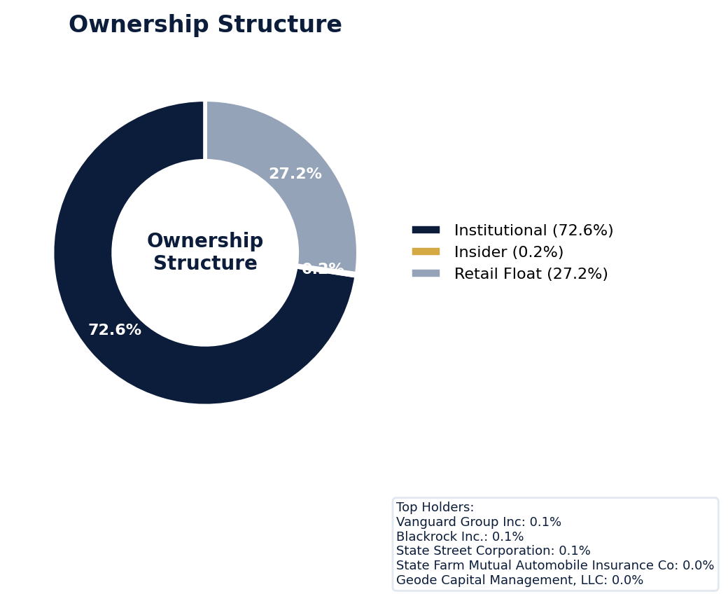
Figure: Ownership breakdown -- institutional, insider, retail float
Category | Percentage
Institutional Ownership | 72.6%
Insider Ownership | 0.2%
Retail Float | 27.2%
Top Holder | Ownership %
Vanguard Group Inc | 0.1%
Blackrock Inc. | 0.1%
State Street Corporation | 0.1%
State Farm Mutual Automobile Insurance Co | 0.0%
Geode Capital Management, LLC | 0.0%
Sentiment & Narrative Coherence
Signal | Assessment
Narrative Coherence | COHERENT
Anti-Takeover Provisions
Anti-takeover provision data not available. Review DEF 14A and charter documents for complete analysis.

ELEVATED CONCERN
CATERPILLAR currently faces no active SCA, but its 8.72% adjusted filing rate is over triple the 2.5% sector average, signaling a chronically elevated litigation environment. The five pending derivative suits, typically precursors to future SCAs, are being defended by a moderate-strength panel, suggesting protracted and costly discovery ahead that will pressure D&O retentions. With six open solicitation matters, plaintiffs' firms are actively monitoring for a corrective disclosure, which could emerge from any ongoing SEC scrutiny despite no formal stage being declared. The company's elevated 8.72% filing rate versus the 2.5% sector benchmark indicates a high recurrence probability for future claims. Defense costs alone from these five derivative actions will erode retention layers, and any future SCA settlement could easily reach nine figures based on its market cap and historical exposure.
Section 6: Litigation & Regulatory Exposure
5 derivative action(s) pending, alleging breach of fiduciary duty by directors and officers. 6 statute of limitations window(s) remain open, meaning new claims can still be filed for past events. Under claims-made D&O policy, coverage is triggered when a claim is reported during the policy period. Defense quality assessment: MODERATE.
Litigation Overview: 0 active matter(s), 2 historical matter(s)
Litigation Timeline
Timeline chart not available (no timeline events).
Securities Class Actions
Case Name | Legal Theory | Coverage | Court | Filing Date | Status | Class Period | Lead Counsel | Settlement | Source
In re Caterpillar Inc. Securities (2017) | Rule 10b-5, Derivative / Fiduciary Duty | Side C (Entity) | D. Del. | 2017-03-03 | DISMISSED | N/A | N/A | N/A | [web search, 2026-04-03, LOW]
SEC Enforcement Pipeline
Pipeline: (Comment Letters) -> (Informal Inquiry) -> (Formal Investigation) -> (Wells Notice) -> (Enforcement Action)
No SEC enforcement pipeline activity detected. [10-K Item 3 + Item 1A + 8-K + EFTS, 2026-04-03, LOW]
Derivative Suits
Case Name | Filing Date | Status | Court | Settlement
N/A | N/A | UNKNOWN | Delaware Court of Chancery | N/A
N/A | N/A | DISMISSED | N/A | N/A
Lowinger v. Oberhelman | N/A | APPEAL | N/A | N/A
N/A | N/A | UNKNOWN | N/A | N/A
N/A | N/A | UNKNOWN | Delaware Court of Chancery | N/A
Regulatory Proceedings
Agency | Type | Status
DOJ | investigation | disclosed
OSHA | penalty | disclosed
Industry Claim Patterns
No industry-specific claim patterns identified.
Statute of Limitations Map
Claim Type | Trigger Date | SOL Expiry | Repose Expiry | Window Open
employment_discrimination | 2026-02-13 | 2028-02-13 | 2028-02-13 | OPEN
antitrust | 2026-02-13 | 2030-02-12 | 2030-02-12 | OPEN
FCPA | 2026-02-13 | 2031-02-12 | 2031-02-12 | OPEN
environmental | 2026-02-13 | 2031-02-12 | 2031-02-12 | OPEN
derivative | 2026-02-13 | 2029-02-12 | 2032-02-12 | OPEN
ERISA | 2026-02-13 | 2029-02-12 | 2032-02-12 | OPEN
Section_11 | 2017-03-03 | 2018-03-03 | 2020-03-02 | CLOSED
Section_14a | 2017-03-03 | 2018-03-03 | 2020-03-02 | CLOSED
10b-5 | 2017-03-03 | 2019-03-03 | 2022-03-02 | CLOSED
D&O Context: 6 open exposure window(s). Claims can still be filed within these periods. [ELEVATED]
Defense Strength Assessment
Factor | Assessment
Federal Forum Provision | No
Exclusive Forum Provision | No
PSLRA Safe Harbor | STRONG
Truth-on-Market Viability | NOT_APPLICABLE
Prior Dismissal Success | No prior dismissals identified in Item 3
Overall Defense Strength | MODERATE
No forum selection provisions identified. Safe harbor usage is STRONG with explicit PSLRA citation and specific cautionary language. [DEF 14A; 10-K, 2026-04-03, LOW]
Contingent Liabilities
No disclosed contingent liabilities found in SEC filings. Review Item 8 footnotes and Item 3 for complete assessment.
Workforce, Product & Environmental Matters
None found.
Whistleblower Indicators
No whistleblower indicators identified in SEC filings. SEC whistleblower tips are not publicly disclosed; absence does not confirm lack of activity.

CATERPILLAR’s quality score of 25.5, resulting from total deductions of 11.83 points, places it in the WALK tier with a modeled claim probability of 4.17-5.95%. The risk is dominated by Prior Litigation, which contributed the largest deduction of 3.19 points from 70 identified signals, and an active DOJ criminal investigation that imposes a binding CRF-3 ceiling, mandating high attachment for any Excess or Side A placement. Further pressure comes from IPO/SPAC/M&A activity, which deducted 3.13 points from 16 signals, and elevated Short Interest that deducted 1.52 points, indicating market skepticism that can fuel shareholder suits. The active "Guidance Track Record" pattern suggests management’s forecasts are a recurring litigation trigger, compounded by Restatement/Audit Issues which deducted 1.48 points from 89 signals. Underwrite this account for high-severity claims, requiring severe terms aligned with its MODERATE claim band.
Section 7: Risk Scoring & Synthesis
Underwriting tier: **WALK** (quality score: 25.5/100). Recommended action: Excess/Side A only, high attachment required. Expected claim probability band: 4.2-6.0%. Top risk contributors: Prior Litigation (F1: -3.2 pts); IPO/SPAC/M&A (F4: -3.1 pts); Short Interest (F6: -1.5 pts). Active composite patterns: Guidance Track Record. **Red flag gates active**: DOJ Criminal Investigation (ceiling: 30); Active DOJ Criminal Investigation (ceiling: 100); Whistleblower/Qui Tam Disclosure (ceiling: 100). Binding ceiling: CRF-3. Claim probability band: MODERATE (4.2%-6.0%).
Tier Classification
Metric | Value
Quality Score | 25.5 / 100
Composite Score (pre-ceiling) | 88.2
Total Risk Points Deducted | 11.8
Tier | WALK
Tier Range | 11 - 30
Action Guidance | Excess/Side A only, high attachment required
Probability Range | 4.2-6.0%
Pricing Multiplier | 2x+ at high attachment
Binding Ceiling | CRF-3
Risk Assessment: CRITICAL [CRITICAL]
D&O Claim Peril Assessment
1 of 8 D&O claim perils show active risk signals. Active perils have at least one causal chain with triggered checks.
Peril | Risk Level | Active Chains | Key Evidence
Securities Claims | ELEVATED | 2/5 | Resolved via web search: not confirmed; Verified (value: -3.00)
Fiduciary Breach | LOW | 0/3 | —
Government Enforcement | LOW | 0/2 | —
Employment & Whistleblower | LOW | 0/1 | —
Insolvency & Bankruptcy | LOW | 0/1 | —
Emerging Risks | LOW | 0/2 | —
Consumer & Product Claims | LOW | 0/1 | —
Commercial Litigation | LOW | 0/1 | —
Active Peril Analysis
Securities Claims: ELEVATED [ELEVATED]
Frequency: moderate | Severity: high | Typical range: $5M - $500M+
2 of 5 causal chains active.
Chain: Restatement → Securities Class Action [ELEVATED]
Financial restatement (especially revenue/earnings) triggers near-automatic SCA filing. Restatements provide strong scienter evidence for plaintiffs.
Triggers:
• FIN.ACCT.restatement
Amplifiers:
• FIN.ACCT.restatement_pattern
Historical filing rate: 65% | Median severity: $25M
Chain: Guidance Miss → Securities Fraud [ELEVATED]
Repeated guidance misses or aggressive forward guidance builds scienter case for securities fraud claim when stock eventually declines.
Triggers:
• FIN.GUIDE.earnings_reaction
Amplifiers:
• EXEC.INSIDER.ceo_net_selling
Historical filing rate: 8% | Median severity: $12M
Composite Score Breakdown
Factor | Name | Max Pts | Deducted | % Used | Top Contributor
F1 | Prior Litigation | 20 | 3.2 | 16% | Signal-driven scoring: 70 signals, coverage=100%
F2 | Stock Decline | 15 | 0.7 | 5% | Signal-driven scoring: 30 signals, coverage=100%
F3 | Restatement/Audit Issues | 12 | 1.5 | 12% | Signal-driven scoring: 89 signals, coverage=100%
F4 | IPO/SPAC/M&A | 10 | 3.1 | 31% | Signal-driven scoring: 16 signals, coverage=100%
F5 | Guidance Misses | 10 | 0.3 | 3% | Signal-driven scoring: 28 signals, coverage=100%
F6 | Short Interest | 8 | 1.5 | 19% | Signal-driven scoring: 30 signals, coverage=100%
F7 | Stock Volatility | 9 | 0.6 | 7% | Signal-driven scoring: 30 signals, coverage=100%
F8 | Financial Distress | 8 | 0.0 | 0% | Signal-driven scoring: 15 signals, coverage=100%
F9 | Governance Issues | 6 | 0.7 | 12% | Signal-driven scoring: 41 signals, coverage=100%
F10 | Officer Stability | 2 | 0.1 | 6% | Signal-driven scoring: 92 signals, coverage=100%
10-Factor Risk Profile
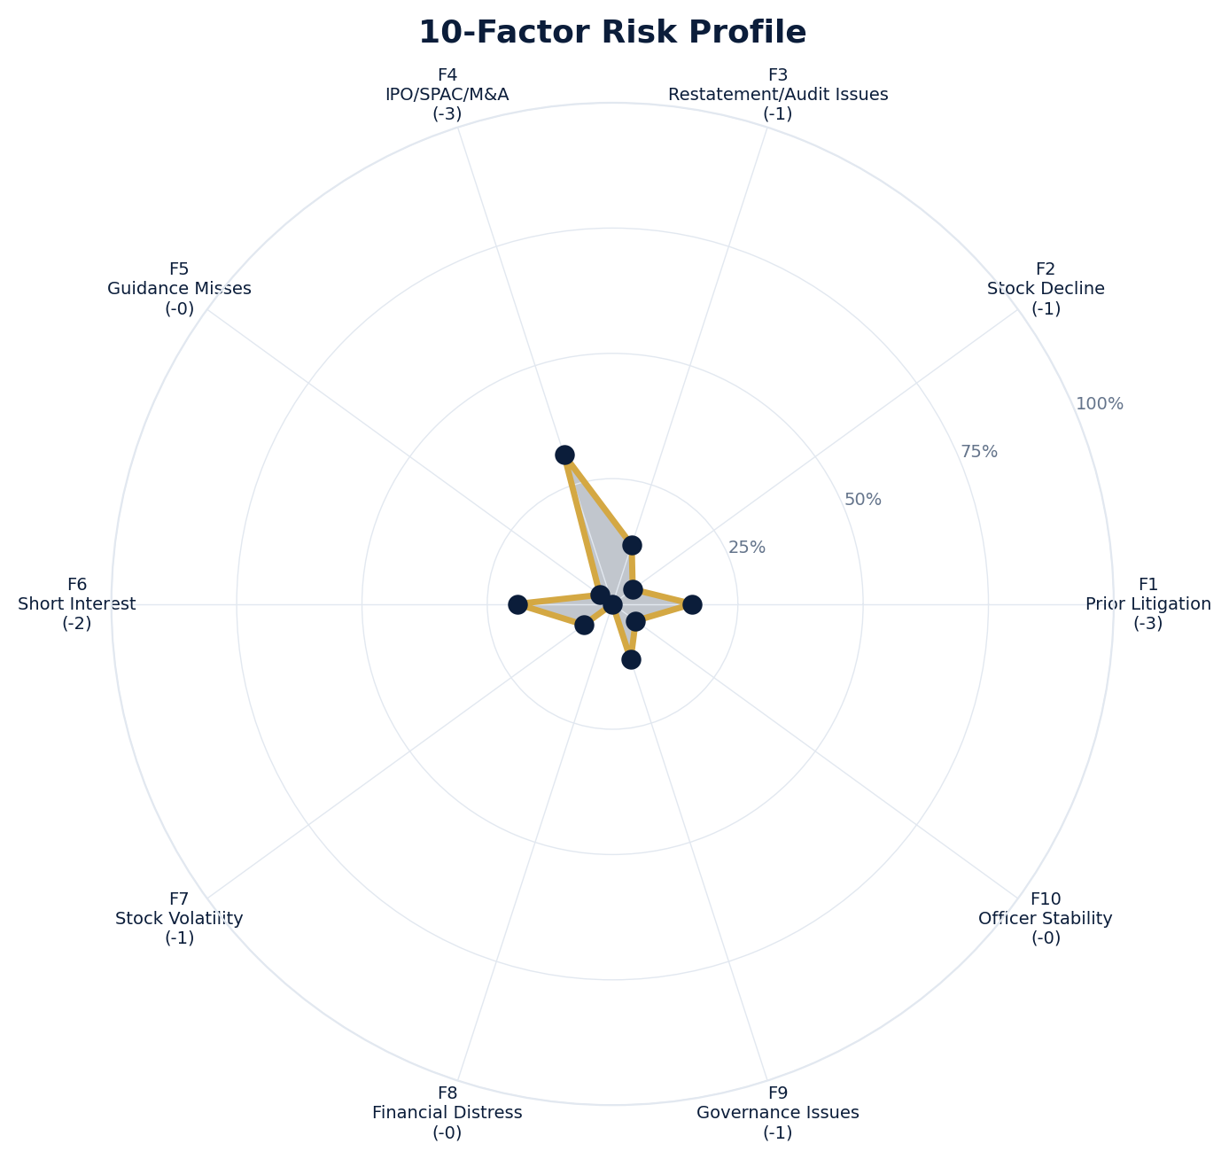
Figure: Radar chart showing risk fraction (points deducted / max) for each of the 10 scoring factors. Larger area = higher risk.
Red Flag Gates
Severity | Description | Source | Impact | Trajectory
CRITICAL | Critical Red Flag: DOJ Criminal Investigation | DOJ criminal: investigation | Ceiling: 30 | NEW
CRITICAL | Critical Red Flag: Active DOJ Criminal Investigation | DOJ criminal: INVESTIGATION | Ceiling: 100 | NEW
CRITICAL | Critical Red Flag: Whistleblower/Qui Tam Disclosure | NLP whistleblower signal: Whistleblower/qui tam language detected: retaliation. Presence of such language in filings may indicate pending or potential False Claims Act or SEC whistleblower actions. | Ceiling: 100 | NEW
LOW | Prior Litigation: 3/20 points | Signal-driven scoring: 70 signals, coverage=100% | F1: 3 pts | NEW
LOW | Stock Decline: 1/15 points | Signal-driven scoring: 30 signals, coverage=100%; Drop contribution modifier: 0.23x (decay + company-specific + disclosure) | F2: 1 pts | NEW
LOW | Restatement/Audit Issues: 1/12 points | Signal-driven scoring: 89 signals, coverage=100% | F3: 1 pts | NEW
LOW | IPO/SPAC/M&A: 3/10 points | Signal-driven scoring: 16 signals, coverage=100% | F4: 3 pts | NEW
LOW | Guidance Misses: 0/10 points | Signal-driven scoring: 28 signals, coverage=100% | F5: 0 pts | NEW
LOW | Short Interest: 2/8 points | Signal-driven scoring: 30 signals, coverage=100% | F6: 2 pts | NEW
LOW | Stock Volatility: 1/9 points | Signal-driven scoring: 30 signals, coverage=100% | F7: 1 pts | NEW
LOW | Governance Issues: 1/6 points | Signal-driven scoring: 41 signals, coverage=100% | F9: 1 pts | NEW
LOW | Officer Stability: 0/2 points | Signal-driven scoring: 92 signals, coverage=100% | F10: 0 pts | NEW
LOW | Pattern: Guidance Track Record (BASELINE) | Pattern evaluation | F5: 0 | NEW
Critical: 3, High: 0, Moderate: 0, Low: 10
Risk Type Classification
Attribute | Value
Primary Risk Type | GUIDANCE_DEPENDENT
Supporting Evidence | F5 guidance misses: 0.3090909090909091 points; Issues guidance (philosophy: CONSERVATIVE)
Severity Scenarios
Analysis based on market cap: $335.6B
Percentile | Label | Settlement Est. | Defense Costs | Total Exposure
25th | favorable | $103.7M | $15.6M | $119.3M
50th | median | $207.4M | $41.5M | $248.9M
75th | adverse | $414.8M | $103.7M | $518.5M
95th | catastrophic | $829.6M | $248.9M | $1.1B
Calibration Notes (SECT7-11)
The following items are flagged NEEDS CALIBRATION and require expert review before final pricing:
- SECT7-11: All scoring parameters require calibration against historical cases
Factor Detail
Factor | Name | Deducted | Rules Triggered | Evidence
F1 | Prior Litigation | 3.2 | N/A | Signal-driven scoring: 70 signals, coverage=100%
F2 | Stock Decline | 0.7 | drop_contribution_adjustment | Signal-driven scoring: 30 signals, coverage=100%; Drop contribution modifier: 0.23x (decay + company-specific + disclosure)
F3 | Restatement/Audit Issues | 1.5 | N/A | Signal-driven scoring: 89 signals, coverage=100%
F4 | IPO/SPAC/M&A | 3.1 | N/A | Signal-driven scoring: 16 signals, coverage=100%
F5 | Guidance Misses | 0.3 | N/A | Signal-driven scoring: 28 signals, coverage=100%
F6 | Short Interest | 1.5 | N/A | Signal-driven scoring: 30 signals, coverage=100%
F7 | Stock Volatility | 0.6 | N/A | Signal-driven scoring: 30 signals, coverage=100%
F9 | Governance Issues | 0.7 | N/A | Signal-driven scoring: 41 signals, coverage=100%
F10 | Officer Stability | 0.1 | N/A | Signal-driven scoring: 92 signals, coverage=100%
Sub-Component Breakdown
Factor | Component | Value
F1 | base | 3.19
F1 | bonus | 0.00
F1 | modifiers | 0.00
F1 | hard_triggers | 0.00
F1 | total_before_cap | 3.19
F1 | capped | 3.19
F2 | base | 3.27
F2 | bonus | 0.00
F2 | modifiers | 0.00
F2 | hard_triggers | 0.00
F2 | drop_contribution_modifier | 0.23
F2 | total_before_cap | 0.75
F2 | capped | 0.75
F3 | base | 1.74
F3 | bonus | 0.00
F3 | modifiers | 0.00
F3 | hard_triggers | 0.00
F3 | total_before_cap | 1.74
F3 | capped | 1.74
F3 | ies_amplification | 0.85
F4 | base | 3.12
F4 | bonus | 0.00
F4 | modifiers | 0.00
F4 | hard_triggers | 0.00
F4 | total_before_cap | 3.12
F4 | capped | 3.12
F5 | base | 0.36
F5 | bonus | 0.00
F5 | modifiers | 0.00
F5 | hard_triggers | 0.00
F5 | total_before_cap | 0.36
F5 | capped | 0.36
F5 | pattern_modifier | 0.00
F5 | ies_amplification | 0.85
F6 | base | 1.79
F6 | bonus | 0.00
F6 | modifiers | 0.00
F6 | hard_triggers | 0.00
F6 | total_before_cap | 1.79
F6 | capped | 1.79
F6 | ies_amplification | 0.85
F7 | base | 0.75
F7 | bonus | 0.00
F7 | modifiers | 0.00
F7 | hard_triggers | 0.00
F7 | total_before_cap | 0.75
F7 | capped | 0.75
F7 | ies_amplification | 0.85
F9 | base | 0.83
F9 | bonus | 0.00
F9 | modifiers | 0.00
F9 | hard_triggers | 0.00
F9 | total_before_cap | 0.83
F9 | capped | 0.83
F9 | ies_amplification | 0.85
F10 | base | 0.11
F10 | bonus | 0.00
F10 | modifiers | 0.00
F10 | hard_triggers | 0.00
F10 | total_before_cap | 0.11
F10 | capped | 0.11
Pattern Detection Results
Pattern | Severity | Triggers Matched | Score Impact
Guidance Track Record | BASELINE |  | F5: +0
Allegation Theory Mapping
Theory | Exposure | Factor Sources | Key Findings
A_DISCLOSURE | MODERATE | F1, F3, F5 | F1: Signal-driven scoring: 70 signals, coverage=100%; F3: Signal-driven scoring: 89 signals, coverage=100%
B_GUIDANCE | LOW | F2, F5 | F2: Signal-driven scoring: 30 signals, coverage=100%; F2: Drop contribution modifier: 0.23x (decay + company-specific + disclosure)
C_PRODUCT_OPS | LOW | F7 | F7: Signal-driven scoring: 30 signals, coverage=100%; 2 regulatory proceedings
D_GOVERNANCE | LOW | F9, F10 | F9: Signal-driven scoring: 41 signals, coverage=100%; F10: Signal-driven scoring: 92 signals, coverage=100%
E_MA | MODERATE | F4 | F4: Signal-driven scoring: 16 signals, coverage=100%
D&O Context: Primary allegation exposure is A_DISCLOSURE. MODERATE exposure in: A_DISCLOSURE, E_MA.
Claim Probability Detail
Metric | Value
Probability Band | MODERATE
Range | 4.2% - 6.0%
Industry Base Rate | 2.5%
Adjustment Rationale | Industry base rate: 2.5%. Tier WALK (15-20%): Substantially above base rate. Cri
Claim probability: MODERATE [ELEVATED]
Tower Position Recommendation
Metric | Value
Recommended Position | HIGH_EXCESS
Minimum Attachment | $207.4M (based on 50th percentile settlement)
Side A/DIC Assessment | Standard Side A considerations
Position | Risk Assessment | Premium Guidance | Attachment
PRIMARY | Primary layer carries 57% of expected loss exposur | Full rate, slight discount for | $0 ground-up
LOW_EXCESS | Low excess layer carries 18% of expected loss expo | Market rate | $5-15M xs $5-15M
MID_EXCESS | Mid excess layer carries 13% of expected loss expo | Market to 1.3x | $15-50M xs $15-50M
HIGH_EXCESS | High excess layer carries 11% of expected loss exp | 1.3-2x with attachment | $50M+ xs $50M+
DECLINE | WALK+ with compounding factors | N/A | N/A
Forensic Composite Scores
Composite | Score | Interpretation
Financial Integrity Score (FIS) | N/A | Not available
Reporting Quality Score (RQS) | N/A | Not available
Cash Flow Quality Score (CFQS) | N/A | Not available
Executive Risk Profile
Metric | Value
Weighted Score | 25
Risk Level | N/A
- [Joseph Creed (CEO)]: Prior litigation: title: Caterpillar CEO Joe Creed takes over added role as board chairman
- [Joseph Creed (CEO)]: Prior litigation: summary: Joe Creed, a central Illinois native, now has an additional role at Caterpillar with Jim Um
- [Joseph Creed (CEO)]: Prior litigation: url: https://www.pjstar.com/story/business/2026/04/02/caterpillar-ceo-joe-creed-now-also-chairman-of
- [Of Shareholders (Director)]: Prior litigation: url: https://shareholdersfoundation.com/caterpillar-inc-nysecat-investor-securities-class-action-law
- [Of Shareholders (Director)]: Prior litigation: snippet: If you purchased shares of Caterpillar Inc. (NYSE:CAT), you may have certain options. Pleas
- [Of Shareholders (Director)]: Prior litigation: snippet: Caterpillar Inc on Wednesday won the dismissal of a lawsuit accusing the heavy machinery ma
Temporal Signals
Type | Direction | Magnitude | Description
Unknown | N/A | N/A
Unknown | N/A | N/A
Unknown | N/A | N/A
Unknown | N/A | N/A
Unknown | N/A | N/A
Unknown | N/A | N/A
Unknown | N/A | N/A
NLP Filing Analysis
Metric | Value
Readability Score | {'current_fog': 18.87, 'prior_fog': None, 'fog_change': None, 'current_flesch': 23.26, 'prior_flesch': None, 'classification': 'CURRENT_ONLY', 'evidence': 'Current Fog Index: 18.9 (prior year unavailable)'}
Tone Assessment | N/A
Risk Language Density | N/A
Peril Assessment
Plaintiff Peril Heat Map
Plaintiff Type | Probability | Severity
Shareholders | ELEVATED | SIGNIFICANT
Regulators | ELEVATED | SIGNIFICANT
Customers | VERY LOW | NUISANCE
Competitors | VERY LOW | NUISANCE
Employees | LOW | MINOR
Creditors | MODERATE | MODERATE
Government | LOW | MINOR
Shareholders: 57 triggered checks. Key: Litigation History Profile: 1 (elevated vs benchmark of 0)
Regulators: 22 triggered checks. Key: Disclosure Complexity Score: 27 (elevated vs benchmark of 25)
Creditors: 3 triggered checks. Key: Credit Facility Utilization: 3500 (elevated vs benchmark of 90)
Bear Cases
Bear Case: A Disclosure
CATERPILLAR INC faces elevated exposure to securities disclosure fraud claims. Key risk indicators: Litigation History Profile (critical); VIE/SPE Off-Balance-Sheet Structures (critical). Estimated severity is significant, warranting detailed underwriter review.
Defense: Defense: No active Section 11 windows — statute of limitations expired for offering claims
Evidence Chain
1. [BIZ.CLASS.litigation_history] Litigation History Profile (Source: total_sca_count)
2. [BIZ.STRUCT.vie_spe] VIE/SPE Off-Balance-Sheet Structures (Source: vie_spe_present)
3. [BIZ.EVENT.ipo_exposure] IPO/Offering Exposure Window (Source: event_ipo_exposure_score)
4. [BIZ.OPS.workforce] Workforce Distribution (Source: workforce_distribution)
5. [BIZ.STRUC.obs_exposure] Off-Balance-Sheet Exposure (Source: obs_exposure_score)
6. [DISC.YOY.removed_risk_factors] Removed Risk Factors (YoY) (Source: yoy_removed_risk_count)
7. [EXEC.PRIOR_LIT.any_officer] Any Officer With Prior Litigation at Previous Company (Source: value)
8. [EXEC.PRIOR_LIT.ceo_cfo] CEO or CFO With Prior Litigation (Source: value)
9. [EXEC.INSIDER.ceo_net_selling] CEO Net Seller of Stock (Source: value)
10. [EXEC.AGGREGATE.board_risk] Board Aggregate Risk Score (Source: value)
Probability: ELEVATED | Severity: SIGNIFICANT
Bear Case: E Ma
CATERPILLAR INC faces elevated exposure to M&A-related claims. Key risk indicators: Litigation History Profile (critical); VIE/SPE Off-Balance-Sheet Structures (critical). Estimated severity is significant, warranting detailed underwriter review.
Evidence Chain
1. [BIZ.CLASS.litigation_history] Litigation History Profile (Source: total_sca_count)
2. [BIZ.STRUCT.vie_spe] VIE/SPE Off-Balance-Sheet Structures (Source: vie_spe_present)
3. [BIZ.EVENT.ipo_exposure] IPO/Offering Exposure Window (Source: event_ipo_exposure_score)
4. [BIZ.OPS.workforce] Workforce Distribution (Source: workforce_distribution)
5. [BIZ.STRUC.obs_exposure] Off-Balance-Sheet Exposure (Source: obs_exposure_score)
6. [DISC.YOY.removed_risk_factors] Removed Risk Factors (YoY) (Source: yoy_removed_risk_count)
7. [EXEC.PRIOR_LIT.any_officer] Any Officer With Prior Litigation at Previous Company (Source: value)
8. [EXEC.PRIOR_LIT.ceo_cfo] CEO or CFO With Prior Litigation (Source: value)
9. [EXEC.INSIDER.ceo_net_selling] CEO Net Seller of Stock (Source: value)
10. [EXEC.AGGREGATE.board_risk] Board Aggregate Risk Score (Source: value)
Probability: ELEVATED | Severity: SIGNIFICANT
Settlement Prediction
Settlement prediction computed but no scenarios available.
Tower Risk Characterization
Tower characterization not available.
Coverage Gaps -- Data Not Available
The following checks could not be evaluated because required data was not acquired. These items are NOT cleared -- they represent gaps in coverage that should be considered in the underwriting decision.
Executive Summary & Key Metrics
[REQUIRED] BIZ.SIZE.growth_trajectory (Public Company Tenure): Required data not available from filings
[REQUIRED] BIZ.SIZE.public_tenure (Revenue Growth YoY): Required data not available from filings
[EVALUATIVE] BIZ.STRUCT.subsidiary_count (Subsidiary Count Complexity): Required data not available from filings
[EVALUATIVE] BIZ.DEPEND.labor (Concentration Risk Composite): Required data not available from filings
[REQUIRED] BIZ.MA.goodwill_balance (Goodwill Balance): Required data not available from filings
[REQUIRED] BIZ.MA.acquisition_spend (Acquisition Spend Magnitude): Required data not available from filings
[EVALUATIVE] BIZ.MA.goodwill_change (Goodwill Trajectory): Required data not available from filings
[REQUIRED] BIZ.MA.acquisition_list (Recent Acquisitions): Required data not available from filings
[REQUIRED] BIZ.MODEL.lifecycle (Segment Lifecycle Risk): Required data not available from filings
[REQUIRED] BIZ.MODEL.segment_margins (Segment Margin Profile): Required data not available from filings
[EVALUATIVE] ABS.DISC.audit_fees (Missing Audit Fee Disclosure): Expected signals not found in evaluation results
[EVALUATIVE] ABS.DISC.board_independence (Missing Board Independence Disclosure): Could not determine disclosure presence or absence
[EVALUATIVE] ABS.DISC.clawback_policy (Missing Clawback Policy Disclosure): Expected signals not found in evaluation results
[EVALUATIVE] ABS.DISC.cyber_risk (Missing Cybersecurity Risk Disclosure): Expected signals not found in evaluation results
[EVALUATIVE] ABS.DISC.debt_covenants (Missing Debt Covenant Disclosure): Expected signals not found in evaluation results
[EVALUATIVE] ABS.DISC.derivative_instruments (Missing Derivative Instruments Disclosure): Expected signals not found in evaluation results
[EVALUATIVE] ABS.DISC.esg (Missing ESG Disclosure): Expected signals not found in evaluation results
[EVALUATIVE] ABS.DISC.executive_comp (Missing Executive Compensation Disclosure): Expected signals not found in evaluation results
[EVALUATIVE] ABS.DISC.goodwill_impairment (Missing Goodwill Impairment Disclosure): Expected signals not found in evaluation results
[EVALUATIVE] ABS.DISC.lease_obligations (Missing Lease Obligation Disclosure): Expected signals not found in evaluation results
[EVALUATIVE] ABS.DISC.litigation_contingency (Missing Litigation Contingency Disclosure): Expected signals not found in evaluation results
[EVALUATIVE] ABS.DISC.pension_obligations (Missing Pension Obligation Disclosure): Expected signals not found in evaluation results
[EVALUATIVE] ABS.DISC.related_party (Missing Related-Party Transaction Disclosure): Expected signals not found in evaluation results
[EVALUATIVE] ABS.DISC.revenue_recognition (Missing Revenue Recognition Policy Disclosure): Expected signals not found in evaluation results
[EVALUATIVE] ABS.DISC.risk_factors (Missing Risk Factor Disclosure): Expected signals not found in evaluation results
[EVALUATIVE] ABS.DISC.segment_reporting (Missing Segment Reporting Disclosure): Expected signals not found in evaluation results
[EVALUATIVE] ABS.DISC.stock_comp (Missing Stock Compensation Disclosure): Expected signals not found in evaluation results
[EVALUATIVE] ABS.DISC.tax_positions (Missing Uncertain Tax Position Disclosure): Expected signals not found in evaluation results
[EVALUATIVE] CONJ.COMP.perf_divergence (Compensation-Performance Divergence): 3/3 component signals unavailable
[EVALUATIVE] CONJ.DISTRESS.insider (Financial Distress + Insider Selling): 2/3 component signals unavailable
[EVALUATIVE] CONJ.GOV.governance_event (Weak Governance + Adverse Event): 3/5 component signals unavailable
[EVALUATIVE] CONJ.FIN.growth_margin_guidance (Rapid Growth + Margin Compression + Guidance Miss): 3/3 component signals unavailable
[EVALUATIVE] CONJ.INSIDER.news_gap (Insider Selling + Material News Gap): 3/3 component signals unavailable
[EVALUATIVE] CONJ.REG.litigation (Regulatory Action + New Material Litigation): 3/3 component signals unavailable
[EVALUATIVE] CTX.FIN.capex_sector (Capital Expenditure in Sector Context): Source signal FIN.INVEST.capex_ratio not in results
[EVALUATIVE] CTX.COMP.lifecycle (CEO Compensation in Lifecycle Context): Source signal EXEC.COMP.ceo_total_comp not in results
[EVALUATIVE] CTX.COMP.product_tower (Compensation Severity by Product/Tower): Source signal EXEC.COMP.ceo_total_comp not in results
[EVALUATIVE] CTX.FIN.debt_maturity (Debt Maturity Profile in Lifecycle Context): Source signal FIN.DEBT.maturity_profile not in results
[EVALUATIVE] CTX.FIN.distress_product (Financial Distress by Product/Tower): Source signal FIN.FORENSIC.altman_z not in results
[EVALUATIVE] CTX.FIN.dividend_lifecycle (Dividend Policy in Lifecycle Context): Source signal FIN.RETURN.dividend_yield not in results
[EVALUATIVE] CTX.EXEC.tenure_lifecycle (Executive Tenure in Lifecycle Context): Source signal EXEC.TURN.c_suite not in results
[EVALUATIVE] CTX.GOV.lifecycle (Board Independence in Lifecycle Context): Required context dimensions ['lifecycle_stage'] not available
[EVALUATIVE] CTX.FIN.growth_lifecycle (Revenue Growth in Lifecycle Context): Required context dimensions ['lifecycle_stage'] not available
[EVALUATIVE] CTX.MKT.insider_lifecycle (Insider Trading in Lifecycle Context): Source signal STOCK.INSIDER.net_selling not in results
[EVALUATIVE] CTX.FIN.leverage_sector (Leverage in Sector Context): Source signal FIN.DEBT.leverage_ratio not in results
[EVALUATIVE] CTX.LIT.size (Litigation Frequency by Company Size): Source signal LIT.SCA.active_cases not in results
[EVALUATIVE] CTX.RISK.ma_lifecycle (M&A Activity in Lifecycle Context): Source signal BIZ.MA.acquisition_activity not in results
[EVALUATIVE] CTX.RISK.regulatory_sector (Regulatory Risk in Sector Context): Source signal LIT.SEC.enforcement not in results
[EVALUATIVE] CTX.RISK.rpt_sector (Related-Party Risk in Sector Context): Source signal GOV.RPT.related_party not in results
[EVALUATIVE] CTX.MKT.short_interest_sector (Short Interest in Sector Context): Source signal STOCK.SHORT.interest_ratio not in results
[EVALUATIVE] CTX.MKT.turnover_sector (Stock Turnover in Sector Context): Source signal STOCK.VOL.turnover_rate not in results
[EVALUATIVE] CTX.MKT.volatility_sector (Stock Volatility in Sector Context): Source signal STOCK.VOL.historical not in results
Financial Health
[EVALUATIVE] FIN.PEER.revenue_bottom_quartile (Revenue Bottom Quartile (Cross-Filer)): No peer comparison data available
[EVALUATIVE] FIN.PEER.leverage_top_decile (Leverage Top Decile (Sector-Relative)): No peer comparison data available
[EVALUATIVE] FIN.PEER.margin_compression (Operating Margin Compression (Cross-Filer)): No peer comparison data available
[EVALUATIVE] FIN.PEER.profitability_laggard (Profitability Laggard (Sector-Relative)): No peer comparison data available
[EVALUATIVE] FIN.PEER.size_outlier_small (Size Outlier Small (Cross-Filer)): No peer comparison data available
[EVALUATIVE] FIN.PEER.cash_flow_weak (Cash Flow Weakness (Cross-Filer)): No peer comparison data available
[EVALUATIVE] LIT.DEFENSE.forum_selection (Federal Forum Selection Clause): Required data not available from filings
Governance & Leadership
[EVALUATIVE] EXEC.INSIDER.cfo_net_selling (CFO Net Seller of Stock): Required data not available from filings
[EVALUATIVE] EXEC.TENURE.cfo_new (CFO Tenure Less Than 2 Years): Data mapping not configured for this check
[REQUIRED] EXEC.PROFILE.board_size (Board Size (Number of Members)): Required data not available from filings
[REQUIRED] EXEC.PROFILE.independent_ratio (Board Independence Percentage): Required data not available from filings
[EVALUATIVE] EXEC.PROFILE.overboarded_directors (Directors Serving on 4+ Boards): Required data not available from filings
[EVALUATIVE] GOV.BOARD.size (Board Size): Required data not available from filings
[EVALUATIVE] GOV.BOARD.independence (Board Independence): Required data not available from filings
[EVALUATIVE] GOV.BOARD.diversity (Board Diversity): Required data not available from filings
[EVALUATIVE] GOV.BOARD.tenure (Tenure): Required data not available from filings
[EVALUATIVE] GOV.BOARD.overboarding (Overboarding): Required data not available from filings
[EVALUATIVE] GOV.BOARD.attendance (Attendance): Required data not available from filings
[EVALUATIVE] GOV.BOARD.meetings (Meetings): Required data not available from filings
[EVALUATIVE] GOV.BOARD.succession (Succession): Required data not available from filings
[EVALUATIVE] GOV.EXEC.cfo_profile (CFO Profile): Required data not available from filings
[EVALUATIVE] GOV.PAY.golden_para (Golden Para): Required data not available from filings
[EVALUATIVE] GOV.PAY.equity_burn (Equity Burn): Required data not available from filings
[EVALUATIVE] GOV.PAY.hedging (Hedging): Required data not available from filings
[REQUIRED] GOV.RIGHTS.bylaws (Bylaws): Required data not available from filings
[EVALUATIVE] GOV.RIGHTS.takeover (Takeover): Required data not available from filings
[EVALUATIVE] GOV.RIGHTS.proxy_access (Proxy Access): Required data not available from filings
[REQUIRED] GOV.RIGHTS.forum_select (Forum Select): Required data not available from filings
[EVALUATIVE] GOV.RIGHTS.supermajority (Supermajority): Required data not available from filings
[EVALUATIVE] GOV.RIGHTS.action_consent (Action Consent): Required data not available from filings
[EVALUATIVE] GOV.RIGHTS.special_mtg (Special Mtg): Required data not available from filings
[EVALUATIVE] GOV.RIGHTS.classified (Classified): Required data not available from filings
Market & Trading
[EVALUATIVE] FIN.COMP.rsu_grants (RSU Grant Trend): Required data not available from filings
[EVALUATIVE] FIN.CONT.loss_accrual (Loss Contingency Accrual): Required data not available from filings
[EVALUATIVE] FIN.CONT.loss_estimate (Loss Contingency Estimate): Required data not available from filings
[EVALUATIVE] FIN.DEBT.maturity_concentration (Debt Maturity Concentration): Data mapping not configured for this check
[EVALUATIVE] FIN.QUALITY.q4_revenue_concentration (Q4 Revenue Concentration): Required data not available from filings
[EVALUATIVE] FIN.QUALITY.revenue_recognition_risk (Revenue Recognition Risk Indicators): Data mapping not configured for this check
[EVALUATIVE] FIN.FORENSIC.level3_fair_value (Level 3 Fair Value Asset Concentration): Data mapping not configured for this check
[EVALUATIVE] FIN.FORENSIC.goodwill_deterioration_pattern (Goodwill Deterioration Pattern): Data mapping not configured for this check
[EVALUATIVE] FIN.FORENSIC.related_party_revenue (Related Party Revenue Concentration): Data mapping not configured for this check
[EVALUATIVE] FWRD.EVENT.ma_integration_risk (M&A Integration Risk): Data mapping not configured for this check
[EVALUATIVE] FIN.FORENSIC.margin_compression (Forensic Margin Compression): Data mapping not configured for this check
[EVALUATIVE] FIN.FORENSIC.buyback_timing (Share Buyback Timing Quality): Data mapping not configured for this check
[EVALUATIVE] FIN.FORENSIC.debt_maturity_concentration (Debt Maturity Concentration): Data mapping not configured for this check
[EVALUATIVE] FIN.FORENSIC.pension_underfunding (Pension Underfunding Risk): Data mapping not configured for this check
[EVALUATIVE] FIN.FORENSIC.dsri_elevated (Days Sales Receivable Index Elevated): Data mapping not configured for this check
[EVALUATIVE] FIN.FORENSIC.aqi_elevated (Asset Quality Index Elevated): Data mapping not configured for this check
[EVALUATIVE] FIN.FORENSIC.tata_elevated (Total Accruals to Total Assets Elevated): Data mapping not configured for this check
[EVALUATIVE] FIN.FORENSIC.non_gaap_gap (Non-GAAP to GAAP Earnings Gap): Data mapping not configured for this check
[EVALUATIVE] FIN.FORENSIC.goodwill_growth_rate (Goodwill Growth Rate): Data mapping not configured for this check
[EVALUATIVE] FIN.FORENSIC.acquisition_to_revenue (Acquisition Spend Relative to Revenue): Data mapping not configured for this check
[EVALUATIVE] FIN.PROFIT.revenue (Revenue Analysis): Required data not available from filings
[EVALUATIVE] FIN.GUIDE.track_record (Guidance Track Record): Required data not available from filings
[EVALUATIVE] FIN.RESTRUCT.severance (Severance Costs): Required data not available from filings
[EVALUATIVE] FIN.IMPAIR.asset_writedown (Asset Impairment): Required data not available from filings
[REQUIRED] NLP.FILING.filing_timing_change (Filing Date Shifted Significantly vs Prior Year): Required data not available from filings
[EVALUATIVE] FIN.FORENSIC.m_score_composite (Beneish M-Score Composite (XBRL)): Data mapping not configured for this check
Gap breakdown: Required items: 12 | Evaluative checks: 98
Total: 110 checks data-unavailable out of 576 total checks (81% coverage)

Calibration Notes
System Intelligence Status
Checks active: 601
Checks incubating: 0 (pending human approval)
Pending feedback: 0 entries
Recent Calibration Changes
Date | Check | Change | Changed By
2026-04-02 | EMERGING_TECH_REGULATORY_GAP | Proposed by ingestion of 'blind_spot:COIN:SEC Sends Wells No | ingestion_pipeline
2026-04-02 | CRYPTO_HACKING_INCIDENTS | Proposed by ingestion of 'blind_spot:COIN:Coinbase Drops on | ingestion_pipeline
2026-04-02 | CRYPTO_SEC_INVESTIGATIONS | Proposed by ingestion of 'blind_spot:COIN:Coinbase Drops on | ingestion_pipeline
2026-04-02 | CRYPTO_REGULATORY_CLARITY | Proposed by ingestion of 'blind_spot:COIN:SEC Sends Wells No | ingestion_pipeline
2026-04-02 | CRYPTO_STAKING_REGULATORY | Proposed by ingestion of 'blind_spot:COIN:SEC Sends Wells No | ingestion_pipeline
2026-04-02 | crypto_cyber_incident_frequency | Proposed by ingestion of 'blind_spot:COIN:Coinbase Drops on | ingestion_pipeline
2026-04-02 | crypto_sec_investigation | Proposed by ingestion of 'blind_spot:COIN:Coinbase Drops on | ingestion_pipeline
2026-04-02 | AUDITOR_RESIGNATION_INTEGRITY | Proposed by ingestion of 'blind_spot:SMCI:Super Micro Comput | ingestion_pipeline
2026-04-02 | CHINA_SALES_DISCLOSURE | Proposed by ingestion of 'blind_spot:SMCI:Super Micro Comput | ingestion_pipeline
2026-04-02 | EXPORT_COMPLIANCE_CONTROLS | Proposed by ingestion of 'blind_spot:SMCI:Super Micro Comput | ingestion_pipeline
Discovery Findings
No new discoveries from this run.
Feedback for CAT
No pending feedback for CAT.

