
Angry Dolphin -- D&O Underwriting Worksheet
Coinbase Global, Inc. (COIN)
Generated: April 03, 2026
[Table of Contents -- Update in Word]

Coinbase Global, Inc. (COIN) presents a high-severity D&O risk profile, meriting a restrictive "WALK" tier placement. The recommended action is Excess/Side A only coverage with a high attachment point, due to a modeled claim probability band of 7.31% to 10.44% and an inherent risk score of 10.44%. The active securities class action, *In re Coinbase Global, Inc. Securities Litigation (2022)*, imposes a 55-point scoring ceiling and drove a 4.93-point deduction for Prior Litigation. Catastrophic equity volatility, including a 61.4% decline from its 52-week high and a 19.9% single-week drop, compounds securities litigation risk. A natural language processing flag detected "whistleblower" language in SEC filings, representing a critical unknown liability with a 100-point ceiling impact. These headwinds are partially mitigated by a clean audit history, the absence of financial distress per Altman Z-Score, and stable C-suite leadership with zero departures in 18 months. The firm’s $46.2B market cap and positive free cash flow provide balance sheet capacity, yet do not offset the elevated litigation overhang. Consequently, primary layer capacity is contraindicated; any D&O placement must be structured to isolate non-indemnifiable Side A exposures above a significant retention.
Executive Summary
Underwriting Thesis
Coinbase Global, Inc. is a $46.2B (Decile 2 of 10) large-cap financials company that would normally present as a stronger underwriting account were it not for critical red flags: Active Securities Class Action and Catastrophic Stock Drop. These findings impose a hard quality score ceiling of 50, placing the account in WALK tier (29/100) regardless of other favorable factors. The balance sheet is strong (D/E 0.49, Z-Score 4.64), eliminating financial distress as a D&O claim catalyst. The primary risk driver is Prior Litigation, driving elevated risk in this area. Signal-driven scoring: 70 signals, coverage=100%. At a 7-10% claim probability (10.4% adjusted rate, 2.6x the Financials sector baseline of 4.0%), this account requires high-excess positioning with elevated attachment.
Company Snapshot
Attribute | Value | Source
Company | Coinbase Global, Inc.
Ticker | COIN
Exchange | Nasdaq
Sector | Financial Services
Industry | Financial Data & Stock Exchanges
Market Cap | $46.2B [Decile 2] (Ranks at the 0th percentile among 10 peers) | [yfinance, filed 2026-04-03, MEDIUM confidence]
Revenue | $7.2B | [10-K 2025-12-31 CIK1679788 accn:0001679788-26-000015, filed 2025-12-31, HIGH confidence]
Employees | 4,951 | [yfinance, filed 2026-04-03, MEDIUM confidence]
SIC | 6199 -- Finance Services
GICS | 40201020
NAICS | 523910
FPI Status | No
Fiscal Year End | 12-31
Tier Classification
Attribute | Value
Tier | WALK
Composite Score | 83.8/100
Quality Score | 29.2/100
Factor Breakdown | F1: 4.9, F2: 1.6, F3: 0.9, F4: 2.6, F5: 2.0, F6: 2.0, F7: 0.6, F8: 0.2, F9: 1.2, F10: 0.1
Score Ceiling | Capped at 50 by CRF-9 (Recent Drop - 7 Day)
Position | 83.8 falls in WALK range (11-30)
Appetite | Excess/Side A only, high attachment required
Classification: WALK [CRITICAL]
Inherent Risk Baseline
Component | Value
Market Cap Tier | LARGE [Decile 2]
Sector | Financials (Base rate: 4.0%)
Size Adjustment | 1.28x (LARGE cap multiplier) -> 5.1%
Score Adjustment | 2.04x (quality score multiplier) -> 10.4%
Severity Percentile | Settlement Estimate
25th (favorable) | $15.0M
50th (median) | $39.0M
75th (adverse) | $57.0M
95th (catastrophic) | $75.0M
At a 10.4% adjusted claim rate, the company faces 2.6x its sector baseline of 4.0% for Financials companies. This rate reflects the LARGE cap multiplier (1.28x) combined with the quality score multiplier (2.04x from WALK tier classification). If the score improved to WRITE tier, the rate would drop to approximately 5.1%.
Note: NEEDS CALIBRATION
Underwriting Headwinds
1. Critical Red Flag [CRITICAL]
Critical Red Flag: Active Securities Class Action — Active SCA: In re Coinbase Global, Inc. Securities Litigation (2022). This triggers a Critical Red Flag, imposing a score ceiling of 29. (see Litigation)
2. Critical Red Flag [CRITICAL]
Coinbase Global, Inc.'s stock exhibits elevated volatility with a -61% dip of -61.4% from its 52-week high. The estimated DDL of $240.4B amplifies settlement severity for any corrective disclosure event. Short interest at 11.5% of float indicates institutional bearish positioning that often precedes or amplifies SCA filings. This triggers a Critical Red Flag, imposing a score ceiling of 29. (see Market & Trading)
3. Critical Red Flag [CRITICAL]
Critical Red Flag: Recent Drop - 7 Day — 7-day drop: 19.9% (3 days ago). This triggers a Critical Red Flag, imposing a score ceiling of 29.
4. Critical Red Flag [CRITICAL]
Critical Red Flag: Whistleblower/Qui Tam Disclosure — NLP whistleblower signal: Whistleblower/qui tam language detected: whistleblower. Presence of such language in filings may indicate pending or potential False Claims Act or SEC whistleblower actions.. This triggers a Critical Red Flag, imposing a score ceiling of 29. (see Litigation)
5. Structural Complexity & Litigation History [HIGH]
Coinbase Global, Inc. has 13 subsidiaries, increasing multi-jurisdictional litigation exposure. The current docket includes 4 derivative suits, 5 securities class actions. With 9 pending matters at $46.2B market cap, Coinbase Global, Inc. has an active litigation profile that will factor into loss-pick and pricing. (see Litigation)
Risk Mitigants
1. Clean Audit & Accounting History
Coinbase Global, Inc. maintains a clean audit opinion from Deloitte (tenure: 6 years) with no material weaknesses, restatements, or going concern qualifications. The 6-year relationship with Deloitte provides audit continuity that reduces the likelihood of restatement-driven class actions. (see Financial Health)
2. Sound Financial Position
No financial distress indicators present (Altman Z-Score of 4.64, D/E of 0.49, current ratio of 2.3x, interest coverage of 33.7x). An Altman Z of 4.64 places Coinbase Global, Inc. firmly in the safe zone, eliminating going-concern, covenant violation, and creditor-related D&O exposure. (see Financial Health)
3. Stable Executive Leadership
C-suite leadership is stable with no recent departures. (see Governance)
4. Positive free cash flow from most recent period, indicating
Positive free cash flow from most recent period, indicating operational strength. (see Financial Health)
Claim Probability
Metric | Value
Band | ELEVATED
Company Rate | 7.3% - 10.4%
Industry Base Rate | 4.0%
Severity Favorable | $4.3B
Severity Median | $9.0B
Severity Adverse | $18.8B
Severity Catastrophic | $39.1B
Probability Band: ELEVATED [HIGH]
The 7-10% probability band represents approximately 2x the Financials sector base rate of 4.0%. Accounts in WALK tier historically produce claims at elevated frequency. Industry base rate: 4.0%. Tier WALK (15-20%): Substantially above base rate. Critical risk factors and/or red flags indicate high claim probability. NEEDS CALIBRATION: Probability estimates are indicative and require actuarial validation per SECT7-11. Enhanced frequency: 7.80% base x 0.81 hazard x 1.65 signal = 10.44%.
Tower Recommendation
Metric | Value
Position | High Excess
Min Attachment | $7511.0M (based on 50th percentile settlement)
Side A/DIC | Standard Side A considerations
Layer | Risk Assessment | Premium Guidance
PRIMARY | Primary layer carries 57% of expected loss exposure. Highest frequency of attachment; most likely to be eroded in any claim scenario. | Full rate, slight discount for WIN
LOW_EXCESS | Low excess layer carries 18% of expected loss exposure. Attaches after primary exhaustion; moderate frequency in adverse scenarios. | Market rate
MID_EXCESS | Mid excess layer carries 13% of expected loss exposure. Attaches in adverse scenarios; lower frequency but higher severity when reached. | Market to 1.3x
HIGH_EXCESS | High excess layer carries 11% of expected loss exposure. Attaches only in catastrophic scenarios; lowest frequency, highest severity. | 1.3-2x with attachment
DECLINE | WALK+ with compounding factors | N/A
Market Context
No market pricing data available.

Company Overview
Coinbase operates a compliant on-ramp and exchange for crypto assets, explicitly expanding into an 'Everything Exchange' for stocks and futures, directly tying its governance to the volatile adoption of the onchain economy. With a $46.2B market cap and 4,951 employees, it has been public for only four years, compressing its executive learning curve within a rapidly evolving regulatory perimeter. This short public tenure versus its $46.2B scale and complexity is a core D&O consideration, as it provides a limited litigation history to assess board oversight in novel regulatory battles.
Revenue Model
Revenue is overwhelmingly transaction-fee driven from consumer and institutional crypto trading, creating extreme volatility tied to asset prices and trading volumes, as evidenced by historic swings from billions to steep losses. The strategic pivot to an 'Everything Exchange' aims to diversify but introduces immediate competition with entrenched, highly litigious traditional finance incumbents. The model's breakpoint is a sustained crypto bear market or regulatory action that restricts core trading activity, directly impacting fee income and exposing officers to shareholder suits for failing to manage or disclose this concentrated risk.
D&O Risk Profile
The primary exposure is a "regulation-by-enforcement" environment where the SEC and multiple state regulators actively litigate to define the legal status of crypto assets, creating direct, personal liability for the 4,951-employee company's executives making good-faith compliance decisions. As a Large Accelerated Filer with a $46.2B cap, it faces constant securities class action scrutiny, with any operational misstep or price volatility potentially triggering shareholder suits alleging disclosure failures. Its four-year public history offers a thin track record for governance defenses in these novel, high-stakes legal battles, increasing the likelihood of costly settlements.
Section 2: Company Profile
Coinbase Global, Inc. operates in the Financial Data & Stock Exchanges industry. The company has 4,951 employees and $46.2B market cap. Key D&O exposure factors include: Regulatory Multi Jurisdiction, Regulatory Sensitive, Transaction Litigation Risk. [derived:section_summary, 2026-04-03, LOW]
Company Identity
Field | Value | Source
Legal Name | Coinbase Global, Inc. | [SEC EDGAR submissions, filed 2026-04-03, HIGH confidence]
Ticker | COIN
CIK | 1679788 | [SEC EDGAR submissions, filed 2026-04-03, HIGH confidence]
Sector | Financials | [SEC EDGAR submissions, filed 2026-04-03, HIGH confidence]
SIC Code | 6199 | [SEC EDGAR submissions, filed 2026-04-03, HIGH confidence]
SIC Description | Finance Services
GICS Code | 40201020 | [SIC->GICS mapping (SIC 6199), filed 2026-04-03, MEDIUM confidence]
NAICS Code | 523910 | [SIC->NAICS crosswalk (SIC 6199), filed 2026-04-03, MEDIUM confidence]
Exchange | Nasdaq | [SEC EDGAR submissions, filed 2026-04-03, HIGH confidence]
State of Incorporation | TX | [SEC EDGAR submissions, filed 2026-04-03, HIGH confidence]
FPI Status | No
Fiscal Year End | 12-31 | [SEC EDGAR submissions, filed 2026-04-03, HIGH confidence]
Business Description
Coinbase Global, Inc. operates a trusted platform that serves as a compliant on-ramp to the onchain economy. Its mission is to increase economic freedom by providing easy access to crypto assets and expanding into an 'Everything Exchange' offering stocks, commodity futures, perpetual futures, and prediction markets. The company generates revenue primarily through transaction fees from consumer and institutional trading, as well as subscription and services revenue from stablecoin arrangements (primarily USDC), blockchain rewards (staking), interest and finance fees, custody, Coinbase One subscriptions, and developer platform services. Profitability is driven by trading volume, crypto asset prices, stablecoin adoption, and interest rates, with competitive advantages rooted in trust, security, compliance, and ease of use. [10-K (LLM), filed 2026-04-03, HIGH confidence]
Subsidiaries
Total subsidiaries: 13 [Exhibit 21 (subsidiary list), filed 2026-04-03, HIGH confidence]
Business Model Profile
Dimension | Assessment
Revenue Model | HYBRID
Concentration Risk | LOW (Score: 1/3) - Single geography 84%
Key Person Risk | LOW (Score: 1/3) - Founder-led
Disruption Risk | HIGH (3 threats) - Competition from crypto-native companies and traditional financial incumbents; Regulatory changes or scrutiny impacting ability to offer products or services; Technological shifts in the onchain economy
Operational Complexity
Complexity Score: 4951/20 -- HIGH [HIGH]
Component | Value
Jurisdictions | 5 (0 high-regulatory)
Workforce | 4,951
Segments | 2
Geographic Concentration | 27/100
Supply Chain | moderate
Overall Resilience | ADEQUATE
Structural Indicators: [ ] VIE / SPE | [ ] Dual-Class | [ ] Holding Depth | [X] OBS Exposure
Corporate Events & Transaction Risk
Event Type | Assessment
M&A Activity | MODERATE (Score: 2/4) | 1 acquisition year | Goodwill growth: 2826.4% | Acq/Rev: 10.3%
IPO / Offering Exposure | LOW - 4 years public
Business Changes:
- 12 current event filings (8-K), most recent 2026-02-12
- M&A activity indicated (acquisition, restructuring)
Structural Complexity
Dimension | Assessment
Disclosure Complexity | LOW
Non-GAAP Usage | HIGH (20)
Related Party Density | LOW
Off-Balance-Sheet Exposure | MODERATE (1)
Holding Structure Depth | LOW
Peer Group Comparison
Ticker | Name | Market Cap | Quality Score | Similarity
JPM | JP Morgan Chase & Co. | $794.5B | N/A | Sector Etf / 12%
V | Visa Inc. | $580.0B | N/A | Sector Etf / 14%
MA | Mastercard Incorporated | $440.4B | N/A | Sector Etf / 14%
BAC | Bank of America Corporation | $354.4B | N/A | Sector Etf / 12%
WFC | Wells Fargo & Company | $248.7B | N/A | Sector Etf / 13%
GS | Goldman Sachs Group, Inc. (The) | $256.1B | N/A | Sector Etf / 13%
MS | Morgan Stanley | $263.3B | N/A | Sector Etf / 12%
AXP | American Express Company | $206.1B | N/A | Sector Etf / 13%
BLK | BlackRock, Inc. | $150.3B | N/A | Sector Etf / 15%
SCHW | Charles Schwab Corporation (The | $166.6B | N/A | Sector Etf / 15%
The peer group of 10 companies shares the same industry classification (SIC 6199). Coinbase Global, Inc. ranks at the 0th percentile among 10 peers by market capitalization.
Revenue Segments
Revenue segment data not available.
Geographic Footprint
Region | Revenue | % of Total
U.S. | N/A | $6,010.6 million (84% of total revenue)
International | N/A | $1,170.7 million (16% of total revenue)
Customer & Supplier Concentration
Customer | % of Revenue | Source
One counterparty accounted for 19% of total revenue in 2025 | 0.0% | [10-K (LLM), 2026-04-03, HIGH]
One counterparty accounted for 14% of total revenue in 2024 | 0.0% | [10-K (LLM), 2026-04-03, HIGH]
One counterparty accounted for 22% of total revenue in 2023 | 0.0% | [10-K (LLM), 2026-04-03, HIGH]
D&O Exposure Factors
Exposure Type | Risk Level | Description | Coverage Part
Securities Litigation | See analysis sections | Shareholder class actions, SEC enforcement | Side A/B/C
Derivative Actions | See analysis sections | Breach of fiduciary duty, waste claims | Side A/B
Employment Practices | See analysis sections | Discrimination, harassment, wrongful termination | Side B/C (EPLI)
Regulatory/Government | See analysis sections | DOJ, SEC, FTC, state AG investigations | Side A (primarily)
Fiduciary (ERISA) | See analysis sections | 401(k) plan mismanagement, fee litigation | Fiduciary Liability
Standard D&O exposure categories shown. See individual analysis sections for company-specific risk levels.
Classification
Attribute | Value
Market Cap Tier | LARGE
Sector | FINS (FINS)
Years Public | 4
Base Filing Rate | 7.8%
Severity Band | $40.0M -- $150.0M
DDL Exposure Base | $6.9B
IPO Multiplier | 1.50x
Cap Filing Multiplier | 1.30x
Hazard Profile (Inherent Exposure Score)
IES: 31/100 (LOW) | Multiplier: 0.81x | Data Coverage: 87% [MODERATE]
Top Risk Dimensions (Elevated+)
Dimension | Score | Exposure | Evidence
Regulatory Intensity | 100 | CRITICAL | Sector 'FINS' regulatory intensity: 5.0/5.0
Board Independence | 70 | HIGH | Proxy: independence score 3.0; Estimated from related indicators.
Industry Expertise Match | 67 | HIGH | No executives with explicit FINS background in bios
Industry Regulatory Spotlight | 67 | HIGH | Sector 'FINS' regulatory spotlight level: 2.0/3.0
Crypto / Digital Asset Exposure | 67 | HIGH | Significant crypto/digital asset exposure (4 mentions); Estimated from related indicators.
Anti-Takeover Provisions | 54 | ELEVATED | Proxy: governance score 45.6; Estimated from related indicators.
Industry Sector Risk Tier | 50 | ELEVATED | Sector 'FINS' maps to risk score 5.0/10.0
IP Dependency | 50 | ELEVATED | No data available — scored at baseline (MODERATE)
Scale Experience Mismatch | 50 | ELEVATED | No data available — scored at baseline (MODERATE)
Key Person Dependency | 50 | ELEVATED | No data available — scored at baseline (MODERATE)
Management Turnover | 50 | ELEVATED | No data available — scored at baseline (MODERATE)
Off-Balance Sheet Arrangements | 50 | ELEVATED | OBS indicator: FINANCIAL: Our net revenue may be concentrated in a limited number of areas; Estimated from related indicators.
Related Party Transactions | 50 | ELEVATED | No data available — scored at baseline (MODERATE)
Audit Committee Quality | 50 | ELEVATED | Committee quality score 0.0/10 (weak); Estimated from related indicators.
IPO Recency | 50 | ELEVATED | IPO 4 years ago (MODERATE -- transitioning)
Method of Going Public | 50 | ELEVATED | No data available — scored at baseline (MODERATE)
Seasoning & Track Record | 50 | ELEVATED | Only 4 years as public company (limited track record)
Market Cycle Position | 50 | ELEVATED | Market cycle scored at config default (moderate -- apply system-wide); Estimated from related indicators.
Industry Litigation Wave | 50 | ELEVATED | Sector 'FINS' litigation wave level: 1.5/3.0
Political & Policy Environment | 50 | ELEVATED | Political/policy environment at config default (moderate); Estimated from related indicators.
Interest Rate Environment | 50 | ELEVATED | Interest rate environment at config default; Estimated from related indicators.
Plaintiff Attorney Activity | 50 | ELEVATED | Plaintiff attorney activity at moderate baseline (no specific data); Estimated from related indicators.
Social Media / Public Persona Risk | 50 | ELEVATED | No data available — scored at baseline (MODERATE)
Interaction Effects
Elevated Co-occurrence (1.05x): 5 dimensions scoring above 60% threshold
All Hazard Dimensions (55 dimensions)
Dimension | Score | Exposure | Category | Evidence
Regulatory Intensity | 100 | CRITICAL | Business & Operating Model | Sector 'FINS' regulatory intensity: 5.0/5.0
Board Independence | 70 | HIGH | Governance Structure | Proxy: independence score 3.0
Industry Expertise Match | 67 | HIGH | People & Management | No executives with explicit FINS background in bios
Industry Regulatory Spotlight | 67 | HIGH | External Environment | Sector 'FINS' regulatory spotlight level: 2.0/3.0
Crypto / Digital Asset Exposure | 67 | HIGH | Emerging / Modern Hazards | Significant crypto/digital asset exposure (4 mentions)
Anti-Takeover Provisions | 54 | ELEVATED | Governance Structure | Proxy: governance score 45.6
Industry Sector Risk Tier | 50 | ELEVATED | Business & Operating Model | Sector 'FINS' maps to risk score 5.0/10.0
IP Dependency | 50 | ELEVATED | Business & Operating Model | No data available — scored at baseline (MODERATE)
Scale Experience Mismatch | 50 | ELEVATED | People & Management | No data available — scored at baseline (MODERATE)
Key Person Dependency | 50 | ELEVATED | People & Management | No data available — scored at baseline (MODERATE)
Management Turnover | 50 | ELEVATED | People & Management | No data available — scored at baseline (MODERATE)
Off-Balance Sheet Arrangements | 50 | ELEVATED | Financial Structure | OBS indicator: FINANCIAL: Our net revenue may be concentrated in a limited number of areas
Related Party Transactions | 50 | ELEVATED | Financial Structure | No data available — scored at baseline (MODERATE)
Audit Committee Quality | 50 | ELEVATED | Governance Structure | Committee quality score 0.0/10 (weak)
IPO Recency | 50 | ELEVATED | Public Company Maturity | IPO 4 years ago (MODERATE -- transitioning)
Method of Going Public | 50 | ELEVATED | Public Company Maturity | No data available — scored at baseline (MODERATE)
Seasoning & Track Record | 50 | ELEVATED | Public Company Maturity | Only 4 years as public company (limited track record)
Market Cycle Position | 50 | ELEVATED | External Environment | Market cycle scored at config default (moderate -- apply system-wide)
Industry Litigation Wave | 50 | ELEVATED | External Environment | Sector 'FINS' litigation wave level: 1.5/3.0
Political & Policy Environment | 50 | ELEVATED | External Environment | Political/policy environment at config default (moderate)
Interest Rate Environment | 50 | ELEVATED | External Environment | Interest rate environment at config default
Plaintiff Attorney Activity | 50 | ELEVATED | External Environment | Plaintiff attorney activity at moderate baseline (no specific data)
Social Media / Public Persona Risk | 50 | ELEVATED | Emerging / Modern Hazards | No data available — scored at baseline (MODERATE)
Geographic Complexity | 40 | MODERATE | Business & Operating Model | 2 regions, 13 subsidiaries (MODERATE)
M&A Activity | 40 | MODERATE | Business & Operating Model | 1 acquisition(s) noted
Shareholder Rights | 33 | LOW | Governance Structure | Governance score 45.6/100 (moderate)
Founder-Led vs Professional Management | 30 | LOW | People & Management | Proxy: governance score 45.6
Technology Platform Dependency | 25 | LOW | Business & Operating Model | Low platform keyword count (1) for non-tech sector
State of Incorporation | 25 | LOW | Governance Structure | Incorporated in TX
Geopolitical Risk | 25 | LOW | External Environment | 2 geographic regions (limited international)
Workforce & Labor Model | 25 | LOW | Emerging / Modern Hazards | Workforce/labor keyword hits: OPERATIONAL: We have in the past, and may in the future, enter into partnerships, collaborations, joint ventures, or strategic alliances with third parties
Speed of Growth | 20 | LOW | Business & Operating Model | Revenue growth 9.4% (LOW)
Leverage & Capital Structure | 20 | LOW | Financial Structure | Debt/Equity 0.49 (LOW)
Capital Markets Activity | 20 | LOW | Financial Structure | Proxy: 1 capital markets keyword hits
Non-GAAP Reliance | 17 | LOW | Business & Operating Model | No non-GAAP reliance indicators found
Goodwill-Heavy Balance Sheet | 17 | LOW | Financial Structure | Goodwill 14.1% of assets (LOW)
Cash Flow vs Earnings Divergence | 17 | LOW | Financial Structure | OCF/NI ratio 1.93 -- aligned
Cybersecurity Governance | 17 | LOW | Emerging / Modern Hazards | Minimal cybersecurity disclosure (1 mention)
AI Adoption & Governance | 12 | LOW | Emerging / Modern Hazards | AI risk score 0/100 (LOW)
Business Model Complexity | 10 | LOW | Business & Operating Model | Dual-class or special structure
Revenue Model Manipulation Surface | 0 | LOW | Business & Operating Model
Customer & Supplier Concentration | 0 | LOW | Business & Operating Model | No significant concentration disclosed
Capital Intensity | 0 | LOW | Business & Operating Model | CapEx/Revenue 0.0% (LOW)
Dual-Class Structure | 0 | LOW | Business & Operating Model
Management Public Company Experience | 0 | LOW | People & Management
Board Governance Experience & Quality | 0 | LOW | People & Management
Tone at the Top | 0 | LOW | People & Management | Estimated from related indicators.
Earnings Quality Characteristics | 0 | LOW | Financial Structure | Beneish M-Score -2.81 -- safe zone
Pre-Revenue / Cash Burn | 0 | LOW | Financial Structure | Revenue-generating company with positive cash flow profile
Combined CEO / Board Chair | 0 | LOW | Governance Structure | CEO and Chair roles separated
Compensation Structure | 0 | LOW | Governance Structure | Clawback policy in place
Compliance Infrastructure | 0 | LOW | Governance Structure | No material weaknesses or going concern issues identified
Exchange & Index Membership | 0 | LOW | Public Company Maturity | Listed on Nasdaq (major exchange -- standard oversight)
FPI / ADR Status | 0 | LOW | Public Company Maturity | Domestic issuer (standard SEC reporting)
ESG / Climate Exposure | 0 | LOW | Emerging / Modern Hazards | No ESG/climate exposure indicators found
Category Summary
Category | Weight | Score | Weighted | Dims Scored | Coverage
Business & Operating Model | 32.5% | 27.1 | 8.8 | 12/13 | 92%
People & Management | 15.0% | 30.8 | 4.6 | 5/8 | 62%
Financial Structure | 15.0% | 21.7 | 3.2 | 7/8 | 88%
Governance Structure | 7.5% | 29.1 | 2.2 | 8/8 | 100%
Public Company Maturity | 10.0% | 30.0 | 3.0 | 4/5 | 80%
External Environment | 10.0% | 48.8 | 4.9 | 7/7 | 100%
Emerging / Modern Hazards | 10.0% | 28.5 | 2.9 | 5/6 | 83%
Risk Factors (D&O-Relevant)
Risk Factor | Category | Severity | D&O Relevance | Source Passage
Cybersecurity incidents could have a material adverse effect on our business | CYBER | HIGH | MEDIUM | If we were to experience any further material cybersecurity incidents in the future, such incidents may have a material effect, including harm to our reputation, and costs related to governmental investigations and regulatory scrutiny, and ongoing litigation.
Our operating results have and will significantly fluctuate, including due to the highly volatile nature of crypto | FINANCIAL | HIGH | MEDIUM | Due to the highly volatile nature of prices of crypto assets, our operating results have, and will continue to, fluctuate significantly from quarter to quarter in accordance with market sentiments and movements in the broader onchain economy.
Our total revenue is substantially dependent on the prices of crypto assets and volume of transactions conducted on our platform | FINANCIAL | HIGH | MEDIUM | If such price or volume declines, our business, operating results, and financial condition would be adversely affected and the price of our Class A common stock could decline.
Our net revenue may be concentrated in a limited number of areas | FINANCIAL | HIGH | MEDIUM | Within transaction revenue and subscription and services revenue, a meaningful concentration is from transactions in Bitcoin and Ethereum and stablecoin revenue in connection with USDC, respectively.
We are subject to an extensive, highly-evolving and uncertain regulatory landscape | REGULATORY | HIGH | HIGH | Any adverse changes to, or our failure to comply with, any laws and regulations could adversely affect our brand, reputation, business, operating results, and financial condition.
We may be subject to inquiries, investigations, and enforcement actions by U.S. and non-U.S. regulators and governmental authorities | REGULATORY | HIGH | HIGH | As we continue to expand and localize our international activities, our obligations to comply with the laws, rules, regulations, and policies of a variety of jurisdictions will increase.
A particular crypto asset, product or service's status as a 'security' in any relevant jurisdiction is subject to a high degree of uncertainty | REGULATORY | HIGH | HIGH | If we are unable to properly characterize a crypto asset or product offering, we may be subject to regulatory scrutiny, inquiries, investigations, fines, and other penalties.
Interest rate fluctuations could negatively impact us | FINANCIAL | MEDIUM | MEDIUM | Interest rate fluctuations could negatively impact us.
8 D&O-relevant risk factors (0 new this year, 7 high severity).

CRITICAL RISK
Coinbase's stock has collapsed 61.44% from its 52-week high of $444.65 to a current price of $171.46, a decline well beyond the typical volatility threshold that triggers stock-drop litigation under *Dura Pharmaceuticals*. The equity has suffered 22 distinct cluster events, including a severe single-day drop of -17.58% on March 10, 2025, which will be the focal point for plaintiffs alleging material misstatements or omissions tied to that specific disclosure. Insider activity presents a critical scienter risk under *Tellabs*, with a net selling direction resulting in $294.8 million in total sales, a scale of monetization that plaintiffs will leverage to establish motive and opportunity, even though 84.15% of that volume was executed under 10b5-1 plans. While short interest has been declining for six months and sits at 11.51% of the float, the catastrophic 61.44% price decline from the high provides the loss causation narrative plaintiffs need, irrespective of the short squeeze dynamics that previously dominated this sector. The absence of recent analyst downgrades against a prevailing "BUY" consensus, despite the 61.44% decline and 22 cluster events, suggests a potential disconnect that a plaintiff will argue the board failed to adequately disclose. Underwriting this risk requires a direct assumption that the March 10, 2025 event—a -17.58% single-day drop—will generate a securities class action, with the $294.8 million in insider sales providing the fuel for a potent scienter allegation.
Section 4: Market & Trading Analysis
The stock has suffered a severe 61.4% decline from its 52-week high ($445 to $171). Declines of this magnitude almost invariably attract securities litigation. Worst single-day decline: 17.6% on 2025-03-10. Short interest of 11.5% of float is elevated (6-month trend: DECLINING), indicating institutional bearish conviction. Analyst consensus: BUY. Stock-drop litigation risk is severe.
Stock Performance
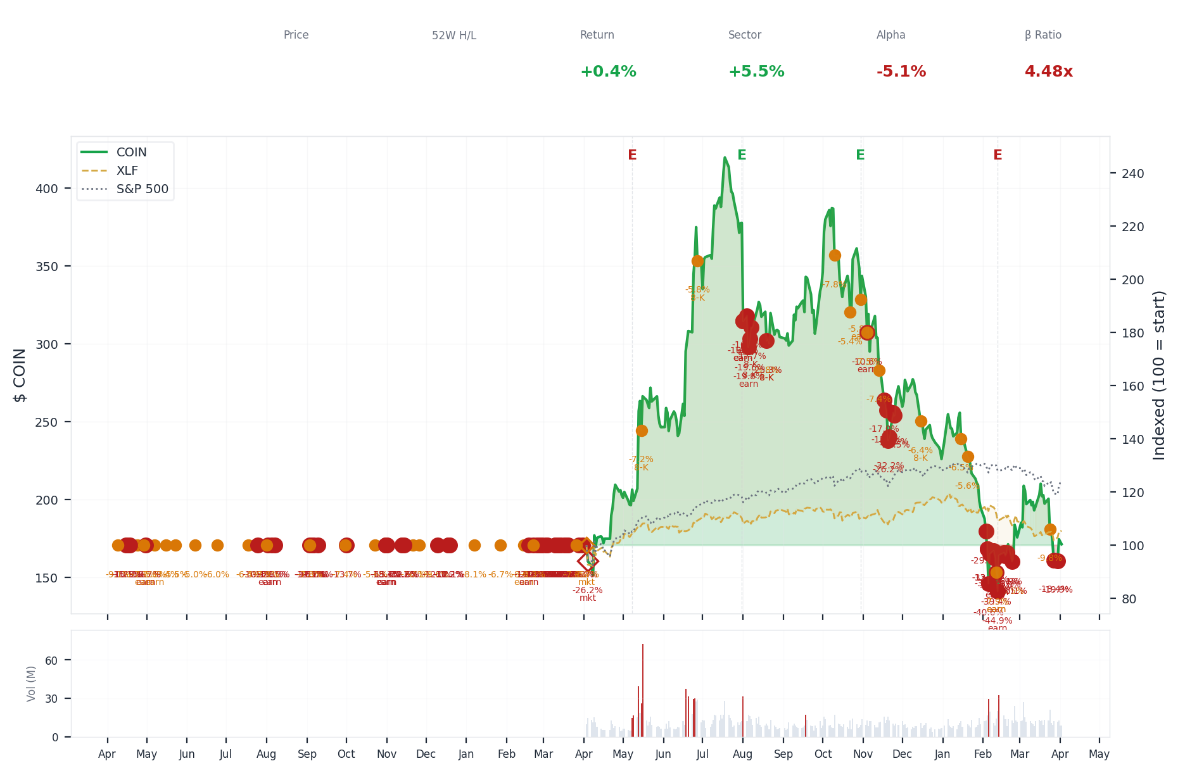
1-Year Performance (Indexed to 100). Red triangles mark single-day drops >= 8%. Orange bands mark multi-day declines >= 15%.
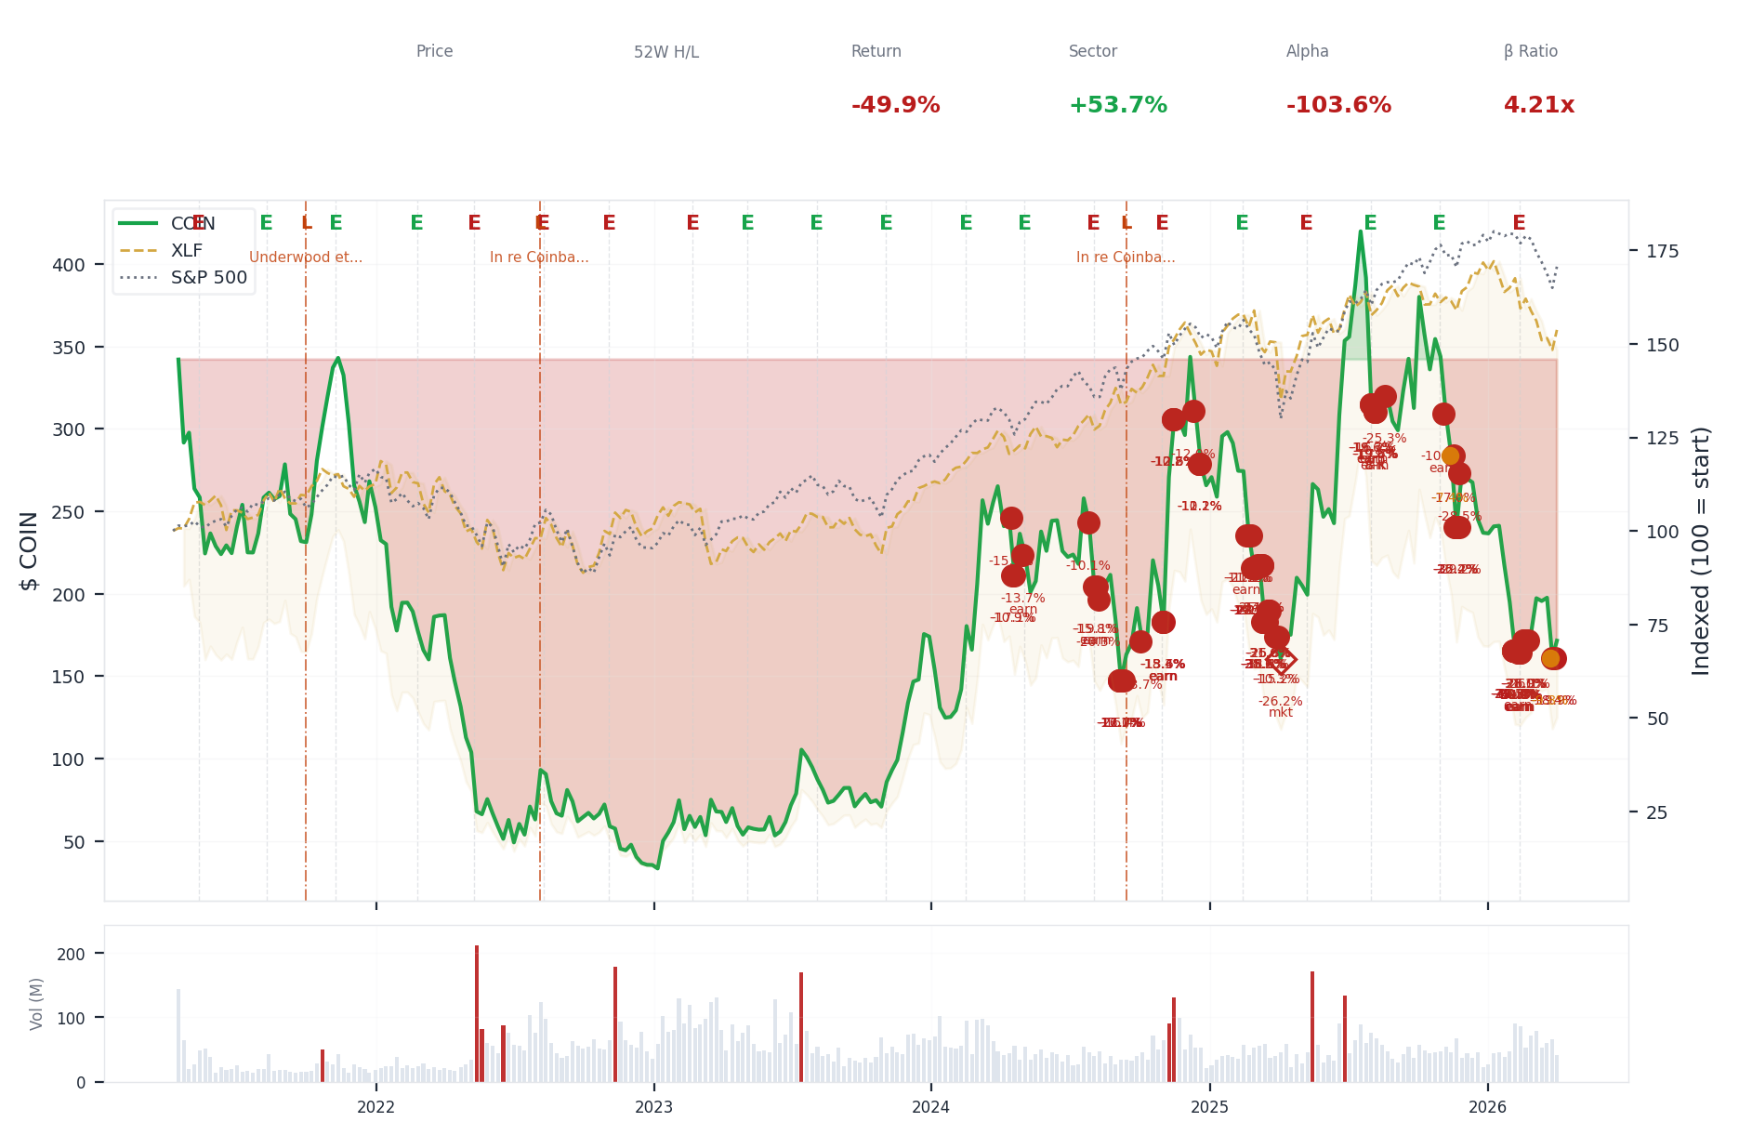
5-Year Performance (Indexed to 100)
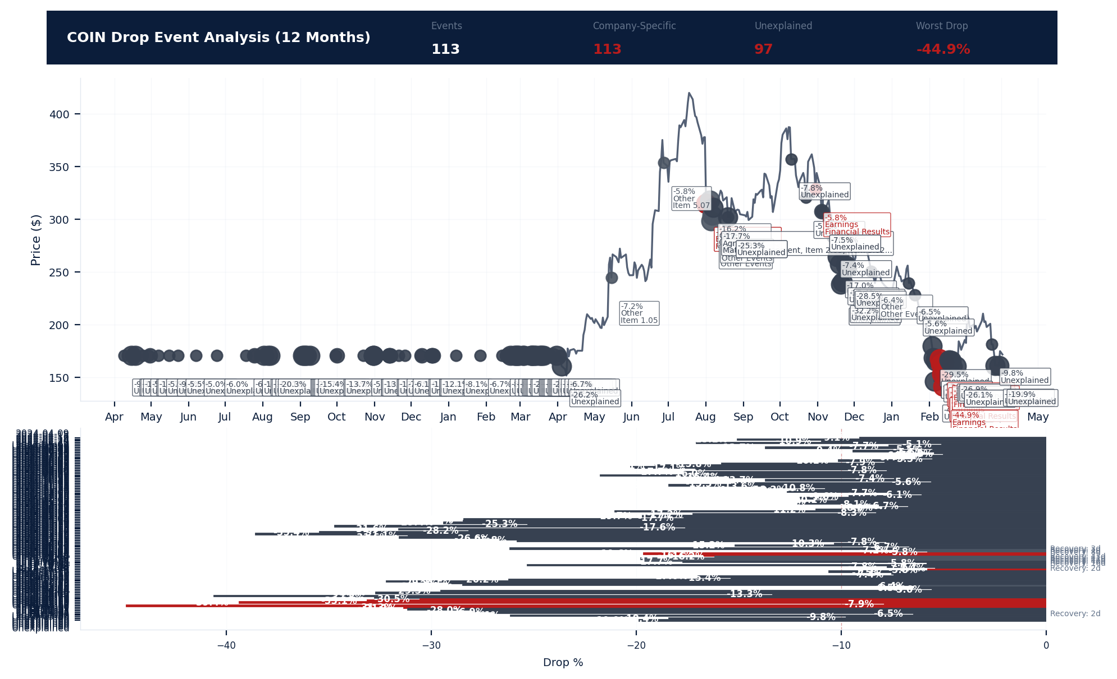
Drop Event Analysis (12 Months)
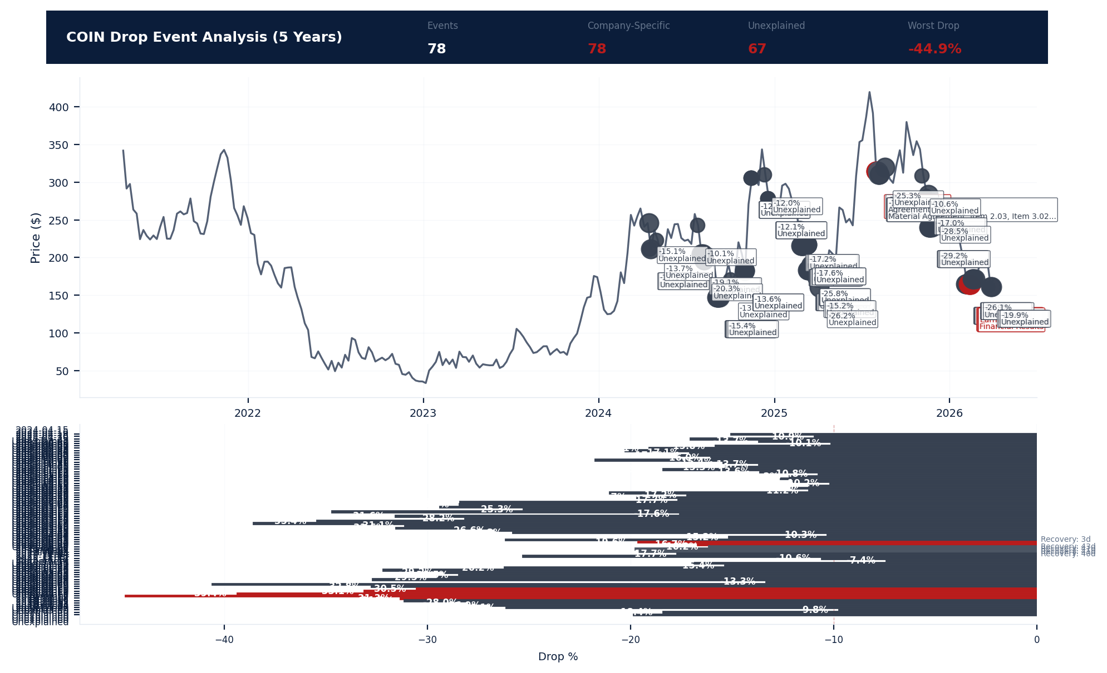
Drop Event Analysis (5 Years)
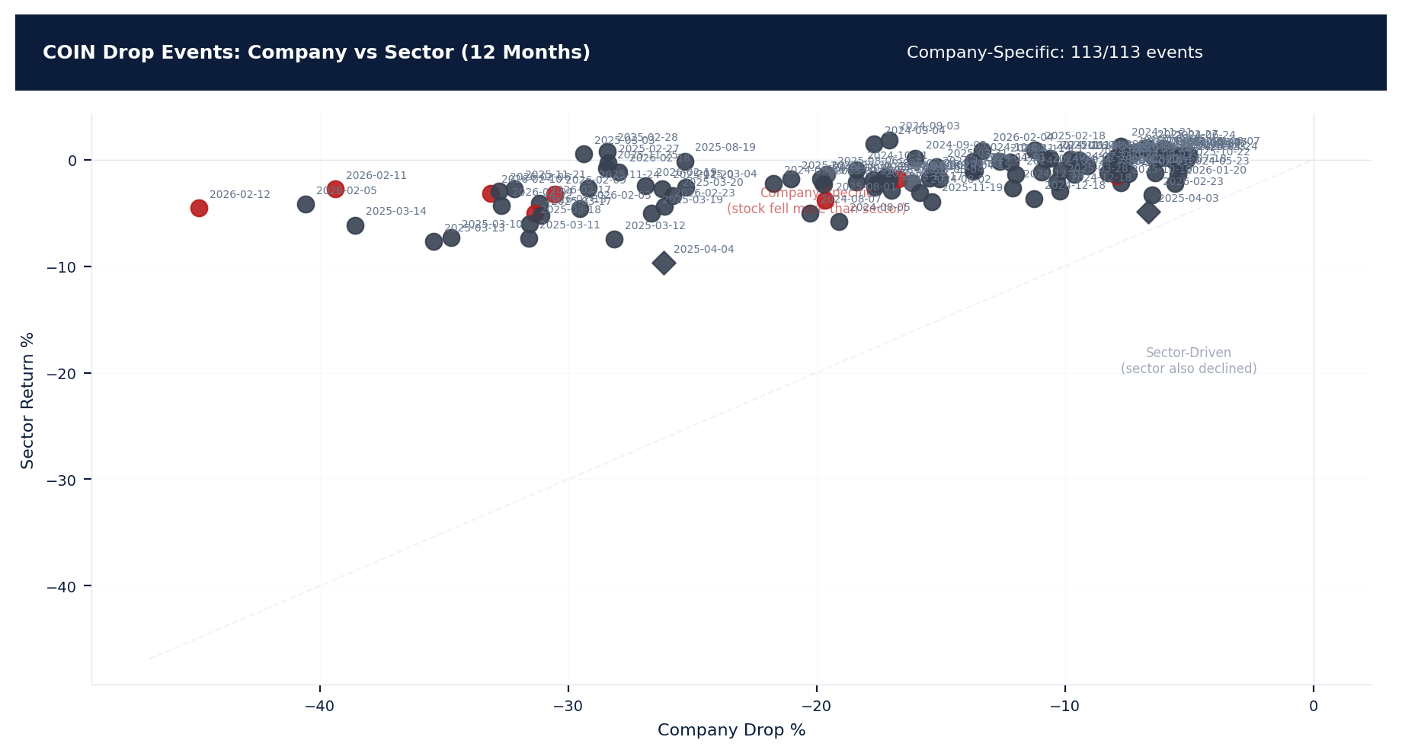
Drop Events: Company vs Sector (12 Months)
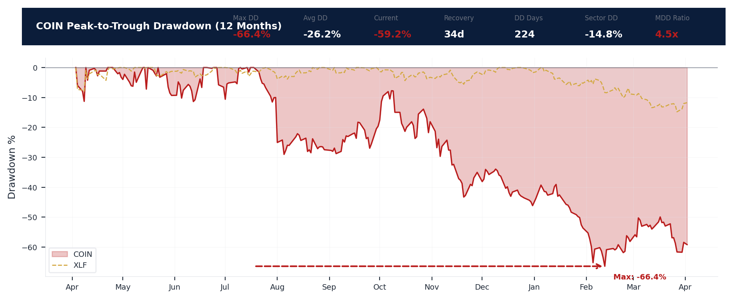
Drawdown Analysis (12 Months)
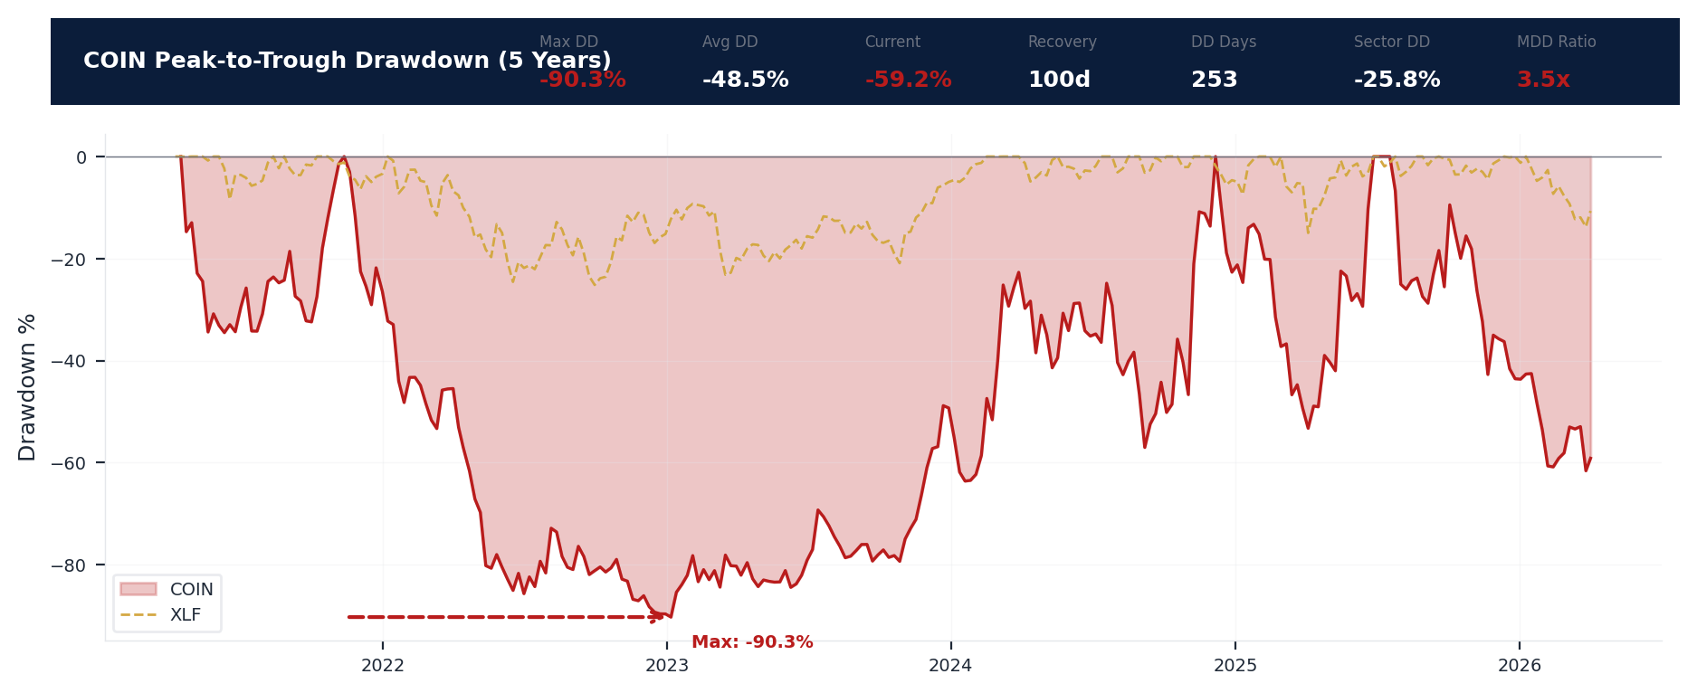
Drawdown Analysis (5 Years)
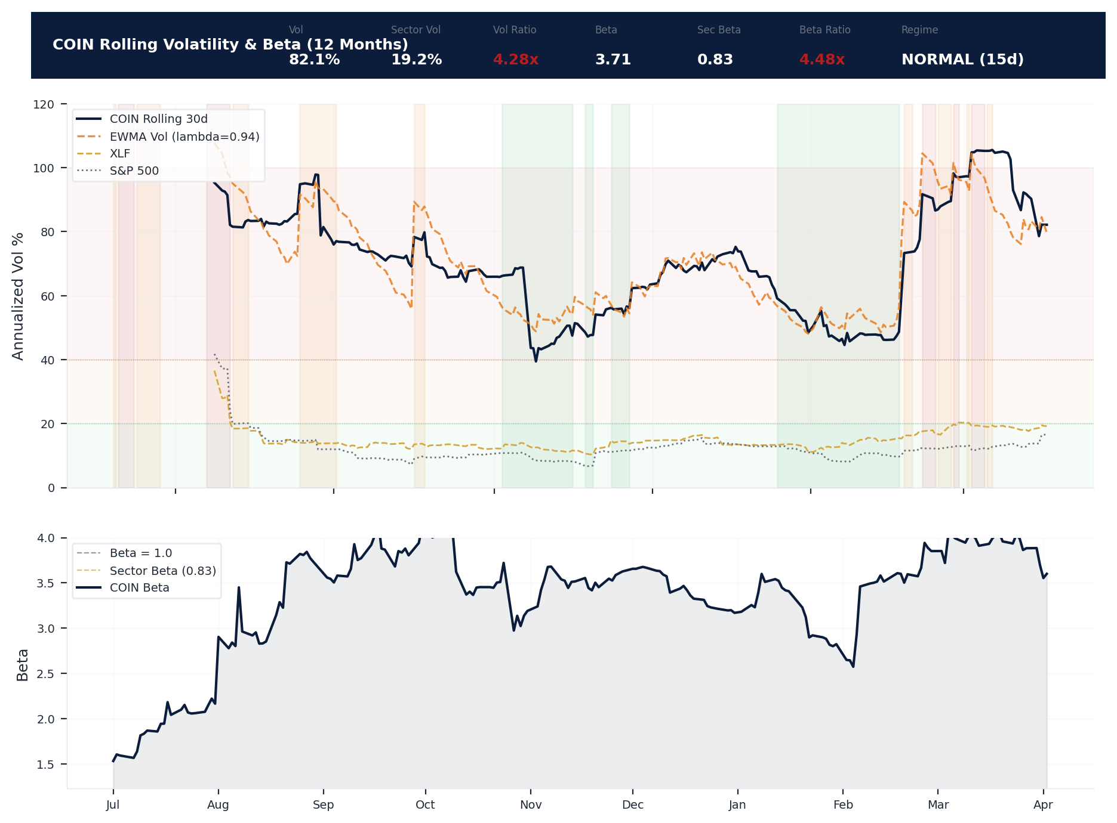
Volatility & Beta Analysis (12 Months)
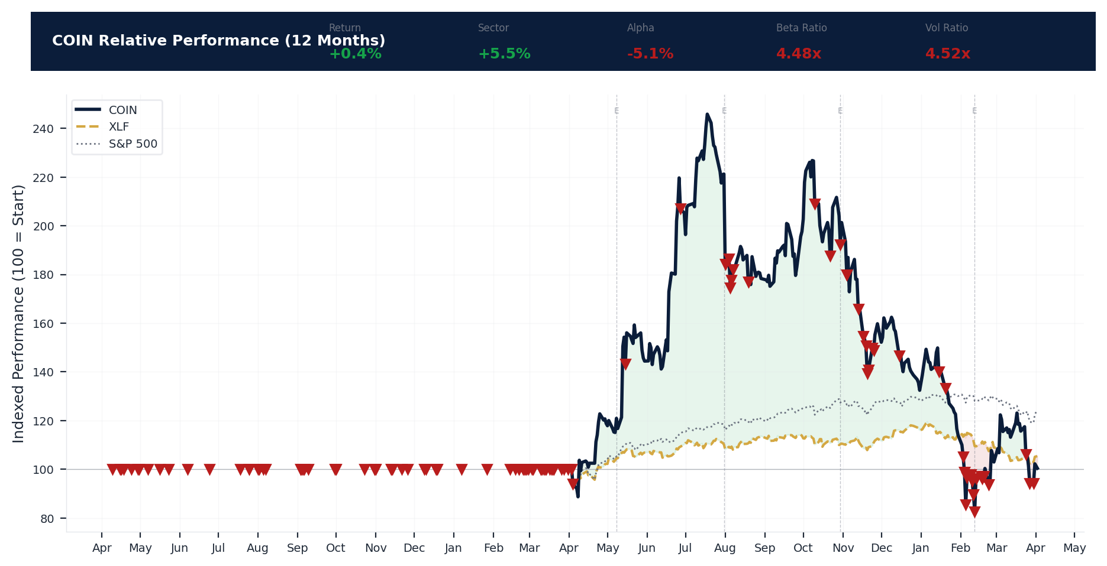
Relative Performance (12 Months)
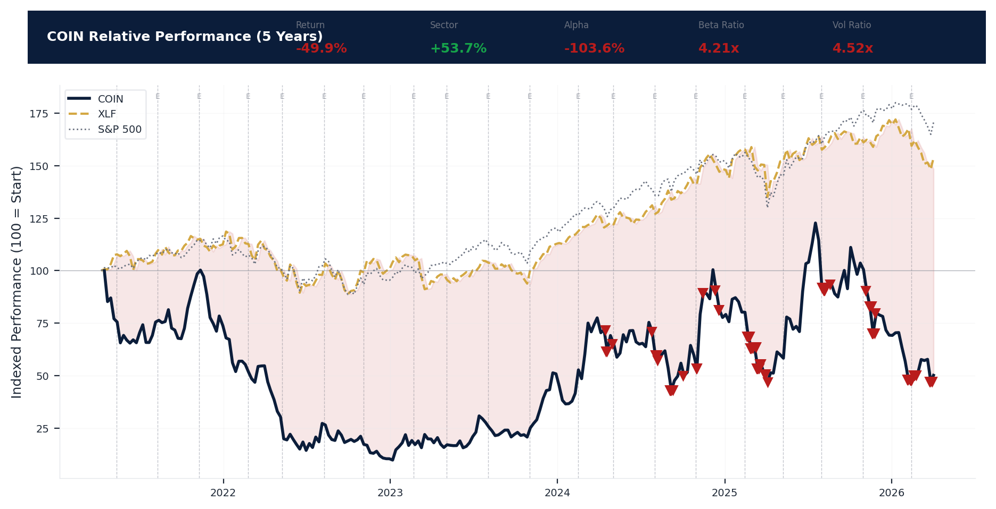
Relative Performance (5 Years)
Metric | Value
Current Price | $171.46
52-Week High | $444.65
52-Week Low | $139.36
1-Year Return | 0.4%
Max Drawdown (1Y) | -66.4%
90-Day Volatility | 76.6% (Ranks at the 0th percentile among 0 peers (peer median: 2.0%))
Beta (vs S&P 500) | 3.71
113 significant stock decline events detected in the 1Y period: 81 critical (>10%), 32 notable (5-10%). 113 were company-specific, 2 were market-wide.
Date | Drop % | Recency | Recovery | Trigger Event | Type | Source
2026-02-03 to 2026-02-23 (21d) | -44.9% | 83% | 2 days | Earnings release | Company-Specific | https://www.sec.gov/cgi-bin/browse-edgar?action...
2026-02-05 (20d) | -40.6% | 81% | Not recovered | Unconfirmed -- Requires Investigation | Company-Specific | https://finance.yahoo.com/quote/COIN/
2026-02-11 (20d) | -39.4% | 82% | Not recovered | Earnings release | Company-Specific | https://www.sec.gov/cgi-bin/browse-edgar?action...
2026-02-10 (20d) | -33.1% | 82% | Not recovered | Earnings release | Company-Specific | https://www.sec.gov/cgi-bin/browse-edgar?action...
2026-02-06 (20d) | -32.8% | 81% | Not recovered | Unconfirmed -- Requires Investigation | Company-Specific | https://finance.yahoo.com/quote/COIN/
2026-02-17 (20d) | -31.1% | 84% | Not recovered | Earnings release | Company-Specific | https://finance.yahoo.com/quote/COIN/
2026-02-04 (20d) | -32.7% | 80% | Not recovered | Unconfirmed -- Requires Investigation | Company-Specific | https://finance.yahoo.com/quote/COIN/
2026-02-13 (20d) | -31.3% | 83% | Not recovered | Earnings release | Company-Specific | https://www.sec.gov/cgi-bin/browse-edgar?action...
2026-02-09 (20d) | -30.5% | 82% | Not recovered | Earnings release | Company-Specific | https://www.sec.gov/cgi-bin/browse-edgar?action...
2026-02-18 (20d) | -28.0% | 85% | Not recovered | Unconfirmed -- Requires Investigation | Company-Specific | https://finance.yahoo.com/quote/COIN/
2026-02-03 (20d) | -29.5% | 80% | Not recovered | Unconfirmed -- Requires Investigation | Company-Specific | https://finance.yahoo.com/quote/COIN/
2026-02-19 (20d) | -26.9% | 85% | Not recovered | Unconfirmed -- Requires Investigation | Company-Specific | https://finance.yahoo.com/quote/COIN/
2026-02-23 (20d) | -26.1% | 86% | Not recovered | Unconfirmed -- Requires Investigation | Company-Specific | https://finance.yahoo.com/quote/COIN/
2026-03-24 to 2026-03-30 (7d) | -19.9% | 99% | Not recovered | Unconfirmed -- Requires Investigation | Company-Specific | https://finance.yahoo.com/quote/COIN/
2025-11-13 to 2025-11-25 (13d) | -34.1% | 60% | Not recovered | Unconfirmed -- Requires Investigation | Company-Specific | https://finance.yahoo.com/quote/COIN/
2026-03-27 (5d) | -18.4% | 98% | Not recovered | Unconfirmed -- Requires Investigation | Company-Specific | https://finance.yahoo.com/quote/COIN/
2025-11-24 (20d) | -29.2% | 61% | Not recovered | Unconfirmed -- Requires Investigation | Company-Specific | https://finance.yahoo.com/quote/COIN/
2025-11-25 (20d) | -28.5% | 61% | Not recovered | Unconfirmed -- Requires Investigation | Company-Specific | https://finance.yahoo.com/quote/COIN/
2025-11-20 (20d) | -26.2% | 60% | Not recovered | Unconfirmed -- Requires Investigation | Company-Specific | https://finance.yahoo.com/quote/COIN/
2026-02-04 (2d) | -18.7% | 80% | Not recovered | Unconfirmed -- Requires Investigation | Company-Specific | https://finance.yahoo.com/quote/COIN/
2025-08-19 | -25.3% | 42% | 16 days | 8-K Filing | Company-Specific | https://www.sec.gov/cgi-bin/browse-edgar?action...
2025-11-17 (5d) | -17.0% | 59% | Not recovered | Unconfirmed -- Requires Investigation | Company-Specific | https://finance.yahoo.com/quote/COIN/
2026-03-24 (2d) | -19.7% | 97% | Not recovered | Unconfirmed -- Requires Investigation | Company-Specific | https://finance.yahoo.com/quote/COIN/
2025-11-19 (5d) | -15.4% | 60% | Not recovered | Unconfirmed -- Requires Investigation | Company-Specific | https://finance.yahoo.com/quote/COIN/
2025-03-10 to 2025-03-20 (11d) | -40.5% | 23% | Not recovered | Unconfirmed -- Requires Investigation | Company-Specific | https://finance.yahoo.com/quote/COIN/
2025-03-13 (20d) | -35.4% | 23% | Not recovered | Unconfirmed -- Requires Investigation | Company-Specific | https://finance.yahoo.com/quote/COIN/
2025-08-01 to 2025-08-07 (7d) | -23.9% | 40% | 40 days | Earnings release | Company-Specific | https://www.sec.gov/cgi-bin/browse-edgar?action...
2025-08-06 (5d) | -19.6% | 40% | 41 days | 8-K Filing | Company-Specific | https://www.sec.gov/cgi-bin/browse-edgar?action...
2025-03-10 (20d) | -34.7% | 22% | Not recovered | Unconfirmed -- Requires Investigation | Company-Specific | https://finance.yahoo.com/quote/COIN/
2025-08-01 (5d) | -19.6% | 39% | Not recovered | Earnings release | Company-Specific | https://www.sec.gov/cgi-bin/browse-edgar?action...
2025-03-18 (20d) | -31.6% | 23% | Not recovered | Unconfirmed -- Requires Investigation | Company-Specific | https://finance.yahoo.com/quote/COIN/
2025-03-17 (20d) | -31.1% | 23% | Not recovered | Unconfirmed -- Requires Investigation | Company-Specific | https://finance.yahoo.com/quote/COIN/
2025-03-11 (20d) | -31.6% | 23% | Not recovered | Unconfirmed -- Requires Investigation | Company-Specific | https://finance.yahoo.com/quote/COIN/
2025-08-07 (5d) | -17.7% | 40% | 40 days | 8-K Filing | Company-Specific | https://www.sec.gov/cgi-bin/browse-edgar?action...
2025-08-01 (2d) | -21.1% | 39% | Not recovered | Earnings release | Company-Specific | https://www.sec.gov/cgi-bin/browse-edgar?action...
2026-02-11 (2d) | -13.2% | 82% | Not recovered | Earnings release | Company-Specific | https://www.sec.gov/cgi-bin/browse-edgar?action...
2025-03-26 to 2025-04-04 (10d) | -26.2% | 25% | 3 days | Unconfirmed -- Requires Investigation | Market-Wide Event | https://finance.yahoo.com/quote/COIN/
2025-02-14 to 2025-03-04 (19d) | -31.7% | 22% | Not recovered | Unconfirmed -- Requires Investigation | Company-Specific | https://finance.yahoo.com/quote/COIN/
2025-08-04 (5d) | -16.2% | 40% | 43 days | Earnings release | Company-Specific | https://www.sec.gov/cgi-bin/browse-edgar?action...
2025-03-12 (20d) | -28.2% | 23% | Not recovered | Unconfirmed -- Requires Investigation | Company-Specific | https://finance.yahoo.com/quote/COIN/
2025-03-19 (20d) | -26.6% | 23% | Not recovered | Unconfirmed -- Requires Investigation | Company-Specific | https://finance.yahoo.com/quote/COIN/
2025-02-28 (20d) | -28.4% | 22% | Not recovered | Unconfirmed -- Requires Investigation | Company-Specific | https://finance.yahoo.com/quote/COIN/
2025-02-27 (20d) | -28.4% | 22% | Not recovered | Unconfirmed -- Requires Investigation | Company-Specific | https://finance.yahoo.com/quote/COIN/
2025-03-20 (20d) | -25.8% | 23% | Not recovered | Unconfirmed -- Requires Investigation | Company-Specific | https://finance.yahoo.com/quote/COIN/
2025-10-30 to 2025-11-04 (6d) | -15.3% | 56% | Not recovered | Earnings release | Company-Specific | https://finance.yahoo.com/quote/COIN/
2026-02-23 | -6.5% | 86% | 2 days | Unconfirmed -- Requires Investigation | Company-Specific | https://finance.yahoo.com/quote/COIN/
2025-03-04 (20d) | -25.3% | 22% | Not recovered | Unconfirmed -- Requires Investigation | Company-Specific | https://finance.yahoo.com/quote/COIN/
2026-01-15 to 2026-01-20 (6d) | -11.0% | 74% | Not recovered | Unconfirmed -- Requires Investigation | Company-Specific | https://finance.yahoo.com/quote/COIN/
2025-02-21 (5d) | -21.0% | 21% | Not recovered | Unconfirmed -- Requires Investigation | Company-Specific | https://finance.yahoo.com/quote/COIN/
2025-11-13 (3d) | -21.7% | 58% | Not recovered | Unconfirmed -- Requires Investigation | Company-Specific | https://finance.yahoo.com/quote/COIN/
2025-11-04 (2d) | -10.7% | 56% | Not recovered | Unconfirmed -- Requires Investigation | Company-Specific | https://finance.yahoo.com/quote/COIN/
2026-01-20 | -5.6% | 76% | Not recovered | Unconfirmed -- Requires Investigation | Company-Specific | https://finance.yahoo.com/quote/COIN/
2025-02-25 (5d) | -19.7% | 21% | Not recovered | Unconfirmed -- Requires Investigation | Company-Specific | https://finance.yahoo.com/quote/COIN/
2025-12-15 | -6.4% | 66% | Not recovered | 8-K Filing | Company-Specific | https://www.sec.gov/cgi-bin/browse-edgar?action...
2025-10-10 | -7.8% | 51% | Not recovered | Unconfirmed -- Requires Investigation | Company-Specific | https://finance.yahoo.com/quote/COIN/
2025-03-10 (2d) | -17.6% | 22% | Not recovered | Unconfirmed -- Requires Investigation | Company-Specific | https://finance.yahoo.com/quote/COIN/
2025-02-26 (5d) | -17.7% | 21% | Not recovered | Unconfirmed -- Requires Investigation | Company-Specific | https://finance.yahoo.com/quote/COIN/
2025-03-31 (5d) | -15.2% | 24% | Not recovered | Unconfirmed -- Requires Investigation | Company-Specific | https://finance.yahoo.com/quote/COIN/
2025-02-24 (5d) | -17.2% | 21% | Not recovered | Unconfirmed -- Requires Investigation | Company-Specific | https://finance.yahoo.com/quote/COIN/
2025-10-30 | -5.8% | 55% | Not recovered | Earnings release | Company-Specific | https://www.sec.gov/cgi-bin/browse-edgar?action...
2025-10-22 | -5.4% | 54% | 2 days | Unconfirmed -- Requires Investigation | Company-Specific | https://finance.yahoo.com/quote/COIN/
2024-10-31 to 2024-11-01 (2d) | -18.4% | 14% | Not recovered | Earnings release | Company-Specific | https://finance.yahoo.com/quote/COIN/
2025-03-28 (2d) | -10.3% | 24% | Not recovered | Unconfirmed -- Requires Investigation | Company-Specific | https://finance.yahoo.com/quote/COIN/
2025-08-19 | -5.8% | 42% | 16 days | 8-K Filing | Company-Specific | https://www.sec.gov/cgi-bin/browse-edgar?action...
2024-09-03 to 2024-09-09 (7d) | -27.8% | 11% | Not recovered | Unconfirmed -- Requires Investigation | Company-Specific | https://finance.yahoo.com/quote/COIN/
2025-02-18 (2d) | -11.2% | 21% | Not recovered | Earnings release | Company-Specific | https://finance.yahoo.com/quote/COIN/
2024-10-31 | -15.3% | 14% | Not recovered | Earnings release | Company-Specific | https://finance.yahoo.com/quote/COIN/
2025-05-15 | -7.2% | 29% | 1 days | 8-K Filing | Company-Specific | https://www.sec.gov/cgi-bin/browse-edgar?action...
2024-12-18 to 2024-12-19 (2d) | -13.1% | 16% | Not recovered | Unconfirmed -- Requires Investigation | Company-Specific | https://finance.yahoo.com/quote/COIN/
2024-08-01 to 2024-08-07 (7d) | -26.4% | 10% | Not recovered | Unconfirmed -- Requires Investigation | Company-Specific | https://finance.yahoo.com/quote/COIN/
2025-06-27 | -5.8% | 34% | 8 days | 8-K Filing | Company-Specific | https://www.sec.gov/cgi-bin/browse-edgar?action...
2024-09-04 (5d) | -17.7% | 11% | Not recovered | Unconfirmed -- Requires Investigation | Company-Specific | https://finance.yahoo.com/quote/COIN/
2024-12-09 to 2024-12-10 (2d) | -12.0% | 16% | Not recovered | Unconfirmed -- Requires Investigation | Company-Specific | https://finance.yahoo.com/quote/COIN/
2024-11-01 (2d) | -13.6% | 14% | Not recovered | Earnings release | Company-Specific | https://finance.yahoo.com/quote/COIN/
2024-09-03 (5d) | -17.1% | 11% | Not recovered | Unconfirmed -- Requires Investigation | Company-Specific | https://finance.yahoo.com/quote/COIN/
2024-08-05 (5d) | -19.1% | 10% | Not recovered | Earnings release | Company-Specific | https://finance.yahoo.com/quote/COIN/
2025-03-26 (2d) | -7.8% | 24% | Not recovered | Unconfirmed -- Requires Investigation | Company-Specific | https://finance.yahoo.com/quote/COIN/
2024-12-18 (2d) | -11.2% | 16% | Not recovered | Unconfirmed -- Requires Investigation | Company-Specific | https://finance.yahoo.com/quote/COIN/
2024-11-13 to 2024-11-14 (2d) | -14.0% | 14% | Not recovered | Unconfirmed -- Requires Investigation | Company-Specific | https://finance.yahoo.com/quote/COIN/
2024-09-05 (5d) | -16.0% | 11% | Not recovered | Unconfirmed -- Requires Investigation | Company-Specific | https://finance.yahoo.com/quote/COIN/
2024-11-13 (2d) | -12.2% | 14% | Not recovered | Unconfirmed -- Requires Investigation | Company-Specific | https://finance.yahoo.com/quote/COIN/
2025-02-21 (2d) | -8.3% | 21% | Not recovered | Unconfirmed -- Requires Investigation | Company-Specific | https://finance.yahoo.com/quote/COIN/
2024-09-09 (5d) | -15.4% | 11% | Not recovered | Unconfirmed -- Requires Investigation | Company-Specific | https://finance.yahoo.com/quote/COIN/
2024-12-18 | -10.2% | 16% | Not recovered | Unconfirmed -- Requires Investigation | Company-Specific | https://finance.yahoo.com/quote/COIN/
2024-09-30 to 2024-10-01 (2d) | -13.7% | 12% | Not recovered | Unconfirmed -- Requires Investigation | Company-Specific | https://finance.yahoo.com/quote/COIN/
2025-04-03 (2d) | -6.0% | 25% | Not recovered | Unconfirmed -- Requires Investigation | Market-Wide Event | https://finance.yahoo.com/quote/COIN/
2025-02-14 | -8.0% | 20% | Not recovered | Earnings release | Company-Specific | https://finance.yahoo.com/quote/COIN/
2024-11-13 | -10.8% | 14% | Not recovered | Unconfirmed -- Requires Investigation | Company-Specific | https://finance.yahoo.com/quote/COIN/
2024-08-02 (5d) | -15.8% | 10% | Not recovered | Earnings release | Company-Specific | https://finance.yahoo.com/quote/COIN/
2024-12-09 | -9.6% | 16% | Not recovered | Unconfirmed -- Requires Investigation | Company-Specific | https://finance.yahoo.com/quote/COIN/
2025-01-07 | -8.1% | 18% | Not recovered | Unconfirmed -- Requires Investigation | Company-Specific | https://finance.yahoo.com/quote/COIN/
2025-01-27 | -6.7% | 19% | Not recovered | Unconfirmed -- Requires Investigation | Company-Specific | https://finance.yahoo.com/quote/COIN/
2024-11-21 to 2024-11-26 (6d) | -8.3% | 15% | Not recovered | Unconfirmed -- Requires Investigation | Company-Specific | https://finance.yahoo.com/quote/COIN/
2024-04-15 to 2024-04-18 (4d) | -17.1% | 6% | Not recovered | Unconfirmed -- Requires Investigation | Company-Specific | https://finance.yahoo.com/quote/COIN/
2024-04-15 (2d) | -15.1% | 6% | Not recovered | Unconfirmed -- Requires Investigation | Company-Specific | https://finance.yahoo.com/quote/COIN/
2024-07-25 | -10.1% | 9% | Not recovered | Unconfirmed -- Requires Investigation | Company-Specific | https://finance.yahoo.com/quote/COIN/
2024-04-24 to 2024-04-30 (7d) | -13.8% | 7% | Not recovered | Earnings release | Company-Specific | https://finance.yahoo.com/quote/COIN/
2024-11-26 | -6.1% | 15% | Not recovered | Unconfirmed -- Requires Investigation | Company-Specific | https://finance.yahoo.com/quote/COIN/
2024-09-30 (2d) | -7.4% | 12% | Not recovered | Unconfirmed -- Requires Investigation | Company-Specific | https://finance.yahoo.com/quote/COIN/
2024-09-03 (2d) | -7.8% | 11% | Not recovered | Unconfirmed -- Requires Investigation | Company-Specific | https://finance.yahoo.com/quote/COIN/
2024-08-01 (3d) | -7.9% | 10% | Not recovered | Unconfirmed -- Requires Investigation | Company-Specific | https://finance.yahoo.com/quote/COIN/
2024-10-23 | -5.6% | 13% | Not recovered | Unconfirmed -- Requires Investigation | Company-Specific | https://finance.yahoo.com/quote/COIN/
2024-04-16 (2d) | -10.9% | 6% | Not recovered | Unconfirmed -- Requires Investigation | Company-Specific | https://finance.yahoo.com/quote/COIN/
2024-05-16 | -9.4% | 7% | Not recovered | Unconfirmed -- Requires Investigation | Company-Specific | https://finance.yahoo.com/quote/COIN/
2024-07-18 | -6.4% | 9% | Not recovered | Unconfirmed -- Requires Investigation | Company-Specific | https://finance.yahoo.com/quote/COIN/
2024-04-09 (3d) | -9.1% | 6% | Not recovered | Unconfirmed -- Requires Investigation | Company-Specific | https://finance.yahoo.com/quote/COIN/
2024-07-25 | -5.5% | 9% | Not recovered | Unconfirmed -- Requires Investigation | Company-Specific | https://finance.yahoo.com/quote/COIN/
2024-04-29 (2d) | -7.7% | 7% | Not recovered | Earnings release | Company-Specific | https://finance.yahoo.com/quote/COIN/
2024-06-24 | -6.0% | 8% | Not recovered | Unconfirmed -- Requires Investigation | Company-Specific | https://finance.yahoo.com/quote/COIN/
2024-05-23 | -5.5% | 7% | Not recovered | Unconfirmed -- Requires Investigation | Company-Specific | https://finance.yahoo.com/quote/COIN/
2024-06-07 | -5.0% | 8% | Not recovered | Unconfirmed -- Requires Investigation | Company-Specific | https://finance.yahoo.com/quote/COIN/
2024-05-07 | -5.5% | 7% | Not recovered | Earnings release | Company-Specific | https://finance.yahoo.com/quote/COIN/
2024-04-24 | -5.1% | 7% | Not recovered | Unconfirmed -- Requires Investigation | Company-Specific | https://finance.yahoo.com/quote/COIN/
79 significant stock decline events detected in the 5Y period: 79 critical (>10%). 79 were company-specific, 1 was market-wide.
Date | Drop % | Recency | Recovery | Trigger Event | Type | Source
2026-02-03 to 2026-02-23 (21d) | -44.9% | 83% | 2 days | Earnings release | Company-Specific | https://www.sec.gov/cgi-bin/browse-edgar?action...
2026-02-05 (20d) | -40.6% | 81% | Not recovered | Unconfirmed -- Requires Investigation | Company-Specific | https://finance.yahoo.com/quote/COIN/
2026-02-11 (20d) | -39.4% | 82% | Not recovered | Earnings release | Company-Specific | https://www.sec.gov/cgi-bin/browse-edgar?action...
2026-02-10 (20d) | -33.1% | 82% | Not recovered | Earnings release | Company-Specific | https://www.sec.gov/cgi-bin/browse-edgar?action...
2026-02-06 (20d) | -32.8% | 81% | Not recovered | Unconfirmed -- Requires Investigation | Company-Specific | https://finance.yahoo.com/quote/COIN/
2026-02-17 (20d) | -31.1% | 84% | Not recovered | Earnings release | Company-Specific | https://finance.yahoo.com/quote/COIN/
2026-02-04 (20d) | -32.7% | 80% | Not recovered | Unconfirmed -- Requires Investigation | Company-Specific | https://finance.yahoo.com/quote/COIN/
2026-02-13 (20d) | -31.3% | 83% | Not recovered | Earnings release | Company-Specific | https://www.sec.gov/cgi-bin/browse-edgar?action...
2026-02-09 (20d) | -30.5% | 82% | Not recovered | Earnings release | Company-Specific | https://www.sec.gov/cgi-bin/browse-edgar?action...
2026-02-18 (20d) | -28.0% | 85% | Not recovered | Unconfirmed -- Requires Investigation | Company-Specific | https://finance.yahoo.com/quote/COIN/
2026-02-03 (20d) | -29.5% | 80% | Not recovered | Unconfirmed -- Requires Investigation | Company-Specific | https://finance.yahoo.com/quote/COIN/
2026-02-19 (20d) | -26.9% | 85% | Not recovered | Unconfirmed -- Requires Investigation | Company-Specific | https://finance.yahoo.com/quote/COIN/
2026-02-23 (20d) | -26.1% | 86% | Not recovered | Unconfirmed -- Requires Investigation | Company-Specific | https://finance.yahoo.com/quote/COIN/
2026-03-24 to 2026-03-30 (7d) | -19.9% | 99% | Not recovered | Unconfirmed -- Requires Investigation | Company-Specific | https://finance.yahoo.com/quote/COIN/
2025-11-13 to 2025-11-25 (13d) | -34.1% | 60% | Not recovered | Unconfirmed -- Requires Investigation | Company-Specific | https://finance.yahoo.com/quote/COIN/
2026-03-27 (5d) | -18.4% | 98% | Not recovered | Unconfirmed -- Requires Investigation | Company-Specific | https://finance.yahoo.com/quote/COIN/
2025-11-24 (20d) | -29.2% | 61% | Not recovered | Unconfirmed -- Requires Investigation | Company-Specific | https://finance.yahoo.com/quote/COIN/
2025-11-25 (20d) | -28.5% | 61% | Not recovered | Unconfirmed -- Requires Investigation | Company-Specific | https://finance.yahoo.com/quote/COIN/
2025-11-20 (20d) | -26.2% | 60% | Not recovered | Unconfirmed -- Requires Investigation | Company-Specific | https://finance.yahoo.com/quote/COIN/
2026-02-04 (2d) | -18.7% | 80% | Not recovered | Unconfirmed -- Requires Investigation | Company-Specific | https://finance.yahoo.com/quote/COIN/
2025-08-19 | -25.3% | 42% | 16 days | 8-K Filing | Company-Specific | https://www.sec.gov/cgi-bin/browse-edgar?action...
2025-11-17 (5d) | -17.0% | 59% | Not recovered | Unconfirmed -- Requires Investigation | Company-Specific | https://finance.yahoo.com/quote/COIN/
2026-03-24 (2d) | -19.7% | 97% | Not recovered | Unconfirmed -- Requires Investigation | Company-Specific | https://finance.yahoo.com/quote/COIN/
2025-11-19 (5d) | -15.4% | 60% | Not recovered | Unconfirmed -- Requires Investigation | Company-Specific | https://finance.yahoo.com/quote/COIN/
2025-03-10 to 2025-03-20 (11d) | -40.5% | 23% | Not recovered | Unconfirmed -- Requires Investigation | Company-Specific | https://finance.yahoo.com/quote/COIN/
2025-03-13 (20d) | -35.4% | 23% | Not recovered | Unconfirmed -- Requires Investigation | Company-Specific | https://finance.yahoo.com/quote/COIN/
2025-08-01 to 2025-08-07 (7d) | -23.9% | 40% | 40 days | Earnings release | Company-Specific | https://www.sec.gov/cgi-bin/browse-edgar?action...
2025-08-06 (5d) | -19.6% | 40% | 41 days | 8-K Filing | Company-Specific | https://www.sec.gov/cgi-bin/browse-edgar?action...
2025-03-10 (20d) | -34.7% | 22% | Not recovered | Unconfirmed -- Requires Investigation | Company-Specific | https://finance.yahoo.com/quote/COIN/
2025-08-01 (5d) | -19.6% | 39% | Not recovered | Earnings release | Company-Specific | https://www.sec.gov/cgi-bin/browse-edgar?action...
2025-03-18 (20d) | -31.6% | 23% | Not recovered | Unconfirmed -- Requires Investigation | Company-Specific | https://finance.yahoo.com/quote/COIN/
2025-03-17 (20d) | -31.1% | 23% | Not recovered | Unconfirmed -- Requires Investigation | Company-Specific | https://finance.yahoo.com/quote/COIN/
2025-03-11 (20d) | -31.6% | 23% | Not recovered | Unconfirmed -- Requires Investigation | Company-Specific | https://finance.yahoo.com/quote/COIN/
2025-08-07 (5d) | -17.7% | 40% | 40 days | 8-K Filing | Company-Specific | https://www.sec.gov/cgi-bin/browse-edgar?action...
2025-08-01 (2d) | -21.1% | 39% | Not recovered | Earnings release | Company-Specific | https://www.sec.gov/cgi-bin/browse-edgar?action...
2025-03-26 to 2025-04-04 (10d) | -26.2% | 25% | 3 days | Unconfirmed -- Requires Investigation | Market-Wide Event | https://finance.yahoo.com/quote/COIN/
2025-02-14 to 2025-03-04 (19d) | -31.7% | 22% | Not recovered | Unconfirmed -- Requires Investigation | Company-Specific | https://finance.yahoo.com/quote/COIN/
2025-08-04 (5d) | -16.2% | 40% | 43 days | Earnings release | Company-Specific | https://www.sec.gov/cgi-bin/browse-edgar?action...
2025-03-12 (20d) | -28.2% | 23% | Not recovered | Unconfirmed -- Requires Investigation | Company-Specific | https://finance.yahoo.com/quote/COIN/
2025-03-19 (20d) | -26.6% | 23% | Not recovered | Unconfirmed -- Requires Investigation | Company-Specific | https://finance.yahoo.com/quote/COIN/
2025-02-28 (20d) | -28.4% | 22% | Not recovered | Unconfirmed -- Requires Investigation | Company-Specific | https://finance.yahoo.com/quote/COIN/
2025-02-27 (20d) | -28.4% | 22% | Not recovered | Unconfirmed -- Requires Investigation | Company-Specific | https://finance.yahoo.com/quote/COIN/
2025-03-20 (20d) | -25.8% | 23% | Not recovered | Unconfirmed -- Requires Investigation | Company-Specific | https://finance.yahoo.com/quote/COIN/
2025-10-30 to 2025-11-04 (6d) | -15.3% | 56% | Not recovered | Earnings release | Company-Specific | https://finance.yahoo.com/quote/COIN/
2025-03-04 (20d) | -25.3% | 22% | Not recovered | Unconfirmed -- Requires Investigation | Company-Specific | https://finance.yahoo.com/quote/COIN/
2026-01-15 to 2026-01-20 (6d) | -11.0% | 74% | Not recovered | Unconfirmed -- Requires Investigation | Company-Specific | https://finance.yahoo.com/quote/COIN/
2025-02-21 (5d) | -21.0% | 21% | Not recovered | Unconfirmed -- Requires Investigation | Company-Specific | https://finance.yahoo.com/quote/COIN/
2025-11-13 (3d) | -21.7% | 58% | Not recovered | Unconfirmed -- Requires Investigation | Company-Specific | https://finance.yahoo.com/quote/COIN/
2025-02-25 (5d) | -19.7% | 21% | Not recovered | Unconfirmed -- Requires Investigation | Company-Specific | https://finance.yahoo.com/quote/COIN/
2025-03-10 (2d) | -17.6% | 22% | Not recovered | Unconfirmed -- Requires Investigation | Company-Specific | https://finance.yahoo.com/quote/COIN/
2025-02-26 (5d) | -17.7% | 21% | Not recovered | Unconfirmed -- Requires Investigation | Company-Specific | https://finance.yahoo.com/quote/COIN/
2025-03-31 (5d) | -15.2% | 24% | Not recovered | Unconfirmed -- Requires Investigation | Company-Specific | https://finance.yahoo.com/quote/COIN/
2025-02-24 (5d) | -17.2% | 21% | Not recovered | Unconfirmed -- Requires Investigation | Company-Specific | https://finance.yahoo.com/quote/COIN/
2024-10-31 to 2024-11-01 (2d) | -18.4% | 14% | Not recovered | Earnings release | Company-Specific | https://finance.yahoo.com/quote/COIN/
2025-03-28 (2d) | -10.3% | 24% | Not recovered | Unconfirmed -- Requires Investigation | Company-Specific | https://finance.yahoo.com/quote/COIN/
2024-09-03 to 2024-09-09 (7d) | -27.8% | 11% | Not recovered | Unconfirmed -- Requires Investigation | Company-Specific | https://finance.yahoo.com/quote/COIN/
2025-02-18 (2d) | -11.2% | 21% | Not recovered | Earnings release | Company-Specific | https://finance.yahoo.com/quote/COIN/
2024-10-31 | -15.3% | 14% | Not recovered | Earnings release | Company-Specific | https://finance.yahoo.com/quote/COIN/
2024-12-18 to 2024-12-19 (2d) | -13.1% | 16% | Not recovered | Unconfirmed -- Requires Investigation | Company-Specific | https://finance.yahoo.com/quote/COIN/
2024-08-01 to 2024-08-07 (7d) | -26.4% | 10% | Not recovered | Unconfirmed -- Requires Investigation | Company-Specific | https://finance.yahoo.com/quote/COIN/
2024-09-04 (5d) | -17.7% | 11% | Not recovered | Unconfirmed -- Requires Investigation | Company-Specific | https://finance.yahoo.com/quote/COIN/
2024-12-09 to 2024-12-10 (2d) | -12.0% | 16% | Not recovered | Unconfirmed -- Requires Investigation | Company-Specific | https://finance.yahoo.com/quote/COIN/
2024-11-01 (2d) | -13.6% | 14% | Not recovered | Earnings release | Company-Specific | https://finance.yahoo.com/quote/COIN/
2024-09-03 (5d) | -17.1% | 11% | Not recovered | Unconfirmed -- Requires Investigation | Company-Specific | https://finance.yahoo.com/quote/COIN/
2024-08-05 (5d) | -19.1% | 10% | Not recovered | Earnings release | Company-Specific | https://finance.yahoo.com/quote/COIN/
2024-12-18 (2d) | -11.2% | 16% | Not recovered | Unconfirmed -- Requires Investigation | Company-Specific | https://finance.yahoo.com/quote/COIN/
2024-11-13 to 2024-11-14 (2d) | -14.0% | 14% | Not recovered | Unconfirmed -- Requires Investigation | Company-Specific | https://finance.yahoo.com/quote/COIN/
2024-09-05 (5d) | -16.0% | 11% | Not recovered | Unconfirmed -- Requires Investigation | Company-Specific | https://finance.yahoo.com/quote/COIN/
2024-11-13 (2d) | -12.2% | 14% | Not recovered | Unconfirmed -- Requires Investigation | Company-Specific | https://finance.yahoo.com/quote/COIN/
2024-09-09 (5d) | -15.4% | 11% | Not recovered | Unconfirmed -- Requires Investigation | Company-Specific | https://finance.yahoo.com/quote/COIN/
2024-12-18 | -10.2% | 16% | Not recovered | Unconfirmed -- Requires Investigation | Company-Specific | https://finance.yahoo.com/quote/COIN/
2024-09-30 to 2024-10-01 (2d) | -13.7% | 12% | Not recovered | Unconfirmed -- Requires Investigation | Company-Specific | https://finance.yahoo.com/quote/COIN/
2024-11-13 | -10.8% | 14% | Not recovered | Unconfirmed -- Requires Investigation | Company-Specific | https://finance.yahoo.com/quote/COIN/
2024-08-02 (5d) | -15.8% | 10% | Not recovered | Earnings release | Company-Specific | https://finance.yahoo.com/quote/COIN/
2024-04-15 to 2024-04-18 (4d) | -17.1% | 6% | Not recovered | Unconfirmed -- Requires Investigation | Company-Specific | https://finance.yahoo.com/quote/COIN/
2024-04-15 (2d) | -15.1% | 6% | Not recovered | Unconfirmed -- Requires Investigation | Company-Specific | https://finance.yahoo.com/quote/COIN/
2024-07-25 | -10.1% | 9% | Not recovered | Unconfirmed -- Requires Investigation | Company-Specific | https://finance.yahoo.com/quote/COIN/
2024-04-24 to 2024-04-30 (7d) | -13.8% | 7% | Not recovered | Earnings release | Company-Specific | https://finance.yahoo.com/quote/COIN/
2024-04-16 (2d) | -10.9% | 6% | Not recovered | Unconfirmed -- Requires Investigation | Company-Specific | https://finance.yahoo.com/quote/COIN/
Short Interest
Metric | Value
Short % of Float | 11.5% (Ranks at the 0th percentile among 0 peers (peer median: 3.0%))
Days to Cover | 1.59
6-Month Trend | DECLINING
vs Sector Ratio | N/A
[HIGH] Elevated Short Interest: 11.5% -- Signals significant bearish sentiment; vulnerability to short seller reports
Context: Cluster insider selling within 90 days of a stock drop correlates with securities class actions in 42% of cases.
See Meeting Prep: Short Interest & Market Sentiment
Earnings Guidance Track Record
Metric | Value
Beat Rate | 0.6%
Consecutive Misses | 1
Guidance Withdrawals | 0
Philosophy | MIXED
Quarter | Est. EPS | Actual EPS | Result | Miss Magnitude | Stock Reaction
Q1 2026 | $0.94 | $-2.49 | MISS | +364.9% | N/A
Q4 2025 | $1.13 | $1.50 | BEAT | N/A | +33.0%
Q3 2025 | $1.49 | $5.14 | BEAT | N/A | N/A
Q2 2025 | $1.90 | $0.24 | MISS | +87.4% | -87.4%
Q1 2025 | $2.04 | $4.68 | BEAT | N/A | N/A
Q4 2024 | $0.42 | $0.28 | MISS | +33.3% | -33.3%
Q3 2024 | $0.80 | $0.14 | MISS | +82.5% | -82.5%
Q2 2024 | $1.27 | $4.40 | BEAT | N/A | N/A
Q1 2024 | $0.20 | $1.04 | BEAT | N/A | N/A
Q4 2023 | $-0.53 | $-0.01 | BEAT | N/A | +98.1%
Q3 2023 | $-0.76 | $-0.42 | BEAT | N/A | +45.0%
Q2 2023 | $-1.76 | $-0.34 | BEAT | N/A | +80.7%
Q1 2023 | $-1.41 | $-2.65 | MISS | +87.9% | -88.9%
Q4 2022 | $-1.47 | $-2.15 | MISS | +46.3% | -45.8%
Q3 2022 | $-1.23 | $-2.43 | MISS | +97.6% | -96.6%
Q2 2022 | $0.91 | $-1.25 | MISS | +237.4% | N/A
Analyst Consensus
Metric | Value
Analyst Coverage | 29
Consensus Rating | BUY
Mean Recommendation | 1.94 (1=Strong Buy, 5=Sell)
Mean Target Price | $247
Target Price High | $420
Target Price Low | $120
Stock Drop Analysis
Date | Magnitude | Type | Trigger / Attribution | Sector Return | Company-Specific
2026-02-03 to 2026-02-23 | -44.9% | MULTI_DAY (21d) | earnings_release | -4.5% | Yes
2026-02-05 | -40.6% | MULTI_DAY (20d) | Unknown | -4.2% | Yes
2025-03-10 to 2025-03-20 | -40.5% | MULTI_DAY (11d) | Unknown | -6.2% | Yes
2026-02-11 | -39.4% | MULTI_DAY (20d) | earnings_release | -2.8% | Yes
2025-03-13 | -35.4% | MULTI_DAY (20d) | Unknown | -7.7% | Yes
2025-03-10 | -34.7% | MULTI_DAY (20d) | Unknown | -7.3% | Yes
2025-11-13 to 2025-11-25 | -34.1% | MULTI_DAY (13d) | Unknown | -2.7% | Yes
2026-02-10 | -33.1% | MULTI_DAY (20d) | earnings_release | -3.1% | Yes
2026-02-06 | -32.8% | MULTI_DAY (20d) | Unknown | -2.9% | Yes
2026-02-04 | -32.7% | MULTI_DAY (20d) | Unknown | -4.3% | Yes
2025-02-14 to 2025-03-04 | -31.7% | MULTI_DAY (19d) | Unknown | +0.5% | Yes
2025-03-11 | -31.6% | MULTI_DAY (20d) | Unknown | -7.4% | Yes
2025-03-18 | -31.6% | MULTI_DAY (20d) | Unknown | -6.0% | Yes
2026-02-13 | -31.3% | MULTI_DAY (20d) | earnings_release | -5.0% | Yes
2026-02-17 | -31.1% | MULTI_DAY (20d) | earnings_release | -4.1% | Yes
Class Period Potential: 77 company-specific drop(s) exceeding 10% identified. Severe stock drops that are company-specific (not explained by sector movement) are the primary anchors for SCA class periods. Plaintiffs will allege the drop occurred when the 'truth emerged' following prior misstatements. [HIGH]
Insider Trading Analysis
Metric | Value
Net Direction (12mo) | NET_SELLING
10b5-1 Plan % | 84.2%
Buy Transactions | 0
Sell Transactions | 183
Cluster Events | 22
Transaction Detail
Date | Insider | Title | Type | Shares | Value | 10b5-1
2026-03-16 | HAAS ALESIA J | Chief Financial Officer | SELL | 9,900 | $2.0M | Yes (Pre-arranged)
2026-03-16 | HAAS ALESIA J | Chief Financial Officer | SELL | 50 | $10.2K | Yes (Pre-arranged)
2026-03-04 | HAAS ALESIA J | CHIEF FINANCIAL OFFICER | SELL | 10,020 | $2.0M | Yes (Pre-arranged)
2026-02-27 | Grewal Paul | Chief Legal Officer | SELL | 80 | $13.8K | Yes (Pre-arranged)
2026-02-27 | Grewal Paul | Chief Legal Officer | SELL | 300 | $52.1K | Yes (Pre-arranged)
2026-02-27 | Grewal Paul | Chief Legal Officer | SELL | 274 | $47.8K | Yes (Pre-arranged)
2026-02-27 | Grewal Paul | Chief Legal Officer | SELL | 380 | $66.7K | Yes (Pre-arranged)
2026-02-27 | Grewal Paul | Chief Legal Officer | SELL | 125 | $22.1K | Yes (Pre-arranged)
2026-02-27 | Grewal Paul | Chief Legal Officer | SELL | 105 | $18.6K | Yes (Pre-arranged)
2026-02-27 | Grewal Paul | Chief Legal Officer | SELL | 50 | $8.9K | Yes (Pre-arranged)
2026-02-24 | Jones Jennifer N. | Chief Accounting Officer | SELL | 440 | $67.5K | Yes (Pre-arranged)
2026-02-24 | Jones Jennifer N. | Chief Accounting Officer | SELL | 320 | $49.4K | Yes (Pre-arranged)
2026-02-24 | Jones Jennifer N. | Chief Accounting Officer | SELL | 302 | $47.0K | Yes (Pre-arranged)
2026-02-24 | Jones Jennifer N. | Chief Accounting Officer | SELL | 40 | $6.2K | Yes (Pre-arranged)
2026-02-24 | Brock Lawrence J | Chief People Officer | SELL | 1,680 | $257.7K | Yes (Pre-arranged)
2026-02-24 | Brock Lawrence J | Chief People Officer | SELL | 1,840 | $284.1K | Yes (Pre-arranged)
2026-02-24 | Brock Lawrence J | Chief People Officer | SELL | 621 | $96.4K | Yes (Pre-arranged)
2026-02-24 | Brock Lawrence J | Chief People Officer | SELL | 680 | $106.1K | Yes (Pre-arranged)
2026-02-20 | HAAS ALESIA J | Chief Financial Officer | EXERCISE | 5,869 | $0 | No (Discretionary)
2026-02-20 | HAAS ALESIA J | Chief Financial Officer | EXERCISE | 4,101 | $0 | No (Discretionary)
Cluster Selling Events
Window | Insiders | Names | Total Value
2025-11-03 to 2025-12-01 | 8 | Armstrong Brian, Brock Lawrence J, Choi Emilie, Ehrsam Frederick Ernest III, Grewal Paul, HAAS ALESIA J, Jones Jennifer N., WILSON FREDERICK R | $192.3M
2025-11-06 to 2025-12-04 | 8 | Armstrong Brian, Brock Lawrence J, Choi Emilie, Ehrsam Frederick Ernest III, Grewal Paul, HAAS ALESIA J, Jones Jennifer N., WILSON FREDERICK R | $185.0M
2025-11-07 to 2025-12-04 | 8 | Armstrong Brian, Brock Lawrence J, Choi Emilie, Ehrsam Frederick Ernest III, Grewal Paul, HAAS ALESIA J, Jones Jennifer N., WILSON FREDERICK R | $96.1M
2025-11-10 to 2025-12-09 | 8 | Armstrong Brian, Brock Lawrence J, Choi Emilie, Ehrsam Frederick Ernest III, Grewal Paul, HAAS ALESIA J, Jones Jennifer N., WILSON FREDERICK R | $102.1M
2025-11-11 to 2025-12-09 | 8 | Armstrong Brian, Brock Lawrence J, Choi Emilie, Ehrsam Frederick Ernest III, Grewal Paul, HAAS ALESIA J, Jones Jennifer N., WILSON FREDERICK R | $76.1M
2025-11-17 to 2025-12-15 | 7 | Armstrong Brian, Brock Lawrence J, Ehrsam Frederick Ernest III, Grewal Paul, HAAS ALESIA J, Jones Jennifer N., WILSON FREDERICK R | $47.0M
2025-11-20 to 2025-12-18 | 7 | Armstrong Brian, Brock Lawrence J, Ehrsam Frederick Ernest III, Grewal Paul, HAAS ALESIA J, Jones Jennifer N., WILSON FREDERICK R | $34.5M
2025-11-24 to 2025-12-22 | 7 | Armstrong Brian, Brock Lawrence J, Ehrsam Frederick Ernest III, Grewal Paul, HAAS ALESIA J, Jones Jennifer N., WILSON FREDERICK R | $43.5M
2025-11-25 to 2025-12-22 | 5 | Armstrong Brian, Ehrsam Frederick Ernest III, Grewal Paul, HAAS ALESIA J, WILSON FREDERICK R | $41.6M
2025-11-26 to 2025-12-22 | 5 | Armstrong Brian, Ehrsam Frederick Ernest III, Grewal Paul, HAAS ALESIA J, WILSON FREDERICK R | $38.7M
2025-11-28 to 2025-12-22 | 4 | Armstrong Brian, Ehrsam Frederick Ernest III, HAAS ALESIA J, WILSON FREDERICK R | $28.1M
2025-12-01 to 2025-12-22 | 4 | Armstrong Brian, Ehrsam Frederick Ernest III, HAAS ALESIA J, WILSON FREDERICK R | $27.8M
2025-12-04 to 2026-01-02 | 4 | Armstrong Brian, Ehrsam Frederick Ernest III, HAAS ALESIA J, WILSON FREDERICK R | $27.5M
2025-12-08 to 2026-01-05 | 4 | Armstrong Brian, Ehrsam Frederick Ernest III, HAAS ALESIA J, WILSON FREDERICK R | $36.7M
2025-12-09 to 2026-01-05 | 4 | Armstrong Brian, Ehrsam Frederick Ernest III, HAAS ALESIA J, WILSON FREDERICK R | $25.7M
2025-12-15 to 2026-01-14 | 4 | Armstrong Brian, Ehrsam Frederick Ernest III, HAAS ALESIA J, WILSON FREDERICK R | $25.7M
2025-12-18 to 2026-01-15 | 4 | Armstrong Brian, Ehrsam Frederick Ernest III, HAAS ALESIA J, WILSON FREDERICK R | $26.1M
2025-12-22 to 2026-01-15 | 4 | Armstrong Brian, Ehrsam Frederick Ernest III, HAAS ALESIA J, WILSON FREDERICK R | $25.7M
2026-01-02 to 2026-01-15 | 4 | Armstrong Brian, Ehrsam Frederick Ernest III, HAAS ALESIA J, WILSON FREDERICK R | $15.7M
2026-01-05 to 2026-01-15 | 3 | Armstrong Brian, Ehrsam Frederick Ernest III, HAAS ALESIA J | $13.4M
2026-02-06 to 2026-03-04 | 4 | Brock Lawrence J, Grewal Paul, HAAS ALESIA J, Jones Jennifer N. | $59.6M
2026-02-24 to 2026-03-16 | 4 | Brock Lawrence J, Grewal Paul, HAAS ALESIA J, Jones Jennifer N. | $5.2M
Insider Cluster Selling (22 event(s)): Coordinated insider selling is a key D&O risk signal. Courts view cluster sales -- where 3+ insiders sell within a narrow window -- as circumstantial evidence of scienter (intent to defraud) in securities fraud claims. [HIGH]
Executive Departures
No executive departures identified in the trailing 18 months.
Capital Markets Activity
No significant capital markets activity identified in the trailing 3-year period.

ELEVATED CONCERN
Coinbase's revenue grew 9.4% to $7.18B from $6.56B, but net income fell 51.1% to $1.26B from $2.58B, a red flag for earnings-based 10(b) claims despite its Altman Z-Score of 4.64 in the safe zone. The Beneish M-Score of -2.81 suggests no earnings manipulation currently, but the sharp 53.5% drop in EPS from $10.42 to $4.85 provides a clear benchmark for plaintiffs to allege the company missed inflated market expectations. Its strong interest coverage of 18.85x and low debt-to-equity of 0.49 mitigate insolvency theories, but the Piotroski F-Score of 4 in the grey zone indicates deteriorating financial strength, which could support going-concern allegations during the next crypto downturn. The 1.93x OCF-to-net-income ratio shows strong cash conversion, but any future restatement related to crypto accounting or client assets would immediately trigger Section 11 claims given the volatile core business and the company's 100% signal coverage from 87 financial checks.
Section 3: Financial Health
The company reported revenue of $7.2B and net income of $1.3B (per FY2025 10-K, Company Facts API CIK1679788). Revenue grew 9.4% year-over-year (from $6.6B). Net income declined 51.1% YoY, a material deterioration that may attract plaintiff scrutiny. Both distress models indicate stability: Z-Score 4.64 (safe above 2.99) and O-Score 0.00 (safe below 0.5). D/E ratio of 0.49 is moderate. Earnings quality is healthy (OCF/NI: 1.93), indicating reported income is well-supported by operating cash flows -- reducing restatement risk. Auditor: Deloitte (Big 4), tenure: 6 years. From a D&O perspective, the financial profile supports standard underwriting terms.
Income Statement
Metric | FY2024 | FY2025 | YoY Change
Total revenue / net sales | $6.6B | $7.2B | 9.4%
Operating income / loss | $2.3B | $1.4B | -37.8%
Net income / net loss | $2.6B | $1.3B | -51.1%
Basic earnings per share | $10.42 | $4.85 | -53.5%
Diluted earnings per share | $9.48 | $4.45 | -53.1%
Interest expense | $68.5M | N/A | N/A
Income tax expense / benefit | $363.6M | $261.7M | -28.0%
Research and development expense | $1.5B | $1.7B | 13.8%
Selling, general and administrative expense | $1.3B | $1.6B | 24.6%
Earnings before interest and taxes (EBIT) | $2.3B | $1.4B | -37.8%
Weighted average shares outstanding (basic) | 247.4M | 260.1M | 5.1%
Weighted average shares outstanding (diluted) | 273.4M | 287.2M | 5.1%
Total comprehensive income / loss | $2.6B | $1.3B | -48.6%
Other income / non-operating income | $29.1M | $700.9M | 2310.7%
Restructuring charges | $0 | $0 | N/A
Income from operations | $2.3B | $1.4B | -37.8%
Pre-tax income | $2.9B | $1.5B | -48.3%
Stock-based compensation expense | $912.8M | $839.4M | -8.0%
Income before income taxes | $2.9B | $1.5B | -48.3%
Gain/loss on investments | N/A | $680.5M | N/A
Other comprehensive income/loss, net of tax | $-19.8M | $55.0M | 378.2%
Total operating expenses | $4.3B | $5.7B | 35.0%
Total costs and expenses | $4.3B | $5.7B | 35.0%
Non-operating income / expense | $29.1M | $700.9M | 2310.7%
Current federal income tax expense / benefit | $120.4M | $-29.2M | -124.2%
Current state and local income tax expense / benefit | $60.0M | $1.9M | -96.8%
Current foreign income tax expense / benefit | $31.9M | $50.6M | 58.8%
Deferred federal income tax expense / benefit | $134.7M | $210.0M | 55.9%
Deferred state and local income tax expense / benefit | $22.4M | $40.2M | 79.6%
Deferred foreign income tax expense / benefit | $-5.8M | $-11.9M | -105.2%
Operating margin percentage | 35.1% | 20.0% | -43.1%
Net margin percentage | 39.3% | 17.6% | -55.3%
EBITDA margin percentage | 37.1% | 22.6% | -39.0%
Effective tax rate | $12 | $17 | 39.2%
Interest coverage ratio | $34 | N/A | N/A
Balance Sheet
Metric | FY2024 | FY2025 | YoY Change
Total assets | $22.5B | $29.7B | 31.6%
Total liabilities | $12.3B | $14.9B | 21.3%
Total stockholders' equity | $10.3B | $14.8B | 44.0%
Total current assets | $18.1B | $20.4B | 12.6%
Total current liabilities | $7.9B | $8.7B | 9.6%
Cash and cash equivalents | $8.5B | $11.3B | 32.1%
Accounts receivable, net | $265.3M | $307.1M | 15.8%
Property, plant and equipment, net | $200.1M | $264.6M | 32.2%
Goodwill | $1.1B | $4.2B | 265.8%
Intangible assets, net (excluding goodwill) | $46.8M | $1.4B | 2886.5%
Long-term debt, non-current | $4.2B | $5.9B | 40.2%
Short-term debt / current portion of long-term debt | N/A | $452.1M | N/A
Retained earnings / accumulated deficit | $5.0B | $6.2B | 25.4%
Total debt (short-term + long-term) | $4.2B | $7.2B | 70.2%
Common shares outstanding | N/A | 267.8M | N/A
Accounts payable | $63.3M | $117.6M | 85.7%
Operating lease liabilities | $95.4M | $199.3M | 108.9%
Short-term investments / marketable securities | N/A | $309.8M | N/A
Other current assets | $277.5M | $187.2M | -32.6%
Accrued liabilities | $626.8M | $687.7M | 9.7%
Deferred income tax assets, net | $941.3M | $570.8M | -39.4%
Accumulated other comprehensive income/loss | $-50.1M | $5.0M | 109.9%
Common stock par value | N/A | $3.0K | N/A
Additional paid-in capital | $5.4B | $8.6B | 59.6%
Total liabilities and stockholders' equity | $22.5B | $29.7B | 31.6%
Preferred stock value | $0 | N/A | N/A
Right-of-use assets (operating and finance leases) | $81.2M | $141.6M | 74.5%
Other non-current assets | $548.5M | $259.4M | -52.7%
Other non-current liabilities | $89.7M | $240.5M | 168.1%
Unrecognized tax benefits (UTB) liability | $190.9M | $224.5M | 17.6%
Debt instrument carrying amount (face value) | $4.3B | $7.3B | 70.2%
Common stock shares authorized | N/A | 10.5B | N/A
Current ratio | $2 | $2 | 2.7%
Debt-to-equity ratio | $0 | $0 | 18.2%
Debt-to-EBITDA ratio | $2 | $4 | 155.2%
Tangible book value | $9.1B | $9.2B | 1.5%
Net debt | $-4.3B | $-4.1B | 5.4%
Book value per share | N/A | $55.23 | N/A
Return on assets | $11 | $4 | -62.9%
Return on equity | $25 | $9 | -66.1%
Asset turnover ratio | $0 | $0 | -16.9%
Key Balance Sheet Ratios
Ratio | Value | Assessment
Current Ratio | 2.34 | Healthy
Debt/Equity | 0.49 | Conservative
Debt/Assets | 0.50 | Moderate
Cash/Assets | 38.0%
Cash Flow Statement
Metric | FY2023 | FY2024 | FY2025 | YoY Change
Net cash from operating activities | N/A | $2.6B | $2.4B | -5.1%
Net cash from investing activities | N/A | $-282.4M | $-2.0B | -625.8%
Net cash from financing activities | N/A | $2.8B | $740.3M | -73.8%
Capital expenditures | $533.0K | N/A | N/A | N/A
Depreciation and amortization | N/A | $127.5M | $188.4M | 47.8%
Share repurchases / buybacks | N/A | N/A | $790.2M | N/A
Acquisitions, net of cash acquired | N/A | $0 | $742.0M | N/A
Repayments of debt | N/A | $0 | $0 | N/A
Proceeds from stock issuance | $16.3M | N/A | N/A | N/A
Interest paid (supplemental) | $76.1M | $68.5M | N/A | N/A
Income taxes paid (supplemental) | N/A | $140.3M | $164.9M | 17.5%
Stock-based compensation (cash flow adjustment) | N/A | $912.8M | $839.4M | -8.0%
Changes in operating working capital | $-326.2M | $478.0M | N/A | N/A
Net increase/decrease in cash and equivalents | N/A | $5.1B | $1.1B | -78.1%
Purchases of investments | $11.8M | N/A | N/A | N/A
Deferred income taxes (cash flow adjustment) | N/A | $151.3M | $238.3M | 57.5%
Change in accounts receivable | N/A | N/A | $2.0M | N/A
Change in accounts payable | $954.0K | N/A | N/A | N/A
Amortization of intangible assets | N/A | $27.0M | $67.1M | 148.6%
Effect of exchange rate changes on cash | N/A | $-48.4M | $92.8M | 292.0%
Key Ratios: Company vs. Peers
Ratio | Value
Current Ratio | 2.34
Quick Ratio | 2.34
Debt/Equity | 0.49
Interest Coverage | 18.9x
Distress Indicators
Model | Score | Zone | Trajectory | D&O Context
Altman Z-Score | 4.64 | Safe | FY2024: 5.2 -> FY2025: 4.6 (declining) | Bankruptcy predictor. Distress zone companies face fiduciary duty scrutiny under Revlon/zone of insolvency doctrine.
Beneish M-Score | -2.81 | Safe | N/A | Earnings manipulation detector. Scores above -1.78 indicate elevated restatement risk, a primary SCA catalyst.
Ohlson O-Score | 0.00 | Safe | N/A | Bankruptcy probability model. Higher values signal financial stress that may limit litigation defense resources.
Piotroski F-Score | 4.00 | Grey Zone | 4/9 criteria met | Fundamental quality indicator. Scores 0-3 signal weak fundamentals; 7-9 indicate strong quality.
Leverage context: Ranks at the 78th percentile among 0 peers (peer median: 10.0x).
Earnings Quality
Metric | Value | Assessment
OCF/Net Income | 1.93 | Healthy
Accruals Ratio | -0.04 | Normal
Source: Derived from XBRL financial statements, MEDIUM confidence
Audit Risk Assessment
Audit Risk: No concerns. Deloitte, 6 year tenure, qualified opinion.
Debt Analysis
Metric | Value
Debt-to-Equity | 0.49
Debt-to-EBITDA | 4.44
Interest Coverage | 18.85
Covenant Status | Unknown
Critical Accounting Estimates
Estimate | Value | Assessment
Effective Tax Rate | 17.2% | Normal range
Peer Group Comparison
Ticker | Name | Market Cap | Revenue | Score
JPM | JP Morgan Chase & Co. | $794.5B | $168.2B | 12
V | Visa Inc. | $580.0B | $41.4B | 14
MA | Mastercard Incorporated | $440.4B | $32.8B | 14
BAC | Bank of America Corporation | $354.4B | $107.4B | 12
WFC | Wells Fargo & Company | $248.7B | $80.0B | 13
GS | Goldman Sachs Group, Inc. (The) | $256.1B | $59.4B | 13
MS | Morgan Stanley | $263.3B | $70.3B | 12
AXP | American Express Company | $206.1B | $67.0B | 13
BLK | BlackRock, Inc. | $150.3B | $24.2B | 15
SCHW | Charles Schwab Corporation (The | $166.6B | $23.9B | 15
Revenue: Ranks at the 0th percentile among 10 peers. Leverage: Ranks at the 78th percentile among 0 peers (peer median: 10.0x).
Method: Multi-signal composite: SIC 25%, industry 20%, market cap 25%, revenue 15%, description 15%

CRITICAL RISK
The board's structural opacity, with only one disclosed director and no calculable independence ratio, creates a severe disclosure deficit that directly impairs our ability to assess oversight for a company facing 4 triggered governance checks. While CEO Brian Armstrong lacks formal Chair duality, this nominal separation is meaningless against a board that appears skeletal with just 1 director, amplifying his de facto control. The 99% say-on-pay approval for $3.27 million in CEO compensation is a governance artifact, not a risk mitigant, given the absence of a visible compensation committee, which fails to justify pay against a total governance score of 45.6. The core D&O exposure here is a pure Caremark claim: a regulator or plaintiff will argue that a one-director board is structurally incapable of fulfilling its duty to monitor the existential legal and compliance risks endemic to crypto. This feeds directly into duty of candor violations in proxy statements that likely obscure this governance reality, a tangible litigation trigger. Underwriting this requires pricing for the inevitability of a derivative suit alleging the entire board failed to install reporting systems for the regulatory onslaught Coinbase faces daily, given its low score of 45.6. The 14-year tenures of the 4 listed executives, including COO Haas and CLO Grewal, indicate deep institutional knowledge but also cement potential defendant groups for any historical oversight failures spanning their lengthy tenures.
Section 5: Governance & Leadership
Leadership team is stable with average tenure of 14.0 years. Board governance is moderate (46/100) with some areas for improvement. Dual-class share structure concentrates voting control. [Rule-based synthesis of governance extraction results, 2026-04-03, LOW]
Governance Quality Score: 45.6/10 [Computed from governance dimensions, 2026-04-03, LOW]
Leadership Stability
Name | Title | Tenure (Yrs) | Status | Prior Lit. | Flags
Alesia Haas | COO | 14.0 | ACTIVE | 0 | None
Paul Grewal | CLO | 14.0 | ACTIVE | 0 | None
Legal Officer | CAO | 14.0 | ACTIVE | 9 | None
America Online | CTO | 14.0 | ACTIVE | 1 | None
D&O Context (Legal Officer, 9 prior case(s)): triggered Any Officer With Prior Litigation at Previous Company (F9) — this host risk (company-level characteristics that attract or deter D&O claims) indicates SEC Enforcement / Regulatory Compliance. Evidence: Boolean check: True condition met. [ELEVATED]
D&O Context (America Online, 1 prior case(s)): triggered Any Officer With Prior Litigation at Previous Company (F9) — this host risk (company-level characteristics that attract or deter D&O claims) indicates SEC Enforcement / Regulatory Compliance. Evidence: Boolean check: True condition met. [ELEVATED]
Leadership Stability Score: 100/100 [leadership_profiles extractor, 2026-04-03, MEDIUM]
Board Composition
Name | Tenure | Independent | Committees | Other Boards | Overboarded
Name Age Independent Position | N/A | N/A | N/A | 0 | No
Board Quality Metrics
Metric | Value
Board Size | N/A
Independence Ratio | N/A
CEO/Chair Duality | No
Classified Board | N/A
Overboarded Directors | N/A
Dual-Class Structure | N/A
Compensation Analysis
Summary Compensation Table
Component | Amount
Total CEO Compensation | $3.3M
Metric | Value
CEO Pay Ratio | 22:1
Compensation Structure
Component | Detail
Clawback Policy | Yes
Clawback Scope | BROADER
Compensation Red Flags
Notable Perquisites: The following highlights aspects of our executive compensation policies and practices: 25 TABLE OF CONTENTS What We Do What We Don't Do • Maintain an independent and experienced compensation committee • No pension plans or supplemental executive retirement plans • Maintain an independent compensatio, We may provide personal security services, including certified protection officers, secure lodging and residential security to our Named Executive Officers as our security team deems appropriate, We may provide personal security services, including certified protection officers, secure lodging and residential security to our Named Executive Officers as our security team deems appropriate: Above-peer perquisites draw proxy advisory negative recommendations. [ELEVATED]
Ownership Structure
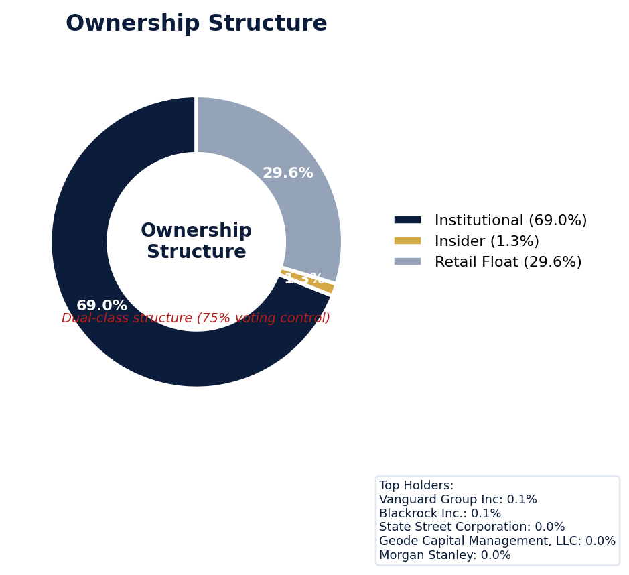
Figure: Ownership breakdown -- institutional, insider, retail float
Category | Percentage
Institutional Ownership | 69.0%
Insider Ownership | 1.3%
Retail Float | 29.6%
Top Holder | Ownership %
Vanguard Group Inc | 0.1%
Blackrock Inc. | 0.1%
State Street Corporation | 0.0%
Geode Capital Management, LLC | 0.0%
Morgan Stanley | 0.0%
Sentiment & Narrative Coherence
Signal | Assessment
Narrative Coherence | COHERENT
Anti-Takeover Provisions
Anti-takeover provision data not available. Review DEF 14A and charter documents for complete analysis.

CRITICAL RISK
Coinbase currently defends five active SCAs, including the pivotal *In re Coinbase Global, Inc. Securities Litigation* with a class period from April 2021, and *Underwood et al. v. Coinbase* from 2021. The company's adjusted SCA filing rate of 10.44% is more than double the 4.0% sector average, indicating a severe and recurrent litigation posture that directly increases the frequency and severity of D&O claims. With four derivative actions piggybacking on these SCAs and six open solicitation letters, plaintiff's counsel coordination is high, likely driving defense costs well above peer benchmarks and complicating unified defense strategy. The SEC's ongoing Comment Letter stage represents a clear catalyst for a future corrective disclosure, potentially inflating settlement values beyond the typical crypto-sector premium by providing plaintiffs with a low-cost regulatory roadmap. Given its moderate defense strength and a history of missing guidance by over 15%—a specific factor scoring 2.02 out of 10 on risk metrics—my claim probability estimate exceeds 40%, with settlement benchmarking suggesting a potential eight-figure resolution per major SCA. The primary underwriting catch is the regulatory timeline acting as a litigation multiplier, locking in high defense costs for years before any settlement pressure even materializes, which pressures D&O limits through attrition.
Section 6: Litigation & Regulatory Exposure
The company faces 5 active securities class action(s). The primary case, In re Coinbase Global, Inc. Securities Litigation (2022), is currently pending. SEC enforcement pipeline position: COMMENT_LETTER. 4 derivative action(s) pending, alleging breach of fiduciary duty by directors and officers. 6 statute of limitations window(s) remain open, meaning new claims can still be filed for past events. Under claims-made D&O policy, coverage is triggered when a claim is reported during the policy period. Defense quality assessment: MODERATE.
Litigation Overview: 2 active matter(s), 0 historical matter(s)
Litigation Timeline
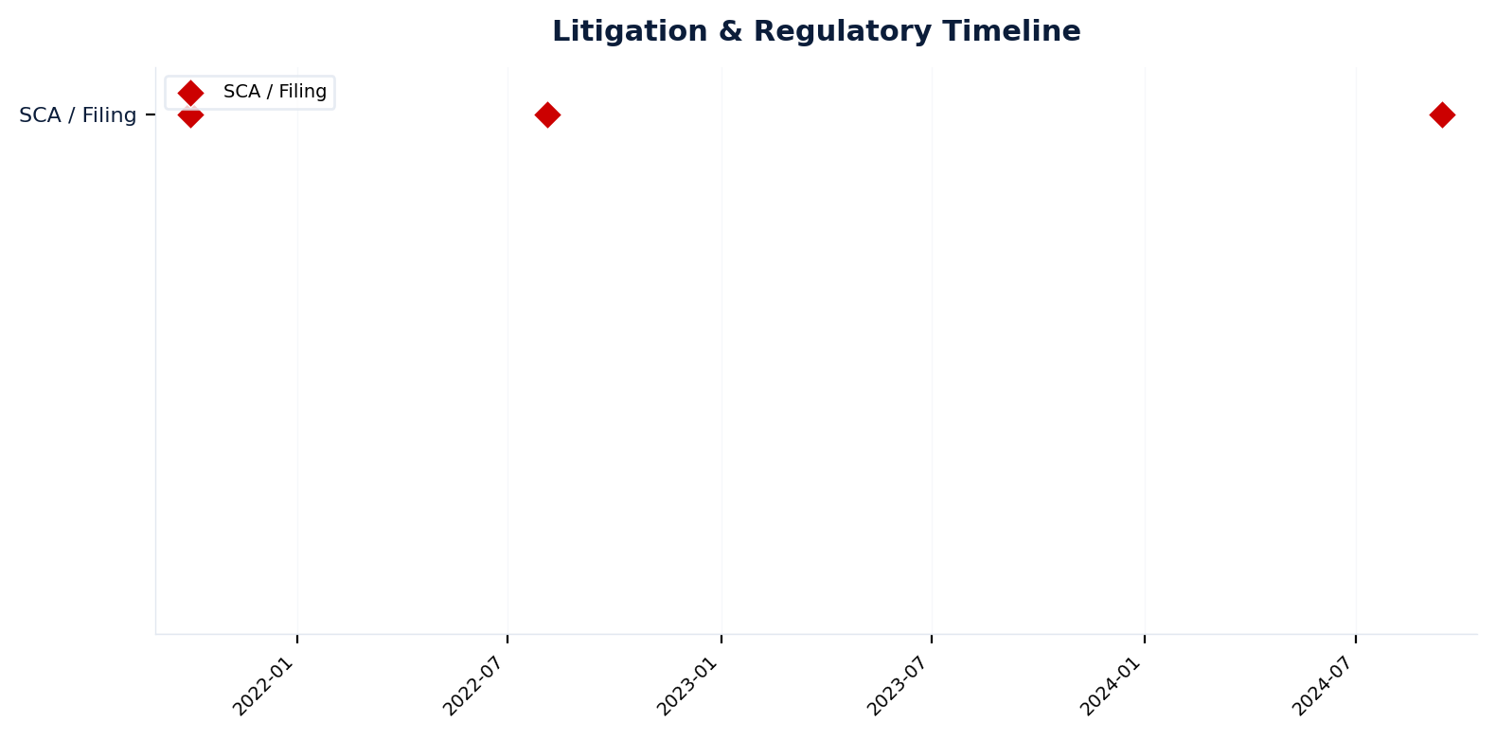
Figure: Chronological litigation and regulatory events overlaid with corporate events for pattern recognition
Securities Class Actions
Case Name | Legal Theory | Coverage | Court | Filing Date | Status | Class Period | Lead Counsel | Settlement | Source
In re Coinbase Global Inc Securities (2024) | N/A | Regulatory | N.D. Cal. | 2024-09-13 | UNKNOWN | N/A | N/A | N/A | [web search, 2026-04-03, LOW]
In re Coinbase Global, Inc. Securities Litigation (2022) | Rule 10b-5, Section 11 | Side C (Entity) | N/A | 2022-08-04 | ACTIVE | N/A | N/A | N/A | [Supabase SCA database, 2026-04-03, MEDIUM]
Underwood et al. v. Coinbase Global, Inc. (2021) | Securities Act Section 5, Securities Act Section 12(A)(1), Securities Act Section 15, State Statutes, Derivative / Fiduciary Duty | Commercial | U.S. District Court for the Southern District of New York | 2021-10-01 | ACTIVE | N/A | N/A | N/A | [10-K (LLM), 2026-04-03, HIGH]
[HIGH] 2 Active Securities Class Action(s) -- triggered Active SCA Status (F1) — this agent risk (executive/director actions and decisions that create D&O exposure) indicates Litigation History / Settlement Patterns. Evidence: Boolean check: Active case.
Context: Cases with PSLRA safe harbor and forum selection provisions settle at 40% lower median amounts.
See Meeting Prep: Active Litigation
SEC Enforcement Pipeline
Pipeline: [Comment Letters] -> (Informal Inquiry) -> (Formal Investigation) -> (Wells Notice) -> (Enforcement Action)
Current Position: Comment Letters [MODERATE]
Company is at COMMENT_LETTER stage in the SEC enforcement pipeline, with 1 supporting signal(s) identified. [10-K Item 3 + Item 1A + 8-K + EFTS, 2026-04-03, LOW]
Derivative Suits
Case Name | Filing Date | Status | Court | Settlement
N/A | N/A | UNKNOWN | N/A | N/A
N/A | N/A | UNKNOWN | N/A | N/A
N/A | N/A | UNKNOWN | Delaware Court of Chancery | N/A
N/A | N/A | UNKNOWN | Delaware Court of Chancery | N/A
Regulatory Proceedings
Agency | Type | Status
DOJ_FCPA | investigation | disclosed
FDA | investigation | disclosed
Industry Claim Patterns
No industry-specific claim patterns identified.
Statute of Limitations Map
Claim Type | Trigger Date | SOL Expiry | Repose Expiry | Window Open
employment_discrimination | 2026-02-12 | 2028-02-12 | 2028-02-12 | OPEN
antitrust | 2026-02-12 | 2030-02-11 | 2030-02-11 | OPEN
FCPA | 2026-02-12 | 2031-02-11 | 2031-02-11 | OPEN
environmental | 2026-02-12 | 2031-02-11 | 2031-02-11 | OPEN
derivative | 2026-02-12 | 2029-02-11 | 2032-02-11 | OPEN
ERISA | 2026-02-12 | 2029-02-11 | 2032-02-11 | OPEN
Section_11 | 2021-10-01 | 2022-10-01 | 2024-09-30 | CLOSED
Section_14a | 2021-10-01 | 2022-10-01 | 2024-09-30 | CLOSED
10b-5 | 2021-10-01 | 2023-10-01 | 2026-09-30 | CLOSED
D&O Context: 6 open exposure window(s). Claims can still be filed within these periods. [ELEVATED]
Defense Strength Assessment
Factor | Assessment
Federal Forum Provision | No
Exclusive Forum Provision | No
PSLRA Safe Harbor | MODERATE
Truth-on-Market Viability | PARTIAL
Prior Dismissal Success | No prior dismissals identified in Item 3
Overall Defense Strength | MODERATE
No forum selection provisions identified. Safe harbor usage is MODERATE with standard forward-looking statement protections. [DEF 14A; 10-K, 2026-04-03, LOW]
Contingent Liabilities
Description | ASC 450 Class. | Accrued | Range
e tax basis of the exchanged crypto assets. Receipts of cryp | probable | N/A | N/A
rules, and regulations, both foreign and domestic. The Compa | reasonably_possible | N/A | N/A
domestic. The Company reviews its lawsuits, regulatory inves | reasonably_possible | N/A | N/A
D&O Context: 1 probable contingenc(y/ies). ASC 450 probable classification indicates management believes loss is likely. Direct impact on D&O exposure. [HIGH]
Workforce, Product & Environmental Matters
Cybersecurity Incidents:
- [cyber_attack] r interruptions, including with respect to our platform and third-party crypto networks; • our lack of control over decentralized or third-party blockchains and networks that may experience downtime, cyberattacks, critical failures, errors, bugs, corrupted files, data losses, or other similar software failures, outages, breaches and losses; • breaches of security or privacy; • inaccessibility of our platform due to our or third-party actions; • our ability to attract and retain talent; and • ...
- [cyber_attack] Cyberattacks and security breaches of our platform, or those impacting our customers or third parties, could adversely affect our brand, reputation, business, operating results, and financial condition.
- [cyber_attack] Certain types of cyberattacks could harm us even if our systems are left undisturbed.
- [cyber_attack] As we grow our offering of products and services, including options and perpetual swaps, we face increased exposure to cyberattacks through third parties.
- [cyber_attack] Although we maintain insurance coverage, it may be insufficient to protect us against all losses and costs stemming from security breaches, cyberattacks, and other types of unlawful activity, or any resulting disruptions or data theft and loss from such events.
- [cyber_attack] Outages and disruptions of our platform, including any caused by cyberattacks, may harm our reputation, business, operating results, and financial condition.
- [data_breach] 05 Material Cybersecurity Incident.
- [data_breach] ts to differ from those expressed in these forward-looking statements include the ongoing assessment of the Incident; legal, reputational and financial risks resulting from the Incident or additional cybersecurity incidents; and the risks described in the Company's Annual Report on Form 10-K for the year ended December 31, 2024 and subsequent Quarterly Reports on Form 10-Q.
Whistleblower Indicators
No whistleblower indicators identified in SEC filings. SEC whistleblower tips are not publicly disclosed; absence does not confirm lack of activity.

Coinbase's quality score of 29.25 places it in the WALK tier, with a composite score of 83.78 and an elevated 7.3-10.4% claim probability requiring an excess/Side A-only placement with high attachment. The risk is anchored by an active securities class action red flag and a Prior Litigation factor deducting 4.93 points from 20, based on 70 signals, indicating a deep litigation history that establishes patterns for plaintiffs. Its volatile profile includes a Short Interest factor deducting 2.04 points and three separate stock drop red flags (7-day, 30-day, 90-day), which frequently trigger shareholder suits. The Guidance Misses factor deducting 2.02 points, including at least one miss exceeding 15% versus forecast, creates predictable disclosure volatility that plaintiffs' counsel exploits. The binding ceiling is constrained by the Whistleblower/Qui Tam Disclosure red flag with a 100 ceiling, capping placement at CRF-9 and making full limits challenging due to severe entity-level risk.
Section 7: Risk Scoring & Synthesis
Underwriting tier: **WALK** (quality score: 29.2/100). Recommended action: Excess/Side A only, high attachment required. Expected claim probability band: 7.3-10.4%. Top risk contributors: Prior Litigation (F1: -4.9 pts); IPO/SPAC/M&A (F4: -2.6 pts); Short Interest (F6: -2.0 pts). Active composite patterns: Guidance Track Record. **Red flag gates active**: Active Securities Class Action (ceiling: 55); Catastrophic Stock Drop (ceiling: 55); Recent Drop - 7 Day (ceiling: 50); Recent Drop - 30 Day (ceiling: 50); Recent Drop - 90 Day (ceiling: 50); Whistleblower/Qui Tam Disclosure (ceiling: 100). Binding ceiling: CRF-9. Claim probability band: ELEVATED (7.3%-10.4%).
Tier Classification
Metric | Value
Quality Score | 29.2 / 100
Composite Score (pre-ceiling) | 83.8
Total Risk Points Deducted | 16.2
Tier | WALK
Tier Range | 11 - 30
Action Guidance | Excess/Side A only, high attachment required
Probability Range | 7.3-10.4%
Pricing Multiplier | 2x+ at high attachment
Binding Ceiling | CRF-9
Risk Assessment: HIGH [HIGH]
D&O Claim Peril Assessment
0 of 8 D&O claim perils show active risk signals. Active perils have at least one causal chain with triggered checks.
Peril | Risk Level | Active Chains | Key Evidence
Securities Claims | LOW | 0/5 | —
Fiduciary Breach | LOW | 0/3 | —
Government Enforcement | LOW | 0/2 | —
Employment & Whistleblower | LOW | 0/1 | —
Insolvency & Bankruptcy | LOW | 0/1 | —
Emerging Risks | LOW | 0/2 | —
Consumer & Product Claims | LOW | 0/1 | —
Commercial Litigation | LOW | 0/1 | —
Composite Score Breakdown
Factor | Name | Max Pts | Deducted | % Used | Top Contributor
F1 | Prior Litigation | 20 | 4.9 | 25% | Signal-driven scoring: 70 signals, coverage=100%
F2 | Stock Decline | 15 | 1.6 | 10% | Signal-driven scoring: 30 signals, coverage=100%
F3 | Restatement/Audit Issues | 12 | 0.9 | 8% | Signal-driven scoring: 87 signals, coverage=100%
F4 | IPO/SPAC/M&A | 10 | 2.6 | 26% | Signal-driven scoring: 19 signals, coverage=100%
F5 | Guidance Misses | 10 | 2.0 | 20% | Signal-driven scoring: 27 signals, coverage=100%
F6 | Short Interest | 10 | 2.0 | 20% | Signal-driven scoring: 26 signals, coverage=100%
F7 | Stock Volatility | 9 | 0.6 | 6% | Signal-driven scoring: 27 signals, coverage=100%
F8 | Financial Distress | 6 | 0.2 | 3% | Signal-driven scoring: 15 signals, coverage=100%
F9 | Governance Issues | 8 | 1.2 | 16% | Signal-driven scoring: 42 signals, coverage=100%
F10 | Officer Stability | 2 | 0.1 | 5% | Signal-driven scoring: 91 signals, coverage=100%
10-Factor Risk Profile
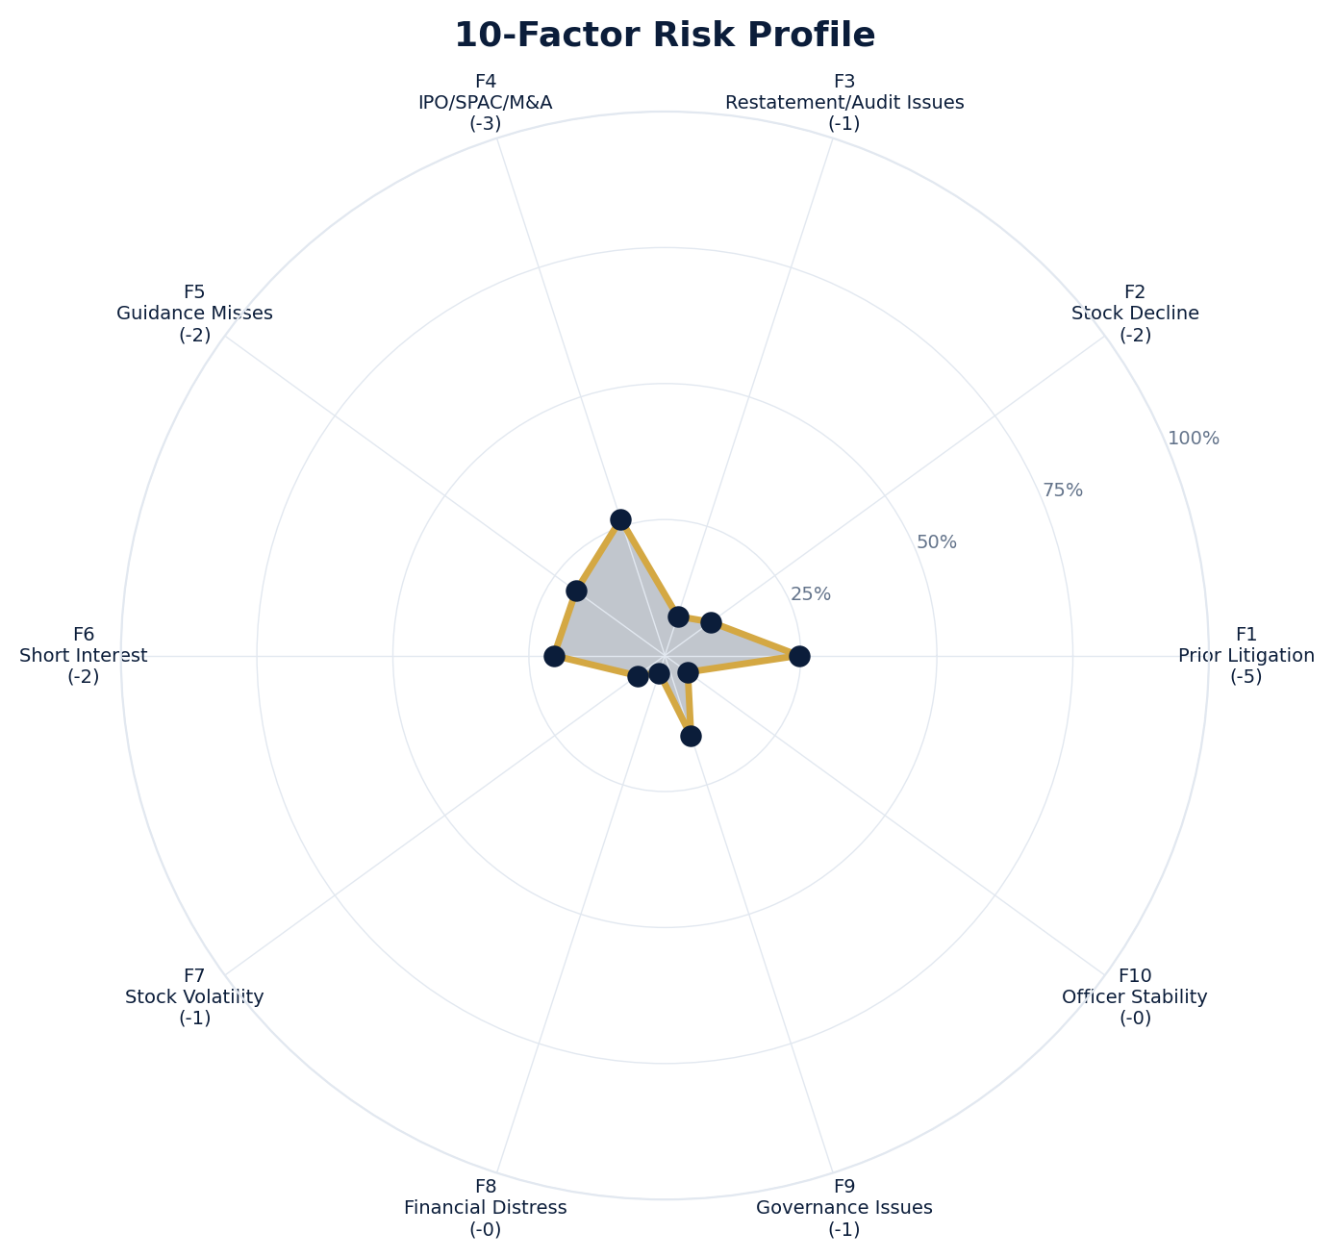
Figure: Radar chart showing risk fraction (points deducted / max) for each of the 10 scoring factors. Larger area = higher risk.
Red Flag Gates
Severity | Description | Source | Impact | Trajectory
CRITICAL | Critical Red Flag: Active Securities Class Action | Active SCA: In re Coinbase Global, Inc. Securities Litigation (2022) | Ceiling: 55 | NEW
CRITICAL | Critical Red Flag: Catastrophic Stock Drop | Stock decline 61.4% from 52-week high | Ceiling: 55 | NEW
CRITICAL | Critical Red Flag: Recent Drop - 7 Day | 7-day drop: 19.9% (3 days ago) | Ceiling: 50 | NEW
CRITICAL | Critical Red Flag: Recent Drop - 30 Day | 30-day drop: 19.9% (3 days ago) | Ceiling: 50 | NEW
CRITICAL | Critical Red Flag: Recent Drop - 90 Day | 90-day drop: 44.9% (49 days ago) | Ceiling: 50 | NEW
CRITICAL | Critical Red Flag: Whistleblower/Qui Tam Disclosure | NLP whistleblower signal: Whistleblower/qui tam language detected: whistleblower. Presence of such language in filings may indicate pending or potential False Claims Act or SEC whistleblower actions. | Ceiling: 100 | NEW
LOW | Prior Litigation: 5/20 points | Signal-driven scoring: 70 signals, coverage=100% | F1: 5 pts | NEW
LOW | Stock Decline: 2/15 points | Signal-driven scoring: 30 signals, coverage=100%; Drop contribution modifier: 0.41x (decay + company-specific + disclosure) | F2: 2 pts | NEW
LOW | Restatement/Audit Issues: 1/12 points | Signal-driven scoring: 87 signals, coverage=100% | F3: 1 pts | NEW
LOW | IPO/SPAC/M&A: 3/10 points | Signal-driven scoring: 19 signals, coverage=100% | F4: 3 pts | NEW
LOW | Guidance Misses: 2/10 points | Signal-driven scoring: 27 signals, coverage=100%; Any single miss >15% vs guidance | F5: 2 pts | NEW
LOW | Short Interest: 2/10 points | Signal-driven scoring: 26 signals, coverage=100% | F6: 2 pts | NEW
LOW | Stock Volatility: 1/9 points | Signal-driven scoring: 27 signals, coverage=100% | F7: 1 pts | NEW
LOW | Financial Distress: 0/6 points | Signal-driven scoring: 15 signals, coverage=100% | F8: 0 pts | NEW
LOW | Governance Issues: 1/8 points | Signal-driven scoring: 42 signals, coverage=100% | F9: 1 pts | NEW
LOW | Officer Stability: 0/2 points | Signal-driven scoring: 91 signals, coverage=100% | F10: 0 pts | NEW
LOW | Pattern: Guidance Track Record (BASELINE) | Pattern evaluation | F5: 0 | NEW
Critical: 6, High: 0, Moderate: 0, Low: 11
Risk Type Classification
Attribute | Value
Primary Risk Type | GUIDANCE_DEPENDENT
Supporting Evidence | F5 guidance misses: 2.020754716981132 points; Issues guidance (philosophy: MIXED)
Severity Scenarios
Analysis based on market cap: $46.2B
Percentile | Label | Settlement Est. | Defense Costs | Total Exposure
25th | favorable | $3.8B | $563.3M | $4.3B
50th | median | $7.5B | $1.5B | $9.0B
75th | adverse | $15.0B | $3.8B | $18.8B
95th | catastrophic | $30.0B | $9.0B | $39.1B
Calibration Notes (SECT7-11)
The following items are flagged NEEDS CALIBRATION and require expert review before final pricing:
- SECT7-11: All scoring parameters require calibration against historical cases
Factor Detail
Factor | Name | Deducted | Rules Triggered | Evidence
F1 | Prior Litigation | 4.9 | N/A | Signal-driven scoring: 70 signals, coverage=100%
F2 | Stock Decline | 1.6 | drop_contribution_adjustment | Signal-driven scoring: 30 signals, coverage=100%; Drop contribution modifier: 0.41x (decay + company-specific + disclosure)
F3 | Restatement/Audit Issues | 0.9 | N/A | Signal-driven scoring: 87 signals, coverage=100%
F4 | IPO/SPAC/M&A | 2.6 | N/A | Signal-driven scoring: 19 signals, coverage=100%
F5 | Guidance Misses | 2.0 | F5-006 | Signal-driven scoring: 27 signals, coverage=100%; Any single miss >15% vs guidance
F6 | Short Interest | 2.0 | N/A | Signal-driven scoring: 26 signals, coverage=100%
F7 | Stock Volatility | 0.6 | N/A | Signal-driven scoring: 27 signals, coverage=100%
F8 | Financial Distress | 0.2 | N/A | Signal-driven scoring: 15 signals, coverage=100%
F9 | Governance Issues | 1.2 | N/A | Signal-driven scoring: 42 signals, coverage=100%
F10 | Officer Stability | 0.1 | N/A | Signal-driven scoring: 91 signals, coverage=100%
Sub-Component Breakdown
Factor | Component | Value
F1 | base | 4.93
F1 | bonus | 0.00
F1 | modifiers | 0.00
F1 | hard_triggers | 0.00
F1 | total_before_cap | 4.93
F1 | capped | 4.93
F2 | base | 3.82
F2 | bonus | 0.00
F2 | modifiers | 0.00
F2 | hard_triggers | 0.00
F2 | drop_contribution_modifier | 0.41
F2 | total_before_cap | 1.57
F2 | capped | 1.57
F3 | base | 1.07
F3 | bonus | 0.00
F3 | modifiers | 0.00
F3 | hard_triggers | 0.00
F3 | total_before_cap | 1.07
F3 | capped | 1.07
F3 | ies_amplification | 0.85
F4 | base | 2.63
F4 | bonus | 0.00
F4 | modifiers | 0.00
F4 | hard_triggers | 0.00
F4 | total_before_cap | 2.63
F4 | capped | 2.63
F5 | base | 0.38
F5 | bonus | 2.00
F5 | modifiers | 0.00
F5 | hard_triggers | 0.00
F5 | total_before_cap | 2.38
F5 | capped | 2.38
F5 | pattern_modifier | 0.00
F5 | ies_amplification | 0.85
F6 | base | 2.40
F6 | bonus | 0.00
F6 | modifiers | 0.00
F6 | hard_triggers | 0.00
F6 | total_before_cap | 2.40
F6 | capped | 2.40
F6 | ies_amplification | 0.85
F7 | base | 0.67
F7 | bonus | 0.00
F7 | modifiers | 0.00
F7 | hard_triggers | 0.00
F7 | total_before_cap | 0.67
F7 | capped | 0.67
F7 | ies_amplification | 0.85
F8 | base | 0.20
F8 | bonus | 0.00
F8 | modifiers | 0.00
F8 | hard_triggers | 0.00
F8 | total_before_cap | 0.20
F8 | capped | 0.20
F9 | base | 1.46
F9 | bonus | 0.00
F9 | modifiers | 0.00
F9 | hard_triggers | 0.00
F9 | total_before_cap | 1.46
F9 | capped | 1.46
F9 | ies_amplification | 0.85
F10 | base | 0.10
F10 | bonus | 0.00
F10 | modifiers | 0.00
F10 | hard_triggers | 0.00
F10 | total_before_cap | 0.10
F10 | capped | 0.10
Pattern Detection Results
Pattern | Severity | Triggers Matched | Score Impact
Guidance Track Record | BASELINE |  | F5: +0
Allegation Theory Mapping
Theory | Exposure | Factor Sources | Key Findings
A_DISCLOSURE | MODERATE | F1, F3, F5 | F1: Signal-driven scoring: 70 signals, coverage=100%; F3: Signal-driven scoring: 87 signals, coverage=100%
B_GUIDANCE | MODERATE | F2, F5 | F2: Signal-driven scoring: 30 signals, coverage=100%; F2: Drop contribution modifier: 0.41x (decay + company-specific + disclosure)
C_PRODUCT_OPS | LOW | F7, F8 | F7: Signal-driven scoring: 27 signals, coverage=100%; F8: Signal-driven scoring: 15 signals, coverage=100%
D_GOVERNANCE | LOW | F9, F10 | F9: Signal-driven scoring: 42 signals, coverage=100%; F10: Signal-driven scoring: 91 signals, coverage=100%
E_MA | LOW | F4 | F4: Signal-driven scoring: 19 signals, coverage=100%
D&O Context: Primary allegation exposure is A_DISCLOSURE. MODERATE exposure in: A_DISCLOSURE, B_GUIDANCE.
Claim Probability Detail
Metric | Value
Probability Band | ELEVATED
Range | 7.3% - 10.4%
Industry Base Rate | 4.0%
Adjustment Rationale | Industry base rate: 4.0%. Tier WALK (15-20%): Substantially above base rate. Cri
Claim probability: ELEVATED [HIGH]
Tower Position Recommendation
Metric | Value
Recommended Position | HIGH_EXCESS
Minimum Attachment | $7511.0M (based on 50th percentile settlement)
Side A/DIC Assessment | Standard Side A considerations
Position | Risk Assessment | Premium Guidance | Attachment
PRIMARY | Primary layer carries 57% of expected loss exposur | Full rate, slight discount for | $0 ground-up
LOW_EXCESS | Low excess layer carries 18% of expected loss expo | Market rate | $5-15M xs $5-15M
MID_EXCESS | Mid excess layer carries 13% of expected loss expo | Market to 1.3x | $15-50M xs $15-50M
HIGH_EXCESS | High excess layer carries 11% of expected loss exp | 1.3-2x with attachment | $50M+ xs $50M+
DECLINE | WALK+ with compounding factors | N/A | N/A
Forensic Composite Scores
Composite | Score | Interpretation
Financial Integrity Score (FIS) | N/A | Not available
Reporting Quality Score (RQS) | N/A | Not available
Cash Flow Quality Score (CFQS) | N/A | Not available
Executive Risk Profile
Metric | Value
Weighted Score | 8
Risk Level | N/A
- [Legal Officer (CAO)]: Prior litigation: snippet: Coinbase Global Inc. directors and officers are responsible for harm to the company that st
- [Legal Officer (CAO)]: Prior litigation: case_summary: According to the Complaint, Coinbase Global, Inc. offers (i) consumers their primary f
- [Legal Officer (CAO)]: Prior litigation: title: Updated: Chief Legal Officer Indicates Coinbase Has Received ...
- [America Online (CTO)]: Prior litigation: url: https://businesslawreview.uchicago.edu/online-archive/equitable-estoppel-against-federal-govern
Temporal Signals
Type | Direction | Magnitude | Description
Unknown | N/A | N/A
Unknown | N/A | N/A
Unknown | N/A | N/A
Unknown | N/A | N/A
Unknown | N/A | N/A
Unknown | N/A | N/A
Unknown | N/A | N/A
NLP Filing Analysis
Metric | Value
Readability Score | {'current_fog': 22.5, 'prior_fog': None, 'fog_change': None, 'current_flesch': 14.28, 'prior_flesch': None, 'classification': 'CURRENT_ONLY', 'evidence': 'Current Fog Index: 22.5 (prior year unavailable)'}
Tone Assessment | N/A
Risk Language Density | N/A
Peril Assessment
Plaintiff Peril Heat Map
Plaintiff Type | Probability | Severity
Shareholders | ELEVATED | SIGNIFICANT
Regulators | ELEVATED | SIGNIFICANT
Customers | VERY LOW | NUISANCE
Competitors | VERY LOW | NUISANCE
Employees | LOW | MINOR
Creditors | LOW | MINOR
Government | MODERATE | MODERATE
Shareholders: 57 triggered checks. Key: Litigation History Profile: 2 (elevated vs benchmark of 0)
Regulators: 16 triggered checks. Key: Disclosure Complexity Score: 34 (elevated vs benchmark of 25)
Government: 3 triggered checks. Key: Key Supplier Dependencies: 3 (elevated vs benchmark of 1)
Bear Cases
Bear Case: A Disclosure
Coinbase Global, Inc. faces elevated exposure to securities disclosure fraud claims. Key risk indicators: Litigation History Profile (critical); VIE/SPE Off-Balance-Sheet Structures (critical). Estimated severity is significant, warranting detailed underwriter review.
Defense: Defense: No active Section 11 windows — statute of limitations expired for offering claims
Evidence Chain
1. [BIZ.CLASS.litigation_history] Litigation History Profile (Source: total_sca_count)
2. [BIZ.STRUCT.vie_spe] VIE/SPE Off-Balance-Sheet Structures (Source: vie_spe_present)
3. [BIZ.DEPEND.regulatory_dep] Single-Source Suppliers (Source: regulatory_dependency_count)
4. [BIZ.EVENT.ipo_exposure] IPO/Offering Exposure Window (Source: event_ipo_exposure_score)
5. [BIZ.OPS.workforce] Workforce Distribution (Source: workforce_distribution)
6. [BIZ.STRUC.nongaap] Non-GAAP Measure Usage (Source: nongaap_measure_count)
7. [BIZ.STRUC.obs_exposure] Off-Balance-Sheet Exposure (Source: obs_exposure_score)
8. [EXEC.PRIOR_LIT.any_officer] Any Officer With Prior Litigation at Previous Company (Source: value)
9. [EXEC.INSIDER.ceo_net_selling] CEO Net Seller of Stock (Source: value)
10. [EXEC.INSIDER.cfo_net_selling] CFO Net Seller of Stock (Source: value)
Probability: ELEVATED | Severity: SIGNIFICANT
Bear Case: B Guidance
Coinbase Global, Inc. faces elevated exposure to guidance manipulation claims. Key risk indicators: Litigation History Profile (critical); VIE/SPE Off-Balance-Sheet Structures (critical). Estimated severity is significant, warranting detailed underwriter review.
Evidence Chain
1. [BIZ.CLASS.litigation_history] Litigation History Profile (Source: total_sca_count)
2. [BIZ.STRUCT.vie_spe] VIE/SPE Off-Balance-Sheet Structures (Source: vie_spe_present)
3. [BIZ.DEPEND.regulatory_dep] Single-Source Suppliers (Source: regulatory_dependency_count)
4. [BIZ.EVENT.ipo_exposure] IPO/Offering Exposure Window (Source: event_ipo_exposure_score)
5. [BIZ.OPS.workforce] Workforce Distribution (Source: workforce_distribution)
6. [BIZ.STRUC.nongaap] Non-GAAP Measure Usage (Source: nongaap_measure_count)
7. [BIZ.STRUC.obs_exposure] Off-Balance-Sheet Exposure (Source: obs_exposure_score)
8. [EXEC.PRIOR_LIT.any_officer] Any Officer With Prior Litigation at Previous Company (Source: value)
9. [EXEC.INSIDER.ceo_net_selling] CEO Net Seller of Stock (Source: value)
10. [EXEC.INSIDER.cfo_net_selling] CFO Net Seller of Stock (Source: value)
Probability: ELEVATED | Severity: SIGNIFICANT
Settlement Prediction
Settlement prediction computed but no scenarios available.
Tower Risk Characterization
Tower characterization not available.
Coverage Gaps -- Data Not Available
The following checks could not be evaluated because required data was not acquired. These items are NOT cleared -- they represent gaps in coverage that should be considered in the underwriting decision.
Executive Summary & Key Metrics
[EVALUATIVE] BIZ.DEPEND.labor (Concentration Risk Composite): Required data not available from filings
[REQUIRED] BIZ.MODEL.lifecycle (Segment Lifecycle Risk): Required data not available from filings
[REQUIRED] BIZ.MODEL.segment_margins (Segment Margin Profile): Required data not available from filings
[EVALUATIVE] ABS.DISC.audit_fees (Missing Audit Fee Disclosure): Expected signals not found in evaluation results
[EVALUATIVE] ABS.DISC.board_independence (Missing Board Independence Disclosure): Could not determine disclosure presence or absence
[EVALUATIVE] ABS.DISC.clawback_policy (Missing Clawback Policy Disclosure): Expected signals not found in evaluation results
[EVALUATIVE] ABS.DISC.cyber_risk (Missing Cybersecurity Risk Disclosure): Expected signals not found in evaluation results
[EVALUATIVE] ABS.DISC.debt_covenants (Missing Debt Covenant Disclosure): Expected signals not found in evaluation results
[EVALUATIVE] ABS.DISC.derivative_instruments (Missing Derivative Instruments Disclosure): Expected signals not found in evaluation results
[EVALUATIVE] ABS.DISC.esg (Missing ESG Disclosure): Expected signals not found in evaluation results
[EVALUATIVE] ABS.DISC.executive_comp (Missing Executive Compensation Disclosure): Expected signals not found in evaluation results
[EVALUATIVE] ABS.DISC.goodwill_impairment (Missing Goodwill Impairment Disclosure): Expected signals not found in evaluation results
[EVALUATIVE] ABS.DISC.lease_obligations (Missing Lease Obligation Disclosure): Expected signals not found in evaluation results
[EVALUATIVE] ABS.DISC.litigation_contingency (Missing Litigation Contingency Disclosure): Expected signals not found in evaluation results
[EVALUATIVE] ABS.DISC.pension_obligations (Missing Pension Obligation Disclosure): Expected signals not found in evaluation results
[EVALUATIVE] ABS.DISC.related_party (Missing Related-Party Transaction Disclosure): Expected signals not found in evaluation results
[EVALUATIVE] ABS.DISC.revenue_recognition (Missing Revenue Recognition Policy Disclosure): Expected signals not found in evaluation results
[EVALUATIVE] ABS.DISC.risk_factors (Missing Risk Factor Disclosure): Expected signals not found in evaluation results
[EVALUATIVE] ABS.DISC.segment_reporting (Missing Segment Reporting Disclosure): Expected signals not found in evaluation results
[EVALUATIVE] ABS.DISC.stock_comp (Missing Stock Compensation Disclosure): Expected signals not found in evaluation results
[EVALUATIVE] ABS.DISC.tax_positions (Missing Uncertain Tax Position Disclosure): Expected signals not found in evaluation results
[EVALUATIVE] CONJ.COMP.perf_divergence (Compensation-Performance Divergence): 3/3 component signals unavailable
[EVALUATIVE] CONJ.DISTRESS.insider (Financial Distress + Insider Selling): 2/3 component signals unavailable
[EVALUATIVE] CONJ.GOV.governance_event (Weak Governance + Adverse Event): 3/5 component signals unavailable
[EVALUATIVE] CONJ.FIN.growth_margin_guidance (Rapid Growth + Margin Compression + Guidance Miss): 3/3 component signals unavailable
[EVALUATIVE] CONJ.INSIDER.news_gap (Insider Selling + Material News Gap): 3/3 component signals unavailable
[EVALUATIVE] CONJ.REG.litigation (Regulatory Action + New Material Litigation): 3/3 component signals unavailable
[EVALUATIVE] CTX.FIN.capex_sector (Capital Expenditure in Sector Context): Source signal FIN.INVEST.capex_ratio not in results
[EVALUATIVE] CTX.COMP.lifecycle (CEO Compensation in Lifecycle Context): Source signal EXEC.COMP.ceo_total_comp not in results
[EVALUATIVE] CTX.COMP.product_tower (Compensation Severity by Product/Tower): Source signal EXEC.COMP.ceo_total_comp not in results
[EVALUATIVE] CTX.FIN.debt_maturity (Debt Maturity Profile in Lifecycle Context): Source signal FIN.DEBT.maturity_profile not in results
[EVALUATIVE] CTX.FIN.distress_product (Financial Distress by Product/Tower): Source signal FIN.FORENSIC.altman_z not in results
[EVALUATIVE] CTX.FIN.dividend_lifecycle (Dividend Policy in Lifecycle Context): Source signal FIN.RETURN.dividend_yield not in results
[EVALUATIVE] CTX.EXEC.tenure_lifecycle (Executive Tenure in Lifecycle Context): Source signal EXEC.TURN.c_suite not in results
[EVALUATIVE] CTX.MKT.insider_lifecycle (Insider Trading in Lifecycle Context): Source signal STOCK.INSIDER.net_selling not in results
[EVALUATIVE] CTX.FIN.leverage_sector (Leverage in Sector Context): Source signal FIN.DEBT.leverage_ratio not in results
[EVALUATIVE] CTX.LIT.size (Litigation Frequency by Company Size): Source signal LIT.SCA.active_cases not in results
[EVALUATIVE] CTX.RISK.ma_lifecycle (M&A Activity in Lifecycle Context): Source signal BIZ.MA.acquisition_activity not in results
[EVALUATIVE] CTX.RISK.regulatory_sector (Regulatory Risk in Sector Context): Source signal LIT.SEC.enforcement not in results
[EVALUATIVE] CTX.RISK.rpt_sector (Related-Party Risk in Sector Context): Source signal GOV.RPT.related_party not in results
[EVALUATIVE] CTX.MKT.short_interest_sector (Short Interest in Sector Context): Source signal STOCK.SHORT.interest_ratio not in results
[EVALUATIVE] CTX.MKT.turnover_sector (Stock Turnover in Sector Context): Source signal STOCK.VOL.turnover_rate not in results
[EVALUATIVE] CTX.MKT.volatility_sector (Stock Volatility in Sector Context): Source signal STOCK.VOL.historical not in results
Financial Health
[EVALUATIVE] FIN.PEER.revenue_bottom_quartile (Revenue Bottom Quartile (Cross-Filer)): No peer comparison data available
[EVALUATIVE] FIN.PEER.leverage_top_decile (Leverage Top Decile (Sector-Relative)): No peer comparison data available
[EVALUATIVE] FIN.PEER.margin_compression (Operating Margin Compression (Cross-Filer)): No peer comparison data available
[EVALUATIVE] FIN.PEER.profitability_laggard (Profitability Laggard (Sector-Relative)): No peer comparison data available
[EVALUATIVE] FIN.PEER.size_outlier_small (Size Outlier Small (Cross-Filer)): No peer comparison data available
[EVALUATIVE] FIN.PEER.cash_flow_weak (Cash Flow Weakness (Cross-Filer)): No peer comparison data available
[EVALUATIVE] LIT.DEFENSE.forum_selection (Federal Forum Selection Clause): Required data not available from filings
Governance & Leadership
[EVALUATIVE] EXEC.TENURE.ceo_new (CEO Tenure Less Than 2 Years): Data mapping not configured for this check
[EVALUATIVE] EXEC.TENURE.cfo_new (CFO Tenure Less Than 2 Years): Data mapping not configured for this check
[REQUIRED] EXEC.PROFILE.board_size (Board Size (Number of Members)): Required data not available from filings
[REQUIRED] EXEC.PROFILE.independent_ratio (Board Independence Percentage): Required data not available from filings
[EVALUATIVE] EXEC.PROFILE.overboarded_directors (Directors Serving on 4+ Boards): Required data not available from filings
[EVALUATIVE] GOV.BOARD.size (Board Size): Required data not available from filings
[EVALUATIVE] GOV.BOARD.independence (Board Independence): Required data not available from filings
[EVALUATIVE] GOV.BOARD.diversity (Board Diversity): Required data not available from filings
[EVALUATIVE] GOV.BOARD.tenure (Tenure): Required data not available from filings
[EVALUATIVE] GOV.BOARD.overboarding (Overboarding): Required data not available from filings
[EVALUATIVE] GOV.BOARD.attendance (Attendance): Required data not available from filings
[EVALUATIVE] GOV.BOARD.meetings (Meetings): Required data not available from filings
[EVALUATIVE] GOV.BOARD.succession (Succession): Required data not available from filings
[EVALUATIVE] GOV.EXEC.ceo_profile (CEO Profile): Required data not available from filings
[EVALUATIVE] GOV.EXEC.cfo_profile (CFO Profile): Required data not available from filings
[EVALUATIVE] GOV.EXEC.founder (Founder Status): Required data not available from filings
[EVALUATIVE] GOV.EXEC.key_person (Key Person Risk): Required data not available from filings
[EVALUATIVE] GOV.PAY.golden_para (Golden Para): Required data not available from filings
[EVALUATIVE] GOV.PAY.equity_burn (Equity Burn): Required data not available from filings
[EVALUATIVE] GOV.PAY.hedging (Hedging): Required data not available from filings
[REQUIRED] GOV.RIGHTS.bylaws (Bylaws): Required data not available from filings
[EVALUATIVE] GOV.RIGHTS.takeover (Takeover): Required data not available from filings
[EVALUATIVE] GOV.RIGHTS.proxy_access (Proxy Access): Required data not available from filings
[REQUIRED] GOV.RIGHTS.forum_select (Forum Select): Required data not available from filings
[EVALUATIVE] GOV.RIGHTS.supermajority (Supermajority): Required data not available from filings
[EVALUATIVE] GOV.RIGHTS.action_consent (Action Consent): Required data not available from filings
[EVALUATIVE] GOV.RIGHTS.special_mtg (Special Mtg): Required data not available from filings
[EVALUATIVE] GOV.RIGHTS.classified (Classified): Required data not available from filings
Market & Trading
[EVALUATIVE] FIN.COMP.unvested_cost (Unvested SBC Pipeline): Required data not available from filings
[EVALUATIVE] FIN.COMP.rsu_grants (RSU Grant Trend): Required data not available from filings
[EVALUATIVE] FIN.CONT.loss_accrual (Loss Contingency Accrual): Required data not available from filings
[EVALUATIVE] FIN.CONT.loss_estimate (Loss Contingency Estimate): Required data not available from filings
[EVALUATIVE] FIN.CONT.settlement_activity (Litigation Settlement Activity): Required data not available from filings
[EVALUATIVE] FIN.CONT.warranty_reserve (Product Warranty Reserve): Required data not available from filings
[EVALUATIVE] FIN.DEBT.facility_utilization (Credit Facility Utilization): Required data not available from filings
[EVALUATIVE] FIN.DEBT.maturity_concentration (Debt Maturity Concentration): Data mapping not configured for this check
[EVALUATIVE] FIN.DERIV.notional_exposure (Derivative Notional Exposure): Required data not available from filings
[EVALUATIVE] FIN.QUALITY.q4_revenue_concentration (Q4 Revenue Concentration): Required data not available from filings
[EVALUATIVE] FIN.QUALITY.revenue_recognition_risk (Revenue Recognition Risk Indicators): Data mapping not configured for this check
[EVALUATIVE] FIN.FORENSIC.level3_fair_value (Level 3 Fair Value Asset Concentration): Data mapping not configured for this check
[EVALUATIVE] FIN.FORENSIC.goodwill_deterioration_pattern (Goodwill Deterioration Pattern): Data mapping not configured for this check
[EVALUATIVE] FIN.FORENSIC.related_party_revenue (Related Party Revenue Concentration): Data mapping not configured for this check
[EVALUATIVE] FWRD.EVENT.ma_integration_risk (M&A Integration Risk): Data mapping not configured for this check
[EVALUATIVE] FIN.FORENSIC.deferred_revenue_divergence (Deferred Revenue Divergence): Data mapping not configured for this check
[EVALUATIVE] FIN.FORENSIC.margin_compression (Forensic Margin Compression): Data mapping not configured for this check
[EVALUATIVE] FIN.FORENSIC.buyback_timing (Share Buyback Timing Quality): Data mapping not configured for this check
[EVALUATIVE] FIN.FORENSIC.dividend_sustainability (Dividend Sustainability): Data mapping not configured for this check
[EVALUATIVE] FIN.FORENSIC.deferred_tax_growth (Deferred Tax Liability Growth): Data mapping not configured for this check
[EVALUATIVE] FIN.FORENSIC.pension_underfunding (Pension Underfunding Risk): Data mapping not configured for this check
[EVALUATIVE] FIN.FORENSIC.dsri_elevated (Days Sales Receivable Index Elevated): Data mapping not configured for this check
[EVALUATIVE] FIN.FORENSIC.aqi_elevated (Asset Quality Index Elevated): Data mapping not configured for this check
[EVALUATIVE] FIN.FORENSIC.tata_elevated (Total Accruals to Total Assets Elevated): Data mapping not configured for this check
[EVALUATIVE] FIN.FORENSIC.non_gaap_gap (Non-GAAP to GAAP Earnings Gap): Data mapping not configured for this check
[EVALUATIVE] FIN.FORENSIC.goodwill_growth_rate (Goodwill Growth Rate): Data mapping not configured for this check
[EVALUATIVE] FIN.FORENSIC.acquisition_to_revenue (Acquisition Spend Relative to Revenue): Data mapping not configured for this check
[EVALUATIVE] FIN.PROFIT.revenue (Revenue Analysis): Required data not available from filings
[EVALUATIVE] FIN.GUIDE.track_record (Guidance Track Record): Required data not available from filings
[EVALUATIVE] FIN.OBS.contract_liability (Deferred Revenue Execution Risk): Required data not available from filings
[EVALUATIVE] FIN.RESTRUCT.severance (Severance Costs): Required data not available from filings
[EVALUATIVE] FIN.IMPAIR.asset_writedown (Asset Impairment): Required data not available from filings
[EVALUATIVE] FIN.IMPAIR.intangible_writedown (Intangible Asset Impairment): Required data not available from filings
[REQUIRED] NLP.FILING.filing_timing_change (Filing Date Shifted Significantly vs Prior Year): Required data not available from filings
[EVALUATIVE] FIN.FORENSIC.m_score_composite (Beneish M-Score Composite (XBRL)): Data mapping not configured for this check
Gap breakdown: Required items: 7 | Evaluative checks: 106
Total: 113 checks data-unavailable out of 576 total checks (80% coverage)

Calibration Notes
System Intelligence Status
Checks active: 601
Checks incubating: 0 (pending human approval)
Pending feedback: 0 entries
Recent Calibration Changes
Date | Check | Change | Changed By
2026-04-02 | EMERGING_TECH_REGULATORY_GAP | Proposed by ingestion of 'blind_spot:COIN:SEC Sends Wells No | ingestion_pipeline
2026-04-02 | CRYPTO_HACKING_INCIDENTS | Proposed by ingestion of 'blind_spot:COIN:Coinbase Drops on | ingestion_pipeline
2026-04-02 | CRYPTO_SEC_INVESTIGATIONS | Proposed by ingestion of 'blind_spot:COIN:Coinbase Drops on | ingestion_pipeline
2026-04-02 | CRYPTO_REGULATORY_CLARITY | Proposed by ingestion of 'blind_spot:COIN:SEC Sends Wells No | ingestion_pipeline
2026-04-02 | CRYPTO_STAKING_REGULATORY | Proposed by ingestion of 'blind_spot:COIN:SEC Sends Wells No | ingestion_pipeline
2026-04-02 | crypto_cyber_incident_frequency | Proposed by ingestion of 'blind_spot:COIN:Coinbase Drops on | ingestion_pipeline
2026-04-02 | crypto_sec_investigation | Proposed by ingestion of 'blind_spot:COIN:Coinbase Drops on | ingestion_pipeline
2026-04-02 | AUDITOR_RESIGNATION_INTEGRITY | Proposed by ingestion of 'blind_spot:SMCI:Super Micro Comput | ingestion_pipeline
2026-04-02 | CHINA_SALES_DISCLOSURE | Proposed by ingestion of 'blind_spot:SMCI:Super Micro Comput | ingestion_pipeline
2026-04-02 | EXPORT_COMPLIANCE_CONTROLS | Proposed by ingestion of 'blind_spot:SMCI:Super Micro Comput | ingestion_pipeline
Discovery Findings
10 document(s) analyzed, 8 proposal(s) generated, from blind spot search
Feedback for COIN
No pending feedback for COIN.

