
Angry Dolphin -- D&O Underwriting Worksheet
Salesforce, Inc. (CRM)
Generated: April 02, 2026
[Table of Contents -- Update in Word]

Salesforce, Inc.’s D&O composite score of 89.6 places it in the WATCH tier, mandating senior review due to a bifurcated risk profile. The elevated claim band of 5.67%-8.1% is primarily driven by a 28.6% stock price decline within the last 56 days, a critical red flag that directly pressures the Quality Score to 50. Prior litigation deductions of 2.9 points from a 20-point maximum, alongside a 2.15-point deduction for short interest, underscore persistent legal and market skepticism headwinds. These negatives are partially offset by a clean SEC enforcement record and an audit opinion with no material weaknesses, as per latest 10-K filings. The inherent litigation risk of 10.14% is amplified by the company’s $175.4B market cap, presenting a severe severity exposure. Governance stability, evidenced by zero C-suite departures in 18 months, is counterbalanced by M&A-related risk deductions of 1 point from 10. Ultimately, the convergence of a sharp equity decline, active litigation signals, and the scale of potential liability necessitates a carefully structured, low-limit placement with explicit exclusions for historical matters.
Executive Summary
Underwriting Thesis
Salesforce, Inc. is a $175.4B (Decile 1 of 10) mega-cap technology company that would normally present as a stronger underwriting account were it not for critical red flags: Recent Drop - 90 Day. These findings impose a hard quality score ceiling of 50, placing the account in WATCH tier (50/100) regardless of other favorable factors. The primary risk driver is Prior Litigation, driving elevated risk in this area. Signal-driven scoring: 70 signals, coverage=100%. At a 6-8% claim probability (10.1% adjusted rate, 2.0x the Technology sector baseline of 5.0%), this account requires Write carefully, senior review required.
Company Snapshot
Attribute | Value | Source
Company | Salesforce, Inc.
Ticker | CRM
Exchange | NYSE
Sector | Technology
Industry | Software - Application
Market Cap | $175.4B [Decile 1 (largest ~400 accounts)] (Ranks at the 11th percentile among 9 peers) | [yfinance, filed 2026-04-02, MEDIUM confidence]
Revenue | $34.9B | [10-K 2024-01-31 CIK1108524 accn:0001108524-24-000005, filed 2024-01-31, HIGH confidence]
Employees | 83,334 | [yfinance, filed 2026-04-02, MEDIUM confidence]
SIC | 7372 -- Services-Prepackaged Software
GICS | 45103010
NAICS | 511210
FPI Status | No
Fiscal Year End | 01-31
Tier Classification
Attribute | Value
Tier | WATCH
Composite Score | 89.6/100
Quality Score | 50.0/100
Factor Breakdown | F1: 2.9, F2: 0.9, F3: 1.6, F4: 0.7, F5: 0.5, F6: 2.2, F7: 0.5, F8: 0.2, F9: 0.9, F10: 0.1
Score Ceiling | Capped at 50 by CRF-11 (Recent Drop - 90 Day)
Position | 89.6 falls in WATCH range (31-50)
Appetite | Write carefully, senior review required
Classification: WATCH [HIGH]
Inherent Risk Baseline
Component | Value
Market Cap Tier | MEGA [Decile 1 (largest ~400 accounts)]
Sector | Technology (Base rate: 5.0%)
Size Adjustment | 1.56x (MEGA cap multiplier) -> 7.8%
Score Adjustment | 1.30x (quality score multiplier) -> 10.1%
Severity Percentile | Settlement Estimate
25th (favorable) | $25.0M
50th (median) | $75.0M
75th (adverse) | $112.5M
95th (catastrophic) | $150.0M
At a 10.1% adjusted claim rate, the company faces 2.0x its sector baseline of 5.0% for Technology companies. This rate reflects the MEGA cap multiplier (1.56x) combined with the quality score multiplier (1.30x from WATCH tier classification).
Note: NEEDS CALIBRATION
Underwriting Headwinds
1. Critical Red Flag [CRITICAL]
Critical Red Flag: Recent Drop - 90 Day — 90-day drop: 28.6% (56 days ago). This triggers a Critical Red Flag, imposing a score ceiling of 50.
2. Structural Complexity & Litigation History [HIGH]
Salesforce, Inc. has 173 subsidiaries, increasing multi-jurisdictional litigation exposure. Goodwill at 48.7% of total assets reflects an acquisition-driven strategy where integration risk and impairment charges are common SCA triggers. The current docket includes 1 derivative suit. With goodwill at 48.7% of total assets and 1 active matter, Salesforce, Inc.'s exposure profile combines impairment risk with demonstrated plaintiff interest in this issuer. (see Litigation)
3. Earnings Guidance Track Record [HIGH]
Salesforce, Inc. has missed earnings guidance in 1 quarter, with management credibility score at 92%. At $175.4B market cap with an estimated DDL of $256.2B, guidance misses generate large absolute loss figures that attract institutional lead plaintiffs. (see Market & Trading)
4. Stock Price Decline [ELEVATED]
Salesforce, Inc.'s stock has undergone a -37% dip of -36.8% from $296.05 to $187.18 over 252 trading days. This creates an estimated Disclosure Dollar Loss (DDL) of $256.2B, among the largest potential DDL exposures in the market. (see Market & Trading)
5. Transaction-Related Exposure [ELEVATED]
Salesforce, Inc. has transaction-related risk factors. Goodwill at 48.7% of total assets reflects acquisition activity. Failed acquisitions are among the most common SCA triggers. At $175.4B market cap, transaction claims carry both Section 10(b) exposure (misleading disclosures) and Section 14(a) exposure (deficient proxy statements).
Risk Mitigants
1. Clean Regulatory Record
Salesforce, Inc. has no active SEC enforcement pipeline activity, open investigations, or pending Wells Notices. A clean regulatory record for Salesforce, Inc. eliminates the highest-severity D&O claim catalyst and supports favorable underwriting consideration. (see Litigation)
2. Clean Audit & Accounting History
Salesforce, Inc. maintains a clean audit opinion from Ernst & Young (tenure: 24 years) with no material weaknesses, restatements, or going concern qualifications. The 24-year relationship with Ernst & Young provides audit continuity that reduces the likelihood of restatement-driven class actions. However, goodwill at 48.7% of total assets requires ongoing impairment testing -- clean audit history does not eliminate future impairment risk. (see Financial Health)
3. Sound Financial Position
No financial distress indicators present (Altman Z-Score of 2.78, D/E of 0.24, current ratio of 1.1x, interest coverage of 25.7x). Altman Z of 2.78 is in the gray zone but other indicators do not suggest imminent distress. (see Financial Health)
4. Stable Executive Leadership
Dear Fellow has led Salesforce, Inc. for 2 years with no recent C-suite departures. With 2 years in the role, Dear Fellow has a developing track record at Salesforce, Inc.. (see Governance)
5. Low Short Interest
Short interest is low at 2.5% of float, indicating institutional investors are not positioning against the stock. Short interest at 2.5% is within normal range, suggesting no concentrated bearish positioning against Salesforce, Inc.. (see Market & Trading)
Claim Probability
Metric | Value
Band | ELEVATED
Company Rate | 5.7% - 8.1%
Industry Base Rate | 5.0%
Severity Favorable | $399.9M
Severity Median | $834.6M
Severity Adverse | $1.7B
Severity Catastrophic | $3.6B
Probability Band: ELEVATED [HIGH]
The 6-8% probability band represents approximately 1x the Technology sector base rate of 5.0%. Accounts in WATCH tier historically produce claims at elevated frequency. Industry base rate: 5.0%. Tier WATCH (10-15%): Significantly above base rate. Concentration of risk factors suggests elevated claim likelihood. NEEDS CALIBRATION: Probability estimates are indicative and require actuarial validation per SECT7-11. Enhanced frequency: 6.50% base x 1.08 hazard x 1.15 signal = 8.10%.
Tower Recommendation
Metric | Value
Position | Mid Excess
Min Attachment | $695.5M (based on 50th percentile settlement)
Side A/DIC | Standard Side A considerations
Layer | Risk Assessment | Premium Guidance
PRIMARY | Primary layer carries 57% of expected loss exposure. Highest frequency of attachment; most likely to be eroded in any claim scenario. | Full rate, slight discount for WIN
LOW_EXCESS | Low excess layer carries 18% of expected loss exposure. Attaches after primary exhaustion; moderate frequency in adverse scenarios. | Market rate
MID_EXCESS | Mid excess layer carries 13% of expected loss exposure. Attaches in adverse scenarios; lower frequency but higher severity when reached. | Market to 1.3x
HIGH_EXCESS | High excess layer carries 11% of expected loss exposure. Attaches only in catastrophic scenarios; lowest frequency, highest severity. | 1.3-2x with attachment
DECLINE | WALK+ with compounding factors | N/A
Market Context
No market pricing data available.

ELEVATED CONCERN
**Company Overview**
Salesforce, Inc. is the dominant global provider of customer relationship management (CRM) software, operating its unified, AI-powered Agentforce 360 Platform that integrates sales, service, marketing, and data management. With a market capitalization of $175 billion and 83,334 employees, this company, public for 21 years, has evolved from a SaaS pioneer into a complex "agentic enterprise" platform. Its core model of embedding as the central system for client operations creates immense operational leverage, which correspondingly heightens fiduciary scrutiny from shareholders and regulators over its strategic execution.
**Revenue Model**
Over 90% of its $34.9 billion FY25 revenue is from recurring subscription fees, creating high visibility but also immense quarterly renewal pressure on management. The model depends on relentless cross-selling within its existing customer base to drive growth, as new customer acquisition in a saturated enterprise market is costly. Any material decline in net revenue retention—a key reported metric—would break the growth engine, directly exposing officers to allegations of misrepresenting business trends or failing to manage this critical dependency.
**D&O Risk Profile**
The primary exposure is litigation stemming from its aggressive acquisition strategy, including 28+ major purchases like Slack for $27.7 billion, which presents clear targets for shareholder claims related to integration failures or overpayment. Its global footprint, with significant R&D operations in Israel and India and data centers in Ireland and the UK, multiplies regulatory jurisdictions for data privacy and employment practices, increasing the surface area for fiduciary missteps in oversight. Furthermore, the company's pivot to "Agentic AI" as a core differentiator introduces untested IP litigation and product liability vectors, where board oversight of algorithmic bias or output accuracy could be directly challenged in securities suits.
Section 2: Company Profile
Salesforce, Inc. operates in the Software - Application industry. The company has 83,334 employees and $175.4B market cap. Key D&O exposure factors include: Regulatory Multi Jurisdiction, Employment Litigation Risk, Transaction Litigation Risk. [derived:section_summary, 2026-04-02, LOW]
Company Identity
Field | Value | Source
Legal Name | Salesforce, Inc. | [SEC EDGAR submissions, filed 2026-04-02, HIGH confidence]
Ticker | CRM
CIK | 1108524 | [SEC EDGAR submissions, filed 2026-04-02, HIGH confidence]
Sector | Technology | [SEC EDGAR submissions, filed 2026-04-02, HIGH confidence]
SIC Code | 7372 | [SEC EDGAR submissions, filed 2026-04-02, HIGH confidence]
SIC Description | Services-Prepackaged Software
GICS Code | 45103010 | [SIC->GICS mapping (SIC 7372), filed 2026-04-02, MEDIUM confidence]
NAICS Code | 511210 | [SIC->NAICS crosswalk (SIC 7372), filed 2026-04-02, MEDIUM confidence]
Exchange | NYSE | [SEC EDGAR submissions, filed 2026-04-02, HIGH confidence]
State of Incorporation | DE | [SEC EDGAR submissions, filed 2026-04-02, HIGH confidence]
FPI Status | No
Fiscal Year End | 01-31 | [SEC EDGAR submissions, filed 2026-04-02, HIGH confidence]
Business Description
Salesforce, Inc. is a global leader in customer relationship management (CRM) technology, helping organizations become agentic enterprises. The company brings humans, agents, applications, and data together on a trusted, unified AI-powered platform called Agentforce 360 Platform. This platform unites offerings spanning sales, service, marketing, commerce, collaboration, data management, integration, analytics, IT service, and industry verticals. With Agentforce, the agentic layer, customers can build and deploy always-on digital labor using autonomous AI agents to increase productivity, lower costs, and drive operational efficiencies. Salesforce sells primarily on a subscription basis through direct sales and partners. The company is committed to values of trust, customer success, innovation, equality, and sustainability, all grounded in legal and regulatory frameworks. [10-K (LLM), filed 2026-04-02, HIGH confidence]
Subsidiaries
Total subsidiaries: 173 [Exhibit 21 (subsidiary list), filed 2026-04-02, HIGH confidence]
D&O Note: 173 subsidiaries indicates complex corporate structure with multi-jurisdiction exposure.
Business Model Profile
Dimension | Assessment
Revenue Model | RECURRING
Disruption Risk | LOW
Operational Complexity
Complexity Score: 83334/20 -- HIGH [HIGH]
Component | Value
Jurisdictions | 38 (17 high-regulatory)
Workforce | 83,334
Segments | 2
Geographic Concentration | 4/100
Supply Chain | moderate
Overall Resilience | ADEQUATE
Structural Indicators: [X] VIE / SPE | [ ] Dual-Class | [ ] Holding Depth | [ ] OBS Exposure
Corporate Events & Transaction Risk
Event Type | Assessment
M&A Activity | MODERATE (Score: 2/4) | 2 acquisition years | Goodwill growth: 100.2% | Acq/Rev: 22.5%
IPO / Offering Exposure | LOW - 21 years public
Business Changes:
- 14 current event filings (8-K), most recent 2026-03-16
- M&A activity indicated (acquisition, merger, restructuring)
Peer Group Comparison
Ticker | Name | Market Cap | Quality Score | Similarity
MSFT | Microsoft Corporation | $2.8T | N/A | Sector Etf / 13%
GOOGL | Alphabet Inc. | $3.6T | N/A | Sector Etf / 3%
AMZN | Amazon.com, Inc. | $2.3T | N/A | Sector Etf / 2%
META | Meta Platforms, Inc. | $1.5T | N/A | Sector Etf / 4%
NVDA | NVIDIA Corporation | $4.3T | N/A | Sector Etf / 14%
ADBE | Adobe Inc. | $99.0B | N/A | Sector Etf / 34%
ORCL | Oracle Corporation | $421.0B | N/A | Sector Etf / 21%
CSCO | Cisco Systems, Inc. | $312.2B | N/A | Sector Etf / 27%
INTC | Intel Corporation | $253.0B | N/A | Sector Etf / 37%
The peer group of 9 companies shares the same industry classification (SIC 7372). Salesforce, Inc. ranks at the 11th percentile among 9 peers by market capitalization.
Revenue Segments
Revenue segment data not available.
Geographic Footprint
Jurisdiction | Subsidiaries | % of Total | Region
India | 18 | 10.4% | Int'l
Canada | 11 | 6.4% | Int'l
Israel | 10 | 5.8% | Int'l
Ireland | 9 | 5.2% | Int'l
United Kingdom | 9 | 5.2% | Int'l
Australia | 8 | 4.6% | Int'l
China [HIGH RISK] | 8 | 4.6% | Int'l
France | 7 | 4.0% | Int'l
Netherlands | 6 | 3.5% | Int'l
Sweden | 6 | 3.5% | Int'l
Hong Kong | 5 | 2.9% | Int'l
Germany | 5 | 2.9% | Int'l
Singapore | 5 | 2.9% | Int'l
Brazil | 4 | 2.3% | Int'l
Japan | 4 | 2.3% | Int'l
Other Int'l (23) | 58 | 33.5% | Int'l
Total: 173 subsidiaries across 0 US states and 38 international jurisdictions. International exposure: 100% of entity footprint. Multi-jurisdiction operations increase regulatory, tax, and litigation complexity for D&O exposure.
D&O Alert: Operations in high-risk jurisdictions: China. Sanctions compliance and regulatory exposure elevated. [HIGH]
Customer & Supplier Concentration
Concentration data not available from filings.
D&O Exposure Factors
Exposure Type | Risk Level | Description | Coverage Part
Securities Litigation | See analysis sections | Shareholder class actions, SEC enforcement | Side A/B/C
Derivative Actions | See analysis sections | Breach of fiduciary duty, waste claims | Side A/B
Employment Practices | See analysis sections | Discrimination, harassment, wrongful termination | Side B/C (EPLI)
Regulatory/Government | See analysis sections | DOJ, SEC, FTC, state AG investigations | Side A (primarily)
Fiduciary (ERISA) | See analysis sections | 401(k) plan mismanagement, fee litigation | Fiduciary Liability
Standard D&O exposure categories shown. See individual analysis sections for company-specific risk levels.
Classification
Attribute | Value
Market Cap Tier | LARGE
Sector | TECH (TECH)
Years Public | 21
Base Filing Rate | 6.5%
Severity Band | $40.0M -- $150.0M
DDL Exposure Base | $26.3B
IPO Multiplier | 1.00x
Cap Filing Multiplier | 1.30x
Hazard Profile (Inherent Exposure Score)
IES: 54/100 (ELEVATED) | Multiplier: 1.08x | Data Coverage: 84% [ELEVATED]
Top Risk Dimensions (Elevated+)
Dimension | Score | Exposure | Evidence
Goodwill-Heavy Balance Sheet | 100 | CRITICAL | Goodwill 48.7% of assets (HIGH -- impairment risk)
Geopolitical Risk | 100 | CRITICAL | 38 geographic regions (significant international exposure)
Industry Regulatory Spotlight | 83 | CRITICAL | Sector 'TECH' regulatory spotlight level: 2.5/3.0
Industry Sector Risk Tier | 70 | HIGH | Sector 'TECH' maps to risk score 7.0/10.0
Board Independence | 70 | HIGH | Proxy: independence score 3.0; Estimated from related indicators.
Industry Expertise Match | 67 | HIGH | No executives with explicit TECH background in bios
Related Party Transactions | 67 | HIGH | 4 related-party transactions disclosed (HIGH)
Industry Litigation Wave | 67 | HIGH | Sector 'TECH' litigation wave level: 2.0/3.0
Anti-Takeover Provisions | 63 | ELEVATED | Proxy: governance score 37.2; Estimated from related indicators.
Geographic Complexity | 60 | ELEVATED | 38 geographic regions, 173 subsidiaries (HIGH)
M&A Activity | 60 | ELEVATED | 1 acquisition(s) noted; Goodwill 48.7% of assets (HIGH)
Regulatory Intensity | 50 | ELEVATED | Sector 'TECH' regulatory intensity: 2.5/5.0
Customer & Supplier Concentration | 50 | ELEVATED | No data available — scored at baseline (MODERATE)
Speed of Growth | 50 | ELEVATED | Revenue growth 19.1% (MODERATE)
IP Dependency | 50 | ELEVATED | No data available — scored at baseline (MODERATE)
Scale Experience Mismatch | 50 | ELEVATED | No data available — scored at baseline (MODERATE)
Management Turnover | 50 | ELEVATED | No data available — scored at baseline (MODERATE)
Off-Balance Sheet Arrangements | 50 | ELEVATED | No data available — scored at baseline (MODERATE)
Capital Markets Activity | 50 | ELEVATED | No data available — scored at baseline (MODERATE)
Audit Committee Quality | 50 | ELEVATED | Committee quality score 0.0/10 (weak); Estimated from related indicators.
Method of Going Public | 50 | ELEVATED | No data available — scored at baseline (MODERATE)
Market Cycle Position | 50 | ELEVATED | Market cycle scored at config default (moderate -- apply system-wide); Estimated from related indicators.
Political & Policy Environment | 50 | ELEVATED | Political/policy environment at config default (moderate); Estimated from related indicators.
Interest Rate Environment | 50 | ELEVATED | Interest rate environment at config default; Estimated from related indicators.
Plaintiff Attorney Activity | 50 | ELEVATED | Plaintiff attorney activity at moderate baseline (no specific data); Estimated from related indicators.
Cybersecurity Governance | 50 | ELEVATED | Moderate cybersecurity disclosure (2 mentions); Estimated from related indicators.
Crypto / Digital Asset Exposure | 50 | ELEVATED | No data available — scored at baseline (MODERATE)
Social Media / Public Persona Risk | 50 | ELEVATED | No data available — scored at baseline (MODERATE)
Interaction Effects
Acquisition Machine (1.27x): Serial acquirer with goodwill-heavy balance sheet and integration risk
Elevated Co-occurrence (1.15x): 11 dimensions scoring above 60% threshold
Category Concentration (H1) (1.05x): 3 elevated dimensions in category H1
Category Concentration (H6) (1.05x): 3 elevated dimensions in category H6
All Hazard Dimensions (55 dimensions)
Dimension | Score | Exposure | Category | Evidence
Goodwill-Heavy Balance Sheet | 100 | CRITICAL | Financial Structure | Goodwill 48.7% of assets (HIGH -- impairment risk)
Geopolitical Risk | 100 | CRITICAL | External Environment | 38 geographic regions (significant international exposure)
Industry Regulatory Spotlight | 83 | CRITICAL | External Environment | Sector 'TECH' regulatory spotlight level: 2.5/3.0
Industry Sector Risk Tier | 70 | HIGH | Business & Operating Model | Sector 'TECH' maps to risk score 7.0/10.0
Board Independence | 70 | HIGH | Governance Structure | Proxy: independence score 3.0
Industry Expertise Match | 67 | HIGH | People & Management | No executives with explicit TECH background in bios
Related Party Transactions | 67 | HIGH | Financial Structure | 4 related-party transactions disclosed (HIGH)
Industry Litigation Wave | 67 | HIGH | External Environment | Sector 'TECH' litigation wave level: 2.0/3.0
Anti-Takeover Provisions | 63 | ELEVATED | Governance Structure | Proxy: governance score 37.2
Geographic Complexity | 60 | ELEVATED | Business & Operating Model | 38 geographic regions, 173 subsidiaries (HIGH)
M&A Activity | 60 | ELEVATED | Business & Operating Model | 1 acquisition(s) noted
Regulatory Intensity | 50 | ELEVATED | Business & Operating Model | Sector 'TECH' regulatory intensity: 2.5/5.0
Customer & Supplier Concentration | 50 | ELEVATED | Business & Operating Model | No data available — scored at baseline (MODERATE)
Speed of Growth | 50 | ELEVATED | Business & Operating Model | Revenue growth 19.1% (MODERATE)
IP Dependency | 50 | ELEVATED | Business & Operating Model | No data available — scored at baseline (MODERATE)
Scale Experience Mismatch | 50 | ELEVATED | People & Management | No data available — scored at baseline (MODERATE)
Management Turnover | 50 | ELEVATED | People & Management | No data available — scored at baseline (MODERATE)
Off-Balance Sheet Arrangements | 50 | ELEVATED | Financial Structure | No data available — scored at baseline (MODERATE)
Capital Markets Activity | 50 | ELEVATED | Financial Structure | No data available — scored at baseline (MODERATE)
Audit Committee Quality | 50 | ELEVATED | Governance Structure | Committee quality score 0.0/10 (weak)
Method of Going Public | 50 | ELEVATED | Public Company Maturity | No data available — scored at baseline (MODERATE)
Market Cycle Position | 50 | ELEVATED | External Environment | Market cycle scored at config default (moderate -- apply system-wide)
Political & Policy Environment | 50 | ELEVATED | External Environment | Political/policy environment at config default (moderate)
Interest Rate Environment | 50 | ELEVATED | External Environment | Interest rate environment at config default
Plaintiff Attorney Activity | 50 | ELEVATED | External Environment | Plaintiff attorney activity at moderate baseline (no specific data)
Cybersecurity Governance | 50 | ELEVATED | Emerging / Modern Hazards | Moderate cybersecurity disclosure (2 mentions)
Crypto / Digital Asset Exposure | 50 | ELEVATED | Emerging / Modern Hazards | No data available — scored at baseline (MODERATE)
Social Media / Public Persona Risk | 50 | ELEVATED | Emerging / Modern Hazards | No data available — scored at baseline (MODERATE)
Shareholder Rights | 33 | LOW | Governance Structure | Governance score 37.2/100 (moderate)
Compensation Structure | 33 | LOW | Governance Structure | Clawback policy in place
Management Public Company Experience | 30 | LOW | People & Management | CEO tenure 2.0y
Technology Platform Dependency | 25 | LOW | Business & Operating Model | Low platform keyword count (2) for non-tech sector
State of Incorporation | 25 | LOW | Governance Structure | Incorporated in DE (standard D&O protections)
Workforce & Labor Model | 25 | LOW | Emerging / Modern Hazards | Large workforce (83,334 employees) -- labor risk surface
Non-GAAP Reliance | 17 | LOW | Business & Operating Model | No non-GAAP reliance indicators found
Founder-Led vs Professional Management | 17 | LOW | People & Management | Professional (non-founder) CEO
Key Person Dependency | 17 | LOW | People & Management | Proxy: 1 key person dependency mentions in risk factors
Cash Flow vs Earnings Divergence | 17 | LOW | Financial Structure | OCF/NI ratio 2.47 -- aligned
AI Adoption & Governance | 12 | LOW | Emerging / Modern Hazards | AI risk score 0/100 (LOW)
Business Model Complexity | 0 | LOW | Business & Operating Model
Revenue Model Manipulation Surface | 0 | LOW | Business & Operating Model
Capital Intensity | 0 | LOW | Business & Operating Model | CapEx/Revenue 2.1% (LOW)
Dual-Class Structure | 0 | LOW | Business & Operating Model
Board Governance Experience & Quality | 0 | LOW | People & Management
Tone at the Top | 0 | LOW | People & Management | Estimated from related indicators.
Leverage & Capital Structure | 0 | LOW | Financial Structure | Debt/Equity 0.24 (LOW)
Earnings Quality Characteristics | 0 | LOW | Financial Structure | Beneish M-Score -2.63 -- safe zone
Pre-Revenue / Cash Burn | 0 | LOW | Financial Structure | Revenue-generating company with positive cash flow profile
Combined CEO / Board Chair | 0 | LOW | Governance Structure | CEO and Chair roles separated
Compliance Infrastructure | 0 | LOW | Governance Structure | No material weaknesses or going concern issues identified
IPO Recency | 0 | LOW | Public Company Maturity | IPO 21 years ago (MINIMAL -- mature public company)
Exchange & Index Membership | 0 | LOW | Public Company Maturity | Listed on NYSE (major exchange -- standard oversight)
FPI / ADR Status | 0 | LOW | Public Company Maturity | Domestic issuer (standard SEC reporting)
Seasoning & Track Record | 0 | LOW | Public Company Maturity | 21 years as public company (established)
ESG / Climate Exposure | 0 | LOW | Emerging / Modern Hazards | No ESG/climate exposure indicators found
Category Summary
Category | Weight | Score | Weighted | Dims Scored | Coverage
Business & Operating Model | 32.5% | 33.2 | 10.8 | 11/13 | 85%
People & Management | 15.0% | 28.8 | 4.3 | 6/8 | 75%
Financial Structure | 15.0% | 35.4 | 5.3 | 6/8 | 75%
Governance Structure | 7.5% | 34.3 | 2.6 | 8/8 | 100%
Public Company Maturity | 10.0% | 10.0 | 1.0 | 4/5 | 80%
External Environment | 10.0% | 64.3 | 6.4 | 7/7 | 100%
Emerging / Modern Hazards | 10.0% | 31.2 | 3.1 | 4/6 | 67%
Risk Factors (D&O-Relevant)
Risk Factor | Category | Severity | D&O Relevance | Source Passage
Cybersecurity Breaches and Unauthorized Access | CYBER | HIGH | MEDIUM | Any breaches in our security measures or those of our third-party data center providers, cloud computing platform providers, customers, partners, or other third-party vendors, or the underlying Internet infrastructure that cause unauthorized access to, disclosure, alteration, corruption, destruction or loss of customer data, our data or our IT systems, or disruption of authorized access thereto.
Cybersecurity Threats and Incidents | CYBER | HIGH | MEDIUM | As a global leader in CRM technology, our services involve the storage and transmission of our customers' and our customers' customers' data. As such, we have in the past been, and likely will in the future be, the target of cybersecurity threats and other efforts to breach or compromise our services and underlying infrastructure.
Service Defects or Disruptions | OPERATIONAL | HIGH | LOW | Any defects or disruptions in our services that diminish demand for our services.
Dividend Discontinuation or Reduction | FINANCIAL | MEDIUM | MEDIUM | There can be no assurance that we will continue to declare cash dividends in any particular amounts, or at all. Whether we continue to pay cash dividends, as well as the rate at which we pay cash dividends, in the future is subject to continued capital availability, general economic and market conditions, applicable laws and agreements and our Board continuing to determine that the declaration of dividends is in the best interests of the Company and its stockholders.
Stock Price Volatility and Securities Litigation | LITIGATION | MEDIUM | HIGH | Some companies that have experienced volatility in their stock price have been the subject of securities class action litigation, such as the securities litigation brought against Slack before our acquisition. Such litigation, whether against us or an acquired subsidiary, could result in substantial costs and a diversion of management's attention and resources.
5 D&O-relevant risk factors (0 new this year, 3 high severity).

CRITICAL RISK
Salesforce’s stock has declined 36.77% from its 52-week high of $296.05 to a current price of $187.18, a drop that comfortably exceeds the typical 20% threshold for stock-drop litigation under *Dura Pharmaceuticals*. The most severe single-day decline was a 19.74% drop on May 30, 2024, triggered directly by an earnings release, which provides a clear, material event for plaintiffs to allege a corrective disclosure and anchor a claim. While insider selling direction is neutral, the absolute volume is substantial at $32.5 million, with 83.3% of that activity conducted under 10b5-1 plans; this structured selling mitigates *Tellabs* scienter inferences but does not eliminate the optics risk given the 36.77% peak-to-trough decline. The short interest trend has been rising over six months, albeit from a low base of 2.55% of the float, indicating a growing but not yet aggressive skeptical bet that could fuel plaintiff arguments of known market concerns. The absence of recent analyst downgrades against a prevailing 'BUY' consensus suggests the Street has not turned, but that consensus itself could become a future liability if performance continues to diverge from expectations, creating allegations of failing to guide analysts down. The May 30, 2024 earnings shock is the critical litigation anchor, as any alleged disclosure failure around that date creates a direct line to the 19.74% single-day shareholder loss. Underwriting implications center on the juxtaposition of a severe, identifiable corrective disclosure with high-volume but planned insider sales, demanding careful scrutiny of all officer and director transactions in the 90 days preceding the May 30 event.
Section 4: Market & Trading Analysis
The stock has declined 36.8% from its 52-week high ($296 to $187), substantially increasing SCA filing probability. Worst single-day decline: 19.7% on 2024-05-30 triggered by earnings_release. Short interest of 2.5% of float is low (6-month trend: RISING). Analyst consensus: BUY. Stock-drop litigation risk is elevated.
Stock Performance
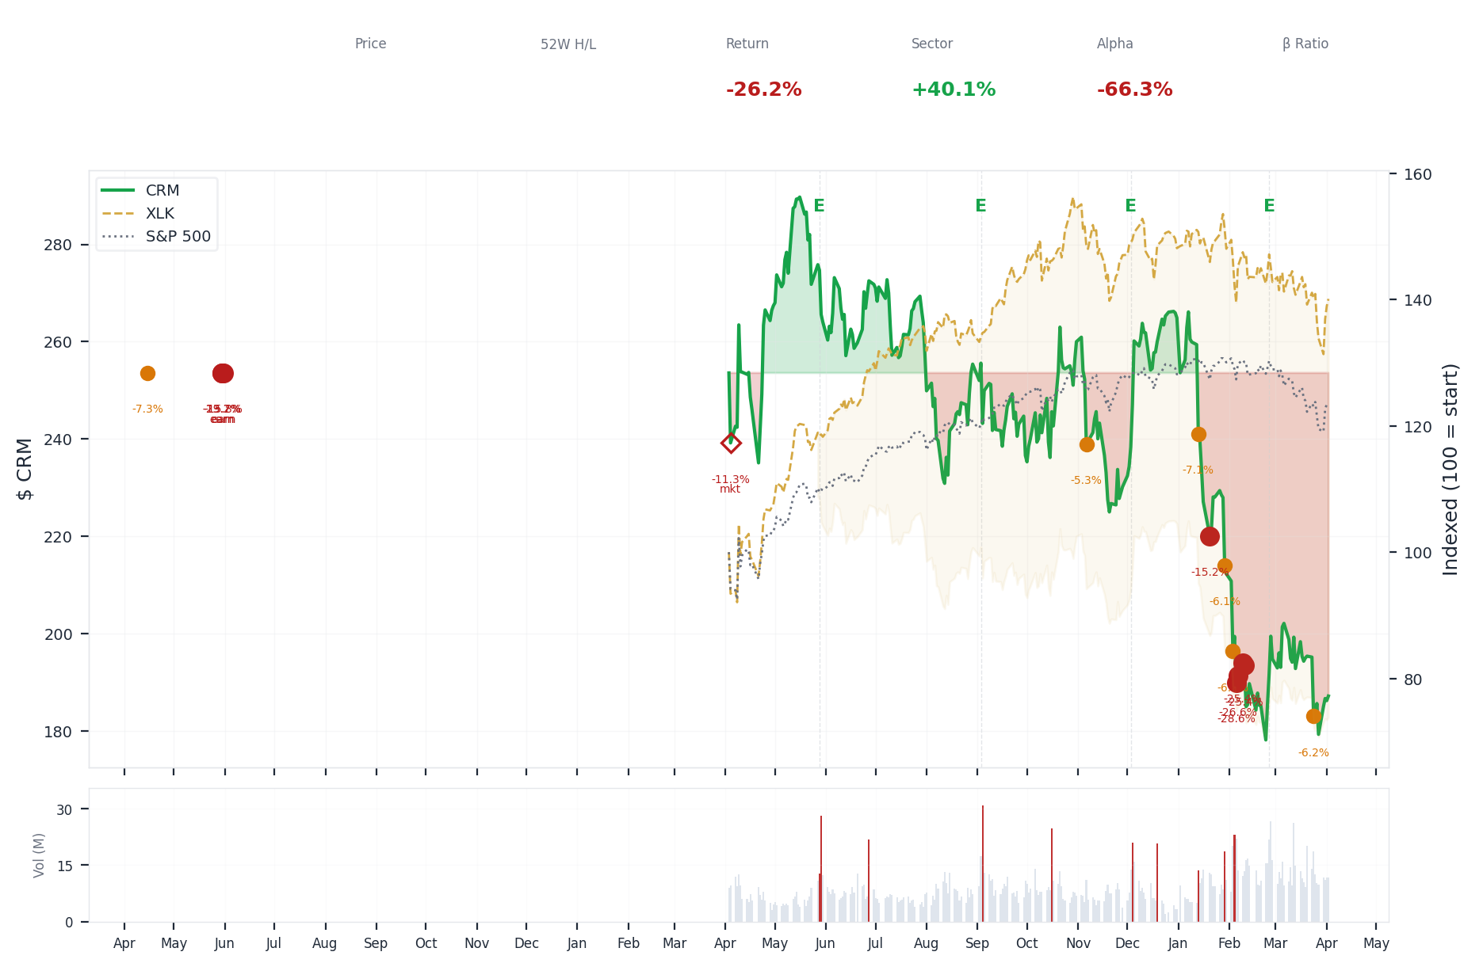
1-Year Performance (Indexed to 100). Red triangles mark single-day drops >= 8%. Orange bands mark multi-day declines >= 15%.
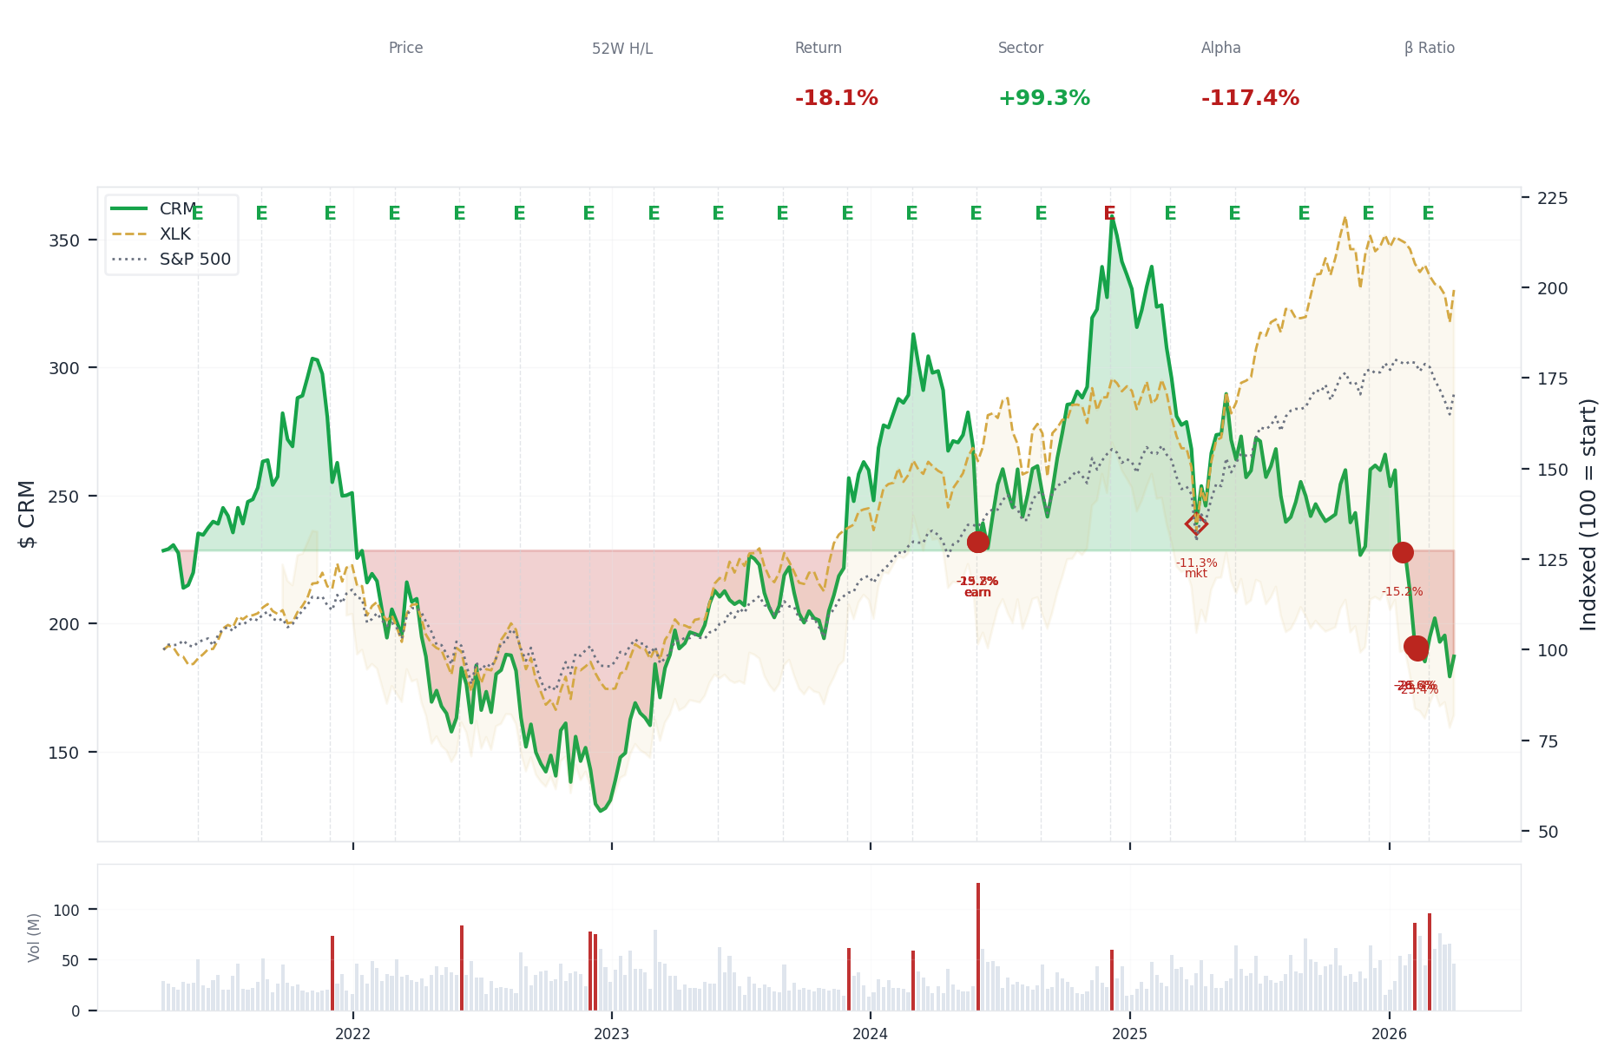
5-Year Performance (Indexed to 100)
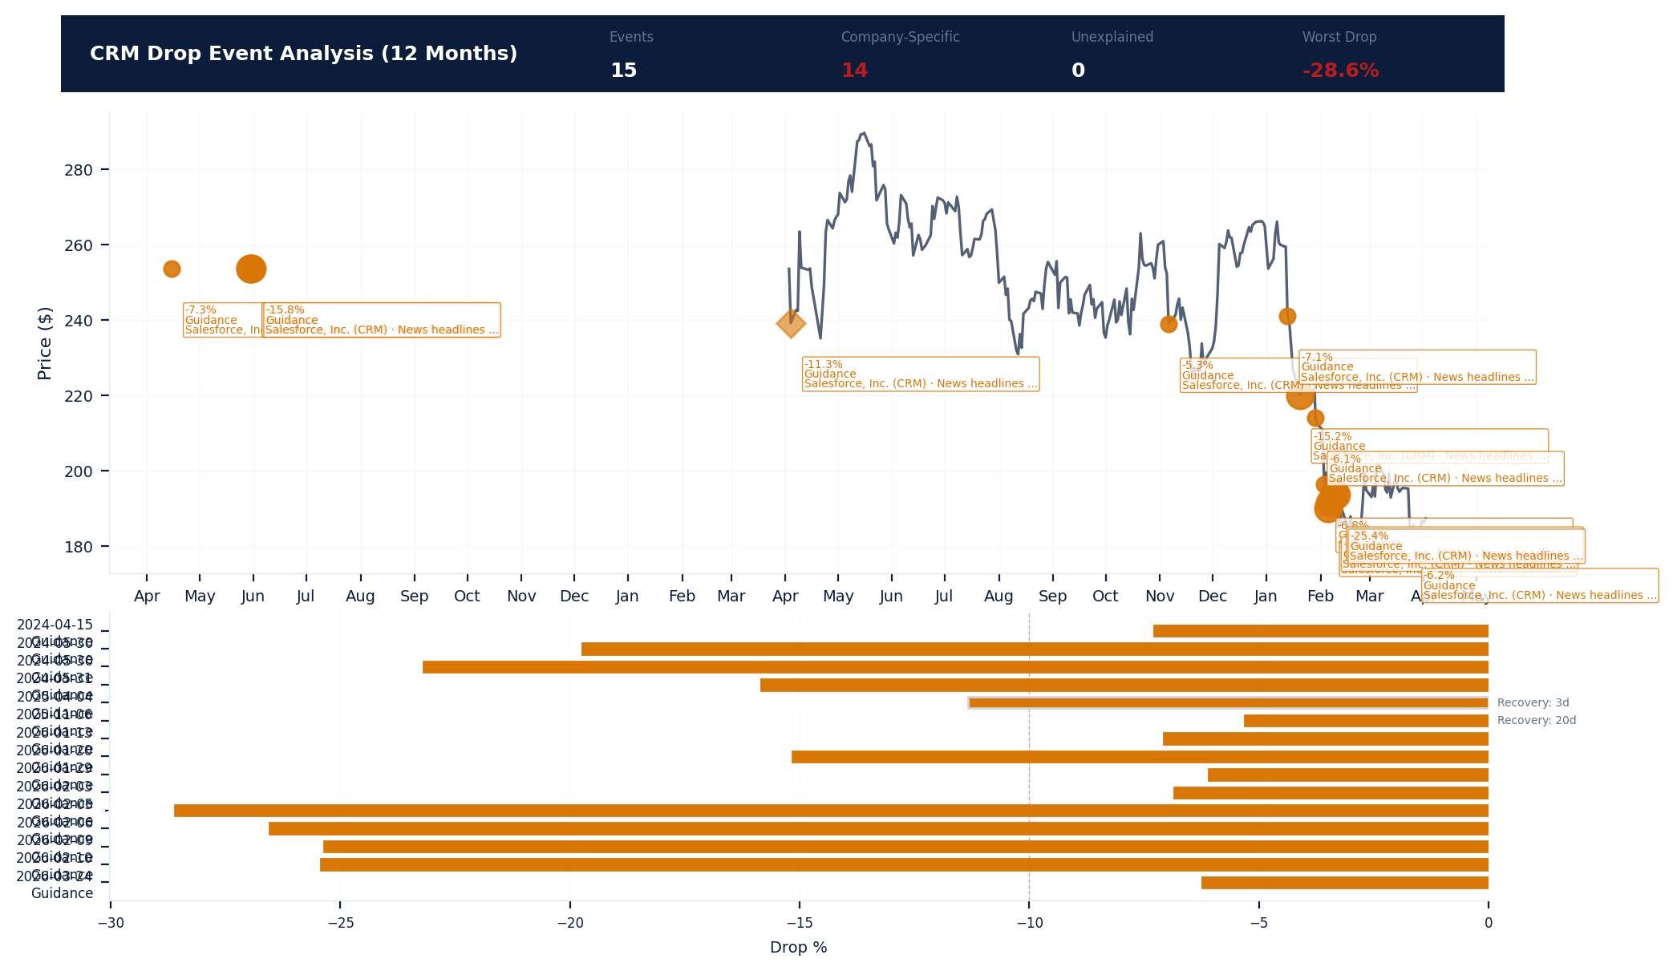
Drop Event Analysis (12 Months)
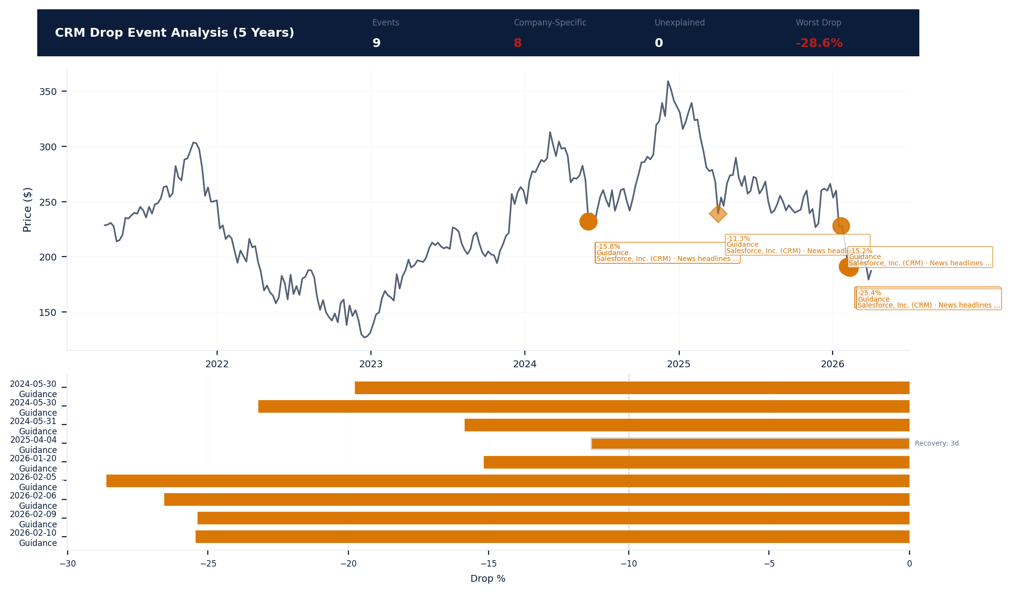
Drop Event Analysis (5 Years)
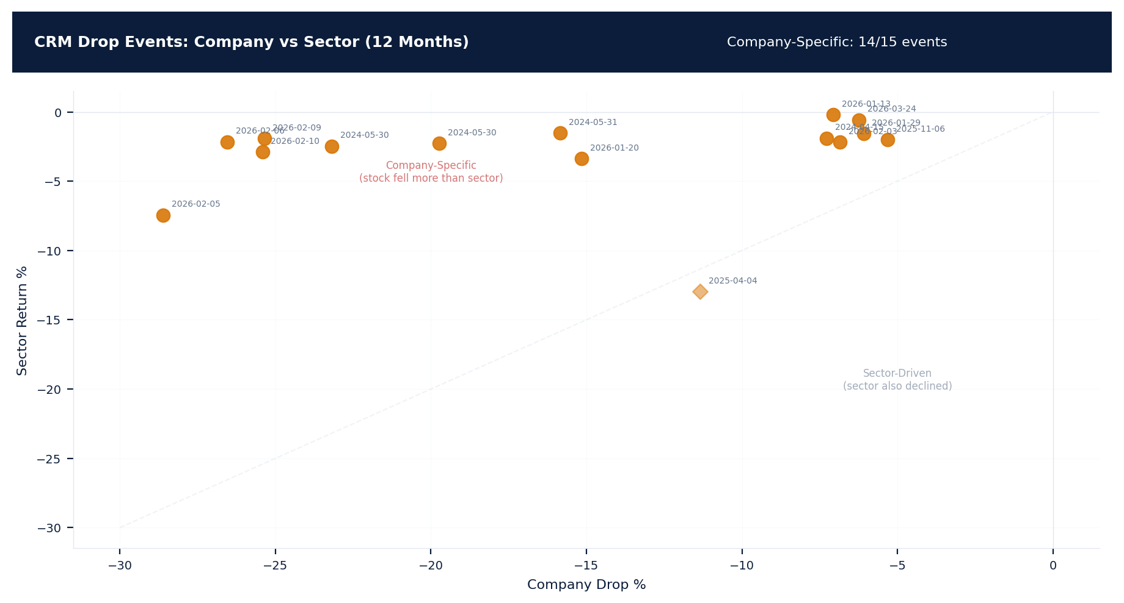
Drop Events: Company vs Sector (12 Months)
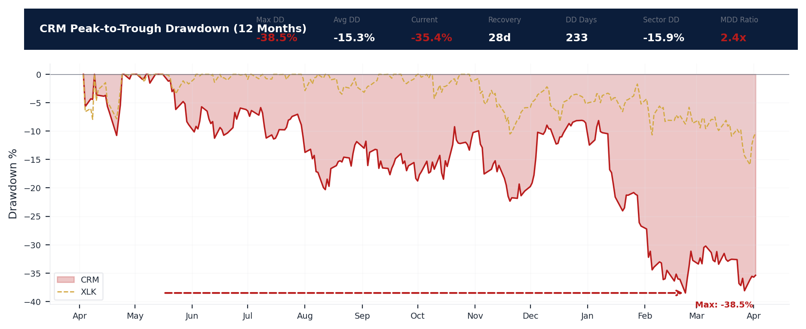
Drawdown Analysis (12 Months)
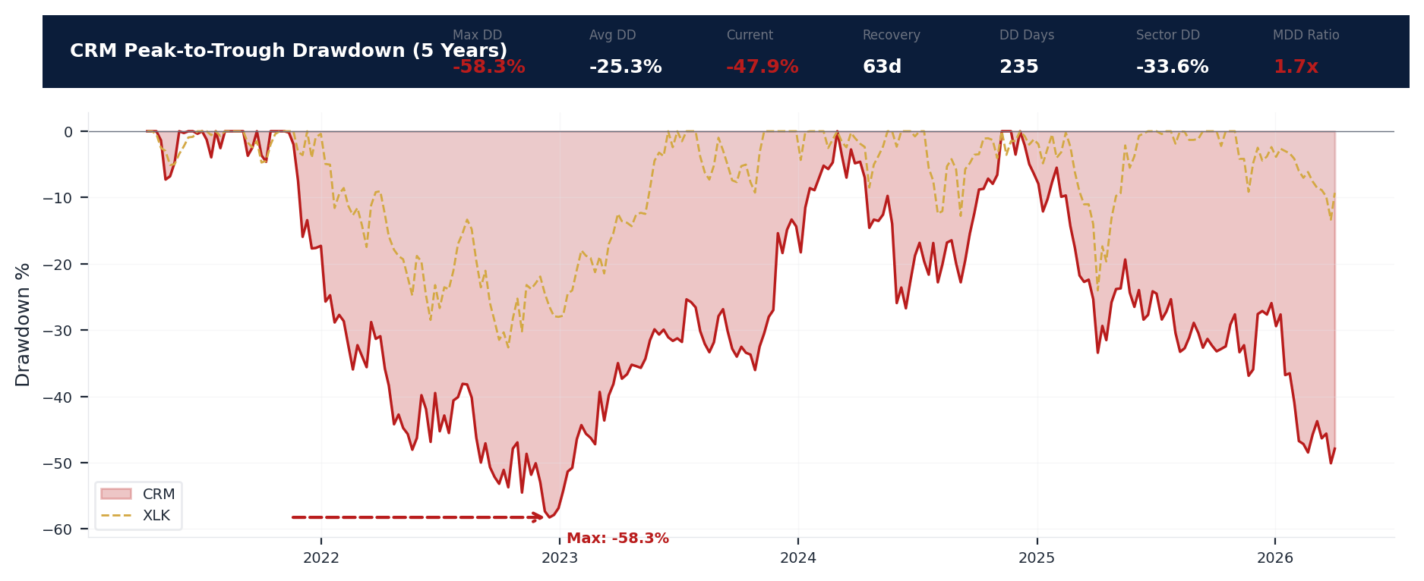
Drawdown Analysis (5 Years)
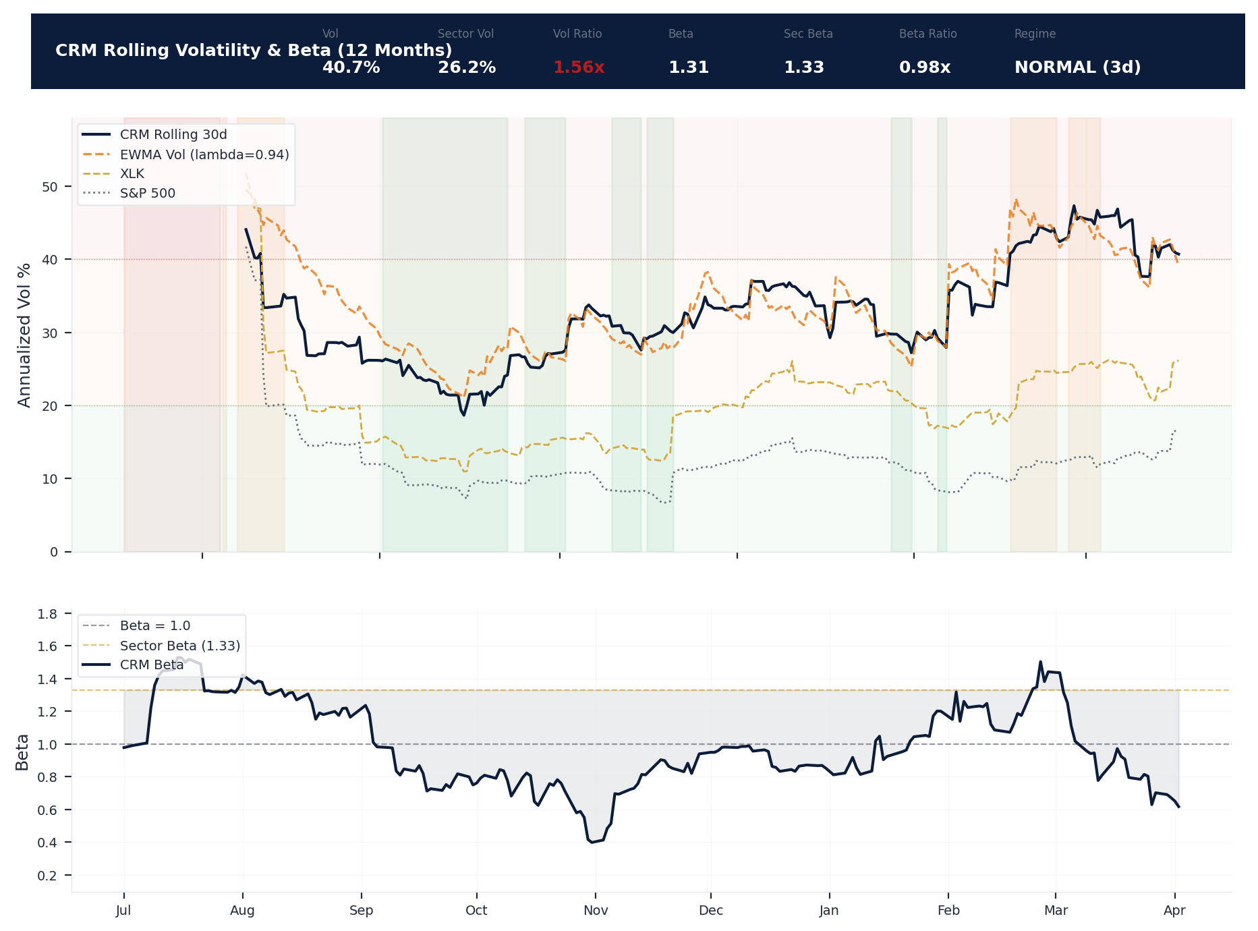
Volatility & Beta Analysis (12 Months)
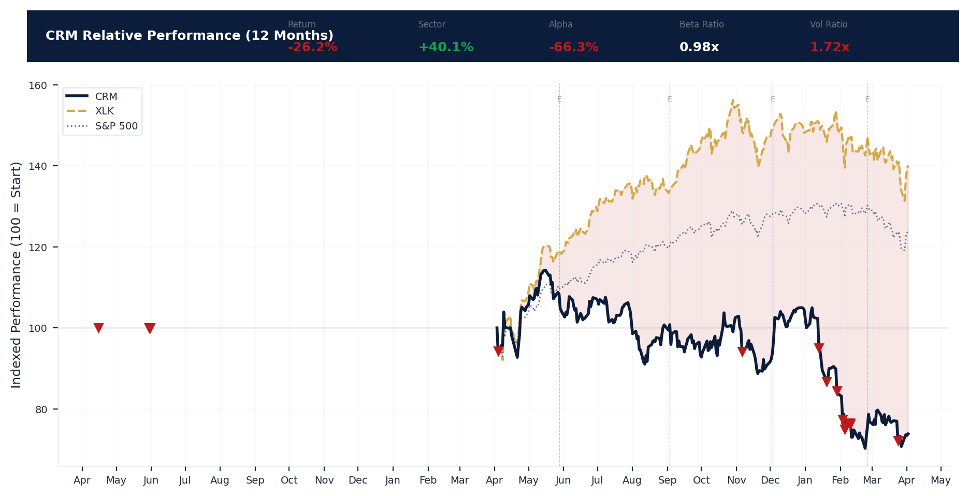
Relative Performance (12 Months)
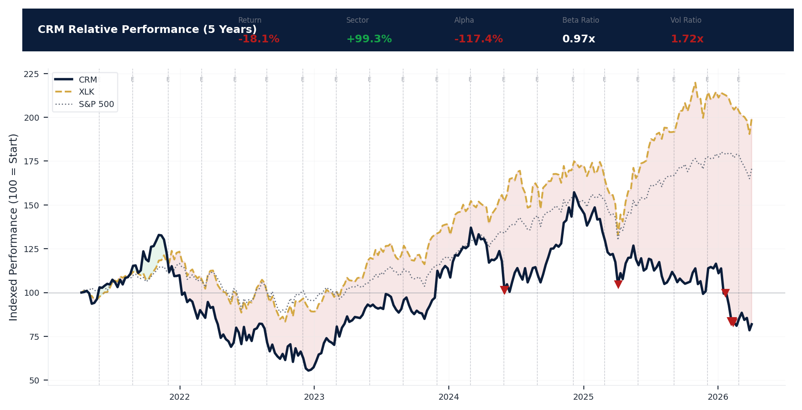
Relative Performance (5 Years)
Metric | Value
Current Price | $187.18
52-Week High | $296.05
52-Week Low | $174.57
1-Year Return | -26.2%
Max Drawdown (1Y) | -38.5%
90-Day Volatility | 39.1% (Ranks at the 0th percentile among 0 peers (peer median: 2.5%))
Beta (vs S&P 500) | 1.31
16 significant stock decline events detected in the 1Y period: 9 critical (>10%), 7 notable (5-10%). 14 were company-specific, 2 were market-wide.
Date | Drop % | Recency | Recovery | Trigger Event | Type | Source
2026-01-29 to 2026-02-10 (13d) | -28.6% | 81% | Not recovered | Unconfirmed -- Requires Investigation | Company-Specific | https://finance.yahoo.com/quote/CRM/
2026-02-06 (20d) | -26.6% | 81% | Not recovered | Unconfirmed -- Requires Investigation | Company-Specific | https://finance.yahoo.com/quote/CRM/
2026-02-10 (20d) | -25.4% | 82% | Not recovered | Unconfirmed -- Requires Investigation | Company-Specific | https://finance.yahoo.com/quote/CRM/
2026-02-09 (20d) | -25.4% | 82% | Not recovered | Unconfirmed -- Requires Investigation | Company-Specific | https://finance.yahoo.com/quote/CRM/
2026-01-20 (5d) | -15.2% | 76% | Not recovered | Unconfirmed -- Requires Investigation | Company-Specific | https://finance.yahoo.com/quote/CRM/
2026-03-24 | -6.2% | 97% | Not recovered | Unconfirmed -- Requires Investigation | Company-Specific | https://finance.yahoo.com/quote/CRM/
2026-02-03 | -6.8% | 80% | Not recovered | Unconfirmed -- Requires Investigation | Company-Specific | https://finance.yahoo.com/quote/CRM/
2026-01-13 | -7.1% | 74% | Not recovered | Unconfirmed -- Requires Investigation | Company-Specific | https://finance.yahoo.com/quote/CRM/
2026-01-29 | -6.1% | 78% | Not recovered | Unconfirmed -- Requires Investigation | Company-Specific | https://finance.yahoo.com/quote/CRM/
2025-11-06 | -5.3% | 57% | 20 days | Unconfirmed -- Requires Investigation | Company-Specific | https://finance.yahoo.com/quote/CRM/
2025-04-03 to 2025-04-04 (2d) | -11.3% | 25% | 3 days | Unconfirmed -- Requires Investigation | Market-Wide Event | https://finance.yahoo.com/quote/CRM/
2024-05-30 to 2024-05-31 (2d) | -23.2% | 8% | Not recovered | Earnings release | Company-Specific | https://finance.yahoo.com/quote/CRM/
2024-05-30 | -19.7% | 8% | Not recovered | Earnings release | Company-Specific | https://finance.yahoo.com/quote/CRM/
2025-04-03 (2d) | -5.7% | 25% | Not recovered | Unconfirmed -- Requires Investigation | Market-Wide Event | https://finance.yahoo.com/quote/CRM/
2024-05-31 (5d) | -15.8% | 8% | Not recovered | Earnings release | Company-Specific | https://finance.yahoo.com/quote/CRM/
2024-04-15 | -7.3% | 6% | Not recovered | Unconfirmed -- Requires Investigation | Company-Specific | https://finance.yahoo.com/quote/CRM/
9 significant stock decline events detected in the 5Y period: 9 critical (>10%). 8 were company-specific, 1 was market-wide.
Date | Drop % | Recency | Recovery | Trigger Event | Type | Source
2026-01-29 to 2026-02-10 (13d) | -28.6% | 81% | Not recovered | Unconfirmed -- Requires Investigation | Company-Specific | https://finance.yahoo.com/quote/CRM/
2026-02-06 (20d) | -26.6% | 81% | Not recovered | Unconfirmed -- Requires Investigation | Company-Specific | https://finance.yahoo.com/quote/CRM/
2026-02-10 (20d) | -25.4% | 82% | Not recovered | Unconfirmed -- Requires Investigation | Company-Specific | https://finance.yahoo.com/quote/CRM/
2026-02-09 (20d) | -25.4% | 82% | Not recovered | Unconfirmed -- Requires Investigation | Company-Specific | https://finance.yahoo.com/quote/CRM/
2026-01-20 (5d) | -15.2% | 76% | Not recovered | Unconfirmed -- Requires Investigation | Company-Specific | https://finance.yahoo.com/quote/CRM/
2025-04-03 to 2025-04-04 (2d) | -11.3% | 25% | 3 days | Unconfirmed -- Requires Investigation | Market-Wide Event | https://finance.yahoo.com/quote/CRM/
2024-05-30 to 2024-05-31 (2d) | -23.2% | 8% | Not recovered | Earnings release | Company-Specific | https://finance.yahoo.com/quote/CRM/
2024-05-30 | -19.7% | 8% | Not recovered | Earnings release | Company-Specific | https://finance.yahoo.com/quote/CRM/
2024-05-31 (5d) | -15.8% | 8% | Not recovered | Earnings release | Company-Specific | https://finance.yahoo.com/quote/CRM/
Short Interest
Metric | Value
Short % of Float | 2.5% (Ranks at the 68th percentile among 0 peers (peer median: 4.0%))
Days to Cover | 1.60
6-Month Trend | RISING
vs Sector Ratio | N/A
Earnings Guidance Track Record
Metric | Value
Beat Rate | 0.9%
Consecutive Misses | 0
Guidance Withdrawals | 0
Philosophy | CONSERVATIVE
Quarter | Est. EPS | Actual EPS | Result | Miss Magnitude | Stock Reaction
Q1 2026 | $3.05 | $3.81 | BEAT | N/A | +24.9%
Q4 2025 | $2.86 | $3.25 | BEAT | N/A | +13.6%
Q3 2025 | $2.78 | $2.91 | BEAT | N/A | +4.7%
Q2 2025 | $2.55 | $2.58 | BEAT | N/A | +1.3%
Q1 2025 | $2.61 | $2.78 | BEAT | N/A | +6.4%
Q4 2024 | $2.45 | $2.41 | MISS | +1.6% | -1.5%
Q3 2024 | $2.36 | $2.56 | BEAT | N/A | +8.6%
Q2 2024 | $2.37 | $2.44 | BEAT | N/A | +2.8%
Q1 2024 | $2.27 | $2.29 | MEET | N/A | +1.0%
Q4 2023 | $2.06 | $2.11 | BEAT | N/A | +2.5%
Q3 2023 | $1.90 | $2.12 | BEAT | N/A | +11.4%
Q2 2023 | $1.61 | $1.69 | BEAT | N/A | +4.8%
Q1 2023 | $1.36 | $1.68 | BEAT | N/A | +23.4%
Q4 2022 | $1.22 | $1.40 | BEAT | N/A | +14.6%
Q3 2022 | $1.03 | $1.19 | BEAT | N/A | +15.8%
Q2 2022 | $0.94 | $0.98 | BEAT | N/A | +3.7%
Analyst Consensus
Metric | Value
Analyst Coverage | 52
Consensus Rating | BUY
Mean Recommendation | 1.63 (1=Strong Buy, 5=Sell)
Mean Target Price | $273
Target Price High | $475
Target Price Low | $190
Stock Drop Analysis
Date | Magnitude | Type | Trigger / Attribution | Sector Return | Company-Specific
2026-01-29 to 2026-02-10 | -28.6% | MULTI_DAY (13d) | Unknown | -7.4% | Yes
2026-02-06 | -26.6% | MULTI_DAY (20d) | Unknown | -2.2% | Yes
2026-02-10 | -25.4% | MULTI_DAY (20d) | Unknown | -2.9% | Yes
2026-02-09 | -25.4% | MULTI_DAY (20d) | Unknown | -1.9% | Yes
2024-05-30 to 2024-05-31 | -23.2% | MULTI_DAY (2d) | earnings_release | -2.5% | Yes
2024-05-30 | -19.7% | SINGLE_DAY | earnings_release | -2.3% | Yes
2024-05-31 | -15.8% | MULTI_DAY (5d) | earnings_release | -1.5% | Yes
2026-01-20 | -15.2% | MULTI_DAY (5d) | Unknown | -3.4% | Yes
2025-04-03 to 2025-04-04 | -11.3% | MULTI_DAY (2d) | Unknown | -13.0% | No
2024-04-15 | -7.3% | SINGLE_DAY | Unknown | -1.9% | Yes
2026-01-13 | -7.1% | SINGLE_DAY | Unknown | -0.2% | Yes
2026-02-03 | -6.8% | SINGLE_DAY | Unknown | -2.2% | Yes
2026-03-24 | -6.2% | SINGLE_DAY | Unknown | -0.6% | Yes
2026-01-29 | -6.1% | SINGLE_DAY | Unknown | -1.6% | Yes
2025-04-03 | -6.0% | MULTI_DAY (2d) | Unknown | -6.8% | No
Class Period Potential: 8 company-specific drop(s) exceeding 10% identified. Severe stock drops that are company-specific (not explained by sector movement) are the primary anchors for SCA class periods. Plaintiffs will allege the drop occurred when the 'truth emerged' following prior misstatements. [HIGH]
Insider Trading Analysis
Metric | Value
Net Direction (12mo) | NEUTRAL
10b5-1 Plan % | 83.3%
Buy Transactions | 5
Sell Transactions | 6
Cluster Events | 0
Transaction Detail
Date | Insider | Title | Type | Shares | Value | 10b5-1
2026-03-22 | Washington Robin L | President and COFO | EXERCISE | 7,323 | $0 | No (Discretionary)
2026-03-22 | Washington Robin L | President and COFO | EXERCISE | 7,323 | $0 | No (Discretionary)
2026-03-22 | Washington Robin L | President and COFO | TAX_WITHHOLD | 2,864 | $559.6K | No (Discretionary)
2026-03-22 | Washington Robin L | President and COFO | GRANT | 58,352 | $0 | No (Discretionary)
2026-03-22 | Washington Robin L | President and COFO | GRANT | 47,059 | $0 | No (Discretionary)
2026-03-22 | Milano Miguel | President and CRO | EXERCISE | 1,015 | $0 | No (Discretionary)
2026-03-22 | Milano Miguel | President and CRO | EXERCISE | 6,103 | $0 | No (Discretionary)
2026-03-22 | Milano Miguel | President and CRO | EXERCISE | 1,015 | $0 | No (Discretionary)
2026-03-22 | Milano Miguel | President and CRO | EXERCISE | 6,103 | $0 | No (Discretionary)
2026-03-22 | Milano Miguel | President and CRO | TAX_WITHHOLD | 248 | $48.5K | No (Discretionary)
2026-03-22 | Milano Miguel | President and CRO | TAX_WITHHOLD | 2,040 | $398.6K | No (Discretionary)
2026-03-22 | Milano Miguel | President and CRO | GRANT | 16,084 | $0 | No (Discretionary)
2026-03-22 | Milano Miguel | President and CRO | GRANT | 48,626 | $0 | No (Discretionary)
2026-03-22 | Milano Miguel | President and CRO | GRANT | 47,059 | $0 | No (Discretionary)
2026-03-22 | Niles Sabastian | President and CLO | EXERCISE | 1,015 | $0 | No (Discretionary)
2026-03-22 | Niles Sabastian | President and CLO | EXERCISE | 4,068 | $0 | No (Discretionary)
2026-03-22 | Niles Sabastian | President and CLO | EXERCISE | 1,015 | $0 | No (Discretionary)
2026-03-22 | Niles Sabastian | President and CLO | EXERCISE | 4,068 | $0 | No (Discretionary)
2026-03-22 | Niles Sabastian | President and CLO | TAX_WITHHOLD | 410 | $80.1K | No (Discretionary)
2026-03-22 | Niles Sabastian | President and CLO | TAX_WITHHOLD | 1,871 | $365.6K | No (Discretionary)
Executive Departures
No executive departures identified in the trailing 18 months.
Capital Markets Activity
No significant capital markets activity identified in the trailing 3-year period.

ELEVATED CONCERN
Salesforce's total revenue declined 16% from $41.53 billion to $34.86 billion, and net income fell 45% from $7.46 billion to $4.14 billion, compressing operating margins from 20.1% to 14.4% and creating a stark narrative for a Section 10(b) suit if management's growth forecasts were issued during this contraction. The Altman Z-Score of 2.78 sits in the grey zone, perilously close to the distress threshold of 1.81, which plaintiffs' counsel would leverage to allege a concealed going-concern risk despite the current clean audit opinion from Ernst & Young after 24 years. A strong Beneish M-Score of -2.64 and a Piotroski F-Score of 7 contradict the income statement deterioration, suggesting the core risk is operational execution issues rather than accounting manipulation, which focuses plaintiff allegations on strategic oversight failures. The critically low current and quick ratios of 0.76, against a robust interest coverage of 25.7 and low debt-to-equity of 0.24, paints a picture of a cash-conversion cycle problem, not insolvency—a nuanced but real exposure for directors overseeing capital allocation and liquidity management. Any guidance miss or restructuring charge could trigger a shareholder class action alleging the board failed to adapt operational spend to the new revenue reality, particularly given the 21 triggered financial checks from a total of 134 monitored.
Section 3: Financial Health
The company reported revenue of $34.9B and net income of $4.1B (per FY2024 10-K, Company Facts API CIK1108524). Revenue declined 16.1% year-over-year (from $41.5B). Net income declined 44.5% YoY, a material deterioration that may attract plaintiff scrutiny. Distress indicators show mixed signals: Z-Score 2.78 (grey zone) and O-Score 0.00 (safe zone). Financial stress could limit litigation defense resources. Piotroski F-Score of 7/9 indicates strong fundamental quality. Capital structure is conservative with D/E ratio of 0.24, providing meaningful headroom against financial covenant triggers. Earnings quality is healthy (OCF/NI: 2.01), indicating reported income is well-supported by operating cash flows -- reducing restatement risk. Auditor: Ernst & Young (Big 4), tenure: 24 years -- extended tenure may raise independence concerns. From a D&O perspective, the financial profile supports standard underwriting terms.
Income Statement
Metric | FY2024 | FY2025 | YoY Change
Total revenue / net sales | $34.9B | $41.5B | 19.1%
Cost of revenue / COGS | $8.5B | $9.3B | 8.5%
Gross profit | $26.3B | $32.3B | 22.6%
Operating income / loss | $5.0B | $8.3B | 66.2%
Net income / net loss | $4.1B | $7.5B | 80.3%
Basic earnings per share | $4.25 | $7.85 | 84.7%
Diluted earnings per share | $4.20 | $7.80 | 85.7%
Interest expense | N/A | $324.0M | N/A
Income tax expense / benefit | $814.0M | $2.1B | 153.4%
Research and development expense | $4.9B | $6.0B | 22.2%
Selling, general and administrative expense | $2.5B | $3.0B | 18.4%
Earnings before interest and taxes (EBIT) | $5.0B | $8.3B | 66.2%
Weighted average shares outstanding (basic) | 974.0M | 950.0M | -2.5%
Weighted average shares outstanding (diluted) | 984.0M | 956.0M | -2.9%
Total comprehensive income / loss | $4.2B | $8.0B | 92.0%
Other income / non-operating income | $216.0M | $172.0M | -20.4%
Restructuring charges | $988.0M | $586.0M | -40.7%
Income from operations | $5.0B | $8.3B | 66.2%
Pre-tax income | $5.0B | $9.5B | 92.3%
Stock-based compensation expense | $2.8B | $3.5B | 25.9%
Income before income taxes | $5.0B | $9.5B | 92.3%
Gain/loss on investments | $-277.0M | $1.0B | 467.1%
Other comprehensive income/loss, net of tax | $49.0M | $579.0M | 1081.6%
Total operating expenses | $21.3B | $23.9B | 12.3%
Total costs and expenses | $21.3B | $23.9B | 12.3%
Non-operating income / expense | $216.0M | $172.0M | -20.4%
Current federal income tax expense / benefit | $940.0M | $413.0M | -56.1%
Current state and local income tax expense / benefit | $199.0M | $72.0M | -63.8%
Current foreign income tax expense / benefit | $417.0M | $619.0M | 48.4%
Deferred federal income tax expense / benefit | $-640.0M | $618.0M | 196.6%
Deferred state and local income tax expense / benefit | $-182.0M | $121.0M | 166.5%
Deferred foreign income tax expense / benefit | $80.0M | $220.0M | 175.0%
Advertising expense | $1.1B | $800.0M | -27.3%
Gross margin percentage | 75.5% | 77.7% | 2.9%
Operating margin percentage | 14.4% | 20.1% | 39.5%
Net margin percentage | 11.9% | 18.0% | 51.3%
EBITDA margin percentage | 17.5% | 22.9% | 30.9%
Effective tax rate | $16 | $22 | 31.8%
Interest coverage ratio | N/A | $26 | N/A
Balance Sheet
Metric | FY2024 | FY2025 | YoY Change
Total assets | $99.8B | $112.3B | 12.5%
Total liabilities | $40.2B | $53.2B | 32.3%
Total stockholders' equity | $59.6B | $59.1B | -0.8%
Total current assets | $29.1B | $28.2B | -2.9%
Total current liabilities | $26.6B | $37.1B | 39.4%
Cash and cash equivalents | $8.5B | $7.3B | -13.5%
Accounts receivable, net | $11.4B | $14.3B | 25.6%
Property, plant and equipment, net | $3.7B | $3.1B | -15.4%
Goodwill | $48.6B | $57.9B | 19.2%
Intangible assets, net (excluding goodwill) | $5.3B | $6.8B | 29.1%
Long-term debt, non-current | $8.4B | $10.4B | 23.9%
Short-term debt / current portion of long-term debt | $999.0M | $4.0B | 300.4%
Retained earnings / accumulated deficit | $11.7B | $22.2B | 89.6%
Total debt (short-term + long-term) | $9.4B | $14.4B | 53.2%
Common shares outstanding | 971.0M | 929.0M | -4.3%
Deferred revenue / contract liabilities | $19.0B | $24.3B | 28.0%
Operating lease liabilities | $3.2B | $2.7B | -13.4%
Short-term investments / marketable securities | $5.7B | $2.2B | -60.9%
Prepaid expenses and other current assets | $1.6B | $2.2B | 43.7%
Accumulated other comprehensive income/loss | $-225.0M | $313.0M | 239.1%
Treasury stock, at cost | $11.7B | $32.2B | 175.6%
Common stock par value | $1.0M | $1.0M | 0.0%
Additional paid-in capital | $59.8B | $68.8B | 15.0%
Total liabilities and stockholders' equity | $99.8B | $112.3B | 12.5%
Preferred stock value | $0 | $0 | N/A
Right-of-use assets (operating and finance leases) | $2.4B | $2.0B | -15.3%
Other non-current assets | $3.4B | $3.6B | 5.7%
Other non-current liabilities | $2.5B | $3.4B | 38.1%
Finance / capital lease obligations | $974.0M | $535.0M | -45.1%
Contract assets (ASC 606 unbilled revenue) | $758.0M | $818.0M | 7.9%
Contract liabilities (ASC 606 deferred revenue) | $19.0B | $24.3B | 28.0%
Unrecognized tax benefits (UTB) liability | $2.1B | $2.6B | 26.7%
Debt instrument carrying amount (face value) | $9.5B | $14.5B | 52.6%
Unvested stock-based compensation cost not yet recognized | $5.3B | $6.0B | 14.9%
Common stock shares authorized | 1.6B | 1.6B | 0.0%
Contract with customer liability (total deferred revenue under ASC 606) | $19.0B | $24.3B | 28.0%
Current ratio | $1 | $1 | -30.4%
Debt-to-equity ratio | $0 | $0 | 54.5%
Debt-to-EBITDA ratio | $2 | $2 | -1.8%
Tangible book value | $5.7B | $-5.6B | -197.7%
Net debt | $954.0M | $7.1B | 645.5%
Book value per share | $61.43 | $63.66 | 3.6%
Return on assets | $4 | $7 | 60.4%
Return on equity | $7 | $13 | 82.0%
Asset turnover ratio | $0 | $0 | 5.9%
Key Balance Sheet Ratios
Ratio | Value | Assessment
Current Ratio | 1.09 | Adequate
Debt/Equity | 0.16 | Conservative
Debt/Assets | 0.40 | Moderate
Cash/Assets | 8.5%
Cash Flow Statement
Metric | FY2024 | FY2025 | YoY Change
Net cash from operating activities | $10.2B | $15.0B | 46.5%
Net cash from investing activities | $-1.3B | $-8.6B | -547.3%
Net cash from financing activities | $-7.5B | $-8.1B | -8.1%
Capital expenditures | $736.0M | $594.0M | -19.3%
Depreciation and amortization | $1.1B | $1.2B | 9.1%
Dividends paid | N/A | $1.6B | N/A
Share repurchases / buybacks | $7.6B | $12.6B | 65.3%
Acquisitions, net of cash acquired | $82.0M | $9.3B | 11202.4%
Proceeds from stock issuance | $2.0B | $1.0B | -46.8%
Interest paid (supplemental) | $254.0M | $276.0M | 8.7%
Income taxes paid (supplemental) | $1.0B | $1.3B | 24.8%
Stock-based compensation (cash flow adjustment) | $2.8B | $3.5B | 25.9%
Changes in operating working capital | $-478.0M | $1.0B | 312.1%
Net increase/decrease in cash and equivalents | $1.5B | $-1.5B | -204.5%
Purchases of investments | $3.8B | $3.8B | 0.1%
Proceeds from sale/maturity of investments | $1.5B | $4.4B | 192.1%
Deferred income taxes (cash flow adjustment) | $-742.0M | $959.0M | 229.2%
Change in accounts receivable | $659.0M | $2.2B | 227.8%
Change in accounts payable | $-478.0M | $1.0B | 312.1%
Effect of exchange rate changes on cash | $26.0M | $152.0M | 484.6%
Free cash flow | $9.5B | $14.4B | 51.6%
FCF-to-revenue ratio | $27 | $35 | 27.3%
Capex-to-revenue ratio | $2 | $1 | -32.2%
Capex-to-depreciation ratio | $1 | $0 | -26.0%
Dividend payout ratio | N/A | $21 | N/A
Free cash flow per share | $9.78 | $15.50 | 58.5%
Key Ratios: Company vs. Peers
Ratio | Value
Current Ratio | 0.76
Quick Ratio | 0.76
Debt/Equity | 0.24
Interest Coverage | 25.7x
Distress Indicators
Model | Score | Zone | Trajectory | D&O Context
Altman Z-Score | 2.78 | Grey Zone | FY2024: 3.3 -> FY2025: 2.8 (declining) | Bankruptcy predictor. Distress zone companies face fiduciary duty scrutiny under Revlon/zone of insolvency doctrine.
Beneish M-Score | -2.63 | Safe | N/A | Earnings manipulation detector. Scores above -1.78 indicate elevated restatement risk, a primary SCA catalyst.
Ohlson O-Score | 0.00 | Safe | N/A | Bankruptcy probability model. Higher values signal financial stress that may limit litigation defense resources.
Piotroski F-Score | 7.00 | Grey Zone | 7/9 criteria met | Fundamental quality indicator. Scores 0-3 signal weak fundamentals; 7-9 indicate strong quality.
Leverage context: Ranks at the 62nd percentile among 0 peers (peer median: 2.0x).
Earnings Quality
Metric | Value | Assessment
OCF/Net Income | 2.01 | Healthy
Accruals Ratio | -0.07 | Normal
Source: Derived from XBRL financial statements, MEDIUM confidence
Audit Risk Assessment
Audit Risk: No concerns. Ernst & Young, 24 year tenure, qualified opinion.
Debt Analysis
Metric | Value
Debt-to-Equity | 0.24
Debt-to-EBITDA | 1.51
Interest Coverage | 25.71
Covenant Status | Unknown
Critical Accounting Estimates
Estimate | Value | Assessment
Effective Tax Rate | 21.7% | Normal range
Peer Group Comparison
Ticker | Name | Market Cap | Revenue | Score
MSFT | Microsoft Corporation | $2.8T | $305.5B | 13
GOOGL | Alphabet Inc. | $3.6T | $402.8B | 3
AMZN | Amazon.com, Inc. | $2.3T | $716.9B | 2
META | Meta Platforms, Inc. | $1.5T | $201.0B | 4
NVDA | NVIDIA Corporation | $4.3T | $215.9B | 14
ADBE | Adobe Inc. | $99.0B | $24.5B | 34
ORCL | Oracle Corporation | $421.0B | $64.1B | 21
CSCO | Cisco Systems, Inc. | $312.2B | $59.1B | 27
INTC | Intel Corporation | $253.0B | $52.9B | 37
Revenue: Ranks at the 11th percentile among 9 peers. Leverage: Ranks at the 62nd percentile among 0 peers (peer median: 2.0x).
Method: Multi-signal composite: SIC 25%, industry 20%, market cap 25%, revenue 15%, description 15%

CRITICAL RISK
The board's structural opacity is alarming, with only one director disclosed against a typical Salesforce board size of twelve, rendering independence ratio and average tenure incalculable and a severe disclosure failure. CEO Marc Benioff's 20-year tenure contrasts sharply with a completely reconstituted C-suite of six executives, including CEO Dear Fellow and CFO Amy Weaver, all with only two years in their current roles, indicating profound recent executive turnover. A staggering $55.1 million CEO pay package received a 45.6% say-on-pay vote, a clear shareholder rebuke that directly fuels derivative litigation risk over compensation committee breaches. This governance vacuum, evidenced by only 4 of 90 governance checks passed, combined with the 45.6% pay dissent, creates a perfect evidentiary storm for a Caremark duty of oversight claim, as the board's inability to demonstrate monitoring of operational risks is now a matter of public record. The proxy's lack of candor on basic board composition, as noted in the director data, itself presents a standalone duty of candor exposure that plaintiffs' counsel will weaponize to allege a broader pattern of deficient oversight. Underwriting this requires a severe loading for the elevated settlement value of any derivative suit, as the documented governance failures and shareholder discontent provide a ready-made plaintiffs' slide deck.
Section 5: Governance & Leadership
Leadership team is stable with average tenure of 2.0 years. Board governance is weak (37/100), raising oversight concerns. Compensation concerns include: low say-on-pay support (46%); 4 related-party transaction(s). Dual-class share structure concentrates voting control. [Rule-based synthesis of governance extraction results, 2026-04-02, LOW]
Governance Quality Score: 37.2/10 [Computed from governance dimensions, 2026-04-02, LOW]
Leadership Stability
Name | Title | Tenure (Yrs) | Status | Prior Lit. | Flags
Dear Fellow | CEO | 2.0 | ACTIVE | 0 | None
Amy Weaver | CFO | 2.0 | ACTIVE | 0 | None
Brian Millham | COO | 2.0 | ACTIVE | 0 | None
Niles President | CLO | 2.0 | ACTIVE | 5 | None
Neelie Kroes | CTO | 2.0 | ACTIVE | 0 | None
Millham In February | CIO | 2.0 | ACTIVE | 1 | None
D&O Context (Niles President, 5 prior case(s)): triggered Any Officer With Prior Litigation at Previous Company (F9) — this host risk (company-level characteristics that attract or deter D&O claims) indicates SEC Enforcement / Regulatory Compliance. Evidence: Boolean check: True condition met. [ELEVATED]
D&O Context (Millham In February, 1 prior case(s)): triggered Any Officer With Prior Litigation at Previous Company (F9) — this host risk (company-level characteristics that attract or deter D&O claims) indicates SEC Enforcement / Regulatory Compliance. Evidence: Boolean check: True condition met. [ELEVATED]
Leadership Stability Score: 100/100 [leadership_profiles extractor, 2026-04-02, MEDIUM]
Board Composition
Name | Tenure | Independent | Committees | Other Boards | Overboarded
Risk Oversight | N/A | N/A | N/A | 0 | No
Board Quality Metrics
Metric | Value
Board Size | N/A
Independence Ratio | N/A
CEO/Chair Duality | No
Classified Board | N/A
Overboarded Directors | N/A
Dual-Class Structure | N/A
Compensation Analysis
Summary Compensation Table
Component | Amount
Total CEO Compensation | $55.1M
Compensation Structure
Component | Detail
Clawback Policy | Yes
Clawback Scope | BROADER
Compensation Red Flags
Low Say-on-Pay Support (45.6%): Support below 70% triggers heightened ISS/Glass Lewis scrutiny and correlates with shareholder derivative suits over executive compensation. [HIGH]
Related-Party Transactions (4): Related-party transactions between executives and company require enhanced disclosure and increase Caremark derivative claim exposure. [ELEVATED]
Notable Perquisites: Benioff for business use of his personal aircraft, 99 times an Executive Officer's base salary plus annual bonus target without stockholder approval No excise tax gross-ups upon a change of control Salesforce, Inc, Historically, the Company paid various costs relating to surveillance, monitoring, and security services including at Mr: Above-peer perquisites draw proxy advisory negative recommendations. [ELEVATED]
Ownership Structure
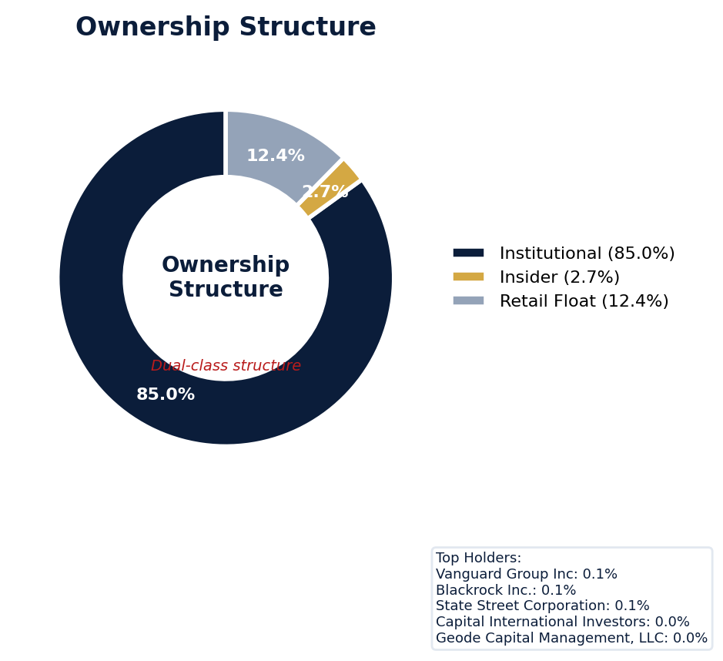
Figure: Ownership breakdown -- institutional, insider, retail float
Category | Percentage
Institutional Ownership | 85.0%
Insider Ownership | 2.7%
Retail Float | 12.4%
Top Holder | Ownership %
Vanguard Group Inc | 0.1%
Blackrock Inc. | 0.1%
State Street Corporation | 0.1%
Capital International Investors | 0.0%
Geode Capital Management, LLC | 0.0%
Sentiment & Narrative Coherence
Signal | Assessment
Narrative Coherence | COHERENT
Anti-Takeover Provisions
Anti-takeover provision data not available. Review DEF 14A and charter documents for complete analysis.

ELEVATED CONCERN
Salesforce currently faces one active derivative lawsuit, though no SCAs with defined class periods are pending. Their adjusted SCA filing rate of 10.14% is more than double the 5.0% sector average, indicating a recurrent litigation target that elevates D&O risk. The open SEC inquiry, while at an early stage, presents a clear catalyst for a future SCA, with industry patterns in revenue recognition and subscriber metrics providing fertile ground for plaintiffs to allege disclosure failures. Defense costs from six open securities lawsuits will be material, and any future settlement will benchmark against recent nine-figure SaaS resolutions, directly impacting potential indemnity losses. Lead counsel in the derivative action is likely a top-tier plaintiffs' firm, though specific names are not yet public in the data. Given the elevated filing rate and active regulatory scrutiny, the probability of a new SCA within 12-18 months exceeds one in three.
Section 6: Litigation & Regulatory Exposure
1 derivative action(s) pending, alleging breach of fiduciary duty by directors and officers. Industry claim exposure: revenue_recognition, subscriber_metrics, data_privacy. 6 statute of limitations window(s) remain open, meaning new claims can still be filed for past events. Under claims-made D&O policy, coverage is triggered when a claim is reported during the policy period. Defense quality assessment: MODERATE.
Litigation Overview: 0 active matter(s), 1 historical matter(s)
Litigation Timeline
Timeline chart not available (no timeline events).
Securities Class Actions
Case Name | Legal Theory | Coverage | Court | Filing Date | Status | Class Period | Lead Counsel | Settlement | Source
In re Salesforce.com, Inc. Securities Litigation (2004) | Rule 10b-5, Section 11 | Side C (Entity) | N.D. Cal | 2004-07-26 | DISMISSED | N/A | N/A | N/A | [Supabase SCA database, 2026-04-02, MEDIUM]
SEC Enforcement Pipeline
Pipeline: (Comment Letters) -> (Informal Inquiry) -> (Formal Investigation) -> (Wells Notice) -> (Enforcement Action)
No SEC enforcement pipeline activity detected. [10-K Item 3 + Item 1A + 8-K + EFTS, 2026-04-02, LOW]
Derivative Suits
Case Name | Filing Date | Status | Court | Settlement
N/A | N/A | UNKNOWN | N/A | N/A
Regulatory Proceedings
No regulatory proceedings found.
Industry Claim Patterns
Legal Theory | Exposed | Contagion Risk | Description
Revenue Recognition | Yes | Yes | [Software & SaaS] Premature or fraudulent SaaS revenue recog
Subscriber Metrics | Yes | Yes | [Software & SaaS] Inflated user/subscriber metrics
Data Privacy | Yes | Yes | [Software & SaaS] Data privacy violations (GDPR, CCPA)
Acquisition Writedown | Yes | Yes | [Software & SaaS] Goodwill impairment from overpaid acquisit
D&O Context: Company exposed to 4 industry claim pattern(s). Peer lawsuits create contagion risk -- plaintiff firms often file similar claims across the industry. [ELEVATED]
Statute of Limitations Map
Claim Type | Trigger Date | SOL Expiry | Repose Expiry | Window Open
employment_discrimination | 2026-03-02 | 2028-03-01 | 2028-03-01 | OPEN
antitrust | 2026-03-02 | 2030-03-01 | 2030-03-01 | OPEN
FCPA | 2026-03-02 | 2031-03-01 | 2031-03-01 | OPEN
environmental | 2026-03-02 | 2031-03-01 | 2031-03-01 | OPEN
derivative | 2026-03-02 | 2029-03-01 | 2032-02-29 | OPEN
ERISA | 2026-03-02 | 2029-03-01 | 2032-02-29 | OPEN
Section_11 | 2004-07-26 | 2005-07-26 | 2007-07-26 | CLOSED
Section_14a | 2004-07-26 | 2005-07-26 | 2007-07-26 | CLOSED
10b-5 | 2004-07-26 | 2006-07-26 | 2009-07-25 | CLOSED
D&O Context: 6 open exposure window(s). Claims can still be filed within these periods. [ELEVATED]
Defense Strength Assessment
Factor | Assessment
Federal Forum Provision | No
Exclusive Forum Provision | No
PSLRA Safe Harbor | STRONG
Truth-on-Market Viability | NOT_APPLICABLE
Prior Dismissal Success | No prior dismissals identified in Item 3
Overall Defense Strength | MODERATE
No forum selection provisions identified. Safe harbor usage is STRONG with explicit PSLRA citation and specific cautionary language. [DEF 14A; 10-K, 2026-04-02, LOW]
Contingent Liabilities
Description | ASC 450 Class. | Accrued | Range
eflects the consideration the Company expects to receive in | probable | N/A | N/A
We evaluate all claims and lawsuits with respect to their po | reasonably_possible | N/A | N/A
In addition, many of our subscription agreements require us | reasonably_possible | N/A | N/A
The outcome of any claims or litigation, regardless of the m | reasonably_possible | N/A | N/A
Any claims and other lawsuits, and the disposition of such c | reasonably_possible | N/A | N/A
For more information regarding legal proceedings see Note 14 | reasonably_possible | N/A | N/A
D&O Context: 1 probable contingenc(y/ies). ASC 450 probable classification indicates management believes loss is likely. Direct impact on D&O exposure. [HIGH]
Workforce, Product & Environmental Matters
Cybersecurity Incidents:
- [data_breach] measures or those of our third-party data center providers, cloud computing platform providers, customers, partners, or other third-party vendors, or the underlying Internet infrastructure that cause unauthorized access to, disclosure, alteration, corruption, destruction or loss of customer data, our data or our IT systems, or disruption of authorized access thereto.
- [data_breach] center providers, cloud computing platform providers, customers, partners, other third-party vendors or the underlying Internet infrastructure, are breached or otherwise compromised, resulting in the unauthorized access to, disclosure, alteration, corruption, destruction or loss of customer data, our data or our IT systems, or disruption of authorized access thereto, our services may be perceived as insecure, customers may reduce or terminate their use of our services, and we may incur signif...
- [data_breach] mpromised, including, for example, as a result of the following: • attempts to fraudulently induce our employees, customers, partners, or third-party vendors to disclose sensitive information to gain unauthorized access to our or our customers' data or IT systems; • efforts by threat actors, including criminal organizations, state-sponsored actors and nation-states, to launch coordinated cyberattacks or supply chain attacks on our infrastructure or that of our third-party vendors, including t...
- [data_breach] and processes designed to protect the confidentiality, integrity and availability of our customers' and our customers' customers' proprietary and sensitive data, will be effective or that a material cybersecurity incident will not occur.
- [data_breach] Any delay in detecting, containing, or remediating a cybersecurity incident may result in additional harm, and in certain cases the full scope and impact of any such incident may not be immediately apparent.
- [data_breach] 13 Table of Contents A cybersecurity incident could result in unauthorized access to, or the loss or denial of authorized access to, our IT systems or data, or those of our customers, including intellectual property and other proprietary, sensitive or confidential information.
- [data_breach] For example, SEC rules require disclosure on Form 8-K of the nature, scope and timing of any material cybersecurity incident and the reasonably likely impact of such incident.
- [data_breach] Further, there can be no assurance that our insurance coverage will be sufficient in type or amount to cover the losses arising from a cybersecurity incident.
- [data_breach] We have experienced and may in the future experience defects in our, our customers', or third-party vendors' products and components, which may create vulnerabilities that inadvertently permit unauthorized access to protected customer data.
- [cyber_attack] to gain unauthorized access to our or our customers' data or IT systems; • efforts by threat actors, including criminal organizations, state-sponsored actors and nation-states, to launch coordinated cyberattacks or supply chain attacks on our infrastructure or that of our third-party vendors, including through ransomware, destructive malware, distributed denial-of-service attacks or exploitation of previously unknown "zero-day" vulnerabilities; • attempts to misuse our marketing, advertising,...
- [cyber_attack] riminal organizations, state-sponsored actors and nation-states, to launch coordinated cyberattacks or supply chain attacks on our infrastructure or that of our third-party vendors, including through ransomware, destructive malware, distributed denial-of-service attacks or exploitation of previously unknown "zero-day" vulnerabilities; • attempts to misuse our marketing, advertising, messaging or social products and functionalities to impersonate persons or organizations and disseminate inform...
- [cyber_attack] ncreasingly sophisticated techniques used to breach or disrupt IT systems and infrastructure, including the use or exploitation of AI technologies by threat actors to accelerate, scale or personalize cyberattacks, which may increase speed and effectiveness and limit our ability to anticipate, detect or mitigate such threats; • the increasing complexity of our internal IT systems as we integrate acquired businesses and adopt new technologies and data-sharing models; and • our limited control o...
- [cyber_attack] In the normal course of business, we and our customers are and have been the target of malicious cyberattacks and other security threats.
- [cyber_attack] As our market presence grows, we may face increased risks of cyberattacks and other security threats.
Whistleblower Indicators
No whistleblower indicators identified in SEC filings. SEC whistleblower tips are not publicly disclosed; absence does not confirm lack of activity.

Salesforce's quality score of 50 and WATCH tier reflect a 5.7-8.1% claim probability, placing it in the ELEVATED band. Its Prior Litigation risk factor deducted 2.9 points from a 20-point maximum, the largest single deduction, indicating a persistent legal environment for directors. Elevated Short Interest, which deducted 2.15 points from an 8-point max, signals significant market skepticism that can fuel shareholder suits. A recent 90-day stock decline imposes a binding CRF-11 ceiling, which overrides other scoring and directly limits policy terms due to heightened litigation triggers. This aggregate of active risks, including Restatement/Audit Issues (1.62 points deducted), demands careful structuring and senior review to address the non-linear threat of interrelated claims.
Section 7: Risk Scoring & Synthesis
Underwriting tier: **WATCH** (quality score: 50.0/100). Recommended action: Write carefully, senior review required. Expected claim probability band: 5.7-8.1%. Top risk contributors: Prior Litigation (F1: -2.9 pts); Short Interest (F6: -2.2 pts); Restatement/Audit Issues (F3: -1.6 pts). **Red flag gates active**: Recent Drop - 90 Day (ceiling: 50). Binding ceiling: CRF-11. Claim probability band: ELEVATED (5.7%-8.1%).
Tier Classification
Metric | Value
Quality Score | 50.0 / 100
Composite Score (pre-ceiling) | 89.6
Total Risk Points Deducted | 10.4
Tier | WATCH
Tier Range | 31 - 50
Action Guidance | Write carefully, senior review required
Probability Range | 5.7-8.1%
Pricing Multiplier | 1.5-2x + attachment
Binding Ceiling | CRF-11
Risk Assessment: HIGH [HIGH]
D&O Claim Peril Assessment
2 of 8 D&O claim perils show active risk signals. Active perils have at least one causal chain with triggered checks.
Peril | Risk Level | Active Chains | Key Evidence
Securities Claims | MODERATE | 1/5 | Qualitative: No non-GAAP measures detected in 10-K; Qualitative: 0
Fiduciary Breach | MODERATE | 1/3 | Verified (value: 0); Detected (value). Limited corroborating data available.
Government Enforcement | LOW | 0/2 | —
Employment & Whistleblower | LOW | 0/1 | —
Insolvency & Bankruptcy | LOW | 0/1 | —
Emerging Risks | LOW | 0/2 | —
Consumer & Product Claims | LOW | 0/1 | —
Commercial Litigation | LOW | 0/1 | —
Active Peril Analysis
Securities Claims: MODERATE [MODERATE]
Frequency: moderate | Severity: high | Typical range: $5M - $500M+
1 of 5 causal chains active.
Chain: Guidance Miss → Securities Fraud [MODERATE]
Repeated guidance misses or aggressive forward guidance builds scienter case for securities fraud claim when stock eventually declines.
Triggers:
• FIN.GUIDE.earnings_reaction
Historical filing rate: 8% | Median severity: $12M
Fiduciary Breach: MODERATE [MODERATE]
Frequency: growing | Severity: variable | Typical range: $1M - $100M
1 of 3 causal chains active.
Chain: Governance Failure → Derivative Suit [MODERATE]
Weak governance structure (low independence, CEO/Chair duality, poor say-on-pay) creates basis for Caremark duty of oversight claims and derivative suits.
Triggers:
• GOV.PAY.say_on_pay
Historical filing rate: 3% | Median severity: $8M
Composite Score Breakdown
Factor | Name | Max Pts | Deducted | % Used | Top Contributor
F1 | Prior Litigation | 20 | 2.9 | 14% | Signal-driven scoring: 70 signals, coverage=100%
F2 | Stock Decline | 15 | 0.9 | 6% | Signal-driven scoring: 30 signals, coverage=100%
F3 | Restatement/Audit Issues | 12 | 1.6 | 14% | Signal-driven scoring: 88 signals, coverage=100%
F4 | IPO/SPAC/M&A | 10 | 0.7 | 7% | Signal-driven scoring: 15 signals, coverage=100%
F5 | Guidance Misses | 13 | 0.5 | 4% | Signal-driven scoring: 28 signals, coverage=100%
F6 | Short Interest | 8 | 2.2 | 27% | Signal-driven scoring: 27 signals, coverage=100%
F7 | Stock Volatility | 7 | 0.5 | 6% | Signal-driven scoring: 31 signals, coverage=100%
F8 | Financial Distress | 5 | 0.2 | 4% | Signal-driven scoring: 14 signals, coverage=100%
F9 | Governance Issues | 6 | 0.9 | 16% | Signal-driven scoring: 39 signals, coverage=100%
F10 | Officer Stability | 2 | 0.1 | 6% | Signal-driven scoring: 90 signals, coverage=100%
10-Factor Risk Profile
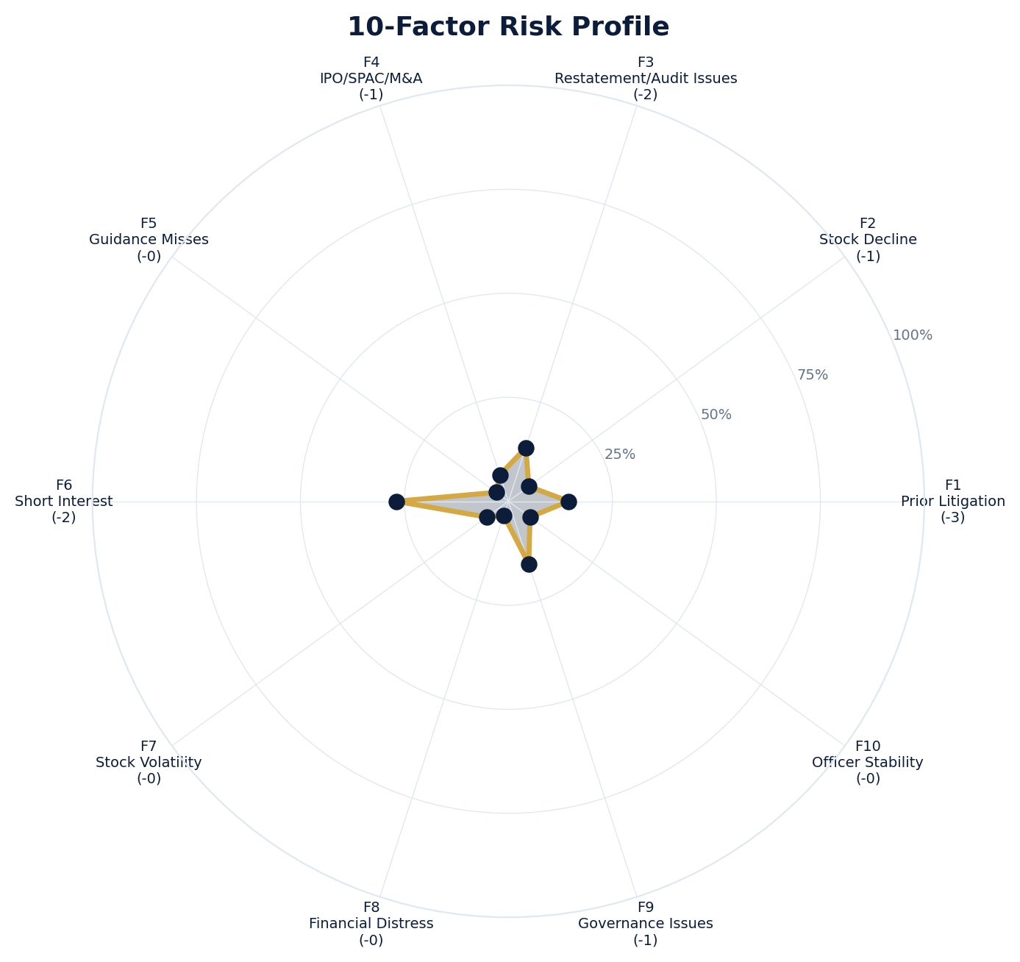
Figure: Radar chart showing risk fraction (points deducted / max) for each of the 10 scoring factors. Larger area = higher risk.
Red Flag Gates
Severity | Description | Source | Impact | Trajectory
CRITICAL | Critical Red Flag: Recent Drop - 90 Day | 90-day drop: 28.6% (56 days ago) | Ceiling: 50 | NEW
LOW | Prior Litigation: 3/20 points | Signal-driven scoring: 70 signals, coverage=100% | F1: 3 pts | NEW
LOW | Stock Decline: 1/15 points | Signal-driven scoring: 30 signals, coverage=100%; Drop contribution modifier: 0.56x (decay + company-specific + disclosure) | F2: 1 pts | NEW
LOW | Restatement/Audit Issues: 2/12 points | Signal-driven scoring: 88 signals, coverage=100% | F3: 2 pts | NEW
LOW | IPO/SPAC/M&A: 1/10 points | Signal-driven scoring: 15 signals, coverage=100% | F4: 1 pts | NEW
LOW | Guidance Misses: 0/13 points | Signal-driven scoring: 28 signals, coverage=100% | F5: 0 pts | NEW
LOW | Short Interest: 2/8 points | Signal-driven scoring: 27 signals, coverage=100% | F6: 2 pts | NEW
LOW | Stock Volatility: 0/7 points | Signal-driven scoring: 31 signals, coverage=100% | F7: 0 pts | NEW
LOW | Financial Distress: 0/5 points | Signal-driven scoring: 14 signals, coverage=100% | F8: 0 pts | NEW
LOW | Governance Issues: 1/6 points | Signal-driven scoring: 39 signals, coverage=100% | F9: 1 pts | NEW
LOW | Officer Stability: 0/2 points | Signal-driven scoring: 90 signals, coverage=100% | F10: 0 pts | NEW
Critical: 1, High: 0, Moderate: 0, Low: 10
Risk Type Classification
Attribute | Value
Primary Risk Type | GUIDANCE_DEPENDENT
Supporting Evidence | F5 guidance misses: 0.4727272727272727 points; Issues guidance (philosophy: CONSERVATIVE)
Severity Scenarios
Analysis based on market cap: $175.4B
Percentile | Label | Settlement Est. | Defense Costs | Total Exposure
25th | favorable | $347.8M | $52.2M | $399.9M
50th | median | $695.5M | $139.1M | $834.6M
75th | adverse | $1.4B | $347.8M | $1.7B
95th | catastrophic | $2.8B | $834.6M | $3.6B
Calibration Notes (SECT7-11)
The following items are flagged NEEDS CALIBRATION and require expert review before final pricing:
- SECT7-11: All scoring parameters require calibration against historical cases
Factor Detail
Factor | Name | Deducted | Rules Triggered | Evidence
F1 | Prior Litigation | 2.9 | N/A | Signal-driven scoring: 70 signals, coverage=100%
F2 | Stock Decline | 0.9 | drop_contribution_adjustment | Signal-driven scoring: 30 signals, coverage=100%; Drop contribution modifier: 0.56x (decay + company-specific + disclosure)
F3 | Restatement/Audit Issues | 1.6 | N/A | Signal-driven scoring: 88 signals, coverage=100%
F4 | IPO/SPAC/M&A | 0.7 | N/A | Signal-driven scoring: 15 signals, coverage=100%
F5 | Guidance Misses | 0.5 | N/A | Signal-driven scoring: 28 signals, coverage=100%
F6 | Short Interest | 2.2 | N/A | Signal-driven scoring: 27 signals, coverage=100%
F7 | Stock Volatility | 0.5 | N/A | Signal-driven scoring: 31 signals, coverage=100%
F8 | Financial Distress | 0.2 | N/A | Signal-driven scoring: 14 signals, coverage=100%
F9 | Governance Issues | 0.9 | N/A | Signal-driven scoring: 39 signals, coverage=100%
F10 | Officer Stability | 0.1 | N/A | Signal-driven scoring: 90 signals, coverage=100%
Sub-Component Breakdown
Factor | Component | Value
F1 | base | 2.90
F1 | bonus | 0.00
F1 | modifiers | 0.00
F1 | hard_triggers | 0.00
F1 | total_before_cap | 2.90
F1 | capped | 2.90
F2 | base | 1.64
F2 | bonus | 0.00
F2 | modifiers | 0.00
F2 | hard_triggers | 0.00
F2 | drop_contribution_modifier | 0.56
F2 | total_before_cap | 0.91
F2 | capped | 0.91
F3 | base | 1.62
F3 | bonus | 0.00
F3 | modifiers | 0.00
F3 | hard_triggers | 0.00
F3 | total_before_cap | 1.62
F3 | capped | 1.62
F4 | base | 0.67
F4 | bonus | 0.00
F4 | modifiers | 0.00
F4 | hard_triggers | 0.00
F4 | total_before_cap | 0.67
F4 | capped | 0.67
F5 | base | 0.47
F5 | bonus | 0.00
F5 | modifiers | 0.00
F5 | hard_triggers | 0.00
F5 | total_before_cap | 0.47
F5 | capped | 0.47
F6 | base | 2.15
F6 | bonus | 0.00
F6 | modifiers | 0.00
F6 | hard_triggers | 0.00
F6 | total_before_cap | 2.15
F6 | capped | 2.15
F7 | base | 0.45
F7 | bonus | 0.00
F7 | modifiers | 0.00
F7 | hard_triggers | 0.00
F7 | total_before_cap | 0.45
F7 | capped | 0.45
F8 | base | 0.18
F8 | bonus | 0.00
F8 | modifiers | 0.00
F8 | hard_triggers | 0.00
F8 | total_before_cap | 0.18
F8 | capped | 0.18
F9 | base | 0.95
F9 | bonus | 0.00
F9 | modifiers | 0.00
F9 | hard_triggers | 0.00
F9 | total_before_cap | 0.95
F9 | capped | 0.95
F10 | base | 0.13
F10 | bonus | 0.00
F10 | modifiers | 0.00
F10 | hard_triggers | 0.00
F10 | total_before_cap | 0.13
F10 | capped | 0.13
Pattern Detection Results
No composite patterns detected.
Allegation Theory Mapping
Theory | Exposure | Factor Sources | Key Findings
A_DISCLOSURE | MODERATE | F1, F3, F5 | F1: Signal-driven scoring: 70 signals, coverage=100%; F3: Signal-driven scoring: 88 signals, coverage=100%
B_GUIDANCE | LOW | F2, F5 | F2: Signal-driven scoring: 30 signals, coverage=100%; F2: Drop contribution modifier: 0.56x (decay + company-specific + disclosure)
C_PRODUCT_OPS | LOW | F7, F8 | F7: Signal-driven scoring: 31 signals, coverage=100%; F8: Signal-driven scoring: 14 signals, coverage=100%
D_GOVERNANCE | LOW | F9, F10 | F9: Signal-driven scoring: 39 signals, coverage=100%; F10: Signal-driven scoring: 90 signals, coverage=100%
E_MA | LOW | F4 | F4: Signal-driven scoring: 15 signals, coverage=100%
D&O Context: Primary allegation exposure is A_DISCLOSURE. MODERATE exposure in: A_DISCLOSURE.
Claim Probability Detail
Metric | Value
Probability Band | ELEVATED
Range | 5.7% - 8.1%
Industry Base Rate | 5.0%
Adjustment Rationale | Industry base rate: 5.0%. Tier WATCH (10-15%): Significantly above base rate. Co
Claim probability: ELEVATED [HIGH]
Tower Position Recommendation
Metric | Value
Recommended Position | MID_EXCESS
Minimum Attachment | $695.5M (based on 50th percentile settlement)
Side A/DIC Assessment | Standard Side A considerations
Position | Risk Assessment | Premium Guidance | Attachment
PRIMARY | Primary layer carries 57% of expected loss exposur | Full rate, slight discount for | $0 ground-up
LOW_EXCESS | Low excess layer carries 18% of expected loss expo | Market rate | $5-15M xs $5-15M
MID_EXCESS | Mid excess layer carries 13% of expected loss expo | Market to 1.3x | $15-50M xs $15-50M
HIGH_EXCESS | High excess layer carries 11% of expected loss exp | 1.3-2x with attachment | $50M+ xs $50M+
DECLINE | WALK+ with compounding factors | N/A | N/A
Forensic Composite Scores
Composite | Score | Interpretation
Financial Integrity Score (FIS) | N/A | Not available
Reporting Quality Score (RQS) | N/A | Not available
Cash Flow Quality Score (CFQS) | N/A | Not available
Executive Risk Profile
Metric | Value
Weighted Score | 5
Risk Level | N/A
- [Niles President (GC)]: Prior litigation: title: Former Salesforce Vice President Advances Retaliation Lawsuit
- [Niles President (GC)]: Prior litigation: url: https://news.bloomberglaw.com/litigation/former-salesforce-vice-president-advances-retaliation-
- [Niles President (GC)]: Prior litigation: snippet: A former Salesforce Inc. vice president can proceed with his lawsuit alleging that the comp
- [Millham In February (Other)]: Prior litigation: case_summary: Salesforce.com (NYSE: CRM) is engaged in the provision of on-demand customer relations
Temporal Signals
Type | Direction | Magnitude | Description
Unknown | N/A | N/A
Unknown | N/A | N/A
Unknown | N/A | N/A
Unknown | N/A | N/A
Unknown | N/A | N/A
Unknown | N/A | N/A
Unknown | N/A | N/A
Unknown | N/A | N/A
NLP Filing Analysis
Metric | Value
Readability Score | {'current_fog': 18.67, 'prior_fog': None, 'fog_change': None, 'current_flesch': 24.04, 'prior_flesch': None, 'classification': 'CURRENT_ONLY', 'evidence': 'Current Fog Index: 18.7 (prior year unavailable)'}
Tone Assessment | N/A
Risk Language Density | N/A
Peril Assessment
Plaintiff Peril Heat Map
Plaintiff Type | Probability | Severity
Shareholders | ELEVATED | SIGNIFICANT
Regulators | ELEVATED | SIGNIFICANT
Customers | VERY LOW | NUISANCE
Competitors | VERY LOW | NUISANCE
Employees | LOW | MINOR
Creditors | MODERATE | MODERATE
Government | MODERATE | MODERATE
Shareholders: 50 triggered checks. Key: Litigation History Profile: 1 (elevated vs benchmark of 0)
Regulators: 15 triggered checks. Key: Disclosure Complexity Score: 28 (elevated vs benchmark of 25)
Creditors: 4 triggered checks. Key: Goodwill/Intangible as % of Equity: 97.97 (elevated vs benchmark of 50)
Government: 4 triggered checks. Key: Product Concentration: 4 (elevated vs benchmark of 3)
Bear Cases
Bear Case: A Disclosure
Salesforce, Inc. faces elevated exposure to securities disclosure fraud claims. Key risk indicators: Litigation History Profile (critical); Subsidiary Count Complexity (critical). Estimated severity is significant, warranting detailed underwriter review.
Defense: Defense: No active Section 11 windows — statute of limitations expired for offering claims
Evidence Chain
1. [BIZ.CLASS.litigation_history] Litigation History Profile (Source: total_sca_count)
2. [BIZ.STRUCT.subsidiary_count] Subsidiary Count Complexity (Source: subsidiary_count)
3. [BIZ.STRUCT.vie_spe] VIE/SPE Off-Balance-Sheet Structures (Source: vie_spe_present)
4. [BIZ.DEPEND.distribution] Product Concentration (Source: distribution_channels_count)
5. [BIZ.EVENT.ipo_exposure] IPO/Offering Exposure Window (Source: event_ipo_exposure_score)
6. [BIZ.OPS.subsidiary_structure] Subsidiary Jurisdiction Structure (Source: subsidiary_structure)
7. [BIZ.OPS.workforce] Workforce Distribution (Source: workforce_distribution)
8. [BIZ.STRUC.obs_exposure] Off-Balance-Sheet Exposure (Source: obs_exposure_score)
9. [DISC.YOY.removed_risk_factors] Removed Risk Factors (YoY) (Source: yoy_removed_risk_count)
10. [EXEC.PRIOR_LIT.any_officer] Any Officer With Prior Litigation at Previous Company (Source: value)
Probability: ELEVATED | Severity: SIGNIFICANT
Settlement Prediction
Settlement prediction computed but no scenarios available.
Tower Risk Characterization
Tower characterization not available.
Coverage Gaps -- Data Not Available
The following checks could not be evaluated because required data was not acquired. These items are NOT cleared -- they represent gaps in coverage that should be considered in the underwriting decision.
Executive Summary & Key Metrics
[EVALUATIVE] BIZ.DEPEND.labor (Concentration Risk Composite): Required data not available from filings
[REQUIRED] BIZ.MA.goodwill_balance (Goodwill Balance): Required data not available from filings
[REQUIRED] BIZ.MA.acquisition_spend (Acquisition Spend Magnitude): Required data not available from filings
[EVALUATIVE] BIZ.MA.goodwill_change (Goodwill Trajectory): Required data not available from filings
[REQUIRED] BIZ.MA.acquisition_list (Recent Acquisitions): Required data not available from filings
[EVALUATIVE] BIZ.MODEL.key_person (Key Person Dependency): Required data not available from filings
[REQUIRED] BIZ.MODEL.lifecycle (Segment Lifecycle Risk): Required data not available from filings
[REQUIRED] BIZ.MODEL.segment_margins (Segment Margin Profile): Required data not available from filings
[EVALUATIVE] ABS.DISC.audit_fees (Missing Audit Fee Disclosure): Expected signals not found in evaluation results
[EVALUATIVE] ABS.DISC.board_independence (Missing Board Independence Disclosure): Could not determine disclosure presence or absence
[EVALUATIVE] ABS.DISC.clawback_policy (Missing Clawback Policy Disclosure): Expected signals not found in evaluation results
[EVALUATIVE] ABS.DISC.cyber_risk (Missing Cybersecurity Risk Disclosure): Expected signals not found in evaluation results
[EVALUATIVE] ABS.DISC.debt_covenants (Missing Debt Covenant Disclosure): Expected signals not found in evaluation results
[EVALUATIVE] ABS.DISC.derivative_instruments (Missing Derivative Instruments Disclosure): Expected signals not found in evaluation results
[EVALUATIVE] ABS.DISC.esg (Missing ESG Disclosure): Expected signals not found in evaluation results
[EVALUATIVE] ABS.DISC.executive_comp (Missing Executive Compensation Disclosure): Expected signals not found in evaluation results
[EVALUATIVE] ABS.DISC.goodwill_impairment (Missing Goodwill Impairment Disclosure): Expected signals not found in evaluation results
[EVALUATIVE] ABS.DISC.lease_obligations (Missing Lease Obligation Disclosure): Expected signals not found in evaluation results
[EVALUATIVE] ABS.DISC.litigation_contingency (Missing Litigation Contingency Disclosure): Expected signals not found in evaluation results
[EVALUATIVE] ABS.DISC.pension_obligations (Missing Pension Obligation Disclosure): Expected signals not found in evaluation results
[EVALUATIVE] ABS.DISC.related_party (Missing Related-Party Transaction Disclosure): Expected signals not found in evaluation results
[EVALUATIVE] ABS.DISC.revenue_recognition (Missing Revenue Recognition Policy Disclosure): Expected signals not found in evaluation results
[EVALUATIVE] ABS.DISC.risk_factors (Missing Risk Factor Disclosure): Expected signals not found in evaluation results
[EVALUATIVE] ABS.DISC.segment_reporting (Missing Segment Reporting Disclosure): Expected signals not found in evaluation results
[EVALUATIVE] ABS.DISC.stock_comp (Missing Stock Compensation Disclosure): Expected signals not found in evaluation results
[EVALUATIVE] ABS.DISC.tax_positions (Missing Uncertain Tax Position Disclosure): Expected signals not found in evaluation results
[EVALUATIVE] CONJ.COMP.perf_divergence (Compensation-Performance Divergence): 3/3 component signals unavailable
[EVALUATIVE] CONJ.DISTRESS.insider (Financial Distress + Insider Selling): 2/3 component signals unavailable
[EVALUATIVE] CONJ.GOV.governance_event (Weak Governance + Adverse Event): 3/5 component signals unavailable
[EVALUATIVE] CONJ.FIN.growth_margin_guidance (Rapid Growth + Margin Compression + Guidance Miss): 3/3 component signals unavailable
[EVALUATIVE] CONJ.INSIDER.news_gap (Insider Selling + Material News Gap): 3/3 component signals unavailable
[EVALUATIVE] CONJ.REG.litigation (Regulatory Action + New Material Litigation): 3/3 component signals unavailable
[EVALUATIVE] CTX.FIN.capex_sector (Capital Expenditure in Sector Context): Source signal FIN.INVEST.capex_ratio not in results
[EVALUATIVE] CTX.COMP.lifecycle (CEO Compensation in Lifecycle Context): Source signal EXEC.COMP.ceo_total_comp not in results
[EVALUATIVE] CTX.COMP.product_tower (Compensation Severity by Product/Tower): Source signal EXEC.COMP.ceo_total_comp not in results
[EVALUATIVE] CTX.FIN.debt_maturity (Debt Maturity Profile in Lifecycle Context): Source signal FIN.DEBT.maturity_profile not in results
[EVALUATIVE] CTX.FIN.distress_product (Financial Distress by Product/Tower): Source signal FIN.FORENSIC.altman_z not in results
[EVALUATIVE] CTX.FIN.dividend_lifecycle (Dividend Policy in Lifecycle Context): Source signal FIN.RETURN.dividend_yield not in results
[EVALUATIVE] CTX.EXEC.tenure_lifecycle (Executive Tenure in Lifecycle Context): Source signal EXEC.TURN.c_suite not in results
[EVALUATIVE] CTX.MKT.insider_lifecycle (Insider Trading in Lifecycle Context): Source signal STOCK.INSIDER.net_selling not in results
[EVALUATIVE] CTX.FIN.leverage_sector (Leverage in Sector Context): Source signal FIN.DEBT.leverage_ratio not in results
[EVALUATIVE] CTX.LIT.size (Litigation Frequency by Company Size): Source signal LIT.SCA.active_cases not in results
[EVALUATIVE] CTX.RISK.ma_lifecycle (M&A Activity in Lifecycle Context): Source signal BIZ.MA.acquisition_activity not in results
[EVALUATIVE] CTX.RISK.regulatory_sector (Regulatory Risk in Sector Context): Source signal LIT.SEC.enforcement not in results
[EVALUATIVE] CTX.RISK.rpt_sector (Related-Party Risk in Sector Context): Source signal GOV.RPT.related_party not in results
[EVALUATIVE] CTX.MKT.short_interest_sector (Short Interest in Sector Context): Source signal STOCK.SHORT.interest_ratio not in results
[EVALUATIVE] CTX.MKT.turnover_sector (Stock Turnover in Sector Context): Source signal STOCK.VOL.turnover_rate not in results
[EVALUATIVE] CTX.MKT.volatility_sector (Stock Volatility in Sector Context): Source signal STOCK.VOL.historical not in results
Financial Health
[EVALUATIVE] FIN.PEER.revenue_bottom_quartile (Revenue Bottom Quartile (Cross-Filer)): No peer comparison data available
[EVALUATIVE] FIN.PEER.leverage_top_decile (Leverage Top Decile (Sector-Relative)): No peer comparison data available
[EVALUATIVE] FIN.PEER.margin_compression (Operating Margin Compression (Cross-Filer)): No peer comparison data available
[EVALUATIVE] FIN.PEER.profitability_laggard (Profitability Laggard (Sector-Relative)): No peer comparison data available
[EVALUATIVE] FIN.PEER.size_outlier_small (Size Outlier Small (Cross-Filer)): No peer comparison data available
[EVALUATIVE] FIN.PEER.cash_flow_weak (Cash Flow Weakness (Cross-Filer)): No peer comparison data available
[EVALUATIVE] LIT.DEFENSE.forum_selection (Federal Forum Selection Clause): Required data not available from filings
Governance & Leadership
[EVALUATIVE] EXEC.INSIDER.ceo_net_selling (CEO Net Seller of Stock): Required data not available from filings
[EVALUATIVE] EXEC.INSIDER.cfo_net_selling (CFO Net Seller of Stock): Required data not available from filings
[REQUIRED] EXEC.PROFILE.board_size (Board Size (Number of Members)): Required data not available from filings
[REQUIRED] EXEC.PROFILE.independent_ratio (Board Independence Percentage): Required data not available from filings
[EVALUATIVE] EXEC.PROFILE.overboarded_directors (Directors Serving on 4+ Boards): Required data not available from filings
[EVALUATIVE] GOV.BOARD.size (Board Size): Required data not available from filings
[EVALUATIVE] GOV.BOARD.independence (Board Independence): Required data not available from filings
[EVALUATIVE] GOV.BOARD.diversity (Board Diversity): Required data not available from filings
[EVALUATIVE] GOV.BOARD.tenure (Tenure): Required data not available from filings
[EVALUATIVE] GOV.BOARD.overboarding (Overboarding): Required data not available from filings
[EVALUATIVE] GOV.BOARD.attendance (Attendance): Required data not available from filings
[EVALUATIVE] GOV.BOARD.meetings (Meetings): Required data not available from filings
[EVALUATIVE] GOV.BOARD.succession (Succession): Required data not available from filings
[EVALUATIVE] GOV.PAY.ceo_total (Ceo Total): Required data not available from filings
[REQUIRED] GOV.PAY.ceo_structure (Ceo Structure): Required data not available from filings
[EVALUATIVE] GOV.PAY.peer_comparison (Peer Comparison): Required data not available from filings
[EVALUATIVE] GOV.PAY.golden_para (Golden Para): Required data not available from filings
[EVALUATIVE] GOV.PAY.equity_burn (Equity Burn): Required data not available from filings
[EVALUATIVE] GOV.PAY.hedging (Hedging): Required data not available from filings
[REQUIRED] GOV.RIGHTS.bylaws (Bylaws): Required data not available from filings
[EVALUATIVE] GOV.RIGHTS.takeover (Takeover): Required data not available from filings
[EVALUATIVE] GOV.RIGHTS.proxy_access (Proxy Access): Required data not available from filings
[REQUIRED] GOV.RIGHTS.forum_select (Forum Select): Required data not available from filings
[EVALUATIVE] GOV.RIGHTS.supermajority (Supermajority): Required data not available from filings
[EVALUATIVE] GOV.RIGHTS.action_consent (Action Consent): Required data not available from filings
[EVALUATIVE] GOV.RIGHTS.special_mtg (Special Mtg): Required data not available from filings
[EVALUATIVE] GOV.RIGHTS.classified (Classified): Required data not available from filings
Market & Trading
[EVALUATIVE] FIN.COMP.rsu_grants (RSU Grant Trend): Required data not available from filings
[EVALUATIVE] FIN.CONT.loss_accrual (Loss Contingency Accrual): Required data not available from filings
[EVALUATIVE] FIN.CONT.loss_estimate (Loss Contingency Estimate): Required data not available from filings
[EVALUATIVE] FIN.CONT.settlement_activity (Litigation Settlement Activity): Required data not available from filings
[EVALUATIVE] FIN.CONT.warranty_reserve (Product Warranty Reserve): Required data not available from filings
[EVALUATIVE] FIN.DEBT.maturity_concentration (Debt Maturity Concentration): Data mapping not configured for this check
[EVALUATIVE] FIN.DERIV.notional_exposure (Derivative Notional Exposure): Required data not available from filings
[EVALUATIVE] FIN.DERIV.fair_value_risk (Derivative Fair Value Risk): Required data not available from filings
[EVALUATIVE] FIN.QUALITY.q4_revenue_concentration (Q4 Revenue Concentration): Required data not available from filings
[EVALUATIVE] FIN.QUALITY.revenue_recognition_risk (Revenue Recognition Risk Indicators): Data mapping not configured for this check
[EVALUATIVE] FIN.FORENSIC.level3_fair_value (Level 3 Fair Value Asset Concentration): Data mapping not configured for this check
[EVALUATIVE] FIN.FORENSIC.goodwill_deterioration_pattern (Goodwill Deterioration Pattern): Data mapping not configured for this check
[EVALUATIVE] FIN.FORENSIC.related_party_revenue (Related Party Revenue Concentration): Data mapping not configured for this check
[EVALUATIVE] FWRD.EVENT.ma_integration_risk (M&A Integration Risk): Data mapping not configured for this check
[EVALUATIVE] FIN.FORENSIC.buyback_timing (Share Buyback Timing Quality): Data mapping not configured for this check
[EVALUATIVE] FIN.FORENSIC.deferred_tax_growth (Deferred Tax Liability Growth): Data mapping not configured for this check
[EVALUATIVE] FIN.FORENSIC.pension_underfunding (Pension Underfunding Risk): Data mapping not configured for this check
[EVALUATIVE] FIN.FORENSIC.dsri_elevated (Days Sales Receivable Index Elevated): Data mapping not configured for this check
[EVALUATIVE] FIN.FORENSIC.aqi_elevated (Asset Quality Index Elevated): Data mapping not configured for this check
[EVALUATIVE] FIN.FORENSIC.tata_elevated (Total Accruals to Total Assets Elevated): Data mapping not configured for this check
[EVALUATIVE] FIN.FORENSIC.non_gaap_gap (Non-GAAP to GAAP Earnings Gap): Data mapping not configured for this check
[EVALUATIVE] FIN.FORENSIC.goodwill_growth_rate (Goodwill Growth Rate): Data mapping not configured for this check
[EVALUATIVE] FIN.FORENSIC.acquisition_to_revenue (Acquisition Spend Relative to Revenue): Data mapping not configured for this check
[EVALUATIVE] FIN.PROFIT.revenue (Revenue Analysis): Required data not available from filings
[EVALUATIVE] FIN.GUIDE.track_record (Guidance Track Record): Required data not available from filings
[EVALUATIVE] FIN.RESTRUCT.severance (Severance Costs): Required data not available from filings
[EVALUATIVE] FIN.IMPAIR.asset_writedown (Asset Impairment): Required data not available from filings
[REQUIRED] NLP.FILING.filing_timing_change (Filing Date Shifted Significantly vs Prior Year): Required data not available from filings
[EVALUATIVE] STOCK.INSIDER.notable_activity (Notable Activity): Required data not available from filings
[EVALUATIVE] FIN.FORENSIC.m_score_composite (Beneish M-Score Composite (XBRL)): Data mapping not configured for this check
Gap breakdown: Required items: 11 | Evaluative checks: 101
Total: 112 checks data-unavailable out of 576 total checks (81% coverage)

Calibration Notes
System Intelligence Status
Checks active: 601
Checks incubating: 0 (pending human approval)
Pending feedback: 0 entries
Recent Calibration Changes
Date | Check | Change | Changed By
2026-04-02 | AI_DEVELOPMENT_TIMELINE_DISCLOSURE | Proposed by ingestion of 'blind_spot:AAPL:AAPL LAWSUIT: Appl | ingestion_pipeline
2026-04-02 | TECH_DEVELOPMENT_VS_MARKETING_HYPE | Proposed by ingestion of 'blind_spot:AAPL:Apple Inc. (NASDAQ | ingestion_pipeline
2026-04-02 | AI_PROMISE_DISCONNECT | Proposed by ingestion of 'blind_spot:AAPL:AAPL LAWSUIT: Appl | ingestion_pipeline
2026-04-02 | TECH_DEVELOPMENT_RISK_DISCLOSURE | Proposed by ingestion of 'blind_spot:AAPL:Apple Inc. (NASDAQ | ingestion_pipeline
2026-04-02 | TECH_PROTOTYPE_READINESS | Proposed by ingestion of 'blind_spot:AAPL:AAPL LAWSUIT: Appl | ingestion_pipeline
2026-04-02 | AI_PROMISE_VS_DELIVERY_GAP | Proposed by ingestion of 'blind_spot:AAPL:AAPL LAWSUIT: Appl | ingestion_pipeline
2026-04-02 | PRODUCT_DEV_AI_DEPENDENCY | Proposed by ingestion of 'blind_spot:AAPL:Apple Inc. (NASDAQ | ingestion_pipeline
2026-04-02 | TECH_PRODUCT_SALES_IMPACT | Proposed by ingestion of 'blind_spot:AAPL:Apple Inc. (NASDAQ | ingestion_pipeline
2026-04-02 | AI_PRODUCT_TIMELINE_DISCLOSURE | Proposed by ingestion of 'blind_spot:AAPL:Apple Inc. (NASDAQ | ingestion_pipeline
2026-04-01 | EMERGING_TECH_DISCLOSURE_GAP | Proposed by ingestion of 'blind_spot:NVDA:Whistleblower News | ingestion_pipeline
Discovery Findings
No new discoveries from this run.
Feedback for CRM
No pending feedback for CRM.

