
Angry Dolphin -- D&O Underwriting Worksheet
Walt Disney Co (DIS)
Generated: April 03, 2026
[Table of Contents -- Update in Word]

**Underwriting Thesis for Walt Disney Co. (DIS)**
Walt Disney Co.’s D&O risk profile is anchored by its robust 90.96 composite score, placing it firmly in the WIN tier and justifying a "must-have account, compete aggressively" stance. The primary underwriting exposure stems from a MODERATE claim probability band of 3.04% to 4.35%, driven by a 2.34% inherent risk percentage. Forensic synthesis identifies Prior Litigation as the leading deduction, costing 2.46 points against a 20-point scale and reflecting 70 identified litigation signals. This is compounded by a 1.78-point deduction for Short Interest and a 1.33-point deduction for IPO/SPAC/M&A activity, the latter indicating integration risks from acquisitions like 21st Century Fox. However, these headwinds are materially offset by a clean SEC enforcement record, a stable C-suite with no departures in 18 months, and a clean audit opinion with no material weaknesses. The $171.3 billion market cap and 175,560-employee scale provide institutional resilience, while a short interest below 5% of the float signals underlying market confidence. Consequently, Disney’s tier reflects a high-quality governance baseline that absorbs litigation volatility, making its D&O placement a core portfolio holding despite its elevated claim probability relative to peers.
Executive Summary
Underwriting Thesis
Walt Disney Co is a $171.3B (Decile 1 of 10) mega-cap communications company scoring 91/100 (WIN tier). The primary risk driver is Prior Litigation, driving elevated risk in this area. Signal-driven scoring: 70 signals, coverage=100%. At a 3-4% claim probability (2.3% adjusted rate, 0.7x the Communications sector baseline of 3.5%), this account requires primary or low-excess participation.
Company Snapshot
Attribute | Value | Source
Company | Walt Disney Co
Ticker | DIS
Exchange | NYSE
Sector | Communication Services
Industry | Entertainment
Market Cap | $171.3B [Decile 1 (largest ~400 accounts)] (Ranks at the 33rd percentile among 9 peers) | [yfinance, filed 2026-04-03, MEDIUM confidence]
Revenue | $94.4B | [10-K 2025-09-27 CIK1744489 accn:0001744489-25-000155, filed 2025-09-27, HIGH confidence]
Employees | 175,560 | [yfinance, filed 2026-04-03, MEDIUM confidence]
SIC | 7990 -- Services-Miscellaneous Amusement & Recreation
GICS | 25301050
NAICS | 713990
FPI Status | No
Fiscal Year End | 10-03
Tier Classification
Attribute | Value
Tier | WIN
Composite Score | 91.0/100
Quality Score | 91.0/100
Factor Breakdown | F1: 2.5, F2: 0.5, F3: 1.2, F4: 1.3, F5: 0.4, F6: 1.8, F7: 0.5, F8: 0.0, F9: 0.7, F10: 0.1
Position | 91.0 falls in WIN range (86-100)
Appetite | Must-have account, compete aggressively
Classification: WIN [MODERATE]
Inherent Risk Baseline
Component | Value
Market Cap Tier | MEGA [Decile 1 (largest ~400 accounts)]
Sector | Communications (Base rate: 3.5%)
Size Adjustment | 1.56x (MEGA cap multiplier) -> 5.5%
Score Adjustment | 0.43x (quality score multiplier) -> 2.3%
Severity Percentile | Settlement Estimate
25th (favorable) | $25.0M
50th (median) | $75.0M
75th (adverse) | $112.5M
95th (catastrophic) | $150.0M
At a 2.3% adjusted claim rate, the company faces 0.7x its sector baseline of 3.5% for Communications companies. This rate reflects the MEGA cap multiplier (1.56x) combined with the quality score multiplier (0.43x from WIN tier classification).
Note: NEEDS CALIBRATION
Underwriting Headwinds
1. Structural Complexity & Litigation History [HIGH]
Walt Disney Co has 31 subsidiaries, increasing multi-jurisdictional litigation exposure. Goodwill at 37.4% of total assets reflects an acquisition-driven strategy where integration risk and impairment charges are common SCA triggers. The current docket includes 3 derivative suits. With goodwill at 37.4% of total assets and 3 active matters, Walt Disney Co's exposure profile combines impairment risk with demonstrated plaintiff interest in this issuer. (see Litigation)
2. Earnings Guidance Track Record [HIGH]
Walt Disney Co has missed earnings guidance in 5 quarters, with management credibility score at 79%. At $171.3B market cap with an estimated DDL of $25.5B, guidance misses generate large absolute loss figures that attract institutional lead plaintiffs. (see Market & Trading)
3. Stock Price Decline [ELEVATED]
Walt Disney Co's stock has undergone a -23% dip of -22.5% from $124.69 to $96.61 over 252 trading days. This creates an estimated Disclosure Dollar Loss (DDL) of $25.5B, among the largest potential DDL exposures in the market. (see Market & Trading)
4. Transaction-Related Exposure [ELEVATED]
Walt Disney Co has transaction-related risk factors. Goodwill at 37.4% of total assets reflects acquisition activity. Failed acquisitions are among the most common SCA triggers. At $171.3B market cap, transaction claims carry both Section 10(b) exposure (misleading disclosures) and Section 14(a) exposure (deficient proxy statements).
5. Stock Volatility [ELEVATED]
Walt Disney Co's stock exhibits elevated volatility with a -23% dip of -22.5% from its 52-week high. The estimated DDL of $25.5B amplifies settlement severity for any corrective disclosure event. (see Market & Trading)
Risk Mitigants
1. Clean Regulatory Record
Walt Disney Co has no active SEC enforcement pipeline activity, open investigations, or pending Wells Notices. A clean regulatory record for Walt Disney Co eliminates the highest-severity D&O claim catalyst and supports favorable underwriting consideration. (see Litigation)
2. Clean Audit & Accounting History
Walt Disney Co maintains a clean audit opinion from Ernst & Young with no material weaknesses, restatements, or going concern qualifications. Ernst & Young's clean opinion supports disclosure reliability for Walt Disney Co's financial statements. However, goodwill at 37.4% of total assets requires ongoing impairment testing -- clean audit history does not eliminate future impairment risk. (see Financial Health)
3. Sound Financial Position
No financial distress indicators present (Altman Z-Score of 2.25, D/E of 0.38, current ratio of 0.7x, interest coverage of 7.5x). Altman Z of 2.25 is in the gray zone but other indicators do not suggest imminent distress. (see Financial Health)
4. Stable Executive Leadership
C-suite leadership is stable with no recent departures. (see Governance)
5. Low Short Interest
Short interest is low at 1.1% of float, indicating institutional investors are not positioning against the stock. At 1.1%, short positioning is minimal -- there is no institutional bearish thesis driving potential short-seller reports or activist campaigns against Walt Disney Co. (see Market & Trading)
Claim Probability
Metric | Value
Band | MODERATE
Company Rate | 3.0% - 4.3%
Industry Base Rate | 3.5%
Severity Favorable | $161.6M
Severity Median | $337.2M
Severity Adverse | $702.5M
Severity Catastrophic | $1.5B
Probability Band: MODERATE [ELEVATED]
The 3-4% probability band represents approximately 1x the Communications sector base rate of 3.5%. Accounts in WIN tier historically produce claims at elevated frequency. Industry base rate: 3.5%. Tier WIN (0-2%): Below base rate. Strong risk profile reduces claim probability below industry average. NEEDS CALIBRATION: Probability estimates are indicative and require actuarial validation per SECT7-11. Enhanced frequency: 4.55% base x 0.96 hazard x 1.00 signal = 4.35%.
Tower Recommendation
Metric | Value
Position | Primary
Min Attachment | $281.0M (based on 50th percentile settlement)
Side A/DIC | Standard Side A considerations
Layer | Risk Assessment | Premium Guidance
PRIMARY | Primary layer carries 57% of expected loss exposure. Highest frequency of attachment; most likely to be eroded in any claim scenario. | Full rate, slight discount for WIN
LOW_EXCESS | Low excess layer carries 18% of expected loss exposure. Attaches after primary exhaustion; moderate frequency in adverse scenarios. | Market rate
MID_EXCESS | Mid excess layer carries 13% of expected loss exposure. Attaches in adverse scenarios; lower frequency but higher severity when reached. | Market to 1.3x
HIGH_EXCESS | High excess layer carries 11% of expected loss exposure. Attaches only in catastrophic scenarios; lowest frequency, highest severity. | 1.3-2x with attachment
DECLINE | WALK+ with compounding factors | N/A
Market Context
No market pricing data available.

ELEVATED CONCERN
Company Overview
The Walt Disney Company, a $171.3 billion market cap public company since 1957, operates a globally integrated entertainment ecosystem spanning linear TV networks, direct-to-consumer streaming (Disney+, Hulu), and massive theme park resorts. Its 175,560 employees across at least five key jurisdictions create and distribute iconic IP, making its brand reputation and creative pipeline its core assets. This scale and cultural influence inherently draw multi-jurisdictional regulatory and public scrutiny, creating compliance complexity for the board in markets like China and the EU.
Revenue Model
Revenue flows from three segments: the high-margin, cash-generative Experiences (parks and cruises), the volatile but brand-critical Entertainment (film and TV production/distribution), and the cash-intensive Sports (ESPN). The $24 billion annual investment in content for streaming and linear platforms is a massive, discretionary capital allocation decision with long-term payoff uncertainty, exposing directors to claims of strategic misstep. The revenue engine breaks if park attendance materially declines or if content spending fails to retain subscribers, directly pressuring management's strategic bets and opening directors to oversight claims.
D&O Risk Profile
Directors face acute exposure from activist investors challenging the strategic pivot to streaming, given its $11 billion in cumulative DTC operating losses since 2019, which forms the basis for potential fiduciary duty claims. The multi-jurisdictional regulatory footprint, specifically in China and the EU, subjects content and data privacy decisions to conflicting political pressures and potential sanctions, creating personal liability risk for directors approving those market entries. Employment litigation risk is elevated across 175k employees, but the concentrated risk is successor liability from the 2019 Fox acquisition and subsequent restructuring, which already spawned shareholder derivative suits alleging poor due diligence.
Section 2: Company Profile
Walt Disney Co operates in the Entertainment industry. The company has 175,560 employees and $171.3B market cap. Key D&O exposure factors include: Regulatory Multi Jurisdiction, Employment Litigation Risk, Transaction Litigation Risk. [derived:section_summary, 2026-04-03, LOW]
Company Identity
Field | Value | Source
Legal Name | Walt Disney Co | [SEC EDGAR submissions, filed 2026-04-03, HIGH confidence]
Ticker | DIS
CIK | 1744489 | [SEC EDGAR submissions, filed 2026-04-03, HIGH confidence]
Sector | Communications | [SEC EDGAR submissions, filed 2026-04-03, HIGH confidence]
SIC Code | 7990 | [SEC EDGAR submissions, filed 2026-04-03, HIGH confidence]
SIC Description | Services-Miscellaneous Amusement & Recreation
GICS Code | 25301050 | [SIC->GICS mapping (SIC 7990), filed 2026-04-03, MEDIUM confidence]
NAICS Code | 713990 | [SIC->NAICS crosswalk (SIC 7990), filed 2026-04-03, MEDIUM confidence]
Exchange | NYSE | [SEC EDGAR submissions, filed 2026-04-03, HIGH confidence]
State of Incorporation | DE | [SEC EDGAR submissions, filed 2026-04-03, HIGH confidence]
FPI Status | No
Fiscal Year End | 10-03 | [SEC EDGAR submissions, filed 2026-04-03, HIGH confidence]
Business Description
The Walt Disney Company is a diversified worldwide entertainment company with operations in three segments: Entertainment, Sports, and Experiences. The Entertainment segment includes linear networks (domestic and international TV channels), direct-to-consumer streaming services (Disney+ and Hulu), and content sales/licensing (theatrical distribution, TV/VOD, home entertainment, music, stage plays). The Sports segment is anchored by ESPN, offering linear networks, direct-to-consumer streaming, and event management. The Experiences segment includes theme parks, resorts, cruise lines, and consumer products. Revenue is generated through subscription fees, advertising, affiliate fees, park admissions, merchandise sales, and content licensing. The company leverages its iconic intellectual property across all segments to drive profitability and maintain a competitive advantage in global entertainment. [10-K (LLM), filed 2026-04-03, HIGH confidence]
Subsidiaries
Total subsidiaries: 31 [Exhibit 21 (subsidiary list), filed 2026-04-03, HIGH confidence]
Business Model Profile
Dimension | Assessment
Revenue Model | HYBRID
Key Person Risk | LOW (Score: 0/3)
Disruption Risk | HIGH (3 threats) - Changes in technology and consumer consumption patterns affecting demand for entertainment offerings.; Shifting patterns of content consumption and how entertainment products/services are generated.; Competition from new technologies and entertainment offerings.
Operational Complexity
Complexity Score: 175560/20 -- HIGH [HIGH]
Component | Value
Jurisdictions | 17 (8 high-regulatory)
Workforce | 175,560
Segments | 3
Geographic Concentration | 7/100
Supply Chain | moderate
Overall Resilience | ADEQUATE
Structural Indicators: [ ] VIE / SPE | [ ] Dual-Class | [X] Holding Depth | [X] OBS Exposure
Corporate Events & Transaction Risk
Event Type | Assessment
M&A Activity | LOW (Score: 0/4) | 0 acquisition years | Goodwill growth: -1.3%
Business Changes:
- 15 current event filings (8-K), most recent 2026-03-20
- M&A activity indicated (acquisition, divestiture, restructuring)
Structural Complexity
Dimension | Assessment
Disclosure Complexity | LOW
Non-GAAP Usage | LOW
Related Party Density | LOW
Off-Balance-Sheet Exposure | HIGH (3)
Holding Structure Depth | MODERATE (1)
Peer Group Comparison
Ticker | Name | Market Cap | Quality Score | Similarity
GOOGL | Alphabet Inc. | $3.6T | N/A | Sector Etf / 15%
META | Meta Platforms, Inc. | $1.5T | N/A | Sector Etf / 18%
NFLX | Netflix, Inc. | $418.5B | N/A | Sector Etf / 28%
CMCSA | Comcast Corporation | $101.8B | N/A | Sector Etf / 28%
T | AT&T Inc. | $198.3B | N/A | Sector Etf / 44%
VZ | Verizon Communications Inc. | $208.4B | N/A | Sector Etf / 41%
TMUS | T-Mobile US, Inc. | $225.3B | N/A | Sector Etf / 42%
CHTR | Charter Communications, Inc. | $27.8B | N/A | Sector Etf / 20%
EA | Electronic Arts Inc. | $51.0B | N/A | Sector Etf / 12%
The peer group of 9 companies shares the same industry classification (SIC 7990). Walt Disney Co ranks at the 33rd percentile among 9 peers by market capitalization.
Revenue Segments
Revenue segment data not available.
Geographic Footprint
Jurisdiction | Subsidiaries | % of Total | Region
Hawaii | 1 | 3.2% | US
New York | 1 | 3.2% | US
Singapore | 4 | 12.9% | Int'l
China [HIGH RISK] | 4 | 12.9% | Int'l
France | 3 | 9.7% | Int'l
United Kingdom | 2 | 6.5% | Int'l
Argentina | 2 | 6.5% | Int'l
Australia | 2 | 6.5% | Int'l
Germany | 2 | 6.5% | Int'l
Japan | 2 | 6.5% | Int'l
Mexico | 2 | 6.5% | Int'l
India | 1 | 3.2% | Int'l
Netherlands | 1 | 3.2% | Int'l
Hong Kong | 1 | 3.2% | Int'l
British Virgin Islands | 1 | 3.2% | Int'l
Cayman Islands | 1 | 3.2% | Int'l
Brazil | 1 | 3.2% | Int'l
Total: 31 subsidiaries across 2 US states and 15 international jurisdictions. International exposure: 94% of entity footprint. Multi-jurisdiction operations increase regulatory, tax, and litigation complexity for D&O exposure.
D&O Alert: Operations in high-risk jurisdictions: China. Sanctions compliance and regulatory exposure elevated. [HIGH]
Customer & Supplier Concentration
Concentration data not available from filings.
D&O Exposure Factors
Exposure Type | Risk Level | Description | Coverage Part
Securities Litigation | See analysis sections | Shareholder class actions, SEC enforcement | Side A/B/C
Derivative Actions | See analysis sections | Breach of fiduciary duty, waste claims | Side A/B
Employment Practices | See analysis sections | Discrimination, harassment, wrongful termination | Side B/C (EPLI)
Regulatory/Government | See analysis sections | DOJ, SEC, FTC, state AG investigations | Side A (primarily)
Fiduciary (ERISA) | See analysis sections | 401(k) plan mismanagement, fee litigation | Fiduciary Liability
Standard D&O exposure categories shown. See individual analysis sections for company-specific risk levels.
Classification
Attribute | Value
Market Cap Tier | LARGE
Sector | COMM (COMM)
Years Public | N/A
Base Filing Rate | 4.5%
Severity Band | $40.0M -- $150.0M
DDL Exposure Base | $25.7B
IPO Multiplier | 1.00x
Cap Filing Multiplier | 1.30x
Hazard Profile (Inherent Exposure Score)
IES: 46/100 (MODERATE) | Multiplier: 0.96x | Data Coverage: 74% [MODERATE]
Top Risk Dimensions (Elevated+)
Dimension | Score | Exposure | Evidence
Goodwill-Heavy Balance Sheet | 100 | CRITICAL | Goodwill 37.1% of assets (HIGH -- impairment risk)
Board Independence | 100 | CRITICAL | Proxy: independence score 0.0; Estimated from related indicators.
Geopolitical Risk | 100 | CRITICAL | 17 geographic regions (significant international exposure)
Industry Expertise Match | 67 | HIGH | No executives with explicit COMM background in bios
Combined CEO / Board Chair | 67 | HIGH | CEO and Chair roles combined -- concentrated authority
Geographic Complexity | 60 | ELEVATED | 17 geographic regions, 31 subsidiaries (HIGH)
M&A Activity | 60 | ELEVATED | 1 acquisition(s) noted; Goodwill 37.1% of assets (HIGH)
Customer & Supplier Concentration | 50 | ELEVATED | No data available — scored at baseline (MODERATE)
Capital Intensity | 50 | ELEVATED | CapEx/Revenue 8.5% (MODERATE); PP&E/Assets 20.9% (MODERATE)
Technology Platform Dependency | 50 | ELEVATED | No data available — scored at baseline (MODERATE)
IP Dependency | 50 | ELEVATED | No data available — scored at baseline (MODERATE)
Scale Experience Mismatch | 50 | ELEVATED | No data available — scored at baseline (MODERATE)
Founder-Led vs Professional Management | 50 | ELEVATED | No data available — scored at baseline (MODERATE)
Management Turnover | 50 | ELEVATED | No data available — scored at baseline (MODERATE)
Off-Balance Sheet Arrangements | 50 | ELEVATED | OBS indicator: LITIGATION: Exclusive forum provision in bylaws; Estimated from related indicators.
Related Party Transactions | 50 | ELEVATED | No data available — scored at baseline (MODERATE)
Capital Markets Activity | 50 | ELEVATED | No data available — scored at baseline (MODERATE)
Audit Committee Quality | 50 | ELEVATED | Committee quality score 0.0/10 (weak); Estimated from related indicators.
Shareholder Rights | 50 | ELEVATED | No data available — scored at baseline (MODERATE)
IPO Recency | 50 | ELEVATED | No data available — scored at baseline (MODERATE)
Method of Going Public | 50 | ELEVATED | No data available — scored at baseline (MODERATE)
Seasoning & Track Record | 50 | ELEVATED | No data available — scored at baseline (MODERATE)
Market Cycle Position | 50 | ELEVATED | Market cycle scored at config default (moderate -- apply system-wide); Estimated from related indicators.
Political & Policy Environment | 50 | ELEVATED | Political/policy environment at config default (moderate); Estimated from related indicators.
Interest Rate Environment | 50 | ELEVATED | Interest rate environment at config default; Estimated from related indicators.
Plaintiff Attorney Activity | 50 | ELEVATED | Plaintiff attorney activity at moderate baseline (no specific data); Estimated from related indicators.
Crypto / Digital Asset Exposure | 50 | ELEVATED | No data available — scored at baseline (MODERATE)
Social Media / Public Persona Risk | 50 | ELEVATED | No data available — scored at baseline (MODERATE)
Interaction Effects
Acquisition Machine (1.27x): Serial acquirer with goodwill-heavy balance sheet and integration risk
Elevated Co-occurrence (1.09x): 7 dimensions scoring above 60% threshold
All Hazard Dimensions (55 dimensions)
Dimension | Score | Exposure | Category | Evidence
Goodwill-Heavy Balance Sheet | 100 | CRITICAL | Financial Structure | Goodwill 37.1% of assets (HIGH -- impairment risk)
Board Independence | 100 | CRITICAL | Governance Structure | Proxy: independence score 0.0
Geopolitical Risk | 100 | CRITICAL | External Environment | 17 geographic regions (significant international exposure)
Industry Expertise Match | 67 | HIGH | People & Management | No executives with explicit COMM background in bios
Combined CEO / Board Chair | 67 | HIGH | Governance Structure | CEO and Chair roles combined -- concentrated authority
Geographic Complexity | 60 | ELEVATED | Business & Operating Model | 17 geographic regions, 31 subsidiaries (HIGH)
M&A Activity | 60 | ELEVATED | Business & Operating Model | 1 acquisition(s) noted
Customer & Supplier Concentration | 50 | ELEVATED | Business & Operating Model | No data available — scored at baseline (MODERATE)
Capital Intensity | 50 | ELEVATED | Business & Operating Model | CapEx/Revenue 8.5% (MODERATE)
Technology Platform Dependency | 50 | ELEVATED | Business & Operating Model | No data available — scored at baseline (MODERATE)
IP Dependency | 50 | ELEVATED | Business & Operating Model | No data available — scored at baseline (MODERATE)
Scale Experience Mismatch | 50 | ELEVATED | People & Management | No data available — scored at baseline (MODERATE)
Founder-Led vs Professional Management | 50 | ELEVATED | People & Management | No data available — scored at baseline (MODERATE)
Management Turnover | 50 | ELEVATED | People & Management | No data available — scored at baseline (MODERATE)
Off-Balance Sheet Arrangements | 50 | ELEVATED | Financial Structure | OBS indicator: LITIGATION: Exclusive forum provision in bylaws
Related Party Transactions | 50 | ELEVATED | Financial Structure | No data available — scored at baseline (MODERATE)
Capital Markets Activity | 50 | ELEVATED | Financial Structure | No data available — scored at baseline (MODERATE)
Audit Committee Quality | 50 | ELEVATED | Governance Structure | Committee quality score 0.0/10 (weak)
Shareholder Rights | 50 | ELEVATED | Governance Structure | No data available — scored at baseline (MODERATE)
IPO Recency | 50 | ELEVATED | Public Company Maturity | No data available — scored at baseline (MODERATE)
Method of Going Public | 50 | ELEVATED | Public Company Maturity | No data available — scored at baseline (MODERATE)
Seasoning & Track Record | 50 | ELEVATED | Public Company Maturity | No data available — scored at baseline (MODERATE)
Market Cycle Position | 50 | ELEVATED | External Environment | Market cycle scored at config default (moderate -- apply system-wide)
Political & Policy Environment | 50 | ELEVATED | External Environment | Political/policy environment at config default (moderate)
Interest Rate Environment | 50 | ELEVATED | External Environment | Interest rate environment at config default
Plaintiff Attorney Activity | 50 | ELEVATED | External Environment | Plaintiff attorney activity at moderate baseline (no specific data)
Crypto / Digital Asset Exposure | 50 | ELEVATED | Emerging / Modern Hazards | No data available — scored at baseline (MODERATE)
Social Media / Public Persona Risk | 50 | ELEVATED | Emerging / Modern Hazards | No data available — scored at baseline (MODERATE)
Industry Sector Risk Tier | 40 | MODERATE | Business & Operating Model | Sector 'COMM' maps to risk score 4.0/10.0
Compensation Structure | 33 | LOW | Governance Structure | Clawback policy in place
Industry Regulatory Spotlight | 33 | LOW | External Environment | Sector 'COMM' regulatory spotlight level: 1.0/3.0
State of Incorporation | 25 | LOW | Governance Structure | Incorporated in DE (standard D&O protections)
AI Adoption & Governance | 25 | LOW | Emerging / Modern Hazards | AI risk score 0/100 (LOW)
Workforce & Labor Model | 25 | LOW | Emerging / Modern Hazards | Large workforce (175,560 employees) -- labor risk surface
Non-GAAP Reliance | 17 | LOW | Business & Operating Model | No non-GAAP reliance indicators found
Key Person Dependency | 17 | LOW | People & Management | Proxy: 1 key person dependency mentions in risk factors
Cash Flow vs Earnings Divergence | 17 | LOW | Financial Structure | OCF/NI ratio 1.46 -- aligned
Industry Litigation Wave | 17 | LOW | External Environment | Sector 'COMM' litigation wave level: 0.5/3.0
Cybersecurity Governance | 17 | LOW | Emerging / Modern Hazards | Minimal cybersecurity disclosure (1 mention)
Speed of Growth | 10 | LOW | Business & Operating Model | Revenue growth 3.4% (STABLE)
Business Model Complexity | 0 | LOW | Business & Operating Model
Regulatory Intensity | 0 | LOW | Business & Operating Model | Sector 'COMM' regulatory intensity: 0.0/5.0
Revenue Model Manipulation Surface | 0 | LOW | Business & Operating Model
Dual-Class Structure | 0 | LOW | Business & Operating Model
Management Public Company Experience | 0 | LOW | People & Management
Board Governance Experience & Quality | 0 | LOW | People & Management
Tone at the Top | 0 | LOW | People & Management | Estimated from related indicators.
Leverage & Capital Structure | 0 | LOW | Financial Structure | Debt/Equity 0.38 (LOW)
Earnings Quality Characteristics | 0 | LOW | Financial Structure | Beneish M-Score -3.09 -- safe zone
Pre-Revenue / Cash Burn | 0 | LOW | Financial Structure | Revenue-generating company with positive cash flow profile
Anti-Takeover Provisions | 0 | LOW | Governance Structure | Estimated from related indicators.
Compliance Infrastructure | 0 | LOW | Governance Structure | No material weaknesses or going concern issues identified
Exchange & Index Membership | 0 | LOW | Public Company Maturity | Listed on NYSE (major exchange -- standard oversight)
FPI / ADR Status | 0 | LOW | Public Company Maturity | Domestic issuer (standard SEC reporting)
ESG / Climate Exposure | 0 | LOW | Emerging / Modern Hazards | No ESG/climate exposure indicators found
Category Summary
Category | Weight | Score | Weighted | Dims Scored | Coverage
Business & Operating Model | 32.5% | 29.8 | 9.7 | 10/13 | 77%
People & Management | 15.0% | 29.2 | 4.4 | 5/8 | 62%
Financial Structure | 15.0% | 33.3 | 5.0 | 6/8 | 75%
Governance Structure | 7.5% | 40.6 | 3.0 | 7/8 | 88%
Public Company Maturity | 10.0% | 30.0 | 3.0 | 2/5 | 40%
External Environment | 10.0% | 50.0 | 5.0 | 7/7 | 100%
Emerging / Modern Hazards | 10.0% | 27.8 | 2.8 | 4/6 | 67%
Risk Factors (D&O-Relevant)
Risk Factor | Category | Severity | D&O Relevance | Source Passage
Cybersecurity threats and incidents | CYBER | HIGH | MEDIUM | The Company faces an increasingly challenging cybersecurity environment, and from time to time the persistent efforts of bad actors to gain unauthorized access to our and our service providers' information systems and our confidential and proprietary information are successful.
Declines in U.S., global and regional economic conditions | FINANCIAL | HIGH | MEDIUM | Declines in U.S., global and regional economic conditions, such as recessions, other less severe slowdowns in economic activity and/or inflationary conditions typically adversely affect demand for our products and services and/or costs to operate our businesses, reducing our revenue and earnings.
Changes in technology and consumer consumption patterns | OPERATIONAL | HIGH | LOW | The media entertainment and technology businesses in which we participate increasingly depend on our ability to successfully adapt to new technologies, including shifting patterns of content consumption and how entertainment products and services are generated.
Extensive government regulation | REGULATORY | HIGH | HIGH | Our businesses are subject to extensive government regulation in the U.S. and internationally. Laws and regulations in any of these and other areas and changes in judicial and agency interpretation or regulatory priorities, actions or initiatives require us to incur additional costs and may limit our ability to implement our business strategies as planned.
Fluctuations in foreign currency exchange rates | FINANCIAL | MEDIUM | MEDIUM | Fluctuations in foreign currency exchange rates against the U.S. dollar impact our results of operations, including by impacting the cost in U.S. dollars of providing our goods and services, our revenues in U.S. dollars generated by our international businesses and the international demand for our domestic products and services.
Exclusive forum provision in bylaws | LITIGATION | MEDIUM | HIGH | The Company's amended and restated bylaws provide to the fullest extent permitted by law that the Court of Chancery of the State of Delaware will be the exclusive forum for certain legal actions between the Company and its stockholders, which could increase costs to bring a claim, discourage claims or limit the ability of the Company's stockholders to bring a claim in a judicial forum viewed by the stockholders as more favorable.
6 D&O-relevant risk factors (0 new this year, 4 high severity).

CRITICAL RISK
Disney's stock has declined 22.5% from its 52-week high of $124.69 to a current price of $96.61, with its most severe single-day drop of 9.51% occurring on May 7, 2024, following an earnings release. This sharp decline, which exceeds the typical 10-15% Dura Pharmaceuticals threshold for stock-drop litigation, is notable given the net insider buying activity and the 100% of all $559,056 in insider selling being executed under 10b5-1 plans. The entirely planned selling weakens any Tellabs inference of scienter, shifting plaintiff focus to operational disclosures. The low 1.13% short interest, which has been declining over six months, reflects market disappointment rather than fraud allegations, aligning with the prevailing 'Buy' analyst consensus despite zero recent upgrades or downgrades. The underwriting catch is that the litigation narrative will center on the credibility of forward guidance around streaming profitability and park margins, the precise issues that triggered the 9.51% May 7th drop. My pricing would reflect heightened securities class action risk from this clear loss causation event, offset only modestly by the favorable insider trading profile and a low F2 score deduction of 0.54 points.
Section 4: Market & Trading Analysis
The stock trades 22.5% below its 52-week high ($125 to current $97), entering the range where SCA filings become economically viable. Worst single-day decline: 9.5% on 2024-05-07 triggered by earnings_release. Short interest of 1.1% of float is low (6-month trend: DECLINING). Analyst consensus: BUY.
Stock Performance
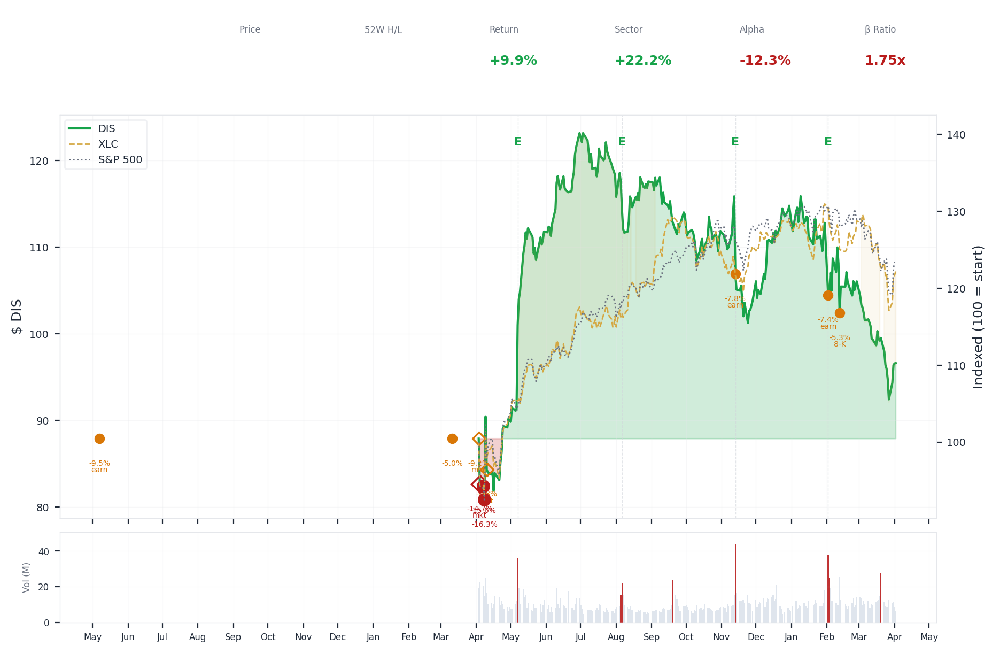
1-Year Performance (Indexed to 100). Red triangles mark single-day drops >= 8%. Orange bands mark multi-day declines >= 15%.
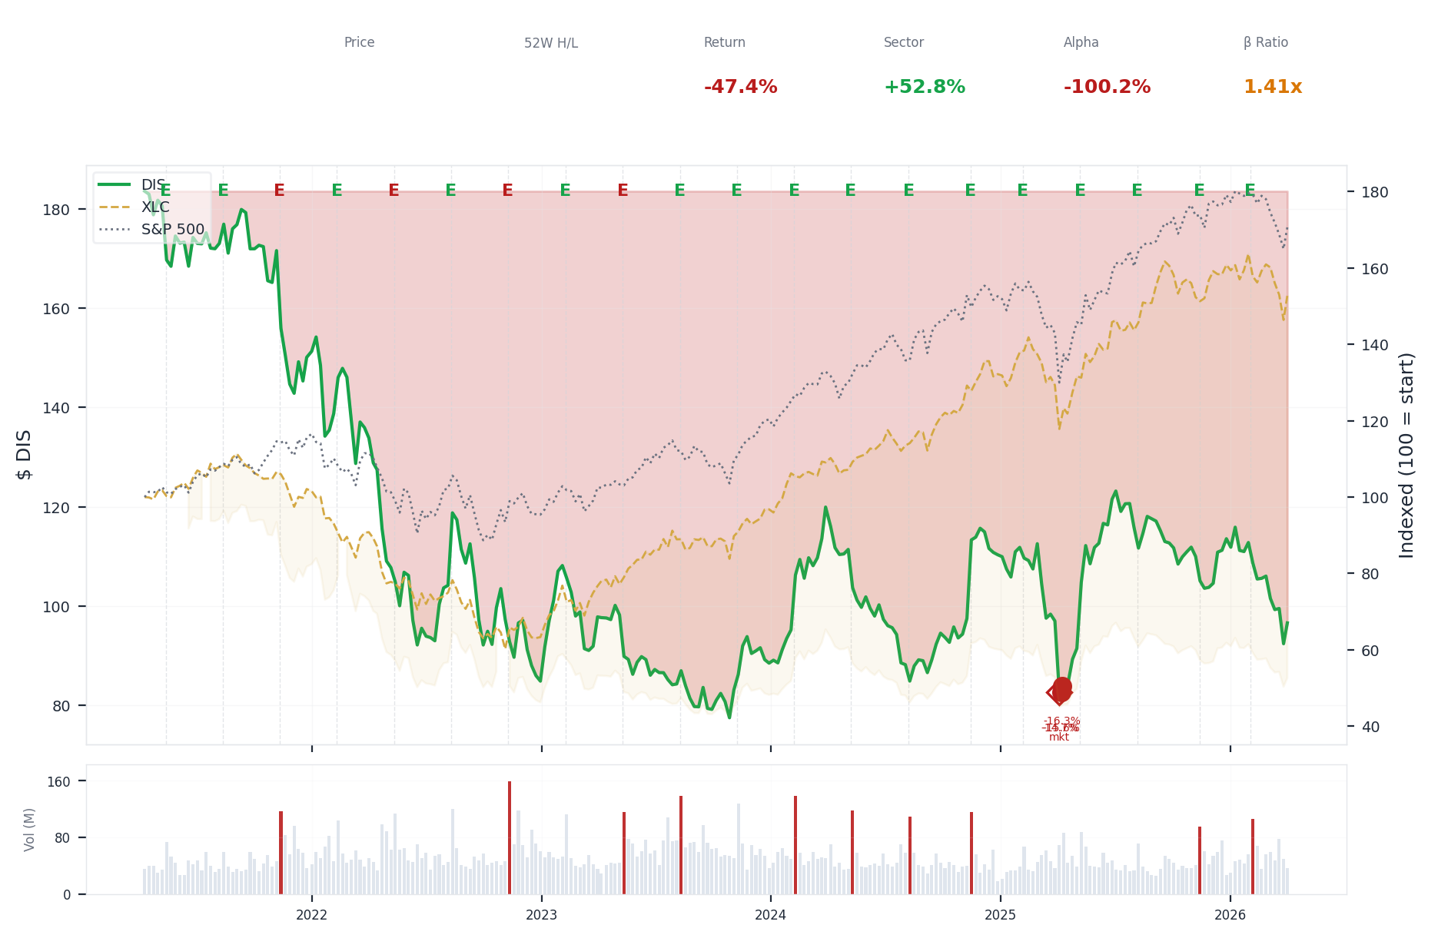
5-Year Performance (Indexed to 100)
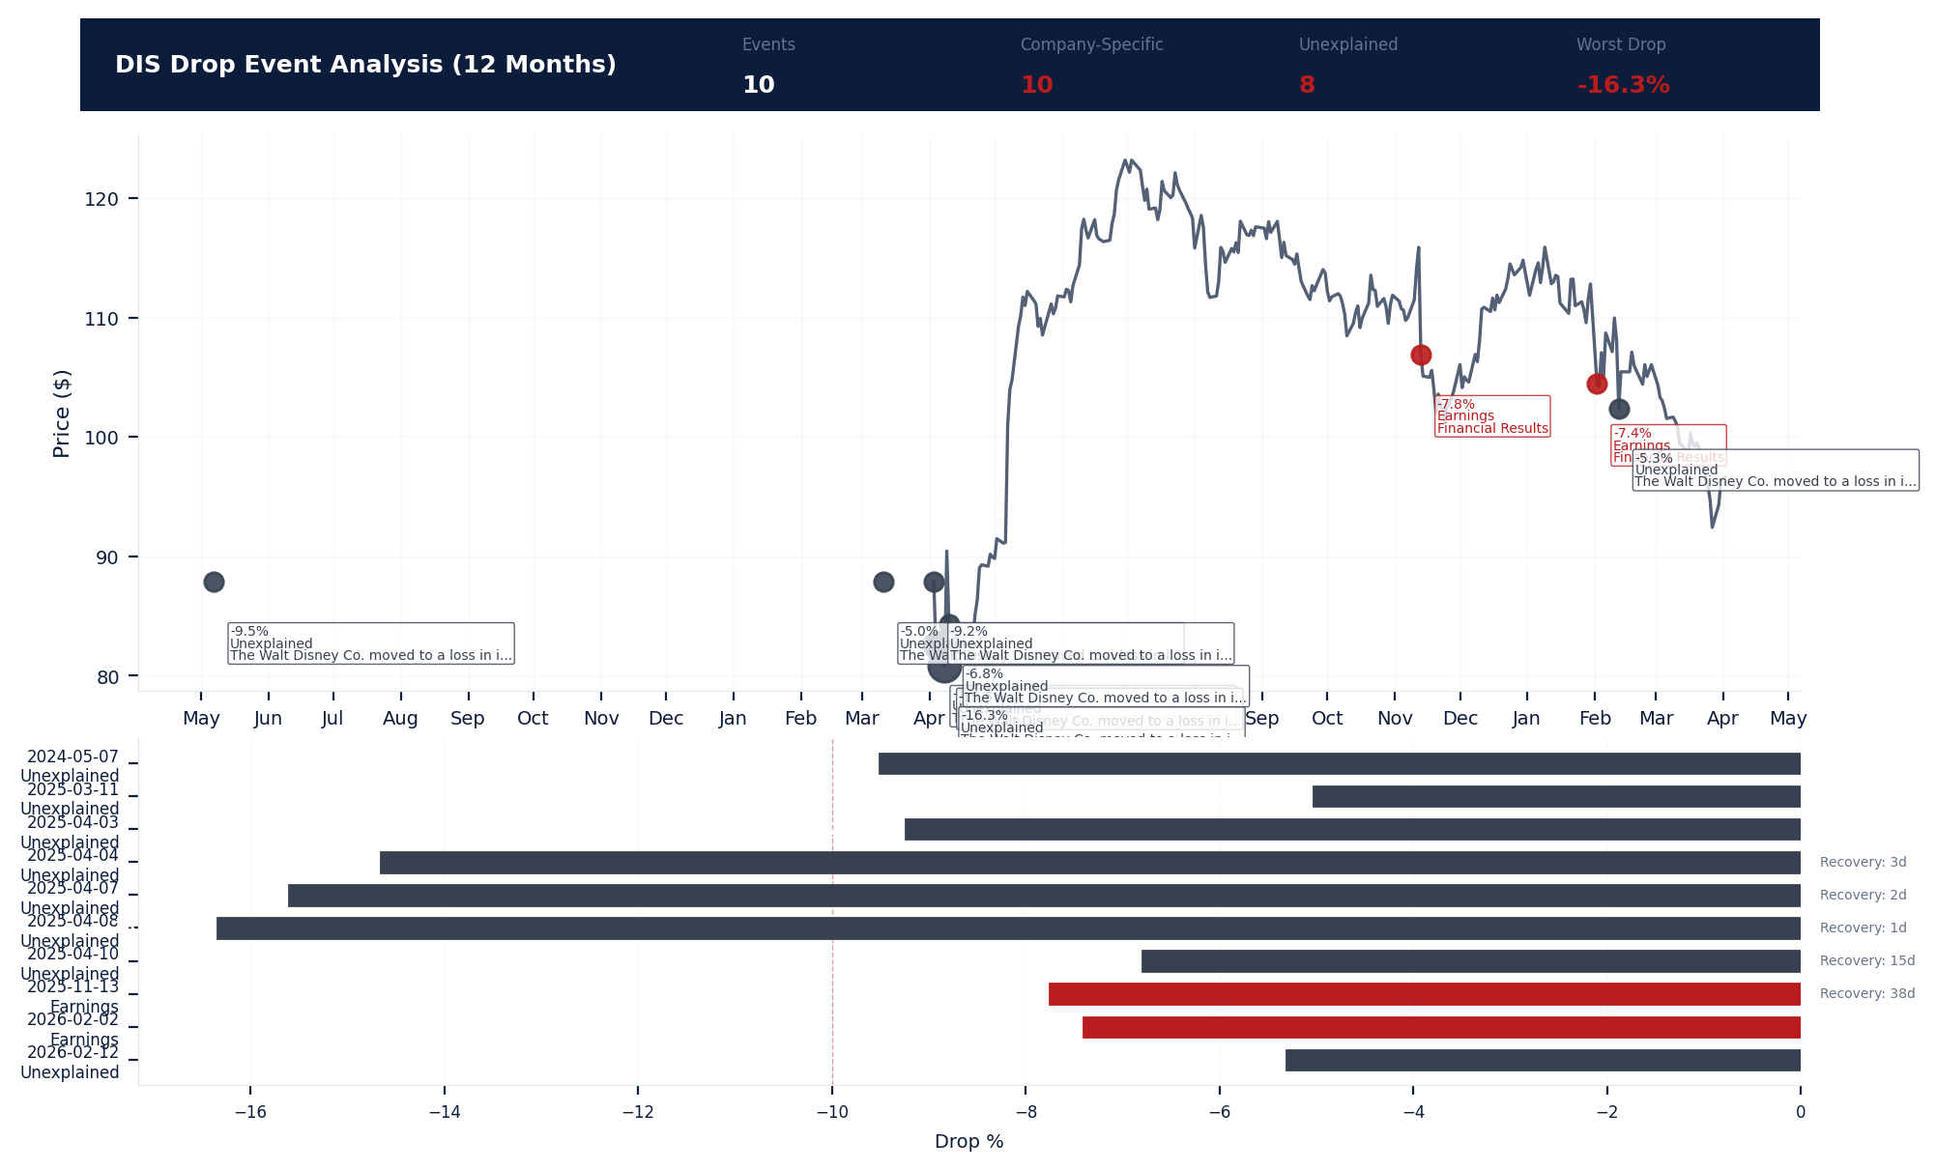
Drop Event Analysis (12 Months)
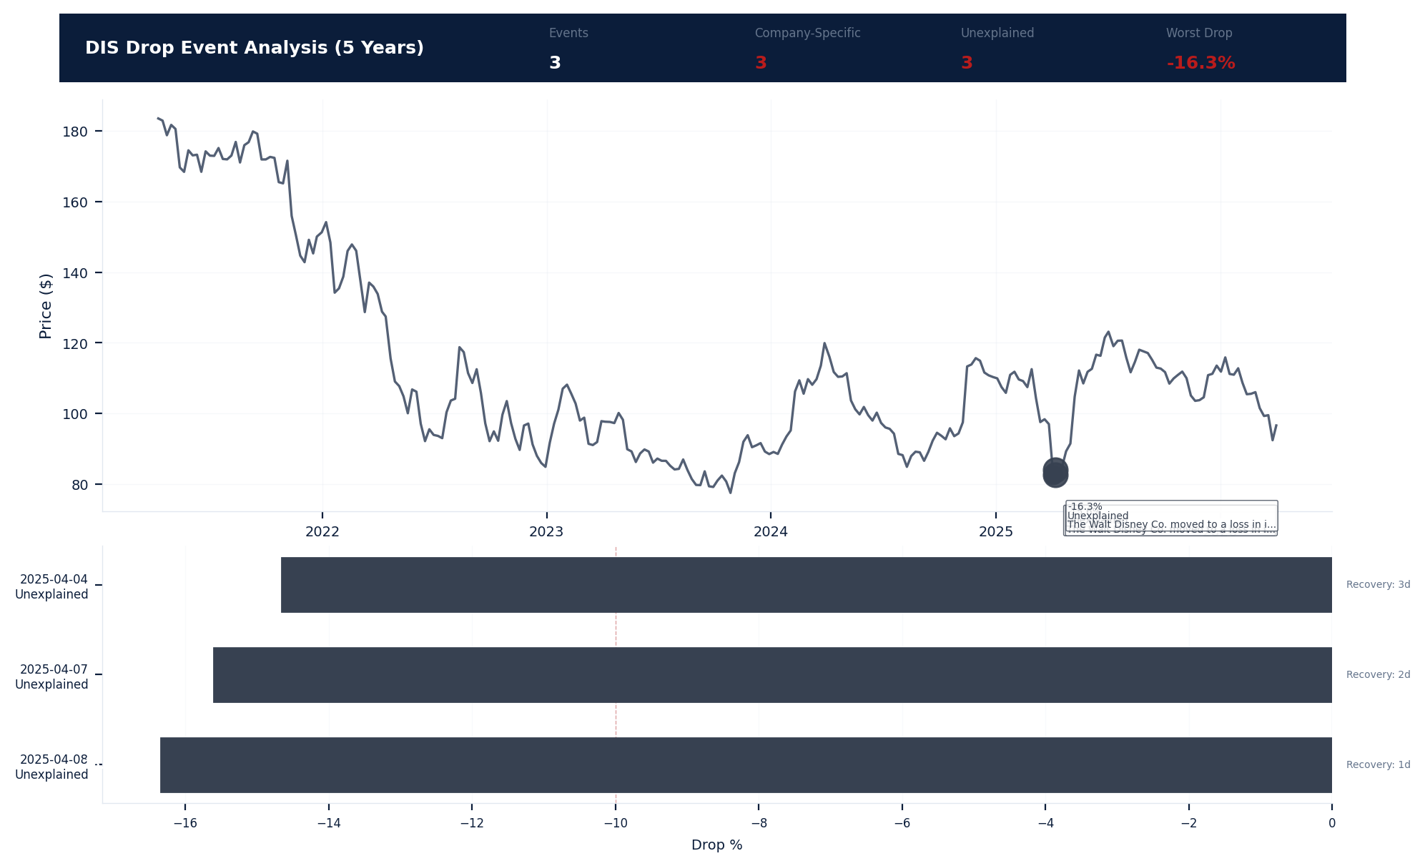
Drop Event Analysis (5 Years)
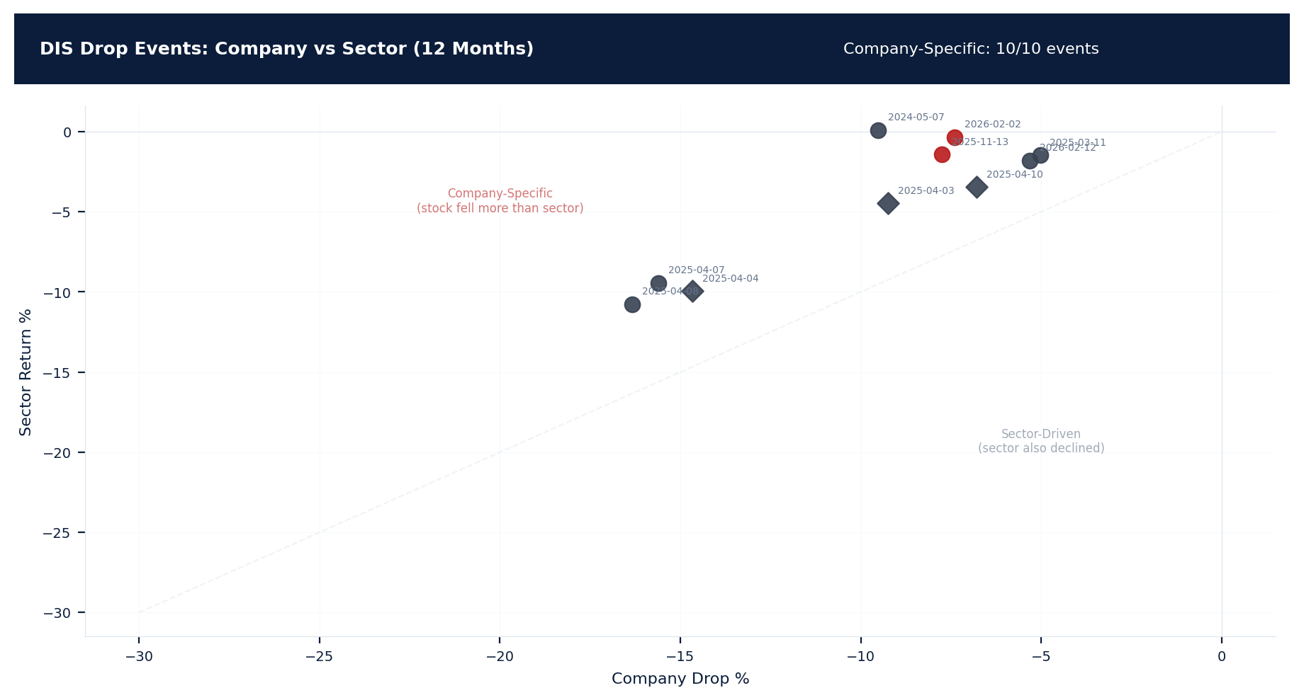
Drop Events: Company vs Sector (12 Months)
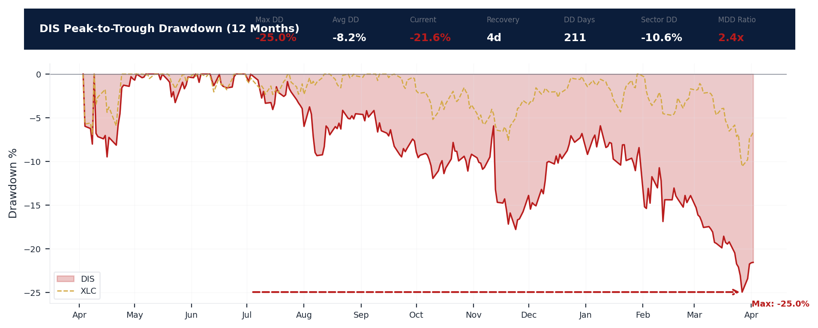
Drawdown Analysis (12 Months)
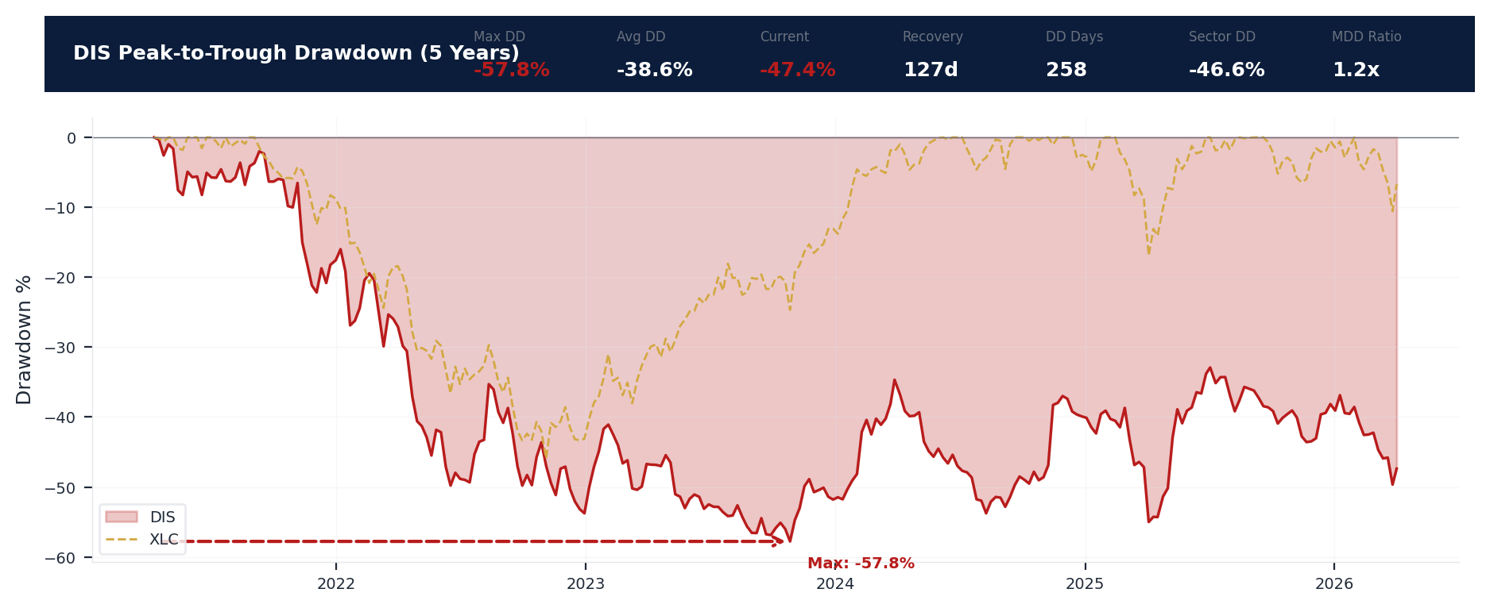
Drawdown Analysis (5 Years)
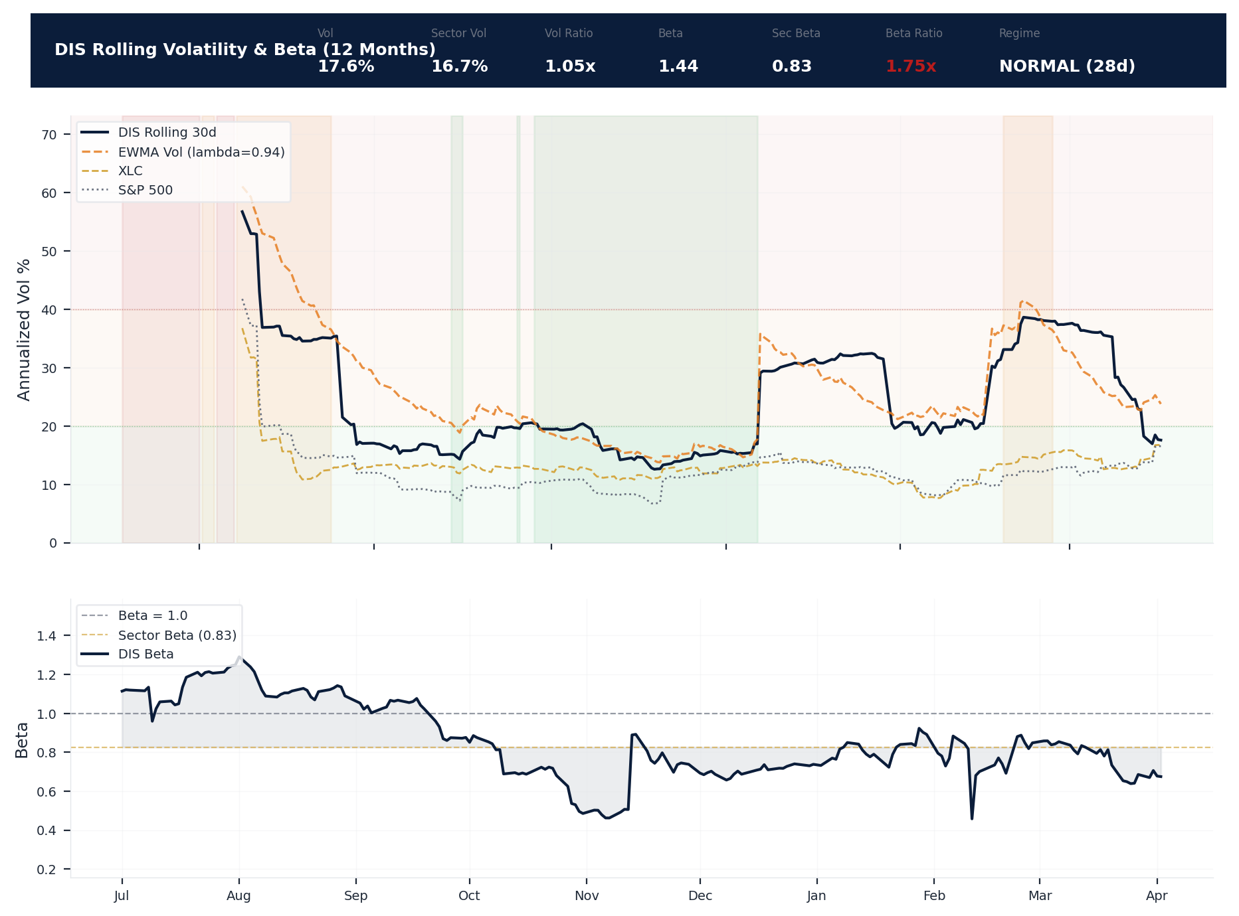
Volatility & Beta Analysis (12 Months)
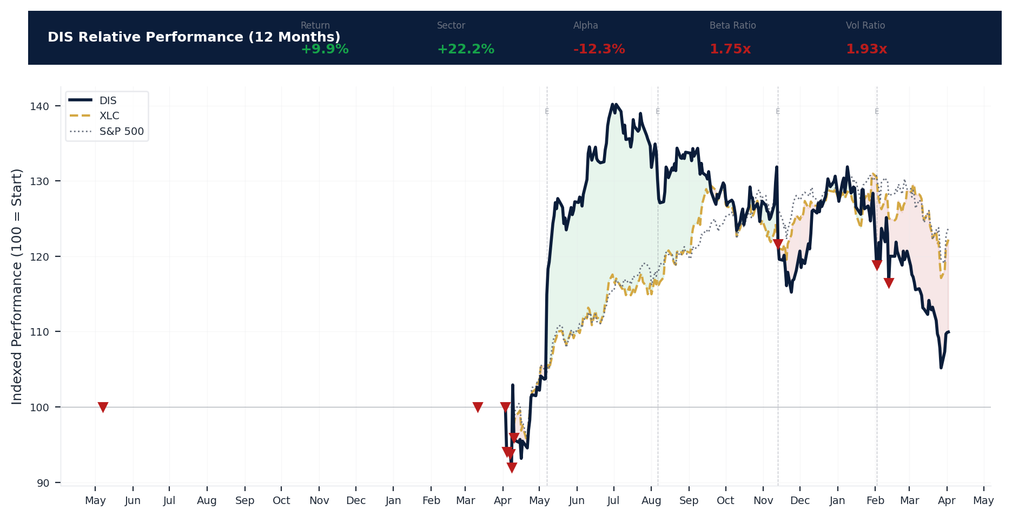
Relative Performance (12 Months)
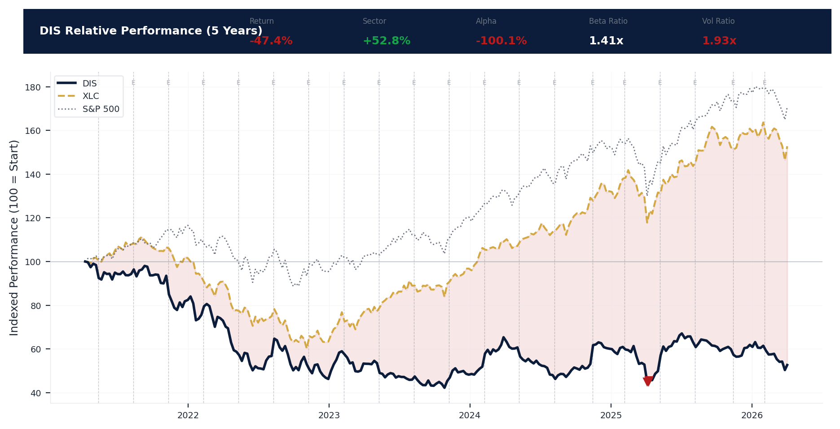
Relative Performance (5 Years)
Metric | Value
Current Price | $96.61
52-Week High | $124.69
52-Week Low | $80.10
1-Year Return | 9.9%
Max Drawdown (1Y) | -25.0%
90-Day Volatility | 26.7% (Ranks at the 0th percentile among 0 peers (peer median: 2.5%))
Beta (vs S&P 500) | 1.44
10 significant stock decline events detected in the 1Y period: 3 critical (>10%), 7 notable (5-10%). 10 were company-specific, 4 were market-wide.
Date | Drop % | Recency | Recovery | Trigger Event | Type | Source
2026-02-02 | -7.4% | 80% | Not recovered | Earnings release | Company-Specific | https://www.sec.gov/cgi-bin/browse-edgar?action...
2025-11-13 | -7.8% | 58% | 38 days | Earnings release | Company-Specific | https://www.sec.gov/cgi-bin/browse-edgar?action...
2026-02-12 | -5.3% | 83% | Not recovered | 8-K Filing | Company-Specific | https://www.sec.gov/cgi-bin/browse-edgar?action...
2025-04-03 to 2025-04-10 (8d) | -17.2% | 25% | 1 days | Unconfirmed -- Requires Investigation | Market-Wide Event | https://apnews.com/hub/walt-disney-co
2025-04-07 (5d) | -15.6% | 25% | 2 days | Unconfirmed -- Requires Investigation | Company-Specific | https://apnews.com/hub/walt-disney-co
2025-04-04 (2d) | -14.7% | 25% | 3 days | Unconfirmed -- Requires Investigation | Market-Wide Event | https://apnews.com/hub/walt-disney-co
2025-04-03 (2d) | -6.0% | 25% | Not recovered | Unconfirmed -- Requires Investigation | Market-Wide Event | https://apnews.com/hub/walt-disney-co
2025-04-10 | -6.8% | 25% | 15 days | Unconfirmed -- Requires Investigation | Market-Wide Event | https://apnews.com/hub/walt-disney-co
2025-03-11 | -5.0% | 23% | Not recovered | Unconfirmed -- Requires Investigation | Company-Specific | https://apnews.com/hub/walt-disney-co
2024-05-07 | -9.5% | 7% | Not recovered | Earnings release | Company-Specific | https://apnews.com/hub/walt-disney-co
3 significant stock decline events detected in the 5Y period: 3 critical (>10%). 3 were company-specific, 2 were market-wide.
Date | Drop % | Recency | Recovery | Trigger Event | Type | Source
2025-04-03 to 2025-04-10 (8d) | -17.2% | 25% | 1 days | Unconfirmed -- Requires Investigation | Market-Wide Event | https://apnews.com/hub/walt-disney-co
2025-04-07 (5d) | -15.6% | 25% | 2 days | Unconfirmed -- Requires Investigation | Company-Specific | https://apnews.com/hub/walt-disney-co
2025-04-04 (2d) | -14.7% | 25% | 3 days | Unconfirmed -- Requires Investigation | Market-Wide Event | https://apnews.com/hub/walt-disney-co
Short Interest
Metric | Value
Short % of Float | 1.1% (Ranks at the 86th percentile among 0 peers (peer median: 4.0%))
Days to Cover | 1.90
6-Month Trend | DECLINING
vs Sector Ratio | N/A
Earnings Guidance Track Record
Metric | Value
Beat Rate | 0.8%
Consecutive Misses | 0
Guidance Withdrawals | 0
Philosophy | CONSERVATIVE
Quarter | Est. EPS | Actual EPS | Result | Miss Magnitude | Stock Reaction
Q1 2026 | $1.58 | $1.63 | BEAT | N/A | +3.4%
Q4 2025 | $1.02 | $1.11 | BEAT | N/A | +8.4%
Q3 2025 | $1.45 | $1.61 | BEAT | N/A | +11.3%
Q2 2025 | $1.21 | $1.45 | BEAT | N/A | +19.8%
Q1 2025 | $1.43 | $1.76 | BEAT | N/A | +22.9%
Q4 2024 | $1.11 | $1.14 | BEAT | N/A | +2.8%
Q3 2024 | $1.19 | $1.39 | BEAT | N/A | +16.4%
Q2 2024 | $1.10 | $1.21 | BEAT | N/A | +9.8%
Q1 2024 | $1.03 | $1.22 | BEAT | N/A | +18.2%
Q4 2023 | $0.71 | $0.82 | BEAT | N/A | +15.1%
Q3 2023 | $0.98 | $1.04 | BEAT | N/A | +6.8%
Q2 2023 | $0.94 | $0.93 | MISS | +1.1% | -0.9%
Q1 2023 | $0.79 | $0.99 | BEAT | N/A | +26.0%
Q4 2022 | $0.56 | $0.30 | MISS | +46.4% | -46.9%
Q3 2022 | $0.99 | $1.09 | BEAT | N/A | +10.0%
Q2 2022 | $1.19 | $1.08 | MISS | +9.2% | -9.2%
Analyst Consensus
Metric | Value
Analyst Coverage | 29
Consensus Rating | BUY
Mean Recommendation | 1.58 (1=Strong Buy, 5=Sell)
Mean Target Price | $129
Target Price High | $160
Target Price Low | $77
Stock Drop Analysis
Date | Magnitude | Type | Trigger / Attribution | Sector Return | Company-Specific
2025-04-03 to 2025-04-10 | -17.2% | MULTI_DAY (8d) | Unknown | -10.8% | Yes
2025-04-07 | -15.6% | MULTI_DAY (5d) | Unknown | -9.4% | Yes
2025-04-04 | -14.7% | MULTI_DAY (2d) | Unknown | -9.9% | Yes
2024-05-07 | -9.5% | SINGLE_DAY | earnings_release | +0.1% | Yes
2025-04-03 | -9.2% | MULTI_DAY (2d) | Unknown | -4.5% | Yes
2025-11-13 | -7.8% | SINGLE_DAY | earnings_release | -1.4% | Yes
2026-02-02 | -7.4% | SINGLE_DAY | earnings_release | -0.3% | Yes
2025-04-10 | -6.8% | SINGLE_DAY | Unknown | -3.5% | Yes
2026-02-12 | -5.3% | SINGLE_DAY | 8-K_filing | -1.8% | Yes
2025-03-11 | -5.0% | SINGLE_DAY | Unknown | -1.5% | Yes
Class Period Potential: 3 company-specific drop(s) exceeding 10% identified. Severe stock drops that are company-specific (not explained by sector movement) are the primary anchors for SCA class periods. Plaintiffs will allege the drop occurred when the 'truth emerged' following prior misstatements. [HIGH]
Insider Trading Analysis
Metric | Value
Net Direction (12mo) | NET_BUYING
10b5-1 Plan % | 100.0%
Buy Transactions | 2
Sell Transactions | 2
Cluster Events | 0
Transaction Detail
Date | Insider | Title | Type | Shares | Value | 10b5-1
2026-03-31 | Froman Michael B. G. | Director | GRANT | 1,088 | $105.5K | No (Discretionary)
2026-03-31 | LAGOMASINO MARIA ELENA | Director | GRANT | 1,267 | $122.8K | No (Discretionary)
2026-03-31 | Darroch Jeremy | Director | GRANT | 1,034 | $100.3K | No (Discretionary)
2026-03-31 | Darroch Jeremy | Director | TAX_WITHHOLD | 89 | $8.5K | No (Discretionary)
2026-03-31 | Darroch Jeremy | Director | DISPOSITION | 218 | $24.5K | No (Discretionary)
2026-03-31 | Darroch Jeremy | Director | DISPOSITION | 163 | $18.6K | No (Discretionary)
2026-03-31 | Everson Carolyn | Director | GRANT | 1,065 | $103.2K | No (Discretionary)
2026-03-31 | WILLIAMS JEFFREY E | Director | GRANT | 154 | $15.0K | No (Discretionary)
2026-03-31 | GORMAN JAMES P | Director | GRANT | 1,477 | $143.2K | No (Discretionary)
2026-03-31 | Barra Mary T | Director | GRANT | 1,253 | $121.5K | No (Discretionary)
2026-03-31 | MCDONALD CALVIN | Director | GRANT | 1,081 | $104.8K | No (Discretionary)
2026-03-31 | Rice Derica W | Director | GRANT | 1,230 | $119.2K | No (Discretionary)
2026-03-31 | Chang Amy | Director | GRANT | 1,081 | $104.8K | No (Discretionary)
2026-03-18 | Walden Dana | President&Chief Creative Ofcr | GRANT | 38,798 | $0 | No (Discretionary)
2026-03-18 | Walden Dana | President&Chief Creative Ofcr | GRANT | 13,149 | $0 | No (Discretionary)
2026-03-18 | DAmaro Joshua W | Chief Executive Officer | GRANT | 71,585 | $0 | No (Discretionary)
2026-03-18 | DAmaro Joshua W | Chief Executive Officer | GRANT | 24,261 | $0 | No (Discretionary)
2026-02-12 | Chang Amy | Director | BUY | 916 | $98.8K | No (Discretionary)
2026-01-22 | Coleman Sonia L | Sr. EVP & Chief People Officer | SELL | 2,473 | $281.9K | Yes (Pre-arranged)
2026-01-17 | WOODFORD BRENT | EVP, Control, Fin Plan & Tax | EXERCISE | 1,162 | N/A | No (Discretionary)
Executive Departures
No executive departures identified in the trailing 18 months.
Capital Markets Activity
No significant capital markets activity identified in the trailing 3-year period.

ELEVATED CONCERN
Disney's revenue grew 3.4% to $94.4B from $91.4B and net income surged 149% to $12.4B from $5.0B, but its Altman Z-Score of 2.252 sits in the grey zone, indicating elevated bankruptcy risk over the next two years that plaintiffs' counsel will weaponize in a claim alleging the board failed to disclose deteriorating financial health. The concerning current ratio of 0.71 and quick ratio of 0.65 reveal persistent liquidity strain despite the income rebound, creating a classic mismatch for a Section 10(b) claim if cash flow falters and the board cannot meet short-term obligations. While the Beneish M-Score of -3.087 suggests no earnings manipulation and the debt-to-equity of 0.38 is manageable, the Piotroski F-Score of 7 is only middling, showing underlying financial strength is not robust enough to shield directors from allegations of poor oversight during strategic shifts. Directors face amplified exposure from strategic bets in streaming; any future impairment or growth shortfall against this complex financial backdrop, which includes an interest coverage ratio of 9.7x and operating income of $17.6B, invites shareholder allegations that the board overpaid for assets or misjudged capital allocation.
Section 3: Financial Health
The company reported revenue of $94.4B and net income of $12.4B (per FY2025 10-K, Company Facts API CIK1744489). Revenue grew 3.4% year-over-year (from $91.4B). Distress indicators show mixed signals: Z-Score 2.25 (grey zone) and O-Score 0.00 (safe zone). Financial stress could limit litigation defense resources. Piotroski F-Score of 7/9 indicates strong fundamental quality. D/E ratio of 0.38 is moderate. Earnings quality is healthy (OCF/NI: 1.46), indicating reported income is well-supported by operating cash flows -- reducing restatement risk. Effective tax rate of 11.9% is below the 21% U.S. statutory rate, warranting review of uncertain tax positions and transfer pricing. Auditor: Ernst & Young (Big 4). From a D&O perspective, the financial profile supports standard underwriting terms.
Income Statement
Metric | FY2024 | FY2025 | YoY Change
Total revenue / net sales | $91.4B | $94.4B | 3.4%
Operating income / loss | $15.6B | $17.6B | 12.5%
Net income / net loss | $5.0B | $12.4B | 149.5%
Basic earnings per share | $2.72 | $6.88 | 152.9%
Diluted earnings per share | $2.72 | $6.85 | 151.8%
Interest expense | $2.1B | $1.8B | -12.5%
Income tax expense / benefit | $1.8B | $1.4B | -20.5%
Selling, general and administrative expense | $15.8B | $16.5B | 4.7%
Earnings before interest and taxes (EBIT) | $15.6B | $17.6B | 12.5%
Weighted average shares outstanding (basic) | 1.8B | 1.8B | -1.1%
Weighted average shares outstanding (diluted) | 1.8B | 1.8B | -1.1%
Total comprehensive income / loss | $4.6B | $13.2B | 188.9%
Other income / non-operating income | $-65.0M | $0 | 100.0%
Restructuring charges | $3.6B | $819.0M | -77.2%
Impairment charges (goodwill, intangibles, long-lived assets) | $2.6B | $2.6B | 0.0%
Income from operations | $15.6B | $17.6B | 12.5%
Pre-tax income | $7.6B | $12.0B | 58.6%
Stock-based compensation expense | $1.4B | $1.4B | -0.2%
Income before income taxes | $7.6B | $12.0B | 58.6%
Income/loss from discontinued operations, net of tax | $0 | N/A | N/A
Other comprehensive income/loss, net of tax | $-323.0M | $748.0M | 331.6%
Total operating expenses | $79.4B | $80.6B | 1.4%
Total costs and expenses | $79.4B | $80.6B | 1.4%
Non-operating income / expense | $-65.0M | $0 | 100.0%
Asset impairment charges (long-lived assets) | $187.0M | N/A | N/A
Current federal income tax expense / benefit | $1.4B | $-130.0M | -109.3%
Current state and local income tax expense / benefit | $237.0M | $413.0M | 74.3%
Current foreign income tax expense / benefit | $973.0M | $906.0M | -6.9%
Deferred federal income tax expense / benefit | $-764.0M | $-2.2B | -184.2%
Deferred state and local income tax expense / benefit | $54.0M | $-527.0M | -1075.9%
Deferred foreign income tax expense / benefit | $-97.0M | $81.0M | 183.5%
Advertising expense | $6.1B | $6.5B | 6.6%
Goodwill impairment loss | $2.6B | $2.6B | 0.0%
RSU/restricted stock units granted in period | $18.0M | $16.0M | -11.1%
Operating margin percentage | 17.1% | 18.6% | 8.8%
Net margin percentage | 5.4% | 13.1% | 141.5%
EBITDA margin percentage | 22.5% | 24.2% | 7.5%
Effective tax rate | $24 | $12 | -49.9%
Interest coverage ratio | $8 | $10 | 28.5%
Balance Sheet
Metric | FY2024 | FY2025 | YoY Change
Total assets | $196.2B | $197.5B | 0.7%
Total stockholders' equity | $100.7B | $109.9B | 9.1%
Total current assets | $25.2B | $24.3B | -3.9%
Total current liabilities | $34.6B | $34.2B | -1.3%
Cash and cash equivalents | $6.0B | $5.7B | -5.1%
Accounts receivable, net | $12.7B | $13.2B | 3.8%
Inventory, net | $2.0B | $2.1B | 5.5%
Property, plant and equipment, net | $37.0B | $41.3B | 11.4%
Goodwill | $73.3B | $73.3B | -0.0%
Intangible assets, net (excluding goodwill) | $10.7B | $9.3B | -13.7%
Long-term debt, non-current | $39.0B | $35.3B | -9.4%
Short-term debt / current portion of long-term debt | $6.8B | $6.7B | -2.0%
Retained earnings / accumulated deficit | $49.7B | $60.4B | 21.5%
Total debt (short-term + long-term) | $45.8B | $42.0B | -8.3%
Common shares outstanding | 1.9B | 1.9B | 0.0%
Accounts payable | $14.8B | $15.1B | 1.8%
Deferred revenue / contract liabilities | $6.7B | $6.2B | -6.5%
Operating lease liabilities | $744.0M | $525.0M | -29.4%
Minority / noncontrolling interest | $4.8B | $4.7B | -1.7%
Other current assets | $2.4B | $1.2B | -51.6%
Long-term investments | $4.5B | $8.1B | 81.6%
Accumulated other comprehensive income/loss | $-3.7B | $-2.9B | 21.2%
Treasury stock, at cost | $3.9B | $7.4B | 89.9%
Common stock par value | $58.6B | $59.8B | 2.1%
Total liabilities and stockholders' equity | $196.2B | $197.5B | 0.7%
Preferred stock value | $0 | $0 | N/A
Right-of-use assets (operating and finance leases) | $3.4B | $3.2B | -6.1%
Other non-current assets | $13.1B | $10.0B | -23.6%
Other non-current liabilities | $10.9B | $9.9B | -8.8%
Finance / capital lease obligations | $190.0M | $162.0M | -14.7%
Contract liabilities (ASC 606 deferred revenue) | $5.6B | $5.7B | 1.8%
Unrecognized tax benefits (UTB) liability | $2.0B | $1.1B | -42.0%
Debt instrument carrying amount (face value) | $45.1B | $41.3B | -8.5%
Common stock shares authorized | 4.6B | 4.6B | 0.0%
Contract with customer liability (total deferred revenue under ASC 606) | $5.6B | $5.7B | 1.8%
Current ratio | $1 | $1 | -2.6%
Quick ratio | $1 | $1 | -3.5%
Debt-to-equity ratio | $0 | $0 | -15.9%
Debt-to-EBITDA ratio | $2 | $2 | -17.4%
Tangible book value | $16.6B | $27.3B | 64.2%
Net debt | $39.8B | $36.3B | -8.8%
Book value per share | $53.00 | $57.83 | 9.1%
Return on assets | $3 | $6 | 148.2%
Return on equity | $5 | $11 | 128.5%
Asset turnover ratio | $0 | $0 | 2.7%
Key Balance Sheet Ratios
Ratio | Value | Assessment
Current Ratio | 0.71 | Concern
Debt/Equity | 0.38 | Conservative
Debt/Assets | 1.00 | High
Cash/Assets | 2.9%
Cash Flow Statement
Metric | FY2024 | FY2025 | YoY Change
Net cash from operating activities | N/A | $18.1B | N/A
Net cash from investing activities | $-6.9B | $-8.0B | N/A
Net cash from financing activities | N/A | $-10.4B | N/A
Capital expenditures | $5.4B | $8.0B | N/A
Depreciation and amortization | $5.0B | $5.3B | N/A
Dividends paid | $1.4B | $1.8B | N/A
Share repurchases / buybacks | $3.0B | $3.5B | N/A
Proceeds from issuance of debt | $132.0M | $1.1B | N/A
Repayments of debt | $3.1B | $3.7B | N/A
Interest paid (supplemental) | $2.1B | $2.0B | N/A
Income taxes paid (supplemental) | $4.0B | $1.2B | N/A
Stock-based compensation (cash flow adjustment) | $1.4B | $1.4B | N/A
Changes in operating working capital | $156.0M | $237.0M | N/A
Net increase/decrease in cash and equivalents | $-8.1B | $-303.0M | N/A
Deferred income taxes (cash flow adjustment) | $-807.0M | $-2.6B | N/A
Change in accounts receivable | $565.0M | $283.0M | N/A
Change in inventory | $42.0M | $114.0M | N/A
Change in accounts payable | $156.0M | $237.0M | N/A
Amortization of intangible assets | $1.6B | $1.5B | N/A
Effect of exchange rate changes on cash | $-14.0M | $31.0M | -83.9%
Free cash flow | N/A | $10.1B | N/A
FCF-to-revenue ratio | N/A | $11 | N/A
Capex-to-revenue ratio | $6 | $8 | N/A
Capex-to-depreciation ratio | $1 | $2 | N/A
Dividend payout ratio | $27 | $15 | N/A
Free cash flow per share | N/A | $5.30 | N/A
Key Ratios: Company vs. Peers
Ratio | Value
Current Ratio | 0.71
Quick Ratio | 0.65
Debt/Equity | 0.38
Interest Coverage | 9.7x
Distress Indicators
Model | Score | Zone | Trajectory | D&O Context
Altman Z-Score | 2.25 | Grey Zone | FY2024: 1.0 -> FY2025: 1.1 (stable) | Bankruptcy predictor. Distress zone companies face fiduciary duty scrutiny under Revlon/zone of insolvency doctrine.
Beneish M-Score | -3.09 | Safe | N/A | Earnings manipulation detector. Scores above -1.78 indicate elevated restatement risk, a primary SCA catalyst.
Ohlson O-Score | 0.00 | Safe | N/A | Bankruptcy probability model. Higher values signal financial stress that may limit litigation defense resources.
Piotroski F-Score | 7.00 | Grey Zone | 7/9 criteria met | Fundamental quality indicator. Scores 0-3 signal weak fundamentals; 7-9 indicate strong quality.
Leverage context: Ranks at the 60th percentile among 0 peers (peer median: 3.0x).
Earnings Quality
Metric | Value | Assessment
OCF/Net Income | 1.46 | Healthy
Accruals Ratio | -0.03 | Normal
Source: Derived from XBRL financial statements, MEDIUM confidence
Audit Risk Assessment
Audit Risk: No concerns. Ernst & Young, unqualified opinion.
Debt Analysis
Metric | Value
Debt-to-Equity | 0.38
Debt-to-EBITDA | 2.39
Interest Coverage | 9.69
Covenant Status | Unknown
Critical Accounting Estimates
Estimate | Value | Assessment
Effective Tax Rate | 11.9% | Below statutory rate -- review required
Peer Group Comparison
Ticker | Name | Market Cap | Revenue | Score
GOOGL | Alphabet Inc. | $3.6T | $402.8B | 15
META | Meta Platforms, Inc. | $1.5T | $201.0B | 18
NFLX | Netflix, Inc. | $418.5B | $45.2B | 28
CMCSA | Comcast Corporation | $101.8B | $123.7B | 28
T | AT&T Inc. | $198.3B | $125.6B | 44
VZ | Verizon Communications Inc. | $208.4B | $138.2B | 41
TMUS | T-Mobile US, Inc. | $225.3B | $88.3B | 42
CHTR | Charter Communications, Inc. | $27.8B | $54.8B | 20
EA | Electronic Arts Inc. | $51.0B | $7.3B | 12
Revenue: Ranks at the 44th percentile among 9 peers. Leverage: Ranks at the 60th percentile among 0 peers (peer median: 3.0x).
Method: Multi-signal composite: SIC 25%, industry 20%, market cap 25%, revenue 15%, description 15%

ELEVATED CONCERN
The board's small size of only two directors, featuring CEO/Chair Bob Iger, concentrates decision-making and amplifies oversight liability, particularly under a potential Caremark claim given the governance checks triggered 6 out of 90 key risk indicators. Iger's $45.8 million compensation, despite a solid 89% say-on-pay vote, could fuel derivative suits alleging misalignment, especially given the CEO/Chair duality and the 1.78-point deduction in the governance scoring for related risks. With only one General Counsel listed among the single executive disclosed, the legal function's bandwidth for managing complex regulatory and proxy disclosure risks across Disney's global operations is a tangible concern for adequate internal controls. The primary D&O exposure here is a shareholder challenge to board process, arguing the compact two-director board failed its duty of candor or oversight amid the company's significant strategic pivots.
Section 5: Governance & Leadership
Leadership team is stable with average tenure of 5.0 years. Compensation concerns include: elevated CEO pay ratio (805:1). [Rule-based synthesis of governance extraction results, 2026-04-03, LOW]
Leadership Stability
Name | Title | Tenure (Yrs) | Status | Prior Lit. | Flags
Securities Regulation | CLO | 5.0 | ACTIVE | 0 | None
Leadership Stability Score: 100/100 [leadership_profiles extractor, 2026-04-03, MEDIUM]
Board Composition
Name | Tenure | Independent | Committees | Other Boards | Overboarded
Mr. Robert Alan Iger | N/A | N/A | N/A | 0 | No
Mr. Josh D'Amaro | N/A | N/A | N/A | 0 | No
[ELEVATED] CEO/Chair Duality -- Single individual holds both CEO and Board Chair roles
Context: Companies with CEO/Chair duality face 1.8x higher derivative suit filing rates due to governance concentration.
See Meeting Prep: Governance Structure
Board Quality Metrics
Metric | Value
Board Size | N/A
Independence Ratio | N/A
CEO/Chair Duality | Yes
Classified Board | N/A
Overboarded Directors | N/A
Dual-Class Structure | N/A
D&O Context: CEO/Chair duality reduces board independence in oversight of management, increasing derivative suit risk. [ELEVATED]
Compensation Analysis
Summary Compensation Table
Component | Amount
Total CEO Compensation | $45.8M
Metric | Value
CEO Pay Ratio | 805:1
CEO Pay Ratio (805:1): Extremely high pay ratios increase Section 14A proxy disclosure litigation risk and shareholder proposal activity. Ratios above 500:1 are material governance concerns for D&O underwriting. [HIGH]
Compensation Structure
Component | Detail
Clawback Policy | Yes
Clawback Scope | BROADER
Compensation Red Flags
Notable Perquisites: No excise tax gross-ups The Company does not provide excise tax gross-ups for executive officers, This column sets forth all of the compensation for each fiscal year that we could not properly report in any other column of the table, including: • the incremental cost to the Company of perquisites and other personal benefits; • tax reimbursement related to relocation benefits and state tax equali, The Company reviews the nature and cost of the program in relation to the security profile and believes that the cost of security services (e: Above-peer perquisites draw proxy advisory negative recommendations. [ELEVATED]
Ownership Structure
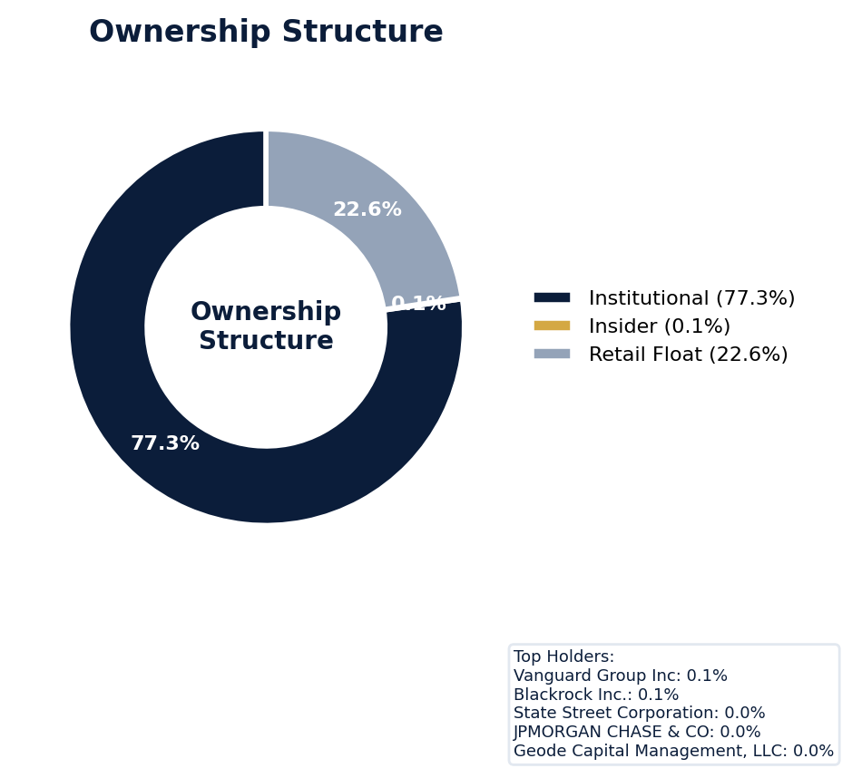
Figure: Ownership breakdown -- institutional, insider, retail float
Category | Percentage
Institutional Ownership | 77.3%
Insider Ownership | 0.1%
Retail Float | 22.6%
Top Holder | Ownership %
Vanguard Group Inc | 0.1%
Blackrock Inc. | 0.1%
State Street Corporation | 0.0%
JPMORGAN CHASE & CO | 0.0%
Geode Capital Management, LLC | 0.0%
Sentiment & Narrative Coherence
Signal | Assessment
Narrative Coherence | COHERENT
Anti-Takeover Provisions
Anti-takeover provision data not available. Review DEF 14A and charter documents for complete analysis.

ELEVATED CONCERN
While Disney currently has no active SCAs, its three pending derivative suits, including *Employees' Retirement System of Rhode Island v. Chapek, et al.*, signal persistent plaintiff focus on its direct-to-consumer pivot and can serve as a precursor to future securities class actions. The company's adjusted SCA filing rate of 2.34% sits below the 3.5% sector average, but its MODERATE defense posture and six open securities lawsuits indicate a steady litigation diet that elevates D&O exposure. The lack of an SEC investigation stage is a positive, yet the derivative cases often presage future SCAs, and any regulatory action would immediately trigger a new class period. Benchmark settlements in the media sector are severe, and with Disney's market cap, even a nuisance SCA settlement could approach nine figures, not counting the defense costs from its six open cases, which already contributed to a 2.46-point deduction in its litigation risk score.
Section 6: Litigation & Regulatory Exposure
3 derivative action(s) pending, alleging breach of fiduciary duty by directors and officers. 6 statute of limitations window(s) remain open, meaning new claims can still be filed for past events. Under claims-made D&O policy, coverage is triggered when a claim is reported during the policy period. Defense quality assessment: MODERATE.
Litigation Overview: 0 active matter(s), 2 historical matter(s)
Litigation Timeline
Timeline chart not available (no timeline events).
Securities Class Actions
Case Name | Legal Theory | Coverage | Court | Filing Date | Status | Class Period | Lead Counsel | Settlement | Source
In re Walt Disney Company Securities Litigation (2004) | Rule 10b-5 | Side C (Entity) | N/A | 2004-02-20 | DISMISSED | N/A | N/A | N/A | [Supabase SCA database, 2026-04-03, MEDIUM]
In re Walt Disney Company Securities Litigation (2002) | Rule 10b-5 | Side C (Entity) | N/A | 2002-08-15 | DISMISSED | N/A | N/A | N/A | [Supabase SCA database, 2026-04-03, MEDIUM]
SEC Enforcement Pipeline
Pipeline: (Comment Letters) -> (Informal Inquiry) -> (Formal Investigation) -> (Wells Notice) -> (Enforcement Action)
No SEC enforcement pipeline activity detected. [10-K Item 3 + Item 1A + 8-K + EFTS, 2026-04-03, LOW]
Derivative Suits
Case Name | Filing Date | Status | Court | Settlement
In re The Walt Disney Co. Derivative | N/A | UNKNOWN | N/A | N/A
N/A | N/A | UNKNOWN | N/A | N/A
SIMEONE V. WALT DISNEY COMPANY - Villanova Law Review' | N/A | UNKNOWN | Delaware Court of Chancery | N/A
Regulatory Proceedings
Agency | Type | Status
FTC | penalty | disclosed
Industry Claim Patterns
No industry-specific claim patterns identified.
Statute of Limitations Map
Claim Type | Trigger Date | SOL Expiry | Repose Expiry | Window Open
employment_discrimination | 2025-11-13 | 2027-11-13 | 2027-11-13 | OPEN
antitrust | 2025-11-13 | 2029-11-12 | 2029-11-12 | OPEN
FCPA | 2025-11-13 | 2030-11-12 | 2030-11-12 | OPEN
environmental | 2025-11-13 | 2030-11-12 | 2030-11-12 | OPEN
derivative | 2025-11-13 | 2028-11-12 | 2031-11-12 | OPEN
ERISA | 2025-11-13 | 2028-11-12 | 2031-11-12 | OPEN
Section_11 | 2002-08-15 | 2003-08-15 | 2005-08-14 | CLOSED
Section_14a | 2002-08-15 | 2003-08-15 | 2005-08-14 | CLOSED
10b-5 | 2002-08-15 | 2004-08-14 | 2007-08-14 | CLOSED
D&O Context: 6 open exposure window(s). Claims can still be filed within these periods. [ELEVATED]
Defense Strength Assessment
Factor | Assessment
Federal Forum Provision | No
Exclusive Forum Provision | No
PSLRA Safe Harbor | MODERATE
Truth-on-Market Viability | PARTIAL
Prior Dismissal Success | No prior dismissals identified in Item 3
Overall Defense Strength | MODERATE
No forum selection provisions identified. Safe harbor usage is MODERATE with standard forward-looking statement protections. [DEF 14A; 10-K, 2026-04-03, LOW]
Contingent Liabilities
Description | ASC 450 Class. | Accrued | Range
s and expenses may increase in future periods, and if it is | probable | N/A | N/A
l results, assuming a combination of litigation and settleme | probable | N/A | N/A
D&O Context: 2 probable contingenc(y/ies). ASC 450 probable classification indicates management believes loss is likely. Direct impact on D&O exposure. [HIGH]
Workforce, Product & Environmental Matters
Cybersecurity Incidents:
- [data_breach] nications and entertainment devices, increased broadband internet speed and penetration, increased availability and speed of mobile data transmission and increasingly sophisticated attempts to obtain unauthorized access to data systems have made the unauthorized digital copying and distribution of our films, television productions and other creative works easier and faster and protection and the enforcement of IP rights more challenging.
Whistleblower Indicators
No whistleblower indicators identified in SEC filings. SEC whistleblower tips are not publicly disclosed; absence does not confirm lack of activity.

Walt Disney's exceptional 91.0 quality score and WIN tier classification place it in the must-have category with an expected loss ratio range of 3.0-4.3%, indicating a superior risk profile within the MODERATE claim band. The primary risk driver is its extensive history of prior litigation, which deducted 2.46 points and presents a persistent, elevated baseline for securities claims. While the MODERATE claim band is acceptable, the company's active engagement in M&A, a factor that deducted 1.33 points, and its complex governance structure, which deducted 0.73 points, introduce recurring event risk for fiduciary duty claims. Underwrite this as a core, high-quality account, but price with a consistent margin for its litigation-heavy profile and strategic activity, given the total deductions of 9.04 points from a maximum possible score.
Section 7: Risk Scoring & Synthesis
Underwriting tier: **WIN** (quality score: 91.0/100). Recommended action: Must-have account, compete aggressively. Expected claim probability band: 3.0-4.3%. Top risk contributors: Prior Litigation (F1: -2.5 pts); Short Interest (F6: -1.8 pts); IPO/SPAC/M&A (F4: -1.3 pts). Claim probability band: MODERATE (3.0%-4.3%).
Tier Classification
Metric | Value
Quality Score | 91.0 / 100
Composite Score (pre-ceiling) | 91.0
Total Risk Points Deducted | 9.0
Tier | WIN
Tier Range | 86 - 100
Action Guidance | Must-have account, compete aggressively
Probability Range | 3.0-4.3%
Pricing Multiplier | 0.5-0.7x
Risk Assessment: LOW [LOW]
D&O Claim Peril Assessment
2 of 8 D&O claim perils show active risk signals. Active perils have at least one causal chain with triggered checks.
Peril | Risk Level | Active Chains | Key Evidence
Securities Claims | MODERATE | 1/5 | Qualitative: No non-GAAP measures detected in 10-K; Qualitative: 0
Fiduciary Breach | MODERATE | 1/3 | Verified (value: 0); Detected (value). Limited corroborating data available.
Government Enforcement | LOW | 0/2 | —
Employment & Whistleblower | LOW | 0/1 | —
Insolvency & Bankruptcy | LOW | 0/1 | —
Emerging Risks | LOW | 0/2 | —
Consumer & Product Claims | LOW | 0/1 | —
Commercial Litigation | LOW | 0/1 | —
Active Peril Analysis
Securities Claims: MODERATE [MODERATE]
Frequency: moderate | Severity: high | Typical range: $5M - $500M+
1 of 5 causal chains active.
Chain: Guidance Miss → Securities Fraud [MODERATE]
Repeated guidance misses or aggressive forward guidance builds scienter case for securities fraud claim when stock eventually declines.
Triggers:
• FIN.GUIDE.earnings_reaction
Historical filing rate: 8% | Median severity: $12M
Fiduciary Breach: MODERATE [MODERATE]
Frequency: growing | Severity: variable | Typical range: $1M - $100M
1 of 3 causal chains active.
Chain: Governance Failure → Derivative Suit [MODERATE]
Weak governance structure (low independence, CEO/Chair duality, poor say-on-pay) creates basis for Caremark duty of oversight claims and derivative suits.
Triggers:
• GOV.BOARD.ceo_chair
Historical filing rate: 3% | Median severity: $8M
Composite Score Breakdown
Factor | Name | Max Pts | Deducted | % Used | Top Contributor
F1 | Prior Litigation | 20 | 2.5 | 12% | Signal-driven scoring: 70 signals, coverage=100%
F2 | Stock Decline | 15 | 0.5 | 4% | Signal-driven scoring: 30 signals, coverage=100%
F3 | Restatement/Audit Issues | 12 | 1.2 | 10% | Signal-driven scoring: 87 signals, coverage=100%
F4 | IPO/SPAC/M&A | 10 | 1.3 | 13% | Signal-driven scoring: 15 signals, coverage=100%
F5 | Guidance Misses | 10 | 0.4 | 4% | Signal-driven scoring: 28 signals, coverage=100%
F6 | Short Interest | 8 | 1.8 | 22% | Signal-driven scoring: 28 signals, coverage=100%
F7 | Stock Volatility | 9 | 0.5 | 6% | Signal-driven scoring: 27 signals, coverage=100%
F8 | Financial Distress | 8 | 0.0 | 0% | Signal-driven scoring: 15 signals, coverage=100%
F9 | Governance Issues | 6 | 0.7 | 12% | Signal-driven scoring: 38 signals, coverage=100%
F10 | Officer Stability | 2 | 0.1 | 6% | Signal-driven scoring: 91 signals, coverage=100%
10-Factor Risk Profile
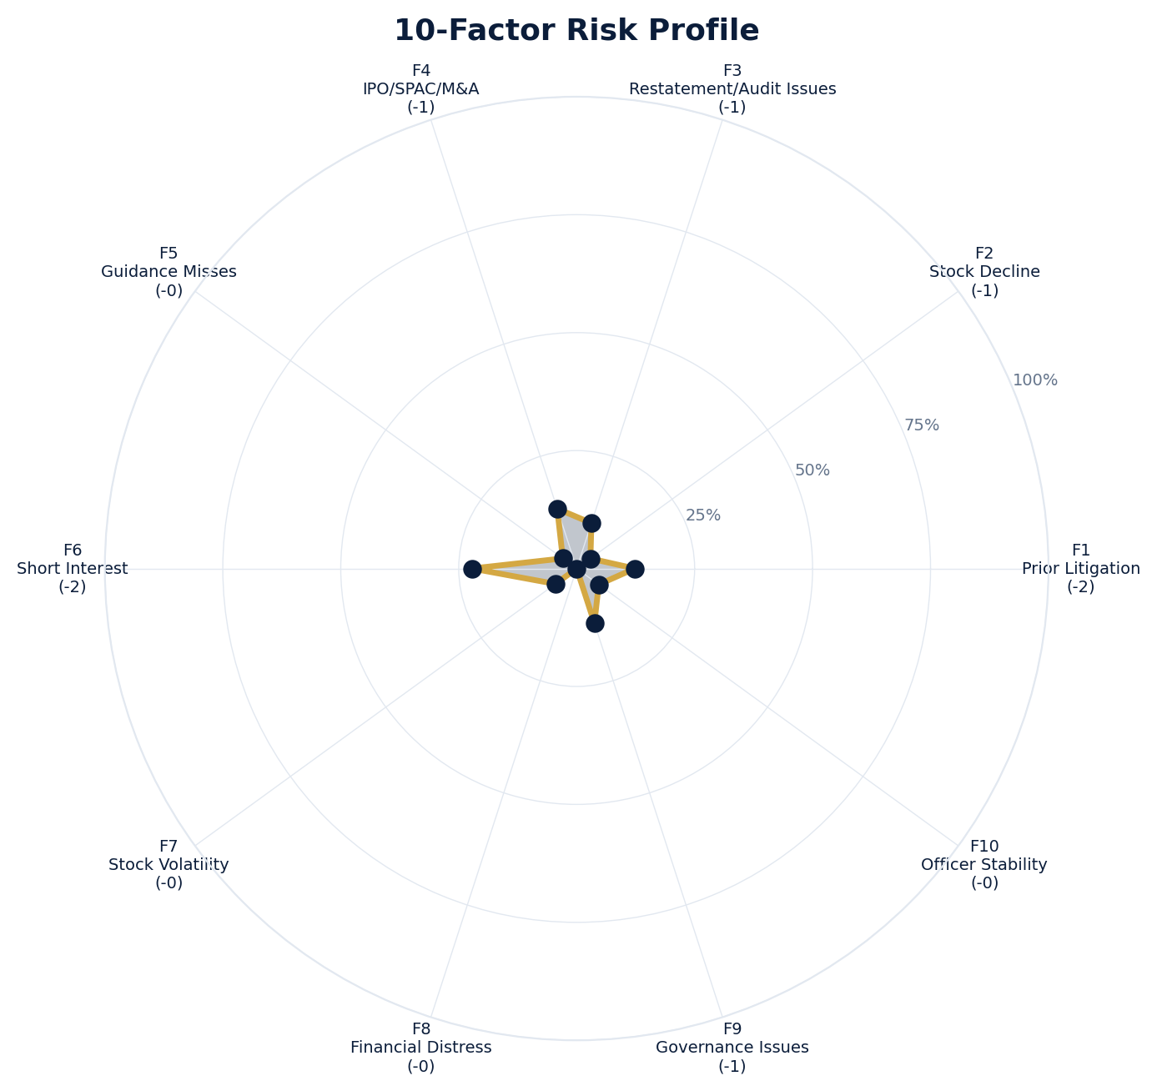
Figure: Radar chart showing risk fraction (points deducted / max) for each of the 10 scoring factors. Larger area = higher risk.
Red Flag Gates
Severity | Description | Source | Impact | Trajectory
LOW | Prior Litigation: 2/20 points | Signal-driven scoring: 70 signals, coverage=100% | F1: 2 pts | NEW
LOW | Stock Decline: 1/15 points | Signal-driven scoring: 30 signals, coverage=100%; Drop contribution modifier: 0.33x (decay + company-specific + disclosure) | F2: 1 pts | NEW
LOW | Restatement/Audit Issues: 1/12 points | Signal-driven scoring: 87 signals, coverage=100% | F3: 1 pts | NEW
LOW | IPO/SPAC/M&A: 1/10 points | Signal-driven scoring: 15 signals, coverage=100% | F4: 1 pts | NEW
LOW | Guidance Misses: 0/10 points | Signal-driven scoring: 28 signals, coverage=100% | F5: 0 pts | NEW
LOW | Short Interest: 2/8 points | Signal-driven scoring: 28 signals, coverage=100% | F6: 2 pts | NEW
LOW | Stock Volatility: 0/9 points | Signal-driven scoring: 27 signals, coverage=100% | F7: 0 pts | NEW
LOW | Governance Issues: 1/6 points | Signal-driven scoring: 38 signals, coverage=100% | F9: 1 pts | NEW
LOW | Officer Stability: 0/2 points | Signal-driven scoring: 91 signals, coverage=100% | F10: 0 pts | NEW
Critical: 0, High: 0, Moderate: 0, Low: 9
Risk Type Classification
Attribute | Value
Primary Risk Type | GUIDANCE_DEPENDENT
Supporting Evidence | F5 guidance misses: 0.36363636363636365 points; Issues guidance (philosophy: CONSERVATIVE)
Severity Scenarios
Analysis based on market cap: $171.3B
Percentile | Label | Settlement Est. | Defense Costs | Total Exposure
25th | favorable | $140.5M | $21.1M | $161.6M
50th | median | $281.0M | $56.2M | $337.2M
75th | adverse | $562.0M | $140.5M | $702.5M
95th | catastrophic | $1.1B | $337.2M | $1.5B
Calibration Notes (SECT7-11)
The following items are flagged NEEDS CALIBRATION and require expert review before final pricing:
- SECT7-11: All scoring parameters require calibration against historical cases
Factor Detail
Factor | Name | Deducted | Rules Triggered | Evidence
F1 | Prior Litigation | 2.5 | N/A | Signal-driven scoring: 70 signals, coverage=100%
F2 | Stock Decline | 0.5 | drop_contribution_adjustment | Signal-driven scoring: 30 signals, coverage=100%; Drop contribution modifier: 0.33x (decay + company-specific + disclosure)
F3 | Restatement/Audit Issues | 1.2 | N/A | Signal-driven scoring: 87 signals, coverage=100%
F4 | IPO/SPAC/M&A | 1.3 | N/A | Signal-driven scoring: 15 signals, coverage=100%
F5 | Guidance Misses | 0.4 | N/A | Signal-driven scoring: 28 signals, coverage=100%
F6 | Short Interest | 1.8 | N/A | Signal-driven scoring: 28 signals, coverage=100%
F7 | Stock Volatility | 0.5 | N/A | Signal-driven scoring: 27 signals, coverage=100%
F9 | Governance Issues | 0.7 | N/A | Signal-driven scoring: 38 signals, coverage=100%
F10 | Officer Stability | 0.1 | N/A | Signal-driven scoring: 91 signals, coverage=100%
Sub-Component Breakdown
Factor | Component | Value
F1 | base | 2.46
F1 | bonus | 0.00
F1 | modifiers | 0.00
F1 | hard_triggers | 0.00
F1 | total_before_cap | 2.46
F1 | capped | 2.46
F2 | base | 1.64
F2 | bonus | 0.00
F2 | modifiers | 0.00
F2 | hard_triggers | 0.00
F2 | drop_contribution_modifier | 0.33
F2 | total_before_cap | 0.54
F2 | capped | 0.54
F3 | base | 1.21
F3 | bonus | 0.00
F3 | modifiers | 0.00
F3 | hard_triggers | 0.00
F3 | total_before_cap | 1.21
F3 | capped | 1.21
F4 | base | 1.33
F4 | bonus | 0.00
F4 | modifiers | 0.00
F4 | hard_triggers | 0.00
F4 | total_before_cap | 1.33
F4 | capped | 1.33
F5 | base | 0.36
F5 | bonus | 0.00
F5 | modifiers | 0.00
F5 | hard_triggers | 0.00
F5 | total_before_cap | 0.36
F5 | capped | 0.36
F6 | base | 1.78
F6 | bonus | 0.00
F6 | modifiers | 0.00
F6 | hard_triggers | 0.00
F6 | total_before_cap | 1.78
F6 | capped | 1.78
F7 | base | 0.50
F7 | bonus | 0.00
F7 | modifiers | 0.00
F7 | hard_triggers | 0.00
F7 | total_before_cap | 0.50
F7 | capped | 0.50
F9 | base | 0.73
F9 | bonus | 0.00
F9 | modifiers | 0.00
F9 | hard_triggers | 0.00
F9 | total_before_cap | 0.73
F9 | capped | 0.73
F10 | base | 0.12
F10 | bonus | 0.00
F10 | modifiers | 0.00
F10 | hard_triggers | 0.00
F10 | total_before_cap | 0.12
F10 | capped | 0.12
Pattern Detection Results
No composite patterns detected.
Allegation Theory Mapping
Theory | Exposure | Factor Sources | Key Findings
A_DISCLOSURE | MODERATE | F1, F3, F5 | F1: Signal-driven scoring: 70 signals, coverage=100%; F3: Signal-driven scoring: 87 signals, coverage=100%
B_GUIDANCE | LOW | F2, F5 | F2: Signal-driven scoring: 30 signals, coverage=100%; F2: Drop contribution modifier: 0.33x (decay + company-specific + disclosure)
C_PRODUCT_OPS | LOW | F7 | F7: Signal-driven scoring: 27 signals, coverage=100%; 1 regulatory proceedings
D_GOVERNANCE | LOW | F9, F10 | F9: Signal-driven scoring: 38 signals, coverage=100%; F10: Signal-driven scoring: 91 signals, coverage=100%
E_MA | LOW | F4 | F4: Signal-driven scoring: 15 signals, coverage=100%
D&O Context: Primary allegation exposure is A_DISCLOSURE. MODERATE exposure in: A_DISCLOSURE.
Claim Probability Detail
Metric | Value
Probability Band | MODERATE
Range | 3.0% - 4.3%
Industry Base Rate | 3.5%
Adjustment Rationale | Industry base rate: 3.5%. Tier WIN (0-2%): Below base rate. Strong risk profile
Claim probability: MODERATE [ELEVATED]
Tower Position Recommendation
Metric | Value
Recommended Position | PRIMARY
Minimum Attachment | $281.0M (based on 50th percentile settlement)
Side A/DIC Assessment | Standard Side A considerations
Position | Risk Assessment | Premium Guidance | Attachment
PRIMARY | Primary layer carries 57% of expected loss exposur | Full rate, slight discount for | $0 ground-up
LOW_EXCESS | Low excess layer carries 18% of expected loss expo | Market rate | $5-15M xs $5-15M
MID_EXCESS | Mid excess layer carries 13% of expected loss expo | Market to 1.3x | $15-50M xs $15-50M
HIGH_EXCESS | High excess layer carries 11% of expected loss exp | 1.3-2x with attachment | $50M+ xs $50M+
DECLINE | WALK+ with compounding factors | N/A | N/A
Forensic Composite Scores
Composite | Score | Interpretation
Financial Integrity Score (FIS) | N/A | Not available
Reporting Quality Score (RQS) | N/A | Not available
Cash Flow Quality Score (CFQS) | N/A | Not available
Executive Risk Profile
Metric | Value
Weighted Score | 0
Risk Level | N/A
Temporal Signals
Type | Direction | Magnitude | Description
Unknown | N/A | N/A
Unknown | N/A | N/A
Unknown | N/A | N/A
Unknown | N/A | N/A
Unknown | N/A | N/A
NLP Filing Analysis
Metric | Value
Readability Score | {'current_fog': 21.85, 'prior_fog': None, 'fog_change': None, 'current_flesch': 16.17, 'prior_flesch': None, 'classification': 'CURRENT_ONLY', 'evidence': 'Current Fog Index: 21.9 (prior year unavailable)'}
Tone Assessment | N/A
Risk Language Density | N/A
Peril Assessment
Plaintiff Peril Heat Map
Plaintiff Type | Probability | Severity
Shareholders | ELEVATED | SIGNIFICANT
Regulators | ELEVATED | SIGNIFICANT
Customers | VERY LOW | NUISANCE
Competitors | VERY LOW | NUISANCE
Employees | LOW | MINOR
Creditors | MODERATE | MODERATE
Government | MODERATE | SIGNIFICANT
Shareholders: 42 triggered checks. Key: Litigation History Profile: 2 (elevated vs benchmark of 0)
Regulators: 9 triggered checks. Key: VIE/SPE Off-Balance-Sheet Structures: Boolean check: VIE/SPE structures present
Creditors: 4 triggered checks. Key: Goodwill/Intangible as % of Equity: 66.71 (elevated vs benchmark of 50)
Government: 5 triggered checks. Key: Key Partnerships: 2 (elevated vs benchmark of 1)
Bear Cases
Bear Case: A Disclosure
Walt Disney Co faces elevated exposure to securities disclosure fraud claims. Key risk indicators: Litigation History Profile (critical); VIE/SPE Off-Balance-Sheet Structures (critical). Estimated severity is significant, warranting detailed underwriter review.
Defense: Defense: No active Section 11 windows — statute of limitations expired for offering claims
Evidence Chain
1. [BIZ.CLASS.litigation_history] Litigation History Profile (Source: total_sca_count)
2. [BIZ.STRUCT.vie_spe] VIE/SPE Off-Balance-Sheet Structures (Source: vie_spe_present)
3. [BIZ.DEPEND.distribution] Product Concentration (Source: distribution_channels_count)
4. [BIZ.EVENT.ipo_exposure] IPO/Offering Exposure Window (Source: event_ipo_exposure_score)
5. [BIZ.OPS.subsidiary_structure] Subsidiary Jurisdiction Structure (Source: subsidiary_structure)
6. [BIZ.OPS.workforce] Workforce Distribution (Source: workforce_distribution)
7. [FIN.LIQ.efficiency] Liquidity Efficiency (Source: xbrl_cash_ratio)
8. [FIN.LIQ.trend] Liquidity Trend (Source: xbrl_current_ratio)
9. [FIN.CAP.buyback_capacity] Buyback Authorization Capacity (Source: xbrl_buyback_remaining_pct)
10. [FIN.FORENSIC.channel_stuffing] Channel Stuffing Indicators (Source: forensic_channel_stuffing)
Probability: ELEVATED | Severity: SIGNIFICANT
Settlement Prediction
Settlement prediction computed but no scenarios available.
Tower Risk Characterization
Tower characterization not available.
Coverage Gaps -- Data Not Available
The following checks could not be evaluated because required data was not acquired. These items are NOT cleared -- they represent gaps in coverage that should be considered in the underwriting decision.
Executive Summary & Key Metrics
[REQUIRED] BIZ.SIZE.growth_trajectory (Public Company Tenure): Required data not available from filings
[REQUIRED] BIZ.SIZE.public_tenure (Revenue Growth YoY): Required data not available from filings
[EVALUATIVE] BIZ.DEPEND.labor (Concentration Risk Composite): Required data not available from filings
[REQUIRED] BIZ.MA.goodwill_balance (Goodwill Balance): Required data not available from filings
[REQUIRED] BIZ.MA.acquisition_spend (Acquisition Spend Magnitude): Required data not available from filings
[EVALUATIVE] BIZ.MA.goodwill_change (Goodwill Trajectory): Required data not available from filings
[REQUIRED] BIZ.MA.acquisition_list (Recent Acquisitions): Required data not available from filings
[REQUIRED] BIZ.MODEL.lifecycle (Segment Lifecycle Risk): Required data not available from filings
[REQUIRED] BIZ.MODEL.segment_margins (Segment Margin Profile): Required data not available from filings
[EVALUATIVE] ABS.DISC.audit_fees (Missing Audit Fee Disclosure): Expected signals not found in evaluation results
[EVALUATIVE] ABS.DISC.board_independence (Missing Board Independence Disclosure): Could not determine disclosure presence or absence
[EVALUATIVE] ABS.DISC.clawback_policy (Missing Clawback Policy Disclosure): Expected signals not found in evaluation results
[EVALUATIVE] ABS.DISC.cyber_risk (Missing Cybersecurity Risk Disclosure): Expected signals not found in evaluation results
[EVALUATIVE] ABS.DISC.debt_covenants (Missing Debt Covenant Disclosure): Expected signals not found in evaluation results
[EVALUATIVE] ABS.DISC.derivative_instruments (Missing Derivative Instruments Disclosure): Expected signals not found in evaluation results
[EVALUATIVE] ABS.DISC.esg (Missing ESG Disclosure): Expected signals not found in evaluation results
[EVALUATIVE] ABS.DISC.executive_comp (Missing Executive Compensation Disclosure): Expected signals not found in evaluation results
[EVALUATIVE] ABS.DISC.goodwill_impairment (Missing Goodwill Impairment Disclosure): Expected signals not found in evaluation results
[EVALUATIVE] ABS.DISC.lease_obligations (Missing Lease Obligation Disclosure): Expected signals not found in evaluation results
[EVALUATIVE] ABS.DISC.litigation_contingency (Missing Litigation Contingency Disclosure): Expected signals not found in evaluation results
[EVALUATIVE] ABS.DISC.pension_obligations (Missing Pension Obligation Disclosure): Expected signals not found in evaluation results
[EVALUATIVE] ABS.DISC.related_party (Missing Related-Party Transaction Disclosure): Expected signals not found in evaluation results
[EVALUATIVE] ABS.DISC.revenue_recognition (Missing Revenue Recognition Policy Disclosure): Expected signals not found in evaluation results
[EVALUATIVE] ABS.DISC.risk_factors (Missing Risk Factor Disclosure): Expected signals not found in evaluation results
[EVALUATIVE] ABS.DISC.segment_reporting (Missing Segment Reporting Disclosure): Expected signals not found in evaluation results
[EVALUATIVE] ABS.DISC.stock_comp (Missing Stock Compensation Disclosure): Expected signals not found in evaluation results
[EVALUATIVE] ABS.DISC.tax_positions (Missing Uncertain Tax Position Disclosure): Expected signals not found in evaluation results
[EVALUATIVE] CONJ.COMP.perf_divergence (Compensation-Performance Divergence): 3/3 component signals unavailable
[EVALUATIVE] CONJ.DISTRESS.insider (Financial Distress + Insider Selling): 2/3 component signals unavailable
[EVALUATIVE] CONJ.GOV.governance_event (Weak Governance + Adverse Event): 3/5 component signals unavailable
[EVALUATIVE] CONJ.FIN.growth_margin_guidance (Rapid Growth + Margin Compression + Guidance Miss): 3/3 component signals unavailable
[EVALUATIVE] CONJ.INSIDER.news_gap (Insider Selling + Material News Gap): 3/3 component signals unavailable
[EVALUATIVE] CONJ.REG.litigation (Regulatory Action + New Material Litigation): 3/3 component signals unavailable
[EVALUATIVE] CTX.FIN.capex_sector (Capital Expenditure in Sector Context): Source signal FIN.INVEST.capex_ratio not in results
[EVALUATIVE] CTX.COMP.lifecycle (CEO Compensation in Lifecycle Context): Source signal EXEC.COMP.ceo_total_comp not in results
[EVALUATIVE] CTX.COMP.product_tower (Compensation Severity by Product/Tower): Source signal EXEC.COMP.ceo_total_comp not in results
[EVALUATIVE] CTX.FIN.debt_maturity (Debt Maturity Profile in Lifecycle Context): Source signal FIN.DEBT.maturity_profile not in results
[EVALUATIVE] CTX.FIN.distress_product (Financial Distress by Product/Tower): Source signal FIN.FORENSIC.altman_z not in results
[EVALUATIVE] CTX.FIN.dividend_lifecycle (Dividend Policy in Lifecycle Context): Source signal FIN.RETURN.dividend_yield not in results
[EVALUATIVE] CTX.EXEC.tenure_lifecycle (Executive Tenure in Lifecycle Context): Source signal EXEC.TURN.c_suite not in results
[EVALUATIVE] CTX.GOV.lifecycle (Board Independence in Lifecycle Context): Required context dimensions ['lifecycle_stage'] not available
[EVALUATIVE] CTX.FIN.growth_lifecycle (Revenue Growth in Lifecycle Context): Required context dimensions ['lifecycle_stage'] not available
[EVALUATIVE] CTX.MKT.insider_lifecycle (Insider Trading in Lifecycle Context): Source signal STOCK.INSIDER.net_selling not in results
[EVALUATIVE] CTX.FIN.leverage_sector (Leverage in Sector Context): Source signal FIN.DEBT.leverage_ratio not in results
[EVALUATIVE] CTX.LIT.size (Litigation Frequency by Company Size): Source signal LIT.SCA.active_cases not in results
[EVALUATIVE] CTX.RISK.ma_lifecycle (M&A Activity in Lifecycle Context): Source signal BIZ.MA.acquisition_activity not in results
[EVALUATIVE] CTX.RISK.regulatory_sector (Regulatory Risk in Sector Context): Source signal LIT.SEC.enforcement not in results
[EVALUATIVE] CTX.RISK.rpt_sector (Related-Party Risk in Sector Context): Source signal GOV.RPT.related_party not in results
[EVALUATIVE] CTX.MKT.short_interest_sector (Short Interest in Sector Context): Source signal STOCK.SHORT.interest_ratio not in results
[EVALUATIVE] CTX.MKT.turnover_sector (Stock Turnover in Sector Context): Source signal STOCK.VOL.turnover_rate not in results
[EVALUATIVE] CTX.MKT.volatility_sector (Stock Volatility in Sector Context): Source signal STOCK.VOL.historical not in results
Financial Health
[EVALUATIVE] FIN.PEER.revenue_bottom_quartile (Revenue Bottom Quartile (Cross-Filer)): No peer comparison data available
[EVALUATIVE] FIN.PEER.leverage_top_decile (Leverage Top Decile (Sector-Relative)): No peer comparison data available
[EVALUATIVE] FIN.PEER.margin_compression (Operating Margin Compression (Cross-Filer)): No peer comparison data available
[EVALUATIVE] FIN.PEER.profitability_laggard (Profitability Laggard (Sector-Relative)): No peer comparison data available
[EVALUATIVE] FIN.PEER.size_outlier_small (Size Outlier Small (Cross-Filer)): No peer comparison data available
[EVALUATIVE] FIN.PEER.cash_flow_weak (Cash Flow Weakness (Cross-Filer)): No peer comparison data available
[EVALUATIVE] LIT.DEFENSE.forum_selection (Federal Forum Selection Clause): Required data not available from filings
Governance & Leadership
[EVALUATIVE] EXEC.INSIDER.ceo_net_selling (CEO Net Seller of Stock): Required data not available from filings
[EVALUATIVE] EXEC.INSIDER.cfo_net_selling (CFO Net Seller of Stock): Required data not available from filings
[EVALUATIVE] EXEC.AGGREGATE.board_risk (Board Aggregate Risk Score): Data mapping not configured for this check
[EVALUATIVE] EXEC.AGGREGATE.highest_risk_individual (Highest Individual Risk Score Exceeds Threshold): Data mapping not configured for this check
[EVALUATIVE] EXEC.TENURE.ceo_new (CEO Tenure Less Than 2 Years): Data mapping not configured for this check
[EVALUATIVE] EXEC.TENURE.cfo_new (CFO Tenure Less Than 2 Years): Data mapping not configured for this check
[REQUIRED] EXEC.PROFILE.board_size (Board Size (Number of Members)): Required data not available from filings
[REQUIRED] EXEC.PROFILE.independent_ratio (Board Independence Percentage): Required data not available from filings
[EVALUATIVE] EXEC.PROFILE.overboarded_directors (Directors Serving on 4+ Boards): Required data not available from filings
[EVALUATIVE] GOV.BOARD.size (Board Size): Required data not available from filings
[EVALUATIVE] GOV.BOARD.independence (Board Independence): Required data not available from filings
[EVALUATIVE] GOV.BOARD.diversity (Board Diversity): Required data not available from filings
[EVALUATIVE] GOV.BOARD.tenure (Tenure): Required data not available from filings
[EVALUATIVE] GOV.BOARD.overboarding (Overboarding): Required data not available from filings
[EVALUATIVE] GOV.BOARD.attendance (Attendance): Required data not available from filings
[EVALUATIVE] GOV.BOARD.meetings (Meetings): Required data not available from filings
[EVALUATIVE] GOV.BOARD.succession (Succession): Required data not available from filings
[EVALUATIVE] GOV.EXEC.ceo_profile (CEO Profile): Required data not available from filings
[EVALUATIVE] GOV.EXEC.cfo_profile (CFO Profile): Required data not available from filings
[EVALUATIVE] GOV.EXEC.founder (Founder Status): Required data not available from filings
[EVALUATIVE] GOV.EXEC.key_person (Key Person Risk): Required data not available from filings
[EVALUATIVE] GOV.PAY.golden_para (Golden Para): Required data not available from filings
[EVALUATIVE] GOV.PAY.equity_burn (Equity Burn): Required data not available from filings
[EVALUATIVE] GOV.PAY.hedging (Hedging): Required data not available from filings
[REQUIRED] GOV.RIGHTS.bylaws (Bylaws): Required data not available from filings
[EVALUATIVE] GOV.RIGHTS.takeover (Takeover): Required data not available from filings
[EVALUATIVE] GOV.RIGHTS.proxy_access (Proxy Access): Required data not available from filings
[REQUIRED] GOV.RIGHTS.forum_select (Forum Select): Required data not available from filings
[EVALUATIVE] GOV.RIGHTS.supermajority (Supermajority): Required data not available from filings
[EVALUATIVE] GOV.RIGHTS.action_consent (Action Consent): Required data not available from filings
[EVALUATIVE] GOV.RIGHTS.special_mtg (Special Mtg): Required data not available from filings
[EVALUATIVE] GOV.RIGHTS.classified (Classified): Required data not available from filings
Market & Trading
[EVALUATIVE] FIN.COMP.unvested_cost (Unvested SBC Pipeline): Required data not available from filings
[EVALUATIVE] FIN.CONT.loss_accrual (Loss Contingency Accrual): Required data not available from filings
[EVALUATIVE] FIN.CONT.loss_estimate (Loss Contingency Estimate): Required data not available from filings
[EVALUATIVE] FIN.CONT.settlement_activity (Litigation Settlement Activity): Required data not available from filings
[EVALUATIVE] FIN.CONT.warranty_reserve (Product Warranty Reserve): Required data not available from filings
[EVALUATIVE] FIN.DEBT.facility_utilization (Credit Facility Utilization): Required data not available from filings
[EVALUATIVE] FIN.DEBT.maturity_concentration (Debt Maturity Concentration): Data mapping not configured for this check
[EVALUATIVE] FIN.DERIV.notional_exposure (Derivative Notional Exposure): Required data not available from filings
[EVALUATIVE] FIN.DERIV.fair_value_risk (Derivative Fair Value Risk): Required data not available from filings
[EVALUATIVE] FIN.QUALITY.q4_revenue_concentration (Q4 Revenue Concentration): Required data not available from filings
[EVALUATIVE] FIN.QUALITY.revenue_recognition_risk (Revenue Recognition Risk Indicators): Data mapping not configured for this check
[EVALUATIVE] FIN.FORENSIC.level3_fair_value (Level 3 Fair Value Asset Concentration): Data mapping not configured for this check
[EVALUATIVE] FIN.FORENSIC.goodwill_deterioration_pattern (Goodwill Deterioration Pattern): Data mapping not configured for this check
[EVALUATIVE] FIN.FORENSIC.related_party_revenue (Related Party Revenue Concentration): Data mapping not configured for this check
[EVALUATIVE] FWRD.EVENT.ma_integration_risk (M&A Integration Risk): Data mapping not configured for this check
[EVALUATIVE] FIN.FORENSIC.margin_compression (Forensic Margin Compression): Data mapping not configured for this check
[EVALUATIVE] FIN.FORENSIC.buyback_timing (Share Buyback Timing Quality): Data mapping not configured for this check
[EVALUATIVE] FIN.FORENSIC.deferred_tax_growth (Deferred Tax Liability Growth): Data mapping not configured for this check
[EVALUATIVE] FIN.FORENSIC.dsri_elevated (Days Sales Receivable Index Elevated): Data mapping not configured for this check
[EVALUATIVE] FIN.FORENSIC.aqi_elevated (Asset Quality Index Elevated): Data mapping not configured for this check
[EVALUATIVE] FIN.FORENSIC.tata_elevated (Total Accruals to Total Assets Elevated): Data mapping not configured for this check
[EVALUATIVE] FIN.FORENSIC.non_gaap_gap (Non-GAAP to GAAP Earnings Gap): Data mapping not configured for this check
[EVALUATIVE] FIN.FORENSIC.goodwill_growth_rate (Goodwill Growth Rate): Data mapping not configured for this check
[EVALUATIVE] FIN.FORENSIC.acquisition_to_revenue (Acquisition Spend Relative to Revenue): Data mapping not configured for this check
[EVALUATIVE] FIN.PROFIT.revenue (Revenue Analysis): Required data not available from filings
[EVALUATIVE] FIN.GUIDE.track_record (Guidance Track Record): Required data not available from filings
[EVALUATIVE] FIN.RESTRUCT.severance (Severance Costs): Required data not available from filings
[EVALUATIVE] FIN.TAX.deferred_tax_gap (Deferred Tax Asset Gap): Required data not available from filings
[REQUIRED] NLP.FILING.filing_timing_change (Filing Date Shifted Significantly vs Prior Year): Required data not available from filings
[EVALUATIVE] STOCK.INSIDER.notable_activity (Notable Activity): Required data not available from filings
[EVALUATIVE] FIN.FORENSIC.m_score_composite (Beneish M-Score Composite (XBRL)): Data mapping not configured for this check
Gap breakdown: Required items: 12 | Evaluative checks: 109
Total: 121 checks data-unavailable out of 576 total checks (79% coverage)

Calibration Notes
System Intelligence Status
Checks active: 601
Checks incubating: 0 (pending human approval)
Pending feedback: 0 entries
Recent Calibration Changes
Date | Check | Change | Changed By
2026-04-02 | UTILIZATION_MGMT_SCRUTINY | Proposed by ingestion of 'blind_spot:UNH:UnitedHealth Group | ingestion_pipeline
2026-04-02 | PUBLIC_OUTRAGE_IMPACT | Proposed by ingestion of 'blind_spot:UNH:UnitedHealth Group | ingestion_pipeline
2026-04-02 | GUIDANCE_CHANGE_POST_CRISIS | Proposed by ingestion of 'blind_spot:UNH:UnitedHealth Group | ingestion_pipeline
2026-04-02 | VAERS_DATA_MONITORING | Proposed by ingestion of 'blind_spot:MRNA:Moderna, Inc. Secu | ingestion_pipeline
2026-04-02 | VACCINE_SAFETY_OVERSIGHT_BOARD | Proposed by ingestion of 'blind_spot:MRNA:Moderna, Inc. Secu | ingestion_pipeline
2026-04-02 | PEDIATRIC_SAFETY_DISCLOSURE_GAP | Proposed by ingestion of 'blind_spot:MRNA:Moderna, Inc. Secu | ingestion_pipeline
2026-04-02 | GOV.FOUNDER_CRIMINAL_EXPOSURE | Proposed by ingestion of 'blind_spot:NVDA:Super Micro Comput | ingestion_pipeline
2026-04-02 | BIZ.CHINA_EXPOSURE_DISCLOSURE | Proposed by ingestion of 'blind_spot:NVDA:Super Micro Comput | ingestion_pipeline
2026-04-02 | GOV.EXPORT_CONTROL_COMPLIANCE | Proposed by ingestion of 'blind_spot:NVDA:Super Micro Comput | ingestion_pipeline
2026-04-02 | AI_DEVELOPMENT_TIMELINE_DISCLOSURE | Proposed by ingestion of 'blind_spot:AAPL:AAPL LAWSUIT: Appl | ingestion_pipeline
Discovery Findings
No new discoveries from this run.
Feedback for DIS
No pending feedback for DIS.

