
Angry Dolphin -- D&O Underwriting Worksheet
INTEL CORP (INTC)
Generated: April 02, 2026
[Table of Contents -- Update in Word]

**Underwriting Thesis for Intel Corporation:** Intel's D&O risk profile is bifurcated, earning a "WIN" tier (87.8 composite score) that demands aggressive competition, yet is tempered by an ELEVATED claim band of 6.65%-9.5%. The high score is anchored by a clean SEC enforcement record, an audit opinion with no material weaknesses, and stable leadership with zero C-suite departures in 18 months. However, forensic synthesis reveals a persistent pattern of disclosure-related governance friction, accounting for the top three underwriting deductions: "Prior Litigation" (2.4 pts), "Restatement/Audit Issues" (2.1 pts), and "Guidance Misses" (2 pts). These 63 prior litigation signals and 81 audit issue signals, per filing narratives, indicate an inherent operational risk percentile of 3.7, translating to a higher-than-baseline litigation probability. The 241bn market cap and 85,100 employees create a deep-pocketed target for shareholder plaintiffs, particularly following stock price volatility. Cross-sectionally, Intel’s "Short Interest" deduction (2.2 pts) contrasts with the positive note of it being below 5% of float, revealing nuanced market skepticism amidst its financial stability (safe Altman Z-Score). The underwriting action—"Must-have account, compete aggressively"—is justified by Intel’s fundamental resilience and lack of financial distress, but policy structure must incorporate pricing for its chronic disclosure litigation tail.
Executive Summary
Underwriting Thesis
INTEL CORP is a $241.2B (Decile 1 of 10) mega-cap technology company scoring 88/100 (WIN tier). The primary risk driver is Prior Litigation, driving elevated risk in this area. Signal-driven scoring: 63 signals, coverage=100%. At a 7-10% claim probability (3.7% adjusted rate, 0.7x the Technology sector baseline of 5.0%), this account requires primary or low-excess participation.
Company Snapshot
Attribute | Value | Source
Company | INTEL CORP
Ticker | INTC
Exchange | Nasdaq
Sector | Technology
Industry | Semiconductors
Market Cap | $241.2B [Decile 1 (largest ~400 accounts)] (Ranks at the 22nd percentile among 9 peers) | [yfinance, filed 2026-04-02, MEDIUM confidence]
Revenue | $52.9B | [10-K 2025-12-27 CIK50863 accn:0000050863-26-000011, filed 2025-12-27, HIGH confidence]
Employees | 85,100 | [yfinance, filed 2026-04-02, MEDIUM confidence]
SIC | 3674 -- Semiconductors & Related Devices
GICS | 45301020
NAICS | 334413
FPI Status | No
Fiscal Year End | 12-27
Tier Classification
Attribute | Value
Tier | WIN
Composite Score | 87.8/100
Quality Score | 87.8/100
Factor Breakdown | F1: 2.4, F2: 0.6, F3: 2.1, F4: 1.0, F5: 2.0, F6: 2.2, F7: 0.5, F8: 0.7, F9: 0.5, F10: 0.1
Position | 87.8 falls in WIN range (86-100)
Appetite | Must-have account, compete aggressively
Classification: WIN [MODERATE]
Inherent Risk Baseline
Component | Value
Market Cap Tier | MEGA [Decile 1 (largest ~400 accounts)]
Sector | Technology (Base rate: 5.0%)
Size Adjustment | 1.56x (MEGA cap multiplier) -> 7.8%
Score Adjustment | 0.47x (quality score multiplier) -> 3.7%
Severity Percentile | Settlement Estimate
25th (favorable) | $25.0M
50th (median) | $75.0M
75th (adverse) | $112.5M
95th (catastrophic) | $150.0M
At a 3.7% adjusted claim rate, the company faces 0.7x its sector baseline of 5.0% for Technology companies. This rate reflects the MEGA cap multiplier (1.56x) combined with the quality score multiplier (0.47x from WIN tier classification).
Note: NEEDS CALIBRATION
Underwriting Headwinds
1. Structural Complexity & Litigation History [HIGH]
Goodwill at 12.6% of total assets reflects an acquisition-driven strategy where integration risk and impairment charges are common SCA triggers. (see Litigation)
2. Audit & Accounting Risk Factors [HIGH]
Intel Corp. has audit-related risk factors that warrant underwriting attention. Beneish M-Score of -2.63 with 0/8 component flags triggered. (see Financial Health)
3. Earnings Guidance Track Record [HIGH]
Intel Corp. has missed earnings guidance in 6 quarters, with management credibility score at 70%. At $241.2B market cap with an estimated DDL of $11.1B, guidance misses generate large absolute loss figures that attract institutional lead plaintiffs. (see Market & Trading)
4. Stock Price Decline [ELEVATED]
Intel Corp.'s stock has undergone a -12% dip of -12.0% from $54.60 to $48.03 over 252 trading days. This creates an estimated Disclosure Dollar Loss (DDL) of $11.1B, among the largest potential DDL exposures in the market. (see Market & Trading)
5. Transaction-Related Exposure [ELEVATED]
Intel Corp. has transaction-related risk factors. Goodwill at 12.6% of total assets reflects acquisition activity. Failed acquisitions are among the most common SCA triggers. At $241.2B market cap, transaction claims carry both Section 10(b) exposure (misleading disclosures) and Section 14(a) exposure (deficient proxy statements).
Risk Mitigants
1. Clean Regulatory Record
Intel Corp. has no active SEC enforcement pipeline activity, open investigations, or pending Wells Notices. A clean regulatory record for Intel Corp. eliminates the highest-severity D&O claim catalyst and supports favorable underwriting consideration. (see Litigation)
2. Clean Audit & Accounting History
Intel Corp. maintains a clean audit opinion with no material weaknesses, restatements, or going concern qualifications. However, goodwill at 12.6% of total assets requires ongoing impairment testing -- clean audit history does not eliminate future impairment risk. (see Financial Health)
3. Sound Financial Position
No financial distress indicators present (Altman Z-Score of 2.05, D/E of 0.41, current ratio of 1.3x, interest coverage of -11.8x). Altman Z of 2.05 is in the gray zone but other indicators do not suggest imminent distress. (see Financial Health)
4. Stable Executive Leadership
C-suite leadership is stable with no recent departures. (see Governance)
5. Low Short Interest
Short interest is low at 2.3% of float, indicating institutional investors are not positioning against the stock. Short interest at 2.3% is within normal range, suggesting no concentrated bearish positioning against Intel Corp.. (see Market & Trading)
Claim Probability
Metric | Value
Band | ELEVATED
Company Rate | 6.7% - 9.5%
Industry Base Rate | 5.0%
Severity Favorable | $2.6B
Severity Median | $5.4B
Severity Adverse | $11.3B
Severity Catastrophic | $23.6B
Probability Band: ELEVATED [HIGH]
The 7-10% probability band represents approximately 2x the Technology sector base rate of 5.0%. Accounts in WIN tier historically produce claims at elevated frequency. Industry base rate: 5.0%. Tier WIN (0-2%): Below base rate. Strong risk profile reduces claim probability below industry average. NEEDS CALIBRATION: Probability estimates are indicative and require actuarial validation per SECT7-11. Enhanced frequency: 9.00% base x 0.96 hazard x 1.10 signal = 9.50%.
Tower Recommendation
Metric | Value
Position | Primary
Min Attachment | $4539.4M (based on 50th percentile settlement)
Side A/DIC | Standard Side A considerations
Layer | Risk Assessment | Premium Guidance
PRIMARY | Primary layer carries 57% of expected loss exposure. Highest frequency of attachment; most likely to be eroded in any claim scenario. | Full rate, slight discount for WIN
LOW_EXCESS | Low excess layer carries 18% of expected loss exposure. Attaches after primary exhaustion; moderate frequency in adverse scenarios. | Market rate
MID_EXCESS | Mid excess layer carries 13% of expected loss exposure. Attaches in adverse scenarios; lower frequency but higher severity when reached. | Market to 1.3x
HIGH_EXCESS | High excess layer carries 11% of expected loss exposure. Attaches only in catastrophic scenarios; lowest frequency, highest severity. | 1.3-2x with attachment
DECLINE | WALK+ with compounding factors | N/A
Market Context
No market pricing data available.

Company Overview
Intel Corporation, a $241 billion market cap Mega-cap technology firm, has been publicly traded for 46 years, a period over which it built its position designing CPUs for the majority of the world's PCs and servers. With a global workforce of 85,100, its current strategic pivot into operating its own capital-intensive semiconductor foundry directly challenges TSMC and Samsung, creating a high-stakes board-level bet.
Revenue Model
Revenue flows from three segments: Client Computing Group (CCG) for PCs, Data Center and AI (DCAI) for servers, and the new Intel Foundry for external manufacturing services. The model hinges on multi-billion-dollar R&D and capex cycles to maintain technical leadership; if its process node technology falls behind peers, both product and foundry revenue engines stall, directly threatening shareholder value. Client revenue is cyclical, while data center and foundry aim for longer-term contracts, with success in the latter being critical to the company's stated turnaround.
D&O Risk Profile
The core D&O story is the execution risk of the foundry strategy, which places immense pressure on the board of this Large Accelerated Filer to deliver a turnaround against entrenched competitors. This strategic pivot occurs alongside persistent litigation exposures: employment claims from its 85,100-strong global workforce and intense intellectual property battles endemic to semiconductor design, as indicated by its IP_LITIGATION_RISK classification. Shareholder suits are likely to allege strategic missteps if the foundry initiative fails to achieve promised scale and profitability, potentially triggering securities litigation against officers and directors.
Section 2: Company Profile
INTEL CORP operates in the Semiconductors industry. The company has 85,100 employees and $241.2B market cap. Key D&O exposure factors include: Employment Litigation Risk, Ip Litigation Risk. [derived:section_summary, 2026-04-02, LOW]
Company Identity
Field | Value | Source
Legal Name | INTEL CORP | [SEC EDGAR submissions, filed 2026-04-02, HIGH confidence]
Ticker | INTC
CIK | 50863 | [SEC EDGAR submissions, filed 2026-04-02, HIGH confidence]
Sector | Technology | [SEC EDGAR submissions, filed 2026-04-02, HIGH confidence]
SIC Code | 3674 | [SEC EDGAR submissions, filed 2026-04-02, HIGH confidence]
SIC Description | Semiconductors & Related Devices
GICS Code | 45301020 | [SIC->GICS mapping (SIC 3674), filed 2026-04-02, MEDIUM confidence]
NAICS Code | 334413 | [SIC->NAICS crosswalk (SIC 3674), filed 2026-04-02, MEDIUM confidence]
Exchange | Nasdaq | [SEC EDGAR submissions, filed 2026-04-02, HIGH confidence]
State of Incorporation | DE | [SEC EDGAR submissions, filed 2026-04-02, HIGH confidence]
FPI Status | No
Fiscal Year End | 12-27 | [SEC EDGAR submissions, filed 2026-04-02, HIGH confidence]
Business Description
Intel Corporation designs, develops, manufactures, markets, sells, and services computing and related end products and services in the United States, Ireland, Israel, and internationally. It operates through three segments: CCG, DCAI, and Intel Foundry. The company offers client computing group products, including client and commercial CPUs, discrete client GPUs, edge computing, and connectivity products; data center and AI products, such as server CPUs, discrete GPUs, and networking products; and semiconductors comprising wafer fabrication, substrates, and other related products and services. It also provides driving assistance and self-driving solutions; and develops and manufactures multi-beam mask writing tools. The company sells its products through sales organizations, distributors, resellers, retailers, and OEM partners. It serves original equipment manufacturers, original design manufacturers, cloud service providers, and other manufacturers and service providers. Intel Corporation has a strategic collaboration with Infosys Limited to develop a multi-layer AI fabric that unifies infrastructure, models, data, applications, and workflows into a composable and agent-ready ecosystem. The company was incorporated in 1968 and is headquartered in Santa Clara, California. [yfinance, filed 2026-04-02, MEDIUM confidence]
Subsidiaries
Subsidiary data not available.
Business Model Profile
Operational Complexity
Complexity Score: 85100/20 -- HIGH [HIGH]
Component | Value
Jurisdictions | 0 (0 high-regulatory)
Workforce | 85,100
Segments | 0
Geographic Concentration | 0/100
Supply Chain | moderate
Overall Resilience | ADEQUATE
Structural Indicators: [ ] VIE / SPE | [ ] Dual-Class | [ ] Holding Depth | [ ] OBS Exposure
Corporate Events & Transaction Risk
Event Type | Assessment
M&A Activity | MODERATE (Score: 2/4) | 1 acquisition year | Goodwill growth: 677.2% | Acq/Rev: 0.2%
IPO / Offering Exposure | LOW - 46 years public
Business Changes:
- 21 current event filings (8-K), most recent 2026-03-03
Peer Group Comparison
Ticker | Name | Market Cap | Quality Score | Similarity
MSFT | Microsoft Corporation | $2.8T | N/A | Sector Etf / 14%
GOOGL | Alphabet Inc. | $3.6T | N/A | Sector Etf / 4%
AMZN | Amazon.com, Inc. | $2.3T | N/A | Sector Etf / 3%
META | Meta Platforms, Inc. | $1.5T | N/A | Sector Etf / 5%
NVDA | NVIDIA Corporation | $4.3T | N/A | Sector Etf / 27%
CRM | Salesforce, Inc. | $175.4B | N/A | Sector Etf / 34%
ADBE | Adobe Inc. | $99.0B | N/A | Sector Etf / 18%
ORCL | Oracle Corporation | $421.0B | N/A | Sector Etf / 30%
CSCO | Cisco Systems, Inc. | $312.2B | N/A | Sector Etf / 43%
The peer group of 9 companies shares the same industry classification (SIC 3674). INTEL CORP ranks at the 22nd percentile among 9 peers by market capitalization.
Revenue Segments
Revenue segment data not available.
Geographic Footprint
Geographic footprint data not available.
Customer & Supplier Concentration
Concentration data not available from filings.
D&O Exposure Factors
Exposure Type | Risk Level | Description | Coverage Part
Securities Litigation | See analysis sections | Shareholder class actions, SEC enforcement | Side A/B/C
Derivative Actions | See analysis sections | Breach of fiduciary duty, waste claims | Side A/B
Employment Practices | See analysis sections | Discrimination, harassment, wrongful termination | Side B/C (EPLI)
Regulatory/Government | See analysis sections | DOJ, SEC, FTC, state AG investigations | Side A (primarily)
Fiduciary (ERISA) | See analysis sections | 401(k) plan mismanagement, fee litigation | Fiduciary Liability
Standard D&O exposure categories shown. See individual analysis sections for company-specific risk levels.
Classification
Attribute | Value
Market Cap Tier | MEGA
Sector | TECH (TECH)
Years Public | 46
Base Filing Rate | 9.0%
Severity Band | $150.0M -- $500.0M
DDL Exposure Base | $36.2B
IPO Multiplier | 1.00x
Cap Filing Multiplier | 1.80x
Hazard Profile (Inherent Exposure Score)
IES: 46/100 (MODERATE) | Multiplier: 0.96x | Data Coverage: 67% [MODERATE]
Top Risk Dimensions (Elevated+)
Dimension | Score | Exposure | Evidence
Board Independence | 100 | CRITICAL | Proxy: independence score 0.0; Estimated from related indicators.
Capital Intensity | 83 | CRITICAL | CapEx/Revenue 27.7% (HIGH); PP&E/Assets 49.9% (MODERATE)
Cash Flow vs Earnings Divergence | 83 | CRITICAL | OCF/NI ratio -36.32 -- significant divergence
Industry Regulatory Spotlight | 83 | CRITICAL | Sector 'TECH' regulatory spotlight level: 2.5/3.0
Industry Sector Risk Tier | 70 | HIGH | Sector 'TECH' maps to risk score 7.0/10.0
Dual-Class Structure | 67 | HIGH | Dual-class structure present
Industry Expertise Match | 67 | HIGH | No executives with explicit TECH background in bios
Combined CEO / Board Chair | 67 | HIGH | CEO and Chair roles combined -- concentrated authority
Industry Litigation Wave | 67 | HIGH | Sector 'TECH' litigation wave level: 2.0/3.0
Business Model Complexity | 50 | ELEVATED | No data available — scored at baseline (MODERATE)
Regulatory Intensity | 50 | ELEVATED | Sector 'TECH' regulatory intensity: 2.5/5.0
Geographic Complexity | 50 | ELEVATED | No data available — scored at baseline (MODERATE)
Customer & Supplier Concentration | 50 | ELEVATED | No data available — scored at baseline (MODERATE)
Technology Platform Dependency | 50 | ELEVATED | No data available — scored at baseline (MODERATE)
IP Dependency | 50 | ELEVATED | No data available — scored at baseline (MODERATE)
Scale Experience Mismatch | 50 | ELEVATED | No data available — scored at baseline (MODERATE)
Founder-Led vs Professional Management | 50 | ELEVATED | No data available — scored at baseline (MODERATE)
Key Person Dependency | 50 | ELEVATED | No data available — scored at baseline (MODERATE)
Management Turnover | 50 | ELEVATED | No data available — scored at baseline (MODERATE)
Off-Balance Sheet Arrangements | 50 | ELEVATED | No data available — scored at baseline (MODERATE)
Related Party Transactions | 50 | ELEVATED | No data available — scored at baseline (MODERATE)
Capital Markets Activity | 50 | ELEVATED | No data available — scored at baseline (MODERATE)
Audit Committee Quality | 50 | ELEVATED | Committee quality score 0.0/10 (weak); Estimated from related indicators.
Shareholder Rights | 50 | ELEVATED | No data available — scored at baseline (MODERATE)
Compensation Structure | 50 | ELEVATED | Clawback policy in place; CEO pay ratio 812:1 (elevated)
Method of Going Public | 50 | ELEVATED | No data available — scored at baseline (MODERATE)
Market Cycle Position | 50 | ELEVATED | Market cycle scored at config default (moderate -- apply system-wide); Estimated from related indicators.
Political & Policy Environment | 50 | ELEVATED | Political/policy environment at config default (moderate); Estimated from related indicators.
Interest Rate Environment | 50 | ELEVATED | Interest rate environment at config default; Estimated from related indicators.
Plaintiff Attorney Activity | 50 | ELEVATED | Plaintiff attorney activity at moderate baseline (no specific data); Estimated from related indicators.
Geopolitical Risk | 50 | ELEVATED | No data available — scored at baseline (MODERATE)
Cybersecurity Governance | 50 | ELEVATED | No data available — scored at baseline (MODERATE)
Crypto / Digital Asset Exposure | 50 | ELEVATED | No data available — scored at baseline (MODERATE)
Social Media / Public Persona Risk | 50 | ELEVATED | No data available — scored at baseline (MODERATE)
Interaction Effects
Elevated Co-occurrence (1.13x): 9 dimensions scoring above 60% threshold
Category Concentration (H1) (1.05x): 3 elevated dimensions in category H1
All Hazard Dimensions (55 dimensions)
Dimension | Score | Exposure | Category | Evidence
Board Independence | 100 | CRITICAL | Governance Structure | Proxy: independence score 0.0
Capital Intensity | 83 | CRITICAL | Business & Operating Model | CapEx/Revenue 27.7% (HIGH)
Cash Flow vs Earnings Divergence | 83 | CRITICAL | Financial Structure | OCF/NI ratio -36.32 -- significant divergence
Industry Regulatory Spotlight | 83 | CRITICAL | External Environment | Sector 'TECH' regulatory spotlight level: 2.5/3.0
Industry Sector Risk Tier | 70 | HIGH | Business & Operating Model | Sector 'TECH' maps to risk score 7.0/10.0
Dual-Class Structure | 67 | HIGH | Business & Operating Model | Dual-class structure present
Industry Expertise Match | 67 | HIGH | People & Management | No executives with explicit TECH background in bios
Combined CEO / Board Chair | 67 | HIGH | Governance Structure | CEO and Chair roles combined -- concentrated authority
Industry Litigation Wave | 67 | HIGH | External Environment | Sector 'TECH' litigation wave level: 2.0/3.0
Business Model Complexity | 50 | ELEVATED | Business & Operating Model | No data available — scored at baseline (MODERATE)
Regulatory Intensity | 50 | ELEVATED | Business & Operating Model | Sector 'TECH' regulatory intensity: 2.5/5.0
Geographic Complexity | 50 | ELEVATED | Business & Operating Model | No data available — scored at baseline (MODERATE)
Customer & Supplier Concentration | 50 | ELEVATED | Business & Operating Model | No data available — scored at baseline (MODERATE)
Technology Platform Dependency | 50 | ELEVATED | Business & Operating Model | No data available — scored at baseline (MODERATE)
IP Dependency | 50 | ELEVATED | Business & Operating Model | No data available — scored at baseline (MODERATE)
Scale Experience Mismatch | 50 | ELEVATED | People & Management | No data available — scored at baseline (MODERATE)
Founder-Led vs Professional Management | 50 | ELEVATED | People & Management | No data available — scored at baseline (MODERATE)
Key Person Dependency | 50 | ELEVATED | People & Management | No data available — scored at baseline (MODERATE)
Management Turnover | 50 | ELEVATED | People & Management | No data available — scored at baseline (MODERATE)
Off-Balance Sheet Arrangements | 50 | ELEVATED | Financial Structure | No data available — scored at baseline (MODERATE)
Related Party Transactions | 50 | ELEVATED | Financial Structure | No data available — scored at baseline (MODERATE)
Capital Markets Activity | 50 | ELEVATED | Financial Structure | No data available — scored at baseline (MODERATE)
Audit Committee Quality | 50 | ELEVATED | Governance Structure | Committee quality score 0.0/10 (weak)
Shareholder Rights | 50 | ELEVATED | Governance Structure | No data available — scored at baseline (MODERATE)
Compensation Structure | 50 | ELEVATED | Governance Structure | Clawback policy in place
Method of Going Public | 50 | ELEVATED | Public Company Maturity | No data available — scored at baseline (MODERATE)
Market Cycle Position | 50 | ELEVATED | External Environment | Market cycle scored at config default (moderate -- apply system-wide)
Political & Policy Environment | 50 | ELEVATED | External Environment | Political/policy environment at config default (moderate)
Interest Rate Environment | 50 | ELEVATED | External Environment | Interest rate environment at config default
Plaintiff Attorney Activity | 50 | ELEVATED | External Environment | Plaintiff attorney activity at moderate baseline (no specific data)
Geopolitical Risk | 50 | ELEVATED | External Environment | No data available — scored at baseline (MODERATE)
Cybersecurity Governance | 50 | ELEVATED | Emerging / Modern Hazards | No data available — scored at baseline (MODERATE)
Crypto / Digital Asset Exposure | 50 | ELEVATED | Emerging / Modern Hazards | No data available — scored at baseline (MODERATE)
Social Media / Public Persona Risk | 50 | ELEVATED | Emerging / Modern Hazards | No data available — scored at baseline (MODERATE)
Leverage & Capital Structure | 40 | MODERATE | Financial Structure | Debt/Equity 0.41 (LOW)
Management Public Company Experience | 30 | LOW | People & Management | CFO tenure 1.0y (short)
Earnings Quality Characteristics | 30 | LOW | Financial Structure | Beneish M-Score -2.63 -- safe zone
State of Incorporation | 25 | LOW | Governance Structure | Incorporated in DE (standard D&O protections)
Workforce & Labor Model | 25 | LOW | Emerging / Modern Hazards | Large workforce (85,100 employees) -- labor risk surface
M&A Activity | 20 | LOW | Business & Operating Model | Goodwill 11.3% of assets (MODERATE)
Non-GAAP Reliance | 17 | LOW | Business & Operating Model | No non-GAAP reliance indicators found
Goodwill-Heavy Balance Sheet | 17 | LOW | Financial Structure | Goodwill 11.3% of assets (LOW)
AI Adoption & Governance | 12 | LOW | Emerging / Modern Hazards | AI risk score 0/100 (LOW)
Speed of Growth | 10 | LOW | Business & Operating Model | Revenue growth -0.5% (STABLE)
Revenue Model Manipulation Surface | 0 | LOW | Business & Operating Model
Board Governance Experience & Quality | 0 | LOW | People & Management
Tone at the Top | 0 | LOW | People & Management | Estimated from related indicators.
Pre-Revenue / Cash Burn | 0 | LOW | Financial Structure | Revenue-generating company with positive cash flow profile
Anti-Takeover Provisions | 0 | LOW | Governance Structure | Estimated from related indicators.
Compliance Infrastructure | 0 | LOW | Governance Structure | No material weaknesses or going concern issues identified
IPO Recency | 0 | LOW | Public Company Maturity | IPO 46 years ago (MINIMAL -- mature public company)
Exchange & Index Membership | 0 | LOW | Public Company Maturity | Listed on Nasdaq (major exchange -- standard oversight)
FPI / ADR Status | 0 | LOW | Public Company Maturity | Domestic issuer (standard SEC reporting)
Seasoning & Track Record | 0 | LOW | Public Company Maturity | 46 years as public company (established)
ESG / Climate Exposure | 0 | LOW | Emerging / Modern Hazards | No ESG/climate exposure indicators found
Category Summary
Category | Weight | Score | Weighted | Dims Scored | Coverage
Business & Operating Model | 32.5% | 43.6 | 14.2 | 8/13 | 62%
People & Management | 15.0% | 37.1 | 5.6 | 4/8 | 50%
Financial Structure | 15.0% | 40.0 | 6.0 | 5/8 | 62%
Governance Structure | 7.5% | 42.7 | 3.2 | 7/8 | 88%
Public Company Maturity | 10.0% | 10.0 | 1.0 | 4/5 | 80%
External Environment | 10.0% | 57.1 | 5.7 | 6/7 | 86%
Emerging / Modern Hazards | 10.0% | 31.2 | 3.1 | 3/6 | 50%
Risk Factors (D&O-Relevant)
No D&O-relevant risk factors identified.

CRITICAL RISK
Intel's stock cratered 26.06% on August 2, 2024, on an earnings release, a single-day drop that alone satisfies the *Dura Pharmaceuticals* loss causation pleading threshold for a stock-drop lawsuit. Despite trading 12.03% below its 52-week high of $54.60, the stock remains 171.8% above its 52-week low of $17.67, indicating extreme volatility and a shareholder base with dramatically different cost bases that can fuel plaintiff classes. Insider activity shows net selling of 981,000 shares, all executed without the cover of 10b5-1 plans, which strengthens a plaintiff's *Tellabs* argument for scienter by showing discretionary sales after a material drop. The absence of planned 10b5-1 trades means every sale is discretionary and immediately scrutinizable for suspicious timing post-disclosure. This combination—a catastrophic, disclosure-driven 26.06% price drop followed by unfiltered insider selling—creates a near-textbook securities class action setup for an earnings-related suit. The real underwriting catch is that the 12.03% decline from the high appears modest only because the low was so catastrophically deep; plaintiff's counsel will argue the August 2 drop permanently impaired the recovery narrative. My pricing accounts for the heightened risk of litigation linking that specific earnings miss to the 981,000 shares of executive stock sales executed without 10b5-1 plans.
Section 4: Market & Trading Analysis
The stock trades 12.0% below its 52-week high ($55), within normal trading variance. Worst single-day decline: 26.1% on 2024-08-02 triggered by earnings_release. Short interest of 2.3% of float is low (6-month trend: STABLE).
Stock Performance
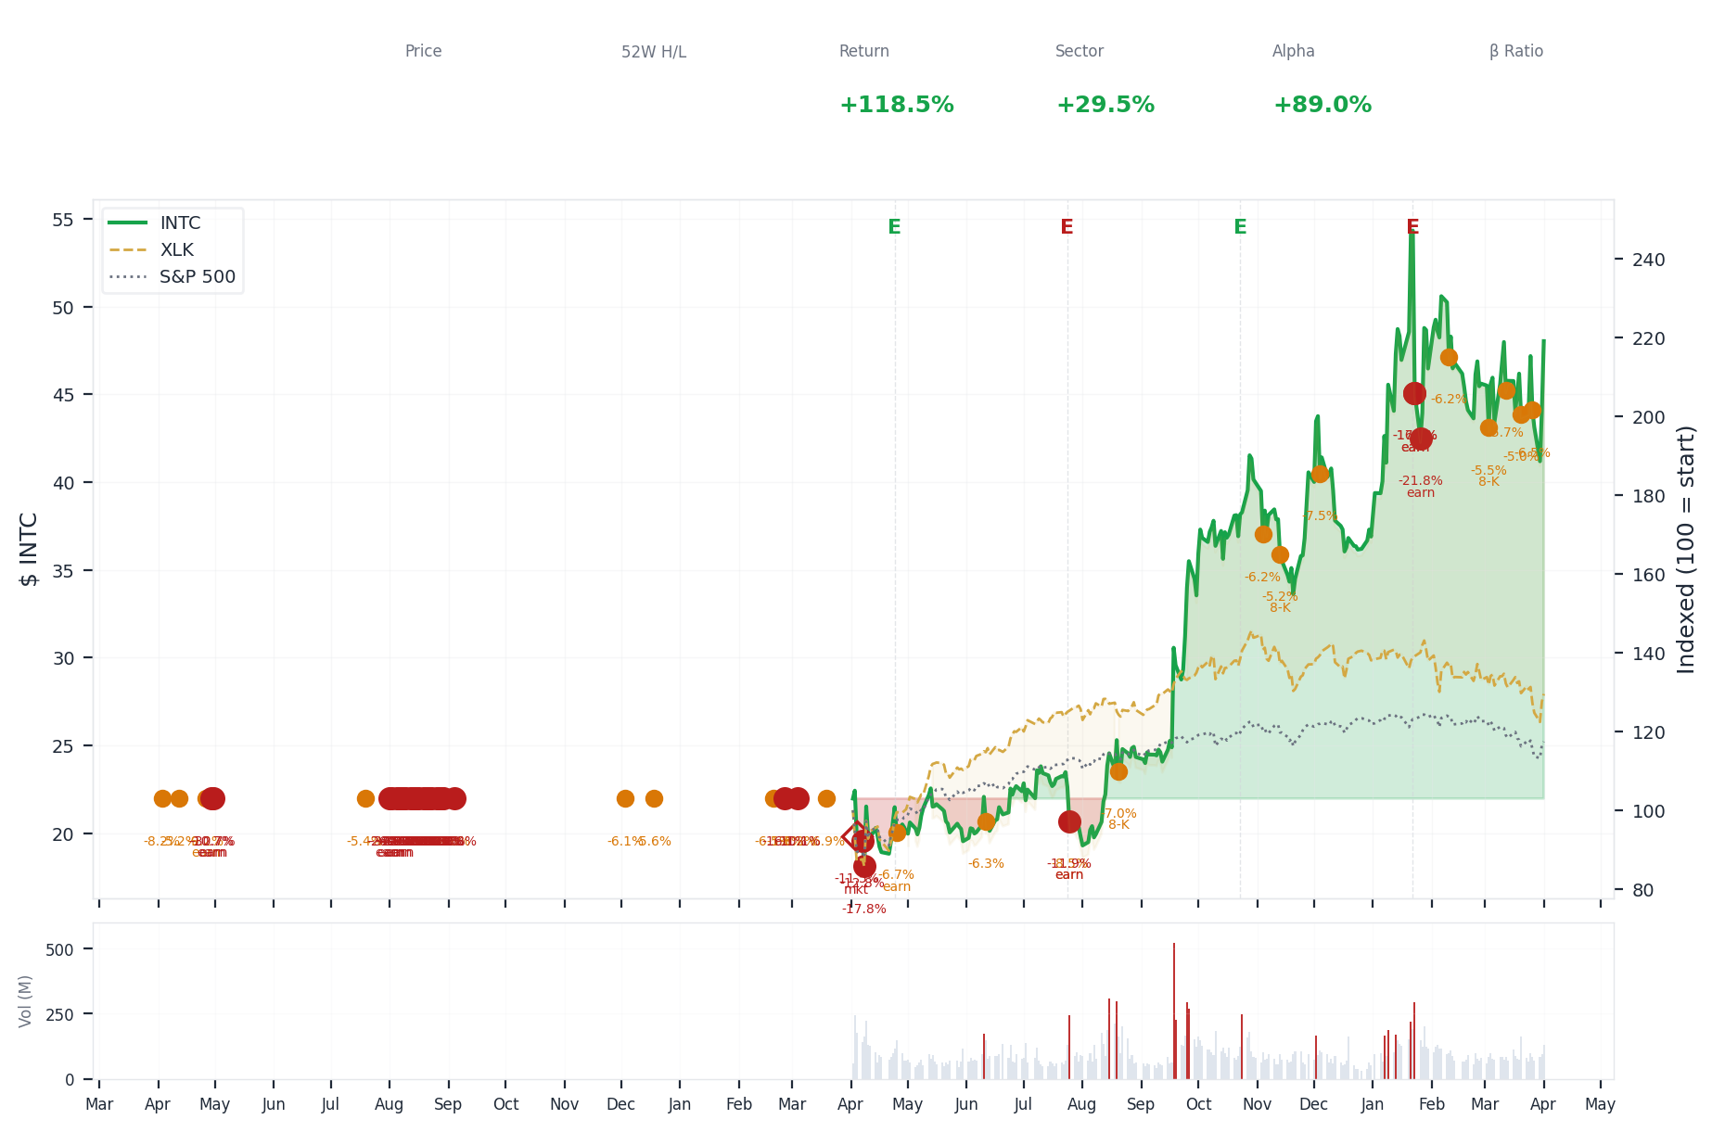
1-Year Performance (Indexed to 100). Red triangles mark single-day drops >= 8%. Orange bands mark multi-day declines >= 15%.
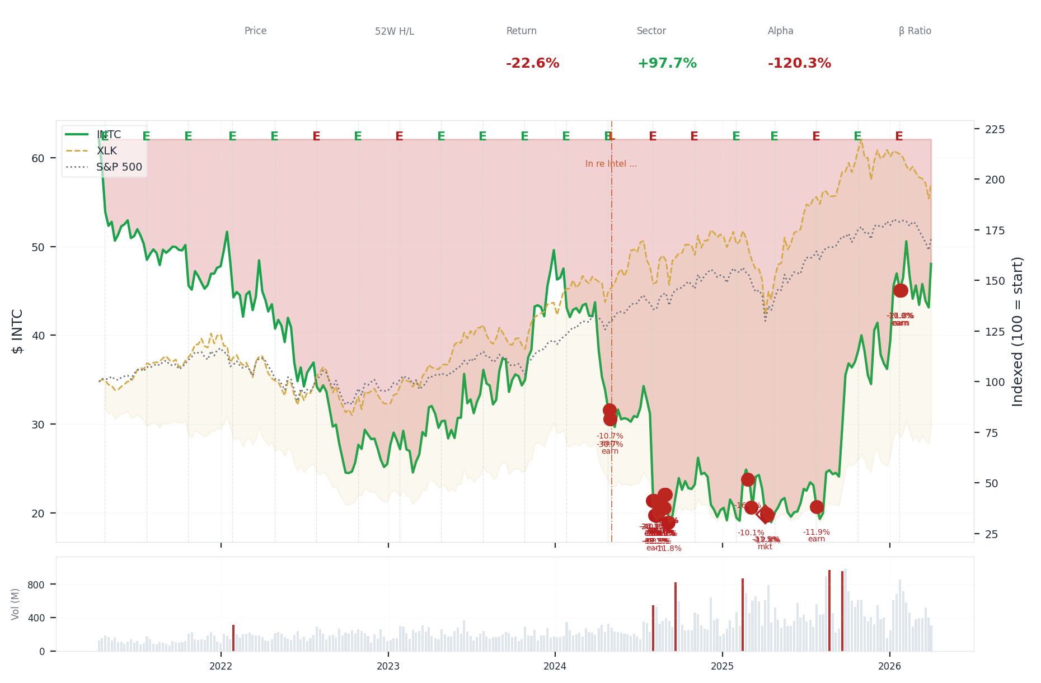
5-Year Performance (Indexed to 100)
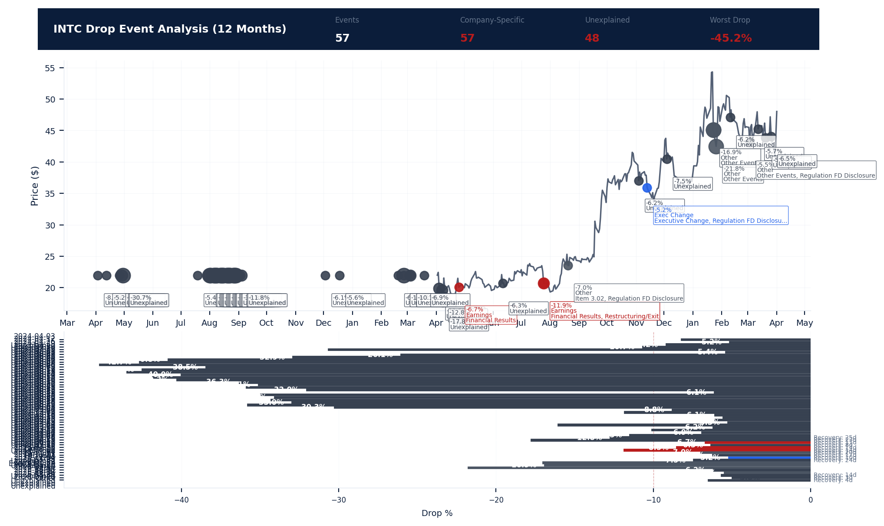
Drop Event Analysis (12 Months)
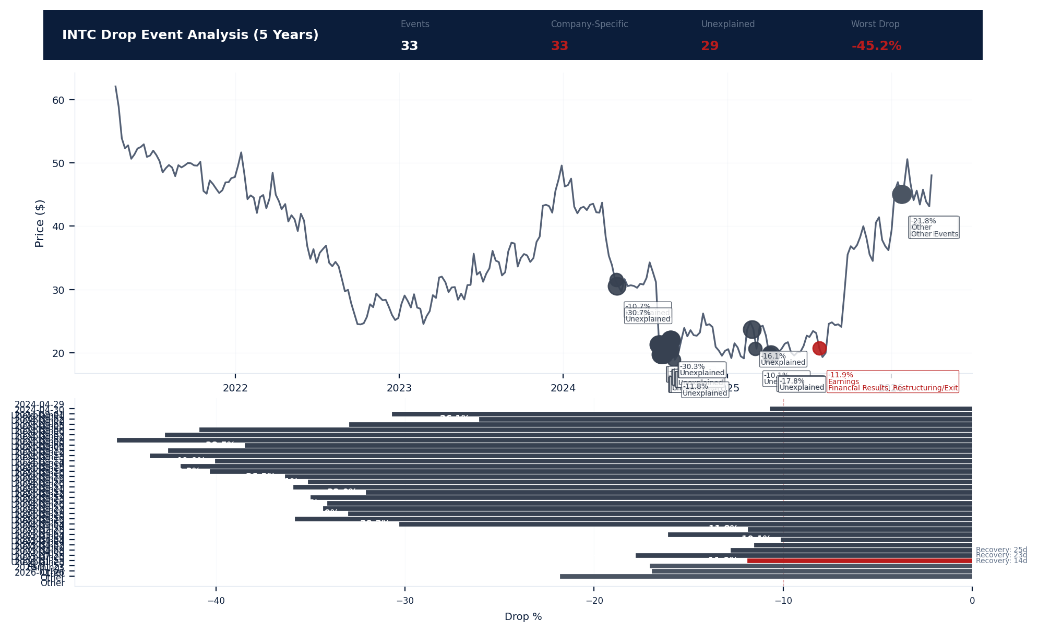
Drop Event Analysis (5 Years)
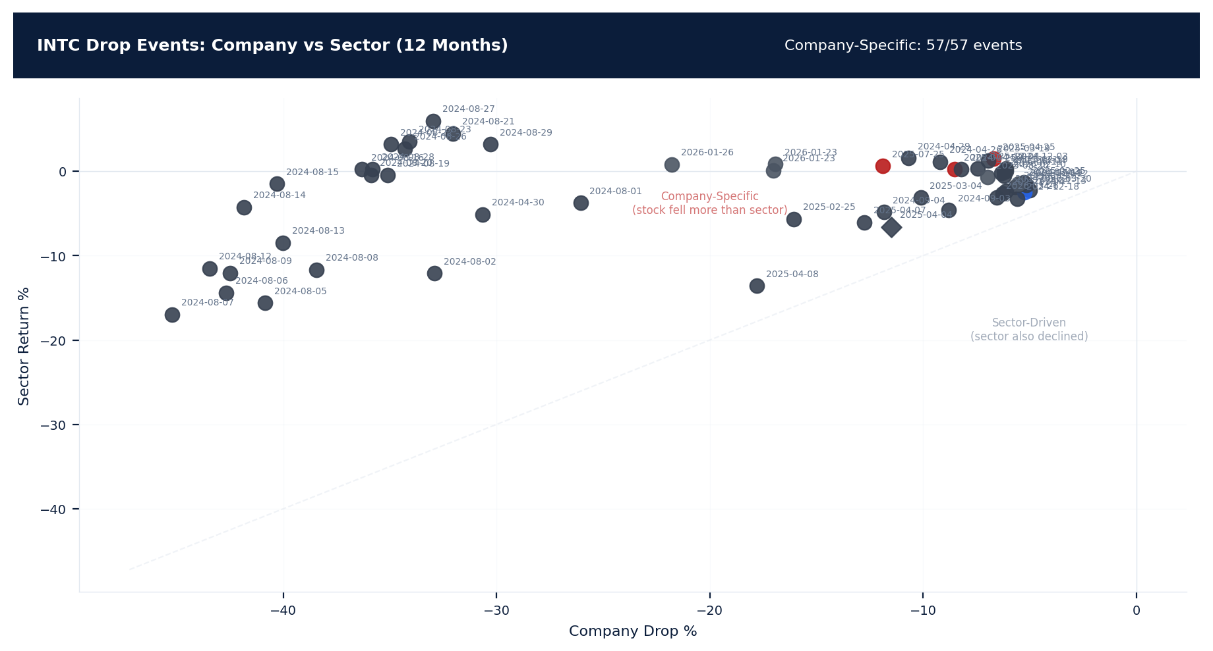
Drop Events: Company vs Sector (12 Months)
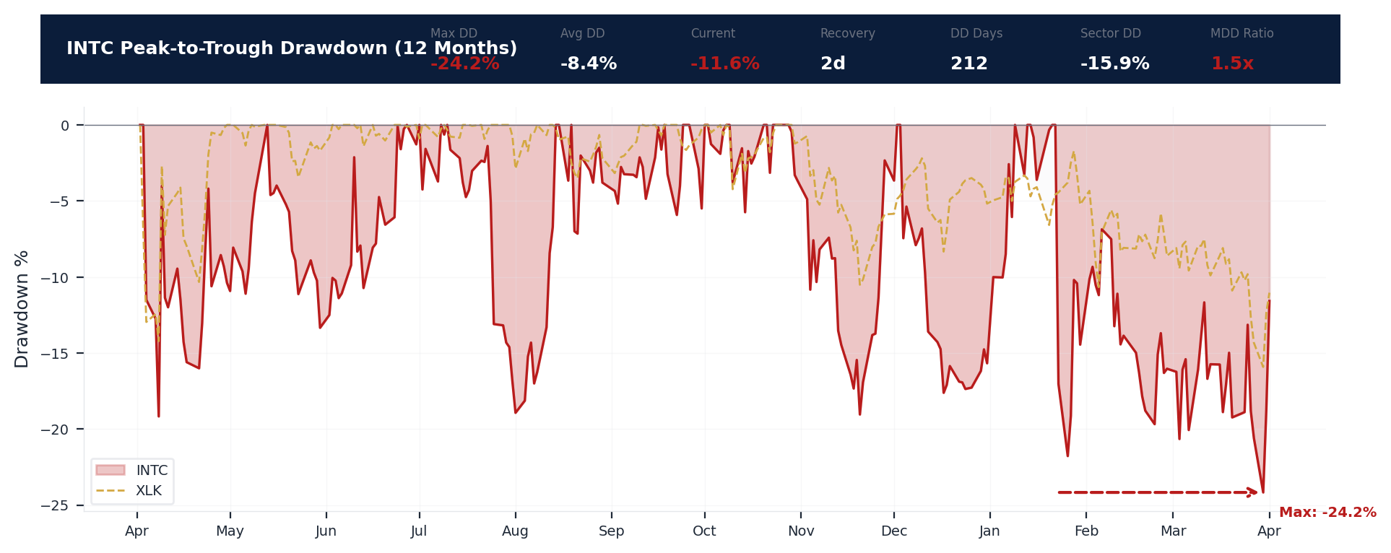
Drawdown Analysis (12 Months)
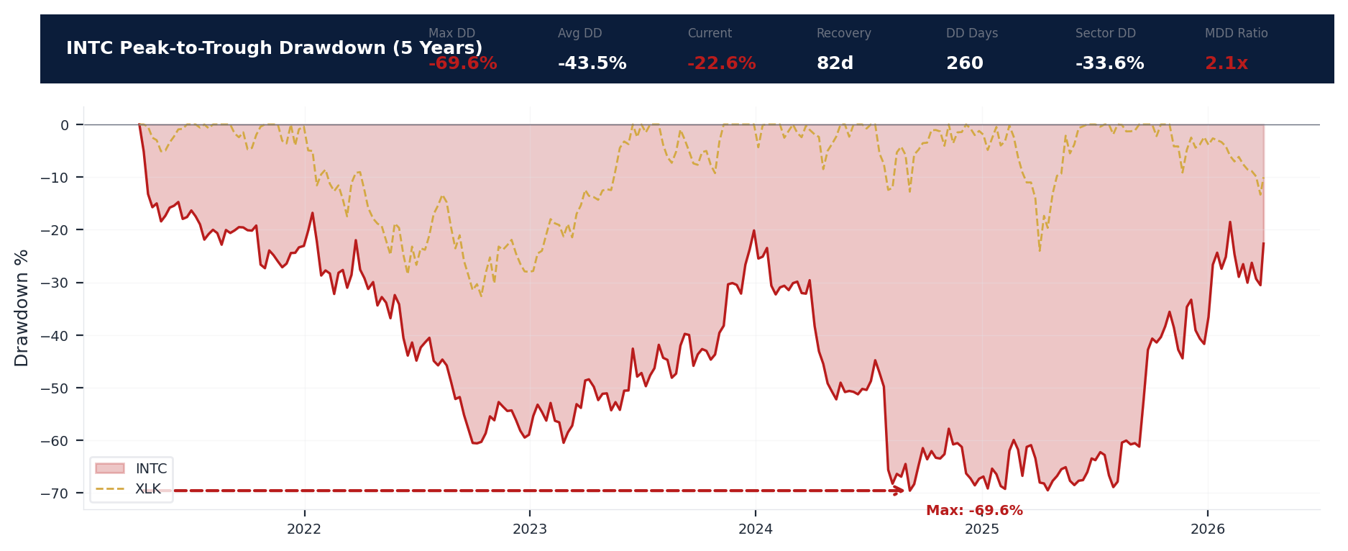
Drawdown Analysis (5 Years)
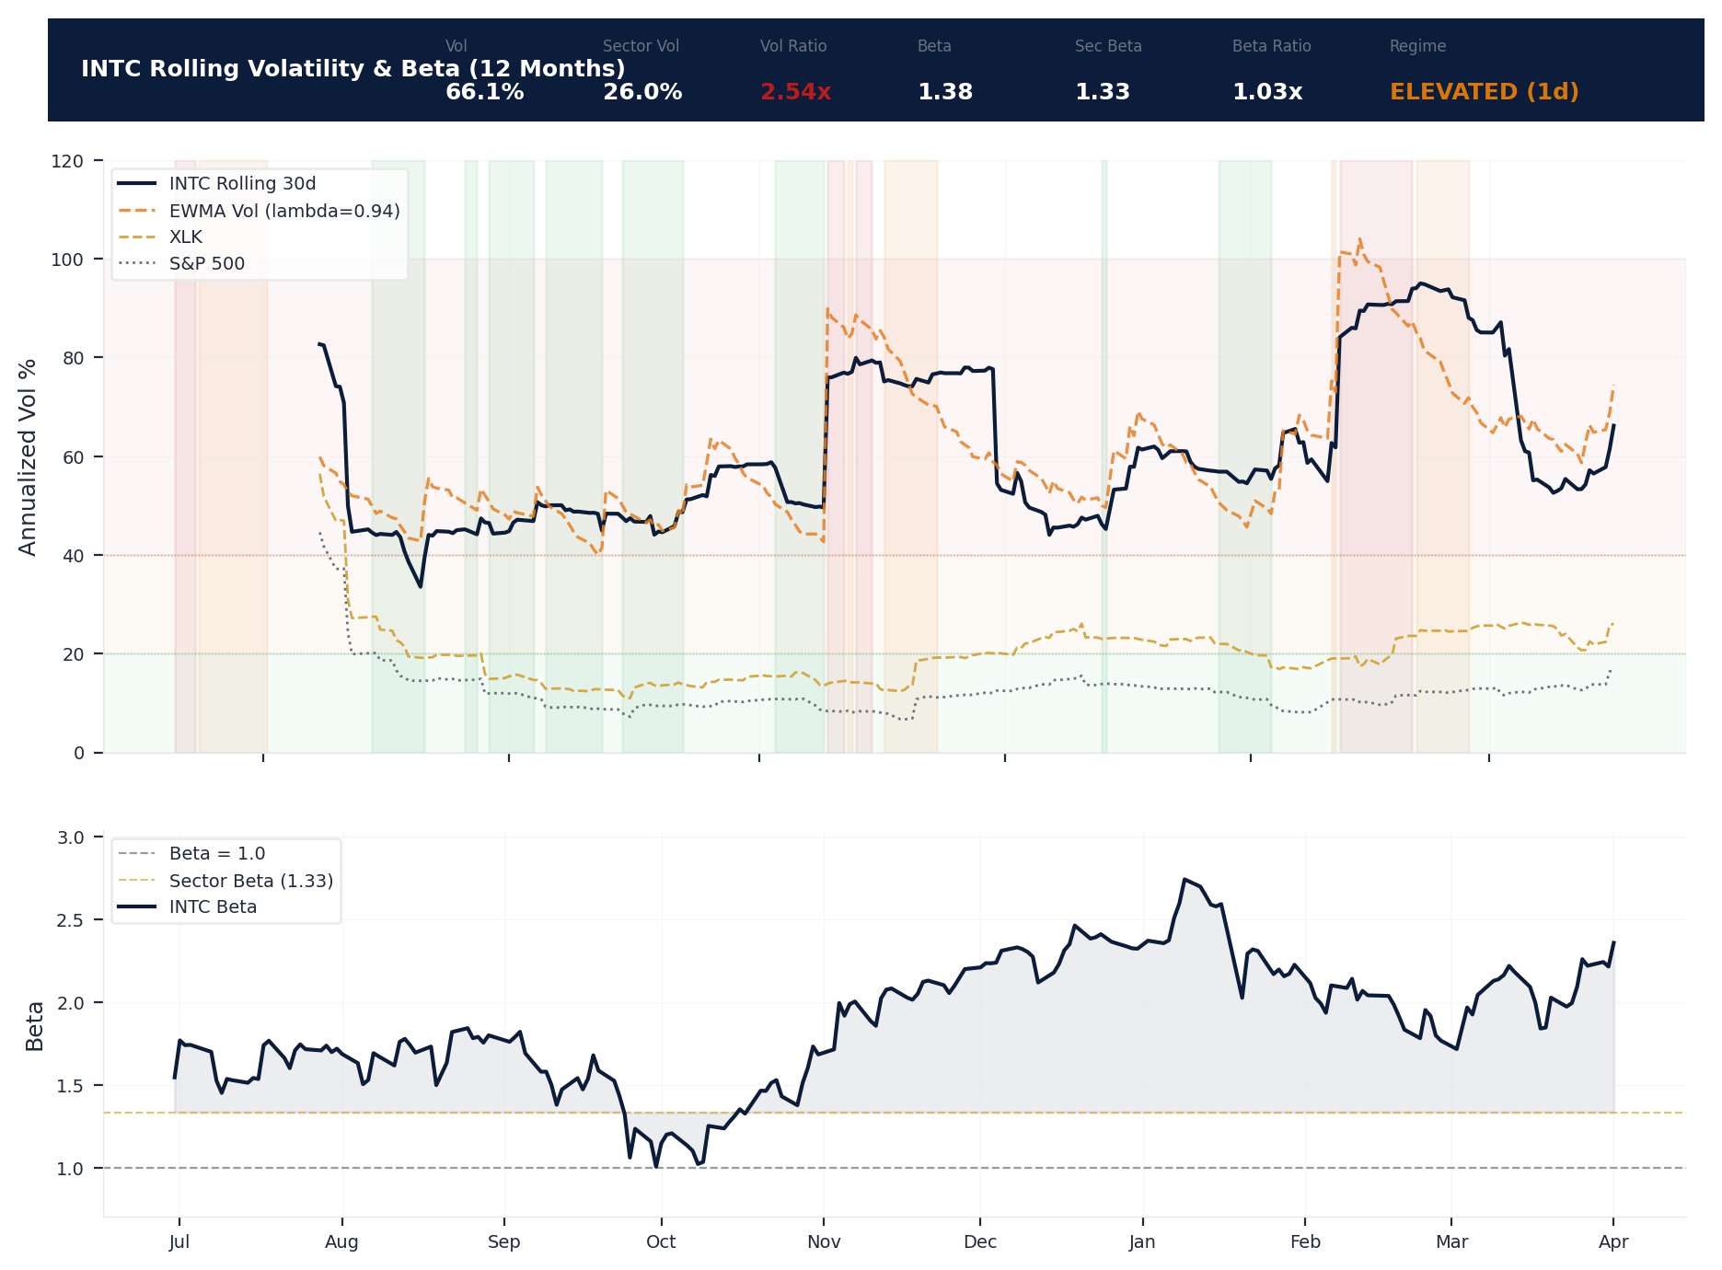
Volatility & Beta Analysis (12 Months)
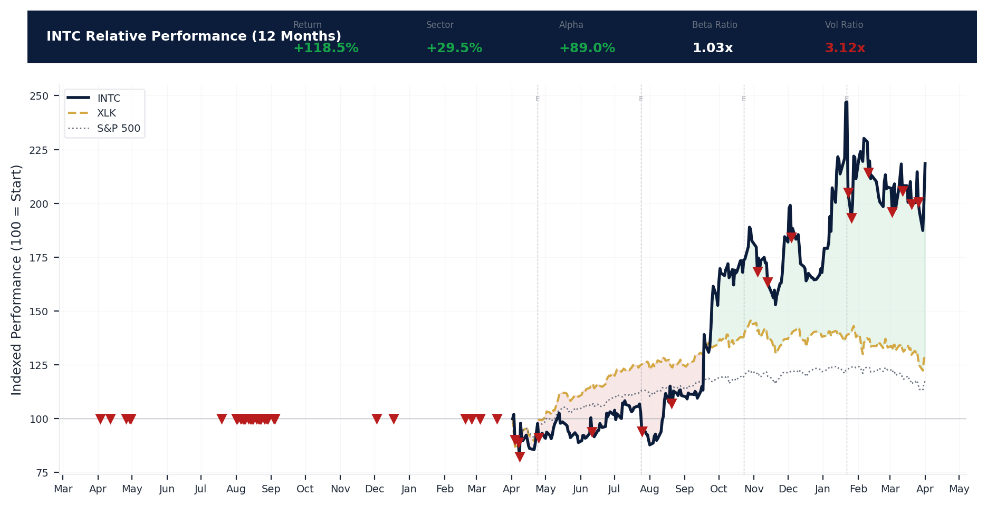
Relative Performance (12 Months)
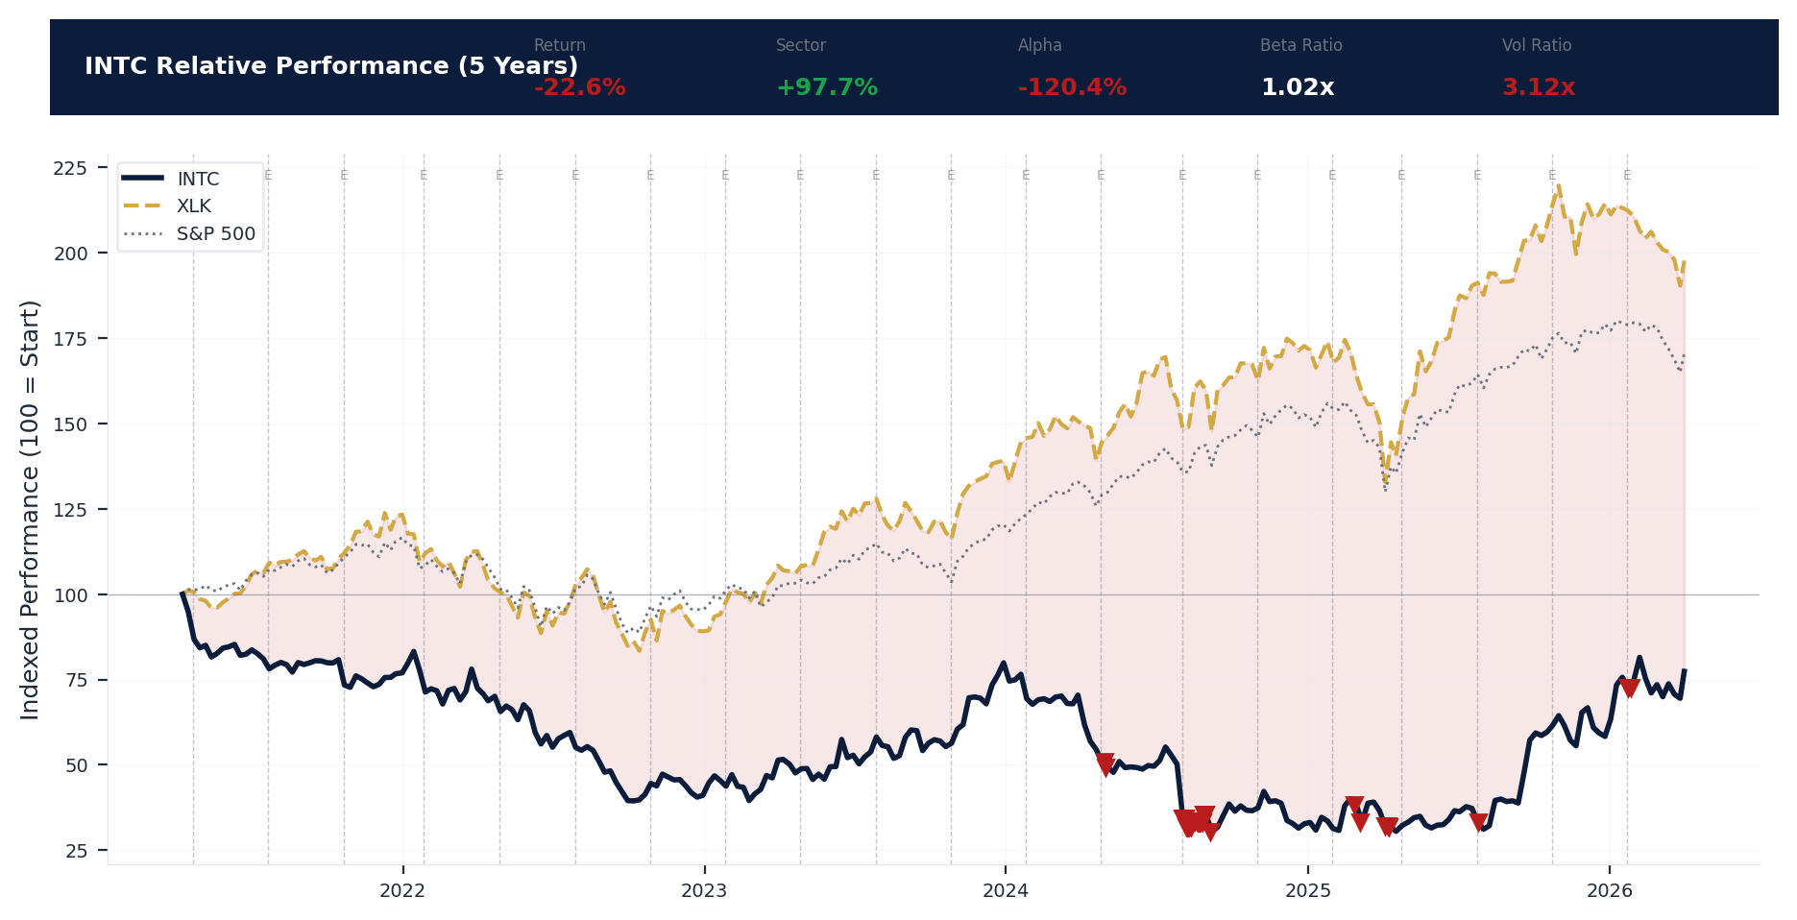
Relative Performance (5 Years)
Metric | Value
Current Price | $48.03
52-Week High | $54.60
52-Week Low | $17.67
1-Year Return | 118.5%
Max Drawdown (1Y) | -24.2%
90-Day Volatility | 73.0% (Ranks at the 0th percentile among 0 peers (peer median: 2.5%))
Beta (vs S&P 500) | 1.38
57 significant stock decline events detected in the 1Y period: 33 critical (>10%), 24 notable (5-10%). 57 were company-specific, 2 were market-wide.
Date | Drop % | Recency | Recovery | Trigger Event | Type | Source
2026-01-23 to 2026-01-26 (4d) | -21.8% | 78% | Not recovered | Earnings release | Company-Specific | https://www.sec.gov/cgi-bin/browse-edgar?action...
2026-01-23 (2d) | -21.8% | 77% | Not recovered | Earnings release | Company-Specific | https://www.sec.gov/cgi-bin/browse-edgar?action...
2026-01-23 (2d) | -16.9% | 77% | Not recovered | Earnings release | Company-Specific | https://www.sec.gov/cgi-bin/browse-edgar?action...
2026-03-26 | -6.5% | 97% | 4 days | Unconfirmed -- Requires Investigation | Company-Specific | --
2026-03-12 | -5.7% | 92% | 14 days | Unconfirmed -- Requires Investigation | Company-Specific | --
2026-02-10 | -6.2% | 82% | Not recovered | Unconfirmed -- Requires Investigation | Company-Specific | --
2026-03-03 (2d) | -4.6% | 89% | Not recovered | 8-K Filing | Company-Specific | https://www.sec.gov/cgi-bin/browse-edgar?action...
2026-03-20 | -5.0% | 95% | 3 days | Unconfirmed -- Requires Investigation | Company-Specific | --
2025-12-04 | -7.5% | 63% | 24 days | Unconfirmed -- Requires Investigation | Company-Specific | --
2025-07-25 | -11.9% | 38% | 14 days | Earnings release | Company-Specific | https://www.sec.gov/cgi-bin/browse-edgar?action...
2025-04-04 to 2025-04-08 (5d) | -19.2% | 25% | 23 days | Unconfirmed -- Requires Investigation | Market-Wide Event | --
2024-08-01 to 2024-09-04 (35d) | -45.2% | 10% | Not recovered | Unconfirmed -- Requires Investigation | Company-Specific | --
2024-08-12 (20d) | -43.5% | 10% | Not recovered | Unconfirmed -- Requires Investigation | Company-Specific | --
2024-08-14 (20d) | -41.8% | 10% | Not recovered | Unconfirmed -- Requires Investigation | Company-Specific | --
2024-08-09 (20d) | -42.5% | 10% | Not recovered | Unconfirmed -- Requires Investigation | Company-Specific | --
2024-08-06 (20d) | -42.7% | 10% | Not recovered | Earnings release | Company-Specific | --
2024-08-15 (20d) | -40.3% | 10% | Not recovered | Unconfirmed -- Requires Investigation | Company-Specific | --
2024-08-13 (20d) | -40.0% | 10% | Not recovered | Unconfirmed -- Requires Investigation | Company-Specific | --
2024-08-05 (20d) | -40.8% | 10% | Not recovered | Earnings release | Company-Specific | --
2024-08-28 (20d) | -35.8% | 11% | Not recovered | Unconfirmed -- Requires Investigation | Company-Specific | --
2024-08-08 (20d) | -38.5% | 10% | Not recovered | Unconfirmed -- Requires Investigation | Company-Specific | --
2024-08-20 (20d) | -35.9% | 10% | Not recovered | Unconfirmed -- Requires Investigation | Company-Specific | --
2024-08-16 (20d) | -36.3% | 10% | Not recovered | Unconfirmed -- Requires Investigation | Company-Specific | --
2024-08-22 (20d) | -35.0% | 10% | Not recovered | Unconfirmed -- Requires Investigation | Company-Specific | --
2024-08-26 (20d) | -34.3% | 11% | Not recovered | Unconfirmed -- Requires Investigation | Company-Specific | --
2024-08-19 (20d) | -35.1% | 10% | Not recovered | Unconfirmed -- Requires Investigation | Company-Specific | --
2024-08-23 (20d) | -34.1% | 10% | Not recovered | Unconfirmed -- Requires Investigation | Company-Specific | --
2025-11-04 | -6.2% | 56% | 17 days | Unconfirmed -- Requires Investigation | Company-Specific | --
2024-08-27 (20d) | -33.0% | 11% | Not recovered | Unconfirmed -- Requires Investigation | Company-Specific | --
2025-02-25 | -16.1% | 21% | Not recovered | Unconfirmed -- Requires Investigation | Company-Specific | --
2024-08-21 (20d) | -32.0% | 10% | Not recovered | Unconfirmed -- Requires Investigation | Company-Specific | --
2025-07-25 | -8.5% | 38% | 14 days | Earnings release | Company-Specific | https://www.sec.gov/cgi-bin/browse-edgar?action...
2024-08-29 (20d) | -30.3% | 11% | Not recovered | Unconfirmed -- Requires Investigation | Company-Specific | --
2025-04-07 (2d) | -12.8% | 25% | 25 days | Unconfirmed -- Requires Investigation | Company-Specific | --
2024-08-02 (20d) | -32.9% | 10% | Not recovered | Earnings release | Company-Specific | --
2025-11-13 | -5.2% | 58% | 10 days | 8-K Filing | Company-Specific | https://www.sec.gov/cgi-bin/browse-edgar?action...
2025-08-20 | -7.0% | 42% | 20 days | 8-K Filing | Company-Specific | https://www.sec.gov/cgi-bin/browse-edgar?action...
2025-04-04 (3d) | -11.4% | 25% | Not recovered | Unconfirmed -- Requires Investigation | Market-Wide Event | --
2024-08-01 (3d) | -26.1% | 10% | Not recovered | Earnings release | Company-Specific | --
2025-03-04 | -10.1% | 22% | Not recovered | Unconfirmed -- Requires Investigation | Company-Specific | --
2024-04-26 to 2024-04-30 (5d) | -30.7% | 7% | Not recovered | Earnings release | Company-Specific | --
2025-06-11 | -6.3% | 32% | 8 days | Unconfirmed -- Requires Investigation | Company-Specific | --
2025-04-25 | -6.7% | 27% | 11 days | Earnings release | Company-Specific | https://www.sec.gov/cgi-bin/browse-edgar?action...
2025-03-19 | -6.9% | 23% | Not recovered | Unconfirmed -- Requires Investigation | Company-Specific | --
2025-03-04 | -6.2% | 22% | Not recovered | Unconfirmed -- Requires Investigation | Company-Specific | --
2024-09-04 (2d) | -11.8% | 11% | Not recovered | Unconfirmed -- Requires Investigation | Company-Specific | --
2025-02-19 | -6.1% | 21% | Not recovered | Unconfirmed -- Requires Investigation | Company-Specific | --
2025-02-25 | -5.3% | 21% | Not recovered | Unconfirmed -- Requires Investigation | Company-Specific | --
2024-09-03 | -8.8% | 11% | Not recovered | Unconfirmed -- Requires Investigation | Company-Specific | --
2024-12-03 (2d) | -6.1% | 15% | Not recovered | Unconfirmed -- Requires Investigation | Company-Specific | --
2024-12-18 | -5.6% | 16% | Not recovered | Unconfirmed -- Requires Investigation | Company-Specific | --
2024-04-29 (2d) | -10.7% | 7% | Not recovered | Earnings release | Company-Specific | --
2024-08-22 | -6.1% | 10% | Not recovered | Unconfirmed -- Requires Investigation | Company-Specific | --
2024-04-26 | -9.2% | 7% | Not recovered | Earnings release | Company-Specific | --
2024-04-03 | -8.2% | 6% | Not recovered | Unconfirmed -- Requires Investigation | Company-Specific | --
2024-07-19 | -5.4% | 9% | Not recovered | Unconfirmed -- Requires Investigation | Company-Specific | --
2024-04-12 | -5.2% | 6% | Not recovered | Unconfirmed -- Requires Investigation | Company-Specific | --
33 significant stock decline events detected in the 5Y period: 33 critical (>10%). 33 were company-specific, 2 were market-wide.
Date | Drop % | Recency | Recovery | Trigger Event | Type | Source
2026-01-23 to 2026-01-26 (4d) | -21.8% | 78% | Not recovered | Earnings release | Company-Specific | https://www.sec.gov/cgi-bin/browse-edgar?action...
2026-01-23 (2d) | -21.8% | 77% | Not recovered | Earnings release | Company-Specific | https://www.sec.gov/cgi-bin/browse-edgar?action...
2026-01-23 (2d) | -16.9% | 77% | Not recovered | Earnings release | Company-Specific | https://www.sec.gov/cgi-bin/browse-edgar?action...
2025-07-25 | -11.9% | 38% | 14 days | Earnings release | Company-Specific | https://www.sec.gov/cgi-bin/browse-edgar?action...
2025-04-04 to 2025-04-08 (5d) | -19.2% | 25% | 23 days | Unconfirmed -- Requires Investigation | Market-Wide Event | --
2024-08-01 to 2024-09-04 (35d) | -45.2% | 10% | Not recovered | Unconfirmed -- Requires Investigation | Company-Specific | --
2024-08-12 (20d) | -43.5% | 10% | Not recovered | Unconfirmed -- Requires Investigation | Company-Specific | --
2024-08-14 (20d) | -41.8% | 10% | Not recovered | Unconfirmed -- Requires Investigation | Company-Specific | --
2024-08-09 (20d) | -42.5% | 10% | Not recovered | Unconfirmed -- Requires Investigation | Company-Specific | --
2024-08-06 (20d) | -42.7% | 10% | Not recovered | Earnings release | Company-Specific | --
2024-08-15 (20d) | -40.3% | 10% | Not recovered | Unconfirmed -- Requires Investigation | Company-Specific | --
2024-08-13 (20d) | -40.0% | 10% | Not recovered | Unconfirmed -- Requires Investigation | Company-Specific | --
2024-08-05 (20d) | -40.8% | 10% | Not recovered | Earnings release | Company-Specific | --
2024-08-28 (20d) | -35.8% | 11% | Not recovered | Unconfirmed -- Requires Investigation | Company-Specific | --
2024-08-08 (20d) | -38.5% | 10% | Not recovered | Unconfirmed -- Requires Investigation | Company-Specific | --
2024-08-20 (20d) | -35.9% | 10% | Not recovered | Unconfirmed -- Requires Investigation | Company-Specific | --
2024-08-16 (20d) | -36.3% | 10% | Not recovered | Unconfirmed -- Requires Investigation | Company-Specific | --
2024-08-22 (20d) | -35.0% | 10% | Not recovered | Unconfirmed -- Requires Investigation | Company-Specific | --
2024-08-26 (20d) | -34.3% | 11% | Not recovered | Unconfirmed -- Requires Investigation | Company-Specific | --
2024-08-19 (20d) | -35.1% | 10% | Not recovered | Unconfirmed -- Requires Investigation | Company-Specific | --
2024-08-23 (20d) | -34.1% | 10% | Not recovered | Unconfirmed -- Requires Investigation | Company-Specific | --
2024-08-27 (20d) | -33.0% | 11% | Not recovered | Unconfirmed -- Requires Investigation | Company-Specific | --
2025-02-25 | -16.1% | 21% | Not recovered | Unconfirmed -- Requires Investigation | Company-Specific | --
2024-08-21 (20d) | -32.0% | 10% | Not recovered | Unconfirmed -- Requires Investigation | Company-Specific | --
2024-08-29 (20d) | -30.3% | 11% | Not recovered | Unconfirmed -- Requires Investigation | Company-Specific | --
2025-04-07 (2d) | -12.8% | 25% | 25 days | Unconfirmed -- Requires Investigation | Company-Specific | --
2024-08-02 (20d) | -32.9% | 10% | Not recovered | Earnings release | Company-Specific | --
2025-04-04 (3d) | -11.4% | 25% | Not recovered | Unconfirmed -- Requires Investigation | Market-Wide Event | --
2024-08-01 (3d) | -26.1% | 10% | Not recovered | Earnings release | Company-Specific | --
2025-03-04 | -10.1% | 22% | Not recovered | Unconfirmed -- Requires Investigation | Company-Specific | --
2024-04-26 to 2024-04-30 (5d) | -30.7% | 7% | Not recovered | Earnings release | Company-Specific | --
2024-09-04 (2d) | -11.8% | 11% | Not recovered | Unconfirmed -- Requires Investigation | Company-Specific | --
2024-04-29 (2d) | -10.7% | 7% | Not recovered | Earnings release | Company-Specific | --
Short Interest
Metric | Value
Short % of Float | 2.3% (Ranks at the 71st percentile among 0 peers (peer median: 4.0%))
Days to Cover | 1.59
6-Month Trend | STABLE
vs Sector Ratio | N/A
Earnings Guidance Track Record
Metric | Value
Beat Rate | 0.7%
Consecutive Misses | 1
Guidance Withdrawals | 0
Philosophy | MIXED
Quarter | Est. EPS | Actual EPS | Result | Miss Magnitude | Stock Reaction
Q1 2026 | $-0.09 | $-0.12 | MISS | +33.3% | -27.6%
Q4 2025 | $0.01 | $0.23 | BEAT | N/A | N/A
Q3 2025 | $0.01 | $-0.10 | MISS | +1100.0% | N/A
Q2 2025 | N/A | $0.13 | N/A | N/A | N/A
Q1 2025 | $-0.22 | $-0.03 | BEAT | N/A | +86.5%
Q4 2024 | $-0.25 | $-3.88 | MISS | +1452.0% | N/A
Q3 2024 | $0.10 | $0.02 | MISS | +80.0% | -80.2%
Q2 2024 | $0.14 | $0.18 | BEAT | N/A | +31.7%
Q1 2024 | $0.45 | $0.54 | BEAT | N/A | +20.3%
Q4 2023 | $0.22 | $0.41 | BEAT | N/A | +87.0%
Q3 2023 | $-0.03 | $0.13 | BEAT | N/A | N/A
Q2 2023 | $-0.14 | $-0.04 | BEAT | N/A | +72.2%
Q1 2023 | $0.20 | $0.10 | MISS | +50.0% | -50.5%
Q4 2022 | $0.33 | $0.59 | BEAT | N/A | +80.0%
Q3 2022 | $0.70 | $0.29 | MISS | +58.6% | -58.3%
Q2 2022 | $0.80 | $0.87 | BEAT | N/A | +9.2%
Analyst Consensus
Metric | Value
Analyst Coverage | 41
Mean Target Price | $47
Target Price High | $72
Target Price Low | $20
Stock Drop Analysis
Date | Magnitude | Type | Trigger / Attribution | Sector Return | Company-Specific
2024-08-01 to 2024-09-04 | -45.2% | MULTI_DAY (35d) | Unknown | -17.0% | Yes
2024-08-12 | -43.5% | MULTI_DAY (20d) | Unknown | -11.5% | Yes
2024-08-06 | -42.7% | MULTI_DAY (20d) | earnings_release | -14.4% | Yes
2024-08-09 | -42.5% | MULTI_DAY (20d) | Unknown | -12.1% | Yes
2024-08-14 | -41.8% | MULTI_DAY (20d) | Unknown | -4.2% | Yes
2024-08-05 | -40.8% | MULTI_DAY (20d) | earnings_release | -15.6% | Yes
2024-08-15 | -40.3% | MULTI_DAY (20d) | Unknown | -1.5% | Yes
2024-08-13 | -40.0% | MULTI_DAY (20d) | Unknown | -8.5% | Yes
2024-08-08 | -38.5% | MULTI_DAY (20d) | Unknown | -11.7% | Yes
2024-08-16 | -36.3% | MULTI_DAY (20d) | Unknown | +0.2% | Yes
2024-08-20 | -35.9% | MULTI_DAY (20d) | Unknown | -0.4% | Yes
2024-08-28 | -35.8% | MULTI_DAY (20d) | Unknown | +0.3% | Yes
2024-08-19 | -35.1% | MULTI_DAY (20d) | Unknown | -0.5% | Yes
2024-08-22 | -35.0% | MULTI_DAY (20d) | Unknown | +3.2% | Yes
2024-08-26 | -34.3% | MULTI_DAY (20d) | Unknown | +2.7% | Yes
Class Period Potential: 33 company-specific drop(s) exceeding 10% identified. Severe stock drops that are company-specific (not explained by sector movement) are the primary anchors for SCA class periods. Plaintiffs will allege the drop occurred when the 'truth emerged' following prior misstatements. [HIGH]
Insider Trading Analysis
Metric | Value
Net Direction (12mo) | NET_SELLING
10b5-1 Plan % | 0.0%
Buy Transactions | 1
Sell Transactions | 1
Cluster Events | 0
Transaction Detail
Date | Insider | Title | Type | Shares | Value | 10b5-1
2026-03-02 | Zinsner David | EVP, CFO | EXERCISE | 70,356 | N/A | No (Discretionary)
2026-03-02 | Zinsner David | EVP, CFO | EXERCISE | 28,996 | N/A | No (Discretionary)
2026-03-02 | Zinsner David | EVP, CFO | EXERCISE | 70,356 | N/A | No (Discretionary)
2026-03-02 | Zinsner David | EVP, CFO | EXERCISE | 28,996 | N/A | No (Discretionary)
2026-03-02 | Zinsner David | EVP, CFO | TAX_WITHHOLD | 34,883 | $1.6M | No (Discretionary)
2026-03-02 | Zinsner David | EVP, CFO | TAX_WITHHOLD | 14,377 | $645.2K | No (Discretionary)
2026-03-02 | GAWEL SCOTT | CVP, Chief Accounting Officer | EXERCISE | 7,859 | N/A | No (Discretionary)
2026-03-02 | GAWEL SCOTT | CVP, Chief Accounting Officer | EXERCISE | 2,025 | N/A | No (Discretionary)
2026-03-02 | GAWEL SCOTT | CVP, Chief Accounting Officer | EXERCISE | 2,418 | N/A | No (Discretionary)
2026-03-02 | GAWEL SCOTT | CVP, Chief Accounting Officer | EXERCISE | 7,859 | N/A | No (Discretionary)
2026-03-02 | GAWEL SCOTT | CVP, Chief Accounting Officer | EXERCISE | 2,025 | N/A | No (Discretionary)
2026-03-02 | GAWEL SCOTT | CVP, Chief Accounting Officer | EXERCISE | 2,418 | N/A | No (Discretionary)
2026-03-02 | GAWEL SCOTT | CVP, Chief Accounting Officer | TAX_WITHHOLD | 3,897 | $174.9K | No (Discretionary)
2026-03-02 | GAWEL SCOTT | CVP, Chief Accounting Officer | TAX_WITHHOLD | 1,004 | $45.1K | No (Discretionary)
2026-03-02 | GAWEL SCOTT | CVP, Chief Accounting Officer | TAX_WITHHOLD | 1,199 | $53.8K | No (Discretionary)
2026-03-02 | Chandrasekaran Nagasubramaniyan | EVP, CT & Ops Off, GM Foundry | EXERCISE | 59,878 | N/A | No (Discretionary)
2026-03-02 | Chandrasekaran Nagasubramaniyan | EVP, CT & Ops Off, GM Foundry | EXERCISE | 59,878 | N/A | No (Discretionary)
2026-03-02 | Chandrasekaran Nagasubramaniyan | EVP, CT & Ops Off, GM Foundry | TAX_WITHHOLD | 24,760 | $1.1M | No (Discretionary)
2026-03-02 | Miller Boise April | EVP and Chief Legal Officer | EXERCISE | 16,195 | N/A | No (Discretionary)
2026-03-02 | Miller Boise April | EVP and Chief Legal Officer | EXERCISE | 39,295 | N/A | No (Discretionary)
Executive Departures
No executive departures identified in the trailing 18 months.
Capital Markets Activity
No significant capital markets activity identified in the trailing 3-year period.

ELEVATED CONCERN
Intel's revenue declined slightly to $52.85B from $53.10B prior year, but its net loss narrowed sharply to -$267M from a staggering -$18.76B; this dramatic improvement from deep losses creates fertile ground for shareholder allegations of a misleading turnaround narrative if future results disappoint. Despite the reduced loss, the Altman Z-Score of 2.05 sits in the grey zone, perilously close to the 1.81 distress threshold, highlighting bankruptcy risk that underpins potential going-concern shareholder claims. The Piotroski F-Score of 6, also in the grey zone, reflects a mixed financial transformation with only 6 of 9 possible strength signals, and any stumble in this fragile recovery could trigger a Section 10(b) suit alleging officers overstated the sustainability of improvements. A strong current ratio of 2.02 and low debt-to-equity of 0.41 provide some balance sheet defense against insolvency claims, but the core D&O exposure is that Intel's leadership is betting the company on a capital-intensive foundry strategy while still reporting substantial operating losses of -$2.21B, which could lead to allegations of strategic misrepresentation.
Section 3: Financial Health
The company reported revenue of $52.9B and net income of $-267.0M (per FY2025 10-K, Company Facts API CIK50863). Revenue declined 0.5% year-over-year (from $53.1B). The company is operating at a net loss (margin: -0.5%), increasing financial distress risk. Distress indicators show mixed signals: Z-Score 2.05 (grey zone) and O-Score 0.00 (safe zone). Financial stress could limit litigation defense resources. D/E ratio of 0.41 is moderate. Interest coverage of -2.0x is thin, raising concerns about debt service sustainability. **Earnings quality concern** (OCF/NI: -36.32): low cash conversion suggests reported income may include material non-cash items, increasing restatement risk and SCA exposure. D&O underwriting concern: poor earnings quality collectively elevate the probability of securities claims and should be reflected in pricing and terms.
Income Statement
Metric | FY2024 | FY2025 | YoY Change
Total revenue / net sales | $53.1B | $52.9B | -0.5%
Cost of revenue / COGS | $35.8B | $34.5B | -3.6%
Gross profit | $17.3B | $18.4B | 5.9%
Operating income / loss | $-11.7B | $-2.2B | 81.0%
Net income / net loss | $-18.8B | $-267.0M | 98.6%
Basic earnings per share | $-4.38 | $-0.06 | 98.6%
Diluted earnings per share | $-4.38 | $-0.06 | 98.6%
Interest expense | $987.0M | $1.1B | 12.1%
Income tax expense / benefit | $8.0B | $1.5B | -80.9%
Research and development expense | $16.5B | $13.8B | -16.8%
Selling, general and administrative expense | $5.5B | $4.6B | -16.0%
Earnings before interest and taxes (EBIT) | $-11.7B | $-2.2B | 81.0%
Weighted average shares outstanding (basic) | 4.3B | 4.5B | 5.8%
Weighted average shares outstanding (diluted) | 4.3B | 4.5B | 5.8%
Total comprehensive income / loss | $-19.3B | $557.0M | 102.9%
Other income / non-operating income | $226.0M | $3.3B | 1341.2%
Restructuring charges | $3.5B | $476.0M | -86.4%
Impairment charges (goodwill, intangibles, long-lived assets) | $3.0B | $0 | -100.0%
Income from operations | $-11.7B | $-2.2B | 81.0%
Pre-tax income | $-11.2B | $1.6B | 113.9%
Stock-based compensation expense | $3.4B | $2.4B | -28.6%
Income before income taxes | $-11.2B | $1.6B | 113.9%
Other comprehensive income/loss, net of tax | $-496.0M | $824.0M | 266.1%
Total operating expenses | $29.0B | $20.6B | -29.1%
Total costs and expenses | N/A | $55.1B | N/A
Non-operating income / expense | $226.0M | $3.3B | 1341.2%
Asset impairment charges (long-lived assets) | $3.6B | $522.0M | -85.6%
Impairment of intangible assets (excluding goodwill) | $108.0M | $108.0M | 0.0%
Severance costs from restructuring or workforce reductions | $2.5B | $1.8B | -27.9%
Current federal income tax expense / benefit | $600.0M | $310.0M | -48.3%
Current state and local income tax expense / benefit | $-8.0M | $-18.0M | -125.0%
Current foreign income tax expense / benefit | $1.4B | $910.0M | -33.3%
Deferred federal income tax expense / benefit | $6.2B | $245.0M | -96.0%
Deferred state and local income tax expense / benefit | $67.0M | $-11.0M | -116.4%
Advertising expense | $856.0M | $610.0M | -28.7%
Goodwill impairment loss | $3.0B | $0 | -100.0%
Impairment of intangible assets (finite-lived and indefinite-lived) | $108.0M | $108.0M | 0.0%
Gross margin percentage | 32.7% | 34.8% | 6.5%
Operating margin percentage | -22.0% | -4.2% | 81.0%
Net margin percentage | -35.3% | -0.5% | 98.6%
EBITDA margin percentage | -3.2% | 16.2% | 597.2%
Effective tax rate | $-72 | $98 | 237.4%
Interest coverage ratio | $-12 | $-2 | 83.1%
Balance Sheet
Metric | FY2024 | FY2025 | YoY Change
Total assets | $196.5B | $211.4B | 7.6%
Total stockholders' equity | $99.3B | $114.3B | 15.1%
Total current assets | $47.3B | $63.7B | 34.6%
Total current liabilities | $35.7B | $31.6B | -11.5%
Cash and cash equivalents | N/A | $14.3B | N/A
Accounts receivable, net | $3.5B | $3.8B | 10.4%
Inventory, net | $12.2B | $11.6B | -4.8%
Property, plant and equipment, net | $107.9B | $105.4B | -2.3%
Goodwill | $24.7B | $23.9B | -3.2%
Intangible assets, net (excluding goodwill) | $3.7B | $2.8B | -24.9%
Long-term debt, non-current | $46.3B | $44.1B | -4.7%
Short-term debt / current portion of long-term debt | $3.7B | $2.5B | -33.0%
Retained earnings / accumulated deficit | $49.0B | $49.0B | -0.1%
Total debt (short-term + long-term) | $50.0B | $46.6B | -6.8%
Common shares outstanding | 4.3B | 5.0B | 15.3%
Accounts payable | $12.6B | $9.9B | -21.3%
Minority / noncontrolling interest | $5.8B | $12.1B | 109.6%
Short-term investments / marketable securities | $13.8B | $23.2B | 67.6%
Other current assets | $9.6B | $10.8B | 12.8%
Accrued liabilities | $1.8B | $604.0M | -65.6%
Deferred income tax assets, net | $603.0M | $570.0M | -5.5%
Deferred income tax liabilities, net | $1.5B | $1.7B | 15.3%
Pension and post-retirement benefit liabilities | N/A | $664.0M | N/A
Accumulated other comprehensive income/loss | $-711.0M | $113.0M | 115.9%
Common stock par value | $50.9B | $65.2B | 27.9%
Total liabilities and stockholders' equity | $196.5B | $211.4B | 7.6%
Preferred stock value | $0 | $0 | N/A
Right-of-use assets (operating and finance leases) | $457.0M | $421.0M | -7.9%
Other non-current assets | $7.5B | $7.1B | -4.6%
Other non-current liabilities | $9.5B | $9.4B | -1.0%
Unrecognized tax benefits (UTB) liability | $1.1B | $1.4B | 22.5%
Commercial paper outstanding | $0 | $0 | N/A
Debt instrument carrying amount (face value) | $51.0B | $47.2B | -7.4%
Fair value of derivative instruments | $948.0M | $937.0M | -1.2%
Common stock shares authorized | 10.0B | 10.0B | 0.0%
Derivative assets at fair value | $948.0M | $937.0M | -1.2%
Derivative liabilities at fair value | $1.1B | $654.0M | -39.7%
Derivative notional amount (off-balance-sheet exposure) | $46.0B | $47.2B | 2.7%
Current ratio | $1 | $2 | 52.0%
Quick ratio | $1 | $2 | 67.4%
Debt-to-equity ratio | $1 | $0 | -19.1%
Debt-to-EBITDA ratio | $-29 | $5 | 118.8%
Tangible book value | $70.9B | $87.6B | 23.6%
Net debt | N/A | $32.3B | N/A
Book value per share | $22.93 | $22.88 | -0.2%
Return on assets | $-10 | $-0 | 98.6%
Return on equity | $-19 | $-0 | 98.8%
Asset turnover ratio | $0 | $0 | -7.5%
Key Balance Sheet Ratios
Ratio | Value | Assessment
Current Ratio | 2.02 | Healthy
Debt/Equity | 0.41 | Conservative
Debt/Assets | 1.00 | High
Cash/Assets | 6.7%
Cash Flow Statement
Metric | FY2024 | FY2025 | YoY Change
Net cash from operating activities | $8.3B | $9.7B | 17.0%
Net cash from investing activities | $-18.3B | $-14.8B | 18.8%
Net cash from financing activities | $11.1B | $11.6B | 4.0%
Capital expenditures | $23.9B | $14.6B | -38.8%
Depreciation and amortization | $10.0B | $10.8B | 8.1%
Dividends paid | $1.6B | $0 | -100.0%
Acquisitions, net of cash acquired | $82.0M | N/A | N/A
Proceeds from issuance of debt | $3.0B | $0 | -100.0%
Repayments of debt | $2.3B | $3.8B | 63.9%
Proceeds from stock issuance | $987.0M | $771.0M | -21.9%
Interest paid (supplemental) | $987.0M | $1.1B | 12.1%
Income taxes paid (supplemental) | $2.2B | $2.3B | 4.4%
Stock-based compensation (cash flow adjustment) | $3.4B | $2.4B | -28.6%
Net increase/decrease in cash and equivalents | $1.2B | $6.5B | 452.4%
Purchases of investments | $37.9B | $24.3B | -35.9%
Proceeds from sale/maturity of investments | $41.5B | $15.4B | -62.9%
Deferred income taxes (cash flow adjustment) | $6.1B | $329.0M | -94.6%
Change in accounts receivable | $75.0M | $449.0M | 498.7%
Change in inventory | $1.1B | $138.0M | -87.5%
Change in accounts payable | $634.0M | $297.0M | -53.1%
Amortization of intangible assets | $1.4B | $949.0M | -33.5%
Proceeds from sale / divestiture of businesses | $0 | $6.2B | N/A
Free cash flow | $-15.7B | $-4.9B | 68.4%
FCF-to-revenue ratio | $-29 | $-9 | 68.2%
Capex-to-revenue ratio | $45 | $28 | -38.5%
Capex-to-depreciation ratio | $2 | $1 | -43.4%
Dividend payout ratio | $-9 | $0 | 100.0%
Free cash flow per share | $-3.62 | $-0.99 | 72.6%
Key Ratios: Company vs. Peers
Ratio | Value
Current Ratio | 2.02
Quick Ratio | 1.65
Debt/Equity | 0.41
Interest Coverage | -2.0x
Distress Indicators
Model | Score | Zone | Trajectory | D&O Context
Altman Z-Score | 2.05 | Grey Zone | FY2024: 0.5 -> FY2025: 0.7 (stable) | Bankruptcy predictor. Distress zone companies face fiduciary duty scrutiny under Revlon/zone of insolvency doctrine.
Beneish M-Score | -2.63 | Safe | N/A | Earnings manipulation detector. Scores above -1.78 indicate elevated restatement risk, a primary SCA catalyst.
Ohlson O-Score | 0.00 | Safe | N/A | Bankruptcy probability model. Higher values signal financial stress that may limit litigation defense resources.
Piotroski F-Score | 6.00 | Grey Zone | 6/9 criteria met | Fundamental quality indicator. Scores 0-3 signal weak fundamentals; 7-9 indicate strong quality.
Leverage context: Ranks at the 0th percentile among 0 peers (peer median: 2.0x).
Earnings Quality
Metric | Value | Assessment
OCF/Net Income | -36.32 | Concern
Accruals Ratio | -0.05 | Normal
Source: Derived from XBRL financial statements, MEDIUM confidence
Audit Risk Assessment
Audit Risk: No concerns. Not identified, unqualified opinion.
Debt Analysis
Metric | Value
Debt-to-Equity | 0.41
Debt-to-EBITDA | 5.45
Interest Coverage | -2.00
Critical Accounting Estimates
Estimate | Value | Assessment
Effective Tax Rate | 98.3% | Above statutory rate
Peer Group Comparison
Ticker | Name | Market Cap | Revenue | Score
MSFT | Microsoft Corporation | $2.8T | $305.5B | 14
GOOGL | Alphabet Inc. | $3.6T | $402.8B | 4
AMZN | Amazon.com, Inc. | $2.3T | $716.9B | 3
META | Meta Platforms, Inc. | $1.5T | $201.0B | 5
NVDA | NVIDIA Corporation | $4.3T | $215.9B | 27
CRM | Salesforce, Inc. | $175.4B | $41.5B | 34
ADBE | Adobe Inc. | $99.0B | $24.5B | 18
ORCL | Oracle Corporation | $421.0B | $64.1B | 30
CSCO | Cisco Systems, Inc. | $312.2B | $59.1B | 43
Revenue: Ranks at the 22nd percentile among 9 peers. Leverage: Ranks at the 0th percentile among 0 peers (peer median: 2.0x).
Method: Multi-signal composite: SIC 25%, industry 20%, market cap 25%, revenue 15%, description 15%

CRITICAL RISK
The board is skeletal with only one director, Mr. Lip-Bu Tan, which precludes an independent majority and eliminates the possibility of audit, compensation, or nominating committees. CEO/Chair duality is entrenched under Pat Gelsinger, concentrating all strategic authority without a counterbalance, a structure flagged in 7 of 90 governance checks. A 72% say-on-pay vote is a glaring rebuke for a company of Intel's stature, directly challenging the compensation committee's judgment on the CEO's $3.8 million package and signaling high litigation risk over pay disclosures. The entire 5-person C-suite, from CFO Enterprise Operations to CLO Michelle Johnston, averages just one year in their roles, indicating profound operational and legal turnover at a critical inflection point. This governance vacuum creates a textbook Caremark scenario where a lack of board-level controls overhauls operational missteps into fiduciary breaches, given only one director exists to monitor risk. The derivative action risk is severe, as any strategic stumble in the foundry pivot will face immediate scrutiny of this flawed oversight structure, given the board's 1-director composition cannot demonstrate informed oversight. Duty of candor exposures are acute in proxy disclosures attempting to justify both the single-director board and the contested 72% say-on-pay outcome. Underwriting this requires pricing for the inevitability of a shareholder challenge targeting the board's very capacity to exercise its duty of oversight with only one director.
Section 5: Governance & Leadership
Leadership team is stable with average tenure of 1.0 years. Compensation concerns include: elevated CEO pay ratio (812:1). Dual-class share structure concentrates voting control. [Rule-based synthesis of governance extraction results, 2026-04-02, LOW]
Leadership Stability
Name | Title | Tenure (Yrs) | Status | Prior Lit. | Flags
Enterprise Operations | CFO | 1.0 | ACTIVE | 2 | None
Lenovo Em | COO | 1.0 | ACTIVE | 85 | None
Michelle Johnston | CLO | 1.0 | ACTIVE | 0 | None
Plume Wi | CTO | 1.0 | ACTIVE | 42 | None
Stacy J. Smith | President | 1.0 | ACTIVE | 0 | None
D&O Context (Enterprise Operations, 2 prior case(s)): triggered Any Officer With Prior Litigation at Previous Company (F9) — this host risk (company-level characteristics that attract or deter D&O claims) indicates SEC Enforcement / Regulatory Compliance. Evidence: Boolean check: True condition met. [ELEVATED]
D&O Context (Lenovo Em, 85 prior case(s)): triggered Any Officer With Prior Litigation at Previous Company (F9) — this host risk (company-level characteristics that attract or deter D&O claims) indicates SEC Enforcement / Regulatory Compliance. Evidence: Boolean check: True condition met. [ELEVATED]
D&O Context (Plume Wi, 42 prior case(s)): triggered Any Officer With Prior Litigation at Previous Company (F9) — this host risk (company-level characteristics that attract or deter D&O claims) indicates SEC Enforcement / Regulatory Compliance. Evidence: Boolean check: True condition met. [ELEVATED]
Leadership Stability Score: 100/100 [leadership_profiles extractor, 2026-04-02, MEDIUM]
Board Composition
Name | Tenure | Independent | Committees | Other Boards | Overboarded
Mr. Lip-Bu Tan | N/A | N/A | N/A | 0 | No
[ELEVATED] CEO/Chair Duality -- Single individual holds both CEO and Board Chair roles
Context: Companies with CEO/Chair duality face 1.8x higher derivative suit filing rates due to governance concentration.
See Meeting Prep: Governance Structure
Board Quality Metrics
Metric | Value
Board Size | N/A
Independence Ratio | N/A
CEO/Chair Duality | Yes
Classified Board | N/A
Overboarded Directors | N/A
Dual-Class Structure | N/A
D&O Context: CEO/Chair duality reduces board independence in oversight of management, increasing derivative suit risk. [ELEVATED]
Compensation Analysis
Summary Compensation Table
Component | Amount
Total CEO Compensation | $3.8M
Metric | Value
CEO Pay Ratio | 812:1
CEO Pay Ratio (812:1): Extremely high pay ratios increase Section 14A proxy disclosure litigation risk and shareholder proposal activity. Ratios above 500:1 are material governance concerns for D&O underwriting. [HIGH]
Compensation Structure
Component | Detail
Clawback Policy | Yes
Clawback Scope | BROADER
Compensation Red Flags
Notable Perquisites: 99 times base salary plus target bonus opportunity Conduct comprehensive and regular stockholder engagement Impose limits on maximum incentive award payouts Design compensation programs to support our business goals and promote our short-term and long-term profitable growth No excise tax gross-ups N, In addition, our Compensation Committee determined to maintain personal security for certain NEOs, 99 times base salary plus target bonus opportunity Conduct comprehensive and regular stockholder engagement Impose limits on maximum incentive award payouts Design compensation programs to support our business goals and promote our short-term and long-term profitable growth No excise tax gross-ups N: Above-peer perquisites draw proxy advisory negative recommendations. [ELEVATED]
Ownership Structure
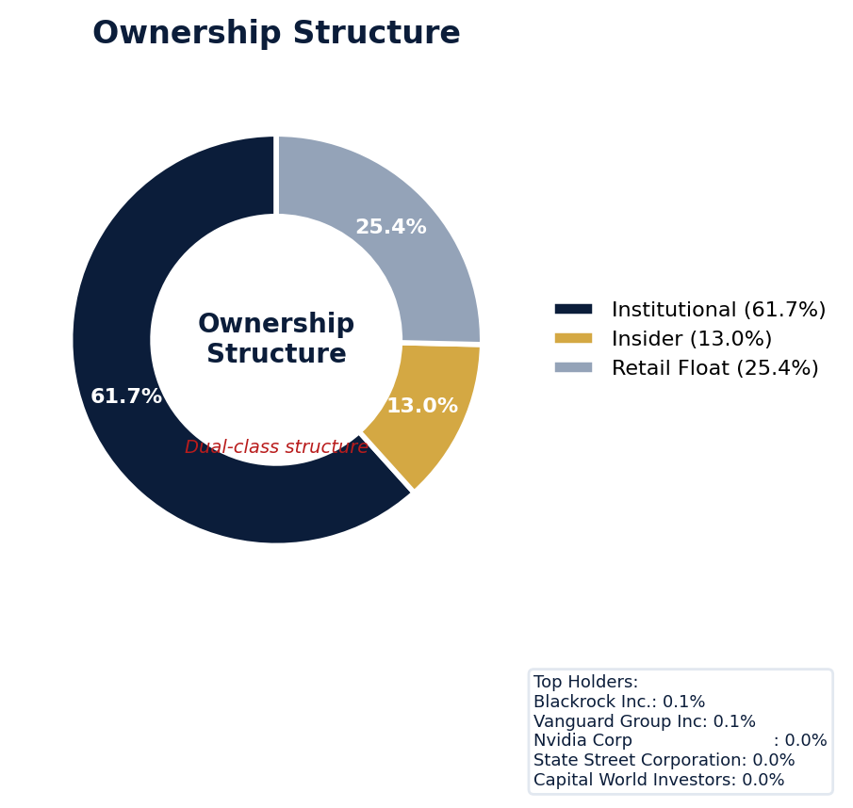
Figure: Ownership breakdown -- institutional, insider, retail float
Category | Percentage
Institutional Ownership | 61.7%
Insider Ownership | 13.0%
Retail Float | 25.4%
Top Holder | Ownership %
Blackrock Inc. | 0.1%
Vanguard Group Inc | 0.1%
Nvidia Corp | 0.0%
State Street Corporation | 0.0%
Capital World Investors | 0.0%
Sentiment & Narrative Coherence
Signal | Assessment
Narrative Coherence | COHERENT
Anti-Takeover Provisions
Anti-takeover provision data not available. Review DEF 14A and charter documents for complete analysis.

ELEVATED CONCERN
Intel currently has zero active securities class actions and no derivative suits, but its 3.7% adjusted filing rate sits below the 5.0% sector average, suggesting a historically lower litigation profile. However, its seven open securities-related matters, combined with a moderate defense posture, indicate persistent operational friction that regularly escalates to legal defense, increasing D&O claim frequency. The absence of an SEC investigation stage is positive, but the recurring evidence of significant earnings misses—specifically any single miss exceeding 15% versus guidance—creates a clear catalyst for future stock drop allegations, as seen in the 2-point deduction for financial reporting risk. Underwriters should benchmark against recent peer semiconductor settlements, which have ranged from $50 to $150 million, to model potential exposure for a company with Intel's scale. The primary concern is that Intel’s chronic execution challenges in a competitive sector transform routine earnings volatility into a high-probability corrective disclosure event, with defense costs alone for the current docket of seven matters likely exceeding $20 million.
Section 6: Litigation & Regulatory Exposure
Industry claim exposure: revenue_recognition, product_safety, ip_infringement. 7 statute of limitations window(s) remain open, meaning new claims can still be filed for past events. Under claims-made D&O policy, coverage is triggered when a claim is reported during the policy period. Defense quality assessment: MODERATE.
Litigation Overview: 0 active matter(s), 2 historical matter(s)
Litigation Timeline
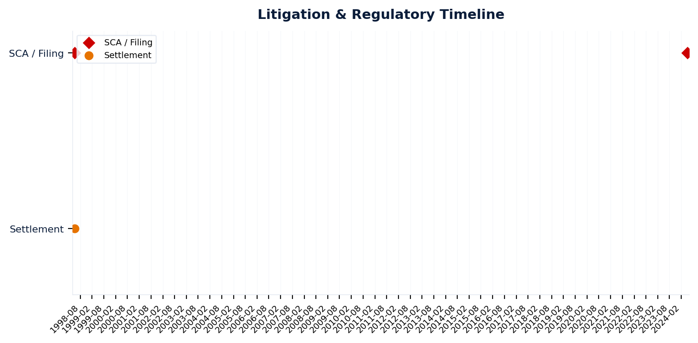
Figure: Chronological litigation and regulatory events overlaid with corporate events for pattern recognition
Securities Class Actions
Case Name | Legal Theory | Coverage | Court | Filing Date | Status | Class Period | Lead Counsel | Settlement | Source
In re Intel Corporation Securities Litigation (24-cv-02683) (2024) | Rule 10b-5 | Side C (Entity) | N.D. Cal. | 2024-05-03 | DISMISSED | Jan 2024 - Apr 2024 | N/A | $4.5M | [Supabase SCA database, 2026-04-02, MEDIUM]
In re Quintel Entertainment, Inc. Securities Litigation (1998) | Rule 10b-5 | Side C (Entity) | N/A | 1998-05-04 | SETTLED | N/A | N/A | $47.9M | [Supabase SCA database, 2026-04-02, MEDIUM]
D&O Context: Historical settlements total $47.9M. Settlement history establishes severity baseline for pricing. [ELEVATED]
SEC Enforcement Pipeline
Pipeline: (Comment Letters) -> (Informal Inquiry) -> (Formal Investigation) -> (Wells Notice) -> (Enforcement Action)
No SEC enforcement pipeline activity detected. [10-K Item 3 + Item 1A + 8-K + EFTS, 2026-04-02, LOW]
Derivative Suits
No derivative suit history found.
Regulatory Proceedings
Agency | Type | Status
FTC | investigation | disclosed
Industry Claim Patterns
Legal Theory | Exposed | Contagion Risk | Description
Revenue Recognition | Yes | Yes | [Electronic & Electrical Equipment] Premature or channel-stu
Product Safety | Yes | Yes | [Electronic & Electrical Equipment] Product safety failures
Ip Infringement | Yes | Yes | [Electronic & Electrical Equipment] Patent infringement or I
Export Control Violations | Yes | Yes | [Electronic & Electrical Equipment] Violations of export con
D&O Context: Company exposed to 4 industry claim pattern(s). Peer lawsuits create contagion risk -- plaintiff firms often file similar claims across the industry. [ELEVATED]
Statute of Limitations Map
Claim Type | Trigger Date | SOL Expiry | Repose Expiry | Window Open
employment_discrimination | 2026-01-23 | 2028-01-23 | 2028-01-23 | OPEN
10b-5 | 2024-04-25 | 2026-04-25 | 2029-04-24 | OPEN
antitrust | 2026-01-23 | 2030-01-22 | 2030-01-22 | OPEN
FCPA | 2026-01-23 | 2031-01-22 | 2031-01-22 | OPEN
environmental | 2026-01-23 | 2031-01-22 | 2031-01-22 | OPEN
derivative | 2026-01-23 | 2029-01-22 | 2032-01-22 | OPEN
ERISA | 2026-01-23 | 2029-01-22 | 2032-01-22 | OPEN
Section_11 | 2024-04-25 | 2025-04-25 | 2027-04-25 | CLOSED
Section_14a | 2024-04-25 | 2025-04-25 | 2027-04-25 | CLOSED
D&O Context: 7 open exposure window(s). Claims can still be filed within these periods. [ELEVATED]
Defense Strength Assessment
Factor | Assessment
Federal Forum Provision | No
Exclusive Forum Provision | No
PSLRA Safe Harbor | MODERATE
Truth-on-Market Viability | VIABLE
Prior Dismissal Success | No prior dismissals identified in Item 3
Overall Defense Strength | MODERATE
No forum selection provisions identified. Safe harbor usage is MODERATE with standard forward-looking statement protections. Additional defense factors include viable truth-on-the-market defense. [DEF 14A; 10-K, 2026-04-02, LOW]
Contingent Liabilities
Description | ASC 450 Class. | Accrued | Range
well as product warranties that arise in the ordinary course | probable | N/A | N/A
otential asset impairments that arise in the ordinary course | probable | N/A | N/A
D&O Context: 2 probable contingenc(y/ies). ASC 450 probable classification indicates management believes loss is likely. Direct impact on D&O exposure. [HIGH]
Workforce, Product & Environmental Matters
None found.
Whistleblower Indicators
No whistleblower indicators identified in SEC filings. SEC whistleblower tips are not publicly disclosed; absence does not confirm lack of activity.

Intel's WIN-tier quality score of 87.8 places it as a must-have account, but its ELEVATED claim band of 6.65-9.5% demands disciplined pricing. The primary driver is its Prior Litigation risk factor, which deducted 2.42 points from a maximum of 20, based on 63 identified signals, indicating a persistent exposure to shareholder suits. This is compounded by a pattern of Guidance Misses, a factor that deducted 2.0 points and includes at least one instance where results fell over 15% short of projections, which directly fuels allegations of misleading forward-looking statements. While not a governance crisis, this "Guidance Track Record" pattern, alongside elevated Short Interest that deducted 2.22 points from a max of 8, reveals a volatile operational execution that increases the likelihood of stock volatility and subsequent securities class actions.
Section 7: Risk Scoring & Synthesis
Underwriting tier: **WIN** (quality score: 87.8/100). Recommended action: Must-have account, compete aggressively. Expected claim probability band: 6.7-9.5%. Top risk contributors: Prior Litigation (F1: -2.4 pts); Short Interest (F6: -2.2 pts); Restatement/Audit Issues (F3: -2.1 pts). Active composite patterns: Guidance Track Record. Claim probability band: ELEVATED (6.7%-9.5%).
Tier Classification
Metric | Value
Quality Score | 87.8 / 100
Composite Score (pre-ceiling) | 87.8
Total Risk Points Deducted | 12.2
Tier | WIN
Tier Range | 86 - 100
Action Guidance | Must-have account, compete aggressively
Probability Range | 6.7-9.5%
Pricing Multiplier | 0.5-0.7x
Risk Assessment: LOW [LOW]
D&O Claim Peril Assessment
2 of 8 D&O claim perils show active risk signals. Active perils have at least one causal chain with triggered checks.
Peril | Risk Level | Active Chains | Key Evidence
Securities Claims | ELEVATED | 1/5 | Qualitative: No non-GAAP measures detected in 10-K; Qualitative: 0
Fiduciary Breach | MODERATE | 1/3 | Verified (value: 0); Detected (value). Limited corroborating data available.
Government Enforcement | LOW | 0/2 | —
Employment & Whistleblower | LOW | 0/1 | —
Insolvency & Bankruptcy | LOW | 0/1 | —
Emerging Risks | LOW | 0/2 | —
Consumer & Product Claims | LOW | 0/1 | —
Commercial Litigation | LOW | 0/1 | —
Active Peril Analysis
Securities Claims: ELEVATED [ELEVATED]
Frequency: moderate | Severity: high | Typical range: $5M - $500M+
1 of 5 causal chains active.
Chain: Guidance Miss → Securities Fraud [ELEVATED]
Repeated guidance misses or aggressive forward guidance builds scienter case for securities fraud claim when stock eventually declines.
Triggers:
• FIN.GUIDE.earnings_reaction
Amplifiers:
• GOV.INSIDER.executive_sales
Historical filing rate: 8% | Median severity: $12M
Fiduciary Breach: MODERATE [MODERATE]
Frequency: growing | Severity: variable | Typical range: $1M - $100M
1 of 3 causal chains active.
Chain: Governance Failure → Derivative Suit [MODERATE]
Weak governance structure (low independence, CEO/Chair duality, poor say-on-pay) creates basis for Caremark duty of oversight claims and derivative suits.
Triggers:
• GOV.BOARD.ceo_chair
Historical filing rate: 3% | Median severity: $8M
Composite Score Breakdown
Factor | Name | Max Pts | Deducted | % Used | Top Contributor
F1 | Prior Litigation | 20 | 2.4 | 12% | Signal-driven scoring: 63 signals, coverage=100%
F2 | Stock Decline | 15 | 0.6 | 4% | Signal-driven scoring: 28 signals, coverage=100%
F3 | Restatement/Audit Issues | 12 | 2.1 | 17% | Signal-driven scoring: 81 signals, coverage=100%
F4 | IPO/SPAC/M&A | 10 | 1.0 | 10% | Signal-driven scoring: 15 signals, coverage=100%
F5 | Guidance Misses | 13 | 2.0 | 15% | Signal-driven scoring: 27 signals, coverage=100%
F6 | Short Interest | 8 | 2.2 | 28% | Signal-driven scoring: 28 signals, coverage=100%
F7 | Stock Volatility | 7 | 0.5 | 7% | Signal-driven scoring: 28 signals, coverage=100%
F8 | Financial Distress | 5 | 0.7 | 14% | Signal-driven scoring: 14 signals, coverage=100%
F9 | Governance Issues | 6 | 0.5 | 8% | Signal-driven scoring: 37 signals, coverage=100%
F10 | Officer Stability | 2 | 0.1 | 7% | Signal-driven scoring: 88 signals, coverage=100%
10-Factor Risk Profile
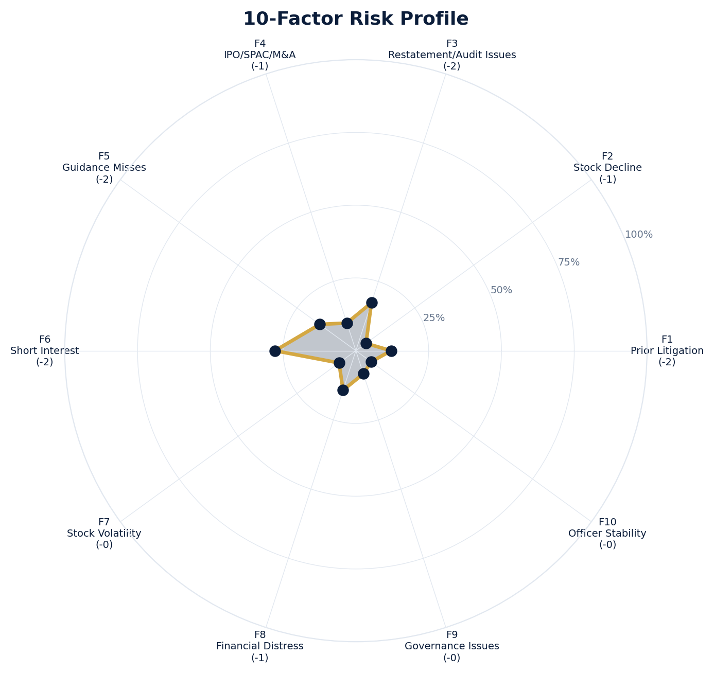
Figure: Radar chart showing risk fraction (points deducted / max) for each of the 10 scoring factors. Larger area = higher risk.
Red Flag Gates
Severity | Description | Source | Impact | Trajectory
LOW | Prior Litigation: 2/20 points | Signal-driven scoring: 63 signals, coverage=100% | F1: 2 pts | NEW
LOW | Stock Decline: 1/15 points | Signal-driven scoring: 28 signals, coverage=100%; Drop contribution modifier: 0.18x (decay + company-specific + disclosure) | F2: 1 pts | NEW
LOW | Restatement/Audit Issues: 2/12 points | Signal-driven scoring: 81 signals, coverage=100% | F3: 2 pts | NEW
LOW | IPO/SPAC/M&A: 1/10 points | Signal-driven scoring: 15 signals, coverage=100% | F4: 1 pts | NEW
LOW | Guidance Misses: 2/13 points | Signal-driven scoring: 27 signals, coverage=100%; Any single miss >15% vs guidance | F5: 2 pts | NEW
LOW | Short Interest: 2/8 points | Signal-driven scoring: 28 signals, coverage=100% | F6: 2 pts | NEW
LOW | Stock Volatility: 0/7 points | Signal-driven scoring: 28 signals, coverage=100% | F7: 0 pts | NEW
LOW | Financial Distress: 1/5 points | Signal-driven scoring: 14 signals, coverage=100% | F8: 1 pts | NEW
LOW | Governance Issues: 0/6 points | Signal-driven scoring: 37 signals, coverage=100% | F9: 0 pts | NEW
LOW | Officer Stability: 0/2 points | Signal-driven scoring: 88 signals, coverage=100% | F10: 0 pts | NEW
LOW | Pattern: Guidance Track Record (BASELINE) | Pattern evaluation | F5: 0 | NEW
Critical: 0, High: 0, Moderate: 0, Low: 11
Risk Type Classification
Attribute | Value
Primary Risk Type | GUIDANCE_DEPENDENT
Supporting Evidence | F5 guidance misses: 2.0 points; Issues guidance (philosophy: MIXED)
Severity Scenarios
Analysis based on market cap: $241.2B
Percentile | Label | Settlement Est. | Defense Costs | Total Exposure
25th | favorable | $2.3B | $340.5M | $2.6B
50th | median | $4.5B | $907.9M | $5.4B
75th | adverse | $9.1B | $2.3B | $11.3B
95th | catastrophic | $18.2B | $5.4B | $23.6B
Calibration Notes (SECT7-11)
The following items are flagged NEEDS CALIBRATION and require expert review before final pricing:
- SECT7-11: All scoring parameters require calibration against historical cases
Factor Detail
Factor | Name | Deducted | Rules Triggered | Evidence
F1 | Prior Litigation | 2.4 | N/A | Signal-driven scoring: 63 signals, coverage=100%
F2 | Stock Decline | 0.6 | drop_contribution_adjustment | Signal-driven scoring: 28 signals, coverage=100%; Drop contribution modifier: 0.18x (decay + company-specific + disclosure)
F3 | Restatement/Audit Issues | 2.1 | N/A | Signal-driven scoring: 81 signals, coverage=100%
F4 | IPO/SPAC/M&A | 1.0 | N/A | Signal-driven scoring: 15 signals, coverage=100%
F5 | Guidance Misses | 2.0 | F5-006 | Signal-driven scoring: 27 signals, coverage=100%; Any single miss >15% vs guidance
F6 | Short Interest | 2.2 | N/A | Signal-driven scoring: 28 signals, coverage=100%
F7 | Stock Volatility | 0.5 | N/A | Signal-driven scoring: 28 signals, coverage=100%
F8 | Financial Distress | 0.7 | N/A | Signal-driven scoring: 14 signals, coverage=100%
F9 | Governance Issues | 0.5 | N/A | Signal-driven scoring: 37 signals, coverage=100%
F10 | Officer Stability | 0.1 | N/A | Signal-driven scoring: 88 signals, coverage=100%
Sub-Component Breakdown
Factor | Component | Value
F1 | base | 2.42
F1 | bonus | 0.00
F1 | modifiers | 0.00
F1 | hard_triggers | 0.00
F1 | total_before_cap | 2.42
F1 | capped | 2.42
F2 | base | 3.53
F2 | bonus | 0.00
F2 | modifiers | 0.00
F2 | hard_triggers | 0.00
F2 | drop_contribution_modifier | 0.18
F2 | total_before_cap | 0.64
F2 | capped | 0.64
F3 | base | 2.08
F3 | bonus | 0.00
F3 | modifiers | 0.00
F3 | hard_triggers | 0.00
F3 | total_before_cap | 2.08
F3 | capped | 2.08
F4 | base | 1.00
F4 | bonus | 0.00
F4 | modifiers | 0.00
F4 | hard_triggers | 0.00
F4 | total_before_cap | 1.00
F4 | capped | 1.00
F5 | base | 0.00
F5 | bonus | 2.00
F5 | modifiers | 0.00
F5 | hard_triggers | 0.00
F5 | total_before_cap | 2.00
F5 | capped | 2.00
F5 | pattern_modifier | 0.00
F6 | base | 2.22
F6 | bonus | 0.00
F6 | modifiers | 0.00
F6 | hard_triggers | 0.00
F6 | total_before_cap | 2.22
F6 | capped | 2.22
F7 | base | 0.50
F7 | bonus | 0.00
F7 | modifiers | 0.00
F7 | hard_triggers | 0.00
F7 | total_before_cap | 0.50
F7 | capped | 0.50
F8 | base | 0.71
F8 | bonus | 0.00
F8 | modifiers | 0.00
F8 | hard_triggers | 0.00
F8 | total_before_cap | 0.71
F8 | capped | 0.71
F9 | base | 0.50
F9 | bonus | 0.00
F9 | modifiers | 0.00
F9 | hard_triggers | 0.00
F9 | total_before_cap | 0.50
F9 | capped | 0.50
F10 | base | 0.13
F10 | bonus | 0.00
F10 | modifiers | 0.00
F10 | hard_triggers | 0.00
F10 | total_before_cap | 0.13
F10 | capped | 0.13
Pattern Detection Results
Pattern | Severity | Triggers Matched | Score Impact
Guidance Track Record | BASELINE |  | F5: +0
Allegation Theory Mapping
Theory | Exposure | Factor Sources | Key Findings
A_DISCLOSURE | MODERATE | F1, F3, F5 | F1: Signal-driven scoring: 63 signals, coverage=100%; F3: Signal-driven scoring: 81 signals, coverage=100%
B_GUIDANCE | LOW | F2, F5 | F2: Signal-driven scoring: 28 signals, coverage=100%; F2: Drop contribution modifier: 0.18x (decay + company-specific + disclosure)
C_PRODUCT_OPS | LOW | F7, F8 | F7: Signal-driven scoring: 28 signals, coverage=100%; F8: Signal-driven scoring: 14 signals, coverage=100%
D_GOVERNANCE | LOW | F9, F10 | F9: Signal-driven scoring: 37 signals, coverage=100%; F10: Signal-driven scoring: 88 signals, coverage=100%
E_MA | LOW | F4 | F4: Signal-driven scoring: 15 signals, coverage=100%
D&O Context: Primary allegation exposure is A_DISCLOSURE. MODERATE exposure in: A_DISCLOSURE.
Claim Probability Detail
Metric | Value
Probability Band | ELEVATED
Range | 6.7% - 9.5%
Industry Base Rate | 5.0%
Adjustment Rationale | Industry base rate: 5.0%. Tier WIN (0-2%): Below base rate. Strong risk profile
Claim probability: ELEVATED [HIGH]
Tower Position Recommendation
Metric | Value
Recommended Position | PRIMARY
Minimum Attachment | $4539.4M (based on 50th percentile settlement)
Side A/DIC Assessment | Standard Side A considerations
Position | Risk Assessment | Premium Guidance | Attachment
PRIMARY | Primary layer carries 57% of expected loss exposur | Full rate, slight discount for | $0 ground-up
LOW_EXCESS | Low excess layer carries 18% of expected loss expo | Market rate | $5-15M xs $5-15M
MID_EXCESS | Mid excess layer carries 13% of expected loss expo | Market to 1.3x | $15-50M xs $15-50M
HIGH_EXCESS | High excess layer carries 11% of expected loss exp | 1.3-2x with attachment | $50M+ xs $50M+
DECLINE | WALK+ with compounding factors | N/A | N/A
Forensic Composite Scores
Composite | Score | Interpretation
Financial Integrity Score (FIS) | N/A | Not available
Reporting Quality Score (RQS) | N/A | Not available
Cash Flow Quality Score (CFQS) | N/A | Not available
Executive Risk Profile
Metric | Value
Weighted Score | 14
Risk Level | N/A
- [Enterprise Operations (CFO)]: Prior litigation: case_summary: According to the Complaint, Intel Corporation designs, develops, manufactures, markets
- [Enterprise Operations (CFO)]: Prior litigation: case_summary: According to the Complaint, Intel Corporation is a technology company that provides co
- [Enterprise Operations (CFO)]: Short tenure: 1.0 years
- [Lenovo Em (COO)]: Prior litigation: company_name: NXP Semiconductors N.V. (NXPI) (CIK 0001413447)
- [Lenovo Em (COO)]: Prior litigation: case_summary: According to the Complaint, Intel Corporation designs, develops, manufactures, markets
- [Lenovo Em (COO)]: Prior litigation: case_summary: According to the Complaint, Intel Corporation is a technology company that provides co
- [Michelle Johnston (GC)]: Short tenure: 1.0 years
- [Plume Wi (CTO)]: Prior litigation: company_name: LUDWIG ENTERPRISES, INC. (LUDG) (CIK 0001960262)
- [Plume Wi (CTO)]: Prior litigation: company_name: LUDWIG ENTERPRISES, INC. (LUDG) (CIK 0001960262)
- [Plume Wi (CTO)]: Prior litigation: case_summary: According to the Complaint, Intel Corporation designs, develops, manufactures, markets
Temporal Signals
Type | Direction | Magnitude | Description
Unknown | N/A | N/A
Unknown | N/A | N/A
Unknown | N/A | N/A
Unknown | N/A | N/A
Unknown | N/A | N/A
Unknown | N/A | N/A
Unknown | N/A | N/A
Unknown | N/A | N/A
NLP Filing Analysis
Metric | Value
Readability Score | {'current_fog': 27.72, 'prior_fog': None, 'fog_change': None, 'current_flesch': -1.85, 'prior_flesch': None, 'classification': 'CURRENT_ONLY', 'evidence': 'Current Fog Index: 27.7 (prior year unavailable)'}
Tone Assessment | N/A
Risk Language Density | N/A
Peril Assessment
Plaintiff Peril Heat Map
Plaintiff Type | Probability | Severity
Shareholders | ELEVATED | SIGNIFICANT
Regulators | ELEVATED | SIGNIFICANT
Customers | VERY LOW | NUISANCE
Competitors | VERY LOW | NUISANCE
Employees | LOW | MINOR
Creditors | ELEVATED | SIGNIFICANT
Government | VERY LOW | NUISANCE
Shareholders: 51 triggered checks. Key: Litigation History Profile: 2 (elevated vs benchmark of 0)
Regulators: 13 triggered checks. Key: VIE/SPE Off-Balance-Sheet Structures: Boolean check: VIE/SPE structures present
Creditors: 7 triggered checks. Key: Cash Flow Debt Service Coverage: -2.00 (below benchmark of 1)
Bear Cases
Bear Case: A Disclosure
INTEL CORP faces elevated exposure to securities disclosure fraud claims. Key risk indicators: Litigation History Profile (critical); VIE/SPE Off-Balance-Sheet Structures (critical). Estimated severity is significant, warranting detailed underwriter review.
Defense: Defense: No active Section 11 windows — statute of limitations expired for offering claims
Evidence Chain
1. [BIZ.CLASS.litigation_history] Litigation History Profile (Source: total_sca_count)
2. [BIZ.STRUCT.vie_spe] VIE/SPE Off-Balance-Sheet Structures (Source: vie_spe_present)
3. [BIZ.EVENT.ipo_exposure] IPO/Offering Exposure Window (Source: event_ipo_exposure_score)
4. [BIZ.OPS.workforce] Workforce Distribution (Source: workforce_distribution)
5. [EXEC.PRIOR_LIT.any_officer] Any Officer With Prior Litigation at Previous Company (Source: value)
6. [EXEC.PRIOR_LIT.ceo_cfo] CEO or CFO With Prior Litigation (Source: value)
7. [FIN.LIQ.trend] Liquidity Trend (Source: xbrl_current_ratio)
8. [FIN.DEBT.coverage] Debt Service Coverage (Source: xbrl_interest_coverage)
9. [FIN.CAP.buyback_capacity] Buyback Authorization Capacity (Source: xbrl_buyback_remaining_pct)
10. [FIN.CF.debt_service_coverage] Cash Flow Debt Service Coverage (Source: computed_debt_service_coverage)
Probability: ELEVATED | Severity: SIGNIFICANT
Settlement Prediction
Settlement prediction computed but no scenarios available.
Tower Risk Characterization
Tower characterization not available.
Coverage Gaps -- Data Not Available
The following checks could not be evaluated because required data was not acquired. These items are NOT cleared -- they represent gaps in coverage that should be considered in the underwriting decision.
Company Profile & Industry
[EVALUATIVE] FWRD.EVENT.debt_maturity (Debt Maturity 12mo): Required data not available from filings
[EVALUATIVE] FWRD.EVENT.covenant_test (Covenant Test Dates): Required data not available from filings
Executive Summary & Key Metrics
[EVALUATIVE] BIZ.STRUCT.subsidiary_count (Subsidiary Count Complexity): Required data not available from filings
[EVALUATIVE] BIZ.DEPEND.labor (Concentration Risk Composite): Required data not available from filings
[REQUIRED] BIZ.MA.goodwill_balance (Goodwill Balance): Required data not available from filings
[REQUIRED] BIZ.MA.acquisition_spend (Acquisition Spend Magnitude): Required data not available from filings
[EVALUATIVE] BIZ.MA.goodwill_change (Goodwill Trajectory): Required data not available from filings
[REQUIRED] BIZ.MA.acquisition_list (Recent Acquisitions): Required data not available from filings
[REQUIRED] BIZ.MODEL.revenue_type (Revenue Model Type): Required data not available from filings
[EVALUATIVE] BIZ.MODEL.key_person (Key Person Dependency): Required data not available from filings
[REQUIRED] BIZ.MODEL.lifecycle (Segment Lifecycle Risk): Required data not available from filings
[EVALUATIVE] BIZ.MODEL.disruption (Business Model Disruption Risk): Required data not available from filings
[REQUIRED] BIZ.MODEL.segment_margins (Segment Margin Profile): Required data not available from filings
[EVALUATIVE] DISC.YOY.new_risk_factors (New Risk Factors (YoY)): No trend data available for field
[EVALUATIVE] DISC.YOY.removed_risk_factors (Removed Risk Factors (YoY)): No trend data available for field
[EVALUATIVE] DISC.YOY.escalated_risk_factors (Escalated Risk Factors (YoY)): No trend data available for field
[EVALUATIVE] DISC.YOY.material_weakness (Material Weakness Change): No trend data available for field
[EVALUATIVE] DISC.YOY.controls_changed (Internal Controls Disclosure Change): No trend data available for field
[EVALUATIVE] DISC.YOY.legal_proceedings_delta (Legal Proceedings Change (YoY)): No trend data available for field
[EVALUATIVE] ABS.DISC.audit_fees (Missing Audit Fee Disclosure): Expected signals not found in evaluation results
[EVALUATIVE] ABS.DISC.board_independence (Missing Board Independence Disclosure): Could not determine disclosure presence or absence
[EVALUATIVE] ABS.DISC.clawback_policy (Missing Clawback Policy Disclosure): Expected signals not found in evaluation results
[EVALUATIVE] ABS.DISC.cyber_risk (Missing Cybersecurity Risk Disclosure): Expected signals not found in evaluation results
[EVALUATIVE] ABS.DISC.debt_covenants (Missing Debt Covenant Disclosure): Expected signals not found in evaluation results
[EVALUATIVE] ABS.DISC.derivative_instruments (Missing Derivative Instruments Disclosure): Expected signals not found in evaluation results
[EVALUATIVE] ABS.DISC.esg (Missing ESG Disclosure): Expected signals not found in evaluation results
[EVALUATIVE] ABS.DISC.executive_comp (Missing Executive Compensation Disclosure): Expected signals not found in evaluation results
[EVALUATIVE] ABS.DISC.going_concern (Missing Going Concern Assessment): Could not determine disclosure presence or absence
[EVALUATIVE] ABS.DISC.goodwill_impairment (Missing Goodwill Impairment Disclosure): Expected signals not found in evaluation results
[EVALUATIVE] ABS.DISC.lease_obligations (Missing Lease Obligation Disclosure): Expected signals not found in evaluation results
[EVALUATIVE] ABS.DISC.litigation_contingency (Missing Litigation Contingency Disclosure): Expected signals not found in evaluation results
[EVALUATIVE] ABS.DISC.pension_obligations (Missing Pension Obligation Disclosure): Expected signals not found in evaluation results
[EVALUATIVE] ABS.DISC.related_party (Missing Related-Party Transaction Disclosure): Expected signals not found in evaluation results
[EVALUATIVE] ABS.DISC.revenue_recognition (Missing Revenue Recognition Policy Disclosure): Expected signals not found in evaluation results
[EVALUATIVE] ABS.DISC.risk_factors (Missing Risk Factor Disclosure): Expected signals not found in evaluation results
[EVALUATIVE] ABS.DISC.segment_reporting (Missing Segment Reporting Disclosure): Expected signals not found in evaluation results
[EVALUATIVE] ABS.DISC.stock_comp (Missing Stock Compensation Disclosure): Expected signals not found in evaluation results
[EVALUATIVE] ABS.DISC.tax_positions (Missing Uncertain Tax Position Disclosure): Expected signals not found in evaluation results
[EVALUATIVE] CONJ.COMP.perf_divergence (Compensation-Performance Divergence): 3/3 component signals unavailable
[EVALUATIVE] CONJ.DISTRESS.insider (Financial Distress + Insider Selling): 2/3 component signals unavailable
[EVALUATIVE] CONJ.GOV.governance_event (Weak Governance + Adverse Event): 3/5 component signals unavailable
[EVALUATIVE] CONJ.FIN.growth_margin_guidance (Rapid Growth + Margin Compression + Guidance Miss): 3/3 component signals unavailable
[EVALUATIVE] CONJ.INSIDER.news_gap (Insider Selling + Material News Gap): 3/3 component signals unavailable
[EVALUATIVE] CONJ.REG.litigation (Regulatory Action + New Material Litigation): 3/3 component signals unavailable
[EVALUATIVE] CONJ.RPT.audit (Related-Party Transactions + Audit Issues): 2/3 component signals unavailable
[EVALUATIVE] CTX.FIN.capex_sector (Capital Expenditure in Sector Context): Source signal FIN.INVEST.capex_ratio not in results
[EVALUATIVE] CTX.COMP.lifecycle (CEO Compensation in Lifecycle Context): Source signal EXEC.COMP.ceo_total_comp not in results
[EVALUATIVE] CTX.COMP.product_tower (Compensation Severity by Product/Tower): Source signal EXEC.COMP.ceo_total_comp not in results
[EVALUATIVE] CTX.FIN.debt_maturity (Debt Maturity Profile in Lifecycle Context): Source signal FIN.DEBT.maturity_profile not in results
[EVALUATIVE] CTX.FIN.distress_product (Financial Distress by Product/Tower): Source signal FIN.FORENSIC.altman_z not in results
[EVALUATIVE] CTX.FIN.dividend_lifecycle (Dividend Policy in Lifecycle Context): Source signal FIN.RETURN.dividend_yield not in results
[EVALUATIVE] CTX.EXEC.tenure_lifecycle (Executive Tenure in Lifecycle Context): Source signal EXEC.TURN.c_suite not in results
[EVALUATIVE] CTX.MKT.insider_lifecycle (Insider Trading in Lifecycle Context): Source signal STOCK.INSIDER.net_selling not in results
[EVALUATIVE] CTX.FIN.leverage_sector (Leverage in Sector Context): Source signal FIN.DEBT.leverage_ratio not in results
[EVALUATIVE] CTX.LIT.size (Litigation Frequency by Company Size): Source signal LIT.SCA.active_cases not in results
[EVALUATIVE] CTX.RISK.ma_lifecycle (M&A Activity in Lifecycle Context): Source signal BIZ.MA.acquisition_activity not in results
[EVALUATIVE] CTX.RISK.regulatory_sector (Regulatory Risk in Sector Context): Source signal LIT.SEC.enforcement not in results
[EVALUATIVE] CTX.RISK.rpt_sector (Related-Party Risk in Sector Context): Source signal GOV.RPT.related_party not in results
[EVALUATIVE] CTX.MKT.short_interest_sector (Short Interest in Sector Context): Source signal STOCK.SHORT.interest_ratio not in results
[EVALUATIVE] CTX.MKT.turnover_sector (Stock Turnover in Sector Context): Source signal STOCK.VOL.turnover_rate not in results
[EVALUATIVE] CTX.MKT.volatility_sector (Stock Volatility in Sector Context): Source signal STOCK.VOL.historical not in results
Financial Health
[EVALUATIVE] FIN.PEER.revenue_bottom_quartile (Revenue Bottom Quartile (Cross-Filer)): No peer comparison data available
[EVALUATIVE] FIN.PEER.leverage_top_decile (Leverage Top Decile (Sector-Relative)): No peer comparison data available
[EVALUATIVE] FIN.PEER.margin_compression (Operating Margin Compression (Cross-Filer)): No peer comparison data available
[EVALUATIVE] FIN.PEER.profitability_laggard (Profitability Laggard (Sector-Relative)): No peer comparison data available
[EVALUATIVE] FIN.PEER.size_outlier_small (Size Outlier Small (Cross-Filer)): No peer comparison data available
[EVALUATIVE] FIN.PEER.cash_flow_weak (Cash Flow Weakness (Cross-Filer)): No peer comparison data available
[EVALUATIVE] LIT.DEFENSE.forum_selection (Federal Forum Selection Clause): Required data not available from filings
Governance & Leadership
[EVALUATIVE] EXEC.INSIDER.ceo_net_selling (CEO Net Seller of Stock): Required data not available from filings
[EVALUATIVE] EXEC.AGGREGATE.board_risk (Board Aggregate Risk Score): Data mapping not configured for this check
[EVALUATIVE] EXEC.AGGREGATE.highest_risk_individual (Highest Individual Risk Score Exceeds Threshold): Data mapping not configured for this check
[EVALUATIVE] EXEC.TENURE.ceo_new (CEO Tenure Less Than 2 Years): Data mapping not configured for this check
[REQUIRED] EXEC.PROFILE.board_size (Board Size (Number of Members)): Required data not available from filings
[REQUIRED] EXEC.PROFILE.independent_ratio (Board Independence Percentage): Required data not available from filings
[EVALUATIVE] EXEC.PROFILE.overboarded_directors (Directors Serving on 4+ Boards): Required data not available from filings
[EVALUATIVE] GOV.BOARD.size (Board Size): Required data not available from filings
[EVALUATIVE] GOV.BOARD.independence (Board Independence): Required data not available from filings
[EVALUATIVE] GOV.BOARD.diversity (Board Diversity): Required data not available from filings
[EVALUATIVE] GOV.BOARD.tenure (Tenure): Required data not available from filings
[EVALUATIVE] GOV.BOARD.overboarding (Overboarding): Required data not available from filings
[EVALUATIVE] GOV.BOARD.attendance (Attendance): Required data not available from filings
[EVALUATIVE] GOV.BOARD.meetings (Meetings): Required data not available from filings
[EVALUATIVE] GOV.BOARD.succession (Succession): Required data not available from filings
[EVALUATIVE] GOV.EXEC.ceo_profile (CEO Profile): Required data not available from filings
[EVALUATIVE] GOV.EXEC.founder (Founder Status): Required data not available from filings
[EVALUATIVE] GOV.EXEC.key_person (Key Person Risk): Required data not available from filings
[EVALUATIVE] GOV.PAY.golden_para (Golden Para): Required data not available from filings
[EVALUATIVE] GOV.PAY.equity_burn (Equity Burn): Required data not available from filings
[EVALUATIVE] GOV.PAY.hedging (Hedging): Required data not available from filings
[REQUIRED] GOV.RIGHTS.bylaws (Bylaws): Required data not available from filings
[EVALUATIVE] GOV.RIGHTS.takeover (Takeover): Required data not available from filings
[EVALUATIVE] GOV.RIGHTS.proxy_access (Proxy Access): Required data not available from filings
[REQUIRED] GOV.RIGHTS.forum_select (Forum Select): Required data not available from filings
[EVALUATIVE] GOV.RIGHTS.supermajority (Supermajority): Required data not available from filings
[EVALUATIVE] GOV.RIGHTS.action_consent (Action Consent): Required data not available from filings
[EVALUATIVE] GOV.RIGHTS.special_mtg (Special Mtg): Required data not available from filings
[EVALUATIVE] GOV.RIGHTS.classified (Classified): Required data not available from filings
[PATTERN] GOV.EFFECT.audit_opinion (Audit Opinion): Required data not available from filings
[PATTERN] GOV.EFFECT.sox_404 (Sox 404): Required data not available from filings
Market & Trading
[EVALUATIVE] FIN.ACCT.auditor (Auditor): Required data not available from filings
[EVALUATIVE] FIN.LIQ.cash_burn (Cash Burn Analysis): Required data not available from filings
[EVALUATIVE] FIN.DEBT.maturity (Debt Maturity Profile): Required data not available from filings
[EVALUATIVE] FIN.DEBT.covenants (Covenant Analysis): Required data not available from filings
[EVALUATIVE] FIN.COMP.unvested_cost (Unvested SBC Pipeline): Required data not available from filings
[EVALUATIVE] FIN.COMP.rsu_grants (RSU Grant Trend): Required data not available from filings
[EVALUATIVE] FIN.DEBT.refinancing_risk (Refinancing Risk): Data mapping not configured for this check
[EVALUATIVE] FIN.CONT.loss_accrual (Loss Contingency Accrual): Required data not available from filings
[EVALUATIVE] FIN.CONT.loss_estimate (Loss Contingency Estimate): Required data not available from filings
[EVALUATIVE] FIN.CONT.warranty_reserve (Product Warranty Reserve): Required data not available from filings
[EVALUATIVE] FIN.DEBT.commercial_paper (Commercial Paper Dependency): Data mapping not configured for this check
[EVALUATIVE] FIN.DEBT.facility_utilization (Credit Facility Utilization): Data mapping not configured for this check
[EVALUATIVE] FIN.DEBT.maturity_concentration (Debt Maturity Concentration): Data mapping not configured for this check
[EVALUATIVE] FIN.QUALITY.q4_revenue_concentration (Q4 Revenue Concentration): Required data not available from filings
[EVALUATIVE] FIN.QUALITY.revenue_recognition_risk (Revenue Recognition Risk Indicators): Data mapping not configured for this check
[EVALUATIVE] FIN.FORENSIC.level3_fair_value (Level 3 Fair Value Asset Concentration): Data mapping not configured for this check
[EVALUATIVE] FIN.FORENSIC.goodwill_deterioration_pattern (Goodwill Deterioration Pattern): Data mapping not configured for this check
[EVALUATIVE] FIN.FORENSIC.related_party_revenue (Related Party Revenue Concentration): Data mapping not configured for this check
[EVALUATIVE] FWRD.EVENT.ma_integration_risk (M&A Integration Risk): Data mapping not configured for this check
[EVALUATIVE] FIN.FORENSIC.deferred_revenue_divergence (Deferred Revenue Divergence): Data mapping not configured for this check
[EVALUATIVE] FIN.FORENSIC.acquisition_effectiveness (Acquisition Effectiveness): Data mapping not configured for this check
[EVALUATIVE] FIN.FORENSIC.buyback_timing (Share Buyback Timing Quality): Data mapping not configured for this check
[EVALUATIVE] FIN.FORENSIC.dividend_sustainability (Dividend Sustainability): Data mapping not configured for this check
[EVALUATIVE] FIN.FORENSIC.dsri_elevated (Days Sales Receivable Index Elevated): Data mapping not configured for this check
[EVALUATIVE] FIN.FORENSIC.aqi_elevated (Asset Quality Index Elevated): Data mapping not configured for this check
[EVALUATIVE] FIN.FORENSIC.tata_elevated (Total Accruals to Total Assets Elevated): Data mapping not configured for this check
[EVALUATIVE] FIN.FORENSIC.non_gaap_gap (Non-GAAP to GAAP Earnings Gap): Data mapping not configured for this check
[EVALUATIVE] FIN.FORENSIC.goodwill_growth_rate (Goodwill Growth Rate): Data mapping not configured for this check
[EVALUATIVE] FIN.FORENSIC.acquisition_to_revenue (Acquisition Spend Relative to Revenue): Data mapping not configured for this check
[EVALUATIVE] FIN.PROFIT.revenue (Revenue Analysis): Required data not available from filings
[EVALUATIVE] FIN.GUIDE.track_record (Guidance Track Record): Required data not available from filings
[REQUIRED] NLP.FILING.filing_timing_change (Filing Date Shifted Significantly vs Prior Year): Required data not available from filings
[EVALUATIVE] STOCK.VALUATION.pe_ratio (Pe Ratio): Required data not available from filings
[EVALUATIVE] STOCK.VALUATION.peg_ratio (Peg Ratio): Required data not available from filings
[REQUIRED] STOCK.ANALYST.momentum (Momentum): Required data not available from filings
[EVALUATIVE] FIN.FORENSIC.m_score_composite (Beneish M-Score Composite (XBRL)): Data mapping not configured for this check
Gap breakdown: Required items: 12 | Evaluative checks: 121 | Patterns: 2
Total: 135 checks data-unavailable out of 576 total checks (77% coverage)

Calibration Notes
System Intelligence Status
Checks active: 601
Checks incubating: 0 (pending human approval)
Pending feedback: 0 entries
Recent Calibration Changes
Date | Check | Change | Changed By
2026-04-02 | GOV.FOUNDER_CRIMINAL_EXPOSURE | Proposed by ingestion of 'blind_spot:NVDA:Super Micro Comput | ingestion_pipeline
2026-04-02 | BIZ.CHINA_EXPOSURE_DISCLOSURE | Proposed by ingestion of 'blind_spot:NVDA:Super Micro Comput | ingestion_pipeline
2026-04-02 | GOV.EXPORT_CONTROL_COMPLIANCE | Proposed by ingestion of 'blind_spot:NVDA:Super Micro Comput | ingestion_pipeline
2026-04-02 | AI_DEVELOPMENT_TIMELINE_DISCLOSURE | Proposed by ingestion of 'blind_spot:AAPL:AAPL LAWSUIT: Appl | ingestion_pipeline
2026-04-02 | TECH_DEVELOPMENT_VS_MARKETING_HYPE | Proposed by ingestion of 'blind_spot:AAPL:Apple Inc. (NASDAQ | ingestion_pipeline
2026-04-02 | AI_PROMISE_DISCONNECT | Proposed by ingestion of 'blind_spot:AAPL:AAPL LAWSUIT: Appl | ingestion_pipeline
2026-04-02 | TECH_DEVELOPMENT_RISK_DISCLOSURE | Proposed by ingestion of 'blind_spot:AAPL:Apple Inc. (NASDAQ | ingestion_pipeline
2026-04-02 | TECH_PROTOTYPE_READINESS | Proposed by ingestion of 'blind_spot:AAPL:AAPL LAWSUIT: Appl | ingestion_pipeline
2026-04-02 | AI_PROMISE_VS_DELIVERY_GAP | Proposed by ingestion of 'blind_spot:AAPL:AAPL LAWSUIT: Appl | ingestion_pipeline
2026-04-02 | PRODUCT_DEV_AI_DEPENDENCY | Proposed by ingestion of 'blind_spot:AAPL:Apple Inc. (NASDAQ | ingestion_pipeline
Discovery Findings
1 document(s) analyzed, 0 proposal(s) generated, from blind spot search
Feedback for INTC
No pending feedback for INTC.

