
Angry Dolphin -- D&O Underwriting Worksheet
Moderna, Inc. (MRNA)
Generated: April 02, 2026
[Table of Contents -- Update in Word]

Moderna, Inc. presents a "NO_TOUCH" tier D&O risk, necessitating a decisive **Decline** of coverage. The company's 17.92% inherent risk probability and a projected claim band of 3.95%-5.64% are unsustainable, driven by acute litigation exposures. A current securities class action (24-cv-12058) filed in 2024 imposes a 55-point scoring ceiling, while NLP-detected whistleblower language in filings suggests potential False Claims Act exposure, creating a 100-point ceiling. The "Prior Litigation" deduction of 4.64 points from a 20-point pool quantifies this pervasive legal overhang. Moderna's $19.5B market cap and 4,700 employees amplify potential settlement scales. Mitigants like a clean SEC enforcement pipeline and stable C-suite are overwhelmed by these specific, material headwinds. The forensic synthesis of active SCAs, whistleblower signals, and a 1.56-point M&A deduction from its 2023 Spikevax restructuring confirms a profile where latent legal liabilities are poised to trigger shareholder claims. Consequently, underwriting action must be prophylactic; the "NO_TOUCH" designation reflects a binary risk that cannot be priced within standard D&O parameters.
Executive Summary
Underwriting Thesis
Moderna, Inc. is a $19.5B (Decile 4 of 10) large-cap healthcare company that would normally present as a stronger underwriting account were it not for critical red flags: Active Securities Class Action and Whistleblower/Qui Tam Disclosure. These findings impose a hard quality score ceiling of 55, placing the account in NO_TOUCH tier (51/100) regardless of other favorable factors. The balance sheet is strong (D/E 0.07, Z-Score 3.77), eliminating financial distress as a D&O claim catalyst. The primary risk driver is Prior Litigation, driving elevated risk in this area. Signal-driven scoring: 70 signals, coverage=100%. At a 4-6% claim probability (17.9% adjusted rate, 4.5x the Healthcare sector baseline of 4.0%), this account requires declination or exceptionally restrictive terms.
Company Snapshot
Attribute | Value | Source
Company | Moderna, Inc.
Ticker | MRNA
Exchange | Nasdaq
Sector | Healthcare
Industry | Biotechnology
Market Cap | $19.5B [Decile 4] (Ranks at the 0th percentile among 10 peers) | [yfinance, filed 2026-04-02, MEDIUM confidence]
Revenue | $1.9B | [10-K 2025-12-31 CIK1682852 accn:0001682852-26-000033, filed 2025-12-31, HIGH confidence]
Employees | 4,700 | [yfinance, filed 2026-04-02, MEDIUM confidence]
SIC | 2836 -- Biological Products, (No Diagnostic Substances)
GICS | 35203010
NAICS | 325414
FPI Status | No
Fiscal Year End | 12-31
Tier Classification
Attribute | Value
Tier | NO_TOUCH
Composite Score | 87.3/100
Quality Score | 50.9/100
Factor Breakdown | F1: 4.6, F2: 0.9, F3: 1.4, F4: 1.6, F5: 0.0, F6: 1.1, F7: 1.2, F8: 1.1, F9: 0.7, F10: 0.2
Score Ceiling | Capped at 55 by CRF-1 (Active Securities Class Action)
Position | 87.3 falls in NO_TOUCH range (0-10)
Appetite | Decline
Classification: NO_TOUCH [CRITICAL]
Inherent Risk Baseline
Component | Value
Market Cap Tier | LARGE [Decile 4]
Sector | Healthcare (Base rate: 4.0%)
Size Adjustment | 1.28x (LARGE cap multiplier) -> 5.1%
Score Adjustment | 3.50x (quality score multiplier) -> 17.9%
Severity Percentile | Settlement Estimate
25th (favorable) | $15.0M
50th (median) | $39.0M
75th (adverse) | $57.0M
95th (catastrophic) | $75.0M
At a 17.9% adjusted claim rate, the company faces 4.5x its sector baseline of 4.0% for Healthcare companies. This rate reflects the LARGE cap multiplier (1.28x) combined with the quality score multiplier (3.50x from NO_TOUCH tier classification). If the score improved to WRITE tier, the rate would drop to approximately 5.1%.
Note: NEEDS CALIBRATION
Underwriting Headwinds
1. Critical Red Flag [CRITICAL]
Critical Red Flag: Active Securities Class Action — Active SCA: In re Moderna, Inc. Securities Litigation (24-cv-12058) (2024). This triggers a Critical Red Flag, imposing a score ceiling of 50. (see Litigation)
2. Critical Red Flag [CRITICAL]
Critical Red Flag: Whistleblower/Qui Tam Disclosure — NLP whistleblower signal: Whistleblower/qui tam language detected: whistleblower, false claims act. Presence of such language in filings may indicate pending or potential False Claims Act or SEC whistleblower actions.. This triggers a Critical Red Flag, imposing a score ceiling of 50. (see Litigation)
3. Structural Complexity & Litigation History [HIGH]
Moderna, Inc. has 44 subsidiaries, increasing multi-jurisdictional litigation exposure. The current docket includes 3 derivative suits, 3 securities class actions. With 6 pending matters at $19.5B market cap, Moderna, Inc. has an active litigation profile that will factor into loss-pick and pricing. (see Litigation)
4. Stock Price Decline [ELEVATED]
Moderna, Inc.'s stock has undergone a -17% dip of -17.4% from $59.55 to $49.20 over 252 trading days. This creates an estimated Disclosure Dollar Loss (DDL) of $1.6B, well above institutional lead plaintiff thresholds. Short interest at 20.4% of float indicates institutional bearish positioning that often precedes or amplifies SCA filings. (see Market & Trading)
5. Transaction-Related Exposure [ELEVATED]
Moderna, Inc. has transaction-related risk factors. At $19.5B market cap, transaction claims carry both Section 10(b) exposure (misleading disclosures) and Section 14(a) exposure (deficient proxy statements).
Risk Mitigants
1. Clean Regulatory Record
Moderna, Inc. has no active SEC enforcement pipeline activity, open investigations, or pending Wells Notices. A clean regulatory record for Moderna, Inc. eliminates the highest-severity D&O claim catalyst and supports favorable underwriting consideration. (see Litigation)
2. Clean Audit & Accounting History
Moderna, Inc. maintains a clean audit opinion from Ernst & Young (tenure: 12 years) with no material weaknesses, restatements, or going concern qualifications. The 12-year relationship with Ernst & Young provides audit continuity that reduces the likelihood of restatement-driven class actions. (see Financial Health)
3. Sound Financial Position
No financial distress indicators present (Altman Z-Score of 3.77, D/E of 0.07, current ratio of 3.7x, interest coverage of -164.4x). An Altman Z of 3.77 places Moderna, Inc. firmly in the safe zone, eliminating going-concern, covenant violation, and creditor-related D&O exposure. (see Financial Health)
4. Stable Executive Leadership
Director Cambridge has led Moderna, Inc. for 0 years with no recent C-suite departures. While Director Cambridge leads the organization, the relatively brief 0-year tenure means limited track record for evaluating management's response to adversity. (see Governance)
Claim Probability
Metric | Value
Band | MODERATE
Company Rate | 4.0% - 5.6%
Industry Base Rate | 4.0%
Severity Favorable | $1.7B
Severity Median | $3.6B
Severity Adverse | $7.5B
Severity Catastrophic | $15.6B
Probability Band: MODERATE [ELEVATED]
The 4-6% probability band represents approximately 1x the Healthcare sector base rate of 4.0%. Accounts in NO_TOUCH tier historically produce claims at elevated frequency. Industry base rate: 4.0%. Tier NO_TOUCH (20-25%): Substantially above base rate. Critical risk factors and/or red flags indicate high claim probability. NEEDS CALIBRATION: Probability estimates are indicative and require actuarial validation per SECT7-11. Enhanced frequency: 5.20% base x 0.83 hazard x 1.30 signal = 5.64%.
Tower Recommendation
Metric | Value
Position | Decline
Min Attachment | $2993.4M (based on 50th percentile settlement)
Side A/DIC | Standard Side A considerations
Layer | Risk Assessment | Premium Guidance
PRIMARY | Primary layer carries 57% of expected loss exposure. Highest frequency of attachment; most likely to be eroded in any claim scenario. | Full rate, slight discount for WIN
LOW_EXCESS | Low excess layer carries 18% of expected loss exposure. Attaches after primary exhaustion; moderate frequency in adverse scenarios. | Market rate
MID_EXCESS | Mid excess layer carries 13% of expected loss exposure. Attaches in adverse scenarios; lower frequency but higher severity when reached. | Market to 1.3x
HIGH_EXCESS | High excess layer carries 11% of expected loss exposure. Attaches only in catastrophic scenarios; lowest frequency, highest severity. | 1.3-2x with attachment
DECLINE | WALK+ with compounding factors | N/A
Market Context
No market pricing data available.

Company Overview
Moderna, Inc. is a $19.5B market cap biotech that commercializes mRNA vaccines, with its three approved products including Spikevax generating nearly all revenue. Its 4,700 employees support a platform targeting oncology and rare diseases beyond its current infectious disease focus. The company has been public for only seven years, compressing its governance maturation into a period of extreme operational scale-up from a clinical-stage entity to a global commercial Large Accelerated Filer, increasing board oversight liability.
Revenue Model
Revenue is overwhelmingly concentrated in COVID-19 vaccine sales from its two COVID products, creating volatile, pandemic-dependent cash flows that peaked in the billions but are now normalizing. This product concentration, with only one other commercialized RSV vaccine (mRESVIA), means the $19.5B market cap company's revenue engine is highly susceptible to shifts in public health demand and competitive pipeline pressure. Future growth is entirely tied to clinical trial outcomes for its pipeline candidates, making financial projections inherently binary and a direct source of securities litigation risk if communications are overly optimistic.
D&O Risk Profile
The core D&O narrative is a Large Accelerated Filer navigating multi-jurisdictional regulatory scrutiny across the US, Europe, and Rest of World for its flagship products, where any adverse safety finding could trigger global shareholder suits. Its seven-year public life means the board that oversaw its explosive commercial scale-up is now defending clinical and commercial decisions in existing securities litigation, given its TRANSACTION_LITIGATION_RISK classification. The transition from a pandemic-driven commercial windfall to a sustainable pipeline company concentrates extraordinary strategic risk on current leadership's R&D bets, exposing directors to allegations of oversight failure in a high-risk sector (SIC 2836).
Section 2: Company Profile
Moderna, Inc. operates in the Biotechnology industry. The company has 4,700 employees and $19.5B market cap. Key D&O exposure factors include: Regulatory Multi Jurisdiction, Transaction Litigation Risk. [derived:section_summary, 2026-04-02, LOW]
Company Identity
Field | Value | Source
Legal Name | Moderna, Inc. | [SEC EDGAR submissions, filed 2026-04-02, HIGH confidence]
Ticker | MRNA
CIK | 1682852 | [SEC EDGAR submissions, filed 2026-04-02, HIGH confidence]
Sector | Healthcare | [SEC EDGAR submissions, filed 2026-04-02, HIGH confidence]
SIC Code | 2836 | [SEC EDGAR submissions, filed 2026-04-02, HIGH confidence]
SIC Description | Biological Products, (No Diagnostic Substances)
GICS Code | 35203010 | [SIC->GICS mapping (SIC 2836), filed 2026-04-02, MEDIUM confidence]
NAICS Code | 325414 | [SIC->NAICS crosswalk (SIC 2836), filed 2026-04-02, MEDIUM confidence]
Exchange | Nasdaq | [SEC EDGAR submissions, filed 2026-04-02, HIGH confidence]
State of Incorporation | DE | [SEC EDGAR submissions, filed 2026-04-02, HIGH confidence]
FPI Status | No
Fiscal Year End | 12-31 | [SEC EDGAR submissions, filed 2026-04-02, HIGH confidence]
Business Description
Moderna, Inc. is a biotechnology company pioneering mRNA medicines. Its platform enables the development of vaccine and therapeutic candidates across infectious disease, oncology, and rare disease. Moderna currently has three commercial products: Spikevax and mNEXSPIKE (COVID-19 vaccines) and mRESVIA (RSV vaccine). Revenue is primarily generated from product sales of these vaccines, with additional revenue from grants, collaborations, licensing, and stand-ready manufacturing agreements. The company is advancing a broad pipeline, including late-stage candidates in seasonal flu, norovirus, oncology (intismeran autogene), and rare diseases, supported by its integrated mRNA platform and global manufacturing network. [10-K (LLM), filed 2026-04-02, HIGH confidence]
Subsidiaries
Total subsidiaries: 44 [Exhibit 21 (subsidiary list), filed 2026-04-02, HIGH confidence]
Business Model Profile
Dimension | Assessment
Revenue Model | TRANSACTION
Key Person Risk | LOW (Score: 1/3) - Founder-led
Disruption Risk | HIGH (3 threats) - Rapid evolution of competitive standards of care in oncology; Potential for new entrants or technological shifts in mRNA field; Regulatory changes impacting vaccine approvals and recommendations
Operational Complexity
Complexity Score: 4700/20 -- HIGH [HIGH]
Component | Value
Jurisdictions | 19 (10 high-regulatory)
Workforce | 4,700
Segments | 2
Geographic Concentration | 6/100
Supply Chain | moderate
Overall Resilience | ADEQUATE
Structural Indicators: [ ] VIE / SPE | [ ] Dual-Class | [ ] Holding Depth | [ ] OBS Exposure
Corporate Events & Transaction Risk
Event Type | Assessment
M&A Activity | LOW (Score: 0/4) | 0 acquisition years | Goodwill growth: -0.0%
IPO / Offering Exposure | LOW - 7 years public
Business Changes:
- 12 current event filings (8-K), most recent 2026-03-05
- M&A activity indicated (acquisition)
Peer Group Comparison
Ticker | Name | Market Cap | Quality Score | Similarity
UNH | UnitedHealth Group Incorporated | $251.7B | N/A | Sector Etf / 11%
JNJ | Johnson & Johnson | $585.7B | N/A | Sector Etf / 11%
LLY | Eli Lilly and Company | $837.4B | N/A | Sector Etf / 12%
PFE | Pfizer, Inc. | $161.1B | N/A | Sector Etf / 12%
ABBV | AbbVie Inc. | $369.4B | N/A | Sector Etf / 11%
MRK | Merck & Company, Inc. | $298.8B | N/A | Sector Etf / 11%
TMO | Thermo Fisher Scientific Inc | $182.6B | N/A | Sector Etf / 12%
ABT | Abbott Laboratories | $178.8B | N/A | Sector Etf / 12%
DHR | Danaher Corporation | $135.3B | N/A | Sector Etf / 12%
BMY | Bristol-Myers Squibb Company | $121.7B | N/A | Sector Etf / 11%
The peer group of 10 companies shares the same industry classification (SIC 2836). Moderna, Inc. ranks at the 0th percentile among 10 peers by market capitalization.
Revenue Segments
Revenue segment data not available.
Geographic Footprint
Region | Revenue | % of Total
United States | N/A | $1,165 million (2025)
Europe | N/A | $50 million (2025)
Rest of world | N/A | $603 million (2025)
Customer & Supplier Concentration
Customer | % of Revenue | Source
FFF Enterprises: 15% of revenue (2025) | 0.0% | [10-K (LLM), 2026-04-02, HIGH]
Public Works and Government Services Canada: 13% of revenue (2025) | 0.0% | [10-K (LLM), 2026-04-02, HIGH]
Cardinal Health: 11% of revenue (2025) | 0.0% | [10-K (LLM), 2026-04-02, HIGH]
United Kingdom Health Security Agency: 16% of revenue (2024) | 0.0% | [10-K (LLM), 2026-04-02, HIGH]
Ministry of Health, Labor, and Welfare of Japan: 21% of revenue (2023) | 0.0% | [10-K (LLM), 2026-04-02, HIGH]
D&O Exposure Factors
Exposure Type | Risk Level | Description | Coverage Part
Securities Litigation | See analysis sections | Shareholder class actions, SEC enforcement | Side A/B/C
Derivative Actions | See analysis sections | Breach of fiduciary duty, waste claims | Side A/B
Employment Practices | See analysis sections | Discrimination, harassment, wrongful termination | Side B/C (EPLI)
Regulatory/Government | See analysis sections | DOJ, SEC, FTC, state AG investigations | Side A (primarily)
Fiduciary (ERISA) | See analysis sections | 401(k) plan mismanagement, fee litigation | Fiduciary Liability
Standard D&O exposure categories shown. See individual analysis sections for company-specific risk levels.
Classification
Attribute | Value
Market Cap Tier | LARGE
Sector | HLTH (HLTH)
Years Public | 7
Base Filing Rate | 5.2%
Severity Band | $40.0M -- $150.0M
DDL Exposure Base | $2.9B
IPO Multiplier | 1.00x
Cap Filing Multiplier | 1.30x
Hazard Profile (Inherent Exposure Score)
IES: 33/100 (LOW) | Multiplier: 0.83x | Data Coverage: 82% [MODERATE]
Top Risk Dimensions (Elevated+)
Dimension | Score | Exposure | Evidence
Regulatory Intensity | 80 | CRITICAL | Sector 'HLTH' regulatory intensity: 4.0/5.0
Management Public Company Experience | 70 | HIGH | CEO tenure 0.0y (short -- elevated risk); CFO tenure 0.0y (short)
Board Independence | 70 | HIGH | Proxy: independence score 3.0; Estimated from related indicators.
Industry Expertise Match | 67 | HIGH | No executives with explicit HLTH background in bios
Combined CEO / Board Chair | 67 | HIGH | CEO and Chair roles combined -- concentrated authority
Pre-Revenue / Cash Burn | 60 | ELEVATED | Negative operating cash flow: $-1873M; Cash runway ~1 months
Anti-Takeover Provisions | 59 | ELEVATED | Proxy: governance score 40.8; Estimated from related indicators.
Industry Sector Risk Tier | 50 | ELEVATED | Sector 'HLTH' maps to risk score 5.0/10.0
Technology Platform Dependency | 50 | ELEVATED | No data available — scored at baseline (MODERATE)
Scale Experience Mismatch | 50 | ELEVATED | No data available — scored at baseline (MODERATE)
Key Person Dependency | 50 | ELEVATED | No data available — scored at baseline (MODERATE)
Management Turnover | 50 | ELEVATED | No data available — scored at baseline (MODERATE)
Off-Balance Sheet Arrangements | 50 | ELEVATED | No data available — scored at baseline (MODERATE)
Cash Flow vs Earnings Divergence | 50 | ELEVATED | OCF/NI ratio 0.66 -- moderate divergence
Related Party Transactions | 50 | ELEVATED | No data available — scored at baseline (MODERATE)
Capital Markets Activity | 50 | ELEVATED | No data available — scored at baseline (MODERATE)
Audit Committee Quality | 50 | ELEVATED | Committee quality score 0.0/10 (weak); Estimated from related indicators.
Method of Going Public | 50 | ELEVATED | No data available — scored at baseline (MODERATE)
Market Cycle Position | 50 | ELEVATED | Market cycle scored at config default (moderate -- apply system-wide); Estimated from related indicators.
Industry Regulatory Spotlight | 50 | ELEVATED | Sector 'HLTH' regulatory spotlight level: 1.5/3.0
Political & Policy Environment | 50 | ELEVATED | Political/policy environment at config default (moderate); Estimated from related indicators.
Interest Rate Environment | 50 | ELEVATED | Interest rate environment at config default; Estimated from related indicators.
Plaintiff Attorney Activity | 50 | ELEVATED | Plaintiff attorney activity at moderate baseline (no specific data); Estimated from related indicators.
Cybersecurity Governance | 50 | ELEVATED | Moderate cybersecurity disclosure (2 mentions); Estimated from related indicators.
Crypto / Digital Asset Exposure | 50 | ELEVATED | No data available — scored at baseline (MODERATE)
Social Media / Public Persona Risk | 50 | ELEVATED | No data available — scored at baseline (MODERATE)
Interaction Effects
Elevated Co-occurrence (1.07x): 6 dimensions scoring above 60% threshold
All Hazard Dimensions (55 dimensions)
Dimension | Score | Exposure | Category | Evidence
Regulatory Intensity | 80 | CRITICAL | Business & Operating Model | Sector 'HLTH' regulatory intensity: 4.0/5.0
Management Public Company Experience | 70 | HIGH | People & Management | CEO tenure 0.0y (short -- elevated risk)
Board Independence | 70 | HIGH | Governance Structure | Proxy: independence score 3.0
Industry Expertise Match | 67 | HIGH | People & Management | No executives with explicit HLTH background in bios
Combined CEO / Board Chair | 67 | HIGH | Governance Structure | CEO and Chair roles combined -- concentrated authority
Pre-Revenue / Cash Burn | 60 | ELEVATED | Financial Structure | Negative operating cash flow: $-1873M
Anti-Takeover Provisions | 59 | ELEVATED | Governance Structure | Proxy: governance score 40.8
Industry Sector Risk Tier | 50 | ELEVATED | Business & Operating Model | Sector 'HLTH' maps to risk score 5.0/10.0
Technology Platform Dependency | 50 | ELEVATED | Business & Operating Model | No data available — scored at baseline (MODERATE)
Scale Experience Mismatch | 50 | ELEVATED | People & Management | No data available — scored at baseline (MODERATE)
Key Person Dependency | 50 | ELEVATED | People & Management | No data available — scored at baseline (MODERATE)
Management Turnover | 50 | ELEVATED | People & Management | No data available — scored at baseline (MODERATE)
Off-Balance Sheet Arrangements | 50 | ELEVATED | Financial Structure | No data available — scored at baseline (MODERATE)
Cash Flow vs Earnings Divergence | 50 | ELEVATED | Financial Structure | OCF/NI ratio 0.66 -- moderate divergence
Related Party Transactions | 50 | ELEVATED | Financial Structure | No data available — scored at baseline (MODERATE)
Capital Markets Activity | 50 | ELEVATED | Financial Structure | No data available — scored at baseline (MODERATE)
Audit Committee Quality | 50 | ELEVATED | Governance Structure | Committee quality score 0.0/10 (weak)
Method of Going Public | 50 | ELEVATED | Public Company Maturity | No data available — scored at baseline (MODERATE)
Market Cycle Position | 50 | ELEVATED | External Environment | Market cycle scored at config default (moderate -- apply system-wide)
Industry Regulatory Spotlight | 50 | ELEVATED | External Environment | Sector 'HLTH' regulatory spotlight level: 1.5/3.0
Political & Policy Environment | 50 | ELEVATED | External Environment | Political/policy environment at config default (moderate)
Interest Rate Environment | 50 | ELEVATED | External Environment | Interest rate environment at config default
Plaintiff Attorney Activity | 50 | ELEVATED | External Environment | Plaintiff attorney activity at moderate baseline (no specific data)
Cybersecurity Governance | 50 | ELEVATED | Emerging / Modern Hazards | Moderate cybersecurity disclosure (2 mentions)
Crypto / Digital Asset Exposure | 50 | ELEVATED | Emerging / Modern Hazards | No data available — scored at baseline (MODERATE)
Social Media / Public Persona Risk | 50 | ELEVATED | Emerging / Modern Hazards | No data available — scored at baseline (MODERATE)
Geographic Complexity | 40 | MODERATE | Business & Operating Model | 3 regions, 44 subsidiaries (MODERATE)
Speed of Growth | 40 | MODERATE | Business & Operating Model | Revenue decline -39.9% (restructuring/distress risk)
Capital Intensity | 33 | LOW | Business & Operating Model | CapEx/Revenue 9.9% (MODERATE)
Shareholder Rights | 33 | LOW | Governance Structure | Governance score 40.8/100 (moderate)
IP Dependency | 25 | LOW | Business & Operating Model | IP keyword hits: LITIGATION: Uncertainty over intellectual property and litigation
State of Incorporation | 25 | LOW | Governance Structure | Incorporated in DE (standard D&O protections)
Geopolitical Risk | 25 | LOW | External Environment | 3 geographic regions (limited international)
M&A Activity | 20 | LOW | Business & Operating Model | 1 acquisition(s) noted
IPO Recency | 20 | LOW | Public Company Maturity | IPO 7 years ago (LOW -- seasoned)
Non-GAAP Reliance | 17 | LOW | Business & Operating Model | No non-GAAP reliance indicators found
Founder-Led vs Professional Management | 17 | LOW | People & Management | Professional (non-founder) CEO
Compensation Structure | 17 | LOW | Governance Structure | Clawback policy in place
Seasoning & Track Record | 17 | LOW | Public Company Maturity | 7 years as public company (developing track record)
Industry Litigation Wave | 17 | LOW | External Environment | Sector 'HLTH' litigation wave level: 0.5/3.0
AI Adoption & Governance | 12 | LOW | Emerging / Modern Hazards | AI risk score 0/100 (LOW)
Earnings Quality Characteristics | 10 | LOW | Financial Structure | Beneish M-Score -4.01 -- safe zone
Business Model Complexity | 0 | LOW | Business & Operating Model
Revenue Model Manipulation Surface | 0 | LOW | Business & Operating Model
Customer & Supplier Concentration | 0 | LOW | Business & Operating Model | No significant concentration disclosed
Dual-Class Structure | 0 | LOW | Business & Operating Model
Board Governance Experience & Quality | 0 | LOW | People & Management
Tone at the Top | 0 | LOW | People & Management | Estimated from related indicators.
Leverage & Capital Structure | 0 | LOW | Financial Structure | Debt/Equity 0.07 (LOW)
Goodwill-Heavy Balance Sheet | 0 | LOW | Financial Structure | Goodwill 0.4% of assets (MINIMAL)
Compliance Infrastructure | 0 | LOW | Governance Structure | No material weaknesses or going concern issues identified
Exchange & Index Membership | 0 | LOW | Public Company Maturity | Listed on Nasdaq (major exchange -- standard oversight)
FPI / ADR Status | 0 | LOW | Public Company Maturity | Domestic issuer (standard SEC reporting)
ESG / Climate Exposure | 0 | LOW | Emerging / Modern Hazards | No ESG/climate exposure indicators found
Workforce & Labor Model | 0 | LOW | Emerging / Modern Hazards | No workforce/labor model risk indicators found
Category Summary
Category | Weight | Score | Weighted | Dims Scored | Coverage
Business & Operating Model | 32.5% | 27.3 | 8.9 | 12/13 | 92%
People & Management | 15.0% | 37.9 | 5.7 | 5/8 | 62%
Financial Structure | 15.0% | 33.8 | 5.1 | 5/8 | 62%
Governance Structure | 7.5% | 40.1 | 3.0 | 8/8 | 100%
Public Company Maturity | 10.0% | 17.3 | 1.7 | 4/5 | 80%
External Environment | 10.0% | 41.7 | 4.2 | 7/7 | 100%
Emerging / Modern Hazards | 10.0% | 27.1 | 2.7 | 4/6 | 67%
Risk Factors (D&O-Relevant)
Risk Factor | Category | Severity | D&O Relevance | Source Passage
[NEW] Risks associated with generative AI and other AI technologies | AI | MEDIUM | LOW | Our use of generative AI ('GenAI') and other AI technologies presents certain risks and challenges given the emerging nature of AI technologies.
Cybersecurity incidents and data breaches | CYBER | HIGH | MEDIUM | Our internal computer systems and physical premises, or those of third parties with which we share sensitive data or information, may fail or suffer security breaches, including from cybersecurity incidents, which could materially disrupt our product development programs and manufacturing operations.
Commercial challenges and lower-than-expected sales | FINANCIAL | HIGH | MEDIUM | We have experienced commercial challenges and may experience additional challenges in the future. In the past, commercial challenges have led to lower-than-expected sales and required us to adapt our business strategy.
Net losses and may not achieve long-term sustainable profitability | FINANCIAL | HIGH | MEDIUM | We incurred net losses in 2025 and 2024, and expect to incur additional losses in the future; we may not achieve long-term sustainable profitability.
Uncertainty over intellectual property and litigation | LITIGATION | HIGH | HIGH | Uncertainty over intellectual property in the pharmaceutical and biotechnology industry has been the source of litigation and other disputes, which is inherently costly and unpredictable and can have adverse financial and freedom-to-operate consequences.
Product liability lawsuits | LITIGATION | HIGH | HIGH | Product liability lawsuits against us could cause us to incur substantial liabilities and limit commercialization of our products.
Intense competition in vaccine and pharmaceutical markets | OPERATIONAL | HIGH | LOW | The vaccine market, and pharmaceutical market more generally, is intensely competitive, and we may be unable to compete effectively in the market for existing or new products, treatment methods or technologies.
Dependence on single-source suppliers | OPERATIONAL | HIGH | LOW | We are dependent on single-source suppliers for some of the components and materials used in, and the manufacturing processes required to develop and commercialize, our products and product candidates.
Regulatory and market uncertainty impacting business and product markets | REGULATORY | HIGH | HIGH | Regulatory and market uncertainty have and may continue to impact our business and the markets for our products. Our ability to successfully commercialize our approved vaccines and any future products depends in part on evolving regulatory requirements, public health recommendations and market acceptance.
Compliance with healthcare fraud and abuse laws | REGULATORY | HIGH | HIGH | We are subject, directly or indirectly, to federal and state healthcare fraud and abuse laws and false claims laws. If we cannot comply, or have not fully complied, with such laws, we could face substantial penalties.
Quarterly and annual operating results may fluctuate | FINANCIAL | MEDIUM | MEDIUM | Our quarterly and annual operating results may fluctuate. As a result, we may fail to meet or exceed the expectations of research analysts or investors, which could cause our stock price to decline.
Volatility of common stock price | FINANCIAL | MEDIUM | MEDIUM | The price of our common stock has been volatile, which could result in substantial losses for shareholders.
Risks of doing business outside of the United States | REGULATORY | MEDIUM | HIGH | We are subject to the risks of doing business outside of the United States.
Data privacy and security regulations | REGULATORY | MEDIUM | HIGH | We are subject to various and evolving laws and regulations governing the privacy and security of personal data, and our failure to comply could result in fines or criminal penalties and damage our reputation.
14 D&O-relevant risk factors (1 new this year, 9 high severity).

CRITICAL RISK
Moderna's stock has declined 17.4% from its 52-week high of $59.55 to a current price of $49.20, with a severe single-day drop of 21.0% on August 1, 2024, triggered directly by an earnings release; this clear, material event satisfies the *Dura Pharmaceuticals* loss causation threshold and provides a definitive anchor date for a stock-drop lawsuit. Persistent net insider selling, totaling $9.26 million, provides a direct path for plaintiffs to allege scienter under *Tellabs*, especially as 75% of that volume was executed under 10b5-1 plans, which a skilled plaintiff's bar will argue were opportunistically adopted ahead of the August earnings disclosure. The stock's 20.4% short interest, combined with a 'HOLD' analyst consensus and zero recent upgrades or downgrades, reflects a skeptical market narrative that will amplify litigation following any further negative clinical or commercial news. My primary concern is the alignment of the documented, earnings-triggered 21.0% price shock with $9.26 million in plan-based executive selling, creating a near-textbook securities class action setup that demands a severe pricing adjustment.
Section 4: Market & Trading Analysis
The stock trades 17.4% below its 52-week high ($60 to current $49), entering the range where SCA filings become economically viable. Worst single-day decline: 21.0% on 2024-08-01 triggered by earnings_release. Short interest of 20.4% of float is elevated (6-month trend: STABLE), indicating institutional bearish conviction. Analyst consensus: HOLD.
Stock Performance
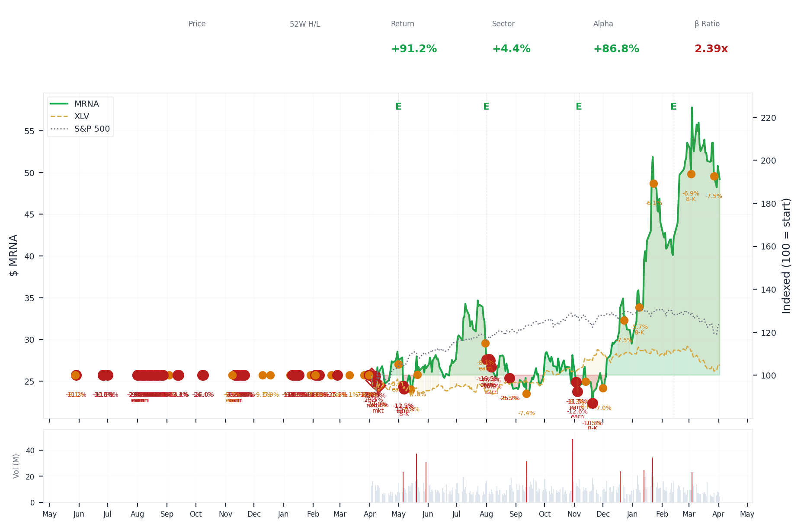
1-Year Performance (Indexed to 100). Red triangles mark single-day drops >= 8%. Orange bands mark multi-day declines >= 15%.
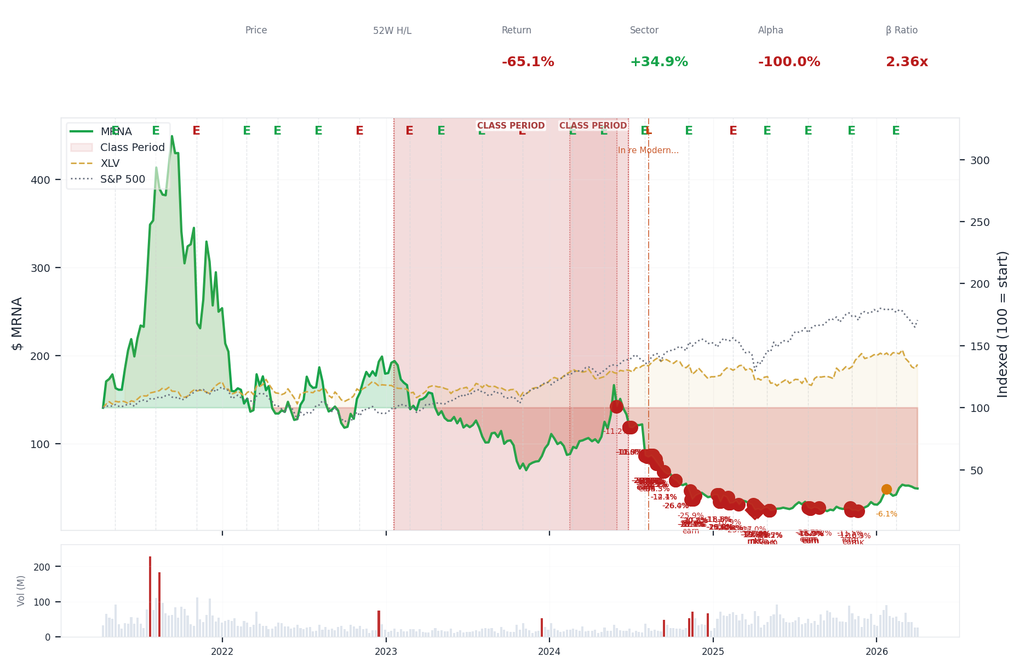
5-Year Performance (Indexed to 100)
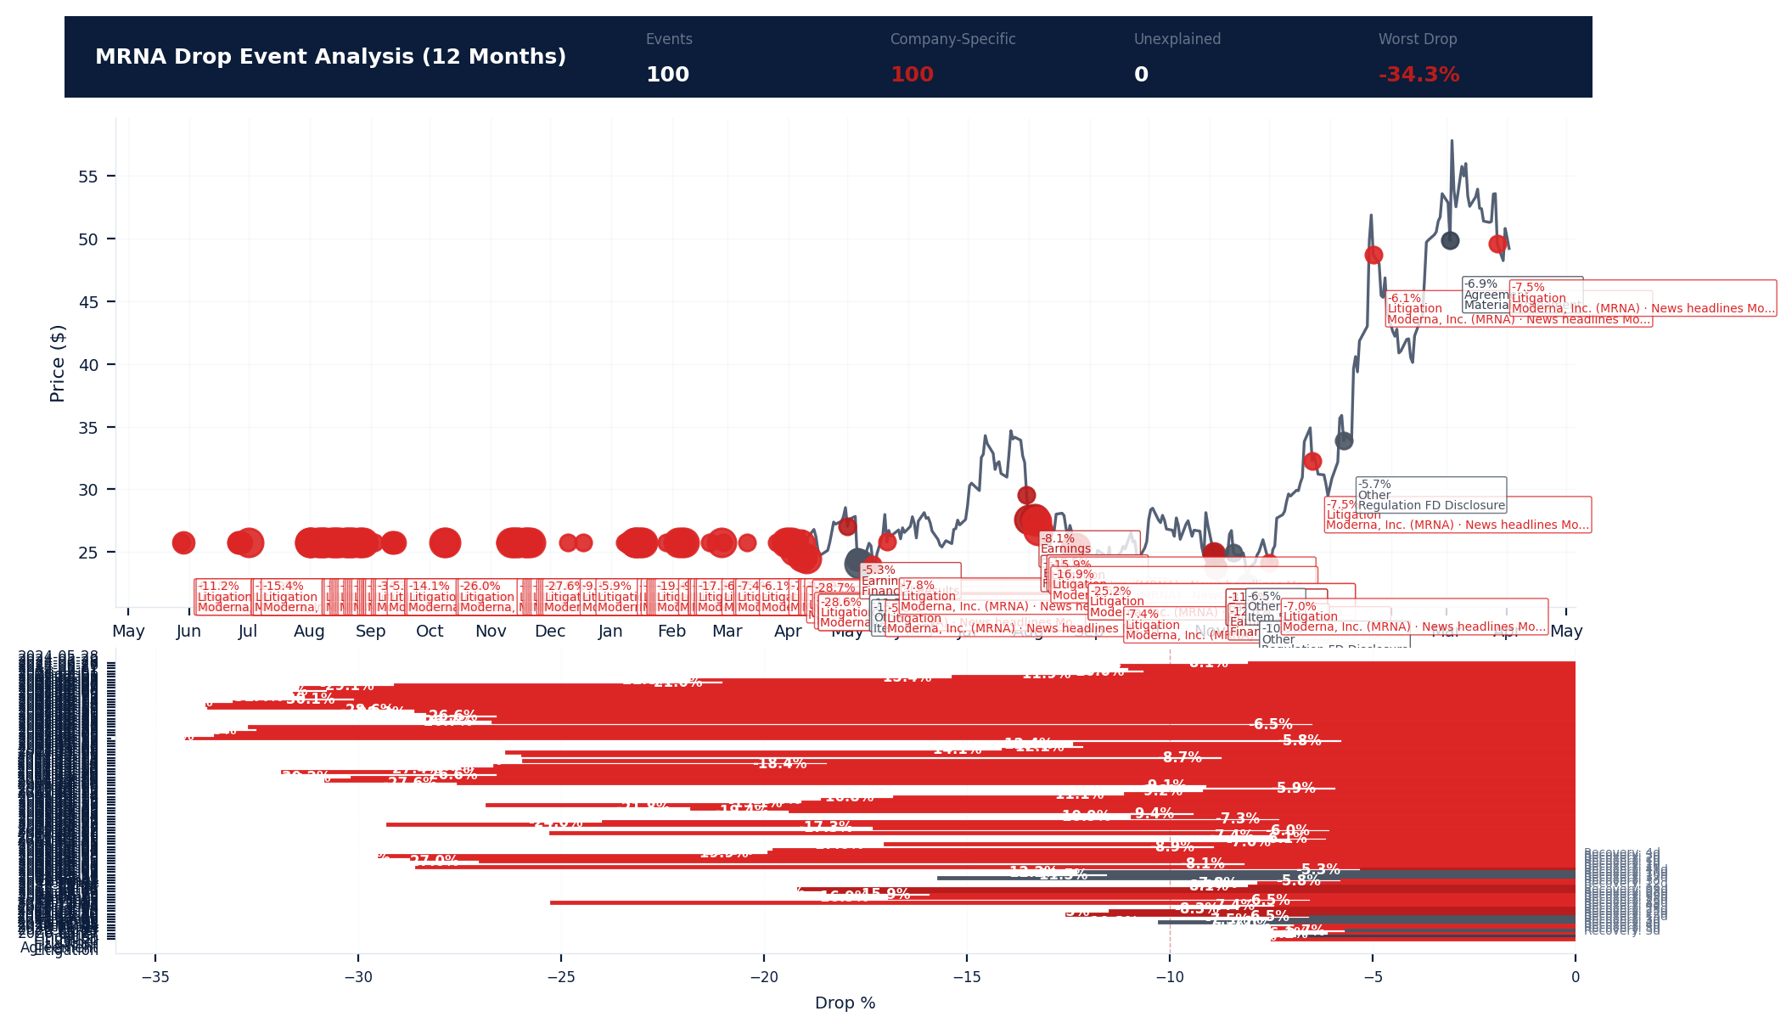
Drop Event Analysis (12 Months)
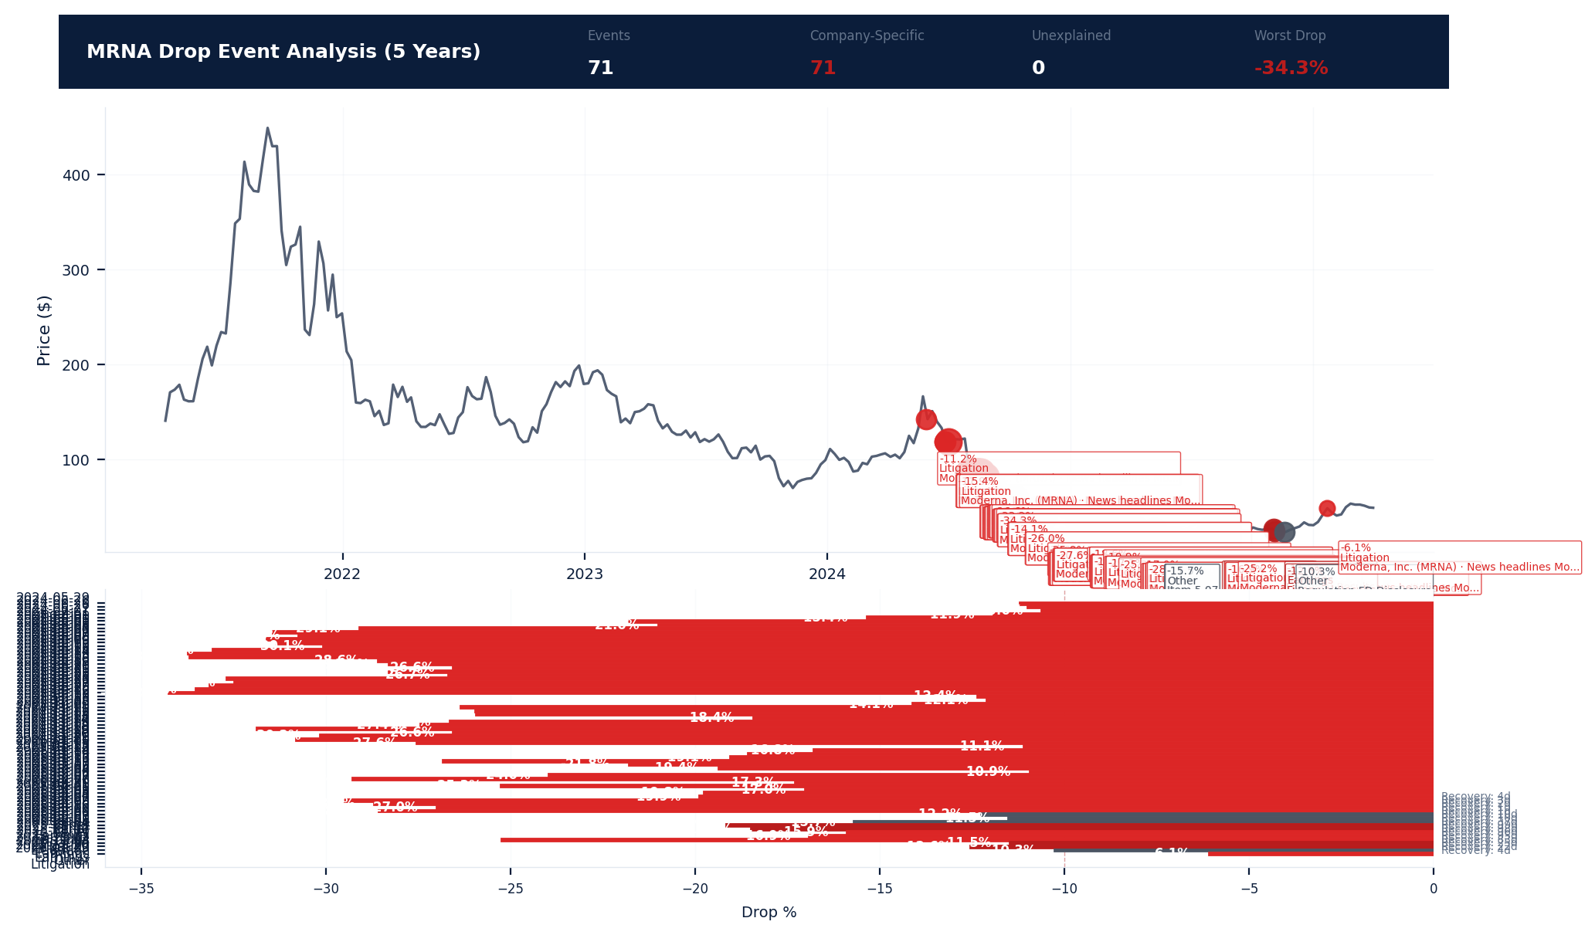
Drop Event Analysis (5 Years)
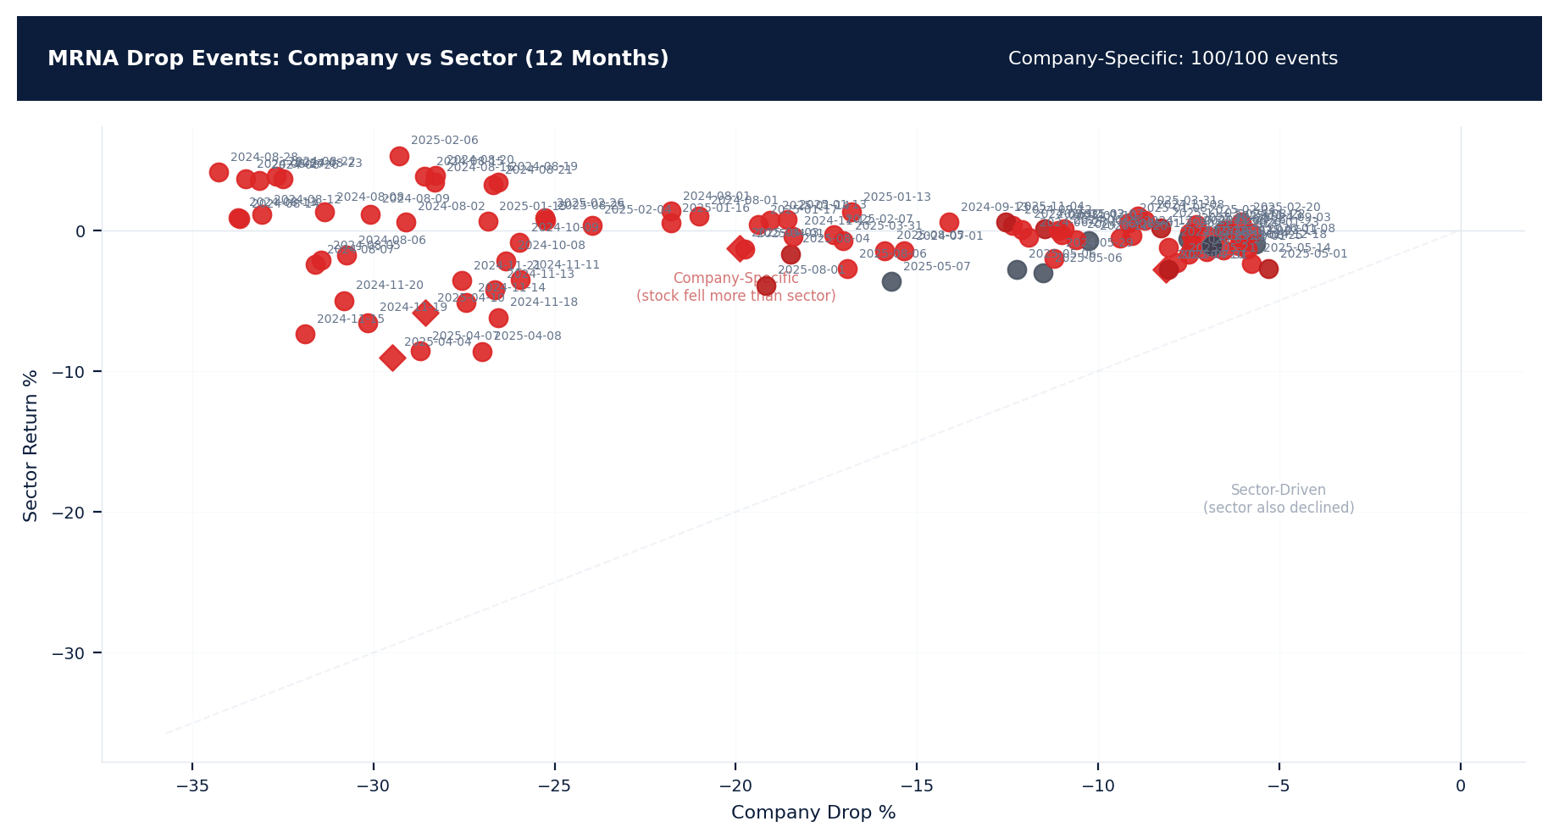
Drop Events: Company vs Sector (12 Months)
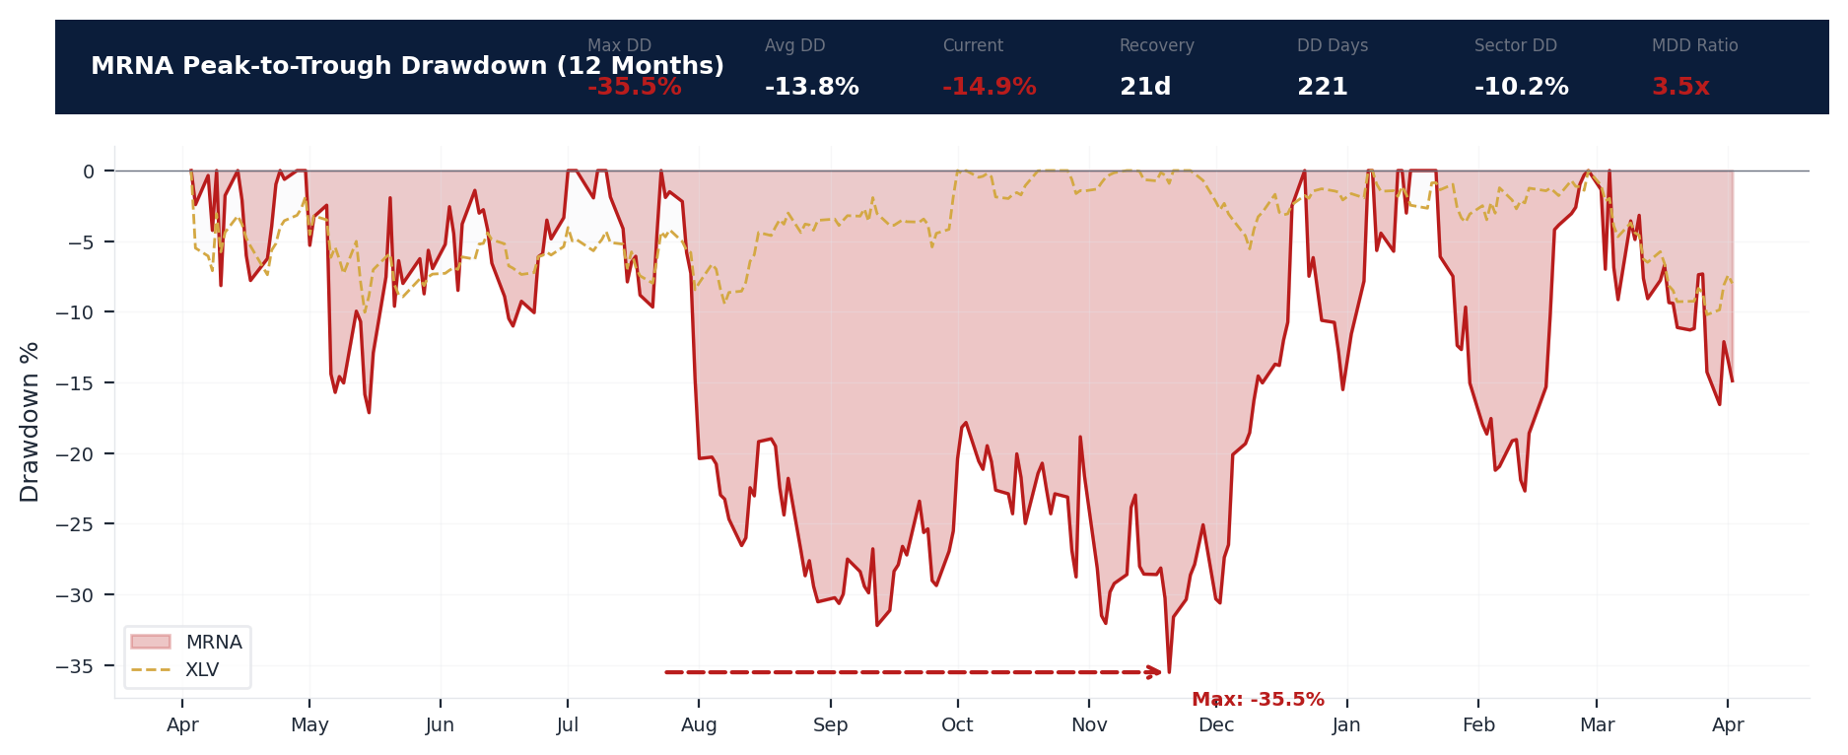
Drawdown Analysis (12 Months)
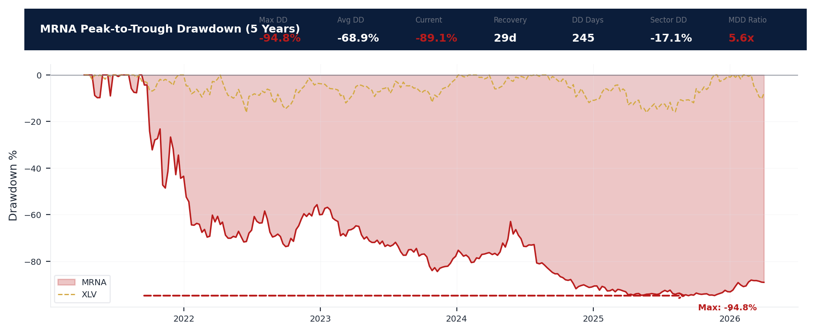
Drawdown Analysis (5 Years)
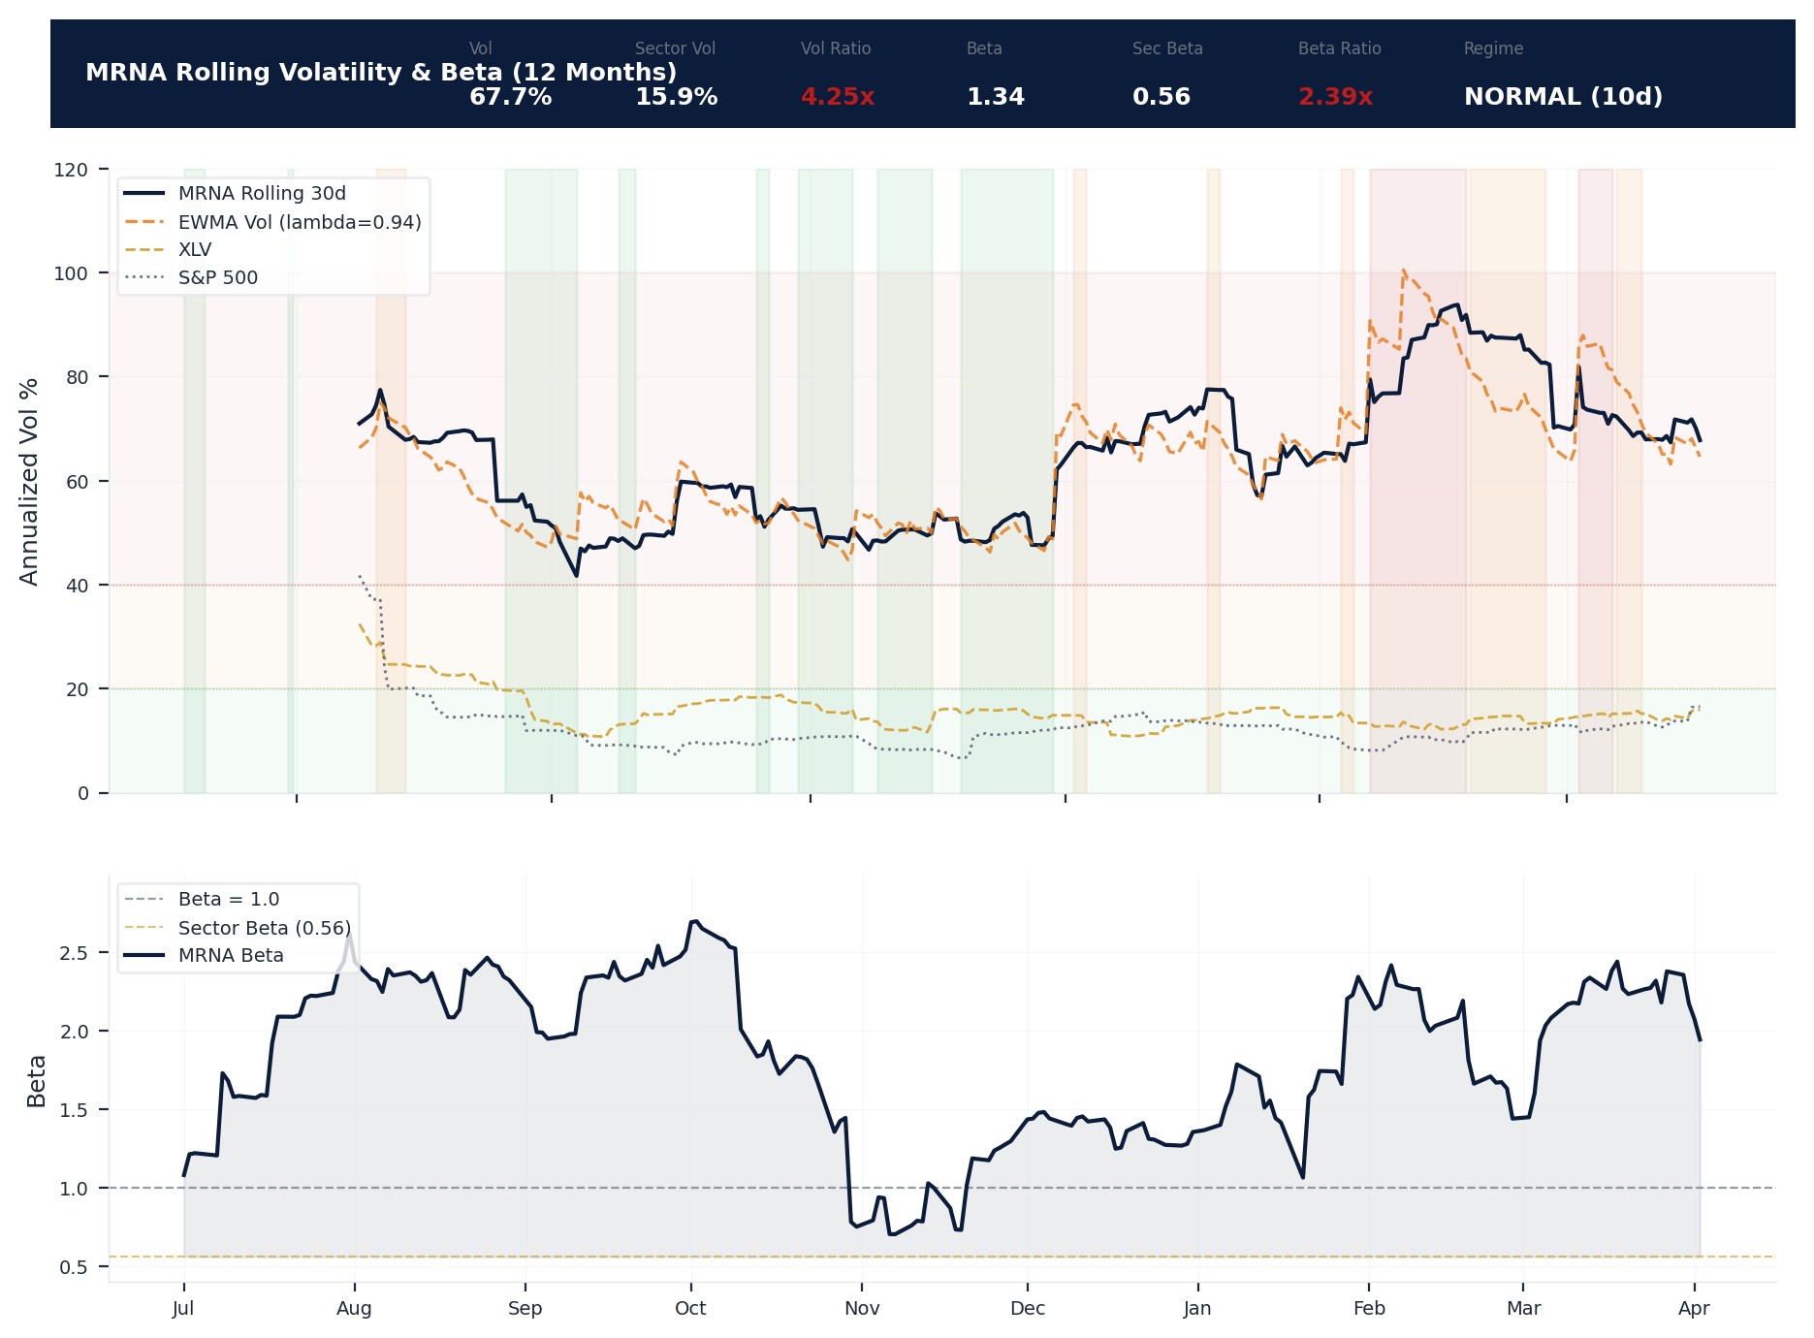
Volatility & Beta Analysis (12 Months)
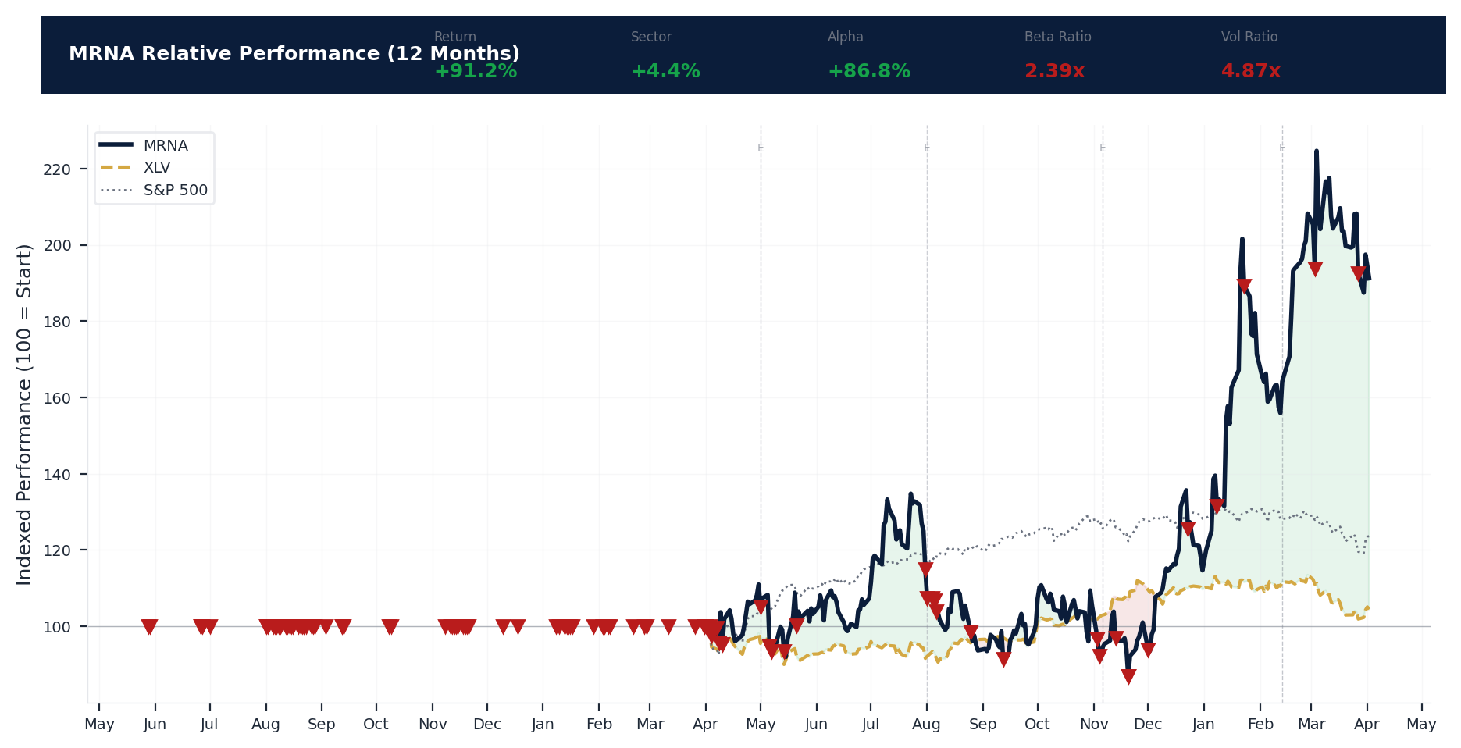
Relative Performance (12 Months)
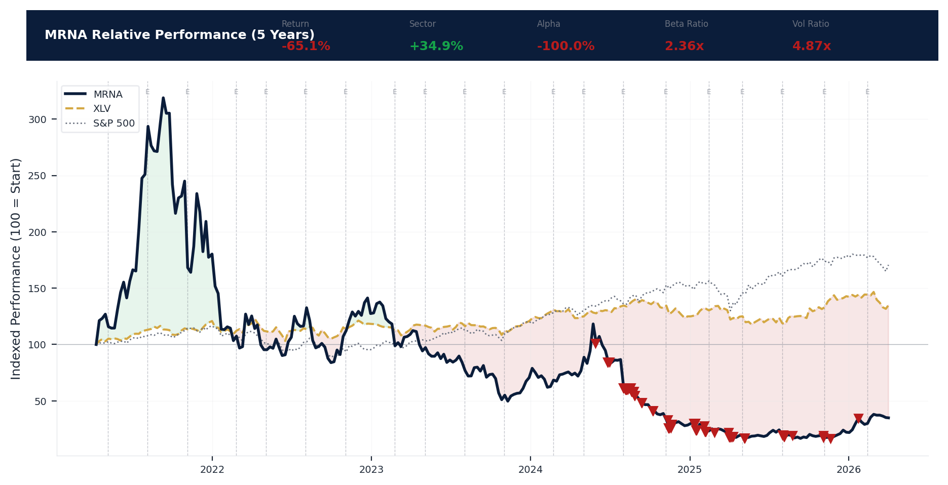
Relative Performance (5 Years)
Metric | Value
Current Price | $49.20
52-Week High | $59.55
52-Week Low | $22.28
1-Year Return | 91.2%
Max Drawdown (1Y) | -35.5%
90-Day Volatility | 75.2% (Ranks at the 0th percentile among 0 peers (peer median: 2.0%))
Beta (vs S&P 500) | 1.34
100 significant stock decline events detected in the 1Y period: 72 critical (>10%), 28 notable (5-10%). 100 were company-specific, 4 were market-wide.
Date | Drop % | Recency | Recovery | Trigger Event | Type | Source
2025-08-25 | -25.2% | 43% | 26 days | Unconfirmed -- Requires Investigation | Company-Specific | https://finance.yahoo.com/quote/MRNA/
2025-07-31 to 2025-08-06 (7d) | -21.8% | 39% | 95 days | Earnings release | Company-Specific | https://www.sec.gov/cgi-bin/browse-edgar?action...
2026-03-27 | -7.5% | 98% | Not recovered | Unconfirmed -- Requires Investigation | Company-Specific | https://finance.yahoo.com/quote/MRNA/
2025-08-04 (5d) | -18.5% | 40% | 98 days | Earnings release | Company-Specific | https://www.sec.gov/cgi-bin/browse-edgar?action...
2025-03-26 to 2025-04-10 (16d) | -31.9% | 25% | 1 days | Unconfirmed -- Requires Investigation | Market-Wide Event | https://finance.yahoo.com/quote/MRNA/
2025-04-10 (20d) | -28.6% | 25% | 1 days | Unconfirmed -- Requires Investigation | Market-Wide Event | https://finance.yahoo.com/quote/MRNA/
2025-04-07 (20d) | -28.7% | 25% | 2 days | Unconfirmed -- Requires Investigation | Company-Specific | https://finance.yahoo.com/quote/MRNA/
2025-11-03 to 2025-11-04 (2d) | -15.6% | 56% | 22 days | Earnings release | Company-Specific | https://www.sec.gov/cgi-bin/browse-edgar?action...
2025-04-08 (20d) | -27.0% | 25% | 1 days | Unconfirmed -- Requires Investigation | Company-Specific | https://finance.yahoo.com/quote/MRNA/
2025-08-06 (5d) | -16.9% | 40% | 95 days | Earnings release | Company-Specific | https://finance.yahoo.com/quote/MRNA/
2025-11-03 (2d) | -11.5% | 56% | 25 days | Earnings release | Company-Specific | https://www.sec.gov/cgi-bin/browse-edgar?action...
2025-08-05 (5d) | -15.9% | 40% | 96 days | Earnings release | Company-Specific | https://finance.yahoo.com/quote/MRNA/
2025-11-20 | -10.3% | 60% | 3 days | 8-K Filing | Company-Specific | https://www.sec.gov/cgi-bin/browse-edgar?action...
2026-03-03 (2d) | +1.9% | 89% | Not recovered | 8-K Filing | Company-Specific | https://www.sec.gov/cgi-bin/browse-edgar?action...
2025-01-29 to 2025-02-07 (10d) | -31.4% | 20% | Not recovered | Unconfirmed -- Requires Investigation | Company-Specific | https://finance.yahoo.com/quote/MRNA/
2025-02-26 to 2025-02-27 (2d) | -30.8% | 21% | Not recovered | Unconfirmed -- Requires Investigation | Company-Specific | https://finance.yahoo.com/quote/MRNA/
2025-12-23 | -7.5% | 68% | 8 days | Unconfirmed -- Requires Investigation | Company-Specific | https://finance.yahoo.com/quote/MRNA/
2025-04-03 (5d) | -19.9% | 25% | 4 days | Unconfirmed -- Requires Investigation | Market-Wide Event | https://finance.yahoo.com/quote/MRNA/
2025-01-08 to 2025-01-17 (10d) | -29.0% | 18% | Not recovered | Unconfirmed -- Requires Investigation | Company-Specific | https://finance.yahoo.com/quote/MRNA/
2025-04-01 (5d) | -19.8% | 24% | Not recovered | Unconfirmed -- Requires Investigation | Company-Specific | https://finance.yahoo.com/quote/MRNA/
2025-02-04 (5d) | -24.0% | 20% | Not recovered | Unconfirmed -- Requires Investigation | Company-Specific | https://finance.yahoo.com/quote/MRNA/
2026-01-23 (3d) | -15.0% | 77% | Not recovered | Unconfirmed -- Requires Investigation | Company-Specific | https://finance.yahoo.com/quote/MRNA/
2025-11-03 | -8.3% | 56% | 23 days | Earnings release | Company-Specific | https://www.sec.gov/cgi-bin/browse-edgar?action...
2024-11-08 to 2024-11-21 (14d) | -36.2% | 14% | Not recovered | Unconfirmed -- Requires Investigation | Company-Specific | https://finance.yahoo.com/quote/MRNA/
2024-11-20 (20d) | -30.8% | 15% | Not recovered | Unconfirmed -- Requires Investigation | Company-Specific | https://finance.yahoo.com/quote/MRNA/
2025-11-20 | -7.5% | 60% | 3 days | 8-K Filing | Company-Specific | https://www.sec.gov/cgi-bin/browse-edgar?action...
2024-11-19 (20d) | -30.2% | 15% | Not recovered | Unconfirmed -- Requires Investigation | Company-Specific | https://finance.yahoo.com/quote/MRNA/
2025-05-01 to 2025-05-07 (7d) | -15.7% | 28% | 10 days | 8-K Filing | Company-Specific | https://www.sec.gov/cgi-bin/browse-edgar?action...
2025-12-01 | -7.0% | 63% | 4 days | Unconfirmed -- Requires Investigation | Company-Specific | https://finance.yahoo.com/quote/MRNA/
2025-03-31 (5d) | -17.0% | 24% | Not recovered | Unconfirmed -- Requires Investigation | Company-Specific | https://finance.yahoo.com/quote/MRNA/
2026-01-08 | -5.7% | 72% | 3 days | 8-K Filing | Company-Specific | https://www.sec.gov/cgi-bin/browse-edgar?action...
2024-11-21 (20d) | -27.6% | 15% | Not recovered | Unconfirmed -- Requires Investigation | Company-Specific | https://finance.yahoo.com/quote/MRNA/
2025-01-16 (5d) | -21.8% | 18% | Not recovered | Unconfirmed -- Requires Investigation | Company-Specific | https://finance.yahoo.com/quote/MRNA/
2024-11-14 (20d) | -27.4% | 14% | Not recovered | Unconfirmed -- Requires Investigation | Company-Specific | https://finance.yahoo.com/quote/MRNA/
2024-11-18 (20d) | -26.6% | 15% | Not recovered | Unconfirmed -- Requires Investigation | Company-Specific | https://finance.yahoo.com/quote/MRNA/
2025-11-13 | -6.5% | 58% | 15 days | 8-K Filing | Company-Specific | https://www.sec.gov/cgi-bin/browse-edgar?action...
2024-11-13 (20d) | -26.7% | 14% | Not recovered | Unconfirmed -- Requires Investigation | Company-Specific | https://finance.yahoo.com/quote/MRNA/
2024-11-11 (20d) | -25.9% | 14% | Not recovered | Earnings release | Company-Specific | https://finance.yahoo.com/quote/MRNA/
2024-08-01 to 2024-08-28 (28d) | -37.4% | 11% | Not recovered | Unconfirmed -- Requires Investigation | Company-Specific | https://finance.yahoo.com/quote/MRNA/
2025-01-17 (5d) | -19.4% | 18% | Not recovered | Unconfirmed -- Requires Investigation | Company-Specific | https://finance.yahoo.com/quote/MRNA/
2024-08-27 (20d) | -33.5% | 11% | Not recovered | Unconfirmed -- Requires Investigation | Company-Specific | https://finance.yahoo.com/quote/MRNA/
2024-08-26 (20d) | -33.2% | 11% | Not recovered | Unconfirmed -- Requires Investigation | Company-Specific | https://finance.yahoo.com/quote/MRNA/
2025-01-14 (5d) | -19.1% | 18% | Not recovered | Unconfirmed -- Requires Investigation | Company-Specific | https://finance.yahoo.com/quote/MRNA/
2025-02-07 (5d) | -17.3% | 20% | Not recovered | Unconfirmed -- Requires Investigation | Company-Specific | https://finance.yahoo.com/quote/MRNA/
2025-05-06 | -12.2% | 28% | 10 days | Earnings release | Company-Specific | https://www.sec.gov/cgi-bin/browse-edgar?action...
2025-09-12 | -7.4% | 46% | 4 days | Unconfirmed -- Requires Investigation | Company-Specific | https://finance.yahoo.com/quote/MRNA/
2024-08-22 (20d) | -32.7% | 10% | Not recovered | Unconfirmed -- Requires Investigation | Company-Specific | https://finance.yahoo.com/quote/MRNA/
2024-08-14 (20d) | -33.7% | 10% | Not recovered | Unconfirmed -- Requires Investigation | Company-Specific | https://finance.yahoo.com/quote/MRNA/
2024-08-23 (20d) | -32.5% | 10% | Not recovered | Unconfirmed -- Requires Investigation | Company-Specific | https://finance.yahoo.com/quote/MRNA/
2024-08-13 (20d) | -33.8% | 10% | Not recovered | Unconfirmed -- Requires Investigation | Company-Specific | https://finance.yahoo.com/quote/MRNA/
2025-01-13 (2d) | -18.6% | 18% | Not recovered | Unconfirmed -- Requires Investigation | Company-Specific | https://finance.yahoo.com/quote/MRNA/
2024-08-12 (20d) | -33.1% | 10% | Not recovered | Unconfirmed -- Requires Investigation | Company-Specific | https://finance.yahoo.com/quote/MRNA/
2024-10-08 to 2024-10-09 (2d) | -26.6% | 12% | Not recovered | Unconfirmed -- Requires Investigation | Company-Specific | https://finance.yahoo.com/quote/MRNA/
2024-10-09 (20d) | -26.0% | 13% | Not recovered | Unconfirmed -- Requires Investigation | Company-Specific | https://finance.yahoo.com/quote/MRNA/
2025-05-06 (2d) | -11.5% | 28% | 10 days | Earnings release | Company-Specific | https://www.sec.gov/cgi-bin/browse-edgar?action...
2025-07-31 (2d) | -14.1% | 39% | Not recovered | Earnings release | Company-Specific | https://www.sec.gov/cgi-bin/browse-edgar?action...
2024-08-07 (5d) | -31.6% | 10% | Not recovered | Unconfirmed -- Requires Investigation | Company-Specific | https://finance.yahoo.com/quote/MRNA/
2024-08-08 (20d) | -31.4% | 10% | Not recovered | Unconfirmed -- Requires Investigation | Company-Specific | https://finance.yahoo.com/quote/MRNA/
2024-08-05 (5d) | -31.4% | 10% | Not recovered | Earnings release | Company-Specific | https://finance.yahoo.com/quote/MRNA/
2025-01-13 | -16.8% | 18% | Not recovered | Unconfirmed -- Requires Investigation | Company-Specific | https://finance.yahoo.com/quote/MRNA/
2024-08-06 (5d) | -30.8% | 10% | Not recovered | Earnings release | Company-Specific | https://finance.yahoo.com/quote/MRNA/
2024-08-09 (20d) | -30.1% | 10% | Not recovered | Unconfirmed -- Requires Investigation | Company-Specific | https://finance.yahoo.com/quote/MRNA/
2024-08-20 (20d) | -28.3% | 10% | Not recovered | Unconfirmed -- Requires Investigation | Company-Specific | https://finance.yahoo.com/quote/MRNA/
2024-08-15 (20d) | -28.6% | 10% | Not recovered | Unconfirmed -- Requires Investigation | Company-Specific | https://finance.yahoo.com/quote/MRNA/
2024-08-16 (20d) | -28.3% | 10% | Not recovered | Unconfirmed -- Requires Investigation | Company-Specific | https://finance.yahoo.com/quote/MRNA/
2024-08-02 (5d) | -29.1% | 10% | Not recovered | Earnings release | Company-Specific | https://finance.yahoo.com/quote/MRNA/
2025-08-25 | -6.5% | 43% | 26 days | Unconfirmed -- Requires Investigation | Company-Specific | https://finance.yahoo.com/quote/MRNA/
2024-08-21 (20d) | -26.7% | 10% | Not recovered | Unconfirmed -- Requires Investigation | Company-Specific | https://finance.yahoo.com/quote/MRNA/
2024-08-19 (20d) | -26.6% | 10% | Not recovered | Unconfirmed -- Requires Investigation | Company-Specific | https://finance.yahoo.com/quote/MRNA/
2024-11-12 (5d) | -18.4% | 14% | Not recovered | Earnings release | Company-Specific | https://finance.yahoo.com/quote/MRNA/
2025-05-21 | -7.8% | 30% | 12 days | Unconfirmed -- Requires Investigation | Company-Specific | https://finance.yahoo.com/quote/MRNA/
2025-03-31 (2d) | -8.9% | 24% | Not recovered | Unconfirmed -- Requires Investigation | Company-Specific | https://finance.yahoo.com/quote/MRNA/
2025-02-03 (2d) | -10.9% | 20% | Not recovered | Unconfirmed -- Requires Investigation | Company-Specific | https://finance.yahoo.com/quote/MRNA/
2024-08-01 (5d) | -21.8% | 10% | Not recovered | Earnings release | Company-Specific | https://finance.yahoo.com/quote/MRNA/
2025-04-10 | -8.1% | 25% | 2 days | Unconfirmed -- Requires Investigation | Market-Wide Event | https://finance.yahoo.com/quote/MRNA/
2024-08-01 (2d) | -21.0% | 10% | Not recovered | Earnings release | Company-Specific | https://finance.yahoo.com/quote/MRNA/
2025-01-10 (2d) | -11.1% | 18% | Not recovered | Unconfirmed -- Requires Investigation | Company-Specific | https://finance.yahoo.com/quote/MRNA/
2025-01-29 | -9.4% | 19% | Not recovered | Unconfirmed -- Requires Investigation | Company-Specific | https://finance.yahoo.com/quote/MRNA/
2025-03-26 | -7.0% | 24% | Not recovered | Unconfirmed -- Requires Investigation | Company-Specific | https://finance.yahoo.com/quote/MRNA/
2025-05-14 | -5.8% | 29% | 3 days | Unconfirmed -- Requires Investigation | Company-Specific | https://finance.yahoo.com/quote/MRNA/
2025-01-08 | -9.2% | 18% | Not recovered | Unconfirmed -- Requires Investigation | Company-Specific | https://finance.yahoo.com/quote/MRNA/
2024-09-12 to 2024-09-13 (2d) | -14.1% | 11% | Not recovered | Unconfirmed -- Requires Investigation | Company-Specific | https://finance.yahoo.com/quote/MRNA/
2025-02-27 | -7.4% | 22% | Not recovered | Unconfirmed -- Requires Investigation | Company-Specific | https://finance.yahoo.com/quote/MRNA/
2025-05-01 | -5.3% | 27% | 41 days | Earnings release | Company-Specific | https://www.sec.gov/cgi-bin/browse-edgar?action...
2024-12-10 | -9.1% | 16% | Not recovered | Unconfirmed -- Requires Investigation | Company-Specific | https://finance.yahoo.com/quote/MRNA/
2025-02-03 (2d) | -7.3% | 20% | Not recovered | Unconfirmed -- Requires Investigation | Company-Specific | https://finance.yahoo.com/quote/MRNA/
2024-09-12 | -12.4% | 11% | Not recovered | Unconfirmed -- Requires Investigation | Company-Specific | https://finance.yahoo.com/quote/MRNA/
2025-03-11 | -6.1% | 23% | Not recovered | Unconfirmed -- Requires Investigation | Company-Specific | https://finance.yahoo.com/quote/MRNA/
2024-09-12 (2d) | -12.1% | 11% | Not recovered | Unconfirmed -- Requires Investigation | Company-Specific | https://finance.yahoo.com/quote/MRNA/
2024-06-26 to 2024-07-01 (6d) | -15.7% | 9% | Not recovered | Unconfirmed -- Requires Investigation | Company-Specific | https://finance.yahoo.com/quote/MRNA/
2025-02-20 | -6.0% | 21% | Not recovered | Unconfirmed -- Requires Investigation | Company-Specific | https://finance.yahoo.com/quote/MRNA/
2024-11-08 (5d) | -8.7% | 14% | Not recovered | Earnings release | Company-Specific | https://finance.yahoo.com/quote/MRNA/
2024-06-27 (2d) | -11.9% | 8% | Not recovered | Unconfirmed -- Requires Investigation | Company-Specific | https://finance.yahoo.com/quote/MRNA/
2024-12-18 | -5.9% | 16% | Not recovered | Unconfirmed -- Requires Investigation | Company-Specific | https://finance.yahoo.com/quote/MRNA/
2024-06-26 | -11.0% | 8% | Not recovered | Unconfirmed -- Requires Investigation | Company-Specific | https://finance.yahoo.com/quote/MRNA/
2024-06-26 (2d) | -10.6% | 8% | Not recovered | Unconfirmed -- Requires Investigation | Company-Specific | https://finance.yahoo.com/quote/MRNA/
2024-05-28 to 2024-05-29 (2d) | -14.4% | 7% | Not recovered | Unconfirmed -- Requires Investigation | Company-Specific | https://finance.yahoo.com/quote/MRNA/
2024-08-22 | -6.5% | 10% | Not recovered | Unconfirmed -- Requires Investigation | Company-Specific | https://finance.yahoo.com/quote/MRNA/
2024-09-03 | -5.8% | 11% | Not recovered | Unconfirmed -- Requires Investigation | Company-Specific | https://finance.yahoo.com/quote/MRNA/
2024-05-28 (2d) | -8.1% | 7% | Not recovered | Unconfirmed -- Requires Investigation | Company-Specific | https://finance.yahoo.com/quote/MRNA/
71 significant stock decline events detected in the 5Y period: 71 critical (>10%). 71 were company-specific, 3 were market-wide.
Date | Drop % | Recency | Recovery | Trigger Event | Type | Source
2025-08-25 | -25.2% | 43% | 26 days | Unconfirmed -- Requires Investigation | Company-Specific | https://finance.yahoo.com/quote/MRNA/
2025-07-31 to 2025-08-06 (7d) | -21.8% | 39% | 95 days | Earnings release | Company-Specific | https://www.sec.gov/cgi-bin/browse-edgar?action...
2025-08-04 (5d) | -18.5% | 40% | 98 days | Earnings release | Company-Specific | https://www.sec.gov/cgi-bin/browse-edgar?action...
2025-03-26 to 2025-04-10 (16d) | -31.9% | 25% | 1 days | Unconfirmed -- Requires Investigation | Market-Wide Event | https://finance.yahoo.com/quote/MRNA/
2025-04-10 (20d) | -28.6% | 25% | 1 days | Unconfirmed -- Requires Investigation | Market-Wide Event | https://finance.yahoo.com/quote/MRNA/
2025-04-07 (20d) | -28.7% | 25% | 2 days | Unconfirmed -- Requires Investigation | Company-Specific | https://finance.yahoo.com/quote/MRNA/
2025-11-03 to 2025-11-04 (2d) | -15.6% | 56% | 22 days | Earnings release | Company-Specific | https://www.sec.gov/cgi-bin/browse-edgar?action...
2025-04-08 (20d) | -27.0% | 25% | 1 days | Unconfirmed -- Requires Investigation | Company-Specific | https://finance.yahoo.com/quote/MRNA/
2025-08-06 (5d) | -16.9% | 40% | 95 days | Earnings release | Company-Specific | https://finance.yahoo.com/quote/MRNA/
2025-11-03 (2d) | -11.5% | 56% | 25 days | Earnings release | Company-Specific | https://www.sec.gov/cgi-bin/browse-edgar?action...
2025-08-05 (5d) | -15.9% | 40% | 96 days | Earnings release | Company-Specific | https://finance.yahoo.com/quote/MRNA/
2025-11-20 | -10.3% | 60% | 3 days | 8-K Filing | Company-Specific | https://www.sec.gov/cgi-bin/browse-edgar?action...
2025-01-29 to 2025-02-07 (10d) | -31.4% | 20% | Not recovered | Unconfirmed -- Requires Investigation | Company-Specific | https://finance.yahoo.com/quote/MRNA/
2025-02-26 to 2025-02-27 (2d) | -30.8% | 21% | Not recovered | Unconfirmed -- Requires Investigation | Company-Specific | https://finance.yahoo.com/quote/MRNA/
2025-04-03 (5d) | -19.9% | 25% | 4 days | Unconfirmed -- Requires Investigation | Market-Wide Event | https://finance.yahoo.com/quote/MRNA/
2025-01-08 to 2025-01-17 (10d) | -29.0% | 18% | Not recovered | Unconfirmed -- Requires Investigation | Company-Specific | https://finance.yahoo.com/quote/MRNA/
2025-04-01 (5d) | -19.8% | 24% | Not recovered | Unconfirmed -- Requires Investigation | Company-Specific | https://finance.yahoo.com/quote/MRNA/
2025-02-04 (5d) | -24.0% | 20% | Not recovered | Unconfirmed -- Requires Investigation | Company-Specific | https://finance.yahoo.com/quote/MRNA/
2026-01-23 (3d) | -15.0% | 77% | Not recovered | Unconfirmed -- Requires Investigation | Company-Specific | https://finance.yahoo.com/quote/MRNA/
2024-11-08 to 2024-11-21 (14d) | -36.2% | 14% | Not recovered | Unconfirmed -- Requires Investigation | Company-Specific | https://finance.yahoo.com/quote/MRNA/
2024-11-20 (20d) | -30.8% | 15% | Not recovered | Unconfirmed -- Requires Investigation | Company-Specific | https://finance.yahoo.com/quote/MRNA/
2024-11-19 (20d) | -30.2% | 15% | Not recovered | Unconfirmed -- Requires Investigation | Company-Specific | https://finance.yahoo.com/quote/MRNA/
2025-05-01 to 2025-05-07 (7d) | -15.7% | 28% | 10 days | 8-K Filing | Company-Specific | https://www.sec.gov/cgi-bin/browse-edgar?action...
2025-03-31 (5d) | -17.0% | 24% | Not recovered | Unconfirmed -- Requires Investigation | Company-Specific | https://finance.yahoo.com/quote/MRNA/
2024-11-21 (20d) | -27.6% | 15% | Not recovered | Unconfirmed -- Requires Investigation | Company-Specific | https://finance.yahoo.com/quote/MRNA/
2025-01-16 (5d) | -21.8% | 18% | Not recovered | Unconfirmed -- Requires Investigation | Company-Specific | https://finance.yahoo.com/quote/MRNA/
2024-11-14 (20d) | -27.4% | 14% | Not recovered | Unconfirmed -- Requires Investigation | Company-Specific | https://finance.yahoo.com/quote/MRNA/
2024-11-18 (20d) | -26.6% | 15% | Not recovered | Unconfirmed -- Requires Investigation | Company-Specific | https://finance.yahoo.com/quote/MRNA/
2024-11-13 (20d) | -26.7% | 14% | Not recovered | Unconfirmed -- Requires Investigation | Company-Specific | https://finance.yahoo.com/quote/MRNA/
2024-11-11 (20d) | -25.9% | 14% | Not recovered | Earnings release | Company-Specific | https://finance.yahoo.com/quote/MRNA/
2024-08-01 to 2024-08-28 (28d) | -37.4% | 11% | Not recovered | Unconfirmed -- Requires Investigation | Company-Specific | https://finance.yahoo.com/quote/MRNA/
2025-01-17 (5d) | -19.4% | 18% | Not recovered | Unconfirmed -- Requires Investigation | Company-Specific | https://finance.yahoo.com/quote/MRNA/
2024-08-27 (20d) | -33.5% | 11% | Not recovered | Unconfirmed -- Requires Investigation | Company-Specific | https://finance.yahoo.com/quote/MRNA/
2024-08-26 (20d) | -33.2% | 11% | Not recovered | Unconfirmed -- Requires Investigation | Company-Specific | https://finance.yahoo.com/quote/MRNA/
2025-01-14 (5d) | -19.1% | 18% | Not recovered | Unconfirmed -- Requires Investigation | Company-Specific | https://finance.yahoo.com/quote/MRNA/
2025-02-07 (5d) | -17.3% | 20% | Not recovered | Unconfirmed -- Requires Investigation | Company-Specific | https://finance.yahoo.com/quote/MRNA/
2025-05-06 | -12.2% | 28% | 10 days | Earnings release | Company-Specific | https://www.sec.gov/cgi-bin/browse-edgar?action...
2024-08-22 (20d) | -32.7% | 10% | Not recovered | Unconfirmed -- Requires Investigation | Company-Specific | https://finance.yahoo.com/quote/MRNA/
2024-08-14 (20d) | -33.7% | 10% | Not recovered | Unconfirmed -- Requires Investigation | Company-Specific | https://finance.yahoo.com/quote/MRNA/
2024-08-23 (20d) | -32.5% | 10% | Not recovered | Unconfirmed -- Requires Investigation | Company-Specific | https://finance.yahoo.com/quote/MRNA/
2024-08-13 (20d) | -33.8% | 10% | Not recovered | Unconfirmed -- Requires Investigation | Company-Specific | https://finance.yahoo.com/quote/MRNA/
2025-01-13 (2d) | -18.6% | 18% | Not recovered | Unconfirmed -- Requires Investigation | Company-Specific | https://finance.yahoo.com/quote/MRNA/
2024-08-12 (20d) | -33.1% | 10% | Not recovered | Unconfirmed -- Requires Investigation | Company-Specific | https://finance.yahoo.com/quote/MRNA/
2024-10-08 to 2024-10-09 (2d) | -26.6% | 12% | Not recovered | Unconfirmed -- Requires Investigation | Company-Specific | https://finance.yahoo.com/quote/MRNA/
2024-10-09 (20d) | -26.0% | 13% | Not recovered | Unconfirmed -- Requires Investigation | Company-Specific | https://finance.yahoo.com/quote/MRNA/
2025-05-06 (2d) | -11.5% | 28% | 10 days | Earnings release | Company-Specific | https://www.sec.gov/cgi-bin/browse-edgar?action...
2024-08-07 (5d) | -31.6% | 10% | Not recovered | Unconfirmed -- Requires Investigation | Company-Specific | https://finance.yahoo.com/quote/MRNA/
2024-08-08 (20d) | -31.4% | 10% | Not recovered | Unconfirmed -- Requires Investigation | Company-Specific | https://finance.yahoo.com/quote/MRNA/
2024-08-05 (5d) | -31.4% | 10% | Not recovered | Earnings release | Company-Specific | https://finance.yahoo.com/quote/MRNA/
2025-01-13 | -16.8% | 18% | Not recovered | Unconfirmed -- Requires Investigation | Company-Specific | https://finance.yahoo.com/quote/MRNA/
2024-08-06 (5d) | -30.8% | 10% | Not recovered | Earnings release | Company-Specific | https://finance.yahoo.com/quote/MRNA/
2024-08-09 (20d) | -30.1% | 10% | Not recovered | Unconfirmed -- Requires Investigation | Company-Specific | https://finance.yahoo.com/quote/MRNA/
2024-08-20 (20d) | -28.3% | 10% | Not recovered | Unconfirmed -- Requires Investigation | Company-Specific | https://finance.yahoo.com/quote/MRNA/
2024-08-15 (20d) | -28.6% | 10% | Not recovered | Unconfirmed -- Requires Investigation | Company-Specific | https://finance.yahoo.com/quote/MRNA/
2024-08-16 (20d) | -28.3% | 10% | Not recovered | Unconfirmed -- Requires Investigation | Company-Specific | https://finance.yahoo.com/quote/MRNA/
2024-08-02 (5d) | -29.1% | 10% | Not recovered | Earnings release | Company-Specific | https://finance.yahoo.com/quote/MRNA/
2024-08-21 (20d) | -26.7% | 10% | Not recovered | Unconfirmed -- Requires Investigation | Company-Specific | https://finance.yahoo.com/quote/MRNA/
2024-08-19 (20d) | -26.6% | 10% | Not recovered | Unconfirmed -- Requires Investigation | Company-Specific | https://finance.yahoo.com/quote/MRNA/
2024-11-12 (5d) | -18.4% | 14% | Not recovered | Earnings release | Company-Specific | https://finance.yahoo.com/quote/MRNA/
2025-02-03 (2d) | -10.9% | 20% | Not recovered | Unconfirmed -- Requires Investigation | Company-Specific | https://finance.yahoo.com/quote/MRNA/
2024-08-01 (5d) | -21.8% | 10% | Not recovered | Earnings release | Company-Specific | https://finance.yahoo.com/quote/MRNA/
2024-08-01 (2d) | -21.0% | 10% | Not recovered | Earnings release | Company-Specific | https://finance.yahoo.com/quote/MRNA/
2025-01-10 (2d) | -11.1% | 18% | Not recovered | Unconfirmed -- Requires Investigation | Company-Specific | https://finance.yahoo.com/quote/MRNA/
2024-09-12 to 2024-09-13 (2d) | -14.1% | 11% | Not recovered | Unconfirmed -- Requires Investigation | Company-Specific | https://finance.yahoo.com/quote/MRNA/
2024-09-12 | -12.4% | 11% | Not recovered | Unconfirmed -- Requires Investigation | Company-Specific | https://finance.yahoo.com/quote/MRNA/
2024-09-12 (2d) | -12.1% | 11% | Not recovered | Unconfirmed -- Requires Investigation | Company-Specific | https://finance.yahoo.com/quote/MRNA/
2024-06-26 to 2024-07-01 (6d) | -15.7% | 9% | Not recovered | Unconfirmed -- Requires Investigation | Company-Specific | https://finance.yahoo.com/quote/MRNA/
2024-06-27 (2d) | -11.9% | 8% | Not recovered | Unconfirmed -- Requires Investigation | Company-Specific | https://finance.yahoo.com/quote/MRNA/
2024-06-26 | -11.0% | 8% | Not recovered | Unconfirmed -- Requires Investigation | Company-Specific | https://finance.yahoo.com/quote/MRNA/
2024-06-26 (2d) | -10.6% | 8% | Not recovered | Unconfirmed -- Requires Investigation | Company-Specific | https://finance.yahoo.com/quote/MRNA/
2024-05-28 to 2024-05-29 (2d) | -14.4% | 7% | Not recovered | Unconfirmed -- Requires Investigation | Company-Specific | https://finance.yahoo.com/quote/MRNA/
Short Interest
Metric | Value
Short % of Float | 20.4% (Ranks at the 0th percentile among 0 peers (peer median: 4.0%))
Days to Cover | 6.35
6-Month Trend | STABLE
vs Sector Ratio | N/A
[HIGH] Elevated Short Interest: 20.4% -- Signals significant bearish sentiment; vulnerability to short seller reports
Context: Cluster insider selling within 90 days of a stock drop correlates with securities class actions in 42% of cases.
See Meeting Prep: Short Interest & Market Sentiment
Earnings Guidance Track Record
Metric | Value
Beat Rate | 0.7%
Consecutive Misses | 0
Guidance Withdrawals | 0
Philosophy | MIXED
Quarter | Est. EPS | Actual EPS | Result | Miss Magnitude | Stock Reaction
Q1 2026 | $-2.60 | $-2.11 | BEAT | N/A | +18.9%
Q4 2025 | $-2.16 | $-0.51 | BEAT | N/A | +76.4%
Q3 2025 | $-2.97 | $-2.13 | BEAT | N/A | +28.3%
Q2 2025 | $-3.11 | $-2.52 | BEAT | N/A | +18.9%
Q1 2025 | $-2.73 | $-2.91 | MISS | +6.6% | -6.7%
Q4 2024 | $-1.94 | $0.03 | BEAT | N/A | N/A
Q3 2024 | $-3.36 | $-3.33 | MEET | N/A | +1.0%
Q2 2024 | $-3.55 | $-3.07 | BEAT | N/A | +13.6%
Q1 2024 | $-0.99 | $0.55 | BEAT | N/A | N/A
Q4 2023 | $-2.05 | $-9.53 | MISS | +364.9% | N/A
Q3 2023 | $-4.12 | $-3.62 | BEAT | N/A | +12.2%
Q2 2023 | $-1.73 | $0.19 | BEAT | N/A | N/A
Q1 2023 | $4.60 | $3.61 | MISS | +21.5% | -21.5%
Q4 2022 | $3.11 | $2.53 | MISS | +18.6% | -18.6%
Q3 2022 | $4.49 | $5.24 | BEAT | N/A | +16.6%
Q2 2022 | $5.62 | $8.58 | BEAT | N/A | +52.6%
Analyst Consensus
Metric | Value
Analyst Coverage | 20
Consensus Rating | HOLD
Mean Recommendation | 2.92 (1=Strong Buy, 5=Sell)
Mean Target Price | $45
Target Price High | $135
Target Price Low | $12
Stock Drop Analysis
Date | Magnitude | Type | Trigger / Attribution | Sector Return | Company-Specific
2024-08-01 to 2024-08-28 | -37.4% | MULTI_DAY (28d) | Unknown | +4.1% | Yes
2024-11-08 to 2024-11-21 | -36.2% | MULTI_DAY (14d) | Unknown | -7.4% | Yes
2024-08-13 | -33.8% | MULTI_DAY (20d) | Unknown | +0.9% | Yes
2024-08-14 | -33.7% | MULTI_DAY (20d) | Unknown | +0.8% | Yes
2024-08-27 | -33.5% | MULTI_DAY (20d) | Unknown | +3.6% | Yes
2024-08-26 | -33.2% | MULTI_DAY (20d) | Unknown | +3.5% | Yes
2024-08-12 | -33.1% | MULTI_DAY (20d) | Unknown | +1.1% | Yes
2024-08-22 | -32.7% | MULTI_DAY (20d) | Unknown | +3.8% | Yes
2024-08-23 | -32.5% | MULTI_DAY (20d) | Unknown | +3.7% | Yes
2025-03-26 to 2025-04-10 | -31.9% | MULTI_DAY (16d) | Unknown | -9.0% | Yes
2024-08-07 | -31.6% | MULTI_DAY (5d) | Unknown | -2.4% | Yes
2024-08-05 | -31.4% | MULTI_DAY (5d) | earnings_release | -2.1% | Yes
2025-01-29 to 2025-02-07 | -31.4% | MULTI_DAY (10d) | Unknown | +5.3% | Yes
2024-08-08 | -31.4% | MULTI_DAY (20d) | Unknown | +1.3% | Yes
2025-02-26 to 2025-02-27 | -30.8% | MULTI_DAY (2d) | Unknown | +0.9% | Yes
Class Period Potential: 70 company-specific drop(s) exceeding 10% identified. Severe stock drops that are company-specific (not explained by sector movement) are the primary anchors for SCA class periods. Plaintiffs will allege the drop occurred when the 'truth emerged' following prior misstatements. [HIGH]
Insider Trading Analysis
Metric | Value
Net Direction (12mo) | NET_SELLING
10b5-1 Plan % | 75.0%
Buy Transactions | 0
Sell Transactions | 4
Cluster Events | 0
Transaction Detail
Date | Insider | Title | Type | Shares | Value | 10b5-1
2026-03-05 | Klinger Shannon Thyme | Chief Legal Officer | EXERCISE | 11,797 | N/A | No (Discretionary)
2026-03-05 | Klinger Shannon Thyme | Chief Legal Officer | EXERCISE | 11,797 | $0 | No (Discretionary)
2026-03-05 | Klinger Shannon Thyme | Chief Legal Officer | TAX_WITHHOLD | 5,704 | $329.7K | No (Discretionary)
2026-03-05 | Mock James M | Chief Financial Officer | EXERCISE | 11,797 | N/A | No (Discretionary)
2026-03-05 | Mock James M | Chief Financial Officer | EXERCISE | 11,797 | $0 | No (Discretionary)
2026-03-05 | Mock James M | Chief Financial Officer | TAX_WITHHOLD | 5,704 | $329.7K | No (Discretionary)
2026-03-02 | Klinger Shannon Thyme | Chief Legal Officer | EXERCISE | 13,885 | $429.9K | Yes (Pre-arranged)
2026-03-02 | Klinger Shannon Thyme | Chief Legal Officer | EXERCISE | 13,885 | $0 | Yes (Pre-arranged)
2026-03-02 | Klinger Shannon Thyme | Chief Legal Officer | SELL | 13,885 | $726.0K | Yes (Pre-arranged)
2026-03-01 | Bancel Stephane | Chief Executive Officer | GRANT | 250,932 | $0 | No (Discretionary)
2026-03-01 | Hoge Stephen | President | GRANT | 125,466 | $0 | No (Discretionary)
2026-03-01 | Hoge Stephen | President | GRANT | 165,230 | $0 | No (Discretionary)
2026-03-01 | Klinger Shannon Thyme | Chief Legal Officer | GRANT | 29,275 | $0 | Yes (Pre-arranged)
2026-03-01 | Klinger Shannon Thyme | Chief Legal Officer | GRANT | 38,553 | $0 | Yes (Pre-arranged)
2026-03-01 | Mock James M | Chief Financial Officer | GRANT | 37,639 | $0 | No (Discretionary)
2026-03-01 | Mock James M | Chief Financial Officer | GRANT | 49,569 | $0 | No (Discretionary)
2026-02-27 | Hoge Stephen | President | EXERCISE | 652 | N/A | No (Discretionary)
2026-02-27 | Hoge Stephen | President | EXERCISE | 611 | N/A | No (Discretionary)
2026-02-27 | Hoge Stephen | President | EXERCISE | 1,436 | N/A | No (Discretionary)
2026-02-27 | Hoge Stephen | President | EXERCISE | 37,131 | N/A | No (Discretionary)
Executive Departures
No executive departures identified in the trailing 18 months.
Capital Markets Activity
No significant capital markets activity identified in the trailing 3-year period.

ELEVATED CONCERN
Moderna's revenue fell 40% to $1.94B from $3.24B, with a net loss widening to $2.82B from $3.56B, framing a post-pandemic narrative of commercial execution risk. The Piotroski F-Score of 2 indicates deep financial distress, which contrasts with a safe Altman Z-Score of 3.77, creating a disconnect where aggressive forward guidance could clash with these deteriorating fundamentals and form the basis for securities fraud claims. A pristine Beneish M-Score of -4.01 and a clean 12-year audit from E&Y with no material weakness lowers near-term restatement risk under Section 11. The $3.07B operating loss and negative 307x interest coverage are direct fodder for going-concern allegations in a shareholder suit, despite the company's disclosure stating no such issue. The extreme liquidity, with a 3.29 current ratio and 0.07 debt-to-equity, paradoxically heightens D&O exposure by suggesting management has ample runway to pursue high-risk, non-core pipelines that could disappoint and trigger 10(b) claims.
Section 3: Financial Health
The company reported revenue of $1.9B and net income of $-2.8B (per FY2025 10-K, Company Facts API CIK1682852). Revenue declined 39.9% year-over-year (from $3.2B). The company is operating at a net loss (margin: -145.2%), increasing financial distress risk. Both distress models indicate stability: Z-Score 3.77 (safe above 2.99) and O-Score 0.00 (safe below 0.5). Piotroski F-Score of 2/9 signals weak fundamentals across profitability, leverage, and operating efficiency dimensions. Capital structure is conservative with D/E ratio of 0.07, providing meaningful headroom against financial covenant triggers. Interest coverage of -307.4x is thin, raising concerns about debt service sustainability. Effective tax rate of 1.9% is below the 21% U.S. statutory rate, warranting review of uncertain tax positions and transfer pricing. Auditor: Ernst & Young (Big 4), tenure: 12 years. From a D&O perspective, the financial profile supports standard underwriting terms.
Income Statement
Metric | FY2024 | FY2025 | YoY Change
Total revenue / net sales | $3.2B | $1.9B | -39.9%
Cost of revenue / COGS | $1.5B | $868.0M | -40.7%
Operating income / loss | $-3.9B | $-3.1B | 22.1%
Net income / net loss | $-3.6B | $-2.8B | 20.8%
Basic earnings per share | $-9.28 | $-7.26 | 21.8%
Diluted earnings per share | $-9.28 | $-7.26 | 21.8%
Interest expense | $24.0M | $10.0M | -58.3%
Income tax expense / benefit | $46.0M | $54.0M | 17.4%
Research and development expense | $4.5B | $3.1B | -31.1%
Selling, general and administrative expense | $1.2B | $1.0B | -13.3%
Earnings before interest and taxes (EBIT) | $-3.9B | $-3.1B | 22.1%
Weighted average shares outstanding (basic) | 384.0M | 389.0M | 1.3%
Weighted average shares outstanding (diluted) | 384.0M | 389.0M | 1.3%
Total comprehensive income / loss | $-3.4B | $-2.8B | 19.8%
Other income / non-operating income | $-87.0M | $-8.0M | 90.8%
Impairment charges (goodwill, intangibles, long-lived assets) | $0 | $0 | N/A
Income from operations | $-3.9B | $-3.1B | 22.1%
Pre-tax income | $-3.6B | $-2.8B | 23.3%
Stock-based compensation expense | $429.0M | $483.0M | 12.6%
Income before income taxes | $-3.6B | $-2.8B | 23.3%
Other comprehensive income/loss, net of tax | $113.0M | $55.0M | -51.3%
Total operating expenses | $7.2B | $5.0B | -30.1%
Total costs and expenses | $7.2B | $5.0B | -30.1%
Non-operating income / expense | $-87.0M | $-8.0M | 90.8%
Asset impairment charges (long-lived assets) | $0 | $0 | N/A
Current federal income tax expense / benefit | $-57.0M | $11.0M | 119.3%
Current state and local income tax expense / benefit | $-1.0M | $4.0M | 500.0%
Current foreign income tax expense / benefit | $13.0M | $29.0M | 123.1%
Deferred federal income tax expense / benefit | $0 | $0 | N/A
Deferred state and local income tax expense / benefit | $0 | $0 | N/A
Deferred foreign income tax expense / benefit | $-1.0M | $10.0M | 1100.0%
Advertising expense | $146.0M | $133.0M | -8.9%
Gross margin percentage | 54.8% | 55.4% | 1.1%
Operating margin percentage | -121.9% | -158.1% | -29.7%
Net margin percentage | -110.0% | -145.2% | -31.9%
EBITDA margin percentage | -116.2% | -147.3% | -26.8%
Effective tax rate | $-1 | $-2 | -52.3%
Interest coverage ratio | $-164 | $-307 | -87.0%
Balance Sheet
Metric | FY2024 | FY2025 | YoY Change
Total assets | $14.1B | $12.3B | -12.8%
Total liabilities | $3.2B | $3.7B | 13.8%
Total stockholders' equity | $10.9B | $8.7B | -20.6%
Total current assets | $8.1B | $6.5B | -19.2%
Total current liabilities | $2.2B | $2.0B | -9.9%
Cash and cash equivalents | $1.9B | $2.6B | 34.7%
Accounts receivable, net | $358.0M | $184.0M | -48.6%
Inventory, net | $117.0M | $153.0M | 30.8%
Property, plant and equipment, net | $2.2B | $2.1B | -2.8%
Goodwill | $52.0M | $52.0M | 0.0%
Intangible assets, net (excluding goodwill) | $40.0M | $45.0M | 12.5%
Long-term debt, non-current | N/A | $590.0M | N/A
Retained earnings / accumulated deficit | $10.0B | $7.2B | -28.1%
Common shares outstanding | 386.0M | 394.0M | 2.1%
Accounts payable | $405.0M | $317.0M | -21.7%
Deferred revenue / contract liabilities | $153.0M | $99.0M | -35.3%
Operating lease liabilities | $685.0M | $670.0M | -2.2%
Short-term investments / marketable securities | $5.1B | $3.2B | -37.1%
Prepaid expenses and other current assets | $599.0M | $408.0M | -31.9%
Other current assets | $58.0M | $45.0M | -22.4%
Accrued liabilities | $1.4B | $1.4B | -2.9%
Deferred income tax assets, net | $81.0M | $81.0M | 0.0%
Deferred income tax liabilities, net | $231.0M | $249.0M | 7.8%
Accumulated other comprehensive income/loss | $-10.0M | $45.0M | 550.0%
Common stock par value | $0 | $0 | N/A
Additional paid-in capital | $866.0M | $1.4B | 59.6%
Total liabilities and stockholders' equity | $14.1B | $12.3B | -12.8%
Preferred stock value | $0 | $0 | N/A
Right-of-use assets (operating and finance leases) | $759.0M | $719.0M | -5.3%
Other non-current assets | $594.0M | $605.0M | 1.9%
Other non-current liabilities | $267.0M | $285.0M | 6.7%
Finance / capital lease obligations | $62.0M | $45.0M | -27.4%
Contract liabilities (ASC 606 deferred revenue) | $153.0M | $99.0M | -35.3%
Unrecognized tax benefits (UTB) liability | $240.0M | $241.0M | 0.4%
Unvested stock-based compensation cost not yet recognized | $820.0M | $633.0M | -22.8%
Common stock shares authorized | 1.6B | 1.6B | 0.0%
Contract with customer liability (total deferred revenue under ASC 606) | $211.0M | $252.0M | 19.4%
Current ratio | $4 | $3 | -10.3%
Quick ratio | $4 | $3 | -11.1%
Tangible book value | $10.8B | $8.6B | -20.9%
Book value per share | $28.24 | $21.95 | -22.3%
Return on assets | $-25 | $-23 | 9.2%
Return on equity | $-33 | $-33 | 0.1%
Asset turnover ratio | $0 | $0 | -31.1%
Key Balance Sheet Ratios
Ratio | Value | Assessment
Current Ratio | 3.29 | Healthy
Debt/Assets | 0.30 | Low
Cash/Assets | 21.0%
Cash Flow Statement
Metric | FY2024 | FY2025 | YoY Change
Net cash from operating activities | $-3.0B | $-1.9B | 37.6%
Net cash from investing activities | $1.9B | $1.9B | -0.1%
Net cash from financing activities | $56.0M | $593.0M | 958.9%
Capital expenditures | $1.1B | $192.0M | -81.7%
Depreciation and amortization | $185.0M | $211.0M | 14.1%
Share repurchases / buybacks | $0 | $2.0M | N/A
Acquisitions, net of cash acquired | $0 | $0 | N/A
Proceeds from stock issuance | $66.0M | $35.0M | -47.0%
Interest paid (supplemental) | $24.0M | $10.0M | -58.3%
Income taxes paid (supplemental) | $197.0M | $26.0M | -86.8%
Stock-based compensation (cash flow adjustment) | $429.0M | $483.0M | 12.6%
Net increase/decrease in cash and equivalents | $-999.0M | $668.0M | 166.9%
Purchases of investments | $6.5B | $5.8B | -11.7%
Proceeds from sale/maturity of investments | $4.0B | $2.4B | -40.7%
Deferred income taxes (cash flow adjustment) | $-1.0M | $10.0M | 1100.0%
Change in accounts receivable | $-534.0M | $-156.0M | 70.8%
Change in inventory | $-83.0M | $34.0M | 141.0%
Change in accounts payable | $-69.0M | $-92.0M | -33.3%
Effect of exchange rate changes on cash | $1.0M | $2.0M | 100.0%
Free cash flow | $-4.1B | $-2.1B | 49.1%
FCF-to-revenue ratio | $-125 | $-106 | 15.2%
Capex-to-revenue ratio | $32 | $10 | -69.6%
Capex-to-depreciation ratio | $6 | $1 | -84.0%
Free cash flow per share | $-10.51 | $-5.24 | 50.1%
Key Ratios: Company vs. Peers
Ratio | Value
Current Ratio | 3.29
Quick Ratio | 3.22
Debt/Equity | 0.07
Interest Coverage | -307.4x
Distress Indicators
Model | Score | Zone | Trajectory | D&O Context
Altman Z-Score | 3.77 | Safe | FY2024: 4.4 -> FY2025: 3.8 (declining) | Bankruptcy predictor. Distress zone companies face fiduciary duty scrutiny under Revlon/zone of insolvency doctrine.
Beneish M-Score | -4.01 | Safe | N/A | Earnings manipulation detector. Scores above -1.78 indicate elevated restatement risk, a primary SCA catalyst.
Ohlson O-Score | 0.00 | Safe | N/A | Bankruptcy probability model. Higher values signal financial stress that may limit litigation defense resources.
Piotroski F-Score | 2.00 | Distress | 2/9 criteria met | Fundamental quality indicator. Scores 0-3 signal weak fundamentals; 7-9 indicate strong quality.
Leverage context: Ranks at the 100th percentile among 0 peers (peer median: 3.0x).
Earnings Quality
Metric | Value | Assessment
OCF/Net Income | 0.66 | Adequate
Accruals Ratio | -0.08 | Normal
Source: Derived from XBRL financial statements, MEDIUM confidence
Audit Risk Assessment
Audit Risk: No concerns. Ernst & Young, 12 year tenure, qualified opinion.
Debt Analysis
Metric | Value
Debt-to-Equity | 0.07
Debt-to-EBITDA | -0.21
Interest Coverage | -307.40
Covenant Status | Unknown
Critical Accounting Estimates
Estimate | Value | Assessment
Effective Tax Rate | 1.9% | Below statutory rate -- review required
Peer Group Comparison
Ticker | Name | Market Cap | Revenue | Score
UNH | UnitedHealth Group Incorporated | $251.7B | $447.6B | 11
JNJ | Johnson & Johnson | $585.7B | $94.2B | 11
LLY | Eli Lilly and Company | $837.4B | $65.2B | 12
PFE | Pfizer, Inc. | $161.1B | $62.6B | 12
ABBV | AbbVie Inc. | $369.4B | $61.2B | 11
MRK | Merck & Company, Inc. | $298.8B | $65.0B | 11
TMO | Thermo Fisher Scientific Inc | $182.6B | $44.6B | 12
ABT | Abbott Laboratories | $178.8B | $44.3B | 12
DHR | Danaher Corporation | $135.3B | $24.6B | 12
BMY | Bristol-Myers Squibb Company | $121.7B | $48.2B | 11
Revenue: Ranks at the 0th percentile among 10 peers. Leverage: Ranks at the 100th percentile among 0 peers (peer median: 3.0x).
Method: Multi-signal composite: SIC 25%, industry 20%, market cap 25%, revenue 15%, description 15%

CRITICAL RISK
Moderna’s governance is structurally immature for its scale, with CEO/Chair duality persisting and a CEO total compensation of $19.93 million receiving only 77% shareholder approval, indicating palpable investor discontent. The board’s independence ratio is indeterminable from public filings, a disclosure opacity that compounds concern alongside an unusually large 17-person board, which inherently dilutes oversight accountability. Every named executive officer among the 3 listed reports zero years of tenure, revealing a complete lack of seasoned leadership at the operational helm during a critical strategic pivot beyond its COVID-19 windfall. This confluence—an untested C-suite, a potentially non-independent and oversized 17-director board, and weak pay alignment with a 77% say-on-pay vote—materially elevates Caremark duty of oversight exposure, particularly around pipeline capital allocation. Derivative action risk is heightened further by the duty of candor obligations for this board in future proxy disclosures, which must rationalize this governance framework to increasingly skeptical institutional holders following a governance score of 40.8 out of 100.
Section 5: Governance & Leadership
Board governance is moderate (41/100) with some areas for improvement. [Rule-based synthesis of governance extraction results, 2026-04-02, LOW]
Governance Quality Score: 40.8/10 [Computed from governance dimensions, 2026-04-02, LOW]
Leadership Stability
Name | Title | Tenure (Yrs) | Status | Prior Lit. | Flags
Director Cambridge | CEO | 0.0 | ACTIVE | 2 | None
Sagan Meetings | CFO | 0.0 | ACTIVE | 0 | None
Noubar Afeyan | President | 0.0 | ACTIVE | 0 | None
D&O Context (Director Cambridge, 2 prior case(s)): triggered Any Officer With Prior Litigation at Previous Company (F9) — this host risk (company-level characteristics that attract or deter D&O claims) indicates SEC Enforcement / Regulatory Compliance. Evidence: Boolean check: True condition met. [ELEVATED]
Leadership Stability Score: 100/100 [leadership_profiles extractor, 2026-04-02, MEDIUM]
Board Composition
Name | Tenure | Independent | Committees | Other Boards | Overboarded
Paul Sagan | N/A | N/A | N/A | 0 | No
Sandra Horning | N/A | N/A | N/A | 0 | No
Global Head | N/A | N/A | N/A | 0 | No
Product Development | N/A | N/A | N/A | 0 | No
Abbas Hussain | N/A | N/A | N/A | 0 | No
Vifor Pharma | N/A | N/A | N/A | 0 | No
Former Global President | N/A | N/A | N/A | 0 | No
Noubar Afeyan | N/A | N/A | N/A | 0 | No
Flagship Pioneering | N/A | N/A | N/A | 0 | No
Elizabeth Nabel | N/A | N/A | N/A | 0 | No
Former President | N/A | N/A | N/A | 0 | No
Brigham Health | N/A | N/A | N/A | 0 | No
David Rubenstein | N/A | N/A | N/A | 0 | No
Elizabeth Tallett | N/A | N/A | N/A | 0 | No
Former Principal | N/A | N/A | N/A | 0 | No
Hunter Partners | N/A | N/A | N/A | 0 | No
Technology Member | N/A | N/A | N/A | 0 | No
[ELEVATED] CEO/Chair Duality -- Single individual holds both CEO and Board Chair roles
Context: Companies with CEO/Chair duality face 1.8x higher derivative suit filing rates due to governance concentration.
See Meeting Prep: Governance Structure
Board Quality Metrics
Metric | Value
Board Size | N/A
Independence Ratio | N/A
CEO/Chair Duality | Yes
Classified Board | N/A
Overboarded Directors | N/A
Dual-Class Structure | N/A
D&O Context: CEO/Chair duality reduces board independence in oversight of management, increasing derivative suit risk. [ELEVATED]
Compensation Analysis
Summary Compensation Table
Component | Amount
Total CEO Compensation | $19.9M
Compensation Structure
Component | Detail
Clawback Policy | Yes
Clawback Scope | BROADER
Compensation Red Flags
Notable Perquisites: We do not provide any tax reimbursement payments (including "gross-ups") on any change-in-control or severance payments or benefits, We have in the past provided, and may in the future provide, security services to our directors, These offer letters set forth the basic terms and conditions of their employment, including initial base salary, initial equity awards, eligibility to participate in our standard employee benefits plans, the at-will employment relationship and, in certain cases, a one-time signing bonus and relocati: Above-peer perquisites draw proxy advisory negative recommendations. [ELEVATED]
Ownership Structure
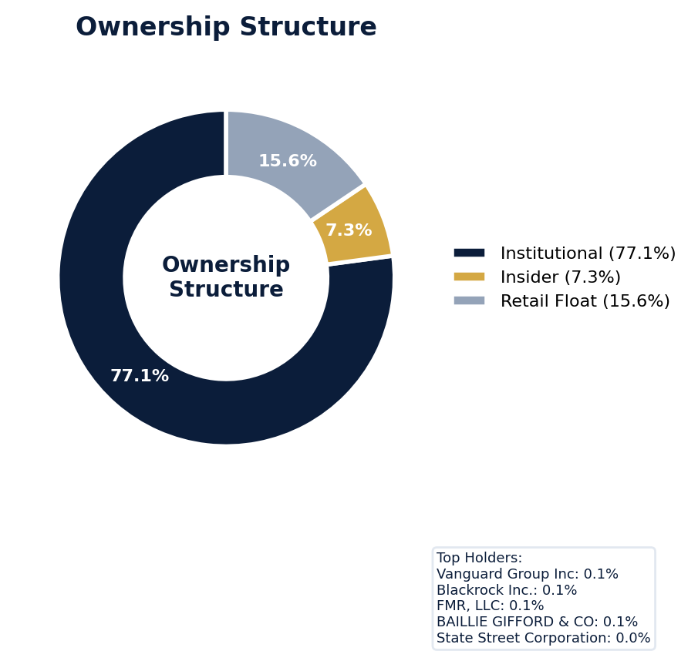
Figure: Ownership breakdown -- institutional, insider, retail float
Category | Percentage
Institutional Ownership | 77.1%
Insider Ownership | 7.3%
Retail Float | 15.6%
Top Holder | Ownership %
Vanguard Group Inc | 0.1%
Blackrock Inc. | 0.1%
FMR, LLC | 0.1%
BAILLIE GIFFORD & CO | 0.1%
State Street Corporation | 0.0%
Sentiment & Narrative Coherence
Signal | Assessment
Narrative Coherence | COHERENT
Anti-Takeover Provisions
Anti-takeover provision data not available. Review DEF 14A and charter documents for complete analysis.

CRITICAL RISK
Moderna faces three active SCAs, including *In re Moderna, Inc. Securities Litigation (24-cv-12058)* covering 2023-01-18 to 2024-06-25 and another with a class period from 2024-02-15 to 2024-05-31, indicating recurrent allegations across overlapping periods. Its company-adjusted SCA filing rate of 17.92% is 4.5 times the 4.0% sector average, signaling a litigation profile significantly more active than its biopharma peers and elevating the risk of follow-on suits. While SEC enforcement is currently at the NONE stage, the specific industry patterns of clinical trial disclosure and drug pricing present a clear path for a future Wells Notice or investigative subpoena to serve as a corrective disclosure, which could materially impact the three existing SCAs. The defense posture is only MODERATE despite seven open solicitation letters, suggesting potential plaintiff bar coordination that may increase settlement pressure. Benchmark settlements against peer companies with similar clinical trial disclosure claims must be factored, but the primary underwriting concern is the high probability of a subsequent SCA; with three already filed and a 17.92% adjusted filing rate, recurrence within the policy period is highly likely. Defense costs across three SCAs and three derivative actions will burn primary layer limits quickly, necessitating specific attritional loss budgeting above the retention given the scale of active litigation.
Section 6: Litigation & Regulatory Exposure
The company faces 3 active securities class action(s). The primary case, In re Moderna, Inc. Securities Litigation (24-cv-12058) (2024), covers a class period from 2023-01-18 to 2024-06-25. 3 derivative action(s) pending, alleging breach of fiduciary duty by directors and officers. Industry claim exposure: clinical_trial_disclosure, off_label_promotion, drug_pricing. 7 statute of limitations window(s) remain open, meaning new claims can still be filed for past events. Under claims-made D&O policy, coverage is triggered when a claim is reported during the policy period. Defense quality assessment: MODERATE.
Litigation Overview: 2 active matter(s), 1 historical matter(s)
Litigation Timeline
Timeline chart not available (no timeline events).
Securities Class Actions
Case Name | Legal Theory | Coverage | Court | Filing Date | Status | Class Period | Lead Counsel | Settlement | Source
In re Moderna, Inc. Securities Litigation (24-cv-12058) (2024) | Rule 10b-5 | Side C (Entity) | D. Mass. | 2024-08-09 | ACTIVE | Jan 2023 - Jun 2024 | N/A | N/A | [Supabase SCA database, 2026-04-02, MEDIUM]
Securities Class Action Litigation (2024) | Rule 10b-5 | Commercial | U.S. District Court for the District of Massachusetts | N/A | ACTIVE | Feb 2024 - May 2024 | N/A | N/A | [10-K (LLM), 2026-04-02, HIGH]
[HIGH] 2 Active Securities Class Action(s) -- triggered Active SCA Status (F1) — this agent risk (executive/director actions and decisions that create D&O exposure) indicates Litigation History / Settlement Patterns. Evidence: Boolean check: Active case.
Context: Cases with PSLRA safe harbor and forum selection provisions settle at 40% lower median amounts.
See Meeting Prep: Active Litigation
SEC Enforcement Pipeline
Pipeline: (Comment Letters) -> (Informal Inquiry) -> (Formal Investigation) -> (Wells Notice) -> (Enforcement Action)
No SEC enforcement pipeline activity detected. [10-K Item 3 + Item 1A + 8-K + EFTS, 2026-04-02, LOW]
Derivative Suits
Case Name | Filing Date | Status | Court | Settlement
N/A | N/A | DISMISSED | D. Del. | N/A
N/A | N/A | UNKNOWN | N/A | N/A
N/A | N/A | UNKNOWN | N/A | N/A
Regulatory Proceedings
Agency | Type | Status
FDA | investigation | disclosed
FDA | investigation | disclosed
Industry Claim Patterns
Legal Theory | Exposed | Contagion Risk | Description
Clinical Trial Disclosure | Yes | Yes | [Pharmaceuticals] Failure to disclose adverse clinical trial
Off Label Promotion | Yes | Yes | [Pharmaceuticals] Off-label marketing leading to DOJ/FTC enf
Drug Pricing | Yes | Yes | [Pharmaceuticals] Drug pricing manipulation or anti-competit
Fda Approval Fraud | Yes | Yes | [Pharmaceuticals] Misleading FDA approval likelihood stateme
D&O Context: Company exposed to 4 industry claim pattern(s). Peer lawsuits create contagion risk -- plaintiff firms often file similar claims across the industry. [ELEVATED]
Statute of Limitations Map
Claim Type | Trigger Date | SOL Expiry | Repose Expiry | Window Open
employment_discrimination | 2026-02-20 | 2028-02-20 | 2028-02-20 | OPEN
10b-5 | 2024-05-31 | 2026-05-31 | 2029-05-30 | OPEN
antitrust | 2026-02-20 | 2030-02-19 | 2030-02-19 | OPEN
FCPA | 2026-02-20 | 2031-02-19 | 2031-02-19 | OPEN
environmental | 2026-02-20 | 2031-02-19 | 2031-02-19 | OPEN
derivative | 2026-02-20 | 2029-02-19 | 2032-02-19 | OPEN
ERISA | 2026-02-20 | 2029-02-19 | 2032-02-19 | OPEN
Section_11 | 2024-05-31 | 2025-05-31 | 2027-05-31 | CLOSED
Section_14a | 2024-05-31 | 2025-05-31 | 2027-05-31 | CLOSED
D&O Context: 7 open exposure window(s). Claims can still be filed within these periods. [ELEVATED]
Defense Strength Assessment
Factor | Assessment
Federal Forum Provision | No
Exclusive Forum Provision | No
PSLRA Safe Harbor | MODERATE
Truth-on-Market Viability | PARTIAL
Prior Dismissal Success | No prior dismissals identified in Item 3
Overall Defense Strength | MODERATE
No forum selection provisions identified. Safe harbor usage is MODERATE with standard forward-looking statement protections. [DEF 14A; 10-K, 2026-04-02, LOW]
Contingent Liabilities
Description | ASC 450 Class. | Accrued | Range
We are involved in various claims and legal proceedings of a | reasonably_possible | N/A | N/A
Most of the issues raised by these claims are highly complex | reasonably_possible | N/A | N/A
Proceedings In August 2022, we filed a lawsuit in the U.S. | reasonably_possible | N/A | N/A
The case has been stayed pending the outcome of two Inter Pa | reasonably_possible | N/A | N/A
action, we seek a judgment of infringement of the asserted p | reasonably_possible | N/A | N/A
and BioNTech SE have filed oppositions seeking revocation of | reasonably_possible | N/A | N/A
Arbutus Patent Litigation In February 2022, Arbutus Biopharm | reasonably_possible | N/A | N/A
In March 2025, Arbutus and Genevant filed five international | reasonably_possible | N/A | N/A
The companies filed lawsuits in the Canadian Federal Court, | reasonably_possible | N/A | N/A
The UPC actions seek relief in all UPC member states and in | reasonably_possible | N/A | N/A
Hearings for the UPC actions are set for May 19 and 20, 2026 | reasonably_possible | N/A | N/A
The Canadian lawsuit is scheduled for trial beginning in Sep | reasonably_possible | N/A | N/A
79 GSK Patent Litigation In October 2024, GlaxoSmithKline Bi | reasonably_possible | N/A | N/A
In July 2025, GSK submitted two lawsuits to the UPC assertin | reasonably_possible | N/A | N/A
In December 2025, GSK served us with two separate complaints | reasonably_possible | N/A | N/A
Northwestern University Patent Litigation In October 2024, N | reasonably_possible | N/A | N/A
(Alnylam) filed two complaints against us in the U.S. | reasonably_possible | N/A | N/A
On August 25, 2023, the Court entered a Final Judgment of no | reasonably_possible | N/A | N/A
Relatedly, in May 2023, Alnylam filed a third complaint agai | reasonably_possible | N/A | N/A
Following the June 2025 Federal Circuit decision in our favo | reasonably_possible | N/A | N/A
Bayer CropSciences Patent Litigation In January 2026, Bayer | reasonably_possible | N/A | N/A
mNG Bio Patent Litigation In January 2026, mNG Bio, LLC (mNG | reasonably_possible | N/A | N/A
BioNTech Patent Litigation In February 2026, BioNTech SE fil | reasonably_possible | N/A | N/A
80 Securities Class Action Litigation In August 2024, a puta | reasonably_possible | N/A | N/A
The action was purportedly brought on behalf of a class of s | reasonably_possible | N/A | N/A
The complaint asserts claims under the Securities Exchange A | reasonably_possible | N/A | N/A
On August 25, 2025, plaintiff filed an amended complaint, wh | reasonably_possible | N/A | N/A
On October 24, 2025, the Company filed a motion to dismiss, | reasonably_possible | N/A | N/A
Derivative Litigation Between September and November 2024, p | reasonably_possible | N/A | N/A
The complaints allege breaches of fiduciary duty and claims | reasonably_possible | N/A | N/A
The cases were stayed pending a decision on defendants' moti | reasonably_possible | N/A | N/A
Workforce, Product & Environmental Matters
None found.
Whistleblower Indicators
No whistleblower indicators identified in SEC filings. SEC whistleblower tips are not publicly disclosed; absence does not confirm lack of activity.

Moderna's 51 quality score places it in the NO-TOUCH tier with a 4.0-5.6% claim probability, driven by an active securities class action and a whistleblower disclosure that impose a binding ceiling of CRF-1. The company's Prior Litigation risk factor deducted 4.64 points, the largest driver of its total 12.66 in deductions, indicating a history that elevates future suit likelihood. This is compounded by IPO/M&A activity (1.56-point deduction) and Restatement/Audit Issues (1.35-point deduction), which are common catalysts for shareholder allegations. The combination of an active class action and a formal whistleblower matter creates a layered, high-severity profile that standard D&O pricing cannot accommodate, leading to a clear decline.
Section 7: Risk Scoring & Synthesis
Underwriting tier: **NO_TOUCH** (quality score: 50.9/100). Recommended action: Decline. Expected claim probability band: 4.0-5.6%. Top risk contributors: Prior Litigation (F1: -4.6 pts); IPO/SPAC/M&A (F4: -1.6 pts); Restatement/Audit Issues (F3: -1.4 pts). **Red flag gates active**: Active Securities Class Action (ceiling: 55); Whistleblower/Qui Tam Disclosure (ceiling: 100). Binding ceiling: CRF-1. Claim probability band: MODERATE (4.0%-5.6%).
Tier Classification
Metric | Value
Quality Score | 50.9 / 100
Composite Score (pre-ceiling) | 87.3
Total Risk Points Deducted | 12.7
Tier | NO_TOUCH
Tier Range | 0 - 10
Action Guidance | Decline
Probability Range | 4.0-5.6%
Pricing Multiplier | N/A
Binding Ceiling | CRF-1
Risk Assessment: HIGH [HIGH]
D&O Claim Peril Assessment
1 of 8 D&O claim perils show active risk signals. Active perils have at least one causal chain with triggered checks.
Peril | Risk Level | Active Chains | Key Evidence
Securities Claims | LOW | 0/5 | —
Fiduciary Breach | MODERATE | 1/3 | Verified (value: 0); Detected (value). Limited corroborating data available.
Government Enforcement | LOW | 0/2 | —
Employment & Whistleblower | LOW | 0/1 | —
Insolvency & Bankruptcy | LOW | 0/1 | —
Emerging Risks | LOW | 0/2 | —
Consumer & Product Claims | LOW | 0/1 | —
Commercial Litigation | LOW | 0/1 | —
Active Peril Analysis
Fiduciary Breach: MODERATE [MODERATE]
Frequency: growing | Severity: variable | Typical range: $1M - $100M
1 of 3 causal chains active.
Chain: Governance Failure → Derivative Suit [MODERATE]
Weak governance structure (low independence, CEO/Chair duality, poor say-on-pay) creates basis for Caremark duty of oversight claims and derivative suits.
Triggers:
• GOV.BOARD.ceo_chair
Historical filing rate: 3% | Median severity: $8M
Composite Score Breakdown
Factor | Name | Max Pts | Deducted | % Used | Top Contributor
F1 | Prior Litigation | 20 | 4.6 | 23% | Signal-driven scoring: 70 signals, coverage=100%
F2 | Stock Decline | 15 | 0.9 | 6% | Signal-driven scoring: 28 signals, coverage=100%
F3 | Restatement/Audit Issues | 12 | 1.4 | 11% | Signal-driven scoring: 86 signals, coverage=100%
F4 | IPO/SPAC/M&A | 10 | 1.6 | 16% | Signal-driven scoring: 16 signals, coverage=100%
F5 | Guidance Misses | 10 | 0.0 | 0% | Signal-driven scoring: 28 signals, coverage=100%
F6 | Short Interest | 8 | 1.1 | 14% | Signal-driven scoring: 26 signals, coverage=100%
F7 | Stock Volatility | 9 | 1.2 | 14% | Signal-driven scoring: 31 signals, coverage=100%
F8 | Financial Distress | 8 | 1.1 | 13% | Signal-driven scoring: 15 signals, coverage=100%
F9 | Governance Issues | 6 | 0.7 | 12% | Signal-driven scoring: 40 signals, coverage=100%
F10 | Officer Stability | 2 | 0.2 | 8% | Signal-driven scoring: 90 signals, coverage=100%
10-Factor Risk Profile
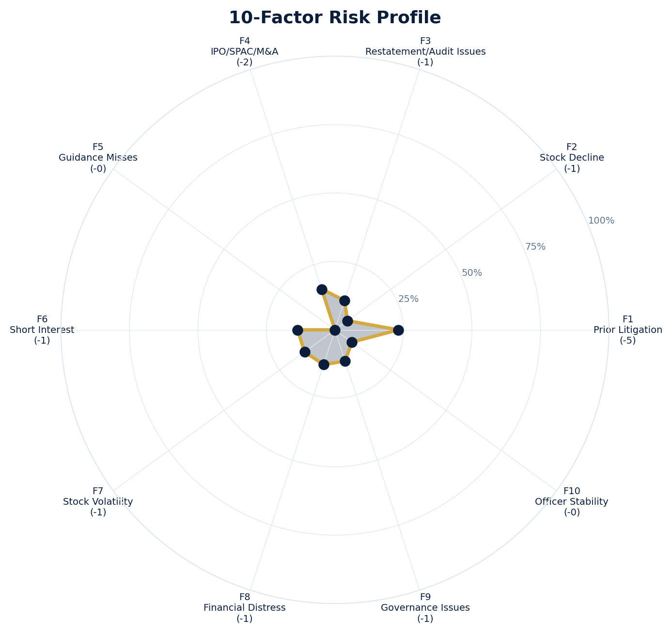
Figure: Radar chart showing risk fraction (points deducted / max) for each of the 10 scoring factors. Larger area = higher risk.
Red Flag Gates
Severity | Description | Source | Impact | Trajectory
CRITICAL | Critical Red Flag: Active Securities Class Action | Active SCA: In re Moderna, Inc. Securities Litigation (24-cv-12058) (2024) | Ceiling: 55 | NEW
CRITICAL | Critical Red Flag: Whistleblower/Qui Tam Disclosure | NLP whistleblower signal: Whistleblower/qui tam language detected: whistleblower, false claims act. Presence of such language in filings may indicate pending or potential False Claims Act or SEC whistleblower actions. | Ceiling: 100 | NEW
LOW | Prior Litigation: 5/20 points | Signal-driven scoring: 70 signals, coverage=100% | F1: 5 pts | NEW
LOW | Stock Decline: 1/15 points | Signal-driven scoring: 28 signals, coverage=100%; Drop contribution modifier: 0.19x (decay + company-specific + disclosure) | F2: 1 pts | NEW
LOW | Restatement/Audit Issues: 1/12 points | Signal-driven scoring: 86 signals, coverage=100% | F3: 1 pts | NEW
LOW | IPO/SPAC/M&A: 2/10 points | Signal-driven scoring: 16 signals, coverage=100% | F4: 2 pts | NEW
LOW | Short Interest: 1/8 points | Signal-driven scoring: 26 signals, coverage=100% | F6: 1 pts | NEW
LOW | Stock Volatility: 1/9 points | Signal-driven scoring: 31 signals, coverage=100% | F7: 1 pts | NEW
LOW | Financial Distress: 1/8 points | Signal-driven scoring: 15 signals, coverage=100% | F8: 1 pts | NEW
LOW | Governance Issues: 1/6 points | Signal-driven scoring: 40 signals, coverage=100% | F9: 1 pts | NEW
LOW | Officer Stability: 0/2 points | Signal-driven scoring: 90 signals, coverage=100% | F10: 0 pts | NEW
Critical: 2, High: 0, Moderate: 0, Low: 9
Risk Type Classification
Attribute | Value
Primary Risk Type | REGULATORY_SENSITIVE
Secondary Risk Type | TRANSFORMATION
Supporting Evidence | Regulated industry SIC: 2836
Severity Scenarios
Analysis based on market cap: $19.5B
Percentile | Label | Settlement Est. | Defense Costs | Total Exposure
25th | favorable | $1.5B | $224.5M | $1.7B
50th | median | $3.0B | $598.7M | $3.6B
75th | adverse | $6.0B | $1.5B | $7.5B
95th | catastrophic | $12.0B | $3.6B | $15.6B
Calibration Notes (SECT7-11)
The following items are flagged NEEDS CALIBRATION and require expert review before final pricing:
- SECT7-11: All scoring parameters require calibration against historical cases
Factor Detail
Factor | Name | Deducted | Rules Triggered | Evidence
F1 | Prior Litigation | 4.6 | N/A | Signal-driven scoring: 70 signals, coverage=100%
F2 | Stock Decline | 0.9 | drop_contribution_adjustment | Signal-driven scoring: 28 signals, coverage=100%; Drop contribution modifier: 0.19x (decay + company-specific + disclosure)
F3 | Restatement/Audit Issues | 1.4 | N/A | Signal-driven scoring: 86 signals, coverage=100%
F4 | IPO/SPAC/M&A | 1.6 | N/A | Signal-driven scoring: 16 signals, coverage=100%
F6 | Short Interest | 1.1 | N/A | Signal-driven scoring: 26 signals, coverage=100%
F7 | Stock Volatility | 1.2 | N/A | Signal-driven scoring: 31 signals, coverage=100%
F8 | Financial Distress | 1.1 | N/A | Signal-driven scoring: 15 signals, coverage=100%
F9 | Governance Issues | 0.7 | N/A | Signal-driven scoring: 40 signals, coverage=100%
F10 | Officer Stability | 0.2 | N/A | Signal-driven scoring: 90 signals, coverage=100%
Sub-Component Breakdown
Factor | Component | Value
F1 | base | 4.64
F1 | bonus | 0.00
F1 | modifiers | 0.00
F1 | hard_triggers | 0.00
F1 | total_before_cap | 4.64
F1 | capped | 4.64
F2 | base | 4.41
F2 | bonus | 0.00
F2 | modifiers | 0.00
F2 | hard_triggers | 0.00
F2 | drop_contribution_modifier | 0.19
F2 | total_before_cap | 0.85
F2 | capped | 0.85
F3 | base | 1.59
F3 | bonus | 0.00
F3 | modifiers | 0.00
F3 | hard_triggers | 0.00
F3 | total_before_cap | 1.59
F3 | capped | 1.59
F3 | ies_amplification | 0.85
F4 | base | 1.56
F4 | bonus | 0.00
F4 | modifiers | 0.00
F4 | hard_triggers | 0.00
F4 | total_before_cap | 1.56
F4 | capped | 1.56
F6 | base | 1.28
F6 | bonus | 0.00
F6 | modifiers | 0.00
F6 | hard_triggers | 0.00
F6 | total_before_cap | 1.28
F6 | capped | 1.28
F6 | ies_amplification | 0.85
F7 | base | 1.45
F7 | bonus | 0.00
F7 | modifiers | 0.00
F7 | hard_triggers | 0.00
F7 | total_before_cap | 1.45
F7 | capped | 1.45
F7 | ies_amplification | 0.85
F8 | base | 1.07
F8 | bonus | 0.00
F8 | modifiers | 0.00
F8 | hard_triggers | 0.00
F8 | total_before_cap | 1.07
F8 | capped | 1.07
F9 | base | 0.85
F9 | bonus | 0.00
F9 | modifiers | 0.00
F9 | hard_triggers | 0.00
F9 | total_before_cap | 0.85
F9 | capped | 0.85
F9 | ies_amplification | 0.85
F10 | base | 0.15
F10 | bonus | 0.00
F10 | modifiers | 0.00
F10 | hard_triggers | 0.00
F10 | total_before_cap | 0.15
F10 | capped | 0.15
Pattern Detection Results
No composite patterns detected.
Allegation Theory Mapping
Theory | Exposure | Factor Sources | Key Findings
A_DISCLOSURE | MODERATE | F1, F3 | F1: Signal-driven scoring: 70 signals, coverage=100%; F3: Signal-driven scoring: 86 signals, coverage=100%
B_GUIDANCE | LOW | F2 | F2: Signal-driven scoring: 28 signals, coverage=100%; F2: Drop contribution modifier: 0.19x (decay + company-specific + disclosure)
C_PRODUCT_OPS | LOW | F7, F8 | F7: Signal-driven scoring: 31 signals, coverage=100%; F8: Signal-driven scoring: 15 signals, coverage=100%
D_GOVERNANCE | LOW | F9, F10 | F9: Signal-driven scoring: 40 signals, coverage=100%; F10: Signal-driven scoring: 90 signals, coverage=100%
E_MA | LOW | F4 | F4: Signal-driven scoring: 16 signals, coverage=100%
D&O Context: Primary allegation exposure is A_DISCLOSURE. MODERATE exposure in: A_DISCLOSURE.
Claim Probability Detail
Metric | Value
Probability Band | MODERATE
Range | 4.0% - 5.6%
Industry Base Rate | 4.0%
Adjustment Rationale | Industry base rate: 4.0%. Tier NO_TOUCH (20-25%): Substantially above base rate.
Claim probability: MODERATE [ELEVATED]
Tower Position Recommendation
Metric | Value
Recommended Position | DECLINE
Minimum Attachment | $2993.4M (based on 50th percentile settlement)
Side A/DIC Assessment | Standard Side A considerations
Position | Risk Assessment | Premium Guidance | Attachment
PRIMARY | Primary layer carries 57% of expected loss exposur | Full rate, slight discount for | $0 ground-up
LOW_EXCESS | Low excess layer carries 18% of expected loss expo | Market rate | $5-15M xs $5-15M
MID_EXCESS | Mid excess layer carries 13% of expected loss expo | Market to 1.3x | $15-50M xs $15-50M
HIGH_EXCESS | High excess layer carries 11% of expected loss exp | 1.3-2x with attachment | $50M+ xs $50M+
DECLINE | WALK+ with compounding factors | N/A | N/A
Forensic Composite Scores
Composite | Score | Interpretation
Financial Integrity Score (FIS) | N/A | Not available
Reporting Quality Score (RQS) | N/A | Not available
Cash Flow Quality Score (CFQS) | N/A | Not available
Executive Risk Profile
Metric | Value
Weighted Score | 9
Risk Level | N/A
- [Director Cambridge (CEO)]: Prior litigation: snippet: CAMBRIDGE, MA / ACCESS Newswire / March 3, 2026 / Moderna, Inc. (NASDAQ:MRNA) today announc
- [Director Cambridge (CEO)]: Prior litigation: snippet: CAMBRIDGE, MA / ACCESS Newswire / March 3, 2026 / Moderna, Inc. (NASDAQ:MRNA) today announc
- [Director Cambridge (CEO)]: Very short tenure: 0.0 years
- [Sagan Meetings (CFO)]: Very short tenure: 0.0 years
- [Sagan Meetings (CFO)]: Recent CFO appointment (<1 year)
- [Noubar Afeyan (COO)]: Very short tenure: 0.0 years
- [Global Head (Director)]: Prior litigation: snippet: Moderna, Inc. (MRNA) · News headlines Moderna (MRNA) has gained attention following a signi
- [Global Head (Director)]: Prior litigation: title: Moderna, Inc. Common Stock (MRNA) News Headlines - Nasdaq
- [Global Head (Director)]: Prior litigation: url: https://www.nasdaq.com/market-activity/stocks/mrna/news-headlines
- [Product Development (Director)]: Prior litigation: snippet: Moderna, Inc. engages in the development of transformative medicines based on messenger rib
Temporal Signals
Type | Direction | Magnitude | Description
Unknown | N/A | N/A
Unknown | N/A | N/A
Unknown | N/A | N/A
Unknown | N/A | N/A
Unknown | N/A | N/A
Unknown | N/A | N/A
Unknown | N/A | N/A
NLP Filing Analysis
Metric | Value
Readability Score | {'current_fog': 21.25, 'prior_fog': None, 'fog_change': None, 'current_flesch': 14.89, 'prior_flesch': None, 'classification': 'CURRENT_ONLY', 'evidence': 'Current Fog Index: 21.3 (prior year unavailable)'}
Tone Assessment | N/A
Risk Language Density | N/A
Peril Assessment
Plaintiff Peril Heat Map
Plaintiff Type | Probability | Severity
Shareholders | ELEVATED | SIGNIFICANT
Regulators | ELEVATED | SIGNIFICANT
Customers | VERY LOW | NUISANCE
Competitors | VERY LOW | NUISANCE
Employees | LOW | MINOR
Creditors | MODERATE | SIGNIFICANT
Government | LOW | MINOR
Shareholders: 59 triggered checks. Key: Litigation History Profile: 2 (elevated vs benchmark of 0)
Regulators: 14 triggered checks. Key: Disclosure Complexity Score: 33 (elevated vs benchmark of 25)
Creditors: 5 triggered checks. Key: Cash Flow Debt Service Coverage: -307.40 (below benchmark of 1)
Bear Cases
Bear Case: A Disclosure
Moderna, Inc. faces elevated exposure to securities disclosure fraud claims. Key risk indicators: Litigation History Profile (critical); VIE/SPE Off-Balance-Sheet Structures (critical). Estimated severity is significant, warranting detailed underwriter review.
Defense: Defense: No active Section 11 windows — statute of limitations expired for offering claims
Evidence Chain
1. [BIZ.CLASS.litigation_history] Litigation History Profile (Source: total_sca_count)
2. [BIZ.STRUCT.vie_spe] VIE/SPE Off-Balance-Sheet Structures (Source: vie_spe_present)
3. [BIZ.DEPEND.regulatory_dep] Single-Source Suppliers (Source: regulatory_dependency_count)
4. [BIZ.EVENT.ipo_exposure] IPO/Offering Exposure Window (Source: event_ipo_exposure_score)
5. [BIZ.OPS.workforce] Workforce Distribution (Source: workforce_distribution)
6. [DISC.YOY.removed_risk_factors] Removed Risk Factors (YoY) (Source: yoy_removed_risk_count)
7. [EXEC.PRIOR_LIT.any_officer] Any Officer With Prior Litigation at Previous Company (Source: value)
8. [EXEC.PRIOR_LIT.ceo_cfo] CEO or CFO With Prior Litigation (Source: value)
9. [EXEC.AGGREGATE.board_risk] Board Aggregate Risk Score (Source: value)
10. [EXEC.TENURE.ceo_new] CEO Tenure Less Than 2 Years (Source: value)
Probability: ELEVATED | Severity: SIGNIFICANT
Settlement Prediction
Settlement prediction computed but no scenarios available.
Tower Risk Characterization
Tower characterization not available.
Coverage Gaps -- Data Not Available
The following checks could not be evaluated because required data was not acquired. These items are NOT cleared -- they represent gaps in coverage that should be considered in the underwriting decision.
Executive Summary & Key Metrics
[EVALUATIVE] BIZ.DEPEND.labor (Concentration Risk Composite): Required data not available from filings
[REQUIRED] BIZ.MA.acquisition_spend (Acquisition Spend Magnitude): Required data not available from filings
[EVALUATIVE] BIZ.MA.goodwill_change (Goodwill Trajectory): Required data not available from filings
[REQUIRED] BIZ.MA.acquisition_list (Recent Acquisitions): Required data not available from filings
[REQUIRED] BIZ.MODEL.lifecycle (Segment Lifecycle Risk): Required data not available from filings
[REQUIRED] BIZ.MODEL.segment_margins (Segment Margin Profile): Required data not available from filings
[EVALUATIVE] ABS.DISC.audit_fees (Missing Audit Fee Disclosure): Expected signals not found in evaluation results
[EVALUATIVE] ABS.DISC.board_independence (Missing Board Independence Disclosure): Could not determine disclosure presence or absence
[EVALUATIVE] ABS.DISC.clawback_policy (Missing Clawback Policy Disclosure): Expected signals not found in evaluation results
[EVALUATIVE] ABS.DISC.cyber_risk (Missing Cybersecurity Risk Disclosure): Expected signals not found in evaluation results
[EVALUATIVE] ABS.DISC.debt_covenants (Missing Debt Covenant Disclosure): Expected signals not found in evaluation results
[EVALUATIVE] ABS.DISC.derivative_instruments (Missing Derivative Instruments Disclosure): Expected signals not found in evaluation results
[EVALUATIVE] ABS.DISC.esg (Missing ESG Disclosure): Expected signals not found in evaluation results
[EVALUATIVE] ABS.DISC.executive_comp (Missing Executive Compensation Disclosure): Expected signals not found in evaluation results
[EVALUATIVE] ABS.DISC.goodwill_impairment (Missing Goodwill Impairment Disclosure): Expected signals not found in evaluation results
[EVALUATIVE] ABS.DISC.lease_obligations (Missing Lease Obligation Disclosure): Expected signals not found in evaluation results
[EVALUATIVE] ABS.DISC.litigation_contingency (Missing Litigation Contingency Disclosure): Expected signals not found in evaluation results
[EVALUATIVE] ABS.DISC.pension_obligations (Missing Pension Obligation Disclosure): Expected signals not found in evaluation results
[EVALUATIVE] ABS.DISC.related_party (Missing Related-Party Transaction Disclosure): Expected signals not found in evaluation results
[EVALUATIVE] ABS.DISC.revenue_recognition (Missing Revenue Recognition Policy Disclosure): Expected signals not found in evaluation results
[EVALUATIVE] ABS.DISC.risk_factors (Missing Risk Factor Disclosure): Expected signals not found in evaluation results
[EVALUATIVE] ABS.DISC.segment_reporting (Missing Segment Reporting Disclosure): Expected signals not found in evaluation results
[EVALUATIVE] ABS.DISC.stock_comp (Missing Stock Compensation Disclosure): Expected signals not found in evaluation results
[EVALUATIVE] ABS.DISC.tax_positions (Missing Uncertain Tax Position Disclosure): Expected signals not found in evaluation results
[EVALUATIVE] CONJ.COMP.perf_divergence (Compensation-Performance Divergence): 3/3 component signals unavailable
[EVALUATIVE] CONJ.DISTRESS.insider (Financial Distress + Insider Selling): 2/3 component signals unavailable
[EVALUATIVE] CONJ.GOV.governance_event (Weak Governance + Adverse Event): 3/5 component signals unavailable
[EVALUATIVE] CONJ.FIN.growth_margin_guidance (Rapid Growth + Margin Compression + Guidance Miss): 3/3 component signals unavailable
[EVALUATIVE] CONJ.INSIDER.news_gap (Insider Selling + Material News Gap): 3/3 component signals unavailable
[EVALUATIVE] CONJ.REG.litigation (Regulatory Action + New Material Litigation): 3/3 component signals unavailable
[EVALUATIVE] CTX.FIN.capex_sector (Capital Expenditure in Sector Context): Source signal FIN.INVEST.capex_ratio not in results
[EVALUATIVE] CTX.COMP.lifecycle (CEO Compensation in Lifecycle Context): Source signal EXEC.COMP.ceo_total_comp not in results
[EVALUATIVE] CTX.COMP.product_tower (Compensation Severity by Product/Tower): Source signal EXEC.COMP.ceo_total_comp not in results
[EVALUATIVE] CTX.FIN.debt_maturity (Debt Maturity Profile in Lifecycle Context): Source signal FIN.DEBT.maturity_profile not in results
[EVALUATIVE] CTX.FIN.distress_product (Financial Distress by Product/Tower): Source signal FIN.FORENSIC.altman_z not in results
[EVALUATIVE] CTX.FIN.dividend_lifecycle (Dividend Policy in Lifecycle Context): Source signal FIN.RETURN.dividend_yield not in results
[EVALUATIVE] CTX.EXEC.tenure_lifecycle (Executive Tenure in Lifecycle Context): Source signal EXEC.TURN.c_suite not in results
[EVALUATIVE] CTX.MKT.insider_lifecycle (Insider Trading in Lifecycle Context): Source signal STOCK.INSIDER.net_selling not in results
[EVALUATIVE] CTX.FIN.leverage_sector (Leverage in Sector Context): Source signal FIN.DEBT.leverage_ratio not in results
[EVALUATIVE] CTX.LIT.size (Litigation Frequency by Company Size): Source signal LIT.SCA.active_cases not in results
[EVALUATIVE] CTX.RISK.ma_lifecycle (M&A Activity in Lifecycle Context): Source signal BIZ.MA.acquisition_activity not in results
[EVALUATIVE] CTX.RISK.regulatory_sector (Regulatory Risk in Sector Context): Source signal LIT.SEC.enforcement not in results
[EVALUATIVE] CTX.RISK.rpt_sector (Related-Party Risk in Sector Context): Source signal GOV.RPT.related_party not in results
[EVALUATIVE] CTX.MKT.short_interest_sector (Short Interest in Sector Context): Source signal STOCK.SHORT.interest_ratio not in results
[EVALUATIVE] CTX.MKT.turnover_sector (Stock Turnover in Sector Context): Source signal STOCK.VOL.turnover_rate not in results
[EVALUATIVE] CTX.MKT.volatility_sector (Stock Volatility in Sector Context): Source signal STOCK.VOL.historical not in results
Financial Health
[EVALUATIVE] FIN.PEER.revenue_bottom_quartile (Revenue Bottom Quartile (Cross-Filer)): No peer comparison data available
[EVALUATIVE] FIN.PEER.leverage_top_decile (Leverage Top Decile (Sector-Relative)): No peer comparison data available
[EVALUATIVE] FIN.PEER.margin_compression (Operating Margin Compression (Cross-Filer)): No peer comparison data available
[EVALUATIVE] FIN.PEER.profitability_laggard (Profitability Laggard (Sector-Relative)): No peer comparison data available
[EVALUATIVE] FIN.PEER.size_outlier_small (Size Outlier Small (Cross-Filer)): No peer comparison data available
[EVALUATIVE] FIN.PEER.cash_flow_weak (Cash Flow Weakness (Cross-Filer)): No peer comparison data available
[EVALUATIVE] LIT.DEFENSE.forum_selection (Federal Forum Selection Clause): Required data not available from filings
Governance & Leadership
[EVALUATIVE] EXEC.INSIDER.ceo_net_selling (CEO Net Seller of Stock): Required data not available from filings
[EVALUATIVE] EXEC.INSIDER.cfo_net_selling (CFO Net Seller of Stock): Required data not available from filings
[REQUIRED] EXEC.PROFILE.board_size (Board Size (Number of Members)): Required data not available from filings
[REQUIRED] EXEC.PROFILE.independent_ratio (Board Independence Percentage): Required data not available from filings
[EVALUATIVE] EXEC.PROFILE.overboarded_directors (Directors Serving on 4+ Boards): Required data not available from filings
[EVALUATIVE] GOV.BOARD.size (Board Size): Required data not available from filings
[EVALUATIVE] GOV.BOARD.independence (Board Independence): Required data not available from filings
[EVALUATIVE] GOV.BOARD.diversity (Board Diversity): Required data not available from filings
[EVALUATIVE] GOV.BOARD.tenure (Tenure): Required data not available from filings
[EVALUATIVE] GOV.BOARD.overboarding (Overboarding): Required data not available from filings
[EVALUATIVE] GOV.BOARD.attendance (Attendance): Required data not available from filings
[EVALUATIVE] GOV.BOARD.meetings (Meetings): Required data not available from filings
[EVALUATIVE] GOV.BOARD.succession (Succession): Required data not available from filings
[EVALUATIVE] GOV.PAY.ceo_total (Ceo Total): Required data not available from filings
[REQUIRED] GOV.PAY.ceo_structure (Ceo Structure): Required data not available from filings
[EVALUATIVE] GOV.PAY.peer_comparison (Peer Comparison): Required data not available from filings
[EVALUATIVE] GOV.PAY.golden_para (Golden Para): Required data not available from filings
[EVALUATIVE] GOV.PAY.equity_burn (Equity Burn): Required data not available from filings
[EVALUATIVE] GOV.PAY.hedging (Hedging): Required data not available from filings
[REQUIRED] GOV.RIGHTS.bylaws (Bylaws): Required data not available from filings
[EVALUATIVE] GOV.RIGHTS.takeover (Takeover): Required data not available from filings
[EVALUATIVE] GOV.RIGHTS.proxy_access (Proxy Access): Required data not available from filings
[REQUIRED] GOV.RIGHTS.forum_select (Forum Select): Required data not available from filings
[EVALUATIVE] GOV.RIGHTS.supermajority (Supermajority): Required data not available from filings
[EVALUATIVE] GOV.RIGHTS.action_consent (Action Consent): Required data not available from filings
[EVALUATIVE] GOV.RIGHTS.special_mtg (Special Mtg): Required data not available from filings
[EVALUATIVE] GOV.RIGHTS.classified (Classified): Required data not available from filings
Market & Trading
[EVALUATIVE] FIN.COMP.rsu_grants (RSU Grant Trend): Required data not available from filings
[EVALUATIVE] FIN.CONT.loss_accrual (Loss Contingency Accrual): Required data not available from filings
[EVALUATIVE] FIN.CONT.loss_estimate (Loss Contingency Estimate): Required data not available from filings
[EVALUATIVE] FIN.CONT.settlement_activity (Litigation Settlement Activity): Required data not available from filings
[EVALUATIVE] FIN.CONT.warranty_reserve (Product Warranty Reserve): Required data not available from filings
[EVALUATIVE] FIN.DEBT.maturity_concentration (Debt Maturity Concentration): Data mapping not configured for this check
[EVALUATIVE] FIN.QUALITY.q4_revenue_concentration (Q4 Revenue Concentration): Required data not available from filings
[EVALUATIVE] FIN.QUALITY.revenue_recognition_risk (Revenue Recognition Risk Indicators): Data mapping not configured for this check
[EVALUATIVE] FIN.FORENSIC.level3_fair_value (Level 3 Fair Value Asset Concentration): Data mapping not configured for this check
[EVALUATIVE] FIN.FORENSIC.goodwill_deterioration_pattern (Goodwill Deterioration Pattern): Data mapping not configured for this check
[EVALUATIVE] FIN.FORENSIC.related_party_revenue (Related Party Revenue Concentration): Data mapping not configured for this check
[EVALUATIVE] FWRD.EVENT.ma_integration_risk (M&A Integration Risk): Data mapping not configured for this check
[EVALUATIVE] FIN.FORENSIC.margin_compression (Forensic Margin Compression): Data mapping not configured for this check
[EVALUATIVE] FIN.FORENSIC.acquisition_effectiveness (Acquisition Effectiveness): Data mapping not configured for this check
[EVALUATIVE] FIN.FORENSIC.buyback_timing (Share Buyback Timing Quality): Data mapping not configured for this check
[EVALUATIVE] FIN.FORENSIC.dividend_sustainability (Dividend Sustainability): Data mapping not configured for this check
[EVALUATIVE] FIN.FORENSIC.debt_maturity_concentration (Debt Maturity Concentration): Data mapping not configured for this check
[EVALUATIVE] FIN.FORENSIC.etr_anomaly (Effective Tax Rate Anomaly): Data mapping not configured for this check
[EVALUATIVE] FIN.FORENSIC.pension_underfunding (Pension Underfunding Risk): Data mapping not configured for this check
[EVALUATIVE] FIN.FORENSIC.dsri_elevated (Days Sales Receivable Index Elevated): Data mapping not configured for this check
[EVALUATIVE] FIN.FORENSIC.aqi_elevated (Asset Quality Index Elevated): Data mapping not configured for this check
[EVALUATIVE] FIN.FORENSIC.tata_elevated (Total Accruals to Total Assets Elevated): Data mapping not configured for this check
[EVALUATIVE] FIN.FORENSIC.non_gaap_gap (Non-GAAP to GAAP Earnings Gap): Data mapping not configured for this check
[EVALUATIVE] FIN.FORENSIC.goodwill_growth_rate (Goodwill Growth Rate): Data mapping not configured for this check
[EVALUATIVE] FIN.FORENSIC.acquisition_to_revenue (Acquisition Spend Relative to Revenue): Data mapping not configured for this check
[EVALUATIVE] FIN.PROFIT.revenue (Revenue Analysis): Required data not available from filings
[EVALUATIVE] FIN.GUIDE.track_record (Guidance Track Record): Required data not available from filings
[EVALUATIVE] FIN.RESTRUCT.charges (Restructuring Charges): Required data not available from filings
[EVALUATIVE] FIN.RESTRUCT.severance (Severance Costs): Required data not available from filings
[EVALUATIVE] FIN.IMPAIR.asset_writedown (Asset Impairment): Required data not available from filings
[EVALUATIVE] FIN.IMPAIR.intangible_writedown (Intangible Asset Impairment): Required data not available from filings
[REQUIRED] NLP.FILING.filing_timing_change (Filing Date Shifted Significantly vs Prior Year): Required data not available from filings
[EVALUATIVE] STOCK.INSIDER.notable_activity (Notable Activity): Required data not available from filings
[EVALUATIVE] STOCK.VALUATION.pe_ratio (Pe Ratio): Required data not available from filings
[EVALUATIVE] STOCK.VALUATION.peg_ratio (Peg Ratio): Required data not available from filings
[EVALUATIVE] FIN.FORENSIC.m_score_composite (Beneish M-Score Composite (XBRL)): Data mapping not configured for this check
Gap breakdown: Required items: 10 | Evaluative checks: 106
Total: 116 checks data-unavailable out of 576 total checks (80% coverage)

Calibration Notes
System Intelligence Status
Checks active: 601
Checks incubating: 0 (pending human approval)
Pending feedback: 0 entries
Recent Calibration Changes
Date | Check | Change | Changed By
2026-04-02 | VAERS_DATA_MONITORING | Proposed by ingestion of 'blind_spot:MRNA:Moderna, Inc. Secu | ingestion_pipeline
2026-04-02 | VACCINE_SAFETY_OVERSIGHT_BOARD | Proposed by ingestion of 'blind_spot:MRNA:Moderna, Inc. Secu | ingestion_pipeline
2026-04-02 | PEDIATRIC_SAFETY_DISCLOSURE_GAP | Proposed by ingestion of 'blind_spot:MRNA:Moderna, Inc. Secu | ingestion_pipeline
2026-04-02 | GOV.FOUNDER_CRIMINAL_EXPOSURE | Proposed by ingestion of 'blind_spot:NVDA:Super Micro Comput | ingestion_pipeline
2026-04-02 | BIZ.CHINA_EXPOSURE_DISCLOSURE | Proposed by ingestion of 'blind_spot:NVDA:Super Micro Comput | ingestion_pipeline
2026-04-02 | GOV.EXPORT_CONTROL_COMPLIANCE | Proposed by ingestion of 'blind_spot:NVDA:Super Micro Comput | ingestion_pipeline
2026-04-02 | AI_DEVELOPMENT_TIMELINE_DISCLOSURE | Proposed by ingestion of 'blind_spot:AAPL:AAPL LAWSUIT: Appl | ingestion_pipeline
2026-04-02 | TECH_DEVELOPMENT_VS_MARKETING_HYPE | Proposed by ingestion of 'blind_spot:AAPL:Apple Inc. (NASDAQ | ingestion_pipeline
2026-04-02 | AI_PROMISE_DISCONNECT | Proposed by ingestion of 'blind_spot:AAPL:AAPL LAWSUIT: Appl | ingestion_pipeline
2026-04-02 | TECH_DEVELOPMENT_RISK_DISCLOSURE | Proposed by ingestion of 'blind_spot:AAPL:Apple Inc. (NASDAQ | ingestion_pipeline
Discovery Findings
3 document(s) analyzed, 4 proposal(s) generated, from blind spot search
Feedback for MRNA
No pending feedback for MRNA.

