
Angry Dolphin -- D&O Underwriting Worksheet
PROCTER & GAMBLE Co (PG)
Generated: April 03, 2026
[Table of Contents -- Update in Word]

Procter & Gamble Co. (PG) is a definitive Tier 1 "WIN" account requiring aggressive underwriting pursuit, anchored by its exceptional 91.5 composite quality score and a low 2.3% inherent litigation risk probability. The primary underwriting thesis balances its dominant consumer staples profile against a defined, manageable claim band of 3.9% to 5.57%. Forensic synthesis identifies Prior Litigation as the most material deduction at 2.03 points, sourced from 70 discrete signals indicating historical disclosure-related legal events, though these are mitigated by a clean audit opinion with no material weaknesses. A secondary deduction of 2.5 points for IPO/SPAC/M&A activity reflects PG’s ongoing portfolio optimization, a necessary operational headwind against its $335B market cap scale. The 1.28-point deduction for Short Interest is negligible, as corroborated by the positive finding of short interest below 5% of float, indicating sustained market confidence. Cross-section analysis reveals critical stability pillars: an Altman Z-Score in the safe zone, zero C-suite departures in 18 months, and consistent positive free cash flow generation. These governance and financial health positives directly offset the identified litigation and M&A risks. Consequently, PG’s risk profile is characterized by high-frequency, low-severity exposures typical of a global conglomerate, not systemic governance failure. The underwriting action is unequivocal: secure this must-have account with terms reflecting its MODERATE claim band, as its 109,000-employee operational footprint and premium tier status justify aggressive competition for placement.
Executive Summary
Underwriting Thesis
PROCTER & GAMBLE Co is a $335.0B (Decile 1 of 10) mega-cap consumer discretionary company scoring 91/100 (WIN tier). The primary risk driver is IPO/SPAC/M&A, driving elevated risk in this area. Signal-driven scoring: 18 signals, coverage=100%. At a 4-6% claim probability (2.3% adjusted rate, 0.7x the Consumer Discretionary sector baseline of 3.5%), this account requires primary or low-excess participation.
Company Snapshot
Attribute | Value | Source
Company | PROCTER & GAMBLE Co
Ticker | PG
Exchange | NYSE
Sector | Consumer Defensive
Industry | Household & Personal Products
Market Cap | $335.0B [Decile 1 (largest ~400 accounts)] (Ranks at the 78th percentile among 9 peers) | [yfinance, filed 2026-04-03, MEDIUM confidence]
Revenue | $84.3B | [10-K 2025-06-30 CIK80424 accn:0000080424-25-000076, filed 2025-06-30, HIGH confidence]
Employees | 109,000 | [yfinance, filed 2026-04-03, MEDIUM confidence]
SIC | 2840 -- Soap, Detergents, Cleang Preparations, Perfumes, Cosmetics
NAICS | 325611
FPI Status | No
Fiscal Year End | 06-30
Tier Classification
Attribute | Value
Tier | WIN
Composite Score | 91.5/100
Quality Score | 91.5/100
Factor Breakdown | F1: 2.0, F2: 0.6, F3: 0.8, F4: 2.5, F5: 0.4, F6: 1.3, F7: 0.1, F8: 0.0, F9: 0.7, F10: 0.1
Position | 91.5 falls in WIN range (86-100)
Appetite | Must-have account, compete aggressively
Classification: WIN [MODERATE]
Inherent Risk Baseline
Component | Value
Market Cap Tier | MEGA [Decile 1 (largest ~400 accounts)]
Sector | Consumer Discretionary (Base rate: 3.5%)
Size Adjustment | 1.56x (MEGA cap multiplier) -> 5.5%
Score Adjustment | 0.42x (quality score multiplier) -> 2.3%
Severity Percentile | Settlement Estimate
25th (favorable) | $25.0M
50th (median) | $75.0M
75th (adverse) | $112.5M
95th (catastrophic) | $150.0M
At a 2.3% adjusted claim rate, the company faces 0.7x its sector baseline of 3.5% for Consumer Discretionary companies. This rate reflects the MEGA cap multiplier (1.56x) combined with the quality score multiplier (0.42x from WIN tier classification).
Note: NEEDS CALIBRATION
Underwriting Headwinds
1. Structural Complexity & Litigation History [HIGH]
Goodwill at 32.9% of total assets reflects an acquisition-driven strategy where integration risk and impairment charges are common SCA triggers. With goodwill at 32.9% of total assets and 0 active matters, PROCTER & GAMBLE Co's exposure profile combines impairment risk with demonstrated plaintiff interest in this issuer. (see Litigation)
2. Earnings Guidance Track Record [HIGH]
PROCTER & GAMBLE Co has missed earnings guidance in 2 quarters, with management credibility score at 79%. At $335.0B market cap with an estimated DDL of $8.4B, guidance misses generate large absolute loss figures that attract institutional lead plaintiffs. (see Market & Trading)
3. Stock Price Decline [ELEVATED]
PROCTER & GAMBLE Co's stock has undergone a -18% dip of -18.1% from $174.80 to $143.12 over 252 trading days. This creates an estimated Disclosure Dollar Loss (DDL) of $8.4B, well above institutional lead plaintiff thresholds. (see Market & Trading)
4. Transaction-Related Exposure [ELEVATED]
PROCTER & GAMBLE Co has transaction-related risk factors. Goodwill at 32.9% of total assets reflects acquisition activity. Failed acquisitions are among the most common SCA triggers. At $335.0B market cap, transaction claims carry both Section 10(b) exposure (misleading disclosures) and Section 14(a) exposure (deficient proxy statements).
5. Stock Volatility [ELEVATED]
PROCTER & GAMBLE Co's stock exhibits elevated volatility with a -18% dip of -18.1% from its 52-week high. The estimated DDL of $8.4B amplifies settlement severity for any corrective disclosure event. (see Market & Trading)
Risk Mitigants
1. Clean Audit & Accounting History
PROCTER & GAMBLE Co maintains a clean audit opinion from Deloitte (tenure: 135 years) with no material weaknesses, restatements, or going concern qualifications. The 135-year relationship with Deloitte provides audit continuity that reduces the likelihood of restatement-driven class actions. However, goodwill at 32.9% of total assets requires ongoing impairment testing -- clean audit history does not eliminate future impairment risk. (see Financial Health)
2. Sound Financial Position
No financial distress indicators present (Altman Z-Score of 5.32, current ratio of 0.7x, interest coverage of 21.1x). An Altman Z of 5.32 places PROCTER & GAMBLE Co firmly in the safe zone, eliminating going-concern, covenant violation, and creditor-related D&O exposure. (see Financial Health)
3. Stable Executive Leadership
C-suite leadership is stable with no recent departures. (see Governance)
4. Low Short Interest
Short interest is low at 1.0% of float, indicating institutional investors are not positioning against the stock. At 1.0%, short positioning is minimal -- there is no institutional bearish thesis driving potential short-seller reports or activist campaigns against PROCTER & GAMBLE Co. (see Market & Trading)
5. Positive free cash flow from most recent period, indicating
Positive free cash flow from most recent period, indicating operational strength. (see Financial Health)
Claim Probability
Metric | Value
Band | MODERATE
Company Rate | 3.9% - 5.6%
Industry Base Rate | 3.5%
Severity Favorable | $9.6M
Severity Median | $20.1M
Severity Adverse | $42.0M
Severity Catastrophic | $87.3M
Probability Band: MODERATE [ELEVATED]
The 4-6% probability band represents approximately 1x the Consumer Discretionary sector base rate of 3.5%. Accounts in WIN tier historically produce claims at elevated frequency. Industry base rate: 3.5%. Tier WIN (0-2%): Below base rate. Strong risk profile reduces claim probability below industry average. NEEDS CALIBRATION: Probability estimates are indicative and require actuarial validation per SECT7-11. Enhanced frequency: 6.30% base x 0.88 hazard x 1.00 signal = 5.57%.
Tower Recommendation
Metric | Value
Position | Primary
Min Attachment | $16.8M (based on 50th percentile settlement)
Side A/DIC | Standard Side A considerations
Layer | Risk Assessment | Premium Guidance
PRIMARY | Primary layer carries 57% of expected loss exposure. Highest frequency of attachment; most likely to be eroded in any claim scenario. | Full rate, slight discount for WIN
LOW_EXCESS | Low excess layer carries 18% of expected loss exposure. Attaches after primary exhaustion; moderate frequency in adverse scenarios. | Market rate
MID_EXCESS | Mid excess layer carries 13% of expected loss exposure. Attaches in adverse scenarios; lower frequency but higher severity when reached. | Market to 1.3x
HIGH_EXCESS | High excess layer carries 11% of expected loss exposure. Attaches only in catastrophic scenarios; lowest frequency, highest severity. | 1.3-2x with attachment
DECLINE | WALK+ with compounding factors | N/A
Market Context
No market pricing data available.

Company Overview
The Procter & Gamble Company is a $335 billion market cap consumer staples titan producing and marketing daily-use branded goods across 180 countries. Its 109,000 employees and century-plus public history underpin a vast operational footprint, where any product or marketing misstep across this scale can trigger global shareholder derivative suits.
Revenue Model
PG generates approximately $80 billion in annual revenue through its five segments—Beauty, Grooming, Health Care, Fabric & Home Care, and Baby, Feminine & Family Care—selling low-cost, high-volume consumables. This sticky model is vulnerable to commodity cost inflation and market share erosion, where a major product recall or failed innovation cycle would directly impair financial results and likely lead to securities litigation alleging disclosure failures.
D&O Risk Profile
Primary exposure is multi-jurisdictional regulatory action across the US and 180 international markets, where disparate product regulations present constant compliance traps that can escalate to director oversight claims. Its "Large Accelerated Filer" status and "MEGA" risk class guarantee intense SEC scrutiny on financial disclosures for a company with 109,000 global employees. Litigation risk is amplified by employment practices across this workforce and transaction risk from ongoing brand portfolio optimization, any misstep in which invites shareholder suits alleging board-level value destruction.
Section 2: Company Profile
PROCTER & GAMBLE Co operates in the Household & Personal Products industry. The company has 109,000 employees and $335.0B market cap. Key D&O exposure factors include: Regulatory Multi Jurisdiction, Employment Litigation Risk, Transaction Litigation Risk. [derived:section_summary, 2026-04-03, LOW]
Company Identity
Field | Value | Source
Legal Name | PROCTER & GAMBLE Co | [SEC EDGAR submissions, filed 2026-04-03, HIGH confidence]
Ticker | PG
CIK | 80424 | [SEC EDGAR submissions, filed 2026-04-03, HIGH confidence]
Sector | Consumer Discretionary | [SEC EDGAR submissions, filed 2026-04-03, HIGH confidence]
SIC Code | 2840 | [SEC EDGAR submissions, filed 2026-04-03, HIGH confidence]
SIC Description | Soap, Detergents, Cleang Preparations, Perfumes, Cosmetics
GICS Code | N/A
NAICS Code | 325611 | [SIC->NAICS crosswalk (SIC 2840), filed 2026-04-03, MEDIUM confidence]
Exchange | NYSE | [SEC EDGAR submissions, filed 2026-04-03, HIGH confidence]
State of Incorporation | OH | [SEC EDGAR submissions, filed 2026-04-03, HIGH confidence]
FPI Status | No
Fiscal Year End | 06-30 | [SEC EDGAR submissions, filed 2026-04-03, HIGH confidence]
Business Description
The Procter & Gamble Company is a world-leading multinational consumer goods company focused on providing trusted, branded products of superior quality, performance and value. Its products are sold in about 180 countries and territories. The company operates through five reportable segments: Beauty (hair care, personal care, skin care), Grooming (appliances, blades & razors), Health Care (oral care, personal health care), Fabric & Home Care (fabric care, home care), and Baby, Feminine & Family Care (baby care, feminine care, family care). Revenue is generated primarily through sales to retail customers including mass merchandisers, e-commerce channels, grocery stores, and others, with Walmart Inc. and its affiliates representing approximately 16% of total sales. The business model relies on product innovation, marketing, and productivity improvements to drive balanced top- and bottom-line growth. Profitability is driven by brand strength, market leadership positions, and cost management. [10-K (LLM), filed 2026-04-03, HIGH confidence]
Subsidiaries
Subsidiary data not available.
Business Model Profile
Dimension | Assessment
Revenue Model | TRANSACTION
Concentration Risk | LOW (Score: 1/3) - Single geography 51%
Key Person Risk | LOW (Score: 0/3) - CEO tenure: 4yr
Disruption Risk | HIGH (4 threats) - Competitive pressures from global and local competitors, private-label brands.; Evolving sales channels and business models, including e-commerce and social commerce.; Technological advances by competitors.; Changing consumer habits and digital marketing platform evolution.
Segment Lifecycle
Segment | Stage | Growth Rate
Beauty | MATURE | 1.0%
Grooming | MATURE | 2.0%
Health Care | GROWTH | 3.0%
Fabric & Home Care | MATURE | 2.0%
Baby, Feminine & Family Care | MATURE | 1.0%
Segment Margins
Segment | Margin | Prior | Change (bps)
Beauty | 18.1% | 19.5% | -140
Grooming | 23.7% | 22.2% | 150
Health Care | 20.3% | 19.1% | 120
Fabric & Home Care | 19.7% | 19.3% | 40
Baby, Feminine & Family Care | 19.8% | 19.8% | 0
Operational Complexity
Complexity Score: 109000/20 -- HIGH [HIGH]
Component | Value
Jurisdictions | 0 (0 high-regulatory)
Workforce | 109,000
Segments | 5
Geographic Concentration | 0/100
Supply Chain | shallow
Overall Resilience | ADEQUATE
Structural Indicators: [ ] VIE / SPE | [ ] Dual-Class | [ ] Holding Depth | [ ] OBS Exposure
Corporate Events & Transaction Risk
Event Type | Assessment
M&A Activity | MODERATE (Score: 2/4) | 2 acquisition years | Goodwill growth: 1146.4% | Acq/Rev: 0.0%
Business Changes:
- 21 current event filings (8-K), most recent 2026-01-22
- M&A activity indicated (acquisition, divestiture, restructuring)
Structural Complexity
Dimension | Assessment
Disclosure Complexity | LOW
Non-GAAP Usage | HIGH (8)
Related Party Density | LOW
Off-Balance-Sheet Exposure | LOW
Holding Structure Depth | LOW
Peer Group Comparison
Ticker | Name | Market Cap | Quality Score | Similarity
KO | Coca-Cola Company (The) | $330.2B | N/A | Sector Etf / 44%
PEP | Pepsico, Inc. | $214.6B | N/A | Sector Etf / 32%
COST | Costco Wholesale Corporation | $450.5B | N/A | Sector Etf / 32%
WMT | Walmart Inc. | $1.0T | N/A | Sector Etf / 13%
PM | Philip Morris International Inc | $246.4B | N/A | Sector Etf / 30%
MO | Altria Group, Inc. | $110.4B | N/A | Sector Etf / 14%
CL | Colgate-Palmolive Company | $68.3B | N/A | Sector Etf / 25%
MDLZ | Mondelez International, Inc. | $74.2B | N/A | Sector Etf / 18%
KHC | The Kraft Heinz Company | $27.0B | N/A | Sector Etf / 15%
The peer group of 9 companies shares the same industry classification (SIC 2840). PROCTER & GAMBLE Co ranks at the 78th percentile among 9 peers by market capitalization.
Revenue Segments
Revenue segment data not available.
Geographic Footprint
Region | Revenue | % of Total
United States | N/A | 49%
International | N/A | 51%
Customer & Supplier Concentration
Customer | % of Revenue | Source
Walmart Inc. and its affiliates represent approximately 16% of total sales in 2025 and 2024 and 15% in 2023. | 0.0% | [10-K (LLM), 2026-04-03, HIGH]
Top ten customers accounted for 43% of total net sales in 2025, 42% in 2024 and 40% in 2023. | 0.0% | [10-K (LLM), 2026-04-03, HIGH]
Key Suppliers
Supplier | Dependency | Source
Sole Source Dependency | N/A | [10-K text, 2026-04-03, MEDIUM]
D&O Exposure Factors
Exposure Type | Risk Level | Description | Coverage Part
Securities Litigation | See analysis sections | Shareholder class actions, SEC enforcement | Side A/B/C
Derivative Actions | See analysis sections | Breach of fiduciary duty, waste claims | Side A/B
Employment Practices | See analysis sections | Discrimination, harassment, wrongful termination | Side B/C (EPLI)
Regulatory/Government | See analysis sections | DOJ, SEC, FTC, state AG investigations | Side A (primarily)
Fiduciary (ERISA) | See analysis sections | 401(k) plan mismanagement, fee litigation | Fiduciary Liability
Standard D&O exposure categories shown. See individual analysis sections for company-specific risk levels.
Classification
Attribute | Value
Market Cap Tier | MEGA
Sector | CONS (CONS)
Years Public | N/A
Base Filing Rate | 6.3%
Severity Band | $150.0M -- $500.0M
DDL Exposure Base | $50.2B
IPO Multiplier | 1.00x
Cap Filing Multiplier | 1.80x
Hazard Profile (Inherent Exposure Score)
IES: 38/100 (MODERATE) | Multiplier: 0.88x | Data Coverage: 80% [MODERATE]
Top Risk Dimensions (Elevated+)
Dimension | Score | Exposure | Evidence
Goodwill-Heavy Balance Sheet | 100 | CRITICAL | Goodwill 33.3% of assets (HIGH -- impairment risk)
Board Independence | 100 | CRITICAL | Proxy: independence score 0.0; Estimated from related indicators.
Industry Expertise Match | 67 | HIGH | No executives with explicit CONS background in bios
Combined CEO / Board Chair | 67 | HIGH | CEO and Chair roles combined -- concentrated authority
M&A Activity | 60 | ELEVATED | 1 acquisition(s) noted; Goodwill 33.3% of assets (HIGH)
IP Dependency | 50 | ELEVATED | No data available — scored at baseline (MODERATE)
Scale Experience Mismatch | 50 | ELEVATED | Proxy: 1 scale/growth keyword hits in risk factors; Estimated from related indicators.
Founder-Led vs Professional Management | 50 | ELEVATED | No data available — scored at baseline (MODERATE)
Management Turnover | 50 | ELEVATED | No data available — scored at baseline (MODERATE)
Off-Balance Sheet Arrangements | 50 | ELEVATED | No data available — scored at baseline (MODERATE)
Capital Markets Activity | 50 | ELEVATED | No data available — scored at baseline (MODERATE)
Audit Committee Quality | 50 | ELEVATED | Committee quality score 0.0/10 (weak); Estimated from related indicators.
Shareholder Rights | 50 | ELEVATED | No data available — scored at baseline (MODERATE)
IPO Recency | 50 | ELEVATED | No data available — scored at baseline (MODERATE)
Method of Going Public | 50 | ELEVATED | No data available — scored at baseline (MODERATE)
Seasoning & Track Record | 50 | ELEVATED | No data available — scored at baseline (MODERATE)
Market Cycle Position | 50 | ELEVATED | Market cycle scored at config default (moderate -- apply system-wide); Estimated from related indicators.
Political & Policy Environment | 50 | ELEVATED | Political/policy environment at config default (moderate); Estimated from related indicators.
Interest Rate Environment | 50 | ELEVATED | Interest rate environment at config default; Estimated from related indicators.
Plaintiff Attorney Activity | 50 | ELEVATED | Plaintiff attorney activity at moderate baseline (no specific data); Estimated from related indicators.
Crypto / Digital Asset Exposure | 50 | ELEVATED | No data available — scored at baseline (MODERATE)
Social Media / Public Persona Risk | 50 | ELEVATED | No data available — scored at baseline (MODERATE)
Workforce & Labor Model | 50 | ELEVATED | Workforce/labor keyword hits: FINANCIAL: Cost fluctuations and pressures, OPERATIONAL: Third-party reliance risks; Estimated from related indicators.
Interaction Effects
Acquisition Machine (1.27x): Serial acquirer with goodwill-heavy balance sheet and integration risk
Elevated Co-occurrence (1.05x): 5 dimensions scoring above 60% threshold
All Hazard Dimensions (55 dimensions)
Dimension | Score | Exposure | Category | Evidence
Goodwill-Heavy Balance Sheet | 100 | CRITICAL | Financial Structure | Goodwill 33.3% of assets (HIGH -- impairment risk)
Board Independence | 100 | CRITICAL | Governance Structure | Proxy: independence score 0.0
Industry Expertise Match | 67 | HIGH | People & Management | No executives with explicit CONS background in bios
Combined CEO / Board Chair | 67 | HIGH | Governance Structure | CEO and Chair roles combined -- concentrated authority
M&A Activity | 60 | ELEVATED | Business & Operating Model | 1 acquisition(s) noted
IP Dependency | 50 | ELEVATED | Business & Operating Model | No data available — scored at baseline (MODERATE)
Scale Experience Mismatch | 50 | ELEVATED | People & Management | Proxy: 1 scale/growth keyword hits in risk factors
Founder-Led vs Professional Management | 50 | ELEVATED | People & Management | No data available — scored at baseline (MODERATE)
Management Turnover | 50 | ELEVATED | People & Management | No data available — scored at baseline (MODERATE)
Off-Balance Sheet Arrangements | 50 | ELEVATED | Financial Structure | No data available — scored at baseline (MODERATE)
Capital Markets Activity | 50 | ELEVATED | Financial Structure | No data available — scored at baseline (MODERATE)
Audit Committee Quality | 50 | ELEVATED | Governance Structure | Committee quality score 0.0/10 (weak)
Shareholder Rights | 50 | ELEVATED | Governance Structure | No data available — scored at baseline (MODERATE)
IPO Recency | 50 | ELEVATED | Public Company Maturity | No data available — scored at baseline (MODERATE)
Method of Going Public | 50 | ELEVATED | Public Company Maturity | No data available — scored at baseline (MODERATE)
Seasoning & Track Record | 50 | ELEVATED | Public Company Maturity | No data available — scored at baseline (MODERATE)
Market Cycle Position | 50 | ELEVATED | External Environment | Market cycle scored at config default (moderate -- apply system-wide)
Political & Policy Environment | 50 | ELEVATED | External Environment | Political/policy environment at config default (moderate)
Interest Rate Environment | 50 | ELEVATED | External Environment | Interest rate environment at config default
Plaintiff Attorney Activity | 50 | ELEVATED | External Environment | Plaintiff attorney activity at moderate baseline (no specific data)
Crypto / Digital Asset Exposure | 50 | ELEVATED | Emerging / Modern Hazards | No data available — scored at baseline (MODERATE)
Social Media / Public Persona Risk | 50 | ELEVATED | Emerging / Modern Hazards | No data available — scored at baseline (MODERATE)
Workforce & Labor Model | 50 | ELEVATED | Emerging / Modern Hazards | Workforce/labor keyword hits: FINANCIAL: Cost fluctuations and pressures, OPERATIONAL: Third-party reliance risks
Regulatory Intensity | 40 | MODERATE | Business & Operating Model | Sector 'CONS' regulatory intensity: 2.0/5.0
Industry Sector Risk Tier | 35 | MODERATE | Business & Operating Model | Sector 'CONS' maps to risk score 3.5/10.0
Related Party Transactions | 33 | LOW | Financial Structure | 1 related-party transaction(s) disclosed
Industry Regulatory Spotlight | 33 | LOW | External Environment | Sector 'CONS' regulatory spotlight level: 1.0/3.0
Technology Platform Dependency | 25 | LOW | Business & Operating Model | Low platform keyword count (2) for non-tech sector
State of Incorporation | 25 | LOW | Governance Structure | Incorporated in OH
Geopolitical Risk | 25 | LOW | External Environment | 2 geographic regions (limited international)
AI Adoption & Governance | 25 | LOW | Emerging / Modern Hazards | AI risk score 0/100 (LOW)
Geographic Complexity | 20 | LOW | Business & Operating Model | 2 regions (LOW)
Non-GAAP Reliance | 17 | LOW | Business & Operating Model | No non-GAAP reliance indicators found
Key Person Dependency | 17 | LOW | People & Management | Proxy: 1 key person dependency mentions in risk factors
Cash Flow vs Earnings Divergence | 17 | LOW | Financial Structure | OCF/NI ratio 1.12 -- aligned
Industry Litigation Wave | 17 | LOW | External Environment | Sector 'CONS' litigation wave level: 0.5/3.0
Cybersecurity Governance | 17 | LOW | Emerging / Modern Hazards | Minimal cybersecurity disclosure (1 mention)
Customer & Supplier Concentration | 12 | LOW | Business & Operating Model | 1 material supplier(s) disclosed
Speed of Growth | 10 | LOW | Business & Operating Model | Revenue growth 0.3% (STABLE)
Business Model Complexity | 0 | LOW | Business & Operating Model
Revenue Model Manipulation Surface | 0 | LOW | Business & Operating Model
Capital Intensity | 0 | LOW | Business & Operating Model | CapEx/Revenue 4.5% (LOW)
Dual-Class Structure | 0 | LOW | Business & Operating Model
Management Public Company Experience | 0 | LOW | People & Management
Board Governance Experience & Quality | 0 | LOW | People & Management
Tone at the Top | 0 | LOW | People & Management | Estimated from related indicators.
Leverage & Capital Structure | 0 | LOW | Financial Structure
Earnings Quality Characteristics | 0 | LOW | Financial Structure | Beneish M-Score -3.06 -- safe zone
Pre-Revenue / Cash Burn | 0 | LOW | Financial Structure | Revenue-generating company with positive cash flow profile
Anti-Takeover Provisions | 0 | LOW | Governance Structure | Estimated from related indicators.
Compensation Structure | 0 | LOW | Governance Structure | Clawback policy in place
Compliance Infrastructure | 0 | LOW | Governance Structure | No material weaknesses or going concern issues identified
Exchange & Index Membership | 0 | LOW | Public Company Maturity | Listed on NYSE (major exchange -- standard oversight)
FPI / ADR Status | 0 | LOW | Public Company Maturity | Domestic issuer (standard SEC reporting)
ESG / Climate Exposure | 0 | LOW | Emerging / Modern Hazards | No ESG/climate exposure indicators found
Category Summary
Category | Weight | Score | Weighted | Dims Scored | Coverage
Business & Operating Model | 32.5% | 20.7 | 6.7 | 12/13 | 92%
People & Management | 15.0% | 29.2 | 4.4 | 6/8 | 75%
Financial Structure | 15.0% | 31.2 | 4.7 | 6/8 | 75%
Governance Structure | 7.5% | 36.5 | 2.7 | 7/8 | 88%
Public Company Maturity | 10.0% | 30.0 | 3.0 | 2/5 | 40%
External Environment | 10.0% | 39.3 | 3.9 | 7/7 | 100%
Emerging / Modern Hazards | 10.0% | 31.9 | 3.2 | 4/6 | 67%
Risk Factors (D&O-Relevant)
Risk Factor | Category | Severity | D&O Relevance | Source Passage
Cybersecurity and IT/OT incidents | CYBER | HIGH | MEDIUM | A significant information security or operational technology incident, including a cybersecurity incident, or the failure of one or more key information or operations technology systems, networks, hardware, processes and/or associated sites involving the Company or one of its service providers could have a material adverse impact on our business or reputation.
Supply chain disruptions | OPERATIONAL | HIGH | LOW | Our ability to meet our customers' needs and achieve cost targets depends on our ability to maintain key manufacturing and supply arrangements... The loss or disruption of such manufacturing and supply arrangements... could have an adverse impact on our business.
Reputation and brand erosion | OPERATIONAL | HIGH | LOW | The Company's reputation, and the reputation of our brands, form the foundation of our relationships with key stakeholders... Our results of operations or cash flows could also be negatively impacted if the Company or one of our brands suffers substantial harm to its reputation.
Changing political and geopolitical conditions | REGULATORY | HIGH | HIGH | Changes in the political conditions in markets in which we manufacture, sell or distribute our products, as well as changing geopolitical conditions, may be difficult to predict and may adversely affect our business and financial results.
Compliance with expanding laws and regulations | REGULATORY | HIGH | HIGH | Our business is subject to a wide variety of laws, regulations, policies and related interpretations across the countries in which we do business... These and other rapidly changing laws, regulations, policies and related interpretations as well as increased enforcement actions... create challenges for the Company.
Foreign currency fluctuations and exchange controls | FINANCIAL | MEDIUM | MEDIUM | We are a global company, with operations in about 70 countries and products sold in about 180 countries and territories around the world. Fluctuations in exchange rates for foreign currencies have and could continue to reduce the U.S. dollar value of sales, earnings and cash flows we receive from non-U.S. markets.
Economic or social disruptions reducing demand | FINANCIAL | MEDIUM | MEDIUM | Our business could be negatively impacted by reduced demand for our products related to one or more significant local, regional or global economic or social disruptions.
Disruptions in credit markets or banking partners | FINANCIAL | MEDIUM | MEDIUM | A disruption in the credit markets or a downgrade of our current credit rating could increase our future borrowing costs and impair our ability to access capital and credit markets on terms commercially acceptable to us.
Cost fluctuations and pressures | FINANCIAL | MEDIUM | MEDIUM | Our costs are subject to fluctuations, particularly due to changes in the prices of commodities, raw and packaging materials and the costs of labor, tariffs, transportation, energy, pensions and healthcare.
Acquisition, joint venture and divestiture risks | FINANCIAL | MEDIUM | MEDIUM | Our financial results have been, and in the future could be, adversely impacted by the dilutive impacts from the loss of earnings associated with divested brands or dissolution of joint ventures.
Tax law changes and disputes | REGULATORY | MEDIUM | HIGH | The Company is subject to taxation in the U.S. and numerous foreign jurisdictions. Changes in the various tax laws can and do occur... The final outcome of tax audits and related litigation... may differ materially from the tax amounts recorded in our Consolidated Financial Statements.
11 D&O-relevant risk factors (0 new this year, 5 high severity).

CRITICAL RISK
PG’s stock has fallen 18.12% from its 52-week high of $174.80 to a current price of $143.12, with a material single-day drop of 5.01% on April 4, 2025, triggered directly by an 8-K filing. That specific disclosure event creates a clear *Dura Pharmaceuticals* loss causation anchor for any shareholder complaint, directly linking the alleged misstatement to the economic loss. Insider activity shows net selling, with $55.6 million in total sales and zero 10b5-1 plan usage across five clustered events, which a plaintiff’s bar will aggressively frame as unusual and indicative of scienter under *Tellabs*, arguing the concentrated, non-planned sales demonstrate foresight of the April drop. This combination of a clear, disclosure-driven 5.01% stock drop coinciding with $55.6 million in unplanned insider liquidation constructs a compelling narrative of scienter, making a motion to dismiss far harder to win. While the short interest is low at 0.99% of the float and the analyst consensus remains a buy, the underwriting story here is about litigation optics: the plaintiffs have a ready-made timeline from the April 8-K and a motive argument from the insider sales, heightening the probability of an SCA filing within the next 12 months.
Section 4: Market & Trading Analysis
The stock trades 18.1% below its 52-week high ($175 to current $143), entering the range where SCA filings become economically viable. Worst single-day decline: 5.0% on 2025-04-04 triggered by 8-K_filing. Short interest of 1.0% of float is low (6-month trend: DECLINING). Analyst consensus: BUY.
Stock Performance
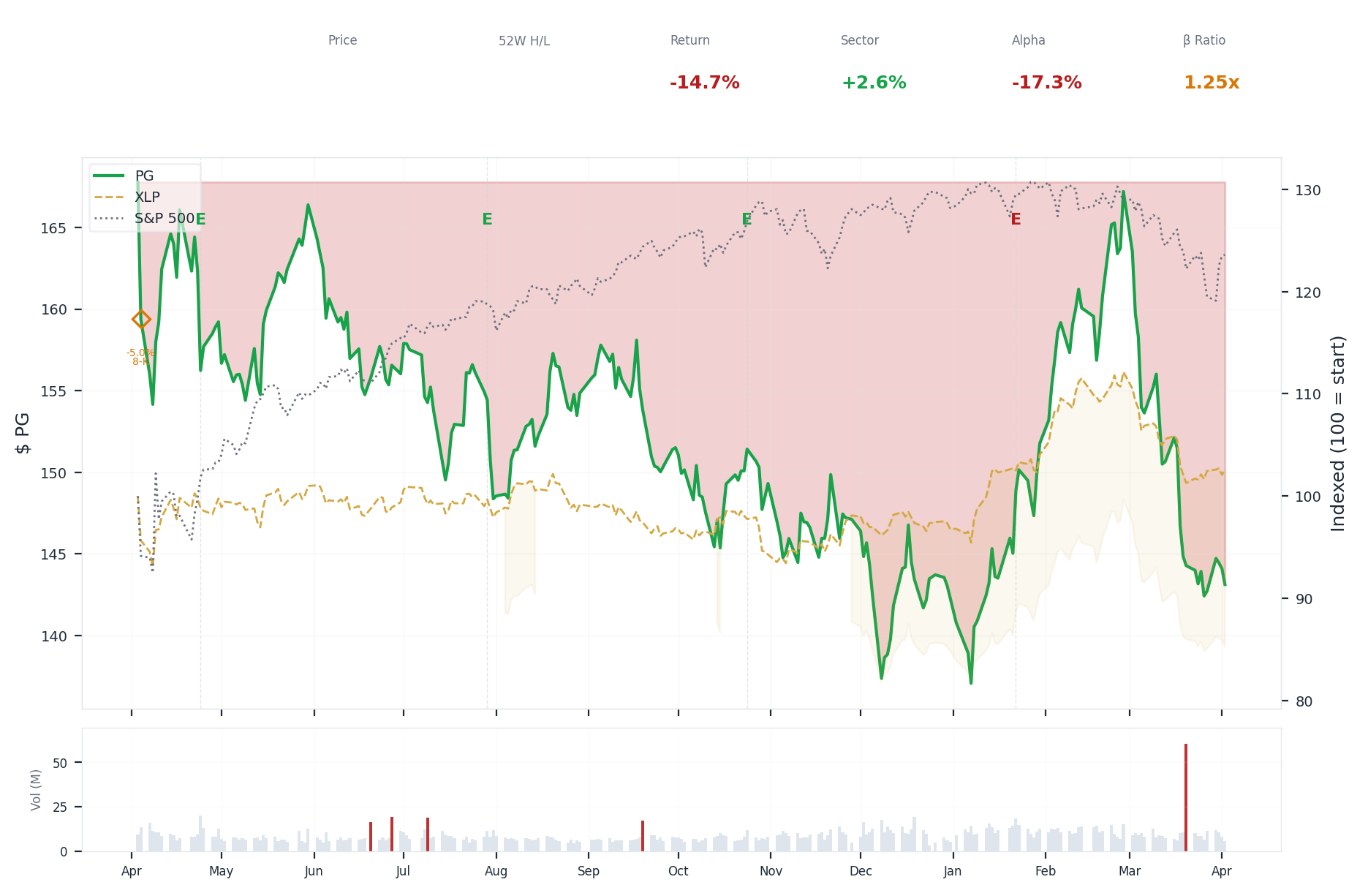
1-Year Performance (Indexed to 100). Red triangles mark single-day drops >= 8%. Orange bands mark multi-day declines >= 15%.
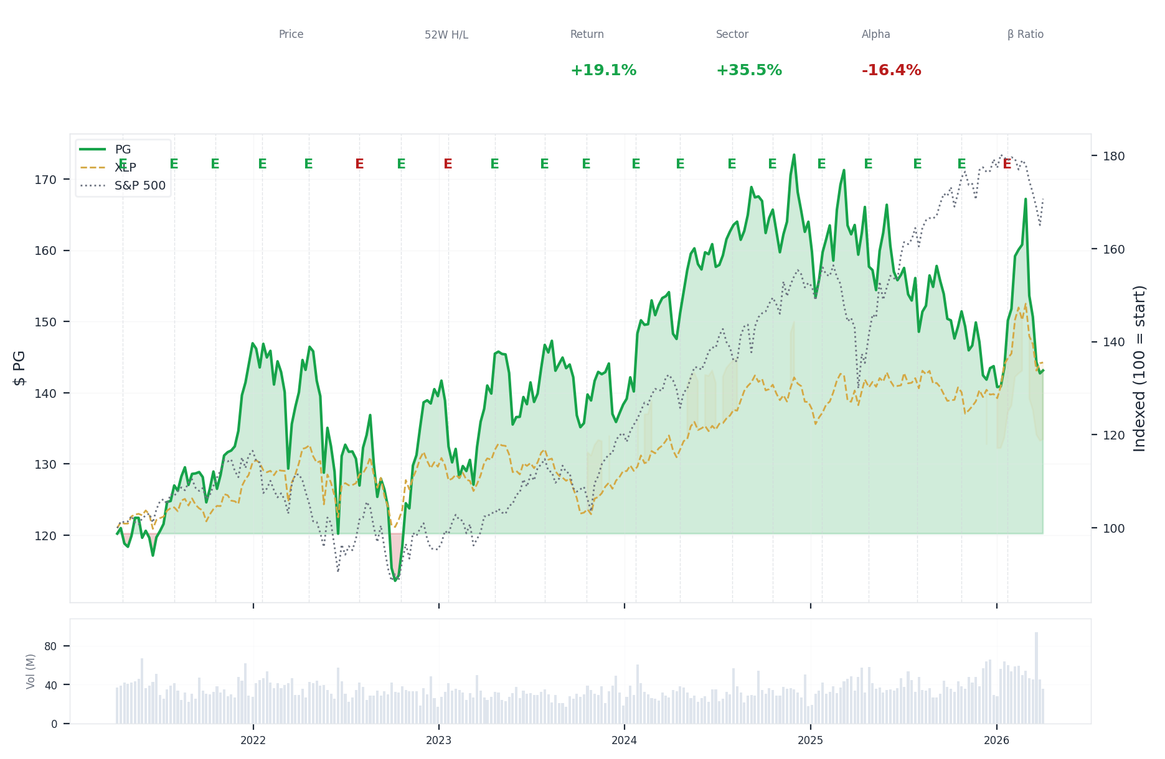
5-Year Performance (Indexed to 100)
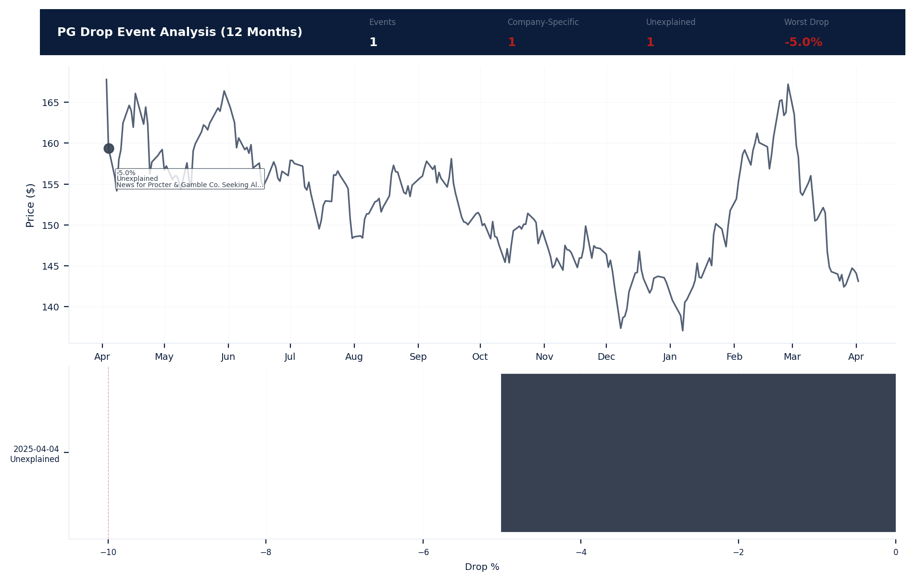
Drop Event Analysis (12 Months)
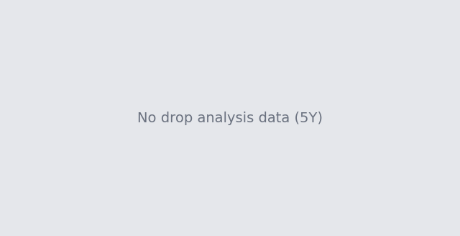
Drop Event Analysis (5 Years)
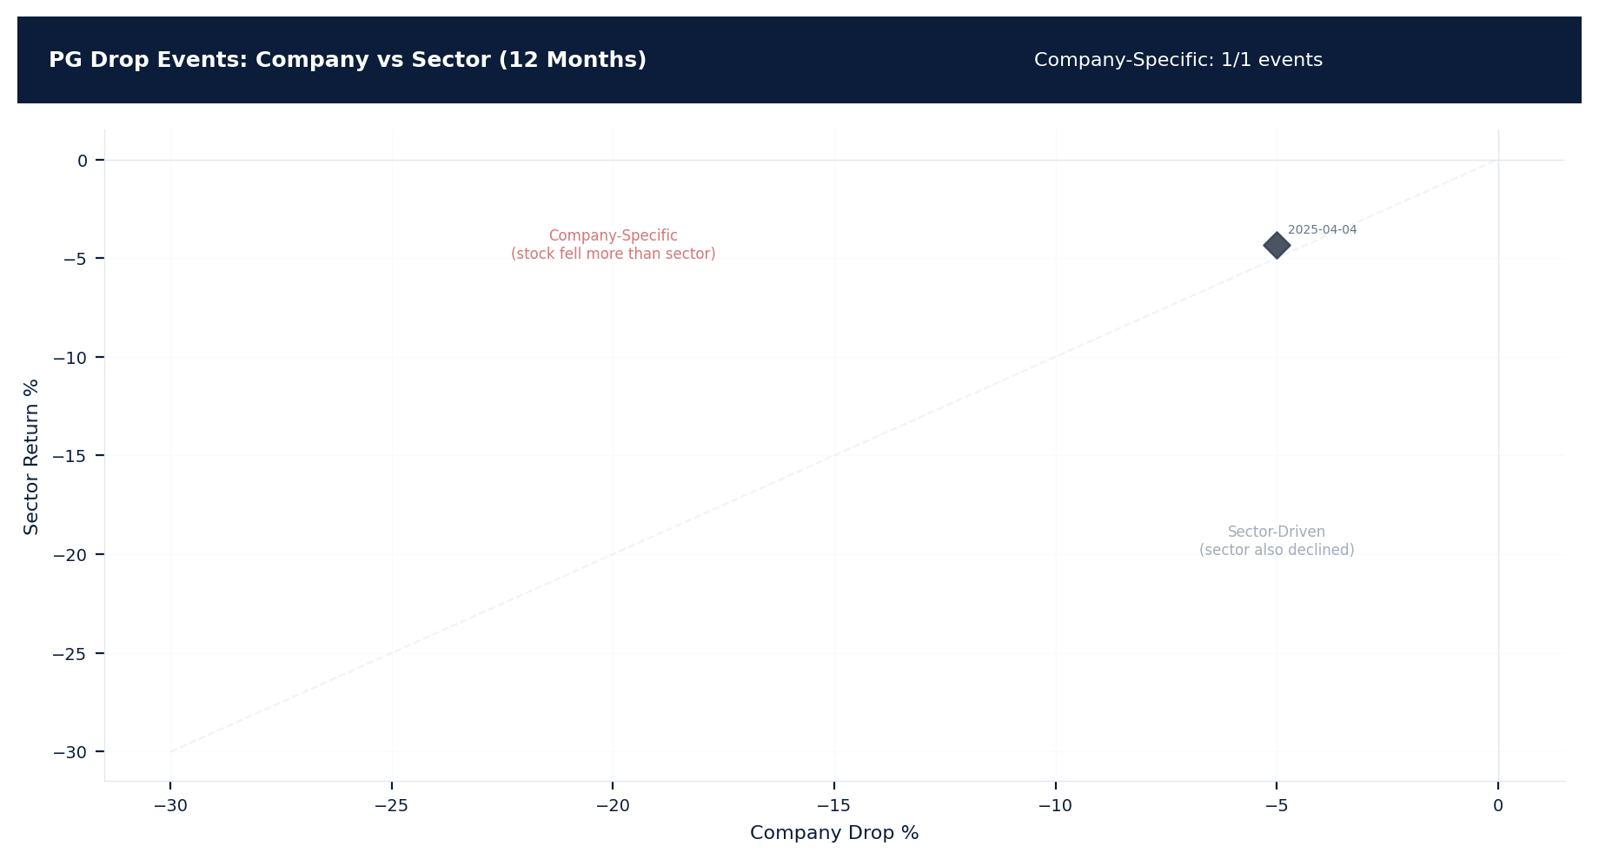
Drop Events: Company vs Sector (12 Months)
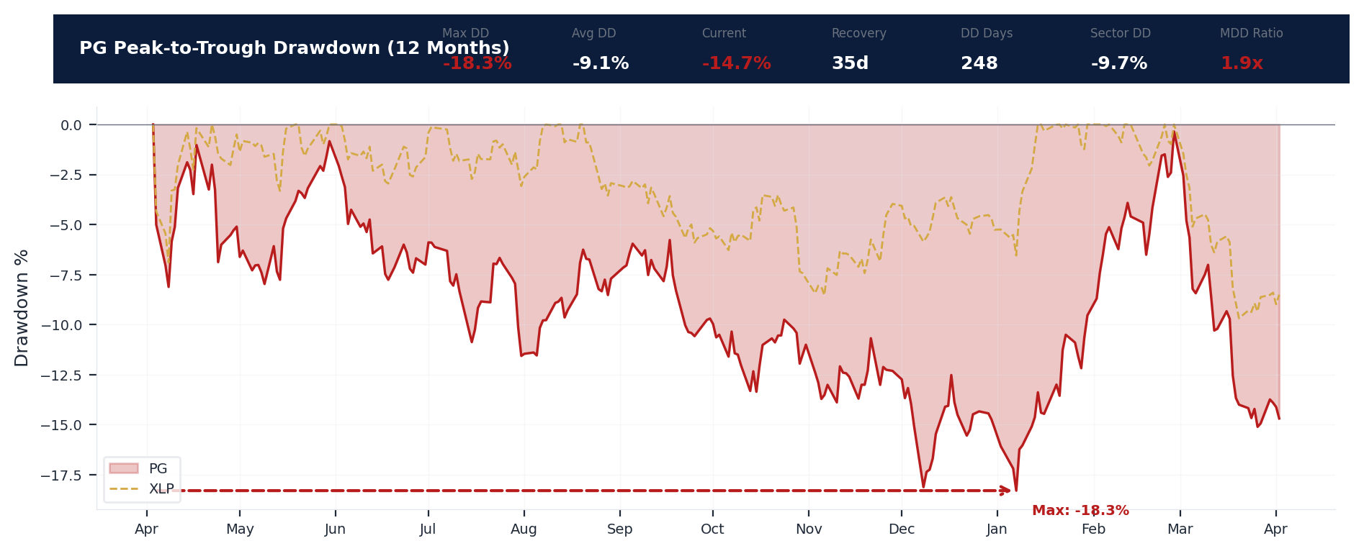
Drawdown Analysis (12 Months)
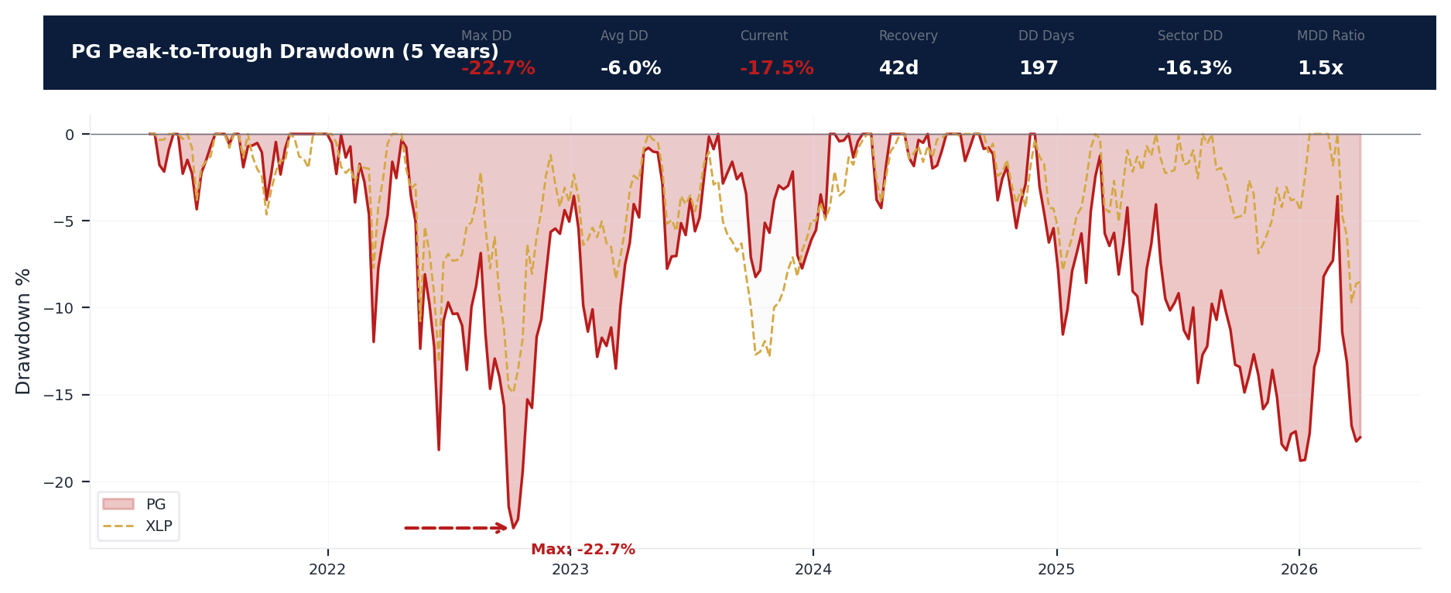
Drawdown Analysis (5 Years)
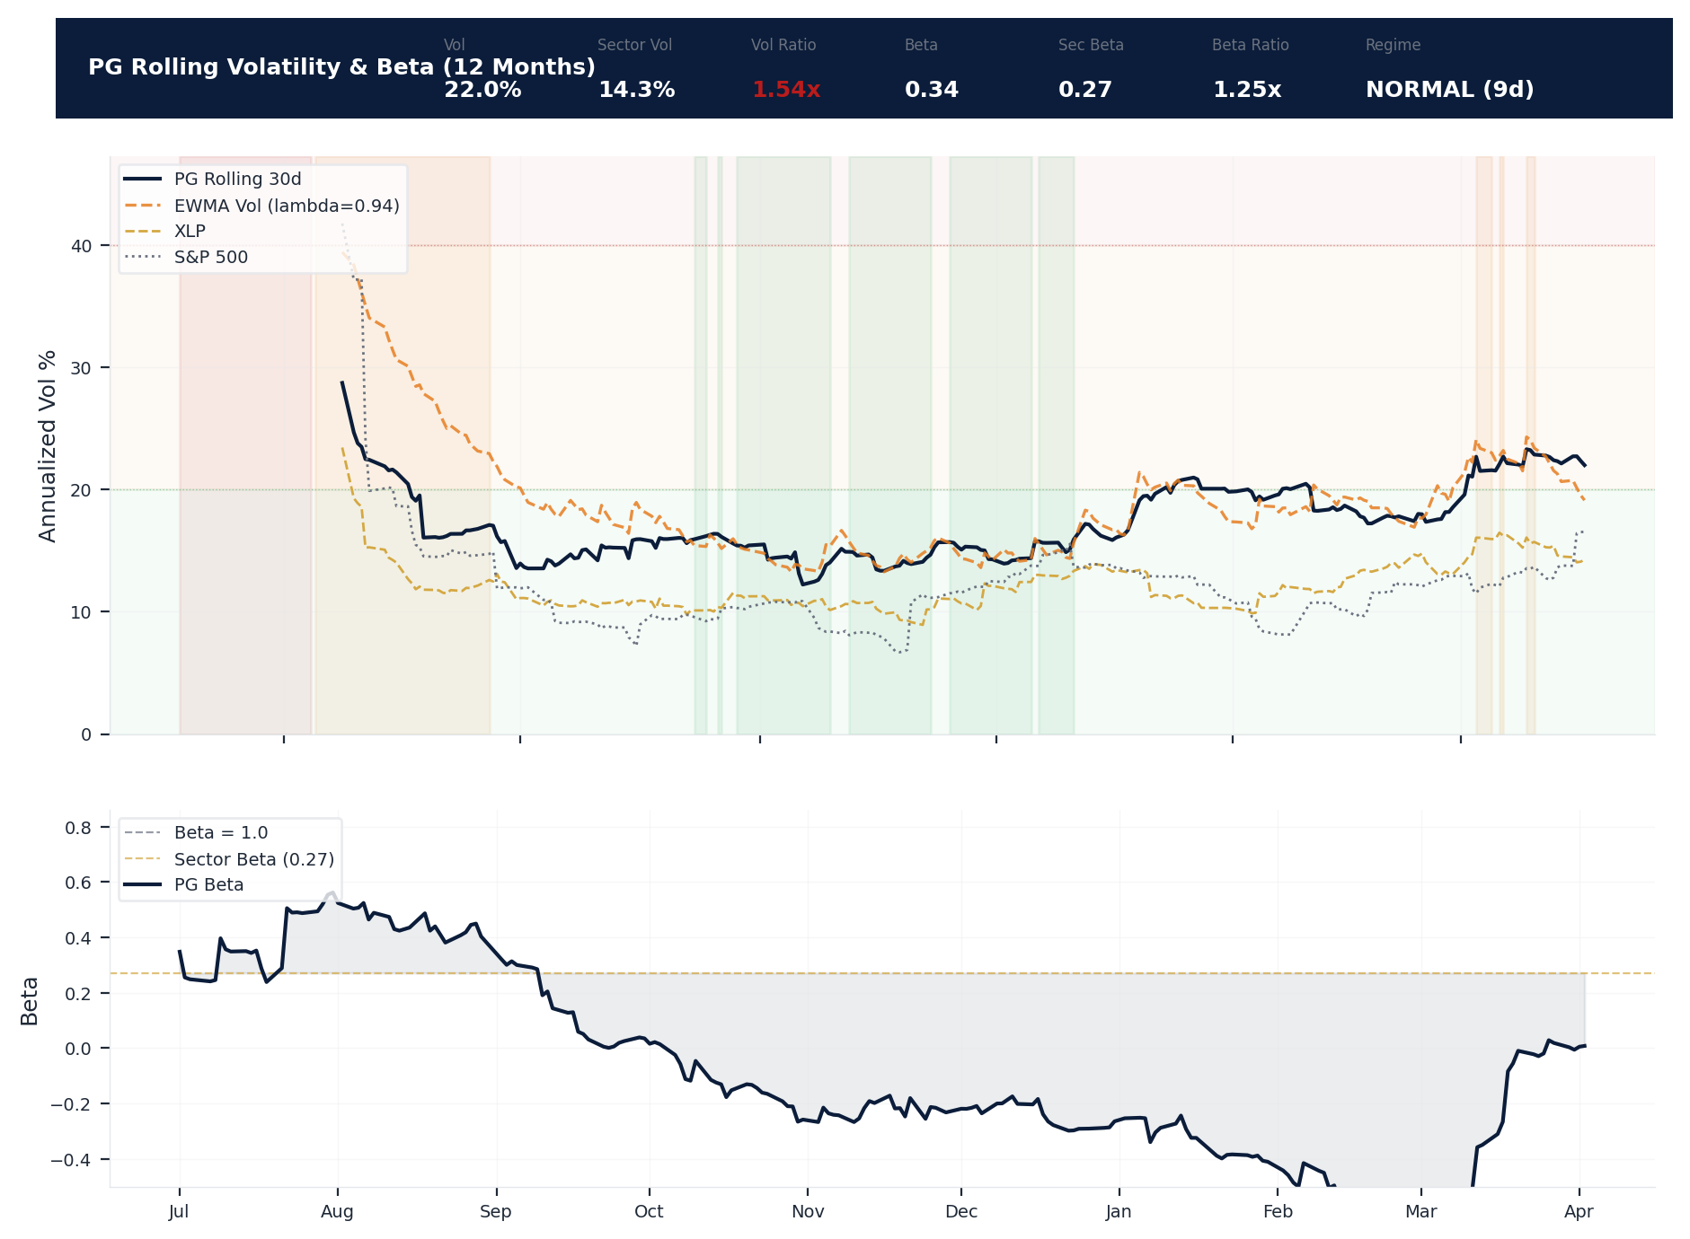
Volatility & Beta Analysis (12 Months)
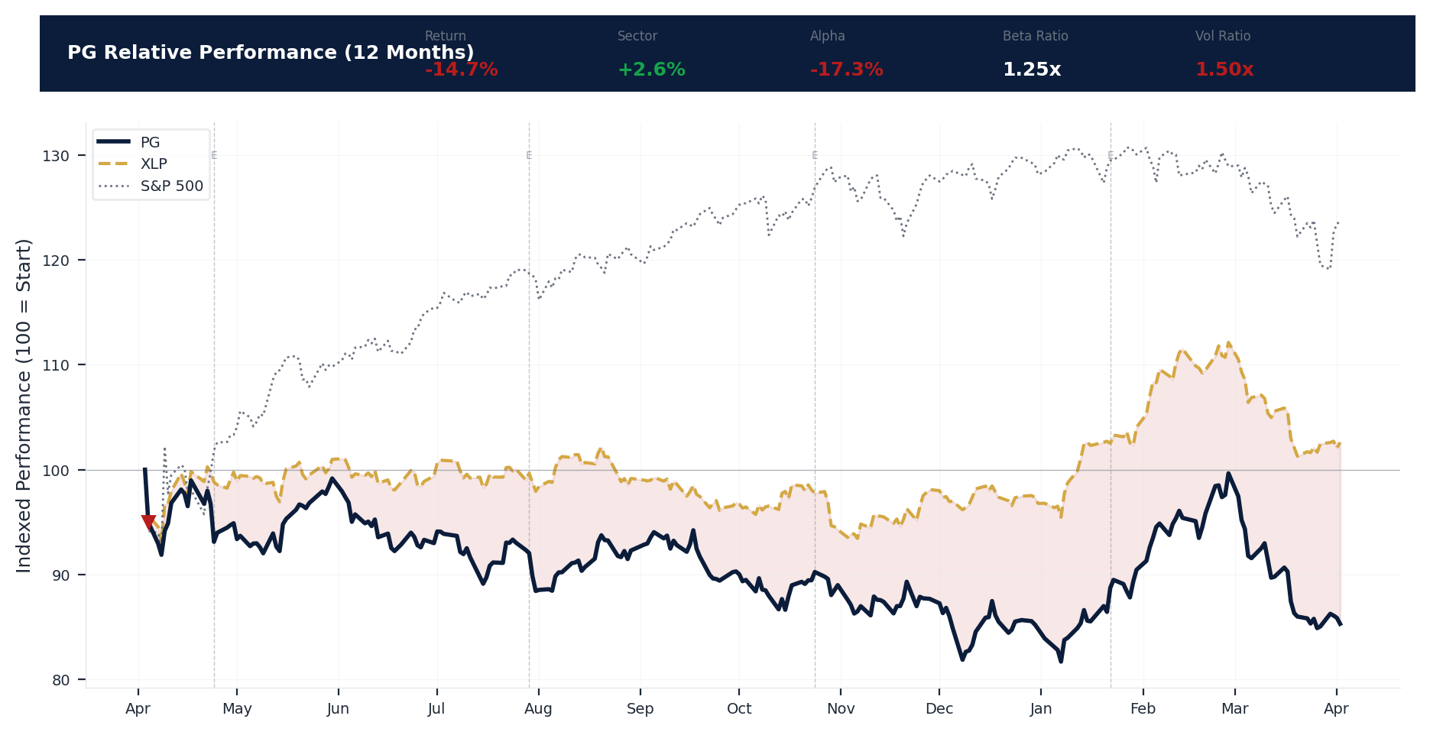
Relative Performance (12 Months)
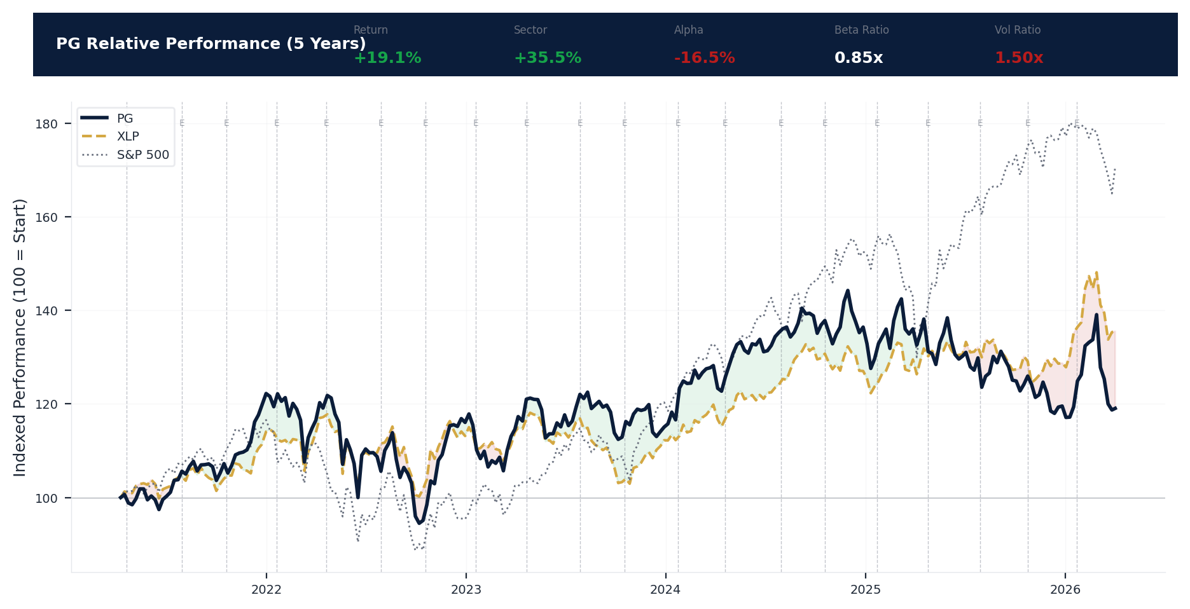
Relative Performance (5 Years)
Metric | Value
Current Price | $143.12
52-Week High | $174.80
52-Week Low | $137.62
1-Year Return | -14.7%
Max Drawdown (1Y) | -18.3%
90-Day Volatility | 20.3% (Ranks at the 0th percentile among 0 peers (peer median: 2.5%))
Beta (vs S&P 500) | 0.34
1 significant stock decline event detected in the 1Y period: 1 notable (5-10%). 1 was company-specific, 1 was market-wide.
Date | Drop % | Recency | Recovery | Trigger Event | Type | Source
2025-04-04 | -5.0% | 25% | Not recovered | 8-K Filing | Market-Wide Event | https://www.sec.gov/cgi-bin/browse-edgar?action...
Short Interest
Metric | Value
Short % of Float | 1.0% (Ranks at the 91st percentile among 0 peers (peer median: 5.5%))
Days to Cover | 2.22
6-Month Trend | DECLINING
vs Sector Ratio | N/A
Earnings Guidance Track Record
Metric | Value
Beat Rate | 0.8%
Consecutive Misses | 1
Guidance Withdrawals | 0
Philosophy | CONSERVATIVE
Quarter | Est. EPS | Actual EPS | Result | Miss Magnitude | Stock Reaction
Q1 2026 | $1.83 | $1.78 | MISS | +2.7% | -2.5%
Q4 2025 | $1.90 | $1.99 | BEAT | N/A | +4.9%
Q3 2025 | $1.42 | $1.48 | BEAT | N/A | +4.1%
Q2 2025 | $1.53 | $1.54 | MEET | N/A | +0.9%
Q1 2025 | $1.86 | $1.88 | BEAT | N/A | +1.1%
Q4 2024 | $1.90 | $1.93 | BEAT | N/A | +1.8%
Q3 2024 | $1.37 | $1.40 | BEAT | N/A | +1.9%
Q2 2024 | $1.41 | $1.52 | BEAT | N/A | +7.5%
Q1 2024 | $1.70 | $1.84 | BEAT | N/A | +8.3%
Q4 2023 | $1.72 | $1.83 | BEAT | N/A | +6.3%
Q3 2023 | $1.32 | $1.37 | BEAT | N/A | +3.5%
Q2 2023 | $1.32 | $1.37 | BEAT | N/A | +3.5%
Q1 2023 | $1.59 | $1.59 | MEET | N/A | -0.0%
Q4 2022 | $1.55 | $1.57 | BEAT | N/A | +1.4%
Q3 2022 | $1.23 | $1.21 | MISS | +1.6% | -1.4%
Q2 2022 | $1.29 | $1.33 | BEAT | N/A | +2.9%
Analyst Consensus
Metric | Value
Analyst Coverage | 22
Consensus Rating | BUY
Mean Recommendation | 2.08 (1=Strong Buy, 5=Sell)
Mean Target Price | $167
Target Price High | $186
Target Price Low | $142
Stock Drop Analysis
Date | Magnitude | Type | Trigger / Attribution | Sector Return | Company-Specific
2025-04-04 | -5.0% | SINGLE_DAY | 8-K_filing | -4.3% | Yes
Company-Specific Drops: 1 event(s) exceeded sector movement. While individually moderate, a pattern of company-specific drops may indicate emerging D&O litigation risk. [ELEVATED]
Insider Trading Analysis
Metric | Value
Net Direction (12mo) | NET_SELLING
10b5-1 Plan % | 0.0%
Buy Transactions | 0
Sell Transactions | 14
Cluster Events | 5
Transaction Detail
Date | Insider | Title | Type | Shares | Value | 10b5-1
2026-03-10 | Portman Robert Jones | Director | GRANT | 49 | $0 | No (Discretionary)
2026-03-10 | Portman Robert Jones | Director | GRANT | 193 | $0 | No (Discretionary)
2026-03-10 | McEvoy Ashley | Director | GRANT | 161 | $0 | No (Discretionary)
2026-03-10 | McCarthy Christine M | Director | GRANT | 209 | $0 | No (Discretionary)
2026-03-10 | Kempczinski Christopher J | Director | GRANT | 201 | $0 | No (Discretionary)
2026-03-10 | JIMENEZ JOSEPH | Director | GRANT | 273 | $0 | No (Discretionary)
2026-03-10 | ARNOLD CRAIG | Director | GRANT | 161 | $0 | No (Discretionary)
2026-02-27 | Francisco Ma. Fatima | CEO - Baby, Fem & Family Care | SELL | 5,249 | $867.6K | No (Discretionary)
2026-02-27 | Francisco Ma. Fatima | CEO - Baby, Fem & Family Care | SELL | 130 | $21.5K | No (Discretionary)
2026-02-27 | Francisco Ma. Fatima | CEO - Baby, Fem & Family Care | SELL | 120 | $19.8K | No (Discretionary)
2026-02-27 | Francisco Ma. Fatima | CEO - Baby, Fem & Family Care | SELL | 50 | $8.3K | No (Discretionary)
2026-02-19 | Whaley Susan Street | Chief Legal Officer & Secy | SELL | 1,809 | $288.5K | No (Discretionary)
2026-02-17 | Francisco Ma. Fatima | CEO - Baby, Fem & Family Care | GRANT | 57 | $0 | No (Discretionary)
2026-02-17 | Whaley Susan Street | Chief Legal Officer & Secy | GRANT | 11 | $0 | No (Discretionary)
2026-02-13 | Aguilar Moses Victor Javier | Chf Rsch, Dev & Innov Officer | EXERCISE | 15,169 | $1.4M | No (Discretionary)
2026-02-13 | Aguilar Moses Victor Javier | Chf Rsch, Dev & Innov Officer | EXERCISE | 15,169 | $0 | No (Discretionary)
2026-02-13 | Aguilar Moses Victor Javier | Chf Rsch, Dev & Innov Officer | SELL | 15,169 | $2.5M | No (Discretionary)
2026-02-12 | Moeller Jon R | Exec. Chairman of the Board | EXERCISE | 162,232 | $18.4M | No (Discretionary)
2026-02-12 | Moeller Jon R | Exec. Chairman of the Board | EXERCISE | 162,232 | $0 | No (Discretionary)
2026-02-12 | Moeller Jon R | Exec. Chairman of the Board | SELL | 162,232 | $26.4M | No (Discretionary)
Cluster Selling Events
Window | Insiders | Names | Total Value
2026-01-23 to 2026-02-19 | 7 | Aguilar Moses Victor Javier, Coombe Gary A, Francisco Ma. Fatima, Moeller Jon R, Pritchard Marc S., Purushothaman Balaji, Whaley Susan Street | $54.5M
2026-02-04 to 2026-02-27 | 6 | Aguilar Moses Victor Javier, Coombe Gary A, Francisco Ma. Fatima, Moeller Jon R, Purushothaman Balaji, Whaley Susan Street | $41.0M
2026-02-11 to 2026-02-27 | 6 | Aguilar Moses Victor Javier, Coombe Gary A, Francisco Ma. Fatima, Moeller Jon R, Purushothaman Balaji, Whaley Susan Street | $39.7M
2026-02-12 to 2026-02-27 | 5 | Aguilar Moses Victor Javier, Coombe Gary A, Francisco Ma. Fatima, Moeller Jon R, Whaley Susan Street | $35.9M
2026-02-13 to 2026-02-27 | 3 | Aguilar Moses Victor Javier, Francisco Ma. Fatima, Whaley Susan Street | $3.7M
Insider Cluster Selling (5 event(s)): Coordinated insider selling is a key D&O risk signal. Courts view cluster sales -- where 3+ insiders sell within a narrow window -- as circumstantial evidence of scienter (intent to defraud) in securities fraud claims. [HIGH]
Executive Departures
No executive departures identified in the trailing 18 months.
Capital Markets Activity
No significant capital markets activity identified in the trailing 3-year period.

ELEVATED CONCERN
Procter & Gamble's revenue grew marginally by 0.3% to $84.3B from $84.0B, but its net income jumped 7.4% to $16.0B, with operating income rising 10.3% to $20.5B, creating a high-performance benchmark that could fuel shareholder expectations and subsequent allegations of failing to meet guidance. The pristine Altman Z-Score of 5.32 and a Beneish M-Score of -3.06 sharply reduce near-term going-concern or accounting fraud allegations under Section 10(b). However, the Piotroski F-Score of 6 indicates mixed financial momentum, which, when paired with an operating cash flow to net income ratio of 1.12, suggests high-quality earnings but leaves room for plaintiffs to isolate weaker segments in a stock drop scenario. The exceptional interest coverage of 22.8x and lack of a material weakness after 135 years with Deloitte severely limits traditional financial statement restatement exposure under Section 11. The primary D&O narrative shifts from solvency to strategic execution, where any failure to sustain this expanded $20.5B operating income or to deploy massive cash flows effectively could trigger fiduciary duty claims.
Section 3: Financial Health
The company reported revenue of $84.3B and net income of $16.0B (per FY2025 10-K, Company Facts API CIK80424). Revenue grew 0.3% year-over-year (from $84.0B). Both distress models indicate stability: Z-Score 5.32 (safe above 2.99) and O-Score 0.00 (safe below 0.5). Earnings quality is healthy (OCF/NI: 1.12), indicating reported income is well-supported by operating cash flows -- reducing restatement risk. Auditor: Deloitte (Big 4), tenure: 135 years -- extended tenure may raise independence concerns. From a D&O perspective, the financial profile supports standard underwriting terms.
Income Statement
Metric | FY2024 | FY2025 | YoY Change
Total revenue / net sales | $84.0B | $84.3B | 0.3%
Cost of revenue / COGS | $40.8B | $41.2B | 0.8%
Operating income / loss | $18.5B | $20.5B | 10.3%
Net income / net loss | $14.9B | $16.0B | 7.4%
Basic earnings per share | $6.18 | $6.67 | 7.9%
Diluted earnings per share | $6.02 | $6.51 | 8.1%
Interest expense | $878.0M | $896.0M | 2.0%
Income tax expense / benefit | $3.8B | $4.1B | 8.3%
Research and development expense | $2.0B | $2.1B | 5.0%
Selling, general and administrative expense | $23.3B | $22.7B | -2.7%
Earnings before interest and taxes (EBIT) | $18.5B | $20.5B | 10.3%
Weighted average shares outstanding (basic) | 2.4B | 2.4B | -0.4%
Weighted average shares outstanding (diluted) | 2.5B | 2.5B | -0.7%
Total comprehensive income / loss | $15.2B | $15.7B | 3.5%
Other income / non-operating income | $668.0M | $154.0M | -77.0%
Restructuring charges | $659.0M | $1.1B | 69.0%
Income from operations | $18.5B | $20.5B | 10.3%
Pre-tax income | $18.8B | $20.2B | 7.5%
Preferred stock dividends | $284.0M | $291.0M | 2.5%
Stock-based compensation expense | $562.0M | $476.0M | -15.3%
Income before income taxes | $18.8B | $20.2B | 7.5%
Gain/loss on sale of assets | $215.0M | $-755.0M | -451.2%
Other comprehensive income/loss, net of tax | $317.0M | $-248.0M | -178.2%
Non-operating income / expense | $668.0M | $154.0M | -77.0%
Current federal income tax expense / benefit | $2.0B | $2.2B | 13.4%
Current state and local income tax expense / benefit | $368.0M | $407.0M | 10.6%
Current foreign income tax expense / benefit | $1.7B | $1.3B | -22.1%
Deferred federal income tax expense / benefit | $-133.0M | $9.0M | 106.8%
Deferred foreign income tax expense / benefit | $-111.0M | $141.0M | 227.0%
Advertising expense | $9.6B | $9.2B | -4.2%
Gross margin percentage | 51.4% | 51.2% | -0.5%
Operating margin percentage | 22.1% | 24.3% | 9.9%
Net margin percentage | 17.7% | 18.9% | 7.1%
EBITDA margin percentage | 25.5% | 27.6% | 8.3%
Effective tax rate | $20 | $20 | 0.7%
Interest coverage ratio | $21 | $23 | 8.1%
Balance Sheet
Metric | FY2024 | FY2025 | YoY Change
Total assets | $122.4B | $125.2B | N/A
Total liabilities | $71.8B | $72.9B | N/A
Total stockholders' equity | $50.6B | $52.3B | N/A
Total current assets | $24.7B | $25.4B | N/A
Total current liabilities | $33.6B | $36.1B | N/A
Accounts receivable, net | $6.1B | $6.2B | N/A
Inventory, net | $7.0B | $7.6B | N/A
Property, plant and equipment, net | $22.2B | $23.9B | N/A
Goodwill | $40.3B | $41.6B | N/A
Intangible assets, net (excluding goodwill) | $22.0B | $21.9B | N/A
Long-term debt, non-current | $25.3B | $25.0B | N/A
Short-term debt / current portion of long-term debt | $7.2B | $9.5B | N/A
Retained earnings / accumulated deficit | $123.8B | $130.0B | N/A
Common shares outstanding | 4.0B | 4.0B | N/A
Accounts payable | $15.4B | $15.2B | N/A
Operating lease liabilities | $909.0M | $956.0M | N/A
Minority / noncontrolling interest | $272.0M | $272.0M | N/A
Prepaid expenses and other current assets | $2.1B | $2.1B | N/A
Accrued liabilities | $11.1B | $11.3B | N/A
Deferred income tax liabilities, net | $6.5B | $5.8B | N/A
Accumulated other comprehensive income/loss | $-11.9B | $-12.1B | N/A
Treasury stock, at cost | $5.0B | $6.5B | N/A
Common stock par value | $4.0B | $4.0B | N/A
Additional paid-in capital | $67.7B | $68.8B | N/A
Total liabilities and stockholders' equity | $122.4B | $125.2B | N/A
Preferred stock value | $801.0M | $781.0M | -1.8%
Right-of-use assets (operating and finance leases) | $875.0M | $925.0M | N/A
Other non-current assets | $13.2B | $12.4B | N/A
Other non-current liabilities | $6.4B | $6.1B | N/A
Unrecognized tax benefits (UTB) liability | $582.0M | $634.0M | N/A
Commercial paper outstanding | $3.3B | $4.1B | N/A
Common stock shares authorized | 10.0B | 10.0B | N/A
Derivative assets at fair value | $120.0M | $19.0M | N/A
Derivative liabilities at fair value | $379.0M | $1.1B | N/A
Derivative notional amount (off-balance-sheet exposure) | $16.3B | $18.7B | N/A
Current ratio | $1 | $1 | N/A
Quick ratio | $1 | $0 | N/A
Tangible book value | $-11.8B | $-11.3B | N/A
Book value per share | $12.61 | $13.04 | N/A
Return on assets | $12 | $13 | N/A
Return on equity | $29 | $31 | N/A
Asset turnover ratio | $1 | $1 | N/A
Key Balance Sheet Ratios
Ratio | Value | Assessment
Current Ratio | 0.70 | Concern
Debt/Assets | 0.58 | Moderate
Cash Flow Statement
Metric | FY2024 | FY2025 | YoY Change
Net cash from operating activities | $19.8B | $17.8B | -10.2%
Net cash from investing activities | $-3.5B | $-3.8B | -9.0%
Net cash from financing activities | $-14.9B | $-14.0B | 5.5%
Capital expenditures | $3.3B | $3.8B | 13.6%
Depreciation and amortization | $2.9B | $2.8B | -1.7%
Dividends paid | $9.3B | $9.9B | 6.0%
Share repurchases / buybacks | $5.0B | $6.5B | 29.8%
Acquisitions, net of cash acquired | $21.0M | $11.0M | -47.6%
Proceeds from issuance of debt | $3.2B | $2.2B | -30.0%
Repayments of debt | $2.3B | $2.0B | -15.3%
Interest paid (supplemental) | $878.0M | $896.0M | 2.0%
Income taxes paid (supplemental) | $4.4B | $4.6B | 4.4%
Stock-based compensation (cash flow adjustment) | $562.0M | $476.0M | -15.3%
Changes in operating working capital | $1.8B | N/A | N/A
Net increase/decrease in cash and equivalents | $1.2B | $75.0M | -93.9%
Deferred income taxes (cash flow adjustment) | $-244.0M | $149.0M | 161.1%
Change in accounts receivable | $766.0M | $-45.0M | -105.9%
Change in inventory | $70.0M | $324.0M | 362.9%
Change in accounts payable | N/A | $-542.0M | N/A
Amortization of intangible assets | $338.0M | $320.0M | -5.3%
Effect of exchange rate changes on cash | $-251.0M | $112.0M | 144.6%
Free cash flow | $16.5B | $14.0B | -15.0%
FCF-to-revenue ratio | $20 | $17 | -15.3%
Capex-to-revenue ratio | $4 | $4 | 13.4%
Capex-to-depreciation ratio | $1 | $1 | 15.5%
Dividend payout ratio | $63 | $62 | -1.2%
Free cash flow per share | $4.12 | $3.50 | -15.0%
Key Ratios: Company vs. Peers
Ratio | Value
Interest Coverage | 22.8x
Distress Indicators
Model | Score | Zone | Trajectory | D&O Context
Altman Z-Score | 5.32 | Safe | FY2024: 5.3 -> FY2025: 5.3 (stable) | Bankruptcy predictor. Distress zone companies face fiduciary duty scrutiny under Revlon/zone of insolvency doctrine.
Beneish M-Score | -3.06 | Safe | N/A | Earnings manipulation detector. Scores above -1.78 indicate elevated restatement risk, a primary SCA catalyst.
Ohlson O-Score | 0.00 | Safe | N/A | Bankruptcy probability model. Higher values signal financial stress that may limit litigation defense resources.
Piotroski F-Score | 6.00 | Grey Zone | 6/9 criteria met | Fundamental quality indicator. Scores 0-3 signal weak fundamentals; 7-9 indicate strong quality.
Earnings Quality
Metric | Value | Assessment
OCF/Net Income | 1.12 | Healthy
Accruals Ratio | -0.01 | Normal
Source: Derived from XBRL financial statements, MEDIUM confidence
Audit Risk Assessment
Audit Risk: No concerns. Deloitte, 135 year tenure, qualified opinion.
Debt Analysis
Metric | Value
Debt-to-Equity | N/A
Debt-to-EBITDA | N/A
Interest Coverage | 22.82
Covenant Status | Unknown
Critical Accounting Estimates
Estimate | Value | Assessment
Effective Tax Rate | 20.3% | Normal range
Peer Group Comparison
Ticker | Name | Market Cap | Revenue | Score
KO | Coca-Cola Company (The) | $330.2B | $47.9B | 44
PEP | Pepsico, Inc. | $214.6B | $93.9B | 32
COST | Costco Wholesale Corporation | $450.5B | $286.3B | 32
WMT | Walmart Inc. | $1.0T | $713.2B | 13
PM | Philip Morris International Inc | $246.4B | $40.6B | 30
MO | Altria Group, Inc. | $110.4B | $20.1B | 14
CL | Colgate-Palmolive Company | $68.3B | $20.4B | 25
MDLZ | Mondelez International, Inc. | $74.2B | $38.5B | 18
KHC | The Kraft Heinz Company | $27.0B | $24.9B | 15
Revenue: Ranks at the 67th percentile among 9 peers.
Method: Multi-signal composite: SIC 25%, industry 20%, market cap 25%, revenue 15%, description 15%

ELEVATED CONCERN
The board’s small size of four directors, combined with CEO/Chair duality held by Jon Moeller, concentrates oversight risk as independence data is unavailable for all four members. A 90.65% say-on-pay vote, while passing, reveals notable 9.35% shareholder dissent that could crystallize into a derivative suit challenging compensation committee decisions under Moeller’s combined leadership. The governance profile shows a specific, material weakness, including a 1.275-point deduction from a recent 8-point proxy analysis, indicating substantive disclosure or procedural failures that directly implicate the duty of candor and can support a plaintiff’s pleading burden. With only one long-tenured CLO, Street Whaley at 11 years, and an executive team data set of only one member, verifying robust internal controls for Caremark duties is challenging, increasing the risk of oversight failure claims. The primary D&O exposure here is a compensation-related derivative action leveraging the chair duality and pay dissent against a board that may lack the structural independence to mount a rigorous defense.
Section 5: Governance & Leadership
Leadership team is stable with average tenure of 11.0 years. Compensation concerns include: 1 related-party transaction(s). [Rule-based synthesis of governance extraction results, 2026-04-03, LOW]
Leadership Stability
Name | Title | Tenure (Yrs) | Status | Prior Lit. | Flags
Street Whaley | CLO | 11.0 | ACTIVE | 0 | None
Leadership Stability Score: 100/100 [leadership_profiles extractor, 2026-04-03, MEDIUM]
Board Composition
Name | Tenure | Independent | Committees | Other Boards | Overboarded
Mr. Jon R. Moeller | N/A | N/A | N/A | 0 | No
Mr. Shailesh G. Jejurikar | N/A | N/A | N/A | 0 | No
Ms. Jennifer L. Davis | N/A | N/A | N/A | 0 | No
Mr. Sundar G. Raman | N/A | N/A | N/A | 0 | No
[ELEVATED] CEO/Chair Duality -- Single individual holds both CEO and Board Chair roles
Context: Companies with CEO/Chair duality face 1.8x higher derivative suit filing rates due to governance concentration.
See Meeting Prep: Governance Structure
Board Quality Metrics
Metric | Value
Board Size | N/A
Independence Ratio | N/A
CEO/Chair Duality | Yes
Classified Board | N/A
Overboarded Directors | N/A
Dual-Class Structure | N/A
D&O Context: CEO/Chair duality reduces board independence in oversight of management, increasing derivative suit risk. [ELEVATED]
Compensation Analysis
Summary Compensation Table
Component | Amount
Total CEO Compensation | $0
Metric | Value
CEO Pay Ratio | 276:1
Compensation Structure
Component | Detail
Clawback Policy | Yes
Clawback Scope | BROADER
Compensation Red Flags
Related-Party Transactions (1): Related-party transactions between executives and company require enhanced disclosure and increase Caremark derivative claim exposure. [ELEVATED]
Notable Perquisites: Any senior executives who enroll will be taxed on the benefit value of these services and the Company will not provide any tax gross-ups for these services, Executive Benefits The Company provides certain other limited benefits to senior executives to fulfill particular business purposes, which are primarily for convenience and personal security, However, certain expatriate allowances, relocation reimbursements, and tax equalization payments are made to employees assigned to work outside their home countries, and the Company will cover the personal income taxes due on these items in accordance with expatriate policy because there is a busine: Above-peer perquisites draw proxy advisory negative recommendations. [ELEVATED]
Ownership Structure
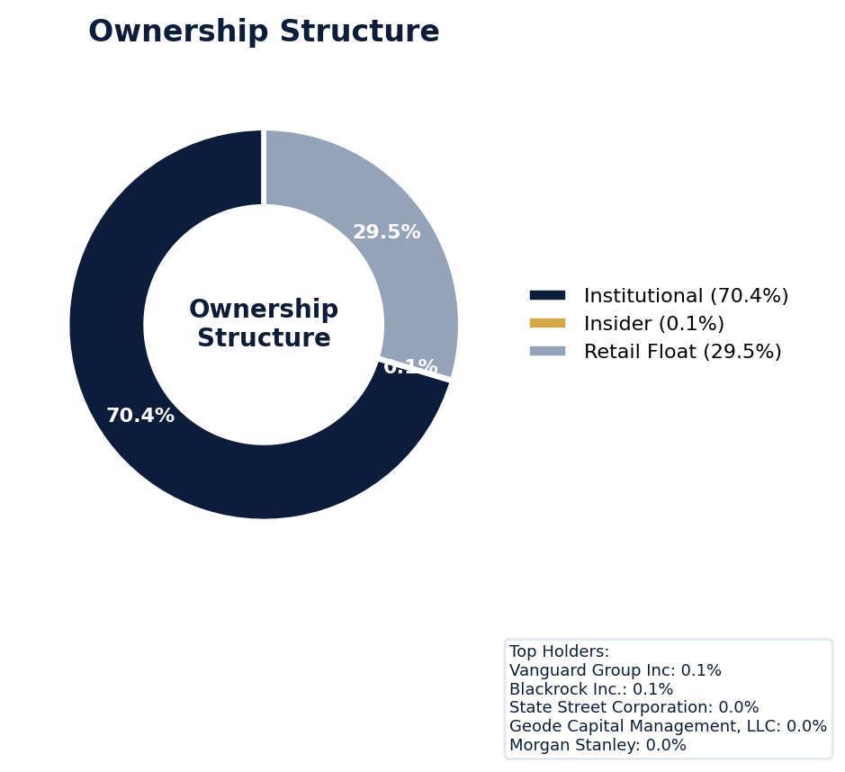
Figure: Ownership breakdown -- institutional, insider, retail float
Category | Percentage
Institutional Ownership | 70.4%
Insider Ownership | 0.1%
Retail Float | 29.5%
Top Holder | Ownership %
Vanguard Group Inc | 0.1%
Blackrock Inc. | 0.1%
State Street Corporation | 0.0%
Geode Capital Management, LLC | 0.0%
Morgan Stanley | 0.0%
Sentiment & Narrative Coherence
Signal | Assessment
Narrative Coherence | COHERENT
Anti-Takeover Provisions
Anti-takeover provision data not available. Review DEF 14A and charter documents for complete analysis.

ELEVATED CONCERN
Procter & Gamble currently faces six open securities class actions, though none of these zero active SCAs have a defined class period. The SEC is in the comment letter stage, which historically serves as a corrective disclosure catalyst for litigation; this regulatory timeline directly informs the exposure window for any future D&O claim. The company's adjusted SCA filing rate of 2.3% is notably below the sector average of 3.5%, suggesting a historically lower litigation profile that may be shifting given the current six open cases. With a moderate defense strength and a claim probability derived from a high signal density of 70 signals for Factor 1, the primary D&O exposure is the high recurrence probability of a new SCA, benchmarked against peer settlements in the consumer staples sector. Defense cost exposure is immediate given the six open cases, even absent a current active SCA, driving near-term defense expenditures.
Section 6: Litigation & Regulatory Exposure
SEC enforcement pipeline position: COMMENT_LETTER. 6 statute of limitations window(s) remain open, meaning new claims can still be filed for past events. Under claims-made D&O policy, coverage is triggered when a claim is reported during the policy period. Defense quality assessment: MODERATE.
Litigation Overview: 0 active matter(s), 1 historical matter(s)
Litigation Timeline
Timeline chart not available (no timeline events).
Securities Class Actions
Case Name | Legal Theory | Coverage | Court | Filing Date | Status | Class Period | Lead Counsel | Settlement | Source
In re Procter & Gamble Company Securities Litigation (2000) | Rule 10b-5 | Side C (Entity) | N/A | 2000-03-08 | SETTLED | Jan 2000 - Jun 2000 | N/A | $49.0M | [Supabase SCA database, 2026-04-03, MEDIUM]
D&O Context: Historical settlements total $49.0M. Settlement history establishes severity baseline for pricing. [ELEVATED]
SEC Enforcement Pipeline
Pipeline: [Comment Letters] -> (Informal Inquiry) -> (Formal Investigation) -> (Wells Notice) -> (Enforcement Action)
Current Position: Comment Letters [MODERATE]
Company is at COMMENT_LETTER stage in the SEC enforcement pipeline, with 1 supporting signal(s) identified. [10-K Item 3 + Item 1A + 8-K + EFTS, 2026-04-03, LOW]
Derivative Suits
No derivative suit history found.
Regulatory Proceedings
Agency | Type | Status
FDA | investigation | disclosed
Industry Claim Patterns
No industry-specific claim patterns identified.
Statute of Limitations Map
Claim Type | Trigger Date | SOL Expiry | Repose Expiry | Window Open
employment_discrimination | 2025-08-04 | 2027-08-04 | 2027-08-04 | OPEN
antitrust | 2025-08-04 | 2029-08-03 | 2029-08-03 | OPEN
FCPA | 2025-08-04 | 2030-08-03 | 2030-08-03 | OPEN
environmental | 2025-08-04 | 2030-08-03 | 2030-08-03 | OPEN
derivative | 2025-08-04 | 2028-08-03 | 2031-08-03 | OPEN
ERISA | 2025-08-04 | 2028-08-03 | 2031-08-03 | OPEN
Section_11 | 2000-06-07 | 2001-06-07 | 2003-06-07 | CLOSED
Section_14a | 2000-06-07 | 2001-06-07 | 2003-06-07 | CLOSED
10b-5 | 2000-06-07 | 2002-06-07 | 2005-06-06 | CLOSED
D&O Context: 6 open exposure window(s). Claims can still be filed within these periods. [ELEVATED]
Defense Strength Assessment
Factor | Assessment
Federal Forum Provision | No
Exclusive Forum Provision | No
PSLRA Safe Harbor | STRONG
Truth-on-Market Viability | NOT_APPLICABLE
Prior Dismissal Success | No prior dismissals identified in Item 3
Overall Defense Strength | MODERATE
No forum selection provisions identified. Safe harbor usage is STRONG with explicit PSLRA citation and specific cautionary language. [DEF 14A; 10-K, 2026-04-03, LOW]
Contingent Liabilities
Description | ASC 450 Class. | Accrued | Range
The Company is subject, from time to time, to certain legal | reasonably_possible | N/A | N/A
Workforce, Product & Environmental Matters
Product Liability:
- [recall] Our results of operations or cash flows could also be negatively impacted if the Company or one of our brands suffers substantial harm to its reputation due to a significant product recall, product-related 6 The Procter & Gamble Company litigation, defects or impurities in our products, product misuse, changing consumer perceptions of certain ingredients, negative perceptions of packaging (such as plastic and other petroleum-based materials), lack of recyclability or other environmen
Cybersecurity Incidents:
- [data_breach] for issues such as labor disputes or controversies, loss or impairment of key manufacturing sites, discontinuity or disruptions in our internal information and data systems or those of our suppliers, cybersecurity incidents including but not limited to ransomware attacks, misuse of artificial intelligence and machine learning technologies, inability to procure sufficient raw or input materials (including water, recycled materials and materials that meet our labor standards), significant chang...
- [data_breach] and other petroleum-based materials), lack of recyclability or other environmental attributes, concerns about actual or alleged labor, equality and inclusion or social practices, privacy failures or data breaches, allegations of product tampering or the distribution and sale of counterfeit products.
- [data_breach] A significant information security or operational technology incident, including a cybersecurity incident, or the failure of one or more key information or operations technology systems, networks, hardware, processes and/or associated sites involving the Company or one of its service providers could have a material adverse impact on our business or reputation.
- [data_breach] IT/OT databases and systems and our third-party providers' databases and systems have been, and will likely continue to be, subject to advanced computer viruses or other malicious codes, ransomware, unauthorized access attempts, denial of service attacks, phishing, social engineering, hacking and other cyber-attacks.
- [data_breach] In addition, if a ransomware attack, other cybersecurity incident or operational disruption occurs, either internally or at our third-party providers, we could be prevented from accessing our data or systems, which may cause interruptions or delays in our business operations, cause us to incur remediation costs, subject us to demands to pay a ransom or damage our
- [data_breach] If such a new system or technology does not function properly, provides flawed or inaccurate outputs or exposes us to increased cybersecurity incidents and failures, it could affect our ability to order materials, make and ship orders and process payments in addition to other operational and information integrity and loss issues.
- [cyber_attack] oss or impairment of key manufacturing sites, discontinuity or disruptions in our internal information and data systems or those of our suppliers, cybersecurity incidents including but not limited to ransomware attacks, misuse of artificial intelligence and machine learning technologies, inability to procure sufficient raw or input materials (including water, recycled materials and materials that meet our labor standards), significant changes in trade policy, natural disasters, increasing sev...
- [cyber_attack] In addition, because the techniques, tools and tactics used in cyber-attacks frequently change, continue to advance in sophistication and may be difficult to detect for periods of time, we and our third-party providers may face difficulties in anticipating and implementing adequate preventative measures or fully mitigating harms after such an attack, including acquired and
- [cyber_attack] Our IT/OT databases and systems and our third-party providers' databases and systems have been, and will likely continue to be, subject to advanced computer viruses or other malicious codes, ransomware, unauthorized access attempts, denial of service attacks, phishing, social engineering, hacking and other cyber-attacks.
- [cyber_attack] ely continue to be, subject to advanced computer viruses or other malicious codes, ransomware, unauthorized access attempts, denial of service attacks, phishing, social engineering, hacking and other cyber-attacks.
- [cyber_attack] nformation, due to any number of causes, including catastrophic events, natural disasters, power outages, computer and telecommunications failures, improper data handling, viruses, phishing attempts, cyber-attacks, malware and ransomware attacks, security incidents, misuse or malicious use of artificial intelligence or employee error or malfeasance, and our business continuity plans do not effectively address these failures on a timely basis, we may suffer interruptions in our ability to mana...
- [cyber_attack] er of causes, including catastrophic events, natural disasters, power outages, computer and telecommunications failures, improper data handling, viruses, phishing attempts, cyber-attacks, malware and ransomware attacks, security incidents, misuse or malicious use of artificial intelligence or employee error or malfeasance, and our business continuity plans do not effectively address these failures on a timely basis, we may suffer interruptions in our ability to manage operations and be expose...
- [cyber_attack] In addition, if a ransomware attack, other cybersecurity incident or operational disruption occurs, either internally or at our third-party providers, we could be prevented from accessing our data or systems, which may cause interruptions or delays in our business operations, cause us to incur remediation costs, subject us to
Whistleblower Indicators
No whistleblower indicators identified in SEC filings. SEC whistleblower tips are not publicly disclosed; absence does not confirm lack of activity.

Procter & Gamble's exceptional 91.5 quality score places it firmly in the WIN tier, with an expected claims probability of only 3.9-5.6%. The primary underwriting concern is its persistent history of prior litigation, which contributed a 2.03-point deduction and drives its MODERATE claim band despite its top-tier operational profile. Its active M&A environment, a key risk factor with an 18-signal history, presents a consistent source of potential securities claims, as does a measurable level of short interest that triggered a 1.28-point deduction. For a company of this caliber, the underwriting story is the disconnect between its world-class fundamentals and the steady drumbeat of legal and transactional exposures, which total 8.54 points in deductions, that keep its risk off the floor.
Section 7: Risk Scoring & Synthesis
Underwriting tier: **WIN** (quality score: 91.5/100). Recommended action: Must-have account, compete aggressively. Expected claim probability band: 3.9-5.6%. Top risk contributors: IPO/SPAC/M&A (F4: -2.5 pts); Prior Litigation (F1: -2.0 pts); Short Interest (F6: -1.3 pts). Claim probability band: MODERATE (3.9%-5.6%).
Tier Classification
Metric | Value
Quality Score | 91.5 / 100
Composite Score (pre-ceiling) | 91.5
Total Risk Points Deducted | 8.5
Tier | WIN
Tier Range | 86 - 100
Action Guidance | Must-have account, compete aggressively
Probability Range | 3.9-5.6%
Pricing Multiplier | 0.5-0.7x
Risk Assessment: LOW [LOW]
D&O Claim Peril Assessment
1 of 8 D&O claim perils show active risk signals. Active perils have at least one causal chain with triggered checks.
Peril | Risk Level | Active Chains | Key Evidence
Securities Claims | LOW | 0/5 | —
Fiduciary Breach | MODERATE | 1/3 | Verified (value: 0); Detected (value). Limited corroborating data available.
Government Enforcement | LOW | 0/2 | —
Employment & Whistleblower | LOW | 0/1 | —
Insolvency & Bankruptcy | LOW | 0/1 | —
Emerging Risks | LOW | 0/2 | —
Consumer & Product Claims | LOW | 0/1 | —
Commercial Litigation | LOW | 0/1 | —
Active Peril Analysis
Fiduciary Breach: MODERATE [MODERATE]
Frequency: growing | Severity: variable | Typical range: $1M - $100M
1 of 3 causal chains active.
Chain: Governance Failure → Derivative Suit [MODERATE]
Weak governance structure (low independence, CEO/Chair duality, poor say-on-pay) creates basis for Caremark duty of oversight claims and derivative suits.
Triggers:
• GOV.BOARD.ceo_chair
Historical filing rate: 3% | Median severity: $8M
Composite Score Breakdown
Factor | Name | Max Pts | Deducted | % Used | Top Contributor
F1 | Prior Litigation | 20 | 2.0 | 10% | Signal-driven scoring: 70 signals, coverage=100%
F2 | Stock Decline | 15 | 0.6 | 4% | Signal-driven scoring: 30 signals, coverage=100%
F3 | Restatement/Audit Issues | 12 | 0.8 | 6% | Signal-driven scoring: 83 signals, coverage=100%
F4 | IPO/SPAC/M&A | 10 | 2.5 | 25% | Signal-driven scoring: 18 signals, coverage=100%
F5 | Guidance Misses | 12 | 0.4 | 3% | Signal-driven scoring: 27 signals, coverage=100%
F6 | Short Interest | 8 | 1.3 | 16% | Signal-driven scoring: 25 signals, coverage=100%
F7 | Stock Volatility | 9 | 0.1 | 2% | Signal-driven scoring: 27 signals, coverage=100%
F8 | Financial Distress | 8 | 0.0 | 0% | Signal-driven scoring: 15 signals, coverage=100%
F9 | Governance Issues | 6 | 0.7 | 12% | Signal-driven scoring: 40 signals, coverage=100%
F10 | Officer Stability | 2 | 0.1 | 6% | Signal-driven scoring: 89 signals, coverage=100%
10-Factor Risk Profile
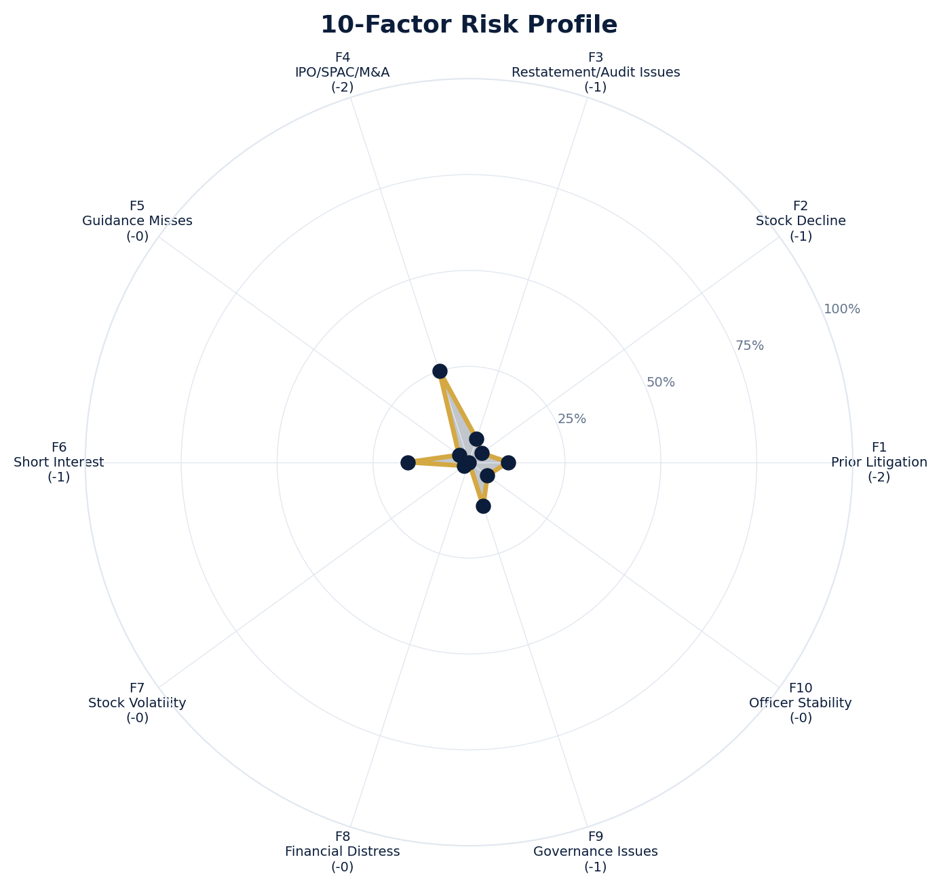
Figure: Radar chart showing risk fraction (points deducted / max) for each of the 10 scoring factors. Larger area = higher risk.
Red Flag Gates
Severity | Description | Source | Impact | Trajectory
LOW | Prior Litigation: 2/20 points | Signal-driven scoring: 70 signals, coverage=100% | F1: 2 pts | NEW
LOW | Stock Decline: 1/15 points | Signal-driven scoring: 30 signals, coverage=100%; Drop contribution modifier: 0.25x (decay + company-specific + disclosure) | F2: 1 pts | NEW
LOW | Restatement/Audit Issues: 1/12 points | Signal-driven scoring: 83 signals, coverage=100% | F3: 1 pts | NEW
LOW | IPO/SPAC/M&A: 2/10 points | Signal-driven scoring: 18 signals, coverage=100% | F4: 2 pts | NEW
LOW | Guidance Misses: 0/12 points | Signal-driven scoring: 27 signals, coverage=100% | F5: 0 pts | NEW
LOW | Short Interest: 1/8 points | Signal-driven scoring: 25 signals, coverage=100% | F6: 1 pts | NEW
LOW | Stock Volatility: 0/9 points | Signal-driven scoring: 27 signals, coverage=100% | F7: 0 pts | NEW
LOW | Governance Issues: 1/6 points | Signal-driven scoring: 40 signals, coverage=100% | F9: 1 pts | NEW
LOW | Officer Stability: 0/2 points | Signal-driven scoring: 89 signals, coverage=100% | F10: 0 pts | NEW
Critical: 0, High: 0, Moderate: 0, Low: 9
Risk Type Classification
Attribute | Value
Primary Risk Type | GUIDANCE_DEPENDENT
Supporting Evidence | F5 guidance misses: 0.3849056603773585 points; Issues guidance (philosophy: CONSERVATIVE)
Severity Scenarios
Analysis based on market cap: $335.0B
Percentile | Label | Settlement Est. | Defense Costs | Total Exposure
25th | favorable | $8.4M | $1.3M | $9.6M
50th | median | $16.8M | $3.4M | $20.1M
75th | adverse | $33.6M | $8.4M | $42.0M
95th | catastrophic | $67.1M | $20.1M | $87.3M
Calibration Notes (SECT7-11)
The following items are flagged NEEDS CALIBRATION and require expert review before final pricing:
- SECT7-11: All scoring parameters require calibration against historical cases
Factor Detail
Factor | Name | Deducted | Rules Triggered | Evidence
F1 | Prior Litigation | 2.0 | N/A | Signal-driven scoring: 70 signals, coverage=100%
F2 | Stock Decline | 0.6 | drop_contribution_adjustment | Signal-driven scoring: 30 signals, coverage=100%; Drop contribution modifier: 0.25x (decay + company-specific + disclosure)
F3 | Restatement/Audit Issues | 0.8 | N/A | Signal-driven scoring: 83 signals, coverage=100%
F4 | IPO/SPAC/M&A | 2.5 | N/A | Signal-driven scoring: 18 signals, coverage=100%
F5 | Guidance Misses | 0.4 | N/A | Signal-driven scoring: 27 signals, coverage=100%
F6 | Short Interest | 1.3 | N/A | Signal-driven scoring: 25 signals, coverage=100%
F7 | Stock Volatility | 0.1 | N/A | Signal-driven scoring: 27 signals, coverage=100%
F9 | Governance Issues | 0.7 | N/A | Signal-driven scoring: 40 signals, coverage=100%
F10 | Officer Stability | 0.1 | N/A | Signal-driven scoring: 89 signals, coverage=100%
Sub-Component Breakdown
Factor | Component | Value
F1 | base | 2.03
F1 | bonus | 0.00
F1 | modifiers | 0.00
F1 | hard_triggers | 0.00
F1 | total_before_cap | 2.03
F1 | capped | 2.03
F2 | base | 2.45
F2 | bonus | 0.00
F2 | modifiers | 0.00
F2 | hard_triggers | 0.00
F2 | drop_contribution_modifier | 0.25
F2 | total_before_cap | 0.61
F2 | capped | 0.61
F3 | base | 0.90
F3 | bonus | 0.00
F3 | modifiers | 0.00
F3 | hard_triggers | 0.00
F3 | total_before_cap | 0.90
F3 | capped | 0.90
F3 | ies_amplification | 0.85
F4 | base | 2.50
F4 | bonus | 0.00
F4 | modifiers | 0.00
F4 | hard_triggers | 0.00
F4 | total_before_cap | 2.50
F4 | capped | 2.50
F5 | base | 0.45
F5 | bonus | 0.00
F5 | modifiers | 0.00
F5 | hard_triggers | 0.00
F5 | total_before_cap | 0.45
F5 | capped | 0.45
F5 | ies_amplification | 0.85
F6 | base | 1.50
F6 | bonus | 0.00
F6 | modifiers | 0.00
F6 | hard_triggers | 0.00
F6 | total_before_cap | 1.50
F6 | capped | 1.50
F6 | ies_amplification | 0.85
F7 | base | 0.17
F7 | bonus | 0.00
F7 | modifiers | 0.00
F7 | hard_triggers | 0.00
F7 | total_before_cap | 0.17
F7 | capped | 0.17
F7 | ies_amplification | 0.85
F9 | base | 0.85
F9 | bonus | 0.00
F9 | modifiers | 0.00
F9 | hard_triggers | 0.00
F9 | total_before_cap | 0.85
F9 | capped | 0.85
F9 | ies_amplification | 0.85
F10 | base | 0.12
F10 | bonus | 0.00
F10 | modifiers | 0.00
F10 | hard_triggers | 0.00
F10 | total_before_cap | 0.12
F10 | capped | 0.12
Pattern Detection Results
No composite patterns detected.
Allegation Theory Mapping
Theory | Exposure | Factor Sources | Key Findings
A_DISCLOSURE | MODERATE | F1, F3, F5 | F1: Signal-driven scoring: 70 signals, coverage=100%; F3: Signal-driven scoring: 83 signals, coverage=100%
B_GUIDANCE | LOW | F2, F5 | F2: Signal-driven scoring: 30 signals, coverage=100%; F2: Drop contribution modifier: 0.25x (decay + company-specific + disclosure)
C_PRODUCT_OPS | LOW | F7 | F7: Signal-driven scoring: 27 signals, coverage=100%; 1 regulatory proceedings
D_GOVERNANCE | LOW | F9, F10 | F9: Signal-driven scoring: 40 signals, coverage=100%; F10: Signal-driven scoring: 89 signals, coverage=100%
E_MA | LOW | F4 | F4: Signal-driven scoring: 18 signals, coverage=100%
D&O Context: Primary allegation exposure is A_DISCLOSURE. MODERATE exposure in: A_DISCLOSURE.
Claim Probability Detail
Metric | Value
Probability Band | MODERATE
Range | 3.9% - 5.6%
Industry Base Rate | 3.5%
Adjustment Rationale | Industry base rate: 3.5%. Tier WIN (0-2%): Below base rate. Strong risk profile
Claim probability: MODERATE [ELEVATED]
Tower Position Recommendation
Metric | Value
Recommended Position | PRIMARY
Minimum Attachment | $16.8M (based on 50th percentile settlement)
Side A/DIC Assessment | Standard Side A considerations
Position | Risk Assessment | Premium Guidance | Attachment
PRIMARY | Primary layer carries 57% of expected loss exposur | Full rate, slight discount for | $0 ground-up
LOW_EXCESS | Low excess layer carries 18% of expected loss expo | Market rate | $5-15M xs $5-15M
MID_EXCESS | Mid excess layer carries 13% of expected loss expo | Market to 1.3x | $15-50M xs $15-50M
HIGH_EXCESS | High excess layer carries 11% of expected loss exp | 1.3-2x with attachment | $50M+ xs $50M+
DECLINE | WALK+ with compounding factors | N/A | N/A
Forensic Composite Scores
Composite | Score | Interpretation
Financial Integrity Score (FIS) | N/A | Not available
Reporting Quality Score (RQS) | N/A | Not available
Cash Flow Quality Score (CFQS) | N/A | Not available
Executive Risk Profile
Metric | Value
Weighted Score | 0
Risk Level | N/A
Temporal Signals
Type | Direction | Magnitude | Description
Unknown | N/A | N/A
Unknown | N/A | N/A
Unknown | N/A | N/A
Unknown | N/A | N/A
Unknown | N/A | N/A
Unknown | N/A | N/A
Unknown | N/A | N/A
NLP Filing Analysis
Metric | Value
Readability Score | {'current_fog': 19.51, 'prior_fog': None, 'fog_change': None, 'current_flesch': 20.29, 'prior_flesch': None, 'classification': 'CURRENT_ONLY', 'evidence': 'Current Fog Index: 19.5 (prior year unavailable)'}
Tone Assessment | N/A
Risk Language Density | N/A
Peril Assessment
Plaintiff Peril Heat Map
Plaintiff Type | Probability | Severity
Shareholders | ELEVATED | SIGNIFICANT
Regulators | ELEVATED | SIGNIFICANT
Customers | VERY LOW | NUISANCE
Competitors | VERY LOW | NUISANCE
Employees | LOW | MINOR
Creditors | LOW | MINOR
Government | MODERATE | MODERATE
Shareholders: 40 triggered checks. Key: Litigation History Profile: 1 (elevated vs benchmark of 0)
Regulators: 13 triggered checks. Key: Disclosure Complexity Score: 30 (elevated vs benchmark of 25)
Government: 3 triggered checks. Key: Product Concentration: 6 (elevated vs benchmark of 3)
Bear Cases
Bear Case: A Disclosure
PROCTER & GAMBLE Co faces elevated exposure to securities disclosure fraud claims. Key risk indicators: Litigation History Profile (critical); VIE/SPE Off-Balance-Sheet Structures (critical). Estimated severity is significant, warranting detailed underwriter review.
Defense: Defense: No active Section 11 windows — statute of limitations expired for offering claims
Evidence Chain
1. [BIZ.CLASS.litigation_history] Litigation History Profile (Source: total_sca_count)
2. [BIZ.STRUCT.vie_spe] VIE/SPE Off-Balance-Sheet Structures (Source: vie_spe_present)
3. [BIZ.DEPEND.distribution] Product Concentration (Source: distribution_channels_count)
4. [BIZ.EVENT.ipo_exposure] IPO/Offering Exposure Window (Source: event_ipo_exposure_score)
5. [BIZ.OPS.workforce] Workforce Distribution (Source: workforce_distribution)
6. [BIZ.STRUC.nongaap] Non-GAAP Measure Usage (Source: nongaap_measure_count)
7. [EXEC.INSIDER.ceo_net_selling] CEO Net Seller of Stock (Source: value)
8. [EXEC.INSIDER.cfo_net_selling] CFO Net Seller of Stock (Source: value)
9. [FIN.FORENSIC.intangible_concentration] Intangible Asset Concentration (Source: forensic_intangible_concentration)
10. [FIN.FORENSIC.channel_stuffing] Channel Stuffing Indicators (Source: forensic_channel_stuffing)
Probability: ELEVATED | Severity: SIGNIFICANT
Settlement Prediction
Settlement prediction computed but no scenarios available.
Tower Risk Characterization
Tower characterization not available.
Coverage Gaps -- Data Not Available
The following checks could not be evaluated because required data was not acquired. These items are NOT cleared -- they represent gaps in coverage that should be considered in the underwriting decision.
Company Profile & Industry
[EVALUATIVE] FWRD.WARN.goodwill_risk (Goodwill Risk): No field_key in data_strategy
[EVALUATIVE] FWRD.WARN.working_capital_trends (Working Capital Trends): No field_key in data_strategy
Executive Summary & Key Metrics
[REQUIRED] BIZ.SIZE.growth_trajectory (Public Company Tenure): Required data not available from filings
[REQUIRED] BIZ.SIZE.public_tenure (Revenue Growth YoY): Required data not available from filings
[EVALUATIVE] BIZ.STRUCT.subsidiary_count (Subsidiary Count Complexity): Required data not available from filings
[EVALUATIVE] BIZ.DEPEND.labor (Concentration Risk Composite): Required data not available from filings
[REQUIRED] BIZ.MA.acquisition_list (Recent Acquisitions): Required data not available from filings
[REQUIRED] BIZ.MODEL.lifecycle (Segment Lifecycle Risk): Required data not available from filings
[EVALUATIVE] ABS.DISC.audit_fees (Missing Audit Fee Disclosure): Expected signals not found in evaluation results
[EVALUATIVE] ABS.DISC.board_independence (Missing Board Independence Disclosure): Could not determine disclosure presence or absence
[EVALUATIVE] ABS.DISC.clawback_policy (Missing Clawback Policy Disclosure): Expected signals not found in evaluation results
[EVALUATIVE] ABS.DISC.cyber_risk (Missing Cybersecurity Risk Disclosure): Expected signals not found in evaluation results
[EVALUATIVE] ABS.DISC.debt_covenants (Missing Debt Covenant Disclosure): Expected signals not found in evaluation results
[EVALUATIVE] ABS.DISC.derivative_instruments (Missing Derivative Instruments Disclosure): Expected signals not found in evaluation results
[EVALUATIVE] ABS.DISC.esg (Missing ESG Disclosure): Expected signals not found in evaluation results
[EVALUATIVE] ABS.DISC.executive_comp (Missing Executive Compensation Disclosure): Expected signals not found in evaluation results
[EVALUATIVE] ABS.DISC.goodwill_impairment (Missing Goodwill Impairment Disclosure): Expected signals not found in evaluation results
[EVALUATIVE] ABS.DISC.lease_obligations (Missing Lease Obligation Disclosure): Expected signals not found in evaluation results
[EVALUATIVE] ABS.DISC.litigation_contingency (Missing Litigation Contingency Disclosure): Expected signals not found in evaluation results
[EVALUATIVE] ABS.DISC.pension_obligations (Missing Pension Obligation Disclosure): Expected signals not found in evaluation results
[EVALUATIVE] ABS.DISC.related_party (Missing Related-Party Transaction Disclosure): Expected signals not found in evaluation results
[EVALUATIVE] ABS.DISC.revenue_recognition (Missing Revenue Recognition Policy Disclosure): Expected signals not found in evaluation results
[EVALUATIVE] ABS.DISC.risk_factors (Missing Risk Factor Disclosure): Expected signals not found in evaluation results
[EVALUATIVE] ABS.DISC.segment_reporting (Missing Segment Reporting Disclosure): Expected signals not found in evaluation results
[EVALUATIVE] ABS.DISC.stock_comp (Missing Stock Compensation Disclosure): Expected signals not found in evaluation results
[EVALUATIVE] ABS.DISC.tax_positions (Missing Uncertain Tax Position Disclosure): Expected signals not found in evaluation results
[EVALUATIVE] CONJ.COMP.perf_divergence (Compensation-Performance Divergence): 3/3 component signals unavailable
[EVALUATIVE] CONJ.DISTRESS.insider (Financial Distress + Insider Selling): 3/3 component signals unavailable
[EVALUATIVE] CONJ.GOV.governance_event (Weak Governance + Adverse Event): 3/5 component signals unavailable
[EVALUATIVE] CONJ.FIN.growth_margin_guidance (Rapid Growth + Margin Compression + Guidance Miss): 3/3 component signals unavailable
[EVALUATIVE] CONJ.INSIDER.news_gap (Insider Selling + Material News Gap): 3/3 component signals unavailable
[EVALUATIVE] CONJ.REG.litigation (Regulatory Action + New Material Litigation): 3/3 component signals unavailable
[EVALUATIVE] CTX.FIN.capex_sector (Capital Expenditure in Sector Context): Source signal FIN.INVEST.capex_ratio not in results
[EVALUATIVE] CTX.COMP.lifecycle (CEO Compensation in Lifecycle Context): Source signal EXEC.COMP.ceo_total_comp not in results
[EVALUATIVE] CTX.COMP.product_tower (Compensation Severity by Product/Tower): Source signal EXEC.COMP.ceo_total_comp not in results
[EVALUATIVE] CTX.FIN.debt_maturity (Debt Maturity Profile in Lifecycle Context): Source signal FIN.DEBT.maturity_profile not in results
[EVALUATIVE] CTX.FIN.distress_product (Financial Distress by Product/Tower): Source signal FIN.FORENSIC.altman_z not in results
[EVALUATIVE] CTX.FIN.dividend_lifecycle (Dividend Policy in Lifecycle Context): Source signal FIN.RETURN.dividend_yield not in results
[EVALUATIVE] CTX.EXEC.tenure_lifecycle (Executive Tenure in Lifecycle Context): Source signal EXEC.TURN.c_suite not in results
[EVALUATIVE] CTX.GOV.lifecycle (Board Independence in Lifecycle Context): Required context dimensions ['lifecycle_stage'] not available
[EVALUATIVE] CTX.FIN.growth_lifecycle (Revenue Growth in Lifecycle Context): Required context dimensions ['lifecycle_stage'] not available
[EVALUATIVE] CTX.MKT.insider_lifecycle (Insider Trading in Lifecycle Context): Source signal STOCK.INSIDER.net_selling not in results
[EVALUATIVE] CTX.FIN.leverage_sector (Leverage in Sector Context): Source signal FIN.DEBT.leverage_ratio not in results
[EVALUATIVE] CTX.LIT.size (Litigation Frequency by Company Size): Source signal LIT.SCA.active_cases not in results
[EVALUATIVE] CTX.RISK.ma_lifecycle (M&A Activity in Lifecycle Context): Source signal BIZ.MA.acquisition_activity not in results
[EVALUATIVE] CTX.RISK.regulatory_sector (Regulatory Risk in Sector Context): Source signal LIT.SEC.enforcement not in results
[EVALUATIVE] CTX.RISK.rpt_sector (Related-Party Risk in Sector Context): Source signal GOV.RPT.related_party not in results
[EVALUATIVE] CTX.MKT.short_interest_sector (Short Interest in Sector Context): Source signal STOCK.SHORT.interest_ratio not in results
[EVALUATIVE] CTX.MKT.turnover_sector (Stock Turnover in Sector Context): Source signal STOCK.VOL.turnover_rate not in results
[EVALUATIVE] CTX.MKT.volatility_sector (Stock Volatility in Sector Context): Source signal STOCK.VOL.historical not in results
Financial Health
[EVALUATIVE] FIN.PEER.revenue_bottom_quartile (Revenue Bottom Quartile (Cross-Filer)): No peer comparison data available
[EVALUATIVE] FIN.PEER.leverage_top_decile (Leverage Top Decile (Sector-Relative)): No peer comparison data available
[EVALUATIVE] FIN.PEER.margin_compression (Operating Margin Compression (Cross-Filer)): No peer comparison data available
[EVALUATIVE] FIN.PEER.profitability_laggard (Profitability Laggard (Sector-Relative)): No peer comparison data available
[EVALUATIVE] FIN.PEER.size_outlier_small (Size Outlier Small (Cross-Filer)): No peer comparison data available
[EVALUATIVE] FIN.PEER.cash_flow_weak (Cash Flow Weakness (Cross-Filer)): No peer comparison data available
[EVALUATIVE] LIT.DEFENSE.forum_selection (Federal Forum Selection Clause): Required data not available from filings
Governance & Leadership
[EVALUATIVE] EXEC.AGGREGATE.board_risk (Board Aggregate Risk Score): Data mapping not configured for this check
[EVALUATIVE] EXEC.AGGREGATE.highest_risk_individual (Highest Individual Risk Score Exceeds Threshold): Data mapping not configured for this check
[EVALUATIVE] EXEC.TENURE.ceo_new (CEO Tenure Less Than 2 Years): Data mapping not configured for this check
[EVALUATIVE] EXEC.TENURE.cfo_new (CFO Tenure Less Than 2 Years): Data mapping not configured for this check
[REQUIRED] EXEC.PROFILE.board_size (Board Size (Number of Members)): Required data not available from filings
[REQUIRED] EXEC.PROFILE.independent_ratio (Board Independence Percentage): Required data not available from filings
[EVALUATIVE] EXEC.PROFILE.overboarded_directors (Directors Serving on 4+ Boards): Required data not available from filings
[EVALUATIVE] GOV.BOARD.size (Board Size): Required data not available from filings
[EVALUATIVE] GOV.BOARD.independence (Board Independence): Required data not available from filings
[EVALUATIVE] GOV.BOARD.diversity (Board Diversity): Required data not available from filings
[EVALUATIVE] GOV.BOARD.tenure (Tenure): Required data not available from filings
[EVALUATIVE] GOV.BOARD.overboarding (Overboarding): Required data not available from filings
[EVALUATIVE] GOV.BOARD.attendance (Attendance): Required data not available from filings
[EVALUATIVE] GOV.BOARD.meetings (Meetings): Required data not available from filings
[EVALUATIVE] GOV.BOARD.succession (Succession): Required data not available from filings
[EVALUATIVE] GOV.EXEC.ceo_profile (CEO Profile): Required data not available from filings
[EVALUATIVE] GOV.EXEC.cfo_profile (CFO Profile): Required data not available from filings
[EVALUATIVE] GOV.EXEC.founder (Founder Status): Required data not available from filings
[EVALUATIVE] GOV.EXEC.key_person (Key Person Risk): Required data not available from filings
[EVALUATIVE] GOV.PAY.golden_para (Golden Para): Required data not available from filings
[EVALUATIVE] GOV.PAY.equity_burn (Equity Burn): Required data not available from filings
[EVALUATIVE] GOV.PAY.hedging (Hedging): Required data not available from filings
[REQUIRED] GOV.RIGHTS.bylaws (Bylaws): Required data not available from filings
[EVALUATIVE] GOV.RIGHTS.takeover (Takeover): Required data not available from filings
[EVALUATIVE] GOV.RIGHTS.proxy_access (Proxy Access): Required data not available from filings
[REQUIRED] GOV.RIGHTS.forum_select (Forum Select): Required data not available from filings
[EVALUATIVE] GOV.RIGHTS.supermajority (Supermajority): Required data not available from filings
[EVALUATIVE] GOV.RIGHTS.action_consent (Action Consent): Required data not available from filings
[EVALUATIVE] GOV.RIGHTS.special_mtg (Special Mtg): Required data not available from filings
[EVALUATIVE] GOV.RIGHTS.classified (Classified): Required data not available from filings
Market & Trading
[EVALUATIVE] FIN.LIQ.position (Liquidity Position): Required data not available from filings
[EVALUATIVE] FIN.LIQ.working_capital (Working Capital Analysis): Required data not available from filings
[EVALUATIVE] FIN.LIQ.efficiency (Liquidity Efficiency): Required data not available from filings
[EVALUATIVE] FIN.LIQ.trend (Liquidity Trend): Required data not available from filings
[EVALUATIVE] FIN.DEBT.structure (Debt Structure): Required data not available from filings
[EVALUATIVE] FIN.COMP.unvested_cost (Unvested SBC Pipeline): Required data not available from filings
[EVALUATIVE] FIN.COMP.rsu_grants (RSU Grant Trend): Required data not available from filings
[EVALUATIVE] FIN.CAP.buyback_capacity (Buyback Authorization Capacity): Required data not available from filings
[EVALUATIVE] FIN.CAP.allocation_balance (Capital Allocation Balance): Required data not available from filings
[EVALUATIVE] FIN.CONT.loss_accrual (Loss Contingency Accrual): Required data not available from filings
[EVALUATIVE] FIN.CONT.loss_estimate (Loss Contingency Estimate): Required data not available from filings
[EVALUATIVE] FIN.CONT.settlement_activity (Litigation Settlement Activity): Required data not available from filings
[EVALUATIVE] FIN.CONT.warranty_reserve (Product Warranty Reserve): Required data not available from filings
[EVALUATIVE] FIN.DEBT.facility_utilization (Credit Facility Utilization): Required data not available from filings
[EVALUATIVE] FIN.DEBT.maturity_concentration (Debt Maturity Concentration): Data mapping not configured for this check
[EVALUATIVE] FIN.QUALITY.q4_revenue_concentration (Q4 Revenue Concentration): Required data not available from filings
[EVALUATIVE] FIN.QUALITY.revenue_recognition_risk (Revenue Recognition Risk Indicators): Data mapping not configured for this check
[EVALUATIVE] FIN.FORENSIC.level3_fair_value (Level 3 Fair Value Asset Concentration): Data mapping not configured for this check
[EVALUATIVE] FIN.FORENSIC.goodwill_deterioration_pattern (Goodwill Deterioration Pattern): Data mapping not configured for this check
[EVALUATIVE] FIN.FORENSIC.related_party_revenue (Related Party Revenue Concentration): Data mapping not configured for this check
[EVALUATIVE] FWRD.EVENT.ma_integration_risk (M&A Integration Risk): Data mapping not configured for this check
[EVALUATIVE] FIN.FORENSIC.deferred_revenue_divergence (Deferred Revenue Divergence): Data mapping not configured for this check
[EVALUATIVE] FIN.FORENSIC.margin_compression (Forensic Margin Compression): Data mapping not configured for this check
[EVALUATIVE] FIN.FORENSIC.buyback_timing (Share Buyback Timing Quality): Data mapping not configured for this check
[EVALUATIVE] FIN.FORENSIC.debt_maturity_concentration (Debt Maturity Concentration): Data mapping not configured for this check
[EVALUATIVE] FIN.FORENSIC.pension_underfunding (Pension Underfunding Risk): Data mapping not configured for this check
[EVALUATIVE] FIN.FORENSIC.dsri_elevated (Days Sales Receivable Index Elevated): Data mapping not configured for this check
[EVALUATIVE] FIN.FORENSIC.aqi_elevated (Asset Quality Index Elevated): Data mapping not configured for this check
[EVALUATIVE] FIN.FORENSIC.tata_elevated (Total Accruals to Total Assets Elevated): Data mapping not configured for this check
[EVALUATIVE] FIN.FORENSIC.non_gaap_gap (Non-GAAP to GAAP Earnings Gap): Data mapping not configured for this check
[EVALUATIVE] FIN.FORENSIC.goodwill_growth_rate (Goodwill Growth Rate): Data mapping not configured for this check
[EVALUATIVE] FIN.FORENSIC.acquisition_to_revenue (Acquisition Spend Relative to Revenue): Data mapping not configured for this check
[EVALUATIVE] FIN.PROFIT.revenue (Revenue Analysis): Required data not available from filings
[EVALUATIVE] FIN.GUIDE.track_record (Guidance Track Record): Required data not available from filings
[EVALUATIVE] FIN.OBS.contract_liability (Deferred Revenue Execution Risk): Required data not available from filings
[EVALUATIVE] FIN.RESTRUCT.severance (Severance Costs): Required data not available from filings
[EVALUATIVE] FIN.IMPAIR.asset_writedown (Asset Impairment): Required data not available from filings
[EVALUATIVE] FIN.IMPAIR.intangible_writedown (Intangible Asset Impairment): Required data not available from filings
[REQUIRED] NLP.FILING.filing_timing_change (Filing Date Shifted Significantly vs Prior Year): Required data not available from filings
[EVALUATIVE] FIN.FORENSIC.m_score_composite (Beneish M-Score Composite (XBRL)): Data mapping not configured for this check
Gap breakdown: Required items: 9 | Evaluative checks: 118
Total: 127 checks data-unavailable out of 566 total checks (78% coverage)

Calibration Notes
System Intelligence Status
Checks active: 601
Checks incubating: 0 (pending human approval)
Pending feedback: 0 entries
Recent Calibration Changes
Date | Check | Change | Changed By
2026-04-02 | UTILIZATION_MGMT_SCRUTINY | Proposed by ingestion of 'blind_spot:UNH:UnitedHealth Group | ingestion_pipeline
2026-04-02 | PUBLIC_OUTRAGE_IMPACT | Proposed by ingestion of 'blind_spot:UNH:UnitedHealth Group | ingestion_pipeline
2026-04-02 | GUIDANCE_CHANGE_POST_CRISIS | Proposed by ingestion of 'blind_spot:UNH:UnitedHealth Group | ingestion_pipeline
2026-04-02 | VAERS_DATA_MONITORING | Proposed by ingestion of 'blind_spot:MRNA:Moderna, Inc. Secu | ingestion_pipeline
2026-04-02 | VACCINE_SAFETY_OVERSIGHT_BOARD | Proposed by ingestion of 'blind_spot:MRNA:Moderna, Inc. Secu | ingestion_pipeline
2026-04-02 | PEDIATRIC_SAFETY_DISCLOSURE_GAP | Proposed by ingestion of 'blind_spot:MRNA:Moderna, Inc. Secu | ingestion_pipeline
2026-04-02 | GOV.FOUNDER_CRIMINAL_EXPOSURE | Proposed by ingestion of 'blind_spot:NVDA:Super Micro Comput | ingestion_pipeline
2026-04-02 | BIZ.CHINA_EXPOSURE_DISCLOSURE | Proposed by ingestion of 'blind_spot:NVDA:Super Micro Comput | ingestion_pipeline
2026-04-02 | GOV.EXPORT_CONTROL_COMPLIANCE | Proposed by ingestion of 'blind_spot:NVDA:Super Micro Comput | ingestion_pipeline
2026-04-02 | AI_DEVELOPMENT_TIMELINE_DISCLOSURE | Proposed by ingestion of 'blind_spot:AAPL:AAPL LAWSUIT: Appl | ingestion_pipeline
Discovery Findings
2 document(s) analyzed, 0 proposal(s) generated, from blind spot search
Feedback for PG
No pending feedback for PG.

