
Angry Dolphin -- D&O Underwriting Worksheet
Super Micro Computer, Inc. (SMCI)
Generated: April 03, 2026
[Table of Contents -- Update in Word]

Super Micro Computer, Inc. (SMCI) presents a high-severity D&O risk profile, meriting a **WATCH** tier classification that mandates senior underwriting review. The core forensic finding is the active *In re Super Micro Computer, Inc. Securities Litigation (2024)*, which imposes a 55-point scoring ceiling and drives a modeled claim probability band of 6.41% to 9.15%. This litigation is compounded by a catastrophic 62.8% stock decline from its 52-week high and a severe 33.8% drop in the last seven days alone, creating the precise volatility that fuels shareholder lawsuits. The "Prior Litigation" factor alone deducted 4.92 points from the underwriting score, against a maximum of 20, indicating a persistent legal overhang. Guidance misses, deducting 1.7 points, and elevated short interest, deducting 1.55 points, further evidence management credibility challenges in a volatile TECH sector. These negatives outweigh mitigants like the absence of SEC investigations, a stable C-suite over 18 months, and positive recent free cash flow. The 11.18% inherent risk percentage and composite score of 87.36 reflect this acute tension between operational strength and extreme securities litigation exposure. Consequently, any D&O placement must be carefully structured with explicit exclusions for the 2024 securities class action and priced to reflect the ELEVATED claim band.
Executive Summary
Underwriting Thesis
Super Micro Computer, Inc. is a $13.9B (Decile 4 of 10) large-cap technology company that would normally present as a stronger underwriting account were it not for critical red flags: Active Securities Class Action and Catastrophic Stock Drop. These findings impose a hard quality score ceiling of 50, placing the account in WATCH tier (33/100) regardless of other favorable factors. The balance sheet is strong (D/E 0.02, Z-Score 4.14), eliminating financial distress as a D&O claim catalyst. The primary risk driver is Prior Litigation, driving elevated risk in this area. Signal-driven scoring: 66 signals, coverage=100%. At a 6-9% claim probability (11.2% adjusted rate, 2.2x the Technology sector baseline of 5.0%), this account requires Write carefully, senior review required.
Company Snapshot
Attribute | Value | Source
Company | Super Micro Computer, Inc.
Ticker | SMCI
Exchange | Nasdaq
Sector | Technology
Industry | Computer Hardware
Market Cap | $13.9B [Decile 4] (Ranks at the 0th percentile among 10 peers) | [yfinance, filed 2026-04-03, MEDIUM confidence]
Revenue | $22.0B | [10-K 2025-06-30 CIK1375365 accn:0001375365-25-000027, filed 2025-06-30, HIGH confidence]
Employees | 6,238 | [yfinance, filed 2026-04-03, MEDIUM confidence]
SIC | 3571 -- Electronic Computers
GICS | 45202030
NAICS | 334111
FPI Status | No
Fiscal Year End | 06-30
Tier Classification
Attribute | Value
Tier | WATCH
Composite Score | 87.4/100
Quality Score | 33.0/100
Factor Breakdown | F1: 4.9, F2: 1.1, F3: 1.1, F4: 0.9, F5: 1.7, F6: 1.5, F7: 0.4, F8: 0.0, F9: 0.8, F10: 0.1
Score Ceiling | Capped at 50 by CRF-9 (Recent Drop - 7 Day)
Position | 87.4 falls in WATCH range (31-50)
Appetite | Write carefully, senior review required
Classification: WATCH [HIGH]
Inherent Risk Baseline
Component | Value
Market Cap Tier | LARGE [Decile 4]
Sector | Technology (Base rate: 5.0%)
Size Adjustment | 1.28x (LARGE cap multiplier) -> 6.4%
Score Adjustment | 1.75x (quality score multiplier) -> 11.2%
Severity Percentile | Settlement Estimate
25th (favorable) | $15.0M
50th (median) | $39.0M
75th (adverse) | $57.0M
95th (catastrophic) | $75.0M
At a 11.2% adjusted claim rate, the company faces 2.2x its sector baseline of 5.0% for Technology companies. This rate reflects the LARGE cap multiplier (1.28x) combined with the quality score multiplier (1.75x from WATCH tier classification). If the score improved to WRITE tier, the rate would drop to approximately 6.4%.
Note: NEEDS CALIBRATION
Underwriting Headwinds
1. Critical Red Flag [CRITICAL]
Critical Red Flag: Active Securities Class Action — Active SCA: In re Super Micro Computer, Inc. Securities Litigation (2024). This triggers a Critical Red Flag, imposing a score ceiling of 33. (see Litigation)
2. Critical Red Flag [CRITICAL]
Super Micro Computer, Inc.'s stock exhibits elevated volatility with a -63% dip of -62.8% from its 52-week high. The estimated DDL of $1078.1B amplifies settlement severity for any corrective disclosure event. Short interest at 19.7% of float indicates institutional bearish positioning that often precedes or amplifies SCA filings. This triggers a Critical Red Flag, imposing a score ceiling of 33. (see Market & Trading)
3. Critical Red Flag [CRITICAL]
Critical Red Flag: Recent Drop - 7 Day — 7-day drop: 33.8% (3 days ago). This triggers a Critical Red Flag, imposing a score ceiling of 33.
4. Structural Complexity & Litigation History [HIGH]
Super Micro Computer, Inc. has 1 subsidiaries, increasing multi-jurisdictional litigation exposure. The current docket includes 3 securities class actions. With 3 pending matters at $13.9B market cap, Super Micro Computer, Inc. has an active litigation profile that will factor into loss-pick and pricing. (see Litigation)
5. Earnings Guidance Track Record [HIGH]
Super Micro Computer, Inc. has missed earnings guidance in 5 quarters, with management credibility score at 70%. At $13.9B market cap with an estimated DDL of $1078.1B, guidance misses generate large absolute loss figures that attract institutional lead plaintiffs. (see Market & Trading)
Risk Mitigants
1. Clean Regulatory Record
Super Micro Computer, Inc. has no active SEC enforcement pipeline activity, open investigations, or pending Wells Notices. A clean regulatory record for Super Micro Computer, Inc. eliminates the highest-severity D&O claim catalyst and supports favorable underwriting consideration. (see Litigation)
2. Sound Financial Position
No financial distress indicators present (Altman Z-Score of 4.14, D/E of 0.02, current ratio of 3.8x, interest coverage of 75.6x). An Altman Z of 4.14 places Super Micro Computer, Inc. firmly in the safe zone, eliminating going-concern, covenant violation, and creditor-related D&O exposure. (see Financial Health)
3. Stable Executive Leadership
Charles Liang has led Super Micro Computer, Inc. for 11 years with no recent C-suite departures. This 11-year leadership continuity during sustained financial health demonstrates management competence that undermines scienter allegations in any potential securities complaint. (see Governance)
4. Positive free cash flow from most recent period, indicating
Positive free cash flow from most recent period, indicating operational strength. (see Financial Health)
Claim Probability
Metric | Value
Band | ELEVATED
Company Rate | 6.4% - 9.2%
Industry Base Rate | 5.0%
Severity Favorable | $2.8B
Severity Median | $5.8B
Severity Adverse | $12.0B
Severity Catastrophic | $25.0B
Probability Band: ELEVATED [HIGH]
The 6-9% probability band represents approximately 2x the Technology sector base rate of 5.0%. Accounts in WATCH tier historically produce claims at elevated frequency. Industry base rate: 5.0%. Tier WATCH (10-15%): Significantly above base rate. Concentration of risk factors suggests elevated claim likelihood. NEEDS CALIBRATION: Probability estimates are indicative and require actuarial validation per SECT7-11. Enhanced frequency: 6.50% base x 0.85 hazard x 1.65 signal = 9.15%.
Tower Recommendation
Metric | Value
Position | Mid Excess
Min Attachment | $4806.0M (based on 50th percentile settlement)
Side A/DIC | Standard Side A considerations
Layer | Risk Assessment | Premium Guidance
PRIMARY | Primary layer carries 57% of expected loss exposure. Highest frequency of attachment; most likely to be eroded in any claim scenario. | Full rate, slight discount for WIN
LOW_EXCESS | Low excess layer carries 18% of expected loss exposure. Attaches after primary exhaustion; moderate frequency in adverse scenarios. | Market rate
MID_EXCESS | Mid excess layer carries 13% of expected loss exposure. Attaches in adverse scenarios; lower frequency but higher severity when reached. | Market to 1.3x
HIGH_EXCESS | High excess layer carries 11% of expected loss exposure. Attaches only in catastrophic scenarios; lowest frequency, highest severity. | 1.3-2x with attachment
DECLINE | WALK+ with compounding factors | N/A
Market Context
No market pricing data available.

Company Overview
Super Micro Computer, Inc. designs and sells application-optimized server and storage systems, with 92% of its revenue from this hardware, creating intense board-level pressure to maintain its position in the competitive AI and enterprise data center markets. The company, public for 19 years, holds a $13.94B market cap with 6,238 employees, classifying it as a Large Accelerated Filer and elevating disclosure standards and shareholder expectations.
Revenue Model
Revenue concentration in server and storage system sales (92%) creates high exposure to cyclical capital expenditure swings, and the lack of recurring software revenue makes its $13.94B business model vulnerable to rapid technology shifts. This dependence means the revenue engine breaks if AI investment slows, directly exposing directors to allegations of strategic failure for not diversifying.
D&O Risk Profile
The primary D&O narrative includes IP litigation risk in SIC 3571, where patent claims are a standard weapon, threatening stock volatility and derivative suits. Its operations in the United States, Asia, and Europe complicate regulatory compliance across jurisdictions, increasing disclosure liability under conflicting laws. While its 19-year public history offers governance maturity, the velocity of change in its core AI market elevates the risk of strategic missteps and subsequent shareholder allegations of oversight failures.
Section 2: Company Profile
Super Micro Computer, Inc. operates in the Computer Hardware industry. The company has 6,238 employees and $13.9B market cap. Key D&O exposure factors include: Regulatory Multi Jurisdiction, Transaction Litigation Risk, Ip Litigation Risk. [derived:section_summary, 2026-04-03, LOW]
Company Identity
Field | Value | Source
Legal Name | Super Micro Computer, Inc. | [SEC EDGAR submissions, filed 2026-04-03, HIGH confidence]
Ticker | SMCI
CIK | 1375365 | [SEC EDGAR submissions, filed 2026-04-03, HIGH confidence]
Sector | Technology | [SEC EDGAR submissions, filed 2026-04-03, HIGH confidence]
SIC Code | 3571 | [SEC EDGAR submissions, filed 2026-04-03, HIGH confidence]
SIC Description | Electronic Computers
GICS Code | 45202030 | [SIC->GICS mapping (SIC 3571), filed 2026-04-03, MEDIUM confidence]
NAICS Code | 334111 | [SIC->NAICS crosswalk (SIC 3571), filed 2026-04-03, MEDIUM confidence]
Exchange | Nasdaq | [SEC EDGAR submissions, filed 2026-04-03, HIGH confidence]
State of Incorporation | CA | [SEC EDGAR submissions, filed 2026-04-03, HIGH confidence]
FPI Status | No
Fiscal Year End | 06-30 | [SEC EDGAR submissions, filed 2026-04-03, HIGH confidence]
Business Description
Super Micro Computer, Inc. is a Silicon Valley-based provider of accelerated compute platforms, offering application-optimized high-performance and high-efficiency server and storage systems for markets including enterprise data centers, cloud computing, artificial intelligence (AI), 5G, and edge computing. The company generates revenue primarily through the sale of server and storage systems (92.2% of net sales in fiscal 2023), complemented by subsystems and accessories (7.8%). Its business model leverages a modular and open architecture (Server Building Block Solutions®) to rapidly develop and customize products, enabling quick time-to-market with new technologies. Profitability is driven by design control, internal manufacturing capabilities, and a focus on energy-efficient solutions that reduce total cost of ownership for customers. The company operates globally with manufacturing facilities in the United States, Taiwan, and the Netherlands, and sells through a combination of direct sales and indirect channel partners. [10-K (LLM), filed 2026-04-03, HIGH confidence]
Subsidiaries
Total subsidiaries: 1 [Exhibit 21 (subsidiary list), filed 2026-04-03, HIGH confidence]
Business Model Profile
Dimension | Assessment
Revenue Model | TRANSACTION
Concentration Risk | LOW (Score: 1/3) - Single geography 68%
Key Person Risk | HIGH (Score: 3/3) - Founder-led | CEO tenure: 30yr | Succession: No
Disruption Risk | HIGH (4 threats) - Increased competition from ODMs with low-cost manufacturing.; Industry consolidation leading to stronger competitors.; Technological shifts and new product introductions.; Market evolution with growth of public cloud shifting server purchasing to lower margin vendors.
Operational Complexity
Complexity Score: 6238/20 -- HIGH [HIGH]
Component | Value
Jurisdictions | 1 (0 high-regulatory)
Workforce | 6,238 (55.3% international)
Segments | 0
Geographic Concentration | 100/100
Supply Chain | moderate
Overall Resilience | WEAK
Structural Indicators: [X] VIE / SPE | [ ] Dual-Class | [ ] Holding Depth | [X] OBS Exposure
Corporate Events & Transaction Risk
Event Type | Assessment
M&A Activity | LOW (Score: 0/4) | 1 acquisition year | Acq/Rev: 0.0%
IPO / Offering Exposure | LOW - 19 years public
Business Changes:
- 15 current event filings (8-K), most recent 2026-03-20
- M&A activity indicated (acquisition)
Structural Complexity
Dimension | Assessment
Disclosure Complexity | LOW
Non-GAAP Usage | LOW
Related Party Density | LOW
Off-Balance-Sheet Exposure | MODERATE (1)
Holding Structure Depth | LOW
Peer Group Comparison
Ticker | Name | Market Cap | Quality Score | Similarity
MSFT | Microsoft Corporation | $2.8T | N/A | Sector Etf / 13%
GOOGL | Alphabet Inc. | $3.6T | N/A | Sector Etf / 3%
AMZN | Amazon.com, Inc. | $2.3T | N/A | Sector Etf / 2%
META | Meta Platforms, Inc. | $1.5T | N/A | Sector Etf / 3%
NVDA | NVIDIA Corporation | $4.3T | N/A | Sector Etf / 14%
CRM | Salesforce, Inc. | $175.4B | N/A | Sector Etf / 22%
ADBE | Adobe Inc. | $99.0B | N/A | Sector Etf / 25%
ORCL | Oracle Corporation | $421.0B | N/A | Sector Etf / 18%
CSCO | Cisco Systems, Inc. | $312.2B | N/A | Sector Etf / 19%
INTC | Intel Corporation | $253.0B | N/A | Sector Etf / 20%
The peer group of 10 companies shares the same industry classification (SIC 3571). Super Micro Computer, Inc. ranks at the 0th percentile among 10 peers by market capitalization.
Revenue Segments
Revenue segment data not available.
Geographic Footprint
Region | Revenue | % of Total
United States | N/A | 67.9%
Asia | N/A | 14.7%
Europe | N/A | 14.1%
Others | N/A | 3.3%
Customer & Supplier Concentration
Key Suppliers
Supplier | Dependency | Source
Two suppliers accounted for 13.5% and 30.7% of total purchases in fiscal 2023. | N/A | [10-K (LLM), 2026-04-03, HIGH]
Ablecom and Compuware (related parties) accounted for 6.6% of cost of sales in fiscal 2023. | N/A | [10-K (LLM), 2026-04-03, HIGH]
D&O Exposure Factors
Exposure Type | Risk Level | Description | Coverage Part
Securities Litigation | See analysis sections | Shareholder class actions, SEC enforcement | Side A/B/C
Derivative Actions | See analysis sections | Breach of fiduciary duty, waste claims | Side A/B
Employment Practices | See analysis sections | Discrimination, harassment, wrongful termination | Side B/C (EPLI)
Regulatory/Government | See analysis sections | DOJ, SEC, FTC, state AG investigations | Side A (primarily)
Fiduciary (ERISA) | See analysis sections | 401(k) plan mismanagement, fee litigation | Fiduciary Liability
Standard D&O exposure categories shown. See individual analysis sections for company-specific risk levels.
Classification
Attribute | Value
Market Cap Tier | LARGE
Sector | TECH (TECH)
Years Public | 19
Base Filing Rate | 6.5%
Severity Band | $40.0M -- $150.0M
DDL Exposure Base | $2.1B
IPO Multiplier | 1.00x
Cap Filing Multiplier | 1.30x
Hazard Profile (Inherent Exposure Score)
IES: 35/100 (MODERATE) | Multiplier: 0.85x | Data Coverage: 89% [MODERATE]
Top Risk Dimensions (Elevated+)
Dimension | Score | Exposure | Evidence
Compliance Infrastructure | 100 | CRITICAL | 5 material weakness(es) disclosed
Off-Balance Sheet Arrangements | 83 | CRITICAL | Multiple OBS indicators: FINANCIAL: Adverse economic conditions may harm our business., FINANCIAL: Our revenue and margins for a particular period are difficult to predict., OTHER: If negative publicity arises with respect to us, our employees, our third-party service providers or our partners, our business and operating results could be adversely affected.; Estimated from related indicators.
Industry Regulatory Spotlight | 83 | CRITICAL | Sector 'TECH' regulatory spotlight level: 2.5/3.0
Speed of Growth | 80 | CRITICAL | Revenue growth 46.6% (HIGH)
Industry Sector Risk Tier | 70 | HIGH | Sector 'TECH' maps to risk score 7.0/10.0
Board Independence | 70 | HIGH | Proxy: independence score 3.0; Estimated from related indicators.
Industry Expertise Match | 67 | HIGH | No executives with explicit TECH background in bios
Industry Litigation Wave | 67 | HIGH | Sector 'TECH' litigation wave level: 2.0/3.0
Anti-Takeover Provisions | 60 | ELEVATED | Proxy: governance score 39.6; Estimated from related indicators.
Regulatory Intensity | 50 | ELEVATED | Sector 'TECH' regulatory intensity: 2.5/5.0
IP Dependency | 50 | ELEVATED | No data available — scored at baseline (MODERATE)
Scale Experience Mismatch | 50 | ELEVATED | Proxy: 1 scale/growth keyword hits in risk factors; Estimated from related indicators.
Management Turnover | 50 | ELEVATED | No data available — scored at baseline (MODERATE)
Goodwill-Heavy Balance Sheet | 50 | ELEVATED | No data available — scored at baseline (MODERATE)
Audit Committee Quality | 50 | ELEVATED | Committee quality score 0.0/10 (weak); Estimated from related indicators.
Method of Going Public | 50 | ELEVATED | No data available — scored at baseline (MODERATE)
Market Cycle Position | 50 | ELEVATED | Market cycle scored at config default (moderate -- apply system-wide); Estimated from related indicators.
Political & Policy Environment | 50 | ELEVATED | Political/policy environment at config default (moderate); Estimated from related indicators.
Interest Rate Environment | 50 | ELEVATED | Interest rate environment at config default; Estimated from related indicators.
Plaintiff Attorney Activity | 50 | ELEVATED | Plaintiff attorney activity at moderate baseline (no specific data); Estimated from related indicators.
Geopolitical Risk | 50 | ELEVATED | 4 geographic regions (moderate international exposure)
Crypto / Digital Asset Exposure | 50 | ELEVATED | No data available — scored at baseline (MODERATE)
Social Media / Public Persona Risk | 50 | ELEVATED | No data available — scored at baseline (MODERATE)
Interaction Effects
Elevated Co-occurrence (1.13x): 9 dimensions scoring above 60% threshold
Category Concentration (H4) (1.05x): 3 elevated dimensions in category H4
All Hazard Dimensions (55 dimensions)
Dimension | Score | Exposure | Category | Evidence
Compliance Infrastructure | 100 | CRITICAL | Governance Structure | 5 material weakness(es) disclosed
Off-Balance Sheet Arrangements | 83 | CRITICAL | Financial Structure | Multiple OBS indicators: FINANCIAL: Adverse economic conditions may harm our business., FINANCIAL: Our revenue and margins for a particular period are difficult to predict., OTHER: If negative publicity arises with respect to us, our employees, our third-party service providers or our partners, our business and operating results could be adversely affected.
Industry Regulatory Spotlight | 83 | CRITICAL | External Environment | Sector 'TECH' regulatory spotlight level: 2.5/3.0
Speed of Growth | 80 | CRITICAL | Business & Operating Model | Revenue growth 46.6% (HIGH)
Industry Sector Risk Tier | 70 | HIGH | Business & Operating Model | Sector 'TECH' maps to risk score 7.0/10.0
Board Independence | 70 | HIGH | Governance Structure | Proxy: independence score 3.0
Industry Expertise Match | 67 | HIGH | People & Management | No executives with explicit TECH background in bios
Industry Litigation Wave | 67 | HIGH | External Environment | Sector 'TECH' litigation wave level: 2.0/3.0
Anti-Takeover Provisions | 60 | ELEVATED | Governance Structure | Proxy: governance score 39.6
Regulatory Intensity | 50 | ELEVATED | Business & Operating Model | Sector 'TECH' regulatory intensity: 2.5/5.0
IP Dependency | 50 | ELEVATED | Business & Operating Model | No data available — scored at baseline (MODERATE)
Scale Experience Mismatch | 50 | ELEVATED | People & Management | Proxy: 1 scale/growth keyword hits in risk factors
Management Turnover | 50 | ELEVATED | People & Management | No data available — scored at baseline (MODERATE)
Goodwill-Heavy Balance Sheet | 50 | ELEVATED | Financial Structure | No data available — scored at baseline (MODERATE)
Audit Committee Quality | 50 | ELEVATED | Governance Structure | Committee quality score 0.0/10 (weak)
Method of Going Public | 50 | ELEVATED | Public Company Maturity | No data available — scored at baseline (MODERATE)
Market Cycle Position | 50 | ELEVATED | External Environment | Market cycle scored at config default (moderate -- apply system-wide)
Political & Policy Environment | 50 | ELEVATED | External Environment | Political/policy environment at config default (moderate)
Interest Rate Environment | 50 | ELEVATED | External Environment | Interest rate environment at config default
Plaintiff Attorney Activity | 50 | ELEVATED | External Environment | Plaintiff attorney activity at moderate baseline (no specific data)
Geopolitical Risk | 50 | ELEVATED | External Environment | 4 geographic regions (moderate international exposure)
Crypto / Digital Asset Exposure | 50 | ELEVATED | Emerging / Modern Hazards | No data available — scored at baseline (MODERATE)
Social Media / Public Persona Risk | 50 | ELEVATED | Emerging / Modern Hazards | No data available — scored at baseline (MODERATE)
Geographic Complexity | 40 | MODERATE | Business & Operating Model | 4 regions, 1 subsidiaries (MODERATE)
Key Person Dependency | 33 | LOW | People & Management | Proxy: 2 key person dependency mentions in risk factors
Related Party Transactions | 33 | LOW | Financial Structure | Proxy: 1 related-party keyword hits
Shareholder Rights | 33 | LOW | Governance Structure | Governance score 39.6/100 (moderate)
Business Model Complexity | 30 | LOW | Business & Operating Model | VIE/off-balance-sheet entities present
Technology Platform Dependency | 25 | LOW | Business & Operating Model | Low platform keyword count (4) for non-tech sector
State of Incorporation | 25 | LOW | Governance Structure | Incorporated in CA
M&A Activity | 20 | LOW | Business & Operating Model | 1 acquisition(s) noted
Capital Markets Activity | 20 | LOW | Financial Structure | Proxy: 1 capital markets keyword hits
Non-GAAP Reliance | 17 | LOW | Business & Operating Model | No non-GAAP reliance indicators found
Founder-Led vs Professional Management | 17 | LOW | People & Management | Professional (non-founder) CEO
Cash Flow vs Earnings Divergence | 17 | LOW | Financial Structure | OCF/NI ratio 1.58 -- aligned
Cybersecurity Governance | 17 | LOW | Emerging / Modern Hazards | Minimal cybersecurity disclosure (1 mention)
Customer & Supplier Concentration | 12 | LOW | Business & Operating Model | 2 material supplier(s) disclosed
AI Adoption & Governance | 12 | LOW | Emerging / Modern Hazards | AI risk score 0/100 (LOW)
Revenue Model Manipulation Surface | 0 | LOW | Business & Operating Model
Capital Intensity | 0 | LOW | Business & Operating Model | CapEx/Revenue 0.6% (LOW)
Dual-Class Structure | 0 | LOW | Business & Operating Model
Management Public Company Experience | 0 | LOW | People & Management | CEO tenure 11.0y (experienced)
Board Governance Experience & Quality | 0 | LOW | People & Management
Tone at the Top | 0 | LOW | People & Management | Estimated from related indicators.
Leverage & Capital Structure | 0 | LOW | Financial Structure | Debt/Equity 0.02 (LOW)
Earnings Quality Characteristics | 0 | LOW | Financial Structure | Beneish M-Score -2.32 -- safe zone
Pre-Revenue / Cash Burn | 0 | LOW | Financial Structure | Revenue-generating company with positive cash flow profile
Combined CEO / Board Chair | 0 | LOW | Governance Structure | CEO and Chair roles separated
Compensation Structure | 0 | LOW | Governance Structure | Clawback policy in place
IPO Recency | 0 | LOW | Public Company Maturity | IPO 19 years ago (MINIMAL -- mature public company)
Exchange & Index Membership | 0 | LOW | Public Company Maturity | Listed on Nasdaq (major exchange -- standard oversight)
FPI / ADR Status | 0 | LOW | Public Company Maturity | Domestic issuer (standard SEC reporting)
Seasoning & Track Record | 0 | LOW | Public Company Maturity | 19 years as public company (established)
ESG / Climate Exposure | 0 | LOW | Emerging / Modern Hazards | No ESG/climate exposure indicators found
Workforce & Labor Model | 0 | LOW | Emerging / Modern Hazards | No workforce/labor model risk indicators found
Category Summary
Category | Weight | Score | Weighted | Dims Scored | Coverage
Business & Operating Model | 32.5% | 30.3 | 9.9 | 12/13 | 92%
People & Management | 15.0% | 27.1 | 4.1 | 7/8 | 88%
Financial Structure | 15.0% | 25.4 | 3.8 | 7/8 | 88%
Governance Structure | 7.5% | 42.3 | 3.2 | 8/8 | 100%
Public Company Maturity | 10.0% | 10.0 | 1.0 | 4/5 | 80%
External Environment | 10.0% | 57.1 | 5.7 | 7/7 | 100%
Emerging / Modern Hazards | 10.0% | 21.5 | 2.1 | 4/6 | 67%
Risk Factors (D&O-Relevant)
Risk Factor | Category | Severity | D&O Relevance | Source Passage
System security violations, data protection breaches, cyber-attacks and other related cyber-security issues could disrupt our internal operations. | CYBER | HIGH | MEDIUM | Malicious computer programmers and hackers may be able to penetrate our network and misappropriate or compromise our confidential information or that of third parties, create system disruptions or cause shutdowns.
Adverse economic conditions may harm our business. | FINANCIAL | HIGH | MEDIUM | If economic conditions, including inflation, increased interest rates, economic output and currency exchange rates, in these markets and other key potential markets for our Total IT Solutions remain uncertain or further deteriorate, including as a result of the downturn in the global economy, the Russia-Ukraine conflict and related sanctions and trade restrictions, the effects of the COVID-19 pandemic or other reasons, customers may delay or reduce their spending.
Our cost structure and ability to deliver server solutions to customers in a timely manner may be adversely affected by volatility of the market for core components. | OPERATIONAL | HIGH | LOW | Prices of certain materials and core components utilized in the manufacture of our server and storage solutions, such as GPUs, serverboards, chassis, CPUs, memory, hard drives and SSDs, represent a significant portion of our cost of sales.
Recent events in eastern Europe and the Taiwan strait present challenges and risks to us. | REGULATORY | HIGH | HIGH | The crisis in eastern Europe continues to pose challenges to global companies, including us, which have customers in the impacted regions. The U.S. and other global governments have placed restrictions on how companies may transact with businesses in these regions, particularly Russia, Belarus and restricted areas in Ukraine.
Our quarterly operating results have fluctuated and will likely fluctuate in the future. | FINANCIAL | MEDIUM | MEDIUM | We believe that our quarterly operating results will continue to be subject to fluctuation due to various factors, many of which are beyond our control.
Our revenue and margins for a particular period are difficult to predict. | FINANCIAL | MEDIUM | MEDIUM | As a result of a variety of factors discussed in this Annual Report, our revenue and margins for a particular quarter are difficult to predict, especially in light of a challenging and inconsistent global macroeconomic environment, lingering impacts of the COVID-19 pandemic, the global economic downturn, recent events in eastern Europe, volatility in emergent and rapidly evolving markets (such as AI), steps we are taking in response thereto, increased competition, the effects of the ongoing trade disputes between the United States and China and related market uncertainty.
If we fail to meet any publicly announced financial guidance or other expectations about our business, it could cause our stock to decline in value. | FINANCIAL | MEDIUM | MEDIUM | We generally provide forward looking financial guidance when we announce our financial results for the prior quarter. No assurances can be given that we will continue to provide forward looking financial guidance, and if we do issue forward looking guidance, the uncertainties related to these items could cause us to revise such guidance.
We may be unable to secure additional financing on favorable terms, or at all. | FINANCIAL | MEDIUM | MEDIUM | We may need to expand our existing credit facilities, enter into new credit facilities or engage in equity, debt or other type of financings to secure additional capital to continue or increase our rate of growth.
Increases in average selling prices for our Total IT Solutions have historically significantly contributed to increases in net sales. | FINANCIAL | MEDIUM | MEDIUM | Increases in average selling prices for our server solutions have significantly contributed to increases in net sales in some of the periods covered by this Annual Report.
Our growth into markets outside the United States exposes us to risks inherent in international business operations. | REGULATORY | MEDIUM | HIGH | We market and sell our systems and subsystems and accessories both inside and outside the United States. We intend to expand our international sales efforts, especially into Asia, and we are expanding our business operations in Europe and Asia, particularly in Taiwan, Malaysia, the Netherlands and Japan.
10 D&O-relevant risk factors (0 new this year, 4 high severity).

CRITICAL RISK
Super Micro’s stock has collapsed 62.76% from its 52-week high of $62.36 to a current price of $23.22, a decline that comfortably exceeds the typical threshold for stock-drop litigation under *Dura Pharmaceuticals*. The most severe single-day drop of 33.32% on March 20, 2026, was triggered directly by an 8-K filing, providing a clear event for plaintiffs to allege material misrepresentation or omission. Insider activity reinforces scienter risk under *Tellabs*, with net selling of $3.47 million in shares and zero percent executed under 10b5-1 plans, indicating all sales were discretionary and stripping management of a key defense. The short interest holding steady at 19.7% of the float reflects a persistent, sophisticated bearish bet that will aggressively parse any disclosure for litigation. The analyst consensus is a stagnant "Hold" with zero recent upgrades or downgrades, suggesting a lack of external catalysts to reverse the narrative and supporting a claim of prolonged disclosure failure. This combination—a catastrophic 62.76% price decline pinned to a specific disclosure, coincident unplanned insider selling, and a high 19.7% short interest—creates a textbook securities class action setup. Underwriting this D&O risk requires heavy weighting on the side of severity, given the readily available loss causation argument from the 33.32% single-day drop. The absence of 10b5-1 plans for insider sales makes every trade look suspicious in hindsight and directly elevates scienter allegations.
Section 4: Market & Trading Analysis
The stock has suffered a severe 62.8% decline from its 52-week high ($62 to $23). Declines of this magnitude almost invariably attract securities litigation. Worst single-day decline: 33.3% on 2026-03-20 triggered by 8-K_filing. Short interest of 19.7% of float is elevated (6-month trend: STABLE), indicating institutional bearish conviction. Analyst consensus: HOLD. Stock-drop litigation risk is severe.
Stock Performance
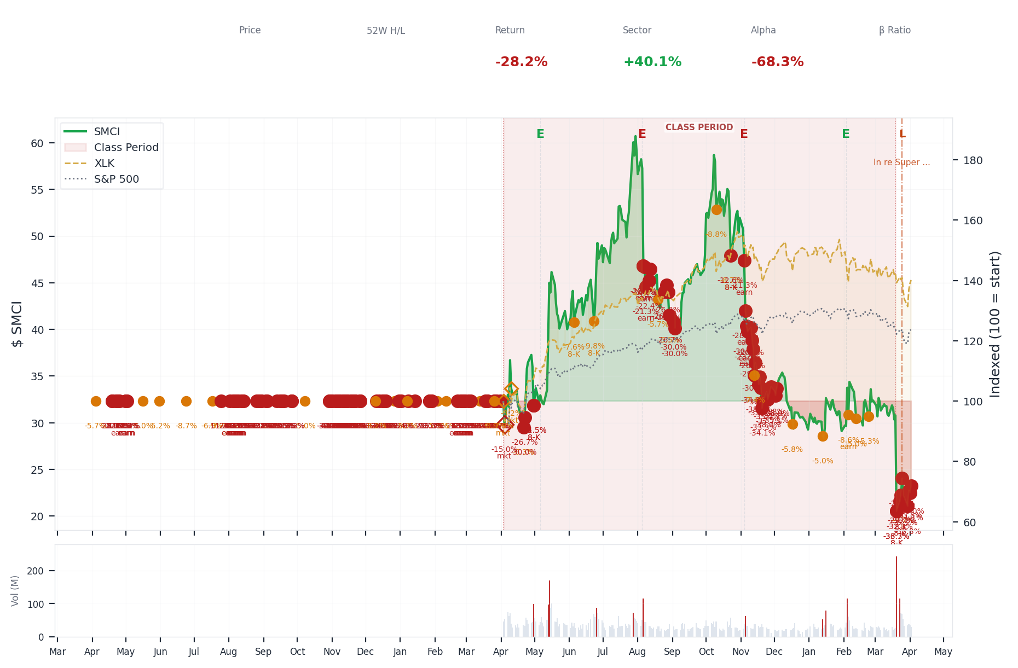
1-Year Performance (Indexed to 100). Red triangles mark single-day drops >= 8%. Orange bands mark multi-day declines >= 15%.
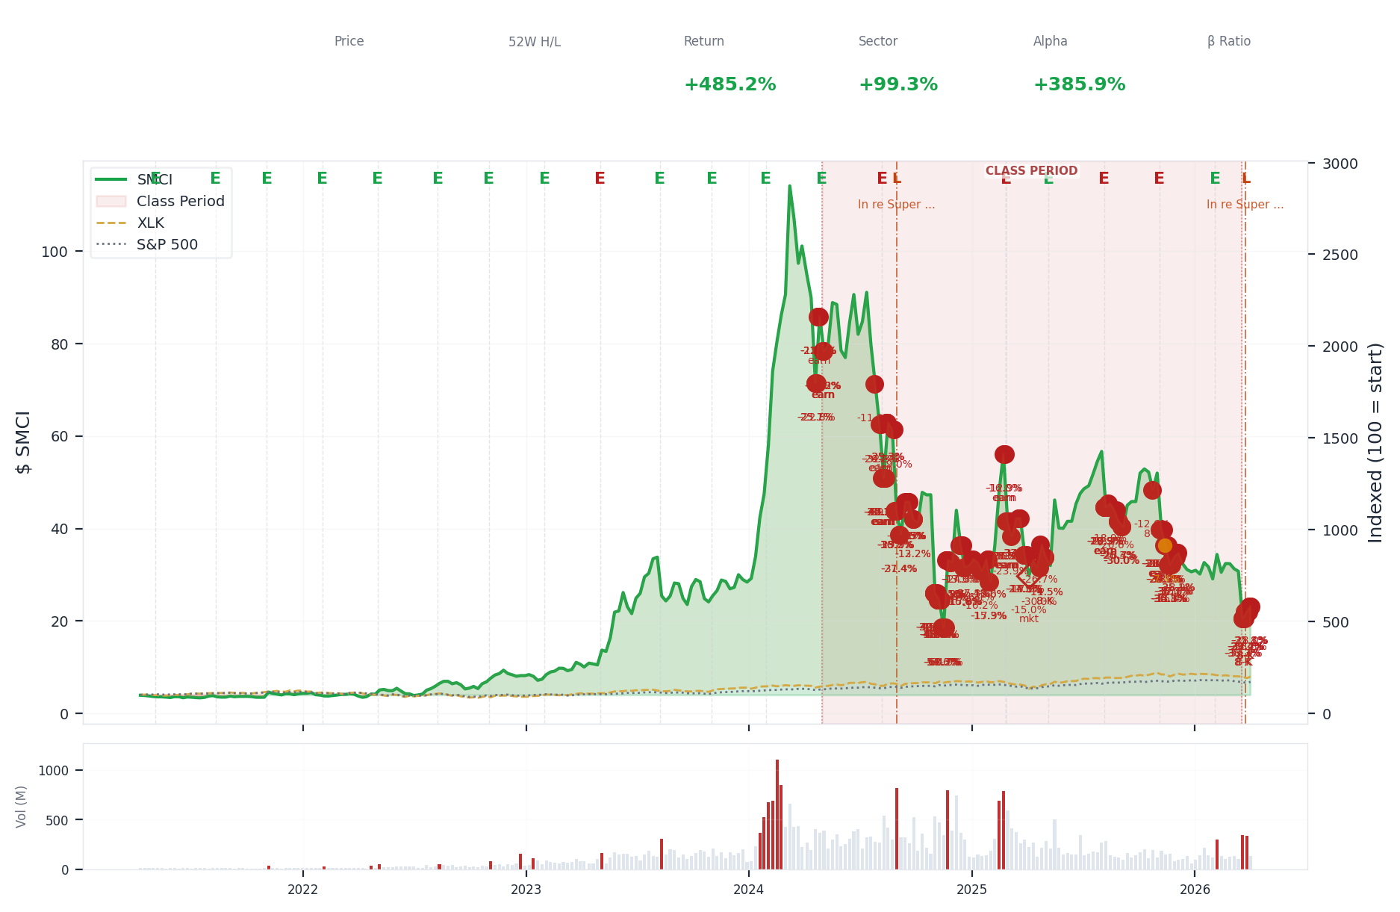
5-Year Performance (Indexed to 100)
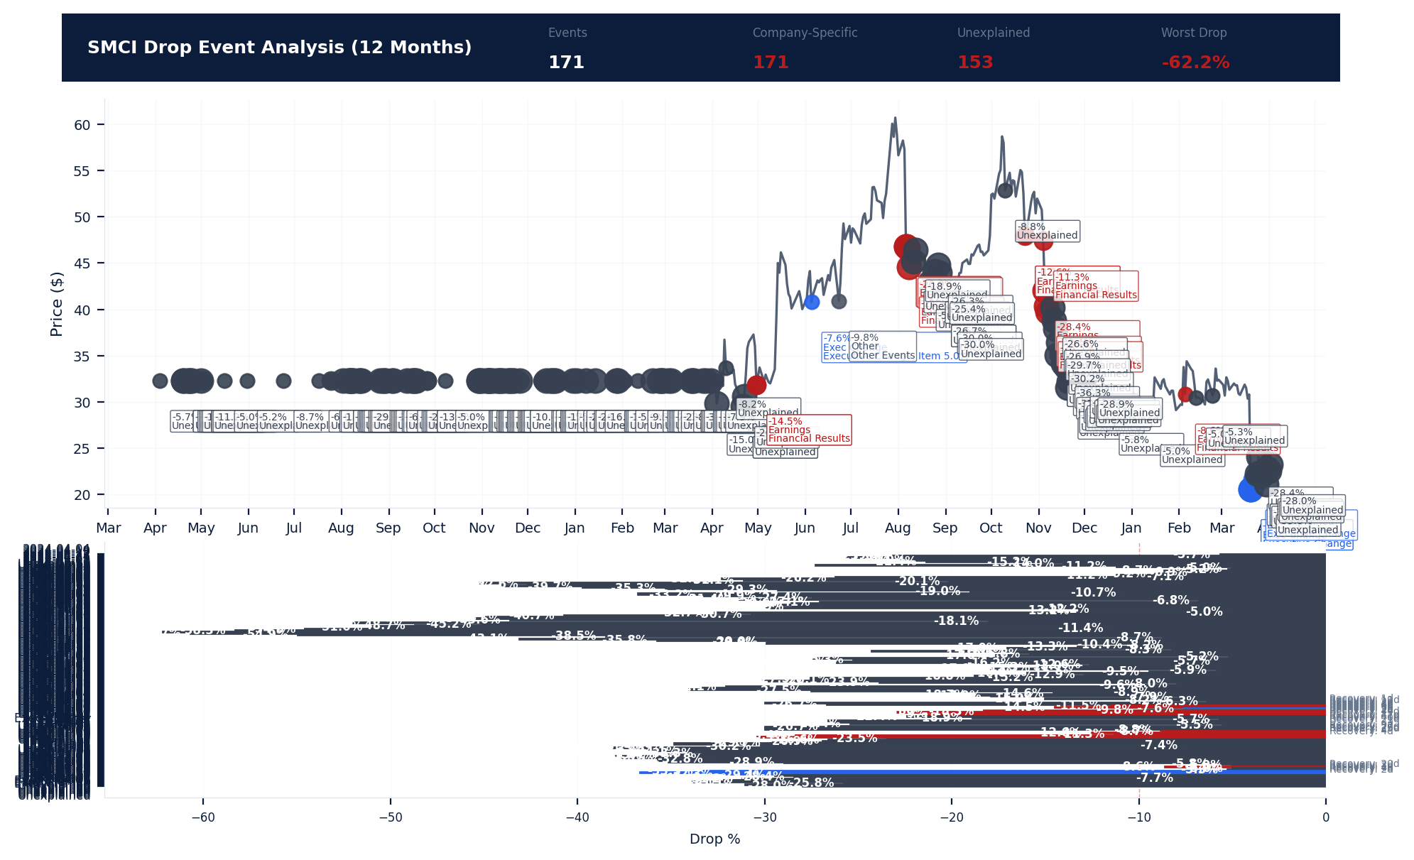
Drop Event Analysis (12 Months)
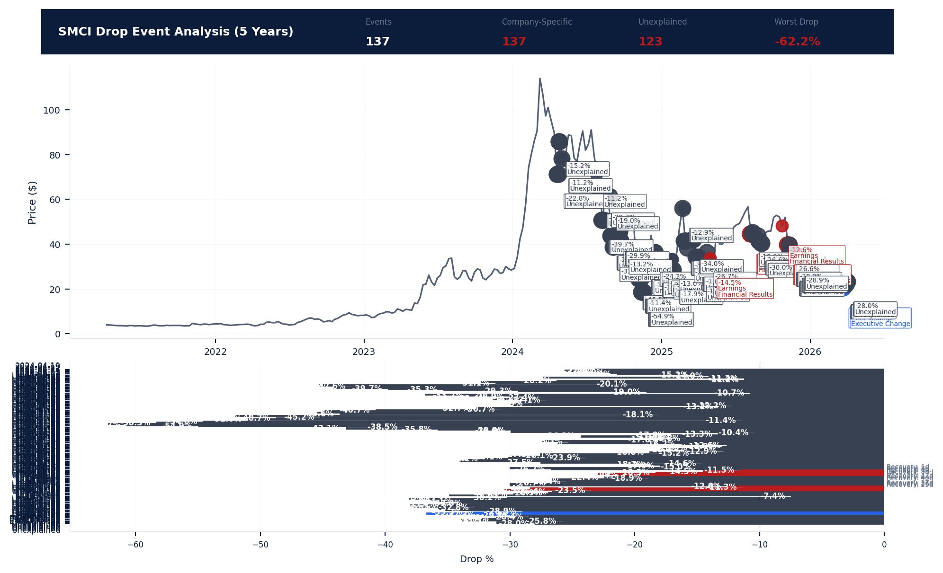
Drop Event Analysis (5 Years)
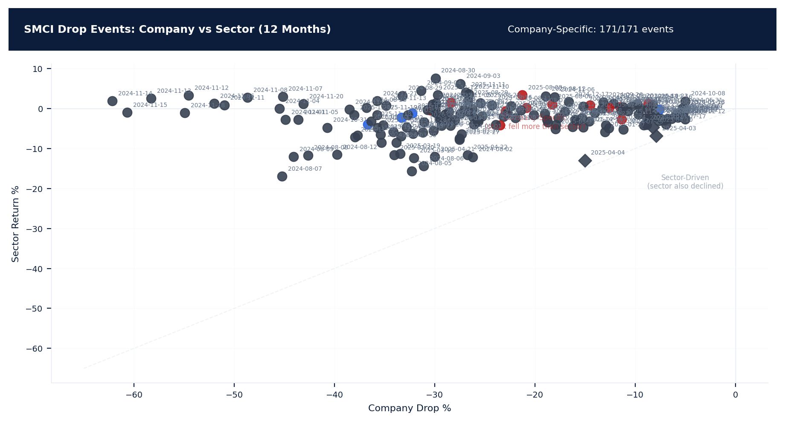
Drop Events: Company vs Sector (12 Months)
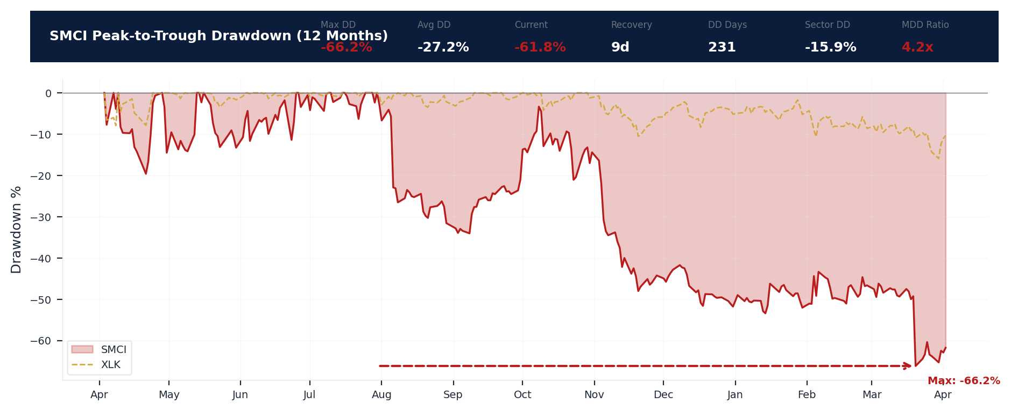
Drawdown Analysis (12 Months)
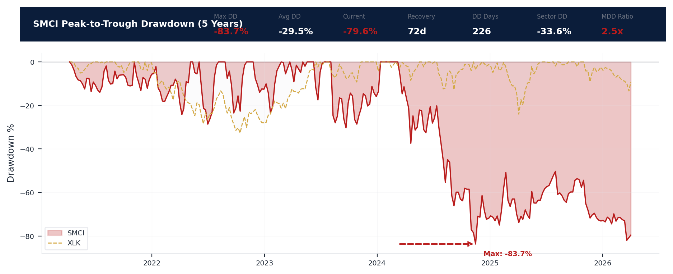
Drawdown Analysis (5 Years)
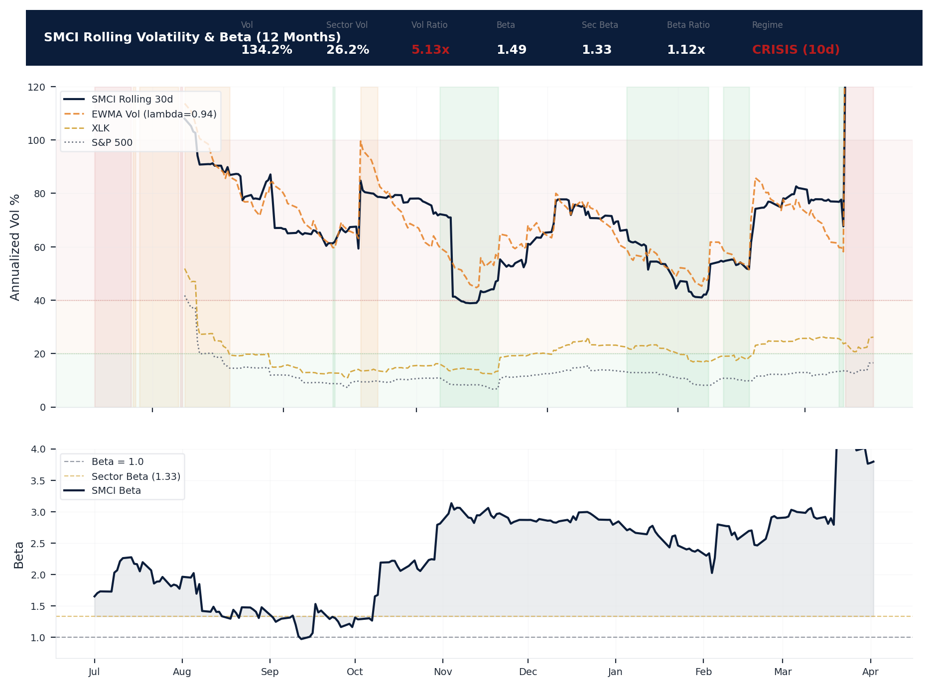
Volatility & Beta Analysis (12 Months)
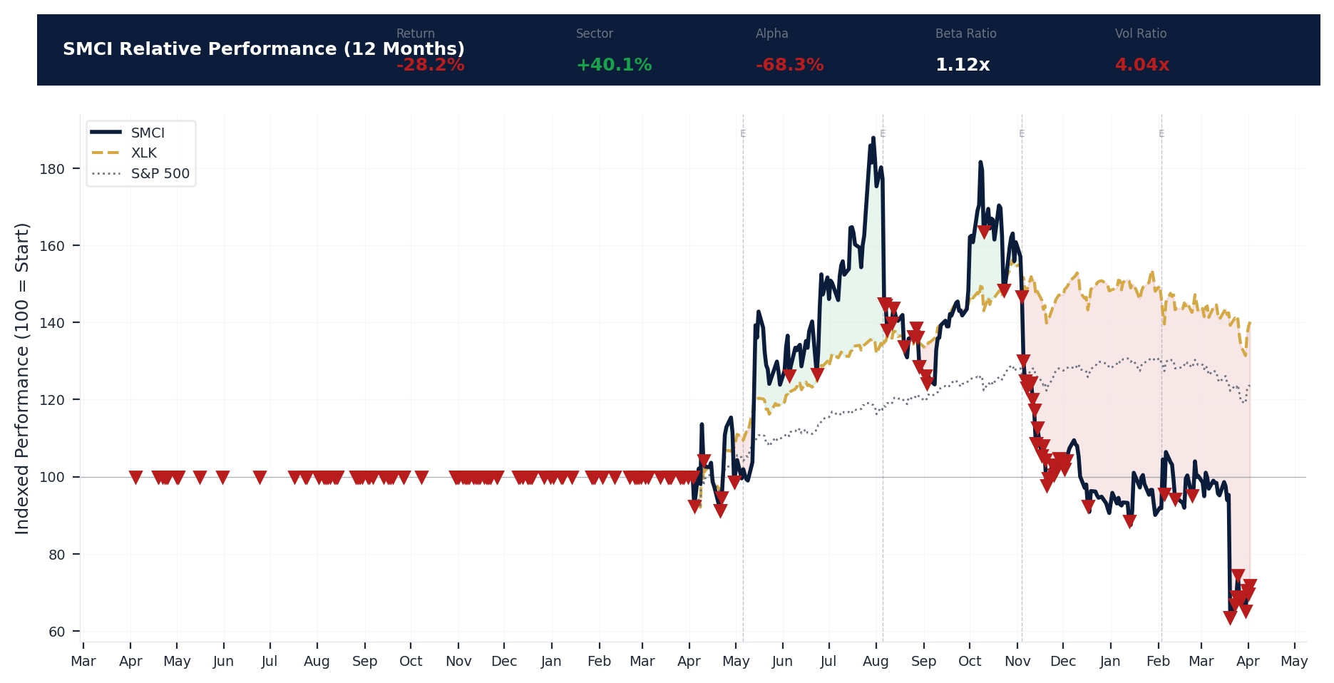
Relative Performance (12 Months)
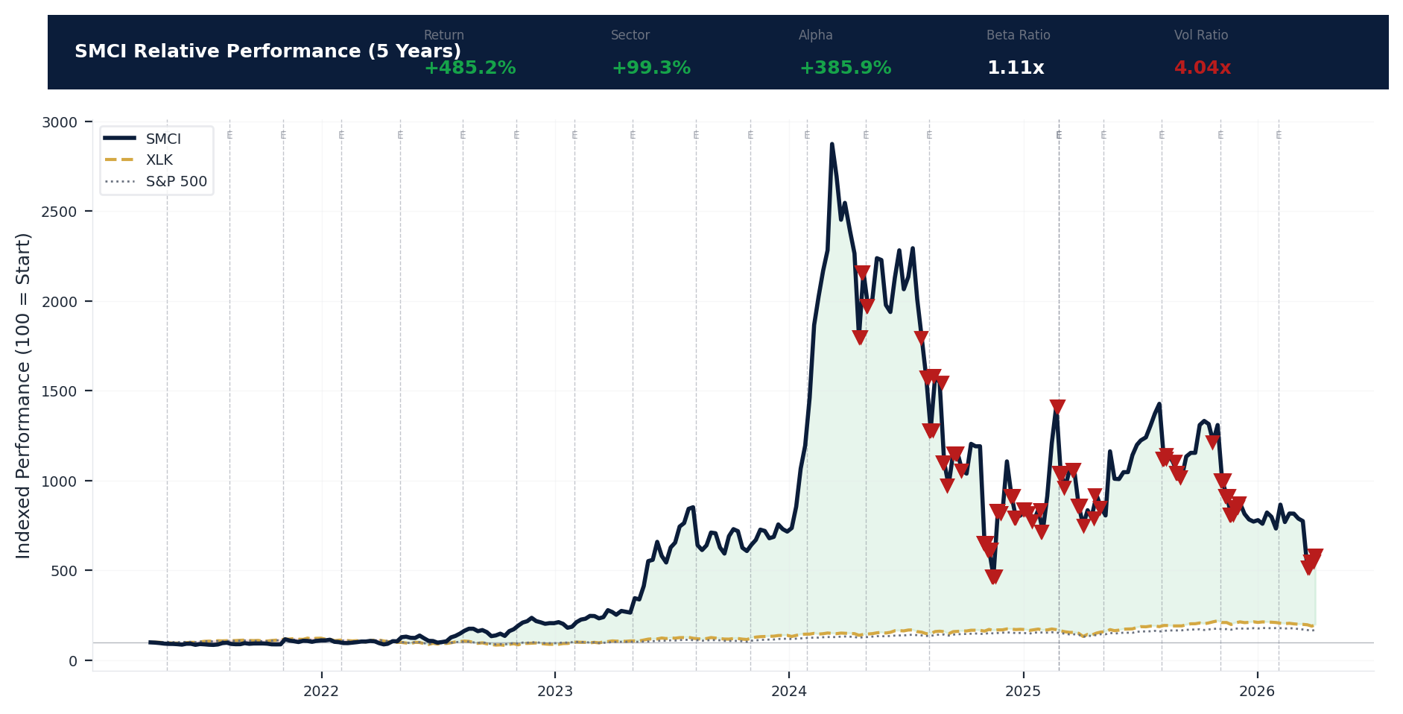
Relative Performance (5 Years)
Metric | Value
Current Price | $23.22
52-Week High | $62.36
52-Week Low | $19.48
1-Year Return | -28.2%
Max Drawdown (1Y) | -66.2%
90-Day Volatility | 85.3% (Ranks at the 0th percentile among 0 peers (peer median: 2.5%))
Beta (vs S&P 500) | 1.49
171 significant stock decline events detected in the 1Y period: 137 critical (>10%), 34 notable (5-10%). 171 were company-specific, 4 were market-wide.
Date | Drop % | Recency | Recovery | Trigger Event | Type | Source
2026-03-20 to 2026-04-02 (14d) | -38.9% | 95% | Not recovered | 8-K Filing | Company-Specific | https://www.sec.gov/cgi-bin/browse-edgar?action...
2026-03-30 (20d) | -33.8% | 99% | Not recovered | Unconfirmed -- Requires Investigation | Company-Specific | https://finance.yahoo.com/quote/SMCI/
2026-03-20 | -33.3% | 95% | Not recovered | 8-K Filing | Company-Specific | https://www.sec.gov/cgi-bin/browse-edgar?action...
2026-03-27 (20d) | -32.2% | 98% | Not recovered | Unconfirmed -- Requires Investigation | Company-Specific | https://finance.yahoo.com/quote/SMCI/
2026-03-23 (5d) | -32.3% | 96% | Not recovered | 8-K Filing | Company-Specific | https://www.sec.gov/cgi-bin/browse-edgar?action...
2026-04-01 (20d) | -31.1% | 100% | Not recovered | Unconfirmed -- Requires Investigation | Company-Specific | https://finance.yahoo.com/quote/SMCI/
2026-03-26 (20d) | -31.2% | 97% | Not recovered | Unconfirmed -- Requires Investigation | Company-Specific | https://finance.yahoo.com/quote/SMCI/
2026-03-24 (5d) | -29.4% | 97% | Not recovered | 8-K Filing | Company-Specific | https://www.sec.gov/cgi-bin/browse-edgar?action...
2026-04-02 (20d) | -28.0% | 100% | Not recovered | Unconfirmed -- Requires Investigation | Company-Specific | https://finance.yahoo.com/quote/SMCI/
2026-03-25 (20d) | -28.4% | 97% | Not recovered | 8-K Filing | Company-Specific | https://www.sec.gov/cgi-bin/browse-edgar?action...
2026-03-31 (20d) | -25.8% | 99% | Not recovered | Unconfirmed -- Requires Investigation | Company-Specific | https://finance.yahoo.com/quote/SMCI/
2025-11-25 (20d) | -38.0% | 61% | Not recovered | Unconfirmed -- Requires Investigation | Company-Specific | https://finance.yahoo.com/quote/SMCI/
2025-11-26 (20d) | -37.7% | 61% | Not recovered | Unconfirmed -- Requires Investigation | Company-Specific | https://finance.yahoo.com/quote/SMCI/
2025-11-04 to 2025-12-03 (30d) | -46.2% | 59% | Not recovered | Unconfirmed -- Requires Investigation | Company-Specific | https://finance.yahoo.com/quote/SMCI/
2025-12-01 (20d) | -35.7% | 63% | Not recovered | Unconfirmed -- Requires Investigation | Company-Specific | https://finance.yahoo.com/quote/SMCI/
2025-12-02 (20d) | -35.1% | 63% | Not recovered | Unconfirmed -- Requires Investigation | Company-Specific | https://finance.yahoo.com/quote/SMCI/
2025-11-18 (20d) | -36.3% | 59% | Not recovered | Unconfirmed -- Requires Investigation | Company-Specific | https://finance.yahoo.com/quote/SMCI/
2025-11-24 (20d) | -35.4% | 61% | Not recovered | Unconfirmed -- Requires Investigation | Company-Specific | https://finance.yahoo.com/quote/SMCI/
2025-11-19 (20d) | -35.8% | 60% | Not recovered | Unconfirmed -- Requires Investigation | Company-Specific | https://finance.yahoo.com/quote/SMCI/
2025-11-20 (20d) | -34.1% | 60% | Not recovered | Unconfirmed -- Requires Investigation | Company-Specific | https://finance.yahoo.com/quote/SMCI/
2025-11-13 (20d) | -34.8% | 58% | Not recovered | Unconfirmed -- Requires Investigation | Company-Specific | https://finance.yahoo.com/quote/SMCI/
2025-11-28 (20d) | -32.8% | 62% | Not recovered | Unconfirmed -- Requires Investigation | Company-Specific | https://finance.yahoo.com/quote/SMCI/
2025-11-21 (20d) | -33.3% | 60% | Not recovered | Unconfirmed -- Requires Investigation | Company-Specific | https://finance.yahoo.com/quote/SMCI/
2025-12-03 (20d) | -28.9% | 63% | Not recovered | Unconfirmed -- Requires Investigation | Company-Specific | https://finance.yahoo.com/quote/SMCI/
2025-11-14 (20d) | -30.2% | 59% | Not recovered | Unconfirmed -- Requires Investigation | Company-Specific | https://finance.yahoo.com/quote/SMCI/
2025-11-06 (20d) | -30.4% | 57% | Not recovered | Earnings release | Company-Specific | https://www.sec.gov/cgi-bin/browse-edgar?action...
2025-11-12 (20d) | -29.7% | 58% | Not recovered | Unconfirmed -- Requires Investigation | Company-Specific | https://finance.yahoo.com/quote/SMCI/
2025-11-05 (20d) | -28.4% | 57% | Not recovered | Earnings release | Company-Specific | https://www.sec.gov/cgi-bin/browse-edgar?action...
2025-11-11 (20d) | -26.9% | 58% | Not recovered | Unconfirmed -- Requires Investigation | Company-Specific | https://finance.yahoo.com/quote/SMCI/
2025-11-10 (20d) | -26.6% | 58% | Not recovered | Unconfirmed -- Requires Investigation | Company-Specific | https://finance.yahoo.com/quote/SMCI/
2025-11-07 (5d) | -23.5% | 57% | Not recovered | Earnings release | Company-Specific | https://www.sec.gov/cgi-bin/browse-edgar?action...
2025-09-03 (20d) | -30.0% | 44% | 25 days | Unconfirmed -- Requires Investigation | Company-Specific | https://finance.yahoo.com/quote/SMCI/
2025-08-25 to 2025-09-03 (10d) | -34.0% | 44% | 9 days | Unconfirmed -- Requires Investigation | Company-Specific | https://finance.yahoo.com/quote/SMCI/
2025-08-29 (20d) | -26.7% | 44% | 27 days | Unconfirmed -- Requires Investigation | Company-Specific | https://finance.yahoo.com/quote/SMCI/
2025-08-25 (20d) | -26.6% | 43% | Not recovered | Unconfirmed -- Requires Investigation | Company-Specific | https://finance.yahoo.com/quote/SMCI/
2025-08-27 (20d) | -26.3% | 43% | Not recovered | Unconfirmed -- Requires Investigation | Company-Specific | https://finance.yahoo.com/quote/SMCI/
2025-08-28 (20d) | -25.4% | 43% | Not recovered | Unconfirmed -- Requires Investigation | Company-Specific | https://finance.yahoo.com/quote/SMCI/
2025-08-06 to 2025-08-12 (7d) | -26.5% | 40% | 40 days | Earnings release | Company-Specific | https://www.sec.gov/cgi-bin/browse-edgar?action...
2025-08-11 (5d) | -22.4% | 41% | 41 days | Unconfirmed -- Requires Investigation | Company-Specific | https://finance.yahoo.com/quote/SMCI/
2024-10-30 to 2024-11-26 (28d) | -63.3% | 14% | Not recovered | Unconfirmed -- Requires Investigation | Company-Specific | https://finance.yahoo.com/quote/SMCI/
2024-11-15 (20d) | -60.7% | 14% | Not recovered | Unconfirmed -- Requires Investigation | Company-Specific | https://finance.yahoo.com/quote/SMCI/
2025-08-08 (5d) | -21.3% | 40% | 42 days | Earnings release | Company-Specific | https://www.sec.gov/cgi-bin/browse-edgar?action...
2025-08-07 (5d) | -20.9% | 40% | Not recovered | Earnings release | Company-Specific | https://www.sec.gov/cgi-bin/browse-edgar?action...
2024-11-13 (20d) | -58.3% | 14% | Not recovered | Unconfirmed -- Requires Investigation | Company-Specific | https://finance.yahoo.com/quote/SMCI/
2024-11-18 (20d) | -54.9% | 15% | Not recovered | Unconfirmed -- Requires Investigation | Company-Specific | https://finance.yahoo.com/quote/SMCI/
2025-03-13 to 2025-03-20 (8d) | -37.1% | 23% | Not recovered | Unconfirmed -- Requires Investigation | Company-Specific | https://finance.yahoo.com/quote/SMCI/
2025-04-21 to 2025-04-22 (2d) | -30.0% | 26% | 1 days | Unconfirmed -- Requires Investigation | Company-Specific | https://finance.yahoo.com/quote/SMCI/
2024-11-12 (20d) | -54.6% | 14% | Not recovered | Unconfirmed -- Requires Investigation | Company-Specific | https://finance.yahoo.com/quote/SMCI/
2025-03-19 (20d) | -33.4% | 23% | Not recovered | Unconfirmed -- Requires Investigation | Company-Specific | https://finance.yahoo.com/quote/SMCI/
2025-08-12 (5d) | -18.9% | 41% | 40 days | Unconfirmed -- Requires Investigation | Company-Specific | https://finance.yahoo.com/quote/SMCI/
2026-03-26 | -7.7% | 97% | Not recovered | Unconfirmed -- Requires Investigation | Company-Specific | https://finance.yahoo.com/quote/SMCI/
2025-03-18 (20d) | -32.1% | 23% | Not recovered | Unconfirmed -- Requires Investigation | Company-Specific | https://finance.yahoo.com/quote/SMCI/
2025-08-06 | -18.3% | 40% | 44 days | Earnings release | Company-Specific | https://www.sec.gov/cgi-bin/browse-edgar?action...
2024-11-06 (20d) | -52.0% | 14% | Not recovered | Unconfirmed -- Requires Investigation | Company-Specific | https://finance.yahoo.com/quote/SMCI/
2024-11-11 (20d) | -51.0% | 14% | Not recovered | Unconfirmed -- Requires Investigation | Company-Specific | https://finance.yahoo.com/quote/SMCI/
2025-04-22 (20d) | -26.7% | 26% | 1 days | Unconfirmed -- Requires Investigation | Company-Specific | https://finance.yahoo.com/quote/SMCI/
2026-02-05 | -8.6% | 81% | 1 days | Earnings release | Company-Specific | https://www.sec.gov/cgi-bin/browse-edgar?action...
2024-11-08 (20d) | -48.7% | 14% | Not recovered | Unconfirmed -- Requires Investigation | Company-Specific | https://finance.yahoo.com/quote/SMCI/
2025-10-23 | -12.6% | 54% | 4 days | 8-K Filing | Company-Specific | https://www.sec.gov/cgi-bin/browse-edgar?action...
2025-02-21 to 2025-03-05 (13d) | -40.1% | 22% | Not recovered | Unconfirmed -- Requires Investigation | Company-Specific | https://finance.yahoo.com/quote/SMCI/
2025-03-26 to 2025-04-04 (10d) | -41.7% | 24% | 1 days | Unconfirmed -- Requires Investigation | Market-Wide Event | https://finance.yahoo.com/quote/SMCI/
2025-11-04 (2d) | -17.2% | 56% | Not recovered | Earnings release | Company-Specific | https://www.sec.gov/cgi-bin/browse-edgar?action...
2024-11-20 (20d) | -43.1% | 15% | Not recovered | Unconfirmed -- Requires Investigation | Company-Specific | https://finance.yahoo.com/quote/SMCI/
2024-11-07 (20d) | -45.2% | 14% | Not recovered | Unconfirmed -- Requires Investigation | Company-Specific | https://finance.yahoo.com/quote/SMCI/
2024-11-04 (20d) | -45.5% | 14% | Not recovered | Unconfirmed -- Requires Investigation | Company-Specific | https://finance.yahoo.com/quote/SMCI/
2024-11-01 (5d) | -44.9% | 14% | Not recovered | Unconfirmed -- Requires Investigation | Company-Specific | https://finance.yahoo.com/quote/SMCI/
2024-11-05 (5d) | -43.6% | 14% | Not recovered | Unconfirmed -- Requires Investigation | Company-Specific | https://finance.yahoo.com/quote/SMCI/
2025-02-27 (5d) | -27.5% | 22% | Not recovered | Earnings release | Company-Specific | https://finance.yahoo.com/quote/SMCI/
2024-11-19 (20d) | -38.5% | 15% | Not recovered | Unconfirmed -- Requires Investigation | Company-Specific | https://finance.yahoo.com/quote/SMCI/
2025-02-28 (5d) | -26.1% | 22% | Not recovered | Earnings release | Company-Specific | https://finance.yahoo.com/quote/SMCI/
2024-10-31 (2d) | -40.7% | 14% | Not recovered | Unconfirmed -- Requires Investigation | Company-Specific | https://finance.yahoo.com/quote/SMCI/
2024-11-21 (20d) | -35.8% | 15% | Not recovered | Unconfirmed -- Requires Investigation | Company-Specific | https://finance.yahoo.com/quote/SMCI/
2025-03-05 (5d) | -23.9% | 22% | Not recovered | Unconfirmed -- Requires Investigation | Company-Specific | https://finance.yahoo.com/quote/SMCI/
2024-12-27 to 2025-01-08 (13d) | -31.9% | 17% | Not recovered | Unconfirmed -- Requires Investigation | Company-Specific | https://finance.yahoo.com/quote/SMCI/
2025-10-23 | -8.7% | 54% | 4 days | 8-K Filing | Company-Specific | https://www.sec.gov/cgi-bin/browse-edgar?action...
2025-01-08 (20d) | -26.1% | 18% | Not recovered | Unconfirmed -- Requires Investigation | Company-Specific | https://finance.yahoo.com/quote/SMCI/
2026-02-23 | -5.3% | 86% | 2 days | Unconfirmed -- Requires Investigation | Company-Specific | https://finance.yahoo.com/quote/SMCI/
2025-10-10 | -8.8% | 51% | Not recovered | Unconfirmed -- Requires Investigation | Company-Specific | https://finance.yahoo.com/quote/SMCI/
2025-03-28 (5d) | -18.7% | 24% | Not recovered | Unconfirmed -- Requires Investigation | Company-Specific | https://finance.yahoo.com/quote/SMCI/
2024-11-26 (20d) | -29.9% | 15% | Not recovered | Unconfirmed -- Requires Investigation | Company-Specific | https://finance.yahoo.com/quote/SMCI/
2024-08-02 to 2024-08-14 (13d) | -45.9% | 10% | Not recovered | Earnings release | Company-Specific | https://finance.yahoo.com/quote/SMCI/
2024-10-30 (3d) | -32.7% | 14% | Not recovered | Unconfirmed -- Requires Investigation | Company-Specific | https://finance.yahoo.com/quote/SMCI/
2024-11-22 (20d) | -29.9% | 15% | Not recovered | Unconfirmed -- Requires Investigation | Company-Specific | https://finance.yahoo.com/quote/SMCI/
2025-01-02 (20d) | -25.3% | 17% | Not recovered | Unconfirmed -- Requires Investigation | Company-Specific | https://finance.yahoo.com/quote/SMCI/
2025-03-31 (5d) | -17.9% | 24% | Not recovered | Unconfirmed -- Requires Investigation | Company-Specific | https://finance.yahoo.com/quote/SMCI/
2024-08-09 (20d) | -44.1% | 10% | Not recovered | Earnings release | Company-Specific | https://finance.yahoo.com/quote/SMCI/
2025-11-13 (3d) | -16.8% | 58% | Not recovered | Unconfirmed -- Requires Investigation | Company-Specific | https://finance.yahoo.com/quote/SMCI/
2024-08-08 (20d) | -42.6% | 10% | Not recovered | Earnings release | Company-Specific | https://finance.yahoo.com/quote/SMCI/
2024-10-30 (2d) | -30.7% | 14% | Not recovered | Unconfirmed -- Requires Investigation | Company-Specific | https://finance.yahoo.com/quote/SMCI/
2026-02-12 | -5.0% | 83% | 4 days | Unconfirmed -- Requires Investigation | Company-Specific | https://finance.yahoo.com/quote/SMCI/
2025-02-25 (2d) | -18.8% | 21% | Not recovered | Earnings release | Company-Specific | https://finance.yahoo.com/quote/SMCI/
2024-08-12 (20d) | -39.7% | 10% | Not recovered | Unconfirmed -- Requires Investigation | Company-Specific | https://finance.yahoo.com/quote/SMCI/
2025-04-30 | -14.5% | 27% | 9 days | 8-K Filing | Company-Specific | https://www.sec.gov/cgi-bin/browse-edgar?action...
2024-12-10 to 2024-12-19 (10d) | -29.3% | 16% | Not recovered | Unconfirmed -- Requires Investigation | Company-Specific | https://finance.yahoo.com/quote/SMCI/
2024-08-26 to 2024-09-06 (12d) | -44.9% | 11% | Not recovered | Unconfirmed -- Requires Investigation | Company-Specific | https://finance.yahoo.com/quote/SMCI/
2025-12-17 | -5.8% | 66% | 20 days | Unconfirmed -- Requires Investigation | Company-Specific | https://finance.yahoo.com/quote/SMCI/
2026-01-13 | -5.0% | 74% | 3 days | Unconfirmed -- Requires Investigation | Company-Specific | https://finance.yahoo.com/quote/SMCI/
2025-04-04 (2d) | -15.0% | 25% | 1 days | Unconfirmed -- Requires Investigation | Market-Wide Event | https://finance.yahoo.com/quote/SMCI/
2024-08-29 (20d) | -33.2% | 11% | Not recovered | Unconfirmed -- Requires Investigation | Company-Specific | https://finance.yahoo.com/quote/SMCI/
2024-08-13 (20d) | -35.3% | 10% | Not recovered | Unconfirmed -- Requires Investigation | Company-Specific | https://finance.yahoo.com/quote/SMCI/
2025-03-27 (2d) | -14.6% | 24% | Not recovered | Unconfirmed -- Requires Investigation | Company-Specific | https://finance.yahoo.com/quote/SMCI/
2024-09-13 to 2024-09-19 (7d) | -30.5% | 12% | Not recovered | Unconfirmed -- Requires Investigation | Company-Specific | https://finance.yahoo.com/quote/SMCI/
2025-01-27 to 2025-02-03 (8d) | -20.7% | 19% | Not recovered | Unconfirmed -- Requires Investigation | Company-Specific | https://finance.yahoo.com/quote/SMCI/
2024-09-04 (20d) | -31.4% | 11% | Not recovered | Unconfirmed -- Requires Investigation | Company-Specific | https://finance.yahoo.com/quote/SMCI/
2024-09-17 (20d) | -29.5% | 11% | Not recovered | Unconfirmed -- Requires Investigation | Company-Specific | https://finance.yahoo.com/quote/SMCI/
2025-02-21 (5d) | -16.0% | 21% | Not recovered | Earnings release | Company-Specific | https://finance.yahoo.com/quote/SMCI/
2025-06-23 | -9.8% | 34% | 2 days | 8-K Filing | Company-Specific | https://www.sec.gov/cgi-bin/browse-edgar?action...
2024-09-18 (20d) | -28.5% | 12% | Not recovered | Unconfirmed -- Requires Investigation | Company-Specific | https://finance.yahoo.com/quote/SMCI/
2024-09-16 (20d) | -28.6% | 11% | Not recovered | Unconfirmed -- Requires Investigation | Company-Specific | https://finance.yahoo.com/quote/SMCI/
2025-02-26 (5d) | -15.2% | 21% | Not recovered | Earnings release | Company-Specific | https://finance.yahoo.com/quote/SMCI/
2024-08-30 (20d) | -29.9% | 11% | Not recovered | Unconfirmed -- Requires Investigation | Company-Specific | https://finance.yahoo.com/quote/SMCI/
2024-08-05 (20d) | -32.3% | 10% | Not recovered | Earnings release | Company-Specific | https://finance.yahoo.com/quote/SMCI/
2025-04-30 | -11.5% | 27% | 9 days | 8-K Filing | Company-Specific | https://www.sec.gov/cgi-bin/browse-edgar?action...
2024-09-13 (20d) | -27.1% | 11% | Not recovered | Unconfirmed -- Requires Investigation | Company-Specific | https://finance.yahoo.com/quote/SMCI/
2024-08-06 (20d) | -31.1% | 10% | Not recovered | Earnings release | Company-Specific | https://finance.yahoo.com/quote/SMCI/
2024-09-03 (20d) | -27.4% | 11% | Not recovered | Unconfirmed -- Requires Investigation | Company-Specific | https://finance.yahoo.com/quote/SMCI/
2024-08-14 (20d) | -29.3% | 10% | Not recovered | Unconfirmed -- Requires Investigation | Company-Specific | https://finance.yahoo.com/quote/SMCI/
2025-01-14 (5d) | -16.2% | 18% | Not recovered | Unconfirmed -- Requires Investigation | Company-Specific | https://finance.yahoo.com/quote/SMCI/
2025-01-28 (2d) | -15.3% | 19% | Not recovered | Unconfirmed -- Requires Investigation | Company-Specific | https://finance.yahoo.com/quote/SMCI/
2024-12-19 (5d) | -17.6% | 16% | Not recovered | Unconfirmed -- Requires Investigation | Company-Specific | https://finance.yahoo.com/quote/SMCI/
2025-02-24 (2d) | -12.9% | 21% | Not recovered | Earnings release | Company-Specific | https://finance.yahoo.com/quote/SMCI/
2024-12-13 (5d) | -17.0% | 16% | Not recovered | Unconfirmed -- Requires Investigation | Company-Specific | https://finance.yahoo.com/quote/SMCI/
2024-12-17 (5d) | -16.6% | 16% | Not recovered | Unconfirmed -- Requires Investigation | Company-Specific | https://finance.yahoo.com/quote/SMCI/
2024-12-18 (5d) | -15.8% | 16% | Not recovered | Unconfirmed -- Requires Investigation | Company-Specific | https://finance.yahoo.com/quote/SMCI/
2024-08-02 (20d) | -26.2% | 10% | Not recovered | Earnings release | Company-Specific | https://finance.yahoo.com/quote/SMCI/
2024-11-06 | -18.1% | 14% | Not recovered | Unconfirmed -- Requires Investigation | Company-Specific | https://finance.yahoo.com/quote/SMCI/
2025-01-27 (2d) | -13.0% | 19% | Not recovered | Unconfirmed -- Requires Investigation | Company-Specific | https://finance.yahoo.com/quote/SMCI/
2025-01-27 | -12.6% | 19% | Not recovered | Unconfirmed -- Requires Investigation | Company-Specific | https://finance.yahoo.com/quote/SMCI/
2025-08-29 | -5.5% | 44% | 9 days | Unconfirmed -- Requires Investigation | Company-Specific | https://finance.yahoo.com/quote/SMCI/
2025-08-19 | -5.7% | 42% | 21 days | Unconfirmed -- Requires Investigation | Company-Specific | https://finance.yahoo.com/quote/SMCI/
2025-06-05 | -7.6% | 31% | 9 days | 8-K Filing | Company-Specific | https://www.sec.gov/cgi-bin/browse-edgar?action...
2025-03-18 | -9.6% | 23% | Not recovered | Unconfirmed -- Requires Investigation | Company-Specific | https://finance.yahoo.com/quote/SMCI/
2024-12-11 (2d) | -13.3% | 16% | Not recovered | Unconfirmed -- Requires Investigation | Company-Specific | https://finance.yahoo.com/quote/SMCI/
2025-03-26 (2d) | -8.9% | 24% | Not recovered | Unconfirmed -- Requires Investigation | Company-Specific | https://finance.yahoo.com/quote/SMCI/
2025-04-10 | -8.2% | 25% | 11 days | Unconfirmed -- Requires Investigation | Market-Wide Event | https://finance.yahoo.com/quote/SMCI/
2024-08-26 (2d) | -19.0% | 11% | Not recovered | Unconfirmed -- Requires Investigation | Company-Specific | https://finance.yahoo.com/quote/SMCI/
2024-08-07 | -20.1% | 10% | Not recovered | Earnings release | Company-Specific | https://finance.yahoo.com/quote/SMCI/
2025-04-03 (2d) | -7.7% | 25% | Not recovered | Unconfirmed -- Requires Investigation | Market-Wide Event | https://finance.yahoo.com/quote/SMCI/
2025-02-11 | -9.5% | 20% | Not recovered | Unconfirmed -- Requires Investigation | Company-Specific | https://finance.yahoo.com/quote/SMCI/
2024-05-01 to 2024-05-02 (2d) | -27.3% | 7% | Not recovered | Earnings release | Company-Specific | https://finance.yahoo.com/quote/SMCI/
2025-03-13 | -8.0% | 23% | Not recovered | Unconfirmed -- Requires Investigation | Company-Specific | https://finance.yahoo.com/quote/SMCI/
2025-04-21 | -6.3% | 26% | 2 days | Unconfirmed -- Requires Investigation | Company-Specific | https://finance.yahoo.com/quote/SMCI/
2024-04-19 to 2024-04-25 (7d) | -26.9% | 6% | Not recovered | Unconfirmed -- Requires Investigation | Company-Specific | https://finance.yahoo.com/quote/SMCI/
2024-11-11 (4d) | -11.4% | 14% | Not recovered | Unconfirmed -- Requires Investigation | Company-Specific | https://finance.yahoo.com/quote/SMCI/
2024-09-26 | -13.2% | 12% | Not recovered | Unconfirmed -- Requires Investigation | Company-Specific | https://finance.yahoo.com/quote/SMCI/
2024-11-26 (2d) | -10.4% | 15% | Not recovered | Unconfirmed -- Requires Investigation | Company-Specific | https://finance.yahoo.com/quote/SMCI/
2024-04-19 | -23.1% | 6% | Not recovered | Unconfirmed -- Requires Investigation | Company-Specific | https://finance.yahoo.com/quote/SMCI/
2024-04-22 (2d) | -22.8% | 6% | Not recovered | Unconfirmed -- Requires Investigation | Company-Specific | https://finance.yahoo.com/quote/SMCI/
2024-09-26 | -12.2% | 12% | Not recovered | Unconfirmed -- Requires Investigation | Company-Specific | https://finance.yahoo.com/quote/SMCI/
2024-04-23 (5d) | -22.0% | 7% | Not recovered | Unconfirmed -- Requires Investigation | Company-Specific | https://finance.yahoo.com/quote/SMCI/
2024-04-24 (5d) | -21.4% | 7% | Not recovered | Unconfirmed -- Requires Investigation | Company-Specific | https://finance.yahoo.com/quote/SMCI/
2024-12-16 | -8.3% | 16% | Not recovered | Unconfirmed -- Requires Investigation | Company-Specific | https://finance.yahoo.com/quote/SMCI/
2024-12-10 (2d) | -8.2% | 16% | Not recovered | Unconfirmed -- Requires Investigation | Company-Specific | https://finance.yahoo.com/quote/SMCI/
2024-11-20 | -8.7% | 15% | Not recovered | Unconfirmed -- Requires Investigation | Company-Specific | https://finance.yahoo.com/quote/SMCI/
2025-02-03 | -5.9% | 20% | Not recovered | Unconfirmed -- Requires Investigation | Company-Specific | https://finance.yahoo.com/quote/SMCI/
2024-08-27 (2d) | -10.7% | 11% | Not recovered | Unconfirmed -- Requires Investigation | Company-Specific | https://finance.yahoo.com/quote/SMCI/
2024-07-24 to 2024-07-25 (2d) | -11.2% | 9% | Not recovered | Unconfirmed -- Requires Investigation | Company-Specific | https://finance.yahoo.com/quote/SMCI/
2025-01-07 (2d) | -5.7% | 18% | Not recovered | Unconfirmed -- Requires Investigation | Company-Specific | https://finance.yahoo.com/quote/SMCI/
2024-04-25 (5d) | -15.2% | 7% | Not recovered | Earnings release | Company-Specific | https://finance.yahoo.com/quote/SMCI/
2024-05-01 | -14.0% | 7% | Not recovered | Earnings release | Company-Specific | https://finance.yahoo.com/quote/SMCI/
2024-12-27 | -5.2% | 17% | Not recovered | Unconfirmed -- Requires Investigation | Company-Specific | https://finance.yahoo.com/quote/SMCI/
2024-07-24 | -9.2% | 9% | Not recovered | Unconfirmed -- Requires Investigation | Company-Specific | https://finance.yahoo.com/quote/SMCI/
2024-05-02 (2d) | -11.2% | 7% | Not recovered | Earnings release | Company-Specific | https://finance.yahoo.com/quote/SMCI/
2024-09-06 | -6.8% | 11% | Not recovered | Unconfirmed -- Requires Investigation | Company-Specific | https://finance.yahoo.com/quote/SMCI/
2024-06-24 (2d) | -8.7% | 8% | Not recovered | Unconfirmed -- Requires Investigation | Company-Specific | https://finance.yahoo.com/quote/SMCI/
2024-08-02 | -7.1% | 10% | Not recovered | Earnings release | Company-Specific | https://finance.yahoo.com/quote/SMCI/
2024-07-17 | -6.9% | 9% | Not recovered | Unconfirmed -- Requires Investigation | Company-Specific | https://finance.yahoo.com/quote/SMCI/
2024-10-08 | -5.0% | 12% | Not recovered | Unconfirmed -- Requires Investigation | Company-Specific | https://finance.yahoo.com/quote/SMCI/
2024-05-31 | -5.2% | 8% | Not recovered | Unconfirmed -- Requires Investigation | Company-Specific | https://finance.yahoo.com/quote/SMCI/
2024-05-16 | -5.0% | 7% | Not recovered | Unconfirmed -- Requires Investigation | Company-Specific | https://finance.yahoo.com/quote/SMCI/
2024-04-04 | -5.7% | 6% | Not recovered | Unconfirmed -- Requires Investigation | Company-Specific | https://finance.yahoo.com/quote/SMCI/
137 significant stock decline events detected in the 5Y period: 137 critical (>10%). 137 were company-specific, 2 were market-wide.
Date | Drop % | Recency | Recovery | Trigger Event | Type | Source
2026-03-20 to 2026-04-02 (14d) | -38.9% | 95% | Not recovered | 8-K Filing | Company-Specific | https://www.sec.gov/cgi-bin/browse-edgar?action...
2026-03-30 (20d) | -33.8% | 99% | Not recovered | Unconfirmed -- Requires Investigation | Company-Specific | https://finance.yahoo.com/quote/SMCI/
2026-03-20 | -33.3% | 95% | Not recovered | 8-K Filing | Company-Specific | https://www.sec.gov/cgi-bin/browse-edgar?action...
2026-03-27 (20d) | -32.2% | 98% | Not recovered | Unconfirmed -- Requires Investigation | Company-Specific | https://finance.yahoo.com/quote/SMCI/
2026-03-23 (5d) | -32.3% | 96% | Not recovered | 8-K Filing | Company-Specific | https://www.sec.gov/cgi-bin/browse-edgar?action...
2026-04-01 (20d) | -31.1% | 100% | Not recovered | Unconfirmed -- Requires Investigation | Company-Specific | https://finance.yahoo.com/quote/SMCI/
2026-03-26 (20d) | -31.2% | 97% | Not recovered | Unconfirmed -- Requires Investigation | Company-Specific | https://finance.yahoo.com/quote/SMCI/
2026-03-24 (5d) | -29.4% | 97% | Not recovered | 8-K Filing | Company-Specific | https://www.sec.gov/cgi-bin/browse-edgar?action...
2026-04-02 (20d) | -28.0% | 100% | Not recovered | Unconfirmed -- Requires Investigation | Company-Specific | https://finance.yahoo.com/quote/SMCI/
2026-03-25 (20d) | -28.4% | 97% | Not recovered | 8-K Filing | Company-Specific | https://www.sec.gov/cgi-bin/browse-edgar?action...
2026-03-31 (20d) | -25.8% | 99% | Not recovered | Unconfirmed -- Requires Investigation | Company-Specific | https://finance.yahoo.com/quote/SMCI/
2025-11-25 (20d) | -38.0% | 61% | Not recovered | Unconfirmed -- Requires Investigation | Company-Specific | https://finance.yahoo.com/quote/SMCI/
2025-11-26 (20d) | -37.7% | 61% | Not recovered | Unconfirmed -- Requires Investigation | Company-Specific | https://finance.yahoo.com/quote/SMCI/
2025-11-04 to 2025-12-03 (30d) | -46.2% | 59% | Not recovered | Unconfirmed -- Requires Investigation | Company-Specific | https://finance.yahoo.com/quote/SMCI/
2025-12-01 (20d) | -35.7% | 63% | Not recovered | Unconfirmed -- Requires Investigation | Company-Specific | https://finance.yahoo.com/quote/SMCI/
2025-12-02 (20d) | -35.1% | 63% | Not recovered | Unconfirmed -- Requires Investigation | Company-Specific | https://finance.yahoo.com/quote/SMCI/
2025-11-18 (20d) | -36.3% | 59% | Not recovered | Unconfirmed -- Requires Investigation | Company-Specific | https://finance.yahoo.com/quote/SMCI/
2025-11-24 (20d) | -35.4% | 61% | Not recovered | Unconfirmed -- Requires Investigation | Company-Specific | https://finance.yahoo.com/quote/SMCI/
2025-11-19 (20d) | -35.8% | 60% | Not recovered | Unconfirmed -- Requires Investigation | Company-Specific | https://finance.yahoo.com/quote/SMCI/
2025-11-20 (20d) | -34.1% | 60% | Not recovered | Unconfirmed -- Requires Investigation | Company-Specific | https://finance.yahoo.com/quote/SMCI/
2025-11-13 (20d) | -34.8% | 58% | Not recovered | Unconfirmed -- Requires Investigation | Company-Specific | https://finance.yahoo.com/quote/SMCI/
2025-11-28 (20d) | -32.8% | 62% | Not recovered | Unconfirmed -- Requires Investigation | Company-Specific | https://finance.yahoo.com/quote/SMCI/
2025-11-21 (20d) | -33.3% | 60% | Not recovered | Unconfirmed -- Requires Investigation | Company-Specific | https://finance.yahoo.com/quote/SMCI/
2025-12-03 (20d) | -28.9% | 63% | Not recovered | Unconfirmed -- Requires Investigation | Company-Specific | https://finance.yahoo.com/quote/SMCI/
2025-11-14 (20d) | -30.2% | 59% | Not recovered | Unconfirmed -- Requires Investigation | Company-Specific | https://finance.yahoo.com/quote/SMCI/
2025-11-06 (20d) | -30.4% | 57% | Not recovered | Earnings release | Company-Specific | https://www.sec.gov/cgi-bin/browse-edgar?action...
2025-11-12 (20d) | -29.7% | 58% | Not recovered | Unconfirmed -- Requires Investigation | Company-Specific | https://finance.yahoo.com/quote/SMCI/
2025-11-05 (20d) | -28.4% | 57% | Not recovered | Earnings release | Company-Specific | https://www.sec.gov/cgi-bin/browse-edgar?action...
2025-11-11 (20d) | -26.9% | 58% | Not recovered | Unconfirmed -- Requires Investigation | Company-Specific | https://finance.yahoo.com/quote/SMCI/
2025-11-10 (20d) | -26.6% | 58% | Not recovered | Unconfirmed -- Requires Investigation | Company-Specific | https://finance.yahoo.com/quote/SMCI/
2025-11-07 (5d) | -23.5% | 57% | Not recovered | Earnings release | Company-Specific | https://www.sec.gov/cgi-bin/browse-edgar?action...
2025-09-03 (20d) | -30.0% | 44% | 25 days | Unconfirmed -- Requires Investigation | Company-Specific | https://finance.yahoo.com/quote/SMCI/
2025-08-25 to 2025-09-03 (10d) | -34.0% | 44% | 9 days | Unconfirmed -- Requires Investigation | Company-Specific | https://finance.yahoo.com/quote/SMCI/
2025-08-29 (20d) | -26.7% | 44% | 27 days | Unconfirmed -- Requires Investigation | Company-Specific | https://finance.yahoo.com/quote/SMCI/
2025-08-25 (20d) | -26.6% | 43% | Not recovered | Unconfirmed -- Requires Investigation | Company-Specific | https://finance.yahoo.com/quote/SMCI/
2025-08-27 (20d) | -26.3% | 43% | Not recovered | Unconfirmed -- Requires Investigation | Company-Specific | https://finance.yahoo.com/quote/SMCI/
2025-08-28 (20d) | -25.4% | 43% | Not recovered | Unconfirmed -- Requires Investigation | Company-Specific | https://finance.yahoo.com/quote/SMCI/
2025-08-06 to 2025-08-12 (7d) | -26.5% | 40% | 40 days | Earnings release | Company-Specific | https://www.sec.gov/cgi-bin/browse-edgar?action...
2025-08-11 (5d) | -22.4% | 41% | 41 days | Unconfirmed -- Requires Investigation | Company-Specific | https://finance.yahoo.com/quote/SMCI/
2024-10-30 to 2024-11-26 (28d) | -63.3% | 14% | Not recovered | Unconfirmed -- Requires Investigation | Company-Specific | https://finance.yahoo.com/quote/SMCI/
2024-11-15 (20d) | -60.7% | 14% | Not recovered | Unconfirmed -- Requires Investigation | Company-Specific | https://finance.yahoo.com/quote/SMCI/
2025-08-08 (5d) | -21.3% | 40% | 42 days | Earnings release | Company-Specific | https://www.sec.gov/cgi-bin/browse-edgar?action...
2025-08-07 (5d) | -20.9% | 40% | Not recovered | Earnings release | Company-Specific | https://www.sec.gov/cgi-bin/browse-edgar?action...
2024-11-13 (20d) | -58.3% | 14% | Not recovered | Unconfirmed -- Requires Investigation | Company-Specific | https://finance.yahoo.com/quote/SMCI/
2024-11-18 (20d) | -54.9% | 15% | Not recovered | Unconfirmed -- Requires Investigation | Company-Specific | https://finance.yahoo.com/quote/SMCI/
2025-03-13 to 2025-03-20 (8d) | -37.1% | 23% | Not recovered | Unconfirmed -- Requires Investigation | Company-Specific | https://finance.yahoo.com/quote/SMCI/
2025-04-21 to 2025-04-22 (2d) | -30.0% | 26% | 1 days | Unconfirmed -- Requires Investigation | Company-Specific | https://finance.yahoo.com/quote/SMCI/
2024-11-12 (20d) | -54.6% | 14% | Not recovered | Unconfirmed -- Requires Investigation | Company-Specific | https://finance.yahoo.com/quote/SMCI/
2025-03-19 (20d) | -33.4% | 23% | Not recovered | Unconfirmed -- Requires Investigation | Company-Specific | https://finance.yahoo.com/quote/SMCI/
2025-08-12 (5d) | -18.9% | 41% | 40 days | Unconfirmed -- Requires Investigation | Company-Specific | https://finance.yahoo.com/quote/SMCI/
2025-03-18 (20d) | -32.1% | 23% | Not recovered | Unconfirmed -- Requires Investigation | Company-Specific | https://finance.yahoo.com/quote/SMCI/
2025-08-06 | -18.3% | 40% | 44 days | Earnings release | Company-Specific | https://www.sec.gov/cgi-bin/browse-edgar?action...
2024-11-06 (20d) | -52.0% | 14% | Not recovered | Unconfirmed -- Requires Investigation | Company-Specific | https://finance.yahoo.com/quote/SMCI/
2024-11-11 (20d) | -51.0% | 14% | Not recovered | Unconfirmed -- Requires Investigation | Company-Specific | https://finance.yahoo.com/quote/SMCI/
2025-04-22 (20d) | -26.7% | 26% | 1 days | Unconfirmed -- Requires Investigation | Company-Specific | https://finance.yahoo.com/quote/SMCI/
2024-11-08 (20d) | -48.7% | 14% | Not recovered | Unconfirmed -- Requires Investigation | Company-Specific | https://finance.yahoo.com/quote/SMCI/
2025-10-23 | -12.6% | 54% | 4 days | 8-K Filing | Company-Specific | https://www.sec.gov/cgi-bin/browse-edgar?action...
2025-02-21 to 2025-03-05 (13d) | -40.1% | 22% | Not recovered | Unconfirmed -- Requires Investigation | Company-Specific | https://finance.yahoo.com/quote/SMCI/
2025-03-26 to 2025-04-04 (10d) | -41.7% | 24% | 1 days | Unconfirmed -- Requires Investigation | Market-Wide Event | https://finance.yahoo.com/quote/SMCI/
2025-11-04 (2d) | -17.2% | 56% | Not recovered | Earnings release | Company-Specific | https://www.sec.gov/cgi-bin/browse-edgar?action...
2024-11-20 (20d) | -43.1% | 15% | Not recovered | Unconfirmed -- Requires Investigation | Company-Specific | https://finance.yahoo.com/quote/SMCI/
2024-11-07 (20d) | -45.2% | 14% | Not recovered | Unconfirmed -- Requires Investigation | Company-Specific | https://finance.yahoo.com/quote/SMCI/
2024-11-04 (20d) | -45.5% | 14% | Not recovered | Unconfirmed -- Requires Investigation | Company-Specific | https://finance.yahoo.com/quote/SMCI/
2024-11-01 (5d) | -44.9% | 14% | Not recovered | Unconfirmed -- Requires Investigation | Company-Specific | https://finance.yahoo.com/quote/SMCI/
2024-11-05 (5d) | -43.6% | 14% | Not recovered | Unconfirmed -- Requires Investigation | Company-Specific | https://finance.yahoo.com/quote/SMCI/
2025-02-27 (5d) | -27.5% | 22% | Not recovered | Earnings release | Company-Specific | https://finance.yahoo.com/quote/SMCI/
2024-11-19 (20d) | -38.5% | 15% | Not recovered | Unconfirmed -- Requires Investigation | Company-Specific | https://finance.yahoo.com/quote/SMCI/
2025-02-28 (5d) | -26.1% | 22% | Not recovered | Earnings release | Company-Specific | https://finance.yahoo.com/quote/SMCI/
2024-10-31 (2d) | -40.7% | 14% | Not recovered | Unconfirmed -- Requires Investigation | Company-Specific | https://finance.yahoo.com/quote/SMCI/
2024-11-21 (20d) | -35.8% | 15% | Not recovered | Unconfirmed -- Requires Investigation | Company-Specific | https://finance.yahoo.com/quote/SMCI/
2025-03-05 (5d) | -23.9% | 22% | Not recovered | Unconfirmed -- Requires Investigation | Company-Specific | https://finance.yahoo.com/quote/SMCI/
2024-12-27 to 2025-01-08 (13d) | -31.9% | 17% | Not recovered | Unconfirmed -- Requires Investigation | Company-Specific | https://finance.yahoo.com/quote/SMCI/
2025-01-08 (20d) | -26.1% | 18% | Not recovered | Unconfirmed -- Requires Investigation | Company-Specific | https://finance.yahoo.com/quote/SMCI/
2025-03-28 (5d) | -18.7% | 24% | Not recovered | Unconfirmed -- Requires Investigation | Company-Specific | https://finance.yahoo.com/quote/SMCI/
2024-11-26 (20d) | -29.9% | 15% | Not recovered | Unconfirmed -- Requires Investigation | Company-Specific | https://finance.yahoo.com/quote/SMCI/
2024-08-02 to 2024-08-14 (13d) | -45.9% | 10% | Not recovered | Earnings release | Company-Specific | https://finance.yahoo.com/quote/SMCI/
2024-10-30 (3d) | -32.7% | 14% | Not recovered | Unconfirmed -- Requires Investigation | Company-Specific | https://finance.yahoo.com/quote/SMCI/
2024-11-22 (20d) | -29.9% | 15% | Not recovered | Unconfirmed -- Requires Investigation | Company-Specific | https://finance.yahoo.com/quote/SMCI/
2025-01-02 (20d) | -25.3% | 17% | Not recovered | Unconfirmed -- Requires Investigation | Company-Specific | https://finance.yahoo.com/quote/SMCI/
2025-03-31 (5d) | -17.9% | 24% | Not recovered | Unconfirmed -- Requires Investigation | Company-Specific | https://finance.yahoo.com/quote/SMCI/
2024-08-09 (20d) | -44.1% | 10% | Not recovered | Earnings release | Company-Specific | https://finance.yahoo.com/quote/SMCI/
2025-11-13 (3d) | -16.8% | 58% | Not recovered | Unconfirmed -- Requires Investigation | Company-Specific | https://finance.yahoo.com/quote/SMCI/
2024-08-08 (20d) | -42.6% | 10% | Not recovered | Earnings release | Company-Specific | https://finance.yahoo.com/quote/SMCI/
2024-10-30 (2d) | -30.7% | 14% | Not recovered | Unconfirmed -- Requires Investigation | Company-Specific | https://finance.yahoo.com/quote/SMCI/
2025-02-25 (2d) | -18.8% | 21% | Not recovered | Earnings release | Company-Specific | https://finance.yahoo.com/quote/SMCI/
2024-08-12 (20d) | -39.7% | 10% | Not recovered | Unconfirmed -- Requires Investigation | Company-Specific | https://finance.yahoo.com/quote/SMCI/
2025-04-30 | -14.5% | 27% | 9 days | 8-K Filing | Company-Specific | https://www.sec.gov/cgi-bin/browse-edgar?action...
2024-12-10 to 2024-12-19 (10d) | -29.3% | 16% | Not recovered | Unconfirmed -- Requires Investigation | Company-Specific | https://finance.yahoo.com/quote/SMCI/
2024-08-26 to 2024-09-06 (12d) | -44.9% | 11% | Not recovered | Unconfirmed -- Requires Investigation | Company-Specific | https://finance.yahoo.com/quote/SMCI/
2025-04-04 (2d) | -15.0% | 25% | 1 days | Unconfirmed -- Requires Investigation | Market-Wide Event | https://finance.yahoo.com/quote/SMCI/
2024-08-29 (20d) | -33.2% | 11% | Not recovered | Unconfirmed -- Requires Investigation | Company-Specific | https://finance.yahoo.com/quote/SMCI/
2024-08-13 (20d) | -35.3% | 10% | Not recovered | Unconfirmed -- Requires Investigation | Company-Specific | https://finance.yahoo.com/quote/SMCI/
2025-03-27 (2d) | -14.6% | 24% | Not recovered | Unconfirmed -- Requires Investigation | Company-Specific | https://finance.yahoo.com/quote/SMCI/
2024-09-13 to 2024-09-19 (7d) | -30.5% | 12% | Not recovered | Unconfirmed -- Requires Investigation | Company-Specific | https://finance.yahoo.com/quote/SMCI/
2025-01-27 to 2025-02-03 (8d) | -20.7% | 19% | Not recovered | Unconfirmed -- Requires Investigation | Company-Specific | https://finance.yahoo.com/quote/SMCI/
2024-09-04 (20d) | -31.4% | 11% | Not recovered | Unconfirmed -- Requires Investigation | Company-Specific | https://finance.yahoo.com/quote/SMCI/
2024-09-17 (20d) | -29.5% | 11% | Not recovered | Unconfirmed -- Requires Investigation | Company-Specific | https://finance.yahoo.com/quote/SMCI/
2025-02-21 (5d) | -16.0% | 21% | Not recovered | Earnings release | Company-Specific | https://finance.yahoo.com/quote/SMCI/
2024-09-18 (20d) | -28.5% | 12% | Not recovered | Unconfirmed -- Requires Investigation | Company-Specific | https://finance.yahoo.com/quote/SMCI/
2024-09-16 (20d) | -28.6% | 11% | Not recovered | Unconfirmed -- Requires Investigation | Company-Specific | https://finance.yahoo.com/quote/SMCI/
2025-02-26 (5d) | -15.2% | 21% | Not recovered | Earnings release | Company-Specific | https://finance.yahoo.com/quote/SMCI/
2024-08-30 (20d) | -29.9% | 11% | Not recovered | Unconfirmed -- Requires Investigation | Company-Specific | https://finance.yahoo.com/quote/SMCI/
2024-08-05 (20d) | -32.3% | 10% | Not recovered | Earnings release | Company-Specific | https://finance.yahoo.com/quote/SMCI/
2025-04-30 | -11.5% | 27% | 9 days | 8-K Filing | Company-Specific | https://www.sec.gov/cgi-bin/browse-edgar?action...
2024-09-13 (20d) | -27.1% | 11% | Not recovered | Unconfirmed -- Requires Investigation | Company-Specific | https://finance.yahoo.com/quote/SMCI/
2024-08-06 (20d) | -31.1% | 10% | Not recovered | Earnings release | Company-Specific | https://finance.yahoo.com/quote/SMCI/
2024-09-03 (20d) | -27.4% | 11% | Not recovered | Unconfirmed -- Requires Investigation | Company-Specific | https://finance.yahoo.com/quote/SMCI/
2024-08-14 (20d) | -29.3% | 10% | Not recovered | Unconfirmed -- Requires Investigation | Company-Specific | https://finance.yahoo.com/quote/SMCI/
2025-01-14 (5d) | -16.2% | 18% | Not recovered | Unconfirmed -- Requires Investigation | Company-Specific | https://finance.yahoo.com/quote/SMCI/
2025-01-28 (2d) | -15.3% | 19% | Not recovered | Unconfirmed -- Requires Investigation | Company-Specific | https://finance.yahoo.com/quote/SMCI/
2024-12-19 (5d) | -17.6% | 16% | Not recovered | Unconfirmed -- Requires Investigation | Company-Specific | https://finance.yahoo.com/quote/SMCI/
2025-02-24 (2d) | -12.9% | 21% | Not recovered | Earnings release | Company-Specific | https://finance.yahoo.com/quote/SMCI/
2024-12-13 (5d) | -17.0% | 16% | Not recovered | Unconfirmed -- Requires Investigation | Company-Specific | https://finance.yahoo.com/quote/SMCI/
2024-12-17 (5d) | -16.6% | 16% | Not recovered | Unconfirmed -- Requires Investigation | Company-Specific | https://finance.yahoo.com/quote/SMCI/
2024-12-18 (5d) | -15.8% | 16% | Not recovered | Unconfirmed -- Requires Investigation | Company-Specific | https://finance.yahoo.com/quote/SMCI/
2024-08-02 (20d) | -26.2% | 10% | Not recovered | Earnings release | Company-Specific | https://finance.yahoo.com/quote/SMCI/
2024-11-06 | -18.1% | 14% | Not recovered | Unconfirmed -- Requires Investigation | Company-Specific | https://finance.yahoo.com/quote/SMCI/
2025-01-27 (2d) | -13.0% | 19% | Not recovered | Unconfirmed -- Requires Investigation | Company-Specific | https://finance.yahoo.com/quote/SMCI/
2025-01-27 | -12.6% | 19% | Not recovered | Unconfirmed -- Requires Investigation | Company-Specific | https://finance.yahoo.com/quote/SMCI/
2024-12-11 (2d) | -13.3% | 16% | Not recovered | Unconfirmed -- Requires Investigation | Company-Specific | https://finance.yahoo.com/quote/SMCI/
2024-08-26 (2d) | -19.0% | 11% | Not recovered | Unconfirmed -- Requires Investigation | Company-Specific | https://finance.yahoo.com/quote/SMCI/
2024-08-07 | -20.1% | 10% | Not recovered | Earnings release | Company-Specific | https://finance.yahoo.com/quote/SMCI/
2024-05-01 to 2024-05-02 (2d) | -27.3% | 7% | Not recovered | Earnings release | Company-Specific | https://finance.yahoo.com/quote/SMCI/
2024-04-19 to 2024-04-25 (7d) | -26.9% | 6% | Not recovered | Unconfirmed -- Requires Investigation | Company-Specific | https://finance.yahoo.com/quote/SMCI/
2024-11-11 (4d) | -11.4% | 14% | Not recovered | Unconfirmed -- Requires Investigation | Company-Specific | https://finance.yahoo.com/quote/SMCI/
2024-09-26 | -13.2% | 12% | Not recovered | Unconfirmed -- Requires Investigation | Company-Specific | https://finance.yahoo.com/quote/SMCI/
2024-11-26 (2d) | -10.4% | 15% | Not recovered | Unconfirmed -- Requires Investigation | Company-Specific | https://finance.yahoo.com/quote/SMCI/
2024-04-19 | -23.1% | 6% | Not recovered | Unconfirmed -- Requires Investigation | Company-Specific | https://finance.yahoo.com/quote/SMCI/
2024-04-22 (2d) | -22.8% | 6% | Not recovered | Unconfirmed -- Requires Investigation | Company-Specific | https://finance.yahoo.com/quote/SMCI/
2024-09-26 | -12.2% | 12% | Not recovered | Unconfirmed -- Requires Investigation | Company-Specific | https://finance.yahoo.com/quote/SMCI/
2024-04-23 (5d) | -22.0% | 7% | Not recovered | Unconfirmed -- Requires Investigation | Company-Specific | https://finance.yahoo.com/quote/SMCI/
2024-04-24 (5d) | -21.4% | 7% | Not recovered | Unconfirmed -- Requires Investigation | Company-Specific | https://finance.yahoo.com/quote/SMCI/
2024-08-27 (2d) | -10.7% | 11% | Not recovered | Unconfirmed -- Requires Investigation | Company-Specific | https://finance.yahoo.com/quote/SMCI/
2024-07-24 to 2024-07-25 (2d) | -11.2% | 9% | Not recovered | Unconfirmed -- Requires Investigation | Company-Specific | https://finance.yahoo.com/quote/SMCI/
2024-04-25 (5d) | -15.2% | 7% | Not recovered | Earnings release | Company-Specific | https://finance.yahoo.com/quote/SMCI/
2024-05-01 | -14.0% | 7% | Not recovered | Earnings release | Company-Specific | https://finance.yahoo.com/quote/SMCI/
2024-05-02 (2d) | -11.2% | 7% | Not recovered | Earnings release | Company-Specific | https://finance.yahoo.com/quote/SMCI/
Short Interest
Metric | Value
Short % of Float | 19.7% (Ranks at the 0th percentile among 0 peers (peer median: 4.0%))
Days to Cover | 3.61
6-Month Trend | STABLE
vs Sector Ratio | N/A
[HIGH] Elevated Short Interest: 19.7% -- Signals significant bearish sentiment; vulnerability to short seller reports
Context: Cluster insider selling within 90 days of a stock drop correlates with securities class actions in 42% of cases.
See Meeting Prep: Short Interest & Market Sentiment
Earnings Guidance Track Record
Metric | Value
Beat Rate | 0.7%
Consecutive Misses | 0
Guidance Withdrawals | 0
Philosophy | MIXED
Quarter | Est. EPS | Actual EPS | Result | Miss Magnitude | Stock Reaction
Q1 2026 | $0.49 | $0.69 | BEAT | N/A | +41.4%
Q4 2025 | $0.39 | $0.35 | MISS | +10.3% | -10.1%
Q3 2025 | $0.44 | $0.41 | MISS | +6.8% | -6.6%
Q2 2025 | $0.30 | $0.31 | BEAT | N/A | +3.8%
Q1 2025 | $0.75 | $0.74 | MISS | +1.3% | -1.9%
Q3 2024 | $0.81 | $0.63 | MISS | +22.2% | -23.2%
Q2 2024 | $0.56 | $0.67 | BEAT | N/A | +19.4%
Q1 2024 | $0.52 | $0.56 | BEAT | N/A | +8.3%
Q4 2023 | $0.32 | $0.34 | BEAT | N/A | +5.7%
Q3 2023 | $0.29 | $0.35 | BEAT | N/A | +20.7%
Q2 2023 | $0.17 | $0.16 | MISS | +5.9% | -4.6%
Q1 2023 | $0.30 | $0.33 | BEAT | N/A | +7.7%
Q4 2022 | $0.28 | $0.34 | BEAT | N/A | +21.4%
Q3 2022 | $0.23 | $0.26 | BEAT | N/A | +11.7%
Q2 2022 | $0.12 | $0.16 | BEAT | N/A | +26.7%
Q1 2022 | $0.08 | $0.09 | BEAT | N/A | +13.2%
Analyst Consensus
Metric | Value
Analyst Coverage | 15
Consensus Rating | HOLD
Mean Recommendation | 2.89 (1=Strong Buy, 5=Sell)
Mean Target Price | $35
Target Price High | $58
Target Price Low | $15
Stock Drop Analysis
Date | Magnitude | Type | Trigger / Attribution | Sector Return | Company-Specific
2024-10-30 to 2024-11-26 | -63.3% | MULTI_DAY (28d) | Unknown | +1.9% | Yes
2024-11-15 | -60.7% | MULTI_DAY (20d) | Unknown | -0.9% | Yes
2024-11-13 | -58.3% | MULTI_DAY (20d) | Unknown | +2.6% | Yes
2024-11-18 | -54.9% | MULTI_DAY (20d) | Unknown | -1.1% | Yes
2024-11-12 | -54.6% | MULTI_DAY (20d) | Unknown | +3.3% | Yes
2024-11-06 | -52.0% | MULTI_DAY (20d) | Unknown | +1.2% | Yes
2024-11-11 | -51.0% | MULTI_DAY (20d) | Unknown | +0.9% | Yes
2024-11-08 | -48.7% | MULTI_DAY (20d) | Unknown | +2.8% | Yes
2025-11-04 to 2025-12-03 | -46.2% | MULTI_DAY (30d) | Unknown | -1.6% | Yes
2024-08-02 to 2024-08-14 | -45.9% | MULTI_DAY (13d) | earnings_release | -17.0% | Yes
2024-11-04 | -45.5% | MULTI_DAY (20d) | Unknown | +0.0% | Yes
2024-11-07 | -45.2% | MULTI_DAY (20d) | Unknown | +3.0% | Yes
2024-08-26 to 2024-09-06 | -44.9% | MULTI_DAY (12d) | Unknown | +0.3% | Yes
2024-11-01 | -44.9% | MULTI_DAY (5d) | Unknown | -2.8% | Yes
2024-08-09 | -44.1% | MULTI_DAY (20d) | earnings_release | -12.1% | Yes
Class Period Potential: 136 company-specific drop(s) exceeding 10% identified. Severe stock drops that are company-specific (not explained by sector movement) are the primary anchors for SCA class periods. Plaintiffs will allege the drop occurred when the 'truth emerged' following prior misstatements. [HIGH]
Insider Trading Analysis
Metric | Value
Net Direction (12mo) | NET_SELLING
10b5-1 Plan % | 0.0%
Buy Transactions | 0
Sell Transactions | 2
Cluster Events | 0
Transaction Detail
Date | Insider | Title | Type | Shares | Value | 10b5-1
2026-02-27 | Liang Charles | President and CEO | EXERCISE | 20,980 | $88.9K | No (Discretionary)
2026-02-27 | Liang Charles | President and CEO | EXERCISE | 20,980 | $0 | No (Discretionary)
2026-02-27 | Liu Liang Chiu-Chu Sara | Director | EXERCISE | 20,980 | $88.9K | No (Discretionary)
2026-02-27 | Liu Liang Chiu-Chu Sara | Director | EXERCISE | 20,980 | $0 | No (Discretionary)
2026-02-17 | Liaw Yih-Shyan Wally | Director | EXERCISE | 3,400 | N/A | No (Discretionary)
2026-02-17 | Liaw Yih-Shyan Wally | Director | EXERCISE | 3,400 | $0 | No (Discretionary)
2026-02-17 | Liaw Yih-Shyan Wally | Director | TAX_WITHHOLD | 1,220 | $36.7K | No (Discretionary)
2026-02-17 | Cheung Kenneth | SVP, Chief Accounting Officer | EXERCISE | 2,250 | N/A | No (Discretionary)
2026-02-17 | Cheung Kenneth | SVP, Chief Accounting Officer | EXERCISE | 2,250 | $0 | No (Discretionary)
2026-02-17 | Cheung Kenneth | SVP, Chief Accounting Officer | TAX_WITHHOLD | 927 | $27.9K | No (Discretionary)
2026-02-17 | Liu Liang Chiu-Chu Sara | Director | EXERCISE | 3,650 | N/A | No (Discretionary)
2026-02-17 | Liu Liang Chiu-Chu Sara | Director | EXERCISE | 3,650 | $0 | No (Discretionary)
2026-02-17 | Liu Liang Chiu-Chu Sara | Director | TAX_WITHHOLD | 2,108 | $63.5K | No (Discretionary)
2026-02-17 | Liang Charles | President and CEO | EXERCISE | 3,650 | N/A | No (Discretionary)
2026-02-17 | Liang Charles | President and CEO | EXERCISE | 3,650 | $0 | No (Discretionary)
2026-02-17 | Liang Charles | President and CEO | TAX_WITHHOLD | 2,108 | $63.5K | No (Discretionary)
2026-02-17 | CLEGG DON W | SVP, Worldwide Sales | EXERCISE | 1,750 | N/A | No (Discretionary)
2026-02-17 | CLEGG DON W | SVP, Worldwide Sales | EXERCISE | 1,750 | $0 | No (Discretionary)
2026-02-17 | CLEGG DON W | SVP, Worldwide Sales | TAX_WITHHOLD | 716 | $21.6K | No (Discretionary)
2026-02-17 | Xiao Jin | Sr. Corporate VP, Engineering | EXERCISE | 4,000 | N/A | No (Discretionary)
Executive Departures
No executive departures identified in the trailing 18 months.
Capital Markets Activity
No significant capital markets activity identified in the trailing 3-year period.

CRITICAL RISK
Super Micro's revenue surged 46.6% to $21.97 billion from $14.99 billion, yet net income declined 9.0% to $1.05 billion from $1.15 billion, revealing significant margin compression despite a $368.5 million increase in gross profit to $2.43 billion. The Altman Z-Score of 4.14 and Beneish M-Score of -2.32 indicate a structurally safe and un-manipulated balance sheet, but the Piotroski F-Score of 5 sits in a grey zone, highlighting inconsistent profitability momentum against this growth which plaintiffs may cite as evidence of financial deterioration. A material weakness in internal controls, as reported by auditor Deloitte in their second year of tenure, directly fuels Section 10(b) and Section 11 litigation theories by undermining the reliability of financial disclosures, irrespective of the clean Beneish score. While a debt-to-equity of 0.02 and interest coverage of 49.2 show minimal financial risk, the 9% net income drop on 47% revenue growth creates a narrative disconnect plaintiffs will exploit as evidence of operational missteps or misleading guidance about profitability. The pristine current ratio of 5.25 suggests potential inefficiency in working capital deployment amidst this hyper-growth, which could attract shareholder scrutiny over capital allocation and support claims of governance failures. This combination—explosive top-line growth, declining bottom-line profitability, and a confirmed material weakness—creates a potent mix for securities class action allegations centered on execution and disclosure, despite the strong solvency metrics.
Section 3: Financial Health
The company reported revenue of $22.0B and net income of $1.0B (per FY2025 10-K, Company Facts API CIK1375365). Revenue grew 46.6% year-over-year (from $15.0B). Net margin of 4.8% is thin, leaving limited buffer against earnings volatility. Both distress models indicate stability: Z-Score 4.14 (safe above 2.99) and O-Score 0.00 (safe below 0.5). Capital structure is conservative with D/E ratio of 0.02, providing meaningful headroom against financial covenant triggers. Earnings quality is healthy (OCF/NI: 1.58), indicating reported income is well-supported by operating cash flows -- reducing restatement risk. Effective tax rate of 12.9% is below the 21% U.S. statutory rate, warranting review of uncertain tax positions and transfer pricing. **5 material weakness(es) in internal controls** identified -- a direct D&O exposure factor that significantly increases restatement and SCA risk. Auditor: Deloitte (Big 4), tenure: 2 years. D&O underwriting concern: material weaknesses in internal controls collectively elevate the probability of securities claims and should be reflected in pricing and terms.
Income Statement
Metric | FY2024 | FY2025 | YoY Change
Total revenue / net sales | $15.0B | $22.0B | 46.6%
Cost of revenue / COGS | $12.9B | $19.5B | 51.2%
Gross profit | $2.1B | $2.4B | 17.9%
Operating income / loss | $1.2B | $1.3B | 3.5%
Net income / net loss | $1.2B | $1.0B | -9.0%
Basic earnings per share | $2.07 | $1.77 | -14.5%
Diluted earnings per share | $1.92 | $1.68 | -12.5%
Interest expense | $16.0M | $25.5M | 59.2%
Income tax expense / benefit | $63.3M | $156.9M | 147.8%
Research and development expense | $463.5M | $636.5M | 37.3%
Selling, general and administrative expense | $197.3M | $267.2M | 35.4%
Earnings before interest and taxes (EBIT) | $1.2B | $1.3B | 3.5%
Weighted average shares outstanding (basic) | 555.9M | 593.7M | 6.8%
Weighted average shares outstanding (diluted) | 602.1M | 628.4M | 4.4%
Total comprehensive income / loss | $1.2B | $1.0B | -9.0%
Other income / non-operating income | $22.7M | $18.5M | -18.6%
Impairment charges (goodwill, intangibles, long-lived assets) | $0 | $0 | N/A
Income from operations | $1.2B | $1.3B | 3.5%
Pre-tax income | $1.2B | $1.2B | -0.2%
Stock-based compensation expense | $231.5M | $314.5M | 35.8%
Income before income taxes | $1.2B | $1.2B | -0.2%
Other comprehensive income/loss, net of tax | $67.0K | $-1.0K | -101.5%
Total operating expenses | $850.6M | $1.2B | 38.4%
Total costs and expenses | $850.6M | $1.2B | 38.4%
Non-operating income / expense | $22.7M | $18.5M | -18.6%
Asset impairment charges (long-lived assets) | $0 | $0 | N/A
Current federal income tax expense / benefit | $173.8M | $266.2M | 53.1%
Current state and local income tax expense / benefit | $21.0M | $36.7M | 75.2%
Current foreign income tax expense / benefit | $37.0M | $68.5M | 85.2%
Deferred federal income tax expense / benefit | $-162.3M | $-161.0M | 0.8%
Deferred state and local income tax expense / benefit | $-5.4M | $-12.0M | -121.7%
Deferred foreign income tax expense / benefit | $-808.0K | $-41.6M | -5050.5%
Advertising expense | N/A | $38.1M | N/A
Gross margin percentage | 13.8% | 11.1% | -19.6%
Operating margin percentage | 8.1% | 5.7% | -29.5%
Net margin percentage | 7.7% | 4.8% | -38.0%
EBITDA margin percentage | 8.3% | 5.9% | -28.9%
Effective tax rate | $5 | $13 | 148.4%
Interest coverage ratio | $76 | $49 | -35.0%
Balance Sheet
Metric | FY2024 | FY2025 | YoY Change
Total assets | $9.8B | $14.0B | 42.7%
Total liabilities | $4.4B | $7.7B | 75.0%
Total stockholders' equity | $5.4B | $6.3B | 16.3%
Total current assets | $8.9B | $12.3B | 37.7%
Total current liabilities | $2.3B | $2.3B | -0.0%
Cash and cash equivalents | $1.7B | $5.2B | 209.6%
Accounts receivable, net | $2.7B | $2.2B | -19.5%
Inventory, net | $4.3B | $4.7B | 8.0%
Property, plant and equipment, net | $414.0M | $504.5M | 21.9%
Retained earnings / accumulated deficit | $2.6B | $3.4B | 32.8%
Total debt (short-term + long-term) | $476.4M | $112.5M | -76.4%
Common shares outstanding | 588.1M | 594.1M | 1.0%
Accounts payable | $1.5B | $1.3B | -12.9%
Deferred revenue / contract liabilities | $193.1M | $368.7M | 91.0%
Operating lease liabilities | $35.4M | $301.6M | 752.3%
Minority / noncontrolling interest | $164.0K | $178.0K | 8.5%
Prepaid expenses and other current assets | $191.8M | $247.4M | 29.0%
Long-term investments | N/A | $112.4M | N/A
Accrued liabilities | $259.7M | $565.6M | 117.8%
Deferred income tax assets, net | $365.2M | $607.4M | 66.3%
Accumulated other comprehensive income/loss | $706.0K | $705.0K | -0.1%
Common stock par value | $2.8B | $2.9B | 1.3%
Total liabilities and stockholders' equity | $9.8B | $14.0B | 42.7%
Right-of-use assets (operating and finance leases) | $34.6M | $293.7M | 748.8%
Other non-current assets | $115.0M | $604.9M | 426.2%
Other non-current liabilities | $67.9M | $326.5M | 381.1%
Contract liabilities (ASC 606 deferred revenue) | $193.1M | $368.7M | 91.0%
Convertible debt outstanding | $1.7B | $4.6B | 173.6%
Unrecognized tax benefits (UTB) liability | $53.4M | $61.6M | 15.2%
Product warranty accrual / reserve | $10.0M | $9.8M | -2.6%
Common stock shares authorized | 1.0B | 1.0B | 0.0%
Contract with customer liability (total deferred revenue under ASC 606) | $193.1M | $368.7M | 91.0%
Current ratio | $4 | $5 | 37.8%
Quick ratio | $2 | $3 | 65.8%
Debt-to-equity ratio | $0 | $0 | -79.8%
Debt-to-EBITDA ratio | $0 | $0 | -77.4%
Net debt | $-1.2B | $-5.1B | -323.8%
Book value per share | $9.21 | $10.61 | 15.1%
Return on assets | $12 | $7 | -36.2%
Return on equity | $21 | $17 | -21.8%
Asset turnover ratio | $2 | $2 | 2.8%
Key Balance Sheet Ratios
Ratio | Value | Assessment
Current Ratio | 5.25 | Healthy
Debt/Equity | 0.02 | Conservative
Debt/Assets | 0.55 | Moderate
Cash/Assets | 36.9%
Cash Flow Statement
Metric | FY2024 | FY2025 | YoY Change
Net cash from operating activities | $-2.5B | $1.7B | 166.8%
Net cash from investing activities | $-194.2M | $-183.2M | 5.7%
Net cash from financing activities | $3.9B | $2.0B | -48.3%
Capital expenditures | $124.3M | $127.2M | 2.4%
Depreciation and amortization | $30.1M | $41.0M | 36.2%
Share repurchases / buybacks | $0 | $200.0M | N/A
Acquisitions, net of cash acquired | $296.0K | $0 | -100.0%
Proceeds from issuance of debt | $2.2B | $1.4B | -35.6%
Repayments of debt | $2.0B | $1.8B | -10.1%
Interest paid (supplemental) | $16.0M | $25.5M | 59.2%
Income taxes paid (supplemental) | $392.0M | $327.2M | -16.6%
Stock-based compensation (cash flow adjustment) | $231.5M | $314.5M | 35.8%
Net increase/decrease in cash and equivalents | $1.2B | $3.5B | 184.9%
Purchases of investments | N/A | $56.0M | N/A
Deferred income taxes (cash flow adjustment) | $-168.5M | $-214.6M | -27.4%
Change in accounts receivable | $1.6B | $-533.3M | -133.6%
Change in inventory | $2.9B | $355.6M | -87.7%
Change in accounts payable | $679.2M | $-181.0M | -126.6%
Effect of exchange rate changes on cash | $-2.2M | $1.7M | 176.4%
Free cash flow | $-2.6B | $1.5B | 158.7%
FCF-to-revenue ratio | $-17 | $7 | 140.0%
Capex-to-revenue ratio | $1 | $1 | -30.1%
Capex-to-depreciation ratio | $4 | $3 | -24.9%
Free cash flow per share | $-4.44 | $2.58 | 158.1%
Key Ratios: Company vs. Peers
Ratio | Value
Current Ratio | 5.25
Quick Ratio | 3.25
Debt/Equity | 0.02
Interest Coverage | 49.2x
Distress Indicators
Model | Score | Zone | Trajectory | D&O Context
Altman Z-Score | 4.14 | Safe | FY2024: 5.0 -> FY2025: 4.1 (declining) | Bankruptcy predictor. Distress zone companies face fiduciary duty scrutiny under Revlon/zone of insolvency doctrine.
Beneish M-Score | -2.32 | Safe | N/A | Earnings manipulation detector. Scores above -1.78 indicate elevated restatement risk, a primary SCA catalyst.
Ohlson O-Score | 0.00 | Safe | N/A | Bankruptcy probability model. Higher values signal financial stress that may limit litigation defense resources.
Piotroski F-Score | 5.00 | Grey Zone | 5/9 criteria met | Fundamental quality indicator. Scores 0-3 signal weak fundamentals; 7-9 indicate strong quality.
Leverage context: Ranks at the 98th percentile among 0 peers (peer median: 2.0x).
Earnings Quality
Metric | Value | Assessment
OCF/Net Income | 1.58 | Healthy
Accruals Ratio | -0.04 | Normal
Source: Derived from XBRL financial statements, MEDIUM confidence
Audit Risk Assessment
Attribute | Value
Auditor | Deloitte
Big 4 Firm | Yes
Tenure (Years) | 2
Opinion Type | adverse
Going Concern | No
Material Weaknesses | 5
Significant Deficiencies | 0
Restatements | 1
Critical Audit Matters (CAMs) | 5
Material Weaknesses (5): disclosed 1 material weakness(es) in internal controls over financial reporting (F3). Material weaknesses are cited in virtually every restatement-driven SCA as evidence that management was reckless in certifying financial statements under SOX 302/906. Research shows material weakness disclosure increases restatement probability by 3.4x. Evaluate the specific control deficiency: revenue recognition weaknesses carry the highest SCA risk, followed by asset valuation and expense timing controls. [HIGH]
- Based upon this evaluation, our Chief Executive Officer and Chief Financial Officer concluded that our disclosure controls and procedures were not effective at the reasonable assurance level as of June 30, 2025 due to the material weaknesses in our internal control over financial reporting described below
- Notwithstanding the identified material weaknesses, management believes and has concluded that the consolidated financial statements included in this Annual Report fairly present, in all material respects, our financial condition, results of operations and cash flows for the periods presented in conformity with U
- We have identified the following unremediated material weaknesses in internal control over financial reporting as of June 30, 2025: (i) information technology general controls for certain systems that support our financial reporting process were not appropriately identified, designed or implemented; (ii) controls to address segregation of duties conflicts were not properly designed and appropriately implemented; (iii) controls over the completeness and accuracy of information we produce, impacti
- The above material weaknesses could have increased the risk of unauthorized access to certain information technology systems that support our financial reporting processes, manipulation of data that we use to produce our financial statements, and/or lack of complete and accurate information, which could lead to financial misstatements and affect our ability to report our information on a timely basis
- Notwithstanding the material weaknesses in internal control over financial reporting described above, management believes and has concluded that the consolidated financial statements included in this Annual Report fairly present, in all material respects, our financial position, results of operations and cash flows for the periods presented in conformity with U
Restatements (1): Restatement History at 1 (threshold: >0 restatements within 5 years) is in the caution zone for Financial Irregularities / Restatement Risk (F3). Monitor for deterioration — trend direction and peer comparison inform the D&O risk assessment. [CRITICAL]
- N/A
Critical Audit Matters (5): Internal Controls at 5 (threshold: >0 material weaknesses disclosed) signals elevated Financial Irregularities / Restatement Risk risk (F3). Internal control deficiencies create the conditions for financial misstatement. Material weaknesses are cited in virtually every restatement-driven SCA as evidence that management was reckless in certifying financial statements under SOX 302/906. [ELEVATED]
- Critical Audit Matters The critical audit matters communicated below are matters arising from the current period audit of the consolidated financial statements that were communicated or required to be communicated to the audit committee and that: (1) relate to accounts or disclosures that are materi
- The communication of the critical audit matters does not alter in any way our opinion on the consolidated financial statements, taken as a whole, and we are not, by communicating the critical audit matters below, providing separate opinions on the critical audit matters or on the accounts or disclos
- We identified the valuation of inventories as a critical audit matter
- The primary procedures we performed to address this critical audit matter included: &#8226; Inquiring of various personnel in the Company including but not limited to finance and operations personnel about the expected product lifecycles and product development plans to understand and evaluate the C
- We identified the auditing of revenue recognition from contracts with customers as a critical audit matter because it involved a high degree of auditor effort required in performing audit procedures
Debt Analysis
Metric | Value
Debt-to-Equity | 0.02
Debt-to-EBITDA | 0.09
Interest Coverage | 49.16
Covenant Status | Unknown
Critical Accounting Estimates
Estimate | Value | Assessment
Effective Tax Rate | 12.9% | Below statutory rate -- review required
Peer Group Comparison
Ticker | Name | Market Cap | Revenue | Score
MSFT | Microsoft Corporation | $2.8T | $305.5B | 13
GOOGL | Alphabet Inc. | $3.6T | $402.8B | 3
AMZN | Amazon.com, Inc. | $2.3T | $716.9B | 2
META | Meta Platforms, Inc. | $1.5T | $201.0B | 3
NVDA | NVIDIA Corporation | $4.3T | $215.9B | 14
CRM | Salesforce, Inc. | $175.4B | $41.5B | 22
ADBE | Adobe Inc. | $99.0B | $24.5B | 25
ORCL | Oracle Corporation | $421.0B | $64.1B | 18
CSCO | Cisco Systems, Inc. | $312.2B | $59.1B | 19
INTC | Intel Corporation | $253.0B | $52.9B | 20
Revenue: Ranks at the 0th percentile among 10 peers. Leverage: Ranks at the 98th percentile among 0 peers (peer median: 2.0x).
Method: Multi-signal composite: SIC 25%, industry 20%, market cap 25%, revenue 15%, description 15%

CRITICAL RISK
The board consists of only three directors with no disclosed independence ratio or qualifications, as the proxy lists placeholder names like "To Serve As" and "Class Expiration," revealing a severe lack of transparency. Charles Liang, with an 11-year tenure as CEO and $18.1 million in total compensation, operates without the counterbalance of an independent chair, concentrating strategic oversight. This minimal structure, combined with a classified board and a governance score of 39.6, creates severe *Caremark* duty of oversight exposure, as there is no evidence of a functioning committee framework to monitor enterprise risk. The proxy's lack of substantive director disclosures directly implicates the duty of candor, making the company highly vulnerable to derivative suits challenging the board's fundamental composition and oversight capacity. Any material operational failure would face immediate allegations of a complete board-level control failure, given that 4 of 90 governance checks were triggered. Underwriting this risk requires pricing for the high probability that any significant loss event will target the directors personally for these systemic governance deficiencies.
Section 5: Governance & Leadership
Leadership team is stable with average tenure of 11.0 years. Board governance is weak (40/100), raising oversight concerns. [Rule-based synthesis of governance extraction results, 2026-04-03, LOW]
Governance Quality Score: 39.6/10 [Computed from governance dimensions, 2026-04-03, LOW]
Leadership Stability
Name | Title | Tenure (Yrs) | Status | Prior Lit. | Flags
Charles Liang | CEO | 11.0 | ACTIVE | 5 | None
D&O Context (Charles Liang, 5 prior case(s)): triggered Any Officer With Prior Litigation at Previous Company (F9) — this host risk (company-level characteristics that attract or deter D&O claims) indicates SEC Enforcement / Regulatory Compliance. Evidence: Boolean check: True condition met. [ELEVATED]
Leadership Stability Score: 100/100 [leadership_profiles extractor, 2026-04-03, MEDIUM]
Board Composition
Name | Tenure | Independent | Committees | Other Boards | Overboarded
To Serve As | N/A | N/A | N/A | 0 | No
Unless Otherwise Specified | N/A | N/A | N/A | 0 | No
Class Expiration | N/A | N/A | N/A | 0 | No
Board Quality Metrics
Metric | Value
Board Size | N/A
Independence Ratio | N/A
CEO/Chair Duality | No
Classified Board | N/A
Overboarded Directors | N/A
Dual-Class Structure | N/A
Compensation Analysis
Summary Compensation Table
Component | Amount
Total CEO Compensation | $18.1M
Compensation Structure
Component | Detail
Clawback Policy | Yes
Clawback Scope | BROADER
Ownership Structure
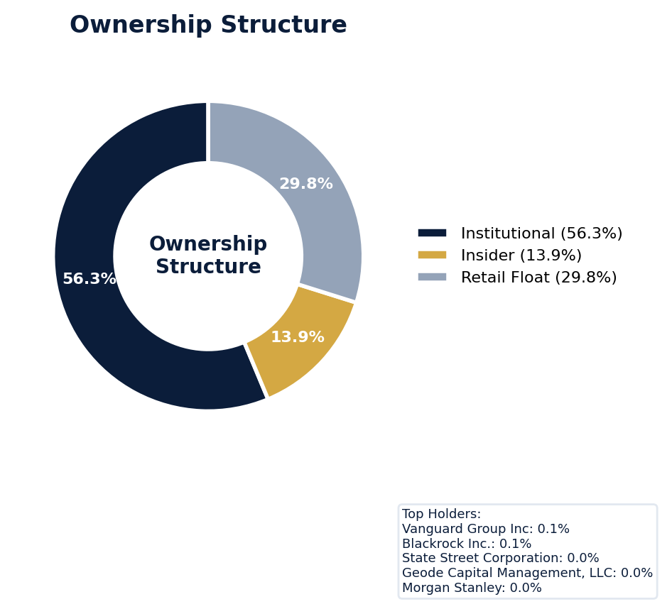
Figure: Ownership breakdown -- institutional, insider, retail float
Category | Percentage
Institutional Ownership | 56.3%
Insider Ownership | 13.9%
Retail Float | 29.8%
Top Holder | Ownership %
Vanguard Group Inc | 0.1%
Blackrock Inc. | 0.1%
State Street Corporation | 0.0%
Geode Capital Management, LLC | 0.0%
Morgan Stanley | 0.0%
Sentiment & Narrative Coherence
Signal | Assessment
Narrative Coherence | COHERENT
Anti-Takeover Provisions
Anti-takeover provision data not available. Review DEF 14A and charter documents for complete analysis.

CRITICAL RISK
Super Micro currently faces three active SCAs, including the *In re Super Micro Computer, Inc. Securities Litigation (2024)* with a class period from April 30, 2024, to March 19, 2026, led by top-tier plaintiffs' firms Robbins Geller, Frank R. Cruz, and Glancy Prongay. The company's adjusted SCA filing rate of 11.18% more than doubles the 5.0% sector average, indicating a severe recurrence probability that demands a material surcharge. With six open solicitation campaigns actively building plaintiff groups and no SEC enforcement stage yet, we face a heightened risk of a corrective disclosure event that will amplify these class actions; defense costs alone will be material given the MODERATE defense strength and the complex, fact-intensive allegations around revenue recognition and supply chain disclosures, which are prevalent industry patterns. The absence of any prior settlement history for benchmarking is a critical blind spot, forcing us to extrapolate from peer hardware companies while accounting for Super Micro's uniquely elevated filing frequency, which is more than twice the sector norm.
Section 6: Litigation & Regulatory Exposure
The company faces 3 active securities class action(s). The primary case, In re Super Micro Computer, Inc. Securities Litigation (2024), is currently pending. Industry claim exposure: revenue_recognition, supply_chain_disclosure, ip_misrepresentation. 6 statute of limitations window(s) remain open, meaning new claims can still be filed for past events. Under claims-made D&O policy, coverage is triggered when a claim is reported during the policy period. Defense quality assessment: MODERATE.
Litigation Overview: 2 active matter(s), 2 historical matter(s)
Litigation Timeline
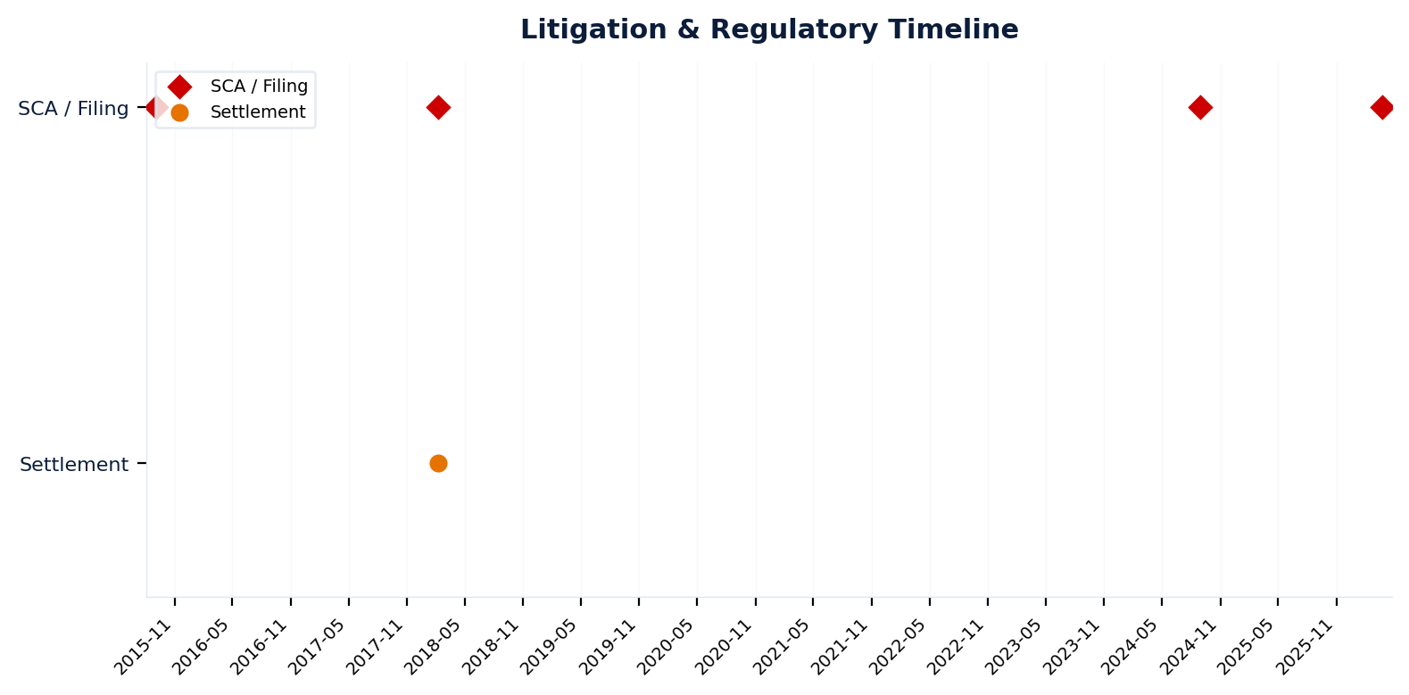
Figure: Chronological litigation and regulatory events overlaid with corporate events for pattern recognition
Securities Class Actions
Case Name | Legal Theory | Coverage | Court | Filing Date | Status | Class Period | Lead Counsel | Settlement | Source
In re Super Micro Computer, Inc. Securities (2026) | N/A | Regulatory | N.D. Cal. | 2026-03-25 | ACTIVE | N/A | Robbins Geller; Frank R. Cruz; Glancy Prongay | N/A | [web search, 2026-04-03, LOW]
In re Super Micro Computer, Inc. Securities Litigation (2024) | Rule 10b-5 | Side C (Entity) | N/A | 2024-08-30 | ACTIVE | N/A | N/A | N/A | [Supabase SCA database, 2026-04-03, MEDIUM]
In re Super Micro Computer, Inc. Securities Litigation (2018) | Rule 10b-5 | Side C (Entity) | N/A | 2018-02-08 | SETTLED | N/A | N/A | $3.4M | [Supabase SCA database, 2026-04-03, MEDIUM]
In re Super Micro Computer, Inc. Securities Litigation (2015) | Rule 10b-5 | Side C (Entity) | N/A | 2015-09-04 | DISMISSED | N/A | N/A | N/A | [Supabase SCA database, 2026-04-03, MEDIUM]
[HIGH] 1 Active Securities Class Action(s) -- triggered Active SCA Status (F1) — this agent risk (executive/director actions and decisions that create D&O exposure) indicates Litigation History / Settlement Patterns. Evidence: Boolean check: Active case.
Context: Cases with PSLRA safe harbor and forum selection provisions settle at 40% lower median amounts.
See Meeting Prep: Active Litigation
D&O Context: Historical settlements total $3.4M. Settlement history establishes severity baseline for pricing. [ELEVATED]
SEC Enforcement Pipeline
Pipeline: (Comment Letters) -> (Informal Inquiry) -> (Formal Investigation) -> (Wells Notice) -> (Enforcement Action)
No SEC enforcement pipeline activity detected. [10-K Item 3 + Item 1A + 8-K + EFTS, 2026-04-03, LOW]
Derivative Suits
No derivative suit history found.
Regulatory Proceedings
Agency | Type | Status
DOJ_FCPA | investigation | disclosed
DOJ | investigation | disclosed
Industry Claim Patterns
Legal Theory | Exposed | Contagion Risk | Description
Revenue Recognition | Yes | Yes | [Technology Hardware] Premature or fraudulent revenue recogn
Supply Chain Disclosure | Yes | Yes | [Technology Hardware] Failure to disclose supply chain disru
Ip Misrepresentation | Yes | Yes | [Technology Hardware] Overstating IP portfolio value or prot
D&O Context: Company exposed to 3 industry claim pattern(s). Peer lawsuits create contagion risk -- plaintiff firms often file similar claims across the industry. [ELEVATED]
Statute of Limitations Map
Claim Type | Trigger Date | SOL Expiry | Repose Expiry | Window Open
employment_discrimination | 2025-08-28 | 2027-08-28 | 2027-08-28 | OPEN
antitrust | 2025-08-28 | 2029-08-27 | 2029-08-27 | OPEN
FCPA | 2025-08-28 | 2030-08-27 | 2030-08-27 | OPEN
environmental | 2025-08-28 | 2030-08-27 | 2030-08-27 | OPEN
derivative | 2025-08-28 | 2028-08-27 | 2031-08-27 | OPEN
ERISA | 2025-08-28 | 2028-08-27 | 2031-08-27 | OPEN
Section_11 | 2015-09-04 | 2016-09-03 | 2018-09-03 | CLOSED
Section_14a | 2015-09-04 | 2016-09-03 | 2018-09-03 | CLOSED
10b-5 | 2015-09-04 | 2017-09-03 | 2020-09-02 | CLOSED
D&O Context: 6 open exposure window(s). Claims can still be filed within these periods. [ELEVATED]
Defense Strength Assessment
Factor | Assessment
Federal Forum Provision | No
Exclusive Forum Provision | No
PSLRA Safe Harbor | MODERATE
Truth-on-Market Viability | VIABLE
Prior Dismissal Success | No prior dismissals identified in Item 3
Overall Defense Strength | MODERATE
No forum selection provisions identified. Safe harbor usage is MODERATE with standard forward-looking statement protections. Additional defense factors include viable truth-on-the-market defense. [DEF 14A; 10-K, 2026-04-03, LOW]
Contingent Liabilities
No disclosed contingent liabilities found in SEC filings. Review Item 8 footnotes and Item 3 for complete assessment.
Workforce, Product & Environmental Matters
Cybersecurity Incidents:
- [data_breach] g attempts by malicious actors, including through hacking, malware, ransomware, denial-of-service attacks, social engineering, exploitation of internet-connected devices, and other attacks, to obtain unauthorized access to, acquire or misuse confidential information, or to disrupt service reliability and threaten the confidentiality, integrity and availability of our systems and information we process.
- [data_breach] Additionally, while our security systems are designed to maintain the physical security of our facilities and information systems, accidental or willful security breaches or incidents or other unauthorized access by third parties to our facilities or our information systems could lead to unauthorized access to, or misappropriation, disclosure, or other processing of proprietary, confidential and other information.
- [data_breach] f our facilities and information systems, accidental or willful security breaches or incidents or other unauthorized access by third parties to our facilities or our information systems could lead to unauthorized access to, or misappropriation, disclosure, or other processing of proprietary, confidential and other information.
- [data_breach] y system failure, disruption, accident or security breach or incident affecting us or our third-party service providers could result in disruptions to our operations and loss or unavailability of, or unauthorized access or damage to, inappropriate access to, or use, disclosure or other processing of confidential information and other information maintained or otherwise processed by us.
- [cyber_attack] Like other companies, we are subject to ongoing attempts by malicious actors, including through hacking, malware, ransomware, denial-of-service attacks, social engineering, exploitation of internet-connected devices, and other attacks, to obtain unauthorized access to, acquire or misuse confidential information, or to disrupt service reliability and threaten the confidentiality, integrity and availability of our systems
- [cyber_attack] Additionally, cybersecurity researchers have warned of increased risks of cyber-attacks, in connection with the Russia-Ukraine war.
- [cyber_attack] to mitigate these potential risks, including through information security policies, employee awareness and training, there is no assurance that such actions have been or will be sufficient to prevent cyber-attacks or security breaches or incidents.
Whistleblower Indicators
No whistleblower indicators identified in SEC filings. SEC whistleblower tips are not publicly disclosed; absence does not confirm lack of activity.

Super Micro's Quality Score of 33/100 places it in the WATCH tier with a 6.4-9.2% claim probability, driven by a 12.64-point deduction from key risk factors. The risk profile is dominated by an active securities class action and a catastrophic stock drop, which impose a binding CRF-9 ceiling and reflect severe, ongoing litigation exposure that directly increases D&O claim severity. A history of prior litigation, contributing a 4.92-point deduction, and specific guidance misses exceeding 15% versus forecasts compound this, indicating a pattern of operational volatility that fuels plaintiff allegations of misleading disclosures. The active "Guidance Track Record" pattern, supported by 28 signals, confirms this is a recurrent governance concern that plaintiffs will target. Underwrite this with extreme caution; the combination of live litigation, volatile guidance, and elevated short interest (a 1.55-point deduction) creates a predictable plaintiff narrative that demands senior review and aggressive pricing.
Section 7: Risk Scoring & Synthesis
Underwriting tier: **WATCH** (quality score: 33.0/100). Recommended action: Write carefully, senior review required. Expected claim probability band: 6.4-9.2%. Top risk contributors: Prior Litigation (F1: -4.9 pts); Guidance Misses (F5: -1.7 pts); Short Interest (F6: -1.5 pts). Active composite patterns: Guidance Track Record. **Red flag gates active**: Active Securities Class Action (ceiling: 55); Catastrophic Stock Drop (ceiling: 55); Recent Drop - 7 Day (ceiling: 50); Recent Drop - 30 Day (ceiling: 50); Recent Drop - 90 Day (ceiling: 50). Binding ceiling: CRF-9. Claim probability band: ELEVATED (6.4%-9.2%).
Tier Classification
Metric | Value
Quality Score | 33.0 / 100
Composite Score (pre-ceiling) | 87.4
Total Risk Points Deducted | 12.6
Tier | WATCH
Tier Range | 31 - 50
Action Guidance | Write carefully, senior review required
Probability Range | 6.4-9.2%
Pricing Multiplier | 1.5-2x + attachment
Binding Ceiling | CRF-9
Risk Assessment: HIGH [HIGH]
D&O Claim Peril Assessment
1 of 8 D&O claim perils show active risk signals. Active perils have at least one causal chain with triggered checks.
Peril | Risk Level | Active Chains | Key Evidence
Securities Claims | ELEVATED | 2/5 | Resolved via web search: confirmed; Verified (value: -2.32)
Fiduciary Breach | LOW | 0/3 | —
Government Enforcement | LOW | 0/2 | —
Employment & Whistleblower | LOW | 0/1 | —
Insolvency & Bankruptcy | LOW | 0/1 | —
Emerging Risks | LOW | 0/2 | —
Consumer & Product Claims | LOW | 0/1 | —
Commercial Litigation | LOW | 0/1 | —
Active Peril Analysis
Securities Claims: ELEVATED [ELEVATED]
Frequency: moderate | Severity: high | Typical range: $5M - $500M+
2 of 5 causal chains active.
Chain: Restatement → Securities Class Action [ELEVATED]
Financial restatement (especially revenue/earnings) triggers near-automatic SCA filing. Restatements provide strong scienter evidence for plaintiffs.
Triggers:
• FIN.ACCT.restatement
Amplifiers:
• FIN.ACCT.material_weakness
• FIN.ACCT.internal_controls
• FIN.ACCT.restatement_pattern
Historical filing rate: 65% | Median severity: $25M
Chain: Guidance Miss → Securities Fraud [ELEVATED]
Repeated guidance misses or aggressive forward guidance builds scienter case for securities fraud claim when stock eventually declines.
Triggers:
• FIN.GUIDE.earnings_reaction
Amplifiers:
• GOV.INSIDER.executive_sales
Historical filing rate: 8% | Median severity: $12M
Composite Score Breakdown
Factor | Name | Max Pts | Deducted | % Used | Top Contributor
F1 | Prior Litigation | 20 | 4.9 | 25% | Signal-driven scoring: 66 signals, coverage=100%
F2 | Stock Decline | 15 | 1.1 | 7% | Signal-driven scoring: 29 signals, coverage=100%
F3 | Restatement/Audit Issues | 12 | 1.1 | 9% | Signal-driven scoring: 84 signals, coverage=100%
F4 | IPO/SPAC/M&A | 10 | 0.9 | 9% | Signal-driven scoring: 17 signals, coverage=100%
F5 | Guidance Misses | 13 | 1.7 | 13% | Signal-driven scoring: 28 signals, coverage=100%
F6 | Short Interest | 8 | 1.5 | 19% | Signal-driven scoring: 23 signals, coverage=100%
F7 | Stock Volatility | 7 | 0.4 | 6% | Signal-driven scoring: 30 signals, coverage=100%
F8 | Financial Distress | 5 | 0.0 | 0% | Signal-driven scoring: 15 signals, coverage=100%
F9 | Governance Issues | 6 | 0.8 | 14% | Signal-driven scoring: 40 signals, coverage=100%
F10 | Officer Stability | 2 | 0.1 | 6% | Signal-driven scoring: 85 signals, coverage=100%
10-Factor Risk Profile
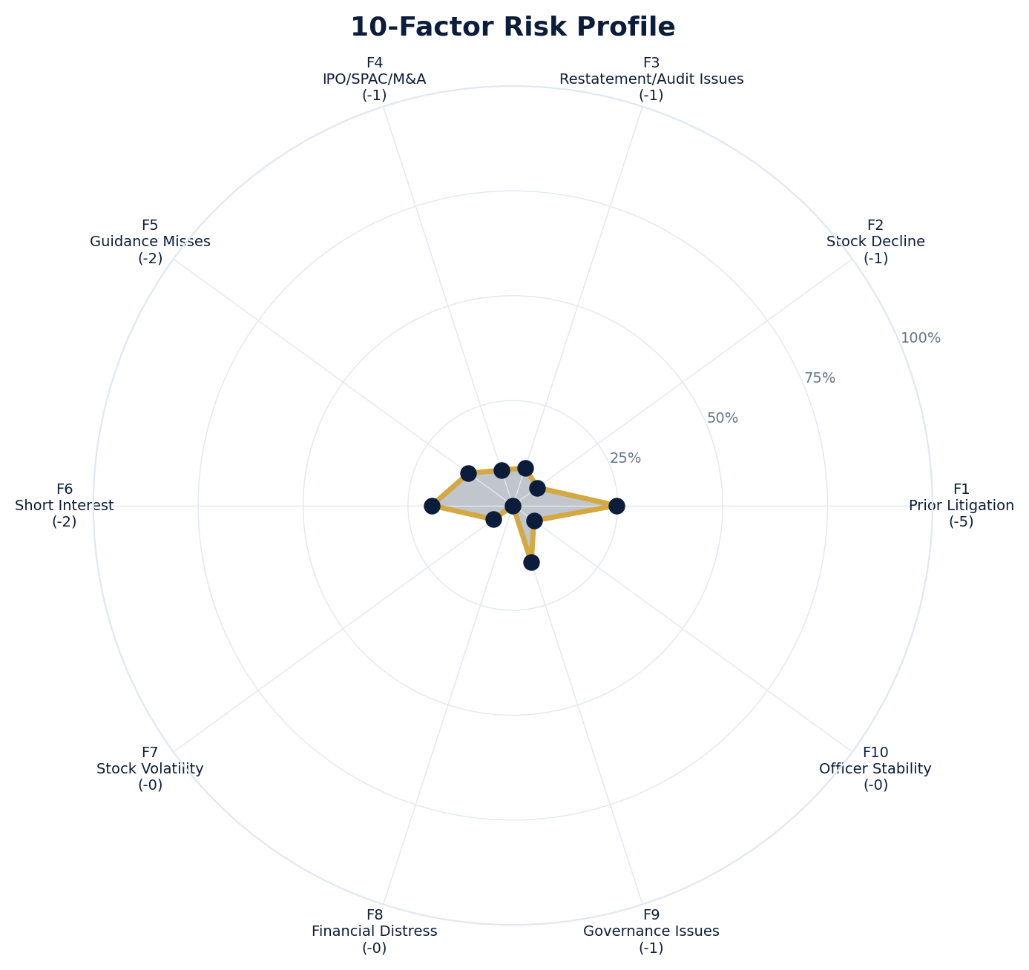
Figure: Radar chart showing risk fraction (points deducted / max) for each of the 10 scoring factors. Larger area = higher risk.
Red Flag Gates
Severity | Description | Source | Impact | Trajectory
CRITICAL | Critical Red Flag: Active Securities Class Action | Active SCA: In re Super Micro Computer, Inc. Securities Litigation (2024) | Ceiling: 55 | NEW
CRITICAL | Critical Red Flag: Catastrophic Stock Drop | Stock decline 62.8% from 52-week high | Ceiling: 55 | NEW
CRITICAL | Critical Red Flag: Recent Drop - 7 Day | 7-day drop: 33.8% (3 days ago) | Ceiling: 50 | NEW
CRITICAL | Critical Red Flag: Recent Drop - 30 Day | 30-day drop: 33.3% (13 days ago) | Ceiling: 50 | NEW
CRITICAL | Critical Red Flag: Recent Drop - 90 Day | 90-day drop: 33.3% (13 days ago) | Ceiling: 50 | NEW
LOW | Prior Litigation: 5/20 points | Signal-driven scoring: 66 signals, coverage=100% | F1: 5 pts | NEW
LOW | Stock Decline: 1/15 points | Signal-driven scoring: 29 signals, coverage=100%; Drop contribution modifier: 0.32x (decay + company-specific + disclosure) | F2: 1 pts | NEW
LOW | Restatement/Audit Issues: 1/12 points | Signal-driven scoring: 84 signals, coverage=100% | F3: 1 pts | NEW
LOW | IPO/SPAC/M&A: 1/10 points | Signal-driven scoring: 17 signals, coverage=100% | F4: 1 pts | NEW
LOW | Guidance Misses: 2/13 points | Signal-driven scoring: 28 signals, coverage=100%; Any single miss >15% vs guidance | F5: 2 pts | NEW
LOW | Short Interest: 2/8 points | Signal-driven scoring: 23 signals, coverage=100% | F6: 2 pts | NEW
LOW | Stock Volatility: 0/7 points | Signal-driven scoring: 30 signals, coverage=100% | F7: 0 pts | NEW
LOW | Governance Issues: 1/6 points | Signal-driven scoring: 40 signals, coverage=100% | F9: 1 pts | NEW
LOW | Officer Stability: 0/2 points | Signal-driven scoring: 85 signals, coverage=100% | F10: 0 pts | NEW
LOW | Pattern: Guidance Track Record (BASELINE) | Pattern evaluation | F5: 0 | NEW
Critical: 5, High: 0, Moderate: 0, Low: 10
Risk Type Classification
Attribute | Value
Primary Risk Type | GUIDANCE_DEPENDENT
Supporting Evidence | F5 guidance misses: 1.7 points; Issues guidance (philosophy: MIXED)
Severity Scenarios
Analysis based on market cap: $13.9B
Percentile | Label | Settlement Est. | Defense Costs | Total Exposure
25th | favorable | $2.4B | $360.4M | $2.8B
50th | median | $4.8B | $961.2M | $5.8B
75th | adverse | $9.6B | $2.4B | $12.0B
95th | catastrophic | $19.2B | $5.8B | $25.0B
Calibration Notes (SECT7-11)
The following items are flagged NEEDS CALIBRATION and require expert review before final pricing:
- SECT7-11: All scoring parameters require calibration against historical cases
Factor Detail
Factor | Name | Deducted | Rules Triggered | Evidence
F1 | Prior Litigation | 4.9 | N/A | Signal-driven scoring: 66 signals, coverage=100%
F2 | Stock Decline | 1.1 | drop_contribution_adjustment | Signal-driven scoring: 29 signals, coverage=100%; Drop contribution modifier: 0.32x (decay + company-specific + disclosure)
F3 | Restatement/Audit Issues | 1.1 | N/A | Signal-driven scoring: 84 signals, coverage=100%
F4 | IPO/SPAC/M&A | 0.9 | N/A | Signal-driven scoring: 17 signals, coverage=100%
F5 | Guidance Misses | 1.7 | F5-006 | Signal-driven scoring: 28 signals, coverage=100%; Any single miss >15% vs guidance
F6 | Short Interest | 1.5 | N/A | Signal-driven scoring: 23 signals, coverage=100%
F7 | Stock Volatility | 0.4 | N/A | Signal-driven scoring: 30 signals, coverage=100%
F9 | Governance Issues | 0.8 | N/A | Signal-driven scoring: 40 signals, coverage=100%
F10 | Officer Stability | 0.1 | N/A | Signal-driven scoring: 85 signals, coverage=100%
Sub-Component Breakdown
Factor | Component | Value
F1 | base | 4.92
F1 | bonus | 0.00
F1 | modifiers | 0.00
F1 | hard_triggers | 0.00
F1 | total_before_cap | 4.92
F1 | capped | 4.92
F2 | base | 3.40
F2 | bonus | 0.00
F2 | modifiers | 0.00
F2 | hard_triggers | 0.00
F2 | drop_contribution_modifier | 0.32
F2 | total_before_cap | 1.08
F2 | capped | 1.08
F3 | base | 1.33
F3 | bonus | 0.00
F3 | modifiers | 0.00
F3 | hard_triggers | 0.00
F3 | total_before_cap | 1.33
F3 | capped | 1.33
F3 | ies_amplification | 0.85
F4 | base | 0.88
F4 | bonus | 0.00
F4 | modifiers | 0.00
F4 | hard_triggers | 0.00
F4 | total_before_cap | 0.88
F4 | capped | 0.88
F5 | base | 0.00
F5 | bonus | 2.00
F5 | modifiers | 0.00
F5 | hard_triggers | 0.00
F5 | total_before_cap | 2.00
F5 | capped | 2.00
F5 | pattern_modifier | 0.00
F5 | ies_amplification | 0.85
F6 | base | 1.82
F6 | bonus | 0.00
F6 | modifiers | 0.00
F6 | hard_triggers | 0.00
F6 | total_before_cap | 1.82
F6 | capped | 1.82
F6 | ies_amplification | 0.85
F7 | base | 0.47
F7 | bonus | 0.00
F7 | modifiers | 0.00
F7 | hard_triggers | 0.00
F7 | total_before_cap | 0.47
F7 | capped | 0.47
F7 | ies_amplification | 0.85
F9 | base | 1.00
F9 | bonus | 0.00
F9 | modifiers | 0.00
F9 | hard_triggers | 0.00
F9 | total_before_cap | 1.00
F9 | capped | 1.00
F9 | ies_amplification | 0.85
F10 | base | 0.12
F10 | bonus | 0.00
F10 | modifiers | 0.00
F10 | hard_triggers | 0.00
F10 | total_before_cap | 0.12
F10 | capped | 0.12
Pattern Detection Results
Pattern | Severity | Triggers Matched | Score Impact
Guidance Track Record | BASELINE |  | F5: +0
Allegation Theory Mapping
Theory | Exposure | Factor Sources | Key Findings
A_DISCLOSURE | MODERATE | F1, F3, F5 | F1: Signal-driven scoring: 66 signals, coverage=100%; F3: Signal-driven scoring: 84 signals, coverage=100%
B_GUIDANCE | LOW | F2, F5 | F2: Signal-driven scoring: 29 signals, coverage=100%; F2: Drop contribution modifier: 0.32x (decay + company-specific + disclosure)
C_PRODUCT_OPS | LOW | F7 | F7: Signal-driven scoring: 30 signals, coverage=100%; 2 regulatory proceedings
D_GOVERNANCE | LOW | F9, F10 | F9: Signal-driven scoring: 40 signals, coverage=100%; F10: Signal-driven scoring: 85 signals, coverage=100%
E_MA | LOW | F4 | F4: Signal-driven scoring: 17 signals, coverage=100%
D&O Context: Primary allegation exposure is A_DISCLOSURE. MODERATE exposure in: A_DISCLOSURE.
Claim Probability Detail
Metric | Value
Probability Band | ELEVATED
Range | 6.4% - 9.2%
Industry Base Rate | 5.0%
Adjustment Rationale | Industry base rate: 5.0%. Tier WATCH (10-15%): Significantly above base rate. Co
Claim probability: ELEVATED [HIGH]
Tower Position Recommendation
Metric | Value
Recommended Position | MID_EXCESS
Minimum Attachment | $4806.0M (based on 50th percentile settlement)
Side A/DIC Assessment | Standard Side A considerations
Position | Risk Assessment | Premium Guidance | Attachment
PRIMARY | Primary layer carries 57% of expected loss exposur | Full rate, slight discount for | $0 ground-up
LOW_EXCESS | Low excess layer carries 18% of expected loss expo | Market rate | $5-15M xs $5-15M
MID_EXCESS | Mid excess layer carries 13% of expected loss expo | Market to 1.3x | $15-50M xs $15-50M
HIGH_EXCESS | High excess layer carries 11% of expected loss exp | 1.3-2x with attachment | $50M+ xs $50M+
DECLINE | WALK+ with compounding factors | N/A | N/A
Forensic Composite Scores
Composite | Score | Interpretation
Financial Integrity Score (FIS) | N/A | Not available
Reporting Quality Score (RQS) | N/A | Not available
Cash Flow Quality Score (CFQS) | N/A | Not available
Executive Risk Profile
Metric | Value
Weighted Score | 17
Risk Level | N/A
- [Charles Liang (CEO)]: Prior litigation: title: A Letter From CEO Charles Liang - Super Micro Computer, Inc.
- [Charles Liang (CEO)]: Prior litigation: url: https://ir.supermicro.com/news/news-details/2026/A-Letter-From-CEO-Charles-Liang-2026-LfRyW8BDw
- [Charles Liang (CEO)]: Prior litigation: snippet: SUPER MICRO COMPUTER, INC.,. CHARLES LIANG, and DAVID WEIGAND,. Defendants. Case No. CLASS
- [To Serve As (Director)]: Prior litigation: title: Super Micro Computer, Inc. Class Action Lawsuit - SMCI
- [To Serve As (Director)]: Prior litigation: url: https://www.rgrdlaw.com/cases-super-micro-computer-class-action-lawsuit-smci.html
- [To Serve As (Director)]: Prior litigation: snippet: The Super Micro class action lawsuit – captioned Bhuva v. Super Micro Computer, Inc., No. 2
Temporal Signals
Type | Direction | Magnitude | Description
Unknown | N/A | N/A
Unknown | N/A | N/A
Unknown | N/A | N/A
Unknown | N/A | N/A
Unknown | N/A | N/A
Unknown | N/A | N/A
Unknown | N/A | N/A
Unknown | N/A | N/A
NLP Filing Analysis
Metric | Value
Readability Score | {'current_fog': 19.98, 'prior_fog': None, 'fog_change': None, 'current_flesch': 21.5, 'prior_flesch': None, 'classification': 'CURRENT_ONLY', 'evidence': 'Current Fog Index: 20.0 (prior year unavailable)'}
Tone Assessment | N/A
Risk Language Density | N/A
Peril Assessment
Plaintiff Peril Heat Map
Plaintiff Type | Probability | Severity
Shareholders | ELEVATED | SIGNIFICANT
Regulators | ELEVATED | SIGNIFICANT
Customers | VERY LOW | NUISANCE
Competitors | VERY LOW | NUISANCE
Employees | LOW | MINOR
Creditors | LOW | MINOR
Government | MODERATE | MODERATE
Shareholders: 51 triggered checks. Key: Litigation History Profile: 3 (elevated vs benchmark of 0)
Regulators: 17 triggered checks. Key: Disclosure Complexity Score: 47 (elevated vs benchmark of 40)
Government: 3 triggered checks. Key: Product Concentration: 2 (elevated vs benchmark of 1)
Bear Cases
Bear Case: A Disclosure
Super Micro Computer, Inc. faces elevated exposure to securities disclosure fraud claims. Key risk indicators: Litigation History Profile (critical); VIE/SPE Off-Balance-Sheet Structures (critical). Estimated severity is significant, warranting detailed underwriter review.
Defense: Defense: No active Section 11 windows — statute of limitations expired for offering claims
Evidence Chain
1. [BIZ.CLASS.litigation_history] Litigation History Profile (Source: total_sca_count)
2. [BIZ.STRUCT.vie_spe] VIE/SPE Off-Balance-Sheet Structures (Source: vie_spe_present)
3. [BIZ.DEPEND.regulatory_dep] Single-Source Suppliers (Source: regulatory_dependency_count)
4. [BIZ.DEPEND.macro_sensitivity] Supply Chain Complexity (Source: macro_sensitivity_count)
5. [BIZ.EVENT.ipo_exposure] IPO/Offering Exposure Window (Source: event_ipo_exposure_score)
6. [BIZ.OPS.workforce] Workforce Distribution (Source: workforce_distribution)
7. [BIZ.STRUC.disclosure_complexity] Disclosure Complexity Score (Source: disclosure_complexity_score)
8. [BIZ.STRUC.obs_exposure] Off-Balance-Sheet Exposure (Source: obs_exposure_score)
9. [EXEC.PRIOR_LIT.any_officer] Any Officer With Prior Litigation at Previous Company (Source: value)
10. [EXEC.PRIOR_LIT.ceo_cfo] CEO or CFO With Prior Litigation (Source: value)
Probability: ELEVATED | Severity: SIGNIFICANT
Settlement Prediction
Settlement prediction computed but no scenarios available.
Tower Risk Characterization
Tower characterization not available.
Coverage Gaps -- Data Not Available
The following checks could not be evaluated because required data was not acquired. These items are NOT cleared -- they represent gaps in coverage that should be considered in the underwriting decision.
Company Profile & Industry
[REQUIRED] FWRD.EVENT.shareholder_mtg (Shareholder Meeting Date): Required data not available from filings
[REQUIRED] FWRD.EVENT.proxy_deadline (Proxy Deadline): Required data not available from filings
Executive Summary & Key Metrics
[EVALUATIVE] BIZ.DEPEND.labor (Concentration Risk Composite): Required data not available from filings
[REQUIRED] BIZ.MODEL.lifecycle (Segment Lifecycle Risk): Required data not available from filings
[REQUIRED] BIZ.MODEL.segment_margins (Segment Margin Profile): Required data not available from filings
[EVALUATIVE] DISC.YOY.new_risk_factors (New Risk Factors (YoY)): No trend data available for field
[EVALUATIVE] DISC.YOY.removed_risk_factors (Removed Risk Factors (YoY)): No trend data available for field
[EVALUATIVE] DISC.YOY.escalated_risk_factors (Escalated Risk Factors (YoY)): No trend data available for field
[EVALUATIVE] DISC.YOY.material_weakness (Material Weakness Change): No trend data available for field
[EVALUATIVE] DISC.YOY.controls_changed (Internal Controls Disclosure Change): No trend data available for field
[EVALUATIVE] DISC.YOY.legal_proceedings_delta (Legal Proceedings Change (YoY)): No trend data available for field
[EVALUATIVE] ABS.DISC.audit_fees (Missing Audit Fee Disclosure): Expected signals not found in evaluation results
[EVALUATIVE] ABS.DISC.board_independence (Missing Board Independence Disclosure): Could not determine disclosure presence or absence
[EVALUATIVE] ABS.DISC.clawback_policy (Missing Clawback Policy Disclosure): Expected signals not found in evaluation results
[EVALUATIVE] ABS.DISC.cyber_risk (Missing Cybersecurity Risk Disclosure): Expected signals not found in evaluation results
[EVALUATIVE] ABS.DISC.debt_covenants (Missing Debt Covenant Disclosure): Expected signals not found in evaluation results
[EVALUATIVE] ABS.DISC.derivative_instruments (Missing Derivative Instruments Disclosure): Expected signals not found in evaluation results
[EVALUATIVE] ABS.DISC.esg (Missing ESG Disclosure): Expected signals not found in evaluation results
[EVALUATIVE] ABS.DISC.executive_comp (Missing Executive Compensation Disclosure): Expected signals not found in evaluation results
[EVALUATIVE] ABS.DISC.goodwill_impairment (Missing Goodwill Impairment Disclosure): Expected signals not found in evaluation results
[EVALUATIVE] ABS.DISC.lease_obligations (Missing Lease Obligation Disclosure): Expected signals not found in evaluation results
[EVALUATIVE] ABS.DISC.litigation_contingency (Missing Litigation Contingency Disclosure): Expected signals not found in evaluation results
[EVALUATIVE] ABS.DISC.pension_obligations (Missing Pension Obligation Disclosure): Expected signals not found in evaluation results
[EVALUATIVE] ABS.DISC.related_party (Missing Related-Party Transaction Disclosure): Expected signals not found in evaluation results
[EVALUATIVE] ABS.DISC.revenue_recognition (Missing Revenue Recognition Policy Disclosure): Expected signals not found in evaluation results
[EVALUATIVE] ABS.DISC.risk_factors (Missing Risk Factor Disclosure): Expected signals not found in evaluation results
[EVALUATIVE] ABS.DISC.segment_reporting (Missing Segment Reporting Disclosure): Expected signals not found in evaluation results
[EVALUATIVE] ABS.DISC.stock_comp (Missing Stock Compensation Disclosure): Expected signals not found in evaluation results
[EVALUATIVE] ABS.DISC.tax_positions (Missing Uncertain Tax Position Disclosure): Expected signals not found in evaluation results
[EVALUATIVE] CONJ.COMP.perf_divergence (Compensation-Performance Divergence): 3/3 component signals unavailable
[EVALUATIVE] CONJ.DISTRESS.insider (Financial Distress + Insider Selling): 2/3 component signals unavailable
[EVALUATIVE] CONJ.GOV.governance_event (Weak Governance + Adverse Event): 3/5 component signals unavailable
[EVALUATIVE] CONJ.FIN.growth_margin_guidance (Rapid Growth + Margin Compression + Guidance Miss): 3/3 component signals unavailable
[EVALUATIVE] CONJ.INSIDER.news_gap (Insider Selling + Material News Gap): 3/3 component signals unavailable
[EVALUATIVE] CONJ.REG.litigation (Regulatory Action + New Material Litigation): 3/3 component signals unavailable
[EVALUATIVE] CTX.FIN.capex_sector (Capital Expenditure in Sector Context): Source signal FIN.INVEST.capex_ratio not in results
[EVALUATIVE] CTX.COMP.lifecycle (CEO Compensation in Lifecycle Context): Source signal EXEC.COMP.ceo_total_comp not in results
[EVALUATIVE] CTX.COMP.product_tower (Compensation Severity by Product/Tower): Source signal EXEC.COMP.ceo_total_comp not in results
[EVALUATIVE] CTX.FIN.debt_maturity (Debt Maturity Profile in Lifecycle Context): Source signal FIN.DEBT.maturity_profile not in results
[EVALUATIVE] CTX.FIN.distress_product (Financial Distress by Product/Tower): Source signal FIN.FORENSIC.altman_z not in results
[EVALUATIVE] CTX.FIN.dividend_lifecycle (Dividend Policy in Lifecycle Context): Source signal FIN.RETURN.dividend_yield not in results
[EVALUATIVE] CTX.EXEC.tenure_lifecycle (Executive Tenure in Lifecycle Context): Source signal EXEC.TURN.c_suite not in results
[EVALUATIVE] CTX.MKT.insider_lifecycle (Insider Trading in Lifecycle Context): Source signal STOCK.INSIDER.net_selling not in results
[EVALUATIVE] CTX.FIN.leverage_sector (Leverage in Sector Context): Source signal FIN.DEBT.leverage_ratio not in results
[EVALUATIVE] CTX.LIT.size (Litigation Frequency by Company Size): Source signal LIT.SCA.active_cases not in results
[EVALUATIVE] CTX.RISK.ma_lifecycle (M&A Activity in Lifecycle Context): Source signal BIZ.MA.acquisition_activity not in results
[EVALUATIVE] CTX.RISK.regulatory_sector (Regulatory Risk in Sector Context): Source signal LIT.SEC.enforcement not in results
[EVALUATIVE] CTX.RISK.rpt_sector (Related-Party Risk in Sector Context): Source signal GOV.RPT.related_party not in results
[EVALUATIVE] CTX.MKT.short_interest_sector (Short Interest in Sector Context): Source signal STOCK.SHORT.interest_ratio not in results
[EVALUATIVE] CTX.MKT.turnover_sector (Stock Turnover in Sector Context): Source signal STOCK.VOL.turnover_rate not in results
[EVALUATIVE] CTX.MKT.volatility_sector (Stock Volatility in Sector Context): Source signal STOCK.VOL.historical not in results
Financial Health
[EVALUATIVE] FIN.PEER.revenue_bottom_quartile (Revenue Bottom Quartile (Cross-Filer)): No peer comparison data available
[EVALUATIVE] FIN.PEER.leverage_top_decile (Leverage Top Decile (Sector-Relative)): No peer comparison data available
[EVALUATIVE] FIN.PEER.margin_compression (Operating Margin Compression (Cross-Filer)): No peer comparison data available
[EVALUATIVE] FIN.PEER.profitability_laggard (Profitability Laggard (Sector-Relative)): No peer comparison data available
[EVALUATIVE] FIN.PEER.size_outlier_small (Size Outlier Small (Cross-Filer)): No peer comparison data available
[EVALUATIVE] FIN.PEER.cash_flow_weak (Cash Flow Weakness (Cross-Filer)): No peer comparison data available
[EVALUATIVE] LIT.DEFENSE.forum_selection (Federal Forum Selection Clause): Required data not available from filings
Governance & Leadership
[EVALUATIVE] EXEC.INSIDER.ceo_net_selling (CEO Net Seller of Stock): Required data not available from filings
[EVALUATIVE] EXEC.INSIDER.cfo_net_selling (CFO Net Seller of Stock): Required data not available from filings
[EVALUATIVE] EXEC.TENURE.cfo_new (CFO Tenure Less Than 2 Years): Data mapping not configured for this check
[REQUIRED] EXEC.PROFILE.board_size (Board Size (Number of Members)): Required data not available from filings
[REQUIRED] EXEC.PROFILE.independent_ratio (Board Independence Percentage): Required data not available from filings
[EVALUATIVE] EXEC.PROFILE.overboarded_directors (Directors Serving on 4+ Boards): Required data not available from filings
[EVALUATIVE] GOV.BOARD.size (Board Size): Required data not available from filings
[EVALUATIVE] GOV.BOARD.independence (Board Independence): Required data not available from filings
[EVALUATIVE] GOV.BOARD.diversity (Board Diversity): Required data not available from filings
[EVALUATIVE] GOV.BOARD.tenure (Tenure): Required data not available from filings
[EVALUATIVE] GOV.BOARD.overboarding (Overboarding): Required data not available from filings
[EVALUATIVE] GOV.BOARD.attendance (Attendance): Required data not available from filings
[EVALUATIVE] GOV.BOARD.meetings (Meetings): Required data not available from filings
[EVALUATIVE] GOV.BOARD.succession (Succession): Required data not available from filings
[EVALUATIVE] GOV.EXEC.cfo_profile (CFO Profile): Required data not available from filings
[EVALUATIVE] GOV.PAY.ceo_total (Ceo Total): Required data not available from filings
[REQUIRED] GOV.PAY.ceo_structure (Ceo Structure): Required data not available from filings
[EVALUATIVE] GOV.PAY.peer_comparison (Peer Comparison): Required data not available from filings
[EVALUATIVE] GOV.PAY.say_on_pay (Say-on-Pay Results): Required data not available from filings
[EVALUATIVE] GOV.PAY.golden_para (Golden Para): Required data not available from filings
[EVALUATIVE] GOV.PAY.equity_burn (Equity Burn): Required data not available from filings
[EVALUATIVE] GOV.PAY.hedging (Hedging): Required data not available from filings
[REQUIRED] GOV.RIGHTS.bylaws (Bylaws): Required data not available from filings
[EVALUATIVE] GOV.RIGHTS.takeover (Takeover): Required data not available from filings
[EVALUATIVE] GOV.RIGHTS.proxy_access (Proxy Access): Required data not available from filings
[REQUIRED] GOV.RIGHTS.forum_select (Forum Select): Required data not available from filings
[EVALUATIVE] GOV.RIGHTS.supermajority (Supermajority): Required data not available from filings
[EVALUATIVE] GOV.RIGHTS.action_consent (Action Consent): Required data not available from filings
[EVALUATIVE] GOV.RIGHTS.special_mtg (Special Mtg): Required data not available from filings
[EVALUATIVE] GOV.RIGHTS.classified (Classified): Required data not available from filings
Market & Trading
[EVALUATIVE] FIN.ASSET.goodwill_equity_ratio (Goodwill/Intangible as % of Equity): Required data not available from filings
[EVALUATIVE] FIN.COMP.unvested_cost (Unvested SBC Pipeline): Required data not available from filings
[EVALUATIVE] FIN.COMP.rsu_grants (RSU Grant Trend): Required data not available from filings
[EVALUATIVE] FIN.CONT.loss_accrual (Loss Contingency Accrual): Required data not available from filings
[EVALUATIVE] FIN.CONT.loss_estimate (Loss Contingency Estimate): Required data not available from filings
[EVALUATIVE] FIN.DEBT.facility_utilization (Credit Facility Utilization): Required data not available from filings
[EVALUATIVE] FIN.DEBT.maturity_concentration (Debt Maturity Concentration): Data mapping not configured for this check
[EVALUATIVE] FIN.DERIV.notional_exposure (Derivative Notional Exposure): Required data not available from filings
[EVALUATIVE] FIN.DERIV.fair_value_risk (Derivative Fair Value Risk): Required data not available from filings
[EVALUATIVE] FIN.QUALITY.q4_revenue_concentration (Q4 Revenue Concentration): Required data not available from filings
[EVALUATIVE] FIN.QUALITY.revenue_recognition_risk (Revenue Recognition Risk Indicators): Data mapping not configured for this check
[EVALUATIVE] FIN.FORENSIC.level3_fair_value (Level 3 Fair Value Asset Concentration): Data mapping not configured for this check
[EVALUATIVE] FIN.FORENSIC.goodwill_deterioration_pattern (Goodwill Deterioration Pattern): Data mapping not configured for this check
[EVALUATIVE] FIN.FORENSIC.related_party_revenue (Related Party Revenue Concentration): Data mapping not configured for this check
[EVALUATIVE] FWRD.EVENT.ma_integration_risk (M&A Integration Risk): Data mapping not configured for this check
[EVALUATIVE] FIN.FORENSIC.goodwill_impairment_risk (Goodwill Impairment Risk): Data mapping not configured for this check
[EVALUATIVE] FIN.FORENSIC.intangible_concentration (Intangible Asset Concentration): Data mapping not configured for this check
[EVALUATIVE] FIN.FORENSIC.acquisition_effectiveness (Acquisition Effectiveness): Data mapping not configured for this check
[EVALUATIVE] FIN.FORENSIC.buyback_timing (Share Buyback Timing Quality): Data mapping not configured for this check
[EVALUATIVE] FIN.FORENSIC.dividend_sustainability (Dividend Sustainability): Data mapping not configured for this check
[EVALUATIVE] FIN.FORENSIC.deferred_tax_growth (Deferred Tax Liability Growth): Data mapping not configured for this check
[EVALUATIVE] FIN.FORENSIC.pension_underfunding (Pension Underfunding Risk): Data mapping not configured for this check
[EVALUATIVE] FIN.FORENSIC.dsri_elevated (Days Sales Receivable Index Elevated): Data mapping not configured for this check
[EVALUATIVE] FIN.FORENSIC.aqi_elevated (Asset Quality Index Elevated): Data mapping not configured for this check
[EVALUATIVE] FIN.FORENSIC.tata_elevated (Total Accruals to Total Assets Elevated): Data mapping not configured for this check
[EVALUATIVE] FIN.FORENSIC.non_gaap_gap (Non-GAAP to GAAP Earnings Gap): Data mapping not configured for this check
[EVALUATIVE] FIN.FORENSIC.goodwill_growth_rate (Goodwill Growth Rate): Data mapping not configured for this check
[EVALUATIVE] FIN.FORENSIC.acquisition_to_revenue (Acquisition Spend Relative to Revenue): Data mapping not configured for this check
[EVALUATIVE] FIN.PROFIT.revenue (Revenue Analysis): Required data not available from filings
[EVALUATIVE] FIN.GUIDE.track_record (Guidance Track Record): Required data not available from filings
[EVALUATIVE] FIN.RESTRUCT.charges (Restructuring Charges): Required data not available from filings
[EVALUATIVE] FIN.RESTRUCT.severance (Severance Costs): Required data not available from filings
[EVALUATIVE] FIN.IMPAIR.asset_writedown (Asset Impairment): Required data not available from filings
[EVALUATIVE] FIN.IMPAIR.intangible_writedown (Intangible Asset Impairment): Required data not available from filings
[REQUIRED] NLP.FILING.filing_timing_change (Filing Date Shifted Significantly vs Prior Year): Required data not available from filings
[EVALUATIVE] STOCK.INSIDER.notable_activity (Notable Activity): Required data not available from filings
[EVALUATIVE] STOCK.VALUATION.peg_ratio (Peg Ratio): Required data not available from filings
[EVALUATIVE] FIN.FORENSIC.m_score_composite (Beneish M-Score Composite (XBRL)): Data mapping not configured for this check
Gap breakdown: Required items: 10 | Evaluative checks: 116
Total: 126 checks data-unavailable out of 576 total checks (78% coverage)

Calibration Notes
System Intelligence Status
Checks active: 601
Checks incubating: 0 (pending human approval)
Pending feedback: 0 entries
Recent Calibration Changes
Date | Check | Change | Changed By
2026-04-02 | EMERGING_TECH_REGULATORY_GAP | Proposed by ingestion of 'blind_spot:COIN:SEC Sends Wells No | ingestion_pipeline
2026-04-02 | CRYPTO_HACKING_INCIDENTS | Proposed by ingestion of 'blind_spot:COIN:Coinbase Drops on | ingestion_pipeline
2026-04-02 | CRYPTO_SEC_INVESTIGATIONS | Proposed by ingestion of 'blind_spot:COIN:Coinbase Drops on | ingestion_pipeline
2026-04-02 | CRYPTO_REGULATORY_CLARITY | Proposed by ingestion of 'blind_spot:COIN:SEC Sends Wells No | ingestion_pipeline
2026-04-02 | CRYPTO_STAKING_REGULATORY | Proposed by ingestion of 'blind_spot:COIN:SEC Sends Wells No | ingestion_pipeline
2026-04-02 | crypto_cyber_incident_frequency | Proposed by ingestion of 'blind_spot:COIN:Coinbase Drops on | ingestion_pipeline
2026-04-02 | crypto_sec_investigation | Proposed by ingestion of 'blind_spot:COIN:Coinbase Drops on | ingestion_pipeline
2026-04-02 | AUDITOR_RESIGNATION_INTEGRITY | Proposed by ingestion of 'blind_spot:SMCI:Super Micro Comput | ingestion_pipeline
2026-04-02 | CHINA_SALES_DISCLOSURE | Proposed by ingestion of 'blind_spot:SMCI:Super Micro Comput | ingestion_pipeline
2026-04-02 | EXPORT_COMPLIANCE_CONTROLS | Proposed by ingestion of 'blind_spot:SMCI:Super Micro Comput | ingestion_pipeline
Discovery Findings
5 document(s) analyzed, 9 proposal(s) generated, from blind spot search
Feedback for SMCI
No pending feedback for SMCI.

