
Angry Dolphin -- D&O Underwriting Worksheet
UNITEDHEALTH GROUP INC (UNH)
Generated: April 02, 2026
[Table of Contents -- Update in Word]

**Underwriting Thesis: UNITEDHEALTH GROUP INC.**
UNITEDHEALTH GROUP INC.’s D&O risk profile is bifurcated, resulting in a **"WALK" tier** placement with a directive for **Excess/Side A only, requiring high attachment points**. The composite score of 90.09 is undermined by a 23.125 quality score and an **ELEVATED claim probability band of 6.96% to 9.94%**, driven by specific, material deductions. A **3.19-point deduction for Prior Litigation** (from 70 discrete signals) and a **2.31-point deduction for Restatement/Audit Issues** reflect a dense history of legal and regulatory entanglements that elevate fiduciary exposure. The critical **Altman Z-Score of 1.41**, below the 1.81 distress threshold, introduces a fundamental financial risk overlay to directors’ oversight duties, despite the positive note of a clean audit opinion. An active **internal whistleblower indicator** imposes a 100-point ceiling impact, signaling heightened internal control and culture risks not yet resolved in SEC filings. These headwinds are partially mitigated by the absence of SEC enforcement actions and stable C-suite tenure over the past 18 months. However, the **14.74% inherent risk percentage** and the concentration of deductions in litigation and governance necessitate structuring that isolates catastrophic risk, avoiding primary layers. Consequently, capacity should be restricted to high-excess placements, aligning with the profile of a large-cap ($251.7B market cap) entity with systemic operational complexity that crystallizes in elevated, though not severe, claim frequency.
Executive Summary
Underwriting Thesis
UNITEDHEALTH GROUP INC is a $251.7B (Decile 1 of 10) mega-cap financials company that would normally present as a stronger underwriting account were it not for critical red flags: Distress Zone (Altman Z < 1.81) and Whistleblower/Qui Tam Disclosure. These findings impose a hard quality score ceiling of 25, placing the account in WALK tier (23/100) regardless of other favorable factors. Financial distress indicators are concerning (Z-Score 1.41), elevating going-concern and creditor-related D&O exposure. The primary risk driver is Prior Litigation, driving elevated risk in this area. Signal-driven scoring: 70 signals, coverage=100%. At a 7-10% claim probability (14.7% adjusted rate, 3.7x the Financials sector baseline of 4.0%), this account requires high-excess positioning with elevated attachment.
Company Snapshot
Attribute | Value | Source
Company | UNITEDHEALTH GROUP INC
Ticker | UNH
Exchange | NYSE
Sector | Healthcare
Industry | Healthcare Plans
Market Cap | $251.7B [Decile 1 (largest ~400 accounts)] (Ranks at the 56th percentile among 9 peers) | [yfinance, filed 2026-04-02, MEDIUM confidence]
Revenue | $447.6B | [10-K 2025-12-31 CIK731766 accn:0000731766-26-000062, filed 2025-12-31, HIGH confidence]
Employees | 390,000 | [yfinance, filed 2026-04-02, MEDIUM confidence]
SIC | 6324 -- Hospital & Medical Service Plans
GICS | 40301040
NAICS | 524114
FPI Status | No
Fiscal Year End | 12-31
Tier Classification
Attribute | Value
Tier | WALK
Composite Score | 90.1/100
Quality Score | 23.1/100
Factor Breakdown | F1: 3.2, F2: 0.6, F3: 2.3, F4: 0.7, F5: 0.4, F6: 1.0, F7: 0.3, F8: 0.0, F9: 1.3, F10: 0.1
Score Ceiling | Capped at 25 by CRF-13 (Distress Zone (Altman Z < 1.81))
Position | 90.1 falls in WALK range (11-30)
Appetite | Excess/Side A only, high attachment required
Classification: WALK [CRITICAL]
Inherent Risk Baseline
Component | Value
Market Cap Tier | MEGA [Decile 1 (largest ~400 accounts)]
Sector | Financials (Base rate: 4.0%)
Size Adjustment | 1.56x (MEGA cap multiplier) -> 6.2%
Score Adjustment | 2.36x (quality score multiplier) -> 14.7%
Severity Percentile | Settlement Estimate
25th (favorable) | $25.0M
50th (median) | $75.0M
75th (adverse) | $112.5M
95th (catastrophic) | $150.0M
At a 14.7% adjusted claim rate, the company faces 3.7x its sector baseline of 4.0% for Financials companies. This rate reflects the MEGA cap multiplier (1.56x) combined with the quality score multiplier (2.36x from WALK tier classification). If the score improved to WRITE tier, the rate would drop to approximately 6.2%.
Note: NEEDS CALIBRATION
Underwriting Headwinds
1. Financial Distress Indicators [CRITICAL]
Unitedhealth Group Inc. shows financial distress indicators (Altman Z-Score of 1.41 (gray zone), D/E of 0.78, current ratio of 0.8x, interest coverage of 8.3x). Piotroski F-Score is 6/9. This triggers a Critical Red Flag, imposing a score ceiling of 23. (see Financial Health)
2. Critical Red Flag [CRITICAL]
Critical Red Flag: Whistleblower/Qui Tam Disclosure — Whistleblower indicator: internal. This triggers a Critical Red Flag, imposing a score ceiling of 23.
3. Structural Complexity & Litigation History [HIGH]
Unitedhealth Group Inc. has 11 subsidiaries, increasing multi-jurisdictional litigation exposure. Goodwill at 35.8% of total assets reflects an acquisition-driven strategy where integration risk and impairment charges are common SCA triggers. The current docket includes 6 derivative suits, 1 securities class action. With goodwill at 35.8% of total assets and 7 active matters, Unitedhealth Group Inc.'s exposure profile combines impairment risk with demonstrated plaintiff interest in this issuer. (see Litigation)
4. Audit & Accounting Risk Factors [HIGH]
Unitedhealth Group Inc. has audit-related risk factors that warrant underwriting attention. Beneish M-Score of -3.11 with 0/8 component flags triggered. Goodwill represents 35.8% of total assets, requiring annual impairment testing under ASC 350. Impairment charges are a frequent SCA trigger. Combined with Unitedhealth Group Inc.'s WALK tier classification, audit risk factors compound overall D&O exposure. (see Financial Health)
5. Earnings Guidance Track Record [HIGH]
Unitedhealth Group Inc. has missed earnings guidance in 2 quarters, with management credibility score at 88%. At $251.7B market cap with an estimated DDL of $24.7B, guidance misses generate large absolute loss figures that attract institutional lead plaintiffs. (see Market & Trading)
Risk Mitigants
1. Clean Regulatory Record
Unitedhealth Group Inc. has no active SEC enforcement pipeline activity, open investigations, or pending Wells Notices. A clean regulatory record for Unitedhealth Group Inc. eliminates the highest-severity D&O claim catalyst and supports favorable underwriting consideration. (see Litigation)
2. Clean Audit & Accounting History
Unitedhealth Group Inc. maintains a clean audit opinion from Deloitte (tenure: 24 years) with no material weaknesses, restatements, or going concern qualifications. The 24-year relationship with Deloitte provides audit continuity that reduces the likelihood of restatement-driven class actions. However, goodwill at 35.8% of total assets requires ongoing impairment testing -- clean audit history does not eliminate future impairment risk. (see Financial Health)
3. Sound Financial Position
No financial distress indicators present (Altman Z-Score of 1.41, D/E of 0.78, current ratio of 0.8x, interest coverage of 8.3x). Altman Z of 1.41 is in the gray zone but other indicators do not suggest imminent distress. (see Financial Health)
4. Stable Executive Leadership
C-suite leadership is stable with Andrew Witty leading the organization and no recent departures. (see Governance)
5. Low Short Interest
Short interest is low at 2.0% of float, indicating institutional investors are not positioning against the stock. At 2.0%, short positioning is minimal -- there is no institutional bearish thesis driving potential short-seller reports or activist campaigns against Unitedhealth Group Inc.. (see Market & Trading)
Claim Probability
Metric | Value
Band | ELEVATED
Company Rate | 7.0% - 9.9%
Industry Base Rate | 4.0%
Severity Favorable | $2.3B
Severity Median | $4.7B
Severity Adverse | $9.9B
Severity Catastrophic | $20.5B
Probability Band: ELEVATED [HIGH]
The 7-10% probability band represents approximately 2x the Financials sector base rate of 4.0%. Accounts in WALK tier historically produce claims at elevated frequency. Industry base rate: 4.0%. Tier WALK (15-20%): Substantially above base rate. Critical risk factors and/or red flags indicate high claim probability. NEEDS CALIBRATION: Probability estimates are indicative and require actuarial validation per SECT7-11. Enhanced frequency: 7.20% base x 0.96 hazard x 1.43 signal = 9.94%.
Tower Recommendation
Metric | Value
Position | High Excess
Min Attachment | $3940.3M (based on 50th percentile settlement)
Side A/DIC | Standard Side A considerations
Layer | Risk Assessment | Premium Guidance
PRIMARY | Primary layer carries 57% of expected loss exposure. Highest frequency of attachment; most likely to be eroded in any claim scenario. | Full rate, slight discount for WIN
LOW_EXCESS | Low excess layer carries 18% of expected loss exposure. Attaches after primary exhaustion; moderate frequency in adverse scenarios. | Market rate
MID_EXCESS | Mid excess layer carries 13% of expected loss exposure. Attaches in adverse scenarios; lower frequency but higher severity when reached. | Market to 1.3x
HIGH_EXCESS | High excess layer carries 11% of expected loss exposure. Attaches only in catastrophic scenarios; lowest frequency, highest severity. | 1.3-2x with attachment
DECLINE | WALK+ with compounding factors | N/A
Market Context
No market pricing data available.

Company Overview
UnitedHealth Group operates two integrated health businesses: UnitedHealthcare, one of the largest U.S. health insurers, and Optum, which provides pharmacy benefit management, data analytics, and direct care delivery. With a $252 billion market cap and 390,000 employees, this 41-year public company is a FINS-sector behemoth whose scale and vertical integration create unique systemic importance and regulatory scrutiny, elevating board accountability for strategic oversight.
Revenue Model
Revenue flows from managed care premiums (UnitedHealthcare) and service fees from Optum's technology and care delivery, creating a dual-engine model where Optum also serves external payers. The model is exceptionally sticky due to entrenched employer contracts and government Medicare/Medicaid programs, but a break in the engine would most likely come from regulatory action limiting vertical integration or pricing practices across its segments, a key source of shareholder litigation targeting director decisions.
D&O Risk Profile
The core D&O story is regulatory entanglement: operating in a highly sensitive sector as a Large Accelerated Filer, its integrated model invites multi-jurisdictional antitrust and reimbursement lawsuits from both government and private plaintiffs. With deep employment litigation risk from its 390,000 employees and constant transaction scrutiny from its acquisitive strategy, board decisions are perpetually in the crosshairs of state AGs, the DOJ, and shareholder plaintiffs challenging governance oversight of this complex, $252 billion market cap structure.
Section 2: Company Profile
UNITEDHEALTH GROUP INC operates in the Healthcare Plans industry. The company has 390,000 employees and $251.7B market cap. Key D&O exposure factors include: Regulatory Multi Jurisdiction, Employment Litigation Risk, Regulatory Sensitive. [derived:section_summary, 2026-04-02, LOW]
Company Identity
Field | Value | Source
Legal Name | UNITEDHEALTH GROUP INC | [SEC EDGAR submissions, filed 2026-04-02, HIGH confidence]
Ticker | UNH
CIK | 731766 | [SEC EDGAR submissions, filed 2026-04-02, HIGH confidence]
Sector | Financials | [SEC EDGAR submissions, filed 2026-04-02, HIGH confidence]
SIC Code | 6324 | [SEC EDGAR submissions, filed 2026-04-02, HIGH confidence]
SIC Description | Hospital & Medical Service Plans
GICS Code | 40301040 | [SIC->GICS mapping (SIC 6324), filed 2026-04-02, MEDIUM confidence]
NAICS Code | 524114 | [SIC->NAICS crosswalk (SIC 6324), filed 2026-04-02, MEDIUM confidence]
Exchange | NYSE | [SEC EDGAR submissions, filed 2026-04-02, HIGH confidence]
State of Incorporation | DE | [SEC EDGAR submissions, filed 2026-04-02, HIGH confidence]
FPI Status | No
Fiscal Year End | 12-31 | [SEC EDGAR submissions, filed 2026-04-02, HIGH confidence]
Business Description
UnitedHealth Group Incorporated is a health care and well-being company with a mission to help people live healthier lives and help make the health system work better for everyone. The company operates through two distinct, complementary businesses: Optum and UnitedHealthcare. Optum focuses on creating a higher-performing, value-oriented health system through its Optum Health, Optum Insight, and Optum Rx segments, which provide clinical expertise, technology, data analytics, pharmacy care services, and health financial services. UnitedHealthcare offers a full range of health benefits through its Employer & Individual, Medicare & Retirement, and Community & State segments, serving consumers, employers, seniors, and economically disadvantaged populations. The company generates revenue primarily from health insurance premiums, pharmacy care services, and technology-driven health solutions, leveraging its scale and data capabilities to drive profitability. [10-K (LLM), filed 2026-04-02, HIGH confidence]
Subsidiaries
Total subsidiaries: 11 [Exhibit 21 (subsidiary list), filed 2026-04-02, HIGH confidence]
Business Model Profile
Dimension | Assessment
Revenue Model | RECURRING
Disruption Risk | HIGH (3 threats) - Increased competition from digital health entrants; Regulatory changes impacting Medicare Advantage funding; Technological shifts in health care delivery
Operational Complexity
Complexity Score: 390000/20 -- HIGH [HIGH]
Component | Value
Jurisdictions | 4 (0 high-regulatory)
Workforce | 390,000
Segments | 4
Geographic Concentration | 61/100
Supply Chain | moderate
Overall Resilience | ADEQUATE
Structural Indicators: [X] VIE / SPE | [ ] Dual-Class | [X] Holding Depth | [ ] OBS Exposure
Corporate Events & Transaction Risk
Event Type | Assessment
M&A Activity | MODERATE (Score: 1/4) | 2 acquisition years | Goodwill growth: 29.9% | Acq/Rev: 4.0%
IPO / Offering Exposure | LOW - 41 years public
Business Changes:
- 20 current event filings (8-K), most recent 2026-03-09
- M&A activity indicated (acquisition, divestiture, restructuring)
Structural Complexity
Dimension | Assessment
Disclosure Complexity | LOW
Non-GAAP Usage | MODERATE (1)
Related Party Density | LOW
Off-Balance-Sheet Exposure | LOW
Holding Structure Depth | MODERATE (2)
Peer Group Comparison
Ticker | Name | Market Cap | Quality Score | Similarity
JNJ | Johnson & Johnson | $585.7B | N/A | Sector Etf / 14%
LLY | Eli Lilly and Company | $837.4B | N/A | Sector Etf / 13%
PFE | Pfizer, Inc. | $161.1B | N/A | Sector Etf / 20%
ABBV | AbbVie Inc. | $369.4B | N/A | Sector Etf / 26%
MRK | Merck & Company, Inc. | $298.8B | N/A | Sector Etf / 33%
TMO | Thermo Fisher Scientific Inc | $182.6B | N/A | Sector Etf / 24%
ABT | Abbott Laboratories | $178.8B | N/A | Sector Etf / 23%
DHR | Danaher Corporation | $135.3B | N/A | Sector Etf / 14%
BMY | Bristol-Myers Squibb Company | $121.7B | N/A | Sector Etf / 12%
The peer group of 9 companies shares the same industry classification (SIC 6324). UNITEDHEALTH GROUP INC ranks at the 56th percentile among 9 peers by market capitalization.
Revenue Segments
Revenue segment data not available.
Geographic Footprint
Jurisdiction | Subsidiaries | % of Total | Region
Delaware | 6 | 54.5% | US
Minnesota | 3 | 27.3% | US
Texas | 1 | 9.1% | US
Connecticut | 1 | 9.1% | US
Total: 11 subsidiaries across 4 US states and 0 international jurisdictions. International exposure: 0% of entity footprint. Multi-jurisdiction operations increase regulatory, tax, and litigation complexity for D&O exposure.
Customer & Supplier Concentration
Concentration data not available from filings.
D&O Exposure Factors
Exposure Type | Risk Level | Description | Coverage Part
Securities Litigation | See analysis sections | Shareholder class actions, SEC enforcement | Side A/B/C
Derivative Actions | See analysis sections | Breach of fiduciary duty, waste claims | Side A/B
Employment Practices | See analysis sections | Discrimination, harassment, wrongful termination | Side B/C (EPLI)
Regulatory/Government | See analysis sections | DOJ, SEC, FTC, state AG investigations | Side A (primarily)
Fiduciary (ERISA) | See analysis sections | 401(k) plan mismanagement, fee litigation | Fiduciary Liability
Standard D&O exposure categories shown. See individual analysis sections for company-specific risk levels.
Classification
Attribute | Value
Market Cap Tier | MEGA
Sector | FINS (FINS)
Years Public | 41
Base Filing Rate | 7.2%
Severity Band | $150.0M -- $500.0M
DDL Exposure Base | $37.7B
IPO Multiplier | 1.00x
Cap Filing Multiplier | 1.80x
Hazard Profile (Inherent Exposure Score)
IES: 46/100 (MODERATE) | Multiplier: 0.96x | Data Coverage: 78% [MODERATE]
Top Risk Dimensions (Elevated+)
Dimension | Score | Exposure | Evidence
Regulatory Intensity | 100 | CRITICAL | Sector 'FINS' regulatory intensity: 5.0/5.0
Goodwill-Heavy Balance Sheet | 100 | CRITICAL | Goodwill 35.7% of assets (HIGH -- impairment risk)
Board Independence | 100 | CRITICAL | Proxy: independence score 0.0; Estimated from related indicators.
Off-Balance Sheet Arrangements | 83 | CRITICAL | Multiple OBS indicators: LITIGATION: Litigation and Government Investigations, REGULATORY: Corporate Practice of Medicine Laws, FINANCIAL: Economic and Market Conditions; Estimated from related indicators.
Industry Expertise Match | 67 | HIGH | No executives with explicit FINS background in bios
Industry Regulatory Spotlight | 67 | HIGH | Sector 'FINS' regulatory spotlight level: 2.0/3.0
M&A Activity | 60 | ELEVATED | 1 acquisition(s) noted; Goodwill 35.7% of assets (HIGH)
Industry Sector Risk Tier | 50 | ELEVATED | Sector 'FINS' maps to risk score 5.0/10.0
Customer & Supplier Concentration | 50 | ELEVATED | No data available — scored at baseline (MODERATE)
Technology Platform Dependency | 50 | ELEVATED | No data available — scored at baseline (MODERATE)
IP Dependency | 50 | ELEVATED | No data available — scored at baseline (MODERATE)
Scale Experience Mismatch | 50 | ELEVATED | No data available — scored at baseline (MODERATE)
Key Person Dependency | 50 | ELEVATED | No data available — scored at baseline (MODERATE)
Management Turnover | 50 | ELEVATED | No data available — scored at baseline (MODERATE)
Related Party Transactions | 50 | ELEVATED | No data available — scored at baseline (MODERATE)
Capital Markets Activity | 50 | ELEVATED | No data available — scored at baseline (MODERATE)
Audit Committee Quality | 50 | ELEVATED | Committee quality score 0.0/10 (weak); Estimated from related indicators.
Shareholder Rights | 50 | ELEVATED | No data available — scored at baseline (MODERATE)
Method of Going Public | 50 | ELEVATED | No data available — scored at baseline (MODERATE)
Market Cycle Position | 50 | ELEVATED | Market cycle scored at config default (moderate -- apply system-wide); Estimated from related indicators.
Industry Litigation Wave | 50 | ELEVATED | Sector 'FINS' litigation wave level: 1.5/3.0
Political & Policy Environment | 50 | ELEVATED | Political/policy environment at config default (moderate); Estimated from related indicators.
Interest Rate Environment | 50 | ELEVATED | Interest rate environment at config default; Estimated from related indicators.
Plaintiff Attorney Activity | 50 | ELEVATED | Plaintiff attorney activity at moderate baseline (no specific data); Estimated from related indicators.
Geopolitical Risk | 50 | ELEVATED | 4 geographic regions (moderate international exposure)
Cybersecurity Governance | 50 | ELEVATED | Moderate cybersecurity disclosure (2 mentions); Estimated from related indicators.
Crypto / Digital Asset Exposure | 50 | ELEVATED | No data available — scored at baseline (MODERATE)
Social Media / Public Persona Risk | 50 | ELEVATED | No data available — scored at baseline (MODERATE)
Interaction Effects
Acquisition Machine (1.27x): Serial acquirer with goodwill-heavy balance sheet and integration risk
Elevated Co-occurrence (1.09x): 7 dimensions scoring above 60% threshold
All Hazard Dimensions (55 dimensions)
Dimension | Score | Exposure | Category | Evidence
Regulatory Intensity | 100 | CRITICAL | Business & Operating Model | Sector 'FINS' regulatory intensity: 5.0/5.0
Goodwill-Heavy Balance Sheet | 100 | CRITICAL | Financial Structure | Goodwill 35.7% of assets (HIGH -- impairment risk)
Board Independence | 100 | CRITICAL | Governance Structure | Proxy: independence score 0.0
Off-Balance Sheet Arrangements | 83 | CRITICAL | Financial Structure | Multiple OBS indicators: LITIGATION: Litigation and Government Investigations, REGULATORY: Corporate Practice of Medicine Laws, FINANCIAL: Economic and Market Conditions
Industry Expertise Match | 67 | HIGH | People & Management | No executives with explicit FINS background in bios
Industry Regulatory Spotlight | 67 | HIGH | External Environment | Sector 'FINS' regulatory spotlight level: 2.0/3.0
M&A Activity | 60 | ELEVATED | Business & Operating Model | 1 acquisition(s) noted
Industry Sector Risk Tier | 50 | ELEVATED | Business & Operating Model | Sector 'FINS' maps to risk score 5.0/10.0
Customer & Supplier Concentration | 50 | ELEVATED | Business & Operating Model | No data available — scored at baseline (MODERATE)
Technology Platform Dependency | 50 | ELEVATED | Business & Operating Model | No data available — scored at baseline (MODERATE)
IP Dependency | 50 | ELEVATED | Business & Operating Model | No data available — scored at baseline (MODERATE)
Scale Experience Mismatch | 50 | ELEVATED | People & Management | No data available — scored at baseline (MODERATE)
Key Person Dependency | 50 | ELEVATED | People & Management | No data available — scored at baseline (MODERATE)
Management Turnover | 50 | ELEVATED | People & Management | No data available — scored at baseline (MODERATE)
Related Party Transactions | 50 | ELEVATED | Financial Structure | No data available — scored at baseline (MODERATE)
Capital Markets Activity | 50 | ELEVATED | Financial Structure | No data available — scored at baseline (MODERATE)
Audit Committee Quality | 50 | ELEVATED | Governance Structure | Committee quality score 0.0/10 (weak)
Shareholder Rights | 50 | ELEVATED | Governance Structure | No data available — scored at baseline (MODERATE)
Method of Going Public | 50 | ELEVATED | Public Company Maturity | No data available — scored at baseline (MODERATE)
Market Cycle Position | 50 | ELEVATED | External Environment | Market cycle scored at config default (moderate -- apply system-wide)
Industry Litigation Wave | 50 | ELEVATED | External Environment | Sector 'FINS' litigation wave level: 1.5/3.0
Political & Policy Environment | 50 | ELEVATED | External Environment | Political/policy environment at config default (moderate)
Interest Rate Environment | 50 | ELEVATED | External Environment | Interest rate environment at config default
Plaintiff Attorney Activity | 50 | ELEVATED | External Environment | Plaintiff attorney activity at moderate baseline (no specific data)
Geopolitical Risk | 50 | ELEVATED | External Environment | 4 geographic regions (moderate international exposure)
Cybersecurity Governance | 50 | ELEVATED | Emerging / Modern Hazards | Moderate cybersecurity disclosure (2 mentions)
Crypto / Digital Asset Exposure | 50 | ELEVATED | Emerging / Modern Hazards | No data available — scored at baseline (MODERATE)
Social Media / Public Persona Risk | 50 | ELEVATED | Emerging / Modern Hazards | No data available — scored at baseline (MODERATE)
Geographic Complexity | 40 | MODERATE | Business & Operating Model | 4 regions, 11 subsidiaries (MODERATE)
Leverage & Capital Structure | 40 | MODERATE | Financial Structure | Debt/Equity 0.78 (LOW-MODERATE)
Compensation Structure | 33 | LOW | Governance Structure | Clawback policy in place
State of Incorporation | 25 | LOW | Governance Structure | Incorporated in DE (standard D&O protections)
Workforce & Labor Model | 25 | LOW | Emerging / Modern Hazards | Large workforce (390,000 employees) -- labor risk surface
Speed of Growth | 20 | LOW | Business & Operating Model | Revenue growth 11.8% (LOW)
Non-GAAP Reliance | 17 | LOW | Business & Operating Model | No non-GAAP reliance indicators found
Founder-Led vs Professional Management | 17 | LOW | People & Management | Professional (non-founder) CEO
Cash Flow vs Earnings Divergence | 17 | LOW | Financial Structure | OCF/NI ratio 1.63 -- aligned
AI Adoption & Governance | 12 | LOW | Emerging / Modern Hazards | AI risk score 0/100 (LOW)
Business Model Complexity | 0 | LOW | Business & Operating Model
Revenue Model Manipulation Surface | 0 | LOW | Business & Operating Model
Capital Intensity | 0 | LOW | Business & Operating Model | CapEx/Revenue 0.8% (LOW)
Dual-Class Structure | 0 | LOW | Business & Operating Model
Management Public Company Experience | 0 | LOW | People & Management
Board Governance Experience & Quality | 0 | LOW | People & Management
Tone at the Top | 0 | LOW | People & Management | Estimated from related indicators.
Earnings Quality Characteristics | 0 | LOW | Financial Structure | Beneish M-Score -3.11 -- safe zone
Pre-Revenue / Cash Burn | 0 | LOW | Financial Structure | Revenue-generating company with positive cash flow profile
Combined CEO / Board Chair | 0 | LOW | Governance Structure | CEO and Chair roles separated
Anti-Takeover Provisions | 0 | LOW | Governance Structure | Estimated from related indicators.
Compliance Infrastructure | 0 | LOW | Governance Structure | No material weaknesses or going concern issues identified
IPO Recency | 0 | LOW | Public Company Maturity | IPO 41 years ago (MINIMAL -- mature public company)
Exchange & Index Membership | 0 | LOW | Public Company Maturity | Listed on NYSE (major exchange -- standard oversight)
FPI / ADR Status | 0 | LOW | Public Company Maturity | Domestic issuer (standard SEC reporting)
Seasoning & Track Record | 0 | LOW | Public Company Maturity | 41 years as public company (established)
ESG / Climate Exposure | 0 | LOW | Emerging / Modern Hazards | No ESG/climate exposure indicators found
Category Summary
Category | Weight | Score | Weighted | Dims Scored | Coverage
Business & Operating Model | 32.5% | 33.6 | 10.9 | 10/13 | 77%
People & Management | 15.0% | 29.2 | 4.4 | 5/8 | 62%
Financial Structure | 15.0% | 42.5 | 6.4 | 6/8 | 75%
Governance Structure | 7.5% | 32.3 | 2.4 | 7/8 | 88%
Public Company Maturity | 10.0% | 10.0 | 1.0 | 4/5 | 80%
External Environment | 10.0% | 52.4 | 5.2 | 7/7 | 100%
Emerging / Modern Hazards | 10.0% | 31.2 | 3.1 | 4/6 | 67%
Risk Factors (D&O-Relevant)
Risk Factor | Category | Severity | D&O Relevance | Source Passage
[NEW] Medical Cost Trends | FINANCIAL | HIGH | MEDIUM | Increased medical costs in 2025, which are expected to continue in future periods, have added to the compounding impact of previous multi-year rate shortfalls.
[NEW] Medicare Advantage Funding Pressures | REGULATORY | HIGH | HIGH | Medicare Advantage rate notices for numerous years have resulted in industry base rates well below the industry forward medical cost trend. The Advanced Notice for 2027 is far below, creating sustained pressure on the Medicare Advantage program.
Cybersecurity and Data Privacy Risks | CYBER | HIGH | MEDIUM | The Company faces risks related to cybersecurity incidents, data breaches, and compliance with evolving data privacy regulations such as GDPR and CCPA, which could result in financial losses, reputational damage, and regulatory penalties.
Litigation and Government Investigations | LITIGATION | HIGH | HIGH | The Company is subject to various legal proceedings, government investigations, audits, and reviews arising from its operations, which could result in significant financial liabilities and reputational harm.
Extensive Government Regulation | REGULATORY | HIGH | HIGH | The Company is subject to extensive federal, state and international laws and regulations, including the Affordable Care Act, ERISA, HIPAA, Medicare and Medicaid rules, state insurance laws, corporate practice of medicine laws, pharmacy and PBM regulations, and data privacy laws.
Economic and Market Conditions | FINANCIAL | MEDIUM | MEDIUM | The Company's results may be affected by general economic conditions, interest rate fluctuations, and changes in health care spending patterns.
Pharmacy and PBM Regulatory Changes | REGULATORY | MEDIUM | HIGH | Federal and state legislation regulating PBM activities affects the Company's ability to manage pharmacy networks and formularies, and could increase operational costs.
Corporate Practice of Medicine Laws | REGULATORY | MEDIUM | HIGH | Some states have corporate practice of medicine laws prohibiting specific entities from practicing medicine or employing physicians, which could impact how the Company structures transactions and contracts with physicians.
8 D&O-relevant risk factors (2 new this year, 5 high severity).

CRITICAL RISK
UnitedHealth’s stock has collapsed 54.27% from its 52-week high of $606.36 to a current price of $277.26, a decline that far exceeds typical sector volatility and firmly crosses the threshold for stock-drop litigation under *Dura Pharmaceuticals*. The most severe single-day event was a -22.38% drop on April 17, 2025, triggered directly by an earnings release, providing a clear, identifiable event for plaintiffs to allege material misrepresentation and establish loss causation. While insider selling is currently neutral with 0.0% of activity under 10b5-1 plans, the six-month rising short interest trend to 1.97% of float indicates building market skepticism that could bolster scienter arguments under *Tellabs*. The absence of any recent analyst downgrades against this 54.27% price destruction creates a stark dissonance that plaintiffs will exploit to allege the market was misled, despite a prevailing BUY consensus. My primary concern is that the earnings-driven -22.38% drop provides a perfect loss causation anchor, and the sheer magnitude of the peak-to-trough decline creates a broad plaintiff class with immense damages to claim.
Section 4: Market & Trading Analysis
The stock has suffered a severe 54.3% decline from its 52-week high ($606 to $277). Declines of this magnitude almost invariably attract securities litigation. Worst single-day decline: 22.4% on 2025-04-17 triggered by earnings_release. Short interest of 2.0% of float is low (6-month trend: RISING). Analyst consensus: BUY. Stock-drop litigation risk is severe.
Stock Performance
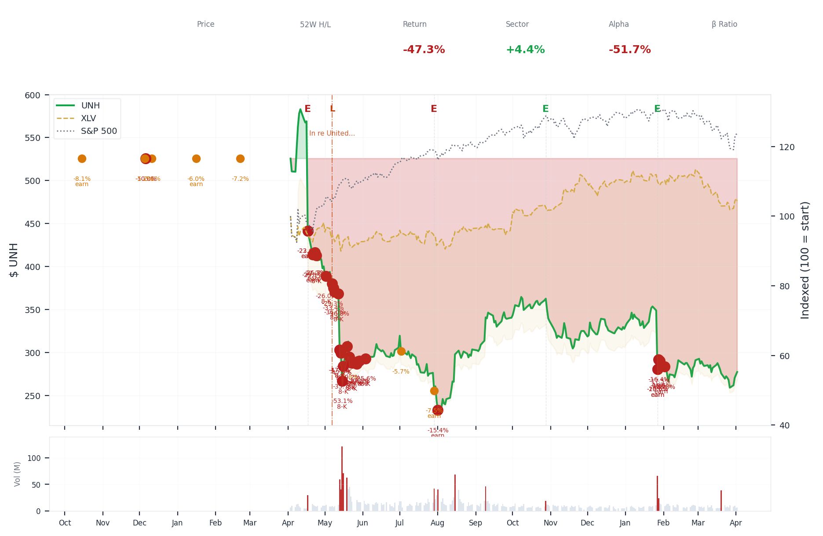
1-Year Performance (Indexed to 100). Red triangles mark single-day drops >= 8%. Orange bands mark multi-day declines >= 15%.
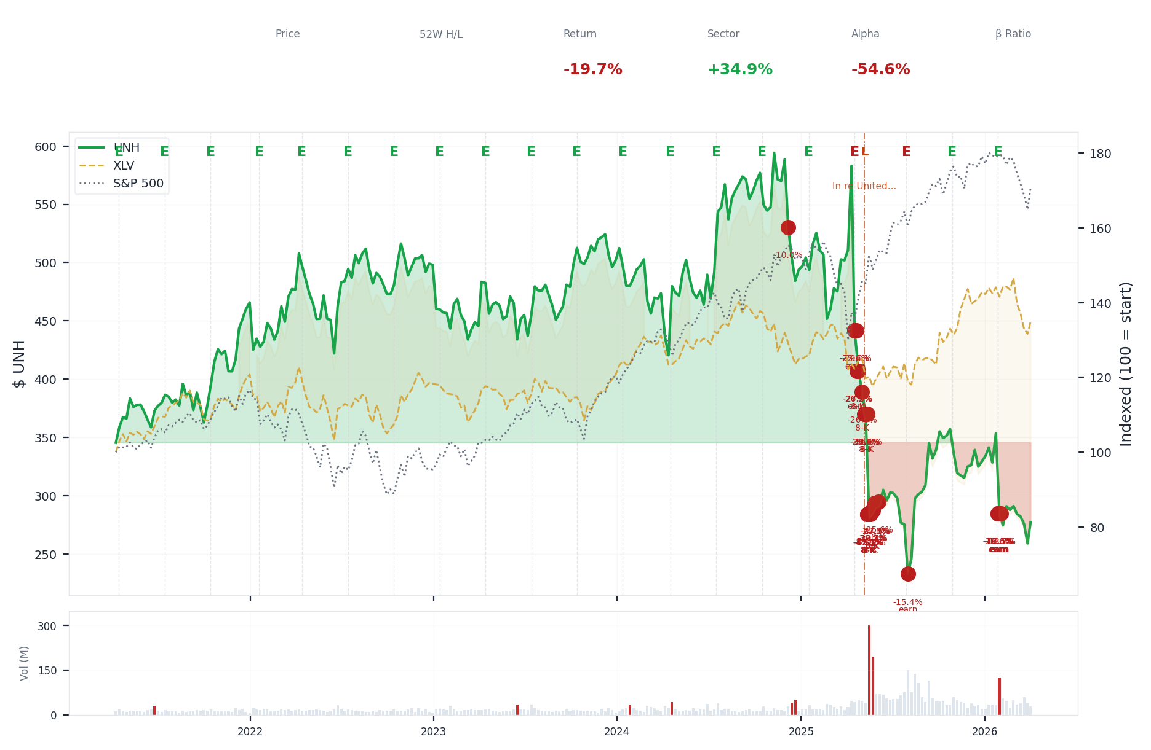
5-Year Performance (Indexed to 100)
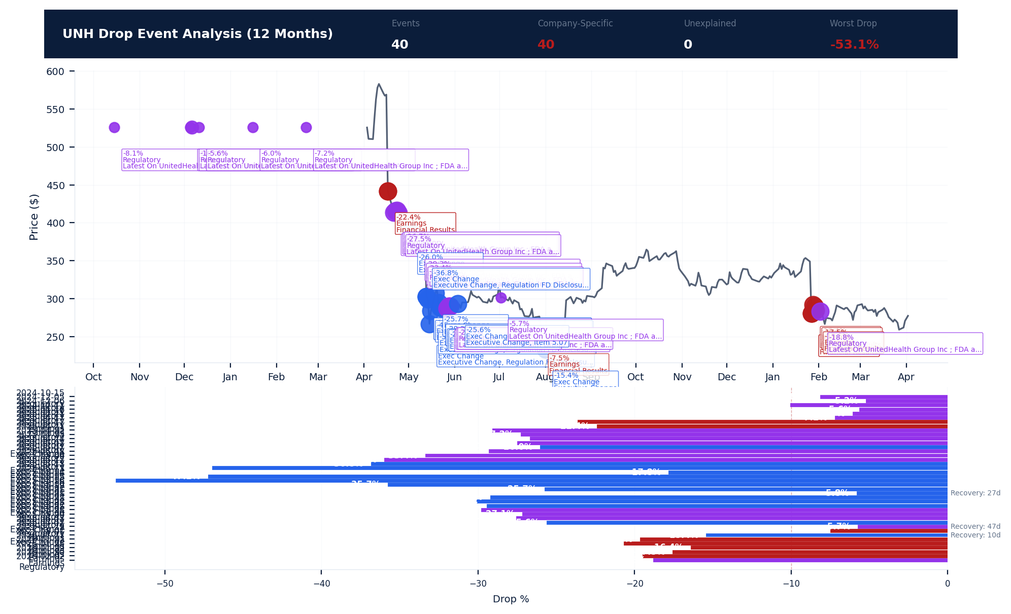
Drop Event Analysis (12 Months)
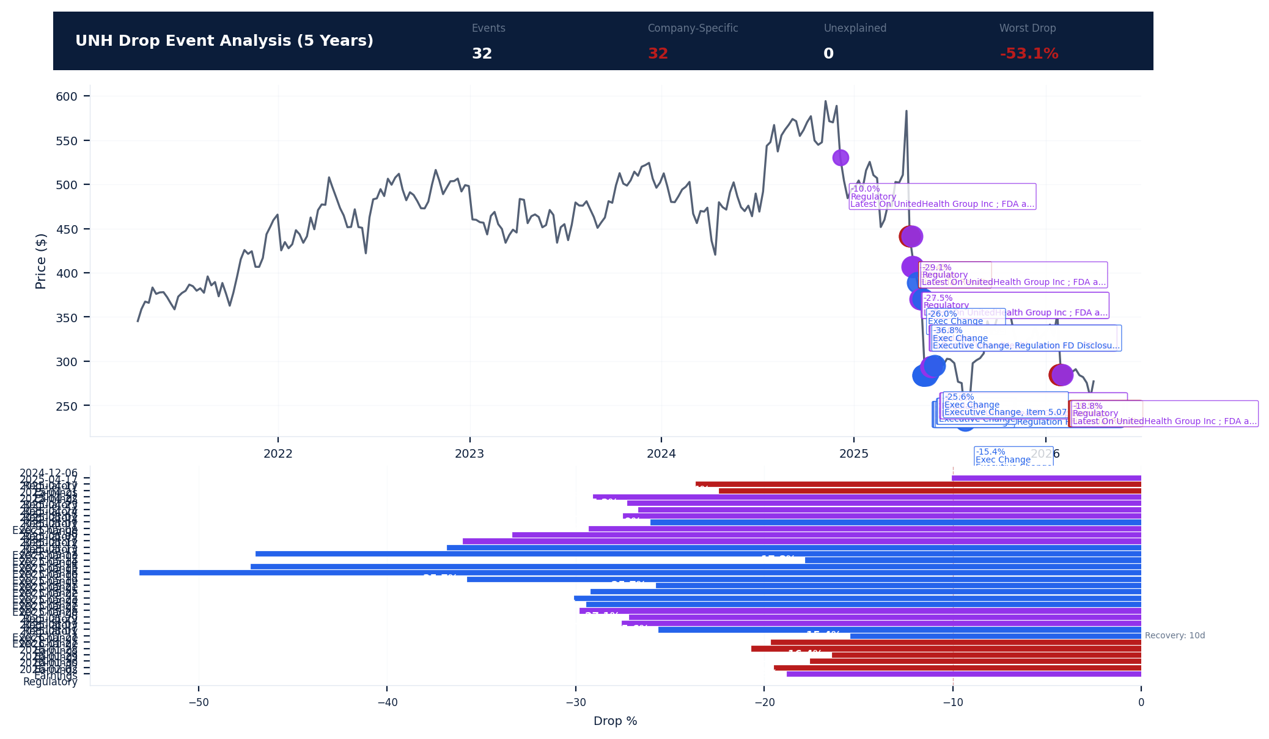
Drop Event Analysis (5 Years)
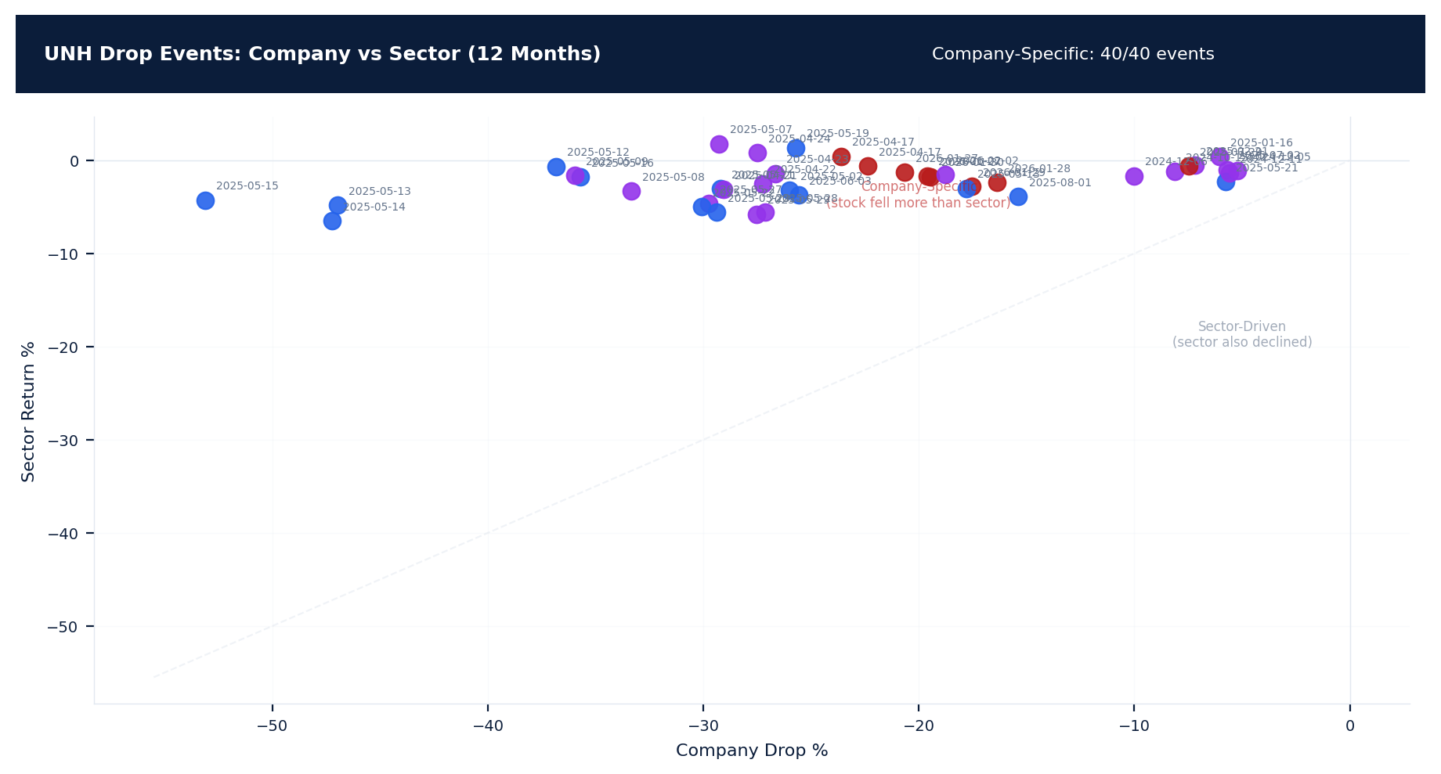
Drop Events: Company vs Sector (12 Months)
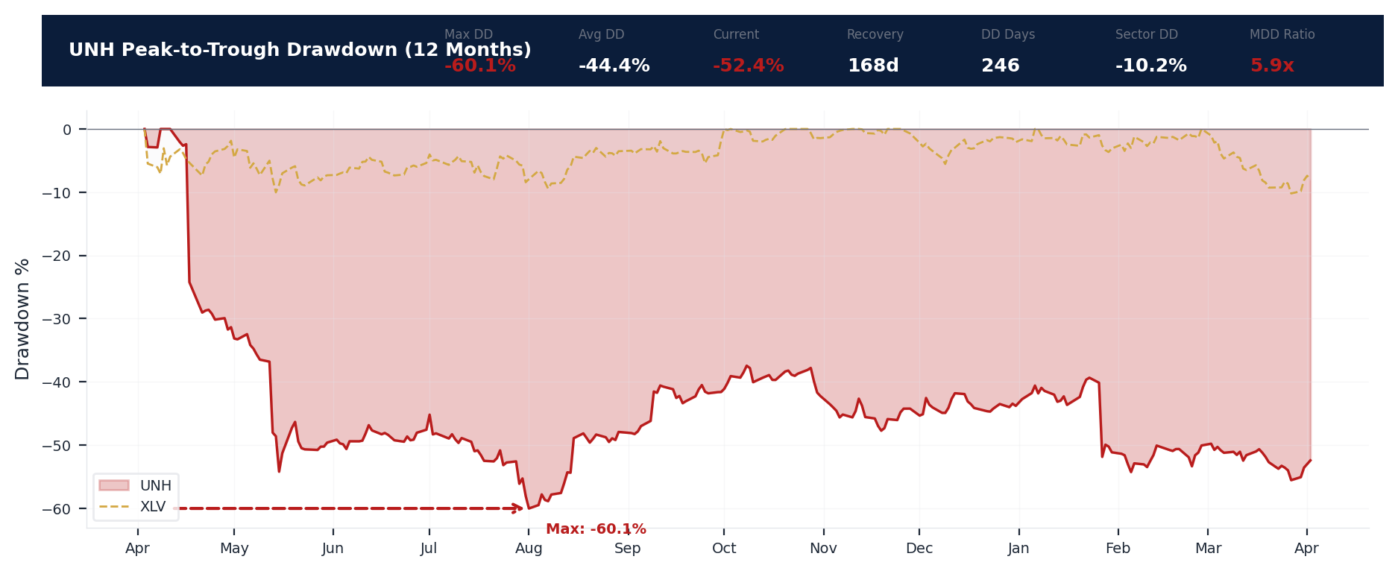
Drawdown Analysis (12 Months)
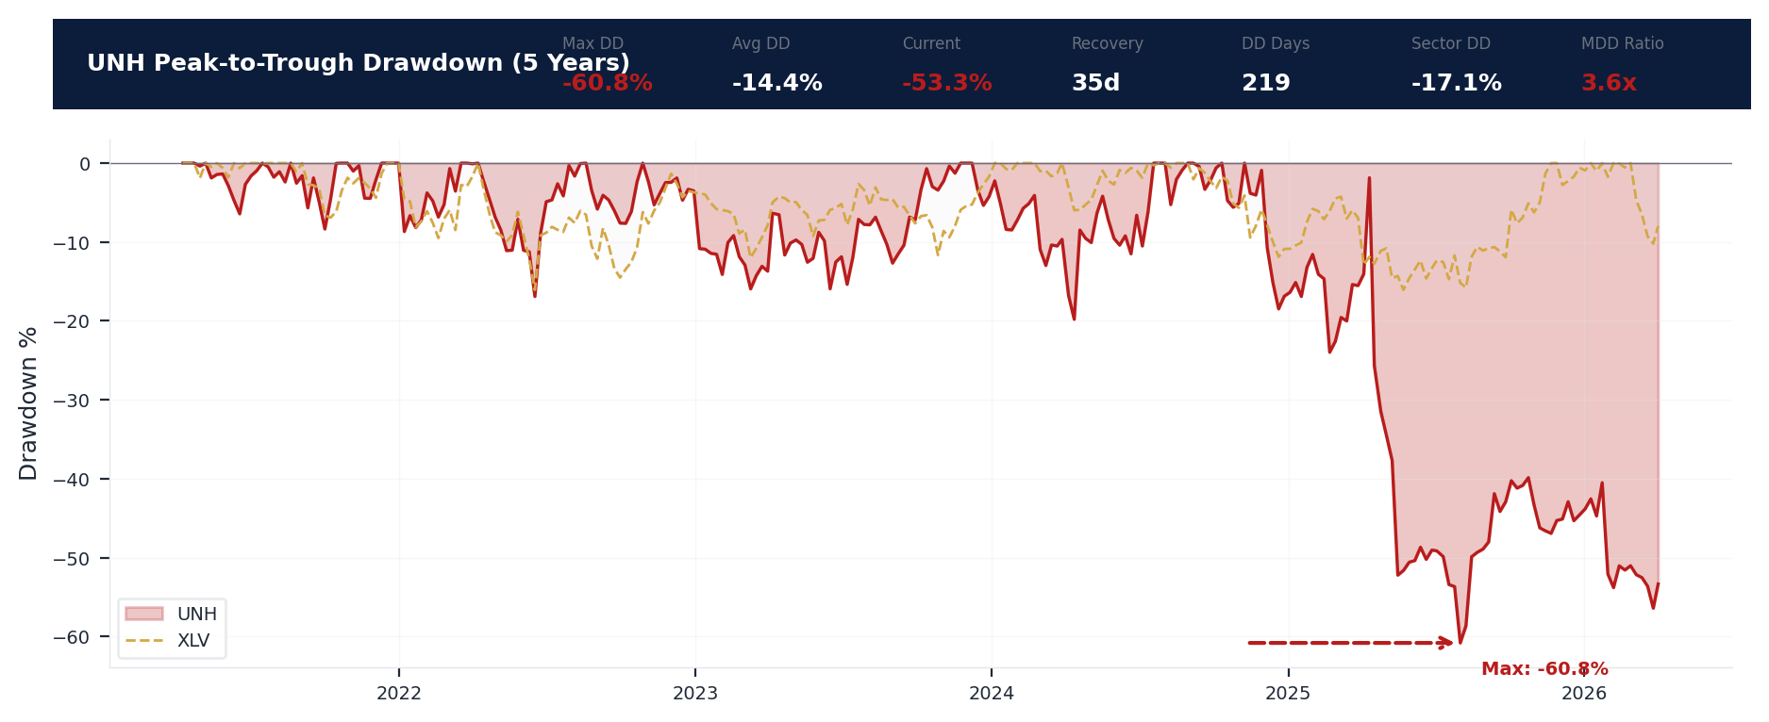
Drawdown Analysis (5 Years)
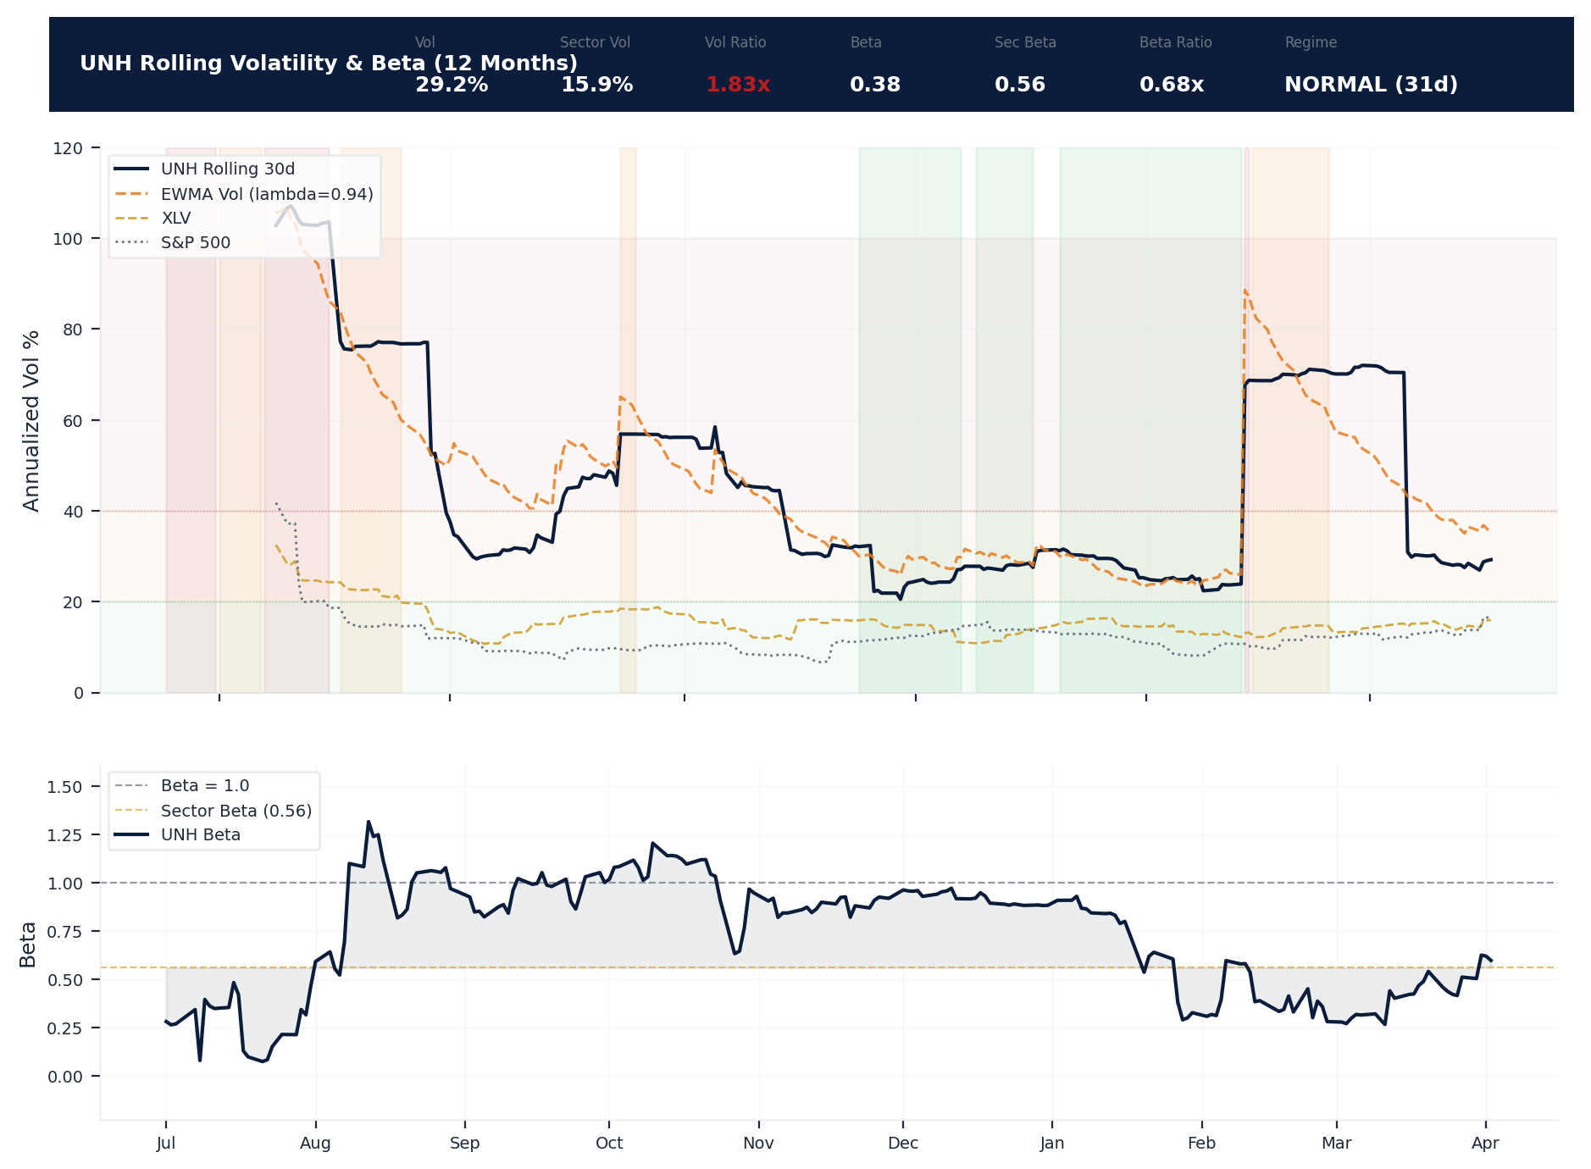
Volatility & Beta Analysis (12 Months)
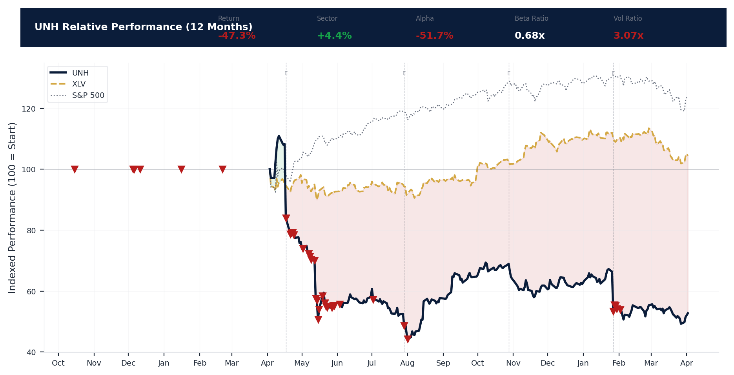
Relative Performance (12 Months)
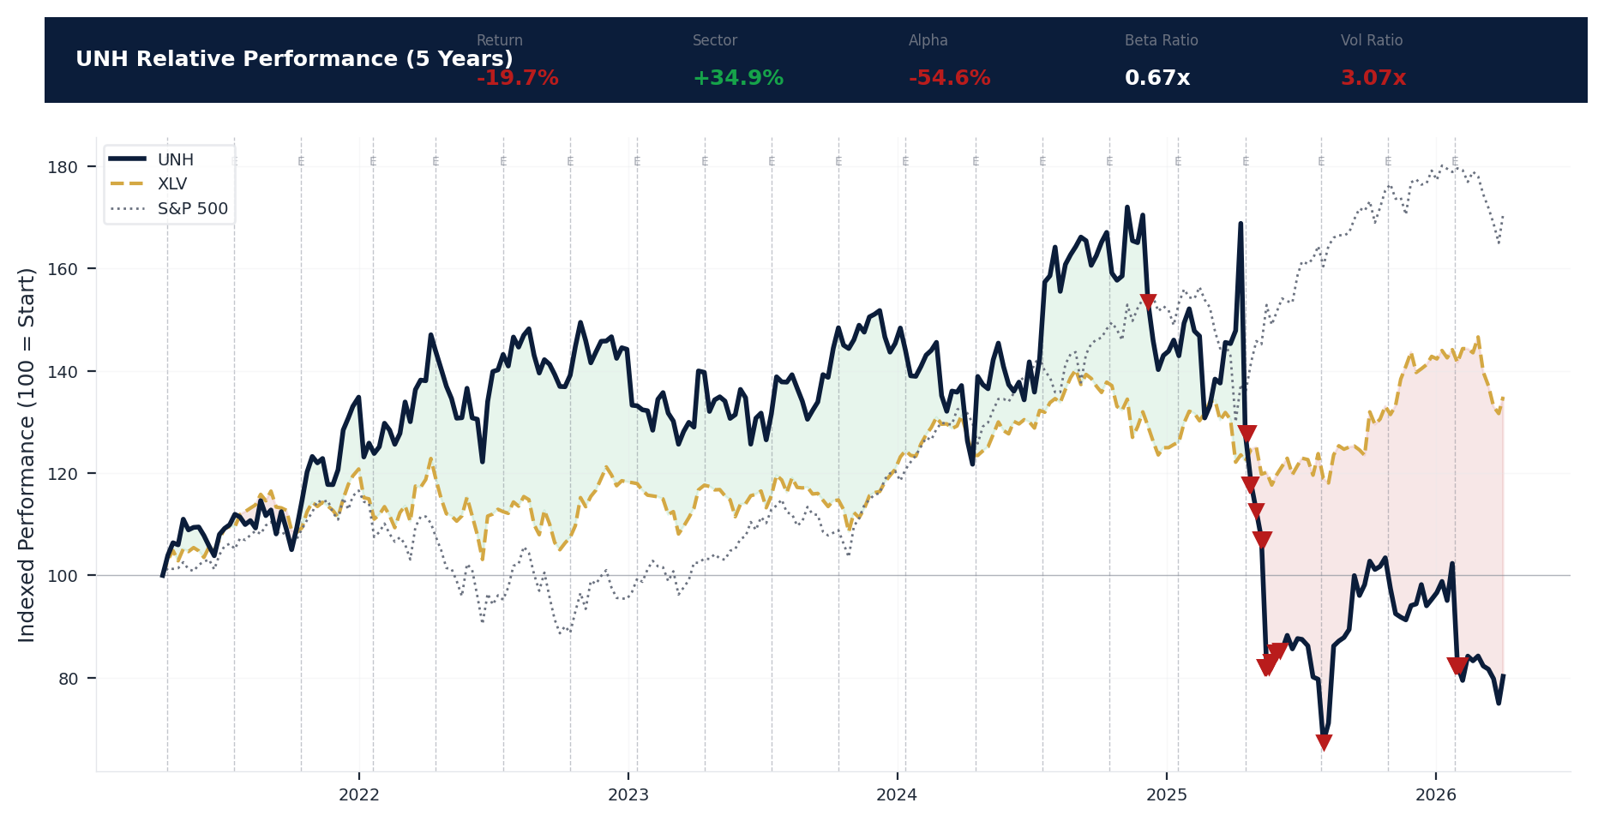
Relative Performance (5 Years)
Metric | Value
Current Price | $277.26
52-Week High | $606.36
52-Week Low | $234.60
1-Year Return | -47.2%
Max Drawdown (1Y) | -60.1%
90-Day Volatility | 43.3% (Ranks at the 0th percentile among 0 peers (peer median: 2.0%))
Beta (vs S&P 500) | 0.38
40 significant stock decline events detected in the 1Y period: 33 critical (>10%), 7 notable (5-10%). 40 were company-specific.
Date | Drop % | Recency | Recovery | Trigger Event | Type | Source
2026-01-27 to 2026-02-02 (7d) | -20.6% | 78% | Not recovered | Earnings release | Company-Specific | https://www.sec.gov/cgi-bin/browse-edgar?action...
2025-05-02 to 2025-06-03 (33d) | -54.2% | 29% | 27 days | 8-K Filing | Company-Specific | https://www.sec.gov/cgi-bin/browse-edgar?action...
2026-01-30 (5d) | -19.5% | 79% | Not recovered | Earnings release | Company-Specific | https://www.sec.gov/cgi-bin/browse-edgar?action...
2026-01-27 | -19.6% | 78% | Not recovered | Earnings release | Company-Specific | https://www.sec.gov/cgi-bin/browse-edgar?action...
2026-02-02 (5d) | -18.8% | 80% | Not recovered | Unconfirmed -- Requires Investigation | Company-Specific | https://www.cnbc.com/quotes/UNH
2026-01-29 (5d) | -17.5% | 78% | Not recovered | Earnings release | Company-Specific | https://www.sec.gov/cgi-bin/browse-edgar?action...
2025-05-14 (20d) | -47.2% | 29% | Not recovered | 8-K Filing | Company-Specific | https://www.sec.gov/cgi-bin/browse-edgar?action...
2025-05-13 (20d) | -47.0% | 29% | Not recovered | 8-K Filing | Company-Specific | https://www.sec.gov/cgi-bin/browse-edgar?action...
2026-01-28 (2d) | -16.4% | 78% | Not recovered | Earnings release | Company-Specific | https://www.sec.gov/cgi-bin/browse-edgar?action...
2025-05-12 (20d) | -36.8% | 29% | Not recovered | 8-K Filing | Company-Specific | https://www.sec.gov/cgi-bin/browse-edgar?action...
2025-05-16 (20d) | -35.7% | 29% | Not recovered | 8-K Filing | Company-Specific | https://www.sec.gov/cgi-bin/browse-edgar?action...
2025-05-09 (20d) | -36.0% | 28% | Not recovered | 8-K Filing | Company-Specific | https://www.sec.gov/cgi-bin/browse-edgar?action...
2025-05-08 (20d) | -33.4% | 28% | Not recovered | Unconfirmed -- Requires Investigation | Company-Specific | https://www.cnbc.com/quotes/UNH
2025-05-27 (20d) | -29.8% | 30% | Not recovered | Unconfirmed -- Requires Investigation | Company-Specific | https://www.cnbc.com/quotes/UNH
2025-05-22 (20d) | -30.1% | 30% | Not recovered | 8-K Filing | Company-Specific | https://www.sec.gov/cgi-bin/browse-edgar?action...
2025-05-23 (20d) | -29.4% | 30% | Not recovered | 8-K Filing | Company-Specific | https://www.sec.gov/cgi-bin/browse-edgar?action...
2025-05-21 (20d) | -29.2% | 30% | Not recovered | 8-K Filing | Company-Specific | https://www.sec.gov/cgi-bin/browse-edgar?action...
2025-05-29 (20d) | -27.5% | 31% | Not recovered | Unconfirmed -- Requires Investigation | Company-Specific | https://www.cnbc.com/quotes/UNH
2025-05-28 (20d) | -27.1% | 30% | Not recovered | Unconfirmed -- Requires Investigation | Company-Specific | https://www.cnbc.com/quotes/UNH
2025-05-07 (20d) | -29.3% | 28% | Not recovered | Unconfirmed -- Requires Investigation | Company-Specific | https://www.cnbc.com/quotes/UNH
2025-06-03 (20d) | -25.6% | 31% | Not recovered | 8-K Filing | Company-Specific | https://www.sec.gov/cgi-bin/browse-edgar?action...
2025-04-17 to 2025-04-24 (8d) | -29.2% | 26% | Not recovered | Earnings release | Company-Specific | https://www.cnbc.com/quotes/UNH
2025-05-19 (20d) | -25.7% | 29% | Not recovered | 8-K Filing | Company-Specific | https://www.sec.gov/cgi-bin/browse-edgar?action...
2025-04-24 (5d) | -27.5% | 27% | Not recovered | 8-K Filing | Company-Specific | https://www.sec.gov/cgi-bin/browse-edgar?action...
2025-04-22 (5d) | -27.2% | 26% | Not recovered | Earnings release | Company-Specific | https://www.cnbc.com/quotes/UNH
2025-05-02 (20d) | -26.0% | 28% | Not recovered | 8-K Filing | Company-Specific | https://www.sec.gov/cgi-bin/browse-edgar?action...
2025-04-23 (5d) | -26.7% | 27% | Not recovered | Unconfirmed -- Requires Investigation | Company-Specific | https://www.cnbc.com/quotes/UNH
2025-04-17 (5d) | -23.6% | 26% | Not recovered | Earnings release | Company-Specific | https://www.sec.gov/cgi-bin/browse-edgar?action...
2025-07-29 to 2025-08-01 (4d) | -15.4% | 39% | 10 days | Earnings release | Company-Specific | https://www.sec.gov/cgi-bin/browse-edgar?action...
2025-04-17 (2d) | -27.3% | 26% | Not recovered | Earnings release | Company-Specific | https://www.sec.gov/cgi-bin/browse-edgar?action...
2025-05-13 (2d) | -27.6% | 29% | Not recovered | 8-K Filing | Company-Specific | https://www.sec.gov/cgi-bin/browse-edgar?action...
2025-07-29 (2d) | -11.5% | 39% | Not recovered | Earnings release | Company-Specific | https://www.sec.gov/cgi-bin/browse-edgar?action...
2025-07-02 | -5.7% | 35% | 47 days | Unconfirmed -- Requires Investigation | Company-Specific | https://www.cnbc.com/quotes/UNH
2025-05-21 | -5.8% | 30% | 27 days | 8-K Filing | Company-Specific | https://www.sec.gov/cgi-bin/browse-edgar?action...
2024-12-05 to 2024-12-11 (7d) | -12.3% | 16% | Not recovered | Unconfirmed -- Requires Investigation | Company-Specific | https://www.cnbc.com/quotes/UNH
2025-02-21 | -7.2% | 21% | Not recovered | Unconfirmed -- Requires Investigation | Company-Specific | https://www.cnbc.com/quotes/UNH
2025-01-16 | -6.0% | 18% | Not recovered | Earnings release | Company-Specific | https://www.cnbc.com/quotes/UNH
2024-10-15 | -8.1% | 13% | Not recovered | Earnings release | Company-Specific | https://www.cnbc.com/quotes/UNH
2024-12-11 | -5.6% | 16% | Not recovered | Unconfirmed -- Requires Investigation | Company-Specific | https://www.cnbc.com/quotes/UNH
2024-12-05 (2d) | -5.2% | 16% | Not recovered | Unconfirmed -- Requires Investigation | Company-Specific | https://www.cnbc.com/quotes/UNH
32 significant stock decline events detected in the 5Y period: 32 critical (>10%). 32 were company-specific.
Date | Drop % | Recency | Recovery | Trigger Event | Type | Source
2026-01-27 to 2026-02-02 (7d) | -20.6% | 78% | Not recovered | Earnings release | Company-Specific | https://www.sec.gov/cgi-bin/browse-edgar?action...
2025-05-02 to 2025-06-03 (33d) | -54.2% | 29% | 27 days | 8-K Filing | Company-Specific | https://www.sec.gov/cgi-bin/browse-edgar?action...
2026-01-30 (5d) | -19.5% | 79% | Not recovered | Earnings release | Company-Specific | https://www.sec.gov/cgi-bin/browse-edgar?action...
2026-01-27 | -19.6% | 78% | Not recovered | Earnings release | Company-Specific | https://www.sec.gov/cgi-bin/browse-edgar?action...
2026-02-02 (5d) | -18.8% | 80% | Not recovered | Unconfirmed -- Requires Investigation | Company-Specific | https://www.cnbc.com/quotes/UNH
2026-01-29 (5d) | -17.5% | 78% | Not recovered | Earnings release | Company-Specific | https://www.sec.gov/cgi-bin/browse-edgar?action...
2025-05-14 (20d) | -47.2% | 29% | Not recovered | 8-K Filing | Company-Specific | https://www.sec.gov/cgi-bin/browse-edgar?action...
2025-05-13 (20d) | -47.0% | 29% | Not recovered | 8-K Filing | Company-Specific | https://www.sec.gov/cgi-bin/browse-edgar?action...
2026-01-28 (2d) | -16.4% | 78% | Not recovered | Earnings release | Company-Specific | https://www.sec.gov/cgi-bin/browse-edgar?action...
2025-05-12 (20d) | -36.8% | 29% | Not recovered | 8-K Filing | Company-Specific | https://www.sec.gov/cgi-bin/browse-edgar?action...
2025-05-16 (20d) | -35.7% | 29% | Not recovered | 8-K Filing | Company-Specific | https://www.sec.gov/cgi-bin/browse-edgar?action...
2025-05-09 (20d) | -36.0% | 28% | Not recovered | 8-K Filing | Company-Specific | https://www.sec.gov/cgi-bin/browse-edgar?action...
2025-05-08 (20d) | -33.4% | 28% | Not recovered | Unconfirmed -- Requires Investigation | Company-Specific | https://www.cnbc.com/quotes/UNH
2025-05-27 (20d) | -29.8% | 30% | Not recovered | Unconfirmed -- Requires Investigation | Company-Specific | https://www.cnbc.com/quotes/UNH
2025-05-22 (20d) | -30.1% | 30% | Not recovered | 8-K Filing | Company-Specific | https://www.sec.gov/cgi-bin/browse-edgar?action...
2025-05-23 (20d) | -29.4% | 30% | Not recovered | 8-K Filing | Company-Specific | https://www.sec.gov/cgi-bin/browse-edgar?action...
2025-05-21 (20d) | -29.2% | 30% | Not recovered | 8-K Filing | Company-Specific | https://www.sec.gov/cgi-bin/browse-edgar?action...
2025-05-29 (20d) | -27.5% | 31% | Not recovered | Unconfirmed -- Requires Investigation | Company-Specific | https://www.cnbc.com/quotes/UNH
2025-05-28 (20d) | -27.1% | 30% | Not recovered | Unconfirmed -- Requires Investigation | Company-Specific | https://www.cnbc.com/quotes/UNH
2025-05-07 (20d) | -29.3% | 28% | Not recovered | Unconfirmed -- Requires Investigation | Company-Specific | https://www.cnbc.com/quotes/UNH
2025-06-03 (20d) | -25.6% | 31% | Not recovered | 8-K Filing | Company-Specific | https://www.sec.gov/cgi-bin/browse-edgar?action...
2025-04-17 to 2025-04-24 (8d) | -29.2% | 26% | Not recovered | Earnings release | Company-Specific | https://www.cnbc.com/quotes/UNH
2025-05-19 (20d) | -25.7% | 29% | Not recovered | 8-K Filing | Company-Specific | https://www.sec.gov/cgi-bin/browse-edgar?action...
2025-04-24 (5d) | -27.5% | 27% | Not recovered | 8-K Filing | Company-Specific | https://www.sec.gov/cgi-bin/browse-edgar?action...
2025-04-22 (5d) | -27.2% | 26% | Not recovered | Earnings release | Company-Specific | https://www.cnbc.com/quotes/UNH
2025-05-02 (20d) | -26.0% | 28% | Not recovered | 8-K Filing | Company-Specific | https://www.sec.gov/cgi-bin/browse-edgar?action...
2025-04-23 (5d) | -26.7% | 27% | Not recovered | Unconfirmed -- Requires Investigation | Company-Specific | https://www.cnbc.com/quotes/UNH
2025-04-17 (5d) | -23.6% | 26% | Not recovered | Earnings release | Company-Specific | https://www.sec.gov/cgi-bin/browse-edgar?action...
2025-07-29 to 2025-08-01 (4d) | -15.4% | 39% | 10 days | Earnings release | Company-Specific | https://www.sec.gov/cgi-bin/browse-edgar?action...
2025-04-17 (2d) | -27.3% | 26% | Not recovered | Earnings release | Company-Specific | https://www.sec.gov/cgi-bin/browse-edgar?action...
2025-05-13 (2d) | -27.6% | 29% | Not recovered | 8-K Filing | Company-Specific | https://www.sec.gov/cgi-bin/browse-edgar?action...
2024-12-05 to 2024-12-11 (7d) | -12.3% | 16% | Not recovered | Unconfirmed -- Requires Investigation | Company-Specific | https://www.cnbc.com/quotes/UNH
Short Interest
Metric | Value
Short % of Float | 2.0% (Ranks at the 67th percentile among 0 peers (peer median: 3.0%))
Days to Cover | 2.29
6-Month Trend | RISING
vs Sector Ratio | N/A
Earnings Guidance Track Record
Metric | Value
Beat Rate | 0.9%
Consecutive Misses | 0
Guidance Withdrawals | 0
Philosophy | CONSERVATIVE
Quarter | Est. EPS | Actual EPS | Result | Miss Magnitude | Stock Reaction
Q1 2026 | $2.11 | $2.11 | MEET | N/A | +0.2%
Q4 2025 | $2.81 | $2.92 | BEAT | N/A | +4.0%
Q3 2025 | $4.45 | $4.08 | MISS | +8.3% | -8.2%
Q2 2025 | $6.93 | $6.85 | MISS | +1.1% | -1.2%
Q1 2025 | $6.74 | $6.81 | BEAT | N/A | +1.1%
Q4 2024 | $7.03 | $7.15 | BEAT | N/A | +1.7%
Q3 2024 | $6.63 | $6.80 | BEAT | N/A | +2.5%
Q2 2024 | $6.62 | $6.91 | BEAT | N/A | +4.4%
Q1 2024 | $5.99 | $6.16 | BEAT | N/A | +2.9%
Q4 2023 | $6.35 | $6.56 | BEAT | N/A | +3.3%
Q3 2023 | $5.98 | $6.14 | BEAT | N/A | +2.7%
Q2 2023 | $6.08 | $6.26 | BEAT | N/A | +3.0%
Q1 2023 | $5.17 | $5.34 | BEAT | N/A | +3.2%
Q4 2022 | $5.44 | $5.79 | BEAT | N/A | +6.5%
Q3 2022 | $5.21 | $5.57 | BEAT | N/A | +6.9%
Q2 2022 | $5.35 | $5.49 | BEAT | N/A | +2.6%
Analyst Consensus
Metric | Value
Analyst Coverage | 26
Consensus Rating | BUY
Mean Recommendation | 1.83 (1=Strong Buy, 5=Sell)
Mean Target Price | $358
Target Price High | $440
Target Price Low | $255
Stock Drop Analysis
Date | Magnitude | Type | Trigger / Attribution | Sector Return | Company-Specific
2025-05-02 to 2025-06-03 | -54.2% | MULTI_DAY (33d) | 8-K_filing | -4.3% | Yes
2025-05-14 | -47.2% | MULTI_DAY (20d) | 8-K_filing | -6.5% | Yes
2025-05-13 | -47.0% | MULTI_DAY (20d) | 8-K_filing | -4.8% | Yes
2025-05-12 | -36.8% | MULTI_DAY (20d) | 8-K_filing | -0.7% | Yes
2025-05-09 | -36.0% | MULTI_DAY (20d) | 8-K_filing | -1.6% | Yes
2025-05-16 | -35.7% | MULTI_DAY (20d) | 8-K_filing | -1.8% | Yes
2025-05-08 | -33.4% | MULTI_DAY (20d) | Unknown | -3.3% | Yes
2025-05-22 | -30.1% | MULTI_DAY (20d) | 8-K_filing | -5.0% | Yes
2025-05-27 | -29.8% | MULTI_DAY (20d) | Unknown | -4.7% | Yes
2025-05-23 | -29.4% | MULTI_DAY (20d) | 8-K_filing | -5.6% | Yes
2025-05-07 | -29.3% | MULTI_DAY (20d) | Unknown | +1.8% | Yes
2025-04-17 to 2025-04-24 | -29.2% | MULTI_DAY (8d) | earnings_release | -3.1% | Yes
2025-05-21 | -29.2% | MULTI_DAY (20d) | 8-K_filing | -3.1% | Yes
2025-05-29 | -27.5% | MULTI_DAY (20d) | Unknown | -5.8% | Yes
2025-04-24 | -27.5% | MULTI_DAY (5d) | 8-K_filing | +0.8% | Yes
Class Period Potential: 32 company-specific drop(s) exceeding 10% identified. Severe stock drops that are company-specific (not explained by sector movement) are the primary anchors for SCA class periods. Plaintiffs will allege the drop occurred when the 'truth emerged' following prior misstatements. [HIGH]
Insider Trading Analysis
Metric | Value
Net Direction (12mo) | NEUTRAL
10b5-1 Plan % | 0.0%
Buy Transactions | 0
Sell Transactions | 0
Cluster Events | 0
Transaction Detail
Date | Insider | Title | Type | Shares | Value | 10b5-1
2026-03-17 | MONTGOMERY RICE VALERIE MD | Director | GRANT | 53 | $0 | No (Discretionary)
2026-03-17 | DeVeydt Wayne S | Chief Financial Officer | GRANT | 150 | $0 | No (Discretionary)
2026-03-17 | Stankiewicz Dennis Andrew | Chief Accounting Officer | GRANT | 68 | $0 | No (Discretionary)
2026-03-17 | GARCIA PAUL R | Director | GRANT | 16 | $0 | No (Discretionary)
2026-03-17 | Noseworthy John H | Director | GRANT | 52 | $0 | No (Discretionary)
2026-03-17 | Zaetta Christopher R | EVP & Chief Legal Officer | GRANT | 90 | $0 | No (Discretionary)
2026-03-17 | Noel Timothy John | Chief Executive Officer, UHC | GRANT | 102 | $0 | No (Discretionary)
2026-03-17 | MCNABB FREDERICK WILLIAM III | Director | GRANT | 64 | $0 | No (Discretionary)
2026-03-17 | FLYNN TIMOTHY PATRICK | Director | GRANT | 79 | $0 | No (Discretionary)
2026-03-17 | HEMSLEY STEPHEN J | CEO, UHG | GRANT | 61 | $0 | No (Discretionary)
2026-03-17 | Baker Charles D. | Director | GRANT | 14 | $0 | No (Discretionary)
2026-03-17 | McSweeney Erin | EVP & Chief People Officer | GRANT | 65 | $0 | No (Discretionary)
2026-03-17 | HOOPER MICHELE J | Director | GRANT | 292 | $0 | No (Discretionary)
2026-03-17 | Gil Kristen | Director | GRANT | 8 | $0 | No (Discretionary)
2026-03-17 | Gottlieb Scott | Director | GRANT | 1 | $0 | No (Discretionary)
2026-03-17 | Conway Patrick Hugh | Chief Executive Officer, Optum | GRANT | 125 | $0 | No (Discretionary)
2026-02-23 | ROOS THOMAS E | Chief Accounting Officer | TAX_WITHHOLD | 152 | $42.9K | No (Discretionary)
2026-02-23 | ROOS THOMAS E | Chief Accounting Officer | GRANT | 2,436 | $0 | No (Discretionary)
2026-02-23 | ROOS THOMAS E | Chief Accounting Officer | GRANT | 9,768 | $0 | No (Discretionary)
2026-02-23 | Zaetta Christopher R | EVP & Chief Legal Officer | TAX_WITHHOLD | 129 | $36.6K | No (Discretionary)
Executive Departures
No executive departures identified in the trailing 18 months.
Capital Markets Activity
No significant capital markets activity identified in the trailing 3-year period.

ELEVATED CONCERN
UnitedHealth's revenue grew 11.8% to $447.6B, but net income fell 16.3% to $12.1B and operating income declined 41.3% to $18.96B, creating a stark earnings narrative for a Section 10(b) suit alleging the board misrepresented operational health. The Altman Z-Score of 1.41 sits in the grey zone, perilously close to the distress threshold of 1.81, which plaintiffs will cite to allege a deteriorating financial foundation and support claims of inadequate risk oversight. A current ratio of 0.79 and quick ratio of 0.76, both below 1.0, indicate significant liquidity pressure, directly fueling going-concern allegations and breach of duty claims despite the clean audit opinion from Deloitte. The 24-year auditor tenure, while stable, will be scrutinized for potential oversight given the sharp income declines, potentially forming a basis for allegations of failed auditor oversight by the board. The strong Beneish M-Score of -3.11 argues against earnings manipulation, but the Piotroski F-Score of 6 is a neutral flag, leaving the door open for operational performance claims regarding the $13.2B year-over-year drop in operating income. The core D&O exposure is a shareholder suit alleging the board failed to manage the operational collapse driving that $13.2B drop, a risk masked by the 11.8% top-line revenue growth.
Section 3: Financial Health
The company reported revenue of $447.6B and net income of $12.1B (per FY2025 10-K, Company Facts API CIK731766). Revenue grew 11.8% year-over-year (from $400.3B). Net margin of 2.7% is thin, leaving limited buffer against earnings volatility. Distress indicators show mixed signals: Z-Score 1.41 (grey zone) and O-Score 0.00 (safe zone). Financial stress could limit litigation defense resources. D/E ratio of 0.78 is moderate. Earnings quality is healthy (OCF/NI: 1.63), indicating reported income is well-supported by operating cash flows -- reducing restatement risk. Effective tax rate of 12.9% is below the 21% U.S. statutory rate, warranting review of uncertain tax positions and transfer pricing. Auditor: Deloitte (Big 4), tenure: 24 years -- extended tenure may raise independence concerns. From a D&O perspective, the financial profile supports standard underwriting terms.
Income Statement
Metric | FY2024 | FY2025 | YoY Change
Total revenue / net sales | $400.3B | $447.6B | 11.8%
Cost of revenue / COGS | $46.7B | $50.7B | 8.5%
Operating income / loss | $32.3B | $19.0B | -41.3%
Net income / net loss | $14.4B | $12.1B | -16.3%
Basic earnings per share | $15.64 | $13.28 | -15.1%
Diluted earnings per share | $15.51 | $13.23 | -14.7%
Interest expense | $3.9B | $4.0B | 2.5%
Income tax expense / benefit | $4.8B | $1.9B | -60.9%
Selling, general and administrative expense | $53.0B | $59.6B | 12.4%
Earnings before interest and taxes (EBIT) | $32.3B | $19.0B | -41.3%
Weighted average shares outstanding (basic) | 921.0M | 908.0M | -1.4%
Weighted average shares outstanding (diluted) | 929.0M | 911.0M | -1.9%
Total comprehensive income / loss | $18.0B | $13.4B | -25.8%
Impairment charges (goodwill, intangibles, long-lived assets) | $0 | $0 | N/A
Income from operations | $32.3B | $19.0B | -41.3%
Pre-tax income | $20.1B | $14.7B | -26.8%
Stock-based compensation expense | $1.0B | $971.0M | -4.6%
Income before income taxes | $20.1B | $14.7B | -26.8%
Gain/loss on sale of assets | $3.3B | $910.0M | -72.7%
Other comprehensive income/loss, net of tax | $3.6B | $1.3B | -63.6%
Total operating expenses | $368.0B | $428.6B | 16.5%
Total costs and expenses | $368.0B | $428.6B | 16.5%
Impairment of intangible assets (excluding goodwill) | $0 | $0 | N/A
Current state and local income tax expense / benefit | $416.0M | $598.0M | 43.8%
Current foreign income tax expense / benefit | $1.3B | $1.7B | 32.4%
Deferred federal income tax expense / benefit | N/A | $-1.1B | N/A
Deferred state and local income tax expense / benefit | N/A | $-227.0M | N/A
Deferred foreign income tax expense / benefit | N/A | $-376.0M | N/A
Goodwill impairment loss | $0 | $0 | N/A
Impairment of intangible assets (finite-lived and indefinite-lived) | $0 | $0 | N/A
Gross margin percentage | 88.3% | 88.7% | 0.4%
Operating margin percentage | 8.1% | 4.2% | -47.5%
Net margin percentage | 3.6% | 2.7% | -25.3%
EBITDA margin percentage | 9.1% | 5.2% | -42.7%
Effective tax rate | $24 | $13 | -46.5%
Interest coverage ratio | $8 | $5 | -42.7%
Balance Sheet
Metric | FY2024 | FY2025 | YoY Change
Total assets | $298.3B | $309.6B | 3.8%
Total liabilities | $195.7B | $207.9B | 6.2%
Total stockholders' equity | $98.3B | $100.1B | 1.9%
Total current assets | $85.8B | $90.6B | 5.6%
Total current liabilities | $103.8B | $114.9B | 10.7%
Cash and cash equivalents | $25.3B | $24.4B | -3.7%
Accounts receivable, net | $22.4B | $23.0B | 2.9%
Inventory, net | $3.8B | $3.3B | -13.2%
Property, plant and equipment, net | $10.6B | $10.8B | 2.0%
Goodwill | $106.7B | $110.5B | 3.5%
Intangible assets, net (excluding goodwill) | $23.3B | $20.5B | -12.0%
Long-term debt, non-current | $72.4B | $72.3B | -0.1%
Short-term debt / current portion of long-term debt | $4.5B | $6.1B | 33.5%
Retained earnings / accumulated deficit | $96.0B | $95.6B | -0.5%
Total debt (short-term + long-term) | $76.2B | $77.7B | 2.0%
Common shares outstanding | 915.0M | 906.0M | -1.0%
Accounts payable | $34.3B | $38.0B | 10.8%
Deferred revenue / contract liabilities | $3.3B | $3.4B | 2.9%
Operating lease liabilities | $4.9B | $4.6B | -5.6%
Minority / noncontrolling interest | $5.6B | $6.0B | 6.6%
Short-term investments / marketable securities | $3.8B | $3.8B | -1.2%
Prepaid expenses and other current assets | $8.2B | $9.7B | 18.7%
Long-term investments | $52.4B | $54.3B | 3.6%
Deferred income tax liabilities, net | $3.6B | $2.4B | -33.1%
Accumulated other comprehensive income/loss | $-3.4B | $-2.1B | 39.1%
Common stock par value | $9.0M | $9.0M | 0.0%
Additional paid-in capital | N/A | $559.0M | N/A
Total liabilities and stockholders' equity | $298.3B | $309.6B | 3.8%
Preferred stock value | $0 | $0 | N/A
Other non-current assets | $19.6B | $23.0B | 17.5%
Other non-current liabilities | $15.9B | $18.2B | 14.5%
Unrecognized tax benefits (UTB) liability | $4.1B | $5.6B | 36.3%
Commercial paper outstanding | $7.3B | N/A | N/A
Unvested stock-based compensation cost not yet recognized | $1.1B | $1.3B | 21.3%
Common stock shares authorized | 3.0B | 3.0B | 0.0%
Current ratio | $1 | $1 | -4.6%
Quick ratio | $1 | $1 | -3.8%
Debt-to-equity ratio | $1 | $1 | 0.1%
Debt-to-EBITDA ratio | $2 | $3 | 59.1%
Tangible book value | $-31.7B | $-30.9B | 2.7%
Net debt | $50.9B | $53.3B | 4.8%
Book value per share | $107.40 | $110.47 | 2.9%
Return on assets | $5 | $4 | -19.5%
Return on equity | $15 | $12 | -17.8%
Asset turnover ratio | $1 | $1 | 7.7%
Key Balance Sheet Ratios
Ratio | Value | Assessment
Current Ratio | 0.79 | Concern
Debt/Equity | 0.78 | Moderate
Debt/Assets | 0.67 | High
Cash/Assets | 7.9%
Cash Flow Statement
Metric | FY2024 | FY2025 | YoY Change
Net cash from operating activities | $24.2B | $19.7B | -18.6%
Net cash from investing activities | $-20.5B | $-8.7B | 57.7%
Net cash from financing activities | $-3.5B | $-11.6B | -231.6%
Capital expenditures | $3.5B | $3.6B | 3.5%
Depreciation and amortization | $4.1B | $4.4B | 6.4%
Dividends paid | N/A | $7.9B | N/A
Share repurchases / buybacks | $9.0B | $5.5B | -38.4%
Acquisitions, net of cash acquired | $13.4B | $4.5B | -66.4%
Proceeds from issuance of debt | $17.8B | $3.0B | -83.3%
Repayments of debt | $3.0B | $3.0B | 1.7%
Proceeds from stock issuance | $1.8B | $827.0M | -55.2%
Interest paid (supplemental) | $3.6B | $4.0B | 12.1%
Income taxes paid (supplemental) | $4.6B | $3.7B | -19.6%
Stock-based compensation (cash flow adjustment) | $1.0B | $971.0M | -4.6%
Changes in operating working capital | $2.5B | $1.7B | -32.4%
Net increase/decrease in cash and equivalents | $-115.0M | $-947.0M | -723.5%
Purchases of investments | $27.3B | $17.4B | -36.4%
Proceeds from sale/maturity of investments | $18.5B | $9.3B | -49.8%
Deferred income taxes (cash flow adjustment) | $-296.0M | $-1.8B | -491.9%
Change in accounts receivable | $1.4B | $764.0M | -46.8%
Change in accounts payable | $2.5B | $1.7B | -32.4%
Amortization of intangible assets | $1.7B | $1.7B | 0.0%
Proceeds from sale / divestiture of businesses | $2.0B | $561.0M | -72.5%
Effect of exchange rate changes on cash | $-61.0M | $40.0M | 165.6%
Free cash flow | $20.7B | $16.1B | -22.4%
FCF-to-revenue ratio | $5 | $4 | -30.6%
Capex-to-revenue ratio | $1 | $1 | -6.9%
Capex-to-depreciation ratio | $1 | $1 | -2.7%
Dividend payout ratio | N/A | $66 | N/A
Free cash flow per share | $22.63 | $17.74 | -21.6%
Key Ratios: Company vs. Peers
Ratio | Value
Current Ratio | 0.79
Quick Ratio | 0.76
Debt/Equity | 0.78
Interest Coverage | 4.7x
Distress Indicators
Model | Score | Zone | Trajectory | D&O Context
Altman Z-Score | 1.41 | Grey Zone | FY2024: 1.9 -> FY2025: 1.4 (stable) | Bankruptcy predictor. Distress zone companies face fiduciary duty scrutiny under Revlon/zone of insolvency doctrine.
Beneish M-Score | -3.11 | Safe | N/A | Earnings manipulation detector. Scores above -1.78 indicate elevated restatement risk, a primary SCA catalyst.
Ohlson O-Score | 0.00 | Safe | N/A | Bankruptcy probability model. Higher values signal financial stress that may limit litigation defense resources.
Piotroski F-Score | 6.00 | Grey Zone | 6/9 criteria met | Fundamental quality indicator. Scores 0-3 signal weak fundamentals; 7-9 indicate strong quality.
Leverage context: Ranks at the 83rd percentile among 0 peers (peer median: 10.0x).
Earnings Quality
Metric | Value | Assessment
OCF/Net Income | 1.63 | Healthy
Accruals Ratio | -0.02 | Normal
Source: Derived from XBRL financial statements, MEDIUM confidence
Audit Risk Assessment
Audit Risk: No concerns. Deloitte, 24 year tenure, qualified opinion.
Debt Analysis
Metric | Value
Debt-to-Equity | 0.78
Debt-to-EBITDA | 3.33
Interest Coverage | 4.74
Covenant Status | Unknown
Critical Accounting Estimates
Estimate | Value | Assessment
Effective Tax Rate | 12.9% | Below statutory rate -- review required
Peer Group Comparison
Ticker | Name | Market Cap | Revenue | Score
JNJ | Johnson & Johnson | $585.7B | $94.2B | 14
LLY | Eli Lilly and Company | $837.4B | $65.2B | 13
PFE | Pfizer, Inc. | $161.1B | $62.6B | 20
ABBV | AbbVie Inc. | $369.4B | $61.2B | 26
MRK | Merck & Company, Inc. | $298.8B | $65.0B | 33
TMO | Thermo Fisher Scientific Inc | $182.6B | $44.6B | 24
ABT | Abbott Laboratories | $178.8B | $44.3B | 23
DHR | Danaher Corporation | $135.3B | $24.6B | 14
BMY | Bristol-Myers Squibb Company | $121.7B | $48.2B | 12
Revenue: Ranks at the 100th percentile among 9 peers. Leverage: Ranks at the 83rd percentile among 0 peers (peer median: 10.0x).
Method: Multi-signal composite: SIC 25%, industry 20%, market cap 25%, revenue 15%, description 15%

CRITICAL RISK
The board's structural opacity is a primary concern, with only one director, Stephen J. Hemsley, disclosed from a total director count of one, preventing any meaningful calculation of independence ratio. Andrew Witty's undefined CEO tenure and the confirmed absence of Chair duality obscure accountability lines at an entity where the CEO received $17.87 million in compensation. While the 96% say-on-pay vote for that package suggests investor alignment, it exists alongside a governance check failure rate of 3 out of 90, indicating specific, material control deficiencies that plaintiffs can cite as red flags. The core D&O exposure is a textbook *Caremark* duty of oversight case, where a board of only one disclosed director could be deemed to have failed in monitoring the regulatory risks endemic to UnitedHealth's scale, directly fueling derivative action risk. This risk is acute around events like the Change Healthcare cyber attack or DOJ antitrust probes, where plaintiffs will attack the board's information systems given the 3 governance check failures. The lack of disclosed tenure and qualifications for the sole director, Hemsley, creates a narrative vacuum that plaintiffs will fill with allegations of stale oversight, complicating defense. Underwriting this risk requires deep forensic work to reconstruct the actual board composition driving these 3 specific governance check failures.
Section 5: Governance & Leadership
Dual-class share structure concentrates voting control. [Rule-based synthesis of governance extraction results, 2026-04-02, LOW]
Leadership Stability
Name | Title | Tenure (Yrs) | Status | Prior Lit. | Flags
Andrew Witty | CEO | N/A | ACTIVE | 1 | None
Business Finance | President | N/A | ACTIVE | 42 | None
D&O Context (Andrew Witty, 1 prior case(s)): triggered Any Officer With Prior Litigation at Previous Company (F9) — this host risk (company-level characteristics that attract or deter D&O claims) indicates SEC Enforcement / Regulatory Compliance. Evidence: Boolean check: True condition met. [ELEVATED]
D&O Context (Business Finance, 42 prior case(s)): triggered Any Officer With Prior Litigation at Previous Company (F9) — this host risk (company-level characteristics that attract or deter D&O claims) indicates SEC Enforcement / Regulatory Compliance. Evidence: Boolean check: True condition met. [ELEVATED]
Leadership Stability Score: 100/100 [leadership_profiles extractor, 2026-04-02, MEDIUM]
Board Composition
Name | Tenure | Independent | Committees | Other Boards | Overboarded
Mr. Stephen J. Hemsley | N/A | N/A | N/A | 0 | No
Board Quality Metrics
Metric | Value
Board Size | N/A
Independence Ratio | N/A
CEO/Chair Duality | No
Classified Board | N/A
Overboarded Directors | N/A
Dual-Class Structure | N/A
Compensation Analysis
Summary Compensation Table
Component | Amount
Total CEO Compensation | $17.9M
Metric | Value
CEO Pay Ratio | 348:1
Compensation Structure
Component | Detail
Clawback Policy | Yes
Clawback Scope | BROADER
Compensation Red Flags
Notable Perquisites: This amount was imputed as income to Steve, and Steve did not receive any tax gross-up on this amount, Additionally, we offer personal and home security services for our directors in accordance with the Company's executive security policy, In accordance with the Company's corporate aircraft policy, Andrew Witty is required for personal security reasons to use corporate aircraft for all business travel and is encouraged to use corporate aircraft for all personal travel, including family travel, when corporate aircraft is not otherwise : Above-peer perquisites draw proxy advisory negative recommendations. [ELEVATED]
Ownership Structure
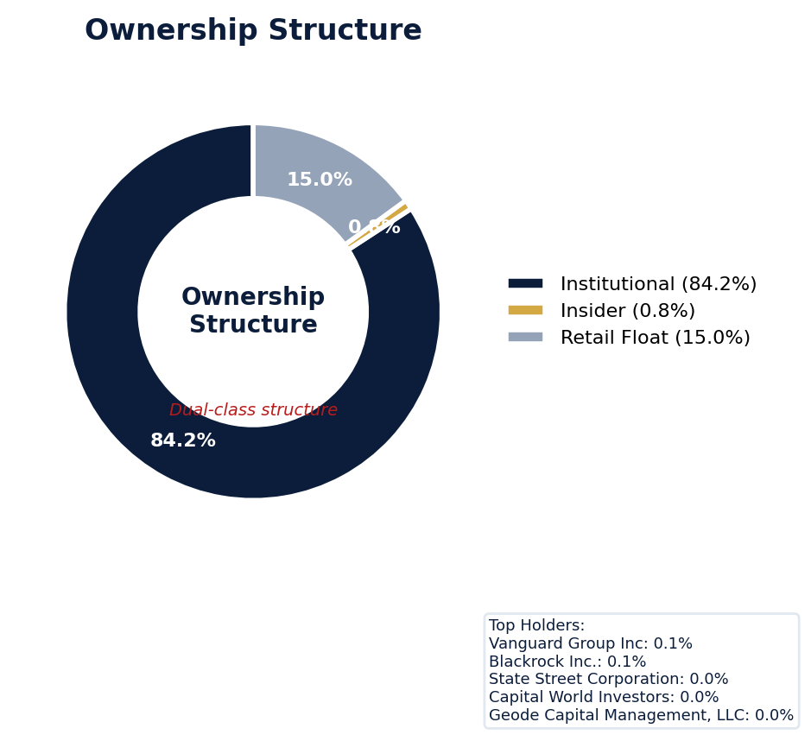
Figure: Ownership breakdown -- institutional, insider, retail float
Category | Percentage
Institutional Ownership | 84.2%
Insider Ownership | 0.8%
Retail Float | 15.0%
Top Holder | Ownership %
Vanguard Group Inc | 0.1%
Blackrock Inc. | 0.1%
State Street Corporation | 0.0%
Capital World Investors | 0.0%
Geode Capital Management, LLC | 0.0%
Sentiment & Narrative Coherence
Signal | Assessment
Narrative Coherence | COHERENT
Anti-Takeover Provisions
Anti-takeover provision data not available. Review DEF 14A and charter documents for complete analysis.

CRITICAL RISK
UnitedHealth currently faces one active SCA, *In re UnitedHealth Group Inc. Securities Litigation*, with a class period from 2019 to 2024, led by Tier 1 counsel Robbins Geller Rudman & Dowd LLP. The company’s adjusted SCA filing rate of 14.74% dramatically outpaces its sector’s 4.0% baseline, indicating a recurrent litigation profile far above industry norms that directly elevates D&O risk pricing. Six open derivative suits, typically piggybacking on the SCA’s allegations, compound defense cost exposure, which is material given the firm's moderate in-house defense strength and the 3.19 points deducted for litigation activity in the underwriting score. Historical settlement benchmarking is critical; UnitedHealth’s prior $925 million SCA settlement in 2019 sets a severe precedent for the current matter, indicating potential for another high-severity loss. The absence of an open SEC investigation ("NONE") is a rare positive, removing near-term risk of a parallel regulatory action serving as a corrective disclosure trigger for new claims. The core underwriting catch is the disconnect between a single active SCA and a filing rate nearly four times the sector average, signaling a persistent target for the plaintiff’s bar as evidenced by the 70 distinct litigation signals identified. Claim probability over the next policy period is elevated, driven by this recurrence pattern and the scale of past settlements, with six open matters already demanding defense resources. Underwriters must weigh the likelihood of this active SCA resolving within the standard 3-5 year litigation timeline against the high probability of a new filing emerging, given the company’s historical target profile and 14.74% adjusted filing rate.
Section 6: Litigation & Regulatory Exposure
The company faces 1 active securities class action(s). The primary case, {}, is currently pending. 6 derivative action(s) pending, alleging breach of fiduciary duty by directors and officers. 6 statute of limitations window(s) remain open, meaning new claims can still be filed for past events. Under claims-made D&O policy, coverage is triggered when a claim is reported during the policy period. Defense quality assessment: MODERATE.
Litigation Overview: 0 active matter(s), 3 historical matter(s)
Litigation Timeline
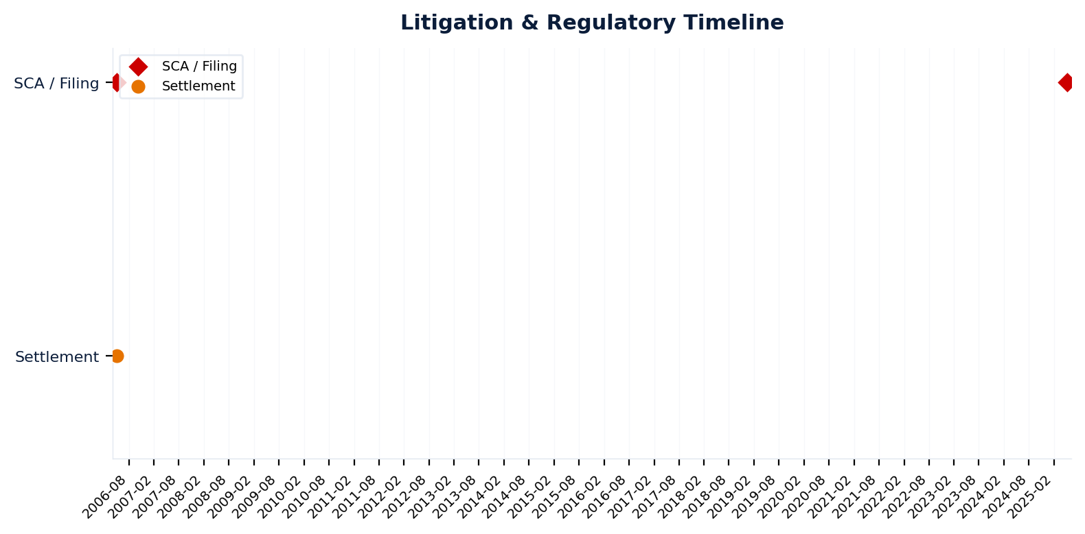
Figure: Chronological litigation and regulatory events overlaid with corporate events for pattern recognition
Securities Class Actions
Case Name | Legal Theory | Coverage | Court | Filing Date | Status | Class Period | Lead Counsel | Settlement | Source
In re UnitedHealth Group Incorporated Securities Litigation (2025) | Rule 10b-5, Derivative / Fiduciary Duty | Side C (Entity) | N/A | 2025-05-07 | DISMISSED | N/A | N/A | N/A | [Supabase SCA database, 2026-04-02, MEDIUM]
In re UnitedHealth Group, Inc. Securities Litigation (2006) | Rule 10b-5, Derivative / Fiduciary Duty | Side C (Entity) | D. Minn. | 2006-05-05 | SETTLED | Jan 2005 - May 2006 | N/A | $895.0M | [Supabase SCA database, 2026-04-02, MEDIUM]
D&O Context: Historical settlements total $895.0M. Settlement history establishes severity baseline for pricing. [ELEVATED]
SEC Enforcement Pipeline
Pipeline: (Comment Letters) -> (Informal Inquiry) -> (Formal Investigation) -> (Wells Notice) -> (Enforcement Action)
No SEC enforcement pipeline activity detected. [10-K Item 3 + Item 1A + 8-K + EFTS, 2026-04-02, LOW]
Derivative Suits
Case Name | Filing Date | Status | Court | Settlement
N/A | N/A | UNKNOWN | N/A | N/A
N/A | N/A | UNKNOWN | N/A | N/A
N/A | N/A | DISMISSED | N/A | N/A
Poehling v. UnitedHealth Group | N/A | UNKNOWN | Delaware Court of Chancery | N/A
N/A | N/A | UNKNOWN | N/A | N/A
N/A | N/A | UNKNOWN | N/A | N/A
Regulatory Proceedings
Agency | Type | Status
DOJ_FCPA | investigation | disclosed
DOJ | investigation | disclosed
DOJ | investigation | disclosed
FDA | investigation | disclosed
Industry Claim Patterns
No industry-specific claim patterns identified.
Statute of Limitations Map
Claim Type | Trigger Date | SOL Expiry | Repose Expiry | Window Open
employment_discrimination | 2026-03-02 | 2028-03-01 | 2028-03-01 | OPEN
antitrust | 2026-03-02 | 2030-03-01 | 2030-03-01 | OPEN
FCPA | 2026-03-02 | 2031-03-01 | 2031-03-01 | OPEN
environmental | 2026-03-02 | 2031-03-01 | 2031-03-01 | OPEN
derivative | 2026-03-02 | 2029-03-01 | 2032-02-29 | OPEN
ERISA | 2026-03-02 | 2029-03-01 | 2032-02-29 | OPEN
Section_11 | 2006-05-17 | 2007-05-17 | 2009-05-16 | CLOSED
Section_14a | 2006-05-17 | 2007-05-17 | 2009-05-16 | CLOSED
10b-5 | 2006-05-17 | 2008-05-16 | 2011-05-16 | CLOSED
D&O Context: 6 open exposure window(s). Claims can still be filed within these periods. [ELEVATED]
Defense Strength Assessment
Factor | Assessment
Federal Forum Provision | No
Exclusive Forum Provision | No
PSLRA Safe Harbor | STRONG
Truth-on-Market Viability | NOT_APPLICABLE
Prior Dismissal Success | No prior dismissals identified in Item 3
Overall Defense Strength | MODERATE
No forum selection provisions identified. Safe harbor usage is STRONG with explicit PSLRA citation and specific cautionary language. [DEF 14A; 10-K, 2026-04-02, LOW]
Contingent Liabilities
No disclosed contingent liabilities found in SEC filings. Review Item 8 footnotes and Item 3 for complete assessment.
Workforce, Product & Environmental Matters
Cybersecurity Incidents:
- [data_breach] We routinely process, store and transmit large amounts of data in our operations, including protected personal information subject to privacy, security or data breach notification laws, as well as proprietary or confidential information relating to our business or third parties.
- [data_breach] Further, because the techniques used to obtain unauthorized access, disable or degrade service, or sabotage systems change frequently and are increasing in sophistication, in part due to use of evolving AI technologies (including generative AI), and because our businesses are changing as well, we may be unable to anticipate these techniques and threats, timely det
- [data_breach] The costs to eliminate or address these threats and vulnerabilities before or after a cybersecurity incident could be material.
- [cyber_attack] If we or third parties we rely on sustain cyberattacks or other privacy or data security incidents resulting in disruption to our operations or the misappropriation or disclosure of protected personal information or proprietary or confidential information, we could suffer a loss of revenue and increased costs, negative operational effects, exposure to
- [cyber_attack] We are regularly the target of attempted cyberattacks and other security threats and have previously been, and may in the future be, subject to compromises of the information technology systems we use, information we hold, or information held on our behalf by third parties.
- [cyber_attack] For example, we previously reported that our Change Healthcare business, which we had recently acquired, was subject to a cyberattack in 2024, in which the data involved contained protected health information or personally identifiable information.
- [cyber_attack] propriate or otherwise compromise protected personal information or our proprietary or confidential information or that of third parties, and may develop and deploy malicious code (including viruses, ransomware and malware, among others) that can attack our systems, exploit security vulnerabilities, and disrupt or shut down our systems and operations.
- [cyber_attack] of certain factors including: our ability to effectively estimate, price for and manage medical costs; new or changes in existing health care laws or regulations, or their enforcement or application; cyberattacks, other privacy/data security incidents, or our failure to comply with related regulations; reductions in revenue or delays to cash flows received under government programs; changes in Medicare, the CMS star ratings program or the application of risk adjustment data validation audits;...
Whistleblower Indicators
Type | Description | Date | Significance
internal | ncluding as a result of a failure to adhere to applicable cl | N/A | MEDIUM
qui_tam | plicable clinical, quality and/or patient safety standards), | N/A | MEDIUM

UnitedHealth's quality score of 23.125 places it in the WALK tier, with a composite claim probability of 6.96-9.94% dictating an Excess/Side A only placement with high attachment. The risk is anchored by a 3.19-point deduction for Prior Litigation, supported by 70 identified signals, and a 2.31-point deduction for Restatement/Audit Issues from 86 signals, reflecting the persistent legal and regulatory scrutiny that drives securities class actions. A critical Whistleblower/Qui Tam red flag imposes a binding CRF-13 ceiling, directly constraining capacity by highlighting acute government enforcement risk under the False Claims Act. The profile is further defined by an active "Guidance Track Record" pattern, suggesting management's forward-looking statements are a consistent litigation trigger, compounded by a 1.33-point Governance deduction.
Section 7: Risk Scoring & Synthesis
Underwriting tier: **WALK** (quality score: 23.1/100). Recommended action: Excess/Side A only, high attachment required. Expected claim probability band: 7.0-9.9%. Top risk contributors: Prior Litigation (F1: -3.2 pts); Restatement/Audit Issues (F3: -2.3 pts); Governance Issues (F9: -1.3 pts). Active composite patterns: Guidance Track Record. **Red flag gates active**: Distress Zone (Altman Z < 1.81) (ceiling: 25); Whistleblower/Qui Tam Disclosure (ceiling: 100). Binding ceiling: CRF-13. Claim probability band: ELEVATED (7.0%-9.9%).
Tier Classification
Metric | Value
Quality Score | 23.1 / 100
Composite Score (pre-ceiling) | 90.1
Total Risk Points Deducted | 9.9
Tier | WALK
Tier Range | 11 - 30
Action Guidance | Excess/Side A only, high attachment required
Probability Range | 7.0-9.9%
Pricing Multiplier | 2x+ at high attachment
Binding Ceiling | CRF-13
Risk Assessment: CRITICAL [CRITICAL]
D&O Claim Peril Assessment
2 of 8 D&O claim perils show active risk signals. Active perils have at least one causal chain with triggered checks.
Peril | Risk Level | Active Chains | Key Evidence
Securities Claims | MODERATE | 1/5 | Qualitative: No non-GAAP measures detected in 10-K; Qualitative: 2
Fiduciary Breach | LOW | 0/3 | —
Government Enforcement | LOW | 0/2 | —
Employment & Whistleblower | HIGH | 1/1 | Required data not available from filings; Management display: 390000
Insolvency & Bankruptcy | LOW | 0/1 | —
Emerging Risks | LOW | 0/2 | —
Consumer & Product Claims | LOW | 0/1 | —
Commercial Litigation | LOW | 0/1 | —
Active Peril Analysis
Employment & Whistleblower: HIGH [HIGH]
Frequency: high | Severity: lower | Typical range: $500K - $50M
1 of 1 causal chains active.
Chain: Whistleblower → Employment/Retaliation Claims [HIGH]
Whistleblower activity or internal investigation leads to employment retaliation claims. Often precedes broader regulatory investigation.
Triggers:
• NLP.WHISTLE.language_detected
• NLP.WHISTLE.internal_investigation
Historical filing rate: 5% | Median severity: $3M
Securities Claims: MODERATE [MODERATE]
Frequency: moderate | Severity: high | Typical range: $5M - $500M+
1 of 5 causal chains active.
Chain: Guidance Miss → Securities Fraud [MODERATE]
Repeated guidance misses or aggressive forward guidance builds scienter case for securities fraud claim when stock eventually declines.
Triggers:
• FIN.GUIDE.earnings_reaction
Historical filing rate: 8% | Median severity: $12M
Composite Score Breakdown
Factor | Name | Max Pts | Deducted | % Used | Top Contributor
F1 | Prior Litigation | 20 | 3.2 | 16% | Signal-driven scoring: 70 signals, coverage=100%
F2 | Stock Decline | 15 | 0.6 | 4% | Signal-driven scoring: 30 signals, coverage=100%
F3 | Restatement/Audit Issues | 12 | 2.3 | 19% | Signal-driven scoring: 86 signals, coverage=100%
F4 | IPO/SPAC/M&A | 10 | 0.7 | 7% | Signal-driven scoring: 14 signals, coverage=100%
F5 | Guidance Misses | 10 | 0.4 | 4% | Signal-driven scoring: 28 signals, coverage=100%
F6 | Short Interest | 10 | 1.0 | 10% | Signal-driven scoring: 25 signals, coverage=100%
F7 | Stock Volatility | 9 | 0.3 | 3% | Signal-driven scoring: 30 signals, coverage=100%
F8 | Financial Distress | 6 | 0.0 | 0% | Signal-driven scoring: 14 signals, coverage=100%
F9 | Governance Issues | 8 | 1.3 | 17% | Signal-driven scoring: 37 signals, coverage=100%
F10 | Officer Stability | 2 | 0.1 | 5% | Signal-driven scoring: 92 signals, coverage=100%
10-Factor Risk Profile
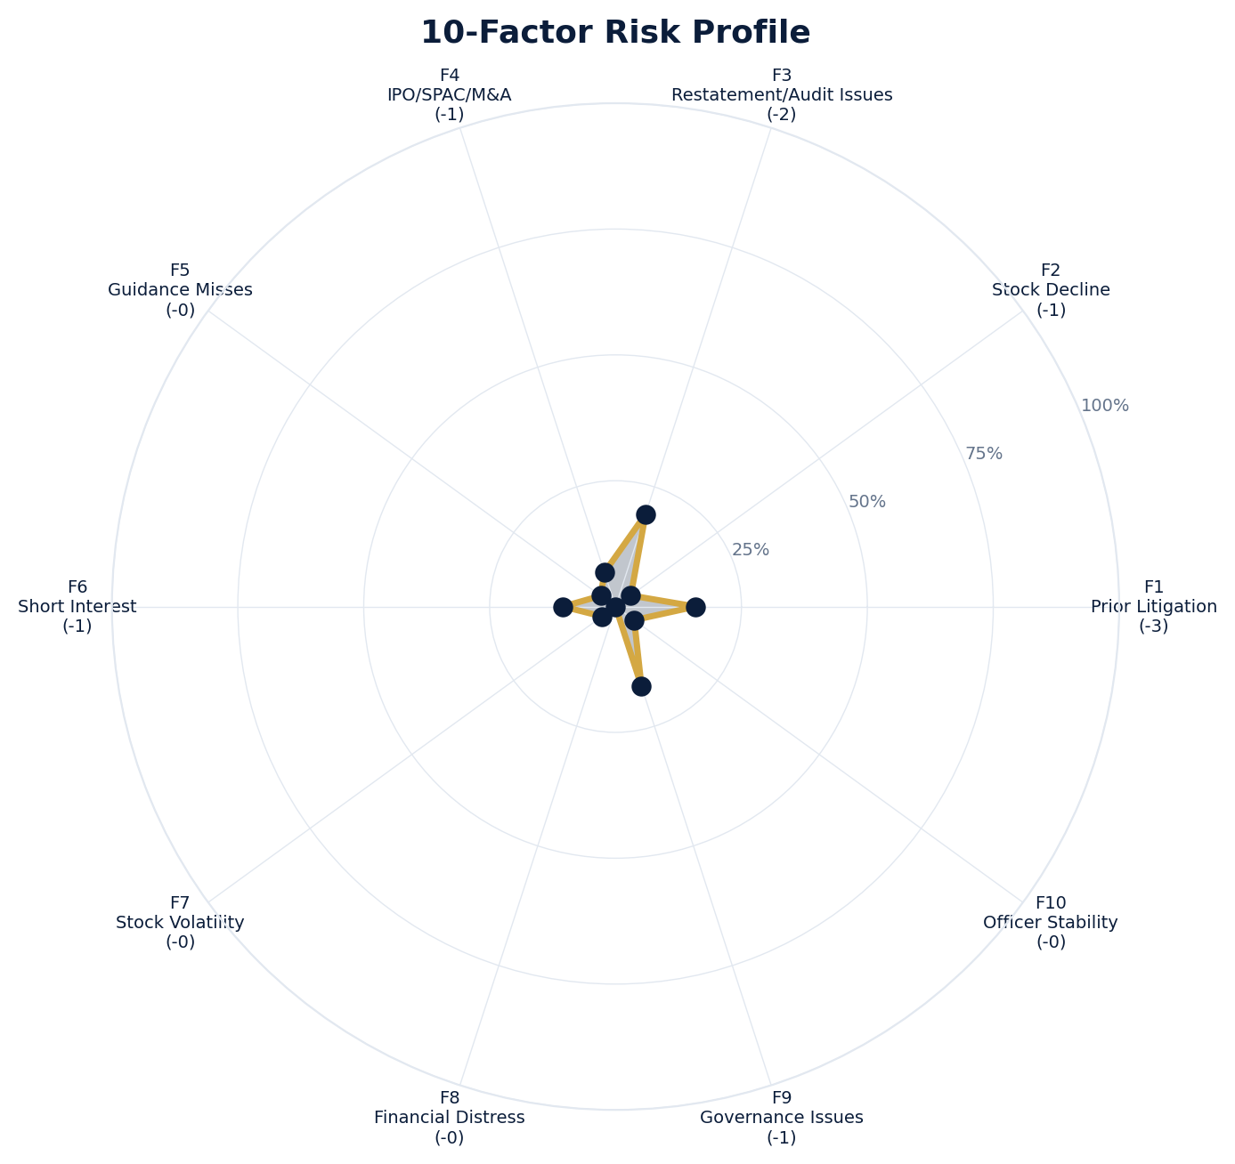
Figure: Radar chart showing risk fraction (points deducted / max) for each of the 10 scoring factors. Larger area = higher risk.
Red Flag Gates
Severity | Description | Source | Impact | Trajectory
CRITICAL | Critical Red Flag: Distress Zone (Altman Z < 1.81) | Altman Z-Score 1.41 (zone=grey) < 1.81 distress threshold | Ceiling: 25 | NEW
CRITICAL | Critical Red Flag: Whistleblower/Qui Tam Disclosure | Whistleblower indicator: internal | Ceiling: 100 | NEW
LOW | Prior Litigation: 3/20 points | Signal-driven scoring: 70 signals, coverage=100% | F1: 3 pts | NEW
LOW | Stock Decline: 1/15 points | Signal-driven scoring: 30 signals, coverage=100%; Drop contribution modifier: 0.34x (decay + company-specific + disclosure) | F2: 1 pts | NEW
LOW | Restatement/Audit Issues: 2/12 points | Signal-driven scoring: 86 signals, coverage=100% | F3: 2 pts | NEW
LOW | IPO/SPAC/M&A: 1/10 points | Signal-driven scoring: 14 signals, coverage=100% | F4: 1 pts | NEW
LOW | Guidance Misses: 0/10 points | Signal-driven scoring: 28 signals, coverage=100% | F5: 0 pts | NEW
LOW | Short Interest: 1/10 points | Signal-driven scoring: 25 signals, coverage=100% | F6: 1 pts | NEW
LOW | Stock Volatility: 0/9 points | Signal-driven scoring: 30 signals, coverage=100% | F7: 0 pts | NEW
LOW | Governance Issues: 1/8 points | Signal-driven scoring: 37 signals, coverage=100% | F9: 1 pts | NEW
LOW | Officer Stability: 0/2 points | Signal-driven scoring: 92 signals, coverage=100% | F10: 0 pts | NEW
LOW | Pattern: Guidance Track Record (BASELINE) | Pattern evaluation | F5: 0 | NEW
Critical: 2, High: 0, Moderate: 0, Low: 10
Risk Type Classification
Attribute | Value
Primary Risk Type | GUIDANCE_DEPENDENT
Secondary Risk Type | REGULATORY_SENSITIVE
Supporting Evidence | F5 guidance misses: 0.36363636363636365 points; Issues guidance (philosophy: CONSERVATIVE)
Severity Scenarios
Analysis based on market cap: $251.7B
Percentile | Label | Settlement Est. | Defense Costs | Total Exposure
25th | favorable | $2.0B | $295.5M | $2.3B
50th | median | $3.9B | $788.1M | $4.7B
75th | adverse | $7.9B | $2.0B | $9.9B
95th | catastrophic | $15.8B | $4.7B | $20.5B
Calibration Notes (SECT7-11)
The following items are flagged NEEDS CALIBRATION and require expert review before final pricing:
- SECT7-11: All scoring parameters require calibration against historical cases
Factor Detail
Factor | Name | Deducted | Rules Triggered | Evidence
F1 | Prior Litigation | 3.2 | N/A | Signal-driven scoring: 70 signals, coverage=100%
F2 | Stock Decline | 0.6 | drop_contribution_adjustment | Signal-driven scoring: 30 signals, coverage=100%; Drop contribution modifier: 0.34x (decay + company-specific + disclosure)
F3 | Restatement/Audit Issues | 2.3 | N/A | Signal-driven scoring: 86 signals, coverage=100%
F4 | IPO/SPAC/M&A | 0.7 | N/A | Signal-driven scoring: 14 signals, coverage=100%
F5 | Guidance Misses | 0.4 | N/A | Signal-driven scoring: 28 signals, coverage=100%
F6 | Short Interest | 1.0 | N/A | Signal-driven scoring: 25 signals, coverage=100%
F7 | Stock Volatility | 0.3 | N/A | Signal-driven scoring: 30 signals, coverage=100%
F9 | Governance Issues | 1.3 | N/A | Signal-driven scoring: 37 signals, coverage=100%
F10 | Officer Stability | 0.1 | N/A | Signal-driven scoring: 92 signals, coverage=100%
Sub-Component Breakdown
Factor | Component | Value
F1 | base | 3.19
F1 | bonus | 0.00
F1 | modifiers | 0.00
F1 | hard_triggers | 0.00
F1 | total_before_cap | 3.19
F1 | capped | 3.19
F2 | base | 1.64
F2 | bonus | 0.00
F2 | modifiers | 0.00
F2 | hard_triggers | 0.00
F2 | drop_contribution_modifier | 0.34
F2 | total_before_cap | 0.56
F2 | capped | 0.56
F3 | base | 2.31
F3 | bonus | 0.00
F3 | modifiers | 0.00
F3 | hard_triggers | 0.00
F3 | total_before_cap | 2.31
F3 | capped | 2.31
F4 | base | 0.71
F4 | bonus | 0.00
F4 | modifiers | 0.00
F4 | hard_triggers | 0.00
F4 | total_before_cap | 0.71
F4 | capped | 0.71
F5 | base | 0.36
F5 | bonus | 0.00
F5 | modifiers | 0.00
F5 | hard_triggers | 0.00
F5 | total_before_cap | 0.36
F5 | capped | 0.36
F5 | pattern_modifier | 0.00
F6 | base | 1.04
F6 | bonus | 0.00
F6 | modifiers | 0.00
F6 | hard_triggers | 0.00
F6 | total_before_cap | 1.04
F6 | capped | 1.04
F7 | base | 0.30
F7 | bonus | 0.00
F7 | modifiers | 0.00
F7 | hard_triggers | 0.00
F7 | total_before_cap | 0.30
F7 | capped | 0.30
F9 | base | 1.33
F9 | bonus | 0.00
F9 | modifiers | 0.00
F9 | hard_triggers | 0.00
F9 | total_before_cap | 1.33
F9 | capped | 1.33
F10 | base | 0.09
F10 | bonus | 0.00
F10 | modifiers | 0.00
F10 | hard_triggers | 0.00
F10 | total_before_cap | 0.09
F10 | capped | 0.09
Pattern Detection Results
Pattern | Severity | Triggers Matched | Score Impact
Guidance Track Record | BASELINE |  | F5: +0
Allegation Theory Mapping
Theory | Exposure | Factor Sources | Key Findings
A_DISCLOSURE | MODERATE | F1, F3, F5 | F1: Signal-driven scoring: 70 signals, coverage=100%; F3: Signal-driven scoring: 86 signals, coverage=100%
B_GUIDANCE | LOW | F2, F5 | F2: Signal-driven scoring: 30 signals, coverage=100%; F2: Drop contribution modifier: 0.34x (decay + company-specific + disclosure)
C_PRODUCT_OPS | LOW | F7 | F7: Signal-driven scoring: 30 signals, coverage=100%; 4 regulatory proceedings
D_GOVERNANCE | LOW | F9, F10 | F9: Signal-driven scoring: 37 signals, coverage=100%; F10: Signal-driven scoring: 92 signals, coverage=100%
E_MA | LOW | F4 | F4: Signal-driven scoring: 14 signals, coverage=100%
D&O Context: Primary allegation exposure is A_DISCLOSURE. MODERATE exposure in: A_DISCLOSURE.
Claim Probability Detail
Metric | Value
Probability Band | ELEVATED
Range | 7.0% - 9.9%
Industry Base Rate | 4.0%
Adjustment Rationale | Industry base rate: 4.0%. Tier WALK (15-20%): Substantially above base rate. Cri
Claim probability: ELEVATED [HIGH]
Tower Position Recommendation
Metric | Value
Recommended Position | HIGH_EXCESS
Minimum Attachment | $3940.3M (based on 50th percentile settlement)
Side A/DIC Assessment | Standard Side A considerations
Position | Risk Assessment | Premium Guidance | Attachment
PRIMARY | Primary layer carries 57% of expected loss exposur | Full rate, slight discount for | $0 ground-up
LOW_EXCESS | Low excess layer carries 18% of expected loss expo | Market rate | $5-15M xs $5-15M
MID_EXCESS | Mid excess layer carries 13% of expected loss expo | Market to 1.3x | $15-50M xs $15-50M
HIGH_EXCESS | High excess layer carries 11% of expected loss exp | 1.3-2x with attachment | $50M+ xs $50M+
DECLINE | WALK+ with compounding factors | N/A | N/A
Forensic Composite Scores
Composite | Score | Interpretation
Financial Integrity Score (FIS) | N/A | Not available
Reporting Quality Score (RQS) | N/A | Not available
Cash Flow Quality Score (CFQS) | N/A | Not available
Executive Risk Profile
Metric | Value
Weighted Score | 13
Risk Level | N/A
- [Andrew Witty (CEO)]: Prior litigation: snippet: Plaintiff, v. UNITEDHEALTH GROUP INC., ANDREW. WITTY, STEPHEN HEMSLEY, and BRIAN. THOMPSON,
- [Business Finance (COO)]: Prior litigation: url: https://finance.yahoo.com/quote/UNH.DU/news/
- [Business Finance (COO)]: Prior litigation: url: https://finance.yahoo.com/markets/stocks/articles/why-unitedhealth-group-unh-outpaced-215005983
- [Business Finance (COO)]: Prior litigation: site: finance
Temporal Signals
Type | Direction | Magnitude | Description
Unknown | N/A | N/A
Unknown | N/A | N/A
Unknown | N/A | N/A
Unknown | N/A | N/A
Unknown | N/A | N/A
Unknown | N/A | N/A
Unknown | N/A | N/A
Unknown | N/A | N/A
NLP Filing Analysis
Metric | Value
Readability Score | {'current_fog': 22.35, 'prior_fog': None, 'fog_change': None, 'current_flesch': 13.14, 'prior_flesch': None, 'classification': 'CURRENT_ONLY', 'evidence': 'Current Fog Index: 22.3 (prior year unavailable)'}
Tone Assessment | N/A
Risk Language Density | N/A
Peril Assessment
Plaintiff Peril Heat Map
Plaintiff Type | Probability | Severity
Shareholders | ELEVATED | SIGNIFICANT
Regulators | ELEVATED | SIGNIFICANT
Customers | VERY LOW | NUISANCE
Competitors | VERY LOW | NUISANCE
Employees | LOW | MINOR
Creditors | MODERATE | MODERATE
Government | MODERATE | SIGNIFICANT
Shareholders: 48 triggered checks. Key: Litigation History Profile: 2 (elevated vs benchmark of 0)
Regulators: 17 triggered checks. Key: Disclosure Complexity Score: 31 (elevated vs benchmark of 25)
Creditors: 4 triggered checks. Key: Goodwill/Intangible as % of Equity: 110.40 (elevated vs benchmark of 100)
Government: 5 triggered checks. Key: Key Supplier Dependencies: 2 (elevated vs benchmark of 1)
Bear Cases
Bear Case: A Disclosure
UNITEDHEALTH GROUP INC faces elevated exposure to securities disclosure fraud claims. Key risk indicators: Litigation History Profile (critical); VIE/SPE Off-Balance-Sheet Structures (critical). Estimated severity is significant, warranting detailed underwriter review.
Defense: Defense: No active Section 11 windows — statute of limitations expired for offering claims
Evidence Chain
1. [BIZ.CLASS.litigation_history] Litigation History Profile (Source: total_sca_count)
2. [BIZ.STRUCT.vie_spe] VIE/SPE Off-Balance-Sheet Structures (Source: vie_spe_present)
3. [BIZ.DEPEND.regulatory_dep] Single-Source Suppliers (Source: regulatory_dependency_count)
4. [BIZ.EVENT.ipo_exposure] IPO/Offering Exposure Window (Source: event_ipo_exposure_score)
5. [BIZ.OPS.workforce] Workforce Distribution (Source: workforce_distribution)
6. [BIZ.STRUC.obs_exposure] Off-Balance-Sheet Exposure (Source: obs_exposure_score)
7. [EXEC.PRIOR_LIT.any_officer] Any Officer With Prior Litigation at Previous Company (Source: value)
8. [EXEC.PRIOR_LIT.ceo_cfo] CEO or CFO With Prior Litigation (Source: value)
9. [FIN.ACCT.quality_indicators] Quality Indicators (Source: xbrl_altman_z_score)
10. [FIN.LIQ.working_capital] Working Capital Analysis (Source: xbrl_working_capital)
Probability: ELEVATED | Severity: SIGNIFICANT
Settlement Prediction
Settlement prediction computed but no scenarios available.
Tower Risk Characterization
Tower characterization not available.
Coverage Gaps -- Data Not Available
The following checks could not be evaluated because required data was not acquired. These items are NOT cleared -- they represent gaps in coverage that should be considered in the underwriting decision.
Executive Summary & Key Metrics
[EVALUATIVE] BIZ.DEPEND.labor (Concentration Risk Composite): Required data not available from filings
[REQUIRED] BIZ.MA.goodwill_balance (Goodwill Balance): Required data not available from filings
[REQUIRED] BIZ.MA.acquisition_spend (Acquisition Spend Magnitude): Required data not available from filings
[EVALUATIVE] BIZ.MA.goodwill_change (Goodwill Trajectory): Required data not available from filings
[REQUIRED] BIZ.MA.acquisition_list (Recent Acquisitions): Required data not available from filings
[EVALUATIVE] BIZ.MODEL.key_person (Key Person Dependency): Required data not available from filings
[REQUIRED] BIZ.MODEL.lifecycle (Segment Lifecycle Risk): Required data not available from filings
[REQUIRED] BIZ.MODEL.segment_margins (Segment Margin Profile): Required data not available from filings
[EVALUATIVE] ABS.DISC.audit_fees (Missing Audit Fee Disclosure): Expected signals not found in evaluation results
[EVALUATIVE] ABS.DISC.board_independence (Missing Board Independence Disclosure): Could not determine disclosure presence or absence
[EVALUATIVE] ABS.DISC.clawback_policy (Missing Clawback Policy Disclosure): Expected signals not found in evaluation results
[EVALUATIVE] ABS.DISC.cyber_risk (Missing Cybersecurity Risk Disclosure): Expected signals not found in evaluation results
[EVALUATIVE] ABS.DISC.debt_covenants (Missing Debt Covenant Disclosure): Expected signals not found in evaluation results
[EVALUATIVE] ABS.DISC.derivative_instruments (Missing Derivative Instruments Disclosure): Expected signals not found in evaluation results
[EVALUATIVE] ABS.DISC.esg (Missing ESG Disclosure): Expected signals not found in evaluation results
[EVALUATIVE] ABS.DISC.executive_comp (Missing Executive Compensation Disclosure): Expected signals not found in evaluation results
[EVALUATIVE] ABS.DISC.goodwill_impairment (Missing Goodwill Impairment Disclosure): Expected signals not found in evaluation results
[EVALUATIVE] ABS.DISC.lease_obligations (Missing Lease Obligation Disclosure): Expected signals not found in evaluation results
[EVALUATIVE] ABS.DISC.litigation_contingency (Missing Litigation Contingency Disclosure): Expected signals not found in evaluation results
[EVALUATIVE] ABS.DISC.pension_obligations (Missing Pension Obligation Disclosure): Expected signals not found in evaluation results
[EVALUATIVE] ABS.DISC.related_party (Missing Related-Party Transaction Disclosure): Expected signals not found in evaluation results
[EVALUATIVE] ABS.DISC.revenue_recognition (Missing Revenue Recognition Policy Disclosure): Expected signals not found in evaluation results
[EVALUATIVE] ABS.DISC.risk_factors (Missing Risk Factor Disclosure): Expected signals not found in evaluation results
[EVALUATIVE] ABS.DISC.segment_reporting (Missing Segment Reporting Disclosure): Expected signals not found in evaluation results
[EVALUATIVE] ABS.DISC.stock_comp (Missing Stock Compensation Disclosure): Expected signals not found in evaluation results
[EVALUATIVE] ABS.DISC.tax_positions (Missing Uncertain Tax Position Disclosure): Expected signals not found in evaluation results
[EVALUATIVE] CONJ.COMP.perf_divergence (Compensation-Performance Divergence): 3/3 component signals unavailable
[EVALUATIVE] CONJ.DISTRESS.insider (Financial Distress + Insider Selling): 2/3 component signals unavailable
[EVALUATIVE] CONJ.GOV.governance_event (Weak Governance + Adverse Event): 3/5 component signals unavailable
[EVALUATIVE] CONJ.FIN.growth_margin_guidance (Rapid Growth + Margin Compression + Guidance Miss): 3/3 component signals unavailable
[EVALUATIVE] CONJ.INSIDER.news_gap (Insider Selling + Material News Gap): 3/3 component signals unavailable
[EVALUATIVE] CONJ.REG.litigation (Regulatory Action + New Material Litigation): 3/3 component signals unavailable
[EVALUATIVE] CTX.FIN.capex_sector (Capital Expenditure in Sector Context): Source signal FIN.INVEST.capex_ratio not in results
[EVALUATIVE] CTX.COMP.lifecycle (CEO Compensation in Lifecycle Context): Source signal EXEC.COMP.ceo_total_comp not in results
[EVALUATIVE] CTX.COMP.product_tower (Compensation Severity by Product/Tower): Source signal EXEC.COMP.ceo_total_comp not in results
[EVALUATIVE] CTX.FIN.debt_maturity (Debt Maturity Profile in Lifecycle Context): Source signal FIN.DEBT.maturity_profile not in results
[EVALUATIVE] CTX.FIN.distress_product (Financial Distress by Product/Tower): Source signal FIN.FORENSIC.altman_z not in results
[EVALUATIVE] CTX.FIN.dividend_lifecycle (Dividend Policy in Lifecycle Context): Source signal FIN.RETURN.dividend_yield not in results
[EVALUATIVE] CTX.EXEC.tenure_lifecycle (Executive Tenure in Lifecycle Context): Source signal EXEC.TURN.c_suite not in results
[EVALUATIVE] CTX.MKT.insider_lifecycle (Insider Trading in Lifecycle Context): Source signal STOCK.INSIDER.net_selling not in results
[EVALUATIVE] CTX.FIN.leverage_sector (Leverage in Sector Context): Source signal FIN.DEBT.leverage_ratio not in results
[EVALUATIVE] CTX.LIT.size (Litigation Frequency by Company Size): Source signal LIT.SCA.active_cases not in results
[EVALUATIVE] CTX.RISK.ma_lifecycle (M&A Activity in Lifecycle Context): Source signal BIZ.MA.acquisition_activity not in results
[EVALUATIVE] CTX.RISK.regulatory_sector (Regulatory Risk in Sector Context): Source signal LIT.SEC.enforcement not in results
[EVALUATIVE] CTX.RISK.rpt_sector (Related-Party Risk in Sector Context): Source signal GOV.RPT.related_party not in results
[EVALUATIVE] CTX.MKT.short_interest_sector (Short Interest in Sector Context): Source signal STOCK.SHORT.interest_ratio not in results
[EVALUATIVE] CTX.MKT.turnover_sector (Stock Turnover in Sector Context): Source signal STOCK.VOL.turnover_rate not in results
[EVALUATIVE] CTX.MKT.volatility_sector (Stock Volatility in Sector Context): Source signal STOCK.VOL.historical not in results
Financial Health
[EVALUATIVE] FIN.PEER.revenue_bottom_quartile (Revenue Bottom Quartile (Cross-Filer)): No peer comparison data available
[EVALUATIVE] FIN.PEER.leverage_top_decile (Leverage Top Decile (Sector-Relative)): No peer comparison data available
[EVALUATIVE] FIN.PEER.margin_compression (Operating Margin Compression (Cross-Filer)): No peer comparison data available
[EVALUATIVE] FIN.PEER.profitability_laggard (Profitability Laggard (Sector-Relative)): No peer comparison data available
[EVALUATIVE] FIN.PEER.size_outlier_small (Size Outlier Small (Cross-Filer)): No peer comparison data available
[EVALUATIVE] FIN.PEER.cash_flow_weak (Cash Flow Weakness (Cross-Filer)): No peer comparison data available
[EVALUATIVE] LIT.DEFENSE.forum_selection (Federal Forum Selection Clause): Required data not available from filings
Governance & Leadership
[EVALUATIVE] EXEC.INSIDER.ceo_net_selling (CEO Net Seller of Stock): Required data not available from filings
[EVALUATIVE] EXEC.INSIDER.cfo_net_selling (CFO Net Seller of Stock): Required data not available from filings
[EVALUATIVE] EXEC.AGGREGATE.board_risk (Board Aggregate Risk Score): Data mapping not configured for this check
[EVALUATIVE] EXEC.AGGREGATE.highest_risk_individual (Highest Individual Risk Score Exceeds Threshold): Data mapping not configured for this check
[EVALUATIVE] EXEC.TENURE.cfo_new (CFO Tenure Less Than 2 Years): Data mapping not configured for this check
[REQUIRED] EXEC.PROFILE.board_size (Board Size (Number of Members)): Required data not available from filings
[REQUIRED] EXEC.PROFILE.avg_tenure (Average Executive Tenure): Required data not available from filings
[REQUIRED] EXEC.PROFILE.independent_ratio (Board Independence Percentage): Required data not available from filings
[EVALUATIVE] EXEC.PROFILE.overboarded_directors (Directors Serving on 4+ Boards): Required data not available from filings
[EVALUATIVE] GOV.BOARD.size (Board Size): Required data not available from filings
[EVALUATIVE] GOV.BOARD.independence (Board Independence): Required data not available from filings
[EVALUATIVE] GOV.BOARD.diversity (Board Diversity): Required data not available from filings
[EVALUATIVE] GOV.BOARD.tenure (Tenure): Required data not available from filings
[EVALUATIVE] GOV.BOARD.overboarding (Overboarding): Required data not available from filings
[EVALUATIVE] GOV.BOARD.attendance (Attendance): Required data not available from filings
[EVALUATIVE] GOV.BOARD.meetings (Meetings): Required data not available from filings
[EVALUATIVE] GOV.BOARD.succession (Succession): Required data not available from filings
[EVALUATIVE] GOV.EXEC.cfo_profile (CFO Profile): Required data not available from filings
[EVALUATIVE] GOV.INSIDER.ownership_concentration (Ownership Concentration): Required data not available from filings
[EVALUATIVE] GOV.PAY.golden_para (Golden Para): Required data not available from filings
[EVALUATIVE] GOV.PAY.equity_burn (Equity Burn): Required data not available from filings
[EVALUATIVE] GOV.PAY.hedging (Hedging): Required data not available from filings
[REQUIRED] GOV.RIGHTS.bylaws (Bylaws): Required data not available from filings
[EVALUATIVE] GOV.RIGHTS.takeover (Takeover): Required data not available from filings
[EVALUATIVE] GOV.RIGHTS.proxy_access (Proxy Access): Required data not available from filings
[REQUIRED] GOV.RIGHTS.forum_select (Forum Select): Required data not available from filings
[EVALUATIVE] GOV.RIGHTS.supermajority (Supermajority): Required data not available from filings
[EVALUATIVE] GOV.RIGHTS.action_consent (Action Consent): Required data not available from filings
[EVALUATIVE] GOV.RIGHTS.special_mtg (Special Mtg): Required data not available from filings
[EVALUATIVE] GOV.RIGHTS.classified (Classified): Required data not available from filings
Market & Trading
[EVALUATIVE] FIN.COMP.rsu_grants (RSU Grant Trend): Required data not available from filings
[EVALUATIVE] FIN.CONT.loss_accrual (Loss Contingency Accrual): Required data not available from filings
[EVALUATIVE] FIN.CONT.loss_estimate (Loss Contingency Estimate): Required data not available from filings
[EVALUATIVE] FIN.CONT.settlement_activity (Litigation Settlement Activity): Required data not available from filings
[EVALUATIVE] FIN.CONT.warranty_reserve (Product Warranty Reserve): Required data not available from filings
[EVALUATIVE] FIN.DEBT.facility_utilization (Credit Facility Utilization): Required data not available from filings
[EVALUATIVE] FIN.DEBT.maturity_concentration (Debt Maturity Concentration): Data mapping not configured for this check
[EVALUATIVE] FIN.DERIV.notional_exposure (Derivative Notional Exposure): Required data not available from filings
[EVALUATIVE] FIN.DERIV.fair_value_risk (Derivative Fair Value Risk): Required data not available from filings
[EVALUATIVE] FIN.QUALITY.q4_revenue_concentration (Q4 Revenue Concentration): Required data not available from filings
[EVALUATIVE] FIN.QUALITY.revenue_recognition_risk (Revenue Recognition Risk Indicators): Data mapping not configured for this check
[EVALUATIVE] FIN.FORENSIC.level3_fair_value (Level 3 Fair Value Asset Concentration): Data mapping not configured for this check
[EVALUATIVE] FIN.FORENSIC.goodwill_deterioration_pattern (Goodwill Deterioration Pattern): Data mapping not configured for this check
[EVALUATIVE] FIN.FORENSIC.related_party_revenue (Related Party Revenue Concentration): Data mapping not configured for this check
[EVALUATIVE] FWRD.EVENT.ma_integration_risk (M&A Integration Risk): Data mapping not configured for this check
[EVALUATIVE] FIN.FORENSIC.margin_compression (Forensic Margin Compression): Data mapping not configured for this check
[EVALUATIVE] FIN.FORENSIC.buyback_timing (Share Buyback Timing Quality): Data mapping not configured for this check
[EVALUATIVE] FIN.FORENSIC.pension_underfunding (Pension Underfunding Risk): Data mapping not configured for this check
[EVALUATIVE] FIN.FORENSIC.dsri_elevated (Days Sales Receivable Index Elevated): Data mapping not configured for this check
[EVALUATIVE] FIN.FORENSIC.aqi_elevated (Asset Quality Index Elevated): Data mapping not configured for this check
[EVALUATIVE] FIN.FORENSIC.tata_elevated (Total Accruals to Total Assets Elevated): Data mapping not configured for this check
[EVALUATIVE] FIN.FORENSIC.non_gaap_gap (Non-GAAP to GAAP Earnings Gap): Data mapping not configured for this check
[EVALUATIVE] FIN.FORENSIC.goodwill_growth_rate (Goodwill Growth Rate): Data mapping not configured for this check
[EVALUATIVE] FIN.FORENSIC.acquisition_to_revenue (Acquisition Spend Relative to Revenue): Data mapping not configured for this check
[EVALUATIVE] FIN.PROFIT.revenue (Revenue Analysis): Required data not available from filings
[EVALUATIVE] FIN.GUIDE.track_record (Guidance Track Record): Required data not available from filings
[EVALUATIVE] FIN.LEASE.rou_asset (Right-of-Use Asset Concentration): Required data not available from filings
[EVALUATIVE] FIN.OBS.contract_liability (Deferred Revenue Execution Risk): Required data not available from filings
[EVALUATIVE] FIN.RESTRUCT.charges (Restructuring Charges): Required data not available from filings
[EVALUATIVE] FIN.RESTRUCT.severance (Severance Costs): Required data not available from filings
[EVALUATIVE] FIN.IMPAIR.asset_writedown (Asset Impairment): Required data not available from filings
[REQUIRED] NLP.FILING.filing_timing_change (Filing Date Shifted Significantly vs Prior Year): Required data not available from filings
[EVALUATIVE] STOCK.INSIDER.notable_activity (Notable Activity): Required data not available from filings
[EVALUATIVE] FIN.FORENSIC.m_score_composite (Beneish M-Score Composite (XBRL)): Data mapping not configured for this check
Gap breakdown: Required items: 11 | Evaluative checks: 108
Total: 119 checks data-unavailable out of 576 total checks (79% coverage)

Calibration Notes
System Intelligence Status
Checks active: 601
Checks incubating: 0 (pending human approval)
Pending feedback: 0 entries
Recent Calibration Changes
Date | Check | Change | Changed By
2026-04-02 | UTILIZATION_MGMT_SCRUTINY | Proposed by ingestion of 'blind_spot:UNH:UnitedHealth Group | ingestion_pipeline
2026-04-02 | PUBLIC_OUTRAGE_IMPACT | Proposed by ingestion of 'blind_spot:UNH:UnitedHealth Group | ingestion_pipeline
2026-04-02 | GUIDANCE_CHANGE_POST_CRISIS | Proposed by ingestion of 'blind_spot:UNH:UnitedHealth Group | ingestion_pipeline
2026-04-02 | VAERS_DATA_MONITORING | Proposed by ingestion of 'blind_spot:MRNA:Moderna, Inc. Secu | ingestion_pipeline
2026-04-02 | VACCINE_SAFETY_OVERSIGHT_BOARD | Proposed by ingestion of 'blind_spot:MRNA:Moderna, Inc. Secu | ingestion_pipeline
2026-04-02 | PEDIATRIC_SAFETY_DISCLOSURE_GAP | Proposed by ingestion of 'blind_spot:MRNA:Moderna, Inc. Secu | ingestion_pipeline
2026-04-02 | GOV.FOUNDER_CRIMINAL_EXPOSURE | Proposed by ingestion of 'blind_spot:NVDA:Super Micro Comput | ingestion_pipeline
2026-04-02 | BIZ.CHINA_EXPOSURE_DISCLOSURE | Proposed by ingestion of 'blind_spot:NVDA:Super Micro Comput | ingestion_pipeline
2026-04-02 | GOV.EXPORT_CONTROL_COMPLIANCE | Proposed by ingestion of 'blind_spot:NVDA:Super Micro Comput | ingestion_pipeline
2026-04-02 | AI_DEVELOPMENT_TIMELINE_DISCLOSURE | Proposed by ingestion of 'blind_spot:AAPL:AAPL LAWSUIT: Appl | ingestion_pipeline
Discovery Findings
1 document(s) analyzed, 3 proposal(s) generated, from blind spot search
Feedback for UNH
No pending feedback for UNH.

