
Angry Dolphin -- D&O Underwriting Worksheet
Apple Inc. (AAPL)
Generated: April 02, 2026
[Table of Contents -- Update in Word]

Apple Inc.’s D&O risk profile is dominated by its exceptional governance and financial stability, but elevated by persistent securities litigation, warranting a "WIN" tier placement and aggressive underwriting pursuit. The composite score of 91.3, driven by a clean SEC record, flawless audits, and a governance score above 70, reflects a fundamentally robust defensive posture. However, the elevated claim band (5.18%-7.4% probability) is directly attributable to a 2.46-point deduction for "Prior Litigation," sourced from 70 distinct litigation signals with 100% coverage. A further 2.19-point deduction for "IPO/SPAC/M&A" activity, despite Apple's maturity, captures ongoing integration and antitrust risks from its acquisitive strategy. The inherent risk percentage of 3.31% is materially offset by the lack of financial distress indicators and zero C-suite departures over 18 months. Consequently, Apple’s $3.75 trillion market cap and 150,000 employees present a scale of exposure that demands premium discipline, but its institutional quality mitigates severity risk. The underwriting thesis balances these cross-sectional implications: litigation frequency is a known, priced-in headwind, while the absence of material weaknesses, SEC investigations, and leadership volatility provides a durable defense against systemic governance failures. Therefore, Apple is a must-have account where capacity should be deployed strategically, with pricing anchored to the 7.4% high-end claim probability, not its top-tier composite score.
Executive Summary
Underwriting Thesis
Apple Inc. is a $3.8T (Decile 1 of 10) mega-cap technology company scoring 91/100 (WIN tier). The primary risk driver is Prior Litigation, driving elevated risk in this area. Signal-driven scoring: 70 signals, coverage=100%. At a 5-7% claim probability (3.3% adjusted rate, 0.7x the Technology sector baseline of 5.0%), this account requires primary or low-excess participation.
Company Snapshot
Attribute | Value | Source
Company | Apple Inc.
Ticker | AAPL
Exchange | Nasdaq
Sector | Technology
Industry | Consumer Electronics
Market Cap | $3.8T [Decile 1 (largest ~400 accounts)] (Ranks at the 90th percentile among 10 peers) | [yfinance, filed 2026-04-02, MEDIUM confidence]
Revenue | $416.2B | [10-K 2025-09-27 CIK320193 accn:0000320193-25-000079, filed 2025-09-27, HIGH confidence]
Employees | 150,000 | [yfinance, filed 2026-04-02, MEDIUM confidence]
SIC | 3571 -- Electronic Computers
GICS | 45202030
NAICS | 334111
FPI Status | No
Fiscal Year End | 09-26
Tier Classification
Attribute | Value
Tier | WIN
Composite Score | 91.3/100
Quality Score | 91.3/100
Factor Breakdown | F1: 2.5, F2: 0.3, F3: 0.8, F4: 2.2, F5: 0.4, F6: 1.3, F7: 0.3, F8: 0.0, F9: 0.7, F10: 0.1
Position | 91.3 falls in WIN range (86-100)
Appetite | Must-have account, compete aggressively
Classification: WIN [MODERATE]
Inherent Risk Baseline
Component | Value
Market Cap Tier | MEGA [Decile 1 (largest ~400 accounts)]
Sector | Technology (Base rate: 5.0%)
Size Adjustment | 1.56x (MEGA cap multiplier) -> 7.8%
Score Adjustment | 0.42x (quality score multiplier) -> 3.3%
Severity Percentile | Settlement Estimate
25th (favorable) | $25.0M
50th (median) | $75.0M
75th (adverse) | $112.5M
95th (catastrophic) | $150.0M
At a 3.3% adjusted claim rate, the company faces 0.7x its sector baseline of 5.0% for Technology companies. This rate reflects the MEGA cap multiplier (1.56x) combined with the quality score multiplier (0.42x from WIN tier classification).
Note: NEEDS CALIBRATION
Underwriting Headwinds
1. Structural Complexity & Litigation History [HIGH]
Apple Inc. has 24 subsidiaries, increasing multi-jurisdictional litigation exposure. The current docket includes 1 securities class action. With 1 pending matter at $3.8T market cap, Apple Inc. has an active litigation profile that will factor into loss-pick and pricing. (see Litigation)
2. Earnings Guidance Track Record [HIGH]
Apple Inc. has missed earnings guidance in 1 quarter, with management credibility score at 92%. At $3.8T market cap with an estimated DDL of $58.2B, guidance misses generate large absolute loss figures that attract institutional lead plaintiffs. (see Market & Trading)
3. Stock Price Decline [ELEVATED]
Apple Inc.'s stock has undergone a -11% dip of -11.4% from $288.62 to $255.63 over 252 trading days. This creates an estimated Disclosure Dollar Loss (DDL) of $58.2B, among the largest potential DDL exposures in the market. (see Market & Trading)
4. Transaction-Related Exposure [ELEVATED]
Apple Inc. has transaction-related risk factors. At $3.8T market cap, transaction claims carry both Section 10(b) exposure (misleading disclosures) and Section 14(a) exposure (deficient proxy statements).
5. Stock Volatility [ELEVATED]
Apple Inc.'s stock exhibits elevated volatility with a -11% dip of -11.4% from its 52-week high. The estimated DDL of $58.2B amplifies settlement severity for any corrective disclosure event. (see Market & Trading)
Risk Mitigants
1. Clean Regulatory Record
Apple Inc. has no active SEC enforcement pipeline activity, open investigations, or pending Wells Notices. A clean regulatory record for Apple Inc. eliminates the highest-severity D&O claim catalyst and supports favorable underwriting consideration. (see Litigation)
2. Clean Audit & Accounting History
Apple Inc. maintains a clean audit opinion from Ernst & Young (tenure: 17 years) with no material weaknesses, restatements, or going concern qualifications. The 17-year relationship with Ernst & Young provides audit continuity that reduces the likelihood of restatement-driven class actions. (see Financial Health)
3. Strong Board Governance
Board governance is strong. Ernst & Young serves as external auditor with a clean opinion and no material weaknesses. (see Governance)
4. Sound Financial Position
No financial distress indicators present (Altman Z-Score of 10.16, D/E of 1.23, current ratio of 0.9x). An Altman Z of 10.16 places Apple Inc. firmly in the safe zone, eliminating going-concern, covenant violation, and creditor-related D&O exposure. (see Financial Health)
5. Stable Executive Leadership
C-suite leadership is stable with Mr. Timothy D. Cook leading the organization and no recent departures. (see Governance)
Claim Probability
Metric | Value
Band | ELEVATED
Company Rate | 5.2% - 7.4%
Industry Base Rate | 5.0%
Severity Favorable | $143.0M
Severity Median | $298.3M
Severity Adverse | $621.5M
Severity Catastrophic | $1.3B
Probability Band: ELEVATED [HIGH]
The 5-7% probability band represents approximately 1x the Technology sector base rate of 5.0%. Accounts in WIN tier historically produce claims at elevated frequency. Industry base rate: 5.0%. Tier WIN (0-2%): Below base rate. Strong risk profile reduces claim probability below industry average. NEEDS CALIBRATION: Probability estimates are indicative and require actuarial validation per SECT7-11. Enhanced frequency: 9.00% base x 0.82 hazard x 1.00 signal = 7.40%.
Tower Recommendation
Metric | Value
Position | Primary
Min Attachment | $248.6M (based on 50th percentile settlement)
Side A/DIC | Standard Side A considerations
Layer | Risk Assessment | Premium Guidance
PRIMARY | Primary layer carries 57% of expected loss exposure. Highest frequency of attachment; most likely to be eroded in any claim scenario. | Full rate, slight discount for WIN
LOW_EXCESS | Low excess layer carries 18% of expected loss exposure. Attaches after primary exhaustion; moderate frequency in adverse scenarios. | Market rate
MID_EXCESS | Mid excess layer carries 13% of expected loss exposure. Attaches in adverse scenarios; lower frequency but higher severity when reached. | Market to 1.3x
HIGH_EXCESS | High excess layer carries 11% of expected loss exposure. Attaches only in catastrophic scenarios; lowest frequency, highest severity. | 1.3-2x with attachment
DECLINE | WALK+ with compounding factors | N/A
Market Context
No market pricing data available.

ELEVATED CONCERN
Company Overview
Apple Inc. is a $3.76 trillion market cap technology company that designs, manufactures, and markets the iPhone, Mac, iPad, and Wearables, and sells services including advertising, cloud, and payment platforms. With 150,000 employees and 45 years as a public company, its operational scale and brand dominance create immense scrutiny on every strategic decision made by its board and officers, elevating fiduciary duty expectations.
Revenue Model
Revenue is split between hardware and a high-margin Services segment; a single failed product cycle or antitrust action against the Services "walled garden" could break the high-margin recurring revenue engine that supports its valuation and trigger shareholder claims for strategic misrepresentation. The model's critical vulnerability is iPhone cyclicality juxtaposed with regulatory pressure on its 30% App Store commission, a key profit driver from its $85B+ annual Services revenue.
D&O Risk Profile
The primary D&O exposure is global antitrust scrutiny from jurisdictions including the Americas, Europe, and Greater China, specifically that the board's strategic defense of its iOS ecosystem will generate direct shareholder claims for oversight failure. Secondary exposure is concentrated in Greater China, which represents nearly 20% of revenue; a geopolitical supply chain or market access decision by the board could instantly crater billions in value, inviting derivative suits. The company's "MEGA" risk classification and status as a Large Accelerated Filer guarantee that any material misstep will be litigated at scale, as seen in its exposure to Transaction, IP, and Employment litigation risks.
Section 2: Company Profile
Apple Inc. operates in the Consumer Electronics industry. The company has 150,000 employees and $3757.2B market cap. Key D&O exposure factors include: Regulatory Multi Jurisdiction, Employment Litigation Risk, Transaction Litigation Risk. [derived:section_summary, 2026-04-02, LOW]
Company Identity
Field | Value | Source
Legal Name | Apple Inc. | [SEC EDGAR submissions, filed 2026-04-02, HIGH confidence]
Ticker | AAPL
CIK | 320193 | [SEC EDGAR submissions, filed 2026-04-02, HIGH confidence]
Sector | Technology | [SEC EDGAR submissions, filed 2026-04-02, HIGH confidence]
SIC Code | 3571 | [SEC EDGAR submissions, filed 2026-04-02, HIGH confidence]
SIC Description | Electronic Computers
GICS Code | 45202030 | [SIC->GICS mapping (SIC 3571), filed 2026-04-02, MEDIUM confidence]
NAICS Code | 334111 | [SIC->NAICS crosswalk (SIC 3571), filed 2026-04-02, MEDIUM confidence]
Exchange | Nasdaq | [SEC EDGAR submissions, filed 2026-04-02, HIGH confidence]
State of Incorporation | CA | [SEC EDGAR submissions, filed 2026-04-02, HIGH confidence]
FPI Status | No
Fiscal Year End | 09-26 | [SEC EDGAR submissions, filed 2026-04-02, HIGH confidence]
Business Description
Apple Inc. designs, manufactures, and markets smartphones, personal computers, tablets, wearables, and accessories, and sells a variety of related services. The company generates revenue primarily through the sale of hardware products (iPhone, Mac, iPad, Wearables, Home and Accessories) and services (advertising, AppleCare, cloud services, digital content, payment services). Apple operates globally with sales outside the U.S. representing a majority of total net sales. It employs a direct and indirect distribution model, with indirect channels accounting for 60% of total net sales in 2025. The company's profitability is driven by high-margin services and innovative product design, supported by a large portfolio of intellectual property and significant research and development investments. [10-K (LLM), filed 2026-04-02, HIGH confidence]
Subsidiaries
Total subsidiaries: 24 [Exhibit 21 (subsidiary list), filed 2026-04-02, HIGH confidence]
Business Model Profile
Dimension | Assessment
Revenue Model | HYBRID
Concentration Risk | LOW (Score: 1/3) - Single geography 43%
Key Person Risk | LOW (Score: 0/3)
Disruption Risk | HIGH (5 threats) - Competitors imitating product features and infringing intellectual property.; Rapid technological advancements and short product life cycles.; Aggressive price competition and downward pressure on margins.; New and emerging technologies like AI introducing legal, regulatory, and ethical risks.; Regulatory changes requiring modifications to products and services.
Segment Lifecycle
Segment | Stage | Growth Rate
iPhone | GROWTH | 4.0%
Mac | GROWTH | 12.0%
iPad | GROWTH | 5.0%
Wearables, Home and Accessories | DECLINING | -4.0%
Services | GROWTH | 14.0%
Operational Complexity
Complexity Score: 150000/20 -- HIGH [HIGH]
Component | Value
Jurisdictions | 14 (5 high-regulatory)
Workforce | 150,000
Segments | 4
Geographic Concentration | 8/100
Supply Chain | moderate
Overall Resilience | ADEQUATE
Structural Indicators: [ ] VIE / SPE | [ ] Dual-Class | [ ] Holding Depth | [ ] OBS Exposure
Corporate Events & Transaction Risk
Event Type | Assessment
M&A Activity | LOW (Score: 0/4) | 0 acquisition years
IPO / Offering Exposure | LOW - 45 years public
Business Changes:
- 10 current event filings (8-K), most recent 2026-02-24
- M&A activity indicated (acquisition)
Peer Group Comparison
Ticker | Name | Market Cap | Quality Score | Similarity
MSFT | Microsoft Corporation | $2.7T | N/A | Sector Etf / 34%
GOOGL | Alphabet Inc. | $3.6T | N/A | Sector Etf / 38%
AMZN | Amazon.com, Inc. | $2.3T | N/A | Sector Etf / 16%
META | Meta Platforms, Inc. | $1.5T | N/A | Sector Etf / 8%
NVDA | NVIDIA Corporation | $4.3T | N/A | Sector Etf / 40%
CRM | Salesforce, Inc. | $174.5B | N/A | Sector Etf / 12%
ADBE | Adobe Inc. | $98.4B | N/A | Sector Etf / 13%
ORCL | Oracle Corporation | $417.7B | N/A | Sector Etf / 14%
CSCO | Cisco Systems, Inc. | $307.9B | N/A | Sector Etf / 13%
INTC | Intel Corporation | $241.2B | N/A | Sector Etf / 13%
The peer group of 10 companies shares the same industry classification (SIC 3571). Apple Inc. ranks at the 90th percentile among 10 peers by market capitalization.
Revenue Segments
Revenue segment data not available.
Geographic Footprint
Region | Revenue | % of Total
Americas | N/A | $178,353 million (42.9%)
Europe | N/A | $111,032 million (26.7%)
Greater China [HIGH RISK] | N/A | $64,377 million (15.5%)
Rest of Asia Pacific | N/A | $33,696 million (8.1%)
Japan | N/A | $28,703 million (6.9%)
D&O Alert: Operations in high-risk jurisdictions: Greater China. Sanctions compliance and regulatory exposure elevated. [HIGH]
Customer & Supplier Concentration
Customer | % of Revenue | Source
One customer represented 12% of total trade receivables as of September 27, 2025. | 0.0% | [10-K (LLM), 2026-04-02, HIGH]
Third-party cellular network carriers accounted for 34% of total trade receivables as of September 27, 2025. | 0.0% | [10-K (LLM), 2026-04-02, HIGH]
Key Suppliers
Supplier | Dependency | Source
Certain components are obtained from single or limited sources. | N/A | [10-K (LLM), 2026-04-02, HIGH]
Substantially all hardware products are manufactured by outsourcing partners located primarily in China mainland, India, Japan, South Korea, Taiwan, and Vietnam. | N/A | [10-K (LLM), 2026-04-02, HIGH]
As of September 27, 2025, two vendors individually represented 46% and 23% of total vendor non-trade receivables. | N/A | [10-K (LLM), 2026-04-02, HIGH]
D&O Exposure Factors
Exposure Type | Risk Level | Description | Coverage Part
Securities Litigation | See analysis sections | Shareholder class actions, SEC enforcement | Side A/B/C
Derivative Actions | See analysis sections | Breach of fiduciary duty, waste claims | Side A/B
Employment Practices | See analysis sections | Discrimination, harassment, wrongful termination | Side B/C (EPLI)
Regulatory/Government | See analysis sections | DOJ, SEC, FTC, state AG investigations | Side A (primarily)
Fiduciary (ERISA) | See analysis sections | 401(k) plan mismanagement, fee litigation | Fiduciary Liability
Standard D&O exposure categories shown. See individual analysis sections for company-specific risk levels.
Classification
Attribute | Value
Market Cap Tier | MEGA
Sector | TECH (TECH)
Years Public | 45
Base Filing Rate | 9.0%
Severity Band | $150.0M -- $500.0M
DDL Exposure Base | $563.6B
IPO Multiplier | 1.00x
Cap Filing Multiplier | 1.80x
Hazard Profile (Inherent Exposure Score)
IES: 32/100 (LOW) | Multiplier: 0.82x | Data Coverage: 87% [MODERATE]
Top Risk Dimensions (Elevated+)
Dimension | Score | Exposure | Evidence
Technology Platform Dependency | 100 | CRITICAL | Platform dependency: 5 mentions (sector: ); Estimated from related indicators.
Off-Balance Sheet Arrangements | 83 | CRITICAL | Multiple OBS indicators: FINANCIAL: Global and regional economic conditions, OPERATIONAL: Dependence on component and product manufacturing by outsourcing partners, FINANCIAL: Inventory and asset write-downs and purchase commitment cancellation risk; Estimated from related indicators.
Industry Regulatory Spotlight | 83 | CRITICAL | Sector 'TECH' regulatory spotlight level: 2.5/3.0
Industry Sector Risk Tier | 70 | HIGH | Sector 'TECH' maps to risk score 7.0/10.0
Industry Expertise Match | 67 | HIGH | No executives with explicit TECH background in bios
Combined CEO / Board Chair | 67 | HIGH | CEO and Chair roles combined -- concentrated authority
Industry Litigation Wave | 67 | HIGH | Sector 'TECH' litigation wave level: 2.0/3.0
Regulatory Intensity | 50 | ELEVATED | Sector 'TECH' regulatory intensity: 2.5/5.0
IP Dependency | 50 | ELEVATED | IP keyword hits: REGULATORY: Complex and changing laws and regulations worldwide, OPERATIONAL: Dependence on third-party intellectual property; Estimated from related indicators.
Scale Experience Mismatch | 50 | ELEVATED | No data available — scored at baseline (MODERATE)
Management Turnover | 50 | ELEVATED | No data available — scored at baseline (MODERATE)
Goodwill-Heavy Balance Sheet | 50 | ELEVATED | No data available — scored at baseline (MODERATE)
Related Party Transactions | 50 | ELEVATED | No data available — scored at baseline (MODERATE)
Method of Going Public | 50 | ELEVATED | No data available — scored at baseline (MODERATE)
Market Cycle Position | 50 | ELEVATED | Market cycle scored at config default (moderate -- apply system-wide); Estimated from related indicators.
Political & Policy Environment | 50 | ELEVATED | Political/policy environment at config default (moderate); Estimated from related indicators.
Interest Rate Environment | 50 | ELEVATED | Interest rate environment at config default; Estimated from related indicators.
Plaintiff Attorney Activity | 50 | ELEVATED | Plaintiff attorney activity at moderate baseline (no specific data); Estimated from related indicators.
Geopolitical Risk | 50 | ELEVATED | 5 geographic regions (moderate international exposure)
Cybersecurity Governance | 50 | ELEVATED | Moderate cybersecurity disclosure (3 mentions); Estimated from related indicators.
Crypto / Digital Asset Exposure | 50 | ELEVATED | No data available — scored at baseline (MODERATE)
Social Media / Public Persona Risk | 50 | ELEVATED | No data available — scored at baseline (MODERATE)
Interaction Effects
Elevated Co-occurrence (1.09x): 7 dimensions scoring above 60% threshold
All Hazard Dimensions (55 dimensions)
Dimension | Score | Exposure | Category | Evidence
Technology Platform Dependency | 100 | CRITICAL | Business & Operating Model | Platform dependency: 5 mentions (sector: )
Off-Balance Sheet Arrangements | 83 | CRITICAL | Financial Structure | Multiple OBS indicators: FINANCIAL: Global and regional economic conditions, OPERATIONAL: Dependence on component and product manufacturing by outsourcing partners, FINANCIAL: Inventory and asset write-downs and purchase commitment cancellation risk
Industry Regulatory Spotlight | 83 | CRITICAL | External Environment | Sector 'TECH' regulatory spotlight level: 2.5/3.0
Industry Sector Risk Tier | 70 | HIGH | Business & Operating Model | Sector 'TECH' maps to risk score 7.0/10.0
Industry Expertise Match | 67 | HIGH | People & Management | No executives with explicit TECH background in bios
Combined CEO / Board Chair | 67 | HIGH | Governance Structure | CEO and Chair roles combined -- concentrated authority
Industry Litigation Wave | 67 | HIGH | External Environment | Sector 'TECH' litigation wave level: 2.0/3.0
Regulatory Intensity | 50 | ELEVATED | Business & Operating Model | Sector 'TECH' regulatory intensity: 2.5/5.0
IP Dependency | 50 | ELEVATED | Business & Operating Model | IP keyword hits: REGULATORY: Complex and changing laws and regulations worldwide, OPERATIONAL: Dependence on third-party intellectual property
Scale Experience Mismatch | 50 | ELEVATED | People & Management | No data available — scored at baseline (MODERATE)
Management Turnover | 50 | ELEVATED | People & Management | No data available — scored at baseline (MODERATE)
Goodwill-Heavy Balance Sheet | 50 | ELEVATED | Financial Structure | No data available — scored at baseline (MODERATE)
Related Party Transactions | 50 | ELEVATED | Financial Structure | No data available — scored at baseline (MODERATE)
Method of Going Public | 50 | ELEVATED | Public Company Maturity | No data available — scored at baseline (MODERATE)
Market Cycle Position | 50 | ELEVATED | External Environment | Market cycle scored at config default (moderate -- apply system-wide)
Political & Policy Environment | 50 | ELEVATED | External Environment | Political/policy environment at config default (moderate)
Interest Rate Environment | 50 | ELEVATED | External Environment | Interest rate environment at config default
Plaintiff Attorney Activity | 50 | ELEVATED | External Environment | Plaintiff attorney activity at moderate baseline (no specific data)
Geopolitical Risk | 50 | ELEVATED | External Environment | 5 geographic regions (moderate international exposure)
Cybersecurity Governance | 50 | ELEVATED | Emerging / Modern Hazards | Moderate cybersecurity disclosure (3 mentions)
Crypto / Digital Asset Exposure | 50 | ELEVATED | Emerging / Modern Hazards | No data available — scored at baseline (MODERATE)
Social Media / Public Persona Risk | 50 | ELEVATED | Emerging / Modern Hazards | No data available — scored at baseline (MODERATE)
Geographic Complexity | 40 | MODERATE | Business & Operating Model | 5 regions, 24 subsidiaries (MODERATE)
Compensation Structure | 33 | LOW | Governance Structure | Clawback policy in place
Anti-Takeover Provisions | 30 | LOW | Governance Structure | Proxy: governance score 70.1
State of Incorporation | 25 | LOW | Governance Structure | Incorporated in CA
AI Adoption & Governance | 25 | LOW | Emerging / Modern Hazards | AI risk score 0/100 (LOW)
Workforce & Labor Model | 25 | LOW | Emerging / Modern Hazards | Workforce/labor keyword hits: REGULATORY: Complex and changing laws and regulations worldwide
M&A Activity | 20 | LOW | Business & Operating Model | 1 acquisition(s) noted
Speed of Growth | 20 | LOW | Business & Operating Model | Revenue growth 6.4% (LOW)
Leverage & Capital Structure | 20 | LOW | Financial Structure | Debt/Equity 1.23 (LOW-MODERATE)
Capital Markets Activity | 20 | LOW | Financial Structure | Proxy: 1 capital markets keyword hits
ESG / Climate Exposure | 20 | LOW | Emerging / Modern Hazards | 2 ESG/climate keyword hits in risk factors
Non-GAAP Reliance | 17 | LOW | Business & Operating Model | No non-GAAP reliance indicators found
Founder-Led vs Professional Management | 17 | LOW | People & Management | Professional (non-founder) CEO
Key Person Dependency | 17 | LOW | People & Management | Proxy: 1 key person dependency mentions in risk factors
Cash Flow vs Earnings Divergence | 17 | LOW | Financial Structure | OCF/NI ratio 1.00 -- aligned
Customer & Supplier Concentration | 12 | LOW | Business & Operating Model | 3 material supplier(s) disclosed
Business Model Complexity | 0 | LOW | Business & Operating Model
Revenue Model Manipulation Surface | 0 | LOW | Business & Operating Model
Capital Intensity | 0 | LOW | Business & Operating Model | CapEx/Revenue 3.1% (LOW)
Dual-Class Structure | 0 | LOW | Business & Operating Model
Management Public Company Experience | 0 | LOW | People & Management
Board Governance Experience & Quality | 0 | LOW | People & Management
Tone at the Top | 0 | LOW | People & Management | Estimated from related indicators.
Earnings Quality Characteristics | 0 | LOW | Financial Structure | Beneish M-Score -2.29 -- safe zone
Pre-Revenue / Cash Burn | 0 | LOW | Financial Structure | Revenue-generating company with positive cash flow profile
Board Independence | 0 | LOW | Governance Structure | Proxy: independence score 10.0
Audit Committee Quality | 0 | LOW | Governance Structure | Committee quality score 10.0/10 (strong)
Shareholder Rights | 0 | LOW | Governance Structure | Governance score 70.1/100 (strong)
Compliance Infrastructure | 0 | LOW | Governance Structure | No material weaknesses or going concern issues identified
IPO Recency | 0 | LOW | Public Company Maturity | IPO 45 years ago (MINIMAL -- mature public company)
Exchange & Index Membership | 0 | LOW | Public Company Maturity | Listed on Nasdaq (major exchange -- standard oversight)
FPI / ADR Status | 0 | LOW | Public Company Maturity | Domestic issuer (standard SEC reporting)
Seasoning & Track Record | 0 | LOW | Public Company Maturity | 45 years as public company (established)
Category Summary
Category | Weight | Score | Weighted | Dims Scored | Coverage
Business & Operating Model | 32.5% | 29.2 | 9.5 | 13/13 | 100%
People & Management | 15.0% | 25.0 | 3.8 | 6/8 | 75%
Financial Structure | 15.0% | 30.0 | 4.5 | 6/8 | 75%
Governance Structure | 7.5% | 19.4 | 1.4 | 8/8 | 100%
Public Company Maturity | 10.0% | 10.0 | 1.0 | 4/5 | 80%
External Environment | 10.0% | 57.1 | 5.7 | 7/7 | 100%
Emerging / Modern Hazards | 10.0% | 36.7 | 3.7 | 4/6 | 67%
Risk Factors (D&O-Relevant)
Risk Factor | Category | Severity | D&O Relevance | Source Passage
Losses or unauthorized access to or releases of confidential information | CYBER | HIGH | MEDIUM | The Company devotes significant resources to systems and data security, including through the use of encryption and other security measures intended to protect its systems and data. But these measures cannot provide absolute security, and losses or unauthorized access to or releases of confidential information occur and could materially adversely affect the Company's business, reputation, results of operations, financial condition and stock price.
Global and regional economic conditions | FINANCIAL | HIGH | MEDIUM | Adverse macroeconomic conditions, including slow growth or recession, high unemployment, inflation, tighter credit, higher interest rates, and currency fluctuations, can adversely impact consumer confidence and spending and materially adversely affect demand for the Company's products and services.
Net sales and gross margin volatility | FINANCIAL | HIGH | MEDIUM | The Company's net sales and gross margins are subject to volatility and downward pressure due to a variety of factors, including: continued industry-wide global product pricing pressures and product pricing actions that the Company may take in response to such pressures; increased competition; the Company's ability to effectively stimulate demand for certain of its products and services; compressed product life cycles; supply shortages; potential increases in the cost of components, outside manufacturing services, and developing, acquiring and delivering content for the Company's services; the Company's ability to manage product quality and warranty costs effectively; shifts in the mix of products and services, or in the geographic, currency or channel mix, including to the extent that regulatory changes require the Company to modify its product and service offerings; fluctuations in foreign exchange rates; inflation and other macroeconomic pressures; the imposition of new or increased tariffs and other trade restrictions, their overall magnitude and duration, and retaliatory actions in response; and the introduction of new products or services, including new products or services with lower profit margins.
Unfavorable results of legal proceedings or government investigations | LITIGATION | HIGH | HIGH | The Company is subject to various claims, legal proceedings and government investigations that have arisen in the ordinary course of business and have not yet been fully resolved, and new matters may arise in the future.
Political events, trade disputes, geopolitical tensions, and other business interruptions | OPERATIONAL | HIGH | LOW | Political events, trade and other international disputes, geopolitical tensions, conflict, terrorism, natural disasters, public health issues, industrial accidents and other business interruptions can have a material adverse effect on the Company and its customers, employees, suppliers, contract manufacturers, logistics providers, distributors, cellular network carriers and other channel partners.
Intense competition and rapid technological change | OPERATIONAL | HIGH | LOW | The Company's products and services are offered in highly competitive global markets. These markets are characterized by aggressive price competition, downward pressure on gross margins, continual improvement in product performance, and price sensitivity on the part of consumers and businesses.
Dependence on component and product manufacturing by outsourcing partners | OPERATIONAL | HIGH | LOW | A significant majority of the Company's manufacturing is performed in whole or in part by outsourcing partners located primarily in China mainland, India, Japan, South Korea, Taiwan and Vietnam, in addition to sourcing from partners and facilities located in the U.S. The Company relies on single-source partners in the U.S., Asia and Europe to supply and manufacture many components, and on partners primarily located in Asia, for final assembly of substantially all of the Company's hardware products.
Supply shortages and pricing risks for components | OPERATIONAL | HIGH | LOW | Because the Company currently obtains certain components from single or limited sources, the Company is subject to significant supply and pricing risks. Many components, including those that are available from multiple sources, are at times subject to industry-wide shortages and significant commodity pricing fluctuations that can materially adversely affect the Company's business, results of operations, financial condition and stock price.
Complex and changing laws and regulations worldwide | REGULATORY | HIGH | HIGH | The Company's global operations are subject to complex and changing laws and regulations worldwide on subjects including antitrust; privacy, data security and data localization; online safety; age verification; consumer protection; advertising, sales, billing and e-commerce; financial services and technology; product liability; intellectual property ownership and infringement; digital platforms; machine learning and artificial intelligence; internet, telecommunications and mobile communications; media, television, film and digital content; availability of third-party software applications and services; labor and employment; anticorruption; import, export and trade; foreign exchange controls and cash repatriation restrictions; anti–money laundering; foreign ownership and investment; national security; tax; and environmental, health and safety, including electronic waste, recycling, product design and climate change.
Intense media, political and regulatory scrutiny | REGULATORY | HIGH | HIGH | The technology industry, including, in some instances, the Company, is subject to intense media, political and regulatory scrutiny, which exposes the Company to increasing regulation, government investigations, legal actions and penalties.
Privacy and data protection laws | REGULATORY | HIGH | HIGH | The Company is subject to an increasing number of federal, state and international laws relating to the collection, use, retention, protection and transfer of various types of personal data. In many cases, these laws apply not only to third-party transactions, but also restrict transfers of personal data among the Company and its international subsidiaries.
Information technology system failures and network disruptions | CYBER | MEDIUM | MEDIUM | The Company and its global supply chain are dependent on complex information technology systems and are exposed to information technology system failures or network disruptions caused by natural disasters, accidents, power disruptions, telecommunications failures, acts of terrorism or war, computer viruses, physical or electronic break-ins, ransomware or other cybersecurity incidents, or other events or disruptions.
Inventory and asset write-downs and purchase commitment cancellation risk | FINANCIAL | MEDIUM | MEDIUM | The Company records a write-down for product and component inventories if cost exceeds net realizable value. The Company reviews other assets, including capital assets held at its suppliers' facilities, inventory prepayments and other long-lived assets, for impairment whenever events or circumstances indicate the assets may not be recoverable.
Investment in new business strategies and acquisitions | FINANCIAL | MEDIUM | MEDIUM | The Company has invested, and in the future may invest, in new business strategies, commercial relationships and acquisitions. Such endeavors may involve significant risks and uncertainties, including distraction of management from current operations, greater-than-expected liabilities and expenses, economic, political, legal and regulatory challenges associated with operating in new businesses, regions or countries, inadequate return on capital, potential impairment of tangible and intangible assets, and significant write-offs.
Foreign exchange rate risk | FINANCIAL | MEDIUM | MEDIUM | The Company's primary exposure to movements in foreign exchange rates relates to non–U.S. dollar–denominated sales, cost of sales and operating expenses worldwide. Gross margins on the Company's products in foreign countries and on products that include components obtained from foreign suppliers have in the past been adversely affected and could in the future be materially adversely affected by foreign exchange rate fluctuations.
Credit risk and investment portfolio fluctuations | FINANCIAL | MEDIUM | MEDIUM | The Company's investments can be negatively affected by changes in liquidity, credit deterioration, financial results, market and economic conditions, political risk, sovereign risk, interest rate fluctuations or other factors. As a result, the value and liquidity of the Company's cash, cash equivalents and marketable securities may fluctuate substantially.
Credit risk on receivables and prepayments | FINANCIAL | MEDIUM | MEDIUM | The Company is exposed to credit risk on its trade accounts receivable, vendor non-trade receivables and prepayments related to long-term supply agreements, and this risk is heightened during periods when economic conditions worsen. The Company distributes its products and certain of its services through third-party cellular network carriers and other resellers. The Company also sells its products and services directly to small and mid-sized businesses and education, enterprise and government customers.
Changes in tax rates and tax liabilities | FINANCIAL | MEDIUM | MEDIUM | The Company is subject to taxes in the U.S. and numerous foreign jurisdictions, including Ireland and Singapore, where a number of the Company's subsidiaries are organized. Due to economic and political conditions, tax laws and tax rates for income taxes and other non-income taxes in various jurisdictions may be subject to significant change.
Stock price volatility | FINANCIAL | MEDIUM | MEDIUM | The Company's stock has experienced substantial price volatility in the past and may continue to do so in the future. Additionally, the Company, the technology industry and the stock market as a whole have, from time to time, experienced extreme stock price and volume fluctuations that have affected stock prices in ways that may have been unrelated to these companies' operating performance.
19 D&O-relevant risk factors (0 new this year, 11 high severity).

CRITICAL RISK
Apple's stock sits at $255.63, a full 11.43% below its 52-week high of $288.62, a gap that exceeds the 10% *Dura Pharmaceuticals* threshold and establishes a core element for a stock-drop claim. The single-day plunge of 9.25% on April 3, 2025, provides a specific, material event for plaintiffs to anchor allegations of corrective disclosure. While 93.33% of insider selling is under 10b5-1 plans, the net volume of $58.6 million alongside one cluster event creates a potent scienter inference under *Tellabs* that plans may have been timed opportunistically. The critical narrative is the juxtaposition of a stable 0.85% short interest and a unanimous "BUY" analyst consensus against this 11.43% price decline and insider liquidity; the lack of recent downgrades suggests any future negative news could be a sharp, unanticipated catalyst for a lawsuit alleging prior knowledge.
Section 4: Market & Trading Analysis
The stock trades 11.4% below its 52-week high ($289), within normal trading variance. Worst single-day decline: 9.2% on 2025-04-03. Short interest of 0.9% of float is low (6-month trend: STABLE). Analyst consensus: BUY.
Stock Performance
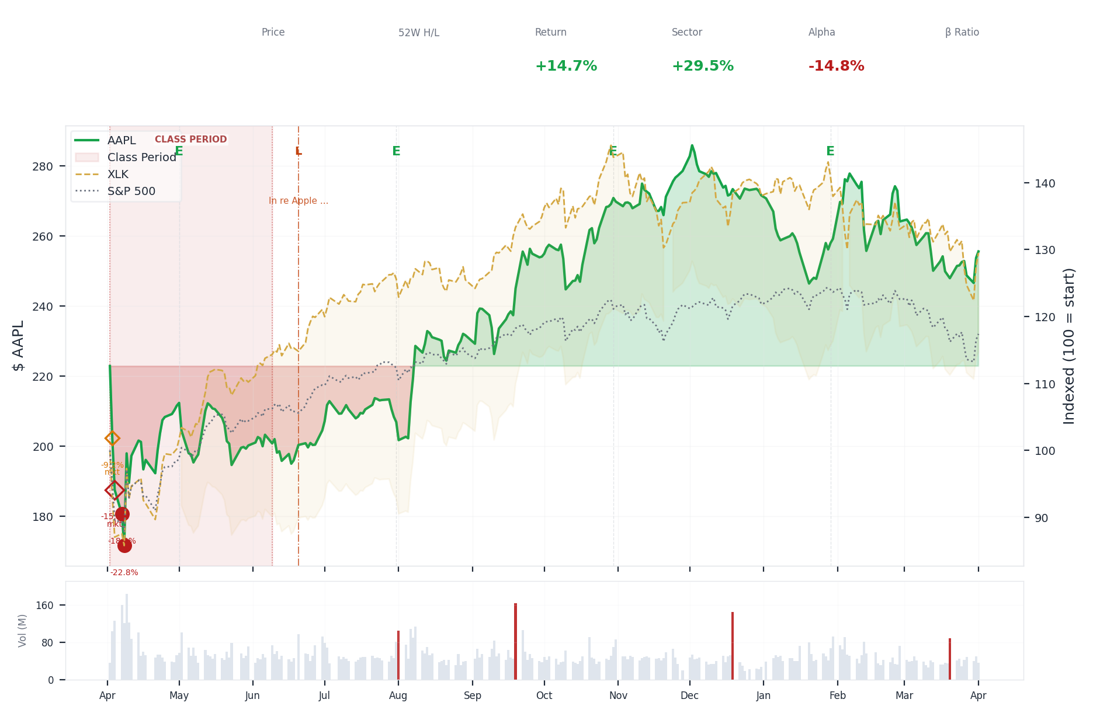
1-Year Performance (Indexed to 100). Red triangles mark single-day drops >= 8%. Orange bands mark multi-day declines >= 15%.
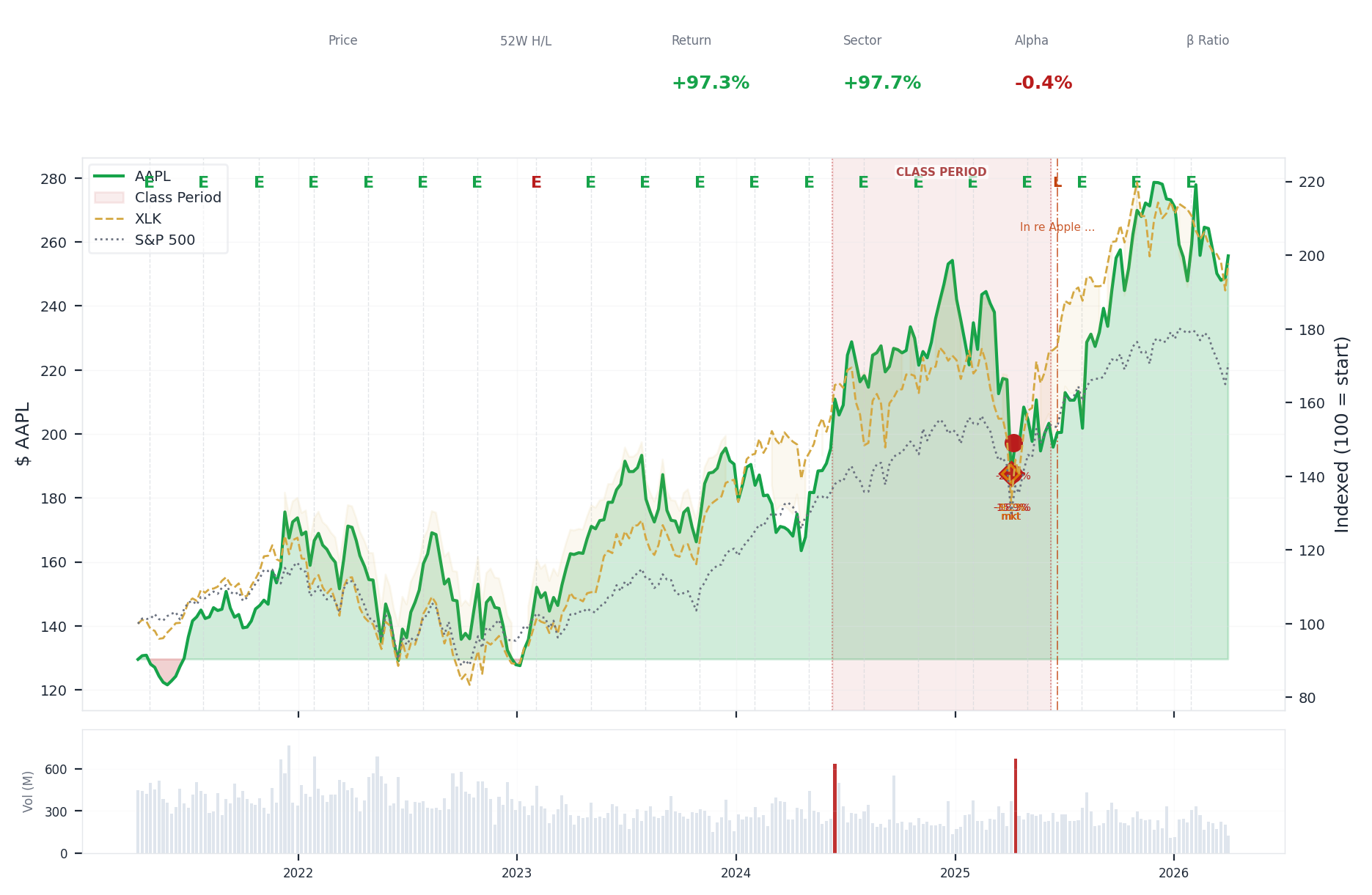
5-Year Performance (Indexed to 100)
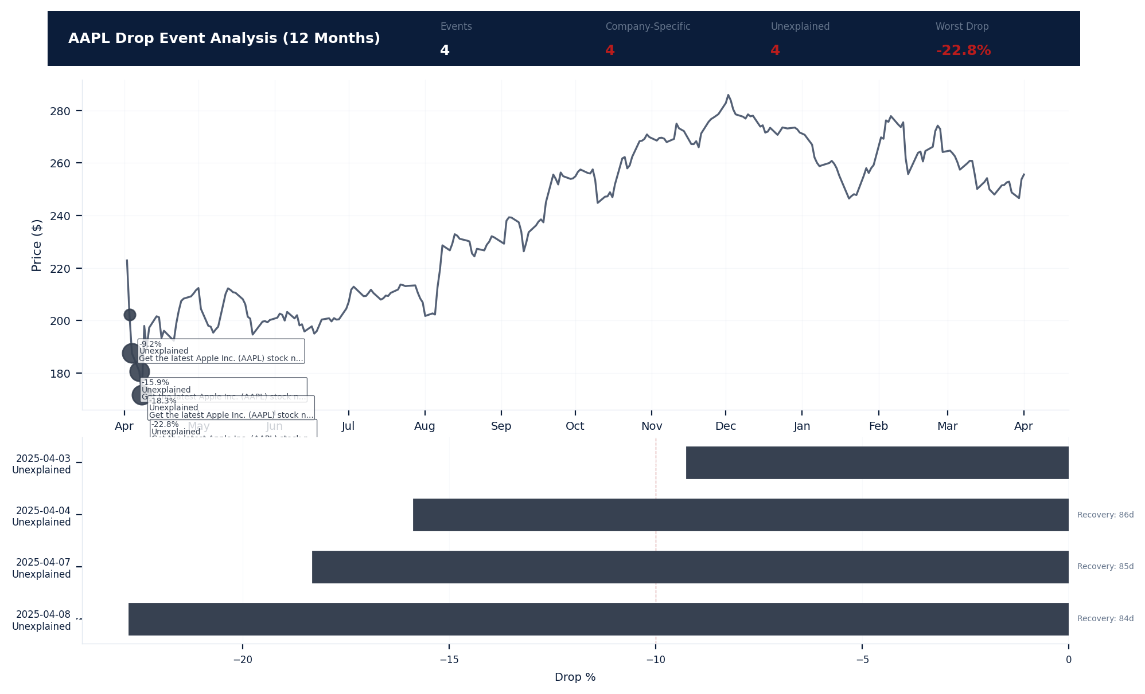
Drop Event Analysis (12 Months)
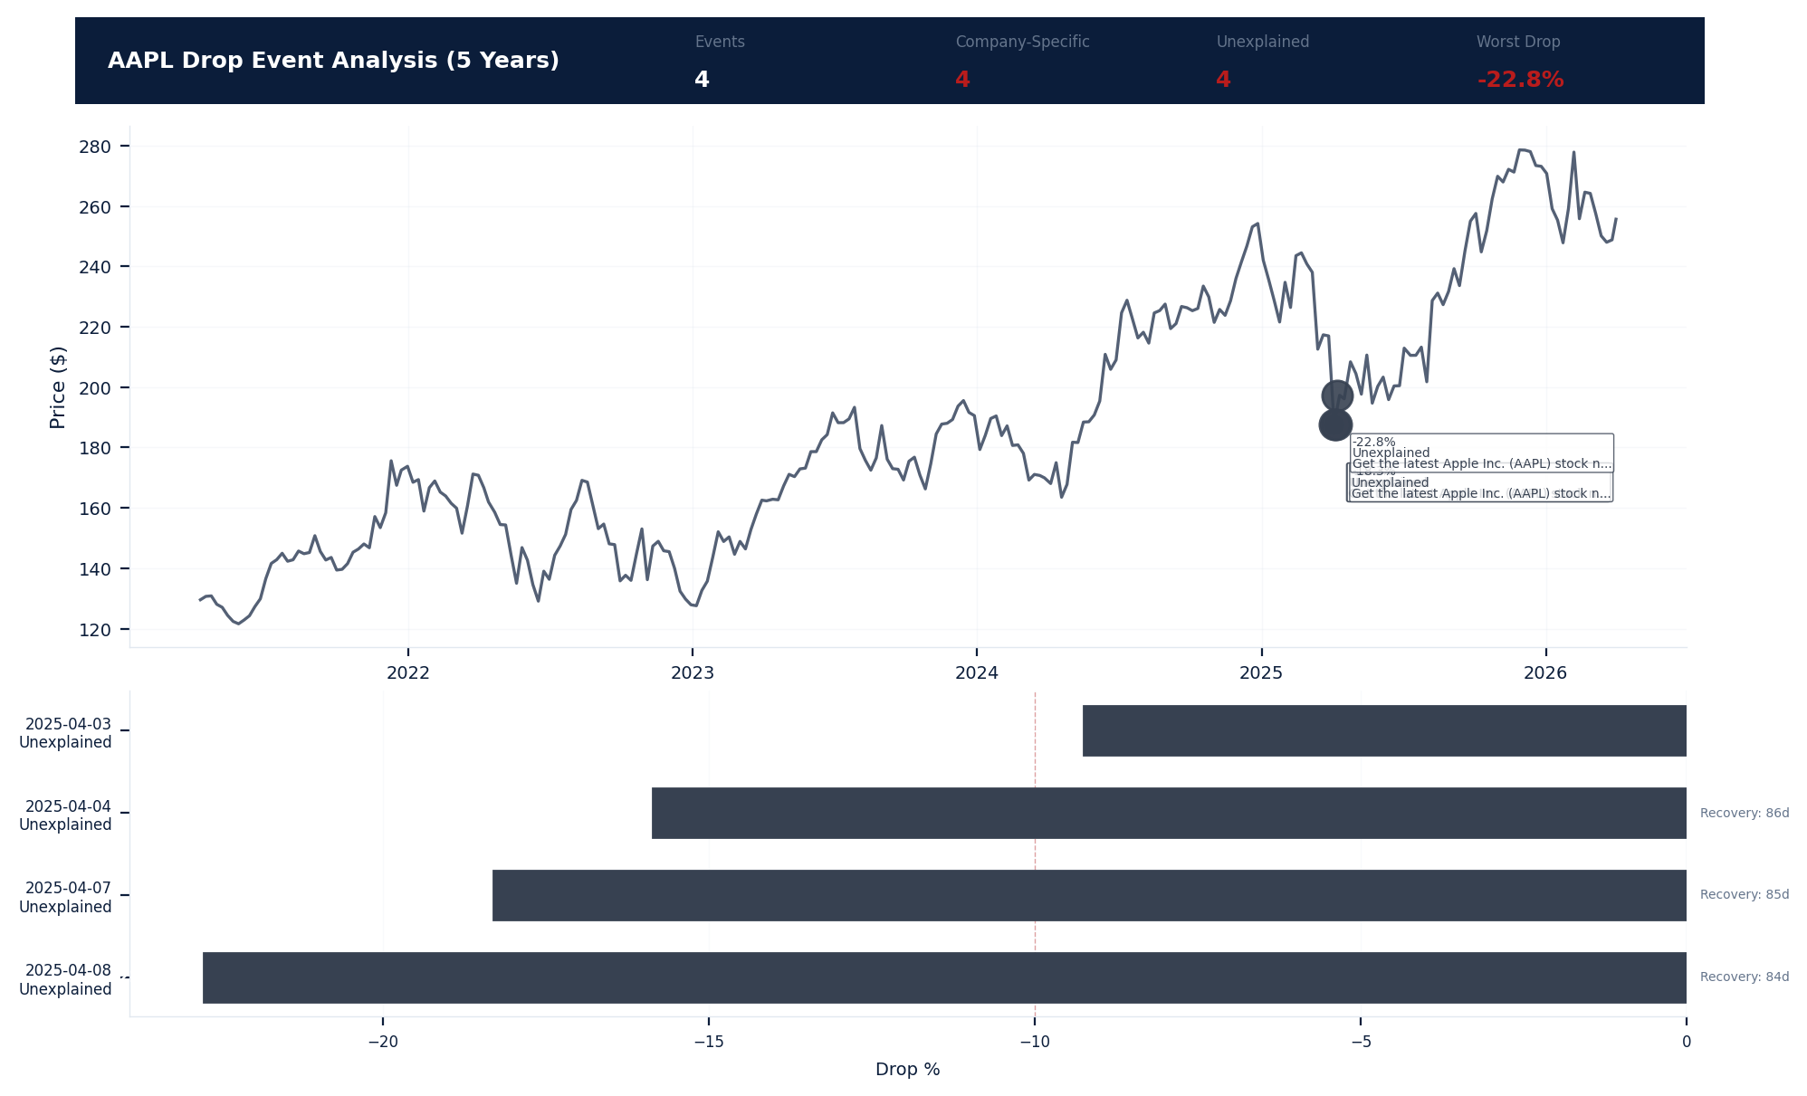
Drop Event Analysis (5 Years)
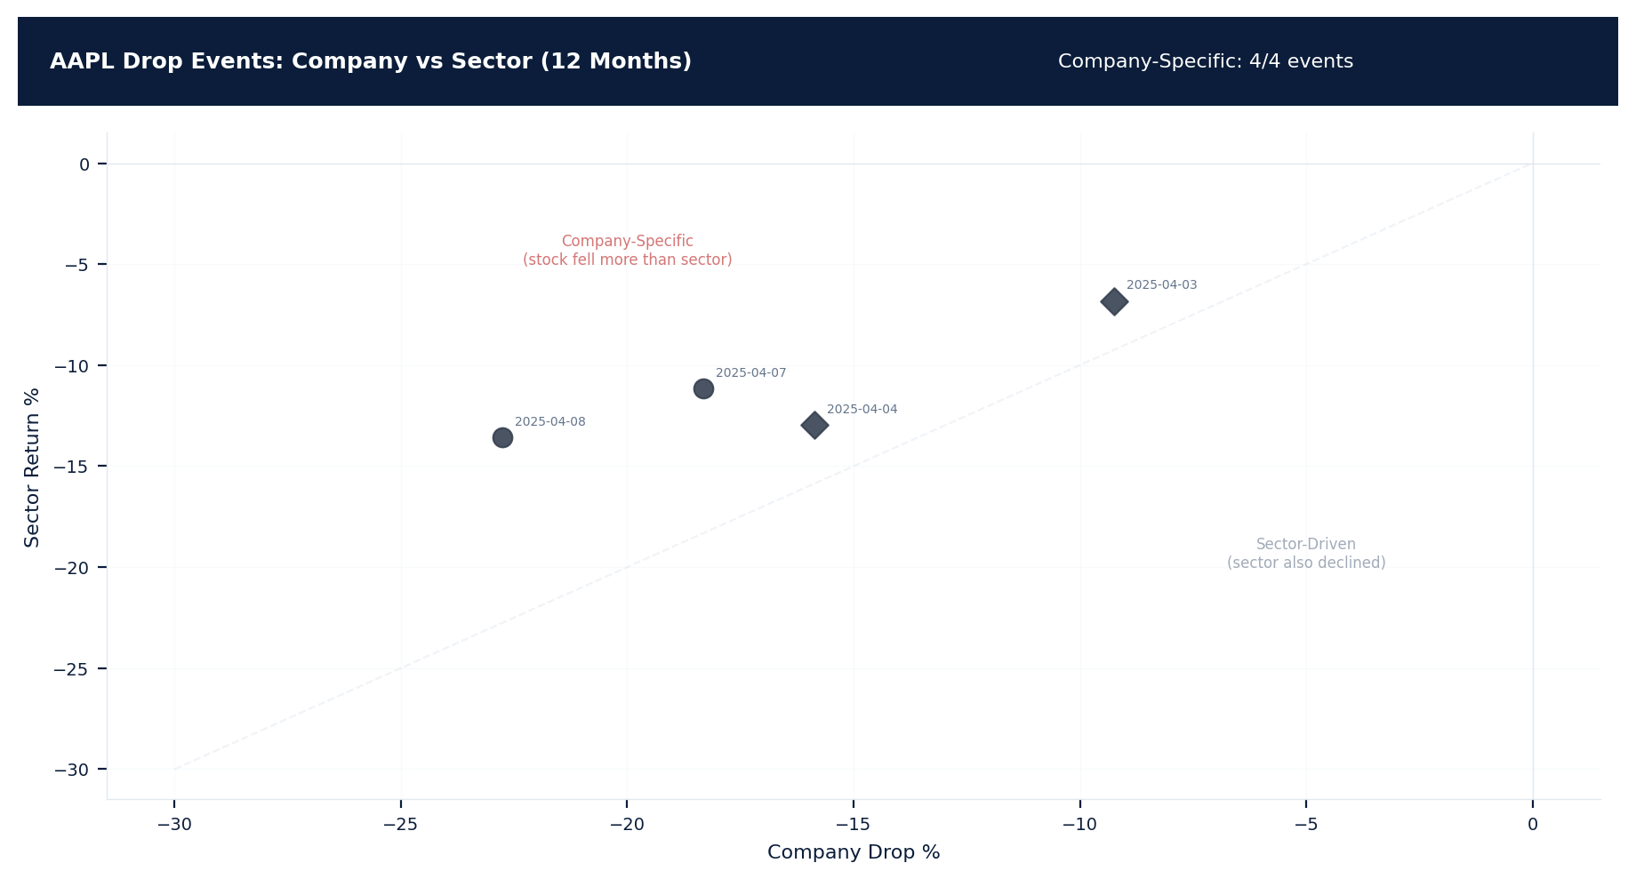
Drop Events: Company vs Sector (12 Months)
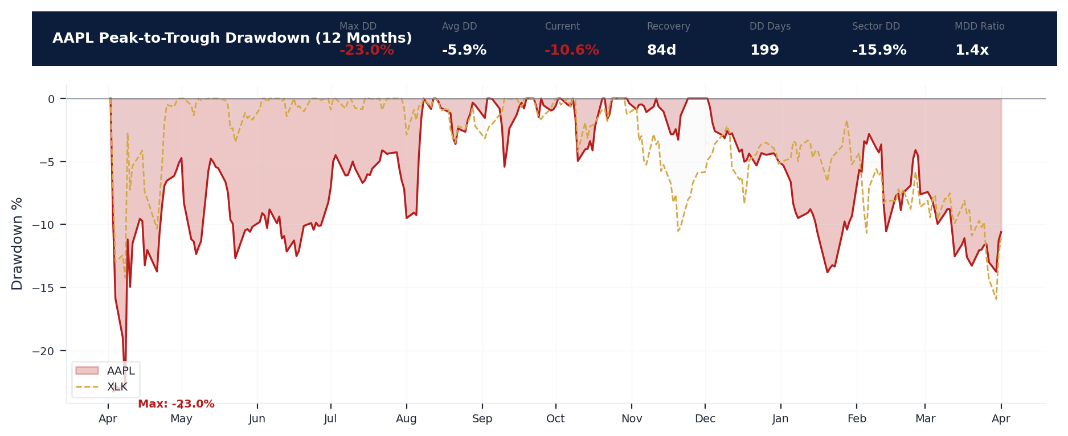
Drawdown Analysis (12 Months)
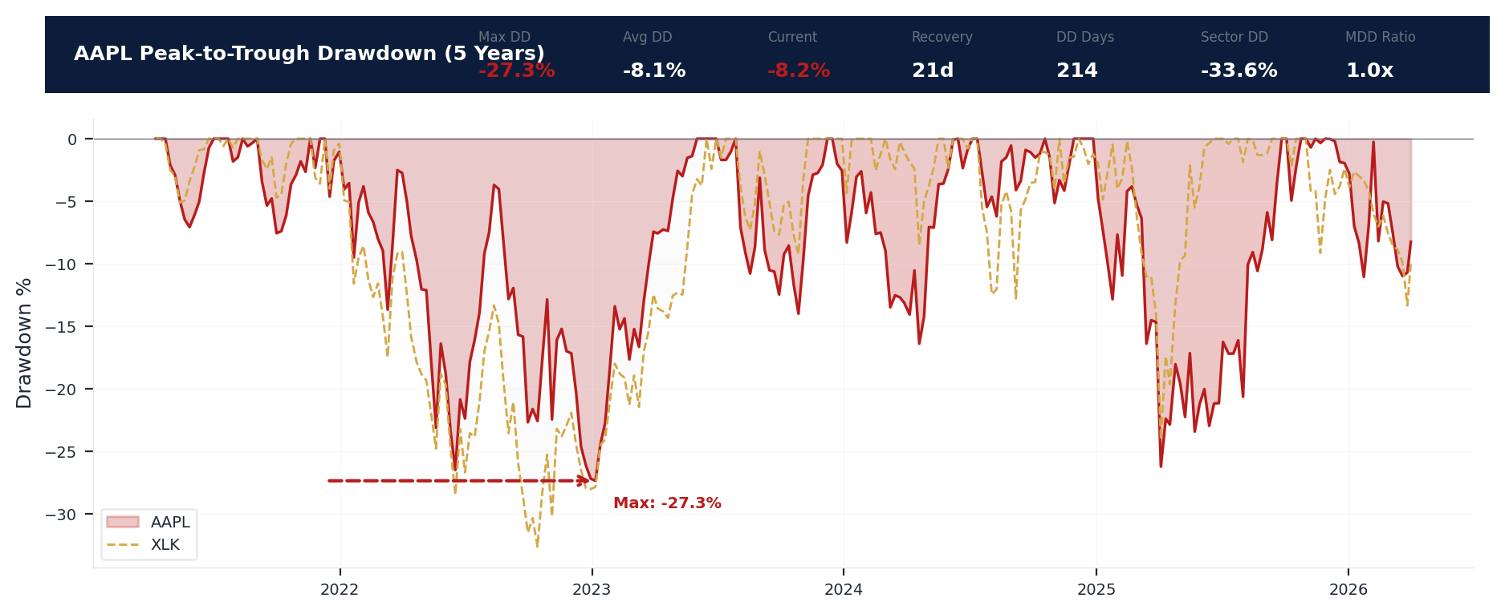
Drawdown Analysis (5 Years)
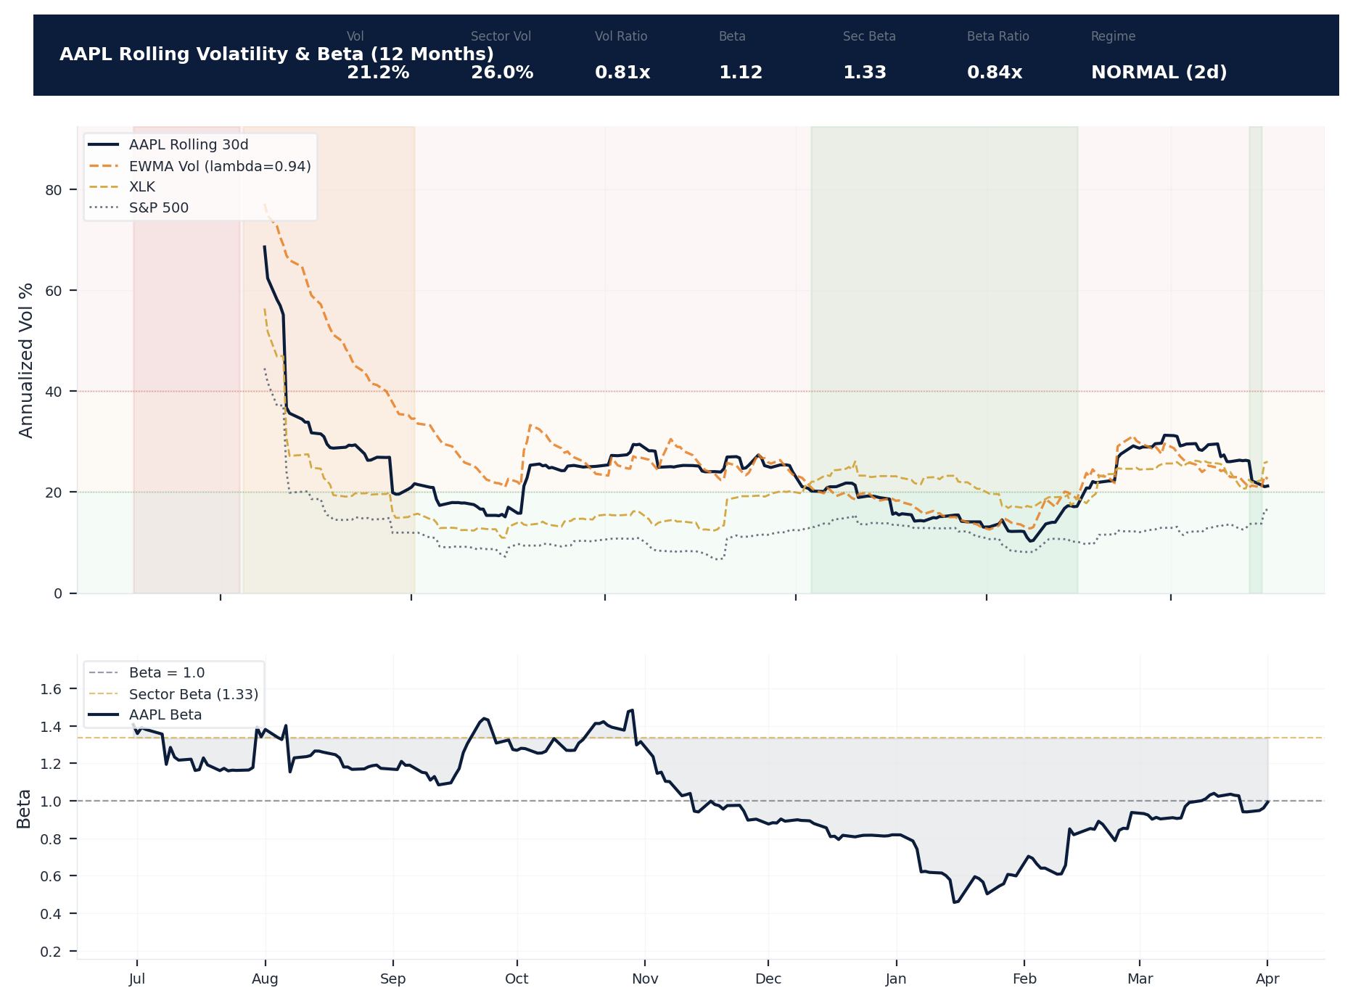
Volatility & Beta Analysis (12 Months)
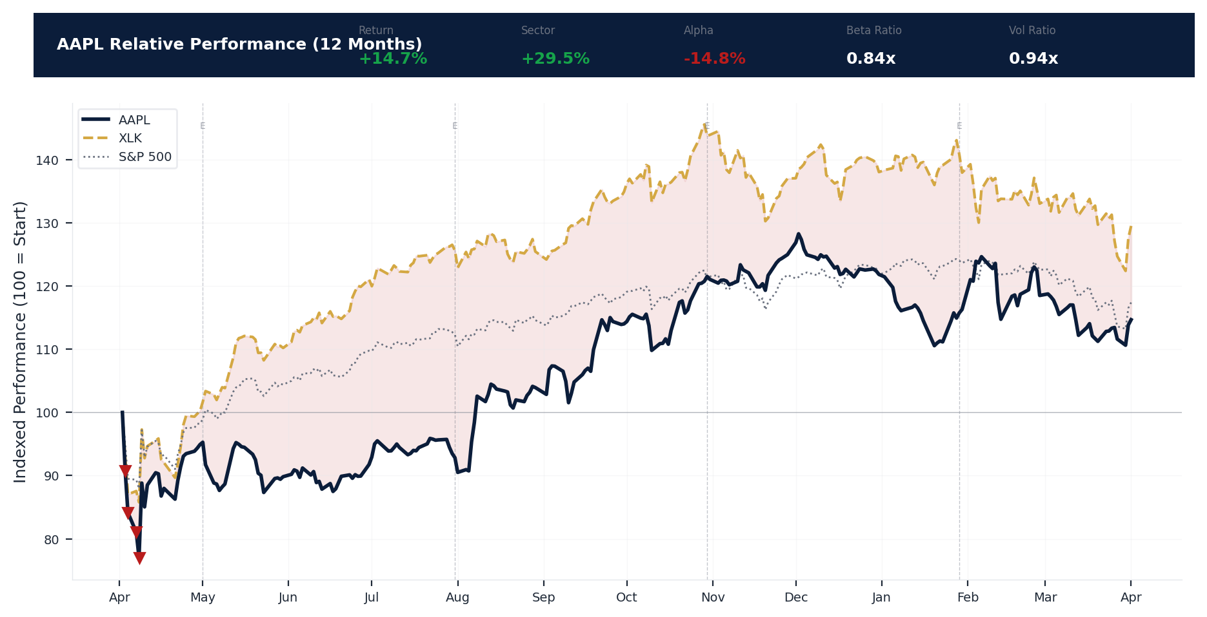
Relative Performance (12 Months)
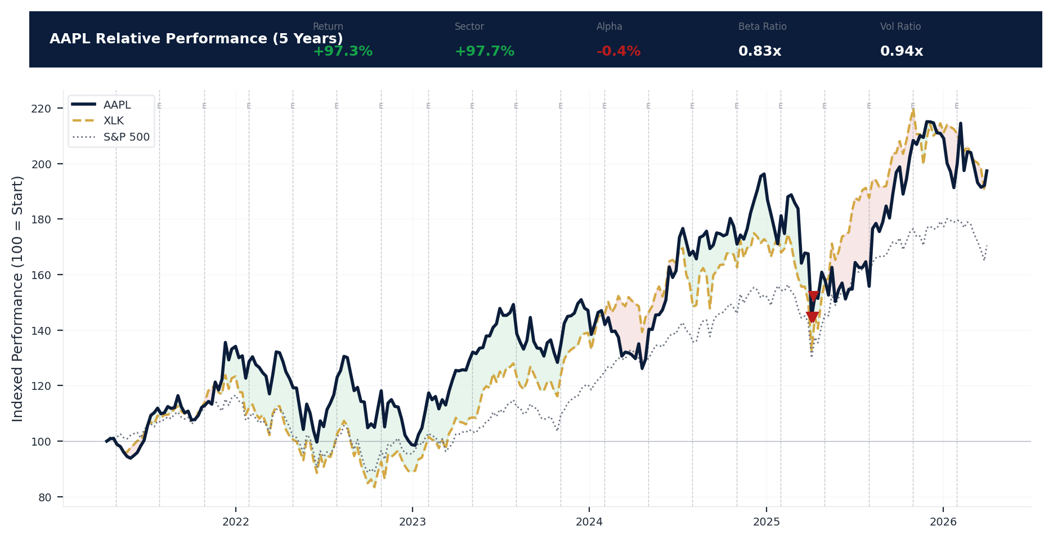
Relative Performance (5 Years)
Metric | Value
Current Price | $255.63
52-Week High | $288.62
52-Week Low | $169.21
1-Year Return | 14.7%
Max Drawdown (1Y) | -23.0%
90-Day Volatility | 22.0% (Ranks at the 0th percentile among 0 peers (peer median: 2.5%))
Beta (vs S&P 500) | 1.12
4 significant stock decline events detected in the 1Y period: 4 critical (>10%). 4 were company-specific, 3 were market-wide.
Date | Drop % | Recency | Recovery | Trigger Event | Type | Source
2025-04-03 to 2025-04-08 (6d) | -23.0% | 25% | 84 days | Unconfirmed -- Requires Investigation | Market-Wide Event | https://finance.yahoo.com/quote/AAPL/news/
2025-04-07 (5d) | -18.3% | 25% | 85 days | Unconfirmed -- Requires Investigation | Company-Specific | https://finance.yahoo.com/quote/AAPL/news/
2025-04-04 (2d) | -15.9% | 25% | 86 days | Unconfirmed -- Requires Investigation | Market-Wide Event | https://finance.yahoo.com/quote/AAPL/news/
2025-04-03 (2d) | -15.9% | 25% | Not recovered | Unconfirmed -- Requires Investigation | Market-Wide Event | https://finance.yahoo.com/quote/AAPL/news/
4 significant stock decline events detected in the 5Y period: 4 critical (>10%). 4 were company-specific, 3 were market-wide.
Date | Drop % | Recency | Recovery | Trigger Event | Type | Source
2025-04-03 to 2025-04-08 (6d) | -23.0% | 25% | 84 days | Unconfirmed -- Requires Investigation | Market-Wide Event | https://finance.yahoo.com/quote/AAPL/news/
2025-04-07 (5d) | -18.3% | 25% | 85 days | Unconfirmed -- Requires Investigation | Company-Specific | https://finance.yahoo.com/quote/AAPL/news/
2025-04-04 (2d) | -15.9% | 25% | 86 days | Unconfirmed -- Requires Investigation | Market-Wide Event | https://finance.yahoo.com/quote/AAPL/news/
2025-04-03 (2d) | -15.9% | 25% | Not recovered | Unconfirmed -- Requires Investigation | Market-Wide Event | https://finance.yahoo.com/quote/AAPL/news/
Short Interest
Metric | Value
Short % of Float | 0.9% (Ranks at the 89th percentile among 0 peers (peer median: 4.0%))
Days to Cover | 3.17
6-Month Trend | STABLE
vs Sector Ratio | N/A
Earnings Guidance Track Record
Metric | Value
Beat Rate | 0.9%
Consecutive Misses | 0
Guidance Withdrawals | 0
Philosophy | CONSERVATIVE
Quarter | Est. EPS | Actual EPS | Result | Miss Magnitude | Stock Reaction
Q1 2026 | $2.67 | $2.84 | BEAT | N/A | +6.2%
Q4 2025 | $1.77 | $1.85 | BEAT | N/A | +4.5%
Q3 2025 | $1.43 | $1.57 | BEAT | N/A | +9.5%
Q2 2025 | $1.63 | $1.65 | BEAT | N/A | +1.5%
Q1 2025 | $2.35 | $2.40 | BEAT | N/A | +2.3%
Q4 2024 | $1.60 | $1.64 | BEAT | N/A | +2.3%
Q3 2024 | $1.34 | $1.40 | BEAT | N/A | +4.3%
Q2 2024 | $1.51 | $1.53 | BEAT | N/A | +1.5%
Q1 2024 | $2.10 | $2.18 | BEAT | N/A | +3.7%
Q4 2023 | $1.39 | $1.46 | BEAT | N/A | +4.8%
Q3 2023 | $1.19 | $1.26 | BEAT | N/A | +5.5%
Q2 2023 | $1.43 | $1.52 | BEAT | N/A | +6.3%
Q1 2023 | $1.95 | $1.88 | MISS | +3.6% | -3.7%
Q4 2022 | $1.27 | $1.29 | BEAT | N/A | +1.4%
Q3 2022 | $1.16 | $1.20 | BEAT | N/A | +3.9%
Q2 2022 | $1.43 | $1.52 | BEAT | N/A | +6.3%
Analyst Consensus
Metric | Value
Analyst Coverage | 40
Consensus Rating | BUY
Mean Recommendation | 1.90 (1=Strong Buy, 5=Sell)
Mean Target Price | $295
Target Price High | $350
Target Price Low | $205
Stock Drop Analysis
Date | Magnitude | Type | Trigger / Attribution | Sector Return | Company-Specific
2025-04-03 to 2025-04-08 | -23.0% | MULTI_DAY (6d) | Unknown | -13.6% | Yes
2025-04-07 | -18.3% | MULTI_DAY (5d) | Unknown | -11.2% | Yes
2025-04-04 | -15.9% | MULTI_DAY (2d) | Unknown | -13.0% | Yes
2025-04-03 | -9.2% | MULTI_DAY (2d) | Unknown | -6.8% | Yes
Class Period Potential: 3 company-specific drop(s) exceeding 10% identified. Severe stock drops that are company-specific (not explained by sector movement) are the primary anchors for SCA class periods. Plaintiffs will allege the drop occurred when the 'truth emerged' following prior misstatements. [HIGH]
Insider Trading Analysis
Metric | Value
Net Direction (12mo) | NET_SELLING
10b5-1 Plan % | 93.3%
Buy Transactions | 0
Sell Transactions | 15
Cluster Events | 1
Transaction Detail
Date | Insider | Title | Type | Shares | Value | 10b5-1
2026-03-15 | Newstead Jennifer | SVP, GC and Secretary | EXERCISE | 60,208 | N/A | No (Discretionary)
2026-03-15 | Newstead Jennifer | SVP, GC and Secretary | EXERCISE | 60,208 | N/A | No (Discretionary)
2026-03-15 | Newstead Jennifer | SVP, GC and Secretary | TAX_WITHHOLD | 32,528 | $8.1M | No (Discretionary)
2026-02-26 | LEVINSON ARTHUR D | Director | GIFT | 1,113 | $0 | No (Discretionary)
2026-02-24 | WAGNER SUSAN | Director | GRANT | 1,139 | $0 | No (Discretionary)
2026-02-24 | SUGAR RONALD D | Director | GRANT | 1,139 | $0 | No (Discretionary)
2026-02-24 | LOZANO MONICA C | Director | GRANT | 1,139 | $0 | No (Discretionary)
2026-02-24 | LEVINSON ARTHUR D | Director | GRANT | 1,011 | $0 | No (Discretionary)
2026-02-24 | JUNG ANDREA | Director | GRANT | 1,139 | $0 | No (Discretionary)
2026-02-24 | Gorsky Alex | Director | GRANT | 1,139 | $0 | No (Discretionary)
2026-02-24 | Austin Wanda M | Director | GRANT | 1,139 | $0 | No (Discretionary)
2026-02-01 | WAGNER SUSAN | Director | EXERCISE | 1,255 | N/A | No (Discretionary)
2026-02-01 | WAGNER SUSAN | Director | EXERCISE | 1,255 | N/A | No (Discretionary)
2026-02-01 | SUGAR RONALD D | Director | EXERCISE | 1,255 | N/A | No (Discretionary)
2026-02-01 | SUGAR RONALD D | Director | EXERCISE | 1,255 | N/A | No (Discretionary)
2026-02-01 | LOZANO MONICA C | Director | EXERCISE | 1,255 | N/A | No (Discretionary)
2026-02-01 | LOZANO MONICA C | Director | EXERCISE | 1,255 | N/A | No (Discretionary)
2026-02-01 | LEVINSON ARTHUR D | Director | EXERCISE | 1,113 | N/A | No (Discretionary)
2026-02-01 | LEVINSON ARTHUR D | Director | EXERCISE | 1,113 | N/A | No (Discretionary)
2026-02-01 | JUNG ANDREA | Director | EXERCISE | 1,255 | N/A | No (Discretionary)
Cluster Selling Events
Window | Insiders | Names | Total Value
2025-10-02 to 2025-10-16 | 4 | Adams Katherine L., COOK TIMOTHY D, O'BRIEN DEIRDRE, Parekh Kevan | $57.6M
Insider Cluster Selling (1 event(s)): Coordinated insider selling is a key D&O risk signal. Courts view cluster sales -- where 3+ insiders sell within a narrow window -- as circumstantial evidence of scienter (intent to defraud) in securities fraud claims. [HIGH]
Executive Departures
No executive departures identified in the trailing 18 months.
Capital Markets Activity
No significant capital markets activity identified in the trailing 3-year period.

Apple's $416.2B revenue and $112.0B net income, up 6.4% and 19.5% respectively from the prior year, provide immense scale to absorb litigation costs, but its sub-1.0 current ratio of 0.89 indicates a deliberate liquidity posture that plaintiffs could mischaracterize as financial stress in a going-concern allegation, despite the audit opinion confirming no going concern issue. Its pristine Beneish M-Score of -2.29 and Piotroski F-Score of 8, based on 134 financial checks with only 12 triggered, virtually eliminate Section 10(b) restatement risk from earnings manipulation, a stark contrast to peers with thinner margins. However, the elevated debt-to-equity of 1.23, against an exceptionally high interest coverage ratio of 33.8, reflects aggressive capital returns; a sustained market downturn could fuel derivative suits alleging fiduciary breach in capital allocation. The Altman Z-Score of 10.16 confirms fundamental safety in the "safe" zone, but the real D&O exposure lies in event-driven litigation targeting its strategic decisions, not its balance sheet, as underscored by a clean audit from Ernst & Young after a 17-year tenure.
Section 3: Financial Health
The company reported revenue of $416.2B and net income of $112.0B (per FY2025 10-K, Company Facts API CIK320193). Revenue grew 6.4% year-over-year (from $391.0B). Financial health is exceptionally strong: Altman Z-Score of 10.16 (safe zone threshold: 2.99) indicates negligible bankruptcy risk. Ohlson O-Score of 0.00 confirms no distress signals. Piotroski F-Score of 8/9 indicates strong fundamental quality. D/E ratio of 1.23 is moderate. Earnings quality is healthy (OCF/NI: 1.00), indicating reported income is well-supported by operating cash flows -- reducing restatement risk. Auditor: Ernst & Young (Big 4), tenure: 17 years. From a D&O perspective, the financial profile supports standard underwriting terms.
Income Statement
Metric | FY2024 | FY2025 | YoY Change
Total revenue / net sales | $391.0B | $416.2B | 6.4%
Cost of revenue / COGS | $210.4B | $221.0B | 5.0%
Gross profit | $180.7B | $195.2B | 8.0%
Operating income / loss | $123.2B | $133.1B | 8.0%
Net income / net loss | $93.7B | $112.0B | 19.5%
Basic earnings per share | $6.11 | $7.49 | 22.6%
Diluted earnings per share | $6.08 | $7.46 | 22.7%
Income tax expense / benefit | $29.7B | $20.7B | -30.4%
Research and development expense | $31.4B | $34.5B | 10.1%
Selling, general and administrative expense | $26.1B | $27.6B | 5.8%
Earnings before interest and taxes (EBIT) | $123.2B | $133.1B | 8.0%
Weighted average shares outstanding (basic) | 15.3B | 14.9B | -2.6%
Weighted average shares outstanding (diluted) | 15.4B | 15.0B | -2.6%
Total comprehensive income / loss | $98.0B | $113.6B | 15.9%
Other income / non-operating income | $269.0M | $-321.0M | -219.3%
Income from operations | $123.2B | $133.1B | 8.0%
Pre-tax income | $123.5B | $132.7B | 7.5%
Stock-based compensation expense | $11.7B | $12.9B | 10.1%
Income before income taxes | $123.5B | $132.7B | 7.5%
Other comprehensive income/loss, net of tax | $4.3B | $1.6B | -62.6%
Total operating expenses | $57.5B | $62.2B | 8.2%
Total costs and expenses | $57.5B | $62.2B | 8.2%
Non-operating income / expense | $269.0M | $-321.0M | -219.3%
Current federal income tax expense / benefit | $5.6B | $11.5B | 106.2%
Current state and local income tax expense / benefit | $1.7B | $1.7B | -2.7%
Current foreign income tax expense / benefit | $25.5B | $8.9B | -65.1%
Deferred federal income tax expense / benefit | $-3.1B | $-1.8B | 41.4%
Deferred state and local income tax expense / benefit | $-298.0M | $-139.0M | 53.4%
Deferred foreign income tax expense / benefit | $347.0M | $604.0M | 74.1%
Gross margin percentage | 46.2% | 46.9% | 1.5%
Operating margin percentage | 31.5% | 32.0% | 1.5%
Net margin percentage | 24.0% | 26.9% | 12.3%
EBITDA margin percentage | 34.4% | 34.8% | 1.0%
Effective tax rate | $24 | $16 | -35.2%
Balance Sheet
Metric | FY2024 | FY2025 | YoY Change
Total assets | $365.0B | $359.2B | -1.6%
Total liabilities | $308.0B | $285.5B | -7.3%
Total stockholders' equity | $57.0B | $73.7B | 29.5%
Total current assets | $153.0B | $148.0B | -3.3%
Total current liabilities | $176.4B | $165.6B | -6.1%
Cash and cash equivalents | $29.9B | $35.9B | 20.0%
Accounts receivable, net | $33.4B | $39.8B | 19.1%
Inventory, net | $7.3B | $5.7B | -21.5%
Property, plant and equipment, net | $45.7B | $49.8B | 9.1%
Long-term debt, non-current | $85.8B | $78.3B | -8.7%
Short-term debt / current portion of long-term debt | $10.9B | $12.3B | 13.2%
Retained earnings / accumulated deficit | $-19.2B | $-14.3B | 25.5%
Total debt (short-term + long-term) | $96.7B | $90.7B | -6.2%
Common shares outstanding | 15.1B | 14.8B | -2.3%
Accounts payable | $69.0B | $69.9B | 1.3%
Deferred revenue / contract liabilities | $8.2B | $9.1B | 9.8%
Operating lease liabilities | $11.5B | $12.5B | 8.3%
Short-term investments / marketable securities | $35.2B | $18.8B | -46.7%
Other current assets | $14.3B | $14.6B | 2.1%
Long-term investments | $91.5B | $77.7B | -15.0%
Accrued liabilities | $26.6B | $13.0B | -51.1%
Deferred income tax assets, net | $19.5B | $20.8B | 6.5%
Accumulated other comprehensive income/loss | $-7.2B | $-5.6B | 22.3%
Common stock par value | $83.3B | $93.6B | 12.4%
Total liabilities and stockholders' equity | $365.0B | $359.2B | -1.6%
Right-of-use assets (operating and finance leases) | $10.2B | $11.2B | 9.5%
Other non-current assets | $74.8B | $83.7B | 11.9%
Other non-current liabilities | $45.9B | $41.5B | -9.5%
Total non-current / long-term assets | $212.0B | $211.3B | -0.3%
Total non-current / long-term liabilities | $131.6B | $119.9B | -8.9%
Finance / capital lease obligations | $896.0M | $1.2B | 37.3%
Contract liabilities (ASC 606 deferred revenue) | $8.2B | $9.1B | 9.8%
Unrecognized tax benefits (UTB) liability | $22.0B | $23.2B | 5.5%
Commercial paper outstanding | $10.0B | $8.0B | -19.9%
Debt instrument carrying amount (face value) | $97.3B | $91.3B | -6.2%
Common stock shares authorized | 50.4B | 50.4B | 0.0%
Contract with customer liability (total deferred revenue under ASC 606) | $12.8B | $13.7B | 7.0%
Current ratio | $1 | $1 | 3.0%
Quick ratio | $1 | $1 | 4.0%
Debt-to-equity ratio | $2 | $1 | -27.5%
Debt-to-EBITDA ratio | $1 | $1 | -12.7%
Net debt | $66.7B | $54.7B | -17.9%
Book value per share | $3.77 | $4.99 | 32.5%
Return on assets | $26 | $31 | 21.4%
Return on equity | $165 | $152 | -7.7%
Asset turnover ratio | $1 | $1 | 8.1%
Key Balance Sheet Ratios
Ratio | Value | Assessment
Current Ratio | 0.89 | Concern
Debt/Equity | 1.23 | Moderate
Debt/Assets | 0.79 | High
Cash/Assets | 10.0%
Cash Flow Statement
Metric | FY2024 | FY2025 | YoY Change
Net cash from operating activities | $118.3B | $111.5B | -5.7%
Net cash from investing activities | $2.9B | $15.2B | 417.7%
Net cash from financing activities | $-122.0B | $-120.7B | 1.1%
Capital expenditures | $9.4B | $12.7B | 34.6%
Depreciation and amortization | $11.4B | $11.7B | 2.2%
Dividends paid | $15.2B | $15.4B | 1.2%
Share repurchases / buybacks | $94.9B | $90.7B | -4.5%
Proceeds from issuance of debt | $0 | $4.5B | N/A
Repayments of debt | $10.0B | $10.9B | 9.8%
Income taxes paid (supplemental) | $26.1B | $43.4B | 66.2%
Stock-based compensation (cash flow adjustment) | $11.7B | $12.9B | 10.1%
Net increase/decrease in cash and equivalents | $-794.0M | $6.0B | 854.5%
Purchases of investments | $48.7B | $24.4B | -49.8%
Proceeds from sale/maturity of investments | $11.1B | $12.9B | 15.8%
Change in accounts receivable | $3.8B | $6.7B | 76.4%
Change in inventory | $1.0B | $-1.4B | -233.8%
Change in accounts payable | $6.0B | $902.0M | -85.0%
Free cash flow | $108.8B | $98.8B | -9.2%
FCF-to-revenue ratio | $28 | $24 | -14.7%
Capex-to-revenue ratio | $2 | $3 | 26.4%
Capex-to-depreciation ratio | $1 | $1 | 31.7%
Dividend payout ratio | $16 | $14 | -15.3%
Free cash flow per share | $7.20 | $6.69 | -7.1%
Key Ratios: Company vs. Peers
Ratio | Value
Current Ratio | 0.89
Quick Ratio | 0.86
Debt/Equity | 1.23
Interest Coverage | 33.8x
Distress Indicators
Financial Integrity: No concerns identified. All distress models in safe zone. Earnings quality metrics within normal ranges.
Leverage: Ranks at the 84th percentile among 0 peers (peer median: 2.0x).
Audit Risk Assessment
Audit Risk: No concerns. Ernst & Young, 17 year tenure, unqualified opinion.
Debt Analysis
Metric | Value
Debt-to-Equity | 1.23
Debt-to-EBITDA | 0.63
Interest Coverage | 33.83
Covenant Status | Unknown
Critical Accounting Estimates
Estimate | Value | Assessment
Effective Tax Rate | 15.6% | Normal range
Peer Group Comparison
Ticker | Name | Market Cap | Revenue | Score
MSFT | Microsoft Corporation | $2.7T | $305.5B | 34
GOOGL | Alphabet Inc. | $3.6T | $402.8B | 38
AMZN | Amazon.com, Inc. | $2.3T | $716.9B | 16
META | Meta Platforms, Inc. | $1.5T | $201.0B | 8
NVDA | NVIDIA Corporation | $4.3T | $215.9B | 40
CRM | Salesforce, Inc. | $174.5B | $41.5B | 12
ADBE | Adobe Inc. | $98.4B | $24.5B | 13
ORCL | Oracle Corporation | $417.7B | $64.1B | 14
CSCO | Cisco Systems, Inc. | $307.9B | $59.1B | 13
INTC | Intel Corporation | $241.2B | $52.9B | 13
Revenue: Ranks at the 80th percentile among 10 peers. Leverage: Ranks at the 84th percentile among 0 peers (peer median: 2.0x).
Method: Multi-signal composite: SIC 25%, industry 20%, market cap 25%, revenue 15%, description 15%

ELEVATED CONCERN
Apple’s governance narrative is dominated by a single, long-tenured director with a 26-year average tenure, creating a documented lack of board diversity with only 1 director and an oversight challenge. CEO Tim Cook’s dual role as Chair concentrates authority, a structure that amplifies exposure under *Caremark* for any strategic missteps given the board’s minimal documented oversight capacity. The board’s $74.3 million CEO pay package, despite a 92% say-on-pay vote, presents a persistent target for shareholder derivative suits alleging waste, a risk heightened by the $1.3 million in deducted governance scoring points. The primary risk is a duty of candor breach in proxy disclosures, where the minimal board detail fails to substantiate rigorous oversight of Cook’s operational decisions against 6 triggered governance checks.
Section 5: Governance & Leadership
Board governance scores well (70/100) across 1 directors. Compensation concerns include: elevated CEO pay ratio (533:1). [Rule-based synthesis of governance extraction results, 2026-04-02, LOW]
Governance Quality Score: 70.1/10 [Computed from governance dimensions, 2026-04-02, LOW]
Leadership Stability
Name | Title | Tenure (Yrs) | Status | Prior Lit. | Flags
Mr. Timothy D. Cook | CEO & Director | N/A | ACTIVE | 0 | None
Mr. Kevan Parekh | Senior VP & CFO | N/A | ACTIVE | 0 | None
Mr. Sabih Khan | Senior VP & Chief Operating Officer | N/A | ACTIVE | 0 | None
Ms. Katherine L. Adams | Senior VP of Government Affairs & Secretary | N/A | ACTIVE | 0 | None
Ms. Jennifer G. Newstead J.D. | Senior VP & General Counsel | N/A | ACTIVE | 0 | None
Leadership Stability Score: 100/100 [leadership_profiles extractor, 2026-04-02, MEDIUM]
Board Composition
Name | Tenure | Independent | Committees | Other Boards | Overboarded
Apple | 26.0 yrs | Yes | Audit, Compensation, Nominating/Governance | 0 | No
[ELEVATED] CEO/Chair Duality -- Single individual holds both CEO and Board Chair roles
Context: Companies with CEO/Chair duality face 1.8x higher derivative suit filing rates due to governance concentration.
See Meeting Prep: Governance Structure
Board Quality Metrics
Metric | Value
Board Size | N/A
Independence Ratio | N/A
CEO/Chair Duality | Yes
Classified Board | N/A
Overboarded Directors | N/A
Dual-Class Structure | N/A
D&O Context: CEO/Chair duality reduces board independence in oversight of management, increasing derivative suit risk. [ELEVATED]
Compensation Analysis
Summary Compensation Table
Component | Amount
Total CEO Compensation | $74.3M
Metric | Value
CEO Pay Ratio | 533:1
CEO Pay Ratio (533:1): Extremely high pay ratios increase Section 14A proxy disclosure litigation risk and shareholder proposal activity. Ratios above 500:1 are material governance concerns for D&O underwriting. [HIGH]
Compensation Structure
Component | Detail
Clawback Policy | Yes
Clawback Scope | BROADER
Compensation Red Flags
Notable Perquisites: No tax gross-ups on perquisites We do not provide tax gross-ups for the limited perquisites provided to our named executive officers, Cook recognizes imputed taxable income and is not provided a tax reimbursement for personal use of private aircraft, " Other Personal Benefits We provide risk-based security services for our employees, including our named executive officers, as determined to be necessary by our security team: Above-peer perquisites draw proxy advisory negative recommendations. [ELEVATED]
Ownership Structure
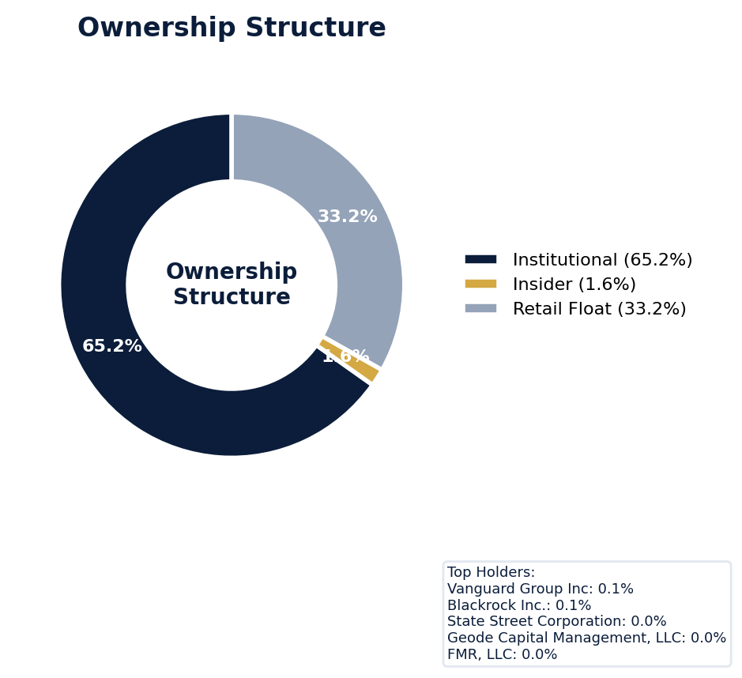
Figure: Ownership breakdown -- institutional, insider, retail float
Category | Percentage
Institutional Ownership | 65.2%
Insider Ownership | 1.6%
Retail Float | 33.2%
Top Holder | Ownership %
Vanguard Group Inc | 0.1%
Blackrock Inc. | 0.1%
State Street Corporation | 0.0%
Geode Capital Management, LLC | 0.0%
FMR, LLC | 0.0%
Sentiment & Narrative Coherence
Signal | Assessment
Narrative Coherence | COHERENT
Anti-Takeover Provisions
Anti-takeover provision data not available. Review DEF 14A and charter documents for complete analysis.

CRITICAL RISK
Apple faces one active securities class action (SCA) with a specific class period from June 10, 2024, to June 9, 2025, led by the elite plaintiff firm Bernstein Litowitz Berger & Grossmann LLP. The company's adjusted SCA filing rate of 3.31% is below the 5.0% sector average, but its historical settlement pattern, averaging $92 million per resolution, presents a high-severity benchmark critical for loss modeling. Six open shareholder lawsuits, coupled with a "MODERATE" defense strength rating, indicate significant defense cost exposure ahead, directly impacting Side C retention layers. The absence of an SEC investigation is a positive for entity coverage, but the litigation themes of revenue recognition and supply chain disclosure are persistent, data-supported industry vulnerabilities for Apple. The lead counsel's tier suggests a high probability of a multimillion-dollar settlement, aligning with past resolutions, which elevates anticipated claim severity. Underwriting must weigh the low 3.31% filing frequency against the high severity history and the plaintiff bar's focus on Apple's complex global operations, a key driver of disclosure-related litigation risk.
Section 6: Litigation & Regulatory Exposure
The company faces 1 active securities class action(s). The primary case, {}, covers a class period from 2024-06-10 to 2025-06-09. Lead counsel: Bernstein Litowitz Berger & Grossmann LLP. Industry claim exposure: revenue_recognition, supply_chain_disclosure, ip_misrepresentation. 6 statute of limitations window(s) remain open, meaning new claims can still be filed for past events. Under claims-made D&O policy, coverage is triggered when a claim is reported during the policy period. Defense quality assessment: MODERATE.
Litigation Overview: 0 active matter(s), 3 historical matter(s)
Litigation Timeline
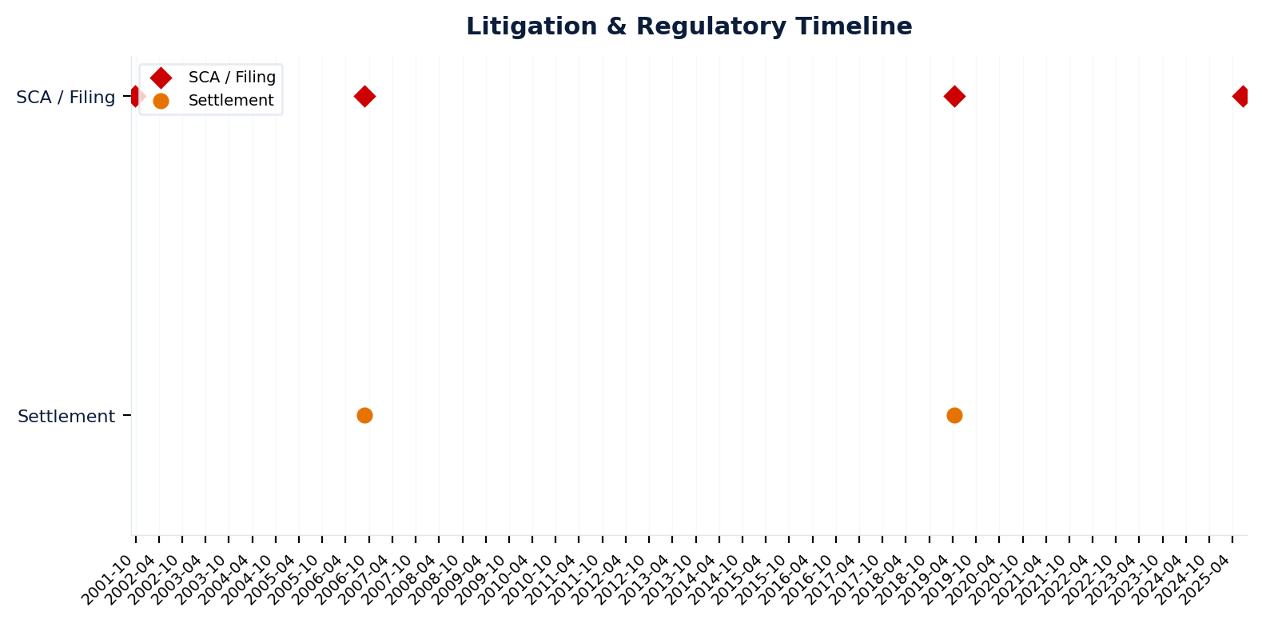
Figure: Chronological litigation and regulatory events overlaid with corporate events for pattern recognition
Securities Class Actions
Case Name | Legal Theory | Coverage | Court | Filing Date | Status | Class Period | Lead Counsel | Settlement | Source
In re Apple Inc. Securities (2025) | Rule 10b-5 | Side C (Entity) | N.D. Cal. | 2025-06-20 | UNKNOWN | N/A | Bernstein Litowitz Berger & Grossmann LLP | N/A | [web search, 2026-04-02, LOW]
In re Apple Inc. Securities Litigation (2019) | Rule 10b-5, Section 11 | Side C (Entity) | N/A | 2019-04-16 | SETTLED | N/A | N/A | $490.0M | [Supabase SCA database, 2026-04-02, MEDIUM]
In re Apple Computer, Inc. Securities Litigation (2006) | Rule 10b-5 | Side C (Entity) | N/A | 2006-08-24 | SETTLED | N/A | N/A | $6.7M | [Supabase SCA database, 2026-04-02, MEDIUM]
In re Apple Computer, Inc. Securities Litigation (2001) | Rule 10b-5 | Side C (Entity) | N/A | 2001-09-27 | DISMISSED | N/A | N/A | N/A | [Supabase SCA database, 2026-04-02, MEDIUM]
D&O Context: Historical settlements total $496.7M. Settlement history establishes severity baseline for pricing. [ELEVATED]
SEC Enforcement Pipeline
Pipeline: (Comment Letters) -> (Informal Inquiry) -> (Formal Investigation) -> (Wells Notice) -> (Enforcement Action)
No SEC enforcement pipeline activity detected. [10-K Item 3 + Item 1A + 8-K + EFTS, 2026-04-02, LOW]
Derivative Suits
No derivative suit history found.
Regulatory Proceedings
Agency | Type | Status
DOJ | investigation | disclosed
FTC | investigation | disclosed
DOJ_FCPA | investigation | disclosed
Industry Claim Patterns
Legal Theory | Exposed | Contagion Risk | Description
Revenue Recognition | Yes | Yes | [Technology Hardware] Premature or fraudulent revenue recogn
Supply Chain Disclosure | Yes | Yes | [Technology Hardware] Failure to disclose supply chain disru
Ip Misrepresentation | Yes | Yes | [Technology Hardware] Overstating IP portfolio value or prot
D&O Context: Company exposed to 3 industry claim pattern(s). Peer lawsuits create contagion risk -- plaintiff firms often file similar claims across the industry. [ELEVATED]
Statute of Limitations Map
Claim Type | Trigger Date | SOL Expiry | Repose Expiry | Window Open
employment_discrimination | 2025-10-31 | 2027-10-31 | 2027-10-31 | OPEN
antitrust | 2025-10-31 | 2029-10-30 | 2029-10-30 | OPEN
FCPA | 2025-10-31 | 2030-10-30 | 2030-10-30 | OPEN
environmental | 2025-10-31 | 2030-10-30 | 2030-10-30 | OPEN
derivative | 2025-10-31 | 2028-10-30 | 2031-10-30 | OPEN
ERISA | 2025-10-31 | 2028-10-30 | 2031-10-30 | OPEN
Section_11 | 2001-09-27 | 2002-09-27 | 2004-09-26 | CLOSED
Section_14a | 2001-09-27 | 2002-09-27 | 2004-09-26 | CLOSED
10b-5 | 2001-09-27 | 2003-09-27 | 2006-09-26 | CLOSED
D&O Context: 6 open exposure window(s). Claims can still be filed within these periods. [ELEVATED]
Defense Strength Assessment
Factor | Assessment
Federal Forum Provision | No
Exclusive Forum Provision | No
PSLRA Safe Harbor | STRONG
Truth-on-Market Viability | NOT_APPLICABLE
Prior Dismissal Success | No prior dismissals identified in Item 3
Overall Defense Strength | MODERATE
No forum selection provisions identified. Safe harbor usage is STRONG with explicit PSLRA citation and specific cautionary language. [DEF 14A; 10-K, 2026-04-02, LOW]
Contingent Liabilities
Description | ASC 450 Class. | Accrued | Range
nties in a manner inconsistent with management's expectation | probable | N/A | N/A
Department of Justice Lawsuit On March 21, 2024, the DOJ and | reasonably_possible | N/A | N/A
The DOJ is seeking equitable relief to redress the alleged a | reasonably_possible | N/A | N/A
In addition, various civil litigation matters have been file | reasonably_possible | N/A | N/A
The California District Court found that certain provisions | reasonably_possible | N/A | N/A
On January 16, 2024, the Company implemented a plan to compl | reasonably_possible | N/A | N/A
On September 30, 2024, the Company filed a motion with the C | reasonably_possible | N/A | N/A
The Company will continue to vigorously defend its actions a | reasonably_possible | N/A | N/A
Although the Company's request to stay the decision pending | reasonably_possible | N/A | N/A
Other Legal Proceedings The Company is subject to other lega | reasonably_possible | N/A | N/A
D&O Context: 1 probable contingenc(y/ies). ASC 450 probable classification indicates management believes loss is likely. Direct impact on D&O exposure. [HIGH]
Workforce, Product & Environmental Matters
Cybersecurity Incidents:
- [data_breach] k disruptions caused by natural disasters, accidents, power disruptions, telecommunications failures, acts of terrorism or war, computer viruses, physical or electronic break-ins, ransomware or other cybersecurity incidents, or other events or disruptions.
- [data_breach] Losses or unauthorized access to or releases of confidential information, including personal information, could subject the Company to significant reputational, financial, legal and operational consequences.
- [data_breach] But these measures cannot provide absolute security, and losses or unauthorized access to or releases of confidential information occur and could materially adversely affect the Company's business, reputation, results of operations, financial condition and stock price.
- [data_breach] ugh the Company takes steps to secure confidential information that is provided to or accessible by third parties working on the Company's behalf, such measures are not always effective and losses or unauthorized access to, or releases of, confidential information occur.
- [data_breach] The Company experiences malicious attacks and other attempts to gain unauthorized access to its systems on a regular basis.
- [data_breach] raudulently induce the Company's or its suppliers' and other third parties' employees or customers into disclosing usernames, passwords or other sensitive information, which can, in turn, be used for unauthorized access to the Company's or such suppliers' or third parties' systems and services.
- [cyber_attack] retail stores and facilities are subject to the risk of interruption by fire, power shortages, nuclear power plant accidents and other industrial accidents, terrorist attacks and other hostile acts, ransomware and other cybersecurity attacks, labor disputes, public health issues and other events beyond the Company's control.
- [cyber_attack] m failures or network disruptions caused by natural disasters, accidents, power disruptions, telecommunications failures, acts of terrorism or war, computer viruses, physical or electronic break-ins, ransomware or other cybersecurity incidents, or other events or disruptions.
- [cyber_attack] The Company relies on global suppliers that are also exposed to ransomware and other malicious attacks that can disrupt business operations.
- [cyber_attack] | 2025 Form 10-K | 11 As with all companies, the security the Company has implemented may not be sufficient for all eventualities and are vulnerable to hacking, ransomware attacks, employee error, malfeasance, system error, faulty password management or other irregularities.
Whistleblower Indicators
No whistleblower indicators identified in SEC filings. SEC whistleblower tips are not publicly disclosed; absence does not confirm lack of activity.

Apple's exceptional 91.3 quality score and WIN tier classification are anchored by its operational strength, yet its ELEVATED claim band of 5.2-7.4% is driven by a Prior Litigation factor that deducted 2.46 points from a possible 20, based on 70 identified signals. The sheer volume of shareholder suits and antitrust challenges, coupled with an IPO/SPAC/M&A factor deducting 2.19 points, creates a predictable, high-frequency D&O claims environment atypical for a company of this caliber. Short interest, a secondary factor deducting 1.31 points, adds consistent speculative pressure that can fuel shareholder allegations of misleading statements. Underwrite to the litigation cadence, not the balance sheet; this is a premium account where pricing must reflect the 5.18-7.4% claim probability range, not just the severity.
Section 7: Risk Scoring & Synthesis
Underwriting tier: **WIN** (quality score: 91.3/100). Recommended action: Must-have account, compete aggressively. Expected claim probability band: 5.2-7.4%. Top risk contributors: Prior Litigation (F1: -2.5 pts); IPO/SPAC/M&A (F4: -2.2 pts); Short Interest (F6: -1.3 pts). Claim probability band: ELEVATED (5.2%-7.4%).
Tier Classification
Metric | Value
Quality Score | 91.3 / 100
Composite Score (pre-ceiling) | 91.3
Total Risk Points Deducted | 8.7
Tier | WIN
Tier Range | 86 - 100
Action Guidance | Must-have account, compete aggressively
Probability Range | 5.2-7.4%
Pricing Multiplier | 0.5-0.7x
Risk Assessment: LOW [LOW]
D&O Claim Peril Assessment
2 of 8 D&O claim perils show active risk signals. Active perils have at least one causal chain with triggered checks.
Peril | Risk Level | Active Chains | Key Evidence
Securities Claims | ELEVATED | 1/5 | Qualitative: No non-GAAP measures detected in 10-K; Qualitative: 0
Fiduciary Breach | MODERATE | 1/3 | Verified (value: 0); Detected (value). Limited corroborating data available.
Government Enforcement | LOW | 0/2 | —
Employment & Whistleblower | LOW | 0/1 | —
Insolvency & Bankruptcy | LOW | 0/1 | —
Emerging Risks | LOW | 0/2 | —
Consumer & Product Claims | LOW | 0/1 | —
Commercial Litigation | LOW | 0/1 | —
Active Peril Analysis
Securities Claims: ELEVATED [ELEVATED]
Frequency: moderate | Severity: high | Typical range: $5M - $500M+
1 of 5 causal chains active.
Chain: Guidance Miss → Securities Fraud [ELEVATED]
Repeated guidance misses or aggressive forward guidance builds scienter case for securities fraud claim when stock eventually declines.
Triggers:
• FIN.GUIDE.earnings_reaction
Amplifiers:
• EXEC.INSIDER.ceo_net_selling
• EXEC.INSIDER.cfo_net_selling
Historical filing rate: 8% | Median severity: $12M
Fiduciary Breach: MODERATE [MODERATE]
Frequency: growing | Severity: variable | Typical range: $1M - $100M
1 of 3 causal chains active.
Chain: Governance Failure → Derivative Suit [MODERATE]
Weak governance structure (low independence, CEO/Chair duality, poor say-on-pay) creates basis for Caremark duty of oversight claims and derivative suits.
Triggers:
• GOV.BOARD.ceo_chair
Historical filing rate: 3% | Median severity: $8M
Composite Score Breakdown
Factor | Name | Max Pts | Deducted | % Used | Top Contributor
F1 | Prior Litigation | 20 | 2.5 | 12% | Signal-driven scoring: 70 signals, coverage=100%
F2 | Stock Decline | 15 | 0.3 | 2% | Signal-driven scoring: 30 signals, coverage=100%
F3 | Restatement/Audit Issues | 12 | 0.8 | 7% | Signal-driven scoring: 82 signals, coverage=100%
F4 | IPO/SPAC/M&A | 10 | 2.2 | 22% | Signal-driven scoring: 16 signals, coverage=100%
F5 | Guidance Misses | 13 | 0.4 | 3% | Signal-driven scoring: 28 signals, coverage=100%
F6 | Short Interest | 8 | 1.3 | 16% | Signal-driven scoring: 27 signals, coverage=100%
F7 | Stock Volatility | 7 | 0.3 | 4% | Signal-driven scoring: 31 signals, coverage=100%
F8 | Financial Distress | 5 | 0.0 | 0% | Signal-driven scoring: 15 signals, coverage=100%
F9 | Governance Issues | 6 | 0.7 | 12% | Signal-driven scoring: 42 signals, coverage=100%
F10 | Officer Stability | 2 | 0.1 | 7% | Signal-driven scoring: 93 signals, coverage=100%
10-Factor Risk Profile
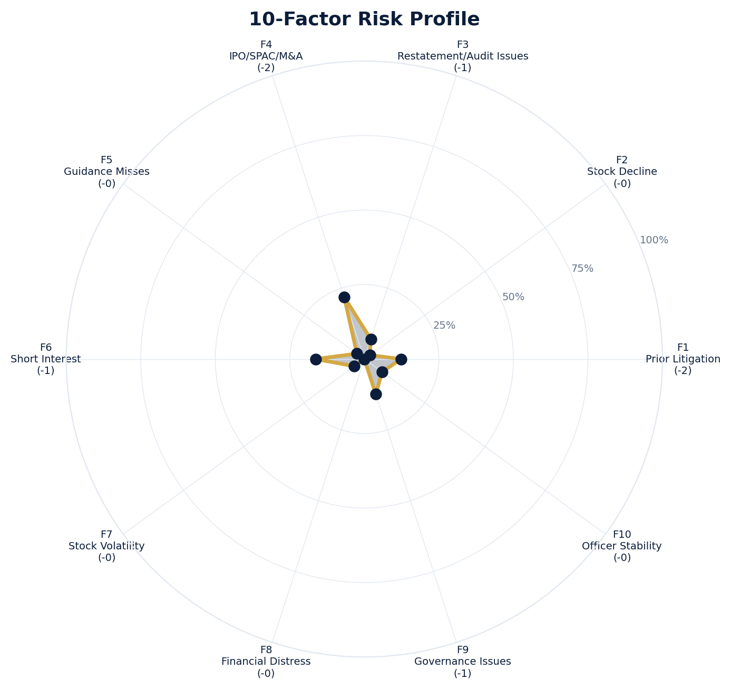
Figure: Radar chart showing risk fraction (points deducted / max) for each of the 10 scoring factors. Larger area = higher risk.
Red Flag Gates
Severity | Description | Source | Impact | Trajectory
LOW | Prior Litigation: 2/20 points | Signal-driven scoring: 70 signals, coverage=100% | F1: 2 pts | NEW
LOW | Stock Decline: 0/15 points | Signal-driven scoring: 30 signals, coverage=100%; Drop contribution modifier: 0.25x (decay + company-specific + disclosure) | F2: 0 pts | NEW
LOW | Restatement/Audit Issues: 1/12 points | Signal-driven scoring: 82 signals, coverage=100% | F3: 1 pts | NEW
LOW | IPO/SPAC/M&A: 2/10 points | Signal-driven scoring: 16 signals, coverage=100% | F4: 2 pts | NEW
LOW | Guidance Misses: 0/13 points | Signal-driven scoring: 28 signals, coverage=100% | F5: 0 pts | NEW
LOW | Short Interest: 1/8 points | Signal-driven scoring: 27 signals, coverage=100% | F6: 1 pts | NEW
LOW | Stock Volatility: 0/7 points | Signal-driven scoring: 31 signals, coverage=100% | F7: 0 pts | NEW
LOW | Governance Issues: 1/6 points | Signal-driven scoring: 42 signals, coverage=100% | F9: 1 pts | NEW
LOW | Officer Stability: 0/2 points | Signal-driven scoring: 93 signals, coverage=100% | F10: 0 pts | NEW
Critical: 0, High: 0, Moderate: 0, Low: 9
Risk Type Classification
Attribute | Value
Primary Risk Type | GUIDANCE_DEPENDENT
Supporting Evidence | F5 guidance misses: 0.4018181818181818 points; Issues guidance (philosophy: CONSERVATIVE)
Severity Scenarios
Analysis based on market cap: $3.8T
Percentile | Label | Settlement Est. | Defense Costs | Total Exposure
25th | favorable | $124.3M | $18.6M | $143.0M
50th | median | $248.6M | $49.7M | $298.3M
75th | adverse | $497.2M | $124.3M | $621.5M
95th | catastrophic | $994.5M | $298.3M | $1.3B
Calibration Notes (SECT7-11)
The following items are flagged NEEDS CALIBRATION and require expert review before final pricing:
- SECT7-11: All scoring parameters require calibration against historical cases
Factor Detail
Factor | Name | Deducted | Rules Triggered | Evidence
F1 | Prior Litigation | 2.5 | N/A | Signal-driven scoring: 70 signals, coverage=100%
F2 | Stock Decline | 0.3 | drop_contribution_adjustment | Signal-driven scoring: 30 signals, coverage=100%; Drop contribution modifier: 0.25x (decay + company-specific + disclosure)
F3 | Restatement/Audit Issues | 0.8 | N/A | Signal-driven scoring: 82 signals, coverage=100%
F4 | IPO/SPAC/M&A | 2.2 | N/A | Signal-driven scoring: 16 signals, coverage=100%
F5 | Guidance Misses | 0.4 | N/A | Signal-driven scoring: 28 signals, coverage=100%
F6 | Short Interest | 1.3 | N/A | Signal-driven scoring: 27 signals, coverage=100%
F7 | Stock Volatility | 0.3 | N/A | Signal-driven scoring: 31 signals, coverage=100%
F9 | Governance Issues | 0.7 | N/A | Signal-driven scoring: 42 signals, coverage=100%
F10 | Officer Stability | 0.1 | N/A | Signal-driven scoring: 93 signals, coverage=100%
Sub-Component Breakdown
Factor | Component | Value
F1 | base | 2.46
F1 | bonus | 0.00
F1 | modifiers | 0.00
F1 | hard_triggers | 0.00
F1 | total_before_cap | 2.46
F1 | capped | 2.46
F2 | base | 1.36
F2 | bonus | 0.00
F2 | modifiers | 0.00
F2 | hard_triggers | 0.00
F2 | drop_contribution_modifier | 0.25
F2 | total_before_cap | 0.34
F2 | capped | 0.34
F3 | base | 0.99
F3 | bonus | 0.00
F3 | modifiers | 0.00
F3 | hard_triggers | 0.00
F3 | total_before_cap | 0.99
F3 | capped | 0.99
F3 | ies_amplification | 0.85
F4 | base | 2.19
F4 | bonus | 0.00
F4 | modifiers | 0.00
F4 | hard_triggers | 0.00
F4 | total_before_cap | 2.19
F4 | capped | 2.19
F5 | base | 0.47
F5 | bonus | 0.00
F5 | modifiers | 0.00
F5 | hard_triggers | 0.00
F5 | total_before_cap | 0.47
F5 | capped | 0.47
F5 | ies_amplification | 0.85
F6 | base | 1.54
F6 | bonus | 0.00
F6 | modifiers | 0.00
F6 | hard_triggers | 0.00
F6 | total_before_cap | 1.54
F6 | capped | 1.54
F6 | ies_amplification | 0.85
F7 | base | 0.34
F7 | bonus | 0.00
F7 | modifiers | 0.00
F7 | hard_triggers | 0.00
F7 | total_before_cap | 0.34
F7 | capped | 0.34
F7 | ies_amplification | 0.85
F9 | base | 0.88
F9 | bonus | 0.00
F9 | modifiers | 0.00
F9 | hard_triggers | 0.00
F9 | total_before_cap | 0.88
F9 | capped | 0.88
F9 | ies_amplification | 0.85
F10 | base | 0.15
F10 | bonus | 0.00
F10 | modifiers | 0.00
F10 | hard_triggers | 0.00
F10 | total_before_cap | 0.15
F10 | capped | 0.15
Pattern Detection Results
No composite patterns detected.
Allegation Theory Mapping
Theory | Exposure | Factor Sources | Key Findings
A_DISCLOSURE | MODERATE | F1, F3, F5 | F1: Signal-driven scoring: 70 signals, coverage=100%; F3: Signal-driven scoring: 82 signals, coverage=100%
B_GUIDANCE | LOW | F2, F5 | F2: Signal-driven scoring: 30 signals, coverage=100%; F2: Drop contribution modifier: 0.25x (decay + company-specific + disclosure)
C_PRODUCT_OPS | LOW | F7 | F7: Signal-driven scoring: 31 signals, coverage=100%; 3 regulatory proceedings
D_GOVERNANCE | LOW | F9, F10 | F9: Signal-driven scoring: 42 signals, coverage=100%; F10: Signal-driven scoring: 93 signals, coverage=100%
E_MA | LOW | F4 | F4: Signal-driven scoring: 16 signals, coverage=100%
D&O Context: Primary allegation exposure is A_DISCLOSURE. MODERATE exposure in: A_DISCLOSURE.
Claim Probability Detail
Metric | Value
Probability Band | ELEVATED
Range | 5.2% - 7.4%
Industry Base Rate | 5.0%
Adjustment Rationale | Industry base rate: 5.0%. Tier WIN (0-2%): Below base rate. Strong risk profile
Claim probability: ELEVATED [HIGH]
Tower Position Recommendation
Metric | Value
Recommended Position | PRIMARY
Minimum Attachment | $248.6M (based on 50th percentile settlement)
Side A/DIC Assessment | Standard Side A considerations
Position | Risk Assessment | Premium Guidance | Attachment
PRIMARY | Primary layer carries 57% of expected loss exposur | Full rate, slight discount for | $0 ground-up
LOW_EXCESS | Low excess layer carries 18% of expected loss expo | Market rate | $5-15M xs $5-15M
MID_EXCESS | Mid excess layer carries 13% of expected loss expo | Market to 1.3x | $15-50M xs $15-50M
HIGH_EXCESS | High excess layer carries 11% of expected loss exp | 1.3-2x with attachment | $50M+ xs $50M+
DECLINE | WALK+ with compounding factors | N/A | N/A
Forensic Composite Scores
Composite | Score | Interpretation
Financial Integrity Score (FIS) | N/A | Not available
Reporting Quality Score (RQS) | N/A | Not available
Cash Flow Quality Score (CFQS) | N/A | Not available
Executive Risk Profile
Metric | Value
Weighted Score | 2
Risk Level | N/A
- [Apple Inc (Director)]: Prior litigation: Apple Inc: 'securities litigation' found in bio
- [Apple Inc (Director)]: Prior litigation: Apple Inc: 'restatement' found in bio
- [Apple Inc (Director)]: Prior litigation: Apple Inc: 'fraud' found in bio
Temporal Signals
Type | Direction | Magnitude | Description
Unknown | N/A | N/A
Unknown | N/A | N/A
Unknown | N/A | N/A
Unknown | N/A | N/A
Unknown | N/A | N/A
Unknown | N/A | N/A
Unknown | N/A | N/A
Unknown | N/A | N/A
NLP Filing Analysis
Metric | Value
Readability Score | {'current_fog': 20.95, 'prior_fog': None, 'fog_change': None, 'current_flesch': 17.15, 'prior_flesch': None, 'classification': 'CURRENT_ONLY', 'evidence': 'Current Fog Index: 20.9 (prior year unavailable)'}
Tone Assessment | N/A
Risk Language Density | N/A
Peril Assessment
Plaintiff Peril Heat Map
Plaintiff Type | Probability | Severity
Shareholders | ELEVATED | SIGNIFICANT
Regulators | ELEVATED | SIGNIFICANT
Customers | VERY LOW | NUISANCE
Competitors | VERY LOW | NUISANCE
Employees | LOW | MINOR
Creditors | LOW | MINOR
Government | MODERATE | MODERATE
Shareholders: 41 triggered checks. Key: Litigation History Profile: 4 (elevated vs benchmark of 0)
Regulators: 15 triggered checks. Key: Disclosure Complexity Score: 29 (elevated vs benchmark of 25)
Government: 4 triggered checks. Key: Product Concentration: 4 (elevated vs benchmark of 3)
Bear Cases
Bear Case: A Disclosure
Apple Inc. faces elevated exposure to securities disclosure fraud claims. Key risk indicators: Litigation History Profile (critical); VIE/SPE Off-Balance-Sheet Structures (critical). Estimated severity is significant, warranting detailed underwriter review.
Defense: Defense: No active Section 11 windows — statute of limitations expired for offering claims
Evidence Chain
1. [BIZ.CLASS.litigation_history] Litigation History Profile (Source: total_sca_count)
2. [BIZ.STRUCT.vie_spe] VIE/SPE Off-Balance-Sheet Structures (Source: vie_spe_present)
3. [BIZ.DEPEND.macro_sensitivity] Supply Chain Complexity (Source: macro_sensitivity_count)
4. [BIZ.DEPEND.distribution] Product Concentration (Source: distribution_channels_count)
5. [BIZ.EVENT.ipo_exposure] IPO/Offering Exposure Window (Source: event_ipo_exposure_score)
6. [BIZ.OPS.workforce] Workforce Distribution (Source: workforce_distribution)
7. [BIZ.STRUC.obs_exposure] Off-Balance-Sheet Exposure (Source: obs_exposure_score)
8. [EXEC.INSIDER.ceo_net_selling] CEO Net Seller of Stock (Source: value)
9. [EXEC.INSIDER.cfo_net_selling] CFO Net Seller of Stock (Source: value)
10. [FIN.LIQ.trend] Liquidity Trend (Source: xbrl_current_ratio)
Probability: ELEVATED | Severity: SIGNIFICANT
Settlement Prediction
Settlement prediction computed but no scenarios available.
Tower Risk Characterization
Tower characterization not available.
Coverage Gaps -- Data Not Available
The following checks could not be evaluated because required data was not acquired. These items are NOT cleared -- they represent gaps in coverage that should be considered in the underwriting decision.
Executive Summary & Key Metrics
[EVALUATIVE] BIZ.DEPEND.labor (Concentration Risk Composite): Required data not available from filings
[REQUIRED] BIZ.MA.goodwill_balance (Goodwill Balance): Required data not available from filings
[REQUIRED] BIZ.MA.acquisition_spend (Acquisition Spend Magnitude): Required data not available from filings
[EVALUATIVE] BIZ.MA.goodwill_change (Goodwill Trajectory): Required data not available from filings
[REQUIRED] BIZ.MA.acquisition_list (Recent Acquisitions): Required data not available from filings
[REQUIRED] BIZ.MODEL.lifecycle (Segment Lifecycle Risk): Required data not available from filings
[REQUIRED] BIZ.MODEL.segment_margins (Segment Margin Profile): Required data not available from filings
[EVALUATIVE] ABS.DISC.audit_fees (Missing Audit Fee Disclosure): Expected signals not found in evaluation results
[EVALUATIVE] ABS.DISC.board_independence (Missing Board Independence Disclosure): Could not determine disclosure presence or absence
[EVALUATIVE] ABS.DISC.clawback_policy (Missing Clawback Policy Disclosure): Expected signals not found in evaluation results
[EVALUATIVE] ABS.DISC.cyber_risk (Missing Cybersecurity Risk Disclosure): Expected signals not found in evaluation results
[EVALUATIVE] ABS.DISC.debt_covenants (Missing Debt Covenant Disclosure): Expected signals not found in evaluation results
[EVALUATIVE] ABS.DISC.derivative_instruments (Missing Derivative Instruments Disclosure): Expected signals not found in evaluation results
[EVALUATIVE] ABS.DISC.esg (Missing ESG Disclosure): Expected signals not found in evaluation results
[EVALUATIVE] ABS.DISC.executive_comp (Missing Executive Compensation Disclosure): Expected signals not found in evaluation results
[EVALUATIVE] ABS.DISC.goodwill_impairment (Missing Goodwill Impairment Disclosure): Expected signals not found in evaluation results
[EVALUATIVE] ABS.DISC.lease_obligations (Missing Lease Obligation Disclosure): Expected signals not found in evaluation results
[EVALUATIVE] ABS.DISC.litigation_contingency (Missing Litigation Contingency Disclosure): Expected signals not found in evaluation results
[EVALUATIVE] ABS.DISC.pension_obligations (Missing Pension Obligation Disclosure): Expected signals not found in evaluation results
[EVALUATIVE] ABS.DISC.related_party (Missing Related-Party Transaction Disclosure): Expected signals not found in evaluation results
[EVALUATIVE] ABS.DISC.revenue_recognition (Missing Revenue Recognition Policy Disclosure): Expected signals not found in evaluation results
[EVALUATIVE] ABS.DISC.risk_factors (Missing Risk Factor Disclosure): Expected signals not found in evaluation results
[EVALUATIVE] ABS.DISC.segment_reporting (Missing Segment Reporting Disclosure): Expected signals not found in evaluation results
[EVALUATIVE] ABS.DISC.stock_comp (Missing Stock Compensation Disclosure): Expected signals not found in evaluation results
[EVALUATIVE] ABS.DISC.tax_positions (Missing Uncertain Tax Position Disclosure): Expected signals not found in evaluation results
[EVALUATIVE] CONJ.COMP.perf_divergence (Compensation-Performance Divergence): 3/3 component signals unavailable
[EVALUATIVE] CONJ.DISTRESS.insider (Financial Distress + Insider Selling): 2/3 component signals unavailable
[EVALUATIVE] CONJ.GOV.governance_event (Weak Governance + Adverse Event): 3/5 component signals unavailable
[EVALUATIVE] CONJ.FIN.growth_margin_guidance (Rapid Growth + Margin Compression + Guidance Miss): 3/3 component signals unavailable
[EVALUATIVE] CONJ.INSIDER.news_gap (Insider Selling + Material News Gap): 3/3 component signals unavailable
[EVALUATIVE] CONJ.REG.litigation (Regulatory Action + New Material Litigation): 3/3 component signals unavailable
[EVALUATIVE] CTX.FIN.capex_sector (Capital Expenditure in Sector Context): Source signal FIN.INVEST.capex_ratio not in results
[EVALUATIVE] CTX.COMP.lifecycle (CEO Compensation in Lifecycle Context): Source signal EXEC.COMP.ceo_total_comp not in results
[EVALUATIVE] CTX.COMP.product_tower (Compensation Severity by Product/Tower): Source signal EXEC.COMP.ceo_total_comp not in results
[EVALUATIVE] CTX.FIN.debt_maturity (Debt Maturity Profile in Lifecycle Context): Source signal FIN.DEBT.maturity_profile not in results
[EVALUATIVE] CTX.FIN.distress_product (Financial Distress by Product/Tower): Source signal FIN.FORENSIC.altman_z not in results
[EVALUATIVE] CTX.FIN.dividend_lifecycle (Dividend Policy in Lifecycle Context): Source signal FIN.RETURN.dividend_yield not in results
[EVALUATIVE] CTX.EXEC.tenure_lifecycle (Executive Tenure in Lifecycle Context): Source signal EXEC.TURN.c_suite not in results
[EVALUATIVE] CTX.MKT.insider_lifecycle (Insider Trading in Lifecycle Context): Source signal STOCK.INSIDER.net_selling not in results
[EVALUATIVE] CTX.FIN.leverage_sector (Leverage in Sector Context): Source signal FIN.DEBT.leverage_ratio not in results
[EVALUATIVE] CTX.LIT.size (Litigation Frequency by Company Size): Source signal LIT.SCA.active_cases not in results
[EVALUATIVE] CTX.RISK.ma_lifecycle (M&A Activity in Lifecycle Context): Source signal BIZ.MA.acquisition_activity not in results
[EVALUATIVE] CTX.RISK.regulatory_sector (Regulatory Risk in Sector Context): Source signal LIT.SEC.enforcement not in results
[EVALUATIVE] CTX.RISK.rpt_sector (Related-Party Risk in Sector Context): Source signal GOV.RPT.related_party not in results
[EVALUATIVE] CTX.MKT.short_interest_sector (Short Interest in Sector Context): Source signal STOCK.SHORT.interest_ratio not in results
[EVALUATIVE] CTX.MKT.turnover_sector (Stock Turnover in Sector Context): Source signal STOCK.VOL.turnover_rate not in results
[EVALUATIVE] CTX.MKT.volatility_sector (Stock Volatility in Sector Context): Source signal STOCK.VOL.historical not in results
Financial Health
[EVALUATIVE] FIN.PEER.revenue_bottom_quartile (Revenue Bottom Quartile (Cross-Filer)): No peer comparison data available
[EVALUATIVE] FIN.PEER.leverage_top_decile (Leverage Top Decile (Sector-Relative)): No peer comparison data available
[EVALUATIVE] FIN.PEER.margin_compression (Operating Margin Compression (Cross-Filer)): No peer comparison data available
[EVALUATIVE] FIN.PEER.profitability_laggard (Profitability Laggard (Sector-Relative)): No peer comparison data available
[EVALUATIVE] FIN.PEER.size_outlier_small (Size Outlier Small (Cross-Filer)): No peer comparison data available
[EVALUATIVE] FIN.PEER.cash_flow_weak (Cash Flow Weakness (Cross-Filer)): No peer comparison data available
[EVALUATIVE] LIT.DEFENSE.forum_selection (Federal Forum Selection Clause): Required data not available from filings
Governance & Leadership
[REQUIRED] EXEC.PROFILE.board_size (Board Size (Number of Members)): Required data not available from filings
[REQUIRED] EXEC.PROFILE.avg_tenure (Average Executive Tenure): Required data not available from filings
[REQUIRED] EXEC.PROFILE.independent_ratio (Board Independence Percentage): Required data not available from filings
[EVALUATIVE] EXEC.PROFILE.overboarded_directors (Directors Serving on 4+ Boards): Required data not available from filings
[EVALUATIVE] GOV.BOARD.size (Board Size): Required data not available from filings
[EVALUATIVE] GOV.BOARD.independence (Board Independence): Required data not available from filings
[EVALUATIVE] GOV.BOARD.diversity (Board Diversity): Required data not available from filings
[EVALUATIVE] GOV.BOARD.tenure (Tenure): Required data not available from filings
[EVALUATIVE] GOV.BOARD.overboarding (Overboarding): Required data not available from filings
[EVALUATIVE] GOV.BOARD.attendance (Attendance): Required data not available from filings
[EVALUATIVE] GOV.BOARD.meetings (Meetings): Required data not available from filings
[EVALUATIVE] GOV.BOARD.succession (Succession): Required data not available from filings
[EVALUATIVE] GOV.PAY.golden_para (Golden Para): Required data not available from filings
[EVALUATIVE] GOV.PAY.equity_burn (Equity Burn): Required data not available from filings
[EVALUATIVE] GOV.PAY.hedging (Hedging): Required data not available from filings
[REQUIRED] GOV.RIGHTS.bylaws (Bylaws): Required data not available from filings
[EVALUATIVE] GOV.RIGHTS.takeover (Takeover): Required data not available from filings
[EVALUATIVE] GOV.RIGHTS.proxy_access (Proxy Access): Required data not available from filings
[REQUIRED] GOV.RIGHTS.forum_select (Forum Select): Required data not available from filings
[EVALUATIVE] GOV.RIGHTS.supermajority (Supermajority): Required data not available from filings
[EVALUATIVE] GOV.RIGHTS.action_consent (Action Consent): Required data not available from filings
[EVALUATIVE] GOV.RIGHTS.special_mtg (Special Mtg): Required data not available from filings
[EVALUATIVE] GOV.RIGHTS.classified (Classified): Required data not available from filings
Market & Trading
[EVALUATIVE] FIN.ASSET.goodwill_equity_ratio (Goodwill/Intangible as % of Equity): Required data not available from filings
[EVALUATIVE] FIN.COMP.rsu_grants (RSU Grant Trend): Required data not available from filings
[EVALUATIVE] FIN.CONT.loss_accrual (Loss Contingency Accrual): Required data not available from filings
[EVALUATIVE] FIN.CONT.loss_estimate (Loss Contingency Estimate): Required data not available from filings
[EVALUATIVE] FIN.CONT.settlement_activity (Litigation Settlement Activity): Required data not available from filings
[EVALUATIVE] FIN.CONT.warranty_reserve (Product Warranty Reserve): Required data not available from filings
[EVALUATIVE] FIN.DEBT.facility_utilization (Credit Facility Utilization): Required data not available from filings
[EVALUATIVE] FIN.DEBT.maturity_concentration (Debt Maturity Concentration): Data mapping not configured for this check
[EVALUATIVE] FIN.DERIV.notional_exposure (Derivative Notional Exposure): Required data not available from filings
[EVALUATIVE] FIN.DERIV.fair_value_risk (Derivative Fair Value Risk): Required data not available from filings
[EVALUATIVE] FIN.QUALITY.q4_revenue_concentration (Q4 Revenue Concentration): Required data not available from filings
[EVALUATIVE] FIN.QUALITY.revenue_recognition_risk (Revenue Recognition Risk Indicators): Data mapping not configured for this check
[EVALUATIVE] FIN.FORENSIC.level3_fair_value (Level 3 Fair Value Asset Concentration): Data mapping not configured for this check
[EVALUATIVE] FIN.FORENSIC.goodwill_deterioration_pattern (Goodwill Deterioration Pattern): Data mapping not configured for this check
[EVALUATIVE] FIN.FORENSIC.related_party_revenue (Related Party Revenue Concentration): Data mapping not configured for this check
[EVALUATIVE] FWRD.EVENT.ma_integration_risk (M&A Integration Risk): Data mapping not configured for this check
[EVALUATIVE] FIN.FORENSIC.goodwill_impairment_risk (Goodwill Impairment Risk): Data mapping not configured for this check
[EVALUATIVE] FIN.FORENSIC.intangible_concentration (Intangible Asset Concentration): Data mapping not configured for this check
[EVALUATIVE] FIN.FORENSIC.acquisition_effectiveness (Acquisition Effectiveness): Data mapping not configured for this check
[EVALUATIVE] FIN.FORENSIC.buyback_timing (Share Buyback Timing Quality): Data mapping not configured for this check
[EVALUATIVE] FIN.FORENSIC.deferred_tax_growth (Deferred Tax Liability Growth): Data mapping not configured for this check
[EVALUATIVE] FIN.FORENSIC.pension_underfunding (Pension Underfunding Risk): Data mapping not configured for this check
[EVALUATIVE] FIN.FORENSIC.dsri_elevated (Days Sales Receivable Index Elevated): Data mapping not configured for this check
[EVALUATIVE] FIN.FORENSIC.aqi_elevated (Asset Quality Index Elevated): Data mapping not configured for this check
[EVALUATIVE] FIN.FORENSIC.tata_elevated (Total Accruals to Total Assets Elevated): Data mapping not configured for this check
[EVALUATIVE] FIN.FORENSIC.non_gaap_gap (Non-GAAP to GAAP Earnings Gap): Data mapping not configured for this check
[EVALUATIVE] FIN.FORENSIC.goodwill_growth_rate (Goodwill Growth Rate): Data mapping not configured for this check
[EVALUATIVE] FIN.FORENSIC.acquisition_to_revenue (Acquisition Spend Relative to Revenue): Data mapping not configured for this check
[EVALUATIVE] FIN.PROFIT.revenue (Revenue Analysis): Required data not available from filings
[EVALUATIVE] FIN.GUIDE.track_record (Guidance Track Record): Required data not available from filings
[EVALUATIVE] FIN.RESTRUCT.charges (Restructuring Charges): Required data not available from filings
[EVALUATIVE] FIN.RESTRUCT.severance (Severance Costs): Required data not available from filings
[EVALUATIVE] FIN.IMPAIR.asset_writedown (Asset Impairment): Required data not available from filings
[EVALUATIVE] FIN.IMPAIR.intangible_writedown (Intangible Asset Impairment): Required data not available from filings
[REQUIRED] NLP.FILING.filing_timing_change (Filing Date Shifted Significantly vs Prior Year): Required data not available from filings
[EVALUATIVE] FIN.FORENSIC.m_score_composite (Beneish M-Score Composite (XBRL)): Data mapping not configured for this check
Gap breakdown: Required items: 11 | Evaluative checks: 102
Total: 113 checks data-unavailable out of 576 total checks (80% coverage)

Calibration Notes
System Intelligence Status
Checks active: 601
Checks incubating: 0 (pending human approval)
Pending feedback: 0 entries
Recent Calibration Changes
Date | Check | Change | Changed By
2026-04-02 | AI_DEVELOPMENT_TIMELINE_DISCLOSURE | Proposed by ingestion of 'blind_spot:AAPL:AAPL LAWSUIT: Appl | ingestion_pipeline
2026-04-02 | TECH_DEVELOPMENT_VS_MARKETING_HYPE | Proposed by ingestion of 'blind_spot:AAPL:Apple Inc. (NASDAQ | ingestion_pipeline
2026-04-02 | AI_PROMISE_DISCONNECT | Proposed by ingestion of 'blind_spot:AAPL:AAPL LAWSUIT: Appl | ingestion_pipeline
2026-04-02 | TECH_DEVELOPMENT_RISK_DISCLOSURE | Proposed by ingestion of 'blind_spot:AAPL:Apple Inc. (NASDAQ | ingestion_pipeline
2026-04-02 | TECH_PROTOTYPE_READINESS | Proposed by ingestion of 'blind_spot:AAPL:AAPL LAWSUIT: Appl | ingestion_pipeline
2026-04-02 | AI_PROMISE_VS_DELIVERY_GAP | Proposed by ingestion of 'blind_spot:AAPL:AAPL LAWSUIT: Appl | ingestion_pipeline
2026-04-02 | PRODUCT_DEV_AI_DEPENDENCY | Proposed by ingestion of 'blind_spot:AAPL:Apple Inc. (NASDAQ | ingestion_pipeline
2026-04-02 | TECH_PRODUCT_SALES_IMPACT | Proposed by ingestion of 'blind_spot:AAPL:Apple Inc. (NASDAQ | ingestion_pipeline
2026-04-02 | AI_PRODUCT_TIMELINE_DISCLOSURE | Proposed by ingestion of 'blind_spot:AAPL:Apple Inc. (NASDAQ | ingestion_pipeline
2026-04-01 | EMERGING_TECH_DISCLOSURE_GAP | Proposed by ingestion of 'blind_spot:NVDA:Whistleblower News | ingestion_pipeline
Discovery Findings
4 document(s) analyzed, 6 proposal(s) generated, from blind spot search
Feedback for AAPL
No pending feedback for AAPL.

