Used Car Price Regression Project Report
Repository : https://github.com/mikegreen15/Used_Car_Price_Estimate
Main conclusion A from-scratch linear model predicts used-car sale prices with a five-fold mean RMSE of $3,557. L2 regularization adds stability for correlated predictors without materially changing prediction error.

Problem Definition
The goal is to estimate sale_price_usd for a newly inspected vehicle before negotiation or financing. This is useful when a marketplace or analyst needs a consistent starting estimate while the final sale price is still unknown. The output is one finite price prediction for each listing_id.
Prediction timing determines which information is legitimate. Vehicle age, mileage, specifications, condition, history, region, and seller type are available. loan_approval_value_usd is excluded even though it is highly correlated with price because financing happens later. Using it would make validation look better while producing a model that could not operate at the intended decision time.

Method
Linear regression combines vehicle characteristics using fitted weights. A positive weight raises the estimate and a negative weight lowers it. The model learns these weights by repeatedly comparing predictions with known training prices and adjusting the weights to reduce mean squared error. All fitting and optimization steps are implemented directly with NumPy; no ready-made regression or least-squares solver is used.

Step | Action | Plain-language purpose
1 | Clean | Parse numeric text; replace missing numbers with training medians; preserve missingness indicators.
2 | Limit extremes | Clip numeric values to training-set 0.5th and 99.5th percentiles so unusual rows have less leverage.
3 | Build features | Add age, mileage, power, engine, condition, and service-history basis terms; one-hot encode categories.
4 | Scale | Standardize constructed features using training means and standard deviations.
5 | Fit | Use hand-coded full-batch Adam with learning rate 0.02, at most 2,200 iterations, and gradient tolerance 2.5e-4.
6 | Predict | Apply the stored feature recipe in the same column order and enforce the observed $1,200 price floor.

Why Regularization Was Considered
Some predictors repeat similar information: model year and vehicle age correlate at -0.998, while engine size and horsepower correlate at +0.822. L2 regularization gently shrinks large slope coefficients so correlated variables cannot trade unstable weights. The intercept is not penalized. When lambda is zero, the objective and gradient reduce exactly to ordinary mean squared error.

Experimental Design
The dataset contains 1,800 labeled listings. Model selection used deterministic five-fold cross-validation: each row served as validation data once, while the remaining 80% trained the model. Every fold relearned medians, clipping limits, category levels, means, and scales using only its training rows. A separate fixed 1,200/600 split reproduced the final prediction workflow and supported presentation graphics.
The L2 experiment held the data split, features, preprocessing, initialization, learning rate, stopping rule, and price-floor handling fixed. Only lambda changed. This isolates regularization rather than mixing its effect with unrelated modeling changes.

Results

Measure | Value | Meaning
Five-fold RMSE | $3,557.22 | Average model-selection error at lambda 0.003
Holdout RMSE | $3,667.36 | Large errors receive extra weight
Holdout MAE | $2,361.95 | Average absolute dollar miss
Median absolute error | $1,724.84 | Half of predictions miss by less
R-squared | 0.9068 | About 90.7% of holdout price variation explained
Within $5,000 | 92.7% | More than nine of ten holdout predictions
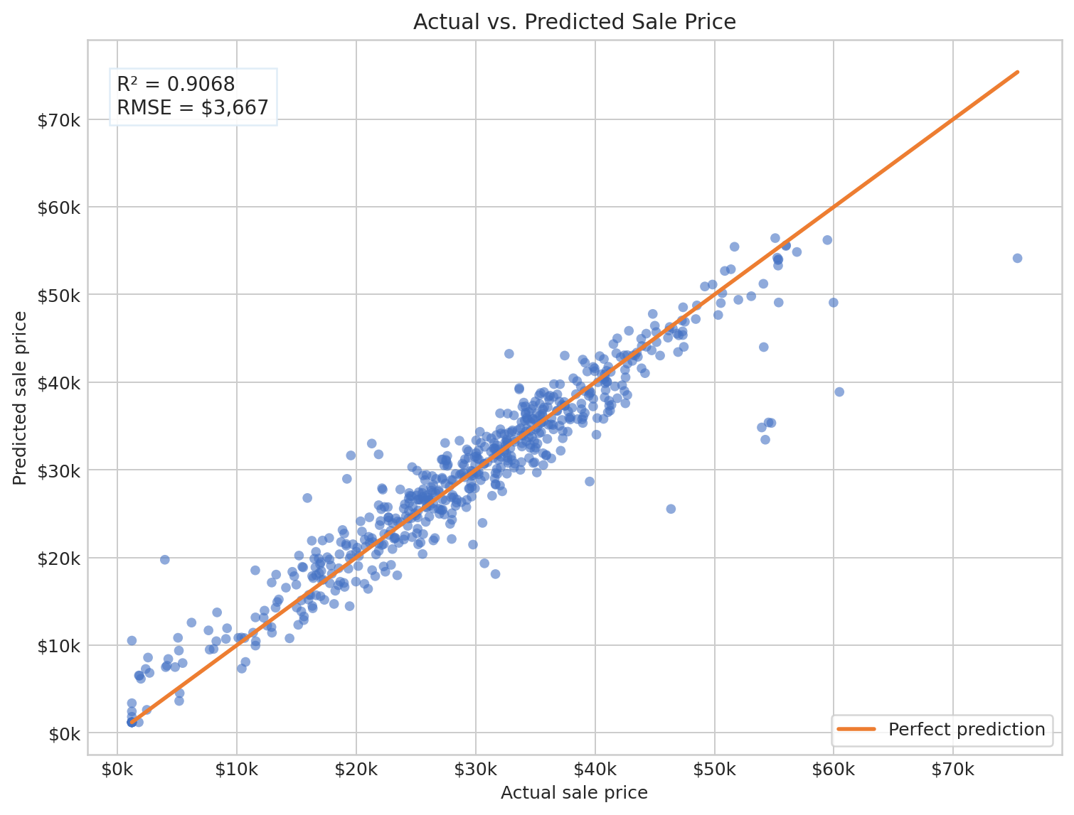
Figure 1 Actual and predicted prices on the 600-row holdout
Points near the orange diagonal are accurate. Most listings follow the diagonal closely, while a few high-priced vehicles are underpredicted. Lambda 0.003 reduced the five-fold mean coefficient norm by about 20.9% compared with lambda 0, while mean RMSE improved by only $0.33. Regularization therefore contributes stability, not a meaningful accuracy gain.

Limitations
- A linear model with fixed basis terms cannot represent every complex price relationship.
- Rare vehicle categories and unusual high-price listings have limited training evidence.
- The repeated $1,200 target is treated as a price floor; the true business rule is not independently confirmed.
- Validation estimates future performance but cannot guarantee the same error on a different market or time period.
- Important unmeasured details, equipment, local demand, and negotiation effects can remain in the residual error.

Conclusion
The final system is reproducible, leakage-aware, and suitable for generating baseline sale-price estimates from new feature-only listings. Its strongest evidence is consistent cross-validation performance, a holdout R-squared of 0.9068, and finite one-to-one predictions keyed by listing_id. The selected L2 penalty is retained because it materially shrinks coefficients in the presence of correlated predictors without sacrificing predictive performance. Future work should test additional time periods, richer vehicle equipment data, and alternative hand-coded basis functions while preserving the same prediction-time rules.

