The features selected for this database come from the accelerometer and gyroscope 3-axial raw signals tAcc-XYZ and tGyro-XYZ. These time domain signals (prefix 't' to denote time) were captured at a constant rate of 50 Hz. Then they were filtered using a median filter and a 3rd order low pass Butterworth filter with a corner frequency of 20 Hz to remove noise. Similarly, the acceleration signal was then separated into body and gravity acceleration signals (tBodyAcc-XYZ and tGravityAcc-XYZ) using another low pass Butterworth filter with a corner frequency of 0.3 Hz.

Subsequently, the body linear acceleration and angular velocity were derived in time to obtain Jerk signals (tBodyAccJerk-XYZ and tBodyGyroJerk-XYZ). Also the magnitude of these three-dimensional signals were calculated using the Euclidean norm (tBodyAccMag, tGravityAccMag, tBodyAccJerkMag, tBodyGyroMag, tBodyGyroJerkMag).

Finally a Fast Fourier Transform (FFT) was applied to some of these signals producing fBodyAcc-XYZ, fBodyAccJerk-XYZ, fBodyGyro-XYZ, fBodyAccJerkMag, fBodyGyroMag, fBodyGyroJerkMag. (Note the 'f' to indicate frequency domain signals).

These signals were used to estimate variables of the feature vector for each pattern:

'-XYZ' is used to denote 3-axial signals in the X, Y and Z directions.

tBodyAcc-XYZ

tGravityAcc-XYZ

tBodyAccJerk-XYZ

tBodyGyro-XYZ

tBodyGyroJerk-XYZ

tBodyAccMag

tGravityAccMag

tBodyAccJerkMag

tBodyGyroMag

tBodyGyroJerkMag

fBodyAcc-XYZ

fBodyAccJerk-XYZ

fBodyGyro-XYZ

fBodyAccMag

fBodyAccJerkMag

fBodyGyroMag

fBodyGyroJerkMag

The set of variables that were estimated from these signals in the result.txt file are:

mean(): Mean value

std(): Standard deviation

Additional vectors obtained by averaging the signals in a signal window sample. These are used on the angle() variable:

gravityMean

tBodyAccMean

tBodyAccJerkMean

tBodyGyroMean

tBodyGyroJerkMean

Codebook for result

Autogenerated data summary from dataMaid

2019-04-29 10:59:11

# Data report overview

The dataset examined has the following dimensions:

|  |  |
| --- | --- |
| Feature | Result |
| Number of observations | 10299 |
| Number of variables | 88 |

# Codebook summary table

|  |  |  |  |  |  |
| --- | --- | --- | --- | --- | --- |
| Label | Variable | Class | # unique values | Missing | Description |
|  | **subjectid** | integer | 30 | 0.00 % |  |
|  | **activity** | factor | 6 | 0.00 % |  |
|  | **tbodyaccmeanx** | numeric | 10292 | 0.00 % |  |
|  | **tbodyaccmeany** | numeric | 10299 | 0.00 % |  |
|  | **tbodyaccmeanz** | numeric | 10293 | 0.00 % |  |
|  | **tbodyaccstdx** | numeric | 10295 | 0.00 % |  |
|  | **tbodyaccstdy** | numeric | 10297 | 0.00 % |  |
|  | **tbodyaccstdz** | numeric | 10297 | 0.00 % |  |
|  | **tgravityaccmeanx** | numeric | 10296 | 0.00 % |  |
|  | **tgravityaccmeany** | numeric | 10298 | 0.00 % |  |
|  | **tgravityaccmeanz** | numeric | 10299 | 0.00 % |  |
|  | **tgravityaccstdx** | numeric | 10288 | 0.00 % |  |
|  | **tgravityaccstdy** | numeric | 10293 | 0.00 % |  |
|  | **tgravityaccstdz** | numeric | 10296 | 0.00 % |  |
|  | **tbodyaccjerkmeanx** | numeric | 10299 | 0.00 % |  |
|  | **tbodyaccjerkmeany** | numeric | 10299 | 0.00 % |  |
|  | **tbodyaccjerkmeanz** | numeric | 10299 | 0.00 % |  |
|  | **tbodyaccjerkstdx** | numeric | 10290 | 0.00 % |  |
|  | **tbodyaccjerkstdy** | numeric | 10296 | 0.00 % |  |
|  | **tbodyaccjerkstdz** | numeric | 10293 | 0.00 % |  |
|  | **tbodygyromeanx** | numeric | 10298 | 0.00 % |  |
|  | **tbodygyromeany** | numeric | 10299 | 0.00 % |  |
|  | **tbodygyromeanz** | numeric | 10297 | 0.00 % |  |
|  | **tbodygyrostdx** | numeric | 10292 | 0.00 % |  |
|  | **tbodygyrostdy** | numeric | 10296 | 0.00 % |  |
|  | **tbodygyrostdz** | numeric | 10296 | 0.00 % |  |
|  | **tbodygyrojerkmeanx** | numeric | 10295 | 0.00 % |  |
|  | **tbodygyrojerkmeany** | numeric | 10299 | 0.00 % |  |
|  | **tbodygyrojerkmeanz** | numeric | 10298 | 0.00 % |  |
|  | **tbodygyrojerkstdx** | numeric | 10292 | 0.00 % |  |
|  | **tbodygyrojerkstdy** | numeric | 10295 | 0.00 % |  |
|  | **tbodygyrojerkstdz** | numeric | 10291 | 0.00 % |  |
|  | **tbodyaccmagmean** | numeric | 10296 | 0.00 % |  |
|  | **tbodyaccmagstd** | numeric | 10294 | 0.00 % |  |
|  | **tgravityaccmagmean** | numeric | 10296 | 0.00 % |  |
|  | **tgravityaccmagstd** | numeric | 10294 | 0.00 % |  |
|  | **tbodyaccjerkmagmean** | numeric | 10292 | 0.00 % |  |
|  | **tbodyaccjerkmagstd** | numeric | 10294 | 0.00 % |  |
|  | **tbodygyromagmean** | numeric | 10298 | 0.00 % |  |
|  | **tbodygyromagstd** | numeric | 10298 | 0.00 % |  |
|  | **tbodygyrojerkmagmean** | numeric | 10293 | 0.00 % |  |
|  | **tbodygyrojerkmagstd** | numeric | 10297 | 0.00 % |  |
|  | **fbodyaccmeanx** | numeric | 10295 | 0.00 % |  |
|  | **fbodyaccmeany** | numeric | 10292 | 0.00 % |  |
|  | **fbodyaccmeanz** | numeric | 10295 | 0.00 % |  |
|  | **fbodyaccstdx** | numeric | 10294 | 0.00 % |  |
|  | **fbodyaccstdy** | numeric | 10297 | 0.00 % |  |
|  | **fbodyaccstdz** | numeric | 10296 | 0.00 % |  |
|  | **fbodyaccmeanfreqx** | numeric | 10299 | 0.00 % |  |
|  | **fbodyaccmeanfreqy** | numeric | 10299 | 0.00 % |  |
|  | **fbodyaccmeanfreqz** | numeric | 10299 | 0.00 % |  |
|  | **fbodyaccjerkmeanx** | numeric | 10293 | 0.00 % |  |
|  | **fbodyaccjerkmeany** | numeric | 10296 | 0.00 % |  |
|  | **fbodyaccjerkmeanz** | numeric | 10294 | 0.00 % |  |
|  | **fbodyaccjerkstdx** | numeric | 10291 | 0.00 % |  |
|  | **fbodyaccjerkstdy** | numeric | 10294 | 0.00 % |  |
|  | **fbodyaccjerkstdz** | numeric | 10290 | 0.00 % |  |
|  | **fbodyaccjerkmeanfreqx** | numeric | 10298 | 0.00 % |  |
|  | **fbodyaccjerkmeanfreqy** | numeric | 10299 | 0.00 % |  |
|  | **fbodyaccjerkmeanfreqz** | numeric | 10298 | 0.00 % |  |
|  | **fbodygyromeanx** | numeric | 10297 | 0.00 % |  |
|  | **fbodygyromeany** | numeric | 10296 | 0.00 % |  |
|  | **fbodygyromeanz** | numeric | 10297 | 0.00 % |  |
|  | **fbodygyrostdx** | numeric | 10297 | 0.00 % |  |
|  | **fbodygyrostdy** | numeric | 10293 | 0.00 % |  |
|  | **fbodygyrostdz** | numeric | 10295 | 0.00 % |  |
|  | **fbodygyromeanfreqx** | numeric | 10298 | 0.00 % |  |
|  | **fbodygyromeanfreqy** | numeric | 10299 | 0.00 % |  |
|  | **fbodygyromeanfreqz** | numeric | 10299 | 0.00 % |  |
|  | **fbodyaccmagmean** | numeric | 10296 | 0.00 % |  |
|  | **fbodyaccmagstd** | numeric | 10298 | 0.00 % |  |
|  | **fbodyaccmagmeanfreq** | numeric | 10299 | 0.00 % |  |
|  | **fbodybodyaccjerkmagmean** | numeric | 10290 | 0.00 % |  |
|  | **fbodybodyaccjerkmagstd** | numeric | 10296 | 0.00 % |  |
|  | **fbodybodyaccjerkmagmeanfreq** | numeric | 10299 | 0.00 % |  |
|  | **fbodybodygyromagmean** | numeric | 10297 | 0.00 % |  |
|  | **fbodybodygyromagstd** | numeric | 10296 | 0.00 % |  |
|  | **fbodybodygyromagmeanfreq** | numeric | 10299 | 0.00 % |  |
|  | **fbodybodygyrojerkmagmean** | numeric | 10293 | 0.00 % |  |
|  | **fbodybodygyrojerkmagstd** | numeric | 10292 | 0.00 % |  |
|  | **fbodybodygyrojerkmagmeanfreq** | numeric | 10299 | 0.00 % |  |
|  | **angletbodyaccmeangravity** | numeric | 10299 | 0.00 % |  |
|  | **angletbodyaccjerkmeangravitymean** | numeric | 10299 | 0.00 % |  |
|  | **angletbodygyromeangravitymean** | numeric | 10299 | 0.00 % |  |
|  | **angletbodygyrojerkmeangravitymean** | numeric | 10299 | 0.00 % |  |
|  | **anglexgravitymean** | numeric | 10299 | 0.00 % |  |
|  | **angleygravitymean** | numeric | 10299 | 0.00 % |  |
|  | **anglezgravitymean** | numeric | 10299 | 0.00 % |  |

# Variable list

## subjectid

|  |  |
| --- | --- |
| Feature | Result |
| Variable type | integer |
| Number of missing obs. | 0 (0 %) |
| Number of unique values | 30 |
| Median | 17 |
| 1st and 3rd quartiles | 9; 24 |
| Min. and max. | 1; 30 |

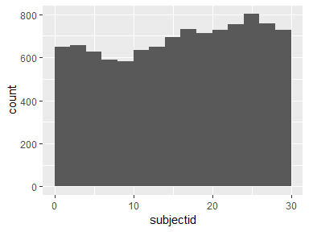

## activity

|  |  |
| --- | --- |
| Feature | Result |
| Variable type | factor |
| Number of missing obs. | 0 (0 %) |
| Number of unique values | 6 |
| Mode | “LAYING” |
| Reference category | LAYING |

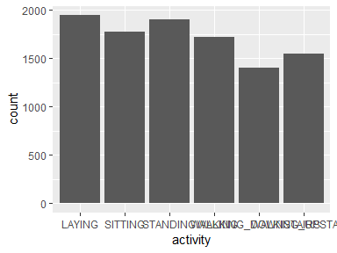

* Observed factor levels: "LAYING", "SITTING", "STANDING", "WALKING", "WALKING_DOWNSTAIRS", "WALKING_UPSTAIRS".

## tbodyaccmeanx

|  |  |
| --- | --- |
| Feature | Result |
| Variable type | numeric |
| Number of missing obs. | 0 (0 %) |
| Number of unique values | 10292 |
| Median | 0.28 |
| 1st and 3rd quartiles | 0.26; 0.29 |
| Min. and max. | -1; 1 |

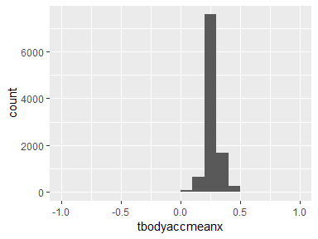

## tbodyaccmeany

|  |  |
| --- | --- |
| Feature | Result |
| Variable type | numeric |
| Number of missing obs. | 0 (0 %) |
| Number of unique values | 10299 |
| Median | -0.02 |
| 1st and 3rd quartiles | -0.02; -0.01 |
| Min. and max. | -1; 1 |

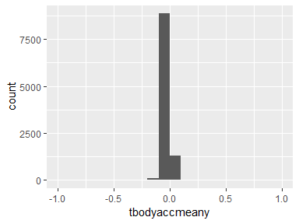

## tbodyaccmeanz

|  |  |
| --- | --- |
| Feature | Result |
| Variable type | numeric |
| Number of missing obs. | 0 (0 %) |
| Number of unique values | 10293 |
| Median | -0.11 |
| 1st and 3rd quartiles | -0.12; -0.1 |
| Min. and max. | -1; 1 |

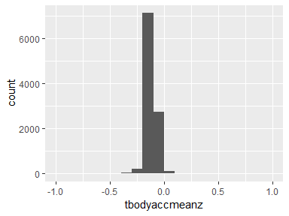

## tbodyaccstdx

|  |  |
| --- | --- |
| Feature | Result |
| Variable type | numeric |
| Number of missing obs. | 0 (0 %) |
| Number of unique values | 10295 |
| Median | -0.94 |
| 1st and 3rd quartiles | -0.99; -0.25 |
| Min. and max. | -1; 1 |

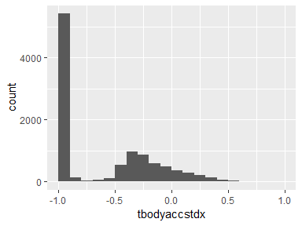

## tbodyaccstdy

|  |  |
| --- | --- |
| Feature | Result |
| Variable type | numeric |
| Number of missing obs. | 0 (0 %) |
| Number of unique values | 10297 |
| Median | -0.84 |
| 1st and 3rd quartiles | -0.98; -0.06 |
| Min. and max. | -1; 1 |

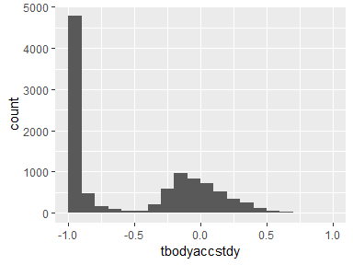

## tbodyaccstdz

|  |  |
| --- | --- |
| Feature | Result |
| Variable type | numeric |
| Number of missing obs. | 0 (0 %) |
| Number of unique values | 10297 |
| Median | -0.85 |
| 1st and 3rd quartiles | -0.98; -0.28 |
| Min. and max. | -1; 1 |

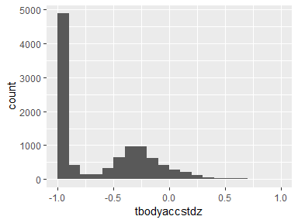

## tgravityaccmeanx

|  |  |
| --- | --- |
| Feature | Result |
| Variable type | numeric |
| Number of missing obs. | 0 (0 %) |
| Number of unique values | 10296 |
| Median | 0.92 |
| 1st and 3rd quartiles | 0.81; 0.95 |
| Min. and max. | -1; 1 |

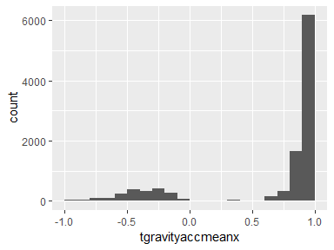

## tgravityaccmeany

|  |  |
| --- | --- |
| Feature | Result |
| Variable type | numeric |
| Number of missing obs. | 0 (0 %) |
| Number of unique values | 10298 |
| Median | -0.14 |
| 1st and 3rd quartiles | -0.24; 0.12 |
| Min. and max. | -1; 1 |

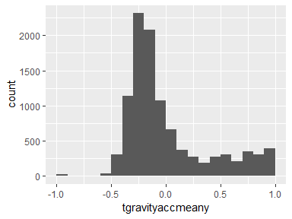

## tgravityaccmeanz

|  |  |
| --- | --- |
| Feature | Result |
| Variable type | numeric |
| Number of missing obs. | 0 (0 %) |
| Number of unique values | 10299 |
| Median | 0.04 |
| 1st and 3rd quartiles | -0.12; 0.22 |
| Min. and max. | -1; 1 |

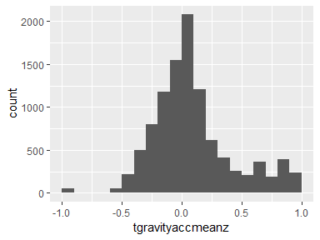

## tgravityaccstdx

|  |  |
| --- | --- |
| Feature | Result |
| Variable type | numeric |
| Number of missing obs. | 0 (0 %) |
| Number of unique values | 10288 |
| Median | -0.98 |
| 1st and 3rd quartiles | -0.99; -0.96 |
| Min. and max. | -1; 1 |

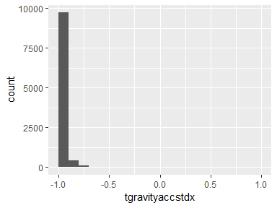

## tgravityaccstdy

|  |  |
| --- | --- |
| Feature | Result |
| Variable type | numeric |
| Number of missing obs. | 0 (0 %) |
| Number of unique values | 10293 |
| Median | -0.98 |
| 1st and 3rd quartiles | -0.99; -0.95 |
| Min. and max. | -1; 1 |

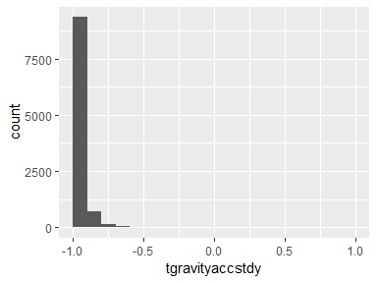

## tgravityaccstdz

|  |  |
| --- | --- |
| Feature | Result |
| Variable type | numeric |
| Number of missing obs. | 0 (0 %) |
| Number of unique values | 10296 |
| Median | -0.97 |
| 1st and 3rd quartiles | -0.99; -0.93 |
| Min. and max. | -1; 1 |

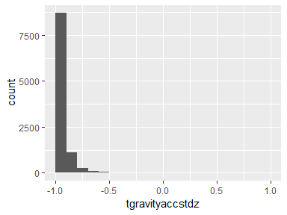

## tbodyaccjerkmeanx

|  |  |
| --- | --- |
| Feature | Result |
| Variable type | numeric |
| Number of missing obs. | 0 (0 %) |
| Number of unique values | 10299 |
| Median | 0.08 |
| 1st and 3rd quartiles | 0.06; 0.09 |
| Min. and max. | -1; 1 |

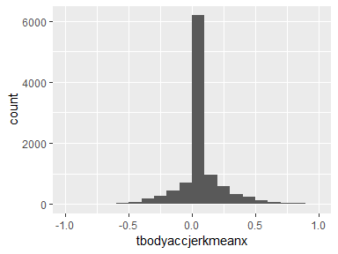

## tbodyaccjerkmeany

|  |  |
| --- | --- |
| Feature | Result |
| Variable type | numeric |
| Number of missing obs. | 0 (0 %) |
| Number of unique values | 10299 |
| Median | 0.01 |
| 1st and 3rd quartiles | -0.02; 0.03 |
| Min. and max. | -1; 1 |

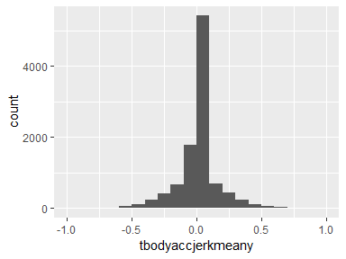

## tbodyaccjerkmeanz

|  |  |
| --- | --- |
| Feature | Result |
| Variable type | numeric |
| Number of missing obs. | 0 (0 %) |
| Number of unique values | 10299 |
| Median | 0 |
| 1st and 3rd quartiles | -0.03; 0.02 |
| Min. and max. | -1; 1 |

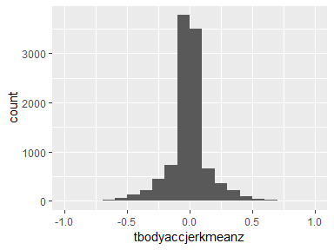

## tbodyaccjerkstdx

|  |  |
| --- | --- |
| Feature | Result |
| Variable type | numeric |
| Number of missing obs. | 0 (0 %) |
| Number of unique values | 10290 |
| Median | -0.95 |
| 1st and 3rd quartiles | -0.99; -0.29 |
| Min. and max. | -1; 1 |

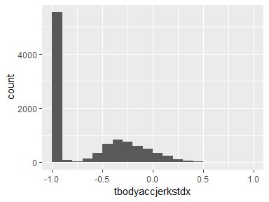

## tbodyaccjerkstdy

|  |  |
| --- | --- |
| Feature | Result |
| Variable type | numeric |
| Number of missing obs. | 0 (0 %) |
| Number of unique values | 10296 |
| Median | -0.93 |
| 1st and 3rd quartiles | -0.99; -0.22 |
| Min. and max. | -1; 1 |

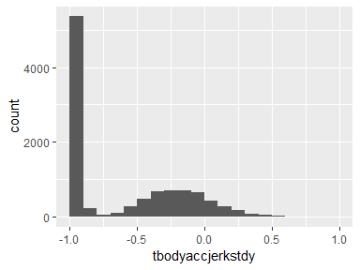

## tbodyaccjerkstdz

|  |  |
| --- | --- |
| Feature | Result |
| Variable type | numeric |
| Number of missing obs. | 0 (0 %) |
| Number of unique values | 10293 |
| Median | -0.95 |
| 1st and 3rd quartiles | -0.99; -0.55 |
| Min. and max. | -1; 1 |

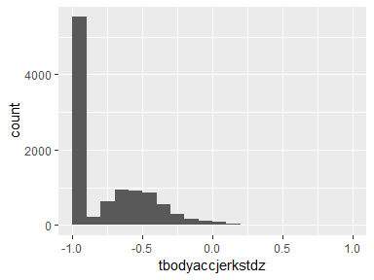

## tbodygyromeanx

|  |  |
| --- | --- |
| Feature | Result |
| Variable type | numeric |
| Number of missing obs. | 0 (0 %) |
| Number of unique values | 10298 |
| Median | -0.03 |
| 1st and 3rd quartiles | -0.05; -0.01 |
| Min. and max. | -1; 1 |

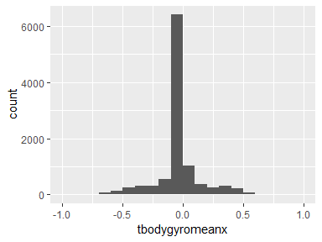

## tbodygyromeany

|  |  |
| --- | --- |
| Feature | Result |
| Variable type | numeric |
| Number of missing obs. | 0 (0 %) |
| Number of unique values | 10299 |
| Median | -0.07 |
| 1st and 3rd quartiles | -0.1; -0.05 |
| Min. and max. | -1; 1 |

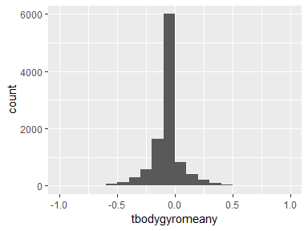

## tbodygyromeanz

|  |  |
| --- | --- |
| Feature | Result |
| Variable type | numeric |
| Number of missing obs. | 0 (0 %) |
| Number of unique values | 10297 |
| Median | 0.09 |
| 1st and 3rd quartiles | 0.06; 0.11 |
| Min. and max. | -1; 1 |

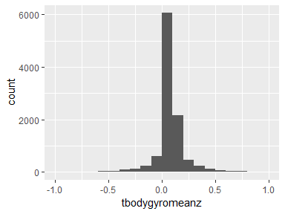

## tbodygyrostdx

|  |  |
| --- | --- |
| Feature | Result |
| Variable type | numeric |
| Number of missing obs. | 0 (0 %) |
| Number of unique values | 10292 |
| Median | -0.9 |
| 1st and 3rd quartiles | -0.99; -0.48 |
| Min. and max. | -1; 1 |

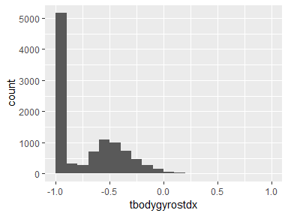

## tbodygyrostdy

|  |  |
| --- | --- |
| Feature | Result |
| Variable type | numeric |
| Number of missing obs. | 0 (0 %) |
| Number of unique values | 10296 |
| Median | -0.91 |
| 1st and 3rd quartiles | -0.98; -0.45 |
| Min. and max. | -1; 1 |

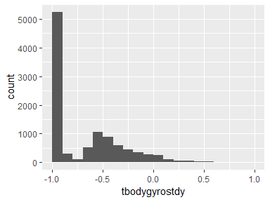

## tbodygyrostdz

|  |  |
| --- | --- |
| Feature | Result |
| Variable type | numeric |
| Number of missing obs. | 0 (0 %) |
| Number of unique values | 10296 |
| Median | -0.88 |
| 1st and 3rd quartiles | -0.99; -0.34 |
| Min. and max. | -1; 1 |

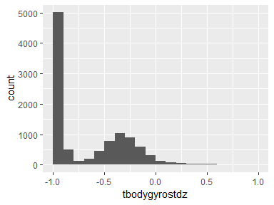

## tbodygyrojerkmeanx

|  |  |
| --- | --- |
| Feature | Result |
| Variable type | numeric |
| Number of missing obs. | 0 (0 %) |
| Number of unique values | 10295 |
| Median | -0.1 |
| 1st and 3rd quartiles | -0.12; -0.08 |
| Min. and max. | -1; 1 |

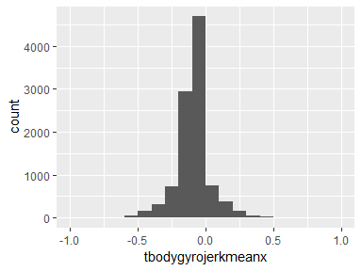

## tbodygyrojerkmeany

|  |  |
| --- | --- |
| Feature | Result |
| Variable type | numeric |
| Number of missing obs. | 0 (0 %) |
| Number of unique values | 10299 |
| Median | -0.04 |
| 1st and 3rd quartiles | -0.06; -0.03 |
| Min. and max. | -1; 1 |

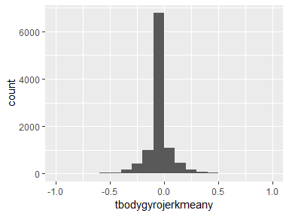

## tbodygyrojerkmeanz

|  |  |
| --- | --- |
| Feature | Result |
| Variable type | numeric |
| Number of missing obs. | 0 (0 %) |
| Number of unique values | 10298 |
| Median | -0.05 |
| 1st and 3rd quartiles | -0.08; -0.03 |
| Min. and max. | -1; 1 |

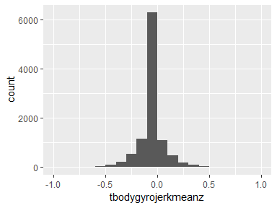

## tbodygyrojerkstdx

|  |  |
| --- | --- |
| Feature | Result |
| Variable type | numeric |
| Number of missing obs. | 0 (0 %) |
| Number of unique values | 10292 |
| Median | -0.93 |
| 1st and 3rd quartiles | -0.99; -0.49 |
| Min. and max. | -1; 1 |

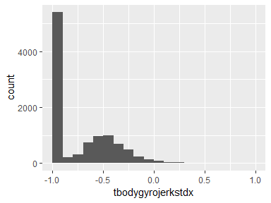

## tbodygyrojerkstdy

|  |  |
| --- | --- |
| Feature | Result |
| Variable type | numeric |
| Number of missing obs. | 0 (0 %) |
| Number of unique values | 10295 |
| Median | -0.95 |
| 1st and 3rd quartiles | -0.99; -0.63 |
| Min. and max. | -1; 1 |

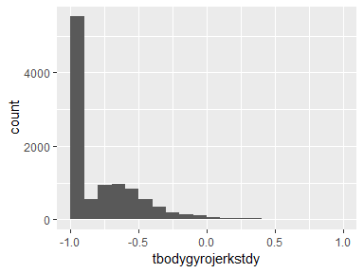

## tbodygyrojerkstdz

|  |  |
| --- | --- |
| Feature | Result |
| Variable type | numeric |
| Number of missing obs. | 0 (0 %) |
| Number of unique values | 10291 |
| Median | -0.95 |
| 1st and 3rd quartiles | -0.99; -0.51 |
| Min. and max. | -1; 1 |

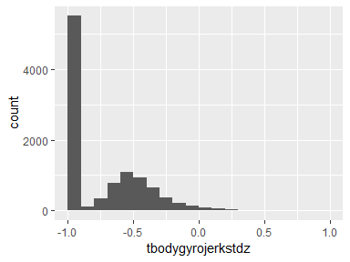

## tbodyaccmagmean

|  |  |
| --- | --- |
| Feature | Result |
| Variable type | numeric |
| Number of missing obs. | 0 (0 %) |
| Number of unique values | 10296 |
| Median | -0.87 |
| 1st and 3rd quartiles | -0.98; -0.12 |
| Min. and max. | -1; 1 |

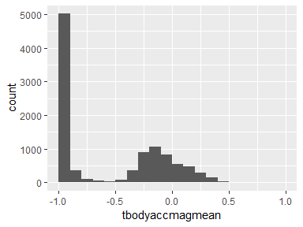

## tbodyaccmagstd

|  |  |
| --- | --- |
| Feature | Result |
| Variable type | numeric |
| Number of missing obs. | 0 (0 %) |
| Number of unique values | 10294 |
| Median | -0.84 |
| 1st and 3rd quartiles | -0.98; -0.24 |
| Min. and max. | -1; 1 |

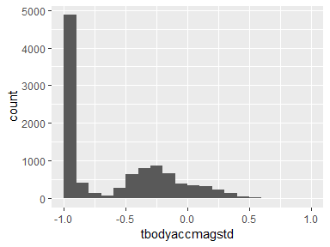

## tgravityaccmagmean

|  |  |
| --- | --- |
| Feature | Result |
| Variable type | numeric |
| Number of missing obs. | 0 (0 %) |
| Number of unique values | 10296 |
| Median | -0.87 |
| 1st and 3rd quartiles | -0.98; -0.12 |
| Min. and max. | -1; 1 |

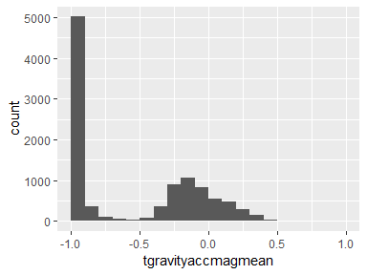

## tgravityaccmagstd

|  |  |
| --- | --- |
| Feature | Result |
| Variable type | numeric |
| Number of missing obs. | 0 (0 %) |
| Number of unique values | 10294 |
| Median | -0.84 |
| 1st and 3rd quartiles | -0.98; -0.24 |
| Min. and max. | -1; 1 |

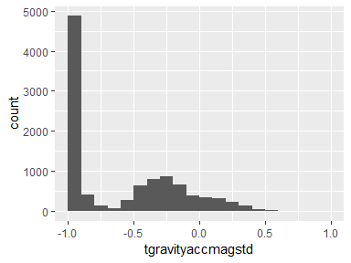

## tbodyaccjerkmagmean

|  |  |
| --- | --- |
| Feature | Result |
| Variable type | numeric |
| Number of missing obs. | 0 (0 %) |
| Number of unique values | 10292 |
| Median | -0.95 |
| 1st and 3rd quartiles | -0.99; -0.3 |
| Min. and max. | -1; 1 |

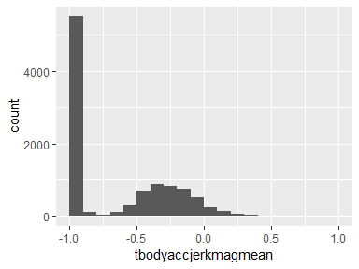

## tbodyaccjerkmagstd

|  |  |
| --- | --- |
| Feature | Result |
| Variable type | numeric |
| Number of missing obs. | 0 (0 %) |
| Number of unique values | 10294 |
| Median | -0.93 |
| 1st and 3rd quartiles | -0.99; -0.27 |
| Min. and max. | -1; 1 |

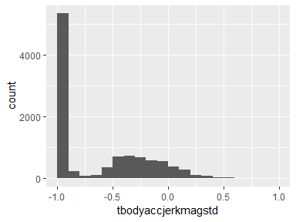

## tbodygyromagmean

|  |  |
| --- | --- |
| Feature | Result |
| Variable type | numeric |
| Number of missing obs. | 0 (0 %) |
| Number of unique values | 10298 |
| Median | -0.82 |
| 1st and 3rd quartiles | -0.98; -0.25 |
| Min. and max. | -1; 1 |

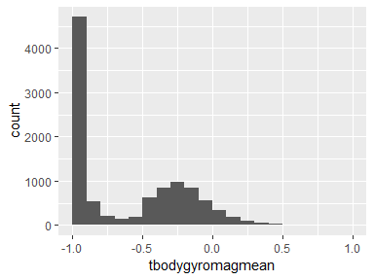

## tbodygyromagstd

|  |  |
| --- | --- |
| Feature | Result |
| Variable type | numeric |
| Number of missing obs. | 0 (0 %) |
| Number of unique values | 10298 |
| Median | -0.83 |
| 1st and 3rd quartiles | -0.98; -0.39 |
| Min. and max. | -1; 1 |

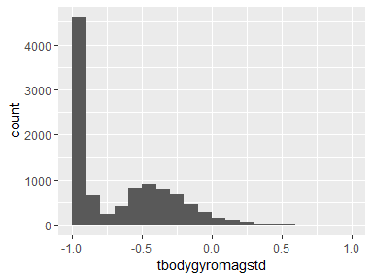

## tbodygyrojerkmagmean

|  |  |
| --- | --- |
| Feature | Result |
| Variable type | numeric |
| Number of missing obs. | 0 (0 %) |
| Number of unique values | 10293 |
| Median | -0.96 |
| 1st and 3rd quartiles | -0.99; -0.55 |
| Min. and max. | -1; 1 |

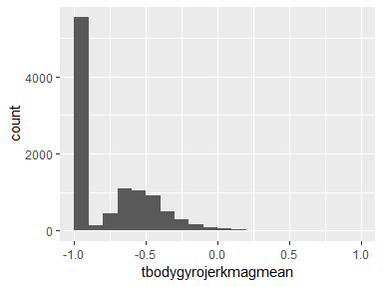

## tbodygyrojerkmagstd

|  |  |
| --- | --- |
| Feature | Result |
| Variable type | numeric |
| Number of missing obs. | 0 (0 %) |
| Number of unique values | 10297 |
| Median | -0.94 |
| 1st and 3rd quartiles | -0.99; -0.61 |
| Min. and max. | -1; 1 |

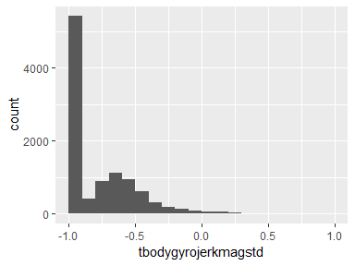

## fbodyaccmeanx

|  |  |
| --- | --- |
| Feature | Result |
| Variable type | numeric |
| Number of missing obs. | 0 (0 %) |
| Number of unique values | 10295 |
| Median | -0.95 |
| 1st and 3rd quartiles | -0.99; -0.26 |
| Min. and max. | -1; 1 |

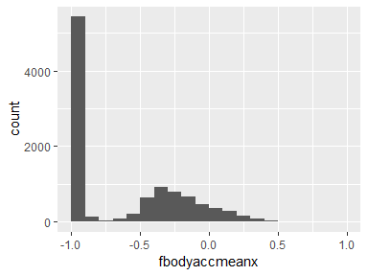

## fbodyaccmeany

|  |  |
| --- | --- |
| Feature | Result |
| Variable type | numeric |
| Number of missing obs. | 0 (0 %) |
| Number of unique values | 10292 |
| Median | -0.86 |
| 1st and 3rd quartiles | -0.98; -0.1 |
| Min. and max. | -1; 1 |

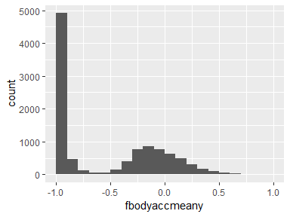

## fbodyaccmeanz

|  |  |
| --- | --- |
| Feature | Result |
| Variable type | numeric |
| Number of missing obs. | 0 (0 %) |
| Number of unique values | 10295 |
| Median | -0.9 |
| 1st and 3rd quartiles | -0.98; -0.37 |
| Min. and max. | -1; 1 |

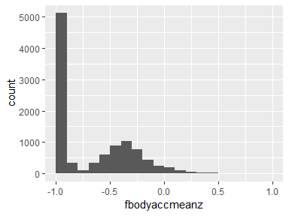

## fbodyaccstdx

|  |  |
| --- | --- |
| Feature | Result |
| Variable type | numeric |
| Number of missing obs. | 0 (0 %) |
| Number of unique values | 10294 |
| Median | -0.94 |
| 1st and 3rd quartiles | -0.99; -0.25 |
| Min. and max. | -1; 1 |

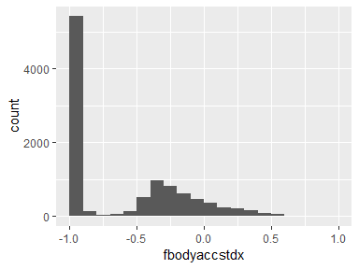

## fbodyaccstdy

|  |  |
| --- | --- |
| Feature | Result |
| Variable type | numeric |
| Number of missing obs. | 0 (0 %) |
| Number of unique values | 10297 |
| Median | -0.83 |
| 1st and 3rd quartiles | -0.98; -0.09 |
| Min. and max. | -1; 1 |

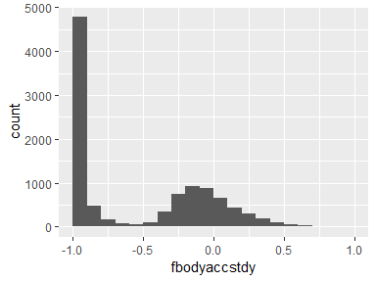

## fbodyaccstdz

|  |  |
| --- | --- |
| Feature | Result |
| Variable type | numeric |
| Number of missing obs. | 0 (0 %) |
| Number of unique values | 10296 |
| Median | -0.84 |
| 1st and 3rd quartiles | -0.98; -0.3 |
| Min. and max. | -1; 1 |

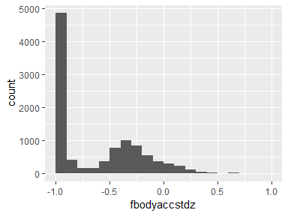

## fbodyaccmeanfreqx

|  |  |
| --- | --- |
| Feature | Result |
| Variable type | numeric |
| Number of missing obs. | 0 (0 %) |
| Number of unique values | 10299 |
| Median | -0.24 |
| 1st and 3rd quartiles | -0.42; -0.02 |
| Min. and max. | -1; 1 |

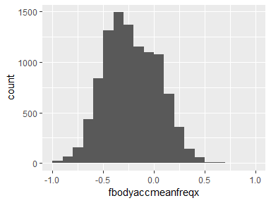

## fbodyaccmeanfreqy

|  |  |
| --- | --- |
| Feature | Result |
| Variable type | numeric |
| Number of missing obs. | 0 (0 %) |
| Number of unique values | 10299 |
| Median | 0 |
| 1st and 3rd quartiles | -0.14; 0.18 |
| Min. and max. | -1; 1 |

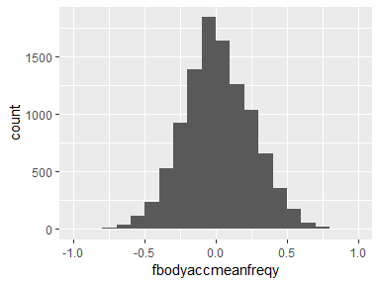

## fbodyaccmeanfreqz

|  |  |
| --- | --- |
| Feature | Result |
| Variable type | numeric |
| Number of missing obs. | 0 (0 %) |
| Number of unique values | 10299 |
| Median | 0.06 |
| 1st and 3rd quartiles | -0.14; 0.25 |
| Min. and max. | -1; 1 |

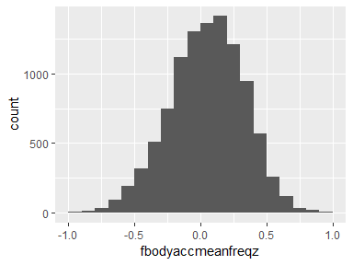

## fbodyaccjerkmeanx

|  |  |
| --- | --- |
| Feature | Result |
| Variable type | numeric |
| Number of missing obs. | 0 (0 %) |
| Number of unique values | 10293 |
| Median | -0.95 |
| 1st and 3rd quartiles | -0.99; -0.33 |
| Min. and max. | -1; 1 |

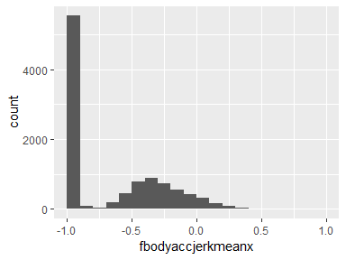

## fbodyaccjerkmeany

|  |  |
| --- | --- |
| Feature | Result |
| Variable type | numeric |
| Number of missing obs. | 0 (0 %) |
| Number of unique values | 10296 |
| Median | -0.93 |
| 1st and 3rd quartiles | -0.98; -0.26 |
| Min. and max. | -1; 1 |

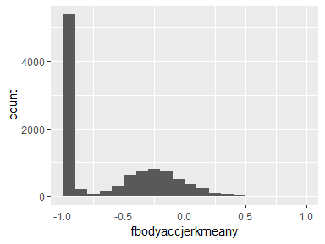

## fbodyaccjerkmeanz

|  |  |
| --- | --- |
| Feature | Result |
| Variable type | numeric |
| Number of missing obs. | 0 (0 %) |
| Number of unique values | 10294 |
| Median | -0.95 |
| 1st and 3rd quartiles | -0.99; -0.51 |
| Min. and max. | -1; 1 |

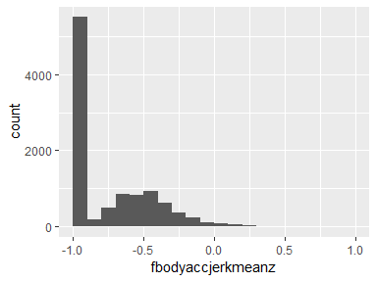

## fbodyaccjerkstdx

|  |  |
| --- | --- |
| Feature | Result |
| Variable type | numeric |
| Number of missing obs. | 0 (0 %) |
| Number of unique values | 10291 |
| Median | -0.96 |
| 1st and 3rd quartiles | -0.99; -0.32 |
| Min. and max. | -1; 1 |

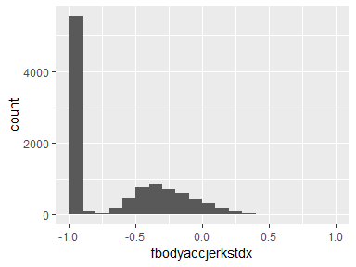

## fbodyaccjerkstdy

|  |  |
| --- | --- |
| Feature | Result |
| Variable type | numeric |
| Number of missing obs. | 0 (0 %) |
| Number of unique values | 10294 |
| Median | -0.93 |
| 1st and 3rd quartiles | -0.99; -0.24 |
| Min. and max. | -1; 1 |

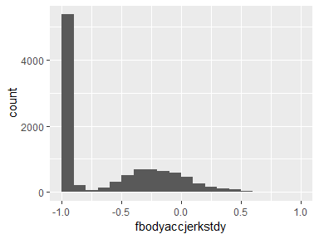

## fbodyaccjerkstdz

|  |  |
| --- | --- |
| Feature | Result |
| Variable type | numeric |
| Number of missing obs. | 0 (0 %) |
| Number of unique values | 10290 |
| Median | -0.96 |
| 1st and 3rd quartiles | -0.99; -0.59 |
| Min. and max. | -1; 1 |

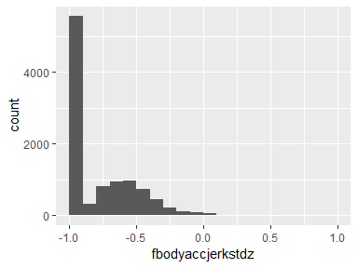

## fbodyaccjerkmeanfreqx

|  |  |
| --- | --- |
| Feature | Result |
| Variable type | numeric |
| Number of missing obs. | 0 (0 %) |
| Number of unique values | 10298 |
| Median | -0.05 |
| 1st and 3rd quartiles | -0.3; 0.2 |
| Min. and max. | -1; 1 |

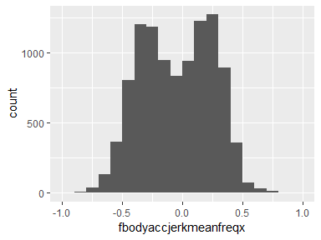

## fbodyaccjerkmeanfreqy

|  |  |
| --- | --- |
| Feature | Result |
| Variable type | numeric |
| Number of missing obs. | 0 (0 %) |
| Number of unique values | 10299 |
| Median | -0.24 |
| 1st and 3rd quartiles | -0.43; 0.01 |
| Min. and max. | -1; 1 |

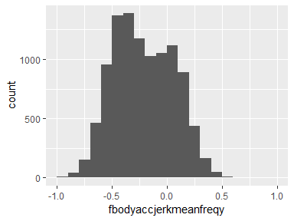

## fbodyaccjerkmeanfreqz

|  |  |
| --- | --- |
| Feature | Result |
| Variable type | numeric |
| Number of missing obs. | 0 (0 %) |
| Number of unique values | 10298 |
| Median | -0.1 |
| 1st and 3rd quartiles | -0.33; 0.09 |
| Min. and max. | -1; 1 |

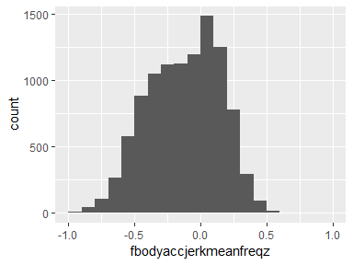

## fbodygyromeanx

|  |  |
| --- | --- |
| Feature | Result |
| Variable type | numeric |
| Number of missing obs. | 0 (0 %) |
| Number of unique values | 10297 |
| Median | -0.89 |
| 1st and 3rd quartiles | -0.99; -0.38 |
| Min. and max. | -1; 1 |

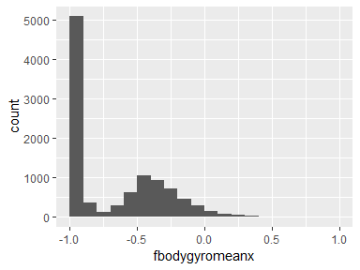

## fbodygyromeany

|  |  |
| --- | --- |
| Feature | Result |
| Variable type | numeric |
| Number of missing obs. | 0 (0 %) |
| Number of unique values | 10296 |
| Median | -0.92 |
| 1st and 3rd quartiles | -0.98; -0.47 |
| Min. and max. | -1; 1 |

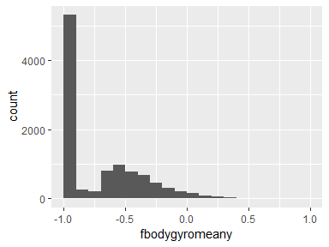

## fbodygyromeanz

|  |  |
| --- | --- |
| Feature | Result |
| Variable type | numeric |
| Number of missing obs. | 0 (0 %) |
| Number of unique values | 10297 |
| Median | -0.89 |
| 1st and 3rd quartiles | -0.99; -0.32 |
| Min. and max. | -1; 1 |

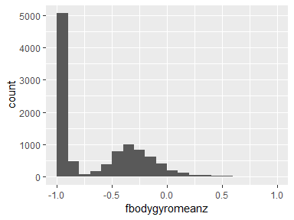

## fbodygyrostdx

|  |  |
| --- | --- |
| Feature | Result |
| Variable type | numeric |
| Number of missing obs. | 0 (0 %) |
| Number of unique values | 10297 |
| Median | -0.91 |
| 1st and 3rd quartiles | -0.99; -0.52 |
| Min. and max. | -1; 1 |

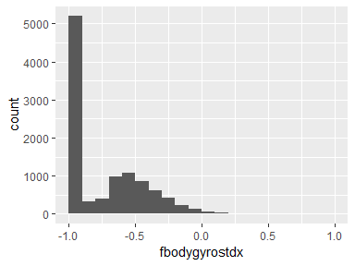

## fbodygyrostdy

|  |  |
| --- | --- |
| Feature | Result |
| Variable type | numeric |
| Number of missing obs. | 0 (0 %) |
| Number of unique values | 10293 |
| Median | -0.91 |
| 1st and 3rd quartiles | -0.98; -0.44 |
| Min. and max. | -1; 1 |

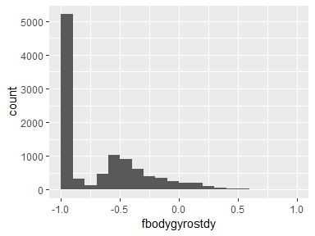

## fbodygyrostdz

|  |  |
| --- | --- |
| Feature | Result |
| Variable type | numeric |
| Number of missing obs. | 0 (0 %) |
| Number of unique values | 10295 |
| Median | -0.89 |
| 1st and 3rd quartiles | -0.99; -0.42 |
| Min. and max. | -1; 1 |

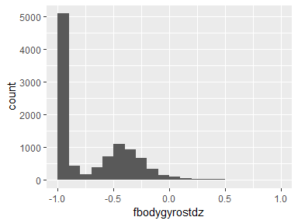

## fbodygyromeanfreqx

|  |  |
| --- | --- |
| Feature | Result |
| Variable type | numeric |
| Number of missing obs. | 0 (0 %) |
| Number of unique values | 10298 |
| Median | -0.1 |
| 1st and 3rd quartiles | -0.27; 0.07 |
| Min. and max. | -1; 1 |

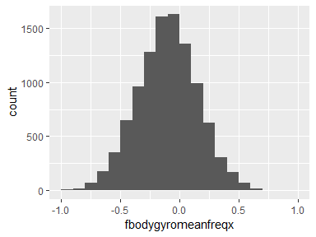

## fbodygyromeanfreqy

|  |  |
| --- | --- |
| Feature | Result |
| Variable type | numeric |
| Number of missing obs. | 0 (0 %) |
| Number of unique values | 10299 |
| Median | -0.17 |
| 1st and 3rd quartiles | -0.36; 0.01 |
| Min. and max. | -1; 1 |

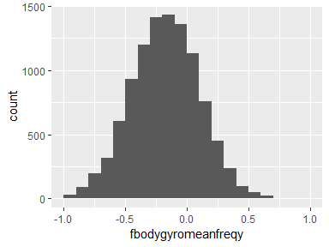

## fbodygyromeanfreqz

|  |  |
| --- | --- |
| Feature | Result |
| Variable type | numeric |
| Number of missing obs. | 0 (0 %) |
| Number of unique values | 10299 |
| Median | -0.05 |
| 1st and 3rd quartiles | -0.23; 0.12 |
| Min. and max. | -1; 1 |

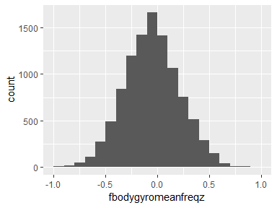

## fbodyaccmagmean

|  |  |
| --- | --- |
| Feature | Result |
| Variable type | numeric |
| Number of missing obs. | 0 (0 %) |
| Number of unique values | 10296 |
| Median | -0.88 |
| 1st and 3rd quartiles | -0.98; -0.22 |
| Min. and max. | -1; 1 |

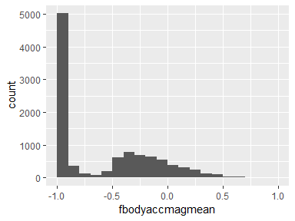

## fbodyaccmagstd

|  |  |
| --- | --- |
| Feature | Result |
| Variable type | numeric |
| Number of missing obs. | 0 (0 %) |
| Number of unique values | 10298 |
| Median | -0.85 |
| 1st and 3rd quartiles | -0.98; -0.38 |
| Min. and max. | -1; 1 |

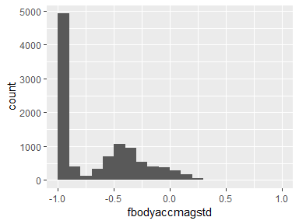

## fbodyaccmagmeanfreq

|  |  |
| --- | --- |
| Feature | Result |
| Variable type | numeric |
| Number of missing obs. | 0 (0 %) |
| Number of unique values | 10299 |
| Median | 0.07 |
| 1st and 3rd quartiles | -0.1; 0.24 |
| Min. and max. | -1; 1 |

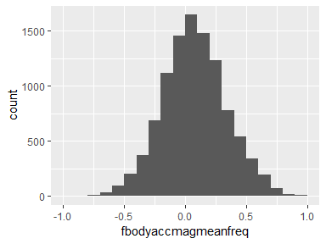

## fbodybodyaccjerkmagmean

|  |  |
| --- | --- |
| Feature | Result |
| Variable type | numeric |
| Number of missing obs. | 0 (0 %) |
| Number of unique values | 10290 |
| Median | -0.93 |
| 1st and 3rd quartiles | -0.99; -0.26 |
| Min. and max. | -1; 1 |

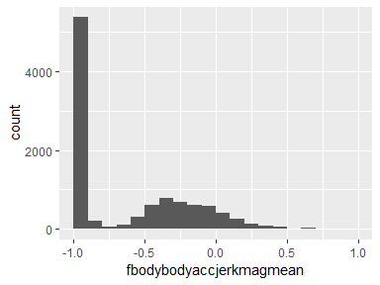

## fbodybodyaccjerkmagstd

|  |  |
| --- | --- |
| Feature | Result |
| Variable type | numeric |
| Number of missing obs. | 0 (0 %) |
| Number of unique values | 10296 |
| Median | -0.93 |
| 1st and 3rd quartiles | -0.99; -0.31 |
| Min. and max. | -1; 1 |

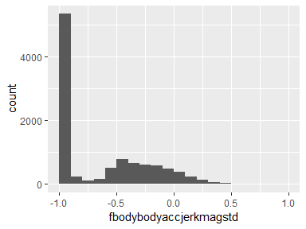

## fbodybodyaccjerkmagmeanfreq

|  |  |
| --- | --- |
| Feature | Result |
| Variable type | numeric |
| Number of missing obs. | 0 (0 %) |
| Number of unique values | 10299 |
| Median | 0.16 |
| 1st and 3rd quartiles | 0; 0.36 |
| Min. and max. | -1; 1 |

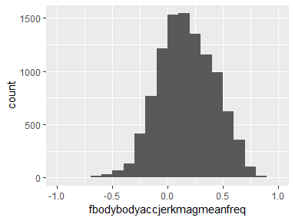

## fbodybodygyromagmean

|  |  |
| --- | --- |
| Feature | Result |
| Variable type | numeric |
| Number of missing obs. | 0 (0 %) |
| Number of unique values | 10297 |
| Median | -0.88 |
| 1st and 3rd quartiles | -0.98; -0.45 |
| Min. and max. | -1; 1 |

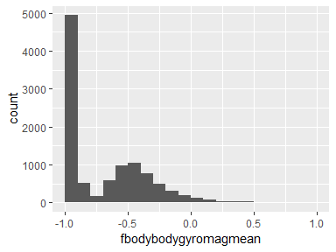

## fbodybodygyromagstd

|  |  |
| --- | --- |
| Feature | Result |
| Variable type | numeric |
| Number of missing obs. | 0 (0 %) |
| Number of unique values | 10296 |
| Median | -0.83 |
| 1st and 3rd quartiles | -0.98; -0.47 |
| Min. and max. | -1; 1 |

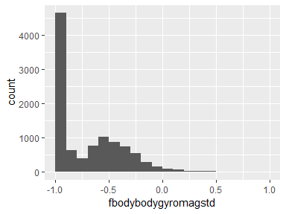

## fbodybodygyromagmeanfreq

|  |  |
| --- | --- |
| Feature | Result |
| Variable type | numeric |
| Number of missing obs. | 0 (0 %) |
| Number of unique values | 10299 |
| Median | -0.05 |
| 1st and 3rd quartiles | -0.23; 0.15 |
| Min. and max. | -1; 1 |

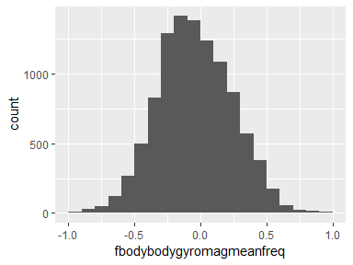

## fbodybodygyrojerkmagmean

|  |  |
| --- | --- |
| Feature | Result |
| Variable type | numeric |
| Number of missing obs. | 0 (0 %) |
| Number of unique values | 10293 |
| Median | -0.95 |
| 1st and 3rd quartiles | -0.99; -0.61 |
| Min. and max. | -1; 1 |

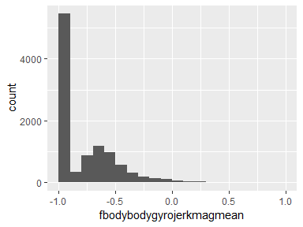

## fbodybodygyrojerkmagstd

|  |  |
| --- | --- |
| Feature | Result |
| Variable type | numeric |
| Number of missing obs. | 0 (0 %) |
| Number of unique values | 10292 |
| Median | -0.94 |
| 1st and 3rd quartiles | -0.99; -0.64 |
| Min. and max. | -1; 1 |

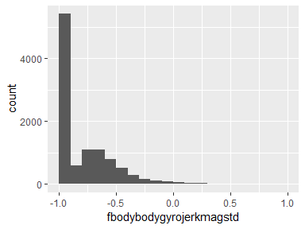

## fbodybodygyrojerkmagmeanfreq

|  |  |
| --- | --- |
| Feature | Result |
| Variable type | numeric |
| Number of missing obs. | 0 (0 %) |
| Number of unique values | 10299 |
| Median | 0.14 |
| 1st and 3rd quartiles | -0.02; 0.29 |
| Min. and max. | -1; 1 |

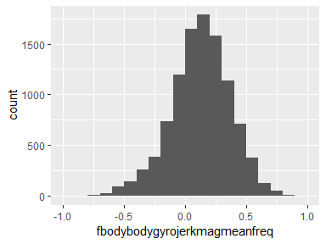

## angletbodyaccmeangravity

|  |  |
| --- | --- |
| Feature | Result |
| Variable type | numeric |
| Number of missing obs. | 0 (0 %) |
| Number of unique values | 10299 |
| Median | 0.01 |
| 1st and 3rd quartiles | -0.12; 0.15 |
| Min. and max. | -1; 1 |

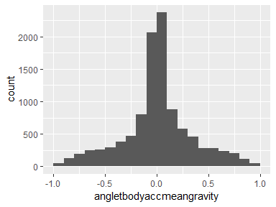

## angletbodyaccjerkmeangravitymean

|  |  |
| --- | --- |
| Feature | Result |
| Variable type | numeric |
| Number of missing obs. | 0 (0 %) |
| Number of unique values | 10299 |
| Median | 0.01 |
| 1st and 3rd quartiles | -0.29; 0.29 |
| Min. and max. | -1; 1 |

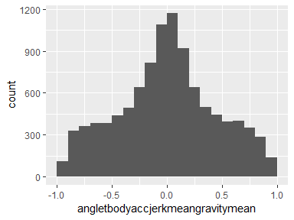

## angletbodygyromeangravitymean

|  |  |
| --- | --- |
| Feature | Result |
| Variable type | numeric |
| Number of missing obs. | 0 (0 %) |
| Number of unique values | 10299 |
| Median | 0.02 |
| 1st and 3rd quartiles | -0.49; 0.54 |
| Min. and max. | -1; 1 |

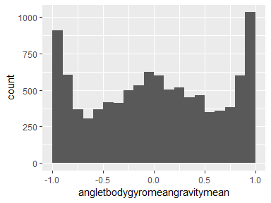

## angletbodygyrojerkmeangravitymean

|  |  |
| --- | --- |
| Feature | Result |
| Variable type | numeric |
| Number of missing obs. | 0 (0 %) |
| Number of unique values | 10299 |
| Median | -0.01 |
| 1st and 3rd quartiles | -0.39; 0.37 |
| Min. and max. | -1; 1 |

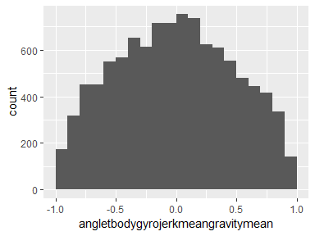

## anglexgravitymean

|  |  |
| --- | --- |
| Feature | Result |
| Variable type | numeric |
| Number of missing obs. | 0 (0 %) |
| Number of unique values | 10299 |
| Median | -0.72 |
| 1st and 3rd quartiles | -0.82; -0.52 |
| Min. and max. | -1; 1 |

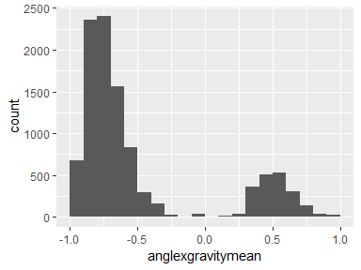

## angleygravitymean

|  |  |
| --- | --- |
| Feature | Result |
| Variable type | numeric |
| Number of missing obs. | 0 (0 %) |
| Number of unique values | 10299 |
| Median | 0.18 |
| 1st and 3rd quartiles | 0; 0.25 |
| Min. and max. | -1; 1 |

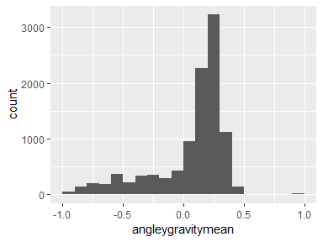

## anglezgravitymean

|  |  |
| --- | --- |
| Feature | Result |
| Variable type | numeric |
| Number of missing obs. | 0 (0 %) |
| Number of unique values | 10299 |
| Median | 0 |
| 1st and 3rd quartiles | -0.13; 0.1 |
| Min. and max. | -1; 1 |

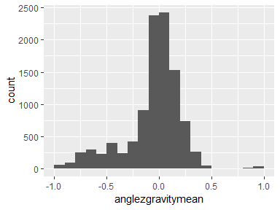

Report generation information:

* Created by Michael Giangrande (username: giangrande_m).
* Report creation time: Mon Apr 29 2019 10:59:20
* Report was run from directory: C:/Stuff/Rtesting/couseralinking/03_GettingCleaningData/courseproject
* dataMaid v1.2.0 [Pkg: 2018-10-03 from CRAN (R 3.5.3)]
* R version 3.5.3 (2019-03-11).
* Platform: x86_64-w64-mingw32/x64 (64-bit)(Windows >= 8 x64 (build 9200)).
* Function call: makeDataReport(data = result, mode = c("summarize", "visualize", "check"), smartNum = FALSE, file = "codebook_result.Rmd", checks = list( character = "showAllFactorLevels", factor = "showAllFactorLevels", labelled = "showAllFactorLevels", haven_labelled = "showAllFactorLevels", numeric = NULL, integer = NULL, logical = NULL, Date = NULL), listChecks = FALSE, maxProbVals = Inf, codebook = TRUE, reportTitle = "Codebook for result")