quiz title: Canvas Quiz Converter feature tour
quiz description: Original practice questions demonstrating every supported Word quiz format.
shuffle answers: true
show correct answers: true
one question at a time: true
GROUP
Group title: Quick science warm-up
pick: 1
points per question: 2

- Which planet is known as the Red Planet?
  - !Mars
  - Venus
  - Earth
  - Jupiter
- Which gas do plants absorb during photosynthesis?
  - Oxygen
  - Nitrogen
  - !Carbon dioxide
  - Helium
- Which material is attracted to a magnet?
  - Plastic
  - Wood
  - !Iron
  - Glass
END_GROUP
Title: Renewable energy
Points: 2
- Which of these are renewable energy sources?
[*] Solar power
[*] Wind power
[*] Hydroelectric power
[ ] Coal
- Which values are even numbers?
[*] 2
[*] 4
[ ] 5
[*] 6
[ ] 9

Title: Feedback example
Points: 2
- What is 2 + 3?
... Adding two and three gives the total.
+ Correct—the sum is five.
- Try counting forward three steps from two.
- 6
... Six is one more than the correct total.
- 1
... One is smaller than either number being added.
- !5
... Five is the correct sum.

- What is the square root of 2 rounded to four decimal places?
<br>Answers within 0.0001 of the target are accepted.
= 1.4142 +- 0.0001
- Estimate the value of $\sqrt[3]{2}$
<br>Answers from 1.2598 through 1.2600 are accepted.
= [1.2598, 1.2600]
- Name one U.S. state that begins with the letter M.
<br>Any one of the listed states is accepted.
<br>Capitalization is ignored.
* Maine
* Maryland
* Massachusetts
* Michigan
* Minnesota
* Mississippi
* Missouri
* Montana

- Describe the pattern shown in the visitor table.
Day | Visitors
Monday | 18
Tuesday | 21
Wednesday | 25
Thursday | 24
Friday | 31
Saturday | 42
Sunday | 38
Weekly average | 28.4

... Use four or more underscore characters to create an essay response.
____
- Upload a photo of a geometric shape you find nearby.
... Use four or more caret characters to create a file-upload response.
^^^^
- A function C is shown below.
<br>$C= 2πr$
<br>Which option integrates C from 0 to r?
- !$\int_{0}^{r}{C.dr}$
- $\int_{0}^{π}{C.dr}$
- $\int_{-π}^{π}{C.dr}$
- $\int_{-r}^{r}{C.dr}$
- According to this workflow, what comes immediately after Draft?
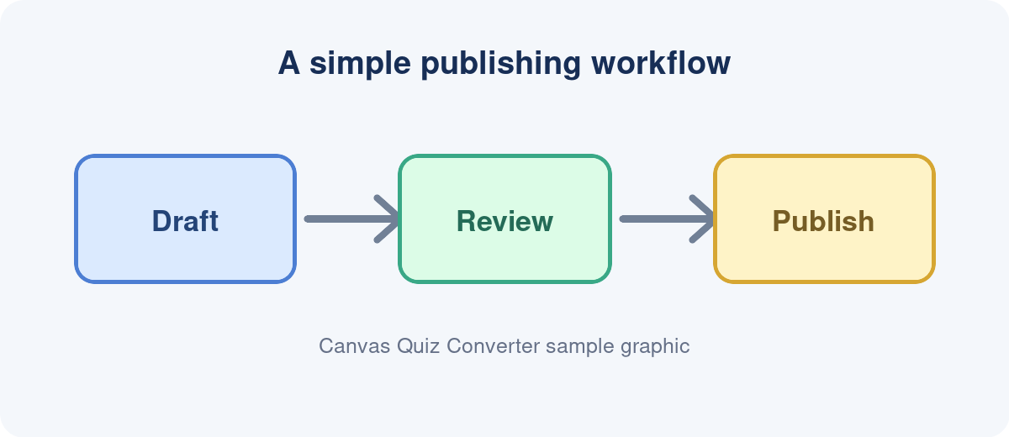
  - !Review
  - Archive
  - Translate
  - Delete
- What does the following chart display?
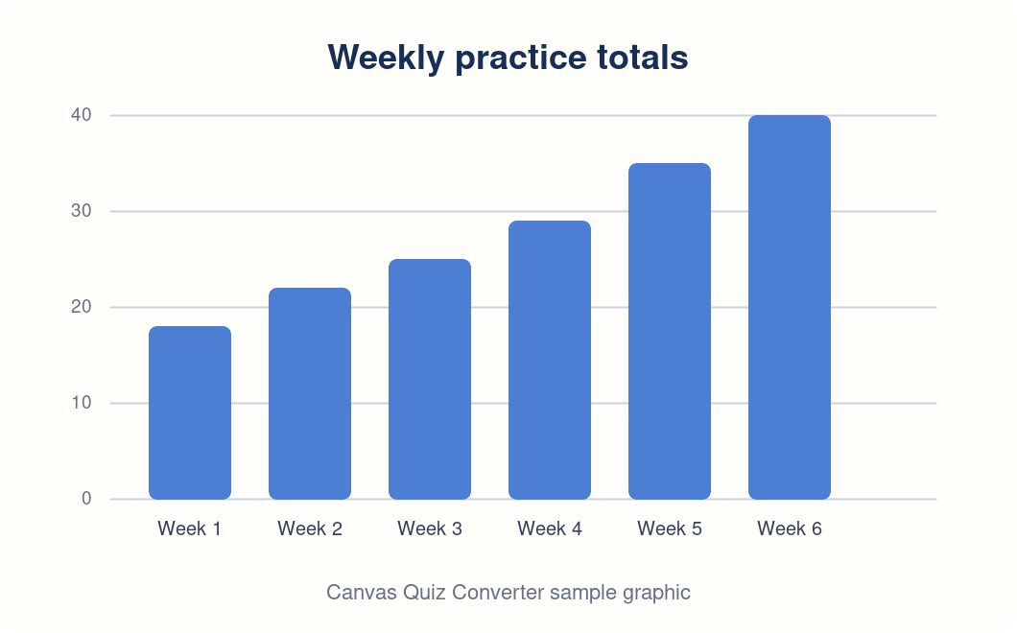
- !Weekly practice totals
- A weather forecast
- A course navigation menu
GROUP
Group title: Format knowledge check
pick: 1
points per question: 2
- Can choices use either a) or a. as their list style?
  - !True
  - False
- Should each question use Word’s automatic numbered-list format?
  - !True
  - False
- Can a single-choice question include more than four options?
  - !True
  - False
- Are embedded images packaged inside the QTI ZIP?
  - !True
  - False
END_GROUP

