HUBBLE’S LAW AS PHOTON VELOCITY

MICHAEL HELLAND
Seattle, WA 98138 USA
mike@mikehelland.com

Applied directly to the wave speed formula, cosmological red-shifts suggest a photon’s velocity decreases with distance. When examined, computer models with photons that decelerate according to Hubble’s constant are shown to produce expected z values for distances without the expansion of space. The duration of the photon’s journey to its destination increases as it decelerates, which mostly correlates to the expected co-moving distance of the standard model, deviating from the standard model by predicting a slower increase in red-shifts over time when z > 8.0, eliminating the need for Hubble’s constant to change with time.

1. Introduction
Finding the right value for Hubble's Constant has been difficult. To examine the problem, imagine you shoot a laser beam into space, and it passes a series of targets placed 200 million light years apart. In a simple universe, the laser beam will reach the first target in 200 million years, the second target in 400 million light years, and so on.
Here's the output of a computer model demonstration.
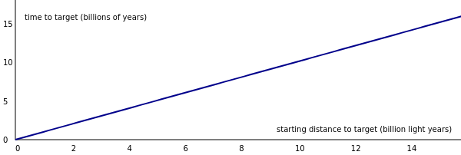
Fig. 1. A photon in a simple, static universe reaches targets at a constant rate
The photon moves at a constant speed and reaches the targets at a consistent rate. Figure 1. plots the time it takes to reach a target (y-axis) over the distance to the target (x-axis).
This is the model we will be expanding on, so let's look at the code. We'll use JavaScript for simplicity.
simple = {
photon: {d: 0},
next: function () {
this.photon.d += c
}
}
The simple model contains two things, a photon and a next() function. The photon has a distance d which starts at zero. Every time next() is called, d increases by c.
We need to define c and also the units of the model:
// time units: 1 million years
// distance units: 1 million light years

// the speed of light 1 million light years / million years
const c = 1
Now we need to do three things:
- Add the targets
- Call the next() function in a loop
- Record when the photon passes a target
That's what the following function does:
function run(model) {

// create targets 200 million light years apart
model.targets = []
for (var i = 200; i <= 30000; i+=200)
model.targets.push({d: i})

var t = 0
var nextTarget = 0

// start the loop
while (model.targets[nextTarget]) {

//advance the model 1 million years
t += 1
model.next()

// if we hit a target record the time
if (model.photon.d >= model.targets[nextTarget].d) {

console.log("Target reached", t)
model.targets[nextTarget].hit = t

nextTarget += 1
}
}
}
The run() function creates an array of targets, and then calls next() in a loop, which moves the photon. The time t is recorded whenever the photon passes a target.
Pretty simple, right?
Well, we don't live in such a simple universe. We observe cosmological redshifts.
The redshifts are interpreted as the expansion of space. In this universe, the targets will be moving away from us according to Hubble's Law, v = H × D, where v is the velocity of the target, H is Hubble's Constant, and D is the distance of the target.
To demonstrate that, we need a model where the next() function moves the targets:
expanding = {
photon: {d: 0},
next: function () {
this.photon.d += c

// targets move at H × D
for (var target of this.targets)
target.d += H * target.start
}
}
While simple.next() just moves the photon, expanding.next() moves the photon and the targets.
The important new line in this model is target.d += H * target.start, and it contains a new constant H, which is Hubble's constant.
So what value do we use for H? According to observations of relatively near phenomena, H is measured to be 74 km/sec/Mpc. But according to measurements at our most distant observable range, H is measured as 67 km/sec/Mpc.
To use these values in the model, they must be converted to the proper units.
- Step 1: convert (km/s / Megaparsec) to (km/s / Million light years)
- Step 2: convert (km/s) to (light years / year)
Which gives:
74 km/s/Mpc = 22.6880185 km/s/Mly = 7.56790836e-5 ly/y/Mly = 0.00076
67 km/s/Mpc = 20.5418546 km/s/Mly = 6.85202514e-5 ly/y/Mly = 0.00069
When you run the expanding model, notice that the targets are moving away from the photon's source. The first one (H = 0.00076) expands slightly faster than the second one (H = 0.00069).
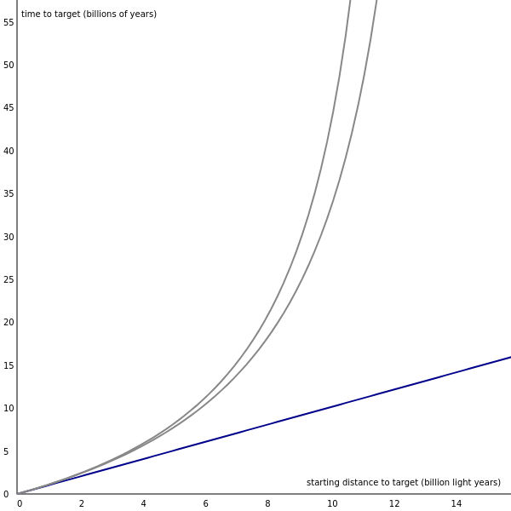
Fig. 2. Photons in an expanding universe reach targets at an increasing rate
As the targets recede, the time t it takes the photon to reach the next target increases, as can be seen by the gray lines in Figure 2. shooting up and away from the blue line of the simple model.
The difference in the values of H may seem small, but to cosmologists it begs to be resolved.

2. Hypothesis
We may state with some confidence that red-shifts are the familiar velocity-shifts, or else they represent some unrecognized principle of nature. We cannot assume that our knowledge of physical principles is yet complete; nevertheless, we should not replace a known, familiar principle by an ad hoc explanation unless we are forced to that step by actual observations.
E. Hubble, The Observational Approach to Cosmology, pg. 22, 1937
Edwin Hubble said that it was convenient for the redshift to be interpreted as a Doppler-like effect, leading to the expanding universe theory. He also said redshifts might be interpreted as how nature actually works. In other words, the redshifts aren't caused by some other phenomenon; cosmological redshift is a new phenomenon in-and-of itself. However, he cautioned, if there are existing ways to explain the redshifts, adding a new principle of nature should be avoided.
But choosing the path of the familiar principles over a new principle has forced us to propose several new principles anyways, including dark energy and inflation. It is also unclear, despite many accurate measurements, how fast space is expanding.
Let's back up then and ask: if cosmological redshifts do represent a new principle of nature, what is that principle? Consider the following premises:
- A decrease in frequency is observed
- The speed of a wave is v = frequency × wavelength
Therefore, if these premises are taken literally and plainly (and somewhat naively):
- the observed decrease in frequency should result in a decrease in speed.
To examine this literal interpretation of redshifts, let's make a new model where the speed of a photon begins at c and decreases as the distance from its source increases.
The simplest of these models is one where H × D is subtracted from c.
Hypothesis 1: the speed of light = c - H × D

hypothesis1 = {
photon: {d: 0},
next: function () {
this.photon.d += c - H * this.photon.d
}
}
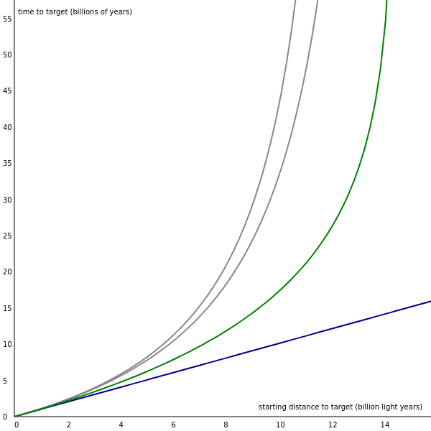
This hypothesis achieves something interesting. Even though the targets are stationary, the time it takes to reach the next target increases in a way that is similar to, but not exactly, the time it would take to reach a moving target.
The difference between the expanding model and hypothesis1 is that H × D has been moved from the velocity of the targets, to the velocity of the photon.

// expanding.next() // hypothesis1.next()
this.photon.d += c this.photon.d += c - H * this.photon.d

for (var target of this.targets)
target.d += H * target.start
Let's check to see how this affects frequency and red-shift. We're going to modify hypothesis1, not to do anything different, but to log more data. We'll store the photon's velocity as v. We'll give the photon an initial wavelength w and frequency freq_init of 499.65 nm and 6×105 Ghz. Then we'll calculate a new frequency freq based on the photon's new velocity v.

hypothesis1 = {
photon: {d: 0, freq_init: 6e5, w: 499.65},
next: function () {
this.photon.v = c - H * this.photon.d
this.photon.d += this.photon.v

this.photon.freq = this.photon.v * 299792458 / this.photon.w
}
}
Now we can update the run() function to log the photon's velocity and frequency at the time it reaches a target.

console.log("Target reached", t)
model.targets[nextTarget].hit = t
model.targets[nextTarget].v = model.photon.v
model.targets[nextTarget].freq = model.photon.freq
With this data, we can graph the velocity and frequency of the photon as it travels. Because we have the freq and freq_init we can also graph the red-shift of the photon given by:
z = (freq_init - freq) / freq
In this view, the green line for hypothesis1 covers up the white line for an expanding model using the same value of H. This shows that hypothesis1 predicts identical red-shifts for targets of the same distance as the expanding model.
However, they are not identical models, of course. hypothesis1 predicts the photon reaches the target sooner than the photon in the expanding model, as seen when the y-axis is set to "time to target". That will be investigated later in this paper.
Hypothesis 1 is a very straightforward implementation of the principle that a photon's speed decreases with distance. Another possibility is something like an inverse square law:
Hypothesis 2: the speed of light = c / (1 + (H × D)2)

hypothesis2 = {
photon: {x: 0},
next: function () {
this.photon.x += c / (1 + Math.pow(H * this.photon.x, 2))
}
}
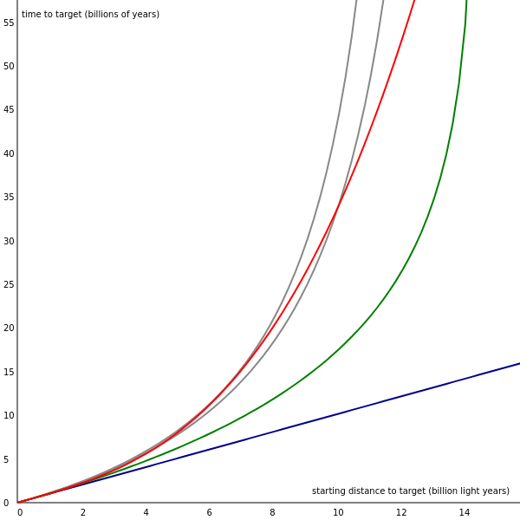
In this hypothesis, the units of H are independent of the units of c. The units of H are inverse length, which makes (1 + H × D) unitless. Hypothesis 2 has some interesting features, but it doesn't match the expected red-shift data exactly like hypothesis 1 does.
You can examine these models and others for yourself on the Testing Page.
In these models, the laser beam shows delays in reaching the targets even though the targets are stationary. The delay occurs because the photon red-shifts and its velocity decreases. In such a universe, space is not expanding.
The remainder of this paper will compare this hypothesis to similar sounding models, discuss the treatment of the photon in the model, and examine possible ways to test the hypothesis.

3. Comparison to other models

Tired Light
There have been hundreds of theories that don't involve expanding space trying to explain how light gets "tired" during long intergalactic journeys, starting all the way back in 1929 when the redshift-distance relation was first published.
Tired light theories fail because they don't account for enough redshift, they can't explain the distance factor, or the redshifts are caused in a way that would include other observable results, which ultimately are not observed.
In general, tired light theories have the following in common:
- Some other phenomenon causes the redshifts
- Light always travels at c, even though it is "tired"
- They are represented by the blue line on the graph, matching a simple static model
The hypothesis that light's speed is inversely proportional to the distance from its source is different:
- Nothing causes the redshifts, they are as fundamental to nature as inertia
- Light travels at less than c after millions of years
- The time it takes light to reach a target is similar to the expanding model
In this hypothesis, one could say light does get "tired", but it does so in a way that is conceptually and mathematically unique to the established Tired Light theories.

Varying Speed of Light (VSL)
For the last few decades there have been versions of a theory going around known as Varying Speed of Light:
There are others that think such dark energy ideas are now getting too convoluted, and that a much simpler explanation, one that even Einstein considered, should now be given serious consideration; a change in the speed of light, or VSL (Varying Speed of Light) as others know it by.
... The differing values [in Hubble's constant] may be explained if the speed of light has changed between the early and late universe,” said Louise Riofrio, an author and scientist who now works at an observatory association in Hawaii.
As mystery of the Universe’s expansion rate widens, a simple solution is offered
In VSL theories:
- c changes
- All photons in the universe slow to the same speed
- Space is expanding
- Intends to represent the accelerating rate of expansion
The hypothesis in this paper is different:
- c is constant
- Individual photons slow down according to their own history, not the universe's
- Space is not expanding
- Intends to represent cosmological redshift
The speed of light does vary in this hypothesis, but in a novel way to Varying Speed of Light theories.

4. Photons
This model represents light at the individual photon level. It's not a quantum theory, nor is it a relativistic theory, but it's also not completely classical. To illustrate, the photon was defined as having a distance from its source.

photon = {
distance: 0
}
Where is this photon? It doesn't have an (x,y,z) coordinate. Instead, it occupies every point around its source at the specified distance. It's not a classical particle or wave in this form.
Later, we added velocity, frequency, and wavelength to the photon.

photon = {
distance: 0,
velocity: 1,
frequency: 6e5,
wavelength: 499.65
}
For the purposes of this model, the photon actually only needs distance and energy.

photon = {
distance: 0,
energy: 2.48,
}
We know from classical mechanics that the speed of a wave is its frequency × wavelength. In quantum mechanics the energy of a photon is frequency × Planck's constant (h). And hypothesis 1 says the speed of a photon is c - H × D. Given these formulas:
speed of a photon v = c - H × D
speed of wave v = f × w
energy of a photon E = h × f
the photon's velocity, frequency, and wavelength can be determined at any time from its distance and initial energy.
However, those values don't need to be there at all times, and since the photon is a quantum particle, they probably shouldn't be there until we need them.
What we know about a photon we determine from its interaction with a measurement apparatus, not because we can observe it in-flight.
We know that a red-shifted photon will deliver less energy than it started out with. Assuming the ratio of energy observed to energy emitted is the same ratio as the photon's velocity to c, we can calculate the observed energy of a photon using just the photon's original energy and the distance from its source:

Eobserved = Eemitted × v/c
= Eemitted × (c - H × D)/c

And if we put that over Planck's constant (h) we get the new red-shifted frequency of the photon:
frequencyobserved = (Eemitted × (c - H × D)/c) / h
The photon's distance from where it was emitted is crucial to keep in mind at all times. Consider light that has traveled billions of years to reach your telescope. The light enters the lens, gets focused to the eyepiece, and then into your eyeball.
Seems pretty straightforward. But at some level, some type of interaction with the light and the lens must be focusing the light. At the quantum level, the photon will have been absorbed by atoms in the lens. Then it is re-emitted (or an entirely new photon is emitted), and focused to your telescope's eyepiece.
The photon may have traveled great distances from its source before it encountered your telescope, but the light inside the telescope will be very close to its source: the lens that focused it. The distance to the source of the photons in the telescope will be less than a meter, not millions of light years.
In that case the refreshed photon will be traveling at c, which now results in an elongated wavelength when calculated.

5. Tests

Test 1: measure the speed of a cosmologically red-shifted photon
This is the first obvious test of the hypothesis.
But it would take thousands or millions of years to perform a fully controlled experiment where light is emitted with a known energy at a known time and travels across a known distance to see the effects of red-shift.
Using light that has already traveled millions of years seems to be the only choice.
But interacting with the photon will cause it to reset its distance and speed, as mentioned in the previous section. The task then is to come up with a clever way to measure the speed of ancient light without disturbing the photon.
Consider a long tube in space with a telescope at one end and an open shutter at the other. The telescope has a nearby galaxy and a highly red-shifted galaxy in its sight.
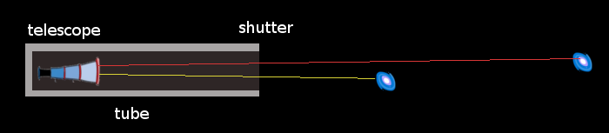
What happens when the shutter is closed?
Prediction: Because the red light is moving slower than the yellow light, first the nearby galaxy will disappear from view, then the distant one.
Obviously the longer the tube is the better the experiment would be. A few kilometers at least, a light second would be great. If we use a predictable and fast enough object in space as the shutter, that might work just as well. The shutter must not reflect any light. The moon may be too bright and too slow to work.

Test 2: the time to target discrepancy
It was noted earlier that the expanding model and hypothesis 1 produce the same red-shifts for the same value of H, but at different times. The photon in hypothesis 1 reaches its targets before the photon in the expanding model. Here's the time it takes to reach a target:
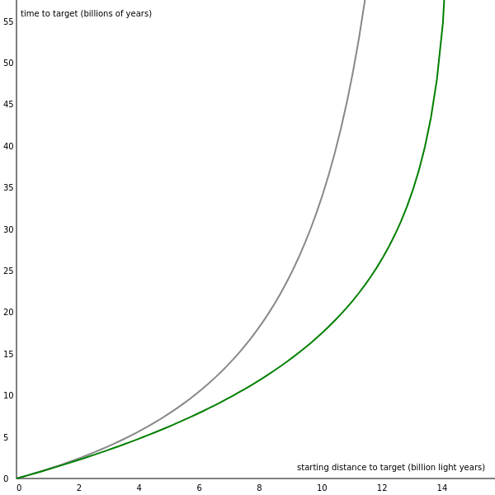
white = expanding, green = hypothesis 1
To look at this further, the following chart of z, lookback time, and co-moving distance was made using WolframAlpha. Units are billion years and billion light years.
Table 1. z, lookback time, and co-moving distance for H₀ = 74 km/s/Mpc and H₀ = 64.7 km/s/Mpc
z | H₀=74 lookback | H₀=74 co-moving distance | H₀=64.7 lookback | H₀=64.7 co-moving distance
1 | 7.4 | 10.4 | 8.1 | 11.4
2 | 9.8 | 16.4 | 10.8 | 18.0
3 | 11.0 | 20.1 | 12.1 | 22.1
4 | 11.6 | 22.8 | 12.7 | 25.0
5 | 11.9 | 24.7 | 13.1 | 27.1
6 | 12.2 | 26.2 | 13.4 | 28.8
7 | 12.3 | 27.5 | 13.5 | 30.2
8 | 12.4 | 28.5 | 13.7 | 31.3
9 | 12.5 | 29.4 | 13.8 | 32.2
10 | 12.6 | 30.1 | 13.8 | 33.0
11 | 12.7 | 30.7 | 13.9 | 33.8
12 | 12.7 | 31.3 | 14.0 | 34.4
13 | 12.7 | 31.8 | 14.0 | 34.9
14 | 12.8 | 32.3 | 14.0 | 35.4
15 | 12.8 | 32.7 | 14.1 | 35.9
16 | 12.8 | 33.1 | 14.1 | 36.3
17 | 12.8 | 33.4 | 14.1 | 36.7
18 | 12.9 | 33.7 | 14.1 | 37.0
19 | 12.9 | 34.0 | 14.1 | 37.4
20 | 12.9 | 34.3 | 14.2 | 37.7
21 | 12.9 | 34.6 | 14.2 | 37.9
22 | 12.9 | 34.8 | 14.2 | 38.2
23 | 12.9 | 35.0 | 14.2 | 38.4
24 | 12.9 | 35.2 | 14.2 | 38.7
25 | 12.9 | 35.4 | 14.2 | 38.9
z [H=74 lookback co-distance] [H=67.4 lookback co-distance]
--------------------------------------------------------------------------

In the expanding model, the lookback time refers to how long ago the light was emitted, and the co-moving distance refers to how far away the light source is now, given that space has expanded since the light was emitted.
In hypothesis 1, the time it takes to make the journey increases due to the photon slowing down. A distant light source won't have moved from expansion between then and now (though it may have its own particular motion). In this case distance and duration trade places. The lookback time correlates with the distance of the target, and the co-moving distance correlates with the time it takes to reach the target.
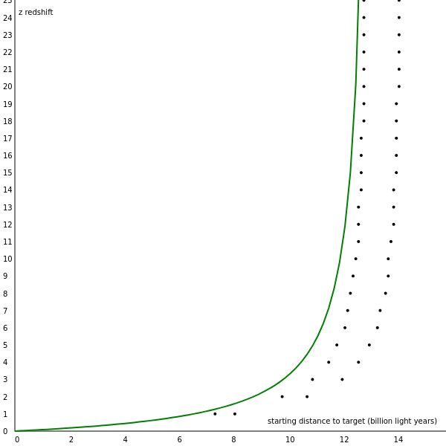
green = hypothesis 1, white dots = WolframAlpha, lookback (left) co-moving distance (right)

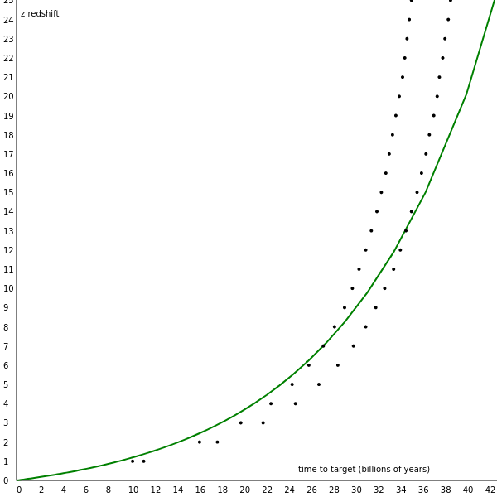
At about a z of 8.0, hypothesis 1 starts to go off the path of the expanding model, predicting a slower rise in z over time.
This deviation from the standard model appears to be what is measured today and known as the Hubble tension, the difficulty in finding a proper value for Hubble's constant. If hypothesis 1 is adopted as Hubble's Law, the tension is resolved.

Test 3: breadcrumbs
If the photon has less energy when it arrives than when it left, what about the missing energy? If the universe were trillions of trillions of years old, and light kept losing energy all over the place, you would think there would be barely anything left in existence by now.
For this reason, it seems sensible that any energy deducted from the photon during its journey through space might be deposited along its path, like a trail of breadcrumbs. Overtime, this discarded energy could coalesce into something larger.
This might be supported by observations of walls and filaments of galaxies:
An analysis of thousands of galaxies finds that they are strung like pearls on a necklace, even on relatively small scales.
On large scales, the universe is comprised of empty voids, punctuated by narrow, winding filaments of dark matter that guide the growth of galaxies and galaxy clusters. This cosmic web, which has taken decades to map, holds a repeating pattern on the order of hundreds of millions of light years.
Galaxies in filaments spaced like pearls on a necklace
Although, how that could be made into a quantifiable prediction is presently unclear.

6. Conclusion
We seem to face, as once before in the days of Copernicus, a choice between a small, finite universe, and a universe indefinitely large plus a new principle of nature.
E. Hubble, The Observational Approach to Cosmology, pg. 52, 1937
Cosmological redshifts have been a known, observed fact since 1929.
We could assume the redshifts indicate motion, which means:
- the universe is expanding
- there are age and size limits to the universe
- the universe inflated in the first nanosecond
- it is dominated by dark matter and dark energy
- it's currently accelerating
Or we could assume the redshifts are themselves a new feature of the universe, which means:
- light doesn't travel to infinity at a constant speed
- what we can see is an insignificant sample of an indefinitely large and old universe
When interpreting the red-shifts as Doppler effects in the 20th century, astronomers didn't know this idea would lead to inflation or dark energy. In fact, they chose the velocity-shift interpretation because it was known and familiar and didn't require new laws of physics.
In retrospect, it should come as no surprise to us that when telescopes could show us what's beyond the Milky Way, they would also reveal a new fundamental law of nature.
If dark energy is in the consideration as a possible fundamental ingredient of nature despite having never been observed, then the actual observations that led to its conjecture, cosmological redshift, should be considered as well.

